PAPER 1: PHYSICAL GEOGRAPHY

Section A: The Challenge of Natural Hazards
- Earthquakes: Kobe and Haiti
- Tropical Storm: Typhoon Haiyan
- Extreme Weather: Somerset Floods

Section B: The Living World
- Tropical Rainforest: Amazon Rainforest
- Desert: The Sahara Desert

Section C: Physical Landscapes in the UK
- Coasts
- Rivers

PAPER 1 EXAM DATE: 18th MAY (9am)

The Challenge of Natural Hazards Page 1

QUIZ A:
- The four layers of the earth are….
- A tectonic plate is…
- Outline one difference between these two oceanic and continental crusts.
- The theory of continental drift states….
- Convection currents are…
- Slab pull is…
- A natural hazard is…..
- Two examples of tectonic hazards are….
- Meteorological hazards are….
- An example of a meteorological hazard is….
- Hazard risk refers to….
- Hazard risk is affected by population density, level of development, type of hazard and climate change. Choose one and explain why.

QUIZ B:
- A plate boundary/margin is….
- In what direction do plates move at a constructive plate margin?
- In what direction do plates move at a destructive plate margin?
- In what direction do plates move at a conservative plate margin?
- In what direction do plates move at a collision plate margin?
- At what plate margin do you get subduction?
- At what plate margin is new land formed?
- What is sea floor spreading?
- At which plate margins do you get volcanoes and earthquakes?
- What which plate margins do you get just earthquakes?
- Fold mountains are…
- At which plate margins do you find fold mountains?

PRACTICE EXAM QUESTIONS

- Explain why tectonic plates move. (6 marks)
- Using Figure 1, explain why tectonic hazards occur at destructive plate margins. (6 marks)
- Study Figure 2, a map showing the earth’s tectonic plates and margins (boundaries). With the help of Figure 2, explain why tectonic hazards occur at location X. (6 marks)
- Using Figure 2, explain why tectonic hazards occur at location Z. (6 marks)
- Explain why tectonic hazards occur at collision plate margins. (4 marks)
- Three plate margins (X, Y and Z) are shown in Figure 2. Identify the plate margins that are represented by X, Y and Z in Figure 2. (3 marks)
- Explain the factors that affect a locations level of hazard risk. (4 marks)

Figure 2
Figure 1
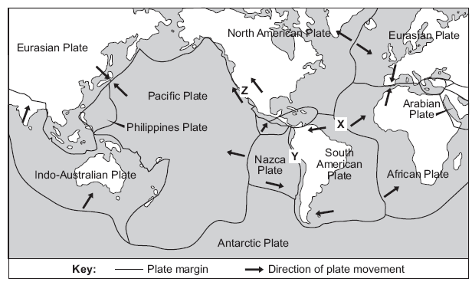

The Challenge of Natural Hazards Page 2

QUIZ A:
- An earthquake is…..
- When did the Kobe earthquake occur?
- What was the magnitude of the Kobe earthquake?
- What plate margins does Kobe lie near?
- Identify three primary effects including statistics.
- What was the name of the elevated road that collapsed?
- Identify three secondary effects including statistics.
- Why are the destroyed homes an example of a secondary effect and not primary?
- Identify three immediate responses including statistics.
- Identify three long term responses including statistics.
- State one reason why the effects are less significant than Haiti’s.

QUIZ B:
- The epicentre is….
- What is radiated from the focus?
- When did the Haiti earthquake occur?
- What was the magnitude of the Haiti earthquake?
- What plate margins does Haiti lie near?
- What is the capital of Haiti?
- Identify three primary effects including statistics.
- Identify three secondary effects including statistics.
- Identify three immediate responses including who provided the aid.
- Identify three long term responses including statistics including who provided the aid.
- State one reason why the effects are worse than Kobe’s.

QUIZ C:
- The point of movement in the earth’s crust is known as….
- Magnitude refers to…
- The magnitude of an earthquake is recorded using….
- State two reasons why people still live in areas that are prone to tectonic hazards.
- Identify one way people can predict earthquakes.
- What occurs on 1st September in Japan? Is this an example of a planning or prediction?
- Earthquake proof buildings are buildings that have been designed to withstand earthquakes. State one way they are protected.
- Not using earthquake buildings, identify a way government and locals can prepare for a potential earthquake.
- What is a hazard map?

PRACTICE EXAM QUESTIONS

- Describe how tectonic hazards can impact on people. (4 marks)
- Study Figure A, a photograph showing an area in Indonesia affected by an earthquake in 2018. Using Figure A and an example you have studied, assess the extent to which primary effects are more significant than secondary effects. (9)
- Study Figure A, a photograph showing an area in Indonesia affected by an earthquake in 2018. Using Figure A and an example you have studied, assess the extent to which tectonic hazards have effects on people and the environment. (9)
- Suggest why effects of tectonic hazards vary between contrasting levels of wealth. (6 marks)
- Study Figure B, showing the largest and deadliest earthquakes from 2008 to 2012.
- To what extent is there a relationship between the largest and deadliest earthquakes shown in the table? (3 marks)
- Outline two reasons why the largest earthquakes do not always cause the most deaths. (4 marks)
- Using an example of a tectonic hazard you have studied, describe how people responded to the tectonic hazard. (6)
- Using a named example, evaluate the immediate and long term responses to a tectonic hazard. (9 marks)
- Explain why people continue to live in areas at risk from earthquakes. (4 marks)
- Describe how planning and prediction can reduce the impacts of future tectonic hazards. (6 marks)
- Assess the extent to which prediction is the most important factor in reducing the effects of tropical storms. (9 marks)
Figure B

The Challenge of Natural Hazards Page 3

QUIZ A:
- A tropical storm is….
- Where and when did Typhoon Haiyan occur?
- What was the strength of Typhoon Haiyan?
- Identify three primary effects including statistics.
- Where were most of the homes destroyed?
- Which airport was destroyed?
- Identify three secondary effects including statistics.
- Which industry was worse affected?
- Identify three immediate responses including who provided the aid.
- Identify three long term responses including who provided the aid.

QUIZ B:
- Two conditions needed for a tropical storm to form are….
- The strength of a tropical storm is measured using the……scale.
- This scale goes from 1 to………
- Tropical storms can be up to ……..m wide.
- Identify the name of the centre of the storm where it is calm and there are no clouds.
- Identify the 8 stages of tropical storm formation. Heavy elephants really can squash Sarah Martin LOL
- Why do tropical storms eventually lose their energy?
- Satellites can be used to predict tropical storms. More specifically……
- Previous data can be used to predict tropical storms. More precisely……
- Suggest one way locals can prepare for a tropical storm.
- Suggest one way governments can prepare for a tropical storm.

PRACTICE EXAM QUESTIONS
- Explain how a tropical storms form. (4 marks)
- Study Figure 2, a satellite image of Cyclone Nargis. Label features X, Y and Z. (3 marks)
- Study Figure 3, a satellite image of Hurricane Katrina shortly before it crossed New Orleans in the USA. Using the image only, forecast the weather conditions in New Orleans over the next 24 hours (4 marks)
- Study Figure 4, a map showing the path of a tropical storm (Typhoon Ketsana), 23 to 30 September, 2009. With the help of Figure 4, describe how tropical storms can impact on communities and the environment. (6)
- Assess the extent to which primary effects are more significant than secondary effects. Use an example of a tropical storm you have studied. (9 marks)
- Assess the extent to which tropical storms have effects on people and the environment. Use an example you have studied. (9 marks)
- Use a case study to describe how people respond to a tropical revolving storm. (6 marks)
- Using a named example, evaluate the immediate and long term responses to a tropical storm you have studied. (9)
- Describe how people can predict tropical storms to reduce future risk. (6 marks)
- Assess the extent to which prediction is the most important factor in reducing the effects of tropical storms. (9 marks)
- Suggest why the number of tropical storms may change in the future. (4 marks)
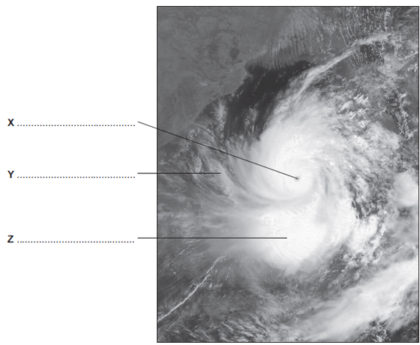
Figure 3
Figure 2

Figure 4

The Challenge of Natural Hazards Page 4

QUIZ A:
- Weather is…
- Extreme weather is…..
- Extreme weather is becoming more common in the UK. What extreme weather event occurred in 2004, 2007 and 2014?
- What extreme weather event occurred in 2003?
- When did the Big Freeze occur?
- The International Disaster Database recorded an increase in the number of…………since……….
- Global atmospheric circulation is….
- In low pressure systems the air rises/sinks.
- In low pressure systems you get rain / dry conditions.
- In high pressure systems the air rises/sinks.
- In high pressure systems you get rain / dry conditions.
- Air moves from areas of high/low pressure to areas of high/low pressure.

QUIZ B:
- Where is Somerset located?
- When did the flood occur?
- How much rain fell in January & February?
- List one other cause of the flood.
- List two social effects of the flood.
- List two economic effect of the flood.
- List one environmental effect of the flood.
- To respond to the flood, the Somerset Council launched a £……………….Flood Action Plan.
- What is dredging?
- What did they do to the river banks to prevent future floods?
- How did they prevent transport routes being affected by future floods?
- How did they help people plan for future floods?

PRACTICE EXAM QUESTIONS
- The weather in the UK is becoming more extreme. Use evidence to support this statement. (6 marks)
- Study Figure 1a, a satellite image of the UK taken on 2nd December, 2010 and Figure 1b, a newspaper extract.
- Describe the extent of snow cover shown in Figure 1a (2 marks)
- Use examples to describe the impacts of extreme weather such as that shown in Figures 1a and 1b. (6)
- Describe the benefits that extreme weather can bring (4 marks)
- Suggest how extreme weather and can social and economic impacts. (6 marks)
- Using an example of an extreme weather event you have studied in the UK, describe how extreme weather can impact on people and the environment. (6 marks)
- Study Figure 6, a map showing the global distribution of climatic zones. Using Figure 6 and your own knowledge, describe and explain the distribution of climatic zones. (6 marks)
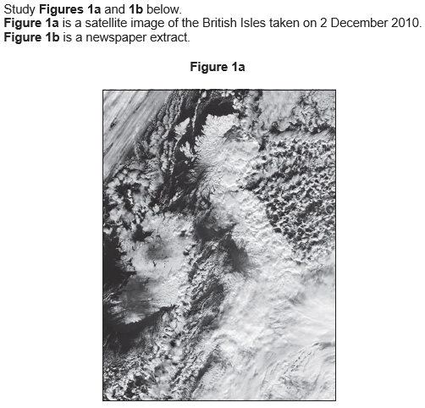

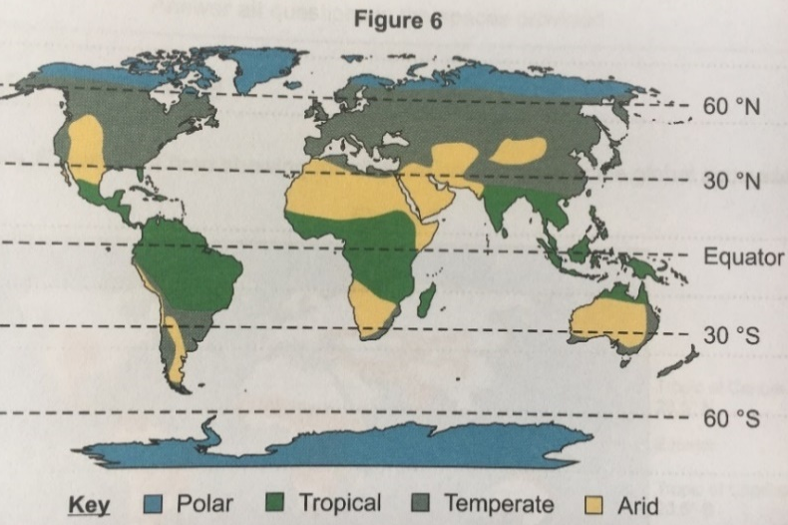

Figure 2

The Challenge of Natural Hazards Page 5

QUIZ A:
- What happens to the temperature of the earth when there is a volcanic eruption?
- A sunspot is….
- When there are many sunspots, the temperature………
- The length of a sunspot cycle is……
- Orbital change is…
- Eccentricity affects global temperatures because…..
- The length of an eccentricity cycle is…..
- List three fossil fuels.
- Sunlight travels to the earth as…………… radiation, however is reflected off the earth’s surface as……………radiation.
- The enhanced greenhouse effect is….
- How have humans caused an increase in methane production?
- How have humans caused an increase in carbon dioxide production?
- How have humans caused an increase in nitrous oxide production?
- How does deforestation result in global warming?

QUIZ B:
- Climate change is….
- Climate change can be proven through ice core data. More precisely…
- Climate change can be proven through thermometer recordings. More specifically…
- Climate change can be proven through photographs. For example…
- Climate change can be proven through paintings. For example…
- Mitigation refers to….
- How can carbon capture mitigate against climate change?
- How does afforestation mitigate against climate change?
- How do international agreements mitigate against climate change?
- How do renewables mitigate against climate change?
- People can also adapt to the likely impacts of climate change. Identify one way people can adapt to likely sea level rise?
- Higher temperatures will result in more pests and diseases. How can farmers adapt to this impact?
- Extreme weather such as droughts are likely. How can people adapt to this impact?

PRACTICE EXAM QUESTIONS
- There is significant evidence of long term climate change. Use evidence to support this statement. (6 marks)
- Study Figure 1, a graph showing changes in the amount of carbon dioxide in the atmosphere. Describe the change in the amount of carbon dioxide in the atmosphere shown in the graph. (2 marks)
- Explain how rising populations will have likely impacts on global temperature. (6 marks)
- Study Figure 3, a map showing the extent of sea ice in the Arctic Ocean on 26th August, 2012. Describe the changes in the extent of Arctic sea ice shown in the map. (2 marks)
- The Kyoto Agreement was aimed at reducing the amount of carbon dioxide being released into the atmosphere.
- Is this an example of mitigation or adaptation? (1 mark)
- Identify two strategies to reduce carbon emissions. (2 marks)
- Explain why the control of pollution needs to be agreed by many countries if it is to be successful. (4 marks)
- Explain how volcanic activity and orbital changes may cause long-term climate change. (4 marks)
- Explain how the use of fossil fuels and changes in agriculture has contributed to global changes in temperature. (4 marks)
- Outline one strategy which aims to reduce the rate of climate change (mitigation). (4 marks)
- Rising sea levels are a major consequence of global warming. How may the problem of rising sea levels be managed? (4)
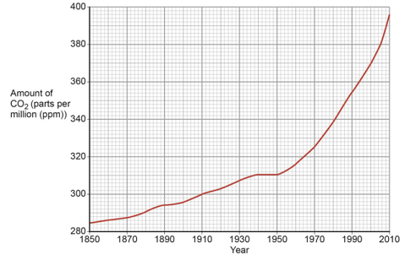
- Describe how people have adapted to the likely impacts of global climate change. (6 marks)
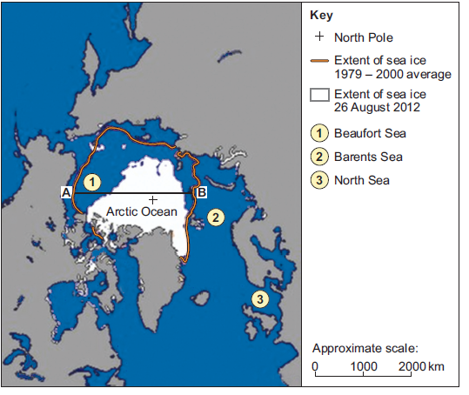
Figure 1

Figure 3

The Living World Page 6

QUIZ A:
- An ecosystem is…
- Ecosystems are made up of producers, consumers and decomposers. A producer is…. For example….
- A consumer is….
- There are different types of consumer. These are….
- What is the difference between an omnivore and herbivore?
- An example of a decomposer is…..
- A food chain is….
Figure 1

Figure 2

Figure 3

Figure 4
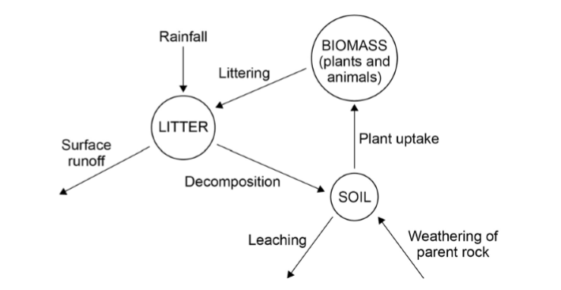
- A food web is….
- An example of a small scale ecosystem is…..
- Why does a pond provide a number of different habitats?
- Identify a producer and consumer in the pond ecosystem.
- Identify one way human activities impact on the pond ecosystem.
- Identify one way climate change could impact on the pond ecosystem.

QUIZ B:
- The rainforest is located….
- The tundra is located….
- Hot deserts are located…..
- The deciduous forest is located…..
- The coniferous forest is located…..
- There are………seasons in the savannah. The…………and……………season.
- The climate in the desert can be described of as…….
- The climate in the tropical rainforest is described as………….
- What is the main vegetation type in the savannah?
- Identify an animal that is commonly found in the savannah.
- The climate in the tundra is…..
- There is sparse/dense vegetation in the tundra.
- An animal that lives in the tundra is…..
- What is the difference between trees in the coniferous and deciduous forest?
- What ecosystem do we live in?

PRACTICE EXAM QUESTIONS
- Study Figure 1, a world map showing some large scale global ecosystems.
- Describe the distribution of hot deserts shown on the map. (2 marks
- Describe the distribution of tropical rainforests shown on the map. (2 marks)
- Describe the distribution of the tundra. (2 marks)
- Outline the difference between a food chain and a food web. (2 marks)
- Outline one reason for the high levels of biodiversity in tropical rainforests. (4 marks)
- Study Figure 2, which shows a food chain.
- Outline the role of the decomposers. (3 marks)
- Suggest how a drought would impact on the ecosystem and food chain. (4 marks)
- Study Figure 3, which shows a food web. Describe how the food web shows that the difference parts of the ecosystem are linked to each other. (3 marks)
- Describe the main features of a small-scale ecosystem in the UK. (4 marks)
- Study Figure 4, a diagram showing the nutrient cycle. Explain why the diagram shown in Figure 9 is an example of nature’s recycling system. (6 marks)

The Living World Page 7

QUIZ A
- The desert is located….
- List two examples of deserts in the world.
- In the desert, temperatures in the day reach……, however at night temperatures are…..
- The desert climate is known as…….
- On average how much precipitation does the desert receive each year?
- State two characteristics of soils in the desert.
- Suggest why soils in the desert are not fertile.
- Define biodiversity.
- State one threat to the desert.
- State one way people use the desert ecosystem.
- Suggest one reason why there is low biodiversity in the desert.

QUIZ B:
- Identify two ways the roots of the cactus have adapted to the desert ecosystem.
- Define succulent and suggest a plant that has this characteristic.
- How does the thick, waxy skin of a cactus help it survive in the desert?
- Suggest one way the roots of the Joshua Tree have adapted to the desert.
- State how the Joshua Tree’s leaves help them survive in the desert.
- State two animals found in the desert.
- Identify one way animals have adapted in the desert. Explain how this helps them survive.
- What does a camel store in their hump and why?
- How many rows of eye lashes does a camel have and why?
- Why do camels have large feet?
- Why do lizards burrow in the day and emerge in the night within the desert?
- What does camouflage mean?
- List two animals that camouflage in the desert.

PRACTICE EXAM QUESTIONS
- Using global atmospheric circulation, explain why the climate in the deserts is arid (hot and dry). (4)
- Why are desert soils often salty? (4 marks)
- Study Figure 1, a photograph from the Mojave Desert. Describe and explain how vegetation in hot deserts adapts to the climate. (6 marks)
- Figure 2 shows some of the world’s hot desert areas and factors affecting rainfall in hot desert areas.
- Which lines of latitude shown in the figure, pass through the world’s hot desert areas? (1 mark)
- Describe the global distribution of hot deserts. (3 marks)
- Using examples, describe and explain how animals adapt to the desert. (6 marks)
Figure 1
Figure 2

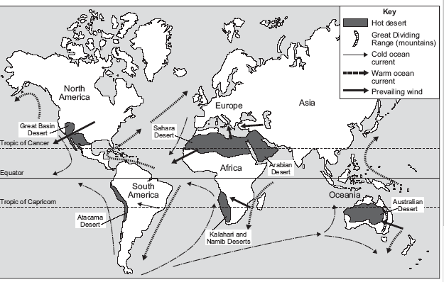

The Living World Page 8

QUIZ A
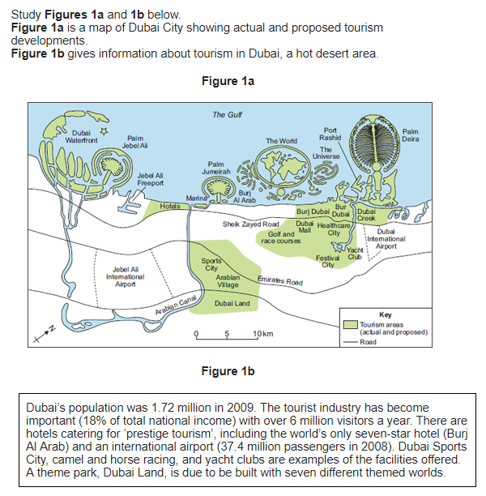

Figure 2
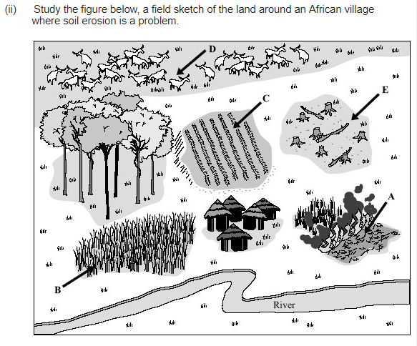

Figure 3

- The Sahara Desert is located…..
- Name the oil field in Algeria.
- How much of Algeria’s GDP comes from oil and gas?
- How many people are employed in the oilfield in Algeria?
- What percentage of Egypt’s GDP comes from agriculture?
- What percentage of Egypt’s population are employed in agriculture?
- Why is there a need for extensive agriculture in Egypt?
- What do they use to irrigate the fields in Egypt?
- Why does agriculture in Egypt result in salinity/salinsation (salty soils)?
- How do the solar farms in Tunisa provide an economic opportunity?
- Why do tourists visit the Sahara?
- How does tourism provide economic opportunities?
- How does lack of rainfall impact on agriculture and solar farming?
- How does the vast size of the Sahara impact on mining for oil and gas and tourism?
- How does the high temperatures impact on tourism and agriculture?
- How many gallons of water are needed to clean solar panels each day?

QUIZ B:
- Desertification is….
- Identify two human activities that result in desertification.
- Overgrazing causes desertification because….
- Overcultivation causes desertification because….
- Deforestation causes desertification because…..
- Climate change causes desertification because….
- Two sustainable strategies to reduce the risk of desertification are……
- Grazing rotation reduces the risk of desertification because…..
- What is break from farming and how does it reduce the risk of desertification?
- How can manure help to reduce desertification?
- What is an earth dam?
- How does afforestation prevent desertification?

PRACTICE EXAM QUESTIONS
- Study Figure 1a, a map of Dubai City showing actual and proposed tourism developments, and 1b, which shows information about tourism in Dubai, a hot desert area.
- Describe the location of tourism areas (actual and proposed) in Dubai City shown in Figure 1a. (3 marks)
- Use Figure 1b to provide evidence of the importance to tourism to Dubai. (3 marks)
- For a hot desert environment or a cold environment you have studied, to what extent have opportunities for economic activity been developed in your chosen environment? (9 marks)
- Desertification is the process where land gradually turns into a desert. Study Figure 2, a field sketch of the land around an African village where desertification is a problem.
- Suggest how human activity has resulted in increased desertification. (4 marks)
- Explain how areas at risk from desertification can be managed. (4 marks)
- Study Figure 3, pie charts showing the amount of desertified land and the level of desertification in three continents.
- What percentage of the desertifed land in Asia is classed as moderate: 21%, 51% or 81%? (1 mark)
- Describe the difference between Africa and Asia shown on the figure. (3 marks)
- Assess the importance of management strategies used to reduce the risk of environmental damage. Use an example of an area on the fringe of a hot desert that you have studied. (9 marks)
- To what extent is your chosen environment at risk from population growth? Use an example of an area on the fringe of a hot desert that you have studied. (9 marks)

The Living World Page 9
Figure 1
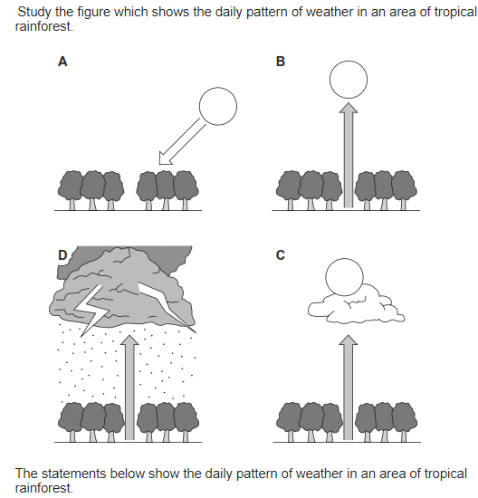

Figure 2

Figure 2b
QUIZ A:
- The location of the rainforest ecosystem is…..
- List two countries where you find rainforests.
- The climate in the rainforest can be described of as…………
- Temperatures in the rainforest range between……………
- There are high temperatures in the rainforest because…..
- The average amount of annual precipitation in the rainforest is………
- How many seasons are there in the rainforest?
- In the rainforest, soils often only have a fertile top layer because…..
- Biodiversity means…..
- Tropical rainforests have high/low biodiversity.
- How much of the world’s plant and animal species are found in the rainforest?

QUIZ B:
- The vegetation in the rainforest is found in………..distinct layers. This is known as s……………..
- The four layers are called…….
- Why do trees grow to 40m tall?
- What is the name of the vines that grow up tree trunks?
- Suggest why vegetation roots in the rainforest are shallow.
- Why do trees need buttress roots in the rainforest?
- What are the conditions like in the shrub and ground layer?
- Why do plants in the shrub and ground layer have large leaves?
- How have plants adapted to high precipitation levels in the rainforest?
- How has the red-eyed tree frog adapted to survive in the rainforest?
- How has the spider monkey adapted to suit the upper canopy layer?

PRACTICE EXAM QUESTIONS
- Study Figure 1, which shows the daily weather patterns.
- Which of images A to D represents the weather pattern seen in Tropical Rainforests? (1 mark)
- Using Figure 1, explain the weather found in rainforests. (4 marks)
- Describe the structure and characteristics of the layers of the rainforest. (6 marks)
- Study the photograph shown in Figure 2 and 2b. Choose a photograph. Describe and explain the features of the vegetation shown in your chosen photograph. (6 marks)
- Describe and explain how animals adapt to the tropical rainforest. (6 marks)
- Explain why nutrients are only found in the top layer of rainforest soils. (4 marks)
- Give one reason why there is high biodiversity in the rainforest. (3 marks)
- Study Figure 4, a climate graph for an area of the tropical rainforest. Describe the patterns of rainfall and temperature shown in the figure. (4 marks)
Figure 4
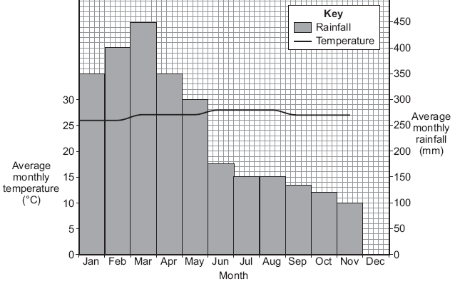
The Living World Page 10

QUIZ A:
- Deforestation is….
- The Amazon rainforest is located….
- ……..% of the amazon has already been deforested.
- The number one cause of deforestation in the rainforest is…….., which accounts for …..% of the deforestation.
- What is the name of the HEP dam in the Amazon?
Figure 2
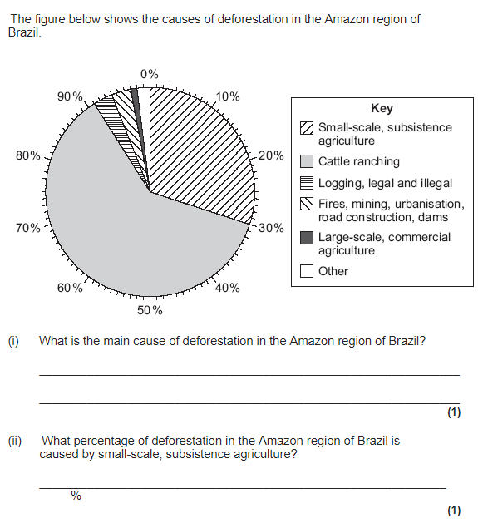
Figure 3
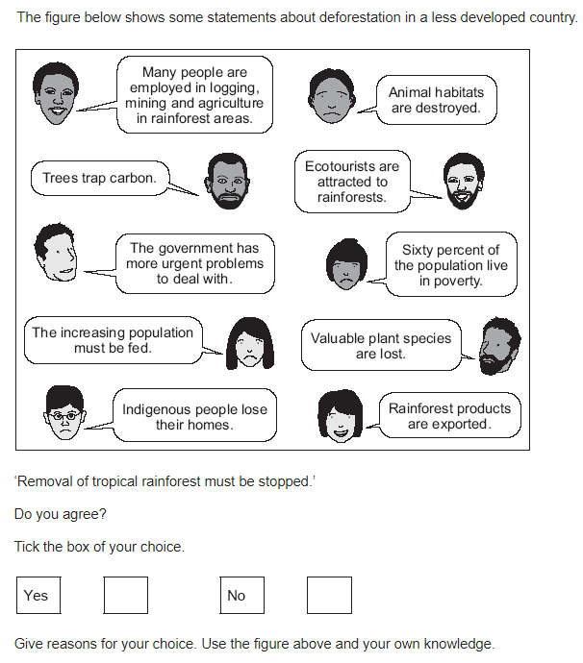
- An example of a mine in the Amazon is….
- An example of a settlement in the Amazon is…..
- State two positive impacts of development in the Amazon rainforest.
- How does improving transport routes bring economic development?
- State one benefit of HEP dams in the Amazon.
- State one social cost of development in the Amazon rainforest.
- State one environmental cost of development in the Amazon rainforest.
- How does deforestation cause climate change?
- Why does deforestation cause soil erosion in the Amazon?

QUIZ B:
- Define sustainability.
- What is debt relief and how does it reduce deforestation?
- Why are rainforests referred to as carbon sinks?
- Identify a rainforest that has been protected due to its role as a carbon sink.
- What is selective logging?
- Identify a national park that has been created in the Amazon Rainforest. How much land has been protected again deforestation?
- How does the FSC help reduce deforestation?
- What is ecotourism?
- Suggest two ways ecotourism is good for the environment.
- State one national sustainable strategy to reduce the rate of deforestation.
- State one international sustainable strategy to reduce the rate of deforestation.

PRACTICE EXAM QUESTIONS
- Study Figure 1, a graph showing the amount of deforestation in the Amazon, between 1994 – 2009 and 2010 – 2017 (estimates). Describe how the rate of deforestation has changed since 1995. (4 marks)
- Study Figure 2, a pie chart showing the causes of deforestation in the Amazon region of Brazil. What is the largest cause of deforestation and what percentage does it account for? (1 mark)
- Explain how development in tropical rainforests creates economic advantages but at a cost to the environment.(6 marks)
- Study Figure 3, showing statements about deforestation that occurs in LICs. To what extent should development of tropical rainforests be stopped? Use Figure 3 and an example that you have studied. (6 marks)
- Study Figure 4, extracts from geography textbooks about international co-operation in managing tropical rainforests. Use the extracts and your own knowledge to explain how international co-operation can ensure that tropical rainforests are managed sustainably. (6 marks)
- Assess the effectiveness of strategies used to reduce environmental damage in a tropical rainforest you have studied. (9)
- Describe how selective logging and replanting are examples of sustainable management in tropical rainforests. (6 marks)

Figure 4
Figure 1

Physical Landscapes in the UK - Coasts Page 11

QUIZ A:
- The distance between two wave crests is known as….
- The vertical distance from the crest to the trough is known as….
- Two features of a constructive wave are….
- Two features of a destructive wave are….
- Wave strength is affected by the strength of winds and the fetch. Fetch refers to…..
- Erosion is…..
- Hydraulic action is….
- Abrasion is….
- What is the type of erosion where material hits into each other and gets smaller and smoother?
- Weathering is…
- Freeze-thaw occurs due to…
- Carbonation is when….

QUIZ B
- Swash is….
- Backwash is
- Material is transported along the coastline in a………pattern, by the process of……
- Deposition is…
- Material is deposited because…
- Deposition often occurs in…..
- What process do destructive waves cause?
- What process do constructive waves cause?
- Infiltration is when…
- Impermeable rocks allow/do not allow liquid to infiltrate.
- Permeable rocks allow/do not allow liquid to infiltrate.
- Saturation is…..

PRACTICE EXAM QUESTIONS
- The following statements are about the different types of weathering. Write the correct type of weathering (mechanical, chemical or biological) next to each statement. (3 marks)
- A change in both the appearance and the mineral composition of the rock.
- The effects of plant roots or burrowing animals on rock.
- The breaking down of rock into smaller pieces without changing its composition.
- Name and describe two processes of coastal erosion. (4 marks)
- Figure 1 shows the process of longshore drift.
- Write labels for X, Y and Z. (2 marks)
- Describe how longshore drift transports material along the coastline. (4 marks)
- State two landforms that result from longshore drift. (2 marks)
- Explain how waves form in the ocean and break at the coastline. (3 marks)
- Compare how constructive and destructive waves differ. (4 marks)
Figure 1

Physical Landscapes in the UK - Coasts Page 12

QUIZ A:
- Mass movement is…..
- One example of mass movement is rotational slump. Explain its formation
- A wavecut platform is…..
Figure 2
Figure 3
Figure 4
Figure 5
- List two erosional landforms found along the coastline.
- In what erosional landform do you find a wave cut notch and overhanging cliff?
- What erosional landform is caused by differential erosion?
- What is a discordant coastline?
- In what erosional landform do you find a stump?
- Explain how a wave cut notch is formed.
- Explain how a wave cut notch is formed.
- What is a headland?
- What is a bay?
- What previous stages have occurred for a stump to be formed?

QUIZ B: DEPOSITIONAL LANDFORMS
- List two depositional landforms.
- In what depositional landform do you find a recurved end and salt marsh?
- What is the offshore, foreshore and backshore?
- What type of waves cause a sandy beach?
- What type of waves cause a pebble beach?
- What is a sand dune?
- Why does sand collect and build up?
- Identify one difference between an embryo dune and mature dune.
- What is as spit?
- What two processes result in spit formation?
- If a spit joins another headland, what is it called?
- If a spit joins an island, what is it called?

PRACTICE EXAM QUESTIONS
- Explain why some areas of the coast are likely to collapse into the sea. (6 marks)
- Study Figure 2, a sketch of North Landing, Flamborough Head.
- Label landforms X, Y and Z (3 marks)
- Explain how processes of erosion result in the formation of a cave, arch, stack. (4 marks)
- Study Figure 3, a photograph of the coast in Cornwall. This photograph shows a headland (X) and wave cut platform (Y).
- Explain the formation of a headland and bay. (4 marks)
- Explain the formation of a wave cut platform. (4 marks)
- Study Figure 4, a sketch map showing features of coastal deposition.
- Identify the depositional landforms on the figure. (3)
- Using Figure 4 and your own knowledge, explain how different landforms may be created by the transport and deposition of sediment along the coast. (6 marks)
- Outline how the formation of a sandy beach and pebble beach differ (3 marks)
- Study Figure 5, a simplified map of part of the Dorset coast. Different types of rock are found in this area.
- Give one pieces of evidence from the figure that suggests clays and sands are the softest rocks. (1 mark)
- How might the coastline around Stair Hole change in the future? Use the figure to help you. (4 marks)
- Explain the formation of a coastal bar. You may use a diagram to support your answer. (6 marks)
- Explain how sand dunes change as you travel inland (3 marks)

Physical Landscapes in the UK - Coasts Page 13

QUIZ A:
Figure 1
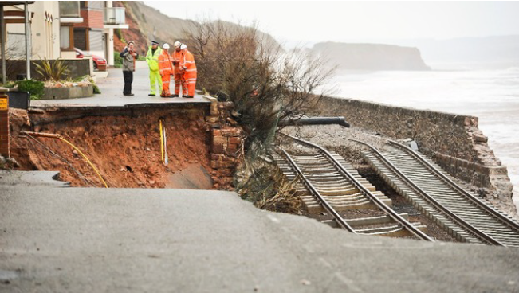
Figure 2
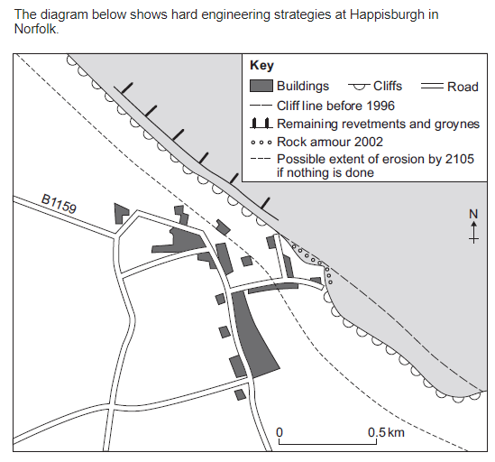Figure 3
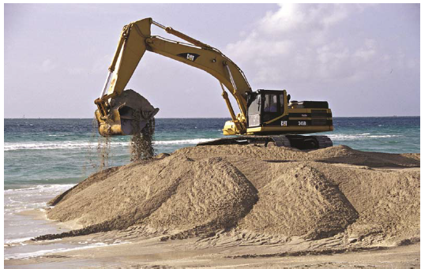
Figure 4
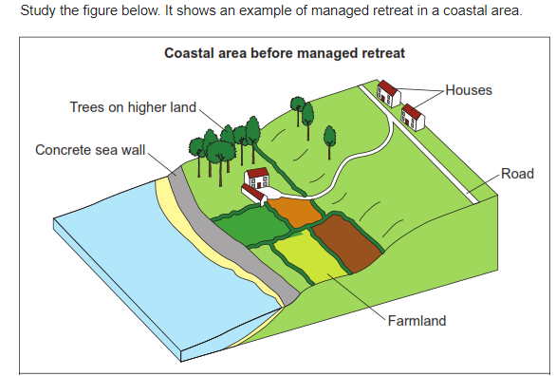
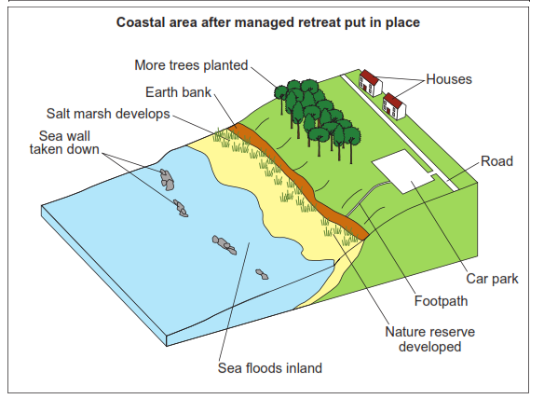
- What is a Shoreline Management Plan?
- What is a cost benefit analysis? (the cost of the…, must be...)
- Hard engineering is….
- A sea wall is…. It prevent erosion because…...
- Rock armour is…... These are….
- Identify one advantage and one disadvantage of using rock armour.
- Gabions are wire cages filled with rocks placed at the front of a cliff. Identify one advantage and one disadvantage of using gabions.
- Groynes are…. They reduce erosion because….
- Groynes can result in negative knock on effects because….
- Soft engineering is…..
- Beach nourishment is……
- Identify one advantage and one disadvantage of using a beach nourishment.

QUIZ B:
- Dune fencing is…..
- Identify one advantage and one disadvantage of using a dune fencing.
- Dune regeneration is when sand dunes are repaired and made larger. One advantage is…. One disadvantage is….
- Beach reprofiling is….
- Identify one advantage and one disadvantage of using beach reprofiling
- Managed retreat is…...
- Why would managed retreat be chosen as a strategy to reduce erosion and flooding?
- What is the biggest cost in managed retreat?
- Where did a large managed retreat project in the UK occur?
- What was the land previously used for?
- Suggest two advantages of the managed retreat project.
- Suggest two disadvantages of the managed retreat project.

PRACTICE EXAM QUESTIONS
- Suggest why the coastal area shown in Figure 1 needs to be protected from the effects of physical processes.
- Figure 2 shows hard engineering strategies at Happisburgh in Norfolk.
  - With the help of the diagram explain how hard engineering can reduce the risk of cliff collapse. (6 marks)
- Discuss the costs and benefits of using hard engineering to reduce the risk of cliff collapse. (6 marks)
- With the help of Figure 3, explain how soft engineering is used to protect coastlines from the effects of physical processes. (6 marks)
- Study Figure 4, diagrams showing an example of managed retreat in a coastal area.
- What is meant by the term managed retreat? (2 marks)
- Using Figure 4, explain how managed retreat protects the coastline. (4 marks)
- Discuss the impact of a managed retreat example you have studied. (6 marks)
- ‘Coastal management schemes are effective in protecting the coastline from physical processes.’
Do you agree?
Using an example, explain your answer. (6 marks)

Physical Landscapes in the UK - Rivers Page 14

QUIZ A
- The water cycle is……
- Two processes within the water cycle are….
Figure 1
Figure 2
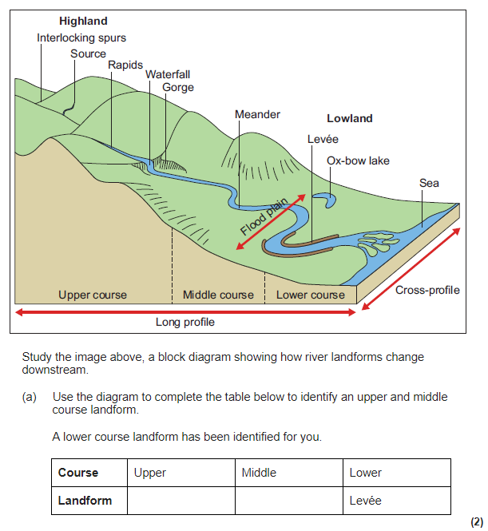
Figure 3

Figure 4
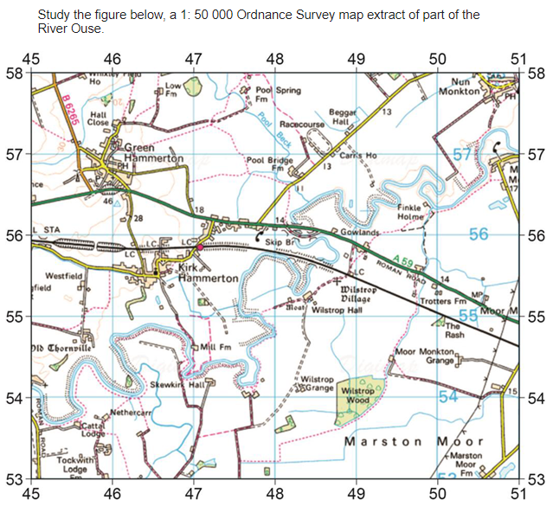
- What is the name of the start of a river?
- Name the point where the river meets the sea
- What is a tributary?
- A contour line is….
- If there is a steep slope contour lines on a map will be close together/far apart.
- The long profile of a river shows…
- The cross profile of a river shows…
- List the three courses of a river.
- How does the long profile of a river differ in the upper and lower courses?

QUIZ B:
- Vertical/lateral erosion is common in the upper course.
- A landform found in the upper course is…
- Vertical/lateral erosion is common in the lower course.
- A landform found in the lower course is…
- What does the following refer to: stones carried by the river hit into each other, gradually making the rocks smaller and smoother?
- What does the following refer to: Sediment carried by the river hits the river channel and removes material?
- Define weathering.
- Does freeze thaw weathering affect the river channel or river valley?
- Traction is…
- Saltation is….

PRACTICE EXAM QUESTIONS
- Study Figure 1, a diagram showing the long and two cross profiles of a river.
- Describe the shape of the river’s long profile. (1 mark)
- Describe the cross profile in the upper course of the river. (3 marks)
- Describe the cross profile in the lower course of the river. (3 marks)
- Explain why the cross profile or a river changes downstream (4 marks)
- State one reason why the size of sediment carried by the river decreases downstream (1 mark)
- Study Figure 2, a block diagram showing how river landforms change downstream. Use the diagram to identify a landform found in the upper course, middle course and lower course. (3 marks)
- Figure 3 shows four ways in which a river transports its load. Label the diagram. (3 marks)
- Describe how a river erodes. (3 marks)
- Study Figure 4, a 1 : 50,000 Ordnance Survey map extract of part of the River Ouse.
- State one characteristic of the course of the River Ouse in grid square 4754. (1 mark)
- Give the difference in height between the river flood plain at 481561 and the spot height at 460563. (1 mark)

Physical Landscapes in the UK - Rivers Page 15

QUIZ A
- Erosional landforms are common in the upper/lower course.
- In which erosional landform do you find:
- An overhanging cliff
Figure 1
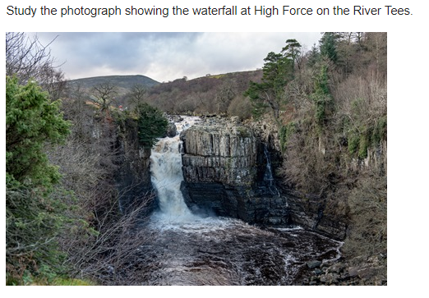
Figure 2
Figure 3

- A narrow, steep sided valley, found upstream from a waterfall.
- A plunge pool
- In which erosional landform does differential erosion occur?
- What does the following refer to: Resistant hard rock creates ridges jut out. These overlap resulting in……
- A meander is….
- What processes occurs on the outside of a bend and why?
- What processes occurs on the inside of a bend and why?
- An oxbow lake is….
- Why does the neck of a meander eventually break through?
- Depositional landforms are common in the upper/lower course.
- A floodplain is….
- Floodplains are caused due to repeated……, resulting in……
- What makes the floodplain wider?

QUIZ B
- A levee is….., ……………..material is deposited first, close to the river channel, while……………material is deposited further out on the floodplain.
- What is an estuary?
- Estuaries are formed in the transitional zone. This is….
- What often forms in estuaries?
- What is a storm hydrograph?
- River discharge is…..
- Give the name for the time between the peak rainfall and peak discharge
- If there is a short lag time what does this mean?
- If there is a steep rising limb what does this mean?
- Identify one physical factor that increases the risk of flooding.
- Identify one human factor that increases the risk of flooding.
- Identify one physical factor that reduces the risk of flooding.
- Identify one human factor that reduces the risk of flooding.

PRACTICE EXAM QUESTIONS
- Study Figure 1, a photograph of the waterfall at High Force on the River Tees.
- Using the photograph, explain the processes involved in the formation of the landforms shown. (6 marks)
- Explain how the waterfall will like change over time. (4 marks)
- Study Figure 2, a photograph of the River Tees in its middle course.
- Identify three characteristics of the channel and valley in the middle course of the river. (3 marks)
- Explain the formation of a meander. (4 marks)
- Explain how river meanders may change over time. (4 marks)
- Draw a labelled cross-section of a meander. (4 marks)
- Explain the processes involved in the formation of interlocking spurs. (6 marks)
- Study Figure 3, a diagram showing some features of the lower course of a river.
- Identify three features of the lower course of a river.
Figure 4

- A levee is shown in the diagram. Explain the processes that result in the formation of levees. (4 marks)
- Explain the formation of an estuary. (4 marks)
- Explain the formation of a floodplain. (4 marks)
- Study Figure 4, a sketch hydrograph of a river flowing through a forest after a period of rain.
- Describe the likely conditions that led to this hydrograph. (4)
- How would a hydrograph look different for a river flowing through a deforested area in the same period of rain? (3))
- The causes of river flooding are usually the result of human factors. Do you agree with this statement? Explain your answer (6 marks)

Physical Landscapes in the UK - Rivers Page 16

QUIZ A:
Figure 1
Figure 2
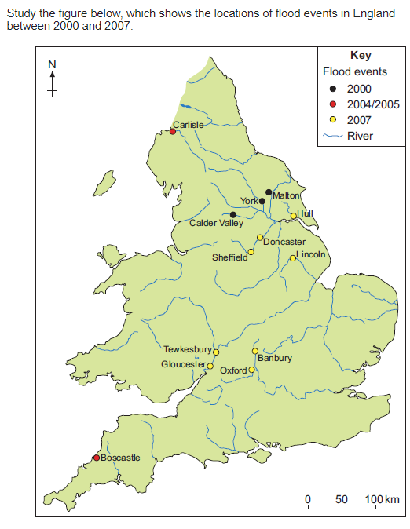

- Hard engineering is….
- One reason to use hard engineering over soft engineering is…..
- What is a dam and reservoir and how can it prevent flooding?
- Suggest one disadvantage of using a dam and reservoir.
- What is channel straightening and how does it prevent flooding?
- What is the strategy where the banks of a river are raised?
- What is a flood relief channel and how does it prevent flooding?
- Suggest one disadvantage of using channel straightening for settlements downstream.
- Soft engineering is…..
- Identify one benefit of using soft engineering over hard engineering.
- How does floodplain zoning reduce the impact of flooding?
- What is one disadvantage of using floodplain zoning?
- Suggest one way people can protect their homes.

QUIZ B:
- What is a wetland and how do they prevent flooding?
- Which strategies reduce the risk of a flood occurring?
- Which strategies help people to prepare for future floods?
- Somerset is located….
- A flood occurred in……., due to heavy rainfall. How much rain fell in January and February?
- List two social effects of the flood.
- List two economic effect of the flood.
- List one environmental effect of the flood.
- To respond to the flood the council launched a £…….Flood Action Plan.
- They dredged……km of the River Tone and River P…… This is when……
- What did they do to the river banks?
- How did they prevent transport routes being affected by future floods?
- How did they help people plan for future floods?

PRACTICE EXAM QUESTIONS
- Study Figure 1, a photograph showing the effects of river flooding in Somerset in 2014.
- Explain the likely economic effects of river flooding on the area shown in the photograph. (4 marks)
- With the help of Figure 1, explain how physical and human factors can increase the risk of river flooding. (6 marks)
- Study Figure 2, a map showing the locations of flood events in England between 2000 and 2007. Describe the locations of the flood events shown in the figure. (4 marks)
- Using an example you have studied, describe how extreme weather events can impact on people and the environment. (6 marks)
- Study Figure 3, newspaper cuttings about the causes of flooding.
- Using the Figure only, give one physical cause and one human cause of flooding. (2 marks)
- Use the Figure and your own knowledge to explain why rivers flood. (6 marks)
- Study Figure 4, a diagram of a flood management scheme. Suggest how the flood management scheme shown in Figure 4 helps reduce the risk of flooding. (4 marks)
- Discuss the effectiveness of hard engineering strategies to reduce the risk of flooding. (6 marks)
- Discuss the effectiveness of soft engineering strategies to reduce the risk of flooding. (6 marks)

Figure 3 Figure 4
