**OASB Science Department**

**Physics Paper 2 Revision Pack (Combined–HT)**

|  |  |  |
| --- | --- | --- |
| Contents | Lesson | Page |
| Mastery Matrix Physics Paper 2 |  | 2-3 |
| Knowledge | 1 | 4-11 |
| Elastic Objects and Waves Summary Page |
| Notes page |
| Exam Questions |
| Knowledge | 2 | 12-19 |
| Magnetism and Electromagnetic Waves Summary Page |
| Notes page |
| Exam Questions |
| Knowledge | 3 | 20-25 |
| Forces and Speed & Velocity Summary Page |
| Notes page |
| Exam Questions |
| Knowledge | 4 | 26-31 |
| d-t and v-t Graphs and Falling Objects & Newton’s Laws Summary Page |
| Notes page |
| Exam Questions |
| Knowledge | 5 | 32-37 |
| Electromagnetism and the motor effect Summary Page |
| Notes page |
| Exam Questions |
| Knowledge | 6 | 38-44 |
| Stopping Distances and Momentum Summary Page |
| Notes page |
| Exam Questions |
| Required Practicals knowledge | 7 | 45-63 |
| Summary Pages |
| Notes page |
| Exam Questions |

Name: ____________________________________________



|  |  |  |  |
| --- | --- | --- | --- |
| **Topic** | **Tier** | **Revision Guide (combined)** | **Learning statement** |
| Elastic Objects & potential energy | F | 160 | Describe elastic and inelastic deformation |
| Elastic Objects & potential energy | F | 160 | Explain the effect of forces on elastic objects |
| Elastic Objects & potential energy | F | 161 | Describe Hooke’s Law qualitatively and using the equation F = ke |
| Elastic Objects & potential energy | F | 161 | Explain ‘word done’ when applied to stretching or compressing a spring |
| Elastic Objects & potential energy | F | 160 | Explain the difference between a linear and a non-linear relationship |
| Elastic Objects & potential energy | F | 160 | Interpret data from a force extension investigation |
| Elastic Objects & potential energy | F | 161 | **RP Force and Extension:** Investigate the relationship between force and extension for spring (Hooke’s Law) |
| Waves | F | 182 | Describe what is meant by ‘a wave’ |
| Waves | F | 182 | Describe the difference between longitudinal and transverse waves giving examples for both |
| Waves | F | 182 | Describe amplitude, wavelength (λ), wave speed (v), frequency (f) and period of a wave (T) and give units for each |
| Waves | F | 183 | Use and rearrange T = 1/f |
| Waves | F | 183 | Use and rearrange v = f  λ |
| Waves | F | 182 | Identify amplitude and wavelength from diagrams of a wave |
| Waves | F | 183 | Describe the method to measure the speed of sound in air and the speed of ripples on the water surface |
| Waves | F | 183 | **RP Waves:** Make observations to identify the suitability of apparatus for measuring frequency, wavelength and speed of waves in a ripple tank and waves on a string or elastic cord. |
| Electromagnetic Waves | F | 184 | Describe what ‘electromagnetic waves’ are |
| Electromagnetic Waves | F | 186 | Recall the order of EM waves & recall their frequency and wavelength and give examples of the uses of these |
| Electromagnetic Waves | F | 186 | Explain how EM waves are generated and absorbed |
| Electromagnetic Waves | F | 187 | Explain the hazardous effects of UV, X-rays and Gamma rays |
| Electromagnetic Waves | HT |  | Link the properties of EM waves to their practical application (HT only) |
| Electromagnetic Waves | HT |  | Apply knowledge of reflection, refraction, transmission and absorption to EM waves (HT only) |
| Electromagnetic Waves | F | 186 | **RP Radiation and Absorption:** investigate how the amount of infrared radiation absorbed or radiated by a surface depends on the nature of that surface |
| Electromagnetic Waves | HT | 187 | Explain how radio a radio works using EM waves (HT only) |
| Forces introduction | F | 158 | Define scalar and vector quantities |
| Forces introduction | F | 158 | Use arrows to represent vector quantities |
| Forces introduction | F | 158 | Define contact and non-contact forces giving examples of each |
| Forces introduction | F | 158 | Define weight and gravity |
| Forces introduction | F | 159 | Use W=m x g |
| Forces introduction | F | 158 | Describe what the centre of mass is |
| Forces introduction | F | 159 | Explain how to measure weight using a calibrated spring balance (i.e. a Newton meter) |
| Resultant forces | F | 159 | Calculate and define resultant forces |
| Resultant forces | F | 159 | Use free body diagrams to show forces |
| Resultant forces | HT | 159 | Use vector diagrams to illustrate the resolution of forces and determine resultant forces (scale drawings) (HT only) |
| Speed and velocity | F | 162 | Explain the difference between distance and displacement |
| Speed and velocity | F | 162 | Define ‘speed’ and explain factors that affect the speed a person walks, runs or cycles at (including average speeds for these activities) |
| Speed and velocity | F | 162 | Recall typical speeds for different types of transportation (TBC – bus, train, car, aeroplane!) using ̴ correctly. |
| Speed and velocity | F | 162 | Recall the speed of sound in air |
| Speed and velocity | F | 162 | State that most moving objects have varying speed including sound, wind, travelling people |
| Speed and velocity | F | 162 | Use and rearrange s = v t (speed = d/t equation!) |
| Speed and velocity | F | 162 | Calculate average speed for non-uniform motion |
| Speed and velocity | F | 162 | Define ‘velocity’ |
| Speed and velocity | HT | 163 | Describe circular motion (HT only) |
| Distance time and velocity time graphs | F | 163 | Draw and interpret distance time graphs and use these to determine speed |
| Distance time and velocity time graphs | HT | 163 | Draw tangents on a distance time graph to determine speed of an accelerating object (HT only) |
| Distance time and velocity time graphs | F | 164 | Use and rearrange the equation a = Δv / t (calculating acceleration) |
| Distance time and velocity time graphs | F | 164 | Estimate the magnitude of every day acceleration |
| Distance time and velocity time graphs | F | 164 | Draw and interpret velocity time graphs in order to calculate acceleration |
| Distance time and velocity time graphs | HT | 164 | Use velocity time graphs to calculate distance/displacement (HT only) |
| Falling objects | F | 164 | Apply the equation v2-u2=2as (For moving and falling objects) [Newton’s equations of motion] |
| Falling objects | F | 166 | Recall the value for acceleration due to gravity (9.8m/s2) |
| Falling objects | F | 166 | Explain the acceleration of objects through fluids (terminal velocity) – making reference to parachutes travelling through air |
| Falling objects | F | 166 | Draw and interpret velocity time graphs for objects that reach terminal velocity |
| Newton’s Laws | F | 163 | Describe and explain Newton’s first law |
| Newton’s Laws | HT | 163 | Explain the concept of inertia (HT only) |
| Newton’s Laws | F | 165 | Describe and explain Newton’s second law using F = m a |
| Newton’s Laws | HT | 165 | Define inertial mass (HT only) |
| Newton’s Laws | F | 164 | Estimate the forces involved in large accelerations for every day road transport using ̴ correctly. |
| Newton’s Laws | F | 165 | **RP Acceleration:** Investigate the effects of varying force on the acceleration of an object with a constant mass and the effects of varying the mass on the acceleration produced by a constant force |
| Moments | F | 166 | Describe and explain Newton’s third law |
| Magnetism | F | 206 | Describe the polarity of magnets and list 4 magnetic materials |
| Magnetism | F | 206 | Explain the difference between a permanent and induced magnet |
| Magnetism | F | 206 | Describe the force between a magnet and a magnetic material |
| Magnetism | F | 206 | Describe the direction and strength of a magnetic field around a magnet |
| Magnetism | F | 206 | Explain how compasses work |
| Magnetism | F | 207 | Describe how to make an electromagnet and how to increase its strength |
| The motor effect and the generator effect | HT | 208 | Describe the motor effect and use this to explain how electric motors work (HT only) |
| The motor effect and the generator effect | HT | 209 | Explain and apply Fleming’s left hand rule (HT only) |
| The motor effect and the generator effect | F | 208 | Recall factors that affect the size of the force on a conductor (HT only) |
| The motor effect and the generator effect | HT | 208 | Use and rearrange the equation F = B I L (HT only) |
| Stopping Distances | F | 168 | Define ‘stopping distance’, ‘thinking distance’ and ‘braking distance’ |
| Stopping Distances | F | 168 | Recall typical values for reaction times (0.2-0.9 seconds) |
| Stopping Distances | F | 168 | Describe factors that effect a drivers reaction time |
| Stopping Distances | F | 168 | Explain methods used to measure human’s reaction times |
| Stopping Distances | F | 169 | Describe factors affecting ‘braking distance’ |
| Stopping Distances | F | 169 | Predict how the distance for a vehicle to make an emergency stop varies over a range of speeds |
| Stopping Distances | F | 169 | Explain the energy transfers when a vehicle brakes |
| Stopping Distances | F | 169 | Link braking force, deceleration and stopping distances |
| Stopping Distances | F | 169 | Explain the dangers caused by large decelerations |
| Stopping Distances | HT | 169 | Estimate the forces involved in the deceleration of road vehicles (HT only) |
| Momentum | HT | 166 | Define ‘momentum’ using p = m v (HT only) |
| Momentum | HT | 167 | Explain conservation of ‘momentum’ (HT only) |
| Gas and fluid pressure | HT | 210 | Describe the motion of particles in a gas and relate this to pressure, kinetic energy and temperature |
| Gas and fluid pressure | HT | 210 | Explain the relationship between temperature and pressure of a gas at constant volume |

**Lesson 1 – Elastic Objects, Potential Energy and Waves**

|  |  |  |
| --- | --- | --- |
|  | **Topic:** | **Elastic objects and potential Energy (P.3)** |
| 1 | What is the equation for elastic potential energy? | Ee=1/2ke2 Elastic potential energy (J) = 1/2 x spring constant (N/m) x extension2 (m) |
| 2 | What is the equation for kinetic energy? | Ek = 1/2 mv2 Kinetic energy (J) = 1/2 x mass (Kg) x velocity2 (m/s) |
| 3 | What is the equation for gravitational potential energy? | Eg=mgh Gravitational potential energy (J) = mass (kg) x gravitational field strength (N/kg) x height (m) |
| 4 | Which equation describes Hooke's Law? | F = ke Force (N) = spring constant (N/m) x extension (m) |
| 5 | What type of energy is stored in a stretched elastic band? | Elastic potential energy |
| 6 | What type of energy is stored in a squashed up tennis ball? | Elastic potential energy |
| 7 | What needs to be applied for an object to change shape? | A force |
| 8 | Define the term for an object returning to its original shape after being stretched | Elastic deformation |
| 9 | Define the term for an object not returning to its original shape after being stretched | Inelastic deformation |
| 10 | Identify the Law: "The extension of a spring is directly proportional to the force applied to it." | Hooke's Law |
| 11 | What sort of energy is stored in a bungee cord? | Elastic potential energy |
| 12 | What do you call the point at which Hooke's Law no longer applies? | The limit of proportionality |
| 13 | In a graph of Hooke's Law, what happens at the limit of proportionality? | Line no longer straight, it will curve |

|  |  |  |
| --- | --- | --- |
|  | **Topic:** | **Waves (P.4)** |
| 1 | What are the two types of waves? | Transverse and longitudinal |
| 2 | What type of wave is sound? | Longitudinal |
| 3 | What type of wave is visible light? | Transverse |
| 4 | How do the particles that make up a wave transfer energy? | They oscillate (vibrate) |
| 5 | What are the 4 properties of a wave? | Frequency, amplitude, wavelength, period |
| 6 | Define "frequency" | The number of waves passing a fixed point per second ( hertz) |
| 7 | Define "amplitude" | Maximum displacement that any particle achieves from its undisturbed position (metres) |
| 8 | Define "wavelength" | Distance from one point on a wave to the same point on the next wave (metres) |
| 9 | Define "period" | Time taken for 1 complete oscillation (seconds) |
| 10 | State the equation to calculate the period of a wave | T=1/f Period (s) = 1/ frequency (Hz) |
| 11 | State the equation to calculate wave speed | v = f x λ  wave speed (m/s) = frequency (Hz) x wavelength (m) |
| 12 | State the relationship between speed and wavelength | They are directly proportional |
| 13 | In a transverse wave, oscillations are ________ to the direction of energy transfer | perpendicular |
| 14 | In a longitudinal wave, oscillations are ___________ to the direction of energy transfer | parallel |
| 15 | What do waves transfer? | Energy (not matter) |

|  |  |  |
| --- | --- | --- |
|  | **Topic:** | **Sound and light waves introduction (P.7)** |
| 1 | What type of waves are sound waves? | Longitudinal |
| 2 | What type of waves are light waves? | Transverse |
| 3 | Light waves travel in _________ _________ | Straight lines |
| 4 | Why can sound waves not travel in a vacuum | A vacuum has no particles |
| 5 | What happens to the speed of a light wave as it enters a more dense medium | The first part of the light wave slows down |
| 6 | Which state does a sound wave travel fastest in? | Solid |
| 7 | Which state does a sound wave travel slowest in? | Gas |
| 8 | What happens to the direction of a light wave as it enters a different medium? | The light wave changes direction towards the normal |
| 9 | What must sound waves travel through? | A medium |
| 10 | When light and sound waves reach a boundary between mediums (materials) what four things can happen to them? | Reflected, refracted, absorbed, transmitted |
| 11 | What happens to the loudness of a sound wave when it's amplitude increases? | The loudness increases |
| 12 | What happens to the pitch of a sound wave when it's frequency increases? | The pitch increases (gets higher) |
| 13 | Do light waves vary their speed? | No, they all travel at the same speed |
| 14 | What is the amplitude of a sound wave related to? | It's volume |
| 15 | What is the frequency and wavelength of a sound wave related to? | It's pitch |

Notes

**Physics Revision: Elastic Objects and**

Mastery Matrix Points

|  |
| --- |
| Describe elastic and inelastic deformation |
| Explain the effect of forces on elastic objects |
| Describe Hooke’s Law qualitatively and using the equation F = ke |
| Explain ‘word done’ when applied to stretching or compressing a spring |
| Explain the difference between a linear and a non-linear relationship |
| Interpret data from a force extension investigation |
| **RP Force and Extension:** Investigate the relationship between force and extension for a spring (Hooke’s Law) |

**Potential Energy**

Understanding and Explaining

1. Explain why more than one force must be applied to a spring to stretch it. (explain what would happen if there was only one force applied!)
2. Describe the energy changes that occur when a spring is elastically deformed (stretched or squashed).

____________________ -> _____________________

1. Sketch a graph of force vs extension for a spring. Label the elastic limit.
2. A student wants to investigate whether Hooke’s Law applies to a rubber band. Describe the method they would use to do this.

Equations:

**Show in words and symbols. Include units.**

Elastic potential energy:

Force on a spring during compression or extension:

Key Knowledge

Elastic limit/limit of proportionality –

Elastic deformation –

Inelastic deformation –

Hooke’s Law (in words)

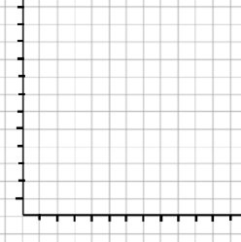

**Physics Revision: Waves**

Mastery Matrix Points

|  |
| --- |
| Describe what is meant by ‘a wave’ |
| Describe the difference between longitudinal and transverse waves giving examples for both |
| Describe amplitude, wavelength (λ), wave speed (v), frequency (f) and period of a wave (T) and give units for each |
| Use and rearrange T = 1/f |
| Use and rearrange v = f  λ |
| Identify amplitude and wavelength from diagrams of a wave |
| Describe the method to measure the speed of sound in air and the speed of ripples on the water surface |
| **RP Waves:** Make observations to identify the suitability of apparatus for measuring frequency, wavelength and speed of waves in a ripple tank and waves on a string or elastic cord. |

Key Knowledge (definitions)

Amplitude –

Wavelength –

Frequency –

Wave speed -

Understanding and Explaining

1. Describe a method to measure the speed of sound waves in air.

1)

2)

3)

4)

1. Describe a method to measure the speed of ripples on a water surface.

1)

2)

3)

4)

3. Label the main parts of these waves:

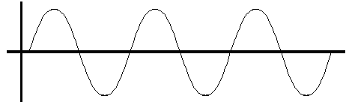 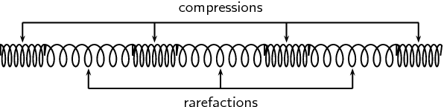

1. A sound wave is travelling in air. The wave then moves into water, then a solid brick block and then back into air. Say if these would stay the same, increase or decrease as the wave moves into each new material.

|  |  |  |  |
| --- | --- | --- | --- |
|  | Into water | Into brick | Into air |
| Frequency |  |  |  |
| Wavelength |  |  |  |
| Speed |  |  |  |

1. Compare longitudinal and transverse waves.

|  |  |
| --- | --- |
| Similarities | Differences |
|  |  |

Equations *in words and symbols. Include units.*

Period of a wave:

The wave equation (wave speed):

**Guided Exam Question**

**Q1.**A student suspended a spring from a laboratory stand and then hung a weight from the spring.

**Figure 1** shows the spring before and after the weight is added.

**Figure 1**

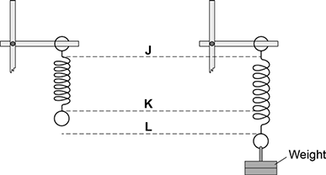

(a)     Which distance gives the extension of the spring?

|  |  |  |
| --- | --- | --- |
|  | Tick **one** box. |  |
|  | from **J** to **K** |  |
|  | from **K** to **L** |  |
|  | from **J** to **L** |  |

**(1)**

(b)     The student used the spring, a set of weights and a ruler to investigate how the extension of the spring depended on the weight hanging from the spring.

**Figure 2** shows that the ruler is in a tilted position and not upright as it should be.

**Figure 2**

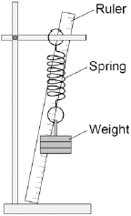

How would leaving the ruler tilted affect the weight and extension data to be recorded by the student?

Use answers from the box to complete each sentence.

Each answer may be used once, more than once or not at all.

|  |  |  |  |
| --- | --- | --- | --- |
|  | **greater than** | **the same as** | **smaller than** |

The weight recorded by the student would be .......................................... the actual weight.

The extension recorded by the student would be .......................................... the actual extension of the spring.

**(2)**

(c)     The student moves the ruler so that it is upright and not tilted.

The student then completed the investigation and plotted the data taken in a graph.

The student’s graph is shown in **Figure 3**.

**Figure 3**

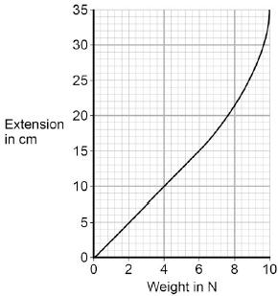

Use **Figure 3** to determine the additional force needed to increase the extension of the spring from 5cm to 15cm.

                    Additional force = ............................................ N

**(1)**

(d)     What can you conclude from **Figure 3** about the limit of proportionality of the spring?

**(1)**

(e)     The student repeated the investigation with three more springs, **K**, **L** and **M**.

The results for these springs are given in **Figure 4**.

**Figure 4**

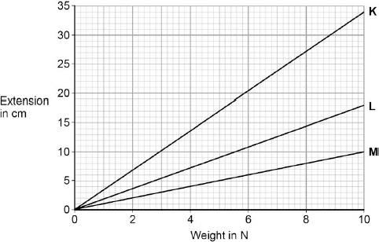

All three springs show the same relationship between the weight and extension.

What is that relationship?

|  |  |  |
| --- | --- | --- |
|  | Tick **one** box. |  |
|  | The extension increases non-linearly with the increasing weight. |  |
|  | The extension is inversely proportional to the weight. |  |
|  | The extension is directly proportional to the weight. |  |

**(1)**

(f)     Which statement, **A**, **B** or **C**, should be used to complete the sentence?

Write the correct letter, **A**, **B** or **C**, in the box below.

**A**         a lower spring constant than

**B**         the same spring constant as

**C**         a greater spring constant than

From **Figure 4** it can be concluded that spring **M** has      the other two springs.

**(1)**

**(Total 7 marks)**

**Independent Exam Question**

**Q2.**Small water waves are created in a ripple tank by a wooden bar. The wooden bar vibrates up and down hitting the surface of the water.

The figure below shows a cross-section of the ripple tank and water.

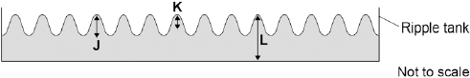

(a)     Which letter shows the amplitude of a water wave?

|  |  |  |
| --- | --- | --- |
|  | Tick **one** box. |  |
|  | **J** |  |
|  | **K** |  |
|  | **L** |  |

**(1)**

(b)     The speed of the wooden bar is changed so that the bar hits the water fewer times each second. What happens to the frequency of the waves produced?

|  |  |  |
| --- | --- | --- |
|  | Tick **one** box. |  |
|  | Increases |  |
|  | Does not change |  |
|  | Decreases |  |

**(1)**

(c)     Describe how the wavelength of the water waves in a ripple tank can be measured accurately.

.............................................................................................................................

.............................................................................................................................

.............................................................................................................................

.............................................................................................................................

.............................................................................................................................

**(2)**

(d)     The speed of a wave is calculated using an equation.

The water waves in a ripple tank have a wavelength of 1.2 cm and a frequency of 18.5 Hz.

How does the speed of these water waves compare to the typical speed of a person walking?

.............................................................................................................................

.............................................................................................................................

.............................................................................................................................

.............................................................................................................................

.............................................................................................................................

.............................................................................................................................

**(4)**

**(Total 8 marks)**

**Lesson 2 – Magnetism and Electromagnetic Waves**

|  |  |  |
| --- | --- | --- |
|  | **Topic:** | **Magnetism (P.38)** |
| 1 | Define "poles" on a magnet | The place where the magnetic force is the strongest |
| 2 | What do two magnets next to each other do? | Exert a force on each other |
| 3 | What is the effect of two like poles on each other? (e.g. N-N) | Repel |
| 4 | What is the effect of two different poles on each other? (e.g. N-S) | Attract |
| 5 | What type of force are attraction and repulsion? | Non-contact |
| 6 | Define "permanent" magnet | Produces its own magnetic field |
| 7 | Define "induced" magnet | A material that becomes a magnet when placed in a magnetic field |
| 8 | What happens to an induced magnet when it is removed from the magnetic field? | Loses all of its magnetism |
| 9 | What is the region around a magnet where magnetic force has an effect called? | Magnetic field |
| 10 | Name 4 magnetic materials | Iron, steel, cobalt, nickel |
| 11 | Describe the force between a magnet and a magnetic material | Attraction |
| 12 | State one factor that effects the strength of a magnetic field | Distance from magnet |
| 13 | What direction do the magnetic field lines go when drawn around a magnet? | North (seeking) pole to south (seeking) pole |
| 14 | How do you plot magnetic field lines around a magnet? | Use a compass to identify north and join dot to dot |
| 15 | How does a compass work for navigation? | The core of the Earth is magnetic! |

|  |  |  |
| --- | --- | --- |
|  | **Topic:** | **Electromagnetic waves 1 (P.5)** |
| 1 | What type of waves are electromagnetic waves? | Transverse |
| 2 | At what speed do all electromagnetic waves travel? | Speed of light (300,000,000m/s) |
| 3 | What do the different types of electromagnetic waves vary in? | Frequency |
| 4 | List the electromagnetic waves in order of frequency from lowest to highest | Radio waves, microwaves, infrared waves, visible light, ultraviolet, X-Rays, gamma rays |
| 5 | Which sub-cellular structure is damaged by ionising radiation? | DNA |
| 6 | Which type of wave is the most ionising? | Gamma Rays |
| 7 | Which wave is used in medical imaging? | X-Rays |
| 8 | Which wave is used in telecommunications? | Radio waves and microwaves |
| 9 | Which wave has the longest wavelength? | Radio waves |
| 10 | State 3 properties shared by all electromagnetic waves | 1) All travel at the speed of light  2) All transverse 3) All travel through a vacuum |
| 11 | Which wave has the shortest wavelength? | Gamma rays |
| 12 | State 1 risk associated with UV rays | Skin cancer |
| 13 | Which two types of waves are ionising radiation? | X-Rays and Gamma Rays |
| 14 | Which wave can be detected by the human eye? | Visible light |
| 15 | Which 3 rays can have hazardous effects on the human body? | UV, X-Ray and Gamma rays |

|  |  |  |
| --- | --- | --- |
|  | **Topic:** | **Electromagnetic waves 2 (P.6)** |
| 1 | What is produced by oscillations in electrical circuits? (HT only) | Radio waves |
| 2 | What happens when a radio wave is absorbed? (HT only) | Alternating current produced |
| 3 | What causes EM waves to be generated/absorbed? | Changes in atoms/nuclei of atoms |
| 4 | State two effects of UV waves | Cause skin to age prematurely, increase risk of skin cancer |
| 5 | State two effects of X-rays and gamma rays | 1) mutations of genes, 2) cancer |
| 6 | State two uses of radio waves | TV and radio |
| 7 | State 2 uses of microwaves | Satellite communication and cooking food |
| 8 | State 3 uses of infrared | Electrical heaters, cooking food, infrared cameras |
| 9 | State 1 use of visible light | Fibre optic communication |
| 10 | State 2 uses of UV waves | Energy efficient lamps and sun tanning |
| 11 | State two uses of X-rays and gamma rays | Medical imaging and treatments |
| 12 | Why are radio waves used in television and radio? (HT only) | Can be reflected from atmosphere due to wavelength |
| 13 | Why are microwaves used in cooking? (HT only) | Frequency matches frequency of water particles vibrating |
| 14 | Why are microwaves used in satellite communication?(HT only) | Frequency allows them to pass through atmosphere |
| 15 | Why are X-rays and gamma rays used in medical imaging? (HT only) | Highly ionising and penetrating |

Notes

**Physics Revision: Magnetism**

Mastery Matrix Points

|  |
| --- |
| Describe the polarity of magnets and list 4 magnetic materials |
| Explain the difference between a permanent and induced magnet |
| Describe the force between a magnet and a magnetic material |
| Describe the direction and strength of a magnetic field around a magnet |
| Explain how compasses work |
| Describe how to make an electromagnet and how to increase its strength |

Key Knowledge

Two like poles attract/repel.

Two unlike poles attract/repel.

Electromagnet –

Permanent magnet –

Induced magnet –

Magnetic field –

4 magnetic materials

-

-

-

-

Draw the magnetic field around these bar magnets:

1



2

 

3

 

Understanding and Explaining

1. Compare permanent and induced magnets. (1 similarity and 1 difference)
2. Describe how to plot the magnetic field pattern of a magnet using a compass.

(i)

(ii)

(iii)

1. Describe how the magnetic field changes around a bar magnet. How is this shown on a scientific diagram?
2. How can you increase the strength of an electromagnet?
3. Explain how to draw the magnetic field around a solenoid (coil of wire). Draw an example.
4. Explain how to draw the magnetic field around a wire. Draw an example.

**Physics Revision: EM Waves**

Mastery Matrix Points

|  |
| --- |
| Describe what ‘electromagnetic waves’ are |
| Recall the order of EM waves & recall their frequency and wavelength and give examples of the uses of these |
| Explain how EM waves are generated and absorbed |
| Explain the hazardous effects of UV, X-rays and Gamma rays |
| Link the properties of EM waves to their practical application (HT only) |
| Apply knowledge of reflection, refraction, transmission and absorption to EM waves (HT only) |
| **RP Radiation and Absorption:** investigate how the amount of infrared radiation absorbed or radiated by a surface depends on the nature of that surface |
| Explain how radio a radio works using EM waves (HT only) |

Key Knowledge

Electromagnetic Waves –

Electromagnetic Spectrum –

Order of the electromagnetic spectrum

LONG WAVELENGTH, LOW FREQUENCY

-

-

-

-

-

-

-

SHORT WAVELENGTH, HIGH FREQUENCY

Absorption –

Transmission –

Emission –

Refraction –

Reflection -

Understanding and Explaining

1. Write a method for the Leslie cube experiment.

i)

ii)

iii)

iv)

v)

1. Draw a diagram to show how an infrared beam would be refracted as it moves from air into a Perspex block.
2. How are radio waves produced and the detected?
3. How are gamma rays produced?
4. Explain how ultraviolet waves, X-rays and gamma rays can be harmful.
5. Complete the table:

|  |  |  |  |  |  |  |  |
| --- | --- | --- | --- | --- | --- | --- | --- |
| E/M Radiation: |  |  |  |  |  |  |  |
| Use: |  |  |  |  |  |  |  |
| Reason: |  |  |  |  |  |  |  |

**Guided Exam Question**

**Q3.**Different parts of the electromagnetic spectrum are useful for different methods of communication.

The diagram shows a transmitter emitting two electromagnetic waves, **L** and **M**.

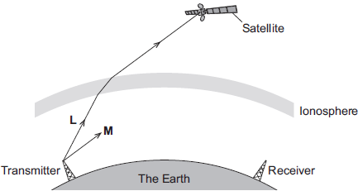

(a)     (i)      Wave **L** is used to send a signal to a satellite.  
Which part of the electromagnetic spectrum does wave **L** belong to?

...............................................................................................................

**(1)**

(ii)     What name is given to the process that occurs as wave **L** passes into the ionosphere?

...............................................................................................................

**(1)**

(b)     Wave **M** is **reflected** by the ionosphere.

(i)      On the diagram above, draw the path of wave **M** until it reaches the receiver.

**(2)**

(ii)     On the diagram above, draw a line to show the normal where wave **M** meets the ionosphere. Label the line **N**.

**(1)**

(c)     Give **two** properties of all electromagnetic waves.

1......................................................................................................................

........................................................................................................................

2......................................................................................................................

........................................................................................................................

**(2)**

**(Total 7 marks)**

**Independent Exam Question**

**Q4.** (a)     **Diagram 1** shows a magnetic closure box when open and shut. It is a box that stays shut, when it is closed, due to the force between two small magnets.

These boxes are often used for jewellery.

**Diagram 1**

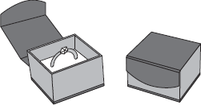

**Diagram 2** shows the two magnets. The poles of the magnets are on the longer faces.

**Diagram 2**

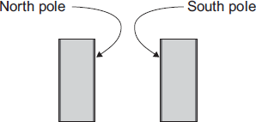

(i)      Draw, on **Diagram 2**, the magnetic field pattern between the two facing poles.

**(2)**

(ii)     The magnets in the magnetic closure box must **not** have two North poles facing each other. Explain why.

................................................................................................................

................................................................................................................

................................................................................................................

................................................................................................................

**(2)**

(b)     A student is investigating how the force of attraction between two bar magnets depends on their separation.

She uses the apparatus shown in **Diagram 3**.

**Diagram 3**

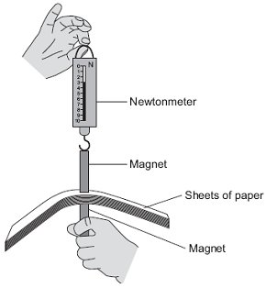

She uses the following procedure:

•        ensures that the newtonmeter does not have a zero error

•        holds one of the magnets

•        puts sheets of paper on top of the magnet

•        places the other magnet, with the newtonmeter magnetically attached, close to the first magnet

•        pulls the magnets apart

•        notes the reading on the newtonmeter as the magnets separate

•        repeats with different numbers of sheets of paper between the magnets.

The results are shown in the table.

|  |  |  |  |  |  |  |  |  |  |
| --- | --- | --- | --- | --- | --- | --- | --- | --- | --- |
| **Number of sheets of paper between the magnets** | 10 | 20 | 30 | 40 | 50 | 60 | 70 | 80 | 120 |
| **Newtonmeter reading as the magnets separate** | 3.1 | 2.6 | 2.1 | 1.5 | 1.1 | 1.1 | 1.1 | 1.1 | 1.1 |

1. Describe the pattern of her results.

……………………………………………………..................................................................................................................

……………………………………………………..................................................................................................................……………………………………………………............................................................................................................. **(2)**

(ii)     No matter how many sheets of paper the student puts between the magnets, the force shown on the newtonmeter never reaches zero. Why?

................................................................................................................

................................................................................................................

**(1)**

(iii)    The student is unable to experiment with fewer than 10 sheets of paper without glueing the magnet to the newtonmeter. Suggest why.

……………………………………………………..................................................................................................................

……………………………………………………..................................................................................................................

……………………………………………………..................................................................................................................

**(2)**

(iv)    Suggest **three** improvements to the procedure that would allow the student to gain more accurate results.

……………………………………………………..................................................................................................................

……………………………………………………..................................................................................................................

……………………………………………………..................................................................................................................

……………………………………………………..................................................................................................................

……………………………………………………..................................................................................................................

……………………………………………………...............................................................................................................

**(3)**

(v)     The thickness of one sheet of paper is 0.1 mm.

What is the separation of the magnets when the force required to separate them is 2.1 N?

................................................................................................................

................................................................................................................

................................................................................................................

Separation of magnets = ................................ mm

**(3)**

**(Total 15 marks)**

**Q5.** (a)     The diagrams below show rays of light striking a mirror and a perspex block.

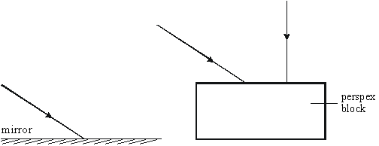

Complete the paths of the three rays of light on the diagrams to show the rays leaving the mirror and the perspex block.

**(4)**

(b)     The diagram below shows a beam of light striking a perspex block.

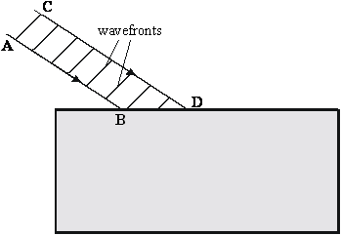

(i)      Continue the paths of the rays AB and CD inside the perspex block.

(ii)     Draw the wavefronts of the beam of light in the perspex.

(iii)     Explain why the beam behaves in the way you have shown.

______________________________________________________________

______________________________________________________________

______________________________________________________________

**(7)**

(c)     The diagram below shows a ray of light striking a perspex-air surface from inside the perspex. The critical angle is 45º.

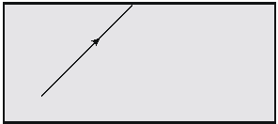

Draw the path of the ray after it reaches the perspex-air boundary.

**(2)**

**(Total 13 marks)**

(b)     State the reason why light is refracted as it crosses from air into glass.

.............................................................................................................................

.............................................................................................................................

**(1)**

**(Total 7 marks)**

**Lesson 3 – Forces, Speed and Velocity**

|  |  |  |
| --- | --- | --- |
|  | **Topic:** | **Forces introduction (P.11)** |
| 1 | Scalar quantities have only _______ | magnitude |
| 2 | Vector quantities have ____ and ___ | magnitude and direction |
| 3 | Magnitude is another word for______ | Size |
| 4 | State 3 scalar quantities | Distance, speed, time |
| 5 | State 3 vector quantities | Displacement, velocity, acceleration |
| 6 | How can you show the size of a vector on a diagram? | Use an arrow. |
| 7 | What is the name of the type of force that occurs when the objects are physically touching? | Contact forces |
| 8 | What is the name of the type of force that occurs when the objects are separated? | Non-contact |
| 9 | Which type of force is magnetic force? | Non-contact |
| 10 | Which type of force is weight? | Non-contact |
| 11 | Which type of force is tension? | Contact |
| 12 | Which type of force is upthrust? | Contact |
| 13 | Define "weight" | The force acting on an object due to gravity |
| 14 | Define "gravitational field strength" | The pull of the Earth on an object |
| 15 | What is the equation for calculating weight? | Weight (N))= Mass (Kg) X Gravitational Field Strength (N/Kg) |
|  |  |  |
|  | **Topic:** | **Scalar and vector quantities (P.12)** |
| 1 | A _________ force is a single force that has the same effect as all the original forces acting together. | resultant |
| 2 | What two things happens to objects if the forces acting on them are balanced? | Stay still or constant speed |
| 3 | State two effects on an object if the forces acting upon it are unbalanced? | Accelerate/decelerate/change direction/squash or stretch |
| 4 | To calculate the resultant force in one direction you _____________ the forces acting up/down or left/right. | subtract |
| 5 | What is the name given to a diagram that shows the forces acting upon an object | Free body diagram |
| 6 | Weight can be measured using a _______ | Newton meter or spring balance |
| 7 | The point at which all the mass of an object acts is called_________ | the centre of mass |
| 8 | Resolve the forces means turn two forces into______ | one force/resultant force |
| 9 | To work out the centre of mass of a regular shape, you should ________________ | draw the lines of symmetry |
| 10 | To work out the centre of mass of an irregular shape, you should ________________ | do the plumb line experiment |
| 11 | Which type of force occurs when air pushes you back? | Air resistance |
| 12 | What are the four forces acting on an accelerating boat? | Weight, thrust, upthrust, water resistance |
| 13 | State the units for weight | Newtons (N) |
| 14 | State the units for mass | Kilograms (kg) |
| 15 | State the units for gravitational field strength | Newtons per kilogram (N/Kg) |
|  |  |  |
|  | **Topic:** | **Speed and velocity (P.13)** |
| 1 | What is the difference between distance and displacement? | Distance = scalar, displacement = vector |
| 2 | Define "speed" | Distance covered in a given time |
| 3 | What is the equation linking displacement, velocity and time? | displacement = velocity x time s (m) = v (m/s) x t (s) |
| 4 | State three factors that may affect the speed a person walks | Age, terrain, fitness |
| 5 | State the typical speed for a person walking | 1.5m/s |
| 6 | State the typical speed for a person running | 3m/s |
| 7 | State the typical speed for a person cycling | 6m/s |
| 8 | State the typical speed for a person driving | 30m/s |
| 9 | State the typical speed for an aeroplane | 250m/s |
| 10 | State the speed of sound in air | 330m/s |
| 11 | State the speed of light in air | 300,000,000m/s |
| 12 | Describe the motion of an object traveling in a circle | Constant speed, changing velocity |
| 13 | Which piece of equipment is used to measure time? | Stopwatch |
| 14 | How is speed calculated for non-uniform motion? | Average speed (m/s) = distance (m) / time (s) s = d / t |
| 15 | Define "velocity" | Speed in a given direction |

Notes

**Revision: Forces**

Key Knowledge

Scalar quantities –

e.g.

Vector quantities –

e.g.

Using arrows to show vectors –

Non-contact forces include…

Contact forces include…

Weight –

Weight is measured by…

Resultant force –

Mastery Matrix Points

|  |
| --- |
| Define scalar and vector quantities |
| Use arrows to represent vector quantities |
| Define contact and non-contact forces giving examples of each |
| Define weight and gravity |
| Use W=m x g |
| Describe what the centre of mass is |
| Explain how to measure weight using a calibrated spring balance (i.e. a Newton meter) |
| Calculate and define resultant forces |
| Use free body diagrams to show forces |
| Use vector diagrams to illustrate the resolution of forces and determine resultant forces (scale drawings) (HT only) |

Equations *in words and symbols. Include units.*

Weight:

Work done:

Understanding and Explaining

1. Describe what may happen to an object if the forces are unbalanced (i.e. there is a resultant force).
2. Describe what may happen to an object that has no resultant force (i.e. the forces are balanced).
3. What is the centre of mass of an object?
4. Extension (HAVE A GO!!) A box is suspended by three strings. Its weight is negligible. Resolve the forces in string 2 and string 3. Is the object in equilibrium (balanced forces) or not?

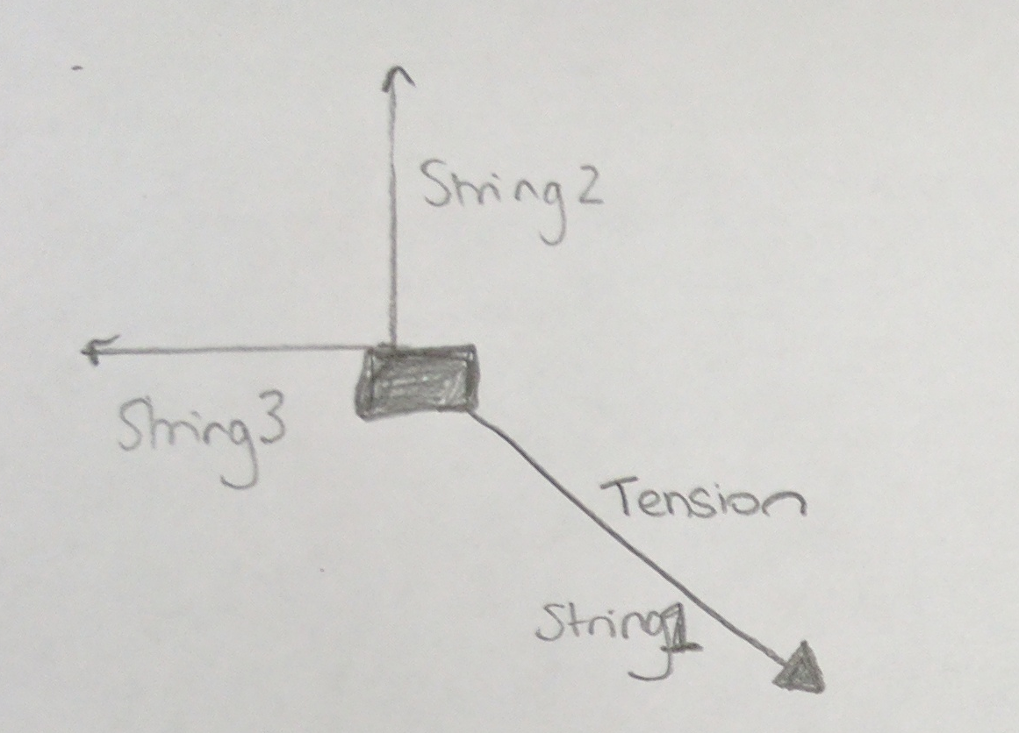

**Physics Revision: Speed and Velocity**

Mastery Matrix Points

|  |
| --- |
| Explain the difference between distance and displacement |
| Define ‘speed’ and explain factors that affect the speed a person walks, runs or cycles at (including average speeds for these activities) |
| Recall typical speeds for different types of transportation (bus, train, car, aeroplane!) using ̴ correctly. |
| Recall the speed of sound in air |
| State that most moving objects have varying speed including sound, wind, travelling people |
| Use and rearrange s = v t (speed = d/t equation!) |
| Calculate average speed for non-uniform motion |
| Define ‘velocity’ |
| Describe circular motion (HT only) |

Key Knowledge

Distance –

Displacement –

Speed of: (in m/s)

* Walking
* Running
* Cycling
* Car
* Bike
* Aeroplane
* Sound

Vector or scalar?

Speed

Velocity

Distance

Displacement

Understanding and Explaining

1. The path of an object is show by the curved line. Measure the displacement in mm.
2. Explain why speed of a moving person or car is rarely constant.
3. Speed of a person walking, running or cycling depends on four main factors. What are these factors?
4. (ii) (iii) (iv)
5. Explain why an object moving in a circle has a constant speed but not a constant velocity.
6. A) Estimate the deceleration of car stopping suddenly on a motorway*. (hint: for change in velocity use the standard velocities in the key knowledge, for time, decide which is the most likely time - 10 seconds, 60 seconds or 120 seconds)*

B) Estimate the deceleration of a train stopping at a station *. (hint: for change in velocity use the standard velocities in the key knowledge, for time, decide which is the most likely time - 10 seconds, 60 seconds or 120 seconds)*

C) Estimate the acceleration of a cyclist starting at rest and reaching their average speed. *(hint: for change in velocity use the standard velocities in the key knowledge, for time, decide which is the most likely time - 10 seconds, 60 seconds or 120 seconds).*

Equations *in words and symbols. Include units.*

Speed:

Acceleration:

Equation of motion (suvat):

**Guided Exam Question**

**Q6.**When two objects interact, they exert forces on each other.

(a)     Which statement about the forces is correct?

Tick (✓) **one** box.

|  |  |  |
| --- | --- | --- |
|  |  | **Tick (✓)** |
|  | The forces are equal in size and act in the same direction. |  |
|  | The forces are unequal in size and act in the same direction. |  |
|  | The forces are equal in size and act in opposite directions. |  |
|  | The forces are unequal in size and act in opposite directions. |  |

**(1)**

(b)     A fisherman pulls a boat towards land.

The forces acting on the boat are shown in **Diagram 1**.

The fisherman exerts a force of 300 N on the boat.  
The sea exerts a resistive force of 250 N on the boat.

**Diagram 1**



(i)      Describe the motion of the boat.

................................................................................................................

................................................................................................................

................................................................................................................

................................................................................................................

**(2)**

(ii)     When the boat reaches land, the resistive force increases to 300 N.  
The fisherman continues to exert a force of 300 N.

Describe the motion of the boat.

Tick (✓) **one** box.

|  |  |  |
| --- | --- | --- |
|  | Accelerating to the right |  |
|  | Constant velocity to the right |  |
|  | Stationary |  |

**(1)**

(iii)    Explain your answer to part **(b)(ii)**.

................................................................................................................

................................................................................................................

................................................................................................................

................................................................................................................

**(2)**

(iv)    Another fisherman comes to help pull the boat. Each fisherman pulls with a force of 300 N, as shown in **Diagram 2**.

**Diagram 2** is drawn to scale.

Add to **Diagram 2** to show the single force that has the same effect as the two 300 N forces.

Determine the value of this resultant force.

**Diagram 2**

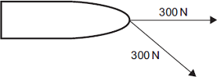

Resultant force = .................................... N

**(4)**

**(Total 10 marks)**

**Independent Exam Question**

**Q7.**A car has an oil leak. Every 5 seconds an oil drop falls from the bottom of the car onto the road.

(a)     What force causes the oil drop to fall towards the road?

........................................................................................................................

**(1)**

(b)     The diagram shows the spacing of the oil drops left on the road during part of a journey



Describe the motion of the car as it moves from **A** to **B**.

........................................................................................................................

Explain the reason for your answer.

........................................................................................................................

........................................................................................................................

........................................................................................................................

........................................................................................................................

**(3)**

(c)     When the brakes are applied, a braking force slows down and stops the car.

(i)      The size of the braking force affects the braking distance of the car.

State **one** other factor that affects the braking distance of the car.

...............................................................................................................

**(1)**

(ii)     A braking force of 3 kN is used to slow down and stop the car in a distance of 25 m.

Calculate the work done by the brakes to stop the car and give the unit.

...............................................................................................................

...............................................................................................................

...............................................................................................................

Work done =..................................................

**(3)**

**(Total 8 marks)**

**Lesson 4 – DT and VT Graphs, Falling Objects and Newton’s Laws**

|  |  |  |
| --- | --- | --- |
|  | **Topic:** | **Distance and velocity-time graphs (P.14)** |
| 1 | State the axes in a distance time graph | X axis = time, Y axis = distance |
| 2 | Describe what is meant by a flat horizontal line (───) on a distance-time graph? | The object is stationary |
| 3 | Describe what is meant by a straight diagonal line (/) away from the x-axis on a distance-time graph? | Object is moving at a constant speed AWAY from start |
| 4 | Describe what is meant by a straight diagonal line (\) towards the x-axis on a distance-time graph? | Object is moving at a constant speed back TOWARDS the start |
| 5 | How do you calculate the speed of an object using a distance-time graph if the speed is constant? | Calculate gradient (ΔY/ΔX) |
| 6 | If an object is not travelling at a constant speed, how will this motion be shown on a distance time graph? | A curve |
| 7 | How do you calculate the speed of an object using a distance time graph if the speed is not constant (the line is a curve!)? | Draw a tangent & calculate gradient |
| 8 | What does a steeper line on a distance-time graph represent? | An object moving faster |
| 9 | Describe the axes on a velocity-time graph | X-axis = time, Y-axis = velocity |
| 10 | Describe what is meant by a flat horizontal line (───) on a velocity-time graph? | The object is moving at a constant velocity |
| 11 | Describe what is meant by a straight diagonal line (/) away from the x-axis on a velocity-time graph? | Object is accelerating |
| 12 | Describe what is meant by a straight diagonal line (\) towards the x-axis on a velocity-time graph? | Object is decelerating |
| 13 | What do you calculate when you calculate the area under a velocity-time graph? (HT only) | Total distance travelled |
| 14 | How do you calculate acceleration (if it is constant - a straight line) from a velocity time graph? | Calculate gradient (ΔY/ΔX) |
| 15 | How do you calculate acceleration (if it is changing - a curved line) from a velocity time graph? | Draw a tangent & calculate gradient |
|  |  |  |
|  | **Topic:** | **Falling objects and Newton's laws (P.15)** |
| 1 | State the equation to calculate uniform acceleration when given velocity and distance | (final velocity)2 - (initial velocity)2 = 2 x acceleration x distance v2-u2=2as |
| 2 | What is the acceleration of an object free falling due to gravity close to the Earth? | 9.8m/s2 |
| 3 | What are the two forces acting upon a falling object? | Weight and air resistance |
| 4 | Describe the motion of an object as it begins to fall through a fluid | It accelerates (weight is bigger than air resistance) |
| 5 | As an object continues to fall through a fluid, the weight remains the same, describe what happens to the air resistance as the object gains speed? | Air resistance increases |
| 6 | What is the term that given to describe the motion of an object when it's weight and the air resistance acting upon it are equal? | Terminal velocity |
| 7 | Describe what happens to the forces acting upon a parachuter when they open their parachute | Air resistance ↑, weight stays constant |
| 8 | According to Newton's First Law, what will affect an object's velocity? | A resultant force |
| 9 | According to Newton's First Law, if the resultant force acting upon a stationary object is zero, what will happen? | The object remains stationary |
| 10 | According to Newton's First Law, if the resultant force acting upon a moving object is zero, what will happen? | Moves with at same velocity |
| 11 | What is the term given to the tendancy of an object to continue in their state of rest or uniform motion? (HT only) | Inertia |
| 12 | Which objects have a large inertia? (HT only) | Objects with a large mass |
| 13 | According to Newton's 2nd Law state what is the relationship between acceleration and force? | Directly proportional |
| 14 | According to Newton's 2nd Law state what is the relationship between acceleration and mass? | Inversely proportional |
| 15 | Write Newton's Second Law as an equation | Resultant force (N) = mass (kg) x acceleration (m/s2) F = ma |

Notes

**Physics Revision: Distance-Time and**

Mastery Matrix Points

|  |
| --- |
| Draw and interpret distance time graphs and use these to determine speed |
| Draw tangents on a distance time graph to determine speed of an accelerating object (HT only) |
| Use and rearrange the equation a = Δv / t (calculating acceleration) |
| Estimate the magnitude of every day acceleration |
| Draw and interpret velocity time graphs in order to calculate acceleration |
| Use velocity time graphs to calculate distance/displacement (HT only) |

**Velocity-Time Graphs**

**Physics Revision: Falling Objects and**

Key Knowledge

Sketch distance-time graphs to show -

Stationary:

Constant speed:

Acceleration:

Deceleration:

Sketch velocity-time graphs to show -

Stationary:

Constant speed:

Acceleration:

Deceleration:

Understanding and Explaining

1. How do you calculate these quantities from each of these graphs?
   1. Distance from a distance time graph.
   2. Speed from a distance time graph (straight line).
   3. Speed from a distance time graph (curved line).
   4. Distance from a velocity time graph.
   5. Speed from a velocity time graph.
   6. Acceleration from a velocity time graph.
2. How do you calculate the area of
   1. A trapezium
   2. A triangle
   3. A rectangle
3. How can you estimate the area under a graph if the graph is curved?

Mastery Matrix Points

|  |
| --- |
| Apply the equation v2-u2=2as (For moving and falling objects) [Newton’s equations of motion] |
| Recall the value for acceleration due to gravity (9.8m/s2) |
| Explain the acceleration of objects through fluids (terminal velocity) – making reference to parachutes travelling through air |
| Draw and interpret velocity time graphs for objects that reach terminal velocity |
| Describe and explain Newton’s first law |
| Explain the concept of inertia (HT only) |
| Describe and explain Newton’s second law using F = m a |
| Defiine inertial mass (HT only) |
| Estimate the forces involved in large accelerations for every day road transport using ̴ correctly. |
| **RP Acceleration:** Investigate the effects of varying force on the acceleration of an object with a constant mass and the effects of varying the mass on the acceleration produced by a constant force |
| Describe and explain Newton’s third law |

**Newton’s Laws**

Key Knowledge

Terminal velocity –

Newton’s first law:

Newton’s second law:

Newton’s third law:

Inertia -

Equations *in words and symbols. Include units.*

Newton’s Second Law:

Equation of motion (suvat):

Understanding and Explaining

1. Describe and explain the motion of a skydiver.

(just after jumping out of plane):

(after 10 seconds of free fall):

(as soon as they open their parachute):

(10 seconds after they’ve opened their parachute):

(when they have landed on the floor):

1. Sketch a velocity time graph to show the motion of a skydiver.
2. Define inertial mass.
3. *Extension (Have a go!!):*

(A) Approximate the braking force of a lorry. (You need to estimate the mass and acceleration to calculate this)

B) Approximate the braking force of a train. (You need to estimate the mass and acceleration to calculate this)

1. Explain why when a tennis ball is struck with a racquet that the racquet strings may break (link to Newton’s Law!!)

**Guided Exam Question**

**Q8.**A train travels from town **A** to town **B**. **Figure 1** shows the route taken by the train. **Figure 1** has been drawn to scale.

**Figure 1**

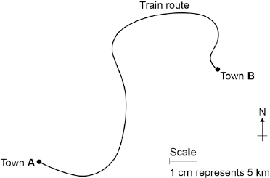

(a)     The distance the train travels between **A** and **B** is not the same as the displacement of the train. What is the difference between distance and displacement?

**……………………………………………………………………………………………………………………………………………………………………………………………..……**

**……………………….…………………………………………………………………………………………………………………………………………………………………………**

**……………………………………………….…………………………………………………………………………………………………………………………………………………**

**(1)**

(b)     Use **Figure 1** to determine the displacement of the train in travelling from **A** to **B**.

Show how you obtain your answer.

**……………………………………………………………………………………………………………………………………………………………………………………………..……**

                          Displacement = ..................................... km

                           Direction = ..................................................

**(2)**

(c)     There are places on the journey where the train accelerates without changing speed.

Explain how this can happen.

**……………………………………………………………………………………………………………………………………………………………………………………………..……**

**……………………….…………………………………………………………………………………………………………………………………………………………………………**

**……………………………………………….…………………………………………………………………………………………………………………………………………………**

**(2)**

(d)     **Figure 2** shows how the velocity of the train changes with time as the train travels along a straight section of the journey.

**Figure 2**

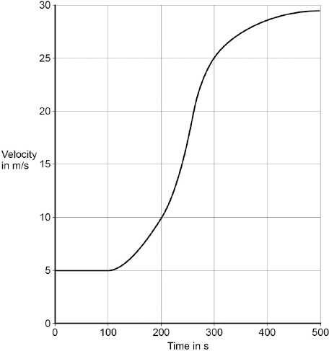

Estimate the distance travelled by the train along the section of the journey shown in **Figure 2**.

To gain full marks you must show how you worked out your answer.

**……………………………………………………………………………………………………………………………………………………………………………………………..……**

**……………………….…………………………………………………………………………………………………………………………………………………………………………**

**……………………………………………….…………………………………………………………………………………………………………………………………………………**

Distance = .....................................

**(3)(Total 8 marks)**

**Independent Exam Question**

**Q9.**The figure below shows the horizontal forces acting on a car.



(a)     Which **one** of the statements describes the motion of the car?

|  |  |  |  |
| --- | --- | --- | --- |
| Tick **one** box. |  |  |  |
| It will be slowing down. |  | It will have a constant speed. |  |
| It will be stationary. |  | It will be speeding up. |  |

**(1)**

(b)     During part of the journey the car is driven at a constant speed for five minutes.

Which one of the equations links distance travelled, speed and time?

|  |  |  |  |  |
| --- | --- | --- | --- | --- |
| Tick **one** box. |  |  |  |  |
| distance travelled = speed + time |  |  | distance travelled = speed − time |  |
| distance travelled = speed × time |  |  | distance travelled = speed ÷ time |  |

**(1)**

(c)     During a different part of the journey the car accelerates from 9m / s to 18m / s in 6 s.

Use the following equation to calculate the acceleration of the car.

   acceleration=

.............................................................................................................................

.............................................................................................................................

            acceleration = .................................................. m / s2

**(2)**

(d)     Which equation links acceleration, mass and resultant force?

|  |  |  |
| --- | --- | --- |
|  | Tick **one** box. |  |
|  | resultant force = mass + acceleration |  |
|  | resultant force = mass × acceleration |  |
|  | resultant force = mass − acceleration |  |
|  | resultant force = mass ÷ acceleration |  |

**(1)**

(e)     The mass of the car is 1120 kg. The mass of the driver is 80 kg.

Calculate the resultant force acting on the car and driver while accelerating.

**……………………………………………………………………………………………………………………………………………………………………………………………..……**

**……………………………………………….…………………………………………………………………………………………………………………………………………………**

              Resultant force = .................................................. N

**(2)**

(f)     Calculate the distance travelled while the car is accelerating.

Use the correct equation from the Physics Equation Sheet.

**……………………………………………………………………………………………………………………………………………………………………………………………..……**

**……………………….…………………………………………………………………………………………………………………………………………………………………………**

                        Distance = .................................................. m

**(3)**

(g)    (Grade 8 question!)  A car driver sees a fallen tree lying across the road ahead and makes an emergency stop.

The braking distance of the car depends on the speed of the car.

For the same braking force, explain what happens to the braking distance if the speed doubles.

You should refer to kinetic energy in your answer.

**……………………………………………………………………………………………………………………………………………………………………………………………..……**

**……………………….…………………………………………………………………………………………………………………………………………………………………………**

**……………………………………………….…………………………………………………………………………………………………………………………………………………**

**……………………….…………………………………………………………………………………………………………………………………………………………………………**

**……………………………………………….…………………………………………………………………………………………………………………………………………………**

**(4)**

**(Total 14 marks)**

**Lesson 5 – Electromagnetism and The Motor Effect**

|  |  |  |
| --- | --- | --- |
|  | **Topic:** | **Motor effect (P.39)** |
| 1 | What happens when a current flows through a wire? | A magnetic field is produced around wire |
| 2 | State two factors that affect the strength of the magnetic field around a wire | Current & distance from the wire |
| 3 | How do you determine the direction of the magnetic field around a wire? | Fleming’s right hand rule (thumb = current direction, fingers = magnetic field direction) |
| 4 | What is a solenoid? | A coil of wire |
| 5 | Describe the shape of the magnetic field around a solenoid | Same as a bar magnet |
| 6 | How can you increase the strength of a solenoid? | Increase current, increase number of coils, add iron core |
| 7 | Define an "electromagnet" | A solenoid (coil of wire) with an iron core |
| 8 | What is the term given to "the force exerted by a conductor and a permanent magnet on each other"? (HT only) | The motor effect |
| 9 | What does each part of Fleming's left-hand rule stand for? (HT only) | ThuMb - thrust (motion), First finger - Force, seCond finger - Current |
| 10 | What is the equation used to work out the force acting on a conductor? (HT only) | Force = magnetic flux density x current x length F = B I l  (N) (T) (A) (m) |
| 11 | What tends to happen to a coil of wire when placed into a magnetic field? | It rotates |
| 12 | Name two pieces of equipment that use the motor effect | Loudspeakers and headphones |

Notes

**Physics Revision: Electromagnetism**

Mastery Matrix Points

|  |
| --- |
| Describe the motor effect and use this to explain how electric motors work (HT only) |
| Explain and apply Fleming’s left hand rule (HT only) |
| Recall factors that affect the size of the force on a conductor (HT only) |
| Use and rearrange the equation F = B I L (HT only) |

Equations *in words and symbols. Include units.*

Magnetic flux density:

Key Knowledge

Motor Effect –

Fleming’s left-hand rule –

First finger:

Second finger:

Thumb:

State three factors that affect the size of the force on a wire placed in a magnetic field:

1)

2)

3)

Understanding and Explaining

1. What factors affect the size of the force on a current carrying conductor (a wire) in a magnetic field?
2. Explain why a wire in a magnetic field experiences a force (if current flows in the wire).
3. Explain how an electric motor works.
4. What is the force felt by a wire of length 10 cm, when a current of 0.25 A flows and the magnetic field strength is 0.2 T?
5. Calculate the magnetic flux density when the current though a wire of length 5 cm is 0.5 A. The force felt by the wire is 0.25 N.
6. Calculate the current in a 5 cm wire when the magnetic field strength is 3.5 T and the force felt by the wire is 0.7 N.

**Guided Exam Question**

**Q10.**The left-hand rule can be used to identify the direction of the force acting on a current-carrying conductor in a magnetic field.

(a)     Use words from the box to label **Figure 1**.

|  |  |  |  |  |
| --- | --- | --- | --- | --- |
|  | **current** | **field** | **force** | **potential difference** |

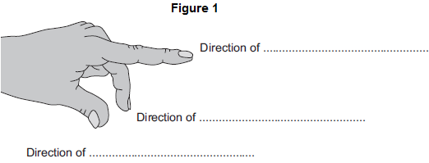

**(3)**

(b)     **Figure 2** shows an electric motor.

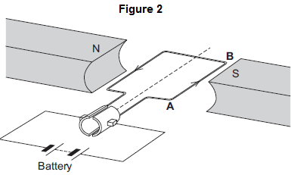

(i)      Draw an arrow on **Figure 2** to show the direction of the force acting on the wire **AB**.

**(1)**

(ii)     Suggest **two** changes that would increase the force acting on the wire **AB**.

1..............................................................................................................

2..............................................................................................................

**(2)**

(iii)    Suggest **two** changes that would reverse the direction of the force acting on the wire **AB**.

1..............................................................................................................

2.............................................................................................................. **(2)**

(c)     A student used an electric motor to lift a mass. This is shown in **Figure 3**.

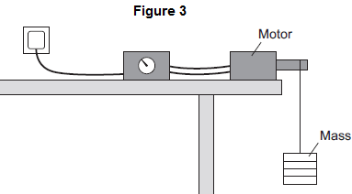

The student varied the electrical input power to the motor. For each different electrical input power, he recorded the time taken to lift the mass and calculated the output power of the motor.

The results are shown in the table.

|  |  |  |  |  |  |
| --- | --- | --- | --- | --- | --- |
|  | **Test** | **Electrical input power in watts** | **Work done lifting the mass in joules** | **Time taken to lift the mass in seconds** | **Output power in watts** |
|  | **A** | 20 | 24 | 2.4 | 10 |
|  | **B** | 40 | 24 | 1.2 | 20 |
|  | **C** | 60 | 24 | 0.8 | 30 |
|  | **D** | 80 | 24 | 0.2 | 120 |

The result for **Test D** is anomalous.

(i)      Calculate the efficiency of the motor in **Test D**.

...............................................................................................................

........................................................................................Efficiency = ....................................(**2)**

(ii)     Comment on your answer to part (c)(i).

...............................................................................................................

...............................................................................................................

**(1)**

(iii)    Suggest a reason for this anomalous result.

...............................................................................................................

...............................................................................................................

**(1)**

**(Total 12 marks)**

**Lesson 7 – Stopping Distances and Momentum**

|  |  |  |
| --- | --- | --- |
|  | **Topic:** | **Stopping distances (P.17)** |
| 1 | Define "stopping distance" | Thinking distance + braking distance |
| 2 | Define "thinking distance" | The distance travelled during the drive's reaction time |
| 3 | Define "braking distance" | The distance travelled under the braking force |
| 4 | What are the typical values for reaction time | 0.2-0.9 seconds |
| 5 | State 4 factors that effect a driver's reaction time | Tiredness, alcohol, drugs, distractions |
| 6 | State 3 factors that may affect braking distance | Adverse weather conditions (ice/snow/wet), worn tyres, worn brakes |
| 7 | What happens to a vehicles braking distance when a car is travelling faster? | Increases |
| 8 | Which force causes a car to slow down? | Friction (between brakes and wheels) |
| 9 | Describe the energy transfers that occur when a force is applied to a car's brakes | Kinetic energy of car -> thermal energy in the brakes |
| 10 | Why is a car travelling at high speed stopping suddenly dangerous? | Need larger braking force -> large deceleration |
| 11 | State 2 dangers of large decelerations | Overheating brakes and skidding car |
| 12 | Define "adverse" | Bad |
| 13 | What is 'inertial mass' (HT only) | A measure of how hard it is to change an object's velocity |
| 14 | Define "inertial mass" | The ratio of force over acceleration |
| 15 | What does this symbol mean? ~ | Approximately |
|  |  |  |
|  | **Topic:** | **Momentum (HT only) (P.18)** |
| 1 | Define "momentum" (HT only) | Momentum = mass x velocity p = m v  (kg m/s) (kg) (m/s) |
| 2 | Define "conservation of momentum" (HT only) | Total momentum before an event = total momentum after event |
| 3 | State the equation to calculate change in momentum (HT only) | F = (m ∆v) / ∆t when (m ∆v) is ∆p |
| 4 | State the relationship between force and momentum (HT only) | Force equals rate of change of momentum |
| 5 | Describe how safety features including seat belts, gym crash mats and cycle helmets work (linking to momentum) (HT only) | Increase time -> decrease rate of change of momentum -> decrease force |

Notes

**Physics Revision: Stopping Distances**

Mastery Matrix Points

|  |
| --- |
| Define ‘stopping distance’, ‘thinking distance’ and ‘braking distance’ |
| Recall typical values for reaction times (0.2-0.9 seconds) |
| Describe factors that effect a drivers reaction time |
| Explain methods used to measure human’s reaction times |
| Describe factors affecting ‘braking distance’ |
| Predict how the distance for a vehicle to make an emergency stop varies over a range of speeds |
| Explain the energy transfers when a vehicle brakes |
| Link braking force, deceleration and stopping distances |
| Explain the dangers caused by large decelerations |
| Estimate the forces involved in the deceleration of road vehicles (HT only) |

Equations *in words and symbols. Include units.*

Stopping distance:

Key Knowledge

Braking distance:

Thinking distance:

Stopping distance:

Increasing the speed, __________ the braking distance.

Typical reaction times: from _____ to____.

Understanding and Explaining

1. Explain how to measure human reaction times.
2. Describe how four factors affect **thinking distances**.
3. (iii)
4. (iv)
5. Describe four factors that affect the **braking distance** of a vehicle.

(i) (iii)

(ii) (iv)

1. Explain why drivers are asked to stay “at least two car lengths” back from the car in front on a motorway.
2. Describe and explain the energy changes during the braking of a vehicle.
3. Explain the dangers caused by large accelerations.

**Physics Revision: Momentum**

Mastery Matrix Points

|  |
| --- |
| Define ‘momentum’ using p = m v (HT only) |
| Explain conservation of ‘momentum’ (HT only) |

Understanding and Explaining

1.     A van has a mass of 3200 kg. The diagram shows the van just before and just after it collides with the back of a car. Just before the collision, the van was moving at 5 m/s and the car was stationary.

|  |  |
| --- | --- |
| **Before collision** | **After collision** |

(i)      Calculate the momentum of the van just before the collision. Show clearly how you work out your answer.

                                              Momentum = .............................. kg m/s

(ii)     The collision makes the van and car join together. What is the total momentum of the van and the car just after the collision?

                                              Momentum = .............................. kg m/s

2.     A van has a mass of 2000 kg. The van is travelling at 9m/s. The diagram shows the van just before and just after it collides with the back of a 1200kg car. The car is moving at 5m/s.

|  |  |
| --- | --- |
| **Before collision** | **After collision** |

(i)      Calculate the momentum of the van just before the collision. Show clearly how you work out your answer.

                                              Momentum = .............................. kg m/s

(ii)     The collision makes the van and car join together. What is the total momentum of the van and the car just after the collision?

                                              Momentum = .............................. kg m/s

Equations *in words and symbols. Include units.*

Momentum:

Equation that relates force and momentum:

Key Knowledge

Law of conservation of momentum:

**Guided Exam Question**

**Q11.**The stopping distance of a car is the sum of the thinking distance and the braking distance.

The table below shows how the thinking distance and braking distance vary with speed.

|  |  |  |  |
| --- | --- | --- | --- |
|  | **Speed  in m / s** | **Thinking distance in m** | **Braking distance in m** |
|  | 10 | 6 | 6.0 |
|  | 15 | 9 | 13.5 |
|  | 20 | 12 | 24.0 |
|  | 25 | 15 | 37.5 |
|  | 30 | 18 | 54.0 |

(a)     What is meant by the braking distance of a vehicle?

.............................................................................................................................

.............................................................................................................................

**(1)**

(b)     The data in the table above refers to a car in good mechanical condition driven by an alert driver.

Explain why the stopping distance of the car increases if the driver is very tired.

.............................................................................................................................

.............................................................................................................................

.............................................................................................................................

.............................................................................................................................

**(2)**

(c)     A student looks at the data in the table above and writes the following:

                           thinking distance ∝ speed

                           thinking distance ∝ speed

Explain whether the student is correct.

.............................................................................................................................

.............................................................................................................................

.............................................................................................................................

.............................................................................................................................

**(2)**

(d)     Applying the brakes with too much force can cause a car to skid.

The distance a car skids before stopping depends on the friction between the road surface and the car tyres and also the speed of the car.

Friction can be investigated by pulling a device called a ‘sled’ across a surface at constant speed.

The figure below shows a sled being pulled correctly and incorrectly across a surface.

The constant of friction for the surface is calculated from the value of the force pulling the sled and the weight of the sled.

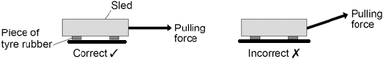

Why is it important that the sled is pulled at a constant speed?

|  |  |  |
| --- | --- | --- |
|  | Tick **one** box. |  |
|  | If the sled accelerates it will be difficult to control. |  |
|  | If the sled accelerates the value for the constant of friction will be wrong. |  |
|  | If the sled accelerates the normal contact force will change. |  |

**(1)**

(e)     If the sled is pulled at an angle to the surface the value calculated for the constant of friction would not be appropriate.Explain why.

.............................................................................................................................

.............................................................................................................................

.............................................................................................................................

.............................................................................................................................

**(2)**

(f)     By measuring the length of the skid marks, an accident investigator determines that the distance a car travelled between the brakes being applied and stopping was 22 m.

The investigator used a sled to determine the friction. The investigator then calculated that the car decelerated at 7.2 m / s2.

Calculate the speed of the car just before the brakes were applied.

Give your answer to two significant figures.

Use the correct equation from the Physics Equation Sheet.

.............................................................................................................................

.............................................................................................................................

.............................................................................................................................

.............................................................................................................................

                     Speed = ................................................... m / s

**(3)**

**(Total 11 marks)**

**Independent Exam Question**

**Q12.**(a)    In any collision, the total momentum of the colliding objects is usually conserved.

(i)      What is meant by the term ‘momentum is conserved’?

...............................................................................................................

...............................................................................................................

**(1)**

(ii)     In a collision, momentum is **not always** conserved.

Why?

...............................................................................................................

...............................................................................................................

**(1)**

(b)     The diagram shows a car and a van, just before and just after the car collided with the van.

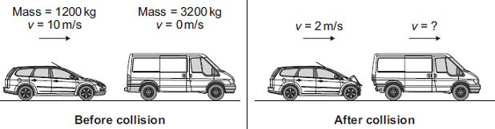

(i)      Use the information in the diagram to calculate the **change** in the momentum of the car.

Show clearly how you work out your answer and give the unit.

...............................................................................................................

...............................................................................................................

...............................................................................................................

...............................................................................................................

Change in momentum = ..................................................

**(3)**

(ii)     Use the idea of conservation of momentum to calculate the velocity of the van when it is pushed forward by the collision.

Show clearly how you work out your answer.

...............................................................................................................

...............................................................................................................

...............................................................................................................

Velocity = .................................................. m/s forward

**(2)**

(c) The figure below shows a skateboarder jumping forwards off his skateboard.

The skateboard is stationary at the moment the skateboarder jumps.

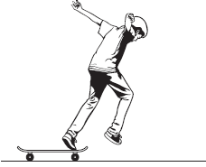

(i)     The skateboard moves backwards as the skateboarder jumps forwards.

Explain, using the idea of momentum, why the skateboard moves backwards.

___________________________________________________________________

___________________________________________________________________

___________________________________________________________________

___________________________________________________________________

___________________________________________________________________

___________________________________________________________________

___________________________________________________________________

___________________________________________________________________

**(3)**

(ii)     The mass of the skateboard is 1.8 kg and the mass of the skateboarder is 42 kg.

Calculate the velocity at which the skateboard moves backwards if the skateboarder jumps forwards at a velocity of 0.3 m / s.

___________________________________________________________________

___________________________________________________________________

___________________________________________________________________

___________________________________________________________________

___________________________________________________________________

___________________________________________________________________

Velocity of skateboard = ____________________ m / s

**(3)**

**(Total 6 marks)**

**Lesson 9: Required practicals**

**Knowledge**

|  |  |  |
| --- | --- | --- |
|  | **Topic:** | **RP: Hooke's Law (P6) (P.46)** |
| 1 | Define Hooke's law | Force is directly proportional to extension of a spring |
| 2 | In this RP, you are investigating the relationship between force and extension of a spring. What would be the IV? | Force |
| 3 | In this RP, you are investigating the relationship between force and extension of a spring. What would be the DV? | Extension of the spring |
| 4 | Which piece of equipment attaches the clamp stand to the work bench? | G-clamp |
| 5 | Which piece of equipment is used to hold the top of the spring? | Boss head clamp |
| 6 | State two potential hazards and give a safety precaution you could take to minimize the risk of each | 1) Weights falling on your toes - clamp the clamp stand to the work bench 2) Spring scratching your eye - wear safety goggles |
| 7 | What is one common mistake during this practical? | Measuring length of spring not extension |
| 8 | What is it called when a spring no longer returns to it's original shape? | Elastic limit |
| 9 | What is meant by extension? | How much longer the spring has got |
| 10 | How could you check the results were repeatable? | Do the each reading 3 times and check you get the same results each time |
| 11 | How could you check the results were reproducible? | Someone else replicates your study and check whether they get the same results |
| 12 | Which piece of equipment is used to measure extension? | Ruler |
| 13 | Which piece of equipment is used to hold the clamp? | Clamp stand |
| 14 | Which symbol means directly proportional? | ∝ |
| 15 | What kind of graph would you plot? | A scatter graph with line of best fit |
|  | **Topic:** | **RP: Forces, mass and acceleration (P7) (P.47)** |
| 1 | Which equation links force, mass and acceleration? | F = ma |
| 2 | The first experiment is looking at the relationship between force, and acceleration. What would be the IV? | Force |
| 3 | The first experiment is looking at the relationship between force, and acceleration. What would be the DV? | Acceleration |
| 4 | The first experiment is looking at the relationship between force, and acceleration. What would be the CV? | Mass |
| 5 | What do you mark on the work bench during experiment 1? | 20cm intervals |
| 6 | Which piece of equipment is used to measure the 20cm intervals? | Ruler |
| 7 | What is recorded when the car passes over each 20cm interval? | The time |
| 8 | Which piece of equipment accurately records time? | Light gates |
| 9 | How do you change the force acting on the trolley? | Add more weight to the end of the string that is pulling the trolley |
| 10 | The first experiment is looking at the relationship between mass and acceleration. What would be the IV? | Mass of the trolley |
| 11 | The first experiment is looking at the relationship between mass and acceleration. What would be the DV? | Acceleration of the trolley |
| 12 | The first experiment is looking at the relationship between mass and acceleration. What would be the CV? | Force applied to the trolley |
| 13 | How do you change the mass of the trolley? | Add a weight to the top of it |
| 14 | What is the expected relationship for mass and acceleration? | Inversely proportional |
| 15 | What is the expected relationship for force and acceleration? | Directly proportional |
|  | **Topic:** | **RP: Waves (P8) (P.48)** |
| 1 | Which piece of equipment is used to investigate water waves? | Ripple tank |
| 2 | Which piece of equipment generates the waves in the water? | Motor and bar |
| 3 | How do we see the water waves when using a ripple tank? | Shine light through water and look at the shadows created |
| 4 | How do you measure the wavelength of the water waves? | Using a ruler |
| 5 | Why do you measure across multiple waves and divide by the number of waves? | Means you are measuring the mean length (more accurate) |
| 6 | How do you measure the frequency of water waves? | Count how many pass a point in 10 seconds and then divide by 10. |
| 7 | How do you calculate wave speed? | velocity = frequency / wavelength v = f / λ (m/s) (Hz) (m) |
| 8 | What is the piece of equipment that generates waves in a piece of string? | A vibration generator |
| 9 | Which piece of equipment is used to measure the length of the wave? | A meter ruler |
| 10 | How do you determine the frequency of the waves in the piece of string? | Read it from the power supply |
| 11 | What is the most common error made when measuring the wavelength? | Only measuring half of the wave |
| 12 | What is the relationship between wave speed and frequency? | Directly proportional |
| 13 | What is the unit for wavelength? | Metres (m) |
| 14 | What is the unit for frequency? | Hertz (Hz) |
| 15 | What is the unit for wave speed? | Metres per second |
|  | **Topic:** | **RP: Light (P9) (triple only) (P.49)** |
| 1 | Which piece of equipment produces a single ray of light? | Ray box |
| 2 | Which piece of equipment is used to measure the angle of incidence and the angle of reflection? | Protractor |
| 3 | What is the line drawn at 90⁰ to the surface called? | The normal |
| 4 | What is the light ray that enters the mirror/glass block called? | The incident ray |
| 5 | What is the light ray that leaves the glass block called? | The refracted ray |
| 6 | What is the light ray that is reflected from the mirror called? | The reflected ray |
| 7 | What is the angle between the normal and the incident ray called? | The angle of incidence |
| 8 | What is the angle between the normal and the reflected ray called? | Angle of reflection |
| 9 | What is the relationship between the angle of incidence and the angle of reflection? | They are equal |
| 10 | What happens to a light ray when it enters a more dense material? | It slows down, moves towards the normal |
| 11 | What happens to a light ray when it enters a less dense material? | Speeds up, moves away from the normal |
| 12 | What is the term given to a wave changing speed and therefore direction when it crosses the boundary between two different materials? | Refraction |
| 13 | What is called when a wave hits a surface and bounces back? | Reflection |
| 14 | Is a light wave transverse or longitudinal? | Transverse |
| 15 | Is a water wave transverse or longitudinal? | Transverse |
|  | **Topic:** | **RP: Radiation and absorption - Leslie Cubes (P10)** |
| 1 | The aim of this investigation is to investigate the amount of infrared radiation radiated from different surfaces. What is the IV? | Type of surface |
| 2 | The aim of this investigation is to investigate the amount of infrared radiation radiated from different surfaces. What is the IV? | Type of surface |
| 3 | The aim of this investigation is to investigate the amount of infrared radiation radiated from different surfaces. What is the DV? | Infrared radiation emitted |
| 4 | The aim of this investigation is to investigate the amount of infrared radiation radiated from different surfaces. What are 2 CVs | Area of surface, thickness of surface |
| 5 | What is the name of a metal cube with different coloured surfaces? | Leslie cube |
| 6 | Which piece of equipment is used to measure the amount of infrared radiation emitted from the surface? | Infrared detector |
| 7 | What are the 4 surfaces of our Leslie cube? | Matt black, matt white, shiny white, shiny silver |
| 8 | What is one hazard and the safety precaution taken? | Leslie cube is hot and might burn you! Use gloves to touch. |
| 9 | What is placed inside the Leslie cube? | Hot water |
| 10 | Which surface should be the best emitter? | Matt black |
| 11 | Which surface should be the worst emitter? | Shiny white |
| 12 | How could you check your findings were repeatable? | Do the experiment again and see whether you got the same results |
| 13 | How could you check your results were reproducible? | Get someone else to do a similar experiment and see if they got the same results |
| 14 | What is the most common error in this experiment? | Holding the infrared detector at different distances from the surface |
| 15 | What type of radiation is infrared? | Transverse (EM wave) |
|  | **Topic:** | **Physics equations (paper 2) (S.11)** |
| 1 | Recall the equation to calculate weight | Weight = mass x gravitational field strength W = mg (N) (kg) (N/Kg) |
| 2 | Recall the equation to calculate work done when you know the force applied and the distance | Work done = force x distance W = Fs (E) (N) (m) |
| 3 | What is the equation to calculate force extension of a spring (Hooke's Law) | Force applied to a spring = spring constant x extension F = ke (N) (N/m) (m) |
| 4 | How do you calculate distance when you know speed and time? | Distance = speed x time s = vt (m) (m/s) (s) |
| 5 | How do you calculate acceleration when you know the change in velocity? | acceleration = change in velocity/time taken a = Δv/t (m/s^2) (m/s) (t) |
| 6 | How do you calculate force when you know mass and acceleration? | Force = mass x acceleration F = ma (N) (kg) (m/s^2) |
| 7 | How do you calculate momentum? | Momentum = mass x velocity  p = m x v (kgm/s) (kg) (m/s) |
| 8 | How do you calculate wave speed? | wave speed = frequency x wavelength v = fλ (m/s) (Hz) (m) |
| 9 | What does this symbol mean? " =" | Equals |
| 10 | What does this symbol mean? " <" | Less than |
| 11 | What does this symbol mean? "<<" | Significantly less than |
| 12 | What does this symbol mean? ">>" | Significantly more than |
| 13 | What does this symbol mean? ">" | More than |
| 14 | What does this symbol mean? "∝" | Directly proportional |
| 15 | What does this symbol mean? " ~ " | Approximately |

Notes

**Physics RP Revision - P6 – Hooke’s Law**

Understanding and Explaining

Equipment:

_____________________________________________________________________________________________________________________________

_____________________________________________________________________________________________________________________________

Method:

Step 1:__________________________________________________________________________________________________________________

_____________________________________________________________________________________________________________________________

Step 2:__________________________________________________________________________________________________________________

_____________________________________________________________________________________________________________________________

Step 3:__________________________________________________________________________________________________________________

_____________________________________________________________________________________________________________________________

Step 4:__________________________________________________________________________________________________________________

_____________________________________________________________________________________________________________________________

Step 5:__________________________________________________________________________________________________________________

_____________________________________________________________________________________________________________________________

Step 6:__________________________________________________________________________________________________________________

_____________________________________________________________________________________________________________________________

Step 7:__________________________________________________________________________________________________________________

_____________________________________________________________________________________________________________________________

Common error made in this practical:

_____________________________________________________________________________________________________________________________

_____________________________________________________________________________________________________________________________

Describe how you could improve the accuracy of the results:

_____________________________________________________________________________________________________________________________

_____________________________________________________________________________________________________________________________

Sketch and annotate a graph of the results:

Key Knowledge

Define:

IV:____________________________

_______________________________

DV:____________________________

_______________________________

CV:____________________________

_______________________________

Repeatable: _____________________

_______________________________

Reproducible: _____________________

_______________________________

Accurate: _____________________

_______________________________

IV in this experiment:

_______________________________

DV in this experiment:

_______________________________

CV in this experiment:

1. __________________________
2. __________________________
3. __________________________

Risk and precaution:

_______________________________

_______________________________

_______________________________

**Physics RP Revision - P7 – Forces, mass and acceleration**

Understanding and Explaining

Equipment:

_____________________________________________________________________________________________________________________________

_____________________________________________________________________________________________________________________________

Method aim 1:

Step 1:__________________________________________________________________________________________________________________

Step 2:__________________________________________________________________________________________________________________

Step 3:__________________________________________________________________________________________________________________

Step 4:__________________________________________________________________________________________________________________

Step 5:__________________________________________________________________________________________________________________

Step 6:__________________________________________________________________________________________________________________

Step 7:__________________________________________________________________________________________________________________

Step 8:__________________________________________________________________________________________________________________

Step 9:__________________________________________________________________________________________________________________

Method aim 2:

Step 1:__________________________________________________________________________________________________________________

Step 2:__________________________________________________________________________________________________________________

Step 3:__________________________________________________________________________________________________________________

Step 4:__________________________________________________________________________________________________________________

Step 5:__________________________________________________________________________________________________________________

Step 6:__________________________________________________________________________________________________________________

Describe the results you would expect to see in each experiment:

_____________________________________________________________________________________________________________________________

_____________________________________________________________________________________________________________________________

Key Knowledge

Define:

Acceleration::_____________________

_______________________________

Equation linking force, mass, acceleration:

Aim 1: How does _________ affect __________________________ when ______________________________?

IV:___________________________

DV:___________________________

CV: ___________________________

Aim 2: How does _________ affect __________________________ when ______________________________?

IV:___________________________

DV:___________________________

CV: ___________________________

**Physics RP Revision – P8 – Waves**

Understanding and Explaining

Big question 1:

Equipment:

_____________________________________________________________________________________________________________________________

_____________________________________________________________________________________________________________________________

Method:

Step 1:__________________________________________________________________________________________________________________

Step 2:__________________________________________________________________________________________________________________

Step 3:__________________________________________________________________________________________________________________

Step 4:__________________________________________________________________________________________________________________

Step 5:__________________________________________________________________________________________________________________

Step 6:__________________________________________________________________________________________________________________

Step 7:__________________________________________________________________________________________________________________

Big question 1:

Equipment:

_____________________________________________________________________________________________________________________________

_____________________________________________________________________________________________________________________________

Method:

Step 1:__________________________________________________________________________________________________________________

Step 2:__________________________________________________________________________________________________________________

Step 3:__________________________________________________________________________________________________________________

Step 4:__________________________________________________________________________________________________________________

Step 5:__________________________________________________________________________________________________________________

Key Knowledge

Define:

Frequency:_______________________

_______________________________

Wavelength:______________________

_______________________________

Amplitude: _____________________

_______________________________

Aim 1: Investigate the properties of _______________________________

IV = ___________________________

DV = ___________________________

CV =

1. _____________________________

2. _____________________________

Big Question 2: Investigate the properties of _____________________________

**Physics RP Revision – P9 – Light**

Understanding and Explaining

Equipment:

_____________________________________________________________________________________________________________________________

_____________________________________________________________________________________________________________________________

Diagram of how the equipment should be set up:

Big question 1:

Method:

Step 1:__________________________________________________________________________________________________________________

Step 2:__________________________________________________________________________________________________________________

Step 3:__________________________________________________________________________________________________________________

Step 4:__________________________________________________________________________________________________________________

Step 5:__________________________________________________________________________________________________________________

Big question 2:

Method:

Step 1:__________________________________________________________________________________________________________________

Step 2:__________________________________________________________________________________________________________________

Step 3:__________________________________________________________________________________________________________________

Step 4:__________________________________________________________________________________________________________________

Step 5:__________________________________________________________________________________________________________________

Step 6:__________________________________________________________________________________________________________________

**(triple only)**

Key Knowledge

Define:

Define:

**Reflection:** _______________________

______________________________________________________________

**Refraction:** ______________________

_______________________________

_______________________________

**Rule for angle of incidence and angle of reflection:** ______________________

______________________________

_______________________________

**Big Question 1:** Investigate __________

_______________________________

IV = ___________________________

DV = ___________________________

CV = ___________________________

**Big Question 2:** Investigate __________

_______________________________

IV = ___________________________

DV = ___________________________

CV = ___________________________

Understanding and Explaining

Equipment:

__________________________________________________________________________________________

__________________________________________________________________________________________

__________________________________________________________________________________________

Method:

Step 1:_________________________________________________________________________________________

__________________________________________________________________________________________

Step 2:_________________________________________________________________________________________

__________________________________________________________________________________________

Step 3:_________________________________________________________________________________________

__________________________________________________________________________________________

**Describe how to make the results accurate:**

1._________________________________________________________________________________________

__________________________________________________________________________________________

2._________________________________________________________________________________________

__________________________________________________________________________________________

3._________________________________________________________________________________________

__________________________________________________________________________________________

**Physics RP Revision –**

**P10 – Radiation and Absorption**

**(**

Key Knowledge

**What surface is the best emitter or infrared radiation?** _____________

**What surface is the best absorber of infrared radiation?** ___________

**Which surface is the worst emitter and absorber of infrared radiation?** ___________________________

**Aim:** Investigate the amount of ____________________________

____________________________

____________________________

IV – _________________________

DV – ________________________

CV -

1. _______________________

2. _______________________

3. _______________________

4. _______________________

**Guided exam questions:**

**Q17.**

A student investigated the behaviour of springs. She had a box of identical springs.

(a)     When a force acts on a spring, the shape of the spring changes.

The student suspended a spring from a rod by one of its loops. A force was applied to the spring by suspending a mass from it.

**Figure 1** shows a spring before and after a mass had been suspended from it.

**Figure 1**

|  |  |  |
| --- | --- | --- |
| **Before** |  | **After** |

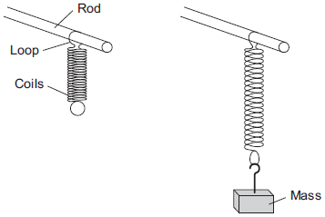

(i)      State **two** ways in which the shape of the spring has changed.

1. ____________________________________________________________

2. ____________________________________________________________

**(2)**

(ii)     No other masses were provided.

Explain how the student could test if the spring was behaving elastically.

______________________________________________________________

______________________________________________________________

______________________________________________________________

______________________________________________________________

**(2)**

(b)     In a second investigation, a student took a set of measurements of force and extension.

Her results are shown in **Table 1** .

**Table 1**

|  |  |  |  |  |  |  |  |
| --- | --- | --- | --- | --- | --- | --- | --- |
| **Force in newtons** | 0.0 | 1.0 | 2.0 | 3.0 | 4.0 | 5.0 | 6.0 |
| **Extension in cm** | 0.0 | 4.0 |  | 12.0 | 16.0 | 22.0 | 31.0 |

(i)      Add the missing value to **Table 1**.

Explain why you chose this value.

______________________________________________________________

______________________________________________________________

______________________________________________________________

______________________________________________________________

**(3)**

(ii)     During this investigation the spring exceeded its limit of proportionality.

Suggest a value of force at which this happened.

Give a reason for your answer.

Force = _________________ N

Reason _______________________________________________________

______________________________________________________________

______________________________________________________________

**(2)**

(c)     In a third investigation the student:

•        suspended a 100 g mass from a spring

•        pulled the mass down as shown in **Figure 2**

•        released the mass so that it oscillated up and down

•        measured the time for 10 complete oscillations of the mass

•        repeated for masses of 200 g, 300 g and 400 g.

**Figure 2**

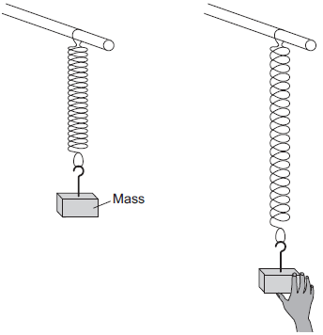

Her results are shown in **Table 2**.

**Table 2**

|  |  |  |  |  |
| --- | --- | --- | --- | --- |
|  | **Time for 10 complete oscillations in seconds** | | | |
| **Mass in g** | **Test 1** | **Test 2** | **Test 3** | **Mean** |
| 100 | 4.34 | 5.20 | 4.32 | 4.6 |
| 200 | 5.93 | 5.99 | 5.86 | 5.9 |
| 300 | 7.01 | 7.12 | 7.08 | 7.1 |
| 400 | 8.23 | 8.22 | 8.25 | 8.2 |

(i)      Before the mass is released, the spring stores energy.

What type of energy does the spring store?

Tick () **one** box.

|  |  |
| --- | --- |
|  | **Tick ()** |
| Elastic potential energy |  |
| Gravitational potential energy |  |
| Kinetic energy |  |

**(1)**

(ii)     The value of time for the 100 g mass in **Test 2** is anomalous.

Suggest **two** likely causes of this anomalous result.

Tick () **two** boxes.

|  |  |
| --- | --- |
|  | **Tick ()** |
| Misread stopwatch |  |
| Pulled the mass down too far |  |
| Timed half oscillations, not complete oscillations |  |
| Timed too few complete oscillations |  |
| Timed too many complete oscillations |  |

**(2)**

(iii)    Calculate the correct mean value of time for the 100 g mass in **Table 2**.

______________________________________________________________

______________________________________________________________

Mean value = __________________ s

**(1)**

(iv)    Although the raw data in **Table 2** is given to 3 significant figures, the mean values are correctly given to 2 significant figures.

Suggest why.

______________________________________________________________

______________________________________________________________

______________________________________________________________

______________________________________________________________

**(2)**

(v)     The student wanted to plot her results on a graph. She thought that four sets of results were not enough.

What extra equipment would she need to get more results?

______________________________________________________________

______________________________________________________________

______________________________________________________________

______________________________________________________________

**(2)**

**(Total 17 marks)**

**Q18.**

All objects emit and absorb infrared radiation.

(a)     Use the correct answer from the box to complete each sentence.

|  |  |  |  |
| --- | --- | --- | --- |
| **dark matt** | **dark shiny** | **light matt** | **light shiny** |

The best emitters of infrared radiation have

_____________________________________ surfaces.

The worst emitters of infrared radiation have

_____________________________________ surfaces.

**(2)**

(b)     **Diagram 1** shows a sphere which is at a much higher temperature than its surroundings.

**Diagram 1**

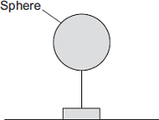

Energy is transferred from the sphere to the surroundings.

The table shows readings for the sphere in three different conditions, **A**, **B** and **C**.

|  |  |  |
| --- | --- | --- |
| **Condition** | **Temperature of sphere in °C** | **Temperature of surroundings in °C** |
| **A** | 70 | 5 |
| **B** | 80 | 0 |
| **C** | 90 | 30 |

In each of the conditions, **A**, **B** and **C**, the sphere transfers energy to the surroundings at a different rate.

Put conditions **A**, **B** and **C** in the correct order.

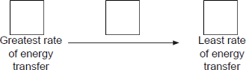

Give a reason for your answer._________________________________________________________________

___________________________________________________________________

**(2)**

(c)     **Diagram 2** shows a can containing water.

A student investigates how quickly a can of water heats up when it is cooler than room temperature.

**Diagram 2**

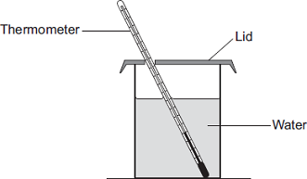

The student has four cans, each made of the same material, with the following outer surfaces.

|  |  |  |  |
| --- | --- | --- | --- |
| **dark matt** | **dark shiny** | **light matt** | **light shiny** |

The student times how long it takes the water in each can to reach room temperature.

Each can contains the same mass of water at the same starting temperature.

(i)      Which can of water will reach room temperature the quickest?

Give a reason for your answer.

______________________________________________________________

______________________________________________________________

______________________________________________________________

______________________________________________________________

**(2)**

(ii)     Apart from material of the can, mass of water and starting temperature, suggest **three** control variables for the student’s investigation.

1. ____________________________________________________________

______________________________________________________________

2. ____________________________________________________________

______________________________________________________________

3. ____________________________________________________________

______________________________________________________________

**(3)**

(d)     The photographs show two different foxes.

**Fox A                                                Fox B**

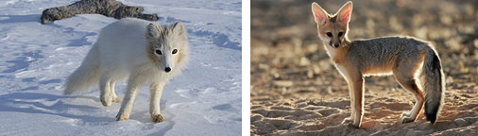

             By Algkalv (Own work) [CC-BY-3.0],                                                          © EcoPic/iStock  
                    via Wikimedia Commons

Which fox is better adapted to survive cold conditions?

Give reasons for your answer.

___________________________________________________________________

___________________________________________________________________

___________________________________________________________________

___________________________________________________________________

___________________________________________________________________

___________________________________________________________________

___________________________________________________________________

___________________________________________________________________

**(3)**

**(Total 12 marks)**

**Q19.**

The data given in the table below was obtained from an investigation into the refraction of light at an air to glass boundary.

|  |  |
| --- | --- |
| **Angle of incidence** | **Angle of refraction** |
| 20° | 13° |
| 30° | 19° |
| 40° | 25° |
| 50° | 30° |

(a)     Describe an investigation a student could complete in order to obtain similar data to that given in the table above.

Your answer should consider any cause of inaccuracy in the data.

A labelled diagram may be drawn as part of your answer.

___________________________________________________________________

___________________________________________________________________

___________________________________________________________________

___________________________________________________________________

___________________________________________________________________

___________________________________________________________________

___________________________________________________________________

___________________________________________________________________

___________________________________________________________________

___________________________________________________________________

**(6)**

(b)     State the reason why light is refracted as it crosses from air into glass.

___________________________________________________________________

___________________________________________________________________

**(1)**

**(Total 7 marks)**

**Biology Revision: Elastic Objects and**

Mastery Matrix Points

|  |
| --- |
| Describe elastic and inelastic deformation |
| Explain the effect of forces on elastic objects |
| Describe Hooke’s Law qualitatively and using the equation F = ke |
| Explain ‘word done’ when applied to stretching or compressing a spring |
| Explain the difference between a linear and a non-linear relationship |
| Interpret data from a force extension investigation |
| **RP Force and Extension:** Investigate the relationship between force and extension for spring (Hooke’s Law) |

**Potential Energy**

Equations:

**Show in words and symbols. Include units.**

Elastic potential energy:

elastic potential energy  = 0.5  × spring constant  × extension 2

Ee = ½ k e2

Force on a spring during compression or extension:

force  = spring constant  × extension

F = k e

force, F, in newtons, N spring constant, k, in newtons per metre, N/m extension, e, in metres, m

Key Knowledge

Elastic limit/limit of proportionality –

the maximum extent to which a solid may be stretched without permanent alteration of size or shape.

Elastic deformation – the object will go back to its original shape.

Inelastic deformation – the object will not go back to its original shape.

Hooke’s Law The extension of an elastic object, such as a spring, is directly proportional to the force applied, provided that the limit of proportionality is not exceeded.

Understanding and Explaining

1. Explain why more than one force must be applied to a spring to stretch it.

One part of the object must be held still with a force whilst the other side is pulled.

1. Describe the energy changes when a spring is elastically deformed (stretched or squashed).

A force that stretches (or compresses) a spring does work and elastic potential energy is stored in the spring. Provided the spring is elastically deformed, the work done on the spring and the elastic potential energy stored are equal.

1. Sketch a graph of force vs extension for a spring. Label the elastic limit.

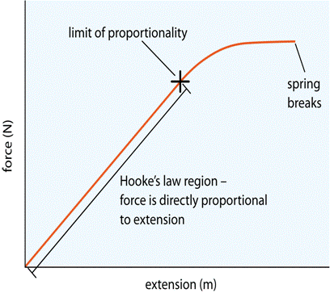

1. What are some common errors when completing the Hooke’s law experiment?

Measuring length instead of extension. Not lining up the ruler to zero. Measuring the mass instead of the weight for force.

**Biology Revision: Waves**

Mastery Matrix Points

|  |
| --- |
| Describe what is meant by ‘a wave’ |
| Describe the difference between longitudinal and transverse waves giving examples for both |
| Describe amplitude, wavelength (λ), wave speed (v), frequency (f) and period of a wave (T) and give units for each |
| Use and rearrange T = 1/f |
| Use and rearrange v = f  λ |
| Identify amplitude and wavelength from diagrams of a wave |
| Describe the method to measure the speed of sound in air and the speed of ripples on the water surface |
| **RP Waves:** Make observations to identify the suitability of apparatus for measuring frequency, wavelength and speed of waves in a ripple tank and waves on a string or elastic cord. |

Understanding and Explaining

1. Describe a method to measure the speed of sound waves in air.

Find the speed of sound by measuring the time taken for an echo to get back to you after clapping your hands or banging two large lumps of wood together, near a wall. The distance to the wall will need to be measured (and doubled to find the distance the sound wave travels). Use speed = distance/time.

1. Describe a method to measure the speed of ripples on a water surface.

Use a ripple tank – measure the number of waves passing per second, measure the wavelength with a ruler. Use the wave equation for speed.

1. Label the main parts of these waves:

 

1. A sound wave is travelling in air. The wave then moves into water, then a solid brick block and then back into air. Say if these would stay the same, increase or decrease as the wave moves into each new material.

|  |  |  |  |
| --- | --- | --- | --- |
|  | **Into water** | **Into brick** | **Into air** |
| **Frequency** | Same | Same | Same |
| **Wavelength** | Decreases | Decreases | Increases |
| **Speed** | Decreases | Decreases | Decreases |

1. Compare longitudinal and transverse waves.

In a transverse wave the oscillations are perpendicular to the direction of energy transfer, whereas in a longitudinal wave the oscillations are parallel to the direction of energy transfer. The transverse waves have crests and troughs, whereas longitudinal waves show areas of compression and rarefaction.

Equations *in words and symbols. Include units.*

Period of a wave:

period =   1_____

frequency

T = 1

f

period, T, in seconds, s frequency, f, in hertz, Hz

The wave equation (wave speed):

wave speed  = frequency × wavelength

v = f  λ

wave speed, v, in metres per second, m/s frequency, f, in hertz, Hz wavelength, λ, in metres, m

Key Knowledge

Amplitude – the maximum displacement of a point on a wave away from its undisturbed position.

Wavelength – the distance from a point on one wave to the equivalent point on the adjacent wave.

Frequency –

the number of waves passing a point each second.

Wave speed –

the speed at which the energy is transferred (or the wave moves) through the medium

**Biology Revision: Magnetism**

Mastery Matrix Points

|  |
| --- |
| Describe the polarity of magnets and list 4 magnetic materials |
| Explain the difference between a permanent and induced magnet |
| Describe the force between a magnet and a magnetic material |
| Describe the direction and strength of a magnetic field around a magnet |
| Explain how compasses work |
| Describe how to make an electromagnet and how to increase its strength |
| Interpret diagrams of electromagnetic devices in order to explain how they work (triple only) |

Key Knowledge

Two like poles ~~attract/~~repel.

Two unlike poles attract/~~repel.~~

Electromagnet –

**A solenoid (coil) with an iron core.**

Permanent magnet – **a magnet that produces its own magnetic field.**

Induced magnet – **a material that becomes a magnet when it is placed in a magnet field.**

Magnetic field – **region around a magnet where the force acts.**

4 magnetic materials

**-iron**

**-steel**

**-cobalt**

**-nickel**

Draw the magnetic field around these bar magnets:

1



2

 

3

 

Understanding and Explaining

1. Compare permanent and induced magnets.

**Permanent magnets produce their own magnetic fields, whereas induced magnets do not. Permanent magnets maintain their magnetic field always whereas induced magnets are only temporarily magnetic (whilst they are in a magnetic field). Permanent magnets can cause attraction and repulsion whereas induced magnets only produce forces of attraction.**

1. Describe how to plot the magnetic field pattern of a magnet using a compass.

**Place the compass around the magnet in different places, each time drawing on a piece of paper an arrow to show the direction the compass pointed. The join up the arrows to show the magnetic field.**

1. Describe how the magnetic field changes around a bar magnet. How is this shown on a scientific diagram?

**The closer the lines are, the stronger the magnetic field is. The field is stronger at the end compared to the middle of the magnets.**

1. How can you increase the strength of an electromagnet?

**More turns on the coil. Higher voltage. Bigger area of the coils. NB cannot say add an iron core because all electromagnets have an iron core.**

1. Explain how to draw the magnetic field around a solenoid. Draw an example.

**RH grip rule – fingers in the direction of the current and thumb points to north.** 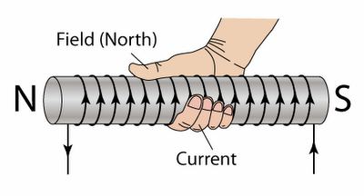

1. Explain how to draw the magnetic field around a wire. Draw an example.

**RH grip rule – thumb shows the current and fingers show magnetic field.** 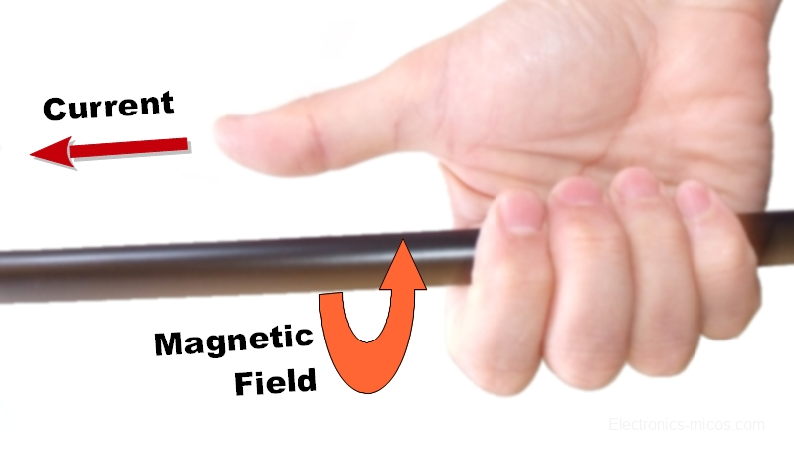

**Biology Revision: Electromagnetic Waves**

Mastery Matrix Points

|  |
| --- |
| Describe what ‘electromagnetic waves’ are |
| Recall the order of EM waves & recall their frequency and wavelength and give examples of the uses of these |
| Explain how EM waves are generated and absorbed |
| Explain the hazardous effects of UV, X-rays and Gamma rays |
| Link the properties of EM waves to their practical application (HT only) |
| Apply knowledge of reflection, refraction, transmission and absorption to EM waves (HT only) |
| **RP Radiation and Absorption:** investigate how the amount of infrared radiation absorbed or radiated by a surface depends on the nature of that surface |
| Explain how radio a radio works using EM waves (HT only) |

Key Knowledge

Electromagnetic Waves – transverse waves that transfer energy from the source of the waves to an absorber.

Electromagnetic Spectrum –

a continuous spectrum of all the types of electromagnetic waves, which travel at the same velocity through a vacuum (space) or air.

Order of the electromagnetic spectrum

LONG WAVELENGTH, LOW FREQUENCY

- Radio

-Microwave

-Infrared

-Visible

-Ultraviolet

-X-rays

-Gamma rays

SHORT WAVELENGTH, HIGH FREQUENCY

Absorption – Take in radiation

Transmission – Radiation goes through the object

Emission – Radiation is given out.

Refraction – Radiation changes direction at the boundary to a material.

Reflection – Radiation bounces back at the boundary to a material.

Understanding and Explaining

1. Describe and explain the Leslie cube experiment.

Leslie's cube is a metal box with four differently painted sides. If it is filled with boiling water from a kettle you can use either your hands or a thermopile (IR detector) connected to a meter to try and decide which surfaces give out the most heat radiation. It shows that black surfaces are the best emitters of heat radiation.

1. Draw a diagram to show how an infrared beam would be refracted as it moves from air into a Perspex block.

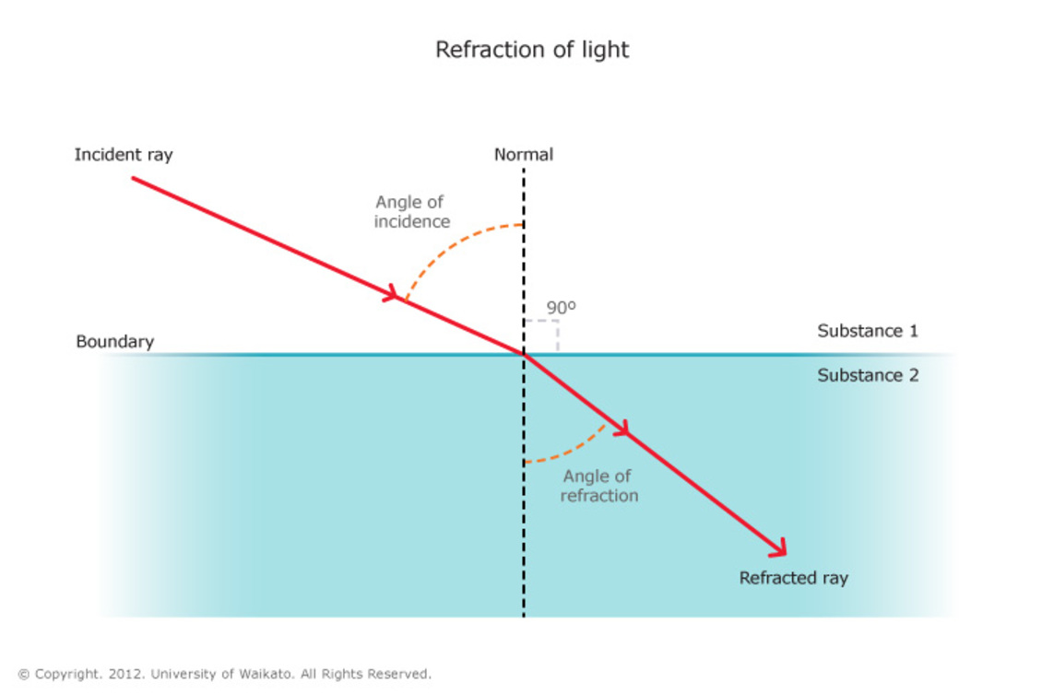

1. How are radio waves produced and the detected?

Radio Transmitter: Radio waves can be produced by oscillations in electrical circuits. Radio Detector: When radio waves are absorbed they may create an alternating current with the same frequency as the radio wave itself, so radio waves can themselves induce oscillations in an electrical circuit.

1. How are gamma rays produced?

Changes in atoms and the nuclei of atoms can result in electromagnetic waves being generated or absorbed over a wide frequency range. Gamma rays originate from changes in the nucleus of an atom.

1. Explain how ultraviolet waves, X-rays and gamma rays can be harmful.

Ultraviolet waves can cause skin to age prematurely and increase the risk of skin cancer. X-rays and gamma rays are ionising radiation that can cause the mutation of genes and cancer. The effects depend on the type of radiation and the size of the dose. Radiation dose (in sieverts) is a measure of the risk of harm resulting from an exposure of the body to the radiation.

1. Complete the table:

|  |  |  |  |  |  |  |  |
| --- | --- | --- | --- | --- | --- | --- | --- |
| E/M Radiation: | Radio | Microwave | Infrared | Visible | Ultraviolet | X-rays | Gamma rays |
| Use: | Tv and radio | Satellite comms and cooking | Electric heaters, cooking, infrared cameras | Fibre optic comms | Energy efficient lamps, sun tanning | Medical imaging and treatments | Medical imaging and treatments |
| Reason: | Long range, low energy | Frequency makes water particles vibrate. Can get through atmosphere | Provides heat. | More efficient way to send info that electrical wires | High energy. | High energy, can penetrate well. | High energy, can penetrate well. |

**Biology Revision: Forces**

Mastery Matrix Points

|  |
| --- |
| Define scalar and vector quantities |
| Use arrows to represent vector quantities |
| Define contact and non-contact forces giving examples of each |
| Define weight and gravity |
| Use W=m x g |
| Describe what the centre of mass is |
| Explain how to measure weight using a calibrated spring balance (i.e. a Newton meter) |
| Calculate and define resultant forces |
| Use free body diagrams to show forces |
| Use vector diagrams to illustrate the resolution of forces and determine resultant forces (scale drawings) (HT only) |

Key Knowledge

Scalar quantities – have magnitude only.

e.g. distance

Vector quantities – have magnitude and an associated direction. e.g. force/velocity/magnetic flux density

Using arrows to show vectors –

The length of the arrow represents the magnitude, and the direction of the arrow the direction

Non-contact forces include…

gravitational force, electrostatic force and magnetic force.

Contact forces include…

friction, air resistance, tension and normal contact force.

Weight –the force acting on an object due to gravity.

Weight is measured by…a calibrated spring-balance (a newtonmeter).

Resultant force – a single force that has the same effect as all the original forces acting together.

Equations *in words and symbols. Include units.*

Weight:

weight = mass × gravitational field strength W = m x g

weight, W, in newtons, N mass, m, in kilograms, kg gravitational field strength, g, in newtons per kilogram, N/kg

Work done:

work done = force × distance moved

W = F s

work done, W, in joules, J force, F, in newtons, N distance, s, in metres, m

Understanding and Explaining

1. Describe what may happen to an object if the forces are unbalanced (i.e. there is a resultant force).

* Accelerate/decelerate
* Change direction
* Squash/stretch

1. Describe what may happen to an object that has no resultant force (i.e. the forces are balanced).

* Stays at a constant speed

1. What is the centre of mass of an object?

A point at which all the mass of an object appears to act.

1. A box is suspended by three strings. Its weight is negligible. Resolve the forces in string 2 and string 3. Is the object in equilibrium (balanced forces) or not?



**Biology Revision: Speed and Velocity**

Mastery Matrix Points

|  |
| --- |
| Explain the difference between distance and displacement |
| Define ‘speed’ and explain factors that affect the speed a person walks, runs or cycles at (including average speeds for these activities) |
| Recall typical speeds for different types of transportation (TBC – bus, train, car, aeroplane!) using ̴ correctly. |
| Recall the speed of sound in air |
| State that most moving objects have varying speed including sound, wind, travelling people |
| Use and rearrange s = v t (speed = d/t equation!) |
| Calculate average speed for non-uniform motion |
| Define ‘velocity’ |
| Describe circular motion (HT only) |

Key Knowledge

Distance – **Distance is how far an object moves.**

Displacement – **Displacement includes both the distance an object moves, measured in a straight line from the start point to the finish point and the direction of that straight line**

Speed of:

* Walking 1.5m/s
* Running 3m/s
* Cycling 6m/s
* Car 30m/s
* Bike 6m/s
* Aeroplane 250m/s
* Sound 330m/s

Vector or scalar?

Speed **Scalar**

Velocity **Vector**

Distance **Scalar**

Displacement **Vector**

Understanding and Explaining

1. The path of an object is show by the curved line. Measure the displacement in mm.

**Depends on the size printed!**

1. Explain why speed of a moving person or car is rarely constant.

**It is constantly changing because it is difficult to ensure you move the exact same distance each second.**

1. Speed of a person walking, running or cycling depends on four main factors. What are these factors?

**Age, terrain, fitness and distance travelled.**

1. Explain why an object moving in a circle has a constant speed but not a constant velocity.

**The direction is changing and velocity is a vector so even if the magnitude is the same, the direction changes as it moves in a circle.**

1. A) Estimate the deceleration of car stopping on a motorway.

**a = change in v/t = 30/2 = 15m/s2**

B) Estimate the deceleration of a train stopping at a station.

**70/10 = 7m/s2**

C) Estimate the acceleration of a cyclist starting at rest and reaching their average speed.

**6m/s/6s = 1m/s2**

Equations *in words and symbols. Include units.*

Speed:

**distance travelled  = speed × time**

**s = v t**

**distance, s, in metres, m speed, v, in metres per second, m/s time, t, in seconds, s**

Acceleration:

**acceleration = change in velocity**

**time taken**

**a = ∆ v/t**

**acceleration, a, in metres per second squared, m/s2 change in velocity, ∆v, in metres per second, m/s time, t, in seconds, s**

Equation of motion (suvat):

**­final velocity 2 − initial velocity 2 = 2 × acceleration × distance**

**v2 − u2 = 2 a s**

**final velocity, v, in metres per second, m/s initial velocity, u, in metres per second, m/s acceleration, a, in metres per second squared, m/s2 distance, s, in metres, m**

**Biology Revision: Distance-Time and**

Mastery Matrix Points

|  |
| --- |
| Draw and interpret distance time graphs and use these to determine speed |
| Draw tangents on a distance time graph to determine speed of an accelerating object (HT only) |
| Use and rearrange the equation a = Δv / t (calculating acceleration) |
| Estimate the magnitude of every day acceleration |
| Draw and interpret velocity time graphs in order to calculate acceleration |
| Use velocity time graphs to calculate distance/displacement (HT only) |

Key Knowledge

Sketch distance-time graphs to show -

Stationary:

**Straight line**

Constant speed:

**Straight line (diagonal)**

Acceleration:

**Curved line up**

Deceleration:

**Curved line down**

Sketch velocity-time graphs to show -

Stationary:

**Straight line (flat on zero)**

Constant speed:

**Straight line (flat)**

Acceleration:

**Straight line (diagonal up)**

Deceleration:

**Straight line (diagonal down)**

**Velocity-Time Graphs**

Understanding and Explaining

1. How do you calculate these quantities from each of these graphs?
   1. Distance from a distance time graph. **Look it up on axis.**
   2. Speed from a distance time graph (straight line). **Use speed = distance/time (the gradient)**
   3. Speed from a distance time graph (curved line). **Use speed = distance/time (draw a tangent)**
   4. Distance from a velocity time graph. **Area under the graph.**
   5. Speed from a velocity time graph. **Look it up on the axis.**
   6. Acceleration from a velocity time graph. **Use** **acceleration = change in v/time (Gradient)**
2. How do you calculate the area of
   1. A trapezium **½ (a+b) h**
   2. A triangle **½ b x h**
   3. A rectangle **b x h**
3. How can you estimate the area under a graph if the graph is curved?

**Count the squares and work out how much each square is worth. Don’t count a square if it is less than half.**

**Physics Revision: Falling Objects and**

Mastery Matrix Points

|  |
| --- |
| Apply the equation v2-u2=2as (For moving and falling objects) [Newton’s equations of motion] |
| Recall the value for acceleration due to gravity (9.8m/s2) |
| Explain the acceleration of objects through fluids (terminal velocity) – making reference to parachutes travelling through air |
| Draw and interpret velocity time graphs for objects that reach terminal velocity |
| Describe and explain Newton’s first law |
| Explain the concept of inertia (HT only) |
| Describe and explain Newton’s second law using F = m a |
| Define inertial mass (HT only) |
| Estimate the forces involved in large accelerations for every day road transport using ̴ correctly. |
| **RP Acceleration:** Investigate the effects of varying force on the acceleration of an object with a constant mass and the effects of varying the mass on the acceleration produced by a constant force |
| Describe and explain Newton’s third law |

**Newton’s Laws**

Key Knowledge

Terminal velocity – **Maximum velocity when resultant force is zero.**

Newton’s first law: **If the resultant force acting on an object is zero and: • the object is stationary, the object remains stationary • the object is moving, the object continues to move at the same speed and in the same direction. So the object continues to move at the same velocity.**

Newton’s second law: **The acceleration of an object is proportional to the resultant force acting on the object, and inversely proportional to the mass of the object.**

Newton’s third law:

**Whenever two objects interact, the forces they exert on each other are equal and opposite.**

Inertia - **The tendency of objects to continue in their state of rest or of uniform motion.**

Equations *in words and symbols. Include units.*

Newton’s Second Law:

**resultant force  = mass × acceleration**

**F = m a**

**force, F, in newtons, N mass, m, in kilograms, kg acceleration, a, in metres per second squared, m/s2**

Equation of motion (suvat):

**­final velocity 2 − initial velocity 2 = 2 × acceleration × distance**

**v2 − u2 = 2 a s**

**final velocity, v, in metres per second, m/s initial velocity, u, in metres per second, m/s acceleration, a, in metres per second squared, m/s2 distance, s, in metres, m**

Understanding and Explaining

1. Describe and explain the motion of a skydiver.

* **Skydiver accelerates because weight is greater than air resistance.**
* **Air resistance increases as the skydiver speeds up.**
* **Air resistance and weight balance. There is no resultant force and (due to Newton’s first law) the skydiver travels at a constant speed known as the terminal velocity.**
* **Skydiver opens parachute and air resistance increases.**
* **Air resistance greater than weight and skydiver decelerates.**
* **Air resistance decreases rapidly until it equals the weight, and a new lower terminal velocity is reached.**
* **Skydiver hits the ground.**

1. Sketch a velocity time graph to show the motion of a skydiver.

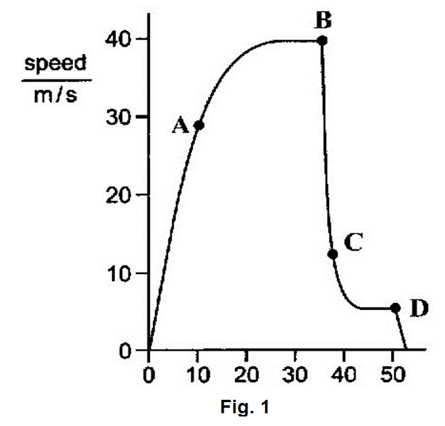

1. Define inertial mass.

**Inertial mass is a measure of how difficult it is to change the velocity of an object. Inertial mass is defined as the ratio of force over acceleration.**

1. A) Approximate the braking force of a lorry. (You need to estimate the mass and acceleration to calculate this)

**F=ma = 10000kg x 2m/s2 = 20,000N**

B) Approximate the braking force of a train. (You need to estimate the mass and acceleration to calculate this)

**F=ma = 100000kg x 1m/s2 = 100,000N**

1. Explain why when a tennis ball is struck with a racquet that the racquet strings may break.

**Due to Newton’s third law, when a racquet hits a tennis ball there is a force on the ball, but also an equal and opposite force on the racquet. This may cause the racquet to break.**

**Biology Revision: Electromagnetism**

Mastery Matrix Points

|  |
| --- |
| Describe the motor effect and use this to explain how electric motors work (HT only) |
| Explain and apply Fleming’s left hand rule (HT only) |
| Recall factors that affect the size of the force on a conductor (HT only) |
| Use and rearrange the equation F = B I L (HT only) |
| Explain how loudspeakers and headphones work (triple only) |
| Explain how potential difference/current can be induced in a circuit (the generator effect!) (triple only) |
| Recall factors that can affect the size of the generator effect (triple only) |
| Apply principals of the generator effect to: a dynamo, microphone, transformers (triple only) |
| Draw and interpret graphs of potential difference generated in a coil against time (triple only) |

Understanding and Explaining

1. What factors affect the size of the force on a current carrying conductor (a wire) in a magnetic field?

* Magnetic flux density (strength of magnetic field)
* Length of the wire (can coil it and add more turns on the coil to increase the force)
* Current (increase the current or potential difference to increase the size of the force)

1. Explain why a wire in a magnetic field experiences a force (if current flows in the wire).

**The current in wire creates magnetic field around wire and the two fields interact or combine giving a resultant force (on the wire). This is called the motor effect.**

1. Explain how an electric motor works.

**A coil of wire carrying a current in a magnetic field tends to rotate. This is the basis of an electric motor. The force on one side of the coil is up (Fleming’s LH rule) and on the other side is down. This causes the rotation. A split ring commutator is used to keep the current flowing in the same direction.**

1. Explain how a moving coil loudspeaker/headphones work.

**Loudspeakers and headphones use the motor effect to convert variations in current in electrical circuits to the pressure variations in sound waves. They consist of a permanent magnet and an electromagnet. As the current or pd in the electromagnet changes the amount that the coil is attracted to or repelled from the other magnet changes. A diaphragm or cone is attached to the coil which then also vibrates causing the sound wave. Larger vibration 🡪 louder sound. Quicker vibration 🡪 higher pitch sound.**

1. Explain how to induce a current in a wire. **If an electrical conductor moves relative to a magnetic field or if there is a change in the magnetic field around a conductor, a potential difference is induced across the ends of the conductor. If the conductor is part of a complete circuit, a current is induced in the conductor. This is called the generator effect.**
2. Explain how microphones work.

**Microphones use the generator effect to convert the pressure variations in sound waves into variations in current in electrical circuits. The sound wave causes a coil to vibrate around a magnet, which induces a current in a wire.**

1. Explain the differences between a step up and step down transformer.

**In a step-up transformer Vs > V p In a step-down transformer Vs < V p. This is because in a step-up there are more turns in the secondary coil and in step-down there are less turns in the secondary coil.**

Equations *in words and symbols. Include units.*

Magnetic flux density:

**force  = magnetic flux density  × current  × length**

**F = B I l**

**force, F, in newtons, N**

**magnetic flux density, B, in tesla, T**

**current, I, in amperes, A (amp is acceptable for ampere)**

length, l, in metres, m

Transformer:

**Vp/Vs = Np/Ns**

**potential difference, V p and Vs in volts, V**

**number of turns on each coil, np and ns** .

Transformer power equation:

**Vs × Is = Vp × Ip**

**Where Vs × I s is the power output (secondary coil) and V p × I p is the power input (primary coil). power input and output, in watts, W**

Key Knowledge

Motor Effect – **When a conductor carrying a current is placed in a magnetic field the magnet producing the field and the conductor exert a force on each other.**

Fleming’s left-hand rule –

First finger: **Magnetic field N to S**

Second finger: **Current (+ to -)**

Thumb: **Force (movement)**

Alternating current pd vs time graph:

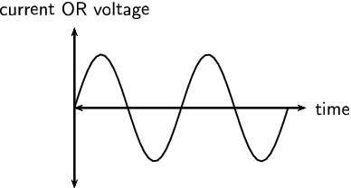

Direct current pd vs time graph:

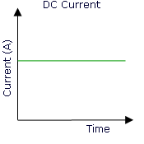

Alternator: Generator that produces ac.

Dynamo: Generator that produces dc.

**Physics Revision: Stopping Distances**

Mastery Matrix Points

|  |
| --- |
| Define ‘stopping distance’, ‘thinking distance’ and ‘braking distance’ |
| Recall typical values for reaction times (0.2-0.9 seconds) |
| Describe factors that effect a drivers reaction time |
| Explain methods used to measure human’s reaction times |
| Describe factors affecting ‘braking distance’ |
| Predict how the distance for a vehicle to make an emergency stop varies over a range of speeds |
| Explain the energy transfers when a vehicle brakes |
| Link braking force, deceleration and stopping distances |
| Explain the dangers caused by large decelerations |
| Interpret graphs relating speed to stopping distance (triple only) |
| Estimate the forces involved in the deceleration of road vehicles (HT only) |

Equations *in words and symbols. Include units.*

Stopping distance:

Stopping distance = braking distance + thinking distance

Key Knowledge

Braking distance: **the distance a vehicle travels under the braking force**

Thinking distance:

**the distance the vehicle travels during the driver’s reaction time**

Stopping distance:

the sum of the thinking distance and braking distance.

Increasing the speed, **increases** the braking distance.

Typical reaction times: **from 0.2s to 0.9s**

Understanding and Explaining

1. Explain how to measure human reaction times.

**Using a ruler or using a computer programme.**

1. Describe how four factors affect thinking distances.

A driver’s reaction time can be affected by tiredness, drugs and alcohol. Distractions may also affect a driver’s ability to react.

1. Describe four factors that affect the braking distance of a vehicle.

Adverse road conditions include wet or icy conditions. Poor condition of the vehicle is limited to the vehicle’s brakes or tyres.

1. Explain why drivers are asked to stay “at least two car lengths” back from the car in front on a motorway.

Driving faster, larger stopping distance, need to leave space for emergency stops.

1. Describe and explain the energy changes during the braking of a vehicle.

When a force is applied to the brakes of a vehicle, work done by the friction force between the brakes and the wheel reduces the kinetic energy of the vehicle and the temperature of the brakes increases.

1. Explain the dangers caused by large deccelerations.

Large decelerations may lead to brakes overheating and/or loss of control.

**Biology Revision: Momentum**

Mastery Matrix Points

|  |
| --- |
| Define ‘momentum’ using p = m v (HT only) |
| Explain conservation of ‘momentum’ (HT only) |
| Complete calculations about the collision of two objects using the momentum equation (triple only) |
| Combine F = m a and a = Δv/t to give the equation F = mΔv/Δt to show force = the rate of change of momentum (triple only) |
| Explain safety features with reference to momentum (air bags, seat belts, gym crash mats, cycle helmets and cushioned playground surfaces) (triple only) |

Key Knowledge

Law of conservation of momentum:

**In a closed system, the total momentum before an event is equal to the total momentum after the event.**

Examples of objects that slow down the rate of change of momentum:

**- air bags**

**- seat belts**

**- gymnasium crash mats**

**- cycle helmets**

**- cushioned surfaces for playgrounds**

Equations *in words and symbols. Include units.*

Momentum:

**momentum = mass  × velocity**

**p = m v**

* **momentum, p, in kilograms metre per second, kg m/s**
* **mass, m, in kilograms, kg**
* **velocity, v, in metres per second, m/s**

Equation that relates force and momentum:

**F = m ∆ v**

**∆ t**

**where m∆v = change in momentum**

Understanding and Explaining

1. Describe how objects such as crash mats in a gym help to reduce the amount of force on a person.

They increase the time of the collision, which reduces the force as force = rate of change in momentum/time.

1. Show how to derive the equation relating momentum and force.

The equations F=ma and a = (v-u)/t combine to give F = m∆v/t

1. (a)     A van has a mass of 3200 kg. The diagram shows the van just before and just after it collides with the back of a car.

|  |  |
| --- | --- |
| **Before collision** | **After collision** |

Just before the collision, the van was moving at 5 m/s and the car was stationary.

(i)      Calculate the momentum of the van just before the collision.

Show clearly how you work out your answer.

**p =mv**

**p = 3200 x 5**

                                              Momentum = **16000** kg m/s

1. **(2)**
3. (ii)     The collision makes the van and car join together.
4. What is the total momentum of the van and the car just after the collision?
5. Momentum = .............................. kg m/s

**Biology Revision: Moments**

Mastery Matrix Points

|  |
| --- |
| Describe examples in which forces cause rotation (triple only) |
| Define moment and use and rearrange the equation M = F x d (triple only) |
| Describe moments for a balanced for a balanced object (triple only) |
| Describe examples in which forces cause rotation (triple only) |

Key Knowledge

Moment of a force – turning effect of a force.

If an object is balanced total **clockwise** moment is equal to the total **anticlockwise** moment.

Pivot/fulcrum – the point that a levers rotates around.

Levers and gears transmit the **turning** effects of forces.

Equations *in words and symbols. Include units.*

Moments:

moment of a force = force  × distance

M = F d

moment of a force, M, in newton-metres, Nm force, F, in newtons, N distance, d, is the perpendicular distance from the pivot to the line of action of the force, in metres, m.

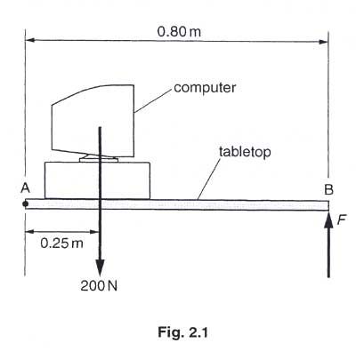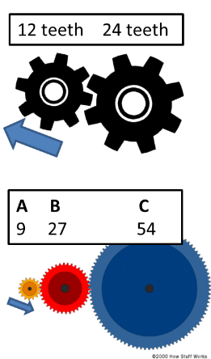

Understanding and Explaining

1. Two people are arm wrestling. Sarah has shorter arms (37cm), Destiny has longer arms (45cm). Destiny is applying a force of 125N. How much force would Sarah need to apply so that they draw and there is no movement?

Moment from Density = Moment from Sarah

F x d = F x d

125 x 45 = F x 37

F=125 x 45

37

**F= 152N**

1. Look at the diagram of the two gear systems.
2. In what direction will the 24 teeth wheel turn? **Anticlockwise**
3. If the 12 teeth wheel takes 20s to rotate once, how long will it take the 24 teeth wheel to rotate once?

**40s**

1. How long will it take the 24 teeth wheel to turn fully 4 times? **160s or 2.67 mins**
2. Look at the second diagram, in which direction will wheel B move? **Clockwise**
3. In which direction will wheel C move? **Anticlockwise**
4. Give the gear ratio for A to B. **9:27 = 1:3**
5. Give the gear ratio for B to C. **27:54 = 1:2**
6. The diagram below shows a computer resting on a tabletop that is hung at point A. The tabletop has a mass of 5.0kg and its centre of gravity is 0.40m from the axis of the hinge at A. The computer has a weight of 200N acting through a point 0.25m from the hinge at A. The tabletop is supported to maintain it in a horizontal position by a force of F acting vertically at B. The distance AB is 0.8m.
7. Calculate the weight of the tabletop:

**W = m x g**

**= 5.0 x 9.8**

**= 49N**

1. Draw and label an arrow to represent the weight (W) of the tabletop. **Arrow drawn down from middle (0.4m scaled) of the table.**
2. Apply the principal of moments about the hinge at A to determine the vertical force F

applied at B that is required to maintain the table top in equilibrium.

**Clockwise moment = anticlockwise moment**

**200x 0.25 + 49 x 0.4 = Fd**

**F = 69.6/0.8**

**F = 87N**

**Physics Paper 2 Answers**

**M1.**(a)     from K to L

**1**

(b)

    4 N

(c) As the weight increases, the extension increases

This is a directly proportional relationship

Up until 7N

when the relationship stops being directly proportional

This is because the limit of proportionality has been reached

**5**

(d)     the limit of proportionality is reached when a weight of 7N is added to the spring

*accept any number from 6.8 to 7.2 inclusive*

**1**

(e)     the extension is directly proportional to the weight.

**1**

(f)     C

**1**

**[7]**

**M2.**(a)     K

**1**

(b)     Decreases

**1**

(c)     use a metre rule / 30 cm ruler to measure across 10 (projected) waves

*accept any practical number of waves number for 10*

**1**

and then divide by 10

**1**

(d)     1.2 cm = 0.012 m

**1**

18.5 × 0.012 = 0.22(2) (m / s)

**1**

*allow 0.22(2) with no working shown for* ***2*** *marks*

typical walking speed = 1.5m / s

*accept any value e.g. in the range 0.7 to 2.0 m / s*

**1**

so the water waves are slower (than a typical walking speed)

*this cannot score on its own*

**1**

**[8]**

**e)** *v = f × λ*

1.2 × 106 / 1200 000

*allow****1****mark for correct substitution  
ie 3.0 × 108 = f × 2.5 × 102*

**2**

hertz / Hz

*do****not****accept hz****or****HZ*

*accept kHz****or****MHz*

*answers 1.2 MHz****or****1200 kHz gain all****3****marks*

*for full credit the unit and numerical value must be consistent*

**1**

**3.**(a)     (i)      microwave

**1**

(ii)     refraction

**1**

(b)     (i)      wave M continues as a straight line to the ionosphere and shown reflected

*accept reflection at or within the ionosphere*

**1**

correctly reflected wave shown as a straight line reaching the top of the receiver

*if more than 2 rays shown 1 mark maximum*

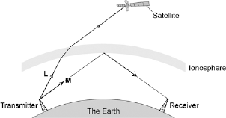

*ignore arrows*

**1**

(ii)     normal drawn at point where their **M** meets the ionosphere

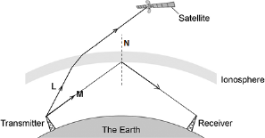

**1**

(c)     any **two** from:

•        transverse

•        same speed (through air)

*accept speed of light* ***or*** *3 × 108 m / s*

•        can be reflected

•        can be refracted

•        can be diffracted

•        can be absorbed

•        transfer energy

•        can travel through a vacuum

*an answer travel at the same speed though a vacuum scores* ***2*** *marks*

•        can be polarised

•        show interference.

*travel in straight lines is insufficient*

**2**

**[7]**

**d)** (i)     **two** correct rays drawn

***1****mark for each correct ray*

•    ray parallel to axis from top of object **and** refracted through focus  
     **and** traced back beyond object

•    ray through centre of lens **and** traced back beyond object

•    ray joining top of object to focus on left of lens taken to the lens  
     refracted parallel to axis **and** traced back parallel to axis beyond object

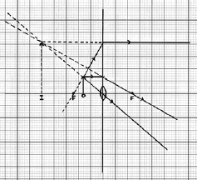

**2**

an arrow showing the position **and** correct orientation of the image for their rays

*to gain this mark, the arrow must go from the intersection of the traced-back rays to the axis****and****the image must be on the same side of the lens as the object and above the axis*

**1**

(ii)     (x) 3.0

*accept 3.0 to 3.5 inclusive*

**or**



correctly calculated

*allow****1****mark for correct substitution into equation using their figures*

*ignore any units*

**2**

(iii)     any **two** from:

in a camera the image is:

•    real not virtual

•    inverted and not upright

*accept upside down for inverted*

•    diminished and not magnified

*accept smaller and bigger  
accept converse answers but it must be clear the direction of the comparison*

*both parts of each marking point are required*

**2**

**4.**(a)     **Level 3 (5–6 marks):**

A detailed and coherent plan covering all the major steps is provided. The steps in the method are logically ordered. The method would lead to the production of valid results.

A source of inaccuracy is provided.

**Level 2 (3–4 marks):**

The bulk of a method is described with mostly relevant detail. The method may not be in a completely logical sequence and may be missing some detail.

**Level 1 (1–2 marks):**

Simple statements are made. The response may lack a logical structure and would not lead to the production of valid results.

**0 marks:**

No relevant content.

**Indicative content**

place a glass block on a piece of paper

draw around the glass block and then remove from the paper

draw a line at 90° to one side of the block (the normal)

use a protractor to measure and then draw a line at an angle of 20° to the normal

replace the glass block

using a ray box and slit point the ray of light down the drawn line

mark the ray of light emerging from the block

remove the block and draw in the refracted ray

measure the angle of refraction with a protractor

repeat the procedure for a range of values of the angle of incidence

**possible source of inaccuracy**

the width of the light ray

which makes it difficult to judge where the centre of the ray is

**6**

(b)     velocity / speed of the light decreases

*allow velocity / speed of the light changes*

**1**

**[7]**

**M5.**(a)     the forces are equal in size and act in opposite directions

**1**

(b)     (i)       forwards / to the right / in the direction of the 300 N force

*answers in either order*

**1**

accelerating

**1**

(ii)     constant velocity to the right

**1**

(iii)    resultant force is zero

*accept forces are equal / balanced*

**1**

so boat continues in the same direction at the same speed

**1**

(iv)    parallelogram or triangle is correctly drawn with resultant  
 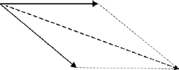

**3**

value of resultant in the range 545 N – 595 N

*parallelogram drawn without resultant gains* ***1*** *mark*

*If no triangle or parallelogram drawn:*

*drawn resultant line is* ***between*** *the two 300 N forces gains* ***1*** *mark*

*drawn resultant line is between and longer than the two 300 N forces gains* ***2*** *marks*

**1**

**[10]**

**M6.**(a)     gravitational / gravity / weight

*do* ***not*** *accept gravitational potential*

**1**

(b)     accelerating

*accept speed / velocity increases*

**1**

the distance between the drops increases

**1**

but the time between the drops is the same

*accept the time between drops is (always) 5 seconds   
accept the drops fall at the same rate*

**1**

(c)     (i)       any **one** from:

•         speed / velocity

•         (condition of) brakes / road surface / tyres

•         weather (conditions)

*accept specific examples, eg wet / icy roads*

*accept mass / weight of car friction is insufficient*

*reference to any factor affecting thinking distance negates this answer*

**1**

(ii)      75 000

*allow* ***1*** *mark for correct substitution, ie 3000 × 25 provided no subsequent step shown*

***or*** *allow* ***1*** *mark for an answer 75****or*** *allow* ***2*** *marks for   
75 k(+ incorrect unit), eg 75 kN*

**2**

joules / J

*do* ***not*** *accept j*

*an answer 75 kJ gains* ***3*** *marks*

*for full marks the unit and numerical answer must be consistent*

**1**

**[8]**

**d)** (i)      a single force that has the same effect as all the forces combined

*accept all the forces added / the sum of the forces / overall force*

**1**

(ii)     constant speed (in a straight line)

*do****not****accept stationary*

**or**constant velocity

**1**

(iii)     3

*allow****1****mark for correct substitution into transformed equation  
accept answer 0.003 gains****1****mark  
answer = 0.75 gains****1****mark*

**2**

          m/s2

**1**

**M7.**(a)     distance is a scalar and displacement is a vector

**or**

distance has magnitude only, displacement has magnitude and direction

**1**

(b)     37.5 km

*accept any value between 37.0 and 38.0 inclusive*

**1**

062° or N62°E

*accept 62° to the right of the vertical*

**1**

*accept an angle in the range 60° −64°*

*accept the angle correctly measured and marked on the diagram*

(c)     train changes direction so velocity changes

**1**

acceleration is the rate of change of velocity

**1**

(d)     number of squares below line = 17

*accept any number between 16 and 18 inclusive*

**1**

each square represents 500 m

**1**

distance = number of squares × value of each square correctly calculated − 8500 m

**1**

**[8]**

**M8.**(a)     It will have a constant speed.

**1**

(b)     distance travelled = speed × time

**1**

**(** c)     a = 18 − 9

 6

**1**

a = 1.5

*allow 1.5 with no working shown for* ***2*** *marks*

**1**

(d)     resultant force = mass × acceleration

**1**

(e)     F = (1120+80) × 1.5

**1**

F = 1800 (N)

*allow 1800 with no working shown for* ***2*** *marks*

**1**

*accept their 10.3 × 1200 correctly calculated for* ***2*** *marks*

(f)     182 − 92 = 2 × 1.5 × s

**1**

s = 182 − 92 / 2 × 1.5

**1**

s = 81 (m)

**1**

*allow 81 (m) with no working shown for* ***3*** *marks*

*accept answer using their 10.3 (if not 1.5) correctly calculated for* ***3*** *marks*

(g)     **Level 2 (3–4 marks):**

A detailed and coherent explanation is provided. The response makes logical links  
between clearly identified, relevant points that include references to the numerical factor.

**Level 1 (1–2 marks):**

Simple statements are made. The response may fail to make logical links between the points raised.

**0 marks:**

No relevant content.

**Indicative content**

•        doubling speed increase the kinetic energy

•        kinetic energy increases by a factor of 4

•        work done (by brakes) to stop the car increases

•        work done increases by a factor of 4

•        work done is force × distance and braking force is constant

•        so if work done increases by 4 then the braking distance must increase by 4

**4**

**[14]**

**M9.**(a)     (i)      turning effect

*accept force multiplied by perpendicular distance from the line of action of the force to the pivot*

**1**

(ii)     moments are equal (in size) and opposite (in direction)

*both parts are required*

*allow clockwise moment = anticlockwise moment*

**1**

(iii)     0.9 (N)

*allow* ***2*** *marks for F = 0.18 ÷ 0.2 provided no subsequent steps*

*allow* ***1*** *mark for (anticlockwise moment) = 0.18 (Nm)*

*allow* ***1*** *mark for correct substitution i.e. 1.5 × 0.12 = F × 0.20*

**3**

(b)     a longer drumstick lever gives a quieter sound

**1**

a longer drumstick lever allows a greater range of volumes

**1**

*a greater force gives a louder sound is insufficient*

**[7]**

**M10.**(a)     (i)      field pattern shows:  
some straight lines in the gap

**1**

direction N to S

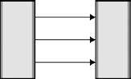

**1**

(ii)     north poles repel

**1**

(so) box will not close

**1**

(b)     (i)       as paper increases (rapid) decrease in force needed

**1**

force levels off (after 50 sheets)

**1**

(ii)     the newtonmeter will show the weight of the top magnet

**1**

(iii)    (top) magnet and newtonmeter separate before magnets separate

*accept reverse argument*

**1**

(because) force between magnets is greater than force between magnet and hook of newtonmeter

**1**

(iv)    any **three** from:

•        means of reading value of force at instant the magnets are pulled apart

•        increase the pulling force gently  
**or**use a mechanical device to apply the pulling force

•        clamp the bottom magnet

•        use smaller sheets of paper

•        fewer sheets of papers between readings (smaller intervals)

•        ensure magnets remain vertical

•        ensure ends of magnet completely overlap

•        repeat the procedure several times for each number of sheets and take a mean

•        make sure all sheets of paper are the same thickness

**3**

(v)     3 (mm)

*30 × 0.1 ecf gains* ***2*** *marks*

*2.1 N corresponds to 30 sheets gains* ***1*** *mark*

**3**

**[15]**

**M11.**(a)     field

*correct order only*

**1**

current

**1**

force

*accept motion*

*accept thrust*

**1**

(b)     (i)      arrow pointing vertically downwards

**1**

(ii)     increase current / p.d.

*accept voltage for p.d.*

**1**

increase strength of magnetic field

*accept move poles closer together*

**1**

(iii)    reverse (poles of) magnets

**1**

reverse battery / current

**1**

(c)     (i)      1.5 or 150%

*efficiency = 120 / 80 (× 100)*

*gains* ***1*** *mark*

*an answer of 1.5 % or 150*

*gains* ***1*** *mark*

**2**

(ii)     efficiency greater than 100%  
**or**output is greater than input  
**or**output should be 40 (W)

**1**

(iii)    recorded time much shorter than actual time

*accept timer started too late*

*accept timer stopped too soon*

**1**

**[12]**

**M12.**(a)     (i)      (enough) dust and gas (from space) is pulled together

*accept nebula for dust and gas*

*accept hydrogen for gas*

*accept gas on its own*

*dust on its own is insufficient*

*mention of air negates this mark*

**1**

by:

gravitational attraction

**or**

gravitational forces

**or**

gravitaty

*ignore any (correct) stages beyond this*

**1**

(ii)     joining of two (atomic) nuclei (to form a larger one)

*do not accept atoms for nuclei*

**1**

(iii)     more sensitive astronomical instruments / telescopes

**or**

infrared telescopes developed

*accept better technology*

*more knowledge is insufficient*

**1**

(b)     (i)      (other) planets / solar systems

*do not accept galaxy*

*moons is insufficient*

**1**

(ii)     provided evidence to support theory

*accept proves the theory*

**1**

(c)     elements heavier than iron are formed only when a (massive) star explodes

*accept materials for elements*

*accept supernova for star explodes*

*accept stars can only fuse elements up to (and including) iron*

**1**

**[7]**

**M13.**(a)     the distance travelled under the braking force

**1**

(b)     the reaction time will increase

**1**

increasing the thinking distance (and so increasing stopping distance)

*(increases stopping distance is insufficient)*

**1**

(c)     No, because although when the speed increases the thinking distance increases by the same factor the braking distance does not.

**1**

eg

increasing from 10 m / s to 20 m / s increases thinking distance from 6 m to 12 m but the braking distance increases from 6 m to 24 m

**1**

(d)     If the sled accelerates the value for the constant of friction will be wrong.

**1**

(e)     only a (the horizontal) component of the force would be pulling the sled forward

**1**

the vertical component of the force (effectively) lifts the sled reducing the force of the surface on the sled

**1**

(f)     − u2 = 2 × −7.2 × 22

*award this mark even with 02 and / or the negative sign missing*

**1**

u = 17.7(99)

**1**

18

**1**

*allow 18 with no working shown for* ***3*** *marks*

*allow 17.7(99) then incorrectly rounded to 17 for* ***2*** *marks*

**[11]**

**14.**(a)     (i)      momentum before = momentum after

*accept no momentum is lost accept no momentum is gained*

**or**(total) momentum stays the same

**1**

(ii)     an external force acts (on the colliding objects)

*accept colliding objects are not isolated*

**1**

(b)     (i)      9600

*allow 1 mark for correct calculation of momentum before or after ie 12000 or 2400****or****correct substitution using change in velocity = 8 m/sie 1200 × 8*

**2**

kg m/s   
**or**Ns

*this may be given in words rather   
than symbols   
do* ***not*** *accept nS*

**1**

(ii)     3 or their (b)(i) 3200 correctly calculated

*allow 1 mark for stating momentum before = momentum after*

**or**

clear attempt to use conservation of momentum

**2**

**(c)**  momentum before (jumping) = momentum after (jumping)

*accept momentum (of the skateboard and skateboarder) is conserved*

**1**

before (jumping) momentum of skateboard and skateboarder is zero

*accept before (jumping) momentum of skateboard is zero*

*accept before (jumping) total momentum is zero*

**1**

after (jumping) skateboarder has momentum (forwards) so skateboard must have (equal) momentum (backwards)

*answers only in terms of equal and opposite forces are insufficient*

**1**

(ii)     7

*accept –7 for****3****marks*

*allow****2****marks for momentum of skateboarder equals 12.6*

***or***

*0 = 42 × 0.3 + (1.8 × –v)*

***or***

*allow****1****mark for stating use of conservation of momentum*

**3**

**M15.**         (a)      (i)      The volume of boiling water.

**1**

(ii)     any **one** from:

•    (more) precise

*do* ***not*** *accept better (reading)*

•    accurate

•    reliable

*do* ***not*** *accept thermometer is unreliable*

•    removes human / reading error

*accept easier to read  
accept take temperature more frequently*

**1**

(b)     **B**

*marks are for the explanation*

temperature falls faster

*this mark point cannot score if* ***A*** *chosen*

**1**

because black is a better / good emitter

*ignore reference to better absorber  
accept for both marks an answer in terms of why* ***A*** *is the white can*

**1**

(c)     (i)      faster than

**1**

(ii)     darker / black surfaces absorb heat faster

*accept black is a better / good absorber*

*dark surfaces attract heat negates this mark*

**1**

(iii)     air is a bad / poor conductor**or**air is a good insulator

*accept air is an insulator*

**1**

**[7]**

**M16.**(a)     air molecules colliding with a surface create pressure

**1**

at increasing altitude distance between molecules increases

**or**

at increasing altitude fewer molecules (above a surface)

**1**

pso number of collisions with a surface decreases

**or**

or so always less weight of air than below (the surface)

**1**

(b)     atmospheric pressure = 20 kPa from graph **and** conversion of 810 cm2 to 0.081 m2

*allow ecf for an incorrect value clearly obtained from the graph*

**1**

5 × 104 =  F

       0.081

**1**

F = 5 × 104 × 0.081

**1**

4050

**1**

4100 (N)

**1**

*allow 4100 (N) with no working shown for* ***5*** *marks*

*allow 4050 with no working shown for* ***4*** *marks*

(c)     force from air pressure acting from inside to outside bigger than force acting inwards

**1**

so keeps the window in position

**1**

**[10]**

**Q17.**

(a)     (i)      any **two** from:

•        length of coils increased

•        coils have tilted

•        length of loop(s) increased

•        increased gap between coils

•        *spring has stretched / got longer*

•        *spring has got thinner*

**2**

(ii)     remove mass

*accept remove force / weight*

**1**

*observe if the* spring returns to its original length / shape *(then* it is behaving elastically)

**1**

(b)     (i)      8.0 (cm)

**1**

extension is directly proportional to force *(up to 4 N)*

*for every 1.0 N extension increases by 4.0 cm (up to 4 N)*

*evidence of processing figures eg* 8.0 *cm* is half way between 4.0 *cm* and 12.0 *cm*

**1**

*allow spring constant (k) goes from to *

**1**

(ii)     any value greater than 4.0 N and less than or equal to 5.0 N

**1**

*the increase in extension is greater than 4 cm per 1.0 N (of force) added*

*dependent on first mark*

**1**

(c)     (i)      elastic potential energy

**1**

(ii)     misread stopwatch

**1**

timed too many complete oscillations

**1**

(iii)    4.3 (s)

*accept 4.33 (s)*

**1**

(iv)    stopwatch reads to 0.01 s

**1**

reaction time is about 0.2 s  
***or****reaction time is less precise than stopwatch*

**1**

(v)     use more masses

**1**

smaller masses eg 50 g

*not exceeding limit of proportionality*

**1**

**[17]**

**Q18.**

(a)     dark matt

**1**

light shiny

**1**

(b)     B      A      C

**1**

biggest temperature difference (80 °C)

*dependent on first mark*

**1**

(c)     (i)       (the can that is) dark matt

**1**

best absorber (of infrared radiation)

**1**

(ii)     any **three** from:

•        same area / shape of can

•        surrounding temperature is the same for all cans

•        same surface underneath cans

•        same position in the room

**3**

(d)     fox A

smaller ears

**1**

thicker fur

**1**

these minimise energy transfer

*dependent on first 2 marks*

**1**

**[12]**

**Q19.**

(a)     **Level 3 (5–6 marks):**

A detailed and coherent plan covering all the major steps is provided. The steps in the method are logically ordered. The method would lead to the production of valid results.

A source of inaccuracy is provided.

**Level 2 (3–4 marks):**

The bulk of a method is described with mostly relevant detail. The method may not be in a completely logical sequence and may be missing some detail.

**Level 1 (1–2 marks):**

Simple statements are made. The response may lack a logical structure and would not lead to the production of valid results.

**0 marks:**

No relevant content.

**Indicative content**

place a glass block on a piece of paper

draw around the glass block and then remove from the paper

draw a line at 90° to one side of the block (the normal)

use a protractor to measure and then draw a line at an angle of 20° to the normal

replace the glass block

using a ray box and slit point the ray of light down the drawn line

mark the ray of light emerging from the block

remove the block and draw in the refracted ray

measure the angle of refraction with a protractor

repeat the procedure for a range of values of the angle of incidence

**possible source of inaccuracy**

the width of the light ray

which makes it difficult to judge where the centre of the ray is

**6**

(b)     velocity / speed of the light decreases

*allow velocity / speed of the light changes*

**1**

**[7]**