**OASB Science Department**

**Physics Paper 1 Revision Pack (Combined – HT)**

|  |  |  |
| --- | --- | --- |
| Contents | Lesson | Page |
| Mastery Matrix Physics Paper 1 |  |  |
| Knowledge | 1 |  |
| Energy, Heat Loss and Efficiency, Work and Power, Specific Heat Capacity Summary Page |
| Notes page |
| Exam Questions |
| Knowledge | 2 |  |
| Energy Equations Summary Page |
| Notes page |
| Exam Questions |
| Knowledge | 3 |  |
| Nuclear Physics & Radioactivity Summary Page |
| Notes page |
| Exam Questions |
| Knowledge | 4 |  |
| Electricity Summary Page |
| Notes page |
| Exam Questions |
| Knowledge | 5 |  |
| Mains Electricity, the National Grid & Energy Resources Summary Page |
| Notes page |
| Exam Questions |
| Knowledge | 6 |  |
| Density, Changes in State and Particles Summary Page |
| Notes page |
| Exam Questions |
| Knowledge | 7 |  |
| Gas pressure Summary Page |
| Notes page |
| Exam Questions |
| Physics Paper 1 Required Practicals Knowledge | 8 |  |
| Physics Paper 1 Required Practicals Summary Page |
| Physics Paper 1 Required Practicals Exam Questions |



|  |  |  |  |  |  |  |
| --- | --- | --- | --- | --- | --- | --- |
| Topic | Tier | Pg. | Learning statement | Revision | | |
| Energy Types | F | 172 | Describe ways in which energy can be transferred within a system |  |  |  |
| Energy Types | F | 170 | Describe ways to store energy |  |  |  |
| Energy Types | F | 170 | Describe the law of conservation of energy |  |  |  |
| Energy Types | F | 170 | Describe concepts of open and closed systems |  |  |  |
| Energy Types | F | 172 | Describe ways to reduce unwanted energy transfers |  |  |  |
| Energy Types | F | 172 | Link energy loss to insulation and thermal conductivity |  |  |  |
| Energy Types | F | 173 | Define renewable and non-renewable energy resources |  |  |  |
| Energy Types | F | 173 | Compare & contrast energy resources in terms of reliability, cost and political, environmental & social factors |  |  |  |
| Work, power and efficiency | F | 160 | Define and calculate work done using E=Pt and E=fd |  |  |  |
| Work, power and efficiency | F | 193 | Define and calculate power using P=VI and E = Pt |  |  |  |
| Work, power and efficiency | F | 193 | Describe examples of applications of power in everyday life |  |  |  |
| Work, power and efficiency | F | 195 | Use and rearrange both equations for calculating efficiency |  |  |  |
| Work, power and efficiency | HT | 195 | Describe ways to increase the efficiency of an energy transfer (HT only) |  |  |  |
| Elastic Objects & potential energy | F | 160 | Describe elastic and inelastic deformation |  |  |  |
| Elastic Objects & potential energy | F | 160 | Explain the effect of forces on elastic objects |  |  |  |
| Elastic Objects & potential energy | F | 161 | Describe Hooke’s Law qualitatively and using the equation F = ke |  |  |  |
| Elastic Objects & potential energy | F | 161 | Explain ‘word done’ when applied to stretching or compressing a spring |  |  |  |
| Elastic Objects & potential energy | F | 160 | Explain the difference between a linear and a non-linear relationship |  |  |  |
| Elastic Objects & potential energy | F | 160 | Interpret data from a force extension investigation |  |  |  |
| Elastic Objects & potential energy | F | 161 | RP Force and Extension: Investigate the relationship between force and extension for spring (Hooke’s Law) |  |  |  |
| Elastic Objects & potential energy | F | 170 | Use the elastic potential energy equation (Ee=1/2ke2) |  |  |  |
| Elastic Objects & potential energy | F | 170 | Use and rearrange the equation for kinetic energy (Ek=1/2mv2) |  |  |  |
| Elastic Objects & potential energy | F | 170 | Use and rearrange the equation for gravitational potential energy (Eg=mgh) |  |  |  |
| Nuclear Physics | F | 212 | Describe the structure and size of an atom |  |  |  |
| Nuclear Physics | F | 212 | Calculate the number of protons, neutrons and electrons in an atom |  |  |  |
| Nuclear Physics | F | 212 | Describe how electrons can change energy level |  |  |  |
| Nuclear Physics | F | 212 | Describe isotopes |  |  |  |
| Nuclear Physics | F | 212 | Describe what an ion is |  |  |  |
| Nuclear Physics | F | 213 | Describe the development of the model of the atom (Plum-pudding, Rutherford, Neils Bohr and Chadwick). |  |  |  |
| Radioactive decay and Radiation | F | 214 | Describe what radioactive decay is |  |  |  |
| Radioactive decay and Radiation | F | 214 | Recall the definition and units for activity and count rate |  |  |  |
| Radioactive decay and Radiation | F | 215 | Describe what makes up alpha, beta, gamma and neutron radiation |  |  |  |
| Radioactive decay and Radiation | F | 214 | Describe the properties of each type of radiation |  |  |  |
| Radioactive decay and Radiation | F | 217 | Use nuclear equations to represent radioactive decay |  |  |  |
| Radioactive decay and Radiation | F | 216 | Define half-life |  |  |  |
| Radioactive decay and Radiation | F | 216 | Complete half-life calculations from graphs or other data |  |  |  |
| Radioactive decay and Radiation | HT | 216 | Use ratios to describe radioactive decay (HT only) |  |  |  |
| Radioactive decay and Radiation | F | 215 | Describe the impact and precautions for radioactive contamination |  |  |  |
| Radioactive decay and Radiation | F | 215 | Analyse data about the effects of radiation on people |  |  |  |
| Density | F | 210 | Use and rearrange ρ =m/v |  |  |  |
| Density | F | 210 | Draw simple diagrams to model the difference between solids, liquids and gases |  |  |  |
| Density | F | 210 | Link the arrangement of atoms and molecules to different densities of the states |  |  |  |
| Density | F | 210 | RP Density: Determine the densities of regular and irregular solid objects and liquids |  |  |  |
| Changes of state and latent heat | F | 210 | Describe how mass is conserved during changes of state |  |  |  |
| Changes of state and latent heat | F | 211 | Explain why changes of state are physical changes |  |  |  |
| Changes of state and latent heat | F | 170 | Define internal energy |  |  |  |
| Changes of state and latent heat | F | 171 | Explain the effect of heating on the energy within a system and calculate energy change during a state change. |  |  |  |
| Changes of state and latent heat | F | 211 | Describe ‘latent heat’ of a material including specific latent heat of fusion and specific latent heat of vaporisation |  |  |  |
| Changes of state and latent heat | F | 211 | Explain and calculate ‘specific latent heat’ using the E=mL |  |  |  |
| Changes of state and latent heat | F | 211 | Interpret heating and cooling graphs that include changes of state |  |  |  |
| Specific Heat Capacity | F | 211 | Explain the differences between ‘heat’ and ‘temperature’ |  |  |  |
| Specific Heat Capacity | F | 171 | Define and calculate specific heat capacity |  |  |  |
| Specific Heat Capacity | F | 171 | Use and rearrange equations for calculating specific heat capacity |  |  |  |
| Specific Heat Capacity | F | 171 | RP Specific Heat Capacity: Investigate the specific heat capacity of materials |  |  |  |
| Specific Heat Capacity | F | 171+211 | Distinguish between specific heat capacity and specific latent heat |  |  |  |
| Gas Pressure and Fluid Pressure | F | 210 | Describe the motion of particles in a gas and relate this to pressure, kinetic energy and temperature |  |  |  |
| Gas Pressure and Fluid Pressure | F | 210 | Explain the relationship between temperature and pressure of a gas at constant volume |  |  |  |
| Electricity Introduction | F | 188 | Identify the key circuit symbols. |  |  |  |
| Electricity Introduction | F | 188 | Define current, charge and potential difference. |  |  |  |
| Electricity Introduction | F | 188 | Use and rearrange equations for calculating current. |  |  |  |
| Electricity Introduction | F | 188 | Predict the current at given points within a series and parallel circuit. |  |  |  |
| Electricity Introduction | F | 189 | Predict the potential difference (voltage) at given points within a series and parallel circuit. |  |  |  |
| Electricity Introduction | F | 189 | Describe the relationship between current, potential difference and resistance. |  |  |  |
| Electricity Introduction | F | 189 | Use and rearrange equations for calculating current, potential difference and resistance. |  |  |  |
| Electricity Introduction | F | 189 | Recall units for current, potential difference and resistance. |  |  |  |
| Series and Parallel Circuits | F | 192 | Compare and contrast series and parallel circuits in terms of current and potential difference. |  |  |  |
| Series and Parallel Circuits | F | 192 | Calculate resistance in series circuits and describe resistance in parallel circuits. |  |  |  |
| Series and Parallel Circuits | F | 189 | RP Resistance: Use circuit diagrams to set up circuits to investigate the factors affecting resistance (length of a wire at constant temperature and combinations of resistors in series and parallel.) |  |  |  |
| Ohmic/Non-ohmic resistors | F | 191 | Describe the relationship between current and potential difference in ohmic conductors. |  |  |  |
| Ohmic/Non-ohmic resistors | F | 191 | Explain how resistances change in thermistors and LDRs. |  |  |  |
| Ohmic/Non-ohmic resistors | F | 191 | List the applications of thermistors and LDRs. |  |  |  |
| Ohmic/Non-ohmic resistors | F | 191 | Interpret graphs to determine whether relationships are linear or non-linear. |  |  |  |
| Ohmic/Non-ohmic resistors | F | 190 | RP I-V CharacteristicsS: Investigate V-I characteristics using circuits. |  |  |  |
| Mains electricity | F | 194 | Describe the properties of mains electricity in the UK (A.C., Frequency and Voltage) |  |  |  |
| Mains electricity | F | 194 | Explain the difference between direct and alternating potential difference |  |  |  |
| Mains electricity | F | 194 | Describe the three core cables and the wires that they are made up of and the dangers of these |  |  |  |
| Energy and Power of Electricity | F | 193 | Use and rearrange the P=IV equation (electrical power) |  |  |  |
| Energy and Power of Electricity | F | 193 | Use and rearrange the P=I2R equation (electrical power) |  |  |  |
| Energy and Power of Electricity | F | 196 | Describe energy transfers in electrical appliances |  |  |  |
| Energy and Power of Electricity | F | 195 | Use and rearrange E=Pt |  |  |  |
| Energy and Power of Electricity | F | 196 | Use and rearrange E=QV |  |  |  |
| Energy and Power of Electricity | F | 193 | Explain how the power of a circuit is related to potential difference, current and energy |  |  |  |
| The National Grid | F | 197 | Describe the components of the national grid |  |  |  |
| The National Grid | F | 197 | Explain the role of step up and step down transformers in the national grid and use this to explain why it is an efficient system for transferring energy |  |  |  |

**Lesson 1 - Energy, Heat Loss and Efficiency, Work and Power, Specific Heat Capacity**

|  |  |  |
| --- | --- | --- |
|  | **Topic:** | **Energy Types (P.1)** |
| 1 | What type of energy store is exemplified by moving objects? | Kinetic energy |
| 2 | The law of conservation of energy states what three things that can happen to energy | Transferred usefully, stored or dissipated |
| 3 | Which word means 'wasted into the surroundings'? | Dissipated |
| 4 | When energy is wasted, it is usually which energy stores? | Thermal and sound |
| 5 | The law of conservation of energy states that which two things cannot happen to energy? | Created or destroyed |
| 6 | What can be done to moving parts in a system to reduce heat loss by friction? | Lubrication (adding oil/grease) |
| 7 | What name is given to a material which does not conduct thermal energy well? | Thermal insulator |
| 8 | What name is given to a material which allows thermal energy to pass through it easily? | Thermal conductor |
| 9 | What is the unit for energy? | Joules (J) |
| 10 | What type of heat transfer occurs in solids? | Conduction |
| 11 | What type of heat transfer happens only in fluids (gas and liquids)? | Convection |
| 12 | Which is the only type of thermal energy transfer can occur in a vacuum? | Radiation |
| 13 | Which dissipates less thermal energy? Thin walls or thick walls? | Thick |
| 14 | Which dissipates less thermal energy? Walls with large or small area | Small |
| 15 | Which dissipates less thermal energy? Large or small temperature difference | Small |
|  | **Topic:** | **Work power and efficiency (P.2)** |
| 1 | What is the equation for work done? | Work done =Force x distance |
| 2 | What are the units for work done? | Joules (J) |
| 3 | What is work done? | Energy transferred. |
| 4 | What are the units for power? | Watts (W) |
| 5 | What is the equation for power? | Power = Energy transferred/time |
| 6 | What are the units for time? | seconds (s) |
| 7 | Define power. | Rate at which energy is transferred. |
| 8 | One watt is the same as… | 1 joule per second. |
| 9 | What is the equation for efficiency in terms of energy? | efficiency = useful output energy transfer/total input energy transfer |
| 10 | What is the equation for efficiency in terms of power? | efficiency = useful output power/total input power |
| 11 | Units for efficiency | No units |
| 12 | Units for force | Newtons (N) |
| 13 | One Joule is the same as… | one Newton-metre |
| 14 | What is the minimum value of efficiency? | 0 |
| 15 | What is the maximum value of efficiency? | 1 |
|  | **Topic:** | **Specific heat capacity (P.26)** |
| 3 | Define "internal energy" | Energy stored inside a system by the particles |
| 4 | How do we calculate internal energy? | Sum of kinetic and potential energy of all particles |
| 5 | How does heating affect the internal energy of a system? | It increases it |
| 6 | State the equation for change in thermal energy | ∆ E = m c ∆ θ Change in energy (J) = mass (kg) x specific heat capacity (J/Kg°C) x change in temperature (°C) |
| 7 | State the units for specific heat capacity | Joules per kilogram per degree Celsius, J/kg °C |
| 8 | Define "specific heat capacity" | Amount of energy required to raise the temperature of one kilogram of the substance by one degree Celsius. |

Notes

**Physics Revision: Energy Loss and**

Mastery Matrix Points

|  |
| --- |
| Describe ways to reduce unwanted energy transfers |
| Link energy loss to insulation and thermal conductivity |
| Use and rearrange both equations for calculating efficiency |
| Describe ways to increase the efficiency of an energy transfer |

Key Knowledge

Ways to reduce unwanted energy transfers:

- ___________________________

- ___________________________

Definitions:

Thermal conductivity is ____________

______________________________

Efficiency is ____________________

______________________________

______________________________

The higher the thermal conductivity of a material the _______ the rate of

energy transfer by conduction.

Two factors that affect how quickly a building cools down

- ____________________________

- ____________________________

Equations:

Efficiency =

How to change from

a decimal to a percentage: __________

a percentage to a decimal: __________

|  |  |  |
| --- | --- | --- |
| *Name* | *Symbol* | *Units* |
|  |  | Watts (W) |
|  |  | Joules (J) |

**Efficiency**

Understanding and Explaining

1. **Explain how the design of a takeaway cup could be changed so that it reduces the unwanted transfer of heat to the surroundings.**

**____________________________________________________________________________________________**

**____________________________________________________________________________________________**

**____________________________________________________________________________________________**

**____________________________________________________________________________________________**

1. **Explain how changes that could be made to a bike to reduce the unwanted transfer of heat through friction.**

**____________________________________________________________________________________________**

**____________________________________________________________________________________________**

**____________________________________________________________________________________________**

**____________________________________________________________________________________________**

1. **Show how to rearrange the efficiency equation for useful energy output.**

**____________________________________________________________________________________________**

1. **Show how to rearrange the efficiency equation for total energy input.**

**____________________________________________________________________________________________**

1. **Show how to rearrange the efficiency equation for total power input.**

**____________________________________________________________________________________________**

1. **Show how to rearrange the efficiency equation for useful power output.**

**____________________________________________________________________________________________**

1. **Describe how you could increase the efficiency of an electric kettle (reduce the wasted heat and sound energy that goes into the surroundings).**

**____________________________________________________________________________________________**

**____________________________________________________________________________________________**

**____________________________________________________________________________________________**

**____________________________________________________________________________________________**

**Physics Revision: Work, Power and**

Mastery Matrix Points

|  |
| --- |
| Define and calculate specific heat capacity |
| Use and rearrange equations for calculating specific heat capacity |
| (Required Practical) Describe the practical used to investigate the specific heat capacity of a given object. |
| Define and calculate work done |
| Define and calculate power |
| Describe examples of applications of power in everyday life |

**Specific Heat Energy**

Understanding and Explaining

1. **Rearrange the specific heat capacity equation for i) m ii) c iii) ∆T**

**____________________________________________________________________________________________**

**____________________________________________________________________________________________**

**____________________________________________________________________________________________**

1. **Explain how to calculate the specific heat capacity of a material using an experiment.**

**____________________________________________________________________________________________**

**____________________________________________________________________________________________**

**____________________________________________________________________________________________**

**____________________________________________________________________________________________**

**____________________________________________________________________________________________**

**____________________________________________________________________________________________**

**____________________________________________________________________________________________**

**____________________________________________________________________________________________**

**____________________________________________________________________________________________**

1. **Rearrange the work done equation for i) d ii) F**

**____________________________________________________________________________________________**

**____________________________________________________________________________________________**

1. **Rearrange the power equation for i) E ii) t.**

**____________________________________________________________________________________________**

**____________________________________________________________________________________________**

1. **Explain why a 10W motor could move a toy car further than a 5W motor in the same time.**

**____________________________________________________________________________________________**

**____________________________________________________________________________________________**

**____________________________________________________________________________________________**

**____________________________________________________________________________________________**

**____________________________________________________________________________________________**

Key Knowledge

Definitions

Specific Heat Capacity is __________

_____________________________

______________________________

______________________________

Work done

_____________________________

______________________________

______________________________

Power

_____________________________

______________________________

______________________________

Equations

Specific Heat Capacity =

Work done =

Power =

**Guided Exam Question**

**Q1.**

A student investigated how much energy from the Sun was incident on the Earth’s surface at her location.

She put an insulated pan of water in direct sunlight and measured the time it took for the temperature of the water to increase by 0.6 °C.

The apparatus she used is shown in the figure below.

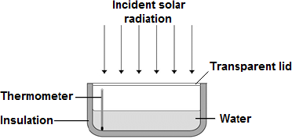

(a)     Choose the most appropriate resolution for the thermometer used by the student.

|  |  |
| --- | --- |
| Tick **one** box. |  |
| 0.1 °C |  |
| 0.5 °C |  |
| 1.0 °C |  |

**(1)**

(b)     The energy transferred to the water was 1050 J.

The time taken for the water temperature to increase by 0.6 °C was 5 minutes.

The specific heat capacity of water is 4200 J / kg °C.

Write down the equation which links energy transferred, power and time.

___________________________________________________________________

**(1)**

(c)     Calculate the mean power supplied by the Sun to the water in the pan.

___________________________________________________________________

___________________________________________________________________

___________________________________________________________________

Average power = _______________________ W

**(2)**

(d)     Calculate the mass of water the student used in her investigation.

Use the correct equation from the Physics Equation Sheet.

___________________________________________________________________

___________________________________________________________________

___________________________________________________________________

Mass = _______________________ kg

**(3)**

(e)     The student’s results can only be used as an estimate of the mean power at her location.

Give **one** reason why.

___________________________________________________________________

___________________________________________________________________

**(1)**

**(Total 8 marks)**

**Independent Exam Question**

**Q2.**

A new design for a kettle is made from two layers of plastic separated by a vacuum.

After the water in the kettle has boiled, the water stays hot for at least 2 hours.

The new kettle is shown below.

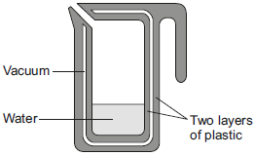

(a)     The energy transferred from the water in the kettle to the surroundings in 2 hours is   
46 200 J.

The mass of water in the kettle is 0.50 kg.

The specific heat capacity of water is 4200 J/kg °C.

The initial temperature of the water is 100 °C.

Calculate the temperature of the water in the kettle after 2 hours.

___________________________________________________________________

___________________________________________________________________

___________________________________________________________________

___________________________________________________________________

Temperature after 2 hours = ___________ °C

**(3)**

(b)     Calculate the average power output from the water in the kettle to the surroundings in 2 hours.

____________________________________________________________________

___________________________________________________________________

___________________________________________________________________

Average power output = ______________ W **(2)**

**(Total 5 marks)**

**Q3.**

Under the same conditions, different materials heat up and cool down at different rates.

(a)     What is meant by specific heat capacity?

___________________________________________________________________

___________________________________________________________________

___________________________________________________________________

___________________________________________________________________

**(2)**

(b)     ‘Quenching’ is a process used to change the properties of steel by cooling it rapidly.

The steel is heated to a very high temperature and then placed in a container of cold water.

(i)      A metalworker quenches a steel rod by heating it to a temperature of 900 °C before placing it in cold water. The mass of the steel rod is 20 kg.

The final temperature of the rod and water is 50 °C.

Calculate the energy transferred from the steel rod to the water.

Specific heat capacity of steel = 420 J/kg °C.

______________________________________________________________

______________________________________________________________

______________________________________________________________

Energy transferred = ____________________ J

**(3)**

(ii)     The temperature of the steel rod eventually returns to room temperature.

Compare the movement and energies of the particles in the steel rod and in the air at room temperature.

______________________________________________________________

______________________________________________________________

______________________________________________________________

______________________________________________________________

**(3)**

**Q4.**

A ‘can-chiller’ is used to make a can of drink colder.The image below shows a can-chiller.

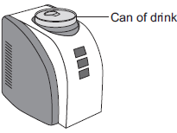

(a)     The initial temperature of the liquid in the can was 25.0 °C.  
The can-chiller decreased the temperature of the liquid to 20.0 °C.  
The amount of energy transferred from the liquid was 6930 J.  
The mass of liquid in the can was 0.330 kg.

Calculate the specific heat capacity of the liquid.

Give the unit.

___________________________________________________________________

___________________________________________________________________

___________________________________________________________________

___________________________________________________________________

Specific heat capacity = _____________________ unit ________________

**(4)**

(b)     Energy is transferred through the metal walls of the can of drink by conduction.  
Explain how.

___________________________________________________________________

___________________________________________________________________

___________________________________________________________________

___________________________________________________________________

___________________________________________________________________

___________________________________________________________________

___________________________________________________________________

___________________________________________________________________

**(4)**

(c)     The energy from the can of drink is transferred to the air around the can-chiller.  
A convection current is set up around the can-chiller. Explain how.

___________________________________________________________________

___________________________________________________________________

___________________________________________________________________

_________________________________________________________________ **(3)**

(d)     The can-chiller has metal cooling fins that are designed to transfer energy quickly to the surroundings.

Give **two** features that would help the metal cooling fins to transfer energy quickly to the surroundings.

1. _________________________________________________________________

2. _________________________________________________________________

**(2)**

**(Total 13 marks)**

**Lesson 2 – Energy Equations & Static Electricity**

|  |  |  |
| --- | --- | --- |
|  | **Topic:** | **Elastic objects and potential Energy (P.3)** |
| 1 | What is the equation for elastic potential energy? | Ee=1/2ke2 Elastic potential energy (J) = 1/2 x spring constant (N/m) x extension2 (m) |
| 2 | What is the equation for kinetic energy? | Ek = 1/2 mv2 Kinetic energy (J) = 1/2 x mass (Kg) x velocity2 (m/s) |
| 3 | What is the equation for gravitational potential energy? | Eg=mgh Gravitational potential energy (J) = mass (kg) x gravitational field strength (N/kg) x height (m) |
| 4 | Which equation describes Hooke's Law? | F = ke Force (N) = spring constant (N/m) x extension (m) |
| 5 | What type of energy is stored in a stretched elastic band? | Elastic potential energy |
| 6 | What type of energy is stored in a squashed up tennis ball? | Elastic potential energy |
| 7 | What needs to be applied for an object to change shape? | A force |
| 8 | Define the term for an object returning to its original shape after being stretched | Elastic deformation |
| 9 | Define the term for an object not returning to its original shape after being stretched | Inelastic deformation |
| 10 | Identify the Law: "The extension of a spring is directly proportional to the force applied to it." | Hooke's Law |
| 11 | What sort of energy is stored in a bungee cord? | Elastic potential energy |
| 12 | What do you call the point at which Hooke's Law no longer applies? | The limit of proportionality |
| 13 | In a graph of Hooke's Law, what happens at the limit of proportionality? | Line no longer straight, it will curve |
| 14 | What is the equation for "gravitational potential energy"? | Eg = mgh |
| 15 | What is the equation for Kinetic Energy? | Ek=1/2mv2 |

Notes

**Physics Revision: Energy Equations**

Mastery Matrix Points

|  |
| --- |
| Describe the law of conservation of energy in open and closed systems. |
| Describe ways in which energy can be transferred within a system |
| Describe ways to store energy |
| Use and rearrange equations for elastic potential energy |
| Use and rearrange equations for kinetic energy |
| Use and rearrange equations for gravitational potential energy |
| Recall the units and symbols for the quantities in these equations |

Key Knowledge

Law of conservation of energy: _______

______________________________

______________________________

Closed systems (choose correct one):

* All energy transferred usefully/ some wasted
* Real life/simplified

Open systems:

* All energy transferred usefully/ some waste
* Real life/simplified

Equations:

Elastic potential energy

Kinetic energy

Gravitational energy

|  |  |  |
| --- | --- | --- |
| Name | Symbol | Units |
|  | Ek |  |
|  | Eg |  |
|  | Ee |  |
|  | m |  |
|  | v |  |
|  | g |  |
|  | h |  |
|  | k |  |
|  | e |  |

Understanding and Explaining

1. **Explain the energy transfers when i) a ball is projected upwards ii) a moving car hits an obstacle iii) an car is accelerated by a constant force iv) a vehicle slows down v) water boils in an electric kettle.**

**i)________________________________________________________________________________________________**

**ii)________________________________________________________________________________________________**

**iii)________________________________________________________________________________________________**

**iv)________________________________________________________________________________________________**

**v)________________________________________________________________________________________________**

1. **Show how to rearrange the elastic potential energy equation for k and then e.**

**k =**

**e =**

1. **Show how to rearrange the kinetic energy equation for m and then v.**

**m=**

**v=**

1. **Show how to rearrange the gravitational potential energy equation for m, g and then h.**

**m=**

**g=**

**h=**

**5. Explain what the kinetic energy of a falling object will be when it hits the ground.**

**_______________________________________________________________________________________________**

**Guided Exam Question**

**Q5.**

The figure below shows a student before and after a bungee jump.

The bungee cord has an unstretched length of 20.0 m.

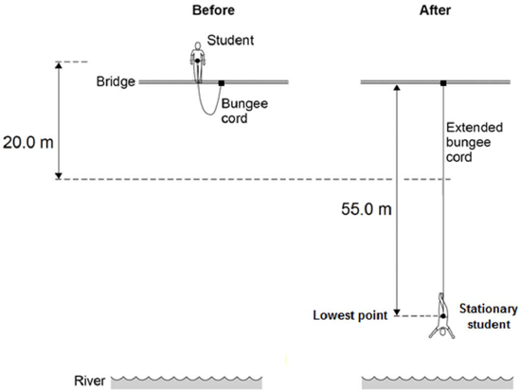

The mass of the student is 50.0 kg.

The gravitational field strength is 9.8 N / kg.

(a)     Write down the equation which links gravitational field strength, gravitational potential energy, height and mass.

___________________________________________________________________

**(1)**

(b)     Calculate the change in gravitational potential energy from the position where the student jumps to the point 20.0 m below.

___________________________________________________________________

___________________________________________________________________

___________________________________________________________________

Change in gravitational potential energy = _____________ J

**(2)**

(c)     80% of this change in gravitational potential energy has been transferred to the student’s kinetic energy store.

How much has the student’s kinetic energy store increased after falling 20.0 m?

Kinetic energy gained = ________________________ J

**(1)**

(d)     Calculate the speed of the student after falling 20.0 m.

Give your answer to two significant figures. ___________________________________________________________________

_______________________________________________________________

Speed = __________________________ m / s

**(4)**

(e)     At the lowest point in the jump, the energy stored by the stretched bungee cord is 24.5 kJ.

The bungee cord behaves like a spring.

Calculate the spring constant of the bungee cord.

Use the correct equation from the Physics Equation Sheet.

___________________________________________________________________

___________________________________________________________________

___________________________________________________________________

___________________________________________________________________

Spring constant = ________________________ N / m

**(3)**

**(Total 11 marks)**

**Independent Exam Questions**

**Q6.**

**Figure 1** shows an exercise device called a chest expander. The three springs are identical.

**Figure 1**

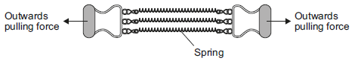

A person pulls outwards on the handles and does work to stretch the springs.

(a)     Complete the following sentence.

When the springs are stretched ___________ ___________ energy is stored in the springs.

**(1)**

(b)     **Figure 2** shows how the extension of a single spring from the chest expander depends on the force acting on the spring.

**Figure 2**

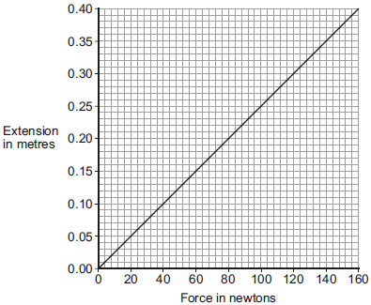

(i)      How can you tell, from **Figure 2**, that the limit of proportionality of the spring has not been exceeded?

______________________________________________________________

______________________________________________________________

**(1)**

(ii)     Use data from **Figure 2** to calculate the spring constant of the spring.

Give the unit.

______________________________________________________________

______________________________________________________________

______________________________________________________________

Spring constant = ___________ Unit ___________

**(3)**

(iii)     Three identical resistors joined in parallel in an electrical circuit share the total current in the circuit.

In a similar way, the three springs in the chest expander share the total force exerted.

By considering this similarity, use **Figure 2** to determine the total force exerted on the chest expander when each spring is stretched by 0.25 m.

______________________________________________________________

______________________________________________________________

Total force = ___________ N

**(2)**

(c)     The student in **Figure 3** is doing an exercise called a chin-up.

**Figure 3**

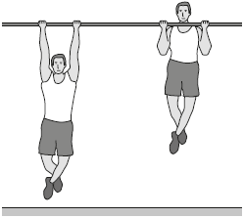

Each time the student does one chin-up he lifts his body 0.40 m vertically upwards.

The mass of the student is 65 kg.

The student is able to do 12 chin-ups in 60 seconds.

Calculate the power developed by the student.

Gravitational field strength = 10 N/kg

___________________________________________________________________

___________________________________________________________________

___________________________________________________________________

___________________________________________________________________

___________________________________________________________________

Power = ___________ W

**(3)**

**(Total 10 marks)**

**Lesson 3 – Nuclear Physics & Radioactivity**

|  |  |  |
| --- | --- | --- |
|  | **Topic:** | **Nuclear physics (P.21)** |
| 1 | What is the size of the atom? | 1 x 10-10m |
| 2 | Which two sub atomic particles are found in the nucleus? | Protons and neutrons |
| 3 | What is the radius of nucleus compared to radius of atom. | 1/10,000 of the size (one ten thousandth of the size) |
| 4 | Electrons go up an energy level when… (HT only) | They absorb electromagnetic radiation. |
| 5 | Electrons move down an energy level when… (HT only) | They emit electromagnetic radiation. |
| 6 | Are atoms positive, negative or neutral? | Neutral |
| 7 | What is the atomic number? | Number of protons |
| 8 | What is the mass number? | Number of protons AND neutrons. |
| 9 | What is an "ion"? | A charged atom (lost or gained electrons) |
| 10 | What are isotopes? | Atoms of the same element with the SAME number of protons but a DIFFERENT number of neutrons. |
| 11 | Describe the plum pudding model | The atom is a ball of positive charge with negative electrons embedded in it |
| 12 | What is the name of the current model of the atom? | Nuclear model |
| 13 | State two conclusions from the alpha scattering experiment | 1) mass of an atom is concentrated in a nucleus in the centre 2) nucleus is positive |
| 14 | State the conclusion provided by Niels Bohr | Electrons orbit the nucleus |
| 15 | State the conclusion provided by James Chadwick | Discovered neutrons |
|  | **Topic:** | **Radioactive decay and radiation (P.22)** |
| 1 | What two words can we use to describe the process of radioactive decay? | Random and unpredictable |
| 2 | What is the word to describe the rate at which a source of unstable nuclei decays? | Activity |
| 3 | What is the word to describe the number of decays recorded each second by a detector? | Count rate |
| 4 | What is the equipment for measuring radiation? | Geiger-Muller tube |
| 5 | Name the four types of nuclear radiation | alpha particle, beta particle, gamma ray, neutron |
| 6 | Describe the structure of an alpha particle | 2 neutrons & 2 protons (helium nucleus) |
| 7 | What is a beta particle? | A negative electron |
| 8 | What is a gamma ray? | An electromagnetic wave |
| 9 | Three main types of radiation in order of high to low ionising power. | alpha, beta, gamma |
| 10 | Three main types of radiation in order of high to low penetrating power. | gamma, beta, alpha |
| 11 | Which materials are able to stop each type of radiation? | Alpha = paper  Beta = aluminium  Gamma = nothing, thick lead absorbs some of it |
| 12 | Distances alpha, beta and gamma can go in air. | Alpha: 3-5cm, Beta: 15cm, Gamma: several metres. |
| 13 | Define "irradiation" | Exposing an object to nuclear radiation.  The irradiated object does not become radioactive. |
| 14 | Define "half life" | The time it takes for the number of unstable nuclei of the isotope in a sample to halve |
| 15 | Define "radioactive contamination" | The unwanted presence of radioactive atoms on other materials |

Notes

**Physics Revision: Nuclear Physics**

Key Knowledge

Radius of an atom = ____________________

Radius of a nucleus is __________ times smaller than the atomic radius.

Label the parts of an atom:

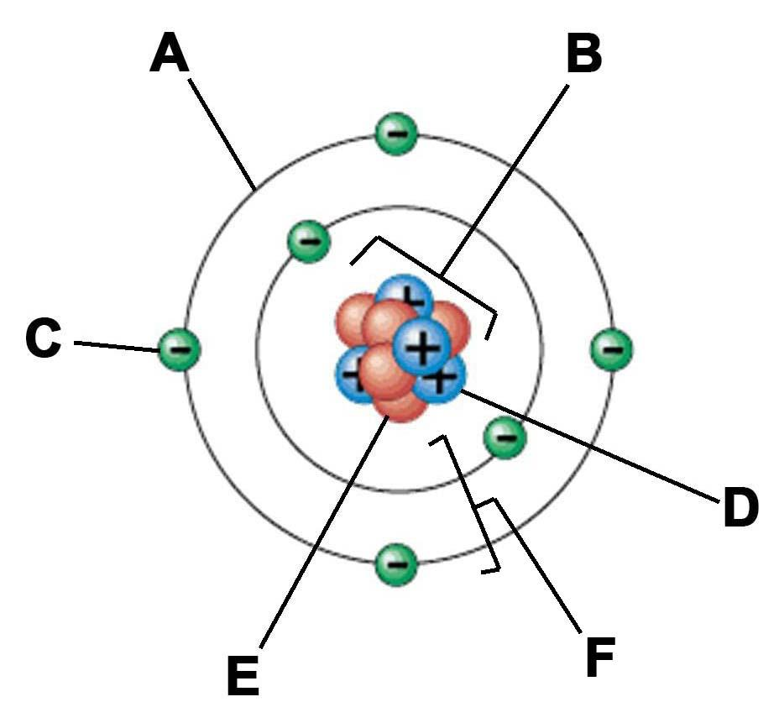

Add to your labels the order of which each part of the atom was discovered.

Using the periodic table:

*To find the number of protons you _________*

*___________________________________*

*To find the number of electron you ________*

*___________________________________*

*To find the number of neutron you _________*

*___________________________________*

Definitions:

Isotope ____________________________

__________________________________

Ion _______________________________

__________________________________

Plum pudding model ____________________

___________________________________

Nuclear model ________________________

____________________________________

Mastery Matrix Points

|  |
| --- |
| Describe the structure and size of an atom |
| Calculate the number of protons, neutrons and electrons in an atom |
| Describe how electrons can change energy level |
| Describe isotopes |
| Describe what an ion is |
| Describe the development of the model of the atom (Plum-pudding, Rutherford, Neils Bohr and Chadwick). |

Understanding and Explaining

1. **Explain what would make an electron jump to a higher energy level.**

**____________________________________________________________________________________________**

1. **Explain what would make an electron fall to a lower energy level.**

**____________________________________________________________________________________________**

1. **Why might scientists make changes to an existing theory?**

**____________________________________________________________________________________________**

1. **Describe the alpha scattering experiment, its results and why the results led to a change in the theory of the atom.**

**________________________________________________________________________________________________**

**________________________________________________________________________________________________**

**________________________________________________________________________________________________**

**________________________________________________________________________________________________**

**________________________________________________________________________________________________**

**________________________________________________________________________________________________**

1. **Explain the role of Niels Bohr in atomic theory.**

**________________________________________________________________________________________________**

**________________________________________________________________________________________________**

1. **Describe the contribution of James Chadwick to atomic theory.**

**________________________________________________________________________________________________**

**________________________________________________________________________________________________**

**Physics Revision: Radioactivity**

Mastery Matrix Points

|  |
| --- |
| Describe what radioactive decay is |
| Recall the definition and units for activity and count rate |
| Describe what makes up alpha, beta, gamma and neutron radiation |
| Describe the properties of each type of radiation |
| Use nuclear equations to represent radioactive decay |
| Define half-life |
| Complete half-life calculations from graphs or other data |
| Use ratios to describe radioactive decay (higher/triple) |
| Describe the impact and precautions for radioactive contamination |
| Analyse data about the effects of radiation on people |

Understanding and Explaining

1. **Explain why some atoms are radioactive.**

**________________________________________________________________________________________________**

1. **Compare and contrast the properties of alpha, beta and gamma radiation, include penetration through materials, their**

**range in air and ionising power.**

**Penetrating power:_______________________________________________________________________________________**

**Range in air:__________________________________________________________________________________**

**Ionising power______________________________________________________________________________________**

1. **Describe how to show these types of decay using nuclear equations. Give an example for each. i) alpha decay ii) beta decay**

**Alpha:_______________________________________________________________________________________**

**Beta:__________________________________________________________________________________**

**Gamma:______________________________________________________________________________________**

1. **Explain how to calculate half-life from a graph of radioactive activity vs time.**

**________________________________________________________________________________________________**

1. **Explain how to calculate how much of a radioactive material would be left if you are given the time, half-life and initial activity.**

**________________________________________________________________________________________________**

1. **What proportion of a radioactive substance would be left after i) one half life has passed ii) two half-lives have passed iii) three half-lives have passed?**

**i)_____________________ii)____________________________iii)_______________________________________________**

1. **Describe 2 risks and suggest some precautions that should be followed if using radioactive materials.**

**i)______________________________________________ii)__________________________________________________**

1. **Explain why it is important that findings of studies into the effects of radiation on humans should be published.**

**________________________________________________________________________________________________**

Key Knowledge

Radioactivity*____________________*

*_____________________________*

*_____________________________*

Activity

*_____________________________*

*_____________________________*

Count rate

*_____________________________*

*_____________________________*

Half life

*_____________________________*

*_____________________________*

Irradiation

*_____________________________*

*_____________________________*

Contamination

*_____________________________*

*_____________________________*

What are these made of?

Alpha – *____________________*

Beta – *____________________*

Gamma – *____________________*

Neutron - *____________________*

Symbols

Alpha –*____________________*

Beta – *____________________*

Gamma - *____________________*

Properties

Alpha –*____________________*

*____________________*

Beta – *____________________*

*____________________*

Gamma - *____________________*

*____________________*

What equipment is used to measure radioactive decay?_______________________

____________________________

**Guided Exam Question**

**Q7.**

In the early part of the 20th century, scientists used the ‘plum pudding’ model to explain the structure of the atom.

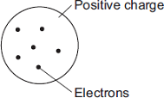

Following work by Rutherford and Marsden, a new model of the atom, called the ‘nuclear’ model, was suggested.

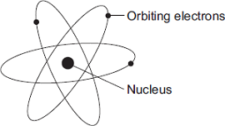

Describe the differences between the two models of the atom.

_______________________________________________________________________

_______________________________________________________________________

_______________________________________________________________________

_______________________________________________________________________

_______________________________________________________________________

_______________________________________________________________________

_______________________________________________________________________

_______________________________________________________________________

**(Total 4 marks)**

**Q8.**

In the early 20th century, scientists developed an alpha particle scattering experiment using gold foil.The diagram shows the paths of some of the alpha particles in the alpha particle scattering experiment.

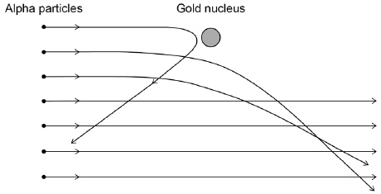

(a)     Explain how the paths of the alpha particles were used to develop the nuclear model of the atom.

___________________________________________________________________

___________________________________________________________________

___________________________________________________________________

___________________________________________________________________

___________________________________________________________________

___________________________________________________________________

___________________________________________________________________

**(4)**

(b)     Niels Bohr adapted the nuclear model by suggesting electrons orbited the nucleus at specific distances.

Explain how the distance at which an electron orbits the nucleus may be changed.

___________________________________________________________________

___________________________________________________________________

___________________________________________________________________

___________________________________________________________________

**(3)**

**(Total 7 marks)**

**Q9.**

A student models the random nature of radioactive decay using 100 dice.

He rolls the dice and removes any that land with the number 6 facing upwards.

He rolls the remaining dice again.

The student repeats this process a number of times.

The table below shows his results.

|  |  |
| --- | --- |
| **Roll number** | **Number of dice remaining** |
| 0 | 100 |
| 1 | 84 |
| 2 | 70 |
| 3 | 59 |
| 4 | 46 |
| 5 | 40 |
| 6 | 32 |
| 7 | 27 |
| 8 | 23 |

(a)     Give **two** reasons why this is a good model for the random nature of radioactive decay.

1. _________________________________________________________________

2. _________________________________________________________________

**(2)**

(b)     The student’s results are shown in **Figure 1**.

**Figure 1**

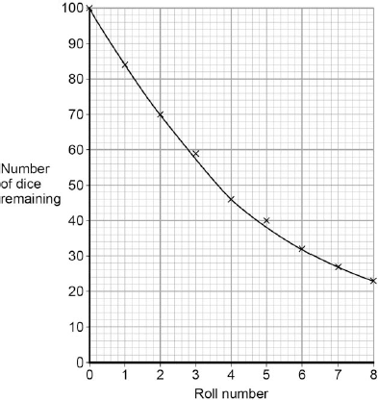

Use **Figure 1** to determine the half-life for these dice using this model.

Show on **Figure 1** how you work out your answer.

Half-life = ________________________ rolls

**(2)**

(c)     A teacher uses a protactinium (Pa) generator to produce a sample of radioactive material that has a half-life of 70 seconds.

In the first stage in the protactinium generator, uranium (U) decays into thorium (Th) and alpha (α) radiation is emitted.

The decay can be represented by the equation shown in **Figure 2**.



Determine the atomic number of thorium (Th) 234.

Atomic number = ______________________

**(1)**

(d)     When protactinium decays, a new element is formed and radiation is emitted.

The decay can be represented by the equation shown in **Figure 3**.

**Figure 3**



When protactinium decays, a new element, **X**, is formed.

Use information from **Figure 2** and **Figure 3** to determine the name of element **X**.

___________________________________________________________________

**(1)**

(e)     Determine the type of radiation emitted as protactinium decays into a new element.

Give a reason for your answer.

___________________________________________________________________

___________________________________________________________________

___________________________________________________________________

___________________________________________________________________

**(2)**

(f)     The teacher wears polythene gloves as a safety precaution when handling radioactive materials.

The polythene gloves do **not** stop the teacher’s hands from being irradiated.

Explain why the teacher wears polythene gloves.

___________________________________________________________________

___________________________________________________________________

___________________________________________________________________

**(2)**

**(Total 10 marks)**

**Q10.**

A teacher used the equipment shown in the diagram to measure the count rate at different distances from a radioactive source.

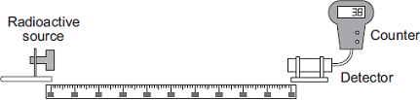

Metre rule

(a)     Her results are shown in **Table 1**.

**Table 1**

|  |  |  |
| --- | --- | --- |
| **Distance in metres** | **Count rate in counts per minute** | **Corrected count rate in counts per minute** |
| 0.4 | 143 | 125 |
| 0.6 | 74 | 56 |
| 0.8 | 49 | 31 |
| 1.0 | 38 | 20 |
| 1.2 | 32 | 14 |
| 1.4 | 28 | 10 |
| 1.6 | 18 | 0 |
| 1.8 | 18 | 0 |
| 2.0 | 18 | 0 |

The background count rate has been used to calculate the corrected count rate.

(i)      What is the value of the background count rate?

Background count rate = _______________ counts per minute

**(1)**

(ii)     What information does the corrected count rate give?

______________________________________________________________

______________________________________________________________

**(1)**

(iii)    The radioactive source used in the demonstration emits only one type of radiation.

The radioactive source is **not** an alpha emitter.

How can you tell from the data in the table?

______________________________________________________________

______________________________________________________________

**(1)**

(iv)    Plot a graph of corrected count rate against distance for distances between 0.4 m and 1.4 m.

Draw a line of best fit to complete the graph.

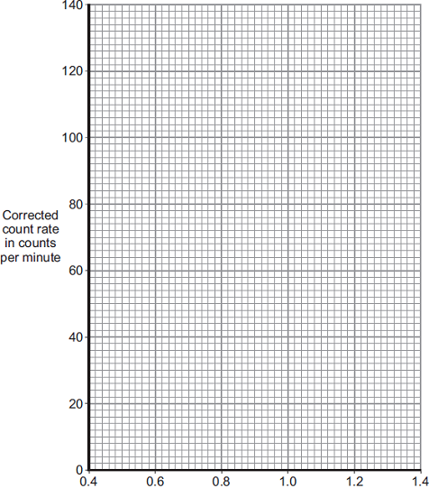

                Distance in metres

**(3)**

(v)     The ‘half-distance’ is the distance a detector has to be moved away from a radioactive source for the corrected count rate to halve.

A student has the hypothesis:  
A radioactive source has a constant ‘half-distance’.

**Table 1** has been repeated for your information.

**Table 1**

|  |  |  |
| --- | --- | --- |
| **Distance in metres** | **Count rate in counts per minute** | **Corrected count rate in counts per minute** |
| 0.4 | 143 | 125 |
| 0.6 | 74 | 56 |
| 0.8 | 49 | 31 |
| 1.0 | 38 | 20 |
| 1.2 | 32 | 14 |
| 1.4 | 28 | 10 |
| 1.6 | 18 | 0 |
| 1.8 | 18 | 0 |
| 2.0 | 18 | 0 |

Use **Table 1** to determine if the hypothesis is correct for this radioactive source.

You should use calculations in your answer.

______________________________________________________________

______________________________________________________________

______________________________________________________________

______________________________________________________________

______________________________________________________________

**(3)**

(b)     A teacher places a beta source and a detector in a magnetic field.

The arrangement of the magnetic field is shown.



The teacher repeated the experiment with the magnetic field in a different direction.

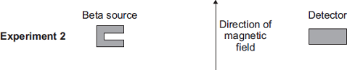

A set of results is shown in **Table 2**.

**Table 2**

|  |  |  |  |
| --- | --- | --- | --- |
| **Distance between source and detector in metres** | **Count rate in counts per minute without magnetic field** | **Count rate in counts per minute in Experiment 1** | **Count rate in counts per minute in Experiment 2** |
| 0.8 | 48 | 48 | 32 |

(i)      Describe **and** explain the effect of the magnetic field on the count rate detected by the detector.

______________________________________________________________

______________________________________________________________

______________________________________________________________

______________________________________________________________

______________________________________________________________

______________________________________________________________

**(2)**

(ii)     The experiment is repeated with a different distance between the source and the detector.

**Table 3** shows the repeated results.

**Table 3**

|  |  |  |  |
| --- | --- | --- | --- |
| **Distance between source and detector in metres** | **Count rate in counts per minute without magnetic field** | **Count rate in counts per minute in Experiment 1** | **Count rate in counts per minute in Experiment 2** |
| 1.8 | 19 | 18 | 20 |

Explain these results.

______________________________________________________________

______________________________________________________________

______________________________________________________________

______________________________________________________________

**(2)**

**Lesson 4 - Electricity**

|  |  |  |
| --- | --- | --- |
|  | **Topic:** | **Electricity introduction (P.29)** |
| 1 | What does LED stand for? | Light emitting diode. |
| 2 | What does LDR stand for? | Light dependent resistor. |
| 3 | State the equation for charge flow | Q=It Charge flow (C) = current (A) x time (S) |
| 4 | State the units for charge flow | Coulombs (C ) |
| 5 | Define 'electrical current' | Flow of electrical charge |
| 6 | What do the symbols I, t and Q represent? | I - current, t - time, Q - charge flow. |
| 7 | State the units for resistance | Ohms (Ω) |
| 8 | How does resistance affect current? | The higher the resistance, the lower the current (inversely proportional) |
| 9 | What is an ohmic conductor? | Electrical component where current and voltage are DIRECTLY PROPORTIONAL |
| 10 | What is a non-ohmic conductor? | Electrical component where current and voltage are NOT directly proportional |
| 11 | Write Ohm's law as an equation | V=IR |
| 12 | Units for potential difference. | Volts (V) |
| 13 | State the units for current. | Amperes (A) |
| 14 | Which piece of equipment is used to measure current in a circuit? | Ammeter |
| 15 | Which piece of equipment is used to measure voltage in a circuit? | Voltmeter |
|  |  |  |
|  |  |  |
|  | **Topic:** | **Series and parallel circuits (P.30)** |
| 1 | Do series circuits have one loop or multiple loops? | 1 loop |
| 2 | Do parallel circuits have one loop or multiple loops? | Multiple loops |
| 3 | Describe the distribution of current in a series circuit | It is the same everywhere |
| 4 | Describe the distribution of potential difference in a series circuit | Split between components |
| 5 | Describe the distribution of current in a parallel circuit | Split up in the different loops |
| 6 | Describe the distribution of potential difference in a parallel circuit | The same in each loop |
| 7 | Name the component used to measure current | Ammeter |
| 8 | Name the component used to measure voltage | Voltmeter |
| 9 | Are voltmeters connected in series or parallel? | in parallel |
| 10 | Are ammeters connected in series or parallel? | In series |
| 11 | State the equation for calculating resistance in a series circuit | Rtotal = R1 +R2 |
| 12 | How do you calculate total resistance in a series circuit? | Sum the resistance of each component |
| 13 | What affect does adding resistors have in a series circuit on the resistance? | Increases the total resistance |
| 14 | What affect does adding resistors have in a parallel circuit on the resistance? | Decreases the total resistance |
| 15 | Equation for resistance in a parallel circuit: | 1/Rtotal = 1/R1 + 1/R2 |
|  |  |  |
|  | **Topic:** | **Ohmic/non-ohmic types of resistors (P.31)** |
| 1 | In ohmic components, which two variables are directly proportional? | Current and potential difference |
| 2 | If current and potential difference are directly proportional, what does this tell us about the resistance? | It is constant (gradient on IV graph). |
| 3 | Sketch an IV graph for an ohmic conductor | C:\Users\lmcglasson\AppData\Local\Microsoft\Windows\INetCache\Content.MSO\8A427B34.tmp |
| 4 | Sketch a graph an IV for a filament bulb. | C:\Users\lmcglasson\AppData\Local\Microsoft\Windows\INetCache\Content.MSO\C9A36B62.tmp |
| 5 | Sketch a graph an IV graph for a diode. | Image result for diode graph |
| 6 | Name 4 non-ohmic conductors | Filament bulb, diodes, thermistors, LDRs |
| 7 | Why are filament light bulbs non-ohmic? | Current ↑, temperature ↑, resistance ↑ |
| 8 | Describe the relationship between current and potential difference for a diode. | Current only flows in one direction (has a very high resistance in the other direction) |
| 9 | Describe the relationship between temperature and resistance in a thermistor. | Temperature ↑, resistance ↓ |
| 10 | State one use of a thermistor | Thermostat |
| 11 | Describe the relationship between light intensity and resistance in an LDR | Light intensity ↑, resistance ↓ |
| 12 | State a use of an LDR | Switching lights on when it gets dark e.g. street lamps. |
| 13 | Draw the symbol of a resistor. | C:\Users\lmcglasson\AppData\Local\Microsoft\Windows\INetCache\Content.MSO\729316C1.tmp |
| 14 | Symbol of a variable resistor. | C:\Users\lmcglasson\AppData\Local\Microsoft\Windows\INetCache\Content.MSO\D098C777.tmp |
| 15 | Symbol of LDR | C:\Users\lmcglasson\AppData\Local\Microsoft\Windows\INetCache\Content.MSO\EFABD79D.tmp |

Notes

**Physics Revision: Circuits**

Key Knowledge



Current:____________________

___________________________

Charge: ____________________

__________________________

Potential Difference: __________

__________________________

Equations:

Charge flow = ________________

__________________________

Potential difference - __________

___________________________

Units:

|  |  |  |
| --- | --- | --- |
| **Quantity** | **Symbol** | **Units** |
| Current |  |  |
| Charge |  |  |
| Potential difference |  |  |
| Time |  |  |
| Resistance |  |  |

Mastery Matrix Points

|  |
| --- |
| Identify the key circuit symbols |
| Define current, charge and potential difference |
| Use and rearrange equations for calculating current |
| Predict the current at given points within a series and parallel circuit |
| Predict the potential difference (voltage) at given points within a series and parallel circuit |
| Describe the relationship between current, potential difference and resistance. |
| Use and rearrange equations for calculating current, potential difference and resistance. |
| Recall units for current, potential difference and resistance. |

Understanding and Explaining

1. **Show how to rearrange the equations V= IR and Q=It.**

I = I=

R= t=

1. **Explain how to work out the current in series and parallel circuits, then complete the missing currents.**

In series circuits…______________________________________________________________________________________________

In parallel circuits…__________________________________________________________________________________________

1. **Explain how to work out the potential difference in in series and parallel circuits.**

In series circuits…______________________________________________________________________________________________

In parallel circuits…___________________________________________________________________________________________

1. **Complete the missing numbers on these circuits.**

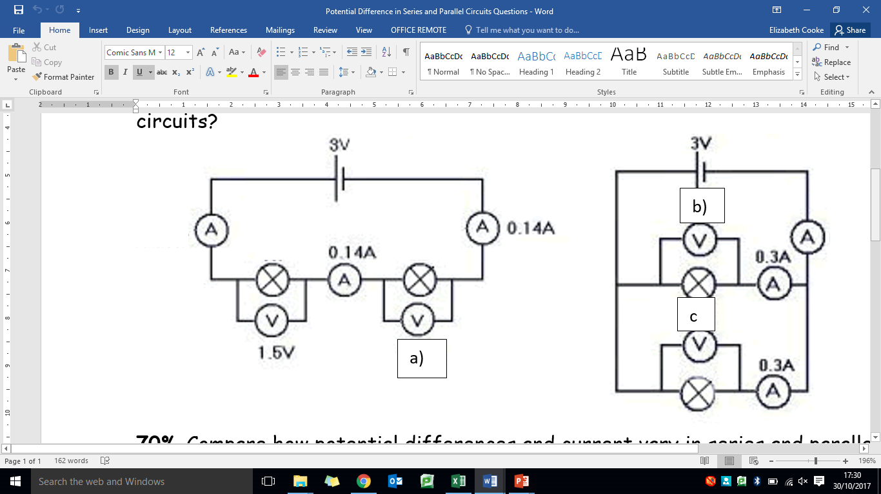 

**Physics Revision: Series and Parallel**

Mastery Matrix Points

|  |
| --- |
| Compare and contrast series and parallel circuits |
| Calculate resistance in series and parallel circuits |
| Explain patterns in resistance using words |

Key Knowledge

Resistance definition:

______________________________

______________________________

Series circuits have…

______________________________

______________________________

Circuit diagram of a series circuit:

Parallel circuits have…

______________________________

______________________________

Circuit diagram of a parallel circuit:

In a series circuit:

Rtotal=

In a parallel circuit, the total resistance of two resistors is ____than the resistance of the

smallest individual resistor.

Understanding and Explaining

1. **Explain how to calculate the total resistance of a series circuit.**

**____________________________________________________________________________________________**

**____________________________________________________________________________________________**

**____________________________________________________________________________________________**

1. **Calculate the total resistance of these components.**

**a) 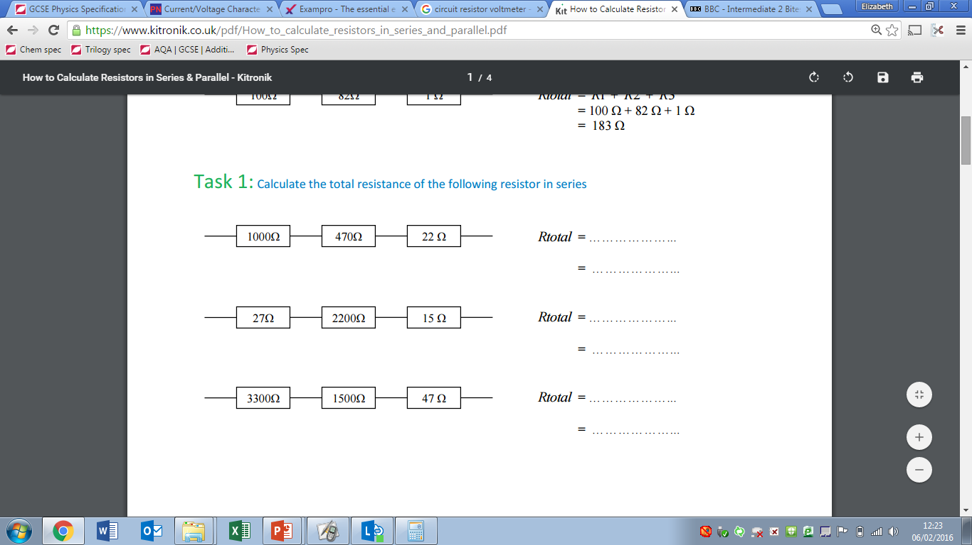b) **

**c)**

1. **Explain what the resistance will be less than in each of these circuits.**

a)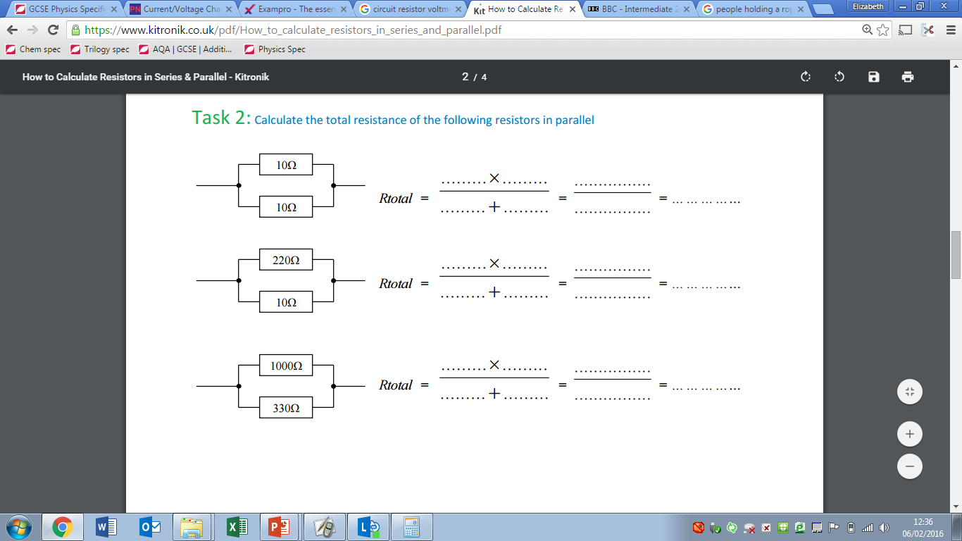b)c)

1. **Explain qualitatively why adding resistors in series increases the total resistance whilst adding resistors in parallel decreases the total resistance.**

**____________________________________________________________________________________________**

**____________________________________________________________________________________________**

**____________________________________________________________________________________________**

**Physics Revision: Advanced Circuits**

Key Knowledge

Sketch graphs of I-V (current-potential difference) relationships for different components:

Fixed resistor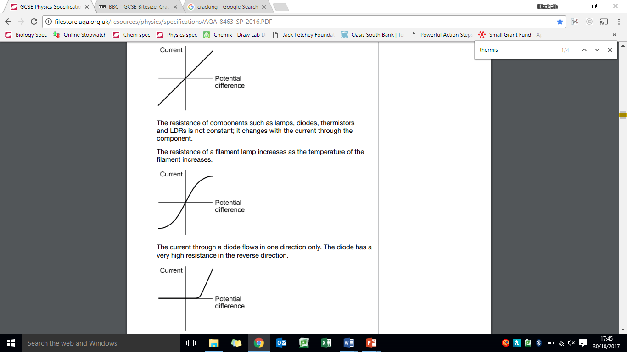

Filament bulb

Light emitting diode

As temperature increases, the resistance of a thermistor……………….

Applications of thermistors:

-

-

-

As light intensity increases, the resistance of an LDR……………….

Applications of LDRs:

-

-

Ohm’s Law (in a sentence and equation) ___________________

___________________________

___________________________

Equation: ____________________

Mastery Matrix Points

|  |
| --- |
| (Required practical) use circuits to investigate resistance |
| Describe the relationship between current and potential difference in ohmic conductors |
| Describe how resistances changes in thermistors and LDRs |
| List the applications of thermistors and LDRs |
| Interpret graphs to determine whether relationships are linear or non-linear |
| (Required practical) Investigate V-I characteristics using circuits |

Understanding and Explaining

1. **Name the variables in an experiment about how the resistance of a wire changes with length of the wire.**

**____________________________________________________________________________________________**

1. **State if these graphs show linear (ohmic) or non-linear (non-ohmic) relationships.**

Resistor = _________________ Bulb = _________________ LED = _____________________



1. **Explain the I-V relationship for each of the graphs above.**

Resistor

**____________________________________________________________________________________________**

Bulb

**____________________________________________________________________________________________**

LED

**____________________________________________________________________________________________**

1. **Draw a circuit diagram to show how you could investigate the I-V relationship for a component.**

**Guided Exam Question**

**Q11.**

The diagram shows a temperature sensing circuit used to control a heating system in a house.

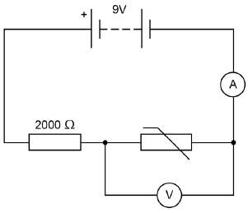

(a)     What quantity does the ammeter measure?

___________________________________________________________________

**(1)**

(b)     The current in the circuit is 3.5 mA when the potential difference across the thermistor is 4.2 V

Calculate the resistance of the thermistor.

___________________________________________________________________

___________________________________________________________________

Resistance = ____________________ Ω

**(3)**

(c)     Calculate the charge that flows through the thermistor in 5 minutes when the current is 3.5 mA.

___________________________________________________________________

___________________________________________________________________

___________________________________________________________________

Charge = ____________________ C

**(3)**

(d)     Explain why the potential difference across the thermistor changes as the temperature in the house decreases.

___________________________________________________________________

___________________________________________________________________

___________________________________________________________________

___________________________________________________________________

**(2)**

(e)     The circuit shown in the diagram can be modified to turn lights on and off by replacing the thermistor with a Light Dependent Resistor (LDR).

Draw the circuit symbol for an LDR in the space below.

**(1)**

**(Total 10 marks)**

**Q12.**

The current in a circuit depends on the potential difference (p.d.) provided by the cells and the total resistance of the circuit.

(a)     Using the correct circuit symbols, draw a diagram to show how you would connect 1.5 V cells together to give a p.d. of 6 V.

**(2)**

(b)     **Figure 1** shows a circuit containing an 18 V battery.

Two resistors, **X** and **Y**, are connected in series.

•         **X** has a resistance of 3 Ω.

•         There is a current of 2 A in **X**.

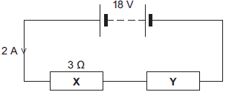

(i)      Calculate the p.d. across **X**.

______________________________________________________________

P.d. across **X** = ______________________ V

**(2)**

(ii)     Calculate the p.d. across **Y**.

______________________________________________________________

______________________________________________________________

P.d. across **Y** = ______________________ V

**(2)**

(iii)    Calculate the total resistance of **X** and **Y**.

______________________________________________________________

______________________________________________________________

______________________________________________________________

Total resistance of **X** and **Y** = ______________________ Ω

**(2)**

(c)     **Figure 2** shows a transformer.

**Figure 2**

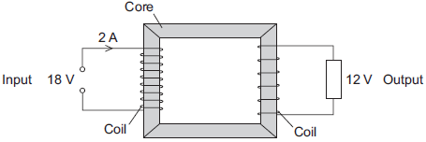

(i)      An 18 V battery could **not** be used as the input of a transformer.

Explain why.

______________________________________________________________

______________________________________________________________

______________________________________________________________

______________________________________________________________

**(2)**

(ii)     The transformer is 100% efficient.

Calculate the output current for the transformer shown in **Figure 2**.

______________________________________________________________

______________________________________________________________

______________________________________________________________

Output current = ______________________ A

**(2)**

**(Total 12 marks)**

**Independent Exam Question**

**Q13.**

(a)     A student set up the circuit shown in the diagram. The student uses the circuit to obtain the data needed to plot a current - potential difference graph for a diode.

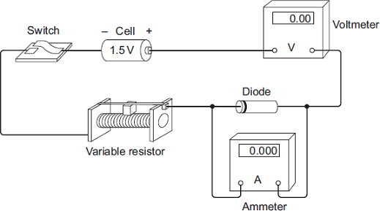

(i)      Draw, in the boxes, the circuit symbol for a diode and the circuit symbol for a variable resistor.

|  |  |  |
| --- | --- | --- |
| **Diode** |  | **Variable resistor** |
|  |  |  |
|  |  |  |
|  |  |  |

**(2)**

(ii)     The student made two mistakes when setting up the circuit.

What **two** mistakes did the student make?

1. ____________________________________________________________

______________________________________________________________

2. ____________________________________________________________

______________________________________________________________

**(2)**

(b)     After correcting the circuit, the student obtained a set of data and plotted the graph below.

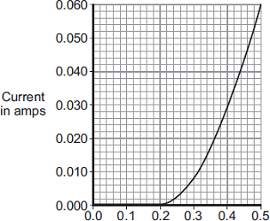

                Potential difference in volts

(i)      At what potential difference did the diode start to conduct an electric current?

___________________________________ V

**(1)**

(ii)     Use data from the graph to calculate the resistance of the diode when the potential difference across the diode is 0.3 V.

______________________________________________________________

______________________________________________________________

Resistance = _____________ ohms

**(3)**

(c)     The diagram shows the trace produced by an alternating current (a.c.) supply on an oscilloscope.

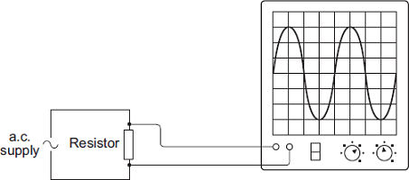

Each horizontal division on the oscilloscope screen represents a time of 0.01s.

(i)      Calculate the frequency of the a.c. supply.

______________________________________________________________

______________________________________________________________

Frequency = _______________________ hertz

**(2)**

(ii)     A diode is now connected in series with the a.c. power supply.

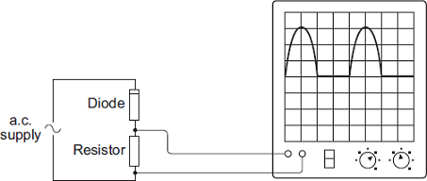

Why does the diode cause the trace on the oscilloscope screen to change?

______________________________________________________________

______________________________________________________________

______________________________________________________________

______________________________________________________________

**(2)**

**(Total 12 marks)**

**Q14.**

The graph shows how the electric current through a 12 V filament bulb varies with the potential difference across the bulb.

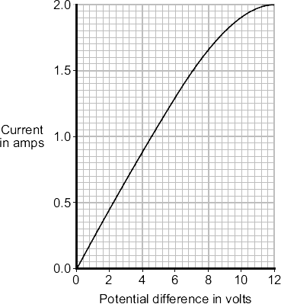

(a)     What is the meaning of the following terms?

electric current

___________________________________________________________________

potential difference

___________________________________________________________________

**(2)**

(b)     The resistance of the metal filament inside the bulb increases as the potential difference across the bulb increases.

Explain why.

___________________________________________________________________

___________________________________________________________________

___________________________________________________________________

___________________________________________________________________

___________________________________________________________________

**(3)**

(c)     Use data from the graph to calculate the rate at which the filament bulb transfers energy, when the potential difference across the bulb is 6 V.

Show clearly how you work out your answer.

___________________________________________________________________

___________________________________________________________________

Rate of energy transfer = __________________ W

**(2)**

**Lesson 5 - Mains Electricity, the National Grid & Energy Resources**

|  |  |  |
| --- | --- | --- |
|  | **Topic:** | **Mains electricity (P.32)** |
| 1 | Is mains electricity AC or DC? | AC |
| 2 | What do AC and DC mean? | Alternating current Direct current. |
| 3 | State the frequency of UK mains supply | 50Hz |
| 4 | State the potential difference of UK mains supply | 230V |
| 5 | What are the names of the three wires in a three core cable | Live, neutral, earth. |
| 6 | State the colour of a)earth wire, b)live wire, c) neutral wire | a)Green and yellow stripes, b)brown, c)blue |
| 7 | State the function of the live wire. | Carries alternating potential difference from the supply |
| 8 | State the function of the neutral wire. | Completes the circuit |
| 9 | Function of the earth wire. | Safety wire to remove excess potential difference (to stop the appliance becoming live) |
| 10 | State the potential difference between the live wire and earth wire. | 230V |
| 11 | State the potential difference of the neutral wire. | At or close to 0V |
| 12 | State the potential difference of the earth wire. | 0V unless there is a fault. |
| 13 | State the equation for electrical power (that uses potential difference) | P= IV |
| 14 | State two things that affect the amount of energy an appliance transfers | Power and time (E=Pt) |
| 15 | State the equation we use to calculate the energy transferred by a device that uses charge flow | E = QV |
|  |  |  |
|  | **Topic:** | **Energy and power of electricity and the National Grid (P.33)** |
| 1 | State the equation that links current, potential difference and power | P = IV power (W) = current (I) x potential difference (V) |
| 2 | State the equation that links current, power and resistance | P = I2R Power (W) = current2 (A) x resistance (Ω) |
| 3 | State the two most commonly wasted forms of energy | Thermal and sound |
| 4 | When energy is wasted, what happens to it? | It is dissipated into the environment |
| 5 | State the equation that links time, energy and power | E=Pt energy (J) = power (W) x time (s) |
| 6 | State the equation that links energy, potential difference and charge flow | E = QV energy (J) = charge flow (C) x potential difference (V) |
| 7 | What is the national grid composed of? | Cables and transformers linking power stations to consumers. |
| 8 | What is the national grid used for? | Supplying electrify to houses |
| 9 | State the effect of step up transformers on potential difference | Increases p.d. |
| 10 | State the effect of step down transformers on potential difference | Decreases p.d. |
| 11 | State the effect of step up transformers on current. | Decreases current. |
| 12 | State the effect of step down transformers on current. | Increases current. |
| 13 | Why are step up transformers used? | To reduce energy loss from cables (thermal) |
| 14 | Why are step down transformers used? | To reduce the potential difference to make it safe for domestic use. |
| 15 | Why is the national grid efficient? | Transformers reduces heat loss from wires when electricity travels long distances |
|  |  |  |

Notes

**Physics Revision: Mains Electricity**

Mastery Matrix Points

|  |
| --- |
| Describe the properties of mains electricity in the UK (A.C., Frequency and Voltage) |
| Explain the difference between direct and alternating potential difference |
| Describe the three core cables and the wires that they are made up of and the dangers of these |
| Describe the components of the national grid |
| Explain the role of step up and step down transformers in the national grid and use this to explain why it is an efficient system for transferring energy |

Key Knowledge

Mains electricity

* ac or dc? ________________
* Frequency: _______________
* Potential difference:________

Three wires in mains plug:

|  |  |
| --- | --- |
| *Wire* | *Colour* |
|  |  |
|  |  |
|  |  |

Potential difference between live wire and earth wire = V

Potential difference of neutral wire = V

Potential difference of earth wire

= V, unless…______________

_________________________

National grid definition: ________

___________________________

Step up transformers: __________

___________________________

Step down transformers: _______

__________________________

**and the National Grid**

Understanding and Explaining

1. **Explain the difference between direct current and alternating current.**

**____________________________________________________________________________________________**

**____________________________________________________________________________________________**

**____________________________________________________________________________________________**

1. **Describe the roles of the live wire, neutral wire and earth wire in a 3 pin UK plug.**

**Live:_________________________________________________________________________________________**

**Neutral:_________________________________________________________________________________________**

**Earth:_________________________________________________________________________________________**

1. **Describe the dangers of i) the live wire, even if the device is off ii) the live wire and earth wire touching.**

**i)____________________________________________________________________________________________**

**ii)____________________________________________________________________________________________**

1. **Explain how step up transformers increase the efficiency at which electricity is transmitted from the national grid.**

**____________________________________________________________________________________________**

**____________________________________________________________________________________________**

**____________________________________________________________________________________________**

1. **Describe and explain the role of step down transformers in the national grid.**

**____________________________________________________________________________________________**

**____________________________________________________________________________________________**

**____________________________________________________________________________________________**

**Physics Revision: Energy Transfers and Resource**

Mastery Matrix Points

|  |
| --- |
| Describe the main energy resources on Earth |
| Define renewable and non-renewable resources |
| Describe how energy resources are used |
| Compare and contrast energy resources in terms of reliability, cost, political, social and environmental factors |
| Explain patterns and trends in the use of energy resources |

Understanding and Explaining

1. **Explain how these energy resources can be used to produce electricity (e.g. turns turbine or burnt) and give the advantages and disadvantages.**

|  |  |  |  |
| --- | --- | --- | --- |
| **Resource** | **How is this used to make electricity?** | **Advantages** | **Disadvantages** |
| fossil fuels (coal, oil and gas) |  |  |  |
| nuclear fuel |  |  |  |
| Biofuel |  |  |  |
| Wind |  |  |  |
| The tides |  |  |  |
| hydro-electricity |  |  |  |
| Geothermal |  |  |  |
| the Sun |  |  |  |
| water waves |  |  |  |

1. **Explain how the use of energy resources has changed over time.**

**____________________________________________________________________________________________**

**____________________________________________________________________________________________**

**____________________________________________________________________________________________**

Key Knowledge

Definitions:

Energy resources

______________________________

Renewable: _____________________

______________________________

Non-renewable__________________

______________________________

Name the renewable energy resources:

Name the non-renewable energy resources:

Which resources are not reliable?

Which resources contribute to global climate change through releasing CO2?

Equations:

P =

P =

E =

E =

**Q15.**

(a)    Describe the difference between an alternating current (a.c.) and a direct current (d.c.).

___________________________________________________________________

___________________________________________________________________

**(2)**

(b)     The diagram shows how the electric supply cable is connected to an electric kettle.  
The earth wire is connected to the metal case of the kettle.

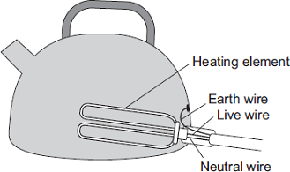

If a fault makes the metal case live, the earth wire and the fuse inside the plug protect anyone using the kettle from an electric shock.

Explain how.

___________________________________________________________________

___________________________________________________________________

___________________________________________________________________

___________________________________________________________________

**(2)**

**(Total 4 marks)**

**Q16.**

Use of renewable sources of energy is expected to increase. The table shows the comparative costs of producing 1 kWh of electricity from different energy sources.

|  |  |
| --- | --- |
| **Types of energy sources used in the UK** | **Cost of producing 1 kWh of electrical energy** |
| Fossil fuels(non-renewable) | Coal                                     1.0 p  Gas                                      1.4 p  Oil                                       1.5 p |
| Nuclearfuels (non-renewable) | Nuclear                               0.9 p |
| Renewable | Hydroelectric                      0.2 p  Wind                                   0.9 p |
| Installation and decommissioning costs are notincluded | |

At present about 2% of electricity generated in the UK uses renewable energy sources. Consider the three types of energy sources in the table and give **one** advantage and **one** disadvantage for each (other than installation and decommissioning costs).

|  |  |
| --- | --- |
| **Advantage** | **Disadvantage** |
| Using fossil fuels  ___________________________________  ___________________________________  ___________________________________ | Using fossil fuels  ___________________________________  ___________________________________  ___________________________________ |
| Using nuclear fuels  ___________________________________  ___________________________________  ___________________________________ | Using nuclear fuels  ___________________________________  ___________________________________  ___________________________________ |
| Using renewable sources  ___________________________________  ___________________________________  ___________________________________ | Using renewable sources  ___________________________________  ___________________________________  ___________________________________ |

**(Total 6 marks)**

**Independent**

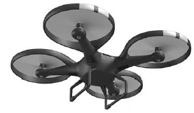**Q17.**

The image shows a battery-powered drone.

(a)     The battery in the drone can store 97.5 kJ of energy.

When the drone is hovering, the power output of the battery is 65.0 W

Calculate the time for which the drone can hover.

___________________________________________________________________

___________________________________________________________________

___________________________________________________________________

___________________________________________________________________

___________________________________________________________________

___________________________________________________________________

Time = ____________________ seconds

**(3)**

(b)     The battery powers 4 motors in the drone.

Each motor has a resistance of 1.60 Ω when the power input to each motor is 19.6 W

The 4 motors are connected in parallel with the battery.

Calculate the current through the battery.

___________________________________________________________________

___________________________________________________________________

___________________________________________________________________

___________________________________________________________________

___________________________________________________________________

Current = ____________________ A

**(4)**

**(Total 7 marks)**

**Q18.**

About half of the UK’s electricity is generated in coal-burning power stations and nuclear power stations.

(a)     Coal-burning power stations and nuclear power stations provide a reliable way of generating electricity.

What is meant by a *reliable way of generating electricity*?

___________________________________________________________________

**(1)**

(b)     Over the next few years, most of the older nuclear power stations in the UK will be closed down, and the process of decommissioning will start.

What does it mean to *decommission* a nuclear power station?

___________________________________________________________________

**(1)**

(c)     Climate change has been strongly linked to the emission of carbon dioxide. Many governments around the world are committed to reducing carbon dioxide emissions.

Generating electricity can increase carbon dioxide emissions.

The companies generating electricity could reduce carbon dioxide emissions.

Give **two** ways the companies could do this.

1. _________________________________________________________________

___________________________________________________________________

2. _________________________________________________________________

___________________________________________________________________

**(2)**

(d)     Electricity is distributed from power stations to consumers along the National Grid.

The voltage across the overhead cables of the National Grid needs to be much higher than the output voltage from the power station generators.

Explain why.

___________________________________________________________________

___________________________________________________________________

___________________________________________________________________

___________________________________________________________________

___________________________________________________________________

___________________________________________________________________

**(3)**

**(Total 7 marks)**

**Lesson 6 – Density and Changes in State**

|  |  |  |
| --- | --- | --- |
|  | **Topic:** | **Density (P.25)** |
| 1 | State the equation for density | ρ =m/v Density (kg/m3) = mass (kg) / volume (m3) |
| 2 | State the units for density | Kilograms per metre cubed (kg/m3) |
| 3 | State the units for volume | Meters cubed, (m3) |
| 4 | How do you calculate the volume of a cube? | V = lxlxl or l3 Volume (m3) = length (m) x length (m) x length (m) |
| 5 | How do you calculate the volume of a cuboid? | V = l x w x h Volume (m3) = length (m) x width (m) x height (m) |
| 6 | State two drawbacks of the particle model | 1) assumes particles are all small solid spheres  2) doesn't show bonds between atoms |
| 7 | Describe the particle model of solids | Particles all touching (bonded) in rows with least kinetic energy |
| 8 | Describe the particle model of liquids | Particles randomly placed, almost all particles touching. |
| 9 | Describe the particle model of gases | Particles placed randomly, none or very few touching with the most kinetic energy |
| 10 | Name the five changes of state | Sublimation, condensing, boiling, freezing and melting |
| 11 | Describe the state change in sublimation | Solid to gas |
| 12 | How do the particles move in a solid? | Vibrate in a fixed position |
| 13 | How do you calculate the density of an irregular shape? | Submerge in water to calculate the volume, use a balance to measure the mass. |
| 14 | How do you calculate the density of a regular shape? | Calculate the volume using l x b x h, use a balance to measure the mass |
| 15 | How do the particles move in a gas? | Randomly, in all directions |
|  |  |  |
|  | **Topic:** | **Changes of state, latent heat and specific heat capacity (P.26)** |
| 1 | Define 'conservation of mass' | Total mass is the same before and after a reaction |
| 2 | Why does temperature not change during a state change? | Energy used to make/break bonds increasing the internal energy not temperature |
| 3 | Define "internal energy" | Energy stored inside a system by the particles |
| 4 | How do we calculate internal energy? | Sum of kinetic and potential energy of all particles |
| 5 | How does heating affect the internal energy of a system? | It increases it |
| 6 | State the equation for change in thermal energy | ∆ E = m c ∆ θ Change in energy (J) = mass (kg) x specific heat capacity (J/Kg°C) x change in temperature (°C) |
| 7 | State the units for specific heat capacity | Joules per kilogram per degree Celsius, J/kg °C |
| 8 | Define "specific heat capacity" | Amount of energy required to raise the temperature of one kilogram of the substance by one degree Celsius. |
| 9 | Define "latent heat" | The energy needed for a substance to change state |
| 10 | Define "specific latent heat of vaporisation" | The amount of energy required to boil one kilogram of the substance with no change in temperature |
| 11 | Define "specific latent heat of fusion" | The amount of energy required to freeze one kilogram of the substance with no change in temperature |
| 12 | Equation for specific latent heat. | E = m L Energy (J) = mass (kg) x specific latent heat (J/kg) |
| 13 | State the units for specific latent heat | Joules per kilogram, J/kg |
| 14 | Describe the key property of a substance with a high specific heat capacity | Will store a lot of energy per kilogram |
| 15 | What does a flat section on a heating and cooling graph represent? | Changes of state |

Notes

**Physics: Density and Changes of State**

Mastery Matrix Points

|  |
| --- |
| Use and rearrange ρ =m/v |
| Draw simple diagrams to model the difference between solids, liquids and gases |
| Link the arrangement of atoms and molecules to different densities of the states |
| RP Density: Determine the densities of regular and irregular solid objects and liquids |
| Describe how mass is conserved during changes of state |
| Explain why changes of state are physical changes |
| Define internal energy |
| Explain the effect of heating on the energy within a system and calculate energy change during a state change. |
| Describe ‘latent heat’ of a material including specific latent heat of fusion and specific latent heat of vaporisation |
| Explain and calculate ‘specific latent heat’ using the E=mL |
| Interpret heating and cooling graphs that include changes of state |
| Explain the differences between ‘heat’ and ‘temperature’ |
| Define and calculate specific heat capacity |
| Use and rearrange equations for calculating specific heat capacity |
| Distinguish between specific heat capacity and specific latent heat |

Understanding and Explaining

1. **Explain how to calculate the density of a) a regular shape b) an irregular shape.**

**a)____________________________________________________________________________________________**

**b)____________________________________________________________________________________________**

**____________________________________________________________________________________________**

1. **Sketch and explain the shape of a heating curve and a cooling curve.**
2. **Define a) specific latent heat of vaporisation b) specific latent heat of fusion.**

**a)____________________________________________________________________________________________**

**b)____________________________________________________________________________________________**

1. **Compare specific latent heat and specific heat capacity.**

**____________________________________________________________________________________________**

**____________________________________________________________________________________________**

**____________________________________________________________________________________________**

Key Knowledge

Equation for density –

The particle model assumes all particles are ________, _______ spheres. It is used to explain _____ and _______ of matter.

What are the state changes?

Melting:

Freezing:

Boiling:

Evaporating:

Condensing:

Sublimating:

Internal Energy – _______________

____________________________

Heat can either

* OR

Equation for specific heat capacity:

Equation for specific latent heat:

**Guided Exam Question**

**Q19.**

A student wants to calculate the density of the two objects shown in the figure below.

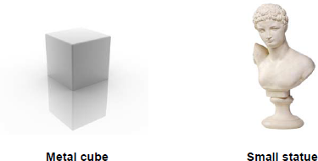

© Whitehoune/iStock/Thinkstock,      © Marc Dietrich/Hemera/Thinkstock

Describe the methods that the student should use to calculate the densities of the two objects.

_______________________________________________________________________

_______________________________________________________________________

_______________________________________________________________________

_______________________________________________________________________

_______________________________________________________________________

_______________________________________________________________________

_______________________________________________________________________

_______________________________________________________________________

_______________________________________________________________________

_______________________________________________________________________

**(Total 6 marks)**

**Q20.**

A student investigated the cooling effect of evaporation.

She used the equipment in **Figure 1** to measure how the temperature of three different liquids changed as the liquids evaporated.

**Figure 1**

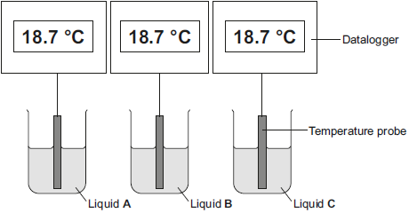

(a)     The temperature and volume of each liquid was the same at the start of the investigation.

State **one** further control variable in this investigation.

___________________________________________________________________

___________________________________________________________________

**(1)**

(b)     Give **two** advantages of using dataloggers and temperature probes compared to using the thermometer shown in **Figure 2**.

**Figure 2**

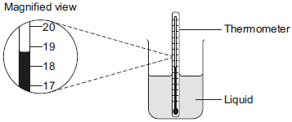

1. _________________________________________________________________

___________________________________________________________________

2. _________________________________________________________________

___________________________________________________________________

**(2)**

(c)     The student’s results are shown in **Figure 3**.

**Figure 3**

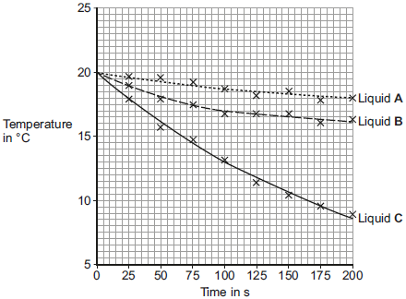

(i)      Calculate the average rate of temperature decrease of liquid **C** between 0 and 100 seconds.

______________________________________________________________

______________________________________________________________

Average rate of temperature decrease = __________ °C / s

**(2)**

(ii)     Give **one** conclusion that can be made about the rate of temperature decrease of **all three** liquids from the results in **Figure 3**.

______________________________________________________________

______________________________________________________________

**(1)**

(iii)     Which liquid had the lowest rate of evaporation? Give a reason for your answer.

Liquid ________________________________________________________

Reason _______________________________________________________

______________________________________________________________

**(1)**

(iv)     A second student did the same investigation but using a smaller volume of liquid than the first student.

All other variables were kept the same.

What effect would this have on the results of the second student’s investigation?

______________________________________________________________

______________________________________________________________

**(1)**

(d)     Explain how the evaporation of a liquid causes the temperature of the remaining liquid to decrease.

___________________________________________________________________

___________________________________________________________________

___________________________________________________________________

___________________________________________________________________

___________________________________________________________________

___________________________________________________________________

___________________________________________________________________

___________________________________________________________________

**(3)**

**(Total 11 marks)**

**Independent Exam Questions**

**Q21.**

According to kinetic theory, all matter is made up of small particles. The particles are constantly moving.

**Diagram 1** shows how the particles may be arranged in a solid.

**Diagram 1**

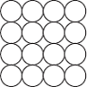

(a)     One kilogram of a gas has a much larger volume than one kilogram of a solid.

Use kinetic theory to explain why.

___________________________________________________________________

___________________________________________________________________

___________________________________________________________________

___________________________________________________________________

___________________________________________________________________

___________________________________________________________________

___________________________________________________________________

___________________________________________________________________

___________________________________________________________________

___________________________________________________________________

**(4)**

(b)     **Diagram 2** shows the particles in a liquid. The liquid is evaporating.

**Diagram 2**

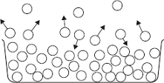

(i)      How can you tell from **Diagram 2** that the liquid is evaporating?

______________________________________________________________

______________________________________________________________

**(1)**

(ii)     The temperature of the liquid in the container decreases as the liquid evaporates.

Use kinetic theory to explain why.

______________________________________________________________

______________________________________________________________

______________________________________________________________

______________________________________________________________

______________________________________________________________

______________________________________________________________

______________________________________________________________

______________________________________________________________

**(3)**

**(Total 8 marks)**

**Q22.**

The diagram shows how the metal chimney from a log-burning stove passes through the inside of a house.

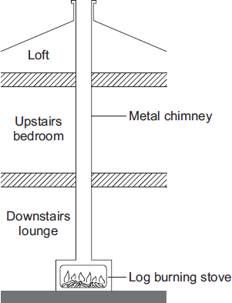

(a)     Explain how heat is transferred by the process of convection from the inside of the stove to the top of the chimney.

___________________________________________________________________

___________________________________________________________________

___________________________________________________________________

___________________________________________________________________

___________________________________________________________________

**(2)**

(b)     Although the outside of the chimney becomes very hot, there is no insulating material around the chimney.

(i)      Explain, in terms of the particles in a metal, how heat is transferred by conduction from the inside to the outside of the metal chimney.

______________________________________________________________

______________________________________________________________

______________________________________________________________

______________________________________________________________

______________________________________________________________

**(2)**

(ii)     Suggest **one** advantage of having no insulation around the chimney.

______________________________________________________________

______________________________________________________________

**(1)**

**(Total 5 marks)**

**Lesson 7 – Gas Pressure**

|  |  |  |
| --- | --- | --- |
|  | **Topic:** | **Gas and fluid pressure (paper 1) (P.27)** |
| 1 | Describe the motion of particles in a gas. | Random movement |
| 2 | How do we determine the temperature of a gas? | Average kinetic energy of the molecules |
| 3 | State two factors that will influence gas pressure | 1) temperature, 2) volume |
| 4 | If a gas is held at a constant volume, describe the relationship between temperature and pressure | Directly proportional |
| 5 | Why does increasing temperature increase the pressure of a gas (if held at a constant volume)? | Particles collide with the side of the container: (a) more frequently and (b) with more energy |
| 6 | Gas pressure causes a force at ___degrees to the container wall. | 90 |
| 7 | State 2 factors that increase when work is done on a gas | Internal energy and temperature |
| 8 | State a situation where doing work on a gas increases the temperature | Bicycle pump |

Notes

**Physics: Gas Pressure**

Mastery Matrix Points

|  |
| --- |
| Describe the motion of particles in a gas and relate this to pressure, kinetic energy and temperature |
| Explain the relationship between temperature and pressure of a gas at constant volume |

Key Knowledge

Particles in a gas move ___________ in ____ directions. They move at a _________ of speeds.

The temperature of a gas is determined by the _____ ______ of the particles.

The motion of particles is determined by

-

-

Pressure produces a force ___________ to the walls of the container/surface.

Understanding and Explaining

1. **Describe the relationship between temperature and pressure of a gas at a constant volume.**

**____________________________________________________________________________________________**

**____________________________________________________________________________________________**

**____________________________________________________________________________________________**

1. **Sketch a graph to show the relationship between temperature and pressure of a gas at a constant volume.**

**3. Explain how pressure occurs inside a balloon**

**____________________________________________________________________________________________**

**____________________________________________________________________________________________**

**____________________________________________________________________________________________**

**Guided Exam Question**

**Q23.**

A student investigated how the pressure of a gas varied with the volume of the gas.

The mass and temperature of the gas were constant.

**Figure 1** shows the equipment the student used.

**Figure 1**

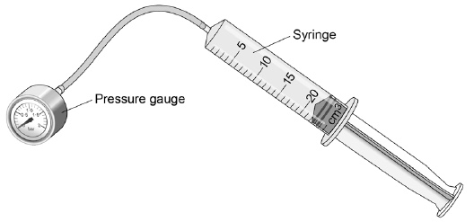

(a)     What is the resolution of the syringe?

____________________ cm3

**(1)**

The student compressed the gas in the syringe and read the pressure from the pressure gauge.

**Figure 2** shows the student's results.

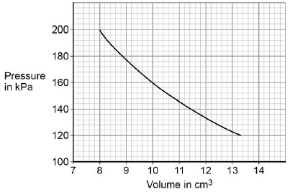

(b)     What conclusion can the student make from the data in **Figure 2**?

Use data from **Figure 2** in your answer.

Give the reason for your answer.

___________________________________________________________________

___________________________________________________________________

___________________________________________________________________

___________________________________________________________________

**(3)**

(c)     Explain why the pressure in the gas increases as the gas is compressed.

___________________________________________________________________

___________________________________________________________________

___________________________________________________________________

___________________________________________________________________

___________________________________________________________________

___________________________________________________________________

___________________________________________________________________

___________________________________________________________________

___________________________________________________________________

**(4)**

**(Total 8 marks)**

**Q24.**

The figure below shows a balloon filled with helium gas.

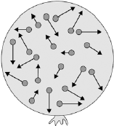

(a)     Describe the movement of the particles of helium gas inside the balloon.

___________________________________________________________________

___________________________________________________________________

___________________________________________________________________

___________________________________________________________________

**(2)**

(b)     What name is given to the total kinetic energy and potential energy of all the particles of helium gas in the balloon?

|  |  |
| --- | --- |
| Tick **one** box. |  |
| External energy |  |
| Internal energy |  |
| Movement energy |  |

**(1)**

(c)     Write down the equation which links density, mass and volume.

___________________________________________________________________

**(1)**

(d)     The helium in the balloon has a mass of 0.00254 kg.

The balloon has a volume of 0.0141 m3.

Calculate the density of helium. Choose the correct unit from the box.

|  |
| --- |
| **m3 / kg**                              **kg / m3**                              **kg m3** |

___________________________________________________________________

___________________________________________________________________

___________________________________________________________________

___________________________________________________________________

Density = __________________ Unit _________

**(3)**

**(Total 7 marks)**

**Required Practicals**

|  |  |  |
| --- | --- | --- |
|  | **Topic:** | **RP: Specific heat capacity (P1) (P.41)** |
| 1 | Which piece of equipment is used to transfer thermal energy into the metal block? | Immersion heater |
| 2 | What supplies energy to the immersion heater? | A power pack |
| 3 | Which piece of equipment measures the potential difference? | Voltmeter |
| 4 | Which piece of equipment measures current? | Ammeter |
| 5 | Which piece of equipment measures the starting and final temperature of the metal block? | Thermometer |
| 6 | Which piece of equipment measures time? | Stop clock |
| 7 | Which piece of equipment measures the mass of the block? | Balance |
| 8 | Why is the block wrapped in insulation? | To prevent loss of thermal energy |
| 9 | How is energy input calculate? | P = I x V and then E = P/t |
| 10 | How could you improve the accuracy of your temperature recording? | Use a digital thermometer |
| 11 | Why might your calculation of "energy" be inaccurate? | Potential difference and current unlikely to be constant throughout experiment |
| 12 | How can you check your results are repeatable? | Repeat the experiment and check whether results are similar |
| 13 | How can you check your result for SHC is accurate? | Compare it to the true value (given in a text book) |
| 14 | State 2 factors that were controlled during the experiment | Time and thickness of insulation |
| 15 | State one hazard and safety precaution | Immersion heater and block get hot! Do not touch! |
|  |  |  |
|  | **Topic:** | **RP: Thermal insulation (P2) (triple only) (P.42)** |
| 1 | What piece of equipment is used to measure the water that will go into the beaker? | Measuring cylinder |
| 2 | Which piece of equipment measures the starting temperature of the water? | Thermometer |
| 3 | Which piece of equipment is used to measure the time? | Stopwatch |
| 4 | What is the purpose of the cardboard lid? | Prevent heat loss through convection |
| 5 | One experiment aimed to find out which type of insulation was better at insulating the beaker. What was the IV? | Type of material |
| 6 | One experiment aimed to find out which type of insulation was better at insulating the beaker. What was the DV? | Temperature change of water |
| 7 | One experiment aimed to find out the most effective thickness for the insulator. What was the IV? | Thickness of the insulator |
| 8 | One experiment aimed to find out the most effective thickness for the insulator. What was the DV? | Temperature change of the water |
| 9 | Is type of insulator a continuous or a categoric variable? | Categoric |
| 10 | State 2 control variables in both experiments | Volume of water & cooling time |
| 11 | Which materials should be the best insulators? | Those with air in them |
| 12 | How will you know which is the best insulator? | Lower temperature change |
| 13 | How could you improve the accuracy of the temperature measurement? | Use a digital thermometer |
| 14 | How could you check your results were repeatable? | Repeat the experiment and see if you got similar results |
| 15 | How could you check your results were repeatable? | Someone else does similar experiment, check they got similar results |
|  |  |  |
|  | **Topic:** | **RP: Resistance (P3) (P.43)** |
| 1 | This experiment aims to see the effect of wire length on resistance. What is the IV? | Wire length |
| 2 | This experiment aims to see the effect of wire length on resistance. What is the DV? | Resistance |
| 3 | This experiment aims to see the effect of wire length on resistance. What is a CV? | Thickness of the wire |
| 4 | Which piece of equipment provides the electrical energy into the circuit? | Powerpack |
| 5 | Which piece of equipment measures the current? | Ammeter |
| 6 | Which piece of equipment measures the potential difference? | Voltmeter |
| 7 | How should the ammeter be placed into the circuit? | In series |
| 8 | How should the voltmeter be placed into the circuit? | In parallel |
| 9 | How do you calculate resistance? | V = IR |
| 10 | Why is the powerpack turned off between readings? | So that wire doesn’t get hot as this increases resistance |
| 11 | What is the expected result for the relationship between wire length and resistance? | As wire length increases, resistance increases |
| 12 | What is the unit for resistance? | Ohms |
| 13 | How do you calculate the resistance of a resistor in a circuit? | Measure current & potential difference and calculate using V=IR |
| 14 | What is the expected relationship for resistance of resistors in a series circuit? | Total resistance = R1 + R2 |
| 15 | What is the expected relationship for resistance of resistors in a parallel circuit? | Total resistance < resistance of smallest resistor |
|  |  |  |
|  | **Topic:** | **RP: Ohm's Law (P4) (P.44)** |
| 1 | This practical is investigating the impact of increasing the potential difference on the current through a component. What would be the IV? | Potential difference |
| 2 | This practical is investigating the impact of increasing the potential difference on the current through a component. What would be the DV? | Current |
| 3 | Why is a variable power pack used? | So that potential difference can be changed |
| 4 | Why are the wires switched around after the first set of readings are taken? | To investigate the effect of using negative potential difference |
| 5 | What is the expected relationship between current and potential difference for a filament light bulb? | NOT directly proportional |
| 6 | What is the expected relationship between current and potential difference for a fixed resistor? | Directly proportional |
| 7 | What is the expected results for a diode when using negative potential difference? | No current |
| 8 | What is the expected results for a diode when using positive potential difference? | Not directly proportional |
| 9 | Why is a milliammeter used when testing the diode? | Current is very small |
| 10 | Why are current and potential different not directly proportional in a filament bulb? | It heats up and resistance increases |
| 11 | What does it mean if a component is described as ohmic? | Current and potential difference are directly proportional |
| 12 | Is a filament bulb ohmic? | No |
| 13 | Is a fixed resistor ohmic? | Yes |
| 14 | Is a diode ohmic? | No |
| 15 | Which symbol means directly proportional? | ∝ |
|  |  |  |
|  | **Topic:** | **RP: Density (P5) (P.45)** |
| 1 | How do you calculate the mass of a regular shaped object? | Use top pan balance |
| 2 | How do you calculate the volume of a regular shaped object? | length x base x height |
| 3 | How do you calculate density? | density = mass / volume |
| 4 | How do you calculate the mass of an irregular object? | Top pan balance |
| 5 | How do you calculate the volume of an irregular object? | Lower into a displacement can (eureka can) and measure volume of water displaced |
| 6 | How do you measure the mass of a liquid? | Weigh empty measuring cylinder, weigh with liquid, subtract first reading from second |
| 7 | How do you measure the volume of a liquid? | Use a measuring cylinder |
| 8 | What type of error do you get if you forget to reset the top pan balance to zero before starting your measurements? | Zero error |
| 9 | What type of error would you get if you repeatedly read the volume from the top of the miniscus (curve of water)? | Systematic |
| 10 | What is the unit for density? | kg/m3 |
| 11 | What is the density of water? | 1000kg/m3 |
| 12 | How can you tell if an object will float in water? | Density less than 1000kg/m3 |
| 13 | How can you check your measurement for density is repeatable? | You would get the same result multiple times |
| 14 | How can you check your measurement for density is reproducible? | Other people would get the same result as you |
| 15 | How could you check your mass readings were precise? | They should be very similar to each other |

**Physics RP Revision - P1 –**

Understanding and Explaining

Method:

__________________________________________________________________________________________________________________

_____________________________________________________________________________________________________________________________

__________________________________________________________________________________________________________________

_____________________________________________________________________________________________________________________________

__________________________________________________________________________________________________________________

_____________________________________________________________________________________________________________________________

__________________________________________________________________________________________________________________

_____________________________________________________________________________________________________________________________

__________________________________________________________________________________________________________________

_____________________________________________________________________________________________________________________________

__________________________________________________________________________________________________________________

_____________________________________________________________________________________________________________________________

__________________________________________________________________________________________________________________

_____________________________________________________________________________________________________________________________

Common error made in this practical:

_____________________________________________________________________________________________________________________________

_____________________________________________________________________________________________________________________________

Describe how you could improve the accuracy of the results:

_____________________________________________________________________________________________________________________________

_____________________________________________________________________________________________________________________________

_____________________________________________________________________________________________________________________________

_____________________________________________________________________________________________________________________________

Describe how to find specific heat capacity

_____________________________________________________________________________________________________________________________

_____________________________________________________________________________________________________________________________

_____________________________________________________________________________________________________________________________

_____________________________________________________________________________________________________________________________

**Specific Heat Capacity**

Key Knowledge

Aim: ____________________________

______________________________________________________________

IV in this experiment:

_______________________________

DV in this experiment:

_______________________________

CV in this experiment:

1. __________________________
2. __________________________
3. __________________________

Risk and precaution:

_______________________________

_______________________________

_______________________________

Equipment:

**Physics RP Revision – P3 - Resistance**

Understanding and Explaining

Method and equipment 1:

__________________________________________________________________________________________________________________

_____________________________________________________________________________________________________________________________

__________________________________________________________________________________________________________________

_____________________________________________________________________________________________________________________________

__________________________________________________________________________________________________________________

_____________________________________________________________________________________________________________________________

__________________________________________________________________________________________________________________

_____________________________________________________________________________________________________________________________

__________________________________________________________________________________________________________________

_____________________________________________________________________________________________________________________________

Describe the expected results:

__________________________________________________________________________________________________________________

_____________________________________________________________________________________________________________________________

Method and equipment 2:

__________________________________________________________________________________________________________________

_____________________________________________________________________________________________________________________________

__________________________________________________________________________________________________________________

_____________________________________________________________________________________________________________________________

__________________________________________________________________________________________________________________

_____________________________________________________________________________________________________________________________

__________________________________________________________________________________________________________________

_____________________________________________________________________________________________________________________________

__________________________________________________________________________________________________________________

_____________________________________________________________________________________________________________________________

__________________________________________________________________________________________________________________

Describe the expected results:

__________________________________________________________________________________________________________________

_____________________________________________________________________________________________________________________________

Key Knowledge

Aim 1: ____________________________

______________________________________________________________

IV 1:

_______________________________

DV 1:

_______________________________

CVs:

1. __________________________
2. __________________________
3. __________________________

Aim 2: ____________________________

______________________________________________________________

Risk and precaution:

_______________________________

_______________________________

_______________________________

**Physics RP Revision –**

Understanding and Explaining

Method (filament bulb/resistor)

__________________________________________________________________________________________________________________

_____________________________________________________________________________________________________________________________

__________________________________________________________________________________________________________________

_____________________________________________________________________________________________________________________________

__________________________________________________________________________________________________________________

_____________________________________________________________________________________________________________________________

__________________________________________________________________________________________________________________

_____________________________________________________________________________________________________________________________

__________________________________________________________________________________________________________________

_____________________________________________________________________________________________________________________________

Method (diode)

__________________________________________________________________________________________________________________

_____________________________________________________________________________________________________________________________

__________________________________________________________________________________________________________________

_____________________________________________________________________________________________________________________________

__________________________________________________________________________________________________________________

_____________________________________________________________________________________________________________________________

__________________________________________________________________________________________________________________

_____________________________________________________________________________________________________________________________

__________________________________________________________________________________________________________________

_____________________________________________________________________________________________________________________________

__________________________________________________________________________________________________________________

**P4 – IV characteristics & Ohms’ Law**

Key Knowledge

Aim 1: ____________________________

______________________________________________________________

Equipment:

Sketch graphs to show the results:

**Physics RP Revision – P5 – Density**

Understanding and Explaining

Method (regular shape)

__________________________________________________________________________________________________________________

_____________________________________________________________________________________________________________________________

__________________________________________________________________________________________________________________

_____________________________________________________________________________________________________________________________

__________________________________________________________________________________________________________________

Method (irregular shape)

__________________________________________________________________________________________________________________

_____________________________________________________________________________________________________________________________

__________________________________________________________________________________________________________________

_____________________________________________________________________________________________________________________________

__________________________________________________________________________________________________________________

_____________________________________________________________________________________________________________________________

__________________________________________________________________________________________________________________

_____________________________________________________________________________________________________________________________

__________________________________________________________________________________________________________________

_____________________________________________________________________________________________________________________________

__________________________________________________________________________________________________________________

Method (liquid)

__________________________________________________________________________________________________________________

_____________________________________________________________________________________________________________________________

__________________________________________________________________________________________________________________

_____________________________________________________________________________________________________________________________

__________________________________________________________________________________________________________________

_____________________________________________________________________________________________________________________________

__________________________________________________________________________________________________________________

_____________________________________________________________________________________________________________________________

__________________________________________________________________________________________________________________

_____________________________________________________________________________________________________________________________

__________________________________________________________________________________________________________________

Key Knowledge

Aim : ____________________________

______________________________________________________________

Equipment (regular shape):

Equipment (irregular shape):

Equipment (liquid):

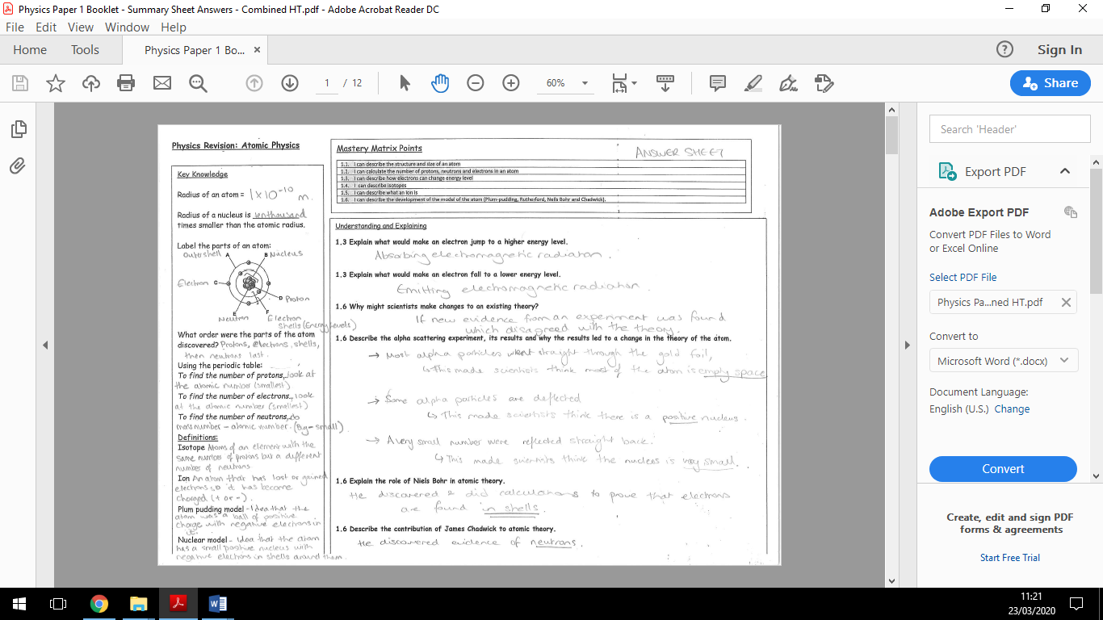

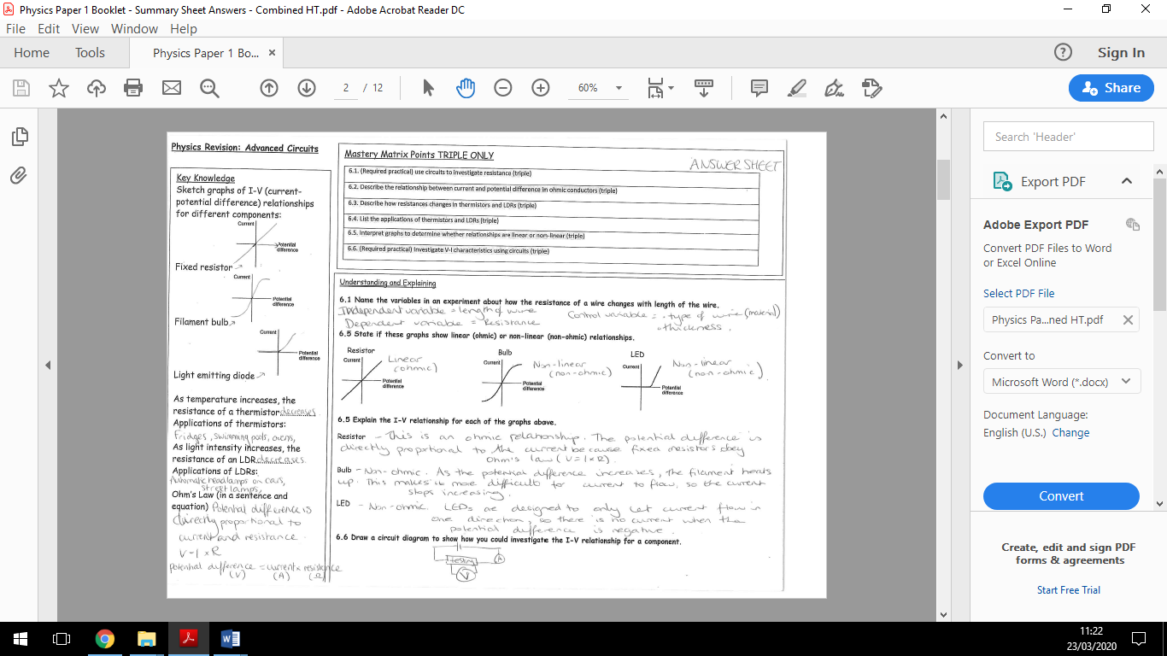

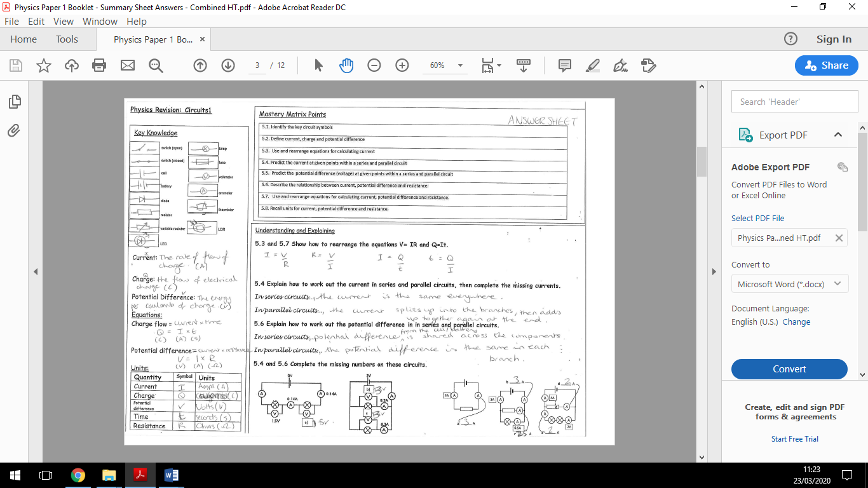

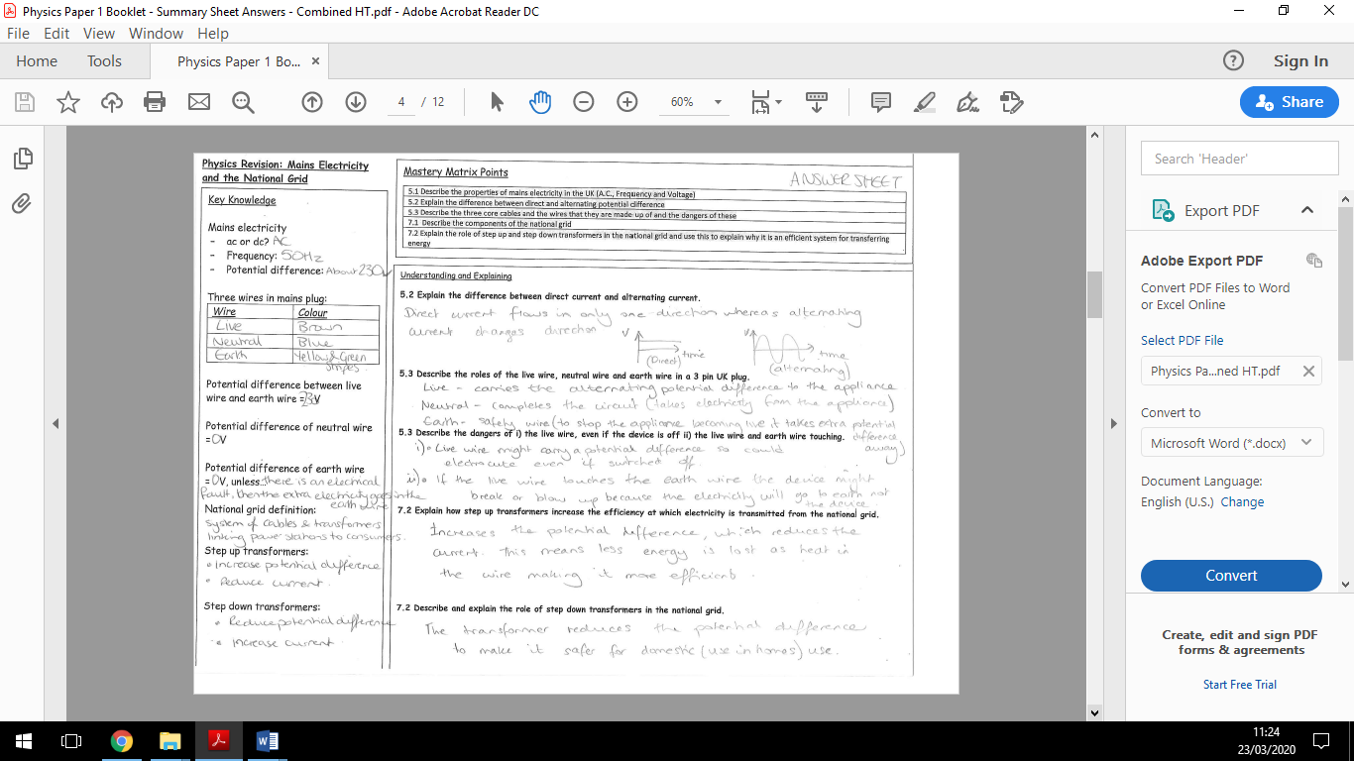

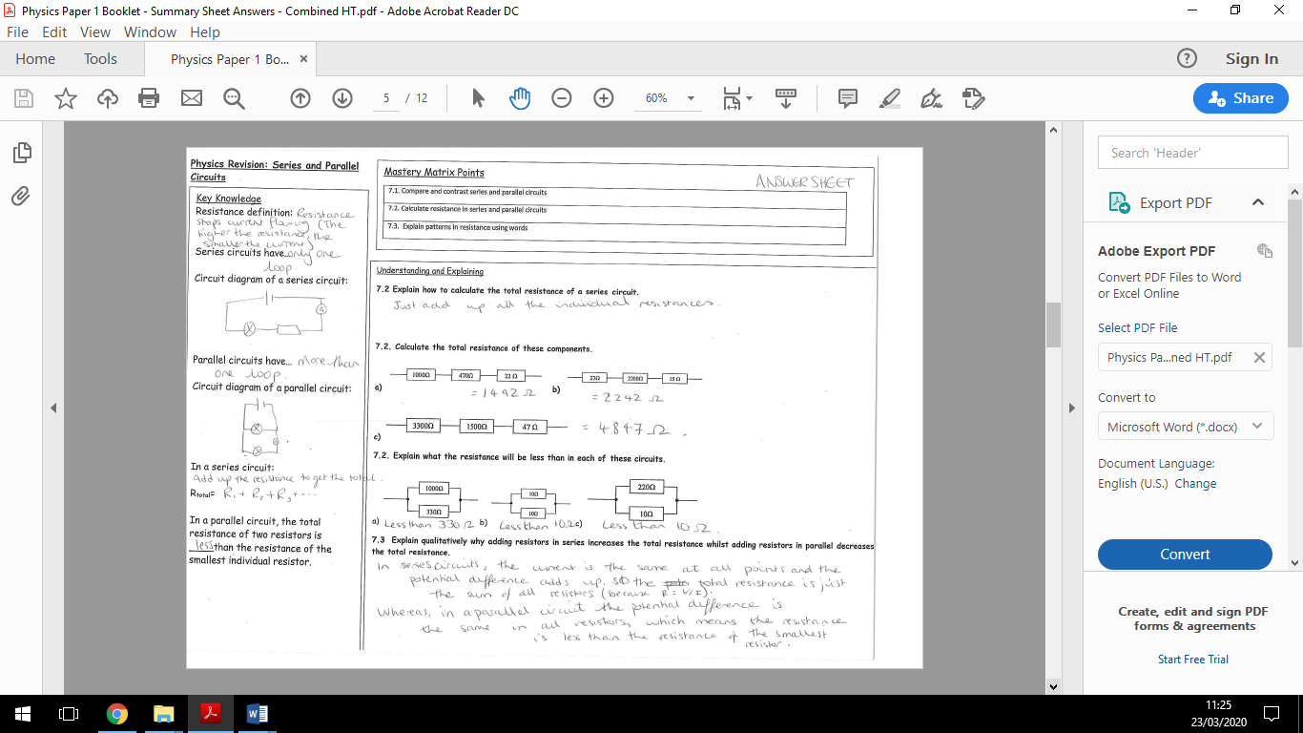

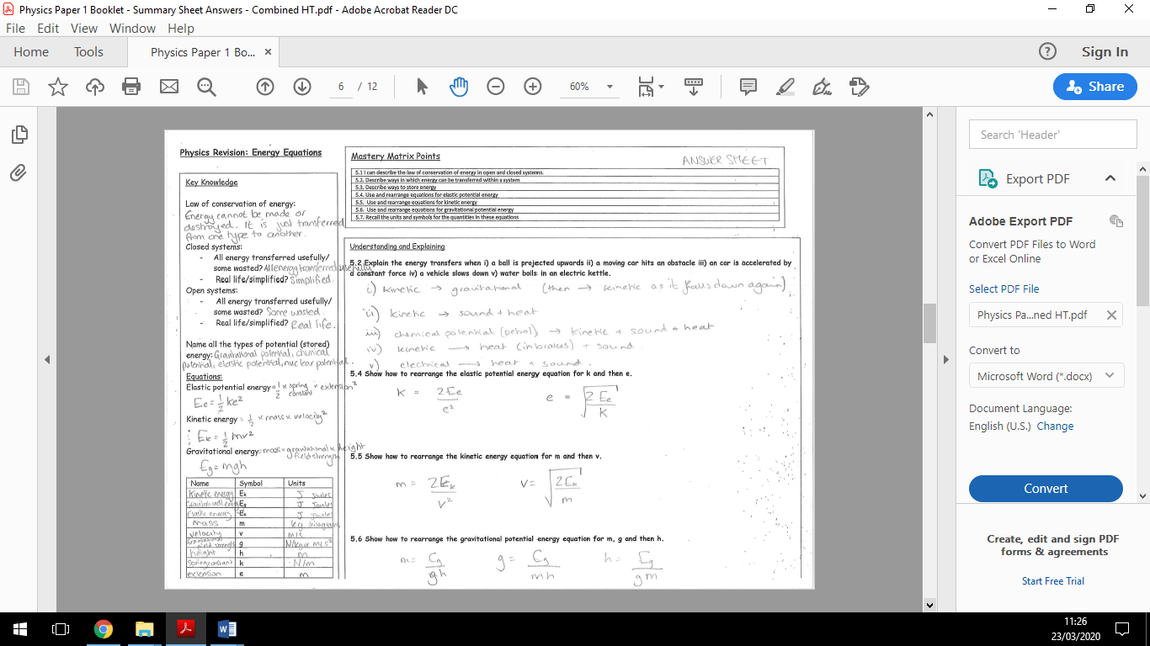

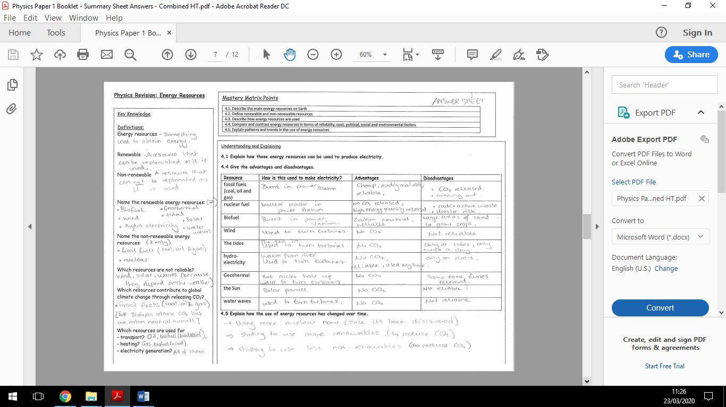

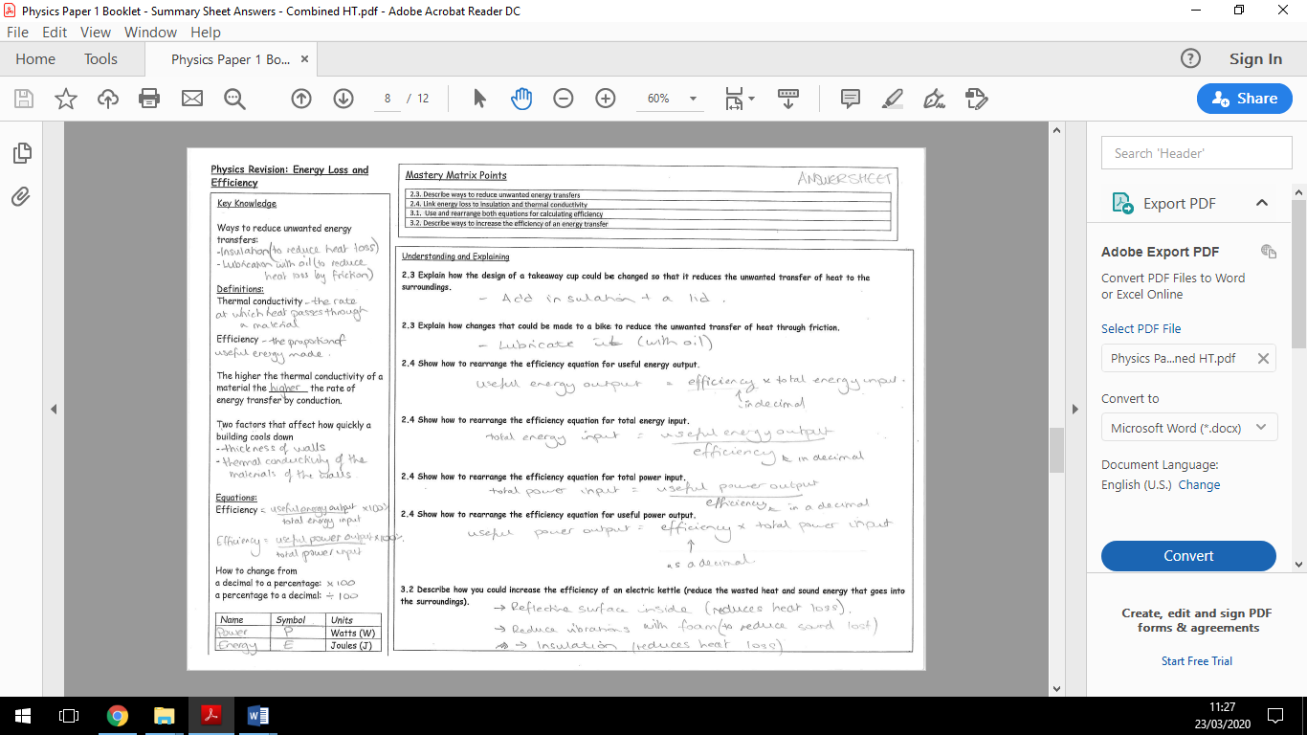

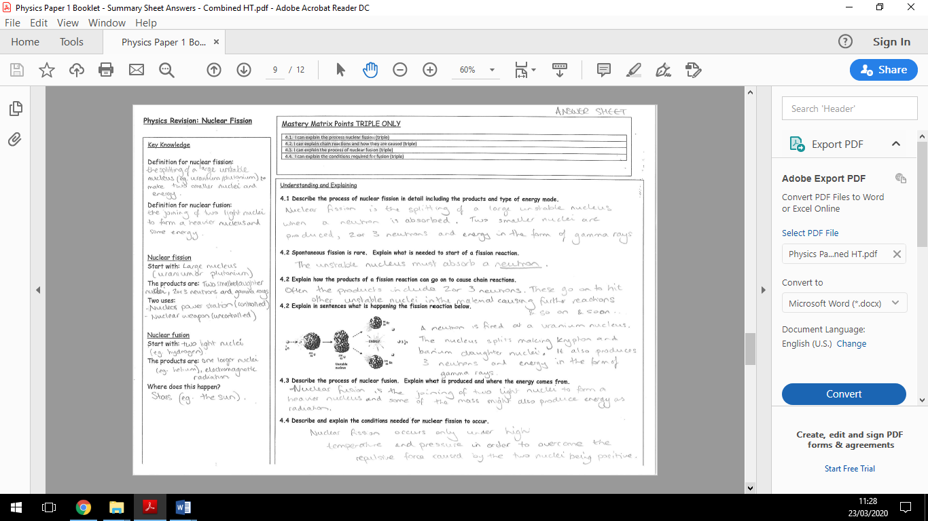

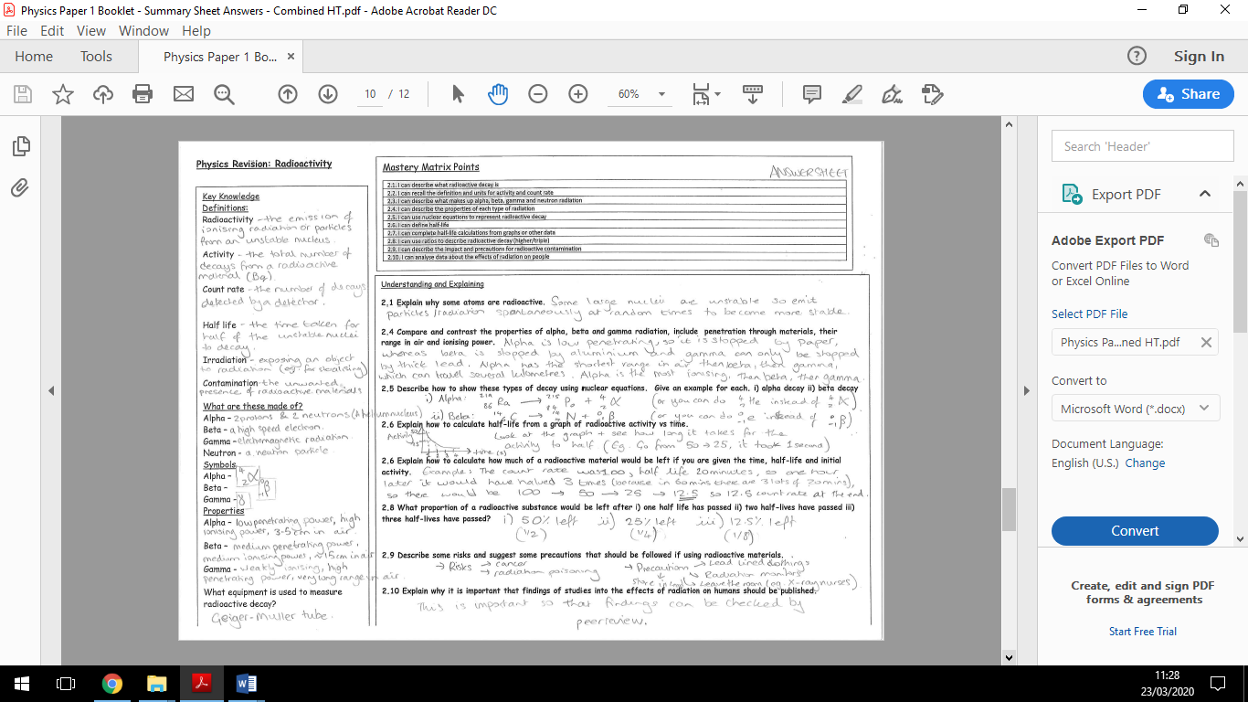

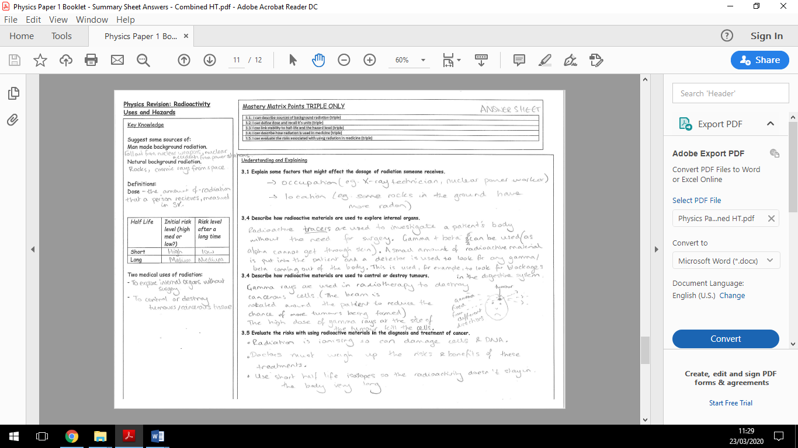

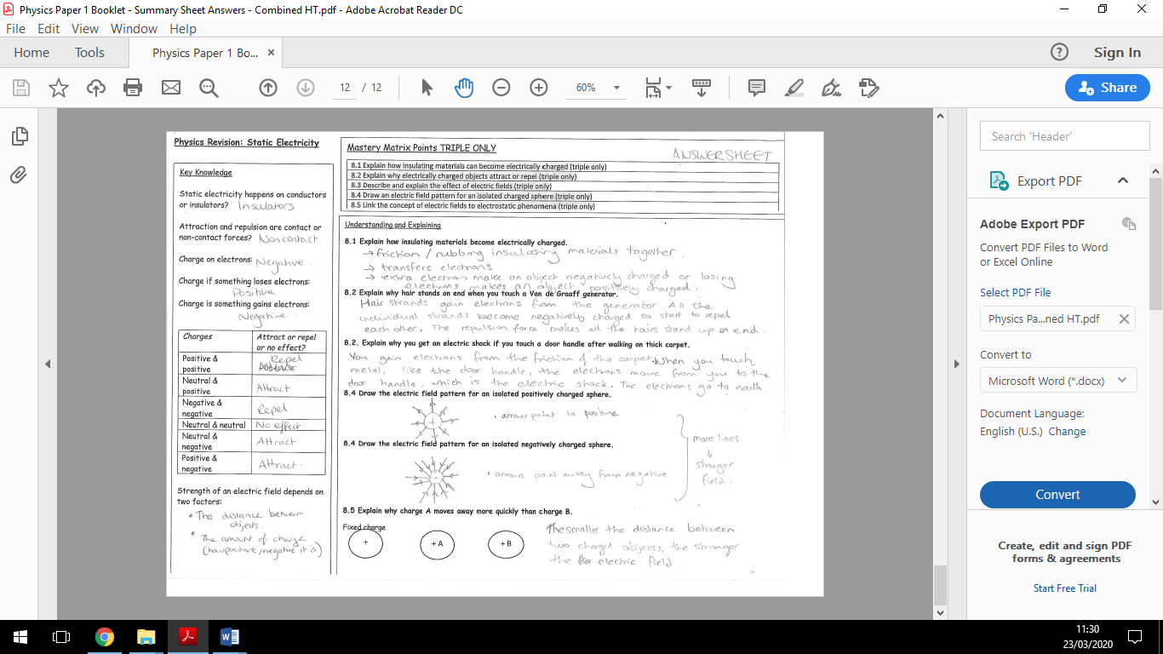

**Physics RP Revision - P1 –**

Method:

1) Measure the mass of the copper block using the top pan balance.

2) Wrap insulation around the block.

3) Place the heater in the larger hole in the block

4) Connect the ammeter and power pack and heater in series and the voltmeter in parallel across the heater.

5) Use a pipette to add a small amount of water to the other hole and put the thermometer in this hole.

6) Set the power pack to 12V and turn it on.

7) Record the ammeter and voltmeter readings

8) Measure the temperature of the copper block and start the stop clock.

9) Record the temperature every minute for 10 minutes.

10) Record your results and use this to calculate the specific heat capacity of the copper block.

11) Repeat with the iron and aluminium blocks.

Common error made in this practical:

Not starting the stopwatch at the correct time, not reading the temperature at the correct time

Describe how you could improve the accuracy of the results:

- Insulate the metal block so the thermal energy does not dissipate

- Read the temperature at eye level

Describe how to find specific heat capacity:

1. Calculate the power of the heater in watts using P = IV.

P = I V

P =

P = W

1. Calculate the work done by the heater using E = Pt

E = Pt

E =

E = J

OR

1. Plot a graph of temperature in oC against work done in J on graph paper.



2. Draw a line of best fit. Take care as the beginning of the graph may be curved.

3. Mark two points on the line you have drawn and calculate the change in temperature (θ) and the change in work done (E) between these points

4. Calculate the specific heat capacity of the block to 2 sf by using the equation

$\text{c = }\frac{\text{E}}{\text{m }\text{ θ }}$ where *m* is the mass of the copper block

**Specific Heat Capacity**

Key Knowledge

Define:

Aim: Determine the specific heat capacity of a material

IV: Material

DV: Temperature change

CV: Energy input, time, mass of the block

Risk and precaution:

Hot water – take care not to touch and wear safety goggles

Equipment:

*3 metal blocks (copper, iron, aluminium)

*a thermometer

*a pipette to put water in the thermometer hole

*a 12 V immersion heater

*a 12 V power supply

*an ammeter and a voltmeter

*five connecting leads

*a stop clock

*a balance.

**Physics RP Revision –**

Understanding and Explaining

**Method and equipment 1:**

*a large beaker

*a small beaker

*a thermometer

*a kettle to heat water

*a piece of cardboard with hole in as a lid *scissors

*a stop clock

*a selection of insulating materials.

1) Put a small beaker inside a large beaker.

2) Add 80cm3 of hot water into the small beaker.

3) Use a piece of cardboard as a lid for the large beaker. It must have a hole in the top for a thermometer.

4) Put the thermometer through the lid into the hot water and record the temperature and start the stop clock.

5) Record the temperature for 3 minutes for 15 minutes.

6) Repeat filling the space between the small and large beaker with different materials.

**Method and equipment 2:**

*100 cm3 beaker

*thermometer

*piece of cardboard with hole

*scissors

*stopwatch

*insulating material

*rubber bands

1) Add 80cm3 of hot water into the beaker.

2) Add a lid to the beaker.

3) Insert the thermometer through the hole in the lid so the bulb is in the hot water.

4) Record the temperature and start the stopwatch.

5) Record the temperature of the water every 3 minutes for 15 minutes.

6) Repeat wrapping 2 layers, 4 layers and then 6 layers of newspaper around the beaker.

**P2 Thermal insulation (triple only)**

Key Knowledge

Aim 1: Investigate the effectiveness of different thermal insulators

IV: Type of material

DV: Temperature change

CV: Volume of water, use of a lid, thickness of material.

Aim 2:

How does thickness of a material affect thermal insulation

IV: Thickness of material

DV: Temperature change

CV: Type of material, volume of water

Risk and precaution:

Hot water – take care not to touch and wear safety goggles

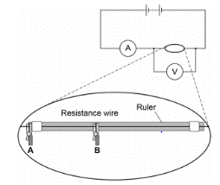**Physics RP Revision – P3 - Resistance**

Key Knowledge

Aim 1: Investigate the effect of the length of a wire on resistance

IV: Length of wire

DV: Resistance

CV: Thickness of the wire

Aim 2: Investigate the effect of different combinations of resistors in series and in parallel.

Risk and precaution:

The wires will get hot – ensure that the power pack is turned off after each reading and do not touch the wires

Understanding and Explaining

Method and equipment 1:

*a power supply

*ammeter

*voltmeter

*crocodile clips

*resistance wire

*metre rule

*connecting leads

1) Set up the circuit as shown in the diagram below.

2) Place the crocodile clips A and B 10cm apart on the wire.

3) Turn on the power pack and measure the readings for the voltmeter and ammeter at this distance.

4) Turn off the power pack so that the wire does not overheat.

5) Move the crocodile clips so that they are 20cm, 30cm, 40cm and 50cm apart and repeat steps 3 & 4.

6) Calculate resistance for each length of wire.

7) Repeat the experiment three times and remove any anomalies so that you can calculate an accurate mean.

Describe the expected results:

As length of wire increases, resistance should increase in a directly proportional relationship. This is because there are more ions for the electrons to collide with.

Method and equipment 2:

*a battery or suitable power supply

*a switch

*ammeter

*voltmeter

*crocodile clips

*two 10 Ω resistors

*connecting leads

1) Set up the circuit as shown below.

2) Switch on and record the readings on the ammeter and the voltmeter.

3) Calculate the total resistance of the series circuit.

4) Set up the circuit for two resistors in parallel.

5) Calculate the total resistance of the parallel circuit.

Describe the expected results:

Total resistance in the series circuit should be approximately 20Ω.

Total resistance in the series circuit should be less than 10Ω.

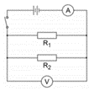

**Physics RP Revision –**

Understanding and Explaining

A filament light bulb/resistor:

1) Use the circuit diagram to set up your circuit.

2) Record the readings on the ammeter and voltmeter.

3) Adjust the voltage on the power pack.

4) Repeat the reading on the ammeter and voltmeter.

5) Switch the wires around on the power pack so that the current is flowing in the opposite direction.

6) Continue to vary the voltage and record the readings on the ammeter and voltmeter.

7) Repeat the experiment but swapping the filament light bulb for a resistor.



A diode:

1) Lower the potential difference to less than 5V.

2) Set up the circuit as shown to the right.

3) Record the readings on the milliammeter and voltmeter.

4) Adjust the potential difference several times to collect several pairs of readings.

5) Swap the wires so that the current flows in the opposite direction and take 4 more pairs of readings.



**P4 – IV characteristics & Ohms’ Law**

Key Knowledge

Aim : Use circuits to investigate the I-V characteristics of a filament lamp, diode and a resistor.

Equipment:

Filament light bulb/resistor:

*ammeter

*voltmeter

*wires

*filament lamp

*variable power pack

*resistor

Diode:

*Milliammeter

*voltmeter

*wires

*diode

*variable power pack

*resistor labelled P

**Filament Bulb:**

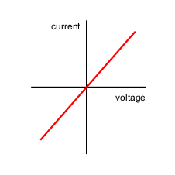

**Resistor:**



**Diode**:

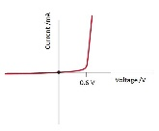

**Physics RP Revision – P5 – Density**

Understanding and Explaining

Regular objects:

1) Calculate the volume of the object using length x width x height.

2) Record the mass of the object using the top pan balance

3) Calculate the density by dividing mass by volume.

Irregular objects:

1) Measure the mass of the irregular shaped object using a top pan balance.

2) Put the displacement can on a wooden block with the spout above an empty beaker.

3) Fill the can with water until the water drips from the spout.

4) Replace the beaker with the measuring cylinder which will give the most accurate reading.

5) Place the object into the displacement can until it is completely submerged.

6) Collect the water and this will give you the volume of the object.

7) Divide this by the object’s mass to give the density.

A liquid:

1) Measure the mass of an empty measuring cylinder.

2) Add 100cm3 of sugar solution into it and record the mass.

3) Use this to calculate the mass of the liquid (total mass – mass of measuring cylinder).

4) Then calculate the liquid’s density by doing volume/mass.

Key Knowledge

Aim : Determine the density of regular and irregularly shaped objects.

Regular objects:

*various regular shaped objects *30cm ruler

*digital balance

Irregular objects:

*a digital balance

* a displacement can

* various measuring cylinders

*beaker of water and an extra empty beaker

*paper towels

*a selection of irregularly shaped objects.

A liquid

*a digital balance

*a 100cm3 measuring cylinder

*sugar solution of unknown concentration

Mark schemes

**Q1.**

(a)     0.1 (°C)

**1**

(b)     power = energy transferred / time

*allow P = E / t*

**1**

*allow E = P × t*

(c)     1050 / 300

**1**

3.5 (W)

**1**

*accept 3.5 (W) with no working shown for* ***2*** *marks*

(d)     1050 = m × 4200 × 0.6

**1**

m = 1050 / (4200 × 0.6)

**1**

m = 0.417 (kg)

**1**

*accept 0.417 (kg) with no working shown for* ***3*** *marks*

(e)     any **one** from:

•        energy used to heat metal pan (as well as the water)

•        energy transfer to the surroundings (through the insulation)

•        angle of solar radiation will have changed during investigation

•        intensity of solar radiation may have varied during investigation

**1**

**[8]**

**Q2.**

(a)     78 (°C)

*allow* ***2*** *marks for correct temperature change ie 22 °C*

*allow* ***1*** *mark for correct substitution*

*ie 46 200 = 0.5 × 4200 x θ*

***or***



**3**

(b)     6.4 (W)

*allow* ***2*** *marks for an answer that rounds to 6.4*

*allow* ***1*** *mark for correct substitution*

*ie 46 200 = P × 7200*

*an answer of 23 000 or 23 100 or 385 gains 1 mark*

**2**

**[5]**

**Q3.**

(a)     energy required to raise the temperature of a substance by 1 °C

*accept heat for energy*

**1**

unit mass / 1 kg

**1**

(b)     (i)      7 140 000 (J)

*allow 2 marks for a correct substitution, ie*

*E = 20 × 420 × 850*

*provided no subsequent step*

*850 gains* ***1*** *mark if no other mark awarded*

**3**

(ii)     particles in the air have more (kinetic) energy than the particles in the steel

*allow particles in the air have a greater speed.*

**1**

**steel**

particles vibrate (about fixed positions)

**1**

**air**

particles move freely

**1**

**Q4.**

(a)     4200

*allow* ***2*** *marks for correct substitution   
ie 6930 = 0.330 × c × 5.0*

*answers of 1050* ***or*** *840*

***or***

*correctly calculated answer from correct substitution of incorrect temperature change*

***or***

*identification of temperature change ie 5 °C   
gain* ***1*** *mark*

**3**

J / kg°C

*accept J / kg K*

**1**

(b)     (in a metal) free electrons

*to gain full credit the answer must be in terms of free electrons*

**1**

gain kinetic energy

*accept move faster*

**1**

(free electrons) transfer energy to other electrons / ions / atoms

*do* ***not*** *accept particles*

**1**

by collision

*allow a maximum of* ***2*** *marks for answers in terms of atoms / ions / particles*

*•        gaining kinetic energy or vibrating faster / more*

*•        transferring energy by collisions*

**1**

(c)     (air) particles spread out

**1**

(which causes the) air to become less dense / expand

*do* ***not*** *accept particles become less dense*

**1**

(so the) warm air rises

*do* ***not*** *accept heat rises   
particles rise is insufficient*

**1**

(d)     large surface area

*ignore references to type of metal or external conditions*

**1**

black / dark (colour)

**1**

**[13]**

**Q5.**

(a)     g.p.e. = mass × gravitational field strength × height

*accept Ep = mgh*

**1**

(b)     Ep = 50 × 9.8 × 20

**1**

9800 (J)

*allow 9800 (J) with no working shown for* ***2*** *marks*

*answer may also be correctly calculated using W = Fs*

*ie allow W = 490 × 20 for* ***1*** *mark*

*or answer of 9800 (J) using this method for* ***2*** *marks*

**1**

(c)     7840 (J)

*allow ecf from ‘11.2’*

**1**

(d)     7840 = ½ × 50 × v2

**1**



*allow  for this point*

**1**

17.7(0875) (m / s)

**1**

18 (m / s)

*allow ecf from ‘11.3’ correctly calculated for* ***3*** *marks*

*allow 18 (m / s) with no working for* ***2*** *marks*

*answer may also be correctly calculated using v2 – u2 = 2as*

**1**

(e)     extension = 35 (m) and conversion of 24.5 kJ to 24500 J

**1**

24 500 = ½ × k × 352

**1**

40

**1**

*allow 40 with no working shown for* ***3*** *marks*

*an answer of ‘16.2’ gains* ***2*** *marks*

**[11]**

**Q6.**

(a)     elastic potential

**1**

(b)     (i)      line is straight

*accept line does not curve*

**1**

(ii)     400

*allow* ***1*** *mark for correct substitution of any pair of numbers correctly taken from the graph e.g.160 = k × 0.40*

**2**

newtons per metre **or** N/m

*if symbols are used they must be correct*

**1**

(iii)     300

*allow* ***1*** *mark for correctly obtaining force on 1 spring = 100N*

**2**

(c)     52

*allow* ***2*** *marks for calculating change in gpe for 1 chin-up as 260 (J) or for 12 chin-ups as 3120 (J)*

*an answer 4.3 gains* ***2*** *marks*

*allow* ***1*** *mark for correct substitution into gpe equation ie gpe = 65 × 10 × 0.4 (× 12)*

***or***

*correct use of power equation with an incorrect value for energy transferred*

**3**

**[10]**

**Q7.**

any **two** pairs from:

*to gain credit it must be clear which model is being described*

*do* ***not*** *accept simple descriptions of the diagram without comparison*

•         nuclear model mass is concentrated at the centre / nucleus (1)

*accept the nuclear model has a nucleus / the plum pudding model does not have a nucleus for* ***1*** *mark*

plum pudding model mass is evenly distributed (1)

•         nuclear model positive charge occupies only a small part of the atom (1)

plum pudding model positive charge spread throughout the atom (1)

•        nuclear model electrons orbit some distance from the centre (1)

*accept electrons in shells / orbits provided a valid comparison is made with the plum pudding model*

plum pudding electrons embedded in the (mass) of positive (charge) (1)

*do* ***not*** *accept electrons at edge of plum pudding*

•        nuclear model the atom mainly empty space (1)

plum pudding model is a ‘solid’ mass (1)

**[4]**

**Q8.**

(a)     most alpha particles pass straight through the atom

**1**

which shows that the atom is mostly empty space

**1**

very few alpha particles are deflected through a large angle

**1**

which shows the atom contains a nucleus where the mass / charge of the atom is concentrated

**1**

(b)     electron may absorb electromagnetic radiation

*full credit may be scored for a description of an electron emitting electromagnetic radiation*

**1**

(and) move further from the nucleus

**1**

to a higher energy level

**1**

**[7]**

**Q9.**

(a)     cannot predict which dice / atom will ‘decay’

*accept answers given in terms of ‘roll a 6’*

**1**

cannot predict when a dice / atom will ‘decay’

**1**

(b)     3.6 to 3.7 (rolls)

*allow* ***1*** *mark for attempt to read graph when number of dice = 50*

**2**

(c)     90

**1**

(d)     uranium

**1**

(e)     beta

**1**

proton number has gone up (as neutron decays to proton and e–)

**1**

(f)     prevents contamination

**or**

prevents transfer of radioactive material to teacher’s hands

**1**

which would cause damage / irradiation over a longer time period.

**1**

**[10]**

**Q10.**

(a)     (i)      18

**1**

(ii)     the count rate for the source

**1**

(iii)    the alpha radiation would not cover such a distance

**1**

(iv)    plots correct to within ½ small square

*allow* ***1*** *mark for 4 correct points plotted*

**2**

correct curve through points as judged by eye

**1**

(v)     two attempts at finding ‘half-distance’ using the table

*20 to 10 cpm d = 0.4 m  
125 to 56 cpm d = 0.2 m  
31 to 14 cpm d = 0.4 m*

*allow* ***1*** *mark for one attempted comparison*

**2**

obeyed or not obeyed

*dependent on previous two marks*

**1**

(b)     (i)      there is no effect on the count rate in experiment 1 because the field is parallel **or** beta particles are not deflected **or** there is no force

**1**

count rate is reduced in experiment 2 because field is perpendicular **or** beta particles are deflected **or** there is a force

**1**

(ii)     only background radiation (as beta do not travel as far)

**1**

slightly different values show the random nature of radioactive decay

**1**

**[13]**

**Q11.**

(a)     current

**1**

(b)     4.2 = 3.5 × 10–3 × R

**1**

R = 4.2 / 3.5 × 10–3

**1**

R = 1200 (Ω)

*an answer of 1200 (Ω) scores* ***3*** *marks*

*an answer of 1.2 scores* ***2*** *marks*

**1**

(c)     conversion from minutes to seconds (300 s)

**1**

Q = 0.0035 × (5 × 60)

**1**

Q = 1.05 C

*an answer of 1.05 (C) scores* ***3*** *marks*

*an answer of 17.5 scores* ***1*** *mark*

*an answer of 1050 or 0.0175 scores* ***2*** *marks*

**1**

(d)     (potential difference) increases

**1**

(because thermistor) resistance increases

*2nd mark dependent on scoring 1st mark*

**1**

(e)     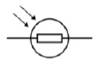

**1**

**[10]**

**Q12.**

(a)     *attempt to draw four cells in series*

**1**

*correct circuit symbols*

*circuit symbol should show a long line and a short line, correctly joined together*

*example of correct circuit symbol:*

**

**1**

(b)     (i)      6 (V)

*allow* ***1*** *mark for correct substitution, ie*

*V = 3  ×  2 scores* ***1*** *mark*

*provided no subsequent step*

**2**

(ii)     12 (V)

*ecf from part (b)(i)*

*18  –  6*

***or***

*18  –  their part (b)(i) scores* ***1*** *mark*

**2**

(iii)    9 (Ω)

*ecf from part (b)(ii) correctly calculated*

*3 + their part (b)(ii) / 2*

***or***

*18 / 2 scores* ***1*** *mark*

*provided no subsequent step*

**2**

(c)     (i)      need a.c.

**1**

battery is d.c.

**1**

(ii)     3 (A)

*allow* ***1*** *mark for correct substitution, ie*

*18  ×  2 = 12  ×  Is scores* ***1*** *mark*

**2**

**[12]**

**Q13.**

(a)     (i)      symbol for a diode 

*accept *

**1**

symbol for a variable resistor  

**1**

(ii)      voltmeter is in series **or** voltmeter is not in parallel

**1**

ammeter is in parallel **or** ammeter is not in series

*accept an answer in terms of how the circuit should be corrected*

*voltmeter and ammeter are wrong way around is insufficient*

**1**

(b)     (i)      0.2 (V)

*accept any value between 0.20 and 0.21 inclusive*

**1**

(ii)     37.5

*allow* ***1*** *mark for I = 0.008****or*** *allow* ***2*** *marks for correct substitution, ie 0.3 = 0.008 × R****or*** *allow* ***1*** *mark for a correct substitution using I = 0.8* ***or*** *I = 0.08****or*** *I = 0.009****or*** *allow* ***2*** *marks for answers of 0.375* ***or*** *3.75* ***or*** *33(.3)*

**3**

(c)     (i)       25

*allow* ***1*** *mark for obtaining period = 0.04(s)*

**2**

(ii)     diode has large resistance in reverse / one direction

**1**

so stops current flow in that / one direction

*allow diodes only let current flow one way / direction*

*allow* ***1*** *mark for the diode has half-rectified the (a.c. power) supply*

**1**

**[12]**

**Q14.**

(a)     electric current  
(rate of) flow of (electric) charge / electrons

*accept *

*with Q and t correctly named*

**1**

potential difference  
work done / energy transferred per coulomb of charge   
(that passes between two points in a circuit)

*accept *

*with W and Q correctly named*

**1**

(b)     metals contain free electrons (and ions)

*accept mobile for free*

**1**

as temperature of filament increases ions vibrate faster /   
with a bigger amplitude

*accept atoms for ions*

*accept ions/atoms gain energy*

*accept vibrate more for vibrate faster*

*do not accept start to vibrate*

**1**

electrons collide more (frequently) with the ions  
**or**(drift) velocity of electrons decreases

*do not accept start to collide*

*accept increasing the p.d. increases the temperature (****1*** *mark)*

***and***

*(and) resistance increases with temperature (****1*** *mark) if no other marks scored*

**1**

(c)     7.8

*allow* ***1*** *mark for obtaining value 1.3 from graph*

***or*** *allow* ***1*** *mark for a correct calculation using an incorrect current in the range 1.2-1.6 inclusive*

**2**

**[7]**

**Q15**

(a)    d.c. flows in (only) one direction

**1**

a.c. changes direction (twice every cycle)

*accept a.c. constantly changing direction*

*ignore references to frequency*

**1**

(b)     a current flows through from the live wire / metal case to the earth wire

*accept a current flows from live to earth*

*do* ***not*** *accept on its own if the current is too high*

**1**

this current causes the fuse to melt

*accept blow for melt*

*do* ***not*** *accept break / snap / blow up for melt*

**1**

**[4]**

**Q16.**

*do* ***not*** *give any credit for renewable* ***or*** *non-renewable* ***or*** *installation* ***or*** *decommissioning costs*

**fossil fuel advantage**

**1**

          a reliable source of energy

**fossil fuel disadvantage**

          pollution by carbon dioxide /

*accept causes acid rain  
accept highest costs / more expensive than nuclear / more expensive than renewable*

**1**

**nuclear advantage**

          do not produce gases that increase the  
greenhouse effect **or** cause acid rain

*accept nuclear is cheaper than fossil*

**1**

**nuclear disadvantage**

          accidents / waste can release very dangerous radioactive material radiation

*accept it produces waste that stays dangerously radioactive for thousands of years* ***or*** *radioactive waste has to be stored safely for thousands of years*

**1**

**renewable advantage**

          there are no fuel costs

*almost pollution free (apart from noise and visual)  
accept cheaper than fossil*

**1**

**renewable disadvantage**

          not a reliable source of energy except for hydroelectric

*accept (most) require large areas of land  
accept visual / noise pollution*

**1**

**[6]**

**Q17.**

(a)     97 500 = 65.0 × t

**1**



**1**

t = 1500 (s)

*an answer of 1500 (s) scores* ***3*** *marks*

*an answer of 1.5 scores* ***2*** *marks*

**1**

(b)     19.6 = I2 × 1.60

**1**



**1**

I = 3.5 (A)

*allow 1 mark for a correct value for I correctly multiplied by 4*

**1**

current through battery = 14 (A)

*an answer of 14 (A) scores* ***4*** *marks*

**1**

**[7]**

**Q18**

(a)     any **one** from:

•         energy / source is constant

•         energy / source does not rely on uncontrollable factors

*accept a specific example, eg the weather*

•         can generate all of the time

*will not run out is insufficient*

**1**

(b)     (dismantle and) remove radioactive waste / materials / fuel

*accept nuclear for radioactive*

*knock down / shut down is insufficient*

**1**

(c)      any **two** from:

•         reduce use of fossil fuelled power stations

*accept specific fossil fuel   
accept use less fossil fuel*

•         use more nuclear power

*accept build new nuclear power stations*

•         use (more) renewable energy sources

*accept a named renewable energy source   
do* ***not*** *accept natural for renewable*

•         make power stations more efficient

•         (use) carbon capture (technology)

*do* ***not*** *accept use less non-renewable (energy) sources*

**2**

(d)     (by increasing the voltage) the current is reduced

**1**

this reduces the energy / power loss (from the cable)

*accept reduces amount of waste energy   
accept heat for energy   
do* ***not*** *accept stops energy loss*

**1**

and this increases the efficiency (of transmission)

**1**

**[7]**

**Q19.**

**Level 3 (5–6 marks):**

Clear and coherent description of both methods including equation needed to calculate density. Steps are logically ordered and could be followed by someone else to obtain valid results.

**Level 2 (3–4 marks):**

Clear description of one method to measure density **or** partial description of both methods. Steps may not be logically ordered.

**Level 1 (1–2 marks):**

Basic description of measurements needed with no indication of how to use them.

**0 marks:**

No relevant content.

**Indicative content**

**For both:**

•        measure mass using a balance

•        calculate density using ρ = m / V

**Metal cube:**

•        measure length of cube’s sides using a ruler

•        calculate volume

**Small statue:**

•        immerse in water

•        measure volume / mass of water displaced

•        volume of water displaced = volume of small statue

**[6]**

**Q20.**

(a)     surface area

**or**

duration of experiment

*accept shape of beaker*

*size of beaker is insufficient*

**1**

(b)     any **two** from:

•        takes readings automatically

*ignore easier* ***or*** *takes readings for you*

•        takes readings more frequently

•        reduces / no instrument reading error

*ignore human error*

•        higher resolution

*allow better resolution*

•        don't need to remove probe to take reading

•        more accurate

**2**

(c)     (i)      0.07 (°C/s)

*allow* ***1*** *mark for obtaining a temperature drop of 7 (°C)*

*allow* ***1*** *mark for an answer between 0.068 and 0.069 (°C/s)*

**2**

(ii)     rate of temperature change is greater at the start

*accept rate of evaporation is greater at the start*

**or**

rate of temperature change decreases

*allow rate of evaporation decreases*

*allow temperature decreases faster at the start*

**1**

(iii)     A

*reason only scores if A is chosen*

lower temperature decrease (over 200 seconds)

*accept lower gradient*

**1**

(iv)     no effect (as rate of evaporation is unchanged)

*allow larger temperature change (per second as mass of liquid is lower)*

**1**

(d)     particles with more energy

*accept particles with higher speeds*

**1**

leave the (surface of the) liquid

**1**

(which) reduces the average (kinetic) energy (of the remaining particles)

*allow reference to the total energy of the liquid reducing*

**1**

**[11]**

**Q21.**

(a)    there are strong forces (of attraction) between the particles in a solid

*accept molecules / atoms for particles throughout   
accept bonds for forces*

**1**

(holding) the particles close together

*particles in a solid are less spread out is insufficient*

**1**

**or**

(holding) the particles in a fixed pattern / positions

but in a gas the forces between the particles are negligible

*accept very small / zero for negligible   
accept bonds for forces*

**1**

so the particles spread out (to fill their container)

*accept particles are not close together   
gas particles are not in a fixed position is insufficient*

**1**

(b)     (i)      particles are (shown) leaving (the liquid / container)

*accept molecules / atoms for particles throughout*

*accept particles are escaping  
particles are getting further apart is insufficient*

**1**

(ii)                *accept molecules / atoms for particles throughout  
          accept speed / velocity for energy throughout*

particles with most energy leave the (surface of the) liquid

*accept fastest particles leave the liquid*

**1**

so the mean / average energy of the remaining particles goes down

**1**

and the lower the average energy (of the particles) the lower the temperature (of the liquid)

**1**

**[8]**

**Q22.**

(a)     any **two** from:

•        (air) particles / molecules / atoms gain energy

•        (air) particles / molecules / atoms move faster

*do* ***not*** *accept move more  
do* ***not*** *accept move with a bigger amplitude / vibrate more*

•        (air) particles / molecules / atoms move apart

•        air expands

*ignore particles expand*

•        air becomes less dense

*ignore particles become less dense*

•        warm / hot air / gases / particles rise

*do* ***not*** *accept heat rises*

*answers in terms of heat particles negates any of the mark points that includes particles*

**2**

(b)     (i)      any **two** from

•    free / mobile electrons gain (kinetic) energy

*accept free / mobile electrons move faster*

*accept vibrate faster for gain energy*

•    free electrons collide with other (free) electrons / ions / atoms / particles

•    atoms / ions / particles collide with other atoms / ions / particles

*answers in terms of heat particles negates this mark point*

**2**

(ii)     (faster) energy / heat transfer to room(s) / house

*accept room(s) / house gets warm(er)*

*accept lounge / bedroom / loft for rooms*

**1**

**[5]**

**Q23.**

(a)     1 (cm3)

**1**

(b)     pressure is inversely proportional to volume

**1**

data to prove inversely proportional relationship

*eg 8 × 200 = 1600*

*and 10 × 160 = 1600*

*if no other marks score allow for* ***1*** *mark: as volume decreases pressure increases*

**2**

(c)     (as the gas is compressed) the volume of gas decreases

**1**

(so there are) more frequent collisions of gas particles with container walls

**1**

(and) each particle collision with the wall causes a force

**1**

(so there is a) greater force on walls

**1**

**[8]**

**Q24.**

(a)     range of speeds

**1**

moving in different directions

*accept random motion*

**1**

(b)     internal energy

**1**

(c)     density = mass / volume

**1**

(d)     0.00254 / 0.0141

**1**

0.18

**1**

*accept 0.18 with no working shown for the* ***2*** *calculation marks*

kg / m3

**1**

**[7]**