**11C Science Revision Plan**

**Follow the schedule below each day and complete the following:**

1. Practice your knowledge using LCWC in a blank exercise book.

2. Complete your summary sheets independently or using your revision guide

3. Check your answers using the mark scheme

4. Complete the exam style questions in the booklet and mark these using the mark scheme

4. Choose a ‘Bridging Booklet’ to complete and self-assess your answers using the mark scheme at the back (you don’t need to print these but you can complete them in your

|  |  |  |  |  |  |
| --- | --- | --- | --- | --- | --- |
| **Week\Lesson** | **1** | **2** | **3** | **4** | **Week\Lesson** |
| **4 - 16th March** |  | Series and Parallel Circuits | Mains electricity | The National Grid | Changes of state and latent heat |
| Ohmic/Non-ohmic and types of resistors | Energy and Power of Electricity | Density | Specific Heat Capacity |
| **5 - 23rd March** | Physics equations practice | Physics RPs | Elements & Compounds | Mixtures (paper 2) |
| Mixtures | Metals in the periodic table (paper 2) |
| **6 - 30th March** | Alkanes and Alkenes (paper 2) | Cracking (paper 2) | Structure of an atom | Metals in the periodic table |
| Fractional Distillation (paper 2) | Organic Compounds (paper 2) | Types of bonding | Reactions of metals |
| **Easter** |  |  |  |  |  |
|  |  |  |  |  |

|  |  |  |  |  |
| --- | --- | --- | --- | --- |
| **1 - 20th April** | Describing chemical reactions  Groups in the periodic table | Acids & alkalis  Chemical tests & calculations | Reactivity of metals  Electrolysis | Exothermic and Endothermic reactions  Volumes and concentrations |
| **2 - 27th April** | Mop up/practice | Mop up/practice | Types of cell  Microscopy | Cell division (mitosis)  Introducing pathogens and types of disease |
| **3 - 4th May** | Detailed disease case studies  Preventing pathogen from making us unwell | Developing new medicines  Using and interpreting data | Breathing and respiration  Blood and the heart | Digestion  Diffusion |
| **4 - 11th May** | EXAMS | | | |
|

**OASB Science Department**

**Chemistry Paper 1 Revision Pack (Combined – HT)**

|  |  |  |
| --- | --- | --- |
| Contents | Lesson | Page |
| Mastery Matrix Chemistry Paper 1 |  |  |
| Knowledge | 1 |  |
| Elements and compounds and mixtures Summary Page |
| Notes page |
| Exam Questions |
| Knowledge | 2 |  |
| Summary of an atom and types of bonding Summary Page |
| Notes page |
| Exam Questions |
| Knowledge | 3 |  |
| Metals in the periodic table and reactions of metals Summary Page |
| Notes page |
| Exam Questions |
| Knowledge | 4 |  |
| Describing chemical reactions & groups in the periodic table Summary Page |
| Notes page |
| Exam Questions |
| Knowledge | 5 |  |
| Acids & alkalis Summary Page |
| Notes page |
| Exam Questions |
| Knowledge | 6 |  |
| Electrolysis Summary Page |
| Notes page |
| Exam Questions |
| Knowledge | 7 |  |
| Exothermic and endothermic reactions Summary Page |
| Notes page |
| Exam Questions |
| Knowledge | 8 |  |
| Volumes and concentrations and chemical calculations Summary Page |
| Notes page |
| Exam Questions |
| Summary Sheet Answers |  |  |
| Exam Question Mark Schemes |  |  |



|  |  |  |  |  |
| --- | --- | --- | --- | --- |
| Topic |  | Tier | Page | Learning objective |
| Chemistry Fundamentals | Elements & Compounds | F | 94 | Describe and draw a model of the three states of matter |
| Chemistry Fundamentals | Elements & Compounds | F | 94 | Use the particle model to explain melting, boiling, freezing and condensing |
| Chemistry Fundamentals | Elements & Compounds | HT | 94 | Explain the limitations of the particle theory |
| Chemistry Fundamentals | Elements & Compounds | F | 95 | Identify a substance’s state using its melting and boiling point |
| Chemistry Fundamentals | Elements & Compounds | F | 88 | Classify a substance as an element or compound |
| Chemistry Fundamentals | Elements & Compounds | F | 88 | Identify the symbol for the first 20 elements |
| Chemistry Fundamentals | Elements & Compounds | F | 88 | Name common compounds from their formula |
| Chemistry Fundamentals | Mixtures | F | 89 | Use key terms (soluble, insoluble, solute, solvent and solution) correctly to describe a substance dissolving |
| Chemistry Fundamentals | Mixtures | F | 89 | Explain how to separate given mixtures (filtration, crystallisation, simple distillation, fractional distillation, chromatography) |
| Chemistry Fundamentals | Structure of an atom | F | 90 | Describe the plum pudding model of the atom |
| Chemistry Fundamentals | Structure of an atom | F | 90 | Describe the current (nuclear) model of the atom giving the relative charge and mass of the subatomic particles |
| Chemistry Fundamentals | Structure of an atom | F | 90 | Recall the radius of an atom and it’s nucleus |
| Chemistry Fundamentals | Structure of an atom | F | 91 | Calculate protons, neutrons and electrons for an atom linking to mass and atomic number |
| Chemistry Fundamentals | Structure of an atom | F | 91 | Draw the electronic structure and work out the electronic configuration for a given atom |
| Chemistry Fundamentals | Structure of an atom | F | 91 | Define an ‘isotope’ |
| Chemistry Fundamentals | Structure of an atom | F | 212 | Link isotopes to relative atomic mass to explain why this is an average |
| Chemistry Fundamentals | Structure of an atom | F | 212 | Calculate the relative atomic mass of an element given the percentage abundance of it’s isotopes |
| Chemistry Fundamentals | Structure of an atom | F | 103 | Calculate the relative formula mass of a substance |
| Chemistry Fundamentals | Metals in the periodic table | F | 92 | Describe how Mendeleev has arranged the periodic table |
| Chemistry Fundamentals | Metals in the periodic table | F | 101 | Explain why something is classified as a metal or non-metal |
| Chemistry Fundamentals | Metals in the periodic table | F | 101 | Describe the uses of metals |
| Chemistry Fundamentals | Metals in the periodic table | F | 88 | Define a ‘chemical reaction’ and given examples |
| Chemistry Fundamentals | Metals in the periodic table | F | 101 | Explain what an alloy is and how it’s properties differ from a pure metal |
| Chemistry Fundamentals | Groups in the periodic table | F | 92+93 | Describe the key properties (state, easy to cut, appearance) of group 1 |
| Chemistry Fundamentals | Groups in the periodic table | F | 92 | Describe and explain how the reactivity changes as you move down group 1 (oxygen, chlorine, water) |
| Chemistry Fundamentals | Groups in the periodic table | F | 93 | Describe the key properties (molecular mass, boiling and melting point) of group 7 |
| Chemistry Fundamentals | Groups in the periodic table | F | 93 | Describe and explain how the reactivity changes as you move down group 7 |
| Chemistry Fundamentals | Groups in the periodic table | F | 92 | Describe the key properties (boiling point, density, reactivity) of group 0 |
| Chemistry Fundamentals | Groups in the periodic table | F | 92 | Describe and explain how the reactivity changes as you move down group 0 |
| Investigative Chemistry | Types of bonding | F | 97 | Describe the structure and properties of giant ionic structures |
| Investigative Chemistry | Types of bonding | F | 97 | Link the structure of giant ionic structures to it’s properties |
| Investigative Chemistry | Types of bonding | F | 98 | Describe the structure and properties of simple covalent structures |
| Investigative Chemistry | Types of bonding | F | 99 | Describe the structure and properties of giant covalent structures (including diamond, graphite and silica) |
| Investigative Chemistry | Types of bonding | F | 99+100 | Compare and contrast giant carbon structures (diamond, graphite, graphene and fullerene – Buckminster fullerenes and nanotubes as examples) |
| Investigative Chemistry | Types of bonding | F |  | Describe two uses of nanotechnology |
| Investigative Chemistry | Types of bonding | F | 101 | Describe how a substance bonds metallically |
| Investigative Chemistry | Types of bonding | F | 101 | Link the structure of giant metallic structures to their properties |
| Investigative Chemistry | Describing chemical reactions | F | 88 | Write a word equation for a given reaction |
| Investigative Chemistry | Describing chemical reactions | F | 88 | Write a balanced symbol equation for a given reaction |
| Investigative Chemistry | Describing chemical reactions | F | 95 | Include appropriate state symbols in an equation |
| Investigative Chemistry | Describing chemical reactions | F | 102 | Compare the mass of reactants and products when looking at a word equation, linking this to the theory of ‘conservation of mass’ (metal and oxygen, thermal decomposition of metal carbonates) |
| Investigative Chemistry | Describing chemical reactions | F |  | Calculate ‘uncertainty’ for a given set of measurements |
| Investigative Chemistry | Reactions of metals | F | 114 | Describe the reaction of given metals with oxygen |
| Investigative Chemistry | Reactions of metals | F | 92 | Describe the reaction of given metals with water |
| Investigative Chemistry | Reactions of metals | F | 116 | Describe the reactions of given metals with acids (magnesium, zinc and iron with hydrochloric and sulphuric acid) |
| Investigative Chemistry | Reactions of metals | F | 114+116 | Predict products from given reactants |
| Investigative Chemistry | Reactions of metals | HT | 115 | Explain these reactions in terms of redox reactions, linking to electrons and the species that is oxidised and reduced (HT only) |
| Investigative Chemistry | Acids & alkalis | F | 116 | Identify the ions produced by different acids and alkalis |
| Investigative Chemistry | Acids & alkalis | F | 116 | Describe the pH scale and how to test pH using universal indicator or a pH probe |
| Investigative Chemistry | Acids & alkalis | HT | 117 | Explain the difference between a strong and weak acid, giving examples (HT only) |
| Investigative Chemistry | Acids & alkalis | HT | 117 | Link pH changes to hydrogen ion concentration (HT only) |
| Investigative Chemistry | Acids & alkalis | F | 116 | Describe neutralisation reactions (alkalis and bases, metal carbonates and acid) |
| Investigative Chemistry | Acids & alkalis | F | 117 | Deduce the formulae of salts from their given ions |
| Investigative Chemistry | Acids & alkalis | F | 117 | Explain the method for producing soluble salts |
| Investigative Chemistry | Acids & alkalis | F | 117 | **RP Making Salts:** Prepare a pure dry sample of a soluble salt from an insoluble oxide or carbonate |
| Investigative Chemistry | Acids & alkalis | F | 116 | Recall the ionic equation for neutralisation |
| Investigative Chemistry | Acids & alkalis | F | 116 | Explain how to use a titration to measure the volume of an acid or an alkali |
| Investigative Chemistry | Chemical calculations | F |  | Calculate the relative formula mass of a substance |
| Investigative Chemistry | Chemical calculations | HT |  | Recall Avogadro's constant (6.02 x 1023) (HT o |
| Investigative Chemistry | Chemical calculations | HT |  | Use the formula moles = mass/Mr to calculate moles in a substance (HT only) |
| Investigative Chemistry | Reactivity of metals | HT | 105 | Calculate masses from balanced symbol equations and link this to limiting reactants and the use of a reactant in excess. (HT only) |
| Investigative Chemistry | Reactivity of metals | F | 114 | Use evidence to rank metals in order of reactivity |
| Investigative Chemistry | Reactivity of metals | F | 114 | Predict what would happen in a displacement reaction between two substance |
| Investigative Chemistry | Reactivity of metals | HT | 115 | Write ionic half equations for displacement reactions (HT only) |
| Investigative Chemistry | Electrolysis | F | 115 | Link reactivity to how metals are extract from their ore |
| Investigative Chemistry | Electrolysis | F |  | Describe how electrolysis is carried out |
| Investigative Chemistry | Electrolysis | F |  | Explain the electrolysis of molten compounds eg. Lead bromide |
| Investigative Chemistry | Electrolysis | F |  | Predict what is produced at each electrode |
| Investigative Chemistry | Electrolysis | HT | 118+119 | Write half equations for the reaction occurring at each electrode (HT only) |
| Investigative Chemistry | Electrolysis | F |  | Explain how electrolysis can be used to extract metals from their ores |
| Investigative Chemistry | Electrolysis | F |  | Explain how electrolysis can be used to determine the presence of hydrogen in an aqueous solution |
| Investigative Chemistry | Electrolysis | F | 119 | **RP Electrolysis:** Investigate what happens when aqueous solutions are electrolysed (including the development of a hypothesis) |
| Reacting substances | Exothermic and Endothermic reactions | F | 120 | Explain how energy is conserved in reactions |
| Reacting substances | Exothermic and Endothermic reactions | F | 120 | Define and give examples and uses of exothermic and endothermic reactions |
| Reacting substances | Exothermic and Endothermic reactions | F | 120 | Evaluate data to decide whether a reaction is exothermic or endothermic |
| Reacting substances | Exothermic and Endothermic reactions | F | 120 | **RP Temperature Changes:** Investigate the variables that affect temperature changes in reacting solutions |
| Reacting substances | Exothermic and Endothermic reactions | F | 121 | Define activation energy |
| Reacting substances | Exothermic and Endothermic reactions | F | 121 | Use reaction profiles to show energies of reactants and products and link to exothermic and endothermic and draw simple reaction profiles for endothermic and exothermic reactions. |
| Reacting substances | Exothermic and Endothermic reactions | F | 122 | Explain whether energy is supplied or released when bonds are broken and made (HT only) |
| Reacting substances | Exothermic and Endothermic reactions | F | 123 | Calculate the overall energy change in a reaction using bond energies and use this to decide if a reaction is endothermic or exothermic (HT only) |
| Reacting substances | Chemical calculations | F | 103 | Link changes in mass to the word equation for a reaction (double only) |
| Reacting substances | Chemical calculations | F | 103 | Calculate the relative formula mass of a substance (double only) |
| Reacting substances | Chemical calculations | HT | 104 | Recall Avogadro's constant (6.02 x 1023) (HT only) (double only) |
| Reacting substances | Chemical calculations | HT | 104 | Use the formula moles = mass/Mr to calculate moles in a substance (HT only) (double only) |
| Reacting substances | Volumes and concentrations | HT | 105 | Calculate masses from balanced symbol equations (double only) |
| Reacting substances | Volumes and concentrations | F | 105 | Calculate the mass of solute in a given volume of solution |
| Reacting substances | Volumes and concentrations | F | 105 | Explain how the mass of a solute and the volume of a solution is related to the concentration (HT only) |
| Reacting substances | Volumes and concentrations | HT | 105 | Calculate the moles of a solute in a given volume of solution |
| Organic Chemistry | Types of bonding | F | 96 | Name the three types of bonds that can form (double only recap) |
| Organic Chemistry | Types of bonding | F | 96 | Explain how atoms bond ionically (double only recap) |
| Organic Chemistry | Types of bonding | F | 96 | Use different models to represent the ions in an ionic compound (double only recap) |
| Organic Chemistry | Types of bonding | F | 96 | Evaluate the use of different models of representation (double only recap) |
| Organic Chemistry | Types of bonding | F | 96 | Work out the empirical formula for different ionic compounds (double only recap) |
| Organic Chemistry | Types of bonding | F | 97 | Describe and explain the properties of ionic compounds (double only recap) |
| Organic Chemistry | Types of bonding | F | 98 | Explain how atoms bond covalently (double only recap) |
| Organic Chemistry | Types of bonding | F | 98 | Use different models to represent the atoms in a covalent compound (hydrogen, chlorine, oxygen, nitrogen, hydrogen chloride, water, ammonia, methane) (double only recap) |
| Organic Chemistry | Types of bonding | F | 99+100 | Describe the structure of diamond, graphite, graphenes and fullerenes (double only recap) |
| Organic Chemistry | Types of bonding | F | 99+100 | Explain the properties of simple and giant covalent compounds (double only recap) |
| Organic Chemistry | Types of bonding | F | 139 | Describe the structure of a polymer (double only recap) |
| Organic Chemistry | Types of bonding | F | 98 | Work out the molecular formula of a substance given a model or diagram of it’s structure (double only recap) |
| Organic Chemistry | Types of bonding | F | 101 | Explain how atoms bond metallically (double only recap) |
| Organic Chemistry | Types of bonding | F | 101 | Describe and explain the properties of giant metallic structures (double only recap) |

**Lesson 1**

|  |  |  |
| --- | --- | --- |
|  | **Topic:** | **Elements, compounds (C.2)** |
| 1 | What is the name for substances made of only ONE type of atom? | Elements |
| 2 | What is the name for substances made of two or more types of atoms NOT chemically bonded together? | Mixtures |
| 3 | What is the name for substances made of two or more types of atoms chemically BONDED together? | Compounds |
| 4 | What is the formula for water? | H2O |
| 5 | What is the formula for Methane? | CH4 |
| 6 | Define "alloy" | A mixture of a metal and at least one other element |
| 7 | Why are alloys harder than pure metals? | Different sized atoms distort the regular rows so that the layers can't slide over each other |
| 8 | What is the word for an element that always exists as two atoms bonded together? | Diatomic |
| 9 | Is an alloy an element, compound or mixture? | Mixture |
| 10 | What is the formula for glucose? | C6H12O6 |
| 11 | Which elements exist diatomically? | N2, H2, O2 and all of group 7 |
| 12 | How many electrons can be held in the first shell and then second and third shell of an atom? | First shell is TWO, all other shells EIGHT |
| 13 | What is the different between Ar (relative atomic mass) and Mr (relative molecular mass) | Ar = for an element Mr = for a compound |
| 14 | Define "ion"? | An electrically charged atom that has gained or lost electrons |
| 15 | How do you calculate Ar of an element | It is it's mass number |
|  | **Topic:** | **Mixtures (C.3)** |
| 1 | Define "pure" substance | A single element or compound |
| 2 | What temperature is the melting point of water? | 0⁰C |
| 3 | What temperature is the boiling point of water? | 100⁰C |
| 4 | Define "formulation" | A mixture designed as a useful product |
| 5 | Give three examples of a formulation | Fuel, paint, alloys |
| 6 | Define "soluble" | Can dissolve |
| 7 | Define "insoluble" | Cannot dissolve |
| 8 | Define "solute" | A solid which can dissolve |
| 9 | Define "solvent" | A liquid in which a solid will dissolve |
| 10 | Define "solution" | A mixture of a dissolved solute and solvent |
| 11 | What is filtration used to separate? | An insoluble solid and a liquid |
| 12 | What is crystallisation used to separate? | A soluble solid and a solvent (collect solid) |
| 13 | What is simple distillation used to separate? | A soluble solid and a solvent (collect liquid) |
| 14 | What is fractional distillation used to separate? | Liquids with different boiling points |
| 15 | What is chromatography used to separate? | Different colours of ink or dye |

Notes

**Chemistry Revision: Elements & Compounds**

Key Knowledge

Definitions:

Element -

Compound –

Melting –

Boiling –

Freezing –

Condensing –

How many elements are in the periodic table? About ____.

Particle model – the atoms are represented as __________________.

|  |  |  |
| --- | --- | --- |
| Solid | Liquid | Gas |
|  |  |  |

The stronger the forces between particles the __________ the melting and boiling point, so the ______ energy is needed to break the bonds between particles.

|  |  |
| --- | --- |
| *Temperature* | *Solid, liquid or gas?* |
| Lower than its melting point |  |
| Between the melting and boiling point |  |
| Higher than its boiling point |  |

Mastery Matrix Points

|  |
| --- |
| Describe and draw a model of the three states of matter |
| Use the particle model to explain melting, boiling, freezing and condensing |
| Identify a substance’s state using its melting and boiling point |
| Classify a substance as an element or compound |
| Identify the symbol for the first 20 elements |
| Name common compounds from their formula |

Understanding and Explaining

1. Describe how the movement and rearrangement of particles changes during
   1. Melting
   2. Boiling
   3. Freezing
   4. Condensing
2. Use the table to answer these questions.
   1. What state would each of the elements be at room temperature (25°C)?
   2. Which elements would be a gas at 2000°C?
3. The particle model is the simplification that all particles are small, solid spheres. This model is useful for explaining changes of state. Describe the limitations (drawbacks) of this model.
4. Are these elements or compounds?
   1. Sodium chloride
   2. Oxygen gas
   3. KI
   4. Co
   5. CO
5. Write the symbols for these elements.

|  |  |  |  |  |  |  |  |
| --- | --- | --- | --- | --- | --- | --- | --- |
| Hydrogen |  | Carbon |  | Sodium |  | Sulfur |  |
| Helium |  | Nitrogen |  | Magnesium |  | Chlorine |  |
| Lithium |  | Oxygen |  | Aluminium |  | Argon |  |
| Beryllium |  | Fluorine |  | Silicon |  | Potassium |  |
| Boron |  | Neon |  | Phosphorus |  | Calcium |  |

1. Name these compounds.

|  |  |  |
| --- | --- | --- |
| 1. LiO | 6. CuCl2 | 11. HCl |
| 2. AlCl3 | 7. H2O | 12. CaBr |
| 3. MgCl2 | 8. H2SO4 | 13. K2O |
| 4. FeS | 9. KNO3 | 14. Al2O3 |
| 5. NaCl | 10. LiOH | 15. CO2 |

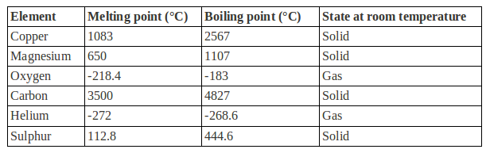

**Chemistry Revision: Mixtures**

Key Knowledge

Mixture –

Soluble –

Insoluble –

Solute –

Solvent –

Filtration

Used to separate:

Equipment:

Crystallisation

Used to separate:

Equipment:

Simple distillation

Used to separate:

Equipment:

Chromatography

Used to separate:

Equipment:

Fractional distillation

Used to separate:

Equipment:

Mastery Matrix Points

|  |
| --- |
| Use key terms (soluble, insoluble, solute, solvent and solution) correctly to describe a substance dissolving |
| Explain how to separate given mixtures (filtration, crystallisation, simple distillation, fractional distillation, chromatography) |
| Explain the difference in difficulty of separating compounds compared to mixtures |

Understanding and Explaining

1. Mixtures be separated by physical processes. Explain what a physical process is and give four examples.
2. Explain why compounds cannot be separated by physical processes.
3. Describe the process of filtration using sandy water as an example.
4. Describe the process of crystallisation using copper sulfate solution as an example.
5. Describe the process of paper chromatography and how you could use it to see if a food dye is pure.
6. Describe the process of distillation using an ethanol and water mixture as an example.
7. Explain the difference between simple distillation and fractional distillation.

**Guided Exam Question**

1. (a)     The list below gives six substances.

•        aluminium

•        beer

•        copper

•        milk

•        pure water

•        sodium chloride

Put each substance in the correct column of the table.

|  |  |  |
| --- | --- | --- |
| ELEMENTS | COMPOUNDS | MIXTURES |
|  |  |  |
|  |  |  |

**(3)**

(b)     Elements can be divided into two groups, metals and non-metals.

          The list below gives some properties of elements.

•        brittle

•        can be hammered into shape

•        dull

•        good conductors of electricity

•        poor conductors of electricity

•        shiny

Put each property into the correct column.

|  |  |
| --- | --- |
| PROPERTIES OF METALS | PROPERTIES OF NON-METALS |
|  |  |
|  |  |
|  |  |

**(3)**

**(Total 6 marks)**

**2.** Ethanol can be made from plants and from crude oil as shown in the diagram below.

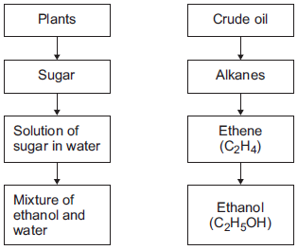

(a)     Describe how the solution of sugar in water is used to produce the mixture of ethanol and water.

___________________________________________________________________

___________________________________________________________________

___________________________________________________________________

___________________________________________________________________

**(2)**

(b)     Ethanol has a boiling point of 78 °C.

Water has a boiling point of 100 °C.

Describe how distillation is used to separate a mixture of ethanol and water.

___________________________________________________________________

___________________________________________________________________

___________________________________________________________________

___________________________________________________________________

___________________________________________________________________

**(3)**

**(Total 5 marks)**

**Independent Exam Question**

1. Rock salt is a mixture of sand and salt. Salt dissolves in water. Sand does not dissolve in water. Some students separated rock salt.

This is the method used.

1. Place the rock salt in a beaker.

2. Add 100 cm3 of cold water.

3. Allow the sand to settle to the bottom of the beaker.

4. Carefully pour the salty water into an evaporating dish.

5. Heat the contents of the evaporating dish with a Bunsen burner until salt crystals start to form.

a) Suggest one improvement to step 2 to make sure all the salt is dissolved in the water.

[1 mark]

…………………………………………………………………………………………………………………………………………………………………………

…………………………………………………………………………………………………………………………………………………………………………

b)The salty water in step 4 still contained very small grains of sand. Suggest one improvement to step 4 to remove all the sand.

[1 mark]

…………………………………………………………………………………………………………………………………………………………………………

…………………………………………………………………………………………………………………………………………………………………………

1. Suggest one safety precaution the students should take in step 5.

[1 mark]

…………………………………………………………………………………………………………………………………………………………………………

…………………………………………………………………………………………………………………………………………………………………………

Another student removed water from salty water using the apparatus in Figure 3.

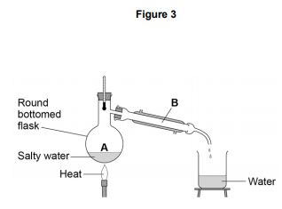

1. Describe how this technique works by referring to the processes at A and B.

[2 marks]

…………………………………………………………………………………………………………………………………………………………………………

…………………………………………………………………………………………………………………………………………………………………………

…………………………………………………………………………………………………………………………………………………………………………

…………………………………………………………………………………………………………………………………………………………………………

1. What is the reading on the thermometer during this process?

[1 mark]

…………………………………………………………… oC

**Lesson 2**

|  |  |  |
| --- | --- | --- |
|  | Topic: | Structure of an atom (C.5) |
| 1 | What is the charge, relative size and location of a proton? | Charge: 1+, Size = 1, Location = Nucleus |
| 2 | What is the charge, relative size and location of a neutron? | Charge: 0, Size = 1, Location = Nucleus |
| 3 | What is the charge, relative size and location of an electron? | Charge: -1, Size = 1/2000, Location = Shells |
| 4 | What is the radius of an atom? | 0.1 nm (1 x 10 -10m) |
| 5 | What is the radius of a nucleus? | 1 x 10 -14m |
| 6 | Define "atomic number" | No. of protons in an atom |
| 7 | Define "atomic mass number" | Sum of protons and neutrons in an atom |
| 8 | Define isotope? | Atoms of the same element that have the same number of protons but different numbers of neutrons |
| 9 | What was the Dalton model of the atom? | Atoms = tiny spheres |
| 10 | Describe Thompson's 'Plum Pudding' model of an atom. | Ball of positive charge with electrons embedded throughout |
| 11 | Describe Rutherford's model of the atom | Dense, positive mass in the centre (the nucleus) |
| 12 | Describe the Neil's Bohr model of the atom | Positive nucleus orbited by negative electrons |
| 13 | Describe Chadwick's 'Nuclear Model' of an atom | Neutrons & protons in a +ve nucleus, -ve electrons in shells |
| 14 | What is the name for the current model of the atom? | Nuclear model |
| 15 | What 3 things did the alpha scattering experiment prove? | 1) Nucleus = positive (deflected & reflected +ve α particles) 2) Nucleus = dense mass in centre of atom, 3) Rest = empty space |
|  | **Topic:** | **Types of bonding (C.7)** |
| 1 | Which type of bonding occurs between metals and non-metals? | Ionic |
| 2 | Which type of bonding occurs between non-metals? | Covalent |
| 3 | Which type of bonding occurs between metals? | Metallic |
| 4 | When electrons leave the shells of an atom, they are said to be ……? | Delocalised |
| 5 | Which type of ions are formed by metals? | Positive ions |
| 6 | Which type of ions are formed by non-metals? | Negative ions |
| 7 | What is graphene? | A single layer of graphite |
| 8 | What is a fullerene? | Hollow carbon structures |
| 9 | What is Buckminster Fullerene? | Spherical carbon shape with 60 carbon atoms |
| 10 | What is an allotrope? | Two or more different physical arrangements of the same atom e.g. diamond, graphite, graphene |
| 11 | What is a carbon nanotube? | A cylindrical fullerene with a very high length to diameter ratio |
| 12 | Describe what happens in ionic bonding | Electrons are transferred from a metal atom to a non-metal atom = strong electrostatic attraction between oppositely charged ions |
| 13 | Describe what happens in covalent bonding | Electrons are shared between atoms = strong electrostatic attraction between electrons and nucleus |
| 14 | Describe what happens in metallic bonding | Electrons become delocalised creating a sea of negative charge = strong electrostatic attraction with positive metal ions & sea of delocalised electrons |
| 15 | Why do noble gases not form compounds? | Because they already have a full outer shell of electrons |
|  |  |  |
|  | **Topic:** | **Properties of materials (C.8)** |
| 1 | State two properties of simple covalent molecules | 1) Low melting & boiling point, 2)Poor conductor of thermal & electrical energy |
| 2 | State three properties of diamond | 1) Hard, 2) Poor electrical conductor, 3) Good thermal conductor |
| 3 | State two properties of graphite | 1) Soft & slippery, 2) Conducts electricity |
| 4 | State two properties of silicon dioxide | 1) Hard, 2) Doesn't conduct electricity |
| 5 | Why do metals and graphite conduct electricity? | Delocalised electrons can move through structure carrying electrical charge |
| 6 | Why do ionic compounds, metallic compounds and giant covalent compounds have high melting and boiling points? | Strong INTRAmolecular bonds/forces = difficult to move apart |
| 7 | Why do simple compounds have low melting and boiling points? | Weak INTERmolecular bonds/forces = easy to move apart |
| 8 | Why do ionic compounds conduct electricity when molten/aqueous? | Ions are free to move carrying charge |
| 9 | Name the structure that ionic bonding forms | Giant ionic lattice |
| 10 | State three examples of giant covalent structures | Diamond, graphite, silicon dioxide |
| 11 | Name the two types of structure that can be formed from covalent bonding | Simple covalent molecules, giant covalent structures |
| 12 | How are unreactive metals (e.g. gold) removed from their ore? | They are native (unreactive so don't form an ore) |
| 13 | How are metals LESS reactive than carbon removed from their ore? | They are reduced (reacted with) by carbon |
| 14 | How are metals MORE reactive than carbon removed from their ore? | Electrolysis |
| 15 | What is reduction & oxidation (in terms of electrons)? (HT only) | Oxidation = Is Loss of electrons, Reduction = Is Gain electrons, (OIL RIG) |

Notes

**Chemistry Revision: Structure of an Atom**

Key Knowledge

Definitions:

Plum pudding model

Nuclear model

Isotope

Ion

Relative atomic mass

Radius of an atom = nm

= m

Radius of a nucleus is __________ times smaller than the atomic radius, about ____________m.

What order were the parts of the atom discovered?

Subatomic particles

|  |  |  |
| --- | --- | --- |
| *Name* | *Relative mass* | *Charge* |
| Proton |  |  |
| Neutron |  |  |
| Electron |  |  |

Using the periodic table:

*To find the number of protons…*

*To find the number of electrons…*

*To find the number of neutrons…*

Mastery Matrix Points

|  |
| --- |
| Describe the plum pudding model of the atom |
| Describe the current (nuclear) model of the atom giving the relative charge and mass of the subatomic particles |
| Recall the radius of an atom and it’s nucleus |
| Calculate protons, neutrons and electrons for an atom linking to mass and atomic number |
| Draw the electronic structure and work out the electronic configuration for a given atom |
| Define an ‘isotope’ |
| Isotopes to relative atomic mass to explain why this is an average |
| Calculate the relative atomic mass of an element given the percentage abundance of its isotopes |
| Calculate the relative formula mass of a substance |

Understanding and Explaining

1. Describe in detail the structure of the atom using the current theory.
2. Describe what the atomic number and mass number on the periodic table tell us.
3. Why might scientists make changes to an existing theory?
4. Describe the alpha scattering experiment, its results and why the results led to a change in the theory of the atom.
5. Explain the role of Niels Bohr in atomic theory.
6. Describe the contribution of James Chadwick to atomic theory.
7. Explain why the relative atomic mass on the periodic table is an average.
8. Calculate the relative atomic mass of neon if the abundances of the atoms are: Ne20 90.92%, Ne21 0.26%, Ne22 8.82%.

**Chemistry Revision: Types of Bonding**

Key Knowledge

Ionic bond –

Covalent bond –

Metallic bond –

Alloy –

Lattice structure (definition and picture) –

Nanoparticle definition –

Corse particles (dust) –

Ways of showing bonding and their drawbacks:

|  |  |  |
| --- | --- | --- |
| *Name of model* | *Example* | *Limitations* |
| Ball and stick | Image result for ball and stick model ionic |  |
| Dot and cross | Image result for dot and cross model |  |
| 2D models | Image result for display formula ethane |  |
| 3D models | Image result for ball and stick model ionic |  |

Examples of simple covalent molecules –

Examples of giant covalent molecules –

Uses of fullerenes –

Uses of nanoparticles -

Mastery Matrix Points

|  |
| --- |
| Describe the structure and properties of giant ionic structures |
| Link the structure of giant ionic structures to its properties |
| Describe the structure and properties of simple covalent structures |
| Describe the structure and properties of giant covalent structures (including diamond, graphite and silica) |
| Compare and contrast giant carbon structures (diamond, graphite, graphene and fullerene – Buckminster fullerenes and nanotubes as examples) |
| Describe two uses of nanotechnology (triple only) |
| Describe how a substance bonds metallically |
| Link the structure of giant metallic structures to their properties |

Understanding and Explaining

1. Describe and explain the properties of simple covalent molecules.

|  |  |
| --- | --- |
| *Property* | *Explanation* |
|  |  |
|  |  |

1. Describe and explain the properties of ionic compounds.

|  |  |
| --- | --- |
| *Property* | *Explanation* |
|  |  |
|  |  |

1. Describe and explain the properties of metallic structures.

|  |  |
| --- | --- |
| *Property* | *Explanation* |
|  |  |
|  |  |
|  |  |

1. Describe and explain the properties of each of these giant covalent structures.

|  |  |  |  |
| --- | --- | --- | --- |
| *Name* | *Structure* | *Properties* | *Explanations* |
| Diamond |  |  |  |
|  |  |
|  |  |
| Graphite |  |  |  |
|  |  |
| Graphene |  |  |  |
|  |  |
| Fullerenes |  |  |  |
|  |  |
| Polymers |  |  |  |

1. Explain why the properties of nanoparticles are different from the same material in bulk, making them more effective.
2. What are the possible risks associated with nanoparticles?
3. Explain why alloys are harder and less malleable that the pure metals they are made from.

**Guided Exam Question**

**Independent Exam Question**

4. **Figure 1** shows the outer electrons in an atom of the Group 1 element potassium and in an atom of the Group 6 element sulfur.

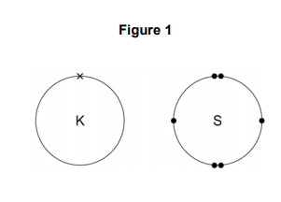

4.1. Potassium forms an ionic compound with sulfur.

Describe what happens when two atoms of potassium react with one atom of sulfur.

Give your answer in terms of electron transfer.

Give the formulae of the ions formed.

[5 marks]

…………………………………………………………………………………………………………………………………………………………………………

…………………………………………………………………………………………………………………………………………………………………………

…………………………………………………………………………………………………………………………………………………………………………

…………………………………………………………………………………………………………………………………………………………………………

…………………………………………………………………………………………………………………………………………………………………………

…………………………………………………………………………………………………………………………………………………………………………

…………………………………………………………………………………………………………………………………………………………………………

…………………………………………………………………………………………………………………………………………………………………………

…………………………………………………………………………………………………………………………………………………………………………

…………………………………………………………………………………………………………………………………………………………………………

…………………………………………………………………………………………………………………………………………………………………………

…………………………………………………………………………………………………………………………………………………………………………

…………………………………………………………………………………………………………………………………………………………………………

…………………………………………………………………………………………………………………………………………………………………………

4.2. The structure of potassium sulfide can be represented using the ball and stick model in Figure 2.

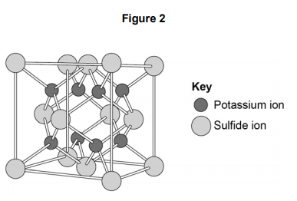

The ball and stick model is not a true representation of the structure of potassium sulfide. Give one reason why.

[1 mark]

…………………………………………………………………………………………………………………………………………………………………………

…………………………………………………………………………………………………………………………………………………………………………

…………………………………………………………………………………………………………………………………………………………………………

…………………………………………………………………………………………………………………………………………………………………………

4.3. Sulfur can also form covalent bonds.

Complete the dot and cross diagram to show the covalent bonding in a molecule of hydrogen sulfide.

Show the outer shell electrons only.

[2 marks]

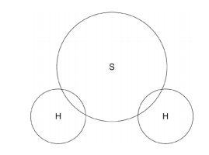

4.5. Covalent compounds such as hydrogen sulfide have low melting points and do not conduct electricity when molten.

Draw one line from each property to the explanation of the property.

[2 marks]

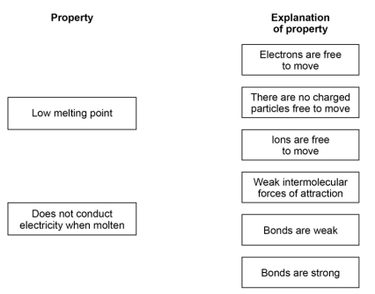

4.6. Ionic compounds such as potassium sulfide have high boiling points and conduct electricity when dissolved in water. Draw one line from each property to the explanation of the property.

[2 marks]

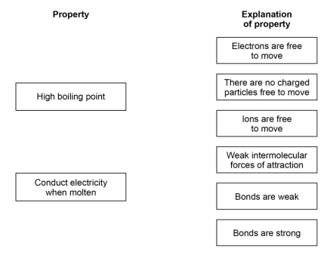

**4.7.** Carbon nanotubes are cylindrical fullerenes. Explain the properties of carbon nanotubes. Answer in terms of structure and bonding.

[6 marks]

…………………………………………………………………………………………………………………………………………………………………………

…………………………………………………………………………………………………………………………………………………………………………

…………………………………………………………………………………………………………………………………………………………………………

…………………………………………………………………………………………………………………………………………………………………………

…………………………………………………………………………………………………………………………………………………………………………

…………………………………………………………………………………………………………………………………………………………………………

…………………………………………………………………………………………………………………………………………………………………………

…………………………………………………………………………………………………………………………………………………………………………

…………………………………………………………………………………………………………………………………………………………………………

…………………………………………………………………………………………………………………………………………………………………………

…………………………………………………………………………………………………………………………………………………………………………

…………………………………………………………………………………………………………………………………………………………………………

…………………………………………………………………………………………………………………………………………………………………………

…………………………………………………………………………………………………………………………………………………………………………

…………………………………………………………………………………………………………………………………………………………………………

…………………………………………………………………………………………………………………………………………………………………………

…………………………………………………………………………………………………………………………………………………………………………

…………………………………………………………………………………………………………………………………………………………………………

…………………………………………………………………………………………………………………………………………………………………………

…………………………………………………………………………………………………………………………………………………………………………

…………………………………………………………………………………………………………………………………………………………………………

**Independent Exam question**

**Q5**

(a)     Lithium reacts with chlorine to produce lithium chloride.

When lithium atoms and chlorine atoms react to produce lithium chloride, lithium ions and chloride ions are formed.

The diagram shows the electronic structures of the atoms and ions.

The symbols **o** and **x** are used to represent electrons.

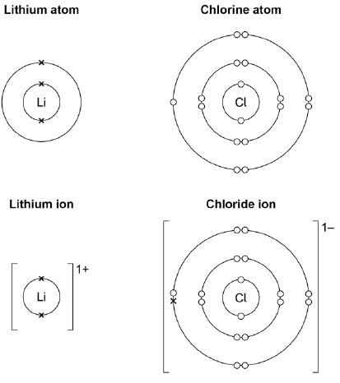

Describe what happens when a lithium atom reacts with a chlorine atom.

Answer in terms of electrons.

___________________________________________________________________

___________________________________________________________________

___________________________________________________________________

___________________________________________________________________

___________________________________________________________________

___________________________________________________________________

**(4)**

**Q6.**

This question is about atomic structure.

The figure below represents the structure of a lithium atom.

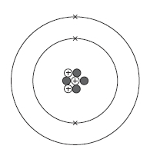

(a)     Name the particle in the atom that has a positive charge.

___________________________________

**(1)**

(b)     Name the particle in the atom that has the smallest mass.

___________________________________

**(1)**

(c)     Complete the sentences.

Choose the answers from the box.

|  |  |  |  |
| --- | --- | --- | --- |
| **3** | **4** | **7** | **10** |

The mass number of the lithium atom is __________________.

The number of neutrons in the lithium atom is __________________.

**(2)**

(d)     Which element forms ions with different charges?

Tick (✔) **one** box.

|  |  |
| --- | --- |
| Compounds |  |
| Ions |  |
| Isotopes |  |
| Molecules |  |

**(1)**

(e)     Name the particle in the atom discovered by James Chadwick.

________________________ .

**(1)**

(f)      An element has two isotopes.

The table shows information about the isotopes.

|  |  |  |
| --- | --- | --- |
|  | **Mass number** | **Percentage (%) abundance** |
| **Isotope 1** | 10 | 20 |
| **Isotope 2** | 11 | 80 |

Calculate the relative atomic mass (*Ar*) of the element.

Use the equation:



Give your answer to 1 decimal place.

___________________________________________________________________

___________________________________________________________________

___________________________________________________________________

___________________________________________________________________

Relative atomic mass (*Ar*) = ______________________

**(2)**

(g)     The radius of an atom is 0.2 nm

The radius of the nucleus is  the radius of the atom.

Calculate the radius of the nucleus.

Give your answer in standard form.

___________________________________________________________________

___________________________________________________________________

___________________________________________________________________

___________________________________________________________________

Radius = ______________________ nm

**(2)**

**(Total 10 marks)**

**Q7.**

This question is about structure and bonding.

(a)     Complete the dot and cross diagram to show the covalent bonding in a nitrogen molecule, N2

Show only the electrons in the outer shell.

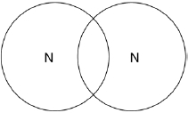

**(2)**

(b)     Explain why nitrogen is a gas at room temperature.

Answer in terms of nitrogen’s structure.

___________________________________________________________________

___________________________________________________________________

___________________________________________________________________

___________________________________________________________________

___________________________________________________________________

___________________________________________________________________

**(3)**

(c)     Graphite and fullerenes are forms of carbon.

Graphite is soft and is a good conductor of electricity.

Explain why graphite has these properties.

Answer in terms of structure and bonding.

___________________________________________________________________

___________________________________________________________________

___________________________________________________________________

___________________________________________________________________

___________________________________________________________________

___________________________________________________________________

___________________________________________________________________

___________________________________________________________________

**(4)**

(d)     **Figure 1** shows a model of a Buckminsterfullerene molecule.

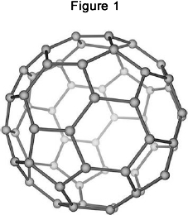

A lubricant is a substance that allows materials to move over each other easily.

Suggest why Buckminsterfullerene is a good lubricant.

Use **Figure 1**.

___________________________________________________________________

___________________________________________________________________

___________________________________________________________________

___________________________________________________________________

**(2)**

Silver can form cubic nanocrystals.

**Figure 2** represents a silver nanocrystal.

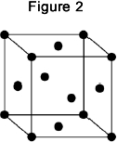

(e)     A silver nanocrystal is a cube of side 20 nm

Calculate the surface area to volume ratio of the nanocrystal.

___________________________________________________________________

___________________________________________________________________

___________________________________________________________________

Surface area to volume ratio = ____________________

**(3)**

**(Total 16 marks)**

**Lesson 3**

|  |  |  |
| --- | --- | --- |
|  | **Topic:** | **Describing chemical reactions, reactions of metals and gas tests (C.9)** |
| 1 | metal + oxygen -> | metal oxide |
| 2 | metal + water -> | metal hydroxide + hydrogen gas |
| 3 | metal + acid -> | metal salt + hydrogen gas |
| 4 | Define oxidation (in terms of oxygen) | Addition of oxygen to an element |
| 5 | Define reduction (in terms of oxygen) | Removal of oxygen from a compound |
| 6 | What is the law of conservation of mass? | No atoms are lost or made during a reaction (mass of reactants = mass of products) |
| 7 | acid + alkali (or base) -> | salt + water |
| 8 | If sulphuric acid reacts with a metal, what will the salt end in? | ______ sulphate |
| 9 | If nitric acid reacts with a metal, what will the salt end in? | ________ nitrate |
| 10 | metal carbonate + acid -> | metal salt + water + carbon dioxide |
| 11 | If hydrochloric acid reacts with a metal, what will the salt end in? | _______ chloride |
| 12 | What is the test for hydrogen gas? | A burning splint will make a squeaky pop |
| 13 | What is the test for carbon dioxide gas? | Limewater will turn cloudy |
| 14 | What is the test for oxygen gas? | A glowing splint will relight |
| 15 | What is the test for chlorine gas? | Damp litmus paper will be bleached and turned white |
|  | **Topic:** | **The periodic table (C.6)** |
| 1 | How are elements arranged in the periodic table? | In order of atomic number (lowest to highest) |
| 2 | What does the column (group) in the periodic table tells us? | Number of electrons in the outer shell |
| 3 | What are the rows of the periodic table called? | Periods |
| 4 | What did Mendeleev do when creating the modern periodic table? | Left gaps to make the pattern fit |
| 5 | Where are alkali metals found in the periodic table? | Group 1 |
| 6 | Where are non-metals found in the periodic table? | Right |
| 7 | Name the groups in the periodic table (1, 7, 0) | 1 = Alkali metals, 7 = Halogens, 0 = Noble gases |
| 8 | State 3 properties of group 7 | Non-metal, highly reactive, diatomic |
| 9 | What happens to reactivity as you move down group 7? | They become less reactive - it is harder to gain an electron |
| 10 | What is the name of the elements found in the middle of the periodic table that are not part of a group? | Transition metals |
| 11 | Give 4 properties of metals | 1) High melting point, 2) Good thermal and electrical conductors, 3) Ductile, 4) Malleable |
| 12 | Give 3 properties of non-metals | 1) Low melting point, 2) Poor thermal and electrical conductors, 3)Brittle |
| 13 | Give 5 properties of the alkali metals | 1) Highly reactive, 2) Low melting and boiling points, 3) Low density, 4) Shiny when cut, 5) Soft |
| 14 | What is formed when alkali metals react with water? | Alkaline metal hydroxide |
| 15 | What happens to reactivity as you move down group 1? | They become more reactive - it is easier to lose their outer electron. |

Notes

**Chemistry Revision: Development of**

Mastery Matrix Points

|  |
| --- |
| Describe how Mendeleev has arranged the periodic table |

**Periodic Table**

Key Knowledge

PERIODIC TABLE BEFORE MENDELEEV:

The periodic table was arrange in order of _______________ and some elements were ___________.

The properties were not the same in the __________.

MENDELEEV’S CHANGES:







This meant that the elements in the same group had similar _______.

Later the discovery of __________ explained why the order of atomic weight had not worked properly.

MODERN PERIODIC TABLE:

In the periodic table, the elements are arranged in order of ______________.

Periods are the _____ of the periodic table, which show that the properties repeat. Elements in the same period have the same number of ______ _________.

Groups are the _________ of the periodic table, which have similar properties within them. Elements in the same group have the same number of ______ in their outer shell.

Understanding and Explaining

1. Explain why elements in the same groups did not have similar properties before Mendeleev’s changes to the periodic table.
2. Describe and explain Mendeleev’s contribution to the modern periodic table.
3. Describe what has been added to the periodic table since Mendeleev made his changes.
4. Sulfur and sodium are in the same period of the periodic table. Suggest one similarity and one difference about their electronic structure.
5. Lithium and sodium are in the same group of the periodic table. Suggest one similarity and one difference about their electronic structure.

**Chemistry Revision: Metals in the Periodic Table**

Understanding and Explaining

1. Compare the properties and reactivity of group 1 metals with the transition metals.
2. Describe the reactions of these metals with oxygen, water and halogens.

|  |  |  |  |
| --- | --- | --- | --- |
| *Metal* | *Reaction with chlorine or other halogen* | *Reaction with water* | *Reaction with oxygen* |
| Cr |  |  |  |
| Mn |  |  |  |
| Fe |  |  |  |
| Co |  |  |  |
| Ni |  |  |  |
| Cu |  |  |  |

1. Explain how you could test an unknown metal to see if it is a group 1 metal or a transition metal.

Mastery Matrix Points

|  |
| --- |
| Explain why something is classified as a metal or non-metal |
| Describe the key properties of the transition metals (chromium, manganese, iron, cobalt, nickel and copper) (triple only) |

Key Knowledge

Metals are found on the _____ of the periodic table.

Non-metals are found on the _____ of the periodic table.

Transition metal properties

-

-

-

-

-

Transition metals are used as _________.

Transition metals form ___________ compounds.

Transition metals can form ions with __________ charges, e.g. Fe2+ and Fe3+.

Name these transition metals –

Cr, Mn, Fe, Co, Ni, Cu.

**Chemistry Revision: Reactivity of Metals**

Understanding and Explaining

1. Describe the reactions below.

|  |  |  |
| --- | --- | --- |
| *Metal* | *Reaction with room temperature water* | *Reaction with dilute acid* |
| Potassium |  |  |
| Sodium |  |  |
| Lithium |  |  |
| Calcium |  |  |
| Magnesium |  |  |
| Zinc |  |  |
| Iron |  |  |
| Copper |  |  |

1. Explain why metals such as gold do not need to be extracted from an ore.
2. Explain how metals such as copper and iron are extracted from their ores. Include a word equation for the extraction of iron from iron oxide and state which chemical is oxidised and which is reduced.
3. Are these chemicals being oxidised or reduced?

|  |  |
| --- | --- |
| 1. Cu2+ 🡪 Cu | 1. I- 🡪 I2 |
| 1. Cl- 🡪 Cl2 | 1. I2 🡪 I- |
| 1. Zn 🡪 Zn2+ | 1. Mg 🡪 Mg2+ |
| 1. Ag+ 🡪Ag | 1. Zn2+ 🡪 Zn |

1. Write ionic equations for these displacement reactions. The first one is done for you.
2. CuSO4 + Zn 🡪 ZnSO4 + Cu Answer: Cu2++ Zn 🡪 Zn2++ Cu
3. CuSO4 + Pb 🡪 PbSO4 + Cu
4. CuSO4 + Mg 🡪 MgSO4 + Cu
5. Pb(NO3)2 + Zn 🡪 Zn(NO3)2 + Pb
6. Pb(NO3)2 + Mg 🡪 Mg(NO3)2 + Pb
7. Zn(NO3)2 + Mg 🡪 Mg(NO3)2 + Zn

Mastery Matrix Points

|  |
| --- |
| Use evidence to rank metals in order of reactivity |
| Predict what would happen in a displacement reaction between two substance |
| Write ionic half equations for displacement reactions (HT only) |
| Link reactivity to how metals are extract from their ore |
| Describe the reaction of given metals with oxygen |
| Describe the reaction of given metals with water |
| Describe the reactions of given metals with acids (magnesium, zinc and iron with hydrochloric and sulphuric acid) |
| Predict products from given reactants |
| Explain these reactions in terms of redox reactions, linking to electrons and the species that is oxidised and reduced (HT only) |
| Calculate masses from balanced symbol equations and link this to limiting reactants and the use of a reactant in excess. (HT only) |

Key Knowledge

The more reactive a metal is the _____ easily it forms positive ions.

The reactivity series (with 8 metals and 2 non-metals):



Metal displacement reactions are when ……………………………………………………………………………………………………………………………………………………

Oxidation

Definition 1 –

Definition 2 –

Reduction

Definition 1 –

Definition 2 –

Ore –

Low reactivity metals are extracted from their ore by…

High reactivity metals are extracted by…………………………

**Guided Exam Question**

**Q8.**

A student investigated the reactivity of three different metals.

This is the method used.

1.       Place 1 g of metal powder in a test tube.

2.       Add 10 cm3 of metal sulfate.

3.       Wait 1 minute and observe.

4.       Repeat using the other metals and metal sulfates.

The student placed a tick in the table below if there was a reaction and a cross if there was no reaction.

|  |  |  |  |
| --- | --- | --- | --- |
|  | **Zinc** | **Copper** | **Magnesium** |
| **Copper sulfate** |  |  |  |
| **Magnesium sulfate** |  |  |  |
| **Zinc sulfate** |  |  |  |

(a)     What is the dependent variable in the investigation?

|  |  |
| --- | --- |
| Tick **one** box. |  |
| Time taken |  |
| Type of metal |  |
| Volume of metal sulfate |  |
| Whether there was a reaction or not |  |

**(1)**

(b)     Give **one** observation the student could make that shows there is a reaction between zinc and copper sulfate.

___________________________________________________________________

___________________________________________________________________

**(1)**

(c)     The student used measuring instruments to measure some of the variables.

Draw **one** line from each variable to the measuring instrument used to measure the variable.

|  |  |  |
| --- | --- | --- |
| **Variable** |  | **Measuring instrument** |
|  |  | Balance |
|  |  |  |
|  |  | Measuring cylinder |
| Mass of metal powder |  |  |
|  |  | Ruler |
|  |  |  |
|  |  | Burette |
| Volume of metal sulfate |  |  |
|  |  | Theromometer |
|  |  |  |
|  |  | Test tube |

**(2)**

(d)     Use the results shown in table above to place zinc, copper and magnesium in order of reactivity.

Most reactive         _____________________

                       _____________________

Least reactive        _____________________

**(1)**

(e)     Suggest **one** reason why the student should **not** use sodium in this investigation.

___________________________________________________________________

___________________________________________________________________

**(1)**

(f)     Which metal is found in the Earth as the metal itself?

|  |  |
| --- | --- |
| Tick **one** box. |  |
| Calcium |  |
| Gold |  |
| Lithium |  |
| Potassium |  |

**(1)**

(g)     Iron is found in the Earth as iron oxide (Fe2O3).

Iron oxide is reduced to produce iron.

Balance the equation for the reaction.

___Fe2O3      +     ___C      →     ___Fe      +      ___CO2

**(1)**

(h)     Name the element used to reduce iron oxide.

___________________________________________________________________

**(1)**

(i)     What is meant by reduction?

|  |  |
| --- | --- |
| Tick **one** box. |  |
| Gain of iron |  |
| Gain of oxide |  |
| Loss of iron |  |
| Loss of oxygen |  |

**(1)**

**(Total 10 marks)**

**Q9.**

Lithium is in Group 1 of the periodic table.

Lithium reacts with water to produce a gas and an alkaline solution.

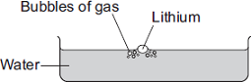

(a)     (i)      Name the gas produced.

______________________________________________________________

**(1)**

(ii)     Which ion causes the solution to be alkaline?

______________________________________________________________

**(1)**

(b)     Potassium is also in Group 1 of the periodic table.  
Potassium reacts with water in a similar way to lithium.

Write down **two** differences you would see between the reactions of potassium and lithium with water.

1. _________________________________________________________________

___________________________________________________________________

2. _________________________________________________________________

___________________________________________________________________

**(2)**

**(Total 4 marks)**

Independent Exam question

**Q10.**

A student was investigating the reaction of lithium and water.

She added a few drops of universal indicator to water in a trough and added a piece of lithium.



The word equation for the reaction is:

lithium + water        lithium hydroxide + hydrogen

(a)     (i)      The lithium floated on the water.

State **two** other observations that the student would **see** during the reaction.

1. ____________________________________________________________

2. ____________________________________________________________

**(2)**

(ii)     Balance the symbol equation for the reaction of lithium and water.

2 Li(s)  +  _____ H2O(l)      _____  LiOH(aq)  +  H2(g)

**(2)**

(iii)    Describe a simple test and the result that would show the gas was hydrogen.

______________________________________________________________

______________________________________________________________

**(1)**

(iv)     All Group 1 metals have similar reactions with water.

State why, in terms of electronic structure.

______________________________________________________________

______________________________________________________________

**(1)**

(b)     Lithium and other Group 1 metals have different properties from the transition metals.

Tick (✔) **two** properties that are properties of Group 1 metals.

|  |  |
| --- | --- |
| They react with oxygen. |  |
| They form coloured compounds. |  |
| They are strong and hard. |  |
| They have low melting points. |  |

**(2)**

**(Total 8 marks)**

**Q11.**

A student investigated displacement reactions of metals.

The student added different metals to copper sulfate solution and measured the temperature change.

The more reactive the metal is compared with copper, the bigger the temperature change.

The apparatus the student used is shown in **Figure 1**.

**Figure 1**

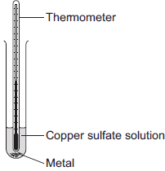

(a)     State **three** variables that the student must control to make his investigation a fair test.

1. _________________________________________________________________

2. _________________________________________________________________

3. _________________________________________________________________

**(3)**

(b)     **Figure 2** shows the thermometer in one experiment before and after the student added a metal to the copper sulfate solution.

**Figure 2**

|  |  |
| --- | --- |
| **Before adding metal** | **After adding metal** |

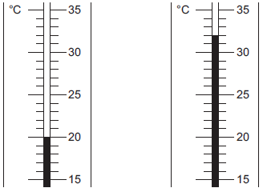

Use **Figure 2** to complete **Table 1**.

**Table 1**

|  |  |
| --- | --- |
| Temperature before adding metal in °C | ________ |
| Temperature after adding metal in °C | ________ |
| Change in temperature in °C | ________ |

**(3)**

(c)     The student repeated the experiment three times with each metal.

**Table 2** shows the mean temperature change for each metal.

**Table 2**

|  |  |
| --- | --- |
| **Metal** | **Mean temperature change in °C** |
| Cobalt | 4.5 |
| Gold | 0.0 |
| Magnesium | 10.0 |
| Nickel | 3.0 |
| Silver | 0.0 |
| Tin | 1.5 |

(i)      On **Figure 3**, draw a bar chart to show the results.

**Figure 3**

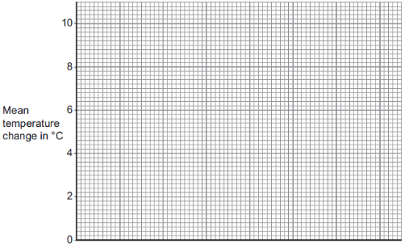

**(3)**

(ii)     Why is a line graph **not** a suitable way of showing the results?

______________________________________________________________

______________________________________________________________

**(1)**

(iii)    Use the results to work out which metal is the most reactive.

Give a reason for your answer.

Most reactive metal _________________________

Reason _______________________________________________________

______________________________________________________________

**(2)**

(iv)    Explain why there was no temperature change when silver metal was added to the copper sulfate solution.

______________________________________________________________

______________________________________________________________

______________________________________________________________

______________________________________________________________

**(2)**

(v)     It is **not** possible to put all six metals in order of reactivity using these results.

Suggest how you could change the experiment to be able to put all six metals into order of reactivity.

______________________________________________________________

______________________________________________________________

______________________________________________________________

______________________________________________________________

______________________________________________________________

**(2)**

**(Total 16 marks)**

**12.**

In the periodic table, the transition elements and Group 1 elements are metals. Some of the properties of two transition elements and two Group 1 elements are shown in Table 2.

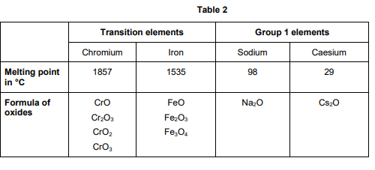

Use your own knowledge and the data in Table 2 to compare the chemical and physical properties of transition elements and Group 1 elements.

[6 marks]

…………………………………………………………………………………………………………………………………………………………………………

…………………………………………………………………………………………………………………………………………………………………………

…………………………………………………………………………………………………………………………………………………………………………

…………………………………………………………………………………………………………………………………………………………………………

…………………………………………………………………………………………………………………………………………………………………………

…………………………………………………………………………………………………………………………………………………………………………

…………………………………………………………………………………………………………………………………………………………………………

…………………………………………………………………………………………………………………………………………………………………………

…………………………………………………………………………………………………………………………………………………………………………

…………………………………………………………………………………………………………………………………………………………………………

…………………………………………………………………………………………………………………………………………………………………………

…………………………………………………………………………………………………………………………………………………………………………

…………………………………………………………………………………………………………………………………………………………………………

…………………………………………………………………………………………………………………………………………………………………………

…………………………………………………………………………………………………………………………………………………………………………

**Lesson 4**

|  |  |  |
| --- | --- | --- |
|  | **Topic:** | **Describing chemical reactions, reactions of metals and gas tests (C.9)** |
| 1 | metal + oxygen -> | metal oxide |
| 2 | metal + water -> | metal hydroxide + hydrogen gas |
| 3 | metal + acid -> | metal salt + hydrogen gas |
| 4 | Define oxidation (in terms of oxygen) | Addition of oxygen to an element |
| 5 | Define reduction (in terms of oxygen) | Removal of oxygen from a compound |
| 6 | What is the law of conservation of mass? | No atoms are lost or made during a reaction (mass of reactants = mass of products) |
| 7 | acid + alkali (or base) -> | salt + water |
| 8 | If sulphuric acid reacts with a metal, what will the salt end in? | ______ sulphate |
| 9 | If nitric acid reacts with a metal, what will the salt end in? | ________ nitrate |
| 10 | metal carbonate + acid -> | metal salt + water + carbon dioxide |
| 11 | If hydrochloric acid reacts with a metal, what will the salt end in? | _______ chloride |
| 12 | What is the test for hydrogen gas? | A burning splint will make a squeaky pop |
| 13 | What is the test for carbon dioxide gas? | Limewater will turn cloudy |
| 14 | What is the test for oxygen gas? | A glowing splint will relight |
| 15 | What is the test for chlorine gas? | Damp litmus paper will be bleached and turned white |
|  | **Topic:** | **The periodic table (C.6)** |
| 1 | How are elements arranged in the periodic table? | In order of atomic number (lowest to highest) |
| 2 | What does the column (group) in the periodic table tells us? | Number of electrons in the outer shell |
| 3 | What are the rows of the periodic table called? | Periods |
| 4 | What did Mendeleev do when creating the modern periodic table? | Left gaps to make the pattern fit |
| 5 | Where are alkali metals found in the periodic table? | Group 1 |
| 6 | Where are non-metals found in the periodic table? | Right |
| 7 | Name the groups in the periodic table (1, 7, 0) | 1 = Alkali metals, 7 = Halogens, 0 = Noble gases |
| 8 | State 3 properties of group 7 | Non-metal, highly reactive, diatomic |
| 9 | What happens to reactivity as you move down group 7? | They become less reactive - it is harder to gain an electron |
| 10 | What is the name of the elements found in the middle of the periodic table that are not part of a group? | Transition metals |
| 11 | Give 4 properties of metals | 1) High melting point, 2) Good thermal and electrical conductors, 3) Ductile, 4) Malleable |
| 12 | Give 3 properties of non-metals | 1) Low melting point, 2) Poor thermal and electrical conductors, 3)Brittle |
| 13 | Give 5 properties of the alkali metals | 1) Highly reactive, 2) Low melting and boiling points, 3) Low density, 4) Shiny when cut, 5) Soft |
| 14 | What is formed when alkali metals react with water? | Alkaline metal hydroxide |
| 15 | What happens to reactivity as you move down group 1? | They become more reactive - it is easier to lose their outer electron. |

Notes

**Chemistry Revision: Describing Chemical Reactions**

Understanding and Explaining

1. Complete word and symbol equations for these reactions. Make sure the chemical equations are balanced, and **include state symbols.**
2. magnesium + hydrochloric acid 🡪
3. calcium carbonate + hydrochloric acid 🡪
4. potassium + water 🡪
5. sodium + sulfuric acid 🡪
6. sulfuric acid + copper oxide 🡪
7. magnesium + oxygen 🡪
8. sodium hydroxide + hydrochloric acid 🡪
9. zinc + hydrochloric acid 🡪
10. potassium + iodine 🡪
11. potassium + oxygen 🡪
12. sodium +water 🡪
13. sodium + chlorine 🡪
14. copper carbonate + sulfuric acid 🡪

Key Knowledge

Rules for chemical equations:

* Use an ____, never an equals sign.
* Show the reactants on the ____ hand side.
* Show the products on the ____ hand side.
* Use only words for a ____equation and symbols for a ______ equation.
* All lower case for word equations and correct case for symbols.

State symbols:

Solid –

Liquid -

Gas –

Aqueous (dissolved)-

*Note:* Most salts are usually aqueous.

General word equations

metal + oxygen 🡪

metal + acid 🡪

metal oxide + acid 🡪

metal hydroxide + acid 🡪

metal carbonate + acid 🡪

metal + halogen 🡪

metal + water 🡪

|  |  |
| --- | --- |
| *Acid* | *Formula* |
| Hydrochloric acid |  |
| Sulfuric acid |  |
| Nitric acid |  |

Mastery Matrix Points

|  |
| --- |
| Write a word equation for a given reaction |
| Write a balanced symbol equation for a given reaction |
| Include appropriate state symbols in an equation |

**Chemistry Revision: Groups in the Periodic Table**

Understanding and Explaining

1. Describe the reactions below.

|  |  |  |
| --- | --- | --- |
| **Reactants** | **Product made (name and formula)** | **Observations during the reaction** |
| Lithium + water |  |  |
| Sodium + water |  |  |
| Potassium + water |  |  |
| Lithium + chlorine |  |  |
| Sodium + chlorine |  |  |
| Potassium + chlorine |  |  |
| Lithium + oxygen |  |  |
| Sodium + oxygen |  |  |
| Potassium + oxygen |  |  |

1. **Describe** and **explain** how the reactivity of group 1 changes as you go down the group.
2. **Explain** why group 7 elements have similar reactions when reacting with metals and non-metals.
3. **Describe** the reactions below.

|  |  |  |
| --- | --- | --- |
| **Reactants** | **Product made (name and formula)** | **Is the product a covalent molecule or ionic lattice?** |
| sodium + chlorine |  |  |
| hydrogen + chlorine |  |  |
| copper + bromine |  |  |
| Sulfur + bromine |  |  |
| lithium + iodine |  |  |
| phosphorus + iodine |  |  |

1. Explain why group 0 elements are unreactive.
2. Explain why the boiling point of group 0 increases as you go down the group.
3. Explain why the reactivity of halogens decreases as you go down the group.
4. Describe what happens in a halogen displacement reaction, such as chlorine + sodium bromide 🡪 sodium chloride + bromine.

Mastery Matrix Points

|  |
| --- |
| Describe the key properties (state, easy to cut, appearance) of group 1 |
| Describe and explain how the reactivity changes as you move down group 1 (oxygen, chlorine, water) |
| Describe the key properties (molecular mass, boiling and melting point) of group 7 |
| Describe and explain how the reactivity changes as you move down group 7 |
| Describe the key properties (boiling point) of group 0 |
| Describe and explain how the reactivity changes as you move down group 0 |

Key Knowledge

Group 1 is called the

The properties of group 1 are

-

-

-

As you go down group 1, the reactivity ………………………..

Group 1 elements all have ____ ___________ in their outer shell.

Group 7 is called the

Properties of group 7

-

-

-

As you go down group 7, the reactivity ………………………..

Group 7 elements all have ____ ___________ in their outer shell.

As you go down group 7, the melting point and boiling point……………………….

Group 0 is called the

Properties of group 0

-

-

-

As you go down group 0 the boiling points ………………………..

Group 0 elements all have ____ ___________ in their outer shell, apart from helium which has _____.

**Guided Exam Question**

**13.1**

In 1866 John Newlands produced an early version of the periodic table.

Part of Newlands’ periodic table is shown below.

|  |  |  |  |  |  |  |  |
| --- | --- | --- | --- | --- | --- | --- | --- |
| **Column** | **1** | **2** | **3** | **4** | **5** | **6** | **7** |
|  | H | Li | Be | B | C | N | O |
|  | F | Na | Mg | Al | Si | P | S |
|  | Cl | K | Ca | Cr | Ti | Mn | Fe |

Newlands’ periodic table arranged all the known elements into columns in order of their atomic weight.

Newlands was trying to show a pattern by putting the elements into columns.

(a)     Iron (Fe) does **not** fit the pattern in column 7.

Give a reason why.

___________________________________________________________________

___________________________________________________________________

**(1)**

(b)     In 1869 Dmitri Mendeleev produced his version of the periodic table.

Why did Mendeleev leave gaps for undiscovered elements in his periodic table?

___________________________________________________________________

___________________________________________________________________

**(1)**

(c)     Newlands and Mendeleev placed the elements in order of atomic weight.

Complete the sentence.

The modern periodic table places the elements in order of

______________________ .

**(1)**

(d)     Lithium, sodium and potassium are all in Group 1 of the modern periodic table.

Explain why.

___________________________________________________________________

___________________________________________________________________

___________________________________________________________________

___________________________________________________________________

**(2)**

**(Total 5 marks)**

**Q13.2**

Use the periodic table and the information in the table below to help you to answer the questions.

The table shows part of an early version of the periodic table.

|  |  |  |  |  |  |  |
| --- | --- | --- | --- | --- | --- | --- |
| **Group 1** | **Group 2** | **Group 3** | **Group 4** | **Group 5** | **Group 6** | **Group 7** |
| H |  |  |  |  |  |  |
| Li | Be | B | C | N | O | F |
| Na | Mg | Al | Si | P | S | Cl |

(a)     Hydrogen was placed at the top of Group 1 in the early version of the periodic table.

The modern periodic table does **not** show hydrogen in Group 1.

(i)      State one **similarity** between hydrogen and the elements in Group 1.

______________________________________________________________

______________________________________________________________

**(1)**

(ii)     State one **difference** between hydrogen and the elements in Group 1.

______________________________________________________________

______________________________________________________________

**(1)**

(b)     Fluorine, chlorine, bromine and iodine are in Group 7, the halogens.

The reactivity of the halogens decreases down the group.

Bromine reacts with a solution of potassium iodide to produce iodine.

Br2 + 2KI  2KBr + I2

(i)      In the reaction between bromine and potassium iodide, there is a reduction of bromine to bromide ions.

In terms of electrons, what is meant by reduction?

______________________________________________________________

______________________________________________________________

**(1)**

(ii)     Complete the half equation for the oxidation of iodide ions to iodine molecules.

2I−               

**(2)**

(iii)    Explain, in terms of electronic structure, why fluorine is the most reactive element in Group 7.

______________________________________________________________

______________________________________________________________

______________________________________________________________

______________________________________________________________

______________________________________________________________

______________________________________________________________

______________________________________________________________

______________________________________________________________

**(3)**

**(Total 8 marks)**

**Independent Exam Question**

**14.** In 1869 there were 60 known elements.

Mendeleev arranged the elements in order of their atomic mass (atomic weight).

He realised that elements with similar properties occurred at regular intervals.

a). Suggest why one of the groups that is on today’s periodic table was not in Mendeleev’s periodic system. [1 mark]

…………………………………………………………………………………………………………………………………………………………………………

…………………………………………………………………………………………………………………………………………………………………………

…………………………………………………………………………………………………………………………………………………………………………

b). Explain the arrangement of the first 20 elements in today’s periodic table. You should answer in terms of atomic structure.

[2 marks]

…………………………………………………………………………………………………………………………………………………………………………

…………………………………………………………………………………………………………………………………………………………………………

…………………………………………………………………………………………………………………………………………………………………………

…………………………………………………………………………………………………………………………………………………………………………

…………………………………………………………………………………………………………………………………………………………………………

…………………………………………………………………………………………………………………………………………………………………………

c). A student put some potassium bromide solution in a test tube. She added a few drops of chlorine solution and observed the result. She repeated the process using different potassium halide salts and different halogens.

**Table 2** shows the student’s results.

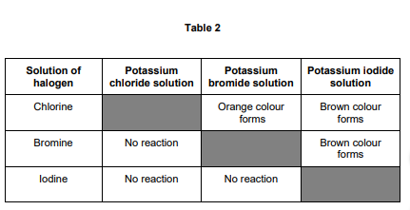

Give the order of reactivity of the halogens from the results in Table 2. Explain how you used the results to show this order of reactivity.

[2 marks]

Order…………………………………………………………………………………………………………………………………………………………………………

…………………………………………………………………………………………………………………………………………………………………………………

Explanation……………………………………………………………………………………………………………………………………………………………………………………………………………………………………………………………………………………………………………………………………………………

…………………………………………………………………………………………………………………………………………………………………………………

……….…………………………………………………………………………………………………………………………………………………………………………

…………………………………………………………………………………………………………………………………………………………………………………

……….…………………………………………………………………………………………………………………………………………………………………………

d). Write a balanced ionic equation for the reaction of chlorine with bromide ions in solution.

[3 marks]

…………………………………………………………………………………………………………………………………………………………………………………

e). Explain the order of reactivity of Group 7 elements. Include information about atomic structure.

[2 marks]

…………………………………………………………………………………………………………………………………………………………………………………

…………………………………………………………………………………………………………………………………………………………………………………

…………………………………………………………………………………………………………………………………………………………………………………

…………………………………………………………………………………………………………………………………………………………………………………

…………………………………………………………………………………………………………………………………………………………………………………

**Lesson 5**

|  |  |  |
| --- | --- | --- |
|  | **Topic:** | **Acids and Alkalis (C.10)** |
| 1 | Which ions make a solution alkaline? | OH- (hydroxide) |
| 2 | Which ions make a solution acidic? | H+ |
| 3 | Give 3 ways to measure the pH of a substance | Litmus paper, universal indicator, pH probe |
| 4 | What pH and colour is universal indicator in an strongly ACIDIC solution? | pH 1 - 3 (red) |
| 5 | What pH and colour is universal indicator in an strongly ALKALINE solution? | pH10-14 (purple) |
| 6 | What pH and colour is universal indicator in a weak ACID? | pH 4-6 (orange/yellow) |
| 7 | What pH and colour is universal indicator in a weak ALKALI? | pH8-9 (blue) |
| 8 | What colour is methyl orange in acid and alkali? | Red (acid), orange (alkali) |
| 9 | What colour is phenolphthalein in acids and alkali? | Colourless (acid), pink (alkali) |
| 10 | What is the difference between the solubility of alkalis and bases? | Alkalis are soluble and bases are insoluble |
| 11 | What is the definition of a) strong acid and b) weak acid? | a) Strong acid completely ionises (breaks down into its ions) in water, b) Weak acid partially ionises in water |
| 12 | Give 3 examples of a strong acid (H only) | Hydrochloric acid, sulphuric acid, nitric acid |
| 13 | List the steps in making a soluble salt | 1) Add solid to heated acid until no more reacts (in excess), 2) Filter excess solid, 3) Leave for 24hrs for water to evaporate (crystallisation), 4) Dab dry |
| 14 | State three examples of weak acids (H only) | Ethanoic acid, citric acid and carbonic acid |
| 15 | What does a decrease in pH by one unit mean? (HT only) | The hydrogen ion concentration increases by a factor of 10 |

Notes

**Chemistry Revision: Acids and Alkalis**

Key Knowledge

Insoluble metal hydroxide - base or alkali?

Soluble metal hydroxide - base or alkali?

Metal oxide - base or alkali?

Metal carbonate - base or alkali?

What ions to acids produce in aqueous solutions?

What ions to alkalis produce in aqueous solutions?

pH Scale – Label strong acid, weak acid, neutral, weak alkali, strong alkali:

|  |  |  |
| --- | --- | --- |
| ***pH*** | ***Description*** | ***Colour in universal indicator*** |
| Image result for ph scale to fill out vertical |  |  |

Ionic equation for neutralisation:

Complete the general word equations:

acid + metal oxide 🡪

acid + metal hydroxide 🡪

acid + metal carbonate 🡪

Mastery Matrix Points

|  |
| --- |
| Identify the ions produced by different acids and alkalis |
| Describe the pH scale and how to test pH using universal indicator or a pH probe |
| Describe neutralisation reactions (alkalis and bases, metal carbonates and acid) |
| Deduce the formulae of salts from their given ions |
| Explain the method for producing soluble salts |
| **Required practical 1: Prepare a pure dry sample of a soluble salt from an insoluble oxide or carbonate** |
| Recall the ionic equation for neutralisation |

Understanding and Explaining

1. Explain why using a pH probe to measure the pH of a chemical may be give precise results than using an indicator, such as universal indicator.
2. Complete the word equations. Then turn to symbol equations.

Copper carbonate + sulfuric acid 🡪

Iron carbonate + hydrochloric acid 🡪

Zinc carbonate + nitric acid 🡪

Iron oxide + hydrochloric acid 🡪

Copper hydroxide + nitric acid 🡪

Copper oxide + hydrochloric acid 🡪

1. Complete the table to show the chemical formula of these salts.

|  |  |  |  |
| --- | --- | --- | --- |
| ***Name*** | ***Formula*** | ***Name*** | ***Formula*** |
| Sodium sulfate |  | Zinc sulfate |  |
| Lithium chloride |  | Zinc nitrate |  |
| Magnesium chloride |  | Potassium sulfate |  |

1. Describe the method and equipment needed to prepare a dry sample of a soluble salt, such as producing copper sulfate from copper oxide and sulfuric acid.

**Step 1:**

**Step 2:**

**Step 3:**

**Step 4:**

**Step 5:**

**Chemistry Revision: Acids and Alkalis 2**

Key Knowledge

Definitions

Strong acid

Weak acid

Dilute acid

Concentrated acid

Examples of weak acids

-

-

-

Examples of strong acids

-

-

-

pH and ion concentration

For a given concentration of aqueous solutions, the stronger an acid,

the _________the pH.

As the pH decreases by one unit, the hydrogen ion concentration of

the solution increases by a factor of ___.

i.e. pH 1 has the _____ hydrogen ions and pH 14 has the _____ hydrogen ions.

Mastery Matrix Points TRIPLE ONLY

|  |
| --- |
| Explain how to use a titration to measure the volume of an acid or an alkali |
|  |

Understanding and Explaining

1. Explain how a concentrated acid can be weak or strong.

2. Describe a method you could use to identify strong and weak acids

**Guided Exam Question**

**15.** A student investigated the reactions of copper carbonate and copper oxide with dilute hydrochloric acid. In both reactions one of the products is copper chloride.

a) Describe how a sample of copper chloride crystals could be made from copper carbonate and dilute hydrochloric acid.

[4 marks]

…………………………………………………………………………………………………………………………………………………………………………………

…………………………………………………………………………………………………………………………………………………………………………………

…………………………………………………………………………………………………………………………………………………………………………………

…………………………………………………………………………………………………………………………………………………………………………………

…………………………………………………………………………………………………………………………………………………………………………………

**15.2**

(a)     A student had a colourless solution.

The student thought the solution was dilute hydrochloric acid.

(i)      The student added universal indicator to this solution.

What colour would the universal indicator change to if the solution is hydrochloric acid?

______________________________________________________________

**(1)**

(ii)     Describe how the student could show that there are chloride ions in this solution.

______________________________________________________________

______________________________________________________________

______________________________________________________________

______________________________________________________________

**(2)**

(b)     The results of a titration can be used to find the concentration of an acid.

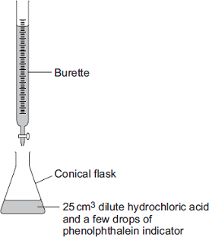

Describe how to use the apparatus to do a titration using 25 cm3 of dilute hydrochloric acid.

In your answer you should include:

•        how you will determine the end point of the titration

•        how you will make sure the result obtained is accurate.

___________________________________________________________________

___________________________________________________________________

___________________________________________________________________

___________________________________________________________________

___________________________________________________________________

___________________________________________________________________

___________________________________________________________________

___________________________________________________________________

___________________________________________________________________

___________________________________________________________________

___________________________________________________________________

**(4)**

(c)     Hydrochloric acid is a strong acid.

Ethanoic acid is a *weak acid*.

What is meant by the term *weak acid*?

___________________________________________________________________

___________________________________________________________________

**(1)**

**Independent Exam Question**

**16.** Sodium hydroxide neutralises sulfuric acid.

The equation for the reaction is:

2NaOH + H2SO4 → Na2SO4 + 2H2O

a). Sulfuric acid is a strong acid. What is meant by a strong acid?

[2 marks]

…………………………………………………………………………………………………………………………………………………………………………………

…………………………………………………………………………………………………………………………………………………………………………………

…………………………………………………………………………………………………………………………………………………………………………………

…………………………………………………………………………………………………………………………………………………………………………………

b)Write the ionic equation for this neutralisation reaction. Include state symbols.

[2 marks]

…………………………………………………………………………………………………………………………………………………………………………………

…………………………………………………………………………………………………………………………………………………………………………………

…………………………………………………………………………………………………………………………………………………………………………………

…………………………………………………………………………………………………………………………………………………………………………………

c) A student used a pipette to add 25.0 cm3 of sodium hydroxide of unknown concentration to a conical flask. The student carried out a titration to find out the volume of 0.100 mol/dm3 sulfuric acid needed to neutralise the sodium hydroxide.

Describe how the student would complete the titration. You should name a suitable indicator and give the colour change that would be seen.

[4 marks]

…………………………………………………………………………………………………………………………………………………………………………………

…………………………………………………………………………………………………………………………………………………………………………………

…………………………………………………………………………………………………………………………………………………………………………………

…………………………………………………………………………………………………………………………………………………………………………………

…………………………………………………………………………………………………………………………………………………………………………………

…………………………………………………………………………………………………………………………………………………………………………………

…………………………………………………………………………………………………………………………………………………………………………………

…………………………………………………………………………………………………………………………………………………………………………………

…………………………………………………………………………………………………………………………………………………………………………………

…………………………………………………………………………………………………………………………………………………………………………………

…………………………………………………………………………………………………………………………………………………………………………………

…………………………………………………………………………………………………………………………………………………………………………………

The student carried out five titrations. Her results are shown in **Table 5.**

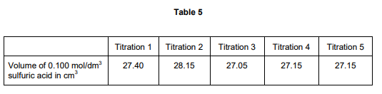

d). Concordant results are within 0.10 cm3 of each other. Use the student’s concordant results to work out the mean volume of 0.100 mol/dm3 sulfuric acid added.

[2 marks]

…………………………………………………………………………………………………………………………………………………………………………………

…………………………………………………………………………………………………………………………………………………………………………………

…………………………………………………………………………………………………………………………………………………………………………………

…………………………………………………………………………………………………………………………………………………………………………………

Mean volume = ……………………………………cm3

e). The equation for the reaction is:

2NaOH + H2SO4 → Na2SO4 + 2H2O

Calculate the concentration of the sodium hydroxide. Give your answer to three significant figures.

[4 marks]

…………………………………………………………………………………………………………………………………………………………………………………

…………………………………………………………………………………………………………………………………………………………………………………

…………………………………………………………………………………………………………………………………………………………………………………

…………………………………………………………………………………………………………………………………………………………………………………

Concentration = …………………………………………….. mol/dm3

f). The student did another experiment using 20 cm3 of sodium hydroxide solution with a concentration of 0.18 mol/dm3 .

Relative formula mass (Mr) of NaOH = 40

Calculate the mass of sodium hydroxide in 20 cm3 of this solution.

[2 marks]

……………………………………………………………………………………………………………..………………………………………………………………………

……………………………………………………………………………………………………………….……………………………………………………………………

……………………………………………………………………………………………………………………………………………………………………………………

…………………………………………………………………………………………………………………………………………………………………………………

Mass = …………………………………………………. g

**Lesson 6**

|  |  |  |
| --- | --- | --- |
|  | **Topic:** | **Electrolysis (C.12)** |
| 1 | Define 'electrolysis' | A substance is decomposed (broken down) using electricity |
| 2 | Why can electrolysis only occur if an ionic substance is molten or aqueous? | The ions are free to move |
| 3 | What is the name of the negative and positive electrode? | Negative: Cathode Positive: Anode |
| 4 | Which ions are attracted to the anode and which to the cathode? | Anode = negative Cathode = positive |
| 5 | Define "electrolyte" | Ions in a solution that are free to move and can conduct electricity |
| 6 | What happens when ions get to an electrode? | Gain or lose electrons becoming neutral atoms again |
| 7 | What happens at the anode? | Electrons transferred from the ion to the anode and the non-metal forms |
| 8 | What happens at the cathode? | Electrons transferred from the cathode to the ion and a metal is formed |
| 9 | When is hydrogen formed from an aqueous solution? | If the metal is MORE reactive than hydrogen |
| 10 | When is a metal (not hydrogen) formed from an aqueous solution? | If the metal is LESS reactive than hydrogen |
| 11 | State one use of electrolysis | Extracting a reactive metal from it's ore |
| 12 | Which useful product could be removed from the solution left after electrolysis of dilute sodium chloride solution? | Sodium hydroxide (bleach) |
| 13 | What would be formed at the anode in electrolysis of dilute sodium chloride solution? | Chlorine gas |
| 14 | What would be formed at the cathode in electrolysis of dilute sodium chloride solution? | Hydrogen |
| 15 | When will oxygen be produced at the anode? | When the solution does NOT contain HALIDE ions. Otherwise the halogen is produced. |
|  | **Topic:** | **Electrolysis & Half equations (HT mainly) (C.13)** |
| 1 | Write an ionic half equation for the reaction of the cathode in electrolysis of dilute sodium chloride solution (HT only) | 2H+ + 2e- -> H2 |
| 2 | Write an ionic half equation for the reaction of the anode in electrolysis of dilute sodium chloride solution (HT only) | 2Cl- -> Cl2 + 2e- |
| 3 | What would be produced at the anode in electrolysis of molten aluminium oxide? (HT only) | Oxygen |
| 4 | What would be produced at the cathode in electrolysis of molten aluminium oxide? (HT only) | Aluminium |
| 5 | Write an ionic half equation for the reaction at the anode in electrolysis of molten aluminium oxide (HT only) | 2O2- -> O2 + 4e- |
| 6 | Write an ionic half equation for the reaction at the cathode in electrolysis of molten aluminium oxide (HT only) | Al3+ + 3e- -> Al |
| 7 | What is the experiment called that allows you to find the concentration of an unknown substance? (triple only) | Titration |
| 8 | What is the piece of equipment called that is used to measure a very precise volume of a solution? (triple only) | Volumetric pipette |
| 9 | Which indicator is used in a titration? (triple only) | Methyl Orange |
| 10 | What is the ionic equation for a neutralisation reaction? (triple only) | H+(aq) + OH- (aq) -> H2O (l) |
| 11 | What is an advantage of using a pH probe rather than universal indicator? | pH probe is more precise |
| 12 | Recall the reactivity series of metals from most reactive to least reactive | Potassium, sodium, lithium, calcium, magnesium, aluminium, (carbon), zinc, iron, tin, lead, (hydrogen), copper, silver, gold, platinum |
| 13 | What is a displacement reaction | More reactive metal displaces less reactive metal from compound |
| 14 | What are the 4 state symbols? | (aq) (s) (l) (g) |
| 15 | Give one disadvantage of using electrolysis to extract a metal from it's ore | Uses lots of energy so expensive |

Notes

**Chemistry Revision: Electrolysis**

Mastery Matrix Points

|  |
| --- |
| Describe how electrolysis is carried out |
| Explain the electrolysis of molten compounds eg. Lead bromide |
| Predict what is produced at each electrode |
| I can write half equations for the reaction occurring at each electrode |
| I can explain how electrolysis can be used to extract metals from their ores |
| I can explain how electrolysis can be used to determine the presence of hydrogen in an aqueous solution |
| **Required practical 3: Investigate what happens when aqueous solutions are electrolysed (including the development of a hypothesis)** |

Understanding and Explaining

1. Describe how electrolysis works.

Passing an electric current through ___________________ causes the ions to move to the electrodes. Positively charged ions move to the _____________electrode (the ____________), and negatively charged ions move to the ______________electrode (the ___________). Ions are ______________ at the electrodes producing elements.

1. Describe and explain the electrolysis of molten lead bromide. Include half equations for the anode and cathode.
2. Explain why electrolysis is used for the extraction of metals such as aluminium (rather than reduction by heating with carbon, which is used to extract other metals like iron).

1. Describe and explain the electrolysis of molten aluminium oxide. Include half equations for the anode and cathode.
2. Why cryolite is used in the electrolysis of aluminium oxide?
3. Give two reasons why the electrolysis of aluminium oxide is expensive.
4. Describe the electrolysis of sodium chloride solution. State what is produced at each of the electrodes. Include half equations.

Key Knowledge

Electrolysis –

Electrolyte -

Cathode –

Anode -

Electrolysis works with a molten or dissolved compound because…

OIL RIG:

Oxidation is

Reduction is

At the anode:

Oxidation - Positive/negative ions gain/lose electrons?

At the cathode

Reduction- Positive/negative ions gain/lose electrons?

In the electrolysis of aqueous solutions, at the negative electrode (________), hydrogen is produced if the metal

is _____ reactive than hydrogen.

At the positive electrode (______), _______ is produced unless the

solution contains halide ions when the halogen is produced. This happens because in the aqueous solution water molecules break down producing _________ions and ________ions that are discharged.

**Guided Exam Question**

**17.** Aluminium is produced from an ore called bauxite. Bauxite contains aluminium oxide.

Look at Figure 7.

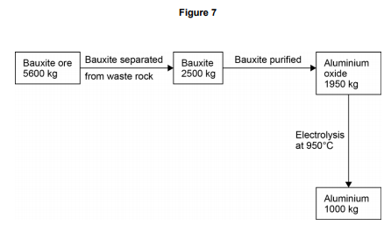

17.1. Calculate the percentage of bauxite that is converted into aluminium oxide.

[2 marks]

…………………………………………………………………………………………………………………………………………………………………………

…………………………………………………………………………………………………………………………………………………………………………

…………………………………………………………………………………………………………………………………………………………………………

Percentage = …………………………………

**Figure 8** shows an electrolysis cell used to extract aluminium

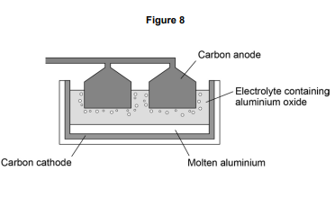

17.3. Why does the carbon anode used in the electrolysis cell need to be continually replaced? [3 marks]

…………………………………………………………………………………………………………………………………………………………………………

…………………………………………………………………………………………………………………………………………………………………………

…………………………………………………………………………………………………………………………………………………………………………

…………………………………………………………………………………………………………………………………………………………………………

17.4. In an electrolysis cell the current is 1.5 × 105 A, at a potential difference of 4V. Calculate the energy transferred by the electrolysis cell in 24 hours. [5 marks]

…………………………………………………………………………………………………………………………………………………………………………

…………………………………………………………………………………………………………………………………………………………………………

…………………………………………………………………………………………………………………………………………………………………………

…………………………………………………………………………………………………………………………………………………………………………

…………………………………………………………………………………………………………………………………………………………………………

…………………………………………………………………………………………………………………………………………………………………………

Energy transferred =…………………………..J

17.5. The half equation at the cathode is:

Al3+ + 3e– -> Al

Calculate the number of moles of electrons needed to produce 1 000 kg of aluminium.

Give your answer to three significant figures. Relative atomic mass (Ar): Al = 27

[3 marks]

…………………………………………………………………………………………………………………………………………………………………………

…………………………………………………………………………………………………………………………………………………………………………

…………………………………………………………………………………………………………………………………………………………………………

…………………………………………………………………………………………………………………………………………………………………………

…………………………………………………………………………………………………………………………………………………………………………

Answer = ………………………….moles

**Independent Exam Question**

**18.** A student investigates a potassium salt, X.

She finds that salt X:

• has a high melting point

• does not conduct electricity when it is solid

• dissolves in water and the solution does conduct electricity.

18 . 1. What is the type of bonding in salt X?

[1 mark]

Tick one box.

Covalent

Giant molecular

Ionic

Metallic

18.2. What is the name given to solutions that conduct electricity?

[1 mark]

…………………………………………………………………………………………………………………………………………………………………………

…………………………………………………………………………………………………………………………………………………………………………

18.3. Why does a solution of salt X in water conduct electricity?

[1 mark]

…………………………………………………………………………………………………………………………………………………………………………

…………………………………………………………………………………………………………………………………………………………………………

…………………………………………………………………………………………………………………………………………………………………………

18.4. The student electrolyses a solution of potassium chloride.

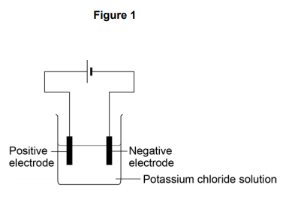**Figure 1** shows the apparatus she uses.

When the current is switched on, bubbles of hydrogen gas are given off at the negative electrode. Explain why hydrogen is produced and not potassium.

[2 marks]

…………………………………………………………………………………………………………………………………………………………………………

…………………………………………………………………………………………………………………………………………………………………………

…………………………………………………………………………………………………………………………………………………………………………

18.5. The student then compares the relative conductivity of different concentrations of potassium chloride. **Figure 2** shows the apparatus she uses.

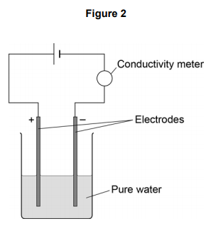

This is the method used.

1. Add potassium chloride solution to the water one drop at a time.

2. Stir the mixture.

3. Record the reading on the conductivity meter.

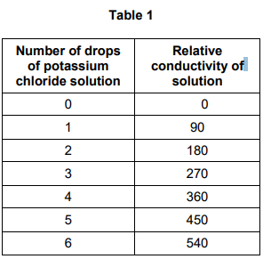**Table 1** shows the student’s results.

18.6. When there is no potassium chloride in the beaker no electrical charge flows.

Suggest why pure water does not conduct electricity.

[2 marks]

…………………………………………………………………………………………………………………………………………………………………………

…………………………………………………………………………………………………………………………………………………………………………

…………………………………………………………………………………………………………………………………………………………………………

…………………………………………………………………………………………………………………………………………………………………………

…………………………………………………………………………………………………………………………………………………………………………

…………………………………………………………………………………………………………………………………………………………………………

18.7. Describe the relationship shown in **Table 1.**

[2 marks]

…………………………………………………………………………………………………………………………………………………………………………

…………………………………………………………………………………………………………………………………………………………………………

…………………………………………………………………………………………………………………………………………………………………………

…………………………………………………………………………………………………………………………………………………………………………

…………………………………………………………………………………………………………………………………………………………………………

**19.**

This question is about zinc and magnesium.

Zinc is produced by electrolysis of molten zinc chloride, as shown in the figure below.

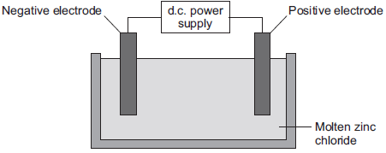

(a)    (i)      Why must the zinc chloride be molten for electrolysis?

______________________________________________________________

______________________________________________________________

**(1)**

(ii)     Describe what happens at the negative electrode.

______________________________________________________________

______________________________________________________________

______________________________________________________________

______________________________________________________________

______________________________________________________________

**(3)**

(iii)    Complete the half equation for the reaction at the positive electrode.

________    https://app.doublestruck.eu/content/AG_CHM/HTML/Q/Q14S2H04_files/img02.png    Cl2    +    ________    e–

**(1)**

(b)     Magnesium can be produced from magnesium oxide.

The equation for the reaction is:

Si(s)    +    2 MgO(s)    https://app.doublestruck.eu/content/AG_CHM/HTML/Q/Q14S2H04_files/img02.png    SiO2(s)    +    2 Mg(g)

(i)      How can you tell from the equation that the reaction is done at a high temperature?

______________________________________________________________

______________________________________________________________ (1)

**Lesson 7**

|  |  |  |
| --- | --- | --- |
|  | **Topic:** | **Endothermic and exothermic reactions (C.14)** |
| 1 | Which type of reaction releases energy into the surroundings? | Exothermic |
| 2 | Which type of reaction absorbs energy from the surroundings? | Endothermic |
| 3 | In an exothermic reaction, what has more energy in it? The products or the reactants? | Reactants |
| 4 | In an endothermic reaction, what has more energy in it? The products or the reactants? | Products |
| 5 | Define "activation energy" | Minimum amount of energy that particles must collide with to react |
| 6 | Is energy released when bonds are broken or bonds are made? (HT only) | Made |
| 7 | Is energy absorbed when bonds are broken or bonds are made? (HT only) | Broken |
| 8 | What would happen to the temperature of the surroundings in an exothermic reaction? | Increase |
| 9 | What would happen to the temperature of the surroundings in an endothermic reaction? | Decrease |
| 10 | Give three examples of endothermic reactions | Thermal decomposition reactions Citric acid + sodium hydrogen carbonate  Sports injury packs |
| 11 | Give two examples of exothermic reactions | Self-heating cans Hand warmers |
| 12 | What is the other name for an energy level diagram? | Reaction profile |
| 13 | What is the substance called that reduces the activation energy required by a reaction? | Catalyst |
| 14 | Do Exothermic or endothermic reactions require a bigger activation energy? | Endothermic |
| 15 | What is the unit for temperature? | Degrees Celsius |
|  |  |  |

Notes

**Chemistry Revision: Exothermic and Endothermic Reactions**

Mastery Matrix Points

|  |
| --- |
| Explain how energy is conserved in reactions |
| Define and give examples and uses of exothermic and endothermic reactions |
| Evaluate data to decide whether a reaction is exothermic or endothermic |
| **Required practical 4: Investigate the variables that affect temperature changes in reacting solutions** |
| Define activation energy |
| Use reaction profiles to show energies of reactants and products and link to exothermic and endothermic and draw simple reaction profiles for endothermic and exothermic reactions. |
| Explain whether energy is supplied or released when bonds are broken and made (HT only) |
| Calculate the overall energy change in a reaction using bond energies and use this to decide if a reaction is endothermic or exothermic (HT only) |

Key Knowledge

Conservation of energy in chemical reactions –

Exothermic –

Examples:

Endothermic –

Examples:

Activation energy –

BENDOMEX –

Reaction profile - exothermic reaction:

Reaction profile - endothermic reaction:

Understanding and Explaining

1. Are these exothermic or endothermic reactions?

|  |  |  |  |  |  |  |
| --- | --- | --- | --- | --- | --- | --- |
| Initial Temp (⁰C) | Final Temp (⁰C) | Exothermic or endothermic? |  | Initial Temp (⁰C) | Final Temp (⁰C) | Exothermic or endothermic? |
| 56 | 80 |  |  | 99 | 200 |  |
| 45 | 22 |  |  | 23 | 26 |  |
| 65 | 65 |  |  | 30 | 10 |  |
| 70 | 21 |  |  | 18 | 25 |  |

1. Reaction profiles show the energy in chemical bonds. Explain why the reaction profiles for both exothermic and endothermic reactions increase initially and then decrease.
2. Link the reaction to the descriptions. Match two descriptions to each name.

Temperature of the surroundings decreases

Exothermic - More energy is needed to make new bonds than break old bonds.

Temperature of the surroundings increases.

Endothermic - More energy is needed to break old bonds than make new bonds.

1. The equation for the reaction between hydrogen and oxygen is shown below.

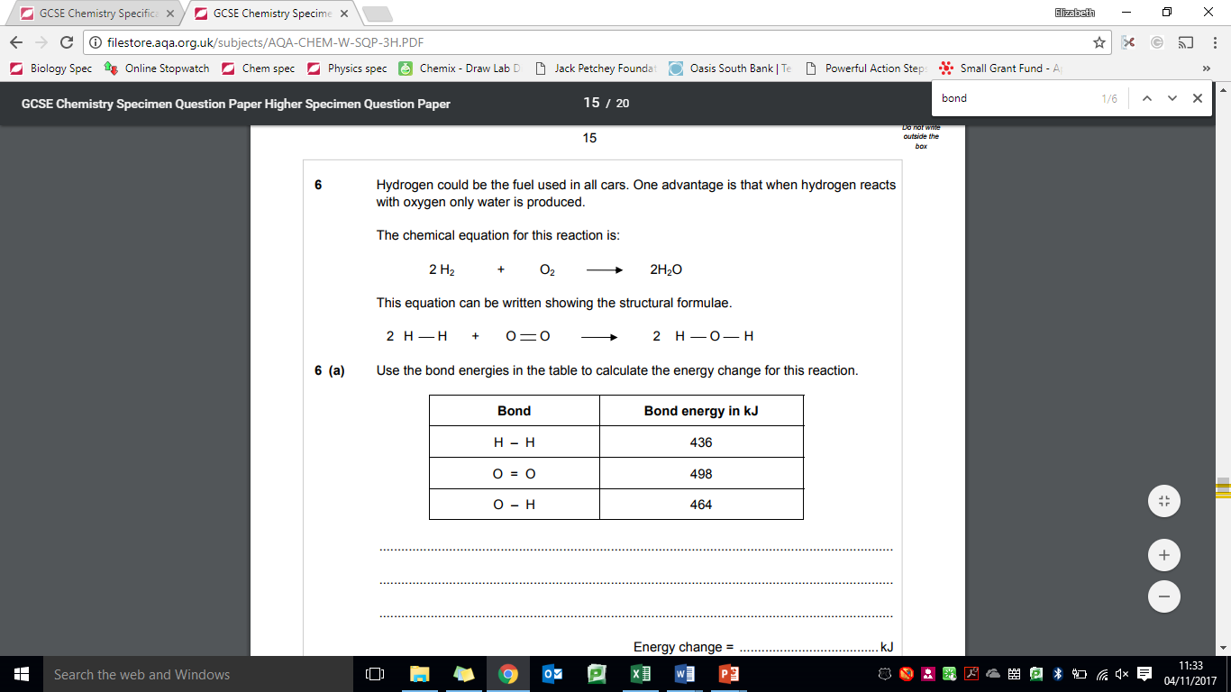 Is the reaction exothermic or endothermic?

**Guided Exam Question**

**20.** The rate of chemical reactions can be changed by changing the conditions.

20.1. Methane burns in oxygen to produce carbon dioxide and water.

The activation energy for the reaction is 2648 kJ/mol.

The reaction gives out 818 kJ/mol of energy.

Figure 1 shows the reaction profile for this reaction.

Complete the reaction profile.

Draw arrows to represent:

• the activation energy

• the energy given out.

**[4 marks]**

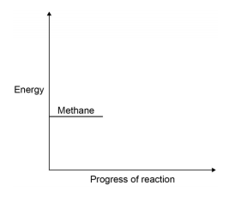

**20.2.** What percentage of the activation energy is the energy given out?

**…………………………………………………………………………………………………………………………………………………………………**

**[4 marks]**

**20.3.** Calcium carbonate decomposes when it is heated:

The decomposition of calcium carbonate is an endothermic reaction.

How would the reaction profile for decomposition of calcium carbonate be different from the reaction profile of methane burning in oxygen?

**[1 mark]**

**20.4** Catalysts are used in chemical reactions in industry.

Give two properties of catalysts.

For each property, explain why it makes the catalyst useful in industry.

**[4 marks]**

**…………………………………………………………………………………………………………………………………………………………………**

**…………………………………………………………………………………………………………………………………………………………………**

**…………………………………………………………………………………………………………………………………………………………………**

**…………………………………………………………………………………………………………………………………………………………………**

**…………………………………………………………………………………………………………………………………………………………………**

**…………………………………………………………………………………………………………………………………………………………………**

**Independent Exam Question**

**21.** A student investigated simple cells using the apparatus shown in Figure 4

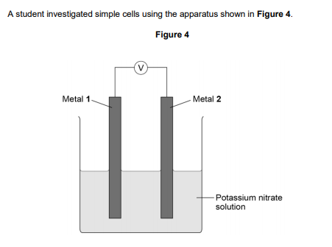

* If metal 2 is more reactive than metal 1 then the voltage measured is positive.
* If metal 1 is more reactive than metal 2 then the voltage measured is negative.
* The bigger the difference in reactivity of the two metals, the larger the voltage produced.

The student’s results are shown in Table 3.

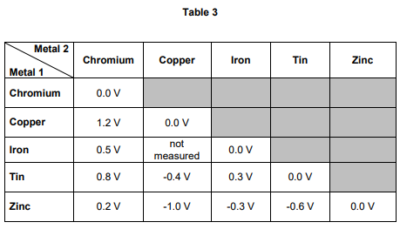

21.1. The ionic equation for the reaction occurring at the zinc electrode in the simple cell made using copper and zinc electrodes is: Zn → Zn2+ + 2e-

Zinc is oxidised in this reaction. Give a reason why this is oxidation.

[1 mark]

**…………………………………………………………………………………………………………………………………………………………………**

**…………………………………………………………………………………………………………………………………………………………………**

**Lesson 8**

|  |  |  |
| --- | --- | --- |
|  | **Topic:** | **Chemical calculations, volumes and concentrations (C.19)** |
| 1 | State the 'law of conservation of mass' | No atoms are lost or made during a chemical reaction |
| 2 | The sum of the Mr of the reactants must equal | The sum of the Mr of the products |
| 3 | State one example of when a reaction may APPEAR to lose mass | When a gas is produced and escapes |
| 4 | State the value of Avogadro's constant (HT only) | 6.02 x 10 23 |
| 5 | State the equation to calculate moles from mass and Mr (HT only) | Moles (mol) = mass (g) /Mr |
| 6 | State how to calculate Mr (relative formula mass) | The sum of the Ar (atomic masses) of each atom |
| 14 | When a symbol equation is balanced, what is shown by the large numbers in front of a formula e.g. 2HCl? | The ratio of moles of each substance |
| 15 | What is the volume of 1 mole of any gas at room temperature and pressure? | 24dm3 |
|  |  |  |

Notes

**Chemistry Revision: Calculations**

Mastery Matrix Points

|  |
| --- |
| Link changes in mass to the word equation for a reaction |
| Calculate the relative formula mass of a substance |
| Recall Avogadro's constant (6.02 x 1023) (HT only) |
| Use the formula moles = mass/Mr to calculate moles in a substance (HT only) |
| Calculate masses from balanced symbol equations (HT only) |

Understanding and Explaining

1. Calculate the mass of magnesium in this experiment.

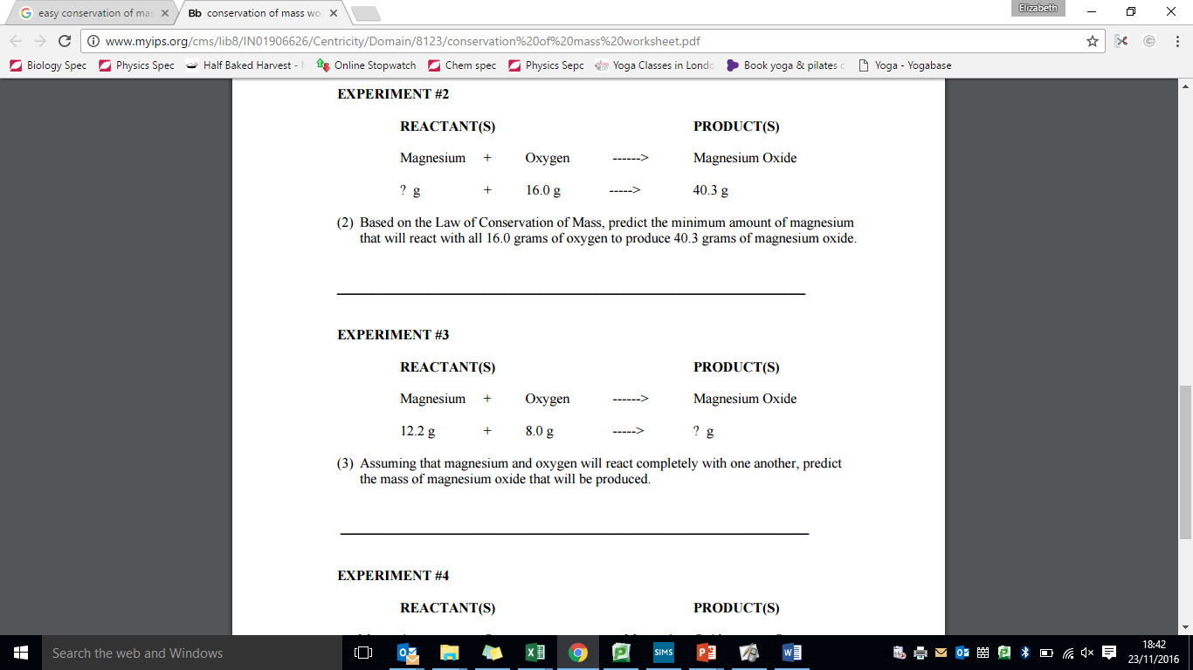

1. Explain why the mass appears to decrease during this reaction.

magnesium + hydrochloric acid 🡪 magnesium chloride + hydrogen

1. If Sarah is reacting 37g of Copper with some HCl, how many moles of Copper is she using?
2. If Abdul has 2 moles of magnesium, how much will it’s mass be? Give your answer in kilograms!
3. In a reaction, magnesium and hydrochloric acid are reacted together. If 48g of magnesium is used, how much hydrochloric acid is used in grams? Start with a balanced symbol equation.

Key Knowledge

Law of conservation of mass:

When does it look like mass goes down in a reaction, even though really it is conserved?

How to calculate relative formula mass:

What is Avogadro’s constant?

Equations:

Moles =

**Chemistry Revision: Volumes and Concentrations**

Mastery Matrix Points

|  |
| --- |
| Calculate the mass of solute in a given volume of solution |
| Explain how the mass of a solute and the volume of a solution is related to the concentration (HT only) |

Key Knowledge

Limiting reactant –

Reactant in excess –

Concentration –

At room temperature and pressure (20⁰C and 1atm), one mole of any gas takes up a volume of ___dm3.

Equations

moles = _____

Concentration (mol/dm3) =

Concentration (g/dm3) =

Volume of gas =

How to convert:

cm3 to dm3 -

dm3 to cm3 -

mol/dm3 to g/dm3 –

g/dm3 to mol/dm3 -

Steps of how to use moles to balance an equation:



Understanding and Explaining

1. Calculate the concentration of a salt solution that contains 20g of salt in 400dm3 of water.
2. 2.00dm3 of sodium hydroxide solution contains 0.5 moles of sodium hydroxide. What is the concentration?
3. In a chemical reaction, 72g of magnesium was reacted with exactly 48g of oxygen molecules to produce 120g of magnesium oxide. Use the number of moles of reactants and products to write a balanced equation for the reaction.

**Guided Exam Question**

**22.**

A student investigated the law of conservation of mass.

The law of conservation of mass states that the mass of the products is equal to the mass of the reactants.

When lead nitrate solution and potassium chromate solution are mixed, a reaction takes place.

This is the equation for the reaction:

Pb(NO3)2(aq) + K2CrO4(aq) ⟶ PbCrO4(s) + 2KNO3(aq)

(b)     The table shows the student’s results.

|  |  |
| --- | --- |
|  | **Mass in g** |
| Beaker **A** and contents before mixing | 128.71 |
| Beaker **B** and contents before mixing | 128.97 |
| Beaker **A** and contents after mixing | 154.10 |
| Beaker **B** after mixing | 103.58 |

Show that the law of conservation of mass is true.

Use the data from the table above.

___________________________________________________________________

___________________________________________________________________

___________________________________________________________________

___________________________________________________________________

**(2)**

(c)     What is the resolution of the balance used to obtain the results in the table?

Tick (✔) **one** box.

|  |  |  |  |  |  |  |  |  |  |  |
| --- | --- | --- | --- | --- | --- | --- | --- | --- | --- | --- |
| 0.01 g |  |  | 0.1 g |  |  | 1 g |  |  | 100 g |  |

**(1)**

(d)     Calculate the relative formula mass (*M*r) of lead nitrate Pb(NO3)2

Relative atomic masses (*A*r): N = 14 O = 16 Pb = 207

___________________________________________________________________

_________________________________________________________________(2)

Relative formula mass = ____________________

(e)     The formula of potassium chromate is K2CrO4

The charge on the potassium ion is +1

What is the formula of the chromate ion?

Tick (✔) **one** box.

|  |  |
| --- | --- |
| CrO4+ |  |
| CrO42+ |  |
| CrO4− |  |
| CrO42− |  |

**(1)**

**(Total 10 marks)**

**Q23.**

Citric acid is a weak acid.

A student titrated citric acid with sodium hydroxide solution.

This is the method used.

1. Pipette 25.0 cm3 of sodium hydroxide solution into a conical flask.

2. Add a few drops of thymol blue indicator to the sodium hydroxide solution.

    Thymol blue is blue in alkali and yellow in acid.

3. Add citric acid solution from a burette until the end-point was reached.

(d)     The table shows the student’s results.

|  |  |  |  |  |  |
| --- | --- | --- | --- | --- | --- |
|  | **Titration 1** | **Titration 2** | **Titration 3** | **Titration 4** | **Titration 5** |
| Volume of citric acid solution in cm3 | 13.50 | 12.10 | 11.10 | 12.15 | 12.15 |

The equation for the reaction is:

C6H8O7 + 3 NaOH ⟶ C6H5O7Na3 + 3 H2O

The concentration of the sodium hydroxide was 0.102 mol / dm 3

Concordant results are those within 0.10 cm 3 of each other.

Calculate the concentration of the citric acid in mol / dm 3

Use only the concordant results from the table in your calculation.

You must show your working.

___________________________________________________________________

___________________________________________________________________

___________________________________________________________________

___________________________________________________________________

___________________________________________________________________

___________________________________________________________________

___________________________________________________________________

Concentration = ____________________ mol / dm 3

**(5)**

**(Total 12 marks)**

**Independent exam questions**

**Q24.**

Some students were investigating the rate at which carbon dioxide gas is produced when metal carbonates react with an acid.

One student reacted 1.00 g of calcium carbonate with 50 cm3, an excess, of dilute hydrochloric acid.

The apparatus used is shown in **Diagram 1**.

**Diagram 1**

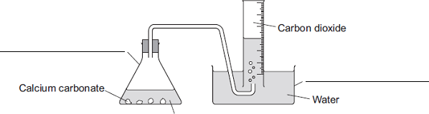Dilute hydrochloric acid

(a)     Complete the **two** labels for the apparatus on the diagram.

**(2)**

(b)     The student measured the volume of gas collected every 30 seconds.

The table shows the student’s results.

|  |  |
| --- | --- |
| **Time in seconds** | **Volume of carbon dioxide collected in cm3** |
| 30 | 104 |
| 60 |  |
| 90 | 198 |
| 120 | 221 |
| 150 | 232 |
| 180 | 238 |
| 210 | 240 |
| 240 | 240 |

(i)      **Diagram 2** shows what the student saw at 60 seconds.

**Diagram 2**

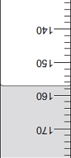

What is the volume of gas collected?

Volume of gas = __________ cm3

**(1)**

(ii)     Why did the volume of gas stop changing after 210 seconds?

______________________________________________________________

______________________________________________________________

**(1)**

(c)     Another student placed a conical flask containing 1.00 g of a Group 1 carbonate (M2CO3) on a balance.

He then added 50 cm3, an excess, of dilute hydrochloric acid to the flask and measured the mass of carbon dioxide given off.

The equation for the reaction is:

M2CO3 + 2HCl    2MCl + H2O + CO2

The final mass of carbon dioxide given off was 0.32 g.

(i)      Calculate the amount, in moles, of carbon dioxide in 0.32 g carbon dioxide.

Relative atomic masses (*A*r): C = 12; O = 16

______________________________________________________________

______________________________________________________________

______________________________________________________________

Moles of carbon dioxide = __________ moles

**(2)**

(ii)     How many moles of the metal carbonate are needed to make this number of moles of carbon dioxide?

______________________________________________________________

______________________________________________________________

Moles of metal carbonate = __________ moles

**(1)**

(iii)    The mass of metal carbonate used was 1.00 g.

Use this information, and your answer to part **(c) (ii)**, to calculate the relative formula mass (*M*r) of the metal carbonate.

If you could not answer part **(c) (ii)**, use 0.00943 as the number of moles of metal carbonate. This is **not** the answer to part **(c) (ii)**.

______________________________________________________________

______________________________________________________________

Relative formula mass (*M*r) of metal carbonate = __________

**(1)**

(iv)    Use your answer to part **(c) (iii)** to calculate the relative atomic mass (*A*r) of the metal in the metal carbonate (M2CO3) and so identify the Group 1 metal in the metal carbonate.

If you could not answer part **(c) (iii)**, use 230 as the relative formula mass of the metal carbonate. This is **not** the answer to part **(c) (iii)**.

To gain full marks, you must show your working.

______________________________________________________________

______________________________________________________________

______________________________________________________________

______________________________________________________________

Relative atomic mass of metal is ____________________________________

Identity of metal _________________________________________________

**(3)**

(d)     Two other students repeated the experiment in part **(c)**.

(i)      When the first student did the experiment some acid sprayed out of the flask as the metal carbonate reacted.

Explain the effect this mistake would have on the calculated relative atomic mass of the metal.

______________________________________________________________

______________________________________________________________

______________________________________________________________

______________________________________________________________

______________________________________________________________

______________________________________________________________

______________________________________________________________

**(3)**

(ii)     The second student used 100 cm3 of dilute hydrochloric acid instead of 50 cm3.

Explain the effect, if any, this mistake would have on the calculated relative atomic mass of the metal.

______________________________________________________________

______________________________________________________________

______________________________________________________________

______________________________________________________________

______________________________________________________________

______________________________________________________________

______________________________________________________________

**(3)**

**Q25.**

A student investigated the reactions of copper carbonate and copper oxide with dilute hydrochloric acid.

In both reactions one of the products is copper chloride.

(b)     A student wanted to make 11.0 g of copper chloride.

The equation for the reaction is:

                             CuCO3 + 2HCl  →  CuCl2 + H2O + CO2

Relative atomic masses, *A*r: H = 1; C = 12; O = 16; Cl = 35.5; Cu = 63.5

Calculate the mass of copper carbonate the student should react with dilute hydrochloric acid to make 11.0 g of copper chloride.

___________________________________________________________________

___________________________________________________________________

___________________________________________________________________

___________________________________________________________________

Mass of copper carbonate = _________________________ g

**(4)**

(c)     The percentage yield of copper chloride was 79.1 %.

Calculate the mass of copper chloride the student actually produced.

___________________________________________________________________

___________________________________________________________________

Actual mass of copper chloride produced = ____________ g

**(2)**

(d)     Look at the equations for the two reactions:

   Reaction 1        CuCO3(s) + 2HCl(aq)  →  CuCl2(aq) + H2O(l) + CO2(g)

   Reaction 2             CuO(s) + 2HCl(aq)  →  CuCl2(aq) + H2O(l)

Reactive formula masses: CuO = 79.5; HCl = 36.5; CuCl2 = 134.5; H2O = 18

The percentage atom economy for a reaction is calculated using:



Calculate the percentage atom economy for Reaction 2.

___________________________________________________________________

___________________________________________________________________

___________________________________________________________________

___________________________________________________________________

___________________________________________________________________

___________________________________________________________________

Percentage atom economy = ________________________ %

**(3)**

(e)     The atom economy for Reaction 1 is 68.45 %.

Compare the atom economies of the two reactions for making copper chloride.

Give a reason for the difference.

___________________________________________________________________

___________________________________________________________________

**(1)**

**Q26.**

A student investigated the rate of reaction of magnesium and hydrochloric acid.

Mg(s) + 2HCl(aq)    MgCl2(aq)  +  H2(g)

The student studied the effect of changing the concentration of the hydrochloric acid.

She measured the time for the magnesium to stop reacting.

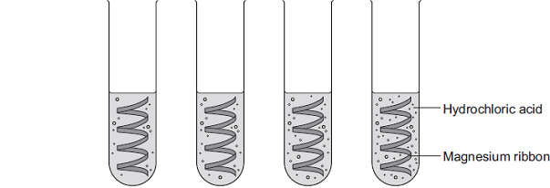

|  |  |  |  |  |
| --- | --- | --- | --- | --- |
| Concentration of hydrochloric acid in moles per dm3 | 0.5 | 1.0 | 1.5 | 2.0 |

(c)     (i)      The student had a solution of sodium hydroxide with a concentration of 0.100 moles per dm3.

She wanted to check the concentration of a solution of hydrochloric acid.

She used a pipette to transfer 5.00 cm3 of the hydrochloric acid into a conical flask.

She filled a burette with the 0.100 moles per dm3 sodium hydroxide solution.

Describe how she should use titration to obtain accurate results.

______________________________________________________________

______________________________________________________________

______________________________________________________________

______________________________________________________________

______________________________________________________________

______________________________________________________________

______________________________________________________________

______________________________________________________________

______________________________________________________________

______________________________________________________________

______________________________________________________________

**(4)**

(ii)     Sodium hydroxide neutralises hydrochloric acid as shown in the equation:

NaOH(aq)  +  HCl(aq)    NaCl(aq) + H2O(l)

The student found that 27.20 cm3 of 0.100 moles per dm3 sodium hydroxide neutralised 5.00 cm3 of hydrochloric acid.

Calculate the concentration of the hydrochloric acid in moles per dm3.

Give your answer to three significant figures.

______________________________________________________________

______________________________________________________________

______________________________________________________________

______________________________________________________________

______________________________________________________________

______________________________________________________________

Concentration of hydrochloric acid = _______________ moles per dm3

**(3)**

**Lesson 9**

|  |  |  |
| --- | --- | --- |
|  | **Topic:** | **RP: Making salts (C1) (C.35)** |
| 1 | What is the aim of the experiment? | Prepare a pure, dry sample of a soluble salt from an insoluble salt. |
| 2 | Which acid should be used? | Metal nitrate = dilute nitric acid Metal sulfate = dilute sulfuric acid Metal chloride = dilute hydrochloric acid |
| 3 | Which metal compound shold be used? | Metal oxide powder |
| 4 | Step 1: | Gently heat the dilute acid |
| 5 | Step 2: | Use a spatula to add excess metal oxide powder |
| 6 | Step 3: | Stir until all the metal oxide stops reacting and some is left in the bottom of the beaker |
| 7 | Step 4: | Filter the excess metal oxide powder |
| 8 | Step 5: | Gently heat the solution in an evaporating basin over a water bath |
| 9 | Step 6: | When crystals start to form, leave the evaporating basin for 24 hours in a warm place |
| 10 | Step 7: | Pat the crystals dry |
| 11 | Why is excess metal oxide used? | To ensure all of the acid and metal oxide have reacted |
| 12 | Why is the solution filtered? | To remove any excess metal oxide |
| 13 | Name two risks and precautions | 1) Take caution when heating the dilute acid as this may spill and burn 2) Wear safety goggles as the solution may spit when evaporating 3) The crystals are toxic so should not be touched |
| 14 | Name the change in state taking place | Water is evaporating (from liquid to gas) |
| 15 | What are possible variations in this method? | Explain how to prepare an insoluble salt from a soluble salt - (react two soluble salts and a precipitate will form, filter, wash with water, then dry in an oven). |
|  |  |  |

Notes

**Chemistry Revision – Rates of reaction – effect of size of marble chip (use volume of gas produced!)**

**Chemistry Revision - Making salts**

Understanding and Explaining

Equipment:

_____________________________________________________________________________________________________________________________

_____________________________________________________________________________________________________________________________

_____________________________________________________________________________________________________________________________

Method:

Step 1:__________________________________________________________________________________________________________________

_____________________________________________________________________________________________________________________________

Step 2:__________________________________________________________________________________________________________________

_____________________________________________________________________________________________________________________________

Step 3:__________________________________________________________________________________________________________________

_____________________________________________________________________________________________________________________________

Step 4:__________________________________________________________________________________________________________________

_____________________________________________________________________________________________________________________________

Step 5:__________________________________________________________________________________________________________________

_____________________________________________________________________________________________________________________________

Step 6:__________________________________________________________________________________________________________________

_____________________________________________________________________________________________________________________________

Step 7:__________________________________________________________________________________________________________________

_____________________________________________________________________________________________________________________________

Key Knowledge

Big question 1:

How do you prepare a pure, dry sample of a soluble salt from an insoluble salt?

Define:

Evaporation:_____________________________________________________

Crystallisation:___________________________________________________

Filtration:_______________________________________________________

Reactant in excess:_________________

_______________________________

IV in this experiment:

_______________________________

DV in this experiment:

_______________________________

CV in this experiment:

1. __________________________
2. __________________________
3. __________________________

**Q1.**

This label has been taken from a bottle of household ammonia solution.

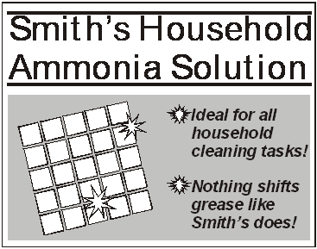

          Household ammonia is a dilute solution of ammonia in water. It is commonly used to remove grease from ovens and windows.

(a)     The amount of ammonia in household ammonia can be found by titration.

          25.0 cm3 of household ammonia is placed in a conical flask. Describe how the volume of dilute nitric acid required to neutralise this amount of household ammonia can be found accurately by titration. Name any other apparatus and materials used.

*To gain full marks you should write down your ideas in good English. Put them into a sensible order and use correct scientific words.*

___________________________________________________________________

___________________________________________________________________

___________________________________________________________________

___________________________________________________________________

___________________________________________________________________

___________________________________________________________________

___________________________________________________________________

___________________________________________________________________

___________________________________________________________________

**(4)**

(b)     In an experiment, it was found that 25.0 cm3 of household ammonia was neutralised by 20.0 cm3 of dilute nitric acid with a concentration of 0.25 moles per cubic decimetre.

          The balanced symbol equation which represents this reaction is

NH3(aq)  +  HNO3(aq)  →  NH4NO3(aq)

          Calculate the concentration of the ammonia in this household ammonia in moles per cubic decimetre.

___________________________________________________________________

___________________________________________________________________

___________________________________________________________________

___________________________________________________________________

Concentration = _______________ moles per cubic decimetre

**(2)**

(c)     The salt, ammonium nitrate, is formed in this reaction.

          Describe, and give the result of, a chemical test which shows that ammonium nitrate contains ammonium ions.

___________________________________________________________________

___________________________________________________________________

___________________________________________________________________

___________________________________________________________________

**(2)**

**(Total 8 marks)**

**Q2.**

Calcium chloride (CaCl2) is a soluble salt.

Calcium chloride can be made by reacting dilute hydrochloric acid with either solid calcium oxide or solid calcium carbonate.

(a)     Name the type of reaction that takes place when dilute hydrochloric acid reacts with calcium oxide.

___________________________________________________________________

**(1)**

(b)     Write a balanced symbol equation for the reaction of dilute hydrochloric acid with calcium oxide.

___________________________________________________________________

**(2)**

(c)     A student added solid calcium oxide to dilute hydrochloric acid in a beaker.

The student added solid calcium carbonate to dilute hydrochloric acid in another beaker.

Describe **one** difference between the two reactions that the student would **see**.

___________________________________________________________________

___________________________________________________________________

**(1)**

(d)     Describe how crystals of calcium chloride can be made from calcium carbonate and dilute hydrochloric acid.

___________________________________________________________________

___________________________________________________________________

___________________________________________________________________

___________________________________________________________________

___________________________________________________________________

___________________________________________________________________

___________________________________________________________________

___________________________________________________________________

**(4)**

(e)     A student dissolved some crystals of a salt in water.

The student added sodium hydroxide solution to the salt solution.

The student added sodium hydroxide solution until it was in excess.

(i)      Describe what the student would **see** if the salt contained calcium ions.

______________________________________________________________

______________________________________________________________

______________________________________________________________

**(2)**

(ii)     Why does the result you have described in part (e)(i) **not** prove that the salt contains calcium ions?

______________________________________________________________

______________________________________________________________

**(1)**

(iii)    Describe an additional test the student could do that would prove the salt contains calcium ions.

______________________________________________________________

______________________________________________________________

______________________________________________________________

**(2)**

**(Total 13 marks)**

**Q3.**

A scientist produces zinc iodide (ZnI2).

This is the method used.

1. Weigh 0.500 g of iodine.

2. Dissolve the iodine in ethanol.

3. Add an excess of zinc.

4. Stir the mixture until there is no further change.

5. Filter off the excess zinc.

6. Evaporate off the ethanol.

(a)     Ethanol is flammable.

Suggest how the scientist could carry out **Step 6** safely.

___________________________________________________________________

___________________________________________________________________

**(1)**

(b)     Explain why the scientist adds excess zinc rather than excess iodine.

___________________________________________________________________

___________________________________________________________________

___________________________________________________________________

___________________________________________________________________

___________________________________________________________________

___________________________________________________________________

**(3)**

(c)     Calculate the minimum mass of zinc that needs to be added to 0.500 g of iodine so that the iodine fully reacts.

The equation for the reaction is:

Zn + I2 ⟶ ZnI2

Relative atomic masses (*M*r): Zn = 65  I = 127

___________________________________________________________________

___________________________________________________________________

___________________________________________________________________

___________________________________________________________________

___________________________________________________________________

___________________________________________________________________

Minimum mass of zinc = ____________________ g

**(3)**

**Q4.**

Sodium hydroxide neutralises sulfuric acid.

The equation for the reaction is:

                 2NaOH + H2SO4  →  Na2SO4 + 2H2O

(a)     Sulfuric acid is a strong acid.

What is meant by a strong acid?

___________________________________________________________________

___________________________________________________________________

___________________________________________________________________

**(2)**

(b)     Write the ionic equation for this neutralisation reaction. Include state symbols.

___________________________________________________________________

**(2)**

(c)     A student used a pipette to add 25.0 cm3 of sodium hydroxide of unknown concentration to a conical flask.

The student carried out a titration to find out the volume of 0.100 mol / dm3 sulfuric acid needed to neutralise the sodium hydroxide.

Describe how the student would complete the titration.

You should name a suitable indicator and give the colour change that would be seen.

___________________________________________________________________

___________________________________________________________________

___________________________________________________________________

___________________________________________________________________

___________________________________________________________________

___________________________________________________________________

___________________________________________________________________

___________________________________________________________________

___________________________________________________________________

___________________________________________________________________

**(4)**

(d)     The student carried out five titrations. Her results are shown in the table below.

|  |  |  |  |  |  |
| --- | --- | --- | --- | --- | --- |
|  | Titration 1 | Titration 2 | Titration 3 | Titration 4 | Titration 5 |
| Volume of 0.100 mol / dm3 sulfuric acid in cm3 | 27.40 | 28.15 | 27.05 | 27.15 | 27.15 |

Concordant results are within 0.10 cm3 of each other.

Use the student’s concordant results to work out the mean volume of 0.100 mol / dm3 sulfuric acid added.

___________________________________________________________________

___________________________________________________________________

___________________________________________________________________

___________________________________________________________________

Mean volume = _____________________________ cm3

**(2)**

(e)     The equation for the reaction is:

                               2NaOH + H2SO4  →  Na2SO4 + 2H2O

Calculate the concentration of the sodium hydroxide.

Give your answer to three significant figures.

___________________________________________________________________

___________________________________________________________________

___________________________________________________________________

___________________________________________________________________

___________________________________________________________________

___________________________________________________________________

___________________________________________________________________

Concentration = _______________________ mol / dm3

**(4)**

(f)     The student did another experiment using 20 cm3 of sodium hydroxide solution with a concentration of 0.18 mol / dm3.

Relative formula mass (*M*r) of NaOH = 40

Calculate the mass of sodium hydroxide in 20 cm3 of this solution.

___________________________________________________________________

___________________________________________________________________

___________________________________________________________________

___________________________________________________________________

Mass = ________________ g

**(2)**

**(Total 16 marks)**

**Chemistry Revision: Groups in the**

Mastery Matrix Points

|  |
| --- |
| Describe the key properties (state, easy to cut, appearance) of group 1 |
| Describe and explain how the reactivity changes as you move down group 1 (oxygen, chlorine, water) |
| Describe the key properties (molecular mass, boiling and melting point) of group 7 |
| Describe and explain how the reactivity changes as you move down group 7 |
| Describe the key properties (boiling point) of group 0 |
| Describe and explain how the reactivity changes as you move down group 0 |

Key Knowledge

Group 1 is called the alkali metals

The properties of group 1 are

- Soft, shiny solids and can be cut by a knife

- Very reactive metals (e.g react vigorously with water)

- Low melting and boiling points compared to other metals

As you go down group 1, the reactivity increases

Group 1 elements all have one electron in their outer shell.

Group 7 is called the halogens

Properties of group 7

- Reactive non-metals

- low melting and boiling points

- Change state as you go down group (gas to liquid to solid)

As you go down group 7, the reactivity decreases

Group 7 elements all have seven electrons in their outer shell.

As you go down group 7, the melting point and boiling point increases

Group 0 is called the Noble gases

Properties of group 0

- Stable

- Gases at room temperature

- Unreactive

As you go down group 0 the boiling points increase

Group 0 elements all have eight electrons in their outer shell, apart from helium which has two.

**Periodic Table**

Understanding and Explaining

1. Describe the reactions below.

|  |  |  |
| --- | --- | --- |
| **Reactants** | **Product made (name and formula)** | **Observations during the reaction** |
| Lithium + water | Lithium hydroxide + hydrogen  LiOH + H2 | Lithium floats across the surface and gently fizzes (hydrogen gas). UI in water changes from green to purple due to an alkali being produced. |
| Sodium + water | Sodium hydroxide + hydrogen  NaOH + H2 | Sodium moves quickly across the surface and fizzes. UI in water changes from green to purple due to an alkali being produced. |
| Potassium + water | Potassium hydroxide + hydrogen  KOH + H2 | Potassium speeds across the surface and fizzing vigorously with purple flames also produced due to the hydrogen igniting. UI in water changes from green to purple due to an alkali being produced. |
| Lithium + chlorine | Lithium chloride  LiCl | Lithium reacts vigorously with chlorine to produce a salt. |
| Sodium + chlorine | Sodium chloride  NaCl | Sodium reacts vigorously with chlorine to produce a salt. |
| Potassium + chlorine | Potassium chloride  KCl | Potassium reacts vigorously with chlorine to produce a salt. |
| Lithium + oxygen | Lithium oxide  Li2O | Reacts with oxygen to produce a dull metal oxide. |
| Sodium + oxygen | Sodium oxide  Na2O | Reacts vigorously with oxygen to produce a dull metal oxide. |
| Potassium + oxygen | Potassium oxide  K2O | Reacts vigorously with oxygen to produce a dull metal oxide. |

1. Describe and explain how the reactivity of group 1 changes as you go down the group.

Group 1 metals react easily because they only have 1 electron in their outer shell and need to lose 1 electron to form a positive ion and become stable. They get more reactive as you move down the group because the atoms get larger. This means that the outer electron gets further from the nucleus and the electrostatic attraction between the positive nucleus and the negative outer electron gets weaker, so the electron is more easily lost.

1. Explain why group 7 elements have similar reactions when reacting with metals and non-metals.

Halogens have similar reactions with both metals, such as lithium, and non-metals, such as hydrogen or carbon, because they can react with both to become stable, either by gaining an electron in ionic bonding or sharing an electron in covalent bonding.

1. Describe the reactions below.

|  |  |  |
| --- | --- | --- |
| **Reactants** | **Product made (name and formula)** | **Is the product a covalent molecule or ionic lattice?** |
| sodium + chlorine | Sodium chloride (NaCl) | Ionic |
| hydrogen + chlorine | Hydrogen chloride (HCl) (hydrochloric acid in water) | Covalent |
| copper + bromine | Copper bromide (CuBr2) | Ionic |
| Sulfur + bromine | Sulphur dibromide (Br2S) | Covalent |
| lithium + iodine | Lithium iodide (LiI) | Ionic |
| phosphorus + iodine | Phosphorus triiodide (PI3) | Covalent |

1. Explain why group 0 elements are unreactive.

Group 0 elements are unreactive due to have full outer shells of electrons, thus not needing to gain or lose electrons to become stable.

1. Explain why the boiling point of group 0 increases as you go down the group.

The boiling point of group 0 increases as you go down the group due to the atoms getting larger and denser.

1. Explain why the reactivity of halogens decreases as you go down the group.

Group 7 halogens react easily because they have 7 electrons in their outer shell meaning that to complete a full outer shell they only need to gain one electron. As you move down the group the atoms become larger as they gain one electron shell. This means that the outer shell becomes further away from the electrostatic attraction of the nucleus and it becomes harder for the nucleus to attract the one electron.

1. Describe what happens in a halogen displacement reaction, such as chlorine + sodium bromide 🡪 sodium chloride + bromine.

Due to chlorine being more reactive than bromine, it displaces the bromide in sodium bromide. This is because chlorine is smaller and has a greater electrostatic attraction between nucleus and the outer electron shell and is able to more easily attract the outer shell electron of sodium to form an ionic bond.

**Chemistry Revision: Electrolysis**

Mastery Matrix Points

|  |
| --- |
| Describe how electrolysis is carried out |
| Explain the electrolysis of molten compounds eg. Lead bromide |
| Predict what is produced at each electrode |
| I can write half equations for the reaction occurring at each electrode |
| I can explain how electrolysis can be used to extract metals from their ores |
| I can explain how electrolysis can be used to determine the presence of hydrogen in an aqueous solution |
| **Required practical 3: Investigate what happens when aqueous solutions are electrolysed (including the development of a hypothesis)** |

Understanding and Explaining

1. Describe how electrolysis works.

Passing an electric current through molten or dissolved ionic compounds causes the ions to move to the electrodes. Positively charged ions move to the negative electrode (the cathode), and negatively charged ions move to the positive electrode (the anode). Ions gain or lose electrons at the electrodes producing elements.

1. Describe and explain the electrolysis of molten lead bromide. Include half equations for the anode and cathode.

Molten ionic compounds separate into ions that are free to move and conduct electricity. The electrolyte, lead bromide, breaks down to lead cations and bromide anions. The lead cations (positive) are attracted to the negative electrode (cathode) where lead is produced by reduction. Bromide ions are attracted to the anode, where they are oxidised to produce diatomic bromine.

Anode: 2Br- - 2e- 🡪 Br2

Cathode: Pb2+ + 2e- 🡪 Pb

1. Explain why electrolysis is used for the extraction of metals such as aluminium (rather than reduction by heating with carbon, which is used to extract other metals like iron).

Aluminium is more reactive than carbon and so carbon cannot displace it from its compound whereas iron is less reactive.

1. Describe and explain the electrolysis of molten aluminium oxide. Include half equations for the anode and cathode.

The electrolyte, aluminium oxide, breaks down to aluminium cations and oxide anions in a mixture of cryolite (an aluminium compound). The aluminium cations are attracted to the graphite cathode where pure aluminium is produced by reduction and sinks to the bottom of the container, due to its higher density than the cryolite. The pure aluminium is then tapped off at the bottom of the container. Oxide ions are attracted to the graphite anodes, where they are oxidised to produce carbon dioxide. This burns away the positive anode meaning the anodes must be regularly replaced.

Anode: 2O2- - 4e- 🡪 O2

Cathode: Al3+ + 3e- 🡪 Al

Key Knowledge

Electrolysis – the breakdown of ionic compounds into their ions using electricity.

Electrolyte - the compound being broken down.

Cathode – negative electrode

Anode - positive electrode.

Electrolysis works with a molten or dissolved ionic compounds because electricity is able to flow due to the ions carrying charge.

OIL RIG:

Oxidation is loss

Reduction is gain

At the anode:

Oxidation - Negative ions lose electrons

At the cathode

Reduction- Positive ions gain electrons

In the electrolysis of aqueous solutions, at the negative electrode (cathode), hydrogen is produced if the metal

is more reactive than hydrogen.

At the positive electrode (anode), metal is produced unless the

solution contains halide ions when the halogen is produced. This happens because in the aqueous solution water molecules break down producing hydroxide ions and hydrogen ions that are discharged.

1. Why cryolite is used in the electrolysis of aluminium oxide?

Cheaper than pure aluminium oxide and means pure aluminium can be tapped off due to a higher density than cryolite

1. Give two reasons why the electrolysis of aluminium oxide is expensive.

Uses a lot of energy (electricity) and the graphite anodes must be replaced regularly.

1. Describe the electrolysis of sodium chloride solution. State what is produced at each of the electrodes. Include half equations.

When ionic compounds are dissolved into water to form aqueous solutions the ions are free to move and conduct electricity. However, the water also breaks down into its ions H+ and OH-. With sodium chloride solution, the cathode attracts (cathode) H+ ions which are reduced to form hydrogen gas. This is due to sodium being more reactive than hydrogen and so is less easily discharged than hydrogen. At the anode, chloride ions (Cl-) are oxidised to produce chlorine gas.

Anode: 2Cl- - 2e- 🡪 Cl2

Cathode: 2H+ + 2e- 🡪 H2

**Chemistry Revision: Elements & Compounds**

Key Knowledge

Definitions: Element – substance made from only 1 type of atom.

Compound – substance made from 2 or more types of atom chemical bonded. The chemical properties of the compound is different than the elements by themselves.

Melting – solid 🡪 liquid

Boiling – liquid 🡪 gas

Freezing – liquid 🡪 solid

Condensing – gas 🡪 liquid

How many elements are in the periodic table? About 100.

Particle model – the atoms are represented as small solid spheres.

|  |  |  |
| --- | --- | --- |
| Solid | Liquid | Gas |
| Image result for particle model | Image result for particle model | Image result for particle model |

The stronger the forces between particles the HIGHER the melting and boiling point, so the MORE energy is needed to break the bonds between particles.

|  |  |
| --- | --- |
| *Temperature* | *Solid, liquid or gas?* |
| Lower than its melting point | Solid |
| Between the melting and boiling point | Liquid |
| Higher than its boiling point | gas |

Mastery Matrix Points

|  |
| --- |
| Describe and draw a model of the three states of matter |
| Use the particle model to explain melting, boiling, freezing and condensing |
| Identify a substance’s state using its melting and boiling point |
| Classify a substance as an element or compound |
| Identify the symbol for the first 20 elements |
| Name common compounds from their formula |

Understanding and Explaining

1. Describe how the movement and rearrangement of particles changes during
   1. Melting – FROM neat rows, regular arrangement, vibrations TO closely packed, random arrangement, moving.
   2. Boiling – FROM closely packed, random arrangement, moving TO moving in random directions, variety of speeds, filling the space.
   3. Freezing – FROM closely packed, random arrangement, moving TO neat rows, regular arrangement, vibrations
   4. Condensing – FROM moving in random directions, variety of speeds, filling the space TO closely packed, random arrangement, moving
2. Use the table to answer these questions.
   1. What state would each of the elements be at room temperature (25°C)?

Copper – Solid, Magnesium – solid, Oxygen – gas, Carbon – soild, helium – gas, sulfur – soild.

* 1. Which elements would be a gas at 2000°C?

Magnesium, oxygen, helium, sulfur

1. The particle model is the simplification that all particles are small, solid spheres. This model is useful for explaining changes of state. Describe the limitations (drawbacks) of this model.

Limitations of the simple model above include that in the model there are no forces, that all particles are represented as spheres and that the spheres are solid.

1. Are these elements or compounds?
   1. Sodium chloride - compound
   2. Oxygen gas - element
   3. KI - compound
   4. Co – element
   5. CO - compound
2. Write the symbols for these elements.

|  |  |  |  |  |  |  |  |
| --- | --- | --- | --- | --- | --- | --- | --- |
| Hydrogen | H2 | Carbon | C | Sodium | Na | Sulfur | S |
| Helium | He | Nitrogen | N2 | Magnesium | Mg | Chlorine | Cl2 |
| Lithium | Li | Oxygen | O2 | Aluminium | Al | Argon | Ar |
| Beryllium | Be | Fluorine | F2 | Silicon | Si | Potassium | K |
| Boron | B | Neon | Ne | Phosphorus | P | Calcium | Ca |

1. Name these compounds.

|  |  |  |
| --- | --- | --- |
| 1. LiO lithium oxide | 6. CuCl2 copper chloride | 11. HCl hydrochloric acid |
| 2. AlCl3 aluminium chloride | 7. H2O water | 12. CaBr calcium bromide |
| 3. MgCl2 magnesium chloride | 8. H2SO4 sulfuric acid | 13. K2O potassium oxide |
| 4. FeS iron sulfide | 9. KNO3 potassium nitrate | 14. Al2O3 aluminium oxide |
| 5. NaCl sodium chloride | 10. LiOH lithium hydroxide | 15. CO2 carbon dioxide |



**Chemistry Revision: Mixtures**

Key Knowledge

Mixture – consists of two or more elements or compounds not chemically combined together. The chemical properties of each substance in the mixture are unchanged.

Soluble – can dissolve

Insoluble – cannot dissolve

Solute – a solid that can dissolve

Solvent – a liquid that dissolves a soluble solid

Filtration

Used to separate: insoluble solids from liquids

Equipment: filter paper, funnel, conical flask

Crystallisation

Used to separate: soluble solids from liquids

Equipment: evaporating basin, Bunsen burner, tripod, guaze, heat proof mat.

Simple distillation

Used to separate: either soluble solid from liquid OR liquids with different boiling points.

Equipment: round bottom flask, condensing tube, test tube, beaker, heater/Bunsen burner.

Chromatography

Used to separate: different coloured dyes.

Equipment: chromatography paper, solvent (water or ethanol), beaker…

Fractional distillation

Used to separate: liquids of different boiling points

Equipment: fractionating colum.

Mastery Matrix Points

|  |
| --- |
| Use key terms (soluble, insoluble, solute, solvent and solution) correctly to describe a substance dissolving |
| Explain how to separate given mixtures (filtration, crystallisation, simple distillation, fractional distillation, chromatography) |
| Explain the difference in difficulty of separating compounds compared to mixtures |

Understanding and Explaining

1. Mixtures be separated by physical processes. Explain what a physical process is and give four examples.

Physical processes are reversible processes that can turn a mixture back into its elements. E.g. crystallisation, distillation, chromatography and filtration.

1. Explain why compounds cannot be separated by physical processes.

Compounds are chemical bonded so require chemical processes to separate the elements out, not physical ones.

1. Describe the process of filtration using sandy water as an example.

Using a filter funnel, filter paper and a conical flask. Place the filter paper folder into the funnel over the conical flask. Pour the sandy water mixture into the filter paper and funnel. The filtrate (water) will be collected in the conical flask. The residue (sand) will be left in the filter paper

1. Describe the process of crystallisation using copper sulfate solution as an example.

An aqueous solution of the salt copper sulphate is evaporate to half its volume and then left to cool and crystallise over several days.

1. Describe the process of paper chromatography and how you could use it to see if a food dye is pure.

Prepare a piece of chromatography paper by drawing a pencil line 1-2cm from the bottom. Dot a sample of the food dye on the pencil line and then dot a sample of the pure food dye on the same pencil line around 1cm distance apart. Place the chromatography paper in water making sure the pencil lines and food dye are above water. Let the solvent run up the paper. Compare the chromatograms of the pure food dye and the sample. If they contain the same spots with the same Rf value then the food dye is pure.

1. Describe the process of distillation using an ethanol and water mixture as an example.

Heat to evaporate a mixture of water and ethanol. The ethanol will boil and become a gas before water as it has a lower boiling point, this will then cool and condense in a condenser. All of the ethanol will boil and cool and condense before water due to its lower boiling point.

1. Explain the difference between simple distillation and fractional distillation.

Simple distillation – only separates a mixture with two substances which have different boiling points. Fractional distillation – uses a fractionating column, has a variety of temperatures throughout the column meaning lots of fractions can cool and condenses at their boiling points as they move up the column.

**Chemistry Revision: Structure of an Atom**

Key Knowledge

Definitions:

Plum pudding model – the atom is a ball of positive charge with negative electrons embedded in it.

Nuclear model - the atom has a small positive nucleus with electrons in shells around the outside.

Isotope – atoms of the same element with the same number of protons and a different number of neutrons.

Ion – charged particles (have lost or gained electrons)

Relative atomic mass - the average mass of one atom of an element to one twelfth of the mass of an atom of carbon-12.

Radius of an atom = 0.1 nm

= 1 x 10-10 m

Radius of a nucleus is TEN THOUSAND times smaller than the atomic radius, about 1 x 10-14m.

What order were the parts of the atom discovered? ELECTRON< PROTON, NEUTRON

Subatomic particles

|  |  |  |
| --- | --- | --- |
| *Name* | *Relative mass* | *Charge* |
| Proton | 1 | +1 |
| Neutron | 1 | 0 |
| Electron | Very small! | -1 |

Using the periodic table:

*To find the number of protons…*

*Look up the atomic number*

*To find the number of electrons…*

*Look up to the atomic number*

*To find the number of neutrons…*

*Mass number – atomic number*

Mastery Matrix Points

|  |
| --- |
| Describe the plum pudding model of the atom |
| Describe the current (nuclear) model of the atom giving the relative charge and mass of the subatomic particles |
| Recall the radius of an atom and it’s nucleus |
| Calculate protons, neutrons and electrons for an atom linking to mass and atomic number |
| Draw the electronic structure and work out the electronic configuration for a given atom |
| Define an ‘isotope’ |
| Isotopes to relative atomic mass to explain why this is an average |
| Calculate the relative atomic mass of an element given the percentage abundance of its isotopes |
| Calculate the relative formula mass of a substance |

Understanding and Explaining

1. Describe in detail the structure of the atom using the current theory.

* Small positive nucleus containing protons and neutrons in the centre of the atom
* Mainly empty space
* Electrons in energy levels called shells around the nucleus.

1. Describe what the atomic number and mass number on the periodic table tell us.

* Atomic number – number of protons
* Mass number – total number of protons and neutrons added together (nucleons)

1. Why might scientists make changes to an existing theory?

* To explain the results from experiments
* Because of new evidence

1. Describe the alpha scattering experiment, its results and why the results led to a change in the theory of the atom.

* Fire atoms from an alpha source at a thin sheet of gold foil
* Use a GM tube detector so look at the path of the alpha particles
* RESULTS – 1. Most of the alpha particles went straight through🡪most of the atom is empty space
* 2. Some of the atoms were deflected 🡪 this shows there was a positive nucleus repelling the alpha particles.
* 3. Very few (one in 20000) alpha particles reflected straight back 🡪 the positive nucleus is very small.

1. Explain the role of Niels Bohr in atomic theory.

* Did calculations to show that electrons are in energy levels called shells.

1. Describe the contribution of James Chadwick to atomic theory.

* Discovered neutrons.

1. Explain why the relative atomic mass on the periodic table is an average.

* It takes into account the abundance of different isotopes – for example chlorine is 35.5 because some of the chlorine has a mass number 36 and some 35, because there are different isotopes, so an average is taken.

1. Calculate the relative atomic mass of neon if the abundances of the atoms are: Ne20 90.92%, Ne21 0.26%, Ne22 8.82%.

Relative atom mass = 90.92/100*20 +0.26/100*21+8.82/100*22

**= 20.179**

**Chemistry Revision: Types of Bonding**

Key Knowledge

Ionic bond – electrostatic attraction between a positive metal ion and a negative non-metal ion. When metal donates electrons to a non-metal.

Covalent bond – when non-metal atoms share pairs of electrons. The electrostatic attraction between the protons in the nucleus and electrons make the bond strong.

Metallic bond – Delocalised electrons around positive metal ions.

Alloy – a mixture of a metal and another substance (a metal or carbon etc).

Lattice structure (definition and picture) –

Alternating positive and negative ions in a regular 3D structure.

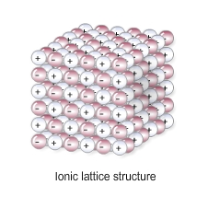

Nanoparticle definition – particles that are 1-100nm, made from a few hundred atoms.

Nanoparticles, are smaller than fine particles (PM2.5), which have diameters between 100 and 2500 nm (1 x 10-7 m and 2.5 x 10-6 m).

Corse particles (dust) –Coarse particles (PM10) have diameters between 1 x 10-5 m and 2.5 x 10-6 m.

Ways of showing bonding and their drawbacks:

|  |  |  |
| --- | --- | --- |
| *Name of model* | *Example* | *Limitations* |
| Ball and stick | Image result for ball and stick model ionic | Doesn’t show electrons |
| Dot and cross | Image result for dot and cross model | Doesn’t show 3d shape |
| 2D models | Image result for display formula ethane | Doesn’t show electron shells or 3d shape |
| 3D models | Image result for ball and stick model ionic | Doesn’t show electron shells. |

Mastery Matrix Points

|  |
| --- |
| Describe the structure and properties of giant ionic structures |
| Link the structure of giant ionic structures to its properties |
| Describe the structure and properties of simple covalent structures |
| Describe the structure and properties of giant covalent structures (including diamond, graphite and silica) |
| Compare and contrast giant carbon structures (diamond, graphite, graphene and fullerene – Buckminster fullerenes and nanotubes as examples) (triple only) |
| Describe two uses of nanotechnology (triple only) |
| Describe how a substance bonds metallically |
| Link the structure of giant metallic structures to their properties |

Understanding and Explaining

1. Describe and explain the properties of simple covalent molecules. E.G. CARBON DIOXIDE, WATER ETC.

|  |  |
| --- | --- |
| *Property* | *Explanation* |
| Low melting and boiling points | Don’t need to break covalent bonds, only weak intermolecular forces which doesn’t take much energy. |
| Do not conduct electricity | The molecules do not have an overall electric charge (no delocalised electrons or ions that can move) |

1. Describe and explain the properties of ionic compounds.

|  |  |
| --- | --- |
| *Property* | *Explanation* |
| High melting and boiling points | large amounts of energy needed to break the many strong bonds. |
| Conduct electricity when molten or dissolved | because the ions are free to move and so charge can flow (not free when solid) |

1. Describe and explain the properties of metallic structures.

|  |  |
| --- | --- |
| *Property* | *Explanation* |
| High melting and boiling point | large amounts of energy needed to break the strong bonds. |
| Malleable (bent and shaped) | In pure metals, atoms are arranged in layers, which can slide over each other. |
| Good conductors | the delocalised electrons in the metal carry electrical charge through the metal |

1. Describe and explain the properties of each of these giant covalent structures.

|  |  |  |  |
| --- | --- | --- | --- |
| *Name* | *Structure* | *Properties* | *Explanations* |
| Diamond | each carbon atom forms four covalent bonds with other carbon atoms | Hard | Lots of strong rigid bonds |
| High melting point | Need to break all strong bonds |
| Doesn’t conduct | No free charges (electrons/ions) |
| Graphite | carbon atom forms three covalent bonds with other carbon atoms in layers of hexagonal rings. | Slippery | Layers can slide over each other |
| Conducts electricity | One electron from each carbon atom is delocalised. |
| Graphene | a single layer of graphite | NOTE: useful in electronics and composites. | |
| Fullerenes | molecules of carbon atoms with hollow shapes or cylindrical fullerenes with very high length to diameter ratios. | NOTE: The first fullerene to be discovered was Buckminsterfullerene (C60) which has a spherical shape.  Their properties make them useful for nanotechnology, electronics and materials | |
| Polymers | Very large molecules with the atoms joined by covalent bonds. | Depends if thermosetting or thermosoftening | Cross links between polymer chains make them more difficult to melt etc. |

1. Explain why the properties of nanoparticles are different from the same material in bulk, making them more effective.

NANOPARTICLES HAVE A LARGER SURFACE AREA TO VOLUME RATIO.

1. What are the possible risks associated with nanoparticles? SCIENTISTS AREN’T SURE – MAYBE HEALTH RISKS DUE TO BEING ABSORBED IN TO THE SKIN ETC.
2. Explain why alloys are harder and less malleable that the pure metals they are made from. IN ALLOYS ATOMS CANNOT SLIDE OVER EACH OTHER BECAUSE THE ATOMS ARE NOT IN NEAT ROWS BECAUSE THE ATOMS ARE DIFFERENT SIZES.

**Chemistry Revision: Development of**

Mastery Matrix Points

|  |
| --- |
| Describe how Mendeleev has arranged the periodic table |

**Periodic Table**

Key Knowledge

PERIODIC TABLE BEFORE MENDELEEV:

The periodic table was arranged in order of ATOMIC WEIGHTS and some elements were MISSING.

The properties were not the same in the GROUPS/COLUMNS.

MENDELEEV’S CHANGES:

1. **Arranged in order of atomic number**
2. **Left gaps for undiscovered elements.**

This meant that the elements in the same group had similar **properties**.

Later the discovery of **isotopes** explained why the order of atomic weight had not worked properly.

MODERN PERIODIC TABLE:

In the periodic table, the elements are arranged in order of **atomic number**.

Periods are the **rows** of the periodic table, which show that the properties repeat. Elements in the same period have the same number of **electron shells (NOTE – not electrons, but shells).**

Groups are the **columns** of the periodic table, which have similar properties within them. Elements in the same group have the same number of **electrons** in their outer shell.

Understanding and Explaining

1. Explain why elements in the same groups did not have similar properties before Mendeleev’s changes to the periodic table.

* The elements in each group didn’t have the same number of electrons in their outer shell so they reacted differently and had different properties.
* This is because some elements hadn’t been discovered which meant the order was incorrect.

1. Describe and explain Mendeleev’s contribution to the modern periodic table.

* **Arranged in order of atomic number**
* **Left gaps for undiscovered elements.**

1. Describe what has been added to the periodic table since Mendeleev made his changes.

* New elements have discovered such as group 0 which are unreactive so were discovered later.

1. Sulfur and sodium are in the same period of the periodic table. Suggest one similarity and one difference about their electronic structure.

* Same number of electron shells but a different number of electrons in their outer shell.

1. Lithium and sodium are in the same group of the periodic table. Suggest one similarity and one difference about their electronic structure.

* Different numbers of electron shells but the same number of electrons in the outer shell.

**Chemistry Revision: Metals in the Periodic Table**

Understanding and Explaining

1. Compare the properties and reactivity of group 1 metals with the transition metals.

**Group 1 are more reactive than transition metals. Group 1 are softer than transition metals. Group 1 have a lower density than transition metals. Group 1 have lower melting and boiling points than the transition metals.**

1. Describe the reactions of these metals with oxygen, water and halogens.

|  |  |  |  |
| --- | --- | --- | --- |
| *Metal* | *Reaction with chlorine or other halogen* | *Reaction with water* | *Reaction with oxygen* |
| Cr | **Makes chromium chloride salt** | **Corrodes slowly to form**  **Chromium hydroxide + hydrogen** | **Makes chromium oxide powder** |
| Mn | **Makes manganese chloride salt** | **As above** | **As above** |
| Fe | **Makes iron chloride salt** | **As above** | **As above** |
| Co | **Makes cobalt chloride salt** | **As above** | **As above** |
| Ni | **Makes nickel chloride salt** | **As above** | **As above** |
| Cu | **Makes copper chloride salt** | **As above** | **As above** |

1. Explain how you could test an unknown metal to see if it is a group 1 metal or a transition metal.

**React with water and see if it fizzes violently (group 1) or gently bubbles (transition metals). Or see if the metal is soft enough to cut.**

Mastery Matrix Points

|  |
| --- |
| Explain why something is classified as a metal or non-metal |
| Describe the key properties of the transition metals (chromium, manganese, iron, cobalt, nickel and copper) (triple only) |

Key Knowledge

Metals are found on the **left** of the periodic table.

Non-metals are found on the **right** of the periodic table.

Transition metal properties

**- form different ions**

**- hard**

**- high melting/boiling point**

**- dense**

**- conduct electricity**

Transition metals are used as **catalysts**.

Transition metals form **coloured** compounds.

Transition metals can form ions with **different** charges, e.g. Fe2+ and Fe3+.

Name these transition metals –

Cr, Mn, Fe, Co, Ni, Cu.

**Chromium**

**Manganese**

**Iron**

**Cobalt**

**Nickel**

**Copper**

**Chemistry Revision: Reactivity of Metals**

Understanding and Explaining

1. Describe the reactions below.

|  |  |  |
| --- | --- | --- |
| *Metal* | *Reaction with room temperature water* | *Reaction with dilute acid* |
| Potassium | **Fizzes (H2 released), lilac flame.** | **Fizzes (H2 released), lilac flame.** |
| Sodium | **Fizzes, floats on the water (cushion of H2 gas)** | **Fizzes, floats on the water (cushion of H2 gas)** |
| Lithium | **Fizzes (H2 released)** | **Fizzes (H2 released)** |
| Calcium | **Fizzes (H2 released)** | **Fizzes (H2 released)** |
| Magnesium | **Bubbles gently if no oxide layer, corrodes over time.** | **Bubbles** |
| Zinc | **Corrodes over time.** | **Bubbles gently** |
| Iron | **Corrodes over time.** | **No reaction/ very gentle corrosion over time.** |
| Copper | **Corrodes over time.** | **No reaction/ very gentle corrosion over time.** |

1. Explain why metals such as gold do not need to be extracted from an ore.

**Its unreactive so hasn’t formed compounds/ it is found native.**

1. Explain how metals such as copper and iron are extracted from their ores. Include a word equation for the extraction of iron from iron oxide and state which chemical is oxidised and which is reduced.

**Heat the metal to melt it then, they mix with carbon. The carbon displaces the metal to produce carbon dioxide. Iron oxide + carbon 🡪 iron + carbon dioxide. Iron is reduced and carbon is oxidised.**

1. Are these chemicals being oxidised or reduced?

|  |  |
| --- | --- |
| 1. **Cu2+ 🡪 Cu Reduced** | 1. **I- 🡪 I2 oxidised** |
| 1. **Cl- 🡪 Cl2 oxidised** | 1. **I2 🡪 I- Reduced** |
| 1. **Zn 🡪 Zn2+ oxidised** | 1. **Mg 🡪 Mg2+ oxidised** |
| 1. **Ag+ 🡪Ag Reduced** | 1. **Zn2+ 🡪 Zn Reduced oxidised** |

1. Write ionic equations for these displacement reactions. The first one is done for you.
2. CuSO4 + Zn 🡪 ZnSO4 + Cu  **Answer: Cu2++ Zn 🡪 Zn2++ Cu**
3. CuSO4 + Pb 🡪 PbSO4 + Cu **Answer: Cu2++ Pb 🡪 Pb2++ Cu**
4. CuSO4 + Mg 🡪 MgSO4 + Cu  **Answer: Cu2++ Mg🡪 Mg2++ Cu**
5. Pb(NO3)2 + Zn 🡪 Zn(NO3)2 + Pb **Answer: Pb2++ Zn 🡪 Zn2++ Pb**
6. Pb(NO3)2 + Mg 🡪 Mg(NO3)2 + Pb **Answer: Pb2++ Mg 🡪 Mg2++ Pb**
7. Zn(NO3)2 + Mg 🡪 Mg(NO3)2 + Zn **Answer: Zn2++ Mg 🡪 Mg2++ Zn**

Mastery Matrix Points

|  |
| --- |
| Use evidence to rank metals in order of reactivity |
| Predict what would happen in a displacement reaction between two substance |
| Write ionic half equations for displacement reactions (HT only) |
| Link reactivity to how metals are extract from their ore |
| Describe the reaction of given metals with oxygen |
| Describe the reaction of given metals with water |
| Describe the reactions of given metals with acids (magnesium, zinc and iron with hydrochloric and sulphuric acid) |
| Predict products from given reactants |
| Explain these reactions in terms of redox reactions, linking to electrons and the species that is oxidised and reduced (HT only) |
| Calculate masses from balanced symbol equations and link this to limiting reactants and the use of a reactant in excess. (HT only) |

Key Knowledge

The more reactive a metal is the more easily it forms positive ions.

The reactivity series (with 8 metals and 2 non-metals):

1. **Potassium**
2. **Sodium**
3. **Lithium**
4. **Calcium**
5. **Magnesium**
6. **CARBON**
7. **Zinc**
8. **Iron**
9. **HYDROGEN**
10. **Copper**

Metal displacement reactions are when **a more reactive metal displaces a less reactive metal in a compound.**

Oxidation

Definition 1 – **reacting with oxygen**

Definition 2 – **loss of electrons**

Reduction

Definition 1 – **losing oxygen**

Definition 2 – **gaining electrons**

Ore – **a compound/rock with enough of a metal to make it worthwhile extracting it.**

Low reactivity metals are extracted from their ore by…**reduction with carbon.**

High reactivity metals are extracted by **electrolysis.**

**Chemistry Revision: Describing Chemical Reactions**

Mastery Matrix Points

|  |
| --- |
| Write a word equation for a given reaction |
| Write a balanced symbol equation for a given reaction |
| Include appropriate state symbols in an equation |

Key Knowledge

Rules for chemical equations:

* Use an ARROW, never an equals sign.
* Show the reactants on the LEFT hand side.
* Show the products on the RIGHT hand side.
* Use only words for a WORD equation and symbols for a BALANCED/SYMBOL equation.
* All lower case for word equations and correct case for symbols.

State symbols:

Solid – (s)

Liquid - (l)

Gas – (g)

Aqueous (dissolved)- (aq)

*Note:* Most salts are usually aqueous.

General word equations

metal + oxygen 🡪 **metal oxide**

metal + acid 🡪 **salt + hydrogen**

metal oxide + acid 🡪 **salt + water**

metal hydroxide + acid 🡪 **salt + water**

metal carbonate + acid 🡪 **salt + water + carbon dioxide**

metal + halogen 🡪 **metal halide**

metal + water 🡪 **metal hydroxide + hydrogen**

|  |  |
| --- | --- |
| *Acid* | *Formula* |
| Hydrochloric acid | **HCl** |
| Sulfuric acid | **H2SO4** |
| Nitric acid | **HNO3** |

Understanding and Explaining

1. Complete word and symbol equations for these reactions. Make sure the chemical equations are balanced, and **include state symbols.**
2. magnesium + hydrochloric acid 🡪 **magnesium chloride + hydrogen**
3. calcium carbonate + hydrochloric acid 🡪 **calcium chloride + water + carbon dioxide**
4. potassium + water 🡪 **potassium hydroxide + hydrogen**
5. sodium + sulfuric acid 🡪 **sodium sulfate + hydrogen**
6. sulfuric acid + copper oxide 🡪 **copper sulfate + water**
7. magnesium + oxygen 🡪 **magnesium oxide**
8. sodium hydroxide + hydrochloric acid 🡪 **sodium chloride +water**
9. zinc + hydrochloric acid 🡪 **zinc chloride + hydrogen**
10. potassium + iodine 🡪 **potassium iodide**
11. potassium + oxygen 🡪 **potassium oxide**
12. sodium +water 🡪 **sodium hydroxide + hydrogen**
13. sodium + chlorine 🡪 **sodium chloride**
14. copper carbonate + sulfuric acid 🡪 **copper sulfate + carbon dioxide + water**

**Chemistry Revision: Acids and Alkalis**

Mastery Matrix Points

|  |
| --- |
| Identify the ions produced by different acids and alkalis |
| Describe the pH scale and how to test pH using universal indicator or a pH probe |
| Describe neutralisation reactions (alkalis and bases, metal carbonates and acid) |
| Deduce the formulae of salts from their given ions |
| Explain the method for producing soluble salts |
| **Required practical 1: Prepare a pure dry sample of a soluble salt from an insoluble oxide or carbonate** |
| Recall the ionic equation for neutralisation |

Key Knowledge

Insoluble metal hydroxide - Base

Soluble metal hydroxide - Alkali

Metal oxide - Base

Metal carbonate - Base

What ions do acids produce in aqueous solutions? H+

What ions to alkalis produce in aqueous solutions? OH-

pH Scale – Label strong acid, weak acid, neutral, weak alkali, strong alkali:

|  |  |  |
| --- | --- | --- |
| ***pH*** | ***Description*** | ***Colour in universal indicator*** |
| Image result for ph scale to fill out vertical | Strong acid  Weak acid  Neutral  Weak alkali  Strong alkali | Red  Orange-yellow  Green  Blue-green  Purple |

Ionic equation for neutralisation:

H+ (aq) + OH- (aq) 🡪 H2O (l)

Complete the general word equations:

acid + metal oxide 🡪 salt + water

acid + metal hydroxide 🡪 salt + water

acid + metal carbonate 🡪 salt + water + carbon dioxide

Understanding and Explaining

1. Explain why using a pH probe to measure the pH of a chemical may be give precise results than using an indicator, such as universal indicator.

A pH probe has a quantitative scale and is accurate to 0.01 of a pH unit. Universal indicator is a qualitative measure subject to human error.

1. Complete the word equations. Then turn to symbol equations.

Copper carbonate + sulfuric acid 🡪 Copper sulfate + water + carbon dioxide CuCO3 + H2SO4 🡪 CuSO4 + H2O

Iron carbonate + hydrochloric acid 🡪 Iron chloride + water + carbon dioxide Fe2(CO3)3 + 6HCl 🡪 2FeCl3 + 3H2O + 3CO2

Zinc carbonate + nitric acid 🡪 Zinc nitrate + water + carbon dioxide ZnCO3 + 2HNO3 🡪 Zn(NO3)2 + H2O + CO2

Iron oxide + hydrochloric acid 🡪 Iron chloride + water Fe2O3 + 6HCl 🡪 2FeCl3 + 3H2O

Copper hydroxide + nitric acid 🡪 Copper nitrate + water Cu(OH)2 + 2HNO3 🡪 Cu(NO3)2 + 2H2O

Copper oxide + hydrochloric acid 🡪 Copper chloride + water CuO + 2HCl 🡪 CuCl2 + H2O

1. Complete the table to show the chemical formula of these salts.

|  |  |  |  |
| --- | --- | --- | --- |
| ***Name*** | ***Formula*** | ***Name*** | ***Formula*** |
| Sodium sulfate | Na2SO4 | Zinc sulfate | ZnSO4 |
| Lithium chloride | LiCl | Zinc nitrate | Zn(NO3)2 |
| Magnesium chloride | MgCl2 | Potassium sulfate | K2SO4 |

1. Describe the method and equipment needed to prepare a dry sample of a soluble salt, such as producing copper sulfate from copper oxide and sulfuric acid.

An excess of solid copper oxide powder is added to a solution of sulfuric acid in a suitable reaction vessel, e.g. a conical flask, forming aqueous copper sulfate. CuO + H2SO4 🡪 CuSO4 + H2O. The solution will turn a characteristic blue colour. The solution is then filtered using filter paper – copper oxide is insoluble so it will not pass through the filter paper. The resultant solution is then either left to evaporate or heated using a crucible until blue copper sulfate crystals are formed.

**Chemistry Revision: Acids and Alkalis 2**

Mastery Matrix Points TRIPLE ONLY

|  |
| --- |
| Explain the difference between a strong and weak acid, giving examples (triple only) |
| Link pH changes to hydrogen ion concentration (triple only) |
| Explain how to use a titration to measure the volume of an acid or an alkali |
| **Required practical 2: Determine the reacting volume of a solution of strong acid and strong alkali by titration linking to concentration (triple only)** |

Key Knowledge

Definitions

Strong acid – an acid that fully dissociates in aqueous solution or water, e.g. hydrochloric acid HCl 🡪 H+ + Cl-

Weak acid – an acid that does not fully dissociate, e.g. ethanoic acid

CH3COOH ⇌ CH3COO- + H+

Dilute acid – an acid that has been diluted with water and has a low concentration of H+ ions

Concentrated acid – an acid that has not been significantly diluted and has a high concentration of H+ ions

Examples of weak acids

- Ethanoic acid

- Citric acid

- Phosphoric acid

Examples of strong acids

- Hydrochloric acid

- Sulfuric acid

- Nitric acid

pH and ion concentration

For a given concentration of aqueous solutions, the stronger an acid,

the lower the pH.

As the pH decreases by one unit, the hydrogen ion concentration of

the solution increases by a factor of 10.

i.e. pH 1 has the most hydrogen ions and pH 14 has the least hydrogen ions.

Understanding and Explaining

1. Explain how a concentrated acid can be weak or strong.

The strength of an acid refers exclusively to its ability to dissociate e.g. HCl 🡪 H+ + Cl-. Strong acids fully dissociate and weak acids partially dissociate. Both strong and weak acids can be concentrated if they are not diluted with significant amounts of water.

1. Describe the equipment and method of using a titration to find out the concentration of a sulfuric acid by reacting it is a known concentration of sodium hydroxide. Include how you will accurately measure the volumes of reactants and the indicator you will use (HINT – universal indicator is NOT suitable to use in titrations because its colour change is too graduated).

A glass pipette, pipette filler, conical flask, burette, phenolphthalein and a black cross are needed. A set amount, say 25 cm3, of sodium hydroxide is added to the conical flask using the glass pipette. A small amount of phenolphthalein is then added to the flask, turning it slightly pink. It is then set on top of the black cross. Whilst swirling the flask, sulfuric acid is slowly added using the burette until a sudden colour change from pink to colourless is observed (the black cross will become visible). The volume of sulphuric acid added is calculated using initial reading – final reading = amount added. This is recorded and the process repeated until consistent results are obtained.

1. Explain the five steps you take to calculate the unknown concentration after a titration is complete.
   1. Calculate the mean titre (ignoring any outlying titres)
   2. Convert this to dm3
   3. The number of moles of sodium hydroxide can be calculated using moles = concentration x volume
   4. Check stoichiometric ratios: e.g. H2SO4 + 2NaOH 🡪 Na2SO4 + 2H2O is 2 : 1, so the number of moles of sulphuric acid should be half of this that of sodium hydroxide.
   5. Finally, the concentration can be calculated using $\text{concentration= }\frac{\text{moles}}{\text{volume}}$.

Use these results as an example: A titration is carried out and 0.04dm3 hydrochloric acid neutralises 0.08dm3 sodium hydroxide of concentration 1.00 mol/dm3. Calculate the concentration of the hydrochloric acid.

$$\text{moles of sodium hydroxide = concentration x volume = 1.00 x 0.08}\text{ = }\text{0.08 mol}$$

$$\text{concentration = }\frac{\text{0.08}}{\text{0.04}}\text{= 2 mol/d}{\text{m}}^{\text{3}}$$

HCl + NaOH 🡪 NaCl + H2O, so reaction is 1 : 1

**Chemistry Revision: Calculations**

Mastery Matrix Points

|  |
| --- |
| Link changes in mass to the word equation for a reaction |
| Calculate the relative formula mass of a substance |
| Calculate the atom economy of a reaction |
| Calculate the percentage yield for a reaction |
| Calculate masses from balanced symbol equations |

Key Knowledge

Law of conservation of mass:

Mass is neither created nor destroyed. In a closed system, the mass of reactants is equal to the mass of products.

When does it look like mass goes down in a reaction, even though really it is conserved?

In an open system where mass could be lost by escaping gases.

How to calculate relative formula mass:

$${\text{M}}_{\text{r}} \text{=} \frac{\text{mass}}{\text{moles}}$$

Equations:

Atom Economy =

$$\frac{{\text{M}}_{\text{r}}\text{ of desired products}}{\text{sum of }{\text{M}}_{\text{r}}\text{ of all products}}\text{x} \text{100}$$

Percentage yield =

$$\frac{\text{actual mass of product obtained}}{\text{maximum theoretical mass of product}}\text{x} \text{100}$$

Massunknown=

Reaction is 1 : 2, therefore the number of moles of MgCl2 = 1 mol

Understanding and Explaining

1. Calculate the mass of magnesium in this experiment. Mass Mg = 24.3g



1. Explain why the mass appears to decrease during this reaction.

magnesium + hydrochloric acid 🡪 magnesium chloride + hydrogen

Hydrogen gas diffuses away, so its mass is not measured.

1. Calculate the atom economy for making hydrogen by reacting zinc with hydrochloric acid: Zn + 2HCl → ZnCl2 + H2
2. Calculate the percentage yield of an investigation that expected to produce 495 tonnes of product A, but only produced 400 tonnes.
$$\frac{\text{actual mass of product obtained}}{\text{maximum theoretical mass of product}}\text{x 100 = }\frac{\text{400}}{\text{495}}\text{ x 100} \text{=} \text{80.8\%}$$

3. In a reaction, magnesium and hydrochloric acid are reacted together. If 48g of magnesium is used, how much hydrochloric acid is used in grams? Start with a balanced symbol equation.

Mg + 2HCl 🡪 MgCl2 + H2

**Chemistry Revision: Exothermic and endothermic reactions**

Key Knowledge

Conservation of energy in chemical reactions – Energy is transferred to or from the surroundings.

Exothermic – A reaction which releases energy into the surroundings.

Examples: Self-heating cans, Hand warmers

Endothermic – A reaction which absorbs energy from the surroundings.

Examples: Thermal decomposition reactions, Citric acid + sodium hydrogen carbonate, Sports injury packs

Activation energy – Minimum amount of energy that particles must collide with to react

BENDOMEX – Bond- breaking is endothermic, Bond-making is exothermic.

Reaction profile -



Reaction profile - endothermic reaction:

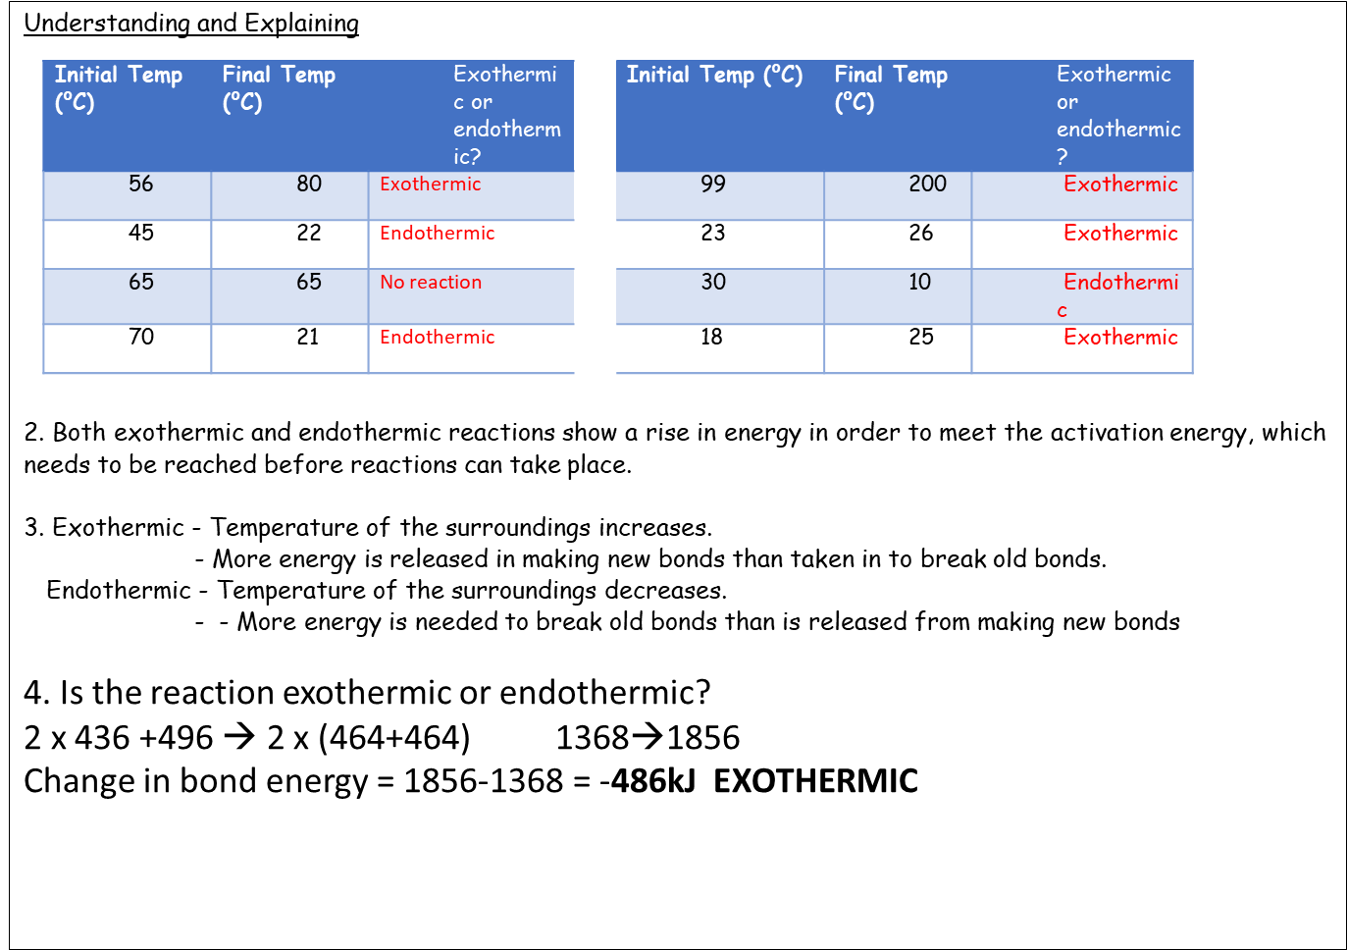

**Chemistry revision: Cells and batteries**

Key Knowledge

Definitions:

Chemical cell – Contain chemicals which react to produce electricity.

Battery – Two or more cells connected together in series to provide a greater voltage.

Rechargeable batteries - the chemical reactions are reversed when an external electrical current is

supplied.

Non-rechargeable – The chemical reactions stop when one of the reactants has been used up.

Fuel cell - supplied by an external source of fuel (eg hydrogen) and oxygen or air.

Alkaline batteries – Non-rechargeable

Factors that affect the voltage produced by a chemical cell

* Type of electrodes (reactivity of metals)
* Type of electrolyte

Word equation for hydrogen fuel cell:

Hydrogen + Water 🡪 Water

Half equation for anode:

2H2 -> 4H+ + 4e-

Half equation for cathode:

O2 + 4H+ + 4e- -> 2H2O

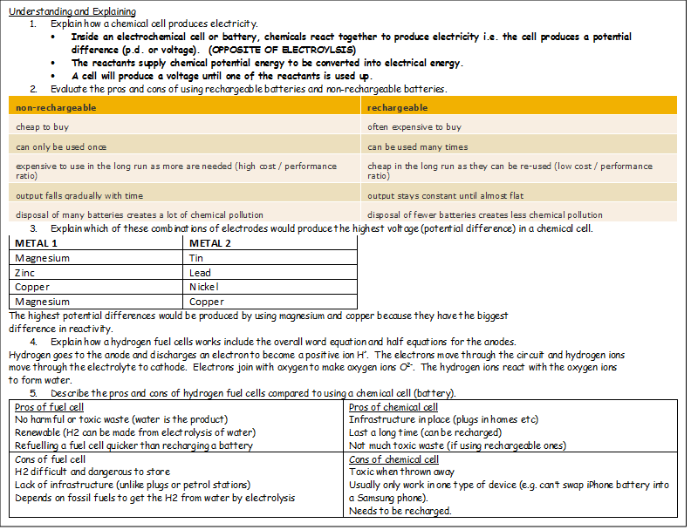

**Chemistry revision: Volume and concentrations**

Key Knowledge

Limiting reactant – The reactant that is completely used up.

Reactant in excess – The reactant that remains at the end of a reaction.

Concentration – The number of solute particles in the solvent.

At room temperature and pressure (20⁰C and 1atm), one mole of any gas takes up a volume of 24 dm3.

Equations

moles = _mass (g)___

  Mr

Concentration (mol/dm3) = moles (mol) / volume (dm3)

Concentration (g/dm3) = concentration in mol/dm3 × Mr

 Volume of gas = number of moles × 24

How to convert:

cm3 to dm3 - Divide by 1000

dm3 to cm3 – Multiply by 1000

mol/dm3 to g/dm3 – Multiply by the Mr

g/dm3 to mol/dm3 – Divide by the Mr

Steps of how to use moles to balance an equation:

1. Write out the equation.

2. Calculate moles of reactants and products.

3.Simplify the ratio.

4. Balance the equation.

Understanding and Explaining

1. Calculate the concentration of a salt solution that contains 20g of salt in 400dm3 of water.

C=20/400 =0.05 g/dm3

1. 2.00dm3 of sodium hydroxide solution contains 0.5 moles of sodium hydroxide. What is the concentration?

C= 0.5/2 = 0.25 mol/dm3

1. Calculate the volume of a 0.80 mol/dm3 potassium bromide solution containing 1.60 moles of potassium bromide.

V= 1.6/0.8 = 2.25 dm3

1. Calculate the number of moles of hydrogen that occupy 6 dm3 at rtp (room temp and pressure).

Moles = 6/24 = 0.25 mol

1. 97g of hydrogen is produced. What volume of gas would this be at rtp?

Mol = 97/1 =97 vol = 97 x 24 = 2,328 dm3

1. 72g of argon is produced. What volume of gas is this at rtp?

Mol = 72/40 =1.8 vol = 1.8 x 24 =43.2 dm3

1. Calculate the volume of oxygen that reactions with 96dm3 of hydrogen in this reaction:

2H2 +O2 🡪 2H2O

96/2 = 48dm3

1. In a chemical reaction, 72g of magnesium was reacted with exactly 48g of oxygen molecules to produce 120g of magnesium oxide. Use the number of moles of reactants and products to write a balanced equation for the reaction.

Mol Mg = 72/24 = 3 = 1

Mol O2 = 48/16 = 3 = 1

Mol MgO = 120/ (24+16) = 3 = 1

Mg + O2 🡪 MgO

1. (a)     elements:               aluminium, copper,compounds:           pure water, sodium chloride*,*mixture:                 beer, milk

*2/3 correct gains 1 mark  
4/5 correct gains 2 marks  
all correct gains 3 marks*

**3**

(b)     metals:                  can be hammered into shape,                            good conductor of electricity, shinynon metals:            brittle, dull, poor conductors of electricity

*2/3 correct gains 1 mark  
4/5 correct gains 2 marks  
all correct gains 3 marks*

**3**

**[6]**

2. (a)     add yeast

**1**

and ferment **or** by fermentation

*allow in a warm place****or****temperatures within the range 20-45oC****or****with an airlock / absence of air*

**1**

(b)     heat (the mixture)

**1**

ethanol has a lower boiling point than water **or** more ethanol than water vaporises **or**ethanol evaporates first or when the temperature reaches 78oC

*allow ethanol and water boil at different temperatures*

**1**

condense (the vapour)

*allow condense at different temperatures for the last two marking points*

*if no other mark is awarded, allow repeat distillation or use fractional distillation apparatus for 1 mark*

**1**

**[5]**

3. (a)     any **one** from:

•        heat

•        stir

**1**

(b)     filter

*accept use a centrifuge*

*accept leave longer (to settle)*

**1**

(c)     any **one** from:

•        wear safety spectacles

•        wear an apron

**1**

(d)     evaporation at **A**

**1**

condensation at **B**

**1**

(e)     100

**1**

**[6)**

4. (a)     electrons transferred from potassium to sulfur

**1**

two potassium atoms each lose one electron

**1**

forming K+ / 1+ ions

**1**

sulfur atoms gain 2 electrons

**1**

forming S2− / 2− ions

**1**

(b)     there are no gaps / sticks between the potassium ions and sulfide ions

**1**

(c)     (two) shared pairs between H and S

**1**

rest correct - no additional hydrogen electrons and two non-bonding pairs on sulfur

*second mark dependent on first*

**1**

(d)     342

**2**

*allow****1****mark for evidence of (2 × 27) + 3[32 + (16 × 4)]*

(e)               **Property**                                   **Explanation of property**

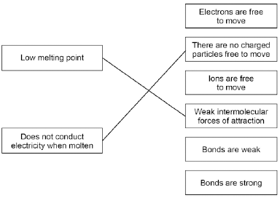

more than one line drawn from a variable negates the mark

**2**

(f)               **Property**                                   **Explanation of property**

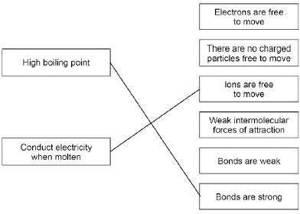

more than one line drawn from a variable negates the mark

**2**

**[14]**

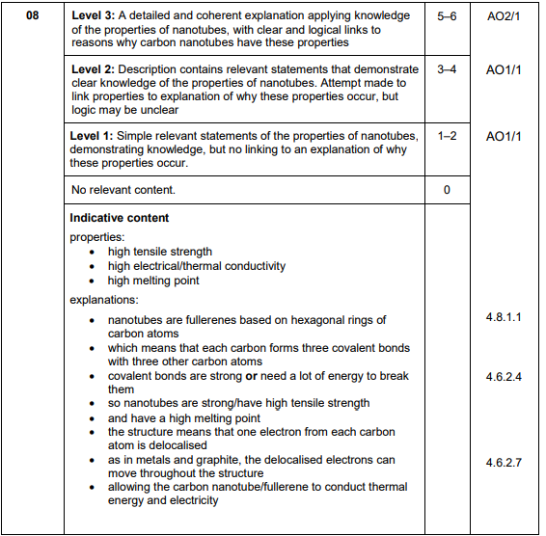

5. a)     lithium (atom) loses (one) electron(s)

**1**

chlorine (atom) gains (one) electron(s)

**1**

reference to transfer of one electron

**1**

to form positive and negative ions

*allow to form noble gas electronic structures*

***or***

*allow to form stable electron arrangements*

***or***

*allow to form full outer shells*

***or***

*allow reference to ionic bonding*

**1**

6.

(a)     proton

**1**

(b)     electron

**1**

(c)     7

**1**

4

**1**

*in this order only*

(d)     isotopes

**1**

(e)     neutron

**1**

(f)      

**1**

= 10.8

**1**

*an answer of 10.8 scores* ***2*** *marks*

(g)      

**1**

= 2 × 10−5 (nm)

*allow 0.00002 (nm)*

**1**

*an answer of 2 × 10−5 (nm) scores 2 marks*

**[10]**

**Q7.**

(a)     six electrons in the overlap

*allow dots, crosses or e(-) for electrons*

**1**

2 non-bonding electrons on each nitrogen atom

***2*** *marks for an answer of:*

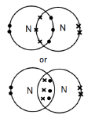

**1**

(b)     weak forces

**1**

between molecules

**or**

intermolecular

*do not allow references to covalent bonding between molecules*

**1**

(which) need little energy to overcome

**1**

(c)     each (carbon) atom forms three covalent bonds

**1**

forming layers (of hexagonal rings)

**1**

(soft)

(because) layers can slide over each other

**1**

(conducts electricity)

(because of) delocalised electrons

**1**

(d)     molecules are spherical

**1**

(so molecules) will roll

**1**

(e)     surface area (= 20 × 20 × 6) = 2400 (nm 2)

**1**

volume (= 203) = 8000 (nm 3)

**1**

ratio = 0.3 (nm 3): 1 (nm 3)

ratio = 0.3 (nm 3): 1 (nm 3)

**or**

1 (nm 3): 3.33 (nm 3)

**1**

(f)      (nanoparticles) have a larger surface area to volume ratio

**1**

so less can be used for the same effect

**1**

**[16]**

**Q8.**

(a)     Whether there was a reaction or not

**1**

(b)     brown / orange / dark deposit on zinc

**or**

blue solution turns colourless / paler

**1**

(c)               **Variable**                                   **Measuring instrument**

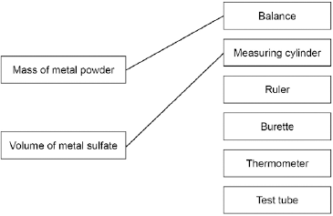

more than one line drawn from a variable negates the mark

**2**

(d)     (Most reactive)        **Magnesium**

**Zinc**

(Least reactive)       **Copper**

*must all be correct*

**1**

(e)     would not be safe **or**

too reactive

*allow too dangerous*

**1**

(f)     Gold

**1**

(g)     2Fe2O3   +   3C   →   4Fe   +   3CO2

*allow multiples*

**1**

(h)     carbon

**1**

(i)     Loss of oxygen

**1**

**[10]**

**Q9.**

(a)     (i)      hydrogen

*accept H2*

*allow H*

**1**

(ii)     hydroxide

*accept OH–*

*allow OH*

*do* ***not*** *accept lithium hydroxide*

**1**

(b)     any **two** from:

*‘it’ = potassium*

potassium:

*accept converse for lithium*

•        reacts / dissolves faster

*allow reacts more vigorously / quickly / violently / explodes  
ignore reacts more*

•        bubbles / fizzes faster

*allow fizzes more*

*allow more gas*

•        moves faster (on the surface)

*allow moves more*

•        melts

*allow forms a sphere*

•        produces (lilac / purple) flame

*allow catches fire / ignites*

*do* ***not*** *accept other colours*

**2**

**[4]**

**Q10.**

(a)     (i)      any **two** from:

•        bubbles / effervescence / fizzing

*ignore hydrogen / gas produced*

•        lithium disappears / gets smaller

*allow dissolves  
do* ***not*** *allow melts / burns*

•        lithium moves on the surface of the water

*ignore floats*

•        (universal indicator) turns blue / purple

**2**

(ii)     2

*left-hand side correct*

**1**

2

*right-hand side correct*

*allow multiples for full credit*

**1**

(iii)    light / burn, which will give a (squeaky) pop / explosion

**1**

(iv)    all have 1 electron in their outer shell / energy level

*allow have the same number of electrons in their outer shell / energy level*

**1**

(b)     They react with oxygen

**1**

They have low melting points

**1**

**[13]**

**Q11.**

(a)     any **three** from:

•        concentration of (salt) solution

•        volume of (salt) solution

*ignore amount of solution*

•        **initial** temperature (of the solution)

*ignore room temperature*

•        surface area / form of metal

•        moles of metal

*allow mass / amount*

*ignore time*

*ignore size of tube*

**3**

(b)     20

**1**

32

**1**

12

*allow ecf*

**1**

(c)     (i)      four bars of correct height

*tolerance is + / - half square*

*3 correct for* ***1*** *mark*

**2**

bars labelled

**1**

(ii)     *one variable* is non-continuous / categoric

*accept qualitative or discrete*

*accept no values between the metals*

**1**

(iii)    magnesium

**1**

because biggest temperature change

*accept gives out most energy*

*ignore rate of reaction*

*dependent on first mark*

**1**

(iv)    does not react / silver cannot displace copper

**1**

because silver not more reactive (than copper) **or** silver below copper in reactivity series

*do* ***not*** *accept silver is less reactive than copper sulfate*

**1**

(v)     replace the copper sulfate

*could be implied*

**1**

with any compound of a named metal less reactive than copper

*allow students to score even if use an insoluble salt*

**1**

**[16]**

12    **Level 3 (5–6 marks):**

A detailed and coherent comparison is given, which demonstrates a broad knowledge and understanding of the key scientific ideas. The response makes logical links between the points raised and uses sufficient examples to support these links.

**Level 2 (3–4 marks):**

A description is given which demonstrates a reasonable knowledge and understanding of the key scientific ideas. Comparisons are made but may not be fully articulated and / or precise.

**Level 1 (1–2 marks):**

Simple statements are made which demonstrate a basic knowledge of some of the relevant ideas. The response may fail to make comparisons between the points raised.

**0 marks:**

No relevant content.

**Indicative content**

Physical

Transition elements

•        high melting points

•        high densities

•        strong

•        hard

Group 1

•        low melting points

•        low densities

•        soft

Chemical

Transition elements

•        low reactivity / react slowly (with water or oxygen)

•        used as catalysts

•        ions with different charges

•        coloured compounds

Group 1

•        very reactive / react (quickly) with water / non-metals

•        not used as catalysts

•        white / colourless compounds

•        only forms a +1 ion

**6**

**Q13.**

(a)     (iron) is a metal

*accept transition element*

*allow (iron) had different properties (to oxygen and sulfur)*

*ignore electrons*

**1**

(b)     so that elements with similar properties could be placed together

*allow to make the pattern fit*

*ignore undiscovered elements*

**1**

(c)     atomic number(s)

*allow proton number(s)*

**1**

(d)     all have one electron in the outer shell (highest energy level)

*allow same number of electrons in the outer shell (highest energy level)*

**1**

(so they) have similar properties

**or**

react in the same way

*allow specific reactions e.g. with water*

**1**

**[5]**

**Q13.2.**

(a)     (i)      any **one** from:

•        one electron in the outer shell / energy level

•        form ions with a 1+ charge

**1**

(ii)     any **one** from:

•        hydrogen is a non-metal

•        (at RTP) hydrogen is a gas

•        hydrogen does not react with water

•        hydrogen has only one electron shell / energy level

•        hydrogen can gain an electron **or** hydrogen can form a negative / hydride / H–ion

•        hydrogen forms covalent bonds **or** shares electrons

*accept answers in terms of the Group 1 elements*

**1**

(b)     (i)      (bromine) gains electrons

*it = bromine*

*do* ***not*** *accept bromide ion gains electrons*

*ignore loss of oxygen*

**1**

(ii)     I2

*must both be on the right hand side of the equation*

**1**

+ 2e–

*2I– – 2e– ➔ I2 for* ***2*** *marks*

**1**

(iii)    fluorine is the smallest atom in Group 7 **or** has the fewest energy levels in Group 7 **or** has the smallest distance between outer shell and nucleus

*the outer shell* ***must*** *be mentioned to score 3 marks*

**1**

fluorine has the least shielding **or** the greatest attraction between the nucleus and the outer shell

**1**

therefore fluorine can gain an electron (into the outer shell) more easily

**1**

**[8]**

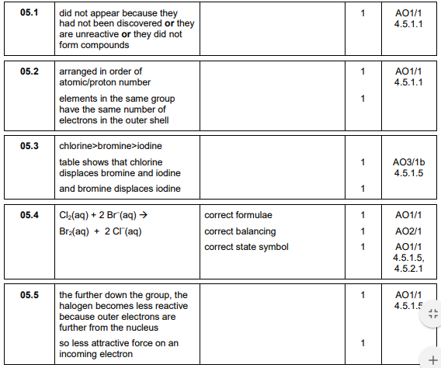14.

15. (a)     add excess copper carbonate (to dilute hydrochloric acid)

*accept alternatives to excess, such as ‘until no more reacts’*

**1**

filter (to remove excess copper carbonate)

*reject heat until dry*

**1**

heat filtrate to evaporate some water **or** heat to point of crystallisation

*accept leave to evaporate or leave in evaporating basin*

**1**

leave to cool (so crystals form)

*until crystals form*

**1**

*must be in correct order to gain****4****marks*

15.2

(a)     (i)      red

*ignore pink*

**1**

(ii)     add silver nitrate (solution)

**1**

white precipitate

*dependent on addition of silver nitrate*

*ignore addition of another acid*

*if hydrochloric acid added max****1****mark*

**1**

(b)     suitable named alkali / sodium hydroxide solution in burette

**1**

add alkali solution until (indicator) becomes pink / red

**1**

*if acid to acid titration described, first two marking points****not****available*

any **two** from:

•        wash / rinse equipment

•        add dropwise or slowly (near end point)

•        swirl / mix

•        read (meniscus) at eye level

•        white background

•        read start and final burette levels / calculate the volume needed

•        repeat

**2**

(c)      does not ionise / dissociate completely

*allow for acids of the same concentration, weak acids have a higher pH or fewer hydrogen ions*

**1**

16 (a)     (sulfuric acid is) completely / fully ionised

**1**

In aqueous solution **or** when dissolved in water

**1**

(b)     H+(aq) + OH−(aq) → H2O(l)

*allow multiples*

***1****mark for equation*

***1****mark for state symbols*

**2**

(c)     adds indicator, eg phenolpthalein / methyl orange / litmus added to the sodium hydroxide  
(in the conical flask)

*do****not****accept universal indicator*

**1**

(adds the acid from a) burette

**1**

with swirling **or** dropwise towards the end point **or** until the indicator just changes colour

**1**

until the indicator changes from pink to colourless (for phenolphthalein) or yellow to red  
(for methyl orange) or blue to red (for litmus)

**1**

(d)     titrations 3, 4 and 5

**or**

https://app.doublestruck.eu/content/AG_CHM/HTML/M/MSP181H08_files/img01.png

**1**

27.12 cm3

*accept 27.12 with no working shown for****2****marks*

**1**

*allow 27.1166 with no working shown for****2****marks*

(e)     Moles H2SO4 = conc × vol = 0.00271

*allow ecf from 8.4*

**1**

Ratio H2SO4:NaOH is 1:2

**or**

Moles NaOH = Moles H2SO4 × 2 = 0.00542

**1**

Concentration NaOH = mol / vol = 0.00542 / 0.025 = 0.2168

**1**

0.217 (mol / dm3)

*accept 0.217 with no working for****4****marks*

**1**

*accept 0.2168 with no working for****3****marks*

(f)        https://app.doublestruck.eu/content/AG_CHM/HTML/M/MSP181H08_files/img02.png   ×   0.18 = no of moles

**or**

0.15 × 40 g

**1**

0.144 (g)

**1**

*accept 0.144g with no working for****2****marks*

**[16]**

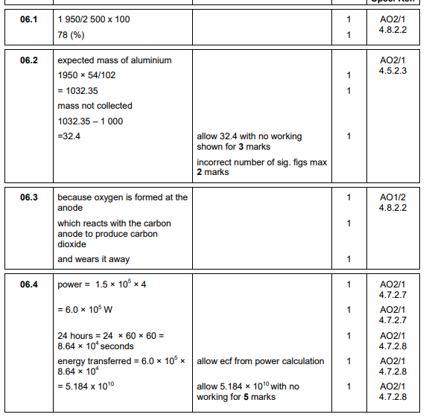17.

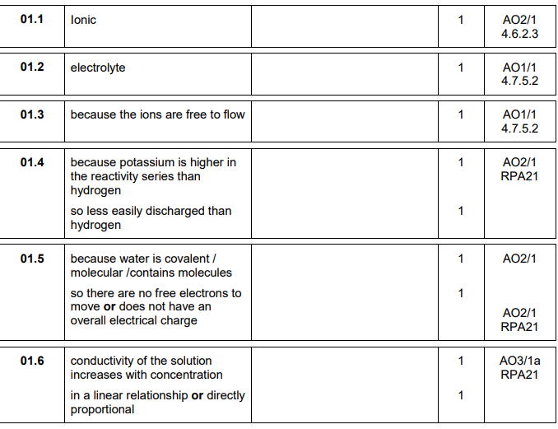18.

19.

a)     (i)      so ions can move (and carry charge)

*accept so current can flow*

*allow so it can conduct (electricity)*

*allow so charged particles can move*

*do****not****accept so electrons can move*

**1**

(ii)     because zinc ions gain electrons

*accept because zinc ions are reduced*

**1**

2 (electrons)

**1**

zinc is formed

*accept correct half equation for****3****marks*

*if no mark gained allow*

*positive ions go to negative electrode****or***

*opposites attract****or***

*reduction (of zinc)****or***

*(zinc) gains electrons for****1****mark*

**1**

(iii)    **2 Cl–**  https://app.doublestruck.eu/content/AG_CHM/HTML/M/M14S2H04_files/img01.png Cl2 + **2** e–

*must be completely correct*

**1**

(b)     (i)      because the magnesium is *a gas*

*allow magnesium goes from solid to gas*

**1**

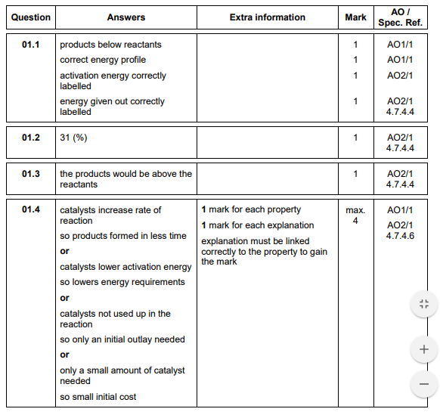20.

21. (a)     (zinc has) lost electron(s)

*accept loss of electrons*

**1**

(b)     copper is the least reactive

**1**

because it gave the most negative voltage when it was metal 2

**or**

it gave the biggest voltage with chromium

**or**

it gave the most positive voltage when it was metal 1

**1**

(c)     −0.7 V

**1**

The voltage with chromium and copper is 1.2

*accept use of other cell pairings such as tin with copper and tin with iron*

**1**

The voltage with chromium and iron is 0.5 and copper is less reactive (than iron)

**1**

(d)     hydrogen   +   oxygen   =   water

**1**

(e)     H2   →   2H+   +   2e−

**1**

O2   +   4H+   +   4e−   →   2H2O

**1**

**[9**

**22.**

(a)     precipitate / solid formed

*allow colour change*

**1**

(b)     total mass before = 257.68 g

total mass after = 257.68 g

**1**

so the mass of products equals

the mass of the reactants

**1**

(c)     0.01 g

**1**

(d)     207 + (2 × 14) + (6 × 16)

**or**

207 + 2 × [14 + (3 × 16)]

**1**

= 331

**1**

*an answer of 331 scores* ***2*** *marks*

(e)     CrO42−

**1**

(f)      carbon dioxide is a gas

*allow a gas is produced*

**1**

the gas escapes during the reaction

**1**

(so) the mass at the end is less than expected

**1**

**[10]**

**Q23.**

(a)     produces H+ / hydrogen ions in aqueous solution

**1**

(but is) only partially / slightly ionised

**1**

(b)     indicator changes colour

**1**

from blue to yellow

*allow from blue to green*

**1**

(when) the acid and alkali are (exactly) neutralised

**or**

(when) no excess of either acid or alkali

**1**

(c)     pipette measures one fixed volume (accurately)

**1**

(but) burette measures variable volumes (accurately)

**1**

(d)     

**1**

(mean titre =) 12.13(3) (cm 3)

**1**

(moles NaOH = conc × vol) = 0.00255

**1**

(moles citric acid =  moles NaOH) = 0.00085

**1**

(conc acid = moles / vol) = 0.0701 (mol / dm 3)

*allow ecf from steps 1, 2, 3 and / or 4*

*allow an answer of 0.0701 (mol / dm 3) without working for* ***1*** *mark only*

**1**

**[12]**

**Q24.**

(a)     left hand: (conical) flask

*do* ***not*** *accept round bottomed  
flask or container which is not a flask*

**1**

right hand: beaker / trough

*accept plastic box*

**1**

(b)     (i)      157

**1**

(ii)     all calcium carbonate used up **or** reaction stopped

*do* ***not*** *accept all acid used up*

**1**

(c)     (i)      0.007(272727…)

*correct answer with or without working gains* ***2*** *marks*

*if answer incorrect, allow (0.32 / 44) for* ***1*** *mark*

**2**

(ii)     0.007(272727…)

*allow ecf from* ***(c)(i)***

**1**

(iii)    (Mr = mass / moles = 1 / 0.00727…) = 137.5 or 138

*allow ecf from* ***(c)(ii)***

*if use 0.00943 moles then = 106*

*if use 0.007 allow 143 (142.857)*

**1**

(iv)    (138) – 60 (= 78)

*23 / 85*

**1**

(78 / 2) = 39

**1**

potassium

*sodium / rubidium*

*identity of metal ecf on Ar, but* ***must*** *be Group 1*

*If no working max* ***1*** *mark*

**1**

(d)     (i)      (relative atomic mass) would decrease

**1**

because the mass lost greater

**1**

so moles carbon dioxide larger **or** moles metal carbonate greater

**1**

(ii)     no change

**1**

because the acid (already) in excess

**1**

so the amount carbon dioxide lost is the same

**1**

**[17]**

**Q25.**

(a)     add excess copper carbonate (to dilute hydrochloric acid)

*accept alternatives to excess, such as ‘until no more reacts’*

**1**

filter (to remove excess copper carbonate)

*reject heat until dry*

**1**

heat filtrate to evaporate some water **or** heat to point of crystallisation

*accept leave to evaporate or leave in evaporating basin*

**1**

leave to cool (so crystals form)

*until crystals form*

**1**

*must be in correct order to gain* ***4*** *marks*

(b)     *M*r CuCl2 = 134.5

*correct answer scores* ***4*** *marks*

**1**

moles copper chloride = (mass / *M*r = 11 / 134.5) = 0.0817843866

**1**

*M*r CuCO3= 123.5

**1**

Mass CuCO3 (=moles × M2= 0.08178 × 123.5) = 10.1(00)

**1**

*accept 10.1 with no working shown for* ***4*** *marks*

(c)    

**or**

11.0 × 0.791

**1**

8.70 (g)

**1**

*accept 8.70(g) with no working shown for* ***2*** *marks*

(d)     Total mass of reactants = 152.5

**1**

134.5

152.5

*allow ecf from step 1*

**1**

88.20 (%)

**1**

*allow 88.20 with no working shown for* ***3*** *marks*

(e)     atom economy using carbonate lower because an additional product is made **or** carbon dioxide is made as well

*allow ecf*

**1**

**[14]**

**Q26.**

(a)     any **two** from:

•        temperature (of the HCl)

•        mass or length of the magnesium

•        surface area of the magnesium

•        volume of HCl

**2**

(b)     (i)      (a greater concentration has) more particles per unit volume

*allow particles are closer together*

**1**

therefore more collisions per unit time **or** more frequent collisions.

**1**

(ii)     particles move faster

*allow particles have more (kinetic) energy*

**1**

therefore more collisions per unit time **or** more frequent collisions

**1**

collisions more energetic (therefore more collisions have energy greater than the activation energy) **or** more productive collisions

**1**

(c)     (i)       add (a few drops) of indicator to the acid in the conical flask

*allow any named indicator*

**1**

add NaOH (from the burette) until the indicator changes colour **or** add the NaOH dropwise

*candidate does not have to state a colour change but penalise an incorrect colour change.*

**1**

repeat the titration

**1**

calculate the **average** volume of NaOH **or** repeat until concordant results are obtained

**1**

(ii)     **moles of NaOH**

0.10 × 0.0272 = 0.00272 moles

*correct answer with or without working gains* ***3*** *marks*

**1**

**Concentration of HCl**

0.00272 / 0.005 = 0.544

*allow ecf from mp1 to mp2*

**1**

correct number of significant figures

**1**

**[14]**

RP lesson 9 answers

**Q1.**

(a)

***must*** *be a description of a titration no titration =* ***0*** *marks*

**Quality of written communication**

*for correct sequencing of 2 of first 3 bullet points  i.e. 1 + 2****or*** *2 + 3* ***or*** *1 + 3*

**1**

any **three** from:

•        nitric acid in burette

*do* ***not*** *accept biuret   
can be inferred from 3rd point*

•        add nitric acid until indicator changes (colour)

*can be named acid-base indicator  
colour change does not have to be correct*

•        note (burette) volume used **or** final  reading

•        accuracy: e.g. repeat

*accept white tile* ***or*** *dropwise near end* ***or*** *white background* ***or*** *swirling the flask* ***or*** *read meniscus at eye level*

**3**

(b)     e.g. formula method:

25 × MNH3 = 0.25 × 20

**1**

MNH3 = 0.2

*correct answer alone =* ***2***

**OR**

moles NH3 = moles HNO3

=  × 0.25 = 0.005 moles (1)

concentration NH3

=  = 0.2 (1)

**1**

(c)     sodium hydroxide **or** potassium hydroxide **or** lithium hydroxide **or** calcium  
hydroxide

*ignore mention of alkali*

**1**

ammonia produced

*accept gas produced turns (damp) (red) litmus blue (not blue litmus)* ***or*** *alkaline gas produced*

*any suitable named indicator e.g. UI with consequential marking white fumes / smoke with (concentrated) HCl*

*do* ***not*** *accept white gas wrong test =* ***0*** *marks*

**1**

**[8]**

**Q2.**

(a)     neutralisation

*ignore reference to exothermic or endothermic*

**1**

(b)     2 HCl + CaO ➔ CaCl2 + H2O

*accept multiples and fractions*

formulae

*ignore state symbols*

**1**

balancing (dependent on first mark)

**1**

(c)     (the carbonate has) fizzing / bubbles / effervescence

*ignore dissolving*

*ignore gas produced*

**1**

(d)     add excess calcium carbonate to acid (and stir) / add CaCO3 until fizzing stops

*ignore heating the acid*

*accept answer using calcium oxide in place of calcium carbonate*

**1**

(remove excess calcium carbonate by) filter(ing)

**1**

warm until a saturated solution forms / point of crystallisation / crystals start to form

*do* ***not*** *accept heat until all water gone*

**1**

leave to cool

*dependent on previous mark*

*If solution* ***not*** *heated allow leave to evaporate (1)*

*until crystals form (1)*

**1**

(e)     (i)      *white* precipitate / *solid* (forms)

**1**

insoluble in excess **or** remains **or** no (further) change in excess

*dependent on a precipitate / solid forming*

**1**

(ii)     same result with magnesium (ions)

*do* ***not*** *accept reference to any other ion(s) that do not give a white precipitate*

*accept other named ions that do give a white precipitate*

**1**

(iii)    flame test **or** description of flame test

**1**

gives a red flame

*accept brick red* ***or*** *orange-red* ***or*** *scarlet*

*do* ***not*** *accept crimson*

**1**

**[13]**

**Q3.**

(a)     heat with a water bath

**or**

heat with an electric heater

**or**

allow to evaporate / crystallise at room temperature

**1**

(b)     to make sure that all the iodine reacts

*allow so can see the reaction is complete*

**1**

(as) excess iodine would remain in solution

**1**

(so) iodine could not be filtered off

*allow (whereas) excess zinc could be filtered off*

**or**

(so) the zinc iodide would not be pure

*allow (so) would have to separate iodine from zinc iodide*

**1**

(c)     

*allow moles I2 = 0.00197*

*allow 65 g Zn: 254 g I2*

**1**

mass Zn = 0.00197 × 65 (g)

**1**

mass = 0.128 (g)

**1**

*allow an expression  (g) for the first* ***2*** *marks*

(d)     

**1**



**1**

= 13.6 (g)

*allow 13.5869... (g)*

**1**

(e)     some product lost on separation

*allow incomplete reaction*

**1**

(f)      *M*r ZnI2 = 319

**1**

moles needed



**or**

mass per dm 3 = 31.9 (g)

**1**

(mass) = 7.98 (g)

*allow 7.975 / 8.0 (g)*

**1**

*an answer of 7.975, 7.98 or 8.0 (g) scores* ***3*** *marks*

**[14]**

**Q4.**

(a)     (sulfuric acid is) completely / fully ionised

**1**

In aqueous solution **or** when dissolved in water

**1**

(b)     H+(aq) + OH−(aq) → H2O(l)

*allow multiples*

***1*** *mark for equation*

***1*** *mark for state symbols*

**2**

(c)     adds indicator, eg phenolpthalein / methyl orange / litmus added to the sodium hydroxide  
(in the conical flask)

*do* ***not*** *accept universal indicator*

**1**

(adds the acid from a) burette

**1**

with swirling **or** dropwise towards the end point **or** until the indicator just changes colour

**1**

until the indicator changes from pink to colourless (for phenolphthalein) or yellow to red  
(for methyl orange) or blue to red (for litmus)

**1**

(d)     titrations 3, 4 and 5

**or**



**1**

27.12 cm3

*accept 27.12 with no working shown for* ***2*** *marks*

**1**

*allow 27.1166 with no working shown for* ***2*** *marks*

(e)     Moles H2SO4 = conc × vol = 0.00271

*allow ecf from 8.4*

**1**

Ratio H2SO4:NaOH is 1:2

**or**

Moles NaOH = Moles H2SO4 × 2 = 0.00542

**1**

Concentration NaOH = mol / vol = 0.00542 / 0.025 = 0.2168

**1**

0.217 (mol / dm3)

*accept 0.217 with no working for* ***4*** *marks*

**1**

*accept 0.2168 with no working for* ***3*** *marks*

(f)           ×   0.18 = no of moles

**or**

0.15 × 40 g

**1**

0.144 (g)

**1**

*accept 0.144g with no working for* ***2*** *marks*

**[16]**

RP Lesson 10 answers

**Q1.**

(a)     **(diagram)**

complete circuit with power supply

**1**

test solution in beaker or other appropriate apparatus

**1**

electrodes

*allow carbon, platinum or inert electrodes*

**1**

**(independent variable)**

salt solutions (with different metal ions)

**1**

**(observation)**

solid / metal deposit on the negative electrode

**1**

(b)     (sometimes) hydrogen is produced

**1**

(because) the metal is more reactive than hydrogen

**1**

(c)     chlorine

**1**

oxygen

**1**

**[9]**

**Q2.**

(a)     use a polystyrene cup instead of a (glass) beaker

*allow insulate the beaker*

*allow use a lid*

**1**

minimises energy transfer from the surroundings

**or**

for better insulation

**1**

(b)     concentration of hydrochloric acid

**1**

(c)     

**1**

= 5.6 (°C)

**1**

± 0.2

**1**

(d)     straight line from origin to (5.0, 6.4)

*must not deviate to anomalous point*

**1**

horizontal line from (5.0, 6.4) to (8.0, 6.4)

*must not deviate to anomalous point*

**1**

(e)     as mass (of potassium hydrogencarbonate) increases, temperature decrease / change increases

**1**

*until 5 g (to 8 g) (of potassium hydrogencarbonate has been added)*

*allow ecf from lines of best fit*

**1**

(because) the reaction has finished

**or**

(because) all the acid has reacted

**or**

(because) no more solid can react

**or**

(because) the solid is in excess

**1**

(f)      not stirred correctly

**1**

**[12]**

**Q3.**

(a)

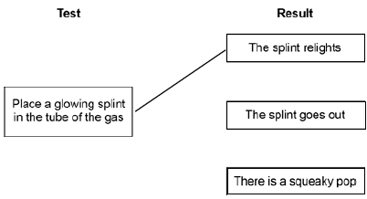

*more than one line from test negates the mark*

**1**

(b)     (i)      place a lighted splint at the mouth of the tube

**1**

there is a squeaky pop

*dependent on correct test*

**1**

(ii)     hydrogen is less reactive than magnesium

*accept converse*

*accept magnesium is too reactive*

**1**

(c)     (i)      any **one** from:

•        to improve appearance or make it look nice

•        to prevent corrosion

•        to make it more durable

•        cheaper than solid silver

**1**

(ii)     solution must be silver nitrate **or** contain silver ions

**1**

otherwise copper will be deposited **or** silver will not be deposited

**1**

spoon must be the negative electrode / cathode

**1**

because silver ions have a positive charge **or** go to negative electrode **or** are discharged at the negative electrode.

**1**

(iii)    because (plastic is an) insulator **or** does not conduct electricity

*accept does not contain mobile electrons*

**1**

**[10]**

**RP lesson 10 answers**