OASB Science Department
Biology Paper 2 Revision Pack (Combined - HT)

Contents | Lesson | Page
Mastery Matrix Biology Paper 2 |  | 2-3
Knowledge | 1 | 4
Reproduction and DNA Summary Page |  | 76-7
Notes page |  | 5
Exam Questions |  | 8-12
Knowledge | 2 | 13
Introducing ecosystems and interdependence Summary Page |  | 14-15
Notes page |  | 15
Exam Questions |  | 17-19
Knowledge | 3 | 20
Natural recycling & Humans and the environment Summary Page |  | 21-22
Notes page |  | 23
Exam Questions |  | 24-26
Knowledge | 4 | 27
Classifying organisms and Natural selection and evolution Summary Page |  | 28-29
Notes page |  | 30
Exam Questions |  | 31-33
Knowledge | 5 | 34
Selective breeding and the nervous system Summary Page |  | 35-36
Notes page |  | 37
Exam Questions |  | 38-40
Knowledge | 6 | 41
Endocrine system and Homeostasis Summary Page |  | 42-43
Notes page |  | 44
Exam Questions |  | 45-47
Knowledge | 7 | 48
Diabetes and hormones in reproductive system Summary Page |  | 49-50
Notes page |  | 51
Exam Questions |  | 52-56

Topic | Tier | Revision Guide (double) | Learning statement
Sexual and asexual reproduction (meiosis) | F | 64 | Explain the process of sexual reproduction and link this to variation
Sexual and asexual reproduction (meiosis) | F | 64 | Explain the process of meiosis which leads to the formation of gametes
Sexual and asexual reproduction (meiosis) | F | 64 | Explain the process of asexual reproduction
Sexual and asexual reproduction (meiosis) | F | 64 | Model the behaviour of chromosomes during meiosis
The DNA code | F | 64 | Describe the structure of DNA
The DNA code | F | 64 | Explain what the human genome is and the importance of mapping it
The DNA code | F | 64 | Use genetic crosses to predict outcomes of a monohybrid cross
Developing new medicines | F | 44 | Explain the issues with the development of new antibiotics in the race against antibiotic resistance and what we can do as a society to reduce the rate of development of antibiotic resistance bacteria (linking to medicine and agriculture)
Introducing ecosystems | F | 74 | Define “ecosystem”
Introducing ecosystems | F | 74 | Define ‘interdependence’ and explain what species depend on
Introducing ecosystems | F | 74 | Describe what plants and animals ‘compete’ with each other for
Introducing ecosystems | F | 74 | Describe structural, behavioural and functional adaptations of organisms
Introducing ecosystems | F | 74 | Define extremophiles linking to the conditions that they inhabit (bacteria in deep sea vents)
Interdependence | F | 76 | Interpret data from graphs and tables relating to predator and prey relationships predicting numbers of species based on changes in this data
Interdependence | F | 76 | List biotic and abiotic factors and explain how changes in them would affect a given community
Interdependence | F | 76 | Define primary, secondary and tertiary consumers
Interdependence | F | 76 | Explain the role of producers in food chains
Interdependence | F | 76 | Use a range of experimental methods to calculate the abundance and distribution of species in a given ecosystem
Interdependence | F | 76 | RP Field Invesitgations (a - triple only): Measure the population size of a common species (b - double & triple) Investigate the effects of a factor on the distribution of a species using sampling techniques
Natural Recycling | F | 76 | Describe the carbon cycle and its importance
Natural Recycling | F | 76 | Describe the water cycle and its importance
Humans and the environment | F | 78 | Define biodiversity and explain its importance
Humans and the environment | F | 78 | Explain in detail human impact on biodiversity (waste management, pollution, land use, deforestation, global warming)
Humans and the environment | F | 78 | Describe and evaluate some of the programs used to reduce the negative effects of humans on ecosystems and biodiversity (breeding programs, protection/regeneration of rare habitats, reintroduction of field margins and hedgerows, reduction of deforestation, reduction of carbon emissions, increased recycling)
Classifying organisms | F | 72 | Describe the role of Carl Linnaeus in development of a classification system (kingdom, phylum, class, order, family, genus, species)
Classifying organisms | F | 72 | Explain the binomial naming system of organisms
Classifying organisms | F | 72 | Define ‘species’ (linking to future fertility and breeding)
Classifying organisms | F | 72 | Explain how classification models have developed over time due to improvements in microscopy and biochemistry)
Natural selection and evolution | F | 72 | Describe and explain the theory of ‘natural selection’ and ‘evolution’
Natural selection and evolution | F | 68 | Describe the evidence for evolution including antibiotic resistant and the fossil record
Natural selection and evolution | F | 68 | Describe what a fossil is and explain how they form and explain why these cannot be used as evidence for how life began on Earth
Natural selection and evolution | F | 68 | Interpret information from evolutionary trees
Natural selection and evolution | F | 68 | Explain what extinction is and describe factors which may contribute to the extinction of a species
Selective breeding & genetic engineering | F | 70 | Describe selective breeding and explain the potential benefits and risks of this process (linking to disease resistance in crops, animals with more milk and meat, large or unusual flowers and domestic dogs with a gentle nature)
Selective breeding & genetic engineering | F | 70 | Define ‘genetic engineering’
Selective breeding & genetic engineering | HT | 70 | Describe the main steps in genetic engineering
Selective breeding & genetic engineering | F | 70 | Give examples of genetic engineering (including crop resistance to diseases, insect attack and herbicides, crops with bigger, better fruits and bacterial cells used in the production of insulin)
Selective breeding & genetic engineering | F | 70 | Evaluate the use of genetic engineering and modification and describe the potential uses of this in the future
The Nervous System | F | 50 | Describe the structure of the nervous system
The Nervous System | F | 50 | Explain how it is adapted for its function and why it is important
The Nervous System | F | 50 | Describe the pathway of a message from stimulus to response
The Nervous System | F | 50 | Describe the design of a reflex arc and explain its purpose
The Nervous System | F | 50 | Use tables and graphs to extract information about reflex actions
The Nervous System | F | 50 | RP Reaction Time: Plan and carry out an investigation into the effect of a factor on human reaction time
Homeostasis | F | 52 | Define ‘homeostasis’ and explain why it is important
Homeostasis | F | 52 | List three factors controlled by homeostasis in the human body (blood glucose concentration, temperature, water levels)
Homeostasis | F | 52 | Explain how these automatic systems are controlled
The endocrine system | F | 52 | Describe the principals of hormonal coordination including what makes up the endocrine system
The endocrine system | F | 52 | Describe what hormones are and label six glands in the body
The endocrine system | F | 52 | Describe the role of the pituitary gland
The endocrine system | HT | 52 | Explain the roles of thyroxine (produced by the thyroid gland) and adrenaline (produced by the adrenal gland) linking this to negative feedback loops (HT only)
The endocrine system | F | 52 | Describe and explain how the body controls blood glucose concentration (making reference to glucose, glycogen, glucagon, negative feedback cycle, insulin and the pancreas)
Diabetes | F | 52 | Explain type 1 and type 2 diabetes and how they can be treated
Diabetes | F | 52 | Compare and contrast the two types of diabetes
Diabetes | F | 52 | Compare data (from graphs) regarding blood glucose levels in people with and without diabetes
Hormones in the reproductive system | F | 54 | Describe the roles of FSH, LH, Oestrogen and progesterone in the menstrual cycle
Hormones in the reproductive system | F | 54 | Describe the roles of oestrogen and progesterone in puberty
Hormones in the reproductive system | HT | 54 | Interpret graphs relating to hormone levels in the menstrual cycle (HT only)
Hormones in the reproductive system | F | 54 | Link hormone cycles to ovulation and menstruation
Hormones in the reproductive system | F | 54 | Evaluate hormonal and non-hormonal methods of contraception (oral, injection, implant, skin patch, condoms, diaphragms, intrauterine device, spermicidal agents, abstinence, sterilisation)
Hormones in the reproductive system | F | 54 | Explain why issues around contraception are not answered solely by the field of Science
Hormones in the reproductive system | F | 54 | Explain the process of embryo screening and evaluate based on ethical, social and economic perspectives
Hormones in the reproductive system | HT | 54 | Explain IVF (in vitro fertilisation) (HT only)
Hormones in the reproductive system | HT | 54 | Explain how developments in microscopy have enabled IVF treatments to be improved (HT only)
Hormones in the reproductive system | HT | 54 | Evaluate social and ethical issues and risks from the perspective of patients and doctors in IVF (HT only)
Hormones in the reproductive system | F | 54 | Compare nervous system and hormonal responses

Lesson 1 – Reproduction and DNA
 | Topic: | Sexual and asexual reproduction (meiosis) (B.5)
1 | Another word for sex cells is… | gametes
2 | State the 2 gametes in animals | Sperm & egg cells
3 | State the 2 gametes in flowering plants | Pollen & egg cells
4 | State the number of parents involved in sexual reproduction | 2
5 | State the number of parents involved in asexual reproduction | 1
6 | Describe the cells produced from mitosis | 2 genetically identical daughter cells
7 | Describe the cells produced from meiosis | 4 genetically different daughter cells
8 | What is mitosis used for? | Growth and repair
9 | What is meiosis used for? | Making gametes
10 | Define "diploid cell" | A cell with a full set of chromosomes
11 | Define "haploid cell" | A cell with half of the number of chromosomes
12 | How many divisions occur in mitosis? | 1
13 | How many divisions occur in meiosis? | 2
14 | Are haploid or diploid cells produced during mitosis? | Diploid
15 | Are haploid or diploid cells produced during meiosis? | Haploid
 | Topic: | The DNA code (B.6)
1 | State the name of the genetic material found in the nucleus of a cell | DNA
2 | Describe the structure of DNA | Double helix
3 | State the name given to one molecule of DNA | Chromosome
4 | State the name of a small section of DNA | A gene
5 | What does a gene code for? | A sequence of amino acids which join to form a specific protein
6 | Define the "human genome" | The sequence of the human DNA
7 | State 3 reasons for mapping the human genome | 1) locating disease causing genes 2) treating inherited disorders 3) tracing human migration patterns
8 | Define "homozygous" | two of same alleles e.g. BB
9 | Define "heterozygous" | Two different alleles e.g. Bb
10 | Define "dominant" | always expressed
11 | Define "recessive" | Expressed only with 2 of this allele present
12 | Define 'genotype' | The 2 alleles present e.g. Bb
13 | Define 'phenotype' | The characteristic expressed e.g. brown eyes
14 | Is cystic fibrosis caused by a dominant or recessive allele? | Recessive
15 | Is Huntingdon's caused by a dominant or recessive allele? | Dominant

Notes

Biology Revision: Reproduction
Key Knowledge

Definitions:
Sexual reproduction –

Asexual reproduction –

Variation –

Mitosis –

Meiosis –

What are the gametes in animals?

What are the gametes in flowering plants?

Mastery Matrix Points
Explain the process of sexual reproduction and link this to variation
Explain the process of meiosis which leads to the formation of gametes
Explain the process of asexual reproduction
Model the behaviour of chromosomes during meiosis

Understanding and Explaining
- What is the cell division that produces gametes?

- What is the cell division that enables the embryo to grow?

- Describe, in detail, the steps in meiosis and what is produced.

- Describe these examples of organisms that reproduce sexually and asexually – malarial parasites, fungi and daffodils.

Biology Revision: DNA
Key Knowledge

Definitions:
Genome –

DNA –

Chromosomes –

Gene –

Three reasons why studying the human genome is important.
-

-

-

Mastery Matrix Points
Describe the structure of DNA
Explain what the human genome is and the importance of mapping it
Use genetic crosses to predict outcomes of a monohybrid cross

Understanding and Explaining
- Describe the structure and function of DNA.

- Draw a genetic cross to show the likelihood of a child having these diseases: a) polydactyly if one parent is heterozygous and the other is homozygous recessive. B) cystic fibrosis if both parents are carriers of the disease.

Guided Exam Question
Q1. A child saved apple seeds from an apple she ate. She planted the seeds in the garden. A few years later the apple trees she had grown produced apples.
(a) The apples from the new trees did not taste like the original apple. Explain why.
........................................................................................................................
........................................................................................................................
........................................................................................................................
........................................................................................................................
........................................................................................................................
(2)
(b) (i) Apple trees can be reproduced so that the apples from the new trees will taste the same as the apples from the parent trees.
Give one method used to reproduce apple trees in this way.
...............................................................................................................
(1)
(ii) Explain why the method you have suggested in part (b)(i) will produce apples that taste the same as the apples from the parent trees.
...............................................................................................................
...............................................................................................................
...............................................................................................................
(2)
(Total 5 marks)
Q2. Organisms can be produced by asexual reproduction and by sexual reproduction.
(a) Give two differences between asexual reproduction and sexual reproduction.
1 .....................................................................................................................
........................................................................................................................
2 .....................................................................................................................
........................................................................................................................
(2)
(b) Adult cell cloning is a type of asexual reproduction. Explain why.
........................................................................................................................
........................................................................................................................
.......................................................................................................................
(2)
(Total 4 marks)

Independent Exam Question
Q3.Starfish can split in half. Each half can then grow new arms to form offspring.
This process is shown in the figure below.
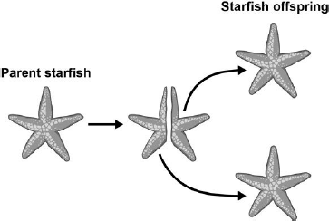
(a) What process produces the starfish offspring?
Tick one box.

Asexual reproduction
Fertilisation
Selective breeding
Sexual reproduction

(1)
(b) More cells are produced as the starfish grows more arms.
What process will produce more cells in the starfish as they grow?
........................................................................................................................
(1)
(c) All the offspring produced are genetically identical.
What name is given to genetically identical organisms?
........................................................................................................................
(1)
(d) Each body cell of the parent starfish contains 44 chromosomes.
How many chromosomes are in each body cell of the offspring?
........................................................................................................................
(1)

Q4. The photograph shows some cells in the root of an onion plant.
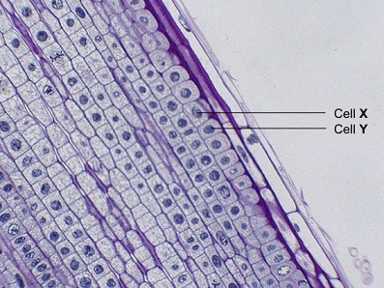
(a) Cells X and Y have just been produced by cell division.
(i) Name the type of cell division that produced cells X and Y.
...............................................................................................................
(1)
(ii) What happens to the genetic material before the cell divides?
...............................................................................................................
(1)
(b) A gardener wanted to produce a new variety of onion.
Explain why sexual reproduction could produce a new variety of onion.
........................................................................................................................
........................................................................................................................
........................................................................................................................
........................................................................................................................
........................................................................................................................
........................................................................................................................
(3)

Q5. A student’s hobby was breeding pet mice. Three of the pet mice were called Stan, Tom and Sharon. Stan and Tom had black fur. Sharon had white fur.
The colour of the fur is controlled by a single gene which has two alleles B and b.
(a) The student first crossed Stan with Sharon. The results are shown on the diagram.
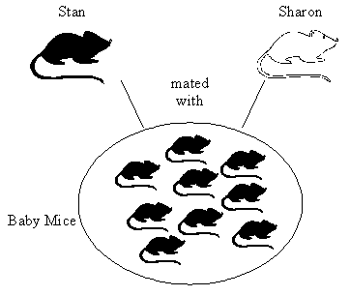
Explain why the baby mice produced by crossing Stan and Sharon all had black fur. You may use a genetic diagram if you wish.

(3)

(b) The student then crossed Tom with Sharon. The results are shown on the diagram.
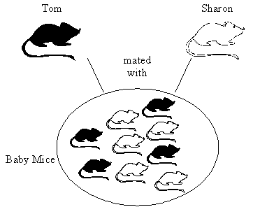
When Tom was crossed with Sharon, some of the baby mice had black fur and some white.
Explain why. You may use a genetic diagram if you wish.

(3)
Q6.Our understanding of genetics and inheritance has improved due to the work of many scientists.
(a) Draw one line from each scientist to the description of their significant work.

 | Scientist |  | Description of significant work
Carried out breeding experiments
on pea plants.
 | Charles Darwin
 |  |  | Wrote 'On the origin of species'.
 | Alfred Russel Wallance
 |  |  | Worked on plant defence systems.
 | Gregor Mendel
 |  |  | Worked on warning colouration in animals.
3)
Q7. (a) Use words from the list to complete the sentences.
alleles chromosomes gametes genes mutations
The nucleus of a cell contains thread-like structures called ..................................... The characteristics of a person are controlled by ..................................... which may exist in different forms called ..................................... .
(3)

Lesson 2 – Ecosystems and Interdependence

 | Topic: | Introducing ecosystems and interdependence (B.20)
1 | State the name given to a habitat and all of the organisms living inside of it? | Ecosystem
2 | What is the name for living factors that affect species? | Biotic
3 | What is the name for non-living factors that affect an environment? | Abiotic
4 | State the 3 types of adaptations that exist | 1) Structural 2) Behavioural 3) Functional
5 | State 4 things that animals compete for | Water, mates, territory, food
6 | State 4 things that plants compete for | Nutrients, Water, Space, Light
7 | What is the scientific word for species relying on each other? | Interdependence
8 | Similar organisms that can breed together to produce fertile offspring are know to be the same _______? | Species
9 | Name 7 abiotic factors | 1) Light intensity, 2) temperature, 3) moisture, 4) soil pH, 5) wind intensity, 6) CO2 levels (plants) 7) oxygen levels (aquatic animals)
10 | Name 4 biotic factors | 1) food availability, 2) new predators, 3) new pathogens, 4) species outcompeting
11 | What is the name given to an organism that lives in an extreme environment? | Extremophile
12 | What is the name given to the TYPE of organism that absorbs sunlight and uses it to produce glucose? | Producer
13 | What type of animal feeds off of the dead remains of other animals? | Scavenger
14 | State two experimental techniques used to determine the abundance and distribution of a species | Transect (line across an environment) & quadrat (1m metal square)
15 | What is the name given to the type of sampling that is done along a line? | Transect

Biology Revision: Ecosystems
Key Knowledge

Ecosystems –

Interdependence –

Species depend on each other for:
-
-
-
-

A stable community is –

Animals compete for:
-
-
-
Plants compete for:
-
-
-
-

Types of adaptations:
 | Definition | Example
Structural
Behavioural
Physiological/
functional

Extremophile:
Mastery Matrix Points
Define “ecosystem”
Define ‘interdependence’ and explain what species depend on
Describe what plants and animals ‘compete’ with each other for
Describe structural, behavioural and functional adaptations of organisms
Define extremophiles linking to the conditions that they inhabit (bacteria in deep sea vents)

Understanding and Explaining
- Explain what interdependence is and how it can be affected if a species is removed from a community.

- Compare what plants and animals compete for.

- What are adaptations? Describe the structural, functional and behavioural adaptations of a venomous snake.

- Describe the three conditions that are considered to be conditions that only extremophiles can live in.

- Describe an example of an extremophile and the habitat it lives in.

Biology Revision: Interdependence
Mastery Matrix Points
Interpret data from graphs and tables relating to predator and prey relationships predicting numbers of species based on changes in this data
List biotic and abiotic factors and explain how changes in them would affect a given community
Define primary, secondary and tertiary consumers
Explain the role of producers in food chains
Use a range of experimental methods to calculate the abundance and distribution of species in a given ecosystem
Required practical: Investigate the effects of a factor on the distribution of a species using sampling techniques

Understanding and Explaining
- Draw a food chain for Lion, Zebra, Grass.

- Explain the role of producers in the food chain.

- Explain what decomposers are and their role in the food chain.

- Explain the difference between using a quadrat for random sampling and for doing a transect experiment.

- Sketch, label and explain a simple predator prey graph.

Key Knowledge
Abiotic factor:

Examples:

Biotic factor:

Examples:

Define:

Quadrat:

Transect:

Predator:

Prey:

Primary consumer:

Secondary consumer:

Tertiary consumer:

Herbivore:

Omnivore:

Carnivore:

Notes

Guided Exam Question
Q8.Students investigated a food chain in a garden. lettuce → snail → thrush (bird)
The students:• estimated the number of lettuce plants in the garden • estimated the number of snails feeding on the lettuces • counted two thrushes in the garden in 5 hours. The table below shows the students’ results and calculations.

 | Organism | Population size | Mean mass of each organism  in g | Biomass of population  in g | Biomass from previous organism that is lost in g | Percentage of biomass lost
 | Lettuce | 50 | 120.0 | 6000
 | Snail | 200 | 2.5 | 500 | 5500 | 91
 | Thrush | 2 | 85.0 | 170 | 330 | 66
(a) (i) Give two ways that biomass is lost along a food chain.
...................................................................................................................
...................................................................................................................
(2)
(ii) Scientists estimate that about 90% of the biomass in food is lost at each step in a food chain. Suggest one reason why the students’ value for the percentage of biomass lost between the snails and the thrushes is only 66%.
...................................................................................................................
...................................................................................................................
(1)
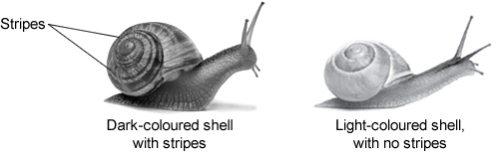
(b) European banded snails have shells with different colours (light or dark) and with stripes or with no stripes. Figure 1 shows two examples of European banded snails.
Figure 2 shows results from surveys in woodlands and in grasslands of the percentage of snails with light-coloured shells and the percentage of snails with no stripes.
Each point on the graph represents the results of one survey in one habitat.
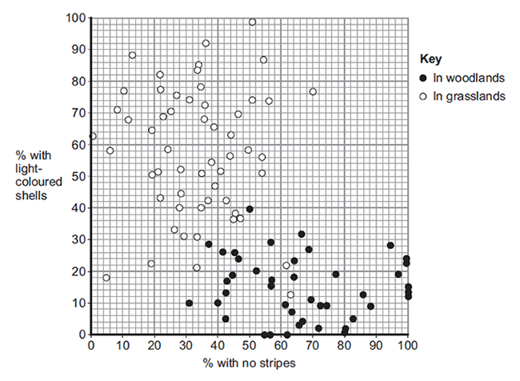
Figure 2 is a scatter graph. Why is a scatter graph used for this data?
...................................................................................... ............................................................................................
(1)
(ii) Compare the general appearance of snails that live in woodlands with the general appearance of snails that live in grasslands. ...................................................................................... ............................................................................................
(2)
(iii) Suggest a reason for the general appearance of snails that live in woodlands. ......................................................................................

………………………………….................................................................................(1) (Total 7 marks)

Independent Exam Question
Q9.(a) Which term describes organisms that can tolerate very hot or very cold places? Draw a ring around the correct answer. (1)
 | an environmental  species | an extremophile  species | an indicator  species
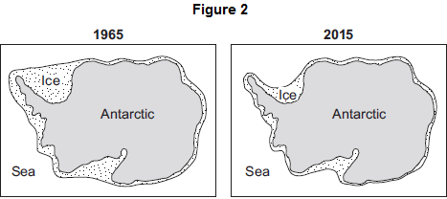
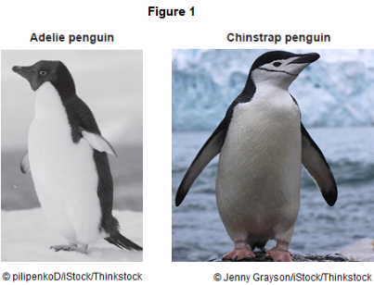
(b) Figure 1 shows photographs of an Adelie penguin and a chinstrap penguin. Adelie penguins and chinstrap penguins live in the Antarctic at temperatures below 0 °C.

Adelie penguins spend most of their time on the ice around the Antarctic. Chinstrap penguins live mainly in the sea around the ice. Since 1965 the number of Adelie penguins has decreased by 6 million.
Figure 2 shows changes to the ice around the Antarctic over the past 50 years.
(i) Use information from Figure 2 to explain why the number of Adelie penguins has decreased since 1965.
...............................................................................................................
...............................................................................................................
...............................................................................................................
...............................................................................................................
(2)
(ii) Suggest what has happened to the number of chinstrap penguins since 1965.
Draw a ring around your answer. increase / decrease
Give a reason for your answer.
...............................................................................................................
...............................................................................................................
(1)
(c) The number of penguins can be used to monitor changes in temperature of the environment. Temperature readings could also be taken using a thermometer. What is the advantage of using penguins, instead of a thermometer, to monitor changes in temperature of the environment? Tick () one box. (1)
(Total 5 marks)

Living organisms show long-term changes.
Thermometers cannot measure temperatures below 0 °C.
Thermometers do not give accurate readings.
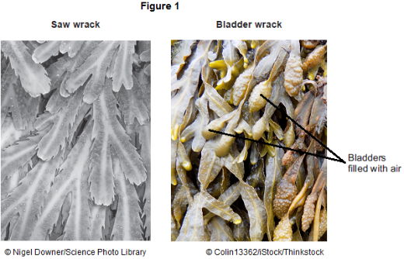
Q10.Organisms compete with each other.
(a) Figure 1 shows two types of seaweed which live in similar seashore habitats.
Most of the time the two seaweeds are covered with water.
Bladder wrack has bladders filled with air.
Bladder wrack grows more quickly than saw wrack.
Suggest an explanation why.
........................................................................................................................
........................................................................................................................
........................................................................................................................
........................................................................................................................
........................................................................................................................
(3)
(b) Figure 2 shows an angler fish.
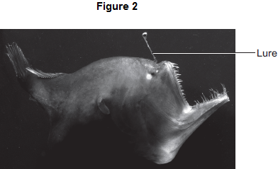
Angler fish live at depths of over 1000 m. In clear water, sunlight does not usually reach more than 100 m deep. Many angler fish have a transparent ‘lure’ containing a high concentration of bioluminescent bacteria. Bioluminescent bacteria produce light. Suggest an advantage to the angler fish of having a lure containing bioluminescent bacteria.
........................................................................................................................
........................................................................................................................
........................................................................................................................
........................................................................................................................
........................................................................................................................
(2)
(Total 5 marks)

Lesson 3: Natural Recycling & Humans and the environment
 | Topic: | Natural recycling (B.28)
1 | How do plant remove carbon from the air? | Photosynthesis (CO2 in)
2 | How is carbon moved from living organisms back into the air? | Respiration (CO2 released)
3 | How is carbon moved from fossil fuels back into the air? | Combustion (CO2 released)
4 | How is carbon moved from dead organisms into the air? | Decomposition (by decomposers) (CO2 released)
5 | What is the scientific name for rain? | Precipitation
6 | How does water move from lakes/the sea into the air? | Evaporation
7 | Which process leads to cloud formation? | Condensation
8 | What is the name of evaporation of water from plants? | Transpiration
 | Topic: | Humans and the environment (B.29)
1 | Define by "biodiversity" | variety of all the different species on earth/within an ecosystem
2 | Why is increased biodiversity good? | Increases ecosystem stability
3 | State three ways that humans can cause water pollution | Sewage, fertilisers, toxic chemicals
4 | State three ways that humans can cause air pollution | Smoke, acidic gases
5 | State three ways that humans can cause land pollution | Landfill sites, toxic chemicals
6 | State 4 ways that humans are decreasing the land available for living organisms | building, quarrying, farming, dumping waste
7 | State two uses of peat | Fuel & fertiliser
8 | What is the name for 'cutting down trees' | Deforestation
9 | State two reasons for deforestation occurring | Land for farming & growing biofuels
10 | State 5 ways that humans are trying to increase biodiversity | 1) Breeding endangered species 2)protecting rare habitats 3) Hedgerows 4) Afforestation 5) Recycling

Biology Revision: Natural Recycling
Mastery Matrix Points
Describe the carbon cycle and its importance
Describe the water cycle and its importance

Understanding and Explaining
- Describe and explain how carbon is cycled around the environment. You can draw a diagram to help you.

- What is the role of microorganisms like bacteria and fungi in the carbon cycle? Why are they so important?

- Describe how water is cycled around the environment. You can draw a diagram to help you.

Key Knowledge
Carbon cycle –

Sedimentation –

How carbon is absorbed from the atmosphere: | How carbon moves from place to place: | How carbon is released into the atmosphere:

Water cycle –

Process | Description
Precipitation
Condensation
Runoff
Infiltration
Subsurface flow
Evaporation
Transpiration

Biology Revision: Humans and the
Mastery Matrix Points
Define biodiversity and explain its importance
Explain in detail human impact on biodiversity (waste management, pollution, land use, deforestation, global warming)
Describe and evaluate some of the programs used to reduce the negative effects of humans on ecosystems and biodiversity (breeding programs, protection/regeneration of rare habitats, reintroduction of field margins and hedgerows, reduction of deforestation, reduction of carbon emissions, increased recycling)

Key Knowledge
Biodiversity –

More resources are being used because the ___________ is increasing and our standard of _________ is increasing.

Pollution and the causes:
Land
Air
Water
Ways land is being used for humans which destroys habitats:
-
-
-
-
-
-

Two reasons why humans do deforestation:
-
-

Five ways humans are trying to reduce the negative effects of people on the planet
-

-

-

-

-

Define ‘endangered’:

Define ‘extinct’:
Environment
Understanding and Explaining
- Explain how our use of the land will have impacted on habitats.

- Explain why biodiversity is important.

- List six biological factors that are threatening our food security.

- Explain what deforestation is and why it is happening.

- Give an example of a breeding program that is being used to increase the number of an endangered species. Describe which animal is being bred and where it is happening.

- Describe the impact that burning fossil fuels has on habitats. Explain why we are being encouraged to use renewable energy sources instead of burning fossil fuels.

Notes

Guided Exam Question
Q11.Human activities have many effects on our ecosystem.
The graph shows the volume of peat compost and peat-free compost used in gardening from 1999 to 2009.
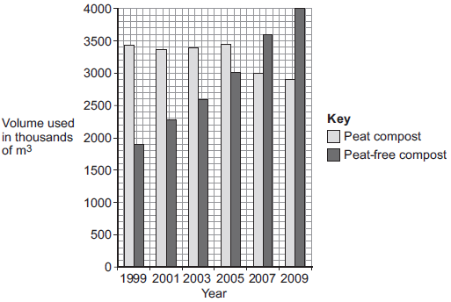
(a) Describe the trends shown in the graph.
........................................................................................................................
........................................................................................................................
........................................................................................................................
(2)
(b) What effect does the destruction of peat bogs have on the gases in the atmosphere?
........................................................................................................................
........................................................................................................................
(1)
(c) Deforestation is also damaging ecosystems.
Describe one effect of deforestation on ecosystems.
(1)
(Total 4 marks)

Independent Exam Question
Q12.Deforestation affects the environment in many ways.
(a) Deforestation increases the amount of carbon dioxide in the atmosphere. Give two reasons why.
1 .....................................................................................................................
........................................................................................................................
2 .....................................................................................................................
........................................................................................................................
(2)

(b) Deforestation also results in a loss of biodiversity.
(i) What is meant by biodiversity?
...............................................................................................................
...............................................................................................................
(1)

(ii) Give two reasons why it is important to prevent organisms becoming extinct.
1 ............................................................................................................
...............................................................................................................
2 ............................................................................................................
...............................................................................................................
(2)
(Total 5 marks)

Q13. Some people are concerned about the distance that food is transported between the grower and the supermarket.
The bar chart shows the distances for some foods.
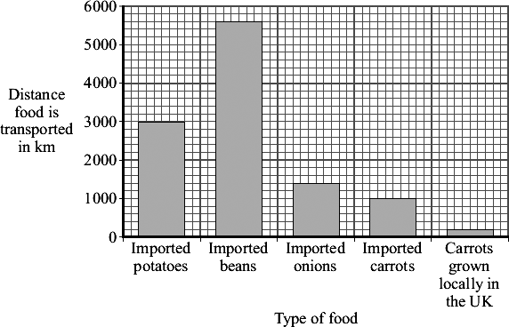
(a) Both imported carrots and carrots grown locally in the UK can be bought in supermarkets all year round. How many times further are imported carrots transported than carrots grown locally in the UK? Show clearly how you work out your answer.
........................................................................................................................
........................................................................................................................
......................... times
(1)
(b) Many of the beans sold in supermarkets in the UK are grown in Kenya, a tropical country in Africa.
Beans grow faster in Kenya than they do in the UK.
Suggest and explain one reason why.
Reason ..........................................................................................................
........................................................................................................................
Explanation ....................................................................................................
........................................................................................................................
(2)
(c) Many people believe that we should buy locally produced food instead of food imported from abroad. Explain how this would help the environment.
........................................................................................................................
........................................................................................................................
........................................................................................................................
........................................................................................................................
.................................................................................................................(2)(Total 5 marks)

Lesson 4 – Classification, Evolution and Natural Selection
 | Topic: | Classifying organisms (B.30)
1 | Name the 7 classification levels proposed by Carl Linnaeus (in order) | Kingdom, Phylum, Class, Order, Family, Genus, Species
2 | What does "binomial" literally mean? | Two names
3 | What do the two parts of a binomial name tell us? | (i) Genus (ii) Species
4 | Who introduced the 'domain' level to the classification system? | Carl Woese
5 | State two pieces of evidence that helped scientists to add the additional 'domain' level to the classification system | *better understanding of biochemical processes  *being able to look at DNA
6 | State the meaning of the domain "archaea" | Primitive bacteria usually living in extreme environments (DNA is NOT contained in a nucleus)
7 | State the meaning of the domain "bacteria" | DNA is NOT contained in a nucleus, don't live in extreme environments
8 | State the meaning of the domain "eukaryote" | Their DNA is contained in a nucleus (protists, fungi, plant and animals)
9 | Define "species" | organisms that can breed together to produce FERTILE offspring
10 | List the 5 'classes' of classification | Mammals, reptiles, birds, fish, amphibians
11 | List 4 ways a species can become extinct slowly | *New predators  *New diseases  *Changes to the environment over time  *More successful competitors
12 | State one way a species can become extinct rapidly | Catastrophic event e.g. volcanic eruption
13 | State the purpose of an evolutionary tree | A diagram used to show how closely related we think organisms are to each other
14 | State two pieces of evidence used to create an evolutionary tree | Fossil records and DNA samples
15 | List the 5 kingdoms? | Prokaryote, Protoctista, Fungi, Animals, Plants
 | Topic: | Natural selection and evolution (B.31)
1 | State three factors that can cause variation in a species | The environment, random mutations, sexual reproduction
2 | Define 'evolution' | The gradual change in the inherited characteristics of a population over time
3 | If enough variation occurs over time due to evolution, a new ________ is created | species
4 | What was Charles Darwin's theory called? | Theory of evolution through natural selection
5 | State the 4 steps to natural selection? | 1)Variation (due to Sexual reproduction/random Mutations) 2)environment Change occurs  3)better adapted organisms Survive and Reproduce  4) pass on these Genes to their offspring  5) leades to gradual change over time called Evolution
6 | State three reasons why Darwin's theory was not originally accepted | *didn't know HOW characteristics were inherited *people believed GOD created all living things *Insufficient EVIDENCE
7 | What is a fossil? | The remains of an organism from hundreds of thousands of years ago
8 | List 4 ways a fossil may have formed | *hard parts of animals not decaying properly *conditions didn’t allow decay *minerals replaced parts of the organism as it decayed *traces (e.g. footprints) preserved
9 | Describe how scientists use fossils | As evidence of how organisms have changed over time (evolution
10 | Explain why fossils can't be used to provide evidence of how life began on Earth | Fossil record is incomplete (there are gaps)
11 | Explain why there are gaps in the fossil record | *Early animals had soft bodies so decayed easily *Geological activities destroyed fossils
12 | What is an antibiotic-resistant bacterium? | A bacteria that cannot be killed by an antibiotic
13 | What was the name of Charles Darwin's book? | The origin of species 1859
14 | Describe Jean-Baptiste Lamarck's (incorrect) theory (triple only) | Changes that occur DURING an organisms lifetime can be inherited by it's offspring
15 | List the 3 steps in speciation (Alfred Wallace's theory) (triple only) | *Separation (e.g. by water)  *Adaptation  *Reproductive isolation (organisms so different they can't interbreed)

Biology Revision: Classifying Organisms
Mastery Matrix Points
Describe the role of Carl Linnaeus in development of a classification system (kingdom, phylum, class, order, family, genus, species)
Explain the binomial naming system of organisms
Define ‘species’ (linking to future fertility and breeding)
Explain how classification models have developed over time due to improvements in microscopy and biochemistry)

Key Knowledge
Carl Linnaeus
Linnaean system of classification :
- Kingdom
-
-
-
-
-
-

Binomial names are…

Species definition:

Two reasons why classification models have changed:
-

-

Carl Woese
Added the three-domain system due to evidence from __________ ___________.
Three domains:
-
-
-

Understanding and Explaining

- Name the five kingdoms and give an example from each.

- Name each of the five classes and give an example of each.

- Dogs are classified as mammals. Explain why.

- Explain how and why classification systems have changed over time.

- Describe each of the three domains.

Biology Revision: Natural Selection &
Mastery Matrix Points
Describe and explain the theory of ‘natural selection’ and ‘evolution’
Describe the evidence for evolution including antibiotic resistance and the fossil record
Describe what a fossil is and explain how they form and explain why these cannot be used as evidence for how life began on Earth
Interpret information from evolutionary trees
Explain what extinction is and describe factors which may contribute to the extinction of a species

Evolution
Key Knowledge

Define:
Natural selection –

Evolution –

Antibiotic resistance -

Fossil –

Extinction-
Understanding and Explaining
- Describe some factors that may lead to the extinction of a species.

- Use Darwin’s theory of evolution through natural selection to explain why a giraffe has a long neck.
(i)
(ii)
(iii)
(iv)

- Describe the evidence for the theory of evolution by natural selection.
(i)
(ii)

- How are fossils formed and why can’t they be used as evidence of how life began?

- Describe the role of Mendel in changing our understanding of inheritance.

Notes

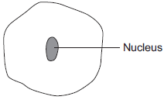
Guided Exam Question
Q14.The diagram below shows a cell.

(a) Draw a ring around the correct answer to complete each sentence.

 | (i) | In the nucleus of a cell, genes are part of | chromosomes.  membranes.  receptors.
(1)
 | (ii) | Different genes control different | characteristics  gametes  nuclei | of an organism.
(1)

(iii) Studying the similarities and differences between organisms allows us to

 | classify  clone  grow | the organisms.
(1)
(b) Complete the following sentence.
Living things can be grouped into animals, microorganisms and ..................... .
(1)
(Total 4 marks)

Independent exam questions
Q15.Darwin’s theory of natural selection states that all living things have evolved from simple life forms.
(a) Use the correct answer from the box to complete the sentence.

three billion three million three thousand
Darwin’s theory states that life began on Earth .........................................
years ago.
(1)
(b) Life evolved due to changes in genes. Changes in genes cause variation. Complete the sentences.
Changes in genes are called ............................................................. .
Individuals with characteristics most suited to the environment are more likely
to survive and ............................................ .
(2)
(Total 3 marks)

Q16.Darwin suggested the theory of natural selection.
(a) Explain how natural selection occurs.
……………………........................................................................................................................
……………………........................................................................................................................
……………………........................................................................................................................
……………………........................................................................................................................
……………………........................................................................................................................
……………………........................................................................................................................
……………………........................................................................................................................
(3)
(b) Latitude is a measure of distance from the Earth’s equator.
Scientists investigated the effect of latitude on:
• the time taken for new species to evolve
• the number of living species.
The table shows the scientists’ results.

 | Latitude  in degrees North of equator | Time taken for new species to evolve in millions of years | Relative number of living species
 | 0 (at the equator) | 3–4 | 100
 | 25 | 2 | 80
 | 50 | 1 | 30
 | 75 (in the Arctic) | 0.5 | 20

As latitude increases environmental conditions become more severe.
(i) Describe the patterns shown by the data.
……………………........................................................................................................................
……………………........................................................................................................................
……………………........................................................................................................................
……………………........................................................................................................................
……………………........................................................................................................................
(2)

(ii) Suggest explanations for the patterns you have described in part (b)(i).
……………………........................................................................................................................
……………………........................................................................................................................
……………………........................................................................................................................
(2)
(Total 7 marks)

17. The drawings show two different species of butterfly.
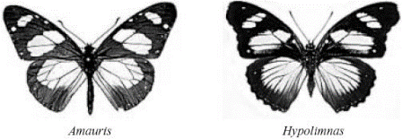
• Both species can be eaten by most birds. • Amauris has a foul taste which birds do not like, so birds have learned not to prey on it. • Hypolimnas does not have a foul taste but most birds do not prey on it.
(a) Suggest why most birds do not prey on Hypolimnas.
.....................................................................................................................................
.....................................................................................................................................
.....................................................................................................................................
(2)

(b) Suggest an explanation, in terms of natural selection, for the markings on the wings of Hypolimnas.
.....................................................................................................................................
.....................................................................................................................................
.....................................................................................................................................
.....................................................................................................................................
.....................................................................................................................................
(3)
(Total 5 marks)

Lesson 5 – Selective Breeding, Genetic Engineering and The Nervous System

 | Topic: | Selective breeding and genetic engineering (B.32)
1 | Describe the purpose of selective breeding | Humans breed plants & animals with particular desirable characteristics
2 | State two reasons to use selective breeding | *produce food crops *produce domesticated animals
3 | List 4 steps in selective breeding | 1) Choose parent with desired characteristic  2) Breed them together  3) Choose best offspring  4) Continue over many generations
4 | State 4 examples of characteristics that you may selectively breed an organism for | *Disease resistance (food crops) *More milk/meat (animals) *Gentle nature (domestic animals) *Large/unusual flowers
5 | State one disadvantage of selective breeding in animals | Inbreeding -> health issues
6 | State one disadvantage of selective breeding in crops | Crops have very similar DNA so disease can kill them all
7 | Define "genetic engineering" | Modifying (changing) the genome (genes) of an organism to give a desired characteristic
8 | State two examples of genetic engineering in practice | *Bacterial cells engineered to produce insulin  *Plant crops engineered to be resistant to disease/have bigger better fruits
9 | Describe the 4 stages of genetic engineering | 1) select desired characteristic 2) isolate gene 3) insert gene into vector 4) replicate
10 | Define "vector" | A ring of DNA (plasmid) or an organism that carries a gene from one organism into another
11 | Is the allele dominant or recessive for (a) Huntingdon's disease (b) cystic fibrosis? | (a) Huntingdon's = dominant  (b) Cystic fibrosis = recessive
 | Topic: | The nervous and endocrine system (B.33)
1 | Define "CNS" | Central Nervous System (brain and spinal cord)
2 | Define "PNS" | Peripheral Nervous System (neurones)
3 | Define "stimulus" | A change in the environment detected by receptors e.g. light, temperature, pressure, smell
4 | Define "receptor" | Specialised cells that detects the stimulus e.g. tongue, skin, nose, eye
5 | Define "effector" | Muscle/gland that responds to the motor neurone to cause a change
6 | Define "sensory neurone" | Neurone carrying electrical impulse FROM receptor to CNS
7 | Define "motor neurone" | Neurone carrying electrical impulse FROM the CNS to effector
8 | Define "relay neurone" | Neurone carrying electrical impulse from one part of the CNS to another
9 | Define "reflex response" | Rapid response which does not use conscious part before response occurs
10 | Describe how messages are sent through the nervous system | Through neurones (electrical)
11 | Describe how messages are sent through the endocrine system | Through blood (chemical)
12 | Which system (nervous or endocrine) transfers messages around the body quicker? | Nervous
13 | Which system (nervous or endocrine) does the response last for longer? | Endocrine
14 | Which gland is called the 'master gland'? | The pituitary gland
15 | Define "synapse" | A gap or junction between two neurons

Biology Revision: Selective Breeding &
Mastery Matrix Points
Describe selective breeding and explain the potential benefits and risks of this process (linking to disease resistance in crops, animals with more milk and meat, large or unusual flowers and domestic dogs with a gentle nature)
Define ‘genetic engineering’
Describe the main steps in genetic engineering
Give examples of genetic engineering (including crop resistance to diseases, insect attack and herbicides, crops with bigger, better fruits and bacterial cells used in the production of insulin)
Evaluate the use of genetic engineering and modification and describe the potential uses of this in the future

Key Knowledge

Selective breeding –

Five uses of selective breeding
-
-
-
-
-

Genetic engineering –

Give uses of genetic engineering
-
-
-
-
-

Steps in genetic engineering:

Genetic Engineering
Understanding and Explaining
- Explain how selective breeding would be used to produce cows with more meat.

- Explain how genetic engineering is used to produce wheat that is resistant to insect attack.

- Explain how bacteria cells are genetically engineered to produce insulin.

Biology Revision: The Nervous
Mastery Matrix Points
Describe the structure of the nervous system
Explain how it is adapted for its function and why it is important
Describe the pathway of a message from stimulus to response
Describe the design of a reflex arc and explain its purpose
Use tables and graphs to extract information about reflex actions
RP Reaction Time: Plan and carry out an investigation into the effect of a factor on human reaction time

Key Knowledge
The nervous system –

CNS (Central nervous system) –

Three types of neurones –

Where are relay neurones found?

Synapses –

Reflex actions –

These are important because…

How does the message travel (electrical or chemical?) in…
- The sensory neurone
- Synapses
- The relay neurone
- The motor neurone?

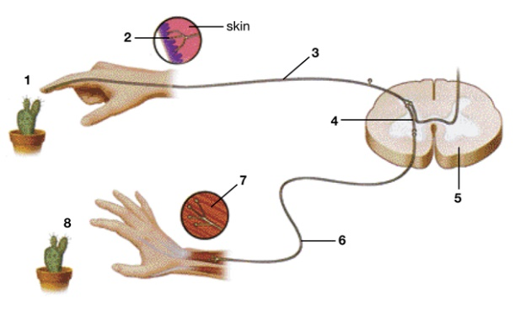
System
Understanding and Explaining
- Describe the path of a reflex response in detail, such as touch a very hot object.

- Label the parts of the reflex arc on the diagram.
- Describe how the message is transmitted across a synapse.

- Write a plan for how to investigate if caffeine affects reaction time.

Notes

Guided Exam Question
Q18.The diagram below shows how a nerve impulse passing along a relay neurone causes an impulse to be sent along another type of neurone, neurone X.
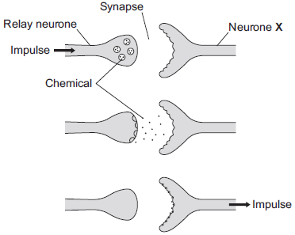
(a) What type of neurone is neurone X?
........................................................................................................................
(1)
(b) Describe how information passes from the relay neurone to neurone X.
Use the diagram to help you.
………………………………........................................................................................................................
………………………………........................................................................................................................
………………………………........................................................................................................................
………………………………........................................................................................................................
………………………………........................................................................................................................
(3)
(c) Scientists investigated the effect of two toxins on the way in which information passes across synapses. The table below shows the results.

Toxin | Effect at the synapse
Curare | Decreases the effect of the chemical on neurone X
Strychnine | Increases the amount of the chemical made in the relay neurone
Describe the effect of each of the toxins on the response by muscles.
Curare ............................................................................................................
........................................................................................................................
........................................................................................................................
Strychnine ......................................................................................................
........................................................................................................................
........................................................................................................................(2)
Independent exam questions
Q19.Many different types of animals are produced using selective breeding.
Some cats are selectively bred so that they do not cause allergies in people.
(a) Suggest two other reasons why people might selectively breed cats.
1 .....................................................................................................................
2 .....................................................................................................................
(2)
(b) Selective breeding could cause problems of inbreeding in cats. Describe one problem inbreeding causes.
........................................................................................................................
(1)
(c) Many people have breathing problems because they are allergic to cats.
The allergy is caused by a chemical called Fel D1. Different cats produce different amounts of Fel D1. A cat has been bred so that it does not produce Fel D1. The cat does not cause an allergic reaction. Explain how the cat has been produced using selective breeding.
……………………........................................................................................................................
……………………........................................................................................................................
……………………........................................................................................................................
……………………........................................................................................................................
……………………........................................................................................................................
(4)
Q20. The article below appeared in the Daily Mail on February 24 1993.
March of the mutant tomatoes as Frankenfood hits the menu
Just when you thought it was safe to go back to the dinner table, ‘Frankenfoods’ are heading for the menu. Rainbow trout with human genes and tomatoes grown with traits of flounder fish are the latest products of food scientists.
It is good news for producers – the trout grow bigger and more quickly, while the tomatoes have a lower freezing point, preventing them becoming damaged. But consumer groups fear a whole breed of these ‘genetically modified organisms’ (GMOs) may be introduced without proper trials.
David King, director of the pressure group Genetic Forum, said: ‘The march of scientists who want to genetically alter food has very serious implications both for animal welfare and the environment.’ ‘You run the risk of introducing triffid-like creatures – plants which have the capacity to overtake landscapes and force out other plant life.’
Genetic forum is to join groups including the RSPCA and World Wide Fund for Nature to debate a number of GMOs awaiting licenses in the United States.
They have called for proper labelling so shoppers can decide for themselves whether they want to buy modified foods.
Two genetic compounds – certain brands of cheddar cheese and bakers’ yeast are already approved for use in British food manufacture, said Mr. King.
British multi-national ICI also has a company, Zeneca seeds, working on genetically altering food and is planning to sell tomatoes in which the ripening gene has been ‘blocked’ to increase shelf life.
An ICI spokesperson said ‘Extensive trials are carried out on all these modified foods and we are required by the Ministry of Agriculture to provide full information on all our trials.’
Growers were able to pick the new tomato when it was ripe and red instead of green and it was wrong to label such an advance ‘Frankenfood’, she said.
‘It has very negative connotations which are not at all correct. The entire drive behind this work is to produce positive benefits to the consumer.’
ICI had helped to produce crops able to resist pests and diseases, bringing food to people who otherwise would go hungry, she added.
(a) The foods described in the article have been produced by genetic engineering. Explain, as fully as you can, how this technique is used to produce ‘genetically modified organisms’.
……………....................................................................................................................................
……………....................................................................................................................................
……………....................................................................................................................................
……………....................................................................................................................................
……………....................................................................................................................................
(4)

(b) Having produced the desired type of tomato by genetic engineering, how might scientists quickly produce large numbers of the new plants to supply to horticulturists?
……………....................................................................................................................................
…………....................................................................................................................................
…………....................................................................................................................................
…………....................................................................................................................................
(2)

(c) Using information from the article and your own knowledge, assess the advantages and disadvantages of producing new types of food by genetic engineering.
……………....................................................................................................................................
…………....................................................................................................................................
…………....................................................................................................................................
…………....................................................................................................................................
…………....................................................................................................................................
…………....................................................................................................................................
……………....................................................................................................................................
……………....................................................................................................................................
……………....................................................................................................................................
…………........................................................................................................................... (6)

Lesson 6 – Endocrine System & Homeostasis

 | Topic: | Homeostasis (B.34)
1 | Name the 6 glands/organs in the endocrine system | Thyroid gland, pituitary gland, pancreas, adrenal gland, testes, ovaries
2 | State the hormone that is released from the adrenal gland and its effect on the body | Adrenaline - "fight or flight" (heart rate increases, blood directed to muscles, air passages dilate)
3 | State the hormone that is released from the thyroid gland and its effect on the body | Thyroxine - increases metabolism (chemical reactions)
4 | State the hormones that is released from the pituitary gland and their effect on the body | FSH (egg development) & LH (ovulation)
5 | State the hormone that is released from the testes and its effect on the body | Testosterone - puberty & sperm production (in boys)
6 | State the hormones that is released from the ovaries and their effect on the body | Oestrogen - causes uterus lining to rebuild  Progesterone - maintains uterus lining
7 | Which two systems help to control homeostasis? | Nervous system and endocrine system
8 | Which disease is linked to an inability to control your blood glucose levels? | Diabetes
9 | Define "homeostasis" | Regulation of internal conditions of a cell or organism to maintain optimum conditions
10 | State three reasons for organisms requiring homeostasis | *So cells don't burst (too much water) *so enzymes work properly (temperature *so chemical reactions occur (water and glucose)
11 | State 4 things that are regulated in the body | Body temperature, blood glucose, water levels, ion levels
12 | Which part of the body detects and controls body temperature | Thermoregulatory centre (in the brain)
13 | State three ways that your body increases your body temperature if you get too cold | *Muscles contract and relax (shiver) to release thermal energy due to respiration *blood vessels in skin constrict to reduce blood flow and thermal energy loss *hairs on arms stand on end, trapping air beneath them
14 | State three ways that your body decreases it's temperature if you get too hot | *Sweat glands release sweat which evaporates - transferring thermal energy to the air *blood vessels in skin dilate so blood flow increases and more thermal energy lost *Hairs on arms lay flat
15 | What happens to the enzymes in your body if you get (a) too hot (b) too cold | (a) too hot = denatured  (b) too cold = work too slowly

Biology Revision: The Endocrine
Mastery Matrix Points
Describe the principals of hormonal coordination including what makes up the endocrine system
Describe what hormones are and label six glands in the body
Describe the role of the pituitary gland
Explain the roles of thyroxine (produced by the thyroid gland) and adrenaline (produced by the adrenal gland) linking this to negative feedback loops (HT only)
Describe and explain how the body controls blood glucose concentration (making reference to glucose, glycogen, glucagon, negative feedback cycle, insulin and the pancreas)

Key Knowledge

Endocrine system –

Hormones –

How are hormones transported?

Name six glands in the human body:
-
-
-
-
-
-

Thyroxine: Produced in …
Job:

Adrenaline: Produced in…
Job:

Negative feedback loops:

System

Understanding and Explaining
- Compare hormonal responses to nervous system responses. (Speed, duration, electrical/chemical, method of transmission)

- Label the glands on the diagram.
- Explain how the body reacts to controls the concentration of glucose in the blood
when:
- Blood glucose is too high

- Blood glucose is too low

- Why is the pituitary gland called the master gland?

Biology Revision: Homeostasis
Mastery Matrix Points
Define ‘homeostasis’ and explain why it is important
List three factors controlled by homeostasis in the human body (blood glucose concentration, temperature, water levels)
Explain how these automatic systems are controlled

Key Knowledge
Homeostasis –

Homeostasis is important because….

Three things that are controlled in the body
-
-
-

All control systems contain
-
-
-

Understanding and Explaining
- Describe what happens to cells if they are a) dehydrated b) overhydrated.

- What are enzymes? What would happen to them if body temperature got:
- Too hot?

- Too cold?

Notes

Guided Exam question:
Q21.Diabetes is a disease in which the concentration of glucose in a person’s blood may rise to fatally high levels. Insulin controls the concentration of glucose in the blood.
(a) Where is insulin produced? Draw a ring around one answer.

 | gall bladder | liver | pancreas

(1)
(b) People with diabetes may control their blood glucose by injecting insulin.
(i) If insulin is taken by mouth, it is digested in the stomach.
What type of substance is insulin? Draw a ring around one answer.

 | carbohydrate | fat | protein

(1)
(ii) Apart from using insulin, give one other way people with diabetes may reduce their blood glucose.
...............................................................................................................
(1)

(c) The bar chart shows the number of people with diabetes in different age groups in the UK.
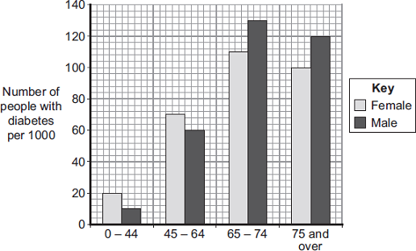
Age in years

(i) Describe how the number of males with diabetes changes between the ages of 0 – 44 years and 75 years and over.
……………………………...............................................................................................................
……………………………...............................................................................................................
……………………………...............................................................................................................
……………………………...............................................................................................................
……………………………...............................................................................................................
……………………………...............................................................................................................
……………………………...............................................................................................................
(3)

(ii) Compare the number of males and females with diabetes:
between the ages of 0 and 64 years
...............................................................................................................
...............................................................................................................
...............................................................................................................
over the age of 65 years.
...............................................................................................................
...............................................................................................................
...............................................................................................................
(2)

Independent Exam Question
Q22. Insulin controls blood glucose concentration.
(a) The rate at which blood glucose concentration changes is affected by the food eaten.
In an experiment a person who does not have diabetes ate two slices of white bread.
The change in her blood glucose concentration was recorded over the next 120 minutes.
The experiment was repeated; first with two slices of brown bread and then with two slices of wholemeal bread. The graph shows the results of the three experiments.
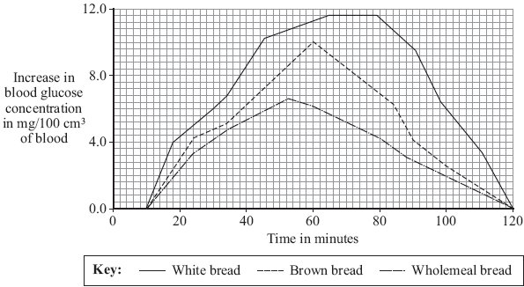
(i) Which type of bread would be most suitable for a person with diabetes?
Type of bread .......................................................................................
Give two reasons for your answer.
1 ........................................................................................................................
...........................................................................................................................
2 ........................................................................................................................
...........................................................................................................................
(2)
(ii) Explain, as fully as you can, the reasons for the changes in blood glucose concentration when the person ate the brown bread.
……………………………...........................................................................................................................
……………………………...........................................................................................................................
……………………………...........................................................................................................................
……………………………...........................................................................................................................
……………………………...........................................................................................................................
……………………………........................................................................................................................ (4)
(b) Pancreatic-cell transplantation is a new treatment for diabetes. Insulin-making cells are taken from up to three dead donors. The cells are kept alive before being injected into the diabetic in a small operation. The cells soon begin to make insulin.
In one recent study 58 % of recipients of pancreatic-cell transplants no longer needed insulin injections.
Give the advantages and disadvantages of the new treatment for diabetes compared with using insulin injections.
.....................................................................................................................................
.....................................................................................................................................
.....................................................................................................................................
.....................................................................................................................................
.....................................................................................................................................
.....................................................................................................................................
.....................................................................................................................................
(3)

Lesson 8 – Diabetes & Hormones in the reproductive system
 | Topic: | Diabetes (B.35)
1 | Which organ monitors and controls your blood glucose concentration? | The Pancreas
2 | Which hormone is released if there is too much glucose in the blood? | Insulin
3 | Which hormone is released if there is too little glucose in the blood? | Glucagon
4 | Describe the effect of insulin have in the body? | (Soluble) glucose stored in the muscle & liver cells as (insoluble) glycogen
5 | Describe the effect of glucagon have in the body? | (Insoluble) glycogen turned into (soluble) glucose and released from liver and muscle cells into blood
6 | Describe what is wrong with a person if they have type one diabetes and how it is treated | Not producing enough insulin (genetic) -> treat with insulin injections
7 | Describe what is wrong with a person if they have type two diabetes and how it is treated | Insulin not having an effect on the muscle/liver cells -> treat with controlled diet and exercise
8 | State the hormones that is released from the pancreas and its effect on the body | Insulin - decreases blood glucose  Glucagon - increases blood glucose
9 | Define "gland" | An organ that releases a hormone into the blood
10 | Define "hormone" | A chemical messenger that travels in the blood and targets organs
11 | Define 'negative feedback' (higher tier only) | Our body's way of monitoring changes in internal conditions and then responding to these changes so that homeostasis is regained
12 | Which type of diabetes is inherited? | Type one
13 | Which type of diabetes is caused by lifestyle | Type two
14 | How do glucagon & insulin travel around the body? | In blood
15 | State a risk factor for type 2 diabetes | Obesity
 | Topic: | Hormones in the reproductive system (B.36)
1 | State the function of FSH (follicle stimulating hormone) | Causes egg to mature
2 | State where FSH is produced | Pituitary Gland
3 | State the hormone that FSH stimulates the production of (HT only) | Oestrogen from ovaries
4 | State the effect of oestrogen | Causes uterus lining to build up
5 | Which hormone inhibits FSH release? (HT only) | Oestrogen
6 | Which hormone does oestrogen stimulate? (HT only) | Luteinising hormone (LH)
7 | State the effect of luteinising hormone (LH) on the body | Causes ovulation
8 | Where is luteinising hormone produced? | Pituitary Gland
9 | Where is progesterone produced? | The empty egg follicle (corpus luteum)
10 | State the role of progesterone | Maintains uterus lining  Inhibits FSH & LH
11 | Name 3 non-hormonal methods of contraception | Barrier method (diaphragm or condoms), abstinence, spermicide, sterilisation, some intrauterine devices
12 | Name 3 hormonal methods of contraception | Oral contraceptive pill, implant, injection, some intrauterine devices
13 | What does IVF stand for? | In Vitro Fertilisation (outside of the body)
14 | What are the 4 stages of IVF? (higher tier only) | 1) Mother given FSH & LH to stimulate maturation of several eggs 2) eggs collected from mother and fertilised by sperm in lab 3) Fertilised eggs develop into embryos 4) Two embryos inserted into mothers uterus
15 | What is embryo screening? | Check embryo for genetic diseases and decide whether or not to use/abort the embryo

Biology Revision: Diabetes
Mastery Matrix Points
Explain type 1 and type 2 diabetes and how they can be treated
Compare and contrast the two types of diabetes
Compare data (from graphs) regarding blood glucose levels in people with and without diabetes

Key Knowledge
Type 1 Diabetes
Cause –

Effect –

Treatment –

Type 2 Diabetes
Cause –

Effect –

Treatment –

Understanding and Explaining
- Name the hormone involved in reducing blood glucose. Where is the hormone produced and which organ does it have an effect on?

- Name the hormone involved in increasing blood glucose. Where is the hormone produced and which organ does it have an effect on?

- Compare and contrast the two types of diabetes. (2 similarities, 2 differences)

- Describe how bacteria can be used to produce a treatment for diabetes.

Biology Revision: Hormones in the
Mastery Matrix Points
Describe the roles of FSH, LH, Oestrogen and progesterone in the menstrual cycle
Describe the roles of oestrogen and progesterone in puberty
Interpret graphs relating to hormone levels in the menstrual cycle (HT only)
Link hormone cycles to ovulation and menstruation
Evaluate hormonal and non-hormonal methods of contraception (oral, injection, implant, skin patch, condoms, diaphragms, intrauterine device, spermicidal agents, abstinence, sterilisation)
Explain why issues around contraception are not answered solely by the field of Science
Explain the process of embryo screening and evaluate based on ethical, social and economic perspectives
Explain the use of FSH and LH as a fertility drug (HT only)
Explain IVF (in vitro fertilisation) (HT only)
Explain how developments in microscopy have enabled IVF treatments to be improved (HT only)
Evaluate social and ethical issues and risks from the perspective of patients and doctors in IVF (HT only)
Compare nervous system and hormonal responses

Reproductive System
Key Knowledge

Male hormones
Testosterone –

Female hormones
Hormone | Roles:
FSH

LH

Oestrogen

Progesterone

Ovulation is…

Ovulation happens about every _____ days.

Hormonal contraceptive methods include…

Non-hormonal contraceptive methods include…

Embryo screening –

IVF –

Understanding and Explaining
- Name one oral contraceptive and one barrier method and then compare oral contraceptives to a barrier method of contraception.

- Explain the role of each hormone in the menstrual cycle. (include the organ it is produced by and where it has an effect).

- Improvements in which piece of equipment have allowed IVF to be developed?

- Give some pros and cons of embryo screening.

- Explain the process of IVF.

- Give some drawbacks of using IVF treatment.

Notes

Guided Exam Question
Q23.The human body produces many hormones.
(a) (i) What is a hormone?
........................................................................................................................
........................................................................................................................
(1)

(ii) Name an organ that produces a hormone.
........................................................................................................................
(1)

(iii) How are hormones transported to their target organs?
........................................................................................................................
(1)

(b) Describe how the hormones FSH, oestrogen and LH are involved in the control of the menstrual cycle.
.................................................................................................................................
.................................................................................................................................
.................................................................................................................................
.................................................................................................................................
.................................................................................................................................
.................................................................................................................................
.................................................................................................................................
.................................................................................................................................
(3)
(Total 6 marks)

Independent Exam Question
Q24.People with type 1 diabetes inject insulin to control their blood glucose level. A pancreas transplant is another treatment for type 1 diabetes. One risk of a pancreas transplant is organ rejection.
(a) Explain why a transplanted organ may be rejected.
.............................................................................................................................
.............................................................................................................................
.............................................................................................................................
.............................................................................................................................
.............................................................................................................................
.............................................................................................................................
(3)

(b) Scientists have developed an artificial pancreas to treat type 1 diabetes.
The diagram below shows how an artificial pancreas works.
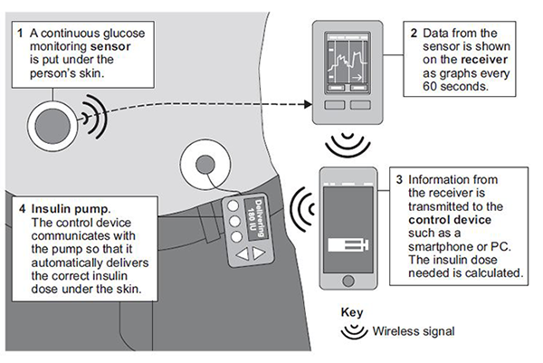

(i) A woman with type 1 diabetes has an artificial pancreas. The woman eats a meal high in sugar. The meal causes her blood glucose level to rise.
Use information from the diagram above to describe what happens to bring the blood glucose level of the woman back to normal.
...................................................................................................................
...................................................................................................................
...................................................................................................................
...................................................................................................................
...................................................................................................................
...................................................................................................................
...................................................................................................................
...................................................................................................................
(4)

(ii) The traditional way of monitoring and treating type 1 diabetes is to take a small sample of blood and put it on a test strip to find out how much insulin to inject.

Suggest one possible advantage, other than not having to do blood tests, of the method used in the diagram above.
...................................................................................................................
...................................................................................................................(1)

Q25. (a) Describe, as fully as you can, how a human foetus gets rid of the carbon dioxide produced during respiration.
.....................................................................................................................................
.....................................................................................................................................
.....................................................................................................................................
.....................................................................................................................................
(3)

(b) The female menstrual cycle is controlled by a number of hormones. The graph below shows the concentrations of four of these hormones at different times during the menstrual cycle.
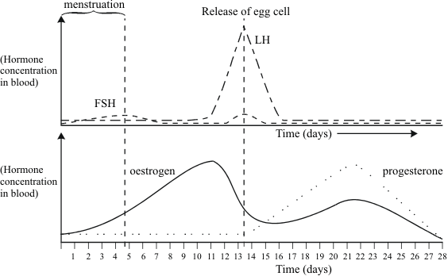
The functions of the four hormones include:
FSH – stimulates the development of immature cells into eggs in the ovary.
LH – stimulates the release of the mature egg cell.
Oestrogen – stimulates production of LH, but inhibits FSH production.
Progesterone – inhibis production of both LH and FSH.
Use this information to explain as fully as you can:

(i) how the concentration of oestrogen can affect and control the development and release of an egg during the monthly cycle;
...........................................................................................................................
...........................................................................................................................
...........................................................................................................................
...........................................................................................................................
...........................................................................................................................
...........................................................................................................................
(3)

(ii) why progesterone continues to be produced throughout pregnancy.
...........................................................................................................................
...........................................................................................................................
...........................................................................................................................
...........................................................................................................................
...........................................................................................................................
(3)
(c) Explain, as fully as you can, how one or more of these hormones could be used to treat infertility.
.....................................................................................................................................
.....................................................................................................................................
.....................................................................................................................................
.....................................................................................................................................
.....................................................................................................................................
.....................................................................................................................................
(3)

(d) A hormone called mifepristone is used in low doses as a female contraceptive. Higher doses can be used to induce an abortion. As a consequence mifepristone is often referred to as ‘the morning-after pill’. The use of mifepristone is currently tightly controlled by the medical profession.
Evaluate the benefits and problems which might arise from making this hormone more freely available.
.....................................................................................................................................
.....................................................................................................................................
.....................................................................................................................................
.....................................................................................................................................
.....................................................................................................................................
.....................................................................................................................................
.....................................................................................................................................
.....................................................................................................................................
.....................................................................................................................................
.....................................................................................................................................
.....................................................................................................................................
(4)
(Total 16 marks)

Biology Revision: Reproduction
Mastery Matrix Points
Explain the process of sexual reproduction and link this to variation
Explain the process of meiosis which leads to the formation of gametes
Explain the process of asexual reproduction
Model the behaviour of chromosomes during meiosis
Compare advantages and disadvantages of sexual and asexual reproduction (triple only)

Key Knowledge

Definitions:
Sexual reproduction – the joining of male and female gametes to produce offspring.
Asexual reproduction – when one parent produces genetically identical offspring.
Variation – differences

Mitosis – Cell division that produces two genetically identical cells.
Meiosis – Cell division that produces four genetically different cells.

What are the gametes in animals? Sperm and egg (ovum)

What are the gametes in flowering plants? Pollen and egg (ovum)

Understanding and Explaining
- What is the cell division that produces gametes?
Meiosis
- What is the cell division that enables the embryo to grow?
Mitosis.
- Describe, in detail, the steps in meiosis and what is produced.
Cells in reproductive organs divide by meiosis to form four genetically different gametes. When a cell divides to form gametes:
• copies of the genetic information are made
• the cell divides twice to form four gametes, each with a single set of chromosomes
• all gametes are genetically different from each other.
- Describe these examples of organisms that reproduce sexually and asexually – malarial parasites, fungi and daffodils.
Malarial parasites reproduce asexually in the human host, but sexually in the mosquito. Many fungi reproduce asexually by spores but also reproduce sexually to give variation. Daffodils reproduce asexually by creating bulbs but also sexually by using flowers.

Biology Revision: DNA
Mastery Matrix Points
Describe the structure of DNA
Explain what the human genome is and the importance of mapping it
Use genetic crosses to predict outcomes of a monohybrid cross

Key Knowledge

Definitions:
Genome – the entire genetic material of that organism

DNA – a polymer made up of two strands forming a double helix

Chromosomes – a group of genes found in the nucleus. Humans have 23 pairs.

Gene – a small section of DNA on a chromosome

Three reasons why studying the human genome is important.
-search for genes linked to different types of disease
-understanding and treatment of inherited disorders

-use in tracing human migration patterns from the past.

Understanding and Explaining

- Describe the structure and function of DNA.
DNA as a polymer with a double helix shape that contains the instructions for making proteins.
The DNA is contained in structures called chromosomes.
A gene is a small section of DNA on a chromosome. Each gene codes for a protein
- Draw a genetic cross to show the likelihood of a child having these diseases: a) polydactyly if one parent is heterozygous and the other is homozygous recessive. B) cystic fibrosis if both parents are carriers of the disease.
- 50% chance of polydactyly.
 | D | d
d | Dd | dd
d | Dd | dd
- 25% chance of cystic fibrosis
 | F | f
F | FF | Ff
f | Ff | ff

Biology Revision: Ecosystems
Mastery Matrix Points
Define “ecosystem”
Define ‘interdependence’ and explain what species depend on
Describe what plants and animals ‘compete’ with each other for
Describe structural, behavioural and functional adaptations of organisms
Define extremophiles linking to the conditions that they inhabit (bacteria in deep sea vents)

Key Knowledge

Ecosystems – the interaction of a community of living organisms (biotic) with the non-living (abiotic) parts of their environment.

Interdependence – If one species is removed it can affect the whole community

Species depend on each other for:
-food
- shelter
- pollination
- seed dispersal

A stable community is – one where all the species and environmental factors are in balance so that population sizes remain fairly constant.

Animals compete for:
-food
-mates
-territory
Plants compete for:
-light
-space
-water
-mineral ions

Types of adaptations:
 | Definition | Example
Structural | A physical feature | Spines on cactus/thick fur
Behavioural | Responses made by an organism | Migration/ resting in the heat of the day
Physiological/  functional | A chemical process | Photosynthesis/ venom

Extremophile: Organisms that live in environments that are very extreme, such as at high temperature, pressure, or salt concentration
Understanding and Explaining
- Explain what interdependence is and how it can be affected if a species is removed from a community.
Interdependence is where all the species and environmental factors are in balance so that population sizes remain fairly constant. If one species dies or is killed by disease or a new predator that has a knock on effect on the animals that eat it and the organisms that eat them.
- Compare what plants and animals compete for.
Animals compete for food, mates and territory whereas plants compete for light, space, water and mineral ions
- What are adaptations? Describe the structural, functional and behavioural adaptations of a venomous snake.
Adaptations are a feature that helps an organism survive and reproduce. A snake has structural adaptations such as camouflaged scaly skin, sharp teeth and a jaw that can dislocate. Function adaptations include producing venom. Behavioural adaptations would include wrapping around its prey (constricting) and hissing to warn organisms.
- Describe the three conditions that are considered to be conditions that only extremophiles can live in.
High temperature, high pressure or high salt concentration.
- Describe an example of an extremophile and the habitat it lives in.
Bacteria that lives in hydrothermal vents.

Biology Revision: Natural Recycling
Mastery Matrix Points
Describe the carbon cycle and its importance
Describe the water cycle and its importance
Explain factors that affect the rate of decay, calculating rate changes using this to explain how to speed up the production of compost (triple only)
Explain how biogas generators can be used to produce a fuel (triple only)
Required practical: Investigate the effects of temperature on the rate of decay of fresh milk by measuring pH change (triple only)

Key Knowledge
Carbon cycle – returns carbon from organisms to the atmosphere as
carbon dioxide to be used by plants in photosynthesis.
Sedimentation – the formation of fossil fuels or rocks by the compression of dead plants and animals over millions of years.
How carbon is absorbed from the atmosphere: | How carbon moves from place to place: | How carbon is released into the atmosphere:
Photosynthesis | Feeding | Respiration
 | Sedimentation | Combustion
 |  | Decomposition
 |  | Volcanic activity
Water cycle – provides fresh water for plants and animals on land before draining into the seas. Water is continuously evaporated and precipitated.

Process | Description
Precipitation | Water released from clouds
Condensation | Water vapour turns into water in clouds.
Surface runoff | Water moving over the ground.
Infiltration | Water moving into the ground from run off or precipitation.
Subsurface flow | Ground water flowing underground.
Evaporation | Turning from water to water vapour
Transpiration | Water evaporating from plants (called evapotranspiration)

Decay/decomposition – break down of dead plant and animal matter by secreting enzymes into the environment. Small soluble food molecules then diffuse into the microorganism.
Factors that affect the rate of decay:
-temperature
-water
-oxygen level
-number of microorganisms
Compost is made from decaying biological matter and is used for compost.
Understanding and Explaining
- Describe and explain how carbon is cycled around the environment.
Carbon is absorbed from the air in the form of carbon dioxide by plants who need the carbon dioxide to photosynthesise. They use the carbon to grow. Then the carbon is either transferred to animals through the food chain (feeding) or the carbon becomes locked away in fossil fuels or rocks through the process of sedimentation. Alternatively, if the plant dies it may just decay/be decomposed. If eaten, the animal might die and decay, which releases carbon back into the atmosphere. Plants and animals both released carbon dioxide into the atmosphere in respiration. Carbon can also be released back into the atmosphere by burning fossil fuels, this is called combustion. Additionally, volcanic activity also releases carbon into the air.
- What is the role of microorganisms like bacteria and fungi in the carbon cycle? Why are they so important?
The role of microorganisms during decay is to cycle materials through the ecosystem by returning carbon to the atmosphere as carbon dioxide and mineral ions to the soil.
Describe how water is cycled around the environment. You can draw a diagram to help you.
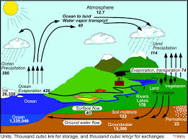

Biology Revision: Humans and the
Mastery Matrix Points
Define biodiversity and explain its importance
Explain in detail human impact on biodiversity (waste management, pollution, land use, deforestation, global warming)
Describe and evaluate some of the programs used to reduce the negative effects of humans on ecosystems and biodiversity (breeding programs, protection/regeneration of rare habitats, reintroduction of field margins and hedgerows, reduction of deforestation, reduction of carbon emissions, increased recycling)

Key Knowledge
Biodiversity –the variety of all the different species of organisms on earth, or within an ecosystem.
More resources are being used because the population is increasing and our standard of living is increasing.

Pollution and the causes:
Land | sewage, fertiliser or toxic chemicals
Air | smoke and acidic gases
Water | from sewage, fertiliser or toxic chemicals
Ways land is being used for humans which destroys habitats:
-building
-quarrying
-farming
-dumping waste
-destroying peat bogs
-deforestation
Two reasons why humans do deforestation:
-land for cattle and rice fields
-grow crops for biofuels
Five ways humans are trying to reduce the negative effects of people on the planet
- breeding programmes for endangered animals
-protection and regeneration of rare habitats
-reintroduction of field margins and hedgerows
-governments reducing deforestation and carbon emissions
-recycling to reduce dumping waste
Define endangered: At risk of extinction
Define extinct: No longer any members of the species left on the planet
Environment
Understanding and Explaining
- Explain how our use of the land will have impacted on habitats.
Habitats for living things have been reduced by humans building, quarrying, farming and dumping waste. Also habitats have been destroyed when peat bogs have been dug up for fuel and also through deforestation.
- Explain why biodiversity is important.
Biodiversity is important because organisms depend on each other (interdependence) and if one organism is affected, then this can have a knock on effect through the whole ecosystem. As humans, biodiverse environments can also bring us new medicines.
- List six biological factors that are threatening our food security.
- the increasing birth rate has threatened food security in some countries
- changing diets in developed countries means scarce food resources are transported around the world
- new pests and pathogens that affect farming
- environmental changes that affect food production, such as widespread famine occurring in some countries if rains fail
- the cost of agricultural inputs
- conflicts that have arisen in some parts of the world which affect the availability of water or food.
4. Explain what deforestation is and why it is happening
Burning down or cutting down large areas of trees to use wood for building materials or to use the land to farm or build on.
5. Give an example of a breeding programme that is being used to increase the number of endangered species. Describe which animal is being bred and where it is happening.
- zoos panda
6. Describe the impact that burning fossil fuels has on habitats. Explain why we are being encouraged to use renewable energy sources instead of burning fossil fuels.
Increases greenhouse gases leads to greenhouse effect leads to climate change leads to ice caps melting, loss of ice on which polar bears can hunt, leads to coral reef depletion, leads to reduction in food available, leads to changes in hunting and migration patterns

Biology Revision: Classifying Organisms
Mastery Matrix Points
Describe the role of Carl Linnaeus in development of a classification system (kingdom, phylum, class, order, family, genus, species)
Explain the binomial naming system of organisms
Define ‘species’ (linking to future fertility and breeding)
Explain how classification models have developed over time due to improvements in microscopy and biochemistry)

Key Knowledge
Carl Linnaeus
Linnaean system of classification:
-Kingdom
-Phylum
-Class
-Order
-Family
-Genus
-Species

Binomial names are…Genus + Species

Species definition: Organisms that can reproduce to make fertile offspring.

Two reasons why classification models have changed:
-improvements in microscopes

- improved understanding of biochemical processes

Carl Woese
Added the three-domain system due to evidence from chemical analysis.
Three domains:

- archaea
- bacteria
- eukaryota

Understanding and Explaining
1. Name the five kingdoms and give an example from each.
Prokaryotae – bacteria e.g. salmonella
Protoctista - malaria causing protist Plasmodium.
Fungi - mushrooms
Plantae - Daisies
Animalia – Humans
2. Name each of the 5 classes and give an example of each
Mammals, reptiles, amphibians, birds, fish
3. Dogs are classified as mammals explain why
They give birth to live young, have hair and are warm blooded.
4. Explain how and why classification systems have changed over time.
As developments in microscopes, chemical analysis and biochemical processes happened, scientists were able to look at cells and what was happening inside organisms. That enabled scientists to add layers and different groups to their classification system.
5. Describe each of the three domains.
- archaea (primitive bacteria usually living in extreme environments)
- bacteria (true bacteria)
- eukaryota (which includes protists, fungi, plants and animals).
Note – these domains are ABOVE the kingdom layer of classification.

Biology Revision: Natural Selection &
Mastery Matrix Points
Describe and explain the theory of ‘natural selection’ and ‘evolution’
Describe the evidence for evolution including antibiotic resistance and the fossil record
Describe what a fossil is and explain how they form and explain why these cannot be used as evidence for how life began on Earth
Interpret information from evolutionary trees
Explain what extinction is and describe factors which may contribute to the extinction of a species

Key Knowledge

Natural selection – that all species of
living things have evolved from simple life forms that first developed more than three billion years ago.

Evolution – a change in the inherited characteristics of a population over time through a process of natural selection which may result in the formation of a new species.

Antibiotic resistance – bacteria evolve through natural selection so that they are no longer able to be destroyed by antibiotics

Fossil – the remains of a dead animal or plant preserved in a rock

Extinction – when no members of an entire species are alive on the planet

Evolution
Understanding and Explaining
- Describe some factors that may lead to the extinction of a species.
Destruction of habitat (caused by climate change, deforestation, human activities etc) or the introduction of a new pathogen or predator.
- Use Darwin’s theory of evolution to explain why giraffes have a long neck
Darwin’s theory would be that the giraffes with the long neck were able to reach the food, so they were more likely to survive and reproduce compared to the other giraffes. They passed on their genes for long necks onto their offspring. The giraffe’s offspring inherited the long necks and so with each generation the giraffe’s necks got longer.
- Describe the evidence for the theory of evolution by natural selection.
Evidence for Darwin’s theory is now available as it has been shown that characteristics are passed on to offspring in genes. There is further evidence in the fossil record and from antibiotic resistance of bacteria.
- How are fossils formed and why can’t they be used as evidence of how life began?
Fossils may be formed
• from parts of organisms that have not decayed because one or more of the conditions needed for decay are absent
• when parts of the organism are replaced by minerals as they decay
• as preserved traces of organisms, such as footprints, burrows and rootlet traces.
Many early forms of life were soft-bodied, which means that they have left few traces behind. What traces there were have been mainly destroyed by geological activity. This is why scientists cannot be certain about how life began on Earth.
- Describe the role of Mendel in changing our understanding of inheritance.
In the mid-19th century, Gregor Mendel carried out breeding experiments on plants. One of his observations was that the inheritance of each characteristic is determined by ‘units’ that are passed on to offspring. This helped scientists to discover genes.

Biology Revision: Selective Breeding &
Mastery Matrix Points
Describe selective breeding and explain the potential benefits and risks of this process (linking to disease resistance in crops, animals with more milk and meat, large or unusual flowers and domestic dogs with a gentle nature)
Define ‘genetic engineering’
Describe the main steps in genetic engineering
Give examples of genetic engineering (including crop resistance to diseases, insect attack and herbicides, crops with bigger, better fruits and bacterial cells used in the production of insulin)
Evaluate the use of genetic engineering and modification and describe the potential uses of this in the future

Key Knowledge

Selective breeding – the process by which humans breed plants and animals for particular genetic characteristics.

Five uses of selective breeding
- breeding food from wild crops
- disease resistance in food crops.
- animals which produce more meat or milk.
- domestic dogs with a gentle nature.
- large or unusual flowers.

Genetic engineering – a process which involves modifying the genome of an organism by introducing a gene from another organism to give a desired characteristic.

Give uses of genetic engineering
- to make crops resistant to diseases
- to produce larger fruits
- to produce insulin from bacteria for humans
- to make crops resistant to drought
-
Steps in genetic engineering:

- Enzymes cut out the desired gene from an organism.

- Gene is inserted into a vector (a bacteria plasmid or a virus)

- Vector used to insert the gene into the required cells.

- Genes inserted into the new organism at an early stage.

- Organism grows and develops with the gene as part of the organism.

Genetic Engineering
Understanding and Explaining
- Explain the use of selective breeding to produce cows with more meat.
Cows with large muscle mass are bred together.
The offspring with the most muscle mass are selected and bred together.
This is repeated over many generations.
- Explain the use of genetic engineering to produce wheat that is resistant to insect attack.
The gene for insect resistance is isolated using restriction enzymes
The gene is inserted into the DNA of a plant
The plant is cloned using cuttings so that all the plants are genetically identical

- Explain how bacteria cells are genetically engineered to produce insulin.
- the gene for making insulin is cut from a length of human DNA using restriction enzymes
- it is inserted into a plasmid using ligase enzymes.
- the plasmid goes into a bacterial cell
- the transgenic bacterium reproduces, resulting in millions of identical bacteria that produce human insulin

Biology Revision: The Nervous
Mastery Matrix Points
Describe the structure of the nervous system
Explain how it is adapted for its function and why it is important
Describe the pathway of a message from stimulus to response
Describe the design of a reflex arc and explain its purpose
Use tables and graphs to extract information about reflex actions
RP Reaction Time: Plan and carry out an investigation into the effect of a factor on human reaction time

Key Knowledge
The nervous system – enables humans to react to their surroundings and to coordinate their behaviour.

CNS (Central nervous system) – the brain and spinal cord - coordinates the response of effectors (muscles contracting or glands secreting hormones)

Three types of neurones – sensory neutron, relay neurone, motor neurone.

Where are relay neurones found?
In the spinal cord.

Synapses – small gaps between neurones.

Reflex actions – automatic and rapid; they do not involve the conscious part of the brain

These are important because…they help us to avoid danger or hurting ourselves.

How does the message travel (electrical or chemical?) in…
- The sensory neurone electrical
- Synapses chemical
- The relay neurone electrical
- The motor neurone? electrical

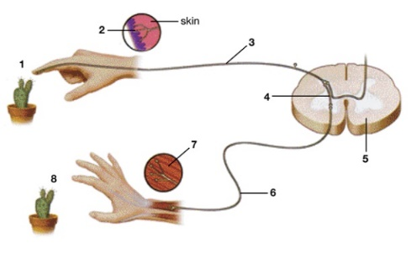
System
Understanding and Explaining
- Describe the path of a reflex response in detail, such as touching a very hot object.
Initially, the stimulus is detector by a receptor, which would be pain or temperature sensors on the skin. An electrical signal then carries the message along the sensory neurone to the first synapse. The message is carried by neurotransmitters across the gap to the relay neurone. After this there is another synapse before the motor neurone. The motor neurone carries the message to the effector (in this case the muscle, which contracts) and the person moves away from or drops the hot object.

- Label the parts of the reflex arc on the diagram.
1 stimulus, 2 receptor, 3 sensory neurone, 4 relay neurone, 5 spinal cord, 6 motor
neurone 7 effector 8 response.
- Describe how the message is transmitted across a synapse.
Neurotransmitter chemicals are produced in the end of the neurone as the electrical signal reaches it. The neurotransmitter chemicals diffuse across the gap and then stimulate an electrical signal in the next neurone.
- Write a plan for how to investigate if caffeine affects reaction time.
Method:
- Test a group of people’s reaction times by using the ruler test.
- Give half of the participants some caffeine drink and half a placebo drink.
- Retest all of their reaction times using the ruler test after twenty minutes.
- Compare the average reaction times for the two groups of people before and after the drink.

Biology Revision: The Endocrine
Mastery Matrix Points
Describe the principals of hormonal coordination including what makes up the endocrine system
Describe what hormones are and label six glands in the body
Describe the role of the pituitary gland
Explain the roles of thyroxine (produced by the thyroid gland) and adrenaline (produced by the adrenal gland) linking this to negative feedback loops (HT only)
Describe and explain how the body controls blood glucose concentration (making reference to glucose, glycogen, glucagon, negative feedback cycle, insulin and the pancreas)

Key Knowledge

Endocrine system – composed of glands which secrete chemicals called hormones directly into the bloodstream.

Hormones – chemical messengers that travel in the blood.
How are hormones transported? In the blood.

Name six glands in the human body:
• pituitary gland
• pancreas
• thyroid
• adrenal gland
• ovary
• testes.

Thyroxine: Produced in the thyroid
Job: stimulates the basal metabolic rate. It plays an important role in growth and development.

Adrenaline: Produced in…the adrenal gland
Job: increases the heart rate and boosts the delivery of oxygen and glucose to the brain and muscles, preparing the body for ‘flight or fight’

Negative feedback loops: when the body responds to a change by trying to reverse it.
If blood glucose is too high… insulin is made

If blood glucose is too low…glucagon is made.

System
Understanding and Explaining
- Compare hormonal responses to nervous system responses.
Hormonal responses are chemical, whereas nervous system responses are mainly electrical.
Hormonal responses are long lasting, whereas nervous system responses do not last long.
Nervous system responses happen quickly, whereas hormonal responses take longer to have an effect.
- Label the glands on the diagram.
From LHS down and around – pancreas, ovaries, testes, adrenal glands, thyroid, pituitary gland.
- Explain how the body controls the concentration of glucose in the blood.
If the blood glucose concentration is too high, the pancreas produces the hormone insulin that causes glucose to move from the blood into the cells. In liver and muscle cells, excess glucose is converted to glycogen for storage.
If the blood glucose concentration is too low, the pancreas produces the hormone glucagon that causes glycogen to be converted into glucose and released into the blood. This is negative feedback.
- Why is the pituitary gland called the master gland?
The pituitary gland in the brain is a ‘master gland’ which secretes several hormones into the blood in response to body conditions. These hormones in turn act on other glands to stimulate other hormones to be released to bring about effects.

Biology Revision: Homeostasis
Mastery Matrix Points
Define ‘homeostasis’ and explain why it is important
List three factors controlled by homeostasis in the human body (blood glucose concentration, temperature, water levels)
Explain how these automatic systems are controlled

Key Knowledge
Homeostasis – the regulation of the internal conditions of a cell or organism to maintain optimum conditions for function in response to internal and external changes.
Homeostasis is important because….it maintains optimal conditions for enzyme action and all cell functions.

Three things that are controlled in the body
-temperature
-water level
-blood glucose concentration

All control systems contain
- receptors
-coordination centres
- effectors (muscles or glands)

Understanding and Explaining
- Describe what happens to cells if they are a) dehydrated b) overhydrated.
- Cells shrivel
- Cells burst

- What are enzymes? What happens if body temperature got

Too hot/too cold
Enzymes can become denatured or not work if the body temperature is too high or too slow and that means that important chemical reactions in the body don’t work.

Biology Revision: Diabetes
Mastery Matrix Points
Explain type 1 and type 2 diabetes and how they can be treated
Compare and contrast the two types of diabetes
Compare data (from graphs) regarding blood glucose levels in people with and without diabetes

Key Knowledge
Type 1 Diabetes
Cause – genetic disorder

Effect – the pancreas fails to produce
sufficient insulin.

Treatment – insulin injections

Type 2 Diabetes
Cause – obesity is the main risk factor

Effect – body cells no longer respond to insulin produced by the pancreas

Treatment – carbohydrate controlled diet and an exercise regime

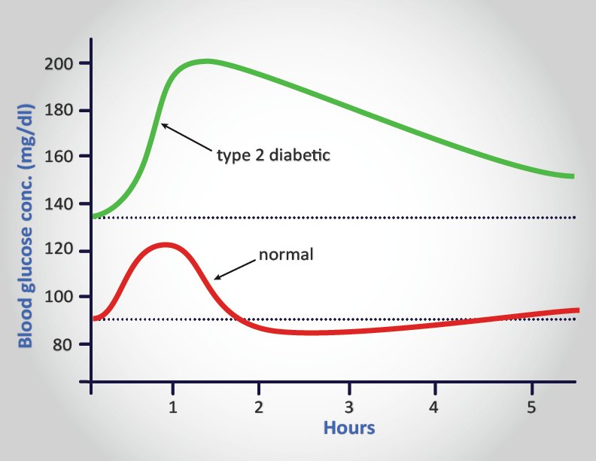
Understanding and Explaining

- Name the hormone involved in reducing blood glucose. Where is the hormone produced and which organ does it have an effect on?
Insulin, produced in the pancreas
Acts on the liver and muscle cells causes them to store glucose and insoluble glycogen

- Name the hormone involved in increasing blood glucose. Where is the hormone produced and which organ does it have an effect on?
Glucagon, produced in the pancreas
Acts on the liver and muscle cells causes them to release glucose

3. Compare and contrast the two types of diabetes.
Type 1 diabetes is caused by a genetic disorder and is characterised by high blood sugar levels. This is in contrast to type 2 diabetes which is caused by obesity. In type 1, the body does not actually produced insulin, whereas in type 2 the body does produced insulin however, the body is not responding to it. Type 1 must be treated with insulin injections, unlike type 2 which is treated with a carbohydrate controlled diet and an exercise regime.

4. Describe how bacteria can be used to produce a treatment for diabetes.
Bacteria are genetically modified this method -
• enzymes are used to isolate the required gene; this gene is inserted into a vector, usually a bacterial plasmid or a virus
• the vector is used to insert the gene into the bacteria cells
• genes are transferred to the bacteria so that they multiply and produce the insulin which is harvested and used to treat diabetes.

Biology Revision: Hormones in the
Mastery Matrix Points
Describe the roles of FSH, LH, Oestrogen and progesterone in the menstrual cycle
Describe the roles of oestrogen and progesterone in puberty
Interpret graphs relating to hormone levels in the menstrual cycle (HT only)
Link hormone cycles to ovulation and menstruation
Evaluate hormonal and non-hormonal methods of contraception (oral, injection, implant, skin patch, condoms, diaphragms, intrauterine device, spermicidal agents, abstinence, sterilisation)
Explain why issues around contraception are not answered solely by the field of Science
Explain the process of embryo screening and evaluate based on ethical, social and economic perspectives
Explain the use of FSH and LH as a fertility drug (HT only)
Explain IVF (in vitro fertilisation) (HT only)
Explain how developments in microscopy have enabled IVF treatments to be improved (HT only)
Evaluate social and ethical issues and risks from the perspective of patients and doctors in IVF (HT only)
Compare nervous system and hormonal responses

Key Knowledge

Male hormones
Testosterone – produced by the testes and it stimulates sperm production.

Female hormones
Hormone | Roles:
FSH | Matures the egg in the ovary  Stimulates oestrogen production
Oestrogen | Maintains the uterus lining  Stops FSH, starts LH
LH | Stimulates the release of the egg  Stimulates progesterone production
Progesterone | Maintains the uterus lining

Ovulation is…the release of the egg

Ovulation happens about every 28 days.

Hormonal contraceptive methods include… oral contraceptives, injection, implant or skin patch
Non-hormonal contraceptive methods include… spermicidal agents, intrauterine devices, condoms and diaphragms

Embryo screening – IVF is used and the embryos are tested in the laboratory. Only embryos without the faulty gene are placed in the womb to grow into a baby.

IVF – producing a fertilised egg outside the body.

Reproductive System
Understanding and Explaining
- Name one oral contraceptive and one barrier method and then compare oral contraceptives to a barrier method of contraception.
The combined pill and the condom Oral contraceptives that contain hormones to inhibit FSH production so that no eggs mature, whereas barrier methods work by preventing the sperm reaching an egg.
- Explain the role of each hormone in the menstrual cycle. (include the organ it is produced by and where it has an effect).
JUST PUT THE TABLE INTO SENTENCES!
3. Improvements in which piece of equipment have allowed IVF to be developed? Microscopes
4. Give some pros and cons of embryo screening.
e.g. Ethical objections to unhealthy embryos being destroyed.
e.g. Only healthy embryos are born – may reduce suffering.

5. Explain the process of IVF.
• IVF involves giving a mother FSH and LH to stimulate the maturation of several eggs. • The eggs are collected from the mother and fertilised by sperm from the father in the laboratory. • The fertilised eggs develop into embryos. • At the stage when they are tiny balls of cells, one or two embryos are inserted into the mother’s uterus (womb).
6. Give some drawbacks of using IVF treatment.
Although fertility treatment gives a woman the chance to have a baby of her own: • it is very emotionally and physically stressful • the success rates are not high • it can lead to multiple births which are a risk to both the babies and the mother.

ANSWER BOOKLET – Biology Paper 2 – Revision booklet – Higher Tier
Lesson 1: Guided:
M1. (a) seeds produced by sexual reproduction / fusion of gametes / fertilisation
allow produced by pollination / crossing
1
mixture of genes / genetic information / chromosomes / DNA
or from two parents / apple trees
if no other mark obtained allow 1 mark for apples had different genes / genetic information / chromosomes / DNA
or
mutation occurred
ignore environmental effects / cloned
1
(b) (i) cuttings / tissue culture
accept grafting allow adult cell cloning
ignore cloning unqualified
ignore genetic engineering
ignore asexual reproduction
1
(ii) asexual reproduction
allow produced by cloning / mitosis
1
have identical genes / genetic information / chromosomes / DNA
or no mixing of genes / genetic information /chromosomes /DNA
1
[5]

Independent:

2 (a) any two from:

assume it refers to asexual

• no fusion in asexual or sexual involves fusion

accept no fertilisation in asexual or fertilisation in sexual

or no mixing of genetic information in asexual or mixing of genetic
information in sexual

accept genes / alleles / chromosomes / genetics for genetic information

or asexual involves splitting (of one individual)

• no gametes in asexual or
sexual involves gametes

accept named gametes

• only one parent in asexual or
sexual involves two parents

• no variation in asexual
or asexual produces clones
or sexual leads to variations

allow offspring of sexual have characteristics of both parents for this point

ignore sexual intercourse

ignore external / internal

ignore plants / animals

ignore mitosis / meiosis

2

(b) nucleus of egg removed or
involves empty egg cell

1

so only one nucleus or one set of genetic information / genes / chromosomes
or
so genetic information / genes / chromosomes from one parent only

1

[4]
M3.(a) asexual reproduction
1
(b) mitosis
1
(c) clones
1
(d) 44
1
[4]
M4. (a) (i) mitosis
correct spelling only
1
(ii) replicates / doubles / is copied / duplicates
accept cloned
ignore multiplied / reproduced
1
(b) fertilisation occurs / fusion (of gametes)
accept converse for asexual, eg none in asexual / just division in asexual
1
so leading to mixing of genetic information / genes / DNA / chromosomes
genes / DNA / chromosomes / genetic information comes from 1 parent in asexual
ignore characteristics
1
one copy (of each allele / gene / chromosome) from each parent
or gametes produced by meiosis
or meiosis causes variation
meiosis must be spelt correctly
1
M5. (a) Stan BB
Sharon bb
all offspring Bb
3
(b) Tom Bb
black offspring Bb
white offspring bb
3
[6]
M6. (a)
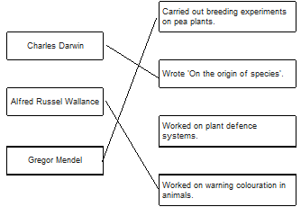 3
M7. (a) chromosomes
genes (reject alleles)
alleles for 1 mark each 3
M8.(a) (i) any two from:
• not all eaten
allow eaten by other animals
• used for respiration
ignore used / lost in heat / movement
• lost as CO₂ / water / urea
• lost as faeces or not all digested
if neither mark awarded allow 1 mark for lost as waste
ignore references to energy losses
do not allow for growth / repair / reproduction
2
(ii) any one from:
• thrushes eat other things
• thrush numbers likely to vary (considerably)
allow it is only an estimate (of population size) or only counted thrushes for 5 hours
• thrushes were not present all the time
• thrushes feed on a much bigger area
1

(b) (i) any one from:
• there are two dependent variables
• there is no independent variable
• to show the association / correlation / pattern (between the two variables)
1
(ii) (snails in woodlands)
more have dark(er) colour(ed shells) or fewer have light-coloured shells
allow converse for grassland, if clear
1
(shells have) no / fewer stripes or have no stripes allow converse for grassland, if clear
1
(iii) less likely to be seen (by predators / birds / thrushes)
allow camouflaged (from predators / birds / thrushes)
allow light coloured shells with stripes would be more visible (to predators / birds / thrushes in woodland (than grassland)).
1
[7]
M9 .(a) an extremophile species
1
(b) (i) smaller ice area allow smaller amount of ice allow less ice
1
(so) less habitat allow fewer places to live / nest
1
(ii) either increase
as more sea to live in
or as less competition for food
or decrease
as less space (ice) to lay eggs
or predators more likely to eat them
there is no mark for increase / decrease alone. The mark is for an appropriate reason linked to increase / decrease
if increase / decrease not ringed the mark may be awarded if it is clear in the explanation which is intended 1
(c) Living organisms show long-term changes. 1
[5]
M10.(a) gets more light (near surface)
allow warmer (near surface)
allow bladders contain (more) carbon dioxide
1
(so) photosynthesises more
1
(because) bladders aid floating (when tide is in)
or
(so) more biomass / glucose / starch produced
ref to ‘more’ needed only once, eg gets more light for photosynthesis gains two marks
if ‘more’ not given do not award mark on the first occasion
1

(b) lets angler fish see / attract its prey / mates or see predators as it is dark (at 1000m)
Or lets angler fish see / attract prey to get food
Or lets angler fish see / attract mates to reproduce
Or lets angler fish see predators to avoid being eaten
must be in a correct pair to gain two marks
2
[5]

M11. (a) any two from:

• (volume of) peat compost has been steady and then declined or volume of peat compost has declined since 2005

allow 2007 instead of 2005

• (volume of) peat-free compost has increased (since 1999)

• (volume of) peat is higher than peat-free until 2005, then peat-free compost is higher (than peat)

allow 2007

• total volume of peat and peat-free compost has increased.

2

(b) increases carbon dioxide (in the atmosphere) ignore methane

1

(c) any one from:

• reduces biodiversity

• destruction of habitats

• disruption of food chains.

1

M12(a) any two from:

ignore CO₂ release unqualified

• burning

• activity of microbes / microbial respiration

• less photosynthesis

Or trees take in CO₂

do not accept CO₂ taken in for respiration

or less CO₂ locked up in wood

• CO₂ given off by clearing machinery

2

(b) (i) range of different species

accept idea of variety of organisms or plants or animals

1

(ii) any two from:

• organisms may produce substances useful to humans

do not accept if food is only example

• duty to preserve for future generations

• effect on other organisms, eg food chain effects

ignore effect on human food supply

• loss of environmental indicators

2

[5]

M13 (a) 5

1

(b) any one from:

allow in either section

• more light

allow more sun / sunnier

• warm(er) / hot

• more water / lot of rain

1

increased / more photosynthesis

allow in either section

allow more biomass / carbohydrate / named (made)

do not allow food

allow enzymes / metabolism faster

NB for 2 marks this must be linked to heat

to gain 2 marks more / increased must be mentioned at least once

1

(c) less pollution / named pollutant eg carbon dioxide / ‘fumes’ / emissions

allow examples of effect of less pollution

eg less global warming / less acid rain

allow any relevant environmental effect

eg imported diseases

1

less fuel used / less transport / named transport

ignore ‘less distance’ / importing

allow ‘less distance travelled’ / ‘less travel’

allow smaller carbon footprint once only for either mark

1

[5]

M14 (a) (i) Chromosomes

1

(ii) Characteristics

1

(iii) Classify

1

(b) Plants

ignore algae

1

[4]
M15.(a) three billion
1
(b) mutation(s)
1
breed / reproduce
in this order only
allow pass on their genes
1
[3]

M16.(a) variation (between organisms within species)
allow described example
allow mutation – but not if caused by change in conditions
1
those most suited / fittest survive
1
genes / alleles passed on (to offspring / next generation)
allow mutation passed on 1
(b) (i) any two from:
allow converse
• increase in latitude reduces number of (living) species
ignore references to severity of conditions
• increase in latitude reduces time for evolution (of new species)
• the less the time to evolve the fewer the number of (living) species
2
(ii) any two from:
do not accept intention or need to evolve
• (increase in latitude reduces number of (living) species because) less food / habitats / more competition at high latitude
allow only extremophiles / well-adapted species can survive
• (increase in latitude reduces time for evolution (of new species) because) severe conditions act more quickly / to a greater extent on the weakest
• (the less the time to evolve the fewer the number of (living) species because) species that evolve slowly don’t survive
2
[7]
M17. (a) wing pattern similar to Amauris 1

birds assume it will have foul taste
1
(b) mutation / variation produced wing pattern similar to Amauris
do not accept breeds with Amauris
do not accept idea of intentional adaptation
1
these butterflies survived
1
breed / genes passed to next generation 1
[5]

M18 (a) motor allow efferent / postsynaptic

allow another relay (neurone)

1

(b) release of chemical (from relay neurone)

allow ecf for ‘motor’ neurone from (a)

allow release of neurotransmitter / named example

1

chemical crosses gap / junction / synapse

allow diffuses across

allow chemical moves to X

1

chemical attaches to X / motor / next neurone (causing impulse)

1

(c) (curare) decrease / no contraction

accept (muscle) relaxes

1

(strychnine) increase / more contraction

if no other mark awarded allow 1 mark for (curare) decrease / no response and (strychnine) increase / more response

1
19.(a) any two from:
• so that they do not have specific genetic defects
• to produce docile cats or so they are not aggressive
allow descriptions of aggression such as biting and scratching
• for aesthetic reasons
allow descriptions of suitable aesthetic reasons
2

(b) (cats) are more likely to pass on (recessive) disorders
or
more likely to be susceptible to diseases
1
(c) Level 2 (3–4 marks):
A detailed and coherent explanation is given, which logically links the process of selective breeding with explanations of how this produces cats that do not cause allergic reactions.
Level 1 (1–2 marks):
Simple statements are made relating to process of selective breeding, but no attempt to
link to explanations.
0 marks:
No relevant content.
Indicative content
process:
• parents with the desired characteristic are selected
• the parents are bred together to produce offspring
• offspring with the desired characteristics are selected and bred
• this is repeated over many generations.
explanations:
• parents who produce the least Fel D1 are initially selected
• in their offspring there will be individuals with differing amounts of Fel D1 produced
• care is taken to ensure cats are healthy and avoid possible problems associated
with selective breeding
• over time the population of (selectively bred) cats will produce less Fel D1
4

M20 (a) genes
cut from plant chromosomes
transferred to cells of other plants
at early stage of development
each for 1 mark
4
(b) use of cuttings
use of tissue culture
each for 1 mark
2
(c) 6 of: pros e.g.:
faster growing tomatoes with longer shelf life
disease-resistant crops
cons e.g.:
lack of proper field trials may have disastrous environmental consequences
example
possible effects of the altered genes on humans
each for 1 mark
6
[12]
M21.(a) pancreas apply list principle 1
(b) (i) protein apply list principle 1
(ii) any one from:
• (controlling / changing) diet
accept sugar(y foods) / named eg
ignore references to starch / fat / protein / fibre
• exercise accept example, eg go for a run
• pancreas transplant accept named drug eg metformin
1
(c) (i) increase ignore reference to women
1
then fall

relevant data quote (for male)
eg max at ages 65–74 or starts at 10 (per thousand) or max at 130 (per thousand) or ends at 120 (per thousand)
accept a difference between any pairs of numbers in data set
accept quotes from scale eg ‘130’ or ’130 per thousand’ but not ’130 thousand’; to within accuracy of +/- 2 (per thousand)
1
(ii) (between 0 and 64) more females (than males) or less males (than females)
ignore numbers
allow eg females more diabetic than males
1
(over 65) more males (than females) or less females (than males)
allow eg males more diabetic than females
1
[8]
M22 (a) (i) (wholemeal bread) any two from:

lower maximum / peak / less change 1

slower rise / change ignore references to rate of fall or first to peak

need to take less insulin / less likely to hyper

no mark for identifying the type of bread but max 1 mark if not identified 1

(ii) any four from:

• amylase / carbohydrase

• starch to sugar

allow starch to glucose

• (sugar) absorbed / diffused / passes into blood

• correct reference to pancreas

allow once only as rise or fall

• insulin produced

• glucose (from blood) into cells / tissue / organ or named
tissue / organ

allow glucose to glycogen

• glucose used in respiration / for energy

max 3 for explaining rise
max 3 for explaining fall

4

(b) any three from:

advantages (compared to insulin injections):

• (may be) permanent / cure

• no / less need for self monitoring

• no / less need for insulin / injections

ignore reference to cost

• no / less need for dietary control

disadvantages (compared to insulin injections):

• low success rate

• (may) still need insulin / dietary control

• operation hazards

• risk of infection from donor

• rejection / need for drugs to prevent rejection

max 2 if only advantages or only disadvantages discussed
can give converse if clear that it relates to insulin injections

3

M23. (a) (i) any one from:
• chemical messenger / message
allow substance / material which is a messenger
• chemical / substance produced by a gland
allow material produced by a gland
• chemical / substance transported to / acting on a target organ
• chemical / substance that controls body functions 1

(ii) gland / named endocrine gland
brain alone is insufficient
allow phonetic spelling
1
(iii) in blood / plasma or circulatory system or bloodstream
accept blood vessels / named
do not accept blood cells / named
1

(b) each hormone must be linked to correct actionapply list principleignore the gland producing hormone
FSH stimulates oestrogen (production) / egg maturation / egg ripening
ignore production / development of egg
1
oestrogen inhibits FSH
allow oestrogen stimulates LH / build up of uterine lining
1
LH stimulates egg / ovum release / ovulation
accept LH inhibits oestrogen
accept LH controls / stimulates
growth of corpus luteum
ignore production of egg 1

M24 (a) immune system allow white blood cells / lymphocytes

ignore phagocytes

1

produces antibodies

1

(which) attack the antigens on the transplanted organ / pancreas

allow transplanted organs have foreign antigens at start of explanation and linked to attacking the organ

1

(b) (i) change / rise detected by the sensor 1

information used to calculate how much insulin she is going to need (bring her blood glucose back to normal)

1

(pump delivers) insulin into the blood 1

(causing) glucose to move into cells

allow (liver) converts glucose to glycogen

1

max 2 if no ref. to artificial pancreas

(ii) any one from:

• it is more accurate or less chance of human error

• (glucose) level will remain more stable or no big rises and falls in blood sugar levels

• you don’t forget to test and / or inject insulin

• if ill or in coma insulin is still injected

ignore continuous and automatic unqualified

1

(a) moves from foetal blood to mothers blood via placenta

for 1 mark each

3

(b) (i) 3 of e.g.
rising levels of oestrogen
result in an increased LH level when LH level peaks
egg release stimulated

any 3 for 1 mark each

3

(ii) 3 of e.g.
continues to inhibit FSH production and to inhibit LH production
so that no eggs are matured or released
Because of danger to later conceived fetus if 2 develop in uterus

any 3 for 1 mark each

3

(c) 3 of e.g.
FSH could stimulate eggs to mature in woman whose own level of FSH too low
LH could stimulate egg release where woman’s own LH production depressed by oestrogen

any 3 for 1 mark each

3

(d) maximum two benefits e.g.
prevents unwanted pregnancy when mother’s physical health at risk
or when mental health at risk
or following e.g. rape
maximum two problems e.g.
involves killing ‘foetus’ rather than preventing gametes meeting
may lead to irresponsible attitude to sexual behaviour
reference to ethical/religious attitudes

for 1 mark each

4

[16]

