OASB Science Department
Biology Paper 1 Revision Pack (Combined – HT)

Contents | Lesson
Mastery Matrix Biology Paper 1
Knowledge | 1
Types of cells and Microscopy Summary Page
Notes page
Exam Questions
Knowledge | 2
Cell division (mitosis) Summary Page
Notes page
Exam Questions
Knowledge | 3
Pathogens and Disease Summary Page
Notes page
Exam Questions
Knowledge | 4
Using & interpreting data Summary Page
Notes page
Exam Questions
Knowledge | 5
Breathing and respiration and blood and the heart Summary Page
Notes page
Exam Questions
Knowledge | 6
Digestion and Types of Transport Summary Page
Notes page
Exam Questions
Knowledge | 7
Gathering the reactants for photosynthesis and using the products of photosynthesis Summary Page
Notes page
Exam Questions
Summary Sheet Answers
Exam Question Mark Schemes

Name: ___________________________________________

Unit | Topic | Tier | Revision Guide (double) | Learning statement
Cell Biology | Types of cell | F | 16+17 | Describe the structure of plant, animal and bacteria cells, classifying as prokaryotic and eukaryotic cells.
Cell Biology | Types of cell | F | 16 | Identify and explain the functions of sub-cellular structures
Cell Biology | Specialised cells | F | 20+24 | Describe the difference between ‘cell differentiation’ and ‘cell division’
Cell Biology | Specialised cells | F | 24 | Describe how cells are specialised and explain their roles (animal cells: sperm cells, nerve cells, muscle cells. Plant cells: root hair, xylem and phloem).
Cell Biology | Specialised cells | F | 25 | Define ‘tissue’, ‘organ’ and ‘organ system’ and explain how they work together to create a functioning ‘organism’
Cell Biology | Microscopy | F | 18 | Compare and contrast electron and light microscopes
Cell Biology | Microscopy | F | 18 | Define ‘magnification’ and ‘resolution’
Cell Biology | Microscopy | F | 19 | Calculate magnification using a formula (magnification = size of image ÷ size of real object)
Cell Biology | Microscopy | F | 18 | Explain how electron microscopy has improved our understanding of subcellular structures
Cell Biology | Microscopy | F | 18 | Define and apply the prefixes ‘centi’, ‘milli’, ‘micro’ and ‘nano’
Cell Biology | Microscopy | F | 19 | RP Microscopy: Use a light microscope to observe, draw and label a selection of plant and animal cells. A scale magnification must be included.
Cell Biology | Cell division (mitosis) | F | 20 | Define, locate and rank in terms of size, ‘Genes’, ‘Chromosomes’, ‘DNA’ and ‘nucleus’
Cell Biology | Cell division (mitosis) | F | 20 | Explain the process of ‘mitosis’ and the ‘cell cycle’ (when, where, how and why)
Cell Biology | Cell division (mitosis) | F | 21 | Describe what stem cells are, where they can be found and how the can be used
Cell Biology | Cell division (mitosis) | F | 21 | Explain the process of ‘therapeutic cloning’
Cell Biology | Cell division (mitosis) | F | 21 | Evaluate the risks and benefits, including the social and ethical implications, of using stem cells in treatments
Cell Biology | Cell division (mitosis) | F | 21 | Explain how plants can be cloned from stem cells and the benefits of doing this
Communicable Diseases | Introducing pathogens and types of disease | F | 30 | Define ‘health’
Communicable Diseases | Introducing pathogens and types of disease | F | 30 | List factors that affect mental and physical health
Communicable Diseases | Introducing pathogens and types of disease | F | 30+40 | Define ‘pathogens’ and explain the difference between ‘communicable’ and ‘non-communicable’ diseases
Communicable Diseases | Introducing pathogens and types of disease | F | 40+41 | Explain how ‘viruses’, ‘bacteria’, ‘protists’ and ‘fungi’ are spread in animals and plants
Communicable Diseases | Introducing pathogens and types of disease | F | 40+41 | Describe the how bacteria and virus cause problems within the body
Communicable Diseases | Introducing pathogens and types of disease | F | 40 | State 4 ways to reduce or prevent the spread of communicable diseases
Communicable Diseases | Detailed disease case studies | F | 40 | Describe three viral diseases in details – the effects, how they are spread, how people are trying to reduce its impact (Measles, HIV and Tobacco Mosaic Virus)
Communicable Diseases | Detailed disease case studies | F | 41 | Describe two bacterial diseases in detail – the effects, how they are spread, how people are trying to reduce its impact (Gonorrhoea and Salmonella)
Communicable Diseases | Detailed disease case studies | F | 41 | Describe one fungal disease in detail – the effects, how it is spread, how people are trying to reduce its impact (Rose Black Spot)
Communicable Diseases | Detailed disease case studies | F | 41 | Describe one protist disease in detail – the effects, how it is spread, how people are trying to reduce its impact (malaria)
Communicable Diseases | Preventing pathogen from making us unwell | F | 42 | Describe how the body prevents entry of pathogens into the body
Communicable Diseases | Preventing pathogen from making us unwell | F | 42 | Describe how the immune system tackles pathogens once they have made it into the body (phagocytosis, antibody production and antitoxin production)
Communicable Diseases | Preventing pathogen from making us unwell | F | 43 | Explain how vaccines work
Communicable Diseases | Preventing pathogen from making us unwell | F | 43 | Discuss the global use of vaccination in the prevention of disease
Communicable Diseases | Preventing pathogen from making us unwell | F | 44 | Explain the use of antibiotics and other medicines
Communicable Diseases | Developing new medicines | F | 44 | Describe how bacteria have developed resistance to antibiotics – in particular MRSA (and use this as an example of evolution)
Communicable Diseases | Developing new medicines | F | 44 | Explain the issues with the development of new antibiotics in the race against antibiotic resistance and what we can do as a society to reduce the rate of development of antibiotic resistance bacteria (linking to medicine and agriculture)
Communicable Diseases | Developing new medicines | F | 44+45 | Describe how many new drugs are still developed from plants and microorganisms (including digitalis and aspirin)
Communicable Diseases | Developing new medicines | F | 45 | Explain how preclinical and clinical trials are used to test new drugs (including tests for safety, effectiveness, toxicity and dosage)
Communicable Diseases | Developing new medicines | F | 44 | Compare and contrast painkillers and antibiotics
Communicable Diseases | Developing new medicines | F | 44+45 | Explain the benefits and drawbacks of antibiotics and limitations of antivirals
Communicable Diseases | Using and interpreting data | F | 30 | Describe situations where types of diseases interact (poor physical health, viruses causing cancer, pathogens -> allergic reactions, immune system defects -> more susceptible to infectious disease)
Communicable Diseases | Using and interpreting data | F | 30 | Translate numerical information between tables and graphs
Communicable Diseases | Using and interpreting data | F | 30 | Construct and interpret bar charts and histograms
Human Biology | Breathing and respiration | F | 48 | Describe the purpose of cellular respiration, recalling the word & symbol equation for aerobic respiration
Human Biology | Breathing and respiration | F | 49 | Explain how the body responds to exercise in terms of heart rate, breathing rate and breath volume
Human Biology | Breathing and respiration | F | 48 | Explain when anaerobic respiration occurs in humans and recall the word equation for this process
Human Biology | Breathing and respiration | F | 49 | Explain what is meant by the term ‘oxygen debt’
Human Biology | Breathing and respiration | HT | 49 | Explain how lactic acid is converted back into glucose following a period of vigorous activity (HT only)
Human Biology | Breathing and respiration | F | 48 | Explain anaerobic respiration in yeast, recalling the word equation for this process
Human Biology | Breathing and respiration | F | 48 | Describe how this process of anaerobic respiration (fermentation) is used by humans in the manufacturing industry
Human Biology | Breathing and respiration | F | 29 | Label the structure and describe the function of the human lungs (including how they are adapted for gaseous exchange)
Human Biology | Blood and the heart | F | 29 | Describe the structure and function of the human heart
Human Biology | Blood and the heart | F | 29 | Describe the roles of the four blood vessels associated with the heart
Human Biology | Blood and the heart | F | 28 | Describe the 3 different types of blood vessel in the body and their structure
Human Biology | Blood and the heart | F | 29 | Carry out rate calculations for blood flow
Human Biology | Blood and the heart | F | 29 | Describe how our body controls our natural resting heart rate
Human Biology | Blood and the heart | F | 28 | Describe the composition of blood and know the functions of each of the components
Human Biology | Blood and the heart | F | 28 | Draw blood cells from under a microscope and recognise different types of blood cells from a photo or diagram, explaining how they are adapted to their functions
Human Biology | Blood and the heart | F | 31 | Describe coronary heart disease
Human Biology | Blood and the heart | F | 31 | Describe what a ‘stent’, ‘statin’, ‘mechanical/biological valve replacement’, ‘pacemaker’ and ‘transplant’ are
Human Biology | Blood and the heart | F | 31 | Evaluate the advantages and disadvantages of treating cardiovascular diseases using drugs, mechanical devices or transplants
Human Biology | Blood and the heart | F | 31 | Evaluate risks associated with the use of blood products
Human Biology | Interpreting disease data | F | 30 | Construct and interpret frequency tables and diagrams
Human Biology | Interpreting disease data | F | 30 | Apply the techniques of scientific sampling to disease incident information
Human Biology | Interpreting disease data | F | 30 | Discuss the human and financial cost of non-communicable diseases (individual, local community, national and global level)
Human Biology | Interpreting disease data | F | 30 | Describe the causal mechanisms of some risk factors for non-communicable diseases (causes of: cardiovascular disease, type 2 diabetes, brain and liver function, lung disease and lung cancer, cancers and foetal damage) including the effects of diet, alcohol and smoking
Human Biology | Interpreting disease data | F | 30 | Use a scatter diagram to identify a correlation between two variables (linking to disease incidence)
Human Biology | Digestion | F | 26 | Describe what the digestive system is
Human Biology | Digestion | F | 26 | Explain the role of enzymes in the digestive system making reference to ‘lock and key’
Human Biology | Digestion | F | 27 | Explain how carbohydrates, proteins and lipids are synthesised, broken down and used, making reference to sugars, amino acids, fatty acids and glycerol
Human Biology | Digestion | F | 27 | Link carbohydrase (amylase), protease, lipase & bile to the breakdown of particular food groups, identifying where they are produced
Human Biology | Digestion | F | 26 | RP Food Tests: Use qualitative reagents to test for a range of carbohydrates, proteins and lipids
Human Biology | Digestion | F | 26 | Describe the effects of temperature and pH on the rate of enzyme reactions and investigate the effect of pH on the rate of reaction of amylase
Human Biology | Digestion | F | 27 | RP Enzymes: Investigate the effect of pH on the rate of reaction of amylase enzyme
Human Biology | Digestion | F | 49 | Define ‘metabolism’
Human Biology | Digestion | F | 49 | Calculate the rate of given chemical reactions
Human Biology | Digestion | F | 49 | Explain the 5 processes that contribute to our metabolism (starch formation, lipid formation, protein synthesis, respiration and protein breakdown)
Human Biology | Diffusion | F | 22 | Define ‘diffusion’ and give examples of diffusion in plants and animals (gas exchange and urea in the kidney)
Human Biology | Diffusion | F | 22 | Explain how different factors affect the rate of diffusion (concentration, surface area, temperature)
Human Biology | Diffusion | F | 22 | Calculate surface area: volume ratios
Human Biology | Diffusion | F | 22 | Explain how surface area: volume ratio of a single celled organism (amoeba) allows sufficient molecule transport
Human Biology | Diffusion | F | 22 | Explain adaptations for exchange materials in: small intestines, lungs, gills, roots and leaves
Plant Biology | Gathering the reactants for photosynthesis | F | 16+32 | Draw and label an unspecialised plant cell and a palisade, root hair, xylem and phloem specialised cell
Plant Biology | Gathering the reactants for photosynthesis | F | 32 | Describe the 5 tissues and name the key organs in the plant
Plant Biology | Gathering the reactants for photosynthesis | F | 32 | Label a transverse section of a leaf
Plant Biology | Gathering the reactants for photosynthesis | F | 22 | Describe the process of osmosis
Plant Biology | Gathering the reactants for photosynthesis | F | 33 | Calculate the rate of water uptake by a plant
Plant Biology | Gathering the reactants for photosynthesis | F | 33 | Calculate the percentage change in mass following osmosis
Plant Biology | Gathering the reactants for photosynthesis | F | 33 | Analyse and draw graphs relating to osmosis
Plant Biology | Gathering the reactants for photosynthesis | F | 23 | RP Osmosis: Analyse the range of concentrations of solutions on the change in mass of plant tissue
Plant Biology | Gathering the reactants for photosynthesis | F | 23 | Describe the process of active transport and explain why it is necessary
Plant Biology | Gathering the reactants for photosynthesis | F | 23 | Compare diffusion, osmosis and active transport
Plant Biology | Gathering the reactants for photosynthesis | F | 23 | Describe the process of active transport and how root hair cells are adapted to this
Plant Biology | Gathering the reactants for photosynthesis | F | 33 | Describe the process of transpiration and translocation (including the structure and function of stomata).
Plant Biology | Gathering the reactants for photosynthesis | F | 33 | Explain the effect of changing temperature, humidity, air movement and light intensity on the rate of transpiration
Plant Biology | Gathering the reactants for photosynthesis | F | 33 | Calculate surface area, volume and mean in transpiration investigation
Plant Biology | Gathering the reactants for photosynthesis | F | 33 | Analyse data from graphs and tables relating to transpiration experiments
Plant Biology | Gathering the reactants for photosynthesis | F | 24 | Describe in detail the location, function and adaptations of xylem tissue, phloem tissue, stomata and guard cells
Plant Biology | Using the products of photosynthesis | F | 46 | Describe the process of photosynthesis
Plant Biology | Using the products of photosynthesis | F | 46 | Recall the word and symbol equation for photosynthesis
Plant Biology | Using the products of photosynthesis | F | 46 | Explain the effects of temperature, light intensity, carbon dioxide intensity and the amount of chlorophyll on the rate of photosynthesis
Plant Biology | Using the products of photosynthesis | F | 47 | Analyse data and calculate rates of photosynthesis and limiting factors from graphs and tables
Plant Biology | Using the products of photosynthesis | F | 47 | Translate information between tabulated and graphical form (from tables to graphs) selecting the appropriate scale for axes
Plant Biology | Using the products of photosynthesis | F | 47 | RP Photosynthesis: Investigate the effect of light intensity on the rate of photosynthesis on an aquatic plant
Plant Biology | Using the products of photosynthesis | F | 47 | Describe how glucose is used after photosynthesis
Plant Biology | Using the products of photosynthesis | F | 47 | Explain the use of nitrate ions within plants
Plant Biology | Using the products of photosynthesis | F | 47 | Use tests to identify starch, glucose and proteins
Plant Biology | Using the products of photosynthesis | HT | 47 | Explain limiting factors of photosynthesis (HT only)
Plant Biology | Using the products of photosynthesis | HT | 47 | Apply inverse square laws and light intensity to the context of photosynthesis. (HT only)
Plant Biology | Using the products of photosynthesis | HT | 47 | Explain the economic importance of limiting factors in greenhouses (HT only)

Lesson 1

Topic: | Types of cells (B.1)
What is the main difference between a prokaryotic and eukaryotic cell? | Eukaryotic have their DNA contained within a nucleus
Give an example of a eukaryotic cell. | Animal and plant cells
Give an example of a prokaryotic cell. | Bacteria
Eukaryotic cells have which sub-cellular structures? | Cell membrane, cytoplasm and genetic material in a nucleus.
What is the function of cell wall? | Supports/ Strengthens the cell
What is the function of mitochondria? | Where respiration takes place
What is the function of the nucleus? | Controls the activities of the cell
What us the function of cell membrane? | Controls what enters/exits the cell
What is the function of the vacuole? | Store sugars and salts
What is the function of chloroplasts? | Absorb light for photosynthesis
What is the function of cytoplasm? | Where chemical reactions of the cell takes place
What is the approximate size of a prokaryotic cell | 0.1-5.0 μm
What is the approximate size of a eukaryote cells | 10-100µm
Which is bigger? A prokaryotic or eukaryotic cell? | Eukaryotic
What is meant by "micro" | 1/1,000,000th (1 millionth)
Topic: | Specialised cells (B.2)
Define "cell differentiation" | A cell becoming specialised to perform a particular function
Define "cell division" | The splitting of a cell into two genetically identical daughter cells
Name 3 specialised cells found in the animals and 3 in plants | Animals: Muscle cell, nerve cell, sperm cell  Plants: Root hair cell, phloem, xylem
State the function of a muscle cell | Produce movement
State one adaptation of a muscle cell | Lots of mitochondria for releasing energy
State the function of a sperm cell | Fertilise the female egg
State three adaptations of a sperm cell | *Tail for movement  *Lots of mitochondria to release energy  *Enzymes in it's head to penetrate egg
State the function of a nerve cell | Carry information from one part of the body to another
State two adaptations of a nerve cell | *Dendrites to connect to other neurones  *Long axon to cover large distances
State the function of a root hair cell | Absorb water and minerals from the soil
State two adaptations of a root hair cell | *Large surface area  *Thin cell wall
State the function of a xylem cell | Carry water from roots to leaves
State two adaptations of a xylem cell | *Lignin to strengthen cells  *End walls broken down to form hollow tubes
State the function of a phloem cell | Transport glucose within a plant
State two adaptations of a phloem cell | *less sub-cellular structures  *end walls have sieve plates to allow glucose through
Topic: | Microscopy (B.3)
How do you calculate the magnification? | magnification = size of image/size of object
Which microscope has the highest magnification? | electron microscopes
Which microscope has the lowest resolution? | Light microscope
Which microscope produces 3D images? | Scanning and transmission Electron microscope
Which microscope shows colours? | Light microscope
Which microscope allows to see inside an object? | Transmission Electron Microscope
Which microscope shows black and white images? | Scanning and transmission electron microscope
Which sub-cellular structures an you see with a higher resolution? | Mitochondria and ribosomes
Define "tissue" | A group of similar specialised cells working together to fulfil a function
Define "organ" | A group of different tissues working together to fulfil a function
Define "organ system" | A group of different organs working together to fulfil a function
Put into order of size (smallest to largest): cell, organism, nucleus, tissue, organ system, organ | nucleus, cell, tissue, organ, organ system, organism
What is meant by "centi"? | 1/100th (1 hundredth)
What is meant by "milli" | 1/1000th (1 thousandth)
What is meant by "nano" | 1/1,000,000,000th (1 billionth)

Notes

Biology Revision: Types of Cell and
Mastery Matrix Points
Describe the structure of plant, animal and bacteria cells, classifying as prokaryotic and eukaryotic cells.
Identify and explain the functions of sub-cellular structures
Describe the difference between ‘cell differentiation’ and ‘cell division’
Describe how cells are specialised and explain their roles (animal cells: sperm cells, nerve cells, muscle cells. Plant cells: root hair, xylem and phloem).
Define ‘tissue’, ‘organ’ and ‘organ system’ and explain how they work together to create a functioning ‘organism’
Compare and contrast electron and light microscopes
Define ‘magnification’ and ‘resolution’
Calculate magnification using a formula (magnification = size of image ÷ size of real object)
Explain how electron microscopy has improved our understanding of subcellular structures
Define and apply the prefixes ‘centi’, ‘milli’, ‘micro’ and ‘nano’
Required Practical 1: Use a light microscope to observe, draw and label a selection of plant and animal cells. A scale magnification must be included.
Compare and contrast electron and light microscopes

Microscopy
Key Knowledge
Prokaryote cells –

e.g.

Eukaryote cells –

e.g.

Cell differentiation -

Cell division –

Tissue –

Organ –

System –

Label the cells:

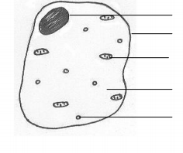

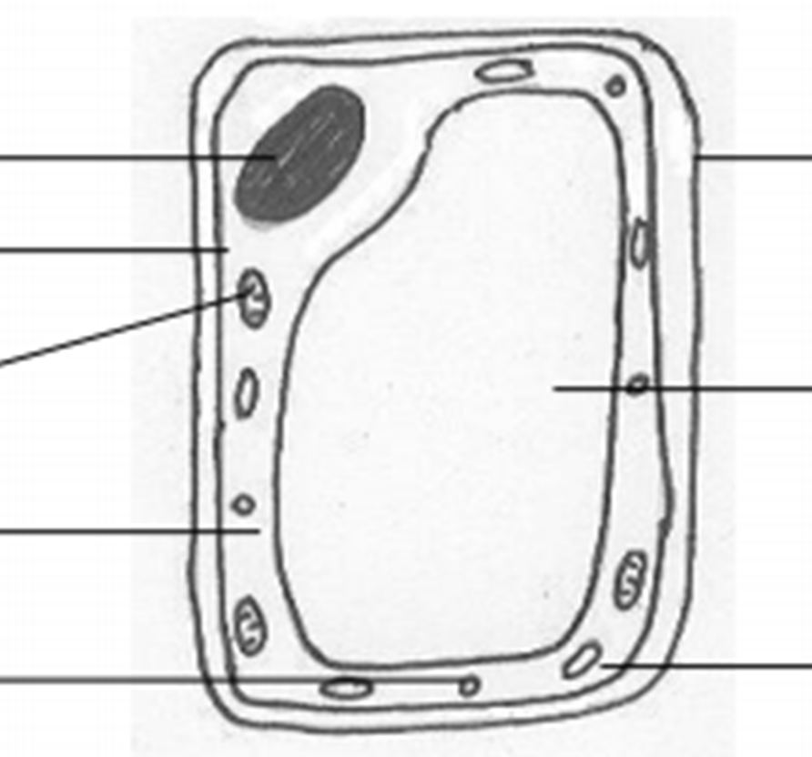
Definitions:
Magnification –
Resolution –
Equation:
Magnification =
Understanding and Explaining
- Describe the structure of a bacteria cell.

- Complete the table about the subcellular structures.
Subcellular structure | Plant, animal or both? | Function:
- Complete the table about specialised cells.
Cell | Function | Adaptations
Muscle
Sperm
Nerve
Root
Xylem
Phloem
- Compare when cell differentiation happens in plants to animals.

- How have electron microscopes improved our understanding of cells?

- Evaluate the pros and cons of light and electron microscopes.

Guided Exam Question
Q1. The image below shows some muscle cells from the wall of the stomach, as seen through a light microscope.
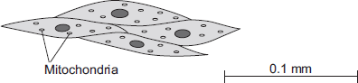
(a) Describe the function of muscle cells in the wall of the stomach.
___________________________________________________________________
___________________________________________________________________
___________________________________________________________________
___________________________________________________________________
(2)
(b) Figure above is highly magnified.
The scale bar in Figure above represents 0.1 mm.
Use a ruler to measure the length of the scale bar and then calculate the magnification of Figure above.
___________________________________________________________________
___________________________________________________________________
___________________________________________________________________
___________________________________________________________________
Magnification = _______________ times
(2)
(c) The muscle cells in Figure above contain many mitochondria.
What is the function of mitochondria?
___________________________________________________________________
___________________________________________________________________
___________________________________________________________________
___________________________________________________________________
(2)
(d) The muscle cells also contain many ribosomes. The ribosomes cannot be seen in Figure above.
(i) What is the function of a ribosome?
______________________________________________________________
______________________________________________________________
(1)
(ii) Suggest why the ribosomes cannot be seen through a light microscope.
______________________________________________________________
______________________________________________________________
(1)
(Total 8 marks)
Q2.
Diagrams A, B and C show cells from different parts of the human body, all drawn to the same scale.
A B C
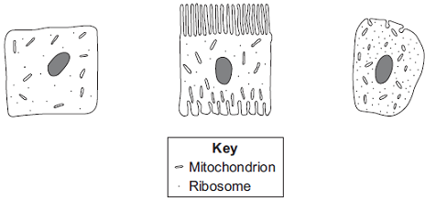
(a) Which cell, A, B or C, appears to be best adapted to increase diffusion into or
out of the cell?
Give one reason for your choice.
___________________________________________________________________
___________________________________________________________________
(1)
(b) (i) Cell C is found in the salivary glands.
Name the enzyme produced by the salivary glands.
______________________________________________________________
(1)
(ii) Use information from the diagram to explain how cell C is adapted for producing this enzyme.
______________________________________________________________
______________________________________________________________
______________________________________________________________
______________________________________________________________
(2)
(Total 4 marks)

Lesson 2

Topic: | Cell division (mitosis) (B.4)
Put in order of size (smallest to largest): genes, chromosomes, DNA, cell, nucleus | DNA, gene, chromosome, nucleus, cell
Name the 3 stages of the cell cycle | Interphase, Mitosis, Cytokinesis
Describe the three things that happen during interphase | 1) The cell grows, 2) chromosomes are copied, 3) more mitochondria and ribosomes are made
Describe what happens during mitosis | Chromosomes pulled to opposite ends of the cell
Describe what happens during cytokinesis | Cell membrane and cytoplasm split in two
State why the cell cycle is important | More cells are made for growth and repair
State what is produced in the cell cycle | Two genetically identical daughter cells
Mitosis produces which type of cells? | Diploid cells
Define "stem cell" | An undifferentiated cell
Name 3 places where stem cells can be found in humans | Embryos, adult bone marrow, meristem
State two conditions that stem cells can be used to treat in humans | Paralysis and type 1 diabetes
State two uses of stem cells in plants | 1) Clone rare species 2) produce disease resistant crops
Describe what is meant by "therapeutic cloning) | Using clones of a patient’s own stem cells to treat them
Which cells are required for therapeutic cloning? | Egg cell and a normal body cell from patient
State two objections to using stem cells in treatment | Potential transfer of viral infections and ethical/religious objections

Notes

Key Knowledge
Inside the nucleus is a chemical called _____. A length of DNA is called a _____. These genes make up ________. Humans have ____ pairs of chromosomes.

Definitions:
Mitosis -

Cell cycle –

Stem cell –

Therapeutic cloning –

Sexual reproduction-

Asexual reproduction-

Stage of cell cycle | What happens?
Growth stage
Mitosis
Cytokinesis

Job of the three types of stem cells
1. embryotic -

2. adult -

3. meristem (plan) –

Two conditions that might be cured by stem cells:
1
2
Biology Revision: Cell Division
Mastery Matrix Points
Define, locate and rank in terms of size, ‘Genes’, ‘Chromosomes’, ‘DNA’ and ‘nucleus’
Explain the process of ‘mitosis’ and the ‘cell cycle’ (when, where, how and why)
Describe what stem cells are, where they can be found and how the can be used
Explain the process of ‘therapeutic cloning’
Evaluate the risks and benefits, including the social and ethical implications, of using stem cells in treatments
Explain how plants can be cloned from stem cells and the benefits of doing this

Understanding and Explaining
- Chromosomes are found in pairs in most body cells. Describe where these 23 pairs of chromosomes come from.

- Why is the cell cycle needed?

- Explain the process of the cell cycle.

- Compare the two types of stem cells found in animals, such as humans.

- Where are adult stem cells found?

- Name the undifferentiated cells found in plants. Where in plants are these found?

- Therapeutic cloning can be used to produce an organ for transplant. Evaluate the pros and cons of using stem cells for therapeutic cloning.

- Stem cells from meristems in plants can be used to produce clones of plants quickly and economically. Suggest two uses of cloning plants in this way.

Guided Exam Question
Q3.
(a) How many pairs of chromosomes are there in a body cell of a human baby?
___________________________________________________________________
(1)
(b) Place the following in order of size, starting with the smallest, by writing
numbers 1 – 4 in the boxes underneath the words.
(1)
(c) For a baby to grow, its cells must develop in a number of ways.
Explain how each of the following is part of the growth process of a baby.
(i) Cell enlargement
______________________________________________________________
(1)
(ii) The process of cell division by mitosis
______________________________________________________________
______________________________________________________________
______________________________________________________________
______________________________________________________________
______________________________________________________________
______________________________________________________________
(3)
(d) Why is cell specialisation (differentiation) important for the development and growth of a healthy baby from a fertilised egg?
___________________________________________________________________
___________________________________________________________________ (2)
(Total 8 marks)

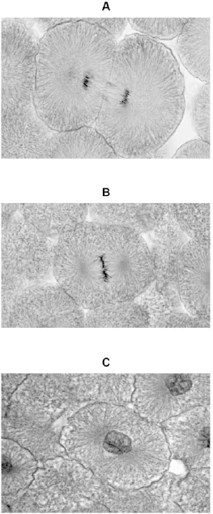
Independent Exam Questions
Q4. Figure 1 shows photographs of some animal cells at different stages during the cell cycle.

(a) Which photograph in Figure 1 shows a cell that is not going through mitosis?
Tick one box.

 | A |  |  | B |  |  | C
(1)
(b) Describe what is happening in photograph A.
___________________________________________________________________
___________________________________________________________________
___________________________________________________________________
___________________________________________________________________
___________________________________________________________________
(2)

(c) A student wanted to find out more about the cell cycle.
The student made a slide of an onion root tip.
She counted the number of cells in each stage of the cell cycle in one field of view.
The table below shows the results.

 |  |  | Stages in the cell cycle
 |  | Non-dividing cells | Stage 1 | Stage 2 | Stage 3 | Stage 4 | Total
 | Number of cells | 20 | 9 | 4 | 2 | 1 | 36

Each stage of the cell cycle takes a different amount of time.
Which stage is the fastest in the cell cycle?
Give a reason for your answer.
Stage _____________________
Reason ____________________________________________________________
___________________________________________________________________
(2)

(d) The cell cycle in an onion root tip cell takes 16 hours.
Calculate the length of time Stage 2 lasts in a typical cell.
Give your answer to 2 significant figures.
___________________________________________________________________
___________________________________________________________________
___________________________________________________________________
Time in Stage 2 = ________________________ minutes
(3)
(e) Bacteria such as Escherichia coli undergo cell division similar to mitosis.
Figure 2 shows a growth curve for E. coli grown in a nutrient broth.
Figure 2
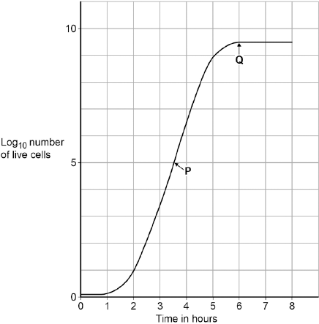
What type of cell division causes the change in number of E. coli cells at P?
___________________________________________________________________
(1)
(f) Suggest why the number of cells levels out at Q.
___________________________________________________________________
___________________________________________________________________
___________________________________________________________________
___________________________________________________________________
___________________________________________________________________
___________________________________________________________________
(2)

Lesson 3

 | Topic: | Introducing pathogens and types of disease (B.7)
1 | Define "health" | State of physical and mental well being
2 | What is the name for a disease that can be passed on from person to person? | Communicable (or infectious)
3 | What is the name for a disease that can NOT be passed on from person to person? | Non-communicable
4 | State three factors other than disease that can have an impact on health | Diet, stress, life events
5 | State one consequence of long term physical ill health | Depression
6 | What is the name given to a disease causing microorganism? | Pathogen
7 | Define "risk factors" | Factors that are linked to an increased rate of disease
8 | State three risk factors for cardiovascular disease | Diet, smoking and exercise
9 | State one risk factor for type 2 diabetes | Obesity
10 | Name 2 organs effected by drinking alcohol | Brain and Liver
11 | Name 2 potential impacts of smoking | Lung disease and lung cancer
12 | State a risk factor for cancer | Contact with carcinogens (including ionising radiation)
13 | State two lifestyle factors that can impact an unborn babies development | Smoking and drinking alcohol
14 | Why is a sample of people used when investigating risk factors for diseases? | Too time consuming/impractical to sample whole population
 | Topic: | Detailed disease case studies (B.8)
1 | Name 4 types of pathogen | Virus, bacteria, fungi, protist
2 | Name 3 viral diseases | Measles, HIV, TMV (tobacco mosaic virus)
3 | Name 2 bacterial diseases | Salmonella & Gonorrhoea
4 | Name 1 fungal disease | Rose black spot
5 | Name 1 protist disease | Malaria
6 | State 2 symptoms of measles | Fever. Red skin rash
7 | State 2 symptoms of HIV | Flu-like symptoms. AIDS
8 | State 1 symptom of TMV | Discolouration of leaves
9 | State 2 symptoms of salmonella | Fever. Cramps. Omitting . Diarrhoea
10 | State 2 symptoms of gonorrhoea | Thick yellow/green discharge. Pain urinating
11 | State 2 symptoms of rose black spot | Purple/black spots on leaves. Leaves turn yellow & drop off
12 | How is measles spread & prevented? | Spread: Air Prevented: Vaccination
13 | How is Gonorrhoea spread & prevented? | Spread: Sex Prevented: Condoms
14 | How is Rose Black Spot spread & prevented? | Spread: Direct contact Prevented: Fungicide & destroying affected leaves
15 | How is Salmonella spread & prevented? | Spread: Food Prevented: Cooking thoroughly & washing hands
 | Topic: | Preventing pathogens from making us unwell (B.9)
1 | State 3 ways that pathogens can be spread | Direct contact, water, air
2 | How do bacteria make us feel unwell? | Produce toxins (poisons) that damage tissues
3 | How do viruses make us feel unwell? | Live & reproduce in cells causing cell damage
4 | Name 4 of the body's non-specific defence systems | Skin, nose, trachea, stomach
5 | How does the skin prevent pathogens from making us unwell? | Prevent them from entering body
6 | How does the nose prevent pathogens from making us unwell? | Mucus to trap dirt & pathogens, ciliated cells to sweep it out
7 | How does the trachea prevent pathogens from making us unwell? | Mucus to trap dirt & pathogens, ciliated cells to sweep it out
8 | How does the stomach prevent pathogens from making us unwell? | Stomach acid to kill pathogens
9 | State three ways that white blood cells can help to defend us against pathogens | Phagocytosis, antibody production, antitoxin production
10 | Which type of white blood cell carries out phagocytosis? | Phagocytes
11 | Which type of white blood cell carries out antibody and antitoxin production? | Lymphocytes
12 | State one thing that can trigger cancers to form | Viruses in cells
13 | What causes tumours to form? | Changes in cells that lead to uncontrolled growth and division
14 | Define "benign tumour" | Growth of abnormal cells contained in ONE area in a membrane
15 | Define "malignant tumour" | Growth of abnormal cells that SPREAD to other parts of the body in blood and INVADE other tissues.
 | Topic: | Developing new medicines (B.10)
1 | State three ways that drugs can be produced | Extracted from plants, microorganisms & synthesised
2 | Where does the heart drug digitalis originate from? | Foxgloves (plant)
3 | Where does the pain killer aspirin originate from? | Willow trees
4 | Where does the antibiotic penicillin originate from? | Penicillium mould
5 | State three things that drugs are tested and trialled for before use | 1) Toxicity (safe), 2) efficacy (does it work), 3) dose (quantity)
6 | What is used to test drugs during preclinical testing? | Cells, tissues & live animals
7 | Who are medicines tested on in stage 1 of clinical trials? | Healthy volunteers (low doses - test for toxicity)
8 | Who are medicines tested on in stage 2 of clinical trials? | Patient volunteers (low doses - test for efficacy & dose)
9 | What is a double blind trial? | Neither experimenter or patient knows if they are taking medicine or placebo
10 | What is a placebo? | A substance that contains no medicine (a control)
11 | What is the name for the injection given to patients to prevent them from catching an infectious disease? | Vaccination
12 | Describe step 1 of vaccinations | 1) small quantity of dead/inactive pathogen
13 | Describe step 2 of vaccinations | 2) white blood cells produce correct antibody (slowly)
14 | Describe step 3 of vaccinations | 3) pathogen enters body & WBC produce correct antibodies (quickly)
15 | State two benefits of vaccination | Prevent illness in an individual & prevent spread to others

Notes

Biology Revision: Health and Pathogens
Mastery Matrix Points
Define ‘health’
List factors that affect mental and physical health
Define ‘pathogens’ and explain the difference between ‘communicable’ and ‘non-communicable’ diseases
Explain how ‘viruses’, ‘bacteria’, ‘protists’ and ‘fungi’ are spread in animals and plants
Describe the how bacteria and virus cause problems within the body
State 4 ways to reduce or prevent the spread of communicable diseases
Describe three viral diseases in details – the effects, how they are spread, how people are trying to reduce its impact (Measles, HIV and Tobacco Mosaic Virus)
Describe two bacterial diseases in detail – the effects, how they are spread, how people are trying to reduce its impact (Gonorrhoea and Salmonella)
Describe one fungal disease in detail – the effects, how it is spread, how people are trying to reduce its impact (Rose Black Spot)

Understanding and Explaining
- Compare the structure and size of viruses and bacteria.

- Describe how communicable diseases can be spread between organisms.

- Explain how the prevent the spread of an epidemic, such as swine flu.

- Complete the table about the diseases.
Disease | Type of pathogen | How is it spread | How can it be prevented? | Can it be treated? How?
Measles

HIV

TMV

Gonorrhoea

Salmonella

Rose black spot

Key Knowledge

Health –

Pathogens –

Factors that affect mental and physical health:
-
-
-

Communicable disease –

Non-communicable disease –

Four types of pathogen
-
-
-
-

Bacteria make us feel ill because…

Viruses make us feel ill because…

Ways diseases can be spread:
-
-
-
-
Ways to prevent the spread of diseases:
-
-
-
-

Biology Revision: Preventing Diseases
Mastery Matrix Points
Describe how the body prevents entry of pathogens into the body
Describe how the immune system tackles pathogens once they have made it into the body (phagocytosis, antibody production and antitoxin production)
Explain how vaccines work
Discuss the global use of vaccination in the prevention of disease
Explain the use of antibiotics and other medicines
Compare and contrast painkillers and antibiotics
Explain the benefits and drawbacks of antibiotics and limitations of antivirals

Key Knowledge

How do these parts of the body try to prevent pathogens entering?
Skin –

Nose –

Trachea and bronchi –

Stomach –

Three jobs of white blood cells –
-
-
-

Definition:
Vaccination –

Phagocytosis –

Immunising –

Antibiotics –
e.g.

Painkillers –
e.g.

Antivirals –

Disadvantage of antivirals:

Understanding and Explaining
- Describe the physical and chemical barriers preventing pathogens from entering the body.

- Explain the roles of phagocytes and lymphocytes (types of white blood cell) in the immune system.

- Describe and explain the shape of this graph showing the number of antibodies produced during a first and second chickenpox infection.
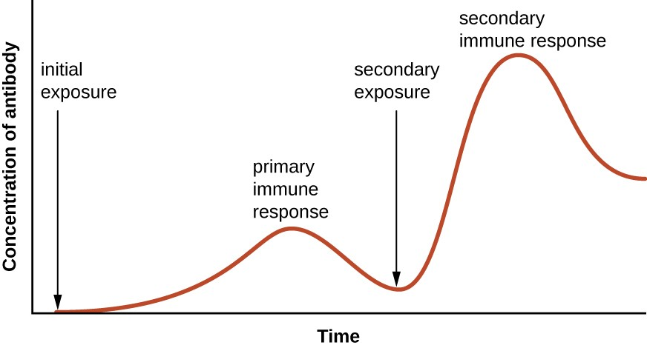
- Explain how the measles vaccine helps to prevent a person becoming ill from the measles pathogen.

- The flu vaccine is often given out in the UK to vulnerable groups, rather than the whole population. Discuss why the government has chosen to immunise only select groups of people, such as 65+ years old and pregnant women.

- A student has influenza cause by a virus. Discuss which of the medicines, painkillers, antibiotics or antivirals, would be suitable to give them. Explain why.

Biology Revision: Developing New Medicines
Mastery Matrix Points
Describe how bacteria have developed resistance to antibiotics – in particular MRSA (and use this as an example of evolution)
Describe how many new drugs are still developed from plants and microorganisms (including digitalis and aspirin)
Explain how preclinical and clinical trials are used to test new drugs (including tests for safety, effectiveness, toxicity and dosage)

Understanding and Explaining

- Explain how new antibiotic resistant strains of bacteria have developed.

- Describe how a new drug would be tested to ensure it is safe.

Key Knowledge
Traditional medicinal drugs were made from__________. Now most are chemically ___________, but might still start from a _______ extract.

During preclinical testing…

During clinical testing…

Drugs are trialled to check the:
-
-
-

Drug | Made from | Used to treat
Digitalis
Aspirin
Penicillin

Definitions:
Placebo -

Double blind trial -

Toxicity -

Efficacy -

Dose -

Guided Exam Question
Q7. Read the following passage.
One of the deadliest diseases in history to be making a comeback in Britain. Doctors are alarmed at the rising number of cases of tuberculosis (TB) over the past three years, after decades in which it had declined.
In the middle of the last century TB accounted for 16% of all deaths in Britain. The turning point in the fight against TB came in 1882 when Robert Koch identified the bacterium that causes the disease. In 1906 two French scientists began developing the vaccine to provide immunity against TB. The vaccine, BCG, (so-called from the initials of the two scientists) has routinely been injected into children aged 12 or 13 who are not already infected with the TB bacterium. BCG does not protect people who are already infected with TB. Recently, however, some Health Authorities have dropped their school vaccination programme.
(a) People infected with a small number of TB bacteria often do not develop the disease.
Explain, as fully as you can, how the body defends itself against the TB bacteria.
___________________________________________________________________
___________________________________________________________________
___________________________________________________________________
___________________________________________________________________
___________________________________________________________________
(3)
(b) The BCG vaccine contains a mild form of the TB bacterium. A person injected with it does not develop the disease.
Explain, as fully as you can, how the vaccine makes the person immune to tuberculosis.
___________________________________________________________________
___________________________________________________________________
___________________________________________________________________
___________________________________________________________________
___________________________________________________________________
(3)
(c) Explain why the BCG vaccine is not effective as a cure for people who already have tuberculosis.
___________________________________________________________________
___________________________________________________________________
___________________________________________________________________
___________________________________________________________________
___________________________________________________________________
(2)
(Total 8 marks)

Independent question:
Q8. Drugs must be trialled before the drugs can be used on patients.
(a) (i) Before the clinical trials, drugs are tested in the laboratory.
The laboratory trials are not trials on people.
What is the drug tested on in these laboratory trials?
______________________________________________________________
(1)
(ii) Drugs must be trialled before the drugs can be used on patients.
Give three reasons why.
______________________________________________________________
______________________________________________________________
______________________________________________________________
______________________________________________________________
______________________________________________________________
______________________________________________________________
(3)
(b) Read the information about cholesterol and ways of treating high cholesterol levels.
Diet and inherited factors affect the level of cholesterol in a person's blood.
Too much cholesterol may cause deposits of fat to build up in blood vessels and reduce the flow of blood. This may cause the person to have a heart attack.
Some drugs can lower the amount of cholesterol in the blood.
The body needs cholesterol. Cells use cholesterol to make new cell membranes and some hormones. The liver makes cholesterol for the body.
Some drugs can help people with high cholesterol levels.
Statins block the enzyme in the liver that is used to produce cholesterol.
People will normally have to take statins for the rest of their lives. Statins can lead to muscle damage and kidney problems. Using some statins for a long time has caused high numbers of deaths.
Cholesterol blockers reduce the absorption of cholesterol from the intestine into the blood.
Cholesterol blockers can sometimes cause problems if the person is using other drugs.
Evaluate the use of the two types of drug for a person with high cholesterol levels.
___________________________________________________________________
___________________________________________________________________
___________________________________________________________________
___________________________________________________________________
___________________________________________________________________
___________________________________________________________________
___________________________________________________________________
___________________________________________________________________
___________________________________________________________________
___________________________________________________________________
___________________________________________________________________
___________________________________________________________________
___________________________________________________________________
___________________________________________________________________
(6)
(Total 10 marks)

Lesson 4

 | Topic: | Using data
1 | Name 5 types of graph used in science | Histogram, bar chart, frequency table, scatter graph, line graph
2 | Why would you draw a bar chart? | One of your variables is categorical
3 | When would you draw a line graph/scatter graph? | When both of your variables are continuous
4 | When would you draw a pie chart? | To show how a total is broken down into it's components
5 | How do you know from looking at a graph that data is directly proportional? | A straight line graph through the origin where the gradient is 'k'
6 | Describe the relationship between directly proportional variables | When one variable is doubled, the other is also doubled
7 | How do you know from looking at a graph that data is inversely proportional? | Curve starting in the top left and ending bottom right
8 | Describe the relationship between inversely proportional variables | When one variable doubles the other is halved
9 | What is a linear relationship? | A straight line on a graph
10 | What is the origin on a graph? | 0,0
11 | What is an anomaly? | A result that doesn’t fit the pattern of results (aka outlier)
12 | How do we calculate gradient on a linear graph? | Δy/Δx
13 | How do we calculate gradient on a linear graph? | Draw a tangent and then Δy/Δx
14 | When would you draw a histogram? | The classes/intervals are different sizes (so bar width is not equal)
15 | Which variable is drawn on which axis? | X axis = independent, Y axis = dependent

Notes

Biology Revision: Using Data
Mastery Matrix Points
Describe situations where types of diseases interact (poor physical health, viruses causing cancer, pathogens -> allergic reactions, immune system defects -> more susceptible to infectious disease)
Translate numerical information between tables and graphs
Construct and interpret bar charts and histograms
Construct and interpret frequency tables and diagrams
Apply the techniques of scientific sampling to disease incident information
Discuss the human and financial cost of non-communicable diseases (individual, local community, national and global level)
Describe the causal mechanisms of some risk factors for non-communicable diseases (causes of: cardiovascular disease, type 2 diabetes, brain and liver function, lung disease and lung cancer, cancers and foetal damage) including the effects of diet, alcohol and smoking
Use a scatter diagram to identify a correlation between two variables (linking to disease incidence)

Key Knowledge

Define:
Epidemiological:

State 2 risk factors for:
- Cardiovascular disease:
(i)
(ii)

- Type 2 diabetes
(i)
(ii)

- Reduced brain function
(i)
(ii)

- Reduced liver function
(i)
(ii)

- Lung disease/lung cancer
(i)
(ii)

- Foetal damage
(i)
(ii)

Understanding and Explaining
- Describe and explain the relationship shown in this graph (6 marks)

              - 2) Describe the relationships shown in this graph (6 marks)

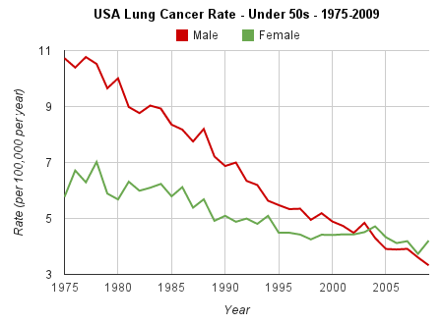

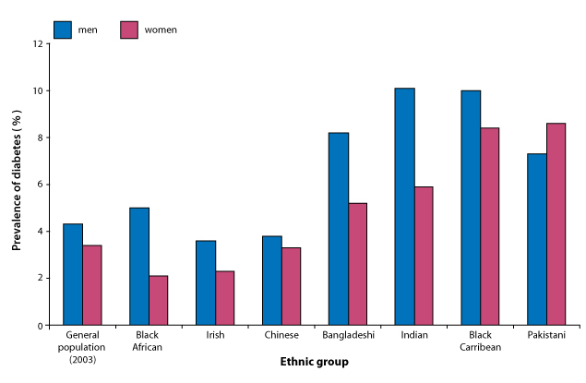

Guided Exam Question
9. Influenza is a disease caused by a virus.
(a) Explain why it is difficult to treat diseases caused by viruses.
___________________________________________________________________
___________________________________________________________________
___________________________________________________________________
___________________________________________________________________
(2)
(b) In some years there are influenza epidemics.
The graph shows the death rate in Liverpool during three influenza epidemics.
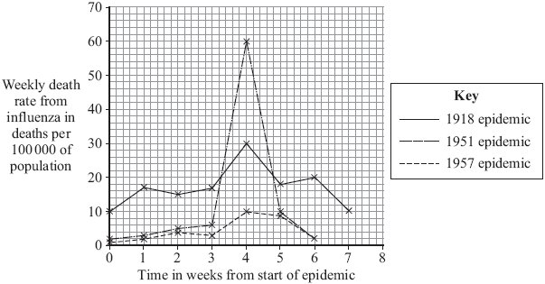

(i) The population of Liverpool in 1951 was approximately 700 000.
Calculate the approximate number of deaths from influenza in week 4 of the 1951 epidemic.
Show clearly how you work out your answer.
______________________________________________________________
______________________________________________________________
Number of deaths _______________
(2)
(ii) In most years, the number of deaths from influenza in Liverpool is very low.
Explain, in terms of the influenza virus and the body’s immune system, why there were large numbers of deaths in years such as 1918 and 1951.
______________________________________________________________
______________________________________________________________
______________________________________________________________
______________________________________________________________
______________________________________________________________
______________________________________________________________
(3)
(Total 7 marks)
Independent Questions:
Q10. Some infections are caused by bacteria.
(a) The genetic material is arranged differently in the cells of bacteria compared with animal and plant cells.
Describe two differences.
___________________________________________________________________
___________________________________________________________________
___________________________________________________________________
___________________________________________________________________
(2)
(b) Tuberculosis (TB) is an infection caused by bacteria.
The table below shows the number of cases of TB in different regions of southern England from 2000–2011.
Number of cases of TB per 100 000 people

Year | London | South East | South West
2000 | 37 | 5 | 3
2001 | 36 | 6 | 4
2002 | 42 | 6 | 6
2003 | 42 | 7 | 4
2004 | 42 | 7 | 5
2005 | 49 | 8 | 5
2006 | 44 | 8 | 3
2007 | 43 | 8 | 5
2008 | 44 | 8 | 5
2009 | 44 | 9 | 6
2010 | 42 | 9 | 5
2011 | 45 | 10 | 5
(i) How does the number of cases of TB for London compare with the rest of southern England?
______________________________________________________________
______________________________________________________________
______________________________________________________________
(1)
(ii) Describe the pattern in the data for cases of TB in the South East.
______________________________________________________________
______________________________________________________________
(1)
(iii) Describe the pattern in the data for cases of TB in the South West.
______________________________________________________________
______________________________________________________________
______________________________________________________________
______________________________________________________________
(2)
(c) (i) On the graph paper below:
• plot the number of cases of TB in London
• label both the axes on the graph
• draw a line of best fit.
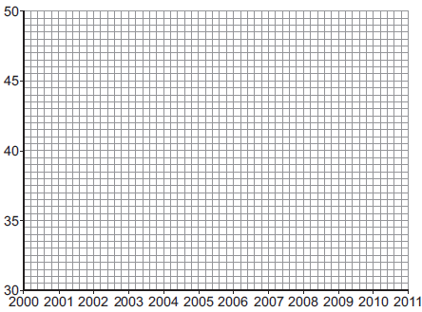
(4)

(ii) Suggest why a student thought the value for 2005 in London was anomalous.
______________________________________________________________
______________________________________________________________
(1)
(d) People can be vaccinated against TB.
Suggest how a vaccination programme would reduce the number of people with TB.
Details of how a vaccine works are not required.
___________________________________________________________________
___________________________________________________________________
___________________________________________________________________
___________________________________________________________________
(2)
(Total 13 marks)

Lesson 5

 | Topic: | Breathing and respiration (B.14)
1 | What is the name of respiration with oxygen? | Aerobic
2 | What is the name of respiration that occurs without oxygen? | Anaerobic
3 | What is the word equation for aerobic respiration | Oxygen + glucose -> carbon dioxide + water
4 | What is the balanced symbol equation for aerobic respiration | C6H12O6 + 6O2 -> 6CO2 + 6H2O
5 | What is the word equation for anaerobic respiration in animals | Glucose -> Lactic acid
6 | What is the balanced symbol equation for anaerobic respiration in animals | C6H12O6 -> 2C3H6O3
7 | What is the word equation for anaerobic respiration in yeast and plant cells | Glucose -> Ethanol + carbon dioxide
8 | What is anaerobic respiration in yeast cells called? | Fermentation
9 | What happens to your breathing and heart rate when you exercise? | Increase
10 | What is the name of the main organ in the respiratory system? | Lungs
11 | What is the name of the sheet of muscle beneath the lungs? | Diaphragm
12 | What is the scientific name for the windpipe? | Trachea
13 | What is the scientific name for the air sac? | Alveoli
14 | The windpipe divides into two tubes when it reaches the lungs. What are these tubes called? | Bronchi/bronchus
15 | State three uses of energy in organisms | 1) Chemical reactions to build larger molecules, 2) movement, 3) keeping warm
 | Topic: | The Heart (B.15)
1 | Which type of vessel leaves the heart? | Arteries
2 | Which type of vessel enters the heart? | Veins
3 | What is the name of the 4 chambers of the heart? | Top: Left/right Atrium  Bottom: Left/right ventricle
4 | Where is the body's natural pacemaker (cells that control the bodies resting heart rate)? | Right atrium
5 | What is the name of the blood vessel that enters the heart from the body? | Vena Cava
6 | What is the name of the blood vessel that enters the heart from the lungs? | Pulmonary vein
7 | What is the name of the blood vessel that goes to the lungs from the heart? | Pulmonary artery
8 | What is the name of the blood vessel that goes from the heart to the rest of your body? | Aorta
9 | Which side of the heart is thicker? | Left
10 | Which side of the heart pumps oxygenated blood out of it and which side pumps deoxygenated? | Oxygenated = Left  Deoxygenated = Right
11 | What is the name for removing a heart from one person and placing it into another person? | Transplant
12 | What is the name of the drug that reduces that amount of cholesterol in a persons body? | Statins
13 | Which organ does a statin effect? | Liver
14 | State 3 adaptations of a red blood cell | *no nucleus, *biconcave shape, *small
15 | State 2 adaptations of a white blood cell | Cytoplasm contains enzymes, flexible cell membrane
 | Topic: | The Blood (B.16)
1 | Which type of blood vessel has thin walls but a large lumen? | Vein
2 | Which type of blood vessel has thick walls but a small lumen? | Artery
3 | Which type of blood vessel has valves? | Veins
4 | Which type of blood vessel has a pulse? | Artery
5 | Give one non-surgical intervention that can reduce the changes of heart disease/a heart attack | Exercise/diet
6 | What is the name of the specialised cell that is designed to carry oxygen? | Red Blood Cell
7 | What is the name of the specialised cell that is designed to fight pathogens? | White Blood Cell
8 | What is the name of the specialised cell that helps to clot our blood? | Platelets
9 | What is the name of the liquid part of blood that carries dissolved substances? | Plasma
10 | Give one substance that is carried in the plasma of blood | Carbon dioxide/urea/glucose
11 | What is the name of the substance that can block arteries? | Cholesterol
12 | What is the name of a disease that occurs when the blood vessels in the muscle of the heart get blocked? | Coronary Heart Disease
13 | What are the blood vessels that provide the heart with oxygen called? | Coronary arteries
14 | What is the name of the piece of wire mesh put inside a blood vessel to keep it open? | Stent
15 | State the equation to calculate blood flow rate calculations | Cardiac output = heart rate x stroke volume  (cm3/min) (beats/min) (cm3)

Notes

Biology Revision: Breathing and Respiration
Key Knowledge
Aerobic Respiration –

Word equation:

Symbol equation:

Happens in:

Anaerobic Respiration –

Word equation:

Symbol equation:

Happens when:

Fermentation -

Word equation:

Symbol equation:

Happens in:

Uses of fermentation:

Oxygen debt –

Gas exchange -

Mastery Matrix Points
Describe the purpose of cellular respiration, recalling the word & symbol equation for aerobic respiration
Explain how the body responds to exercise in terms of heart rate, breathing rate and breath volume
Explain when anaerobic respiration occurs in humans and recall the word equation for this process
Explain what is meant by the term ‘oxygen debt’
Explain how lactic acid is converted back into glucose following a period of vigorous activity (triple only)
Explain anaerobic respiration in yeast, recalling the word equation for this process
Describe how this process of anaerobic respiration (fermentation) is used by humans in the manufacturing industry
Label the structure and describe the function of the human lungs (including how they are adapted for gaseous exchange)

Understanding and Explaining
- Describe how these factors change during vigorous exercise:
- breathing rate
- heart rate
- breath volume.

- Explain why these factors change during vigorous exercise:
- breathing rate
- heart rate
- breath volume.
- Explain why anaerobic respiration takes place during vigorous exercise.

- Explain what happens to the lactic acid produced during vigorous exercise.

- Compare anaerobic respiration in humans to anaerobic respiration in yeast.

- Describe the process of gas exchange.

- Describe and explain how the lungs. 8. Label the lungs:
are adapted for gas exchange

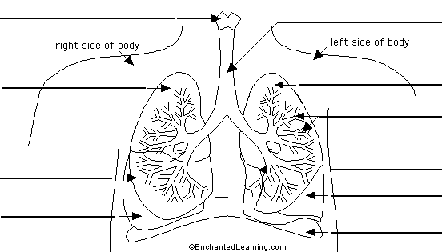

Biology Revision: Blood and the Heart
Mastery Matrix Points
Describe the structure and function of the human heart
Describe the roles of the four blood vessels associated with the heart
Describe the 3 different types of blood vessel in the body and their structure
Carry out rate calculations for blood flow
Describe how our body controls our natural resting heart rate
Describe the composition of blood and know the functions of each of the components
Draw blood cells from under a microscope and recognise different types of blood cells from a photo or diagram, explaining how they are adapted to their functions
Describe coronary heart disease
Describe what a ‘stent’, ‘statin’, ‘mechanical/biological valve replacement’, ‘pacemaker’ and ‘transplant’ are
Evaluate the advantages and disadvantages of treating cardiovascular diseases using drugs, mechanical devices or transplants
Evaluate risks associated with the use of blood products

Key Knowledge

What are the roles of these parts of the heart?
Vena cava –
Pulmonary artery –
Pulmonary vein –
Aorta –

Which part of the heart contains the cells that are the body’s natural pacemaker?

Blood vessel | Job | adaptations
Artery

Vein

Capillary

Rate of blood flow =

Four parts of the blood and their function:

Definition of coronary heart disease:

What are:
- Stents?
- Statins?
- Pacemaker?
- Transplant?

What are:
A:
B:
C:
D:
E:
F:
G:
H:
I:
E
F
G
H
I
A
B
C
D

Understanding and Explaining
- Explain how the heart works including the route the blood travels through and where the blood flows.

- Which side of the heart is more muscular? Explain why.

- Calculate the cardiac output of the heart if the 4. Label the components of blood on this microscope photo.
stroke volume is 50cm³ and the heart rate is 67bpm?
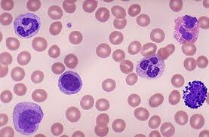
- Evaluate the risks of having a blood transfusion.

- Explain what coronary heart disease is. Explain the causes and effects too.

- Evaluate the four ways to treat heart conditions. Give a pro and con for each.

Guided Exam Question
Q12.All living cells respire.
(a) Respiration transfers energy from glucose for muscle contraction.
Describe how glucose from the small intestine is moved to a muscle cell.
___________________________________________________________________
___________________________________________________________________
___________________________________________________________________
___________________________________________________________________
(2)
(b) The diagram below shows an experiment to investigate anaerobic respiration in yeast cells.
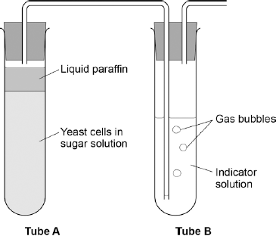
What is the purpose of the liquid paraffin in Tube A?

Tick one box.
To prevent evaporation
To stop air getting in
To stop the temperature going up
To stop water getting in
(1)
(c) The indicator solution in Tube B shows changes in the concentration of carbon dioxide (CO₂).
The indicator is:
• blue when the concentration of CO₂ is very low
• green when the concentration of CO₂ is low
• yellow when the concentration of CO₂ is high.
What colour would you expect the indicator to be in Tube B during maximum rate of anaerobic respiration?

Tick one box.
Blue
Green
Yellow
(1)
(d) Suggest how the experiment could be changed to give a reproducible way to measure the rate of the reaction.
Include any apparatus you would use.
___________________________________________________________________
___________________________________________________________________
___________________________________________________________________
___________________________________________________________________
(2)
(e) Compare anaerobic respiration in a yeast cell with anaerobic respiration in a muscle cell.
___________________________________________________________________
___________________________________________________________________
___________________________________________________________________
___________________________________________________________________
___________________________________________________________________
___________________________________________________________________
___________________________________________________________________
___________________________________________________________________
(3)
(Total 9 marks)
Independent Exam Questions:
Q13. The circulatory system contains arteries and veins.
(a) (i) Describe how the structure of an artery is different from the structure of a vein.
______________________________________________________________
______________________________________________________________
______________________________________________________________
______________________________________________________________
(2)
(ii) A comparison is made between blood taken from an artery in the leg and blood taken from a vein in the leg.
Give two differences in the composition of the blood.
1. ____________________________________________________________
______________________________________________________________
2. ____________________________________________________________
______________________________________________________________
(2)

(b) During operations patients can lose a lot of blood. Patients often need blood transfusions to keep them alive.
The text shows information about a new artificial blood product.
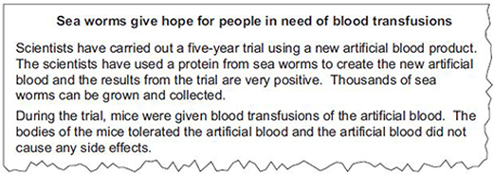
Suggest two possible advantages of using the new artificial blood, instead of using human blood for a transfusion in humans.
1. _________________________________________________________________
___________________________________________________________________
2. _________________________________________________________________
___________________________________________________________________
(2)
(Total 6 marks)

Lesson 6
 | Topic: | Digestion (B.17)
1 | Which enzyme breaks down lipids, carbohydrates and proteins? | Lipids = lipase  carbohydrates = amylase  Proteins = protease
2 | Which enzyme is produced by the salivary glands? | Amylase
3 | What is the name of the leaf shaped organ that produces enzymes? | Pancreas
4 | What is the name of the organ that produces bile? | Liver
5 | What is the name of the organ that stores bile? | Gall bladder
6 | Is bile acidic or alkaline? | Alkaline
7 | What is added to the stomach to kills pathogens? | Hydrochloric acid
8 | What is the name of the process that breaks down large globules of fat into smaller ones? | Emulsification
9 | Write the word equation for the digestion of carbohydrates | Starch -> glucose
10 | Write the word equation for the digestion of proteins | Proteins -> amino acids
11 | Write the word equation for the digestion of fats | lipids -> fatty acids + glycerol
12 | Which part of the digestive system are nutrients and water absorbed into the blood from? | Nutrients = small intestine  Water = large intestine
13 | What is the scientific name for the food pipe? | Oesophagus
14 | What is the name of the process where food is pushed down the food pipe? | Peristalsis
15 | Name the food group that cannot be digested in the body | Fibre
 | Topic: | Transport in cells (diffusion, active transport and osmosis) (B.19)
1 | Substances moving from a high concentration to a low concentration is called… | Diffusion
2 | Two examples of diffusion in humans are: | CO2 + O2 in gas exchange, urea from cells to blood
3 | Three factors that affect the rate of diffusion are: | Concentration gradient, temperature, surface area of the membrane
4 | How are single celled organisms adapted for diffusion? | Large surface area : volume ratio
5 | How is the small intestine adapted for exchanging materials? | *Villi for large S.A. *villi one cell thick *good blood supply
6 | How is the lungs adapted for exchanging materials? | *Alveoli large surface area: volume ratio, surface is moist, good blood supply
7 | How is the gills adapted for exchanging materials? | *large S.A. *moist *good blood flow to maintain concentration gradient
8 | How is the roots adapted for exchanging materials? | *Large SA to volume ratio *lots of mitochondria for respiration -> energy for active transport
9 | How is the leaves adapted for exchanging materials? | *Stomata *thin so that distance for diffusion is smaller
10 | Four ways that to increase the rate of transport | *Large surface area, thin membrane, efficient blood supply (in animals), well ventilated (in animals)
11 | Water moves from a dilute to concentrated solution across a partially permeable membrane via... | Osmosis
12 | Pure water will move into a potato because of | Osmosis
13 | (RP) How can you tell the concentration of sugar in a piece of potato? | 1) Place into different concentrations of sugar solution. 2) Plot graph 3)Find concentration where change in mass is 0
14 | When a substance moves against the concentration gradient, it is called.. | Active transport
15 | Active transport requires ________ from _________. | energy respiration

Notes

Biology Revision: Digestion
Mastery Matrix Points
Describe what the digestive system is
Explain the role of enzymes in the digestive system making reference to ‘lock and key’
Explain how carbohydrates, proteins and lipids are synthesised, broken down and used, making reference to sugars, amino acids, fatty acids and glycerol
Link carbohydrase (amylase), protease, lipase & bile to the breakdown of particular food groups, identifying where they are produced
Required practical: Use qualitative reagents to test for a range of carbohydrates, proteins and lipids
Describe the effects of temperature and pH on the rate of enzyme reactions and investigate the effect of pH on the rate of reaction of amylase
Required practical: Investigate the effect of pH on the rate of reaction of amylase enzyme
Define ‘metabolism’
Calculate the rate of given chemical reactions
Explain the 5 processes that contribute to our metabolism (starch formation, lipid formation, protein synthesis, respiration and protein breakdown)

Understanding and Explaining
- Explain how carbohydrates are broken down in the body.

- Explain how proteins are broken down in the body.

- Explain how lipids are broken down in the body.

- Describe the role of bile in the body. Include where it is produced, stored and where it works.

- Sketch a graph to show how enzyme activity changes with pH. Label the optimum pH on your graph. Sketch another to show how enzyme activity changes with temperature. Label the optimum temperature on your graph.

- Describe how to prepare foods for the food tests.

- Which of the food test needs to be heated to work?

- Describe a method for investigating the effect of pH on an enzyme such as amylase.
Key Knowledge
Metabolism -

Digestion –

Enzymes –

Lock and key model (include a diagram) –

Enzyme | Breaks down… | To produce…

Enzyme | Produced in | Works in

Food Tests:
Chemical | Used to test for: | Positive result is:

Rate of reaction =

Five processes that contribute to our metabolism
-
-
-
-
-

Biology Revision: Diffusion
Key Knowledge

Diffusion –

Two examples of diffusion
-
-

Factor | How this affects the rate of diffusion
Temperature
Concentration gradient (difference)
Surface area of membrane

Method for calculating surface area to volume ratio (SA:V) –

Mastery Matrix Points
Define ‘diffusion’ and give examples of diffusion in plants and animals (gas exchange and urea in the kidney)
Explain how different factors affect the rate of diffusion1. (concentration, surface area, temperature)
Calculate surface area: volume ratios
Explain how surface area: volume ratio of a single celled organism (amoeba) allows sufficient molecule transport
Explain adaptations for exchange materials in: small intestines, lungs, gills, roots and leaves

Understanding and Explaining
- Describe the diffusion of urea in the kidneys.

- Describe the process of gas exchange.

- Ameoba is a single celled organism. Explain why amoeba does not need a respiratory system or circulatory system.

- The surface area to volume ratio of cell A is 5:1. Cell B has a surface area to volume ratio of 0.75:1. In which cell will diffusion happen faster? Explain your answer.

- Explain the adaptations of these structures that help molecules diffuse efficiently across them.
  - Gills

  - Lungs

  - Roots

  - Leaves

  - Small intestine

Guided Exam Question
Q14.The diagrams show the same cell of a common pond plant.
Diagram A shows the cell in a hypotonic solution.
Diagram B shows the same cell in a hypertonic solution.
Diagram A Diagram B
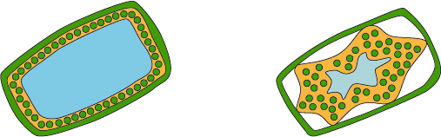
(a) What is a hypertonic solution?
___________________________________________________________________
___________________________________________________________________
___________________________________________________________________
___________________________________________________________________
(2)
(b) What word is used to describe plant cells placed in:
(i) a hypotonic solution
______________________________________________________________
(1)
(ii) a hypertonic solution?
______________________________________________________________
(1)
(c) Explain what has happened to the plant cell in diagram B.
___________________________________________________________________
___________________________________________________________________
___________________________________________________________________
___________________________________________________________________
___________________________________________________________________
___________________________________________________________________
___________________________________________________________________
___________________________________________________________________
(4)
(d) Animal cells will also change when placed in different solutions.
Some red blood cells are put in a hypotonic solution.
Describe what would happen to these red blood cells and explain why this is different from what happened to the plant cell in diagram A.
___________________________________________________________________
___________________________________________________________________
___________________________________________________________________
___________________________________________________________________
___________________________________________________________________
___________________________________________________________________
___________________________________________________________________
___________________________________________________________________
___________________________________________________________________
___________________________________________________________________
(4)
(Total 12 marks)
Independent Questions:
Q15. (a) A food contains protein. Describe, in as much detail as you can, what happens to this protein after the food is swallowed.
___________________________________________________________________
___________________________________________________________________
___________________________________________________________________
___________________________________________________________________
___________________________________________________________________
___________________________________________________________________
___________________________________________________________________
___________________________________________________________________
(4)

(b) The table shows the activity of lipase on fat in three different conditions.

CONDITION | UNITS OF LIPASE ACTIVITY PER MINUTE
Lipase + acid solution | 3.3
Lipase + weak alkaline solution | 15.3
Lipase + bile | 14.5
Explain, as fully as you can, the results shown in the table.
___________________________________________________________________
___________________________________________________________________
___________________________________________________________________
___________________________________________________________________
___________________________________________________________________
___________________________________________________________________
(3)
(Total 7 marks)

Lesson 7

 | Topic: | Structure of a plant (B.21)
1 | What is the name of the plant tissue where new cells are made? | Meristem
2 | What is the name of the specialised plant cell adapted to absorb water & nutrients from the soil? | Root Hair Cell
3 | What is the name of the specialised plant cell adapted to open and close the stomata of a plant? | Guard Cell
4 | Which word describes a guard cell (a) filled with water? (b) that has very little water | (a) filled = Turgid  (b) lacking water = flaccid
5 | What is the name of the specialised cell that is adapted to absorb lots of light energy in the leaf? | Palisade cell
6 | What is the chemical in chloroplasts that allow plant cells to absorb lots of light energy? | Chlorophyll
7 | Which type of plant tissue is made up of sieve cells and companion cells? | Phloem
8 | What is the name for the hole in a leaf that allows gases in and water out? | Stoma/Stomata
9 | What is the name of the plant tissue that is made up of a hollow tube of dead cells? | Xylem
10 | Which tissue in a plant transports water? | Xylem
11 | Which tissue in a plant transports glucose? | Phloem
12 | In which plant organ is glucose made? | Leaf
13 | What is the name for the process that converts water and carbon dioxide into glucose and oxygen? | Photosynthesis
14 | Which organ of a plant is designed to absorb water? | Root
15 | Which organ of a plant is designed to transport substances from the roots to the leaves and vice versa? | Stem
 | Topic: | Transport in plants (B.23)
1 | Define the term "osmosis" | Movement of water from a dilute solution to a concentrated solution through a semi permeable membrane
2 | How do you calculate rate of water uptake by a plant? | volume of water absorbed ÷ time taken
3 | How do you calculate percentage change in mass following osmosis? | Change in mass/initial mass x 100
4 | When looking at an osmosis graph (change in mass of unknown substance vs concentration of known sucrose solution) - how can you identify the concentration of the unknown substance? | When the line of best fix crosses the X axis
5 | Which piece of equipment is used to cut a cylindrical piece of potato? | A cork borer
6 | What is the name given to a semi permeable piece of tubing? | Visking tube
7 | Which substance moves into a plant by osmosis? | Water
8 | How are root hair cells adapted for osmosis? | Large surface area and large vacuole
9 | Define 'active transport' | Movement of substances from a dilute to a concentrated solution against the concentration gradient. Requires energy
10 | Name a substance that is moved into plants by active transport | Mineral ions
11 | How are root hair cells adapted for active transport? | Lots of mitochondria for respiration
12 | Define "diffusion" | Movement of particles from an area of high concentration to an area of low concentration
13 | Name one substance that moves into a leaf by diffusion | Carbon dioxide
14 | Name two substance that moves out of a leaf by diffusion | Oxygen and water
15 | Which cells open and close to control the diffusion of substances from a leaf? | Guard cells
 | Topic: | Transpiration and translocation (B.24)
1 | Name the process by which glucose is moved from a leaf to other parts of the cell | Translocation
2 | What is the scientific name given to the evaporation of water from a leaf? | Transpiration
3 | On which side of the leaf are there more stomata? | Underside/lower
4 | What is covering the top layer of the leaf to reduce the loss of water? | Waxy Cuticle
5 | Which organ in a plant does water enter through? | Root
6 | Do guard cells become flaccid or turgid when it is very sunny? | Turgid
7 | Do stomata open or close when it is night time? | Close
8 | Describe the structure of xylem | Hollow tubes strengthened with lignin
9 | Describe the structure of phloem | Elongated cells with a sieve plate and companion cell
10 | How do you calculate surface area of a cuboid? | Sum of all the 2D faces
11 | State four factors that increases the rate of transpiration | 1) High wind intensity  2) high light intensity  3) arid (dry)  4) high temperature
12 | Why does high wind intensity increase transpiration? | Increases concentration gradient
13 | Why does high light intensity increase transpiration? | Causes stomata to open
14 | Why does arid conditions increase the rate of transpiration? | Increases concentration gradient
15 | Why does high temperature increase the rate of transpiration? | Water particles have more kinetic energy
 | Topic: | Photosynthesis (B.25)
1 | Name the two reactants in photosynthesis | Carbon Dioxide and water
2 | Name the two products formed in photosynthesis | Oxygen and glucose
3 | Write the word equation for photosynthesis | Carbon dioxide + water -> oxygen and glucose
4 | Write the symbol equation for photosynthesis | CO2 + H2O -> O2 + C6H12O6
5 | Describe what happens to the rate of photosynthesis as temperature increases | Rate increases and then decreases
6 | Describe what happens to the rate of photosynthesis as light intensity increases | Rate increases and then remains constant
7 | Describe what happens to the rate of photosynthesis as carbon dioxide increases | Rate increases and then remains constant
8 | State one limiting factor for photosynthesis | Light, Chlorophyll, carbon dioxide
9 | Name the plant used to investigate the effect of different factors on rate of photosynthesis | Elodea (pondweed)
10 | How can you calculate the rate of photosynthesis of an aquatic plant? | Count the number of O2 bubbles produced in a minute
11 | How can you more accurately calculate the rate of photosynthesis of an aquatic plant? | Record volume of gas produced (using a gas syringe)
12 | Which cells are adapted for increased photosynthesis? | Palisade cells
13 | How are palisade cells adapted for increased rates of photosynthesis? | Lots of chloroplasts (and chlorophyll)
14 | State three limiting factors for photosynthesis | 1) Carbon dioxide concentration, 2) Temperature, 3) Light intensity
15 | In a variegated leaf, why do some parts appear white? | There is no chlorophyll
 | Topic: | The products of photosynthesis (B.26)
1 | State 5 uses of glucose produced during photosynthesis | 1) respiration, 2) stored as insoluble starch, 3) stored as fats/oils 4) making cellulose, 5) making amino acids
2 | State two substances required for making proteins in plants | Nitrate ions and glucose
3 | Which substance is used to test for the presence of starch? | Iodine solution
4 | What colour will iodine solution turn in the presence of starch? | Blue/black
5 | What colour will iodine solution turn if no starch is present? | Remains orange
6 | Which substance is used to test for the presence of sugar? | Benedict's solution
7 | What colour will benedict's solution turn in the presence of sugar? | Red (lots of sugar), orange (some sugar), green (small amount of sugar)
8 | What colour will benedict's solution turn if no glucose is present? | Remains blue
9 | Which substance is used to test for the presence of protein? | Biuret's solution
10 | What colour will biuret solution turn in the presence of protein? | Purple
11 | What colour will biuret solution turn if no protein is present? | Remains blue
12 | Which substance is used to test for the presence of lipids (fats)? | Ethanol
13 | What colour will ethanol solution turn in the presence of fats? | Creamy white
14 | What colour will ethanol solution turn if no fat is present? | Remains colourless
15 | Describe the relationship between a light's distance from a plant and rate of photosynthesis (HT only) | power ÷ distance squared (inverse square law)

Notes

Biology Revision: Plant Structures
Mastery Matrix Points
Draw and label an unspecialised plant cell and a palisade, root hair, xylem and phloem specialised cell | Describe the process of active transport and explain why it is necessary
Describe the 5 tissues and name the key organs in the plant | Compare diffusion, osmosis and active transport
Label a transverse section of a leaf | Describe the process of active transport and how root hair cells are adapted to this
Describe the process of osmosis | Describe the process of transpiration and translocation (including the structure and function of stomata).
Calculate the rate of water uptake by a plant | Explain the effect of changing temperature, humidity, air movement and light intensity on the rate of transpiration
Calculate the percentage change in mass following osmosis | Calculate surface area, volume and mean in transpiration investigation
Analyse and draw graphs relating to osmosis | Analyse data from graphs and tables relating to transpiration experiments
Required practical: Analyse the range of concentrations of solutions on the change in mass of plant tissue | Describe in detail the location, function and adaptations of xylem tissue, phloem tissue, stomata and guard cells

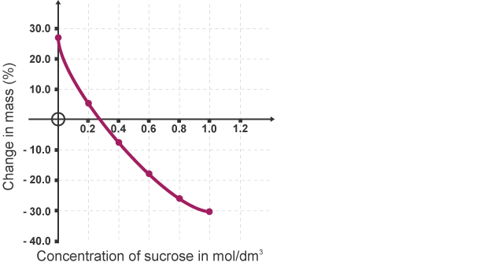
Understanding and Explaining
- A student completes an osmosis experiment using potato cylinders. Describe how you could work out the concentration of the sucrose in the potato using their results graph.

- Describe how active transport works.

- In root hairs cells, water and nutrients move into the plant. How do the nutrients move into the cell? By what process does the water move into the cell?

- Compare the processes of osmosis and active transport.

- Describe and explain three factors that affect transpiration.

- Describe two examples of active transport.
A:
B:
C:
D:
E:
F:
G:
H:
I:

Key Knowledge
Function of these plant tissues:
epidermal tissue:
palisade mesophyll:
spongy mesophyll:
xylem:
phloem:
meristem tissue:
Label the leaf tissues:
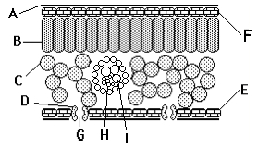

How are these adapted
for their job?
Root hair cells:
Xylem:
Phloem:
Guard cells:

Definitions:
Osmosis:
Active transport:
Transpiration:
Translocation:
Calculations
rate of water uptake =

% change in mass =

Biology Revision: Photosynthesis
Mastery Matrix Points
Describe the process of photosynthesis
Recall the word and symbol equation for photosynthesis
Explain the effects of temperature, light intensity, carbon dioxide intensity and the amount of chlorophyll on the rate of photosynthesis
Analyse data and calculate rates of photosynthesis and limiting factors from graphs and tables
Required Practical: Investigate the effect of light intensity on the rate of photosynthesis on an aquatic plant
Describe how glucose is used after photosynthesis
Explain the use of nitrate ions within plants

Understanding and Explaining
- Describe the limiting factors at points A, B and C on the graph.
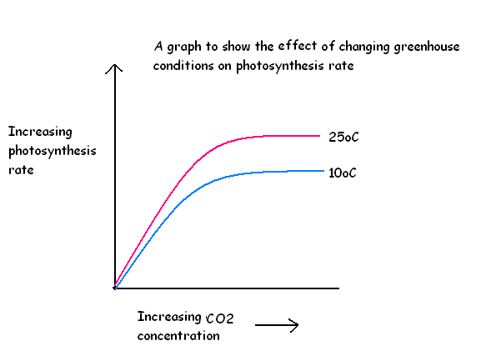
- Explain the importance of nitrate ions in healthy growth of a plant.

- Describe the process of photosynthesis in detail.

- Explain how farmers must balance increasing limiting factors with costs to ensure maximum profit.
A:

B:

C:
A
B
C
Key Knowledge

Photosynthesis
Definition

Word equation:

Symbol equation:

Four limiting factors of photosynthesis:
-
-
-
-

Equation:
Rate of reaction =

Uses of glucose after photosynthesis
-
-
-
-
-

Guided Exam Question
Q16.
(a) Complete the equation for photosynthesis.
______________ + water 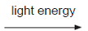 ______________ + ______________
(3)
(b) The rate of photosynthesis in a plant depends on several factors in the environment.
These factors include light intensity and the availability of water.
Describe and explain the effects of two other factors that affect the rate of photosynthesis.
You may include one or more sketch graphs in your answer.

___________________________________________________________________
___________________________________________________________________
___________________________________________________________________
___________________________________________________________________
___________________________________________________________________
___________________________________________________________________
___________________________________________________________________
___________________________________________________________________
___________________________________________________________________
___________________________________________________________________
___________________________________________________________________
___________________________________________________________________
(5)
(Total 8 marks)

Q17.
Green plants can make glucose.
(a) Plants need energy to make glucose.
How do plants get this energy?
___________________________________________________________________
___________________________________________________________________
___________________________________________________________________
___________________________________________________________________
(2)
(b) Plants can use the glucose they have made to supply them with energy.
Give four other ways in which plants use the glucose they have made.
___________________________________________________________________
___________________________________________________________________
___________________________________________________________________
___________________________________________________________________
___________________________________________________________________
___________________________________________________________________
___________________________________________________________________
___________________________________________________________________
(4)
(Total 6 marks)

Biology Revision: Blood and the Heart
Mastery Matrix Points
Describe the structure and function of the human heart
Describe the roles of the four blood vessels associated with the heart
Describe the 3 different types of blood vessel in the body and their structure
Carry out rate calculations for blood flow
Describe how our body controls our natural resting heart rate
Describe the composition of blood and know the functions of each of the components
Draw blood cells from under a microscope and recognise different types of blood cells from a photo or diagram, explaining how they are adapted to their functions
Describe coronary heart disease
Describe what a ‘stent’, ‘statin’, ‘mechanical/biological valve replacement’, ‘pacemaker’ and ‘transplant’ are
Evaluate the advantages and disadvantages of treating cardiovascular diseases using drugs, mechanical devices or transplants
Evaluate risks associated with the use of blood products

Key Knowledge
A = pulmonary artery
B – vena cava
C = right atrium
D = right ventricle
E = aorta
F = pulmonary vein
G = left atrium
H = valves
I = left ventricle

What are the roles of these parts of the heart?
Vena cava – carry deoxygenated blood from the cells to the heart
Pulmonary artery – carry deoxygenated blood from the heart to the lungs
Pulmonary vein – carry oxygenated blood from the lungs to the heart
Aorta – carry oxygenated blood under high pressure from the heart to the cells

Which part of the heart contains the cells that are the body’s natural pacemaker? A group of cells located in the right atrium

Blood vessel | Job | adaptations
Artery | Carry blood away from the heart | Thick elastic wall to maintain high pressure.  Smaller lumen to maintain high pressure.
Vein | Carry towards the heart | Thinner walls  Large lumen  Valves to prevent the backflow of blood
Capillary | Surround cells to to allow substances to pass between blood and cells | Narrow to give a larger surface area for diffusion  Thin walls to give a shorter pathway for diffusion

Rate of blood flow =

Four parts of the blood and their function:
- red blood cells = contain haemoglobin to bond to oxygen (making oxyhaemoglobin) so it can be carried to cells for respiration
- white blood cells = destroy pathogens through phagocytosis and production of antibodies
- platelets = fragments of cells which cause the blood to clot
- plasma = the liquid into which substances dissolve and are carried around the body
Definition of coronary heart disease: Layers of fatty deposits build up in the coronary arteries and make them narrow, reducing blood flow to the heart

What are:
- Stents = a wire mesh is inserted into the blocked coronary artery and opened up to remove the blockage and increase blood flow
- Statins = drugs which reduce the cholesterol levels in the blood
- Pacemaker = a machine which sits next to the heart and maintains a regular heart rate
- Transplant = a faulty heart is removed and replaced with a heart from a human or animal donor

Understanding and Explaining
- Explain how the heart works including the route the blood travels through and where the blood flows.
Deoxygenated blood enters the heart through the vena cava passes through right atrium passes through valve into right ventricle passes through valve into pulmonary artery taken to the lungs where it picks up oxygen oxygenated blood back to the heart via the pulmonary vein into the left atrium through the valve into the left ventricle through the valve into the aorta pumped under high pressure to rest of the body

- Which side of the heart is more muscular? Explain why.
The left because it has to pump blood under higher pressure further (around the body and not just to the lungs) so needs more muscle tissue to pump more powerfully.

- Calculate the cardiac output of the heart if the stroke volume is 50cm³ and the heart rate is 67bpm?
cardiac output = heart rate x stroke volume
= 67 x 50
= 3,350 cm3/min
- Label the components of blood on this microscope photo.
A = White blood cells B = red blood cells C = platelets D = plasma
- Evaluate the risks of having a blood transfusion.
Negatives Positive
Allergic reaction Replaces blood loss
Fever
Autoimmune response
Fluid overload
Infection

- Explain what coronary heart disease is. Explain the causes and effects too.
Layers of fatty deposits build up in the coronary arteries and make them narrow, reducing blood flow to the heart. The cardiac muscle cells do not get enough oxygen and die, leading to a heart attack.
Risk factors: smoking, lack of exercise, high intake of saturated fat
- Evaluate the four ways to treat heart conditions. Give a pro and con for each.
1. Stents = less invasive operation, only use a local anaesthetic, shorter recovery time, fatty tissue could build up again if diet isn’t changed
2. Statin = reduce the build-up of fatty deposits, no need for an operation, person has to remember to take tablets for rest of life
3. Artificial hearts = keeps person healthy while waiting for a donor heart, only a temporary solution
4 Donor heart = healthy heart so person should have no health problems in the future, body may reject the donor heart

Key Knowledge
Aerobic Respiration –
Respiration with oxygen
Word equation:
glucose + oxygen -> carbon dioxide +water
Symbol equation: C₆H₁₂O₆ + 6O₂ 6CO₂ + 6H₂O

Happens in: Mitochondria

Anaerobic Respiration –
Respiration without Oxygen

Word equation: Glucose Lactic Acid

Symbol equation: C₆H₁₂O₆ 2C₃H₆O₃

Happens when: Insufficient Oxygen

Fermentation - anaerobic respiration in yeast cells
Word equation:
glucose -> ethanol + carbon dioxide
Symbol equation:
C₆H₁₂O₆ → 2C₂H₅OH + 2CO₂
Happens in:
Yeast
Uses of fermentation: Bread and alcoholic drinks
Oxygen debt – The amount of extra O₂ needed to react with the lactic acid

Gas exchange - the 'swapping’ of gases between the air in the alveoli and the blood

Describe how these factors change during vigorous exercise:
breathing rate increases
heart rate increases
breath volume. increases

Explain why these factors change during vigorous exercise:
breathing rate – body needs more supply of oxygen for respiration
heart rate – more blood needed to supply cells with oxygen for respiration
breath volume. – gets more oxygen into the lungs and more carbon dioxide removed from the body.
Explain why anaerobic respiration takes place during vigorous exercise.
Muscles are not supplied with enough oxygen to facilitate aerobic respiration, so the muscle cells use anaerobic respiration instead.
Explain what happens to the lactic acid produced during vigorous exercise.
After exercise, blood flowing through the muscles transports the lactic acid to the liver.
The extra oxygen brought in by the body after exercise is used to react with the lactic acid and remove it from the cells.

Compare anaerobic respiration in humans to anaerobic respiration in yeast.
Anaerobic respiration in humans breaks down glucose into lactic acid. In yeast, anaerobic respiration breaks glucose down into ethanol and carbon dioxide.
Describe the process of gas exchange.
The heart send blood to the lungs via the pulmonary artery. Air obtained by breathing reaches the lungs through the trachea, through the bronchi, through the bronchioles to the alveoli. At the alveoli, the oxygen from the air diffuses through the thing walls of the alveoli into the bloodstream to be circulated around the body. At the same time, carbon dioxide from the bloodstream diffuses into the lungs to be expelled from the body.

Describe and explain how the lungs are adapted for gas exchange.
The alveoli have a large, moist surface area, maximising the opportunity for gas exchange. They have a very rich blood supply, which maximises the opportunity for gas exchange. They are very close to the blood capillaries, having very thin walls which minimises the distance for gases to diffuse.

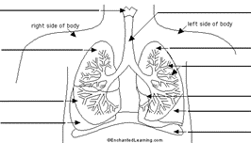
Larynx
Right Lung
Diaphragm
Left Lung
Bronchioles
Alveoli
Pleural Membrane
Trachea
Pleural Membrane

Biology Revision: Diffusion
Key Knowledge

Diffusion – the net movement of particles from an area of high concentration to an area of low concentration (down a concentration gradient)

Two examples of diffusion
- gas exchange in the lungs (oxygen diffuses out of the alveoli into the bloodstream, carbon dioxide diffuses from the blood stream into the alveoli)
- glucose diffuses from the small intestine into the bloodstream
- oxygen and carbon dioxide diffuse in/out of the stomata in a leaf

Factor | How this affects the rate of diffusion
Temperature | Increases because the particles are moving faster with more kinetic energy.
Concentration gradient (difference) | Increases because particles move down their concentration gradient
Surface area of membrane | Increases because there is a greater surface area for diffusion to take place.

Method for calculating surface area to volume ratio (SA:V) –

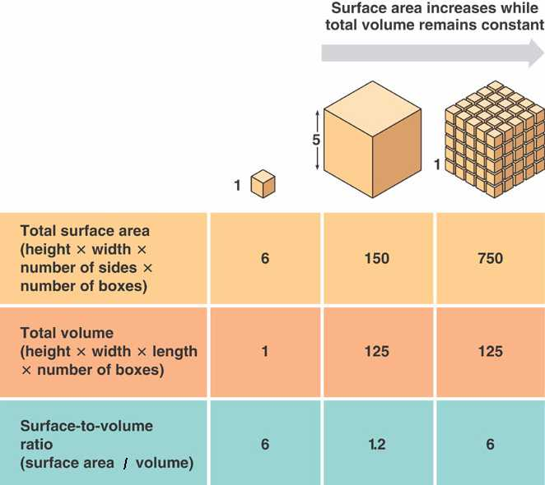

Mastery Matrix Points
Define ‘diffusion’ and give examples of diffusion in plants and animals (gas exchange and urea in the kidney)
Explain how different factors affect the rate of diffusion1. (concentration, surface area, temperature)
Calculate surface area: volume ratios
Explain how surface area: volume ratio of a single celled organism (amoeba) allows sufficient molecule transport
Explain adaptations for exchange materials in: small intestines, lungs, gills, roots and leaves

Understanding and Explaining
- Describe the diffusion of urea in the kidneys. Urea is a waste product from the breakdown of proteins. It diffuses from inside the cells and into the bloodstream. When it reaches the kidneys, the urea is filtered out into the urine and excreted.

- Describe the process of gas exchange.
- Air breathed into lungs and travels to the alveoli
- High concentration of oxygen in the alveoli, low concentration in the bloodstream (deoxygenated blood)
- Oxygen diffuses down its concentration gradient from the alveoli into the bloodstream where it binds to haemoglobin on red blood cells
- Carbon dioxide is produced during aerobic respiration in cells
- High concentration of carbon dioxide in the bloodstream, low concentration in the alveoli
- Carbon dioxide diffuses down its concentration gradient from the bloodstream to the alveoli

- Ameoba is a single celled organism. Explain why amoeba does not need a respiratory system or circulatory system.
Ameoba have a larger surface area to volume ratio and permeable membranes so substances can diffuse directly across the cell membrane

- The surface area to volume ratio of cell A is 5:1. Cell B has a surface area to volume ratio of 0.75:1. In which cell will diffusion happen faster? Explain your answer.
In the cell with a ratio of 5:1 because it has a higher surface area to volume ratio.

- Explain the adaptations of these structures that help molecules diffuse efficiently across them.
  - Gills = large surface area, constant supply of oxygen as water moves past the gills, thin membrane for diffusion, rich blood supply to the gills to keep removing the gases and keep the concentration gradient high

  - Lungs = moist membrane, large surface area, lots of capillaries to remove the gases and keep the concentration gradient high, thin membrane only one cell thick to give a short diffusion pathway

  - Roots = elongation in the root hair cells gives a large surface area, thin membrane to give a short diffusion pathway, water moved away and up through the xylem to keep the concentration gradient high

  - Leaves = stomata to allow gases in and out, guard cells to open and close the stomata, spongy mesophyll to allow space for gases to diffuse

  - Small intestine = villi are small finger-like projections which provide a large surface area, thin membrane to give a short diffusion pathway, lots of capillaries provide a rich blood supply and keep the concentration gradient high

Biology Revision: Digestion
Mastery Matrix Points
Describe what the digestive system is
Explain the role of enzymes in the digestive system making reference to ‘lock and key’
Explain how carbohydrates, proteins and lipids are synthesised, broken down and used, making reference to sugars, amino acids, fatty acids and glycerol
Link carbohydrase (amylase), protease, lipase & bile to the breakdown of particular food groups, identifying where they are produced
Required practical: Use qualitative reagents to test for a range of carbohydrates, proteins and lipids
Describe the effects of temperature and pH on the rate of enzyme reactions and investigate the effect of pH on the rate of reaction of amylase
Required practical: Investigate the effect of pH on the rate of reaction of amylase enzyme
Define ‘metabolism’
Calculate the rate of given chemical reactions
Explain the 5 processes that contribute to our metabolism (starch formation, lipid formation, protein synthesis, respiration and protein breakdown)

Key Knowledge
Metabolism – the rate at which chemical reactions take place in our cells

Digestion – the breakdown of large insoluble molecules into small soluble molecules so that they can be absorbed into the bloodstream

Enzymes – biological catalysts that speed up the rate of digestion

Lock and key model (include a diagram) –
- Enzymes have an active site with a specific shape complimentary to the substrate (large molecule)
- The substrate binds to the active site
- The large molecule is broken down and the smaller products are released

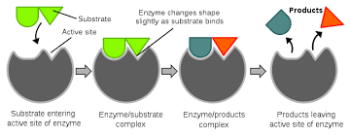

Enzyme | Breaks down… | To produce…
amylase | carbohydrate (starch) | glucose
protease | protein | amino acids
lipase | lipids (fats) | glycerol and fatty acids

Enzyme | Produced in | Works in
amylase | salivary glands  pancreas | mouth  small intestine
protease | stomach  pancreas | stomach  small intestine
lipase | pancreas | small intestine

Food Tests:
Chemical | Used to test for: | Positive result is:
iodine | starch | blue/black
Biuret reagent | protein | purple
Benedict’s reagent | sugars | red
Sudan III | lipids | red layer on top

Rate of reaction = the speed at which a reaction takes place

Five processes that contribute to our metabolism
- ratio of muscle to fat
- gender
- exercise
- genetics
- age

Understanding and Explaining
- Explain how carbohydrates are broken down in the body.
Amylase breaks down carbohydrates into glucose in two places:
1. Produced by the salivary glands in the mouth
2. Produced by the pancreas and works in the small intestine
- Explain how proteins are broken down in the body.
Proteins are broken down by protease into amino acids in two places.
1. Protease produced by the stomach works in the stomach
2. Protease produced by the pancreas works in the small intestine
- Explain how lipids are broken down in the body.
Lipids are broken down by lipase into fatty acids and glycerol. Lipase is produced in the pancreas and works in the small intestine.
- Describe the role of bile in the body. Include where it is produced, stored and where it works.
Bile is produced by the liver and stored in the gall bladder until it is needed. It is secreted into the small intestine where it neutralises the acid from the stomach and emulsifies the fat droplets (breaks them down from large droplets into small droplets. This gives a larger surface area for lipase to work.
- Sketch a graph to show how enzyme activity changes with pH. Label the optimum pH on your graph. Sketch another to show how enzyme activity changes with temperature. Label the optimum temperature on your graph.
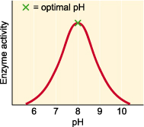 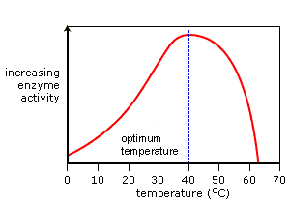
- Describe how to prepare foods for the food tests.
Take a sample of food, grind it up using a pestle and mortar, add distilled water, filter the solution, pour into a test tube.
- Which of the food test needs to be heated to work?
Using Benedict’s solution to test for sugars
- Describe a method for investigating the effect of pH on an enzyme such as amylase.
a. 5 different solutions of amylase at 5 different pH levels (2, 4, 7, 9, 11)
b. Spotting tile with equal drops of iodine
c. Solution of starch kept at 37⁰C using water bath
d. Add the amylase at pH 2 to the starch solution and start a timer.
e. Mix continuously and add one drop of the mixture to a different spot in the tile every 30s.
f. Repeat for each pH keeping the volume of solutions, the temperature and the time the same.

Key Knowledge
Define:
Epidemiological: Relating to diseases.

State 2 risk factors for:
Cardiovascular disease:
(i) Smoking
(ii) Obesity

Type 2 diabetes
(i) Obesity
(ii) Sedentary life style

Reduced brain function
(i) Drugs
(ii) Alcohol

Reduced liver function
(i) Alcohol
(ii) Obesity

Lung disease/lung cancer
(i) Smoking
(ii) Obesity

Foetal damage
(i) Alcohol
(ii) Smoking

Understanding and Explaining
- Between 1975 and 2009, the USA lung cancer rate decreases in both females and males.
- There was a larger decreases in males than there were in females.
- In 1975 there was a much higher rate in males than in females, in 2009 there was a slightly higher rate in females than in males.
- There were periods of time where the rates for males increased (1987, 1976, 2002) as well as in females (1978, 1994 2004).
- The overall rate has decreased over this time because as more research has taken place, people have become more aware of the correlation between smoking and lung cancer, meaning that less people are smoking.
- Medicine techniques to treat lung cancer has also improved throughout the years which could mean prevention of lung cancer is higher.
- Across all ethnicities, there is a higher prevalence of diabetes in males than in females.
- The prevalence of diabetes is less in Irish and Chinese people than in the general population.
- There is the least prevalence of diabetes in Black African Women.
- Diabetes is most prevalent in Black Caribbean Men.
- The ethnic group where diabetes is most prevalent in both genders is Black Caribbean.
- The prevalence of diabetes is twice as much for in Bangladeshi males than it is for the males in general population, and more than double in Black Caribbean and Indian males.

Key Knowledge
Health – a person's mental or physical condition.
Pathogens – a disease causing microorganism
Factors that affect mental and physical health:
- Diet
- Exercise
- Lifestyle choices (Alcohol, Smoking etc)
Communicable disease – A disease that can be passed on from person to person
Non-communicable disease – Cannot be spread from organism to organism
Four types of pathogen
- Virus
- Bacteria
- Fungi
- Protist
Bacteria make us feel ill because they produce toxins (poisons) that damage tissues
Viruses make us feel ill because they live & reproduce in cells causing cell damage
Ways diseases can be spread: Air, Water, Direct Contact
Ways to prevent the spread of diseases: Washing hands thoroughly, water treatment and covering up sneezes.

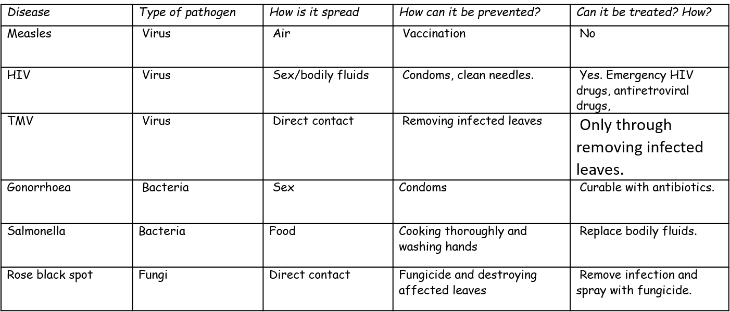
Compare the structure and size of viruses and bacteria.
Bacteria are much larger than viruses. Bacteria have plasmid and chromosomal DNA inside of a cell wall and a cell membrane, sometimes with a flagellum for transport. Viruses consist of a fragment of genetic information inside a protective protein coat.
Describe how communicable diseases can be spread between organisms.
Communicable diseases can be spread through water, direct contact or air. Droplets containing microbes fly into the air when people sneeze or cough. The microbes they contain get into other people if breathed in. Microbes can be passed from one person to another when people touch each other, or when they touch something an infected person has handled. Water can have harmful microbes in it. The microbes get into the body when the water is swallowed.

Explain how the prevent the spread of an epidemic, such as swine flu.
The spread of an epidemic can be prevented by addressing the methods of spreading. By cleansing skin with antiseptics and washing, the risk of spreading microbes through touch is reduced. By boiling or adding chlorine to water, the spread of microbes through water is prevented. By covering up the face when coughing or sneezing, the spread of microbes through air is prevented.

Key Knowledge
How do these parts of the body try to prevent pathogens entering?
Skin – Prevent them from entering body

Nose – Mucus to trap dirt & pathogens, ciliated cells to sweep it out

Trachea and bronchi – Mucus to trap dirt & pathogens, ciliated cells to sweep it out

Stomach – Stomach acid to kill pathogens

Three jobs of white blood cells – Phagocytosis, antibody production, antitoxin production

Definition:
Vaccination – injection given to patients, containing dead or inactive pathogens, to prevent them from catching an infectious disease

Phagocytosis – Pathogen being surrounded, engulfed and digested by a white blood cell

Immunising – Preventing someone from being vulnerable to pathogens.

Antibiotics – Medicine that kills bacteria
e.g. Penicillin

Painkillers – Medicine which treat symptoms
e.g. Paracetamol

Antivirals – Drugs that prevent viruses reproducing

Disadvantage of antivirals: Side-effects include nausea and vomiting.

- Describe the physical and chemical barriers preventing pathogens from entering the body.
The skin prevents pathogens entering the body as a physical barrier to the outside world. The nose, trachea and bronchi are all lined with mucus, which traps dirt and pathogens before they enter the lungs. Ciliated cells in the nose, trachea and bronchi then sweep the pathogens out of the body. Stomach acid contains hydrochloric acid, which kills any pathogens that enter.
2. Explain the roles of phagocytes and lymphocytes (types of white blood cell) in the immune system.
Phagocytes find any pathogens in the blood stream, they engulf the pathogen and digest them, removing them from the body.
Lymphocytes produce antibodies and antitoxins.
Antibodies stick to the antigens of pathogens and cause them to stick together which means the phagocytes can ingest them at a quicker rate.
Antitoxins neutralise the effects of toxins produced by pathogens.
3. Describe and explain the shape of this graph showing the number of antibodies produced during a first and second chickenpox infection. The second response is quicker and more antibodies are produced because the body has learnt how to produce the correct antibodies already
4. Explain how the measles vaccine helps to prevent a person becoming ill from the measles pathogen.
The vaccine contains a dead/weak form of measles. This is injected into the blood. The white blood cells produce antibodies to kill the measles pathogen. If infected for real, the body responds more quickly and is able to produce the antibodies to kill the pathogen before symptoms appear.
5. The flu vaccine is often given out in the UK to vulnerable groups, rather than the whole population. Discuss why the government has chosen to immunise only select groups of people, such as 65+ years old and pregnant women.
Balance between cost and who will be the most effected/more likely to become very ill from the flu.
6. A student has influenza cause by a virus. Discuss which of the medicines, painkillers, antibiotics or antivirals, would be suitable to give them. Explain why. Antivirals and painkillers – antivirals will kill the pathogen and painkillers would relieve some of the symptoms. Antibiotics are not useful because they only kill bacteria.

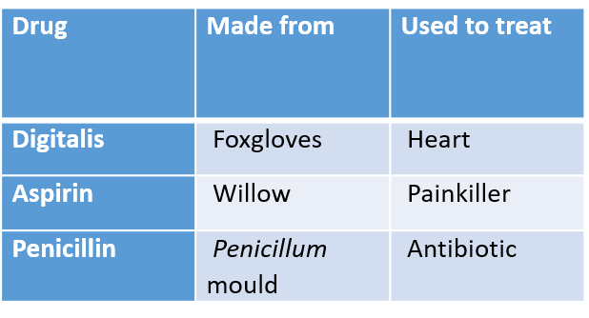
Key Knowledge
Key Knowledge
Traditional medicinal drugs were made from microorganisms and plants. Now most are chemically synthesized, but might still start from a plant extract.
During preclinical testing, drugs are tested using computer models, human cells or animal testing to make sure they are safe for human use.
During clinical testing, drugs are tested on healthy volunteers to check they are safe. The substances are then tested on people with the illness to ensure they are safe and that they work.

Drugs are trialled to check the:
- Toxicity
- Efficacy
- Dose
Definitions:
Placebo – a substance that contains no medicine (a control)
Double blind trial - Neither experimenter or patient knows if they are taking medicine or placebo
Toxicity – Is the drug safe to use? (Is it toxic or poisonous)
Efficacy – How well does the drug work?
Dose – How much of the drug is needed to work.

Understanding and Explaining
Explain how new antibiotic resistant strains of bacteria have developed.
- Mutated bacteria carrying resistant gene
- Antibiotics kill bacteria not carrying the gene.
- Mutated bacteria becomes more prevalent due to other bacteria dying.
- Mutated bacteria reproduce and pass their genes onto their offspring.

Describe how a new drug would be tested to ensure it is safe.
- Lab testing on animals or tissues to find out the toxicity, the efficacy and the dose.
- Phase 1, Low doses are tested on healthy volunteers to evaluate the safety and side effects on volunteers.
- Phase 2, Tested on a large group of people to see if it is effective, to evaluate its safety and to decide the best dose.
- Phase 3, Test on larger group of people to confirm it works and to check side effects.
- The drug has been fully tested and can be sold.

Biology Revision: Plant Structures

Mastery Matrix Points
Draw and label an unspecialised plant cell and a palisade, root hair, xylem and phloem specialised cell
Describe the 5 tissues and name the key organs in the plant
Label a transverse section of a leaf
Describe the process of osmosis
Calculate the rate of water uptake by a plant
Calculate the percentage change in mass following osmosis
Analyse and draw graphs relating to osmosis
Required practical: Analyse the range of concentrations of solutions on the change in mass of plant tissue
Describe the process of active transport and explain why it is necessary
Compare diffusion, osmosis and active transport
Describe the process of active transport and how root hair cells are adapted to this
Describe the process of transpiration and translocation (including the structure and function of stomata).
Explain the effect of changing temperature, humidity, air movement and light intensity on the rate of transpiration
Calculate surface area, volume and mean in transpiration investigation
Analyse data from graphs and tables relating to transpiration experiments
Describe in detail the location, function and adaptations of xylem tissue, phloem tissue, stomata and guard cells

Key Knowledge
Function of these plant tissues:
epidermal tissue = covers the outer surfaces of the plant for protection
palisade mesophyll = the main site of photosynthesis
spongy mesophyll = air spaces between the cells to allow gases to diffuse
xylem = transports water and minerals from roots to leaves
phloem = transports glucose (dissolved) from leaves to rest of plant
meristem tissue – found at the roots and shoots (where new cells are made)
Label the leaf tissues:
A = Waxy cuticle
B = Palisade layer
C =Spongy mesophyll
D = Guard cells
E = lower epidermis
F = upper epidermis
G = stomata

How are these adapted to their job?
Root hair cells
-No chloroplasts
-Large surface area to absorb water and minerals
-Large vacuole to store water
Xylem
-Dead cells
-Thick cellulose walls
-Hollow lumen allows water through
Phloem
Contain 2 parts:
-Sieve tubes are hollow to allow glucose through
-Companion cells contain the sub-cellular structures needed for cells to live
Guard cells
-Become turgid when filled with water (stomata open)
-Become flaccid when water leaves (stomata close)

Definitions:
Osmosis – the diffusion of water from a dilute solution to a concentrated solution
through a partially permeable membrane
Active transport - moves substances from a more dilute solution to a more concentrated solution (against a concentration gradient). This requires energy from respiration
Transpiration – the loss of water from the leaves of a plant

Translocation – movement of glucose from the leaves through the phloem

Calculations
rate of water uptake = volume of water taken up ÷ time

% change in mass = change in mass x 100
original mass

Understanding and Explaining
- A student completes an osmosis experiment using potato cylinders. Describe how you could work out the concentration of the sucrose in the potato using their results graph.
Find the concentration where the change in mass is 0. This is where the line of best fit meets the x axis.

- Describe how active transport works.
Substances are pumped against their concentration gradient by proteins in the cell membrane. This uses energy.
- In root hairs cells, water and nutrients move into the plant. How do the nutrients move into the cell? By what process does the water move into the cell?
Substances move by diffusion from the soil (where there is a high concentration of minerals) into the root hair cell (where there is a lower concentration of minerals). When the concentration of minerals in the soil decreases, the cell starts to use active transport to pump the minerals against their concentration gradient. Water moves into the root hair cell by osmosis.
- Compare the processes of osmosis and active transport.
Osmosis does not require energy and is passive, whereas active transport requires energy.
Osmosis is the movement of water molecules only, whereas active transport is the movement of different molecules,
In osmosis, the water molecules follow their concentration gradient, whereas in active transport the substances go against their concentration gradient.
- Describe and explain three factors that affect transpiration.
An increase in air temperature increases the rate because there is more energy available to allow the water to evaporate, making space for more water to move out and take its place.
An increase in air flow (wind speed) will increase the rate because water vapour is being constantly removed, allowing more water to leave the leaf to take its place.
An increase in light intensity will increase the rate because it will cause the stomata to open allowing water to leave.
An increase in humidity will decrease the rate because there is not enough space for water molecules to leave the leaf as the air is already full of water molecules.
- Describe two examples of active transport.
a. Glucose is pumped against its concentration gradient in the small intestine to the blood stream.
b. minerals are pumped against their concentration gradient from the soil into the root hair cell.

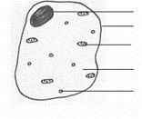
Label the cells:

Definitions:
Magnification – a measure of how many times an object has been enlarged
Resolution – The smallest distance between two separate points.

Equation:
Magnification = image size
real size

Key Knowledge
Prokaryote cells – Cells that do not contain membrane-bound organelles (particularly no nucleus!)

e.g. Bacteria and Archaea

Eukaryote cells – Cells that contain membrane-bound organelles.

e.g. Plant and Animal Cells

Cell differentiation – Specialisation of cells to fulfil a specific role in the body.

Cell division – Multiplication of cells through mitosis in body cells or meiosis in gametes.

Tissue – a group of specialised cells that have a similar structure and function.

Organ – Organs are made of tissues. One organ may contain several tissues.

System – Organ systems are groups of organs that perform a particular function.

Nucleus
Cell membrane
Mitochondria
Cytoplasm
Ribosomes

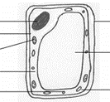
Cell wall
Vacuole
Mitochondria
Nucleus
Cell membrane
Chloroplasts
Cytoplasm
Ribosomes

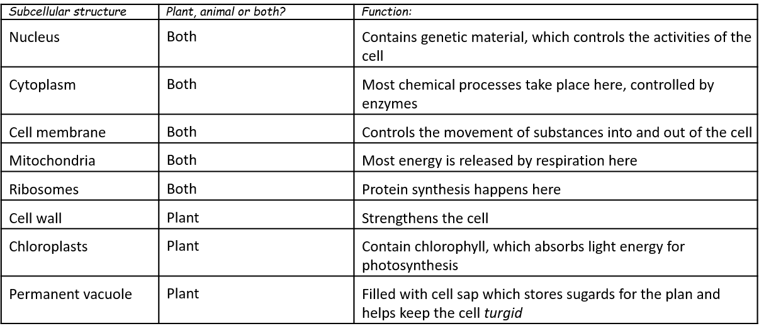
Understanding and Explaining
Describe the structure of a bacteria cell.
The bacteria cell is surrounded by a cell membrane and a cell wall. The contents of the bacteria cell do not include a nucleus, because the bacteria is prokaryotic. The two forms of DNA in the bacteria cell are plasmid and chromosomal. The bacteria cell may also feature a flagellum, which helps the bacteria move around.

Complete the table about the subcellular structures.

Understanding and Explaining

Compare when cell differentiation happens in plants to animals.
Most plant cells can differentiate into different cell types, whereas in animal cells only stem cells can differentiate into different cell types. Other animal cell functions remain fixed. Stem cells can be taken from embryos, umbilical cords and bone marrow.
How have electron microscopes improved our understanding of cells?
Electron microscopes have a greater magnification than previous microscopes. This has allowed for clearer images of cells and their organelles.
Evaluate the pros and cons of light and electron microscopes.
Light microscopes are smaller and lighter, so are easier to transport. Less expensive. Electron microscopes have higher resolution and higher magnification. Light microscopes can form images with colour, as opposed to greyscale (electron). Light microscope images can be viewed immediately but electron microscopes require extra equipment.

`

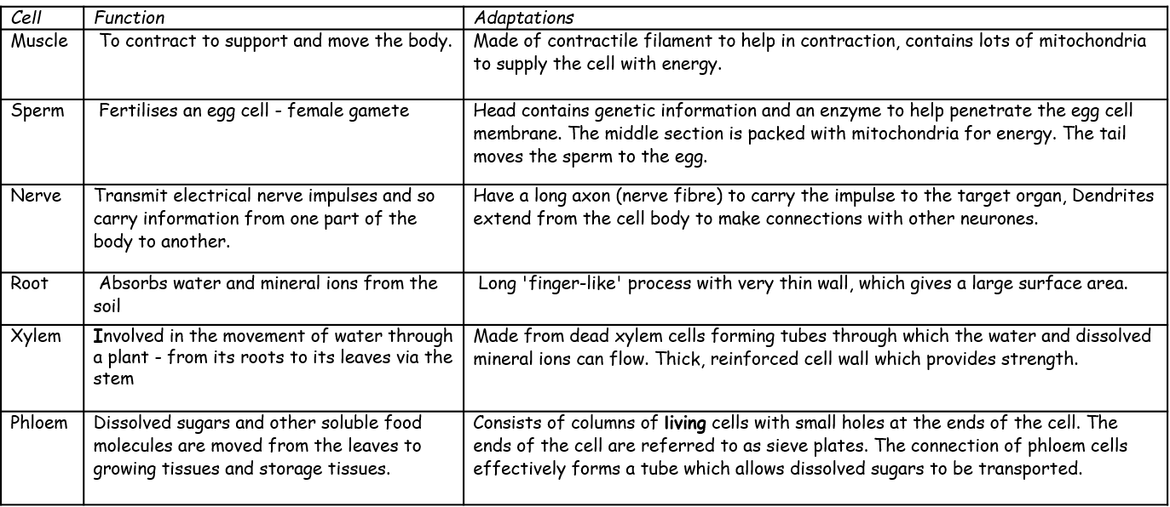

Mark Scheme – Paper 1 Biology – Double Science HT
Q1.
(a) contract / shorten
ignore relax
do not allow expand
1
to churn / move / mix food
accept peristalsis / mechanical digestion
ignore movement unqualified
1
(b) 400
acceptable range 390-410
allow 1 mark for answer in range of 39 to 41
allow 1 mark for answer in range of 3900 to 4100
2
(c) to transfer energy for use
allow to release / give / supply / provide energy
do not allow to ‘make’ / ߢproduce’ / ‘create’ energy
allow to make ATP
ignore to store energy
1
by (aerobic) respiration or from glucose
do not allow anaerobic
energy released for respiration = max 1 mark
1
(d) (i) to make protein / enzyme
ignore ‘antibody’ or other named protein
1
(ii) too small / very small
allow light microscope does not have sufficient magnification / resolution
allow ribosomes are smaller than mitochondria
ignore not sensitive enough
ignore ribosomes are transparent
1
[8]
Q2.
(a) B
no mark for “B” alone, the mark is for B and the explanation.
large(r) surface / area or large(r) membrane
accept reference to microvilli
ignore villi / hairs / cilia
accept reasonable descriptions of the surface eg folded membrane / surface
do not accept wall / cell wall
1
(b) (i) any one from:
• (salivary) amylase
• carbohydrase
1
(ii) many ribosomes
do not mix routes. If both routes given award marks for the greater.
1
ribosomes produce protein
accept amylase / enzyme / carbohydrase is made of protein
or
(allow)
many mitochondria (1)
mitochondria provide energy to build / make protein (1)
accept ATP instead of energy
1
[4]
Q3.
(a) 23
1
(b) chromosome nucleus gene cell
2 3 1 4
1
(c) (i) any one from
(cells which are bigger) take up more space
(cells) have to get bigger or mature to divide
1
(ii) chromosomes duplicate or
make exact copies of self
accept forms pairs of chromatids
1
nuclei divide
accept chromatids or
chromosomes separate
1
identical (daughter) cells formed
accept for example, skin cells make
more skin cells or cells are clones
1
(d) any two from
Differentiation mark
babies need or are made of different types of cells or cells that have
different functions
accept different cells are needed
for different organs
Division or specialisation mark
as fertilised egg starts to divide each cell specialises to form a part of the body
accept specialised cells make
different parts of the body
Growth mark
specialised cells undergo mitosis to grow further cells
accept cells divide or reproduce
to form identical cells
2
[8]

Q4.
(a) C
1
(b) cytoplasm and cell membrane dividing
accept cytokinesis for 1 mark
1
to form two identical daughter cells
1
(c) stage 4
1
only one cell seen in this stage
1
(d) (4 / 36) × 16 × 60
1
107 / 106.7
1
110 (minutes)
allow 110 (minutes) with no working shown for 3 marks
1
(e) binary fission
do not accept mitosis
1
(f) shortage of nutrients / oxygen
1
so cells die
or
death rate = rate of cell division
1
[11]

Q5.
(a) vector
1
(b) any three from:
• destroy the snails
• isolate infected dogs
• treat infected dogs
allow vaccination
• educate owners about picking up dog faeces
3
(c) stop mosquitoes breeding
allow correct description
1
use mosquito nets
allow use of insect repellent
1
[6]
Q6.
(a) produces toxins / damage cells / reproduce rapidly or reproduce in cells
ignore invade cells
1
(b) any three from:
• TV crew immune / Indians not immune / Indians have weak(er) immune
system
ignore resistant
• TV crew had / produced antibodies / Indians had no antibodies or antibody
production faster in TV crew
• TV crew had previous exposure to flu / had been vaccinated
or
Indian tribe had no previous exposure to flu / had not been vaccinated
allow immunised
• Indians caught disease from TV crew
or
TV crew were carriers (of the virus)
3
[4]
Q7.
(a) white cells ingest bacteria
produce antibodies which destroy bacteria
produce antitoxins which counteract poisons produced by bacteria
for 1 mark each
3
(b) dead/mild microbes
stimulate antibody production
white cells can quickly produce these again
for 1 mark each
3
(c) adds more bacteria (mild)
does not affect TB bacteria
for 1 mark each
2
[8]
Q8.
(a) (i) any one from:
• cells
• tissues
• (live) animals / named
allow mammals
1
(ii) any three from:
(to test for)
• toxicity / check not poisonous / not harmful
allow side-effect
allow converse
• interaction with other drugs
• efficacy or to see if they work or check if they treat the disease
allow converse
• dosage or how much is needed
3
(b) argued evaluation
comparison can be written anywhere in evaluation allow use of ‘only’ for implied comparison for each point eg only statins damage muscles / kidneys / organs
any six from:
• statin can damage / muscles / kidneys / organs but cholesterol blockers don’t
ignore liver
if neither of the first 2 points are given accept for 1 mark
• statins can cause death but cholesterol blockers don’t
statins are more dangerous than cholesterol blockers or statins have more side effects
• cholesterol blockers can interfere with action of other drugs but statins don’t
• statins are for a life time but cholesterol blockers are not
• statins (might) reduce cholesterol to zero but cholesterol blockers only
reduce it or statins reduce cholesterol more
allow statins (might) stop membrane / hormone production but cholesterol blockers don’t
• statins better for people with inherited high cholesterol
• cholesterol blockers better for people with dietary cholesterol problems
• taking/using statins/cholesterol blockers is better than dying from heart
attack or build up of fat in blood vessels or reduced blood flow
6
[10]
Q9.
(a) any two from
• live inside / infect body cells
• difficult for drugs to enter (body) cells / drug would kill (body) cell
• antibiotics ineffective against viruses
• viruses mutate frequently
2
(b) (i) 420
correct answer with or without working
if answer incorrect evidence of ‘number of deaths’ × 7 or 60 seen gains 1 mark
ignore 6 000 000
2
(ii) any three from:
• virus / flu mutates
• people no longer / not immune
ignore resistance
• white blood cells / memory cells / immune system do not
recognise virus
• relevant reference to antibodies / antigens
• current vaccine ineffective or no vaccine available then
or takes time to develop new vaccine
allow no tamiflu / anti-viral drugs
• conditions less hygienic / lack of hygiene
• people in poor health (following world wars)
allow people had ‘weak’ immune system
3
[7]
M10
(a) any two from:
• only one ‘chromosome’
allow one strand of DNA
• circular
allow loop
• may have plasmids
• not in a nucleus / no nucleus
2
(b) (i) any one from:
• London is much higher
or converse
• more variable / wider range
allow ‘on average it is 5 / 6 times greater’
1

(ii) increases
Included figures must be correct
1
(iii) overall slight increase
accept ‘doesn’t change much’
1
variable / goes up and down
1
(c) (i) both axes correctly labelled
x = Year
y = Number of cases
1
correct points
all correct = 2 marks
1-2 errors = 1 mark
> 2 errors = 0 marks
2
suitable line of best fit
accept straight line or smooth curve
1
(ii) doesn’t fit the pattern / line of best fit
1
(d) provides immunity / protection (to TB)
ignore ‘stops people catching it’
ignore ‘resistance’
1
prevents TB spreading
accept ref to herd immunity
1
[13]
Q12.
(a) glucose is absorbed by diffusion into the bloodstream
1
then blood delivers glucose to muscles in capillaries
1
(b) to stop air getting in
1
(c) yellow
1
(d) collect the CO₂ / gas with a measuring cylinder / gas syringe
1
(volume collected) in a certain time using a timer / watch
1

(e) yeast produces ethanol but muscles produce lactic acid
marks can be awarded from correct word or balanced symbol equations
1
yeast produces CO₂ but muscles do not
answers must be comparative
1
both release small amounts of energy
1
ignore both occur without oxygen
[9]
Q13.
(a) (i) doesn’t have valves
allow veins have valves
1
has a thicker wall or thicker layer of muscle
allow has a smaller lumen
ignore references to elastic (in walls)
1
(ii) any two from:
• (artery has) more oxygen
• (artery has) more glucose
allow (artery has) more amino acids / fatty acids
• (artery has) less carbon dioxide
• (artery has) less lactic acid
ignore urea
ignore reference to pressure
accept converse for veins if veins is clearly stated
2
(b) any two from:
• no rejection
allow no tissue matching required
• abundant supply
• low risk of infection
allow named example ie HIV, CJD
• longer shelf life
allow less space needed for storage
ignore side effects
2
[6]
Q14.
(a) more concentrated
must be a comparison
1
than the cell / cytoplasm
accept more salty / solutes / ions
accept cell is less concentrated than solution for 2 marks
1
(b) (i) turgid
1
(ii) plasmolysed
accept flaccid
1
(c) any four from:
• water left the cell (in A)
• by osmosis
• from dilute to more concentrated solution
accept high to low water potential or from high to low water concentration
• via partially permeable membrane
• so cell membrane shrank away from cell wall
4
(d) water enters the cells (by osmosis)
allow 1 mark for:
1
they burst / lyse / lysis occurs
water leaves and cell shrinks (if they think it is hypertonic solution)
1
animal cells have no cell wall or plant cells have a cell wall
1
cell wall prevents lysis / bursting / allows turgidity
allow correct description
1
[12]
Q15.
(a) digested / broken down / made soluble by protease enzyme
in stomach in small intestine / from stomach / from pancreas
into amino acids
amino acids / small molecules absorbed into blood
any four for 1 mark each
4
(b) ideas that
lipase / enzyme works best in alkaline / neutral conditions
acid denatures or inactivates enzyme / inhibits enzyme activity
bile emulsifies fat / bile produces larger surface area of fats / bile alkaline
for enzyme to work on / which increase activity of enzymes
any three for 1 mark each
3
[7]

Q16.
(a) LHS – carbon dioxide / CO₂
allow CO2
ignore CO²
1
RHS
in either order
glucose / carbohydrate / sugar
allow starch
allow C₆H₁₂O₆ / C6H12O6
ignore C⁶H¹²O⁶
1
oxygen
allow O₂ / O2
ignore O² / O
1
(b) any five from:
• factor 1: CO² (concentration)
• effect - as CO₂ increases so does rate and then it levels off or shown in a graph
• explanation:
(graph increases) because CO₂ is the raw material or used in photosynthesis / converted to organic substance / named eg
or
(graph levels off) when another factor limits the rate.
accept points made via an annotated / labelled graph
• factor 2: temperature
allow warmth / heat
• effect – as temperature increases, so does the rate and then it decreases or shown in a graph
allow ‘it peaks’ for description of both phases
• explanation:
(rise in temp) increases rate of chemical reactions / more kinetic energy
allow molecules move faster / more collisions
or
(decreases) because the enzyme is denatured.
context must be clear = high temperature

allow other factor plus effect plus explanation:
eg light wavelength / colour / pigments / chlorophyll / pH / minerals / ions / nutrients / size of leaves
2nd or 3rd mark can be gained from correct description and explanation
5
[8]

Q17.
(a) light is trapped / absorbed / used
extra answers cancel mark
ignore solar / sunshine
1
by chlorophyll / chloroplasts
if no other marks awarded, allow 1 mark for photosynthesis / equation for photosynthesis
1
(b) (to make) starch (for storage)
ignore ‘for growth’ unqualified
ignore respiration
1
(to make) fat / oil (for storage)
1
(to make) amino acids / proteins / enzymes
1
(to make) cellulose / cell walls
allow for active transport
allow any other correct, named organic substances (eg DNA / ATP / chlorophyll / hormone)
if no named examples, allow ‘to make named cell structures’ for max. 1 mark
1
[6]

