**Year 10 Separate Science**

**Mock Exam Revision**

**Paper 1**

Instead of a year 10 end of year exam this year, you will be sitting a science mock paper.

This paper will include all topics learnt in both year 9 and year 10.

This revision homework must be completed weekly.

The format of each homework is the same:

* **Section 1**: 3 x look, cover, write, check for both sets of knowledge.  
  Each set must have a title and have a number (1,2 or 3)>  
  An example of what this looks like is shown below:

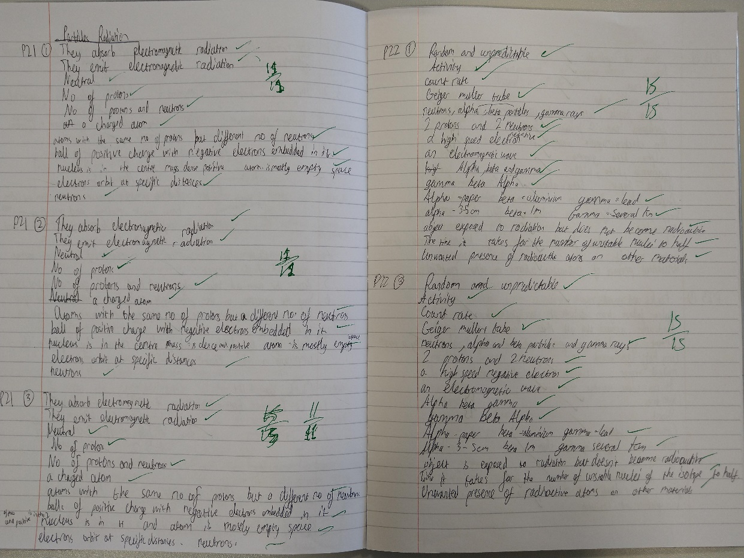

* **Section 2**: answer the mastery matrix statements and self-assess using the knowledge and/or your revision guide
* **Section 3**: answer the exam questions and self-assess using the mark scheme

**Revision Homework 1: Biology**

**Section 1: Knowledge**

|  |  |  |
| --- | --- | --- |
|  | **Topic:** | **Transport in cells (diffusion, active transport and osmosis) (B.19)** |
| 1 | Substances moving from a high concentration to a low concentration is called… | Diffusion |
| 2 | Two examples of diffusion in humans are: | CO2 + O2 in gas exchange, urea from cells to blood |
| 3 | Three factors that affect the rate of diffusion are: | Concentration gradient, temperature, surface area of the membrane |
| 4 | How are single celled organisms adapted for diffusion? | Large surface area : volume ratio |
| 5 | How is the small intestine adapted for exchanging materials? | *Villi for large S.A. *villi one cell thick *good blood supply |
| 6 | How is the lungs adapted for exchanging materials? | *Alveoli large surface area: volume ratio, surface is moist, good blood supply |
| 7 | How is the gills adapted for exchanging materials? | *large S.A. *moist *good blood flow to maintain concentration gradient |
| 8 | How is the roots adapted for exchanging materials? | *Large SA to volume ratio *lots of mitochondria for respiration -> energy for active transport |
| 9 | How is the leaves adapted for exchanging materials? | *Stomata *thin so that distance for diffusion is smaller |
| 10 | Four ways that to increase the rate of transport | *Large surface area, thin membrane, efficient blood supply (in animals), well ventilated (in animals) |
| 11 | Water moves from a dilute to concentrated solution across a partially permeable membrane via... | Osmosis |
| 12 | Pure water will move into a potato because of | Osmosis |
| 13 | (RP) How can you tell the concentration of sugar in a piece of potato? | 1) Place into different concentrations of sugar solution. 2) Plot graph 3)Find concentration where change in mass is 0 |
| 14 | When a substance moves against the concentration gradient, it is called.. | Active transport |
| 15 | Active transport requires ________ from _________. | energy respiration |

|  |  |  |
| --- | --- | --- |
|  | **Topic** | **Required Practical: Osmosis** |
| 1 | What is the independent variable? | The concentration of the solution |
| 2 | What is the dependent variable? | The percentage change in mass |
| 3 | Name 5 control variables | 1)Length of potato 2) Diameter of potato 3) Volume of solution 4) Time potato is left for 5) Temperature of solution |
| 4 | Give 3 ways to make the results accurate | 1) Read the volume of the solution from the meniscus 2) Dab the potatoes dry before measuring the mass 3) Use a digital top pan balance |
| 5 | Name one risk and precaution | Risk = cutting yourself with the potato borer Precaution = push the borer down towards the desk not upwards |
| 6 | What is the purpose of the distilled water? | To act as a control to compare your results to |
| 7 | How is the concentration inside the tissue estimated? | Plot a graph of concentration against % change in mass and find where the line of best fit crosses 0% |
| 8 | How is the percentage change in mass calculated? | % change in mass = change in mass / initial mass |
| 9 | Why is percentage change calculated rather than just the change? | The potato may be slightly different sizes and shapes to begin with |
| 10 | Why does the tissue increase in mass? | Water has entered the tissue by osmosis in more dilute solutions |
| 11 | How can you tell if there has been an increase in mass? | The % change in mass is +ve |
| 12 | Why does the tissue decrease in mass? | Water has left the tissue by osmosis in more concentrated solutions |
| 13 | How can you tell if there has been a decrease in mass? | The % change in mass is -ve |
| 14 | What does no change in mass mean? | The concentration of the solution is the same as the concentration inside the tissue |
| 15 | What are possible variations on this method? | 1) Using any other vegetable/plant tissue 2) Using any other food substance  3) Using a salt solution |

**Section 2:**Mastery matrix statements to be answered and then self-assessed using revision guide and knowledge

|  |  |
| --- | --- |
| 6.1 | Define ‘diffusion’ and give examples of diffusion in plants and animals (gas exchange and urea in the kidney) |
| 6.2 | Explain how different factors affect the rate of diffusion (concentration, surface area, temperature) |
| 6.3 | Calculate surface area: volume ratios |
| 6.4 | Explain how surface area: volume ratio of a single celled organism (amoeba) allows sufficient molecule transport |
| 6.5 | Explain adaptations for exchange materials in: small intestines, lungs, gills, roots and leaves |
| 3.4 | Describe the process of osmosis |
| 3.5 | Calculate the rate of water uptake by a plant |
| 3.6 | Calculate the percentage change in mass following osmosis |
| 3.7 | Analyse and draw graphs relating to osmosis |
| 3.8 | RP Osmosis: Analyse the range of concentrations of solutions on the change in mass of plant tissue |
| 3.9 | Describe the process of active transport and explain why it is necessary |
| 3.10 | Compare diffusion, osmosis and active transport |
| 3.11 | Describe the process of active transport and how root hair cells are adapted to this |

**Section 3: Exam questions**

A student used cubes of potato to investigate the effect of surface area and volume on the rate of osmosis.

The diagram shows two of the cubes of potato the student used.

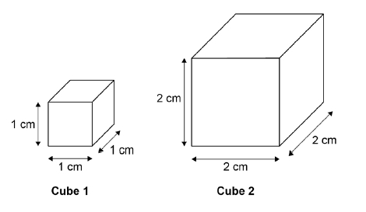

The surface area to volume ratio of **cube 1** is 6:1.

(a)     Calculate the total surface area of **cube 2**.

___________________________________________________________________

___________________________________________________________________

Total surface area of **cube 2** = ____________________ cm2

**(1)**

(b)     Calculate the volume of **cube 2**.

___________________________________________________________________

___________________________________________________________________

Volume of **cube 2** = ____________________ cm3

**(1)**

(c)     Calculate the surface area to volume ratio of **cube 2**.

Use the equation:



___________________________________________________________________

___________________________________________________________________

Surface area to volume ratio of **cube 2** = ____________________ : 1

**(1)**

This is the method used.

1.   Cut two cubes of potato of size 2 cm × 2 cm × 2 cm

•   Cut one of these cubes into 8 cubes of potato of size 1 cm × 1 cm × 1 cm (sample **A**).

•   Do not cut the other cube (sample **B**).

2.   Measure the mass of each sample **A** and the mass of sample **B**.

3.   Place all the cubes into a beaker of distilled water.

4.   Leave for 30 minutes.

5.   Remove the cubes from the beaker and dry the surfaces with a paper towel.

6.   Measure the mass of each sample of cubes.

(d)     Why were 8 cubes of size 1 cm × 1 cm × 1 cm but only one cube of size 2 cm × 2 cm × 2 cm cube used?

___________________________________________________________________

___________________________________________________________________

**(1)**

(e)     Why did the student dry the surface of each potato cube in step **5** of the method?

___________________________________________________________________

___________________________________________________________________

**(1)**

The table below shows the student’s results.

|  |  |  |  |
| --- | --- | --- | --- |
|  | **Mass at start in g** | **Mass at end in g** | **Mass change in g** |
| **Sample A**  **Eight cubes, each measuring 1 cm × 1 cm × 1 cm** | 10.4 | 12.2 | 1.8 |
| **Sample B**  **One cube, measuring 2 cm × 2 cm × 2 cm** | 9.9 | 10.7 | **X** |

(f)      Calculate mass change **X** in the table above.

___________________________________________________________________

___________________________________________________________________

Mass change **X** = ____________________ g

**(1)**

(g)     Explain why the masses of both samples of cubes increased.

___________________________________________________________________

___________________________________________________________________

___________________________________________________________________

___________________________________________________________________

**(2)**

(h)     It would be better to calculate percentage change in mass rather than change in mass. Why is this a more valid method? Tick **one** box.

|  |  |  |
| --- | --- | --- |
| Because it makes it a fair test. |  |  |
| Because it makes the investigation of the samples of cubes more accurate. |  |  |
| Because the samples of cubes were different masses at the start of the investigation. |  |  |

**(1)**

(i)      Explain why the mass of the cubes in sample **A** increased more than the mass of the cube in sample **B**.

___________________________________________________________________

___________________________________________________________________

___________________________________________________________________

___________________________________________________________________

**(2)**

**(Total 11 marks)**

**Mark schemes**

(a)     (surface area =) 24 (cm2)

**1**

(b)    (volume =) 8 (cm3)

**1**

(c)     3 (:1)

*allow ecf from (a) and (b)*

**1**

(d)     to keep the volume (of the cubes) the same in both sets

*allow to compare with the 2 × 2 × 2 cube*

**or**

so both sets of cubes are 8 cm3

*ignore to keep it fair*

**1**

(e)     so that excess water does not contribute to the mass of the cubes

**1**

(f)      0.8 (g)

*if no answer given, check for answer in the table*

**1**

(g)     (because) water moved into the cubes (by osmosis)

*allow water moves in by diffusion*

**1**

because the solution outside the cubes was more dilute than inside the cells

*allow converse*

*allow because the concentration of water was higher outside the cubes / in the beaker / solution than inside the cells*

**1**

(h)     because the samples of cubes were different masses at the start of the investigation

**1**

(i)      more water was taken in

**1**

because they had a larger surface area to volume ratio

*allow more / faster osmosis happened* **1[11]**

**Revision Homework 2: Biology**

**Section 1: Knowledge**

|  |  |  |
| --- | --- | --- |
|  | **Topic:** | **The Heart (B.15)** |
| 1 | Which type of vessel leaves the heart? | Arteries |
| 2 | Which type of vessel enters the heart? | Veins |
| 3 | What is the name of the 4 chambers of the heart? | Top: Left/right Atrium Bottom: Left/right ventricle |
| 4 | Where is the body's natural pacemaker (cells that control the bodies resting heart rate)? | Right atrium |
| 5 | What is the name of the blood vessel that enters the heart from the body? | Vena Cava |
| 6 | What is the name of the blood vessel that enters the heart from the lungs? | Pulmonary vein |
| 7 | What is the name of the blood vessel that goes to the lungs from the heart? | Pulmonary artery |
| 8 | What is the name of the blood vessel that goes from the heart to the rest of your body? | Aorta |
| 9 | Which side of the heart is thicker? | Left |
| 10 | Which side of the heart pumps oxygenated blood out of it and which side pumps deoxygenated? | Oxygenated = Left Deoxygenated = Right |
| 11 | What is the name for removing a heart from one person and placing it into another person? | Transplant |
| 12 | What is the name of the drug that reduces that amount of cholesterol in a persons body? | Statins |
| 13 | Which organ does a statin effect? | Liver |
| 14 | State 3 adaptations of a red blood cell | *no nucleus, *biconcave shape, *small |
| 15 | State 2 adaptations of a white blood cell | Cytoplasm contains enzymes, flexible cell membrane |
|  | | |
|  | **Topic:** | **Kidneys (separate only) (B.18)** |
| 1 | When amino acids are broken down by the liver, what is produced? | Amino acid -> ammonia (toxic) -> urea |
| 2 | What is the name for the process where amino acids are converted into ammonia? | Deamination |
| 3 | Where in the body are amino acids converted into ammonia? | The liver |
| 4 | Why is ammonia converted straight into urea? | Because it's toxic |
| 5 | What is the name for the process where useful substances are reabsorbed from urine into the blood? | Selective reabsorption |
| 6 | What are the tiny tubes in the kidney called? | Tubules |
| 7 | Which hormone controls the water level in the body? | Antidiuretic hormone (ADH) |
| 8 | Where is the hormone that controls the water level in the body released from? | Pituitary gland |
| 9 | What happens to the amount of ADH released when there is too much water in the blood? | Very little ADH released |
| 10 | What happens to the amount of ADH released when there is too little water in the blood? | A lot of ADH released |
| 11 | Name a treatment for kidney failure? | Dialysis or transplant |
| 12 | What is the name of the blood vessel going into and out of the kidney? | In: Renal ARTERY Out: Renal VEIN |
| 13 | What type of transport is used for water to be reabsorbed from the kidney tubules into the blood? | Osmosis |
| 14 | What type of transport is used for glucose/mineral ions to be reabsorbed from the kidney tubules into the blood? | Active Transport |
| 15 | Why is protein not filtered out of the blood by the nephron? | Too big |

**Section 2:**Mastery matrix statements to be answered and then self-assessed using revision guide and knowledge

|  |  |  |
| --- | --- | --- |
|  |  |  |
| 2.1 | Blood and the heart | Describe the structure and function of the human heart |
| 2.2 | Describe the roles of the four blood vessels associated with the heart |
| 2.3 | Describe the 3 different types of blood vessel in the body and their structure |
| 2.4 | Carry out rate calculations for blood flow |
| 2.5 | Describe how our body controls our natural resting heart rate |
| 2.6 | Describe the composition of blood and know the functions of each of the components |
| 2.7 | Draw blood cells from under a microscope and recognise different types of blood cells from a photo or diagram, explaining how they are adapted to their functions |
| 2.8 | Describe coronary heart disease |
| 2.9 | Describe what a ‘stent’, ‘statin’, ‘mechanical/biological valve replacement’, ‘pacemaker’ and ‘transplant’ are |
| 2.10 | Evaluate the advantages and disadvantages of treating cardiovascular diseases using drugs, mechanical devices or transplants |
| 2.11 | Evaluate risks associated with the use of blood products |
| 5.1 | Kidneys | Describe the function of the kidneys (triple only) |
| 5.2 | Describe how urea is formed from excess amino acids (triple only) |
| 5.3 | Explain how the kidneys produce urine (triple only) |
| 5.4 | Use bar charts & tables of glucose, ions & urea to analyse data from before & after filtration (triple only) |
| 5.5 | Describe the effect of ADH on the permeability of the kidney tubules and link to the ‘negative feedback loop’ (triple only) |
| 5.6 | Explain how kidney failure may be treated (including dialysis and kidney transplant) (triple only) |
| 5.7 | Evaluate treating organ failure with mechanical devices e.g. transplant (triple only) |

**Section 3: Exam questions  
Q1.** The heart pumps blood to the lungs and to the cells of the body.

(a)     Name the blood vessel that transports blood from the body to the right atrium.

___________________________________________________________________

**(1)**

(c)     Describe the route taken by oxygenated blood from the lungs to the body cells.

___________________________________________________________________

___________________________________________________________________

___________________________________________________________________

___________________________________________________________________

___________________________________________________________________

___________________________________________________________________

___________________________________________________________________

___________________________________________________________________

**(4)**

**Q2.**

Blood is filtered in the kidneys.

Some substances are then reabsorbed.

The amount of each substance reabsorbed varies.

Each day, a person:

•   filters 180 dm3 of water out of the blood

•   produces 2 dm3 of urine.

The diagram shows the process of filtration in the kidney.

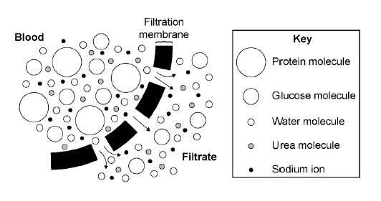

(a)     Explain why protein is **not** found in the urine of a healthy person.

___________________________________________________________________

___________________________________________________________________

___________________________________________________________________

___________________________________________________________________

**(2)**

(b)     Explain why glucose is **not** found in the urine of a healthy person.

___________________________________________________________________

___________________________________________________________________

___________________________________________________________________

___________________________________________________________________

**(2)**

(d)     The information below gives some features of two types of treatment for kidney disease.

|  |
| --- |
| **Dialysis treatment**  •   A dialysis session lasts about 8 hours.  •   A person needs 3 dialysis sessions every week for the rest of their life.  •   The person must have a diet low in protein and salt.  •   Dialysis costs £30 000 per year.  **Kidney transplant**  •   A kidney transplant requires surgery using general anaesthetic.  •   A suitable kidney donor is needed.  •   Drugs are used to suppress the immune system.  •   A transplant, and the first year’s medical care, costs £51 000.  •   After the first year, the cost of drugs is £5 000 per year. |

Evaluate the use of a kidney transplant instead of dialysis treatment for kidney disease.

___________________________________________________________________

___________________________________________________________________

___________________________________________________________________

___________________________________________________________________

___________________________________________________________________

___________________________________________________________________

___________________________________________________________________

___________________________________________________________________

**(6)**

Mark schemes

**Q1.**

(a)     vena cava **1**

(b)     0.5 mm = 0.05 cm **1**

time =   **1**

24.875 **1**

25 (s)

**Q2.**

(a)     (molecules are) (too) large **1**

cannot pass through (filtration) membrane / (holes in) filter allow ‘is not filtered out of the blood’ **1**

(b)     glucose is reabsorbed

*ignore ‘is absorbed’ unless qualified by ‘into blood’* **1**

all of it

**1**

(d)     **Indicative content**

**pro transplant:**

•   (dialysis requires repeated treatments to prevent) build-up of toxins

**or**

to prevent raised blood pressure between sessions

•   inconvenience of dialysis, e.g. long sessions of immobility **or** repeated hospital visits

•   (dialysis requires restricted diet) to prevent build-up of urea / ions

•   there is a greater risk of infection with dialysis e.g. repeated puncturing of skin **or** use of non-sterile equipment allows entry of microorganisms

•   there is a risk of blood clots with dialysis

•   dialysis more expensive in the long term / 2+ years

**or**

examples given e.g. 2 yrs dialysis = £60 000 compared with 2 yrs after transplant

= (£51 000 + £5 000) = £56 000

•   transplant is a long term treatment **or** may remain healthy for many years

**con transplant:**

•   shortage of kidney donors leading to long waiting time

•   requires death of another person **or** live donation leaving a person with just one kidney

•   exploitation of poor people for donor kidneys (paying for organs)

•   need to match tissue type

•   rejection – role of wbcs / lymphocytes

•   need immunosuppressant drugs – susceptibility to infection

•   dangers of surgery – physical damage / infection / brain damage from anaesthetic

•   high initial cost – limited funding (either personal or NHS / CCG)

**[13]**

**Revision Homework 3: Biology**

**Section 1: Knowledge**

|  |  |  |
| --- | --- | --- |
|  | **Topic:** | **Digestion (B.17)** |
| 1 | Which enzyme breaks down lipids, carbohydrates and proteins? | Lipids = lipase carbohydrates = amylase Proteins = protease |
| 2 | Which enzyme is produced by the salivary glands? | Amylase |
| 3 | What is the name of the leaf shaped organ that produces enzymes? | Pancreas |
| 4 | What is the name of the organ that produces bile? | Liver |
| 5 | What is the name of the organ that stores bile? | Gall bladder |
| 6 | Is bile acidic or alkaline? | Alkaline |
| 7 | What is added to the stomach to kills pathogens? | Hydrochloric acid |
| 8 | What is the name of the process that breaks down large globules of fat into smaller ones? | Emulsification |
| 9 | Write the word equation for the digestion of carbohydrates | Starch -> glucose |
| 10 | Write the word equation for the digestion of proteins | Proteins -> amino acids |
| 11 | Write the word equation for the digestion of fats | lipids -> fatty acids + glycerol |
| 12 | Which part of the digestive system are nutrients and water absorbed into the blood from? | Nutrients = small intestine Water = large intestine |
| 13 | What is the scientific name for the food pipe? | Oesophagus |
| 14 | What is the name of the process where food is pushed down the food pipe? | Peristalsis |
| 15 | Name the food group that cannot be digested in the body | Fibre |
|  | | |
|  | **Topic** | **Cycle and Decomposition** |
| 1 | How do plant remove carbon from the air? | Photosynthesis (CO2 in) |
| 2 | How is carbon moved from living organisms back into the air? | Respiration (CO2 released) |
| 3 | How is carbon moved from fossil fuels back into the air? | Combustion (CO2 released) |
| 4 | How is carbon moved from dead organisms into the air? | Decomposition (by decomposers) (CO2 released) |
| 5 | What is the scientific name for rain? | Precipitation |
| 6 | How does water move from lakes/the sea into the air? | Evaporation |
| 7 | Which process leads to cloud formation? | Condensation |
| 8 | What is the name of evaporation of water from plants? | Transpiration |
| 9 | State 3 factors that affect the rate of decay (separate only) | Temperature, water, availability of oxygen |
| 10 | State one human use of decomposition (separate only) | Making compost |
| 11 | Which gas is produced by a biogas generator? (separate only) | Methane |
| 12 | Describe the effect of temperature on rate of decay (separate only) | increase temp -> increase decay (to 37⁰C) |
| 13 | Which enzyme breaks down the fat in milk? (separate only) | Lipase |
| 14 | State the colour of phenolphthalein in acidic and alkaline conditions (separate only) | Alkaline (pink) Acid (colourless) |
| 15 | How do decomposers feed? (separate only) | Secrete enzymes, small food molecules diffuse into decomposer |

**Section 2:**Mastery matrix statements to be answered and then self-assessed using revision guide and knowledge

|  |  |
| --- | --- |
|  |  |
| 4.1 | Describe what the digestive system is |
| 4.2 | Explain the role of enzymes in the digestive system making reference to ‘lock and key’ |
| 4.3 | Explain how carbohydrates, proteins and lipids are synthesised, broken down and used, making reference to sugars, amino acids, fatty acids and glycerol |
| 4.4 | Link carbohydrase (amylase), protease, lipase & bile to the breakdown of particular food groups, identifying where they are produced |
| 4.5 | RP Food Tests: Use qualitative reagents to test for a range of carbohydrates, proteins and lipids |
| 4.6 | Describe the effects of temperature and pH on the rate of enzyme reactions and investigate the effect of pH on the rate of reaction of amylase |
| 4.7 | RP Enzymes: Investigate the effect of pH on the rate of reaction of amylase enzyme |
| 4.8 | Define ‘metabolism’ |
| 4.9 | Calculate the rate of given chemical reactions |
| 4.10 | Explain the 5 processes that contribute to our metabolism (starch formation, lipid formation, protein synthesis, respiration and protein breakdown) |

**Section 3: Exam questions:**

**Q1.** The diagram gives information about some parts of the human digestive system.

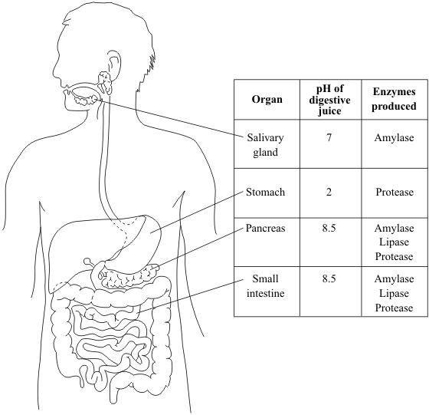

(a)     (i)      Name the organ which **makes** bile.

______________________________________________________________

**(1)**

(ii)     Label this organ with the letter **X** on the diagram.

**(1)**

          Information in the table may help you to answer parts (b) and (c).

(b)     Name **two** parts of the digestive system where protein is digested.

1. _________________________________________________________________

2. _________________________________________________________________

**(2)**

(c)     Suggest **two** reasons why starch is not digested in the stomach.

1. _________________________________________________________________

___________________________________________________________________

2. _________________________________________________________________

___________________________________________________________________

**(2)**

**Q2.**

(a)     Complete the table to give one site where digestive substances are made.

|  |  |
| --- | --- |
| **Digestive substance** | **One site of production** |
| bile |  |
| amylase |  |
| lipase |  |
| protease |  |

**(4)**

(b)     Describe **two** ways that the mouth can break down starchy foods.

___________________________________________________________________

___________________________________________________________________

___________________________________________________________________

___________________________________________________________________

**(2)**

(c)     Describe how the liver helps to digest fats.

___________________________________________________________________

___________________________________________________________________

___________________________________________________________________

**(2)**

**Q3.** The table shows the amounts of carbohydrate, fat and protein in 100 g portions of five foods, A - E.

|  |  |  |  |
| --- | --- | --- | --- |
|  | MASS IN 100 g PORTION (g) | | |
| FOOD | CARBOHYDRATE | FAT | PROTEIN |
| A | 0 | 1 | 20 |
| B | 50 | 2 | 8 |
| C | 0 | 82 | 0 |
| D | 12 | 0 | 1 |
| E | 20 | 0 | 2 |

(a)     A person eats 50 g of food E.

How much carbohydrate would the person eat?

________ g

**(1)**

(b)     Describe, in as much detail as you can, what happens to the protein after food A is swallowed.

___________________________________________________________________

___________________________________________________________________

___________________________________________________________________

___________________________________________________________________

___________________________________________________________________

___________________________________________________________________

___________________________________________________________________

**(4)**

**(Total 5 marks)**

Mark schemes

**Q1.**

(a)     (i)      liver **1**

(ii)     on diagram:

‘**X**’ on liver

*must be unambiguous (eg not overlapping gall bladder)  
intersection of X in liver* **1**

(b)     stomach **1**

small intestine

*accept duodenum or ileum  
extra wrong answers cancel the mark,  
eg small intestine (colon) = no marks* **1**

(c)     amylase not produced by stomach

*accept no starch digesting enzymes in the stomach  
accept correct enzyme not in stomach  
accept only proteases in stomach  
do* ***not*** *accept protease does not digest starch* **1**

          acid / low / wrong pH in stomach **or** enzyme would be denatured in  
stomach **or** amylase only works in neutral / alkaline conditions

*incorrect extra information cancels mark  
do* ***not*** *accept amylase does not work in the stomach* **1**

**Q2.**

(a)     liver **1**

          mouth or salivary glands **or**duodenum **or** small intestine **or**pancreas **1**

          pancreas

*accept duodenum* ***or*** *ileum* ***or****small intestine*

*do* ***not*** *accept stomach* **1**

          stomach **or** duodenum **or** ileum **or**small intestine **or** pancreas **1**

(b)     teeth breakdown food

*accept chewing* **1**

          amylase **or** saliva (breaks down starch) **1**

(c)     produces bile (salts) **1**

          emulsifies (fat) **or** produces droplets  
**or** disperses fat) **1**

**Q3.**

(a)     10 **1**

(b)     digested / broken down / made soluble by protease / enzyme  
in stomach / in small intestine / from stomach / from pancreas  
into amino acids amino acids/smaller molecules/products of digestion absorbed into blood

*any four for 1 mark each*

**4**

**[5]**

**Revision Homework 4: Chemistry**

**Section 1: Knowledge**

|  |  |  |
| --- | --- | --- |
|  | **Topic:** | **Types of bonding (C.7)** |
| 1 | Which type of bonding occurs between metals and non-metals? | Ionic |
| 2 | Which type of bonding occurs between non-metals? | Covalent |
| 3 | Which type of bonding occurs between metals? | Metallic |
| 4 | When electrons leave the shells of an atom, they are said to be ……? | Delocalised |
| 5 | Which type of ions are formed by metals? | Positive ions |
| 6 | Which type of ions are formed by non-metals? | Negative ions |
| 7 | What is graphene? | A single layer of graphite |
| 8 | What is a fullerene? | Hollow carbon structures |
| 9 | What is Buckminster Fullerene? | Spherical carbon shape with 60 carbon atoms |
| 10 | What is an allotrope? | Two or more different physical arrangements of the same atom e.g. diamond, graphite, graphene |
| 11 | What is a carbon nanotube? | A cylindrical fullerene with a very high length to diameter ratio |
| 12 | Describe what happens in ionic bonding | Electrons are transferred from a metal atom to a non-metal atom = strong electrostatic attraction between oppositely charged ions |
| 13 | Describe what happens in covalent bonding | Electrons are shared between atoms = strong electrostatic attraction between electrons and nucleus |
| 14 | Describe what happens in metallic bonding | Electrons become delocalised creating a sea of negative charge = strong electrostatic attraction with positive metal ions & sea of delocalised electrons |
| 15 | Why do noble gases not form compounds? | Because they already have a full outer shell of electrons |
|  | | |
|  | **Topic:** | **Properties of materials (C.8)** |
| 1 | State two properties of simple covalent molecules | 1) Low melting & boiling point, 2)Poor conductor of thermal & electrical energy |
| 2 | State three properties of diamond | 1) Hard, 2) Poor electrical conductor, 3) Good thermal conductor |
| 3 | State two properties of graphite | 1) Soft & slippery, 2) Conducts electricity |
| 4 | State two properties of silicon dioxide | 1) Hard, 2) Doesn't conduct electricity |
| 5 | Why do metals and graphite conduct electricity? | Delocalised electrons can move through structure carrying electrical charge |
| 6 | Why do ionic compounds, metallic compounds and giant covalent compounds have high melting and boiling points? | Strong INTRAmolecular bonds/forces = difficult to move apart |
| 7 | Why do simple compounds have low melting and boiling points? | Weak INTERmolecular bonds/forces = easy to move apart |
| 8 | Why do ionic compounds conduct electricity when molten/aqueous? | Ions are free to move carrying charge |
| 9 | Name the structure that ionic bonding forms | Giant ionic lattice |
| 10 | State three examples of giant covalent structures | Diamond, graphite, silicon dioxide |
| 11 | Name the two types of structure that can be formed from covalent bonding | Simple covalent molecules, giant covalent structures |
| 12 | How are unreactive metals (e.g. gold) removed from their ore? | They are native (unreactive so don't form an ore) |
| 13 | How are metals LESS reactive than carbon removed from their ore? | They are reduced (reacted with) by carbon |
| 14 | How are metals MORE reactive than carbon removed from their ore? | Electrolysis |
| 15 | What is reduction & oxidation (in terms of electrons)? (HT only) | Oxidation = Is Loss of electrons, Reduction = Is Gain electrons, (OIL RIG) |

**Section 2:**Mastery matrix statements to be answered and then self-assessed using revision guide and knowledge

|  |
| --- |
| * 1. Describe the structure and properties of giant ionic structures |
| 1.2. Link the structure of giant ionic structures to it’s properties |
| 1.3. Describe the structure and properties of simple covalent structures |
| 1.4. Describe the structure and properties of giant covalent structures (including diamond, graphite and silica) |
| 1.5. Compare and contrast giant carbon structures (diamond, graphite, graphene and fullerene – Buckminster fullerenes and nanotubes as examples) (triple only) |
| 1.6. Describe two uses of nanotechnology (triple only) |
| 1.7. Describe how a substance bonds metallically |
| 1.8. Link the structure of giant metallic structures to their properties |

**Section 3: Exam questions**

**Q1.** This question is about structure and bonding.

(c)     Graphite and fullerenes are forms of carbon. Graphite is soft and is a good conductor of electricity. Explain why graphite has these properties. Answer in terms of structure and bonding.

___________________________________________________________________

___________________________________________________________________

___________________________________________________________________

___________________________________________________________________

___________________________________________________________________

___________________________________________________________________

___________________________________________________________________

___________________________________________________________________

**(4)**

(d)     **Figure 1** shows a model of a Buckminsterfullerene molecule.

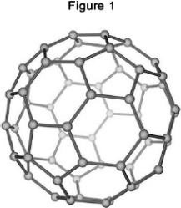

A lubricant is a substance that allows materials to move over each other easily.

Suggest why Buckminsterfullerene is a good lubricant.

Use **Figure 1**.

___________________________________________________________________

___________________________________________________________________

___________________________________________________________________

___________________________________________________________________

**(2)**

Silver can form cubic nanocrystals.

**Figure 2** represents a silver nanocrystal.

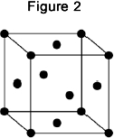

(e)     A silver nanocrystal is a cube of side 20 nm

Calculate the surface area to volume ratio of the nanocrystal.

___________________________________________________________________

___________________________________________________________________

___________________________________________________________________

___________________________________________________________________

___________________________________________________________________

Surface area to volume ratio = ____________________

**(3)**

(f)      Silver nanoparticles are sometimes used in socks to prevent foot odour.

Suggest why it is cheaper to use nanoparticles of silver rather than coarse particles of silver.

___________________________________________________________________

___________________________________________________________________

___________________________________________________________________

___________________________________________________________________

**(2)**

**Q2.**

This question is about the properties and uses of materials.

Use your knowledge of structure and bonding to answer the questions.

(a)     Explain how copper conducts electricity.

___________________________________________________________________

___________________________________________________________________

___________________________________________________________________

___________________________________________________________________

___________________________________________________________________

**(2)**

(b)     Explain why diamond is hard.

___________________________________________________________________

___________________________________________________________________

___________________________________________________________________

___________________________________________________________________

___________________________________________________________________

**(2)**

Mark schemes

**Q1.**

(c)     each (carbon) atom forms three covalent bonds **1**

forming layers (of hexagonal rings) **1**

(soft)

(because) layers can slide over each other **1**

(conducts electricity)

(because of) delocalised electrons **1**

(d)     molecules are spherical **1**

(so molecules) will roll **1**

(e)     surface area (= 20 × 20 × 6) = 2400 (nm 2) **1**

volume (= 203) = 8000 (nm 3) **1**

ratio = 0.3 (nm 3): 1 (nm 3)

ratio = 0.3 (nm 3): 1 (nm 3)

**or**

1 (nm 3): 3.33 (nm 3) **1**

(f)      (nanoparticles) have a larger surface area to volume ratio **1**

so less can be used for the same effect **1**

**Q2.**

(a)     has delocalised/free electrons **1**

(so electrons) can move through the structure/metal **1**

(b)     giant structure/giant lattice **1**

strong bonds/strong covalent bonds **1**

**Revision Homework 5: Chemistry**

**Section 1: Knowledge**

|  |  |  |  |
| --- | --- | --- | --- |
|  | **Topic:** | | **Acids and Alkalis (C.10)** |
| 1 | Which ions make a solution alkaline? | | OH- (hydroxide) |
| 2 | Which ions make a solution acidic? | | H+ |
| 3 | Give 3 ways to measure the pH of a substance | | Litmus paper, universal indicator, pH probe |
| 4 | What pH and colour is universal indicator in an strongly ACIDIC solution? | | pH 1 - 3 (red) |
| 5 | What pH and colour is universal indicator in an strongly ALKALINE solution? | | pH10-14 (purple) |
| 6 | What pH and colour is universal indicator in a weak ACID? | | pH 4-6 (orange/yellow) |
| 7 | What pH and colour is universal indicator in a weak ALKALI? | | pH8-9 (blue) |
| 8 | What colour is methyl orange in acid and alkali? | | Red (acid), orange (alkali) |
| 9 | What colour is phenolphthalein in acids and alkali? | | Colourless (acid), pink (alkali) |
| 10 | What is the difference between the solubility of alkalis and bases? | | Alkalis are soluble and bases are insoluble |
| 11 | What is the definition of a) strong acid and b) weak acid? | | a) Strong acid completely ionises (breaks down into its ions) in water, b) Weak acid partially ionises in water |
| 12 | Give 3 examples of a strong acid (H only) | | Hydrochloric acid, sulphuric acid, nitric acid |
| 13 | List the steps in making a soluble salt | | 1) Add solid to heated acid until no more reacts (in excess), 2) Filter excess solid, 3) Leave for 24hrs for water to evaporate (crystallisation), 4) Dab dry |
| 14 | State three examples of weak acids (H only) | | Ethanoic acid, citric acid and carbonic acid |
| 15 | What does a decrease in pH by one unit mean? (HT only) | | The hydrogen ion concentration increases by a factor of 10 |
|  | **Topic** | **Chemical calculations, volumes and concentrations** | |
| 1 | State the 'law of conservation of mass' | No atoms are lost or made during a chemical reaction | |
| 2 | The sum of the Mr of the reactants must equal | The sum of the Mr of the products | |
| 3 | State one example of when a reaction may APPEAR to lose mass | When a gas is produced and escapes | |
| 4 | State the value of Avogadro's constant (HT only) | 6.02 x 10 23 | |
| 5 | State the equation to calculate moles from mass and Mr (HT only) | Moles (mol) = mass (g) /Mr | |
| 6 | State how to calculate Mr (relative formula mass) | The sum of the Ar (atomic masses) of each atom | |
| 7 | State how to calculate atom economy (separate only) | (Mr of desired product / sum of Mr of all reactants) x 100 | |
| 8 | State how to calculate percentage yield (separate only) | (actual yield / theoretical yield) x 100 | |
| 9 | State how to calculate the mass of a reactant from a balanced symbol equation (separate only) | (mass of product / Mr of product) x Mr of reactant | |
| 10 | State how to calculate the mass of a product from a balanced symbol equation (separate only) | (mass of reactant / Mr of reactant) x Mr of product | |
| 11 | State how to calculate moles for gases (separate only) | volume (dm3) = moles (mol) x 24dm3 | |
| 12 | State how to calculate concentration (separate only) | concentration (mol/dm3) = moles (mol) / volume (dm3) | |
| 13 | State how to convert cm3 into dm3 (separate only) | Divide by 1000 | |
| 14 | When a symbol equation is balanced, what is shown by the large numbers in front of a formula e.g. 2HCl? | The ratio of moles of each substance | |
| 15 | What is the volume of 1 mole of any gas at room temperature and pressure? | 24dm3 | |

**Section 2:**Mastery matrix statements to be answered and then self-assessed using revision guide and knowledge

|  |
| --- |
| Identify the ions produced by different acids and alkalis |
| Describe the pH scale and how to test pH using universal indicator or a pH probe |
| Explain the difference between a strong and weak acid, giving examples (triple only) |
| Link pH changes to hydrogen ion concentration (triple only) |
| Describe neutralisation reactions (alkalis and bases, metal carbonates and acid) |
| Deduce the formulae of salts from their given ions |
| Explain the method for producing soluble salts |
| **Required practical 1: Prepare a pure dry sample of a soluble salt from an insoluble oxide or carbonate** |
| Recall the ionic equation for neutralisation |
| Explain how to use a titration to measure the volume of an acid or an alkali |

**Section 3: Exam questions**

**Q1.** This question is about acids and alkalis.

(a)  Dilute hydrochloric acid is a strong acid. Explain why an acid can be described as both strong and dilute.

___________________________________________________________________

___________________________________________________________________

___________________________________________________________________

___________________________________________________________________

**(2)**

(b)  A 1.0 × 10−3 mol/dm3 solution of hydrochloric acid has a pH of 3.0

What is the pH of a 1.0 × 10−5 mol/dm3 solution of hydrochloric acid?

pH = ___________________

**(1)**

A student titrated 25.0 cm3 portions of dilute sulfuric acid with a 0.105 mol/dm3 sodium hydroxide solution.

(c)  The table below shows the student’s results.

|  |  |  |  |  |  |
| --- | --- | --- | --- | --- | --- |
|  | **Titration 1** | **Titration 2** | **Titration 3** | **Titration 4** | **Titration 5** |
| Volume of sodium hydroxide solution in cm3 | 23.50 | 21.10 | 22.10 | 22.15 | 22.15 |

The equation for the reaction is:

2 NaOH + H2SO4 ⟶ Na2SO4 + 2 H2O

Calculate the concentration of the sulfuric acid in mol/dm3

Use only the student’s concordant results.

Concordant results are those within 0.10 cm3 of each other.

___________________________________________________________________

___________________________________________________________________

___________________________________________________________________

___________________________________________________________________

___________________________________________________________________

___________________________________________________________________

___________________________________________________________________

___________________________________________________________________

___________________________________________________________________

___________________________________________________________________

Concentration of sulfuric acid = ___________________ mol/dm3

**(5)**

(d)  Explain why the student should use a pipette to measure the dilute sulfuric acid and a burette to measure the sodium hydroxide solution.

___________________________________________________________________

___________________________________________________________________

___________________________________________________________________

___________________________________________________________________

**(2)**

(e)  Calculate the mass of sodium hydroxide in 30.0 cm3 of a 0.105 mol/dm3 solution.  
Relative formula mass (*M*r): NaOH = 40

___________________________________________________________________

___________________________________________________________________

___________________________________________________________________

___________________________________________________________________

Mass of sodium hydroxide = ___________________ g

**(2)**

**Q2.**

A student investigated the law of conservation of mass.

The law of conservation of mass states that the mass of the products is equal to the mass of the reactants.

This is the method used.

1. Pour lead nitrate solution into a beaker labelled **A**.

2. Pour potassium chromate solution into a beaker labelled **B**.

3. Measure the mass of both beakers and contents.

4. Pour the solution from beaker **B** into beaker **A**.

5. Measure the mass of both beakers and contents again.

When lead nitrate solution and potassium chromate solution are mixed, a reaction takes place.

This is the equation for the reaction:

Pb(NO3)2(aq) + K2CrO4(aq) ⟶ PbCrO4(s) + 2KNO3(aq)

(a)     What would the student see when the reaction takes place?

___________________________________________________________________

___________________________________________________________________

**(1)**

(b)     The table shows the student’s results.

|  |  |
| --- | --- |
|  | **Mass in g** |
| Beaker **A** and contents before mixing | 128.71 |
| Beaker **B** and contents before mixing | 128.97 |
| Beaker **A** and contents after mixing | 154.10 |
| Beaker **B** after mixing | 103.58 |

Show that the law of conservation of mass is true.

Use the data from the table above.

___________________________________________________________________

___________________________________________________________________

___________________________________________________________________

___________________________________________________________________

**(2)**

(c)     What is the resolution of the balance used to obtain the results in the table?

Tick (✔) **one** box.

|  |  |  |  |  |  |  |  |  |  |  |
| --- | --- | --- | --- | --- | --- | --- | --- | --- | --- | --- |
| 0.01 g |  |  | 0.1 g |  |  | 1 g |  |  | 100 g |  |

**(1)**

(d)     Calculate the relative formula mass (*M*r) of lead nitrate Pb(NO3)2

Relative atomic masses (*A*r): N = 14 O = 16 Pb = 207

___________________________________________________________________

___________________________________________________________________

___________________________________________________________________

___________________________________________________________________

Relative formula mass = ____________________

**(2)**

(f)      Another student also tests the law of conservation of mass using the same method.

The student uses a different reaction.

This is the equation for the reaction.

Na2CO3(aq) + 2HCI(aq) ⟶ 2NaCl(aq) + CO2(g) + H2O(I)

Explain why this student’s results would **not** appear to support the law of conservation of mass.

___________________________________________________________________

___________________________________________________________________

___________________________________________________________________

___________________________________________________________________

___________________________________________________________________

___________________________________________________________________

**(3)**

**(Total 10 marks)**

Mark schemes

**Q1.**

(a)  (strong because) completely ionised (in aqueous solution) **1**

(dilute because) small amount of acid per unit volume **1**

(b)  5.0 **1**

(c)  (titre):

chooses titrations 3, 4, 5 **1**

average titre = 22.13 (cm3) **1**

(calculation):

(moles NaOH =

  **1**

(moles H2SO4 =

½ × 0.002324 =) 0.001162 **1**

(concentration =



= 0.0465 (mol/dm3) **1**

*alternative approach for step 3, step 4 and step 5*

**

*(concentration H2SO4 =)*

**

*= 0.0465 (mol/dm3) (1)*

(d)  pipette measures a fixed volume (accurately) **1**

(but) burette measures variable volume

*allow can measure drop by drop* **1**

(e)  

**or** 0.00315 (mol)

**or**

(mass per dm3 =) 0.105 × 40

**or** 4.2 (g) **1**



= 0.126 (g) **1**

**Q2.**

(a)     precipitate / solid formed **1**

(b)     total mass before = 257.68 g

total mass after = 257.68 g **1**

so the mass of products equals

the mass of the reactants **1**

(c)     0.01 g **1**

(d)     207 + (2 × 14) + (6 × 16)

**or**

207 + 2 × [14 + (3 × 16)] **1**

= 331 **1**

(e)     CrO42− **1**

(f)      carbon dioxide is a gas **1**

the gas escapes during the reaction **1**

(so) the mass at the end is less than expected **1**

**Revision Homework 6: Chemistry**

**Section 1: Knowledge**

|  |  |  |
| --- | --- | --- |
|  | **Topic:** | **Electrolysis (C.12)** |
| 1 | Define 'electrolysis' | A substance is decomposed (broken down) using electricity |
| 2 | Why can electrolysis only occur if an ionic substance is molten or aqueous? | The ions are free to move |
| 3 | What is the name of the negative and positive electrode? | Negative: Cathode Positive: Anode |
| 4 | Which ions are attracted to the anode and which to the cathode? | Anode = negative Cathode = positive |
| 5 | Define "electrolyte" | Ions in a solution that are free to move and can conduct electricity |
| 6 | What happens when ions get to an electrode? | Gain or lose electrons becoming neutral atoms again |
| 7 | What happens at the anode? | Electrons transferred from the ion to the anode and the non-metal forms |
| 8 | What happens at the cathode? | Electrons transferred from the cathode to the ion and a metal is formed |
| 9 | When is hydrogen formed from an aqueous solution? | If the metal is MORE reactive than hydrogen |
| 10 | When is a metal (not hydrogen) formed from an aqueous solution? | If the metal is LESS reactive than hydrogen |
| 11 | State one use of electrolysis | Extracting a reactive metal from it's ore |
| 12 | Which useful product could be removed from the solution left after electrolysis of dilute sodium chloride solution? | Sodium hydroxide (bleach) |
| 13 | What would be formed at the anode in electrolysis of dilute sodium chloride solution? | Chlorine gas |
| 14 | What would be formed at the cathode in electrolysis of dilute sodium chloride solution? | Hydrogen |
| 15 | When will oxygen be produced at the anode? | When the solution does NOT contain HALIDE ions. Otherwise the halogen is produced. |
|  | | |
|  | **Topic:** | **Electrolysis & Half equations (HT mainly) (C.13)** |
| 1 | Write an ionic half equation for the reaction of the cathode in electrolysis of dilute sodium chloride solution (HT only) | 2H+ + 2e- -> H2 |
| 2 | Write an ionic half equation for the reaction of the anode in electrolysis of dilute sodium chloride solution (HT only) | 2Cl- -> Cl2 + 2e- |
| 3 | What would be produced at the anode in electrolysis of molten aluminium oxide? (HT only) | Oxygen |
| 4 | What would be produced at the cathode in electrolysis of molten aluminium oxide? (HT only) | Aluminium |
| 5 | Write an ionic half equation for the reaction at the anode in electrolysis of molten aluminium oxide (HT only) | 2O2- -> O2 + 4e- |
| 6 | Write an ionic half equation for the reaction at the cathode in electrolysis of molten aluminium oxide (HT only) | Al3+ + 3e- -> Al |
| 7 | What is the experiment called that allows you to find the concentration of an unknown substance? (separate only) | Titration |
| 8 | What is the piece of equipment called that is used to measure a very precise volume of a solution? (separate only) | Volumetric pipette |
| 9 | Which indicator is used in a titration? (separate only) | Methyl Orange |
| 10 | What is the ionic equation for a neutralisation reaction? (separate only) | H+(aq) + OH- (aq) -> H2O (l) |
| 11 | What is an advantage of using a pH probe rather than universal indicator? | pH probe is more precise |
| 12 | Recall the reactivity series of metals from most reactive to least reactive | Potassium, sodium, lithium, calcium, magnesium, aluminium, (carbon), zinc, iron, tin, lead, (hydrogen), copper, silver, gold, platinum |
| 13 | What is a displacement reaction | More reactive metal displaces less reactive metal from compound |
| 14 | What are the 4 state symbols? | (aq) (s) (l) (g) |
| 15 | Give one disadvantage of using electrolysis to extract a metal from it's ore | Uses lots of energy so expensive |

**Section 2:**Mastery matrix statements to be answered and then self-assessed using revision guide and knowledge

|  |  |
| --- | --- |
| 8.1. Describe how electrolysis is carried out (triple only) |  |
| Explain the electrolysis of molten compounds eg. Lead bromide (triple only) |  |
| 8.2. Predict what is produced at each electrode (triple only) |  |
| 8.3. I can write half equations for the reaction occurring at each electrode (triple only) |  |
| 8.4. I can explain how electrolysis can be used to extract metals from their ores (triple only) |  |
| 8.5. I can explain how electrolysis can be used to determine the presence of hydrogen in an aqueous solution (triple only) |  |
| **Required practical 3: Investigate what happens when aqueous solutions are electrolysed (including the development of a hypothesis) (triple only)** |  |

**Section 3: Exam questions**

**Q1.** This question is about zinc.

**Figure 1** shows the electrolysis of molten zinc chloride.

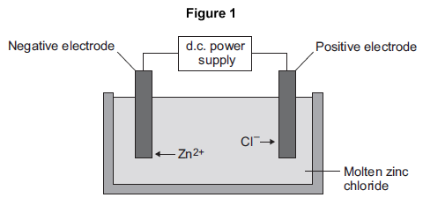

(a)     Zinc chloride is an ionic substance.

Complete the sentence.  
When zinc chloride is molten, it will conduct _________________________ .

**(1)**

(b)     Zinc ions move towards the negative electrode where they gain electrons to produce zinc.

(i)      Name the product formed at the positive electrode.

____________________________________

**(1)**

(ii)     Explain why zinc ions move towards the negative electrode.

______________________________________________________________

______________________________________________________________

______________________________________________________________

______________________________________________________________

**(2)**

(iii)    What type of reaction occurs when the zinc ions gain electrons?

|  |  |
| --- | --- |
| Tick (✔) **one** box. |  |
| Neutralisation |  |
| Oxidation |  |
| Reduction |  |

**(1)**

**Q2. T**his question is about magnesium and magnesium chloride.

(b)     Magnesium chloride can be electrolysed. The diagram below shows two experiments for electrolysing magnesium chloride.

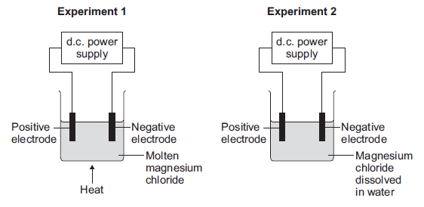

(i)      Explain why magnesium chloride must be molten or dissolved in water to be electrolysed.

______________________________________________________________

______________________________________________________________

______________________________________________________________

______________________________________________________________

**(2)**

(ii)     Explain how magnesium is produced at the negative electrode in **Experiment 1**.

______________________________________________________________

______________________________________________________________

______________________________________________________________

______________________________________________________________

______________________________________________________________

______________________________________________________________

**(3)**

(iii)    In **Experiment 2** a gas is produced at the negative electrode. Name the gas produced at the negative electrode.

____________________________________

**(1)**

(iv)     Suggest why magnesium is **not** produced at the negative electrode in **Experiment 2**.

______________________________________________________________

______________________________________________________________

**(1)**

(v)     Complete and balance the half equation for the reaction at the positive electrode.

_____ Cl⁻       →       Cl2       +       _____

**(1)**

**Q3.** Some students investigated reactions to produce magnesium.  
(a)     The students used electrolysis to produce magnesium from magnesium chloride, as shown in the figure below.

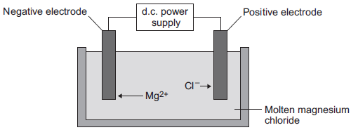

(i)      Magnesium chloride contains magnesium ions and chloride ions. Why does solid magnesium chloride **not** conduct electricity?

______________________________________________________________

______________________________________________________________

**(1)**

(ii)     One of the products of the electrolysis of molten magnesium chloride is magnesium.  
Name the other product.

______________________________________________________________

**(1)**

(iii)    Why do magnesium ions (Mg2+) move to the negative electrode?

______________________________________________________________

______________________________________________________________

**(1)**

(iv)    At the negative electrode, the magnesium ions (Mg2+) gain electrons to become magnesium atoms. How many electrons does each magnesium ion gain?

____________________

**(1)**

(b)     The students did the experiment four times and weighed the magnesium produced. The table below shows their results.

|  |  |
| --- | --- |
| **Experiment** | **Mass of magnesium  produced in grams** |
| 1 | 1.13 |
| 2 | 0.63 |
| 3 | 1.11 |
| 4 | 1.09 |

(i)      There is an anomalous result. Suggest **one** possible reason for the anomalous result.

______________________________________________________________

______________________________________________________________

**(1)**

(ii)     Calculate the mean mass of magnesium produced, taking account of the anomalous result.

______________________________________________________________

______________________________________________________________

______________________________________________________________

Mean mass = ____________________ g

**(2)**

Mark schemes

**Q1.**

(a)     electricity **1**

(b)     (i)      chlorine/Cl2 **1**

(ii)     (zinc ions are) positive **1**

and (opposite charges) attract **1**

(iii)     reduction **1**

**Q2.**

(b)     (i)      because ions can move **1**

(and ions move) to the electrodes

**or**

(and ions) carry charge

**1**

*accept converse for solid*

(ii)     magnesium (ions) attracted (to the electrode) **1**

so magnesium ions gain electrons **1**

2 electrons

*accept a correct half equation for 2nd* ***and*** *3rd marking points***1**

(iii)     hydrogen

*allow H2*

**1**

(iv)     magnesium is more reactive than hydrogen

*accept converse*

*allow magnesium is high in the reactivity series* ***or*** *magnesium is very/too reactive.*

*do* ***not*** *accept magnesium ions are more reactive than hydrogen ions*

**1**

(v)     **2** Cl- → Cl2 + **2e-**

*must be completely correct*

**1**

**Q3.**

(a)     (i)      ions cannot move

*allow only conducts as a liquid*

**1**

(ii)     chlorine

**1**

(iii)    they are positively / oppositely charged

**or**

they are attracted

**1**

(iv)    2

**1**

(b)     (i)      any **one** from:

•        not all the magnesium was collected

*allow some magnesium was lost*

•        *used less time* ***or*** *lower current* ***or*** *different battery / power pack* ***or*** *different balance* ***or*** *lower voltage*

•        error in reading balance

•        error in recording result

**1**

(ii)     1.11

*correct answer with or without working gains* ***2*** *marks.*

*if answer incorrect, allow* ***1*** *mark for 0.99*

***or*** *for 1.13 + 1.11 + 1.09*

**2**

**Revision Homework 7: Physics**

**Section 1: Knowledge**

|  |  |  |
| --- | --- | --- |
|  | **Topic** | **Transformers** |
| 1 | What makes up a transformer? (separate only) | Primary coil, secondary coil and iron core. |
| 2 | Why is iron used in a transformer? (separate only) | Iron is easily magnetised. |
| 3 | Recall the transformer equation (separate only) | Vp/Vs = Np/Ns |
| 4 | If Vs > Vp, is this a step up or step down transformer? | Step up transformer. |
| 5 | If Vs < Vp, is this a step up or step down transformer? | Step down transformer. |
| 6 | Recall the equation relating current and potential difference in each coil. | VsIs = VpIp |
| 7 | What does Vs stand for? | Potential difference in secondary coil |
| 8 | What does Is stand for? | Current in secondary coil |
| 9 | What does Vs stand for? | Potential difference in primary coil |
| 10 | What does Is stand for? | Current in primary coil |
| 11 | State the effect of step up transformers on current and potential difference | ↑ p.d., ↓ current |
| 12 | State the effect of step down transformers on current and potential difference | ↓ p.d., ↑current |
| 13 | Why are step up transformers used? | To reduce energy loss from cables (thermal) |
| 14 | Why are step down transformers used? | To reduce the potential difference to make it safe for domestic use. |
| 15 | Why is the national grid efficient? | Transformers reduces heat loss from wires when electricity travels long distances |

|  |  |  |
| --- | --- | --- |
|  | **Topic** | **Electromagnetic induction** |
| 1 | How is a potential difference 'induced' in a wire? | An electrical conductor moves in a magnetic field or a magnet is moved into a coil of wire |
| 2 | When does an induced potential difference cause an induced current? | When the wire is in a complete circuit |
| 3 | What is the name given to a current being induced in a conductor? | The generator effect |
| 4 | When a current is induced in a wire, what is produced? | A magnetic field that opposes the original change |
| 5 | What effects the direction of induced potential difference/induced current | Direction of the movement of the conductor or magnet |
| 6 | State 3 factors that increase the induced potential difference/current | 1) increased speed of movement, 2) increased magentic field strength, 3) number of coils increases |
| 7 | State one device that makes use of the generator effect | Microphones |
| 8 | How does a microphone work? | Air particles oscillate (sound wave) which causes diaphragm of microphone to oscilate which causes a magnet to move into and out of coil of wire inducing oscillating current |
| 9 | What is a transformer made out of? | A primary and secondary coil |
| 10 | What is used to make the core of the transformer? | Iron |
| 11 | Why is an iron core used? | Easily magnetised |
| 12 | What is the equation used to calculate current and voltage in the primary and secondary coil? | V(s) x I (s) = V (p) x I (p) |
| 13 | How does a transformer work? | A.C. in primary coil -> alternating magnetic field -> induced alternating P.D. in secondary coil |
| 14 | Which has more coils in a step-up transformer? | Secondary coil |
| 15 | Which has more coils in a step-down transformer? | Primary coil |

**Section 2:**Mastery matrix statements to be answered and then self-assessed using revision guide and knowledge

|  |
| --- |
| 6.1 Describe the components of the national grid |
| 6.2 Explain the role of step up and step down transformers in the national grid and use this to explain why it is an efficient system for transferring energy |
| 6.3 Describe the structure of a transformer (triple only) |
| 6.4 Use and rearrange the transformer equation (PLEASE ADD IN!) (triple only) |
| 6.5 Apply this equation to describe the efficiency of transformers and the purpose of step up and step down transformers (triple only) |
| 6.6 Use the coil equation (PLEASE ADD IN!) and relate this to power input and output (triple only) |
| 6.7 Apply these equations to explain the advantages of transmitting energy at a high potential difference. |

**Section 3: Exam questions**   
**Q1. Figure 1** shows the construction of a simple transformer.

**Figure 1**

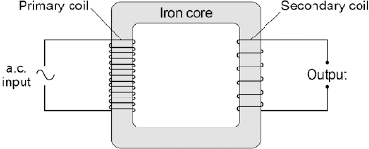

(a)     Why is iron a suitable material for the core of a transformer?

|  |  |
| --- | --- |
| Tick **one** box. |  |
| It is a metal. |  |
| It will not get hot. |  |
| It is easily magnetised. |  |
| It is an electrical conductor. |  |

**(1)**

(b)     A student makes three simple transformers, **J**, **K** and **L**. **Figure 2** shows how the potential difference across the secondary coil of each transformer varies as the potential difference across the primary coil of each transformer is changed. **Figure 2**

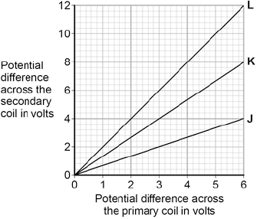

How can you tell that transformer **J** is a step-down transformer?

___________________________________________________________________

___________________________________________________________________

**(1)**

(c)     Each of the transformers has 50 turns on the primary coil.

Calculate the number of turns on the secondary coil of transformer **L**.

Use the correct equation from the Physics Equations Sheet.

___________________________________________________________________

___________________________________________________________________

___________________________________________________________________

Number of turns on the secondary coil = ________________

**(3)**

**(Total 5 marks)**

**Q2.** Transformers are used to change potential differences (p.d.) in the National Grid.

**Figure 1** shows a step-up transformer that is used at a power station.

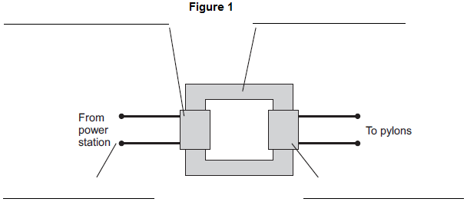

(a)     (i)      Use words from the box to label **Figure 1**.

|  |  |  |
| --- | --- | --- |
| **Input p.d.** | **Iron core** | **Output p.d.** |
| **Primary coil** | **Secondary coil** | |

**(4)**

(ii)     One of the coils in **Figure 1** has a p.d. of 25 kV across it and has 1000 turns.

The other coil has a p.d. of 400 kV across it.

Calculate the number of turns on this other coil.

______________________________________________________________

______________________________________________________________

______________________________________________________________

______________________________________________________________

Number of turns = ____________________

**(2)**

(iii)    Explain why a step-up transformer is used at a power station.

______________________________________________________________

______________________________________________________________

______________________________________________________________

______________________________________________________________

______________________________________________________________

______________________________________________________________

**(3)**

(b)     **Figure 2** shows a mobile phone charger.

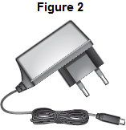

The charger contains a step-down transformer. A switch mode transformer is used rather than a traditional transformer.

Describe the advantages of using a switch mode transformer in the charger rather than a traditional transformer.

___________________________________________________________________

___________________________________________________________________

___________________________________________________________________

___________________________________________________________________

___________________________________________________________________

___________________________________________________________________

**(3)**

**Q3.** A student used a simple transformer to investigate how the number of turns on the secondary coil affects the potential difference (p.d.) across the secondary coil. The student kept the p.d. across the primary coil fixed at 2V. **Figure 1** shows the results collected by the student.

**Figure 1**

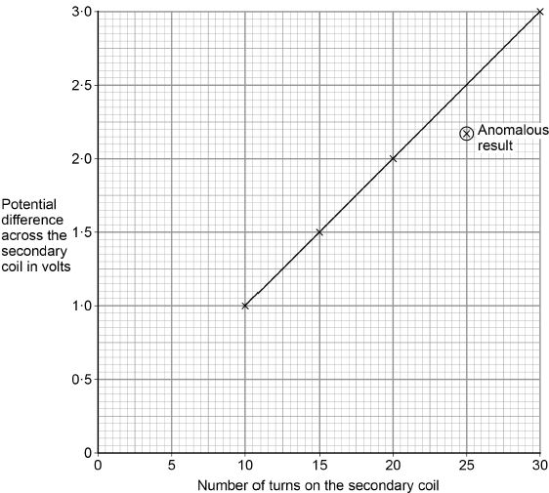

(a)  **Figure 1** contains one anomalous result. Suggest **one** possible reason why this anomalous result occurred.

___________________________________________________________________

___________________________________________________________________

**(1)**

(b)  The transformer changes from being a step-down to a step-up transformer. How can you tell from **Figure 1** that this happens?

___________________________________________________________________

___________________________________________________________________

___________________________________________________________________

**(1)**

A spot-welder is a device that uses a transformer to produce a large current to join sheets of metal together. **Figure 2** shows a transformer demonstrating how a large current can heat and join two nails together. **Figure 2**

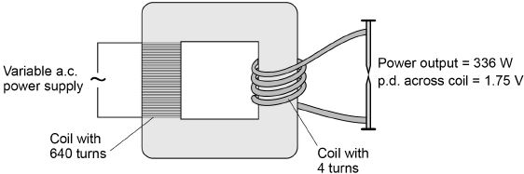

(c)  How does the amount of infrared radiation emitted by the nails change when the power supply is switched on?

___________________________________________________________________

___________________________________________________________________

**(1)**

(d)  Calculate the current from the power supply needed to provide a power output of 336 W.

Use the data in **Figure 2**.

The transformer is 100% efficient.

___________________________________________________________________

___________________________________________________________________

___________________________________________________________________

___________________________________________________________________

___________________________________________________________________

___________________________________________________________________

Current = _____________________ A

**(5)**

**(Total 8 marks)**

Mark schemes

**Q1.**

(a)     It is easily magnetised. **1**

(b)     p.d. across the secondary coil is smaller (than p.d. across the primary coil) **1**

(c)     ratio Vp   =  6

Vs     12

*accept any other correct ratio taken from the graph* **1**

6 = 50

12   Np

*use of the correct turns ratio and substitution or correct transformation and substitution* **1**

Np = 100 **1**

**[5]**

**Q2.**

(a)     (i)

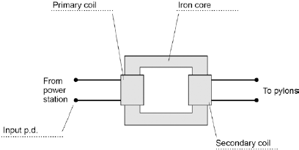

**1**

**1**

**1**

**1**

(ii)     16 000

*allow 1 mark for correct substitution*

*ie 400 ÷ 25 = n ÷ 1000*

**2**

(iii)    p.d. increased (by transformer at power station)

*do not accept energy increased*

**1**

so current decreases

**1**

this reduces energy / power loss (in cables)

*allow heat for energy*

*allow increases the efficiency*

*do* ***not*** *accept no energy losses*

**1**

(b)     smaller / lighter **1**

uses little power / energy **1**

when left switched on with no load applied

*dependent on second marking point* **1**

**[12]**

**Q3.**

(a)  any **one** from:

•   too few turns / coils on the secondary

*allow number of turns / coils on the primary was increased*

•   p.d. across the primary was reduced

*ignore human error*

**1**

(b)  the p.d. (across the secondary) goes above 2V

*allow p.d. across secondary is higher than p.d. across primary after 20 turns*

**1**

(c)  it increases (until the nails reach a constant temperature)

**1**

(d)  

**1**



**1**

Vp = 280 (V)

**1**

280 × Ip = 336 **1**

Ip = 1.2 (A) **1**

**or**

336 = Is × 1.75 (1)



Is = 192 (A) (1)



Ip = 1.2 (A) (1)

**Revision Homework 8: Physics**

**Section 1: Knowledge**

|  |  |  |
| --- | --- | --- |
|  | **Topic:** | **Radioactive decay and radiation (P.22)** |
| 1 | What two words can we use to describe the process of radioactive decay? | Random and unpredictable |
| 2 | What is the word to describe the rate at which a source of unstable nuclei decays | Activity |
| 3 | What is the word to describe the number of decays recorded each second by a detector | Count rate |
| 4 | What is the equipment for measuring radiation. | Geiger-Muller tube |
| 5 | Name the four types of nuclear radiation | alpha particle, beta particle, gamma ray, neutron |
| 6 | Describe the structure of an alpha particle | 2 neutrons & 2 protons (helium nucleus) |
| 7 | What is a beta particle? | A negative electron |
| 8 | What is a gamma ray? | An electromagnetic wave |
| 9 | Three main types of radiation in order of high to low ionising power. | alpha, beta, gamma |
| 10 | Three main types of radiation in order of high to low penetrating power. | gamma, beta, alpha |
| 11 | Which materials are able to stop each type of radiation? | Alpha = paper, beta = aluminium, gamma = nothing, thick lead absorbs some of it |
| 12 | Distances alpha, beta and gamma can go in air. | Alpha: 3-5cm, Beta: ~1m, Gamma: several hundred km |
| 13 | Define "irradiation" | Exposing an object to nuclear radiation.  The irradiated object does not become radioactive. |
| 14 | Define "half life" | The time it takes for the number of unstable nuclei of the isotope in a sample to halve |
| 15 | Define "radioactive contamination" | The unwanted presence of radioactive atoms on other materials |
|  |  |  |
|  | **Topic:** | **Background decay and radiation (P.23)** |
| 1 | State two natural sources of background radiation | Rocks and cosmic rays |
| 2 | State two man made sources of background radiation | Fallout from nuclear weapons testing, nuclear accidents |
| 3 | Define 'background radiation' | Radiation around us all the time. |
| 4 | Define 'radiation dose' | The amount of radiation that is absorbed by a person (Sv) |
| 5 | Would a long or short half life radioactive material be more dangerous in the long term? | Long half life material. |
| 6 | State 2 medical uses of nuclear radiation | Exploring internal organs, control/destruction of unwanted tissue. |
| 7 | Why is using nuclear radiation to treat a tumour a risk? | The radiation might cause a tumour |
| 8 | Give an example of an internal organ that would be explored with radiation | Intestines - to look for blockages. |
| 9 | Would you use a short or long half life material for using a tracer in the intestine? | Short - an hour or so - you don't want to leave the hospital if you are still give out high levels of radiation. |
| 10 | What kind of radiation is used to look at internal organs? | Beta |
| 11 | Why can't alpha be used to look at internal organs? | Stopped by skin |
| 12 | What kind of radiation is used to destroy tumours? | Gamma rays (sometimes beta) |
| 13 | Why is gamma used to destroy tumours? | Ionising & can penetrate the skin and bones |
| 14 | Why is a long half life material high risk? | It will still be giving out radiation in years to come |
| 15 | State 2 factors that affect the amount of background radiation people are exposed to | Occupation (job) & location |

**Section 2:**Mastery matrix statements to be answered and then self-assessed using revision guide and knowledge

|  |
| --- |
| Describe what radioactive decay is |
| Recall the definition and units for activity and count rate |
| Describe what makes up alpha, beta, gamma and neutron radiation |
| Describe the properties of each type of radiation |
| Use nuclear equations to represent radioactive decay |
| Define half-life |
| Complete half-life calculations from graphs or other data |
| Use ratios to describe radioactive decay (HT only) |
| Describe the impact and precautions for radioactive contamination |
| Analyse data about the effects of radiation on people |
| Describe sources of background radiation (separate only) |
| Define dose and recall it’s units (separate only) |
| Link stability to half-life and the hazard level (separate only |
| Describe how radiation is used in medicine (separate only) |
| Evaluate the risks associated with using radiation in medicine (separate only) |

**Section 3: Exam questions**

**Q1.**

A teacher used a Geiger-Muller tube and counter to measure the number of counts in 60 seconds for a radioactive rock.

(a)  The counter recorded 819 counts in 60 seconds. The background radiation count rate was 0.30 counts per second.

Calculate the count rate for the rock.

___________________________________________________________________

___________________________________________________________________

___________________________________________________________________

___________________________________________________________________

Count rate = ______________________ per second

**(3)**

(b)  A householder is worried about the radiation emitted by the granite worktop in his kitchen.

1 kg of granite has an activity of 1250 Bq. The kitchen worktop has a mass of 180 kg.

Calculate the activity of the kitchen worktop in Bq.

___________________________________________________________________

___________________________________________________________________

___________________________________________________________________

___________________________________________________________________

Activity = ___________________ Bq

**(2)**

(c)  The average total radiation dose per year in the UK is 2.0 millisieverts.

The table below shows the effects of radiation dose on the human body.

|  |  |
| --- | --- |
| **Radiation dose in millisieverts** | **Effects** |
| 10 000 | Immediate illness; death within a few weeks |
| 1000 | Radiation sickness; unlikely to cause death |
| 100 | Lowest dose with evidence of causing cancer |

The average radiation dose from the granite worktop is 0.003 millisieverts per day.

Explain why the householder should **not** be concerned about his yearly radiation dose from the granite worktop.

One year is 365 days.

___________________________________________________________________

___________________________________________________________________

___________________________________________________________________

___________________________________________________________________

**(2)**

(d)  Bananas are a source of background radiation. Some people think that the unit of radiation dose should be changed from sieverts to Banana Equivalent Dose.

Suggest **one** reason why the Banana Equivalent Dose may help the public be more aware of radiation risks.

___________________________________________________________________

___________________________________________________________________

___________________________________________________________________

___________________________________________________________________

**(1)**

**(Total 8 marks)**

**Q2.** Smoke alarms contain an alpha radiation source and a radiation detector. **Figure 1** shows part of the inside of a smoke alarm.

**Figure 1**

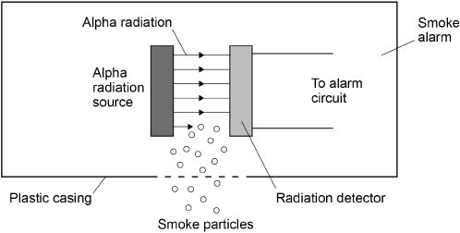

(a)  The smoke alarm stays off while alpha radiation reaches the detector.

Why does the alarm switch on when smoke particles enter the plastic casing?

___________________________________________________________________

___________________________________________________________________

___________________________________________________________________

**(1)**

(b)  Why is it safe to use a source of alpha radiation in a house?

___________________________________________________________________

___________________________________________________________________

___________________________________________________________________

**(1)**

(c)  The smoke alarm would not work with a radiation source that emits beta or gamma radiation. Explain why.

___________________________________________________________________

___________________________________________________________________

___________________________________________________________________

___________________________________________________________________

**(2)**

(d)  **Figure 2** shows how the count rate detected from the radiation source in the smoke alarm changes with time.

**Figure 2**

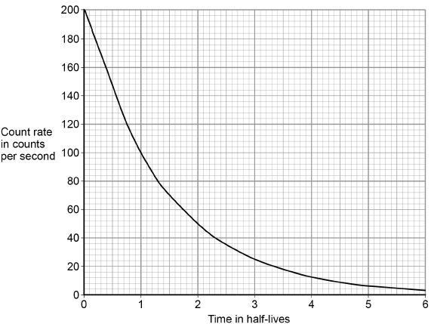

The smoke alarm switches on when the count rate falls to 80 counts per second.

Explain why the radiation source inside the smoke alarm should have a long half-life.

___________________________________________________________________

___________________________________________________________________

___________________________________________________________________

___________________________________________________________________

**(2)**

(e)  A patient who been injected with a radioactive source for medical diagnosis.

Explain the ideal properties of a radioactive source for use in medical diagnosis.

___________________________________________________________________

___________________________________________________________________

___________________________________________________________________

___________________________________________________________________

___________________________________________________________________

___________________________________________________________________

___________________________________________________________________

___________________________________________________________________

**(4)**

**(Total 10 marks)**

**Q3.**

Alpha particles, beta particles and gamma rays are types of nuclear radiation.

(a)     Describe the structure of an alpha particle.

___________________________________________________________________

___________________________________________________________________

**(1)**

(b)     Nuclear radiation can change atoms into ions by the process of ionisation.

(i)      Which type of nuclear radiation is the least ionising?

Tick (✔) **one** box.

|  |  |
| --- | --- |
| alpha particles |  |
| beta particles |  |
| gamma rays |  |

**(1)**

(ii)     What happens to the structure of an atom when the atom is ionised?

______________________________________________________________

______________________________________________________________

**(1)**

(c)     People working with sources of nuclear radiation risk damaging their health.

State **one** precaution these people should take to reduce the risk to their health.

___________________________________________________________________

___________________________________________________________________

**(1)**

**(Total 4 marks)**

Mark schemes

**Q1.**

(a)  

**1**

count rate = 13.65

**1**

corrected count rate = 13.35 (per second)

*allow an answer of*

*background = 0.30 × 60*

*= 18 (per minute)*

*corrected count rate*

*= 819 – 18*

*corrected count rate*

*= 801 per minute*

**1**

*an answer of 13.35 (per second) scores* ***3*** *marks*

*an answer of 13.95 (per second) scores* ***2*** *marks*

*an answer of 801 (per second) scores* ***2*** *marks*

(b)  activity = 1250 × 180

**1**

activity = 225 000 (Bq)

**1**

*an answer of 225 000 (Bq) scores* ***2*** *marks*

(c)  yearly dose = 0.003 × 365

*allow yearly dose = 1.095 (mSv)*

**1**

which is << 100 (mSv)

**or**

(well) below the lowest dose with evidence of causing cancer / harm

**1**

(d)  people are able to compare a radiation risk / dose / hazard to the radiation dose from (eating) bananas

**1**

**[8]**

**Q2.**

(a)  smoke absorbs / stops alpha radiation

*allow alpha particles for alpha radiation*

*alpha radiation does not reach the detector is insufficient*

**1**

(b)  alpha radiation is not very penetrating

*allow alpha particles for alpha radiation*

**or**

alpha radiation does not penetrate skin

*allow alpha radiation does not travel very far (in air)*

**1**

(c)  beta and gamma radiation will penetrate smoke

*allow beta and gamma radiation will not be stopped by smoke*

**1**

no change (in the count rate) would be detected

*allow the change detected (in the count rate) would be too small*

**1**

(d)  (a long half-life means) the count rate is (approximately) constant

*allow activity of source is (approximately) constant*

**or**

a short half-life means the count rate decreases quickly

**1**

until 1.3 half-lives the count rate is above 80 per second

*allow after 1.3 half-lives the count rate is below 80 per second*

**or**

until 1.3 half-lives the count rate is above the threshold for the smoke alarm to be activated

**or**

after 1.3 half-lives the smoke alarm will be activated all the time

*so don’t have to replace source or smoke detector is insufficient*

**1**

(e)  **Level 2:** Relevant points (reasons / causes) are identified, given in detail and logically linked to form a clear account.

**3−4**

**Level 1:** Relevant points (reasons / causes) are identified, and there are attempts at logically linking. The resulting account is not fully clear.

**1−2**

**No relevant content**

**0**

**Indicative content**

•   short half-life or half-life of a few hours

•   (short half-life means) less damage to cells / tissues / organs / body

•   low ionising power

•   (low ionising power means) less damage to cells / tissues / organs / body

•   highly penetrating

•   (highly penetrating means) it can be detected outside the body

•   emits gamma radiation

**[10]**

**Q3.**

(a)     2 protons and 2 neutrons

*accept 2p and 2n*

*accept (the same as a) helium nucleus*

*symbol is insufficient*

*do not accept 2 protons and neutrons*

**1**

(b)     (i)      gamma rays

**1**

(ii)     loses/gains (one or more) electron(s)

**1**

(c)     any **one** from:

•        wear protective clothing

•        work behind lead/concrete/glass shielding

•        limit time of exposure

•        use remote handling

*accept wear mask/gloves*

*wear goggles is insufficient*

*wear protective equipment/gear is insufficient*

*accept wear a film badge*

*accept handle with (long) tongs*

*accept maintain a safe distance*

*accept avoid direct contact*

**1**

**[4]**

**Revision Homework 9: Physics**

**Section 1: Knowledge**

|  |  |  |
| --- | --- | --- |
|  | **Topic:** | **Changes of state, latent heat and specific heat capacity (P.26)** |
| 1 | Define 'conservation of mass' | Total mass is the same before and after a reaction |
| 2 | Why does temperature not change during a state change? | Energy used to make/break bonds increasing the internal energy not temperature |
| 3 | Define "internal energy" | Energy stored inside a system by the particles |
| 4 | How do we calculate internal energy? | Sum kinetic and potential energy of all particles |
| 5 | How does heating affect the internal energy of a system? | It increases it |
| 6 | State the equation for change in thermal energy | ∆ E = m c ∆ θ Change in energy (J) = mass (kg) x specific heat capacity (J/Kg°C) x change in temperature (°C) |
| 7 | State the units for specific heat capacity | Joules per kilogram per degree Celsius, J/kg °C |
| 8 | Define "specific heat capacity" | Amount of energy required to raise the temperature of one kilogram of the substance by one degree Celsius. |
| 9 | Define "latent heat" | The energy needed for a substance to change state |
| 10 | Define "specific latent heat of vaporisation" | The amount of energy required to boil one kilogram of the substance with no change in temperature |
| 11 | Define "specific latent heat of fusion" | The amount of energy required to change the state of a solid to a liquid without a change in temperature |
| 12 | Equation for specific latent heat. | E = m L Energy (J) = mass (kg) x specific latent heat (J/kg) |
| 13 | State the units for specific latent heat | Joules per kilogram, J/kg |
| 14 | Describe the key property of a substance with a high specific heat capacity | Will store a lot of energy per kilogram |
| 15 | What does a flat section on a heating and cooling graph represent? | Changes of state |
|  | | |
|  | **Topic:** | **Gas and fluid pressure (paper 1) (P.27)** |
| 1 | Describe the motion of particles in a gas. | Random movement |
| 2 | How do we determine the temperature of a gas? | Average kinetic energy of the molecules |
| 3 | State two factors that will influence gas pressure | 1) temperature, 2) volume |
| 4 | If a gas is held at a constant volume, describe the relationship between temperature and pressure | Directly proportional |
| 5 | Why does increasing temperature increase the pressure of a gas (if held at a constant volume)? | Particles collide with the side of the container: (a) more frequently and (b) with more energy |
| 6 | State the two effects that pressure changes can have two effects on a gas (separate only) | Gas is compressed or expands |
| 7 | Define "gas pressure" (separate only) | The force per unit area that the gas exerts on the walls of its container. |
| 8 | Describe the relationship between volume and gas pressure (at a constant temperature) (separate only) | Inversely proportional |
| 9 | Explain why an increase in volume causes a decrease in gas pressure (separate only) | (a) Fewer collisions with the wall (b) less energy in collisions |
| 10 | Write Boyle's law in words (separate only) | Pressure x volume = constant |
| 11 | Write Boyle's law as an equation (separate only) | p V = C or P1V1=P2V2 |
| 12 | What is meant by this symbol "∝"? (separate only) | Proportional |
| 13 | Gas pressure causes a force at ___degrees to the container wall. | 90 |
| 14 | State 2 factors that increase when work is done on a gas | Internal energy and temperature |
| 15 | State a situation where doing work on a gas increases the temperature | Bicycle pump |

**Section 2:**Mastery matrix statements to be answered and then self-assessed using revision guide and knowledge

|  |
| --- |
| Explain and calculate ‘specific latent heat’ using the E=mL |
| Interpret heating and cooling graphs that include changes of state |
| Explain the differences between ‘heat’ and ‘temperature’ |
| Define and calculate specific heat capacity |
| Use and rearrange equations for calculating specific heat capacity |
| RP Specific Heat Capacity: Investigate the specific heat capacity of materials |
| Distinguish between specific heat capacity and specific latent heat |

**Section 3: Exam questions**

**Q1.** Two students investigated the change of state of stearic acid from liquid to solid.

They measured how the temperature of stearic acid changed over 5 minutes as it changed from liquid to solid.

**Figure 1** shows the different apparatus the two students used.

**Figure 1**

**Student A’s apparatus**                  **Student B’s apparatus**

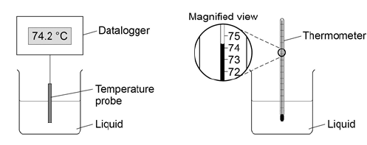

(a)     Choose **two** advantages of using student **A**’s apparatus.

|  |  |
| --- | --- |
| Tick **two** boxes. |  |
| Student **A**’s apparatus made sure the test was fair. |  |
| Student **B**’s apparatus only measured categoric variables. |  |
| Student **A**’s measurements had a higher resolution. |  |
| Student **B** was more likely to misread the temperature. |  |

**(2)**

(b)     Student **B** removed the thermometer from the liquid each time he took a temperature reading.

What type of error would this cause?

|  |  |
| --- | --- |
| Tick **one** box. |  |
| A systematic error |  |
| A random error |  |
| A zero error |  |

**(1)**

(c)     Student **A**’s results are shown in **Figure 2**.

**Figure 2**

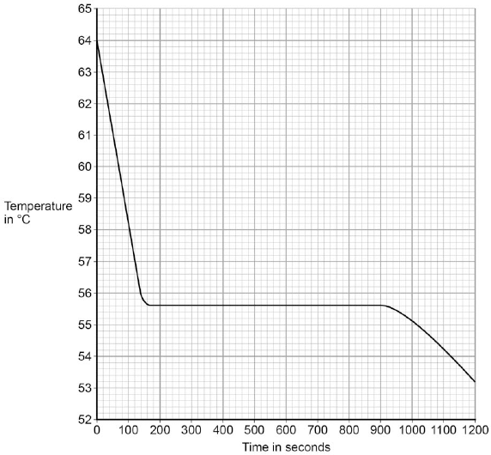

What was the decrease in temperature between 0 and 160 seconds?

|  |  |
| --- | --- |
| Tick **one** box. |  |
| 8.2 °C |  |
| 8.4 °C |  |
| 53.2 °C |  |
| 55.6 °C |  |

**(1)**

(d)     Use **Figure 2** to determine the time taken for the stearic acid to change from a liquid to a solid.

Time = ____________ seconds

**(1)**

(e)     Calculate the energy transferred to the surroundings as 0.40 kg of stearic acid changed state from liquid to solid.

The specific latent heat of fusion of stearic acid is 199 000 J / kg.

Use the correct equation from the Physics Equations Sheet.

___________________________________________________________________

___________________________________________________________________

___________________________________________________________________

Energy = _____________________ J

**(2)**

(f)     After 1200 seconds the temperature of the stearic acid continued to decrease.

Explain why.

___________________________________________________________________

___________________________________________________________________

___________________________________________________________________

___________________________________________________________________

**(2)**

**(Total 9 marks)**

**Q2. A** cyclist riding along a flat road.

(c)  When the cyclist uses the brakes, the bicycle slows down.

This causes the temperature of the brake pads to increase by 50 °C.

The mass of the brake pads is 0.040 kg.

The specific heat capacity of the material of the brake pads is 480 J/kg °C.

Calculate the change in thermal energy of the brake pads.

Use the equation:

change in thermal energy = mass × specific heat capacity × temperature change

___________________________________________________________________

___________________________________________________________________

___________________________________________________________________

Change in thermal energy = ______________________ J

**(2)**

(d)  How is the internal energy of the particles in the brake pads affected by the increase in temperature?

Tick **one** box.

|  |  |
| --- | --- |
| Decreased |  |
| Increased |  |
| Not affected |  |

**(1)**

**Q3.** Under the same conditions, different materials heat up and cool down at different rates.

(a)     What is meant by specific heat capacity?

___________________________________________________________________

___________________________________________________________________

___________________________________________________________________

___________________________________________________________________

**(2)**

(b)     ‘Quenching’ is a process used to change the properties of steel by cooling it rapidly.

The steel is heated to a very high temperature and then placed in a container of cold water.

(i)      A metalworker quenches a steel rod by heating it to a temperature of 900 °C before placing it in cold water. The mass of the steel rod is 20 kg.

The final temperature of the rod and water is 50 °C.

Calculate the energy transferred from the steel rod to the water.

Specific heat capacity of steel = 420 J/kg °C.

______________________________________________________________

______________________________________________________________

______________________________________________________________

Energy transferred = ____________________ J

**(3)**

(ii)     The temperature of the steel rod eventually returns to room temperature.

Compare the movement and energies of the particles in the steel rod and in the air at room temperature.

______________________________________________________________

______________________________________________________________

______________________________________________________________

______________________________________________________________

______________________________________________________________

______________________________________________________________

**(3)**

(iii)    When the steel rod is being quenched, the temperature of the water rises to 50 °C. After a few hours the water cools down to room temperature.

Some of the cooling of the water is due to evaporation.

Explain in terms of particles how evaporation causes the cooling of water.

______________________________________________________________

______________________________________________________________

______________________________________________________________

______________________________________________________________

______________________________________________________________

______________________________________________________________

______________________________________________________________

______________________________________________________________

______________________________________________________________

______________________________________________________________

**(4)**

**(Total 12 marks)**

Mark schemes

**Q1.**

(a)     Student A’s measurements had a higher resolution

**1**

Student B was more likely to misread the temperature

**1**

(b)     a random error

**1**

(c)     8.4 °C

**1**

(d)     740 (seconds)

*allow answers in the range 730 – 780*

**1**

(e)     0.40 × 199 000

**1**

79 600 (J)

**1**

*accept 79 600 (J) with no working shown for* ***2*** *marks*

(f)     stearic acid has a higher temperature than the surroundings

*accept stearic acid is hotter than the surroundings*

**1**

temperature will decrease until stearic acid is the same as the room temperature / surroundings

**1**

**[9]**

**Q2.**

(c)  E = 0.040 × 480 × 50

**1**

E = 960 (J)

**1**

*an answer of 960 (J) scores* ***2*** *marks*

(d)  increased

**1**

**[7]**

**Q3.**

(a)     energy required to raise the temperature of a substance by 1 °C

*accept heat for energy*

**1**

unit mass / 1 kg

**1**

(b)     (i)      7 140 000 (J)

*allow 2 marks for a correct substitution, ie*

*E = 20 × 420 × 850*

*provided no subsequent step*

*850 gains* ***1*** *mark if no other mark awarded*

**3**

(ii)     particles in the air have more (kinetic) energy than the particles in the steel

*allow particles in the air have a greater speed.*

**1**

**steel**

particles vibrate (about fixed positions)

**1**

**air**

particles move freely

**1**

(ii)     the most energetic particles

*accept molecules for particles throughout*

*accept the fastest particles*

**1**

have enough energy to escape from (the surface of) the water

**1**

therefore the mean energy of the remaining particles decreases

*accept speed for energy*

**1**

as energy decreased, temperature has decreased

**1**

**[12]**

**Revision Homework 10: Biology**

**Section 1: Knowledge**

|  |  |  |
| --- | --- | --- |
|  | **Topic** | **Parts of the cell** |
| 1 | What is the main difference between a prokaryotic and eukaryotic cell? | Eukaryotic have their DNA contained within a nucleus |
| 2 | Give an example of a eukaryotic cell. | Animal and plant cells |
| 3 | Give an example of a prokaryotic cell. | Bacteria |
| 4 | Eukaryotic cells have which sub-cellular structures? | Cell membrane, cytoplasm and genetic material in a nucleus. |
| 5 | What is the function of cell wall? | Supports/ Strengthens the cell |
| 6 | What is the function of mitochondria? | Where respiration takes place |
| 7 | What is the function of the nucleus? | Controls the activities of the cell |
| 8 | What us the function of cell membrane? | Controls what enters/exits the cell |
| 9 | What is the function of the vacuole? | Store sugars and salts |
| 10 | What is the function of chloroplasts? | Absorb light for photosynthesis |
| 11 | What is the function of cytoplasm? | Where chemical reactions of the cell takes place |
| 12 | What is the approximate size of a prokaryotic cell | 0.1-5.0 μm |
| 13 | What is the approximate size of a eukaryote cells | 10-100µm |
| 14 | Which is bigger? A prokaryotic or eukaryotic cell? | Eukaryotic |
| 15 | What is meant by "micro" | 1/1,000,000th (1 millionth) |
|  |  |  |
|  | **Topic:** | **Specialised cells (B.2)** |
| 1 | Define "cell differentiation" | A cell becoming specialised to perform a particular function |
| 2 | Define "cell division" | The splitting of a cell into two genetically identical daughter cells |
| 3 | Name 3 specialised cells found in the animals and 3 in plants | Animals: Muscle cell, nerve cell, sperm cell Plants: Root hair cell, phloem, xylem |
| 4 | State the function of a muscle cell | Produce movement |
| 5 | State one adaptation of a muscle cell | Lots of mitochondria for releasing energy |
| 6 | State the function of a sperm cell | Fertilise the female egg |
| 7 | State three adaptations of a sperm cell | *Tail for movement *Lots of mitochondria to release energy *Enzymes in it's head to penetrate egg |
| 8 | State the function of a nerve cell | Carry information from one part of the body to another |
| 9 | State two adaptations of a nerve cell | *Dendrites to connect to other neurones *Long axon to cover large distances |
| 10 | State the function of a root hair cell | Absorb water and minerals from the soil |
| 11 | State two adaptations of a root hair cell | *Large surface area *Thin cell wall |
| 12 | State the function of a xylem cell | Carry water from roots to leaves |
| 13 | State two adaptations of a xylem cell | *Lignin to strengthen cells *End walls broken down to form hollow tubes |
| 14 | State the function of a phloem cell | Transport glucose within a plant |
| 15 | State two adaptations of a phloem cell | *less sub-cellular structures *end walls have sieve plates to allow glucose through |

**Section 2:**Mastery matrix statements to be answered and then self-assessed using revision guide and knowledge

|  |
| --- |
| Describe the structure of plant, animal and bacteria cells, classifying as prokaryotic and eukaryotic cells. |
| Identify and explain the functions of sub-cellular structures |
| Describe the difference between ‘cell differentiation’ and ‘cell division’ |
| Describe how cells are specialised and explain their roles (animal cells: sperm cells, nerve cells, muscle cells. Plant cells: root hair, xylem and phloem). |
| Define ‘tissue’, ‘organ’ and ‘organ system’ and explain how they work together to create a functioning ‘organism’ |

**Section 3: Exam questions**

**Q1.** Living organisms are made of cells.

(a)     Animal and plant cells have several parts. Each part has a different function.

Draw **one** line from each cell part to the correct function of that part.

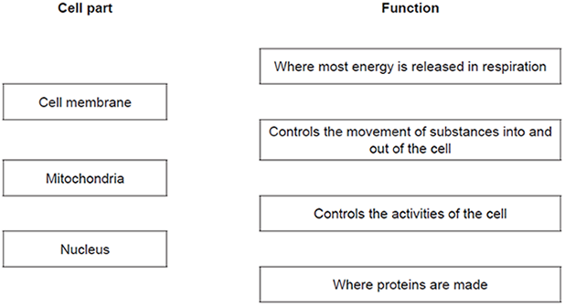

**(3)**

(b)     The diagram below shows a cell from a plant leaf.

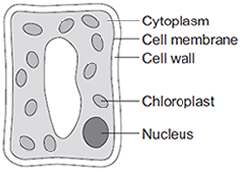

Which **two** parts in the diagram above are **not** found in an animal cell?

1. _________________________________________________________________

2. _________________________________________________________________

**(2)**

**(Total 5 marks)**

**Q2.** The image below shows some muscle cells from the wall of the stomach, as seen through a light microscope.

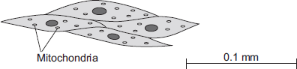

(a)     Describe the function of muscle cells in the wall of the stomach.

___________________________________________________________________

___________________________________________________________________

___________________________________________________________________

___________________________________________________________________

**(2)**

(b)     The figure above is highly magnified. The scale bar in the figure above represents 0.1 mm. Use a ruler to measure the length of the scale bar and then calculate the magnification of the figure above.

___________________________________________________________________

___________________________________________________________________

___________________________________________________________________

___________________________________________________________________

Magnification = _______________ times

**(2)**

(c)     The muscle cells in **Figure above** contain many mitochondria. What is the function of mitochondria?

___________________________________________________________________

___________________________________________________________________

___________________________________________________________________

___________________________________________________________________

**(2)**

(d)     The muscle cells also contain many ribosomes. The ribosomes cannot be seen in the figure above.  
(i)      What is the function of a ribosome?

______________________________________________________________

______________________________________________________________

**(1)**

(ii)     Suggest why the ribosomes **cannot** be seen through a light microscope.

______________________________________________________________

___________________________________________________________**(1)**

**Q3.** The diagrams show four types of cell, **A**, **B**, **C** and **D**.  
Two of the cells are plant cells and two are animal cells.

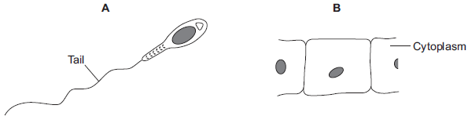

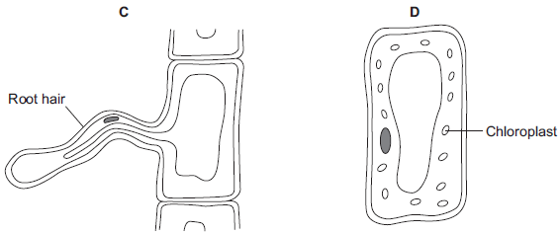

(a)     (i)      Which **two** of the cells are plant cells?

Tick () **one** box.

|  |  |
| --- | --- |
| **A** and **B** |  |
| **A** and **D** |  |
| **C** and **D** |  |

**(1)**

(ii)     Give **one** reason for your answer.

______________________________________________________________

______________________________________________________________

**(1)**

(b)     (i)      Which cell, **A**, **B**, **C** or **D**, is adapted for swimming?    

**(1)**

(ii)     Which cell, **A**, **B**, **C** or **D**, can produce glucose by photosynthesis?    

**(1)**

(c)     Cells **A**, **B**, **C** and **D** all use oxygen.

For what process do cells use oxygen?

Draw a ring around **one** answer.

|  |  |  |
| --- | --- | --- |
| **osmosis** | **photosynthesis** | **respiration** |

**(1)**

**(Total 5 marks)**

**Q4.** Diagrams **A**, **B** and **C** show cells from different parts of the human body, all drawn to the same scale.

**A**                                        **B**                                **C**

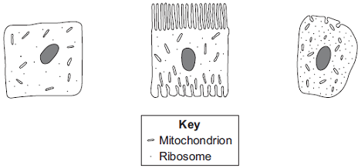

(a)     Which cell, **A**, **B** or **C**, appears to be best adapted to increase diffusion into or   
out of the cell?      

Give **one** reason for your choice.

___________________________________________________________________

___________________________________________________________________

**(1)**

(b)     (i)      Cell **C** is found in the salivary glands.

Name the enzyme produced by the salivary glands.

______________________________________________________________

**(1)**

(ii)     Use information from the diagram to explain how cell **C** is adapted for producing this enzyme.

______________________________________________________________

______________________________________________________________

______________________________________________________________

______________________________________________________________

**(2)**

**(Total 4 marks)**

Mark schemes

**Q1.**

(a)    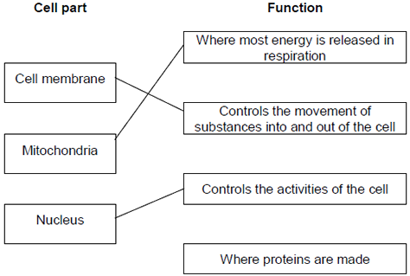

*extra lines cancel*

**3**

(b)     Cell wall

*in either order*

**1**

Chloroplast

*allow (permanent) vacuole*

**1**

**[5]**

**Q2.**

(a)     contract / shorten

*ignore relax*

*do* ***not*** *allow expand*

**1**

to churn / move / mix food

*accept peristalsis / mechanical digestion*

*ignore movement unqualified*

**1**

(b)     400

*acceptable range 390-410*

*allow 1 mark for answer in range of 39 to 41*

*allow 1 mark for answer in range of 3900 to 4100*

**2**

(c)     to transfer energy for use

*allow to release / give / supply / provide energy*

*do* ***not*** *allow to ‘make’ / ߢproduce’ / ‘create’ energy*

*allow to make ATP*

*ignore to store energy*

**1**

by (aerobic) respiration **or** from glucose

*do* ***not*** *allow anaerobic*

*energy released* ***for*** *respiration = max 1 mark*

**1**

(d)     (i)      to make protein / enzyme

*ignore ‘antibody’ or other named protein*

**1**

(ii)     too small / very small

*allow light microscope does not have sufficient magnification / resolution*

*allow ribosomes are smaller than mitochondria*

*ignore not sensitive enough*

*ignore ribosomes are transparent*

**1**

**[8]**

**Q3.**

(a)     (i)      **C** and **D**

*no mark if more than one box is ticked*

**1**

(ii)     any **one** from:

*do* ***not*** *allow if other cell parts are given in a list*

•        (have) cell wall(s)

•        (have) vacuole(s)

**1**

(b)     (i)      **A**

*apply list principle*

**1**

(ii)     **D**

*apply list principle*

**1**

(c)     respiration

*apply list principle*

**1**

**[5]**

**Q4.**

(a)    **B**

*no mark for “B” alone, the mark is for B* ***and*** *the explanation.*

large(r) surface / area **or** large(r) membrane

*accept reference to microvilli*

*ignore villi / hairs / cilia*

*accept reasonable descriptions of the surface eg folded membrane / surface*

*do* ***not*** *accept wall / cell wall*

**1**

(b)    (i)      any **one** from:

•        (salivary) amylase

•        carbohydrase

**1**

(ii)     many ribosomes

*do* ***not*** *mix routes. If both routes given award marks for the greater.*

**1**

ribosomes produce protein

*accept amylase / enzyme / carbohydrase is made of protein*

**or**

(allow)

many mitochondria      (1)

mitochondria provide energy to build / make protein      (1)

*accept ATP instead of energy*

**1**

**[4]**