Year 10 – Spring 2 – Independent study pack (combined science 1-22)
This will be accompanied by a series of videos that deliver each lesson.
Lesson 13: Mains Electricity
L.O.: Describe the key features of main electricity in the UK.
- What is a diode? (1)
- What particle carries the charge in an electrical circuit? (1)
- Give one use for an LDR. (1)
- Name one control variable when investigating the affect of the length of the wire on resistance. (1)
- Write this number in standard form: 0.000087 (1)
Challenge: Draw a series circuit containing a bulb, that would allow you to measure the potential difference.
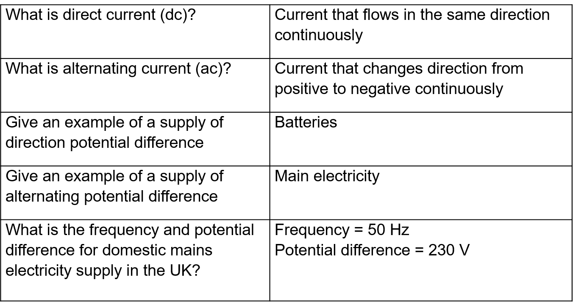

Recall Quiz: (5 mins)
- What is the frequency of domestic electricity in the UK?
- What is the potential difference of domestic electricity in the UK?
- Is battery an example of AC or DC?
- Is mains electricity an example of AC or DC?
- What is AC?

Example 1: I do
Describe “direct current” in an electrical circuit and give an example of a circuit with direct current.
- In direct current the supply of potential difference is always in one direction (e.g. positive)
- This means that the current also only flows in one direction.
- An example of a circuit with direct current is:
- where the supply of potential difference is a battery
Example 2: We do
Describe “alternating current” in an electrical circuit and give an example of a circuit with alternating current.
- In alternating current the supply of potential difference…
- This means that the direction that the current flows also…
- The frequency of an alternating circuit determines how many ___________ cycles (one ___________, one ___________ loop) the current does per second
- An example of a circuit with alternating current is:
- where the supply of potential difference is supplied by…

Example 3: You do
Describe “direct current” and “alternating current” in an electrical circuit

Independent task:
Describe the differences are between alternating current and direct current
Success criteria:
- Use comparative connective (e.g. whereas, however, on the other hand…)
- Described the difference in supply of potential difference for ac and dc circuits
- Described the difference in the current flow for ac and dc circuits
- Give examples of each type
- Describe how an oscilloscope trace would look for ac and dc

Complete the exam questions
Q1. The picture shows an electric cooker hob. The simplified circuit diagram shows how the four heating elements connect to the mains electricity supply. The heating elements are identical.
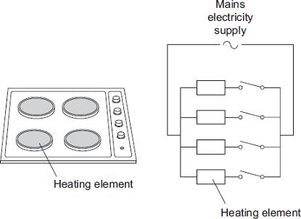
When all four heating elements are switched on at full power the hob draws a current of 26 A from the 230 V mains electricity supply.
(a) Calculate the resistance of one heating element when the hob is switched on at full power.
Give your answer to 2 significant figures.
___________________________________________________________________
___________________________________________________________________
___________________________________________________________________
Resistance = _______________ Ω
(3)
(b) The table gives the maximum current that can safely pass through copper wires of different cross-sectional area.

Cross-sectional area in mm² | Maximum safe current in amps
1.0 | 11.5
2.5 | 20.0
4.0 | 27.0
6.0 | 34.0

The power sockets in a home are wired to the mains electricity supply using cables containing 2.5 mm² copper wires. Most electrical appliances are connected to the mains electricity supply by plugging them into a standard power socket.
It would not be safe to connect the electric cooker hob to the mains electricity supply by plugging it into a standard power socket.
Why?
___________________________________________________________________
___________________________________________________________________
___________________________________________________________________
___________________________________________________________________
(2)
(c) Mains electricity is an alternating current supply. Batteries supply a direct current.
What is the difference between an alternating current and a direct current?
___________________________________________________________________
___________________________________________________________________
___________________________________________________________________
___________________________________________________________________
(2)
Q2. (a) The diagram shows the information plate on an electric kettle. The kettle is plugged into the a.c. mains electricity supply.

230 V | 2760 W
50 Hz
Use the information from the plate to answer the following questions.
(i) What is the frequency of the a.c. mains electricity supply?
______________________________________________________________
(1)
(ii) What is the power of the electric kettle?
______________________________________________________________
(1)
(b) To boil the water in the kettle, 2400 coulombs of charge pass through the heating element in 200 seconds.
Calculate the current flowing through the heating element and give the unit.
Choose the unit from the list below.

amps | volts | watts
___________________________________________________________________
___________________________________________________________________
___________________________________________________________________
Current = ______________________________
(3)
(c) The amount of charge passing through the heating element of an electric kettle depends on the time the kettle is switched on.
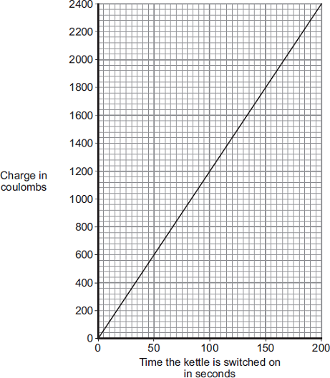
What pattern links the amount of charge passing through the heating element and the time the kettle is switched on?
___________________________________________________________________
___________________________________________________________________
(2)
(Total 7 marks)
Q3.
(a) The diagram shows the traces produced on an oscilloscope when it is connected across different electricity supplies.
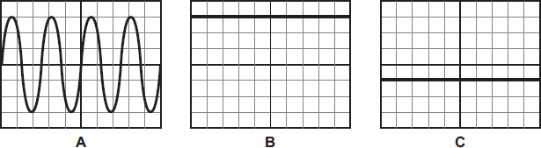
Which of the traces could have been produced by the mains electricity supply?
___________________________________________________________________
Give a reason for your answer.
___________________________________________________________________
___________________________________________________________________
(2)
(b) The picture shows two adaptors being used to plug five electrical appliances into the same socket.
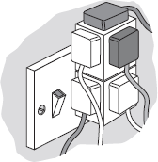
Explain why it is dangerous to have all five appliances switched on and working at the same time.
___________________________________________________________________
___________________________________________________________________
___________________________________________________________________
___________________________________________________________________
(2)
(Total 4 marks)

14. Plugs
L.O.: Describe the three core cables and wires making up a plug.

Do now:
- What does A.C. and DC stand for?
- Which current has a value which is always constant?
- What happens to kinetic energy of ions when temperature increases?
- Name the piece of equipment used to measure the count rate of a radioactive source.
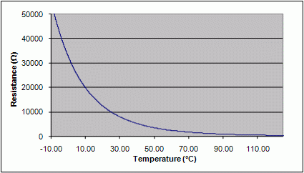
- Convert 5kW to W

Challenge: State what component this graph is from and describe the trend seen in the graph

Knowledge:
How are most electrical appliances connected to the mains? | Using a three-core cable
Name the three wires used in a plug | Live, neutral and earth
What is used to cover each wire? | Coloured insulation
What is the colour of insulation covering each wire? | Live wire – brown  Neutral wire – blue  Earth wire – green and yellow stripes
What is the role of the live wire? | To carry the alternating potential difference from the supply
What is the role of the neutral wire? | Complete the circuit
What is the role of the earth wire? | It is the safety wire that stops the appliance becoming live

Recall Quiz: (5 mins)
- What is the (a) colour (b) role of the live wire?
- What is the (a) colour (b) role of the earth wire?
- What is the (a) colour (b) role of the neutral wire?

PARTS OF THE PLUG
Fuse: The electrical symbol for a fuse is
The fuse is in the plug for safety. The wire inside is very thin and melts if there is too much current. When it melts, it breaks the circuit so stops current from flowing.
Live wire:
The live wire is brown coloured. It carries the alternating potential difference from the mains supply to the appliance to make it work. The potential difference in the live wire alternates between positive and negative. The potential difference across the live wire is 230 V. Touching the live wire, even if the circuit is open, can be dangerous because the potential difference of 230V is applied across your body which can be fatal. Since the potential difference between the live wire (230V) and the earth wire (0V) is large, if a connection is provided between the earth and live wire by a person, a huge current can flow through the person, them giving them a lethal shock.
Neutral wire:
The neutral wire is blue coloured. It takes the current away from the appliance and completes the circuit. The potential difference across the neutral wire is 0V.
Earth wire:
The earth wire has yellow and green stripes. It prevents the appliance from becoming “live” and so is the main safety mechanism before the fuse. It works by being connected to the outer casing of an appliance, if the live wire touches the casing the casing becomes “live”. Since the earth wire is connected to the outer casing, the current can flow through the earth to the ground making the appliance safe to touch. In other words, it protects you from an electric shock because if there was a fault and the whole appliance went “live” the earth wire carries the extra electricity away. It should have a potential of 0V. The earth wire only carries current when there is a fault.
Cable grip:
This keeps all the wires in place at the bottom of the plug.
Cable:
This keeps all the wires together from the plug to the appliance. It is made of stranded copper wire with coloured inner insulation and stiff outer insulation.
Use the information above to complete the table below:
Name of plug part | Does it carry current? | Does it have a potential difference across it? | Is it a safety feature? | Role
Fuse
Live wire
Neutral wire
Earth wire
Cable grip
Cable

Example 1: I do
Explain how the fuse increases the safety when connecting an appliance to the mains supply.
- A fuse is a very thin metal wire.
- The fuse makes up part of the circuit between the mains supply, plug and the appliance.
- If too much current flows through the circuit, the fuse gets very hot causing it to melt.
- This stops any current flowing making the appliance safe.

Example 2: We do
Explain how the earth wire ensure that the appliance is also safe to touch.
- The earth wire is connect to the _________ _________ of the appliance
- It has _________ potential difference across it and when the appliance is working normally does not carry any _________
- If the live wire touches the outer casing, it causes the outer casing to become _________
- Due to the _________ potential difference between the earth wire and the live wire, when the appliance becomes live a large _________ will flow through the earth wire to the _________ making the appliance safe

Example 3: You do
Explain why a human should never provide an electrical connection between the live wire and the earth wire
Independent task:
Describe the main features and explain the plug ensure an appliance is safe to use
Success criteria:
- Describe the appearance of the three wires
- Stated the role of each wire
- Explain the role of the fuse
- Explained the role of the earth wire

Q1.
(a) The diagram shows the inside of an incorrectly wired three-pin plug.
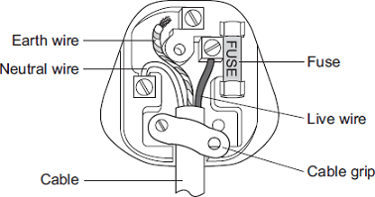
(i) What two changes need to be made so that the plug is wired correctly?
1. ____________________________________________________________
______________________________________________________________
2. ____________________________________________________________
(2)
(ii) The fuse inside a plug is a safety device.
Explain what happens when too much current passes through a fuse.
______________________________________________________________
______________________________________________________________
(2)
(b) Each of these pictures shows an electrical appliance being used in a bathroom.
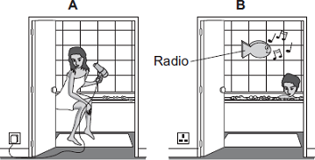
Using the hairdryer in picture A is dangerous. However, it is safe to use the battery-operated radio in picture B. (hint- think about mains electricity p.d)
Explain why.
___________________________________________________________________
___________________________________________________________________
___________________________________________________________________
___________________________________________________________________
(2)
Q1.
(a) The diagram shows the inside of an incorrectly wired three-pin plug.
(i) What two changes need to be made so that the plug is wired correctly?
1. ____________________________________________________________
______________________________________________________________
2. ____________________________________________________________
(2)
(ii) The fuse inside a plug is a safety device.
Explain what happens when too much current passes through a fuse.
______________________________________________________________
______________________________________________________________
(2)

(b) Each of these pictures shows an electrical appliance being used in a bathroom.
Using the hairdryer in picture A is dangerous. However, it is safe to use the battery-operated radio in picture B.
Explain why.
___________________________________________________________________
___________________________________________________________________
___________________________________________________________________
___________________________________________________________________
(2)

15. Power
L.O.: Calculate the power transferred in an electrical circuit.
Do Now:
1. Name the following in a plug:
a. Blue wire b. Brown wire c. Green and yellow wire
2. Name the part of the plug that breaks when the current is too __high.
3. Give the frequency and p.d. of mains electricity.
4. Define an anomalous result.
5. Convert 2.5kHz to Hz
Challenge: Explain why providing the connect between the live wire and the earth is dangerous but not between the neutral wire and earth
Knowledge:
What is (electrical) power? | How much energy is transferred electrically through a circuit every second
What are the units for power? | Watts or W
What is the equation linking power, current and potential difference? | Power (W) = current (A) x potential difference (V)  P = I V
What is the equation linking power, current and resistance? | Power = (current)² x resistance  P = I²R

Recall Quiz: (5 mins)
- What are the units for power?
- Define electrical power
- Write out the equation linking power (P) current (I) and resistance (R)
- Write out the equation linking power (P) current (I) and potential difference (V)
- State the units for current, potential difference and resistance

Example 1: I do
A pair of hair straighteners have a current of 15A and a p.d. of 230V. Calculate the power output.
P = IV
P = 15 x 230
P = 3450 W

Example 2: We do
A pair of hair straighteners has a power output of 2000W and a p.d. of 230V. Calculate the current flowing through them.
Example 3: You do
A 12 V power supply provides a 50mA current through a circuit. Calculate the power
Example 4: I do
A lamp has a resistance of 5.0 Ω. If the current through the circuit is 650mA, calculate the power
Example 5: We do
The current through a circuit is 8.5 A. Calculate the resistance of the circuit if the power transferred is 4.5 W
Example 6: You do
The current through a circuit is 32 A. Calculate the resistance of the circuit if the power transferred is 3.1k W
Challenge: You do
A 35 kΩ resistor is in a circuit. The power transferred is 0.75kW. Calculate the current through the resistor.

Independent practice:
30% | 50% | 70%
- What is the formula linking power, current and voltage? | 7. A kettle has a current of 10A and a p.d. of 230V. Calculate the power output. | 13. The heating element in a kettle produces an output of 1200W using mains electricity. Calculate the current flowing through it.
- Rearrange this formula to calculate current. | 8. A TV has a current of 80A and a p.d. of 230V. Calculate the power output. | 14. A TV produces an output of 5kW using mains electricity. Calculate the current flowing through it.
- Rearrange this formula to calculate voltage. | 9. A toaster has a current of 20A and a p.d. of 230V. Calculate the power output. | 15. A toaster produces an output of 2.5kW using mains electricity. Calculate the current flowing through it.
- What is the formula linking power, current and resistance? | 10. Work out the resistance for the kettle from question 7. | 16. If the resistance of a kettle is 20Ω, with a power output of 2.2kW, what is the current flowing through it?
- Rearrange this formula to find current. | 11. Work out the resistance for the TV from question 8. | 17. If the resistance of a TV is 70Ω, with a power output of 5kW, what is the current flowing through it?
- Rearrange this formula to find resistance. | 12. Work out the resistance for the toaster from question 9. | 18. If the resistance of a toaster is 20Ω, with a current flowing through it of 20A, what is the power output?

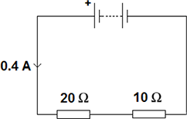
Electrical Power calculations:
Q1.An electrical circuit is shown in the figure below.
(a) The current in the circuit is direct current.
What is meant by direct current?

Tick one box.
Current that continuously changes direction.
Current that travels directly to the component.
Current that is always in the same direction.

(1)
(b)
Calculate the potential difference across the battery in the circuit in the figure above.
.............................................................................................................................
.............................................................................................................................
Potential difference = .......................................... V
(3)
(c)
Calculate the power output of the battery in the figure above.
Give your answer to one significant figure.
.............................................................................................................................
Power = ......................................... W
(2)
Q2.A student set up the electrical circuit shown in the figure below.
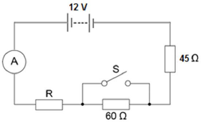
(a) The ammeter displays a reading of 0.10 A.
Calculate the potential difference across the 45 Ω resistor.
.............................................................................................................................
.............................................................................................................................
Potential difference = ............................................. V
(2)

(b) Calculate the resistance of the resistor labelled R.
.............................................................................................................................
.............................................................................................................................
.............................................................................................................................
Resistance = ............................................. Ω
(3)

(c) State what happens to the total resistance of the circuit and the current through the circuit when switch S is closed.
.............................................................................................................................
.............................................................................................................................
.............................................................................................................................
(2)

Q3. The diagram shows a 12 volt lighting system. Each lamp has a power of 32 watts.
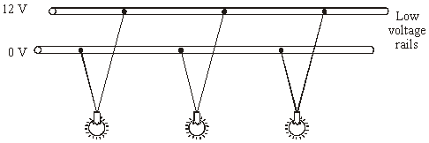

(i) Write down the equation that links current, potential difference and power.
...................................................................................................................
(1)

(ii) Calculate the input current to the lighting system. Show clearly how you work out your answer.
.............................................................................................................................
.............................................................................................................................
current = ........................................................................ A
(2)
16. Energy Transfers in Electrical Devices
L.O. Calculate the energy transferred by a device
Do Now:
- What is the formula for calculating power if we know the current and the potential difference?
- What would the formula be to calculate power if you knew the resistance and the current?
- Which part of the plug is:
- the blue wire b. the brown wire c. the green and yellow wire
4. Name the relationship in this graph.
5. Convert from 0.25kW to W
Challenge: Explain why beta particles are most suitable for monitoring the thickness of aluminium foil
Key Knowledge:
What are everyday appliances designed to bring about? | Energy transfers
What affects the amount of energy an appliance transfers? | - How long the appliance is switched on for  - The power of the appliance
When is work done in a circuit? | When charge flows in the circuit
What are the energy transfers in a battery operated motor? | Store of chemical energy in battery is transferred electrically to a store of kinetic energy in the motor
What are the energy transfers in a heater run through the mains | The store of chemical energy in the fuels is transferred electrically to a store of thermal energy in the heater
What are two equations to calculate the energy transferred by electrical work? | Energy transferred (J)= power (W) x time (s)  E = P t  Energy transferred (J) = charge flow (C) x potential difference (V)  E = QV

Recall Quiz: (5 mins)
- What two things determine the amount of energy transferred?
- What is the store of energy in a battery?
- How is energy transferred through electrical wires?
- Write the equation linking energy transferred, power and time
- Write the equation linking energy transferred, charge flow and potential difference

Example 1: I do
Describe the energy transfers in a battery power radio
- The store of chemical energy in the battery
- is transferred to electrically to the radio.
- The radio transfers the energy by radiation through sound

Example 2: We do
Describe the energy transfers in a hair dryer that is connected to the mains supply
- The store of __________ energy in the fuel
- is transferred to __________ to the hair dryer
- where the energy is stored as __________ and __________

Example 3: You do
Describe the energy transfers in a battery powered heater
Example 1: I do
Calculate the charge flow through a circuit which has a p.d. of 5V and transfers 10J of energy.
E = Q V
10 = Q x 5
10 = Q
5
2 C = Q
Example 2: We do
A TV has 60C of charge flowing through it and a potential difference of 230V. How much energy does it transfer
Example 3: You do
A radio transfers 12kJ of energy when it has a potential difference of 230 V across it. Calculate the charge flow.
Example 4: You do
A pair of straighteners is used for 60s and has a power rating of 60W. How much energy does it transfer?
Independent practice:
- A TV has 80C of charge flowing through it and a potential difference of 230V. How much energy does it transfer?
- A pair of straighteners is used for one minute and has a power rating of 75W. How much energy does it transfer?
- A set of speakers has a potential difference of 230V and has 85C of charge flowing through it when it is switched on. How much energy is transferred?
- A projector is used for 120s and has a power rating of 80W. how much energy will it transfer?
- How do you convert minutes to seconds?
- How do you convert hours to seconds?
- How do you convert kW to W?
- How do you convert kJ to J?
- A 2kW heater is on for one hour. How much energy does it use?
- A hairdryer uses 5kJ of energy in one hour. What is its power?
- A printer has a power rating of 4kW and is on for 5 minutes. How much energy does it transfer?
Challenge:
The charge that flows through a shower in 300 seconds is 18 000 C. The electric shower has a power of 13.8 kW. Calculate the resistance of the heating element in the shower.
Write down any equations you use.
17. Calculations Practice
Do Now:
- How is energy transferred through electrical cabling?
- How is energy stored in a battery?
- Write two equations to calculate power
- Name the equipment used to measure the resistance of a component directly
- Convert from cm³ to m³
Challenge: describe the energy transfers taking place when a battery powered fan is turned on
Key Knowledge:
1 | Charge (Q), current (I), time (t) | Q = It
2 | Potential difference (V), current (I), resistance (R) | V = IR
3 | Total resistance in series circuit | R_{total} = R₁ + R₂ + …
4 | Power (P), potential difference (V), current (A) | P = IV
5 | Power (P), current (A), resistance (R) | P = I²R
6 | Energy transferred (E), power (P), time (t) | E = Pt
7 | Energy transferred (E), potential difference (V), charge flow (Q) | E = QV
Recall Quiz: (5 mins)
Complete the equations
- Q = _____ t
- E = P ______
- R_{total} = …
- P = _____ R
- E = ______V
- P = ______ V
_____ = I R

Quick unit conversion quiz
- mA A
- mV V
- μA A
- nJ J
- kJ J
- kW W
- Minutes seconds
- Hours seconds
Independent Practice:
- What is the equation for energy, potential difference and charge flow? | - What is the equation for power, energy and time? | - What is the equation to calculate resistance, power and current?
- What is the equation to calculate potential difference, power and the current? | - What is the equation for potential difference, charge flow and energy? | - What is the equation for current, power and potential difference?
- What is the potential difference if the power of a device is 10W and the current is 9A? | - What is the p.d. if the charge flow is 90C and the energy transferred is 24J? | - A device has a power rating of 30W and is on for 1 minute and 16 seconds. How much energy would be transferred?
- What would be the current passing through a wire if the resistance is 10Ω and the power is 28W? | - How much energy would be transferred in total by a hair dryer if the power rating was 92W and it took 3 minutes and 6 seconds to dry your hair? | - What is the charge flow if the potential difference is 18V and the energy transferred is 8J?
- What is the power rating of a device if the energy transferred is 28kJ in 31 seconds? | - What is the power rating of a device if the current passing through it is 24A and the resistance is 89Ω | - What is the potential difference if the current is 90A and the power is 20W?

18. Electromagnets
L.O. Describe the structure and function of electromagnets.
Do Now:
- Recall the name of the brown wire in a plug.
- Write the equation that allows us to calculate charge flow from potential difference and energy (in words).
- State what will happen if two like poles (the same) of two magnets are brought together.
- Name the piece of equipment used to measure current.
- Calculate the resistance of a wire with 4A of current flowing through it with a 12V potential difference.
Challenge: Describe how you could calculate the resistance of a given wire of 40cm length. (4)

What happens when a current flows in a conducting wire? | A magnetic field is created around the wire
What does the right hand grip rule shows us for a wire? | Thumb = current  Fingers = magnetic field
What is a solenoid? | A wire looped into coils
What does the right hand grip rule shows us for a solenoid? | Thumb = magnetic field  Fingers = current
What is an electromagnet? | A solenoid with an iron core in the centre
How can we increase the strength of an electromagnet? | Increase the Current  Increase number of Coils  Add an iron Core

Independent Practice
1. Suggest three factors that affect the strength of the magnetic field around an electromagnet.
2. Describe how increasing the number of coils on a solenoid affects the strength of the magnetic field around the wire.
3. Explain how to work out the direction of a magnetic field around a straight wire.
4. Explain how to work out the direction of a magnetic field around a solenoid.
5. Draw an example of the magnetic field around a solenoid. Label clearly the flow of current and the direction of the magnetic field using arrows.

Plenary Quiz:
1. What happens when a current flows in a conducting wire?
2. What does the right hand grip rule shows us for a wire?
3. What is a solenoid?
4. What does the right hand grip rule shows us for a solenoid?
What is an electromagnet?
5. How can we increase the strength of an electromagnet?

19. The National Grid & Transformers
L.O. Describe the National Grid & explain the role of transformers

Do Now:
- Recall three things you could do to increase the strength of the magnetic field around an electromagnet (1)
- Explain how you could change the poles of an electromagnet (1)
- Give the equation that links energy, power and time (1)
- What is the resolution on this ammeter? (1)
- Convert 76kJ into the J (1)

Challenge: A man connects his 2.9 kW electric kettle to the 230 V mains supply. Calculate the current in the kettle element. Give your answer to 2 significant figures. (3)
Key Knowledge:
What is the national grid composed of? | Cables and transformers linking power stations to consumers
What is the national grid used for? | Supplying electrify to houses
State the effect of step up transformers on potential difference | Increases p.d (reduces energy loss)
State the effect of step down transformers on potential difference | Decreases p.d. (safe for domestic use)

Application Task
Describe and explain the national grid (include the purpose and efficiency of the national grid) (6 marks)

The National Grid is …
A problem with having lots of cables which transfer the electricity is that …
We can reduce this problem by using transformers. …
The job of a step-up transformer is to …
If we didn’t have a step-up transformer then we would lose lots of….
The job of a step-down transformer is to …
If we didn’t have a step-down transformer before the electricity got to our homes then …

Exam Question:
Q1. The diagram shows how electricity is distributed from power stations to consumers.
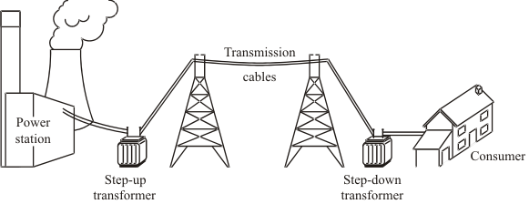
(a) (i) What name is given to the network of cables and transformers that links power stations to consumers?
______________________________________________________________
(1)
(ii) What does a step-up transformer do?
______________________________________________________________
(1)
(iii) Explain why step-up transformers are used in the electricity distribution system.
______________________________________________________________
______________________________________________________________
______________________________________________________________
______________________________________________________________(2)
(b) Most of the world’s electricity is generated in power stations that burn fossil fuels.
State one environmental problem that burning fossil fuels produces.
___________________________________________________________________
___________________________________________________________________
(1)
(c) Electricity can be generated using energy from the wind. A company wants to build a new wind farm. Not everyone thinks that this is a good idea.
(i) What arguments could the company give to persuade people that a wind farm is a good idea?
______________________________________________________________
______________________________________________________________
______________________________________________________________
______________________________________________________________
(2)
(ii) What reasons may be given by the people who think that wind farms are not a good idea?
______________________________________________________________
______________________________________________________________
______________________________________________________________
______________________________________________________________(2)

Please print this section for separate science students ONLY:
20. Transformer Structure
L.O. Explain how transformers are designed for their function.
Do Now:
- Recall the purpose of the national grid (1)
- Describe the function of a step down transformer (1)
- State the colour of the neutral wire in a plug (1)
- Define “systematic error” (1)
- Calculate the resistance if the current is 32A and potential difference is 90V (1)
Challenge: How much energy would be transferred in total by a hair dryer if the power rating was 9230kW and it took 2 minutes and 16 seconds to dry your hair?
Key Knowledge:
What is the relationship between coil number in a step up transformer? | Np<Ns
What is the relationship between coil number in a step down transformer? | Np>Ns
State the use of a step up transformer | Increase potential difference so current can be reduced to prevent heat loss
State the use of a step down transformer | Reduce the potential difference so it is safe for use in your home.
Recall the equation to calculate potential difference when number of coils is known | V_{p} = n_{p}  V_{s} n_{s}
Recall the equation to calculate current in a transformer | V_{p} = n_{p}  V_{s} n_{s}
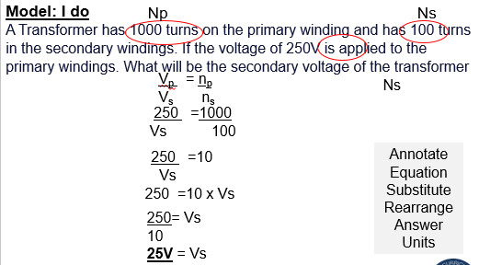
Practice: (you do)
- A transformer has 500 turns of the primary winding and 10 turns of the secondary winding. Determine the secondary voltage if the secondary circuit is open and the primary voltage is 120 V.
- A transformer has 8 windings in its primary core and 5 in its secondary coil. If the primary voltage is 240 V, find the secondary voltage.
- A transformer has a primary coil of 100 turns and a secondary coil of 300 turns.
What will be the voltage out of the secondary coil if we apply 20 V to the primary?
- If we need to change 240 V down to 12 V, and our transformer to has 2000 turns on its primary coil, how many turns should it have on its secondary coil?
Independent task:
How does a step up transformer work?
- What happens in the primary coil?
- What does this cause to happen?
- What effect does this have on the secondary coil?
- What is the impact of having more coils on the secondary coil?

Fill in the blanks in the table. Show your workings.

Q1 | Primary voltage | Secondary Voltage | Primary number of revolutions | Secondary number of revolutions
(a) | 250V | 50V | 50
(b) | 240V | 60V | 48
(c) | 60V | 240V |  | 48
(d) | 200V | 100V | 50
(e) |  | 600V | 45 | 900

- A primary transformer has a voltage of 240V and number of revolutions 500 turns, what is the secondary voltage if the number of turns is 25.
- What is the simplified ratio of a primary voltage of 60V to a secondary voltage of 12V?
- What is the ratio of number of revolutions on the primary transformer of 500 turns to the number of revolutions on the secondary transformer of 350 turns? Simplify your answer

Challenge exam question
Q1. Batteries inside laptop computers are charged using laptop chargers. The laptop charger contains a traditional transformer.
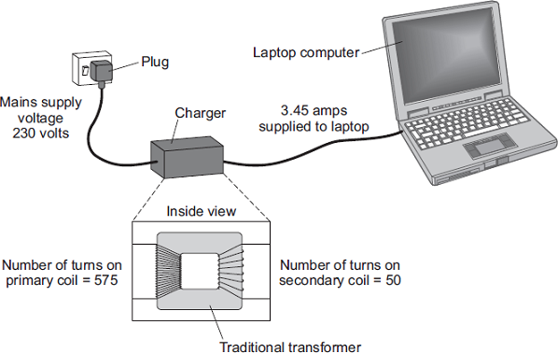
(a) The alternating current flowing through the primary coil of the transformer creates an alternating current in the secondary coil.
Explain how.
___________________________________________________________________
___________________________________________________________________
___________________________________________________________________
___________________________________________________________________
___________________________________________________________________
___________________________________________________________________
___________________________________________________________________
___________________________________________________________________
(3)
(b) (i) Use information from the diagram to calculate the potential difference the charger supplies to the laptop.
______________________________________________________________
______________________________________________________________
______________________________________________________________
______________________________________________________________
Potential difference = _____________________________ V
(2)
(ii) Calculate the current in the primary coil of the transformer when the laptop is being charged.
Assume the transformer is 100% efficient.
______________________________________________________________
______________________________________________________________
______________________________________________________________
______________________________________________________________
Current = _____________________________ A
(2)
(c) Laptop batteries and mobile phone batteries can only be recharged a limited number of times. After this, the batteries cannot store enough charge to be useful. Scientists are developing new batteries that can be recharged many more times than existing batteries.
Suggest one other advantage of developing these new batteries.
___________________________________________________________________
___________________________________________________________________
___________________________________________________________________(1)
21. Transformer Power Equation
L.O. Apply the power equation to explain how a transformer is designed.

Do Now:
- Describe the structure of a step-up transformer (1)
- Decide which is a step up and which is a step down transformer. Give a reason for your answer. (1)
- Recall Ohm’s Law (1)
- How would you measure resistance in a circuit? (1)
- Calculate the number of coils on a secondary coil if there is a potential difference of 12V and 10 turns on the primary coil and 36V on the secondary coil (1)

Challenge: would the transformer in question 5 be a step up or step down transformer?

Key Knowledge:
What is the equation that links power, potential difference and current? | P = IV
How efficient are transformers? | About 98% (we assume 100%!)
How can we show  “power in = power out”  as an equation? | V_{p} x I_{p} = V_{s} x I_{s}

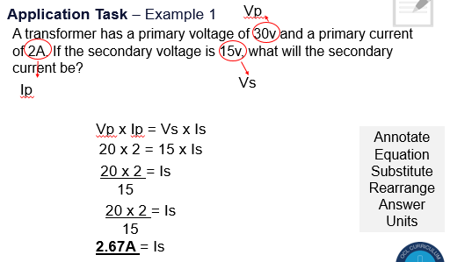

Independent practice…
- A transformer a primary current of 30A. If the secondary voltage is 10v and the secondary current is 2.4A, what will the primary voltage be? (1)
- A transformer has a secondary voltage of 15v and a secondary current of 4A. If the primary voltage is 2v, what will the primary current be? (1)
- A transformer has a primary voltage of 3v and a primary current of 30A. If the secondary current is 1.5A, what will the secondary voltage be? (1)
- A transformer has 300 turns on the primary coil, a primary voltage of 20V and a primary current of 5A. If the secondary coil has 200 turns, calculate the voltage and current on the secondary coil. (2)

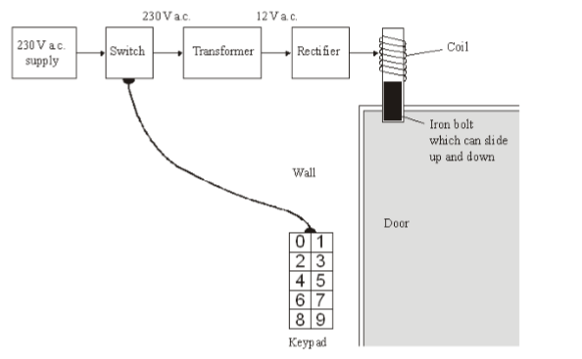
Transformer practice questions
1. The diagram shows the design for a remotely controlled door bolt.
When the correct numbers are entered into the keypad the transformer switches on. Then the door can be opened.

(a) What kind of transformer is shown in the diagram?
.................................................................................................................................... (1)
(b) What does the abbreviation a.c. stand for?
.................................................................................................................................... (1)
(c) Complete the sentences using the correct words from the box.
(i) When a current flows in the coil, the coil becomes a ................................... .
(ii) The coil ................................... the iron bolt which moves ............................ (3)

Q2. (a) The diagram shows the structure of a traditional transformer.
Use words from the box to label the diagram.
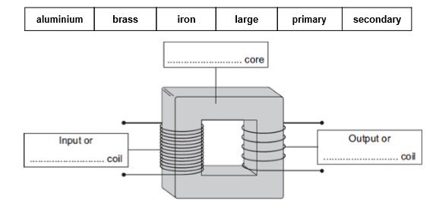

(3)
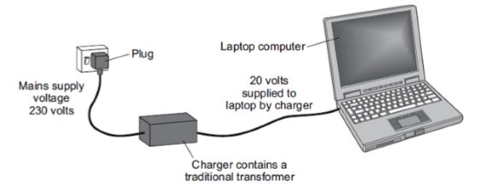
(b) Batteries inside laptop computers are charged using laptop chargers. The laptop charger contains a traditional transformer.

The laptop charger contains a step-down transformer. What does a step-down transformer do?
........................................................................................................................
........................................................................................................................ (1)
3. A transformer is used to reduce the 230 V a.c. mains to the 12 V supply required for the lighting system. The transformer has 1150 turns on its primary coil.
(i) Write down the equation which links the number of turns of each transformer coil to the voltage across each transformer coil.
....................................................................................................................................
.................................................................................................................................... (1)
(ii) Calculate the number of turns on the secondary coil of the transformer. Show clearly how you work out your answer.
....................................................................................................................................
....................................................................................................................................
....................................................................................................................................
number of turns on the secondary coil = ...................... (2)

22. The Solar System
L.O. Describe our Solar System
Do Now:
- Describe the job of a step up transformer (1)
- State the equation that allows you to work out the current in a secondary coil given current and potential difference of the primary coil (1)
- Recall gravitational field strength on Earth (1)
- Define “accurate” (1)
- Rearrange the equation in question 2 to find the potential difference in the secondary coil (1)

Key Knowledge:
What is our galaxy called? | The Milky Way
What is our solar system composed of? | The sun (a star), eight planets, dwarf planets and their moons
What is the order of the planets (closest to the sun to furthest from the sun) | Mercury, Venus, Earth, Mars, Jupiter, Saturn, Uranus, Neptune
What is a natural satellite? | A celestial body that orbits a larger body (normally a planet) e.g. the moon
What is an artificial satellite? | A man made object that orbits a larger body e.g. a weather satellite.

Models of the Solar System
https://www.youtube.com/watch?v=BOxtiUPdHiM

- What did the Ancient Greeks believe about the solar system?
- What was the problem with the Ancient Greeks model?
- Which two scientists changed the theory of what was at the centre of the solar system?
- What had the Greeks mistook Mars for?
- What did Galileo Galilee do in the 1700s?
- What did Galileo discover that changed our view of the solar system?
- Name 2 large telescopes that now exist
- What do we now believe about the structure of the solar system (include as much detail as you can!).
- Looking at the diagrams of the two models below, identify two similarities and two differences between the original heliocentric model of the solar system and our current beliefs.

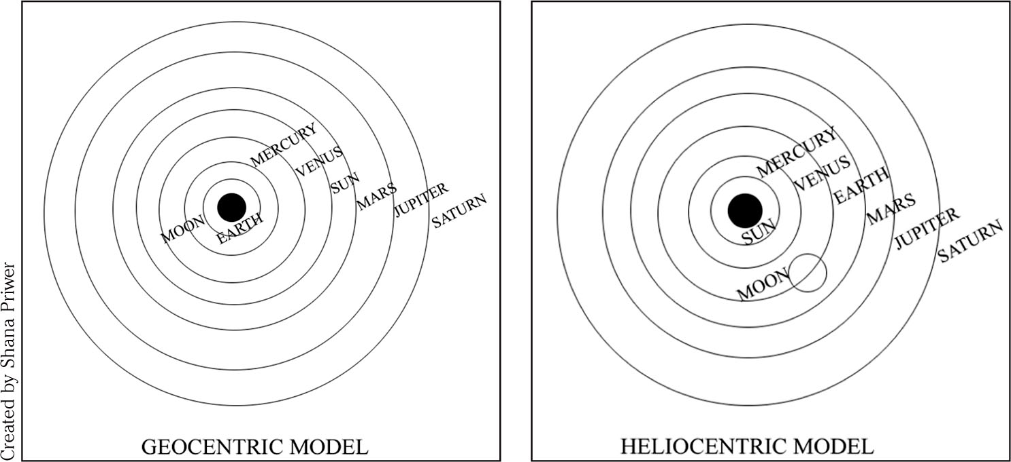

Application task:
- Describe our current model of the solar system.
- Describe the model of the solar system proposed by the Ancient Greeks.
- State two reasons for the change in our views of the solar system.

23. Life Cycle of a star
L.O. Describe how size of a star affects it’s lifecycle.

Do Now:
- List the planets in order from furthest from the sun to closest to the sun.(1)
- What is the difference between a star and a planet? (1)
- Recall Ohm’s law(1)
- Which piece of equipment is used to measure force (1)
- Calculate gravitational potential energy if a man of 60kg jumps 10m into the air on mars where gravitational field strength is 3.711 N/kg(1)

Challenge: 90% of his energy is turned into kinetic energy when he falls back down to the ground. What would be the velocity of the man as he lands on the ground?

Key Knowledge:
What is a “nebula”? | A cloud of dust and gas.
Name the stages in the life cycle of a small star (e.g. the sun) | Nebula -> protostar -> main sequence star -> red giant -> white dwarf -> black dwarf
Name the stages in the life cycle of a massive star. | Nebula -> protostar -> main sequence star -> red giant -> supernova -> neutron star OR black hole
How are all naturally occurring chemical elements produced? | Fusion in stars.
How are elements heavier than iron produced? | Fusion in supernovae
Describe the forces acting upon a star | Gravitational pull inwards  Fusion (gas pressure force) outwards

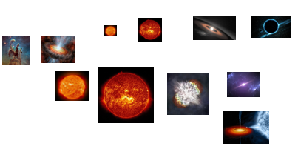

Extended practice:
Describe, in as much detail as you can, the life history of a star like our Sun and compare this with a massive star. (6 marks)

24. Orbits
LO. Explain circular and elliptical orbits.

Do Now:
- Recall the factor that will determine what will happen to a star during it’s lifecycle (1)
- Recall the name for a cloud of dust and gas that forms a star (1)
- State the definition for ‘velocity’ (1)
- Name the piece of equipment used to detect radiation (1)
- A transformer has 400 turns on the primary coil and 200 on the secondary. If the primary potential difference is 300V, what will the secondary potential difference be? (1)

Challenge: what is the difference between speed and velocity? Explain how an object could be traveling at a constant speed when it’s velocity was changing.

Key knowledge
What is the general name for a force causing circular motion? | Centripetal force (acting towards to the centre)
Which force is the centripetal force causing a massive object to orbit another massive object in space | Gravitational force (towards centre)
Which direction is acceleration during circular motion? | Towards the centre
In circular motion, why is the speed constant but the velocity not? | Direction is constantly changing

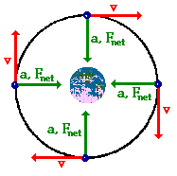
Application Task:
- What causes the centripetal force that allows planets and satellites (both natural and artificial) to maintain their circular orbits?
- Draw a diagram showing the orbit of the Earth around the sun. Label
  - The sun
  - The Earth
  - The direction of the velocity
  - The direction of the centripetal force
- Explain how even though the moon, in the picture to the left, is maintaining a constant speed the velocity is changing.
- In which direction is the acceleration in the sun-Earth system?
- Challenge: What could happen to Earth if the orbital speed was i) too slow ii) too fast?

Orbits Practice Exam Questions
Q1. (a) There are eight planets in orbit around the Sun.
Which other type of object orbits the Sun?
Tick one box.

Dwarf planet |  |  | Moon
Galaxy |  |  | Star
(1)
(b) Complete the sentences.
Choose the answers from the box.
Black hole Gravity Friction Nebula Protostar Upthrust

The Sun was formed when a ____________________ in space was pulled together by ____________________ .
(2)
(c) The Sun has reached the Main Sequence stage in its lifecycle.
What stage in the lifecycle of the Sun will follow the Main Sequence stage?
___________________________________________________________________
(1)
The table shows some data about the eight planets that orbit the Sun.

Planet | Distance from the Sun compared to the Earth | Time to orbit the Sun in years | Mean surface temperature in °C
Mercury | 0.4 | 0.2 | +125
Venus | 0.7 | 0.6 | +465
Earth | 1.0 | 1.0 | +22
Mars | 1.5 | 1.9 | –48
Jupiter | X | 12 | –108
Saturn | 9.6 | 30 | –180
Uranus | 19.3 | 84 | –216
Neptune | 30.0 | 165 | –201

(d) What pattern links the distance a planet is from the Sun and the time taken by the planet to orbit the Sun?
___________________________________________________________________
___________________________________________________________________
___________________________________________________________________
(1)
(e) Estimate the value of X in the table.
Distance = ____________________
(1)
(f) A student looked at the data in the table and wrote the following conclusion:
‘The mean surface temperature of a planet decreases the
further the planet is from the Sun.'
Explain why this conclusion is not totally correct.
___________________________________________________________________
___________________________________________________________________
___________________________________________________________________
___________________________________________________________________
___________________________________________________________________
___________________________________________________________________
(3)
(Total 9 marks)
Q2. Man-made satellites can orbit the Earth, as shown in the figure below.
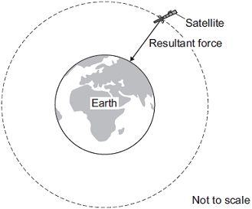
The satellite experiences a resultant force directed towards the centre of the orbit.
The resultant force is called the centripetal force
(a) What provides the centripetal force on the satellite?
___________________________________________________________________ (1)
(b) State two factors that determine the size of the centripetal force on the satellite.
1. _________________________________________________________________
2. _________________________________________________________________
(2)
(c) The table below gives data for five different satellites orbiting the Earth.

Satellite | Average height above Earth’s surface in kilometres | Time taken to orbit Earth once in minutes | Mass of satellite in kilograms
A | 370 | 93 | 419 000
B | 697 | 99 | 280
C | 827 | 103 | 630
D | 5 900 | 228 | 400
E | 35 800 | 1440 | 2 030
(i) State the relationship, if any, between the height of the satellite above the Earth’s surface and the time taken for the satellite to orbit the Earth once.
______________________________________________________________
______________________________________________________________
(1)
(ii) State the relationship, if any, between the time taken for the satellite to orbit the Earth once and the satellite’s mass.
______________________________________________________________
______________________________________________________________
(1)
(d) Over 300 years ago, the famous scientist Isaac Newton proposed, with a ‘thought experiment’, the idea of satellites.
Newton suggested that if an object was fired at the right speed from the top of a high mountain, it would circle the Earth.
Why did many people accept Isaac Newton’s idea as being possible?
Tick (✓) one box.
Isaac Newton was a respected scientist who had made new discoveries before.
Isaac Newton went to university.
It was a new idea that nobody else had thought of before.
(1)

25. Changing Orbits
L.O: Explain how changing speeds effects orbits

Do Now:
- Draw a diagram of the moon orbiting the earth. Add arrows to show the direction of motion and the direction of acceleration (2)
- Recall the general name given to the force that keeps an object in circular motion (1)
- Describe what happens to an atom during decay that results in beta radiation (1)
- Recall the units for gravitational field strength (1)
- Calculate the area of a circle that has a radius of 4cm. Give your answer to 3 s,g.(1)

Challenge: Bhuvan kicks the ball. The mass of the ball is 500 g, and its initial speed is 4 m/s. Show that its initial kinetic energy is 4 joules. [2]

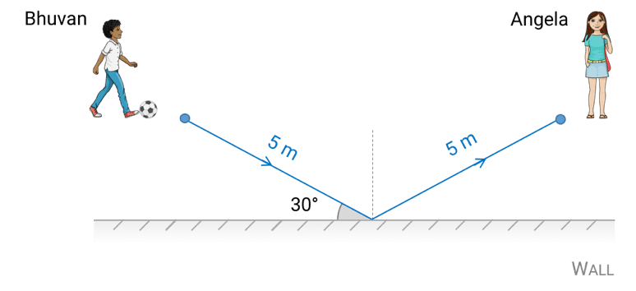

Key Knowledge:

Recall 3 factors that will affect the size of centripetal force | - Mass of the object  - Radius of the orbit  - Speed of the object
What will happen to an object orbiting the sun if it slows down and it’s orbit radius does not change. | Pulled into the sun
What will happen to an object orbiting the sun if it speeds up and it’s orbit radius does not change? | It will fly off into space
State the relationship between distance from the sun and speed of orbit | Closer to the sun, faster the orbit
To keep an object in a stable orbit, what must happen to the radius of an orbit if an object speeds up? | The orbit radius must get smaller.

Orbits Independent Practice
 | Mercury | Venus | Earth | Mars | Jupiter | Saturn | Uranus | Neptune
Distance from Sun (millions km) | 60 | 108 | 149.6 | 228 | 778 | 1427 | 2870 | 4497
Orbital period (days) | 88 | 225 | 356.25 | 687 | 4383 | 10960 | 30681 | 60270

- (a) Describe the relationship between orbital period and the distance from the sun.
- Which planet would orbit with a greater speed between Saturn and earth? Why?
- Scientists want to put an satellite into orbit around the sun. The position of it will be between Venus and the Earth. Estimate it’s orbital period.
- A man-made satellite orbits the Earth. The satellite experiences a resultant force directed towards the centre of the orbit.

- What provides the force on the satellite?
- Why does this force not cause the satellite to change speed?
- What effect, if any, would increasing the speed of the satellite have on the height of the orbit?
- In which direction is the instantaneous velocity of a satellite in orbit?
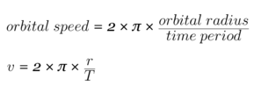
Challenge: Calculate the orbital speed of these different objects.
Use this equation:

Hint: multiple the orbital radius by 1 million.
Planet | Orbital Radius (millions of km) | Orbital Period (Days) | Orbital Period (Seconds) | Orbital Speed (km/s)
Mercury | 57.9 | 88
Venus | 108.2 | 225
Earth | 149.6 | 365
Mars | 227.9 | 687
Jupiter | 778.3 | 4,331
Saturn | 1,433 | 10,759
Uranus | 2,871 | 30,799
Neptune | 4,504 | 60,190

