PAPER 2: HUMAN GEOGRAPHY

Section A: Urban Issues and Challenges
- Urban area in LIC/NEE: Rio de Janeiro
- Urban area in the UK: London
- Sustainable urban planning

Section B: The Changing Economic World
- Causes, impacts and reducing the gap
- Case study of LIC/NEE: Nigeria.
- Case study of UK

Section C: The Challenge of Resource Management
- Question 3: the UK and resources
- Question 4: Food
- Example of a large scale agricultural development: Thanet Earth
- Example of increasing food supply in an LIC/NEE sustainably: Makueni

PAPER 2 EXAM DATE: 3rd JUNE (2pm)

Urbanisation Page 17

QUIZ A
Figure 1
Figure 2
Figure 4
Figure 6
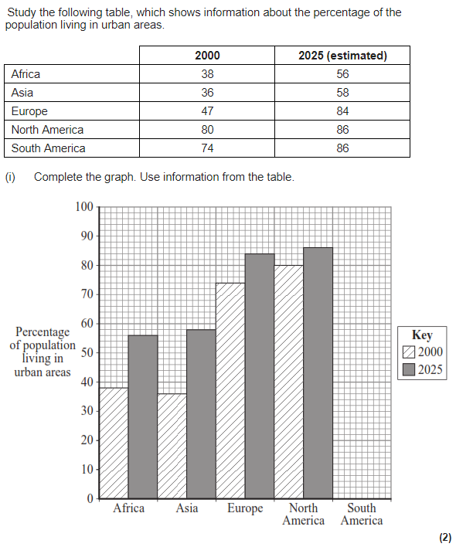
- Urban means…
- Rural means…..
- Urbanisation is…..
- In 2015……..% of the world’s population lived in urban areas.
- In 2050 it is predicted that……..% will live in urban areas.
- Urban growth is….
- Two causes of urban growth are…..
- A megacity has a population of….
- Natural increase occurs when there is a………..birth rate and…………death rate = population………
- Natural increase is common in NEE/LICs. True or false?
- Rural to urban migration is the movement of people from……to……
- State two push factors that result in urbanisation.
- State two pull factors that result in urbanisation.

QUIZ B
- Urbanisation is more common in LICs / HICs.
- Urbanisation is caused due to industrialisation which pulls people to cities. Industrialisation is…….
- The UK went through industrialisation in……………..
- LICs and NEEs are currently going through industrialisation. As a result…..
- Urbanisation is also happening due to natural increase. Natural increase when the birth rate is………..than the death rate. This occurs in stages……………….of the DTM.
- Are LICs or HICs currently experiencing natural increase?
- How does this affect their population?
- The UK is currently in stage………..of the DTM. Therefore there is a……….birth rate and…………death rate
- How does this affect their population?
- The 2 case studies we learn about in this unit are……

PRACTICE EXAM QUESTIONS
- Study Figure 1, a map showing the percentage of the population living in urban settlements in different parts of the world.
- Describe two differences in the percentages of population living in urban settlements in South America and Africa. (2)
- Suggest two reasons for the slow rate of urban growth in many higher income countries. (2 marks)
- Study Figure 2, a graph showing changes in the world’s rural and urban population from 1950 to 2050 (predicted). Describe how urban populations have changed. (4 marks)
- Study Figure 4, a table showing estimated population change in a number of cities.
- Which city is predicted to have the largest increase in population between 2000 and 2015? (1 mark)
- Use the figure to compare the estimated population changes of cities in more developed countries and less developed countries. (4 marks)
- Give two reasons why people in LICs are attracted to urban areas. (2 marks)
- Study Figure 6, a graph showing information about the percentage of the population living in urban areas.
- Compare the estimated rate of change in Asia with that in North America. (2 marks)
- Suggest one reason for the estimated rate of change in North America (2 marks)
- In which continent is the percentage of population living in urban areas estimated to increase the most between 2000 – 2025? (1 mark)
- Suggest one reason why the percentage increase in urban population in Asia is high. (1 mark)

Urbanisation Page 18

QUIZ A:
Opportunities:
Figure 1
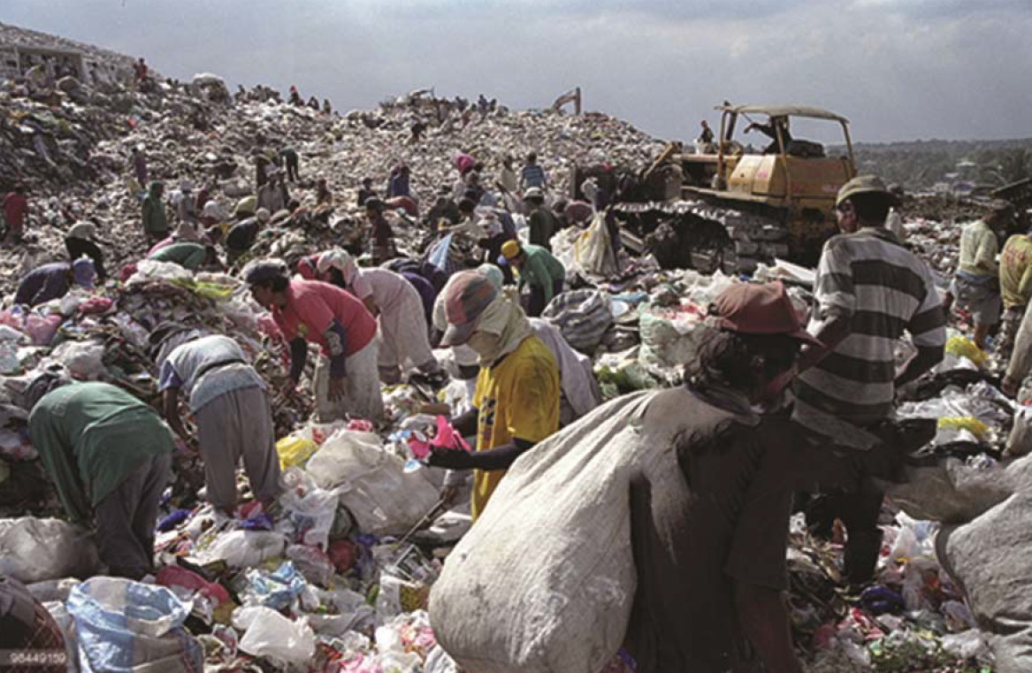
Figure 2

- Rio de Janeiro is located….
- State how Rio provides entertainment opportunities.
- An economic opportunity in Rio is employment. More specifically……
- A social opportunity in Rio is access to education. More specifically……….
- To ensure access to electricity in Rio, they have…..
- To ensure access to sanitation in Rio, they have built……
- To ensure access to clean water, they have….
- What is the life expectancy in Rio and the average in Brazil?
- Suggest one reason for the higher life expectancy in Rio.
- Suggest one example of international transport Rio has.
Challenges:
- Only…….% have access to a local family health clinic.
- There is a lack of teachers and schools due to……
- …….% does not have access to running water.
- There are blackouts due to……
- Many people are unemployed or work in the informal sector. For example….

QUIZ B:
Challenges (continued)
- Air pollution is caused due to………
Figure 3
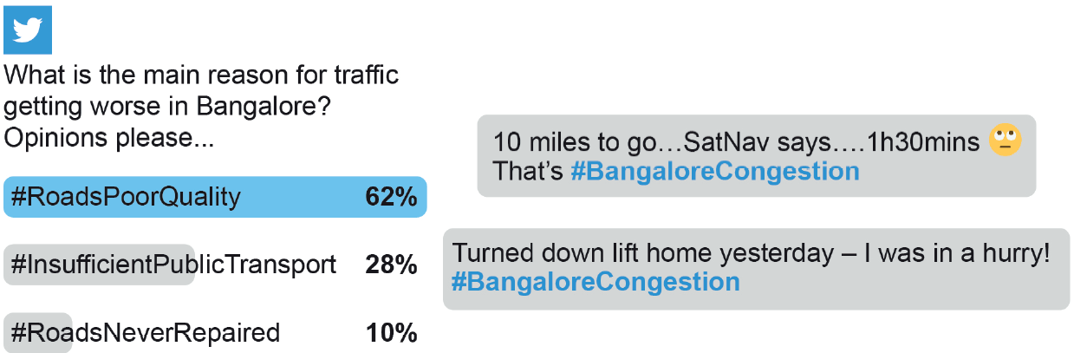Figure 4
- Air pollution results in………….deaths per year.
- ……tonnes of sewage runs into rivers daily = water pollution.
- Rubbish is left on the streets because……
Favelas:
- On the outskirts of Rio there are favelas. A favela is…..
- They are built on steep slopes. As a result……
- There is a lack of services:…% do not have access to electricity…% do not have access to sanitation.
- There are a lack of jobs. More specifically………..
- There are gangs and crime rate is high. More specifically……
- Urban planning is…..
- What favela did the Favela Bairro Project help?
- They built water and sanitation pipes. As a result……
- They built a cable car that connected the favela to Ipanema (central Rio). As a result…..
- They installed a Pacifying Police Unit. This improved quality of life by…..
- They gave 100% mortgages. This improved quality of life by...
- Identify two ways the changes were unsuccessful.

PRACTICE EXAM QUESTIONS
- To what extent do urban areas in lower income countries (LICs) or newly emerging economies (NEEs) provide social and economic opportunities for people?
- Explain how urban growth in LICs and NEEs provide social, economic and environmental challenges. Use a case study and your own knowledge. (9 marks)
- Study Figure 1, a photograph of a rubbish dump in the Payatas slum in Manila, a city in the Philippines.
- Suggest one opportunity for people shown in Figure 1. (3 marks)
- Use Figure 1 and a case study of a city in a LIC/NEE to assess the challenge of providing services to the city’s population. (6 marks)
- Study Figure 2, a photograph showing pollution in rapidly urbanising countries. Using the photograph and your own knowledge explain how rapid urbanisation and industrialisation in LICs and NEEs lead to pollution in urban areas. (6 marks)
- Study Figure 3, some social media comments about traffic in Bangalore, a city in India.
- Using Figure 3 suggest one problem faced by people in Bangalore due to traffic congestion. (2 marks)
- Use Figure 3 and a case study of a city in a LIC or NEE to suggest why managing traffic congestion and air pollution may be challenging. (6 marks)
- Study Figure 4, a report of an interview with a resident of a squatter settlement in Manila, a city in the Philippines.
- Suggest how Marina’s life has been improved by living in a squatter settlement. (2 marks)
- Describe how squatter settlements provide challenges for people living in them. (4 marks)
- Evaluate the effectiveness of an urban planning strategy in helping to improve the quality of life for the urban poor. Use an example of a city in a lower income country (LIC) or newly emerging economy (NEE). (9 marks)
- Use a case study to explain how squatter settlements can be improved. (6 marks)

Urbanisation Page 19

QUIZ A
- What percentage of the UK’s population live in urban areas?
- Identify one reason why people choose to live in urban areas.
- Urban areas grew in the UK due to i………………….., which occurred in the 18th and 19th centuries. This resulted in urbanisation because…..
- In the 1950s the UK went through d…………. This resulted in the creation of……
- Suggest one reason why there is a sparse population in Scotland and Wales.
- Suggest one reason why there is a dense population in south east England.
- Counter-urbanisation is….
- Suggest how UK cities are likely to change in the future.
- State one reason why London is nationally important.
- State one reason why London is internationally important.

QUIZ B
- Suggest one advantage of London’s multicultural population.
- Suggest one disadvantage of London’s multicultural population.
- An example of an urban regeneration project we have studied is….
- Why did the Lower Lea Valley go into decline?
- What happened in 2007?
- How much money was spent improving the Lower Lea Valley?
- State two social benefit of the regeneration of the Lower Lea Valley.
- State one economic benefit of the regeneration of the Lower Lea Valley.
- State one environmental benefit of the regeneration of the Lower Lea Valley.
- Suggest two negative impacts of the regeneration of the Lower Lea Valley.

PRACTICE EXAM QUESTIONS
- Study Figure 3, which describes part of the Central Govan Action Plan, a project to improve conditions in the Govan area of Glasgow. Using Figure 3 and your own knowledge, explain how urban regeneration projects can reduce levels of urban deprivation. [6 marks]
- Outline one way that national migration has led to change in the character of a named UK city. [2 marks]
- Within the UK, 82% of the population live in urban areas. Suggest two reasons why. (4 marks)
- Study Figure 4, showing some information about Granby Four Streets and Veolas Street before and after regeneration.
- To what extent do urban regeneration projects benefit people and the environment? Use an example that you have studied. (9 marks)

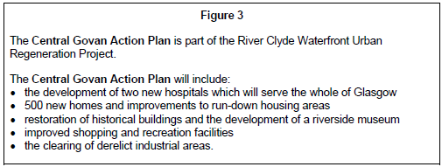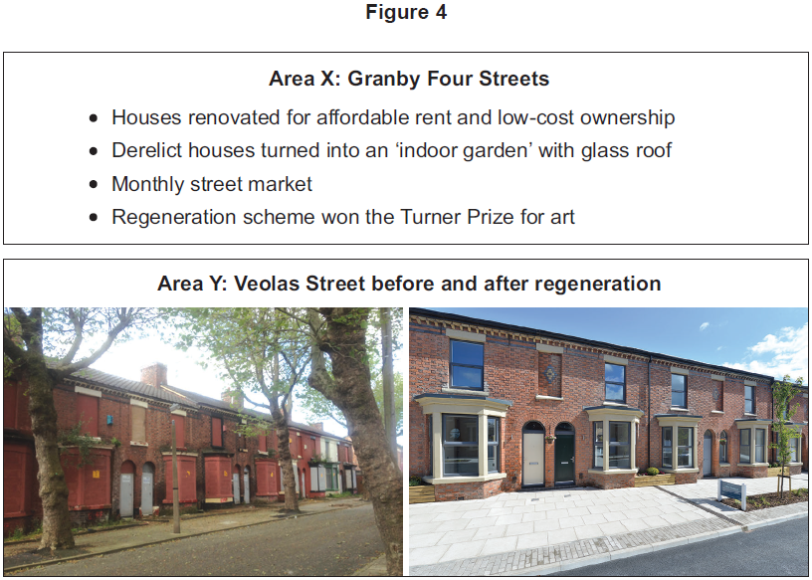

Urbanisation Page 20

QUIZ A:
Opportunities:
- Identify two social opportunities in London. For each you must state a specific example.
- How many jobs were in London in 2012?
Figure 2
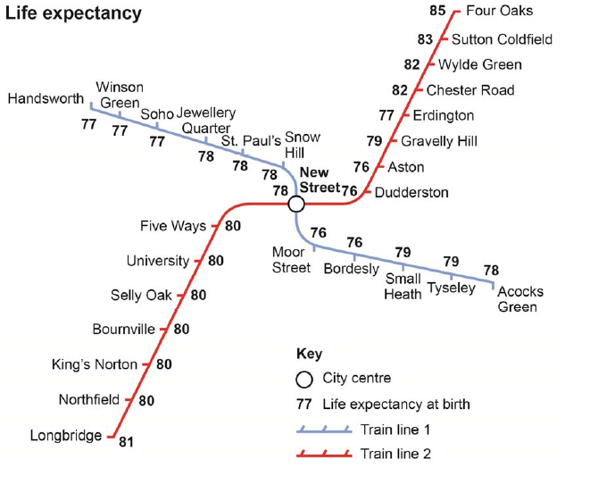Figure 4
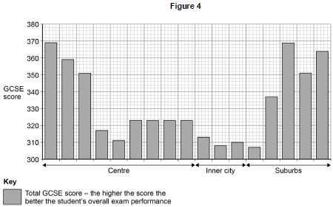
- What is the average wage in London?
- What is the most common employment sector in London?
- What percentage of the UK’s GDP comes from London?
- Where can you find quaternary jobs in London?
- An integrated transported system is…..
- How does the integrated transport system make London more environmentally friendly?
- London focuses on urban greening. ……….% of London is green space.
- How many roof gardens are there in London?
- Give the name of two parks in London.
Challenges
- Many area in London’s inner city are derelict. This means….
- This was caused due to……….which occurred in 1950s.
- One reason this occurred was because factories closed down and moved abroad. Why did they move abroad?
- Social inequality is common in London. This is….
- An example of social inequality is…..
- Social inequality is due to….

QUIZ B:
Challenges:
- The rural-urban fringe is…..
- There is a lack of housing in London. More specifically London’s population is growing by……….people per ear, however only…………new homes are being built.
- A brownfield site is…..
- An advantage and disadvantage of building new homes on brownfield sites is….
- A greenfield site is……
- An advantage and disadvantage of building new homes on greenfield sites is….
- Urban sprawl refers to……
- People move to the rural-urban fringe because….
- An environmental impact of urban sprawl is….
- You can reduce urban sprawl by….
- Air pollution is common in London due to…..
- An impact of air pollution is…..
- One way London is trying to reduce air pollution is by…..
- Waste pollution is common in London. This is a problem because….
- One way London is trying to reduce waste pollution is by…

PRACTICE EXAM QUESTIONS
- Using an example describe how urban greening provides social and environmental advantages. (6 marks)
- Explain how the growth of urban areas has created social and economic opportunities. (4 marks)
- To what extent has urban change created opportunities in a UK city you have studied? [9 marks]
- Discuss the effects of urban sprawl on people and the environment. (6 marks)
- Study Figure 2, a topological map showing variation in life expectancy along two train lines in Birmingham.
- Calculate the range in life expectancy shown in Figure 2. (1 mark)
- Using Figure 2 and your own understanding, suggest why there are inequalities in health in urban areas.(4 marks)
- To what extent has urban change created environmental challenges in a UK city you have studied? (9 marks)
- Assess the extent to which brownfield sites are the preferred sites for new housing. (6 marks)
- Providing suitable housing (of the right quality and quantity) is a major issue in many urban areas. Using a named example, explain how the need to provide suitable housing is being met in the inner city and suburbs. (6 marks)
- The Central Business Districts and Inner Cities in many urban areas in HICs have experienced decline. Suggest why many inner cities of UK cities have gone into decline. (4 marks)
- Study Figure 4, a graph showing GCSE scores along a transect through a UK city.
- Calculate the range in GCSE scores shown in Figure 4. (1 mark)
- Using Figure 4 and your own understanding, suggest reason(s) for inequalities in education in urban areas in the UK. (4)

Urbanisation Page 21

QUIZ A: SUSTAINABLE URBAN PLANNING
Figure 1
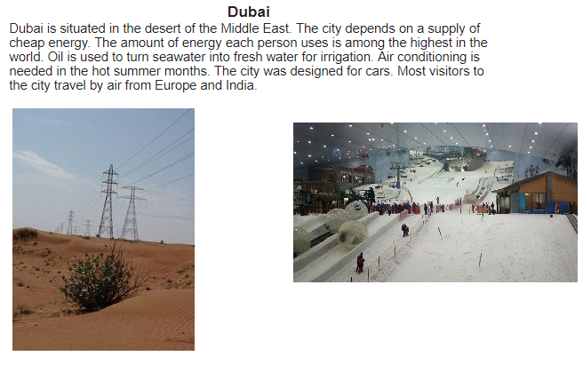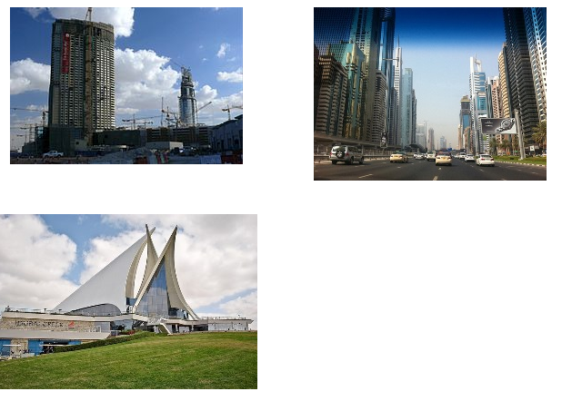
Figure 2
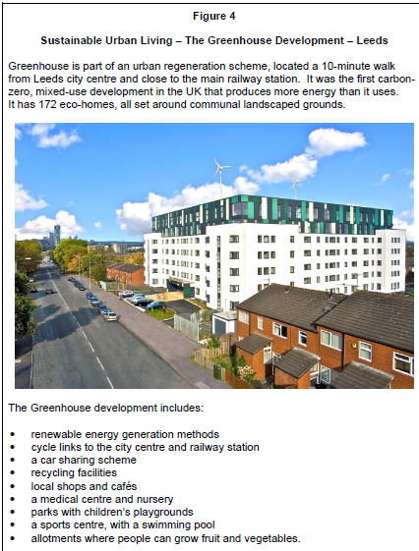

- Freiburg is located…
- In what year did it set a goal to become a sustainable city?
- State one way sustainable cities can increase the amount of water they have access to.
- State one way sustainable cities can prevent the overuse of water.
- By what year does Freiburg plan to be 100% powered by renewable energy?
- How many solar panel installations are used in Freiburg?
- How have the government encouraged households prevent overusing energy?
- State how many trees have been planted in the city?
- What % of deforested trees are re-grown?
- What percentage of the city is forested?

QUIZ B: TRAFFIC MANAGEMENT STRATEGIES
- Identify two problems that traffic congestion can cause.
- What are cycle routes?
- How has London encouraged people to cycle?
- What is park and ride?
- What is a social benefit of park and ride?
- What is an environmental benefit of park and ride?
- How many park & ride schemes are in London?
- What is an Integrated Transport system?
- How does it reduce traffic congestion?
- What is the congestion charge and how much does it cost?
- How far did it reduce congestion in London?
- Identify one way London has made their buses faster.
- Identify one way London has made their buses greener.

PRACTICE EXAM QUESTIONS
- Study Figure 1, information about the city of Dubai in the Middle East.
- What is sustainable urban living? (1 mark)
- Give three pieces of evidence from the figure to suggest that Dubai is not a sustainable city. (3 marks)
- Study Figure 2, showing information about a ‘Sustainable Urban Living’ project. Using Figure 2 and your own knowledge, discuss how the features of the Greenhouse development will make for more sustainable urban living. [6 marks]
- Using an example, explain how the development of public transport is reducing traffic pressures in urban areas. (6 marks)
- Traffic congestion is a problem in many urban areas. Explain how traffic congestion can be reduced. (6 marks)
- Evaluate the effectiveness of an urban transport scheme(s) you have studied. (9 marks)

Changing Economic World Page 22
Figure 1
Figure 2
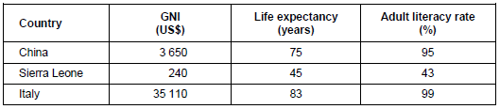Figure 3

QUIZ A
- Development is…
- Development indicators are….
- List the four indicators that the UN uses in the Human Development Index (HDI)
- The development gap is….
- Explain one human cause of the development gap: education, trade, colonialism.
- Explain one physical cause of the development gap: landlocked, climate.
- Differential wealth is an effect of the gap. How this impact on quality of life in Africa and the USA?
- How does development affect migration?
- A population pyramid is…..
- Do LICs or HICs have a wide base? Why?
- Do LICs or HICs have wide bars at the top of the pyramid? Why?
- What happens to the width of the bars in an LIC population pyramid?

QUIZ B
- How many stages are there in the DTM?
- Why does death rate fall in stage 2?
- Why does birth rate fall in stage 3?
- Suggest why birth rate begins to fall again in stage 5?
- What is debt relief?
- Debt relief is used to help LICs or NEEs develop by…
- Identify a country that has use tourism to develop.
- Suggest one positive and one negative impact tourism had on the host country.
- What is aid and provide an example.
Figure 4
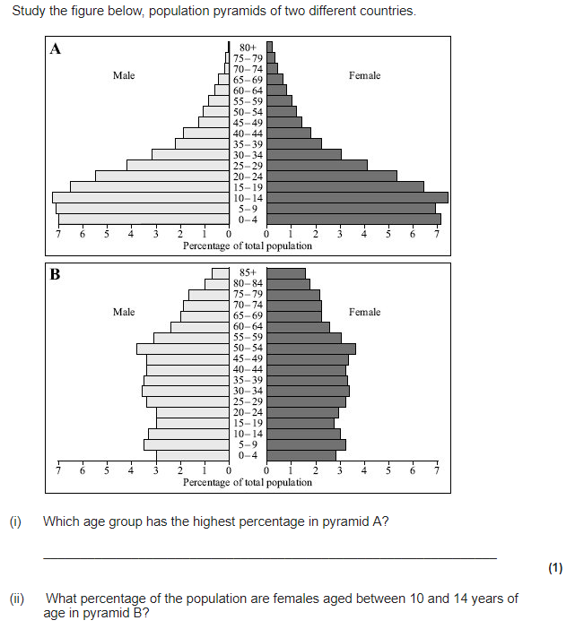
Figure 5
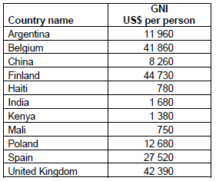
- What is fair trade?
- Suggest one way fair trade helps people in LICs/NEEs.
- Suggest one way investment helps people in LICs/NEEs.
- What is a microfinance loan?
- Suggest one example of a microfinance loan programme in an LIC or NEE.

PRACTICE EXAM QUESTIONS
- Study Figure 1, a world map showing the global distribution of Human Development Index (HBI) values.
- Compare HDI values in Africa & South America. (2 marks)
- Outline one disadvantage of using a single measure of development. (3)
- Study Figure 2. Explain how one of the indicators of development in Figure 2 shows the differences in the quality of life between the three countries. (4)
- Study Figure 3, population pyramids of two countries.
- What % of the population are females, aged between 10 and 14 years of age in pyramid B? (1 mark)
- Compare the shapes of the two pyramids. (3 marks)
- Explain how these population pyramids suggest that these countries are in different stages of the Demographic Transition Model (6 marks)
- Outline one way Fairtrade deals with the issue of unequal development (4)
- Suggest one reason why Fairtrade schemes are not always successful. (2 marks)
- Using an example, assess the impact tourism has on poorer countries. (9 marks)
- Study the text box in Figure 4, an extract from a website about a microfinance programme in Africa. Use the extract and your own knowledge to explain how people in the poorer part of the world can attempt to improve their own quality of life. (4 marks)
- Suggest how the growth of tourism in a LIC or NEE might help to reduce the development gap. (4 marks)
- Study Figure 5 (previous page), a table showing the Gross National Income (GNI) data for selected countries in 2016. Calculate the mean, median and interquartile range value for the GNI data in Figure 5.

Changing Economic World Page 23

QUIZ A
- Nigeria is an example of a NEE. Nigeria is located….
- Nigeria’s population is…..
- Nigeria is considered important due to its growing economy. More specifically…..
- Nigeria is considered important due to its oil production. More specifically…..
- Nigeria is considered important due to its international links. More specifically……
- What are Nigeria’s main exports?
Figure 1
Figure 2
- Who does Nigeria trade with?
- Nigeria has a multi-ethnic and multi-faith population. This means….
- Nigeria’s multi-ethnic and multi-faith population often results in conflict. For example…..
- A stable government was establish in…...
- Nigeria is going through industrialisation. More specifically….
- In 1999 people were mainly employed in…
- Today, more people are employed in……and…….industries.

QUIZ B
- When did Nigeria gain independence?
- Following Nigeria’s independence, there was a period of……..
- Why were people pushed out of agriculture?
- What attracted people to factories and services?
- Why were there more jobs available in factories?
- Why were there more jobs available in services?
- What is the multiplier effect?
- State one way economic development has social benefits.
- Suggest two services that have been improved due to Nigeria’s development.
- List one reason why families have more disposable income.
- How will increased incomes benefit Nigerian families?
- Suggest how development in Nigeria has meant the government have more to spend on education and healthcare.
- Use the multiplier effect to state how one change in Nigeria results in further benefits.
- Identify the three main priorities for Nigeria in order for them to develop further.

PRACTICE EXAM QUESTIONS
- Describe the importance of a LIC/NEE that you have studied. (3)
- Using a named example, describe how development in trade links has helped them develop. (4 marks)
- Many call centres have moved from the UK to India.
- What sector of the economy includes call centres: primary, secondary or tertiary?
- Study Figure 1, statements about why call centres have developed in India. For each statement, identify whether the reason is social, economic or political. (3 marks)
- Explain how developments in ICT and transportation have encouraged globalisation. (4 marks)
- Study Figure 2, a graph that shows how the share of world manufacturing production has changed between 1970 and 2010.
- What percentage of the world’s manufacturing production did the rich world produce in 1970? (1 mark)
- What was the increase in East Asia’s share of world manufacturing production between 1970 and 2010? (1 mark)
- Describe and explain the changes that have happened between 1970 and 2010. (6 marks)
- Using a case study of a LIC/NEE country, explain how manufacturing industry can encourage economic development. (6 marks)
- Describe the benefits of industrial growth in an economically developing area you have studied. Use an example(s) that you have studied. (6 marks)
- Using a case study of a LIC or NEE, describe and explain how their economy has changed. (6 marks)

Changing Economic World Page 24

QUIZ A:
- What is a Transnational Corporation?
- How many TNCs operate in Nigeria?
- Why do TNCs open up factories in Nigeria?
- Shell oil drills oil in the………
- Where is Shell Oil’s headquarters?
- State one way Shell has socially benefitted Nigeria.
- State one way Shell has economically benefitted Nigeria.
- State one way Shell had a negative social impact on Nigeria.
- State one way Shell had a negative impact the economy.
- State one way Shell had a negative impact on the environment
Figure 1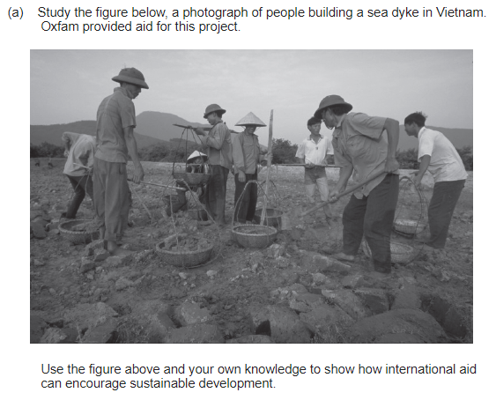
Figure 2
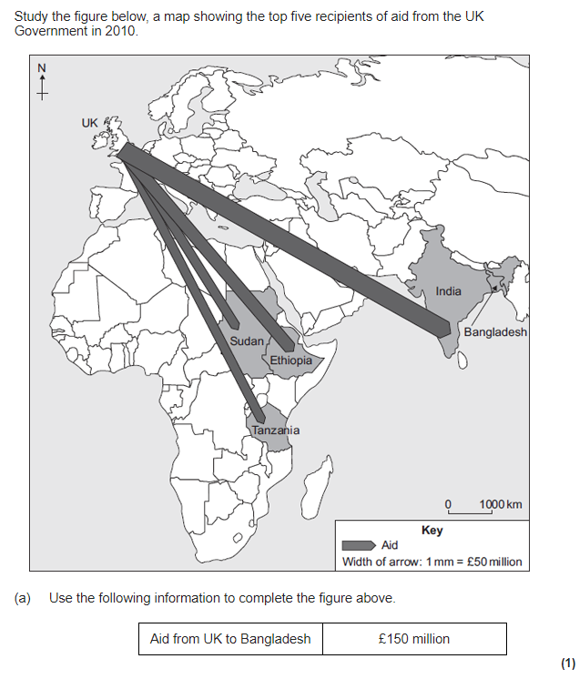

QUIZ B:
- What is industrial growth?
- How has it affected Nigeria’s environment?
- What is urban growth?
- How has it caused issues in Nigeria?
- Where does oil extraction occur?
- What happened in 2008/9?
- What two industries were affected?
- How did Shell compensate the victims?
- What is commercial farming?
- How has it affected Nigeria’s environment?

QUIZ B:
- Define aid
- List two types of aid.
- Suggest one reason why Nigeria needs aid.
- How much monetary aid did Nigeria receive in 2013?
- How does Nets for Life help Nigerians?
- How does the USA help Nigerians?
- How did the World Bank support Nigeria in 2014?
- What is the Aduwan Centre?
- What two organisations helped create the Aduwan Centre?
- How does the Aduwan Centre support Nigerians?

PRACTICE EXAM QUESTIONS
- Using a case study of a LIC or NEE country, explain the link between Transnational Corporations (TNCs) and industrial development in the country. (6 marks)
- Transnational corporations (TNCs) mainly bring advantages to the host country.
Do you agree with this statement: YES or NO?
Justify your decision. (9 marks)
- Intel is planning to build a new chip assembly and testing factory in China.
- China is a good place for a TNC to build a new factory. Suggest two reasons why. (2 marks)
- A new factory might benefit the area in which it is built. Describe some of the benefits. (4 marks)
- Outline how international aid can have social and economic impacts. Use an example of an LIC or NEE that you have studied. (6 marks)
- Study Figure 1, a photograph of people building a sea dyke in Vietnam. Oxfam provided aid for this project. Use the figure above and your own knowledge to show how international aid can encourage sustainable development. (6 marks)
- Study Figure 2, a map showing the top five recipients of aid from the UK Government in 2010. Use the following information to complete the figure: Aid from UK to Bangladesh: £150 million. (1 mark)
- Explain how rapid economic growth can impact on the environment. Use an example of an LIC or NEE that you have studied. (6 marks)
- Describe the effects of air pollution and water pollution in urban areas in poorer parts of the world. (4 marks)
- To what extent has economic development benefitted a LIC or NEE that you have studied. (9 marks)

Changing Economic World Page 25

QUIZ A
Figure 1
Figure 2
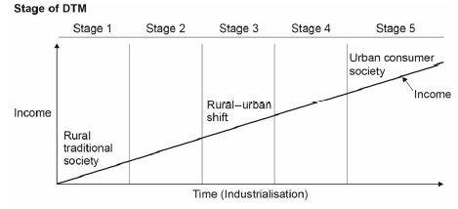
Figure 3
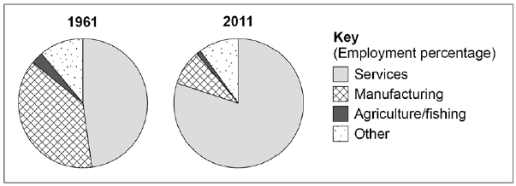
Figure 4
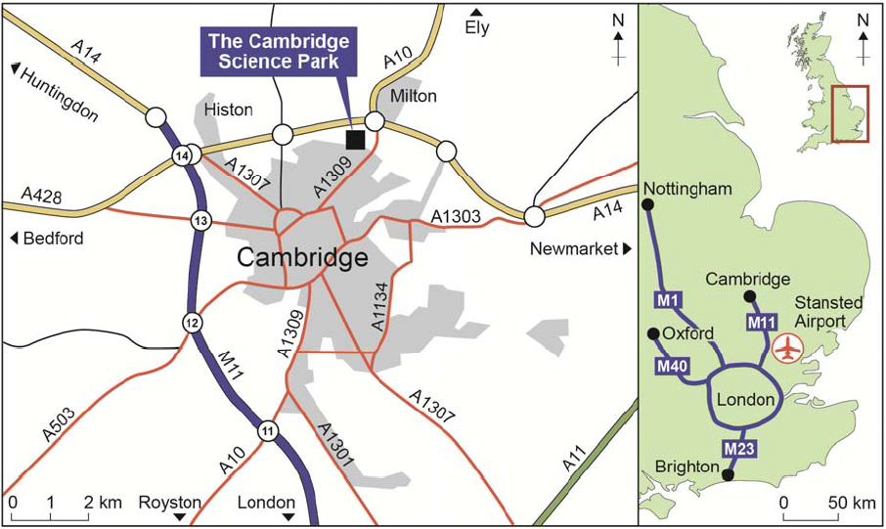
- What was the main economic sector in the UK in the 1600s?
- In the 18th and 19th centuries the UK went through i…………., which meant….
- In the 1950s the UK went through d………….
- This led to the creation of a………………. More specifically…..
- Suggest one reason why de-industrialisation occurred.
- How much of the UK’s GDP comes from the tertiary sector?
- Suggest one main industry in the tertiary sector that brings the UK a lot of income.
- Quaternary sector jobs are often found in science parks. These are usually located on the outskirts of cities. Suggest two reasons for this.
- State two advantages of Cambridge Science Park’s location.
- State one disadvantage of Cambridge Science Park’s location.
- What percentage of people in the UK live in rural areas?

QUIZ B
- Counter-urbanisation is the movement of people from……….to………. It results in an increase/decrease in people living in rural areas.
- Outward migration is the movement of people…… It results in an increase/decrease in people living in rural areas.
- Identify one area where counter-urbanisation is common and one area where outward migration is common.
- Identify one advantage and one disadvantage of population growth in rural areas.
- Identify one advantage and one disadvantage of population decline in rural areas.
- State one way the UK has improved its railway service. Identify one advantage and one disadvantage of this development.
- State one way the UK has improved its roads. Identify one advantage and one disadvantage of this development.
- State one way the UK has improved its ports. Identify one advantage and one disadvantage of this development.
- State one way the UK has improved its airports. Identify one advantage and one disadvantage of this development.

PRACTICE EXAM QUESTIONS
- Study Figure 1, a map, which shows the location of steel-making, a secondary industry, in the UK in 2005.
- Describe the distribution of steelworks in the UK? (4)
- Explain the factors that led to the decline of secondary industries in HICs. (4 marks)
- Discuss the social and environmental impacts of changing rural populations in the UK. (6 marks)
- Give two ways in which the rural environment is protected from development. (2 marks)
- The north-south divide is the real or imagined cultural and economic differences between the north and south of the UK.
- Describe two causes of the divide. (4 marks)
- Suggest how one or more strategies might reduce regional differences in the UK. [9 marks]
- Using Figure 2 and your own understanding, explain the link between the DTM and a country’s level of development. (4 marks)
- Study Figure 3, pie charts showing information about the changing industrial structure of the United Kingdom.
- Describe the changes to the industrial structure shown in Figure 3. [2 marks]
- Suggest reasons for the changes shown in Figure 3. (6 marks)
- Study Figure 4, maps showing the location of the Cambridge Science Park in the UK.
- Using Figure 4, explain the advantages of this location for the Cambridge Science Park. (4 marks)
- Give two reasons why there has been a growth in the number of science parks in the UK. (2 marks)
- Assess the importance of transport improvements to the UK economy (9 marks)
- Suggest how the UK is moving towards a post-industrial economy. (4 marks)

Changing Economic World Page 26

QUIZ A:
- The UK is linked with the wider world through the Commonwealth, EU and trade. The commonwealth is….
- State the number of countries in the commonwealth.
- What values do countries within the Commonwealth share?
- The UK is also linked through its membership in the EU. This is….
- In what year did the UK join the EU?
- An example of a modern industry in the UK is……
- Identify one way car manufacturing harms the environment.
- Identify one way the use of cars (driving) harms the environment.
- Identify one way the disposal of cars harms the environment.
- Identify one way car manufacturing can be more sustainable?
- Identify one way the use of cars (driving) can be more sustainable?
- Identify one way the disposal of cars can be more sustainable?
- When was the End of Life Vehicle regulation implemented?
- What is the name of Nissan’s hybrid car?
- Why do hybrid cars cause less environmental damage than petrol or diesel cars?

QUIZ B:
- What is the north-south divide?
- List one social difference between quality of life in the north and south of the UK.
- List one economic difference between quality of life in the north and south of the UK.
- How did de-industrialisation cause the north south divide?
- Identify one other cause of the north-south divide.
- What is the High Speed 2?
- How will it reduce the north-south divide?
- What is a Local Enterprise Partnership (LEP)?
- How will the LEP reduce the north-south divide?
- Suggest one other way the government has tried to reduce the north-south divide.
- How does the free movement of people within the EU affect migration to the UK?
- The EU makes it easier to trade between countries within the EU (free movement of goods). How did this affect the UK’s trading partners?
- How did the EU support farmers in the UK?
- Links with the wider world have been made easier due to improved transport and communications in the UK. In 2014, what percentage of the UK use the internet?

PRACTICE EXAM QUESTIONS
- Study Figure 8, a photograph showing a modern industrial development. Using Figure 8 to help you, explain how modern industrial developments can be made more environmentally sustainable. (4 marks)
- Using an example you have studied, describe how modern industries within the UK can impact on the environment. (6 marks)
- Assess the extent to which modern industries have negative environmental impacts. Use an example you have studied. (6)
- The UK is one of the most connected countries in the world. Use evidence to support this statement. (6 marks)
- Assess the extent to which UK’s international links provide social and economic benefits? (9 marks)
- Until recently, the UK was a member of the EU.
- How did this provide social and economic benefits for the UK? (6 marks)
- Suggest one negative impact of being a member in this trade group. (2 mark)
Figure 8
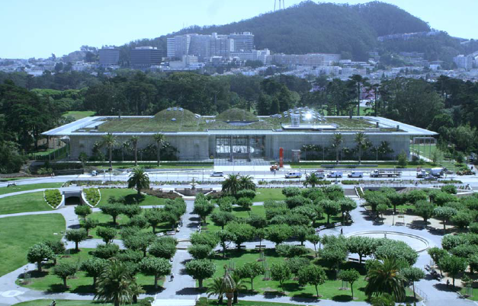

The Challenge of Resource Management Page 27

QUIZ A
- How much of the UKs food is imported?
- State one reason the UKs food is imported.
- Identify a negative impact of importing food?
- What is organic farming?
- State one advantage and one disadvantage of using organic farming.
- What is agribusiness?
- State one advantage and one disadvantage of using agribusiness.
- Why has water use in the UK increased?
- Why is there a water deficit in south-east England?
- Why is there a water surplus in central Scotland?
- What is a water transfer scheme?
- Identify how much of the UKs water is clean.
- State two causes of water pollution.
- State two impact of water pollution – one social and one environmental.
- State two ways water pollution is managed. Use specific examples.

QUIZ C
- State three essential resources.
- Where in the world is there a food surplus and food deficit?
- Identify a cause of water deficit.
- Identify one reason why NEEs use more energy than LICs.
- The UK’s energy mix is made up of…..
- How many coal fields are open in the UK?
- Why are renewable energies likely to be used more in the future?
- Why are less fossil fuels used today?
- State one reason why fossil fuels will continue to be used in the future.
- State one advantage of using fossil fuels. State whether it is an economic or environmental impact.
- State one disadvantage of using fossil fuels. State whether it is an economic or environmental impact
- State one advantage of using renewable energies. State whether it is an economic or environmental impact.
- State one disadvantage of using renewable energies. State whether it is an economic or environmental impact.
- State one advantage of using nuclear energy. State whether it is an economic or environmental impact.
- State one disadvantage of using nuclear energy. State whether it is an economic or environmental impact.

PRACTICE EXAM QUESTIONS
- Suggest how inequalities in the consumption of resources influence well-being. (3 marks)
- Explain how inequalities in the supply of resources influence social well-being. (3 marks)
- Discuss how modern farming methods in the UK can impact on the people and the environment. (6 marks)
- To what extent is it preferable to source food locally in the UK rather than import from abroad? [6 marks]
- Study Figure 10, comments from a government report into water quality and pollution in the UK. Discuss the challenges of managing water quality and pollution in the UK. Use Figure 10 and your own understanding. (6 marks)
- Assess the effectiveness of water transfer schemes in meeting the UK’s changing demand for water. (6 marks)
- Study Figure 9, a graph showing the UK’s energy mix from 2006 to 2016. Using Figure 10 and your own understanding, discuss the issues arising from the UK’s changing energy mix. (6 marks)

Figure 9 Figure 10
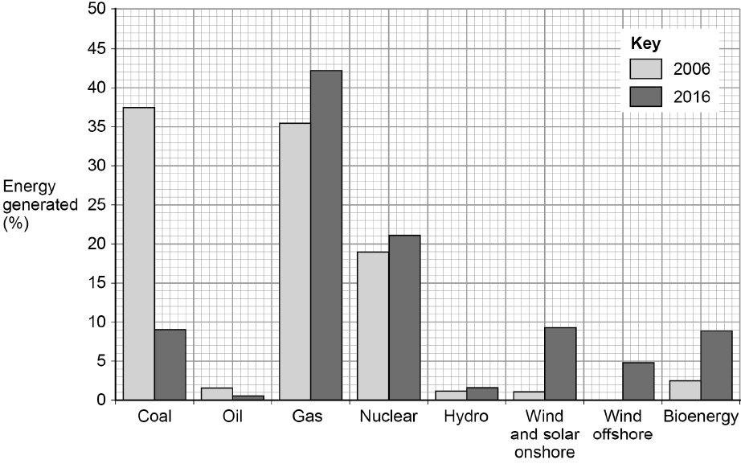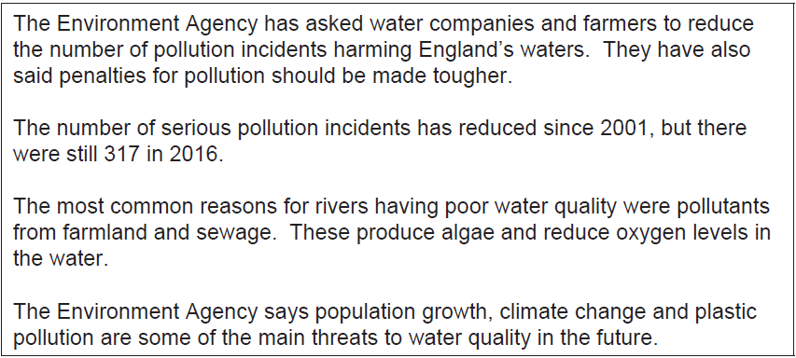

The Challenge of Resource Management Page 28

QUIZ A:
- Food consumption refers to….
- Food security is….
- Undernourishment is….
- A physical cause of food insecurity is…. + More specifically…..
- A human cause of food insecurity is…. + More specifically….
- A social impact of food insecurity is famine. A famine occurred in Somalia in……………, which killed….
- Food insecurity = increased food prices because…..
Figure 1
Figure 2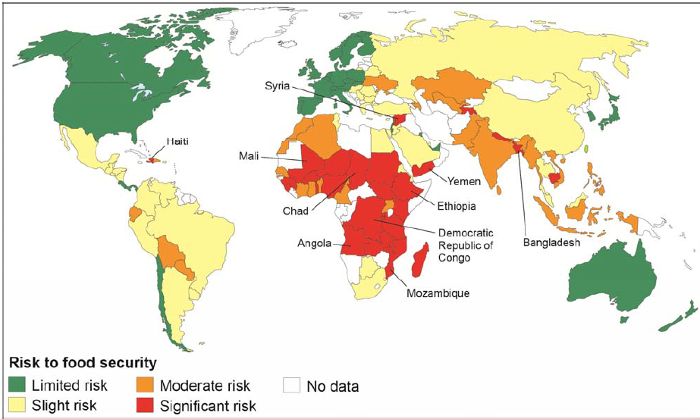
Figure 3

- Increase in food prices = food riots. An example of a food riot occurred in…..
- This food riot resulted in……and lasted…..
- Food insecurity can result in farming on marginal land. Farming on marginal land = soil erosion. More specifically……
- To reduce the risk of food insecurity they launched the green revolution. This is…..
- Why did they launch the new green revolution?

QUIZ B:
- Hydroponics is used to increase food supply. This is…..
- Aeroponics is used to increase food supply. This is…..
- State two advantages of using hydroponics and aeroponics.
- State one disadvantage of using hydroponics and aeroponics.
- Irrigation is use to reduce food insecurity because…..
- Two examples of irrigation are……
- The most sustainable type of irrigation is………..because…..
- How does irrigation cause salinisation?
- Biotechnology and GM crops are used to reduce food insecurity. This is….
- Suggest an example of GM crop.
- State one example of how the use of GM crops has benefitted the Philippines.
- Provide one advantage and one disadvantage of using GM crops.
- What does appropriate technology mean?
- Suggest an appropriate technology for a LIC.

PRACTICE EXAM QUESTIONS
- Study Figure 1, a map showing the percentage of population that was undernourished in Africa in 2014.
- What percentage of the population was undernourished in Chad in 2014? (1 mark)
- Using the map, describe the distribution of countries in Africa where there are high and very high levels of undernourishment. (2 marks)
- Describe the distribution of countries with a significant risk to food security shown in Figure 2. (3 marks)
- Figure 3 shows a list of impacts that are caused by using irrigation in farming. Using Figure 3 and your own understanding discuss the impacts of using irrigation as a method to increase food security. (6 marks)
- Outline the physical and human causes of food insecurity. (6 marks)
- Suggest how food insecurity might affect the quality of life of people. (3 marks)
- Assess the effectiveness of strategies used to increase global food security. (6 marks)

The Challenge of Resource Management Page 29

QUIZ A:
- State two sustainable strategies to increase food supply.
- What is organic farming?
- Suggest one reason why organic farming is sustainable.
- Why is it sustainable to eat seasonal food?
- What is urban farming?
- Give one environmental advantage of urban farming.
- What does reduce food waste mean?
- Suggest one way people can reduce food waste in their homes.
- Suggest one way reducing food waste will increase food supply.
- Identify one characteristic of a sustainable source of meat.
- Identify one characteristic of a sustainable source of fish.
- Why should people not buy food from large scale intensive fish and meat farms?

QUIZ B:
- An example of a large scale agricultural development is Thanet Earth. This is located…
- State three characteristics of how they grow food at Thanet Earth.
- State two sustainable strategies they use. Hint: water and CO₂
- Suggest how they ensure they use water sustainably.
- One social and one economic advantage of Thanet Earth are….
- One social and one environmental disadvantage of Thanet Earth are….
- An example of how a local scheme in an LIC/NEE to increase food supply sustainably is……
- Makueni is located…..
- They experience food insecurity because….
- The African Sand Dam Foundation and the charity………………………joined up in 2004 to try and increase food supply.
- To increase food supply they created a sand dam and built a water harvesting tank. A sand dam is……
- Where is the water stored?
- Water is not lost due to evaporation because…..
- The water helps to increase food supply because….
- An additional social benefit of the scheme is…..

PRACTICE EXAM QUESTIONS
- Describe the distribution of countries which had 15–24.9% of their population undernourished as shown in Figure 1. (2)
- Some strategies to increase food supply are more appropriate than others for LICs to invest in. (6 marks)
- Explain how different strategies can be used to make food supplies more sustainable. (6 marks)
- Use an example from a LIC/NEE to explain how local strategies are being used to increase sustainable supplies of food. (6)
- Describe the main features of a large scale agricultural development project you have studied. (4 marks)
- ‘A large scale agricultural development can bring both advantages and disadvantages.’ Explain this statement using an example you have studied. (6 marks)
Figure 1 