Key Knowledge: Tunnelling Electron Microscope
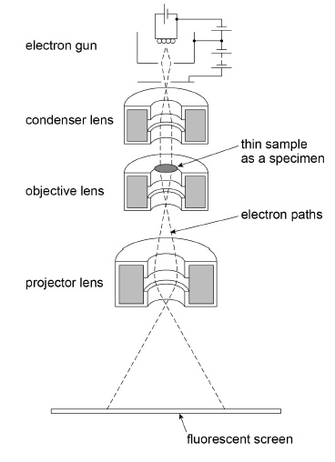
4. Specimen must be very thin and in evacuated chamber
5. Electrons incident in sample can do three things:
- pass straight through specimen
- be absorbed by specimen
- be diffracted by specimen

3. Condenser lens: uses magnetic fields to deflects electrons into parallel beam that is directed straight at the specimen

1. Electrons produced by thermionic emission
2. Electrons are accelerated using a potential difference between filament and anode

6. Objective lens forms magnified image
7. Projector lens magnifies image further and forms image on the screen
8. At screen:
- darker patches due to thicker or denser parts of specimen where electrons were absorbed
- lighter patches due to thinker/less dense part of specimen that enable electrons to be transmitted

Factors that affect the resolution (~1 pm):
- If any electron are diffraction: objective aperture is set to smallest size to prevent diffracted electron beams from contributing to the image on screen
- Decreasing wavelength increases resolution
  - Lower wavelength achieved by faster speeds
  - Faster speed achieved by increasing the anode voltage
- If temperature of filament isn’t constant then electrons are emitted with different speeds which alters their wavelength
- The speed of electrons is not always the same which causes different pathways through the lens and so aberration
- The sample thickness reduces the speed of the electrons increasing the wavelength• The sample thickness reduces the speed of the electrons increasing the wavelength and decreasing the detail.

