Key Knowledge: Scanning tunnelling microscope
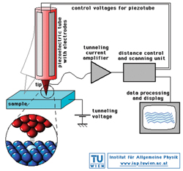
Setup:
- A very fine conducting probe is used to scan a small area of the surface of a metallic or semi-conducting sample
- Probe is positioned so that the tip of the probe is 1 nm above the surface
- There is a very small voltage between probe tip and the sample surface
Operation:
- Creates image using a phenomenon called quantum tunnelling
- Quantum tunnelling relies on the wave-like nature of electrons. The de Broglie wavelength of an electron in a metal at room temperature is ~1 nm which is equal to the gap
- Some of the electrons will move between the tip of the probe and the sample surface
- The potential difference across the probe-tip and sample surface makes sure that electrons only move in one direction
- There is a small but finite probability that electrons jump the gap

Modes of operation
- Constant height mode:
height of probe is kept constant during scanning
only undulation in surface sample affect the size of the gap
the smaller the gap the more electrons that tunnel
size of recorded current in probe increases or decreases depending on the size of gap
tunnelling current is sensitive to changes of gap width of order 0.001 nm
variation of current with time enables surface to be mapped out
- Constant current mode:
current in probe is kept constant
height of probe is moved accordingly to maintain constant current
variations of vertical height of tip with time enable image of surface to be created

