Lesson Title: ‘Look we have coming to Dover’ by Daljit Nagra

Do now: read the poem and use your unseen poetry checklist to capture your first impressions:

Links
For another example of how humour can explore serious themes, Ciaran O’Driscoll’s ‘Please Hold’ makes an interesting comparison.

Key context:
Dover is one of the key entry points into the UK for immigrants, legal and illegal. It therefore provides a clue as to the narrative voice.
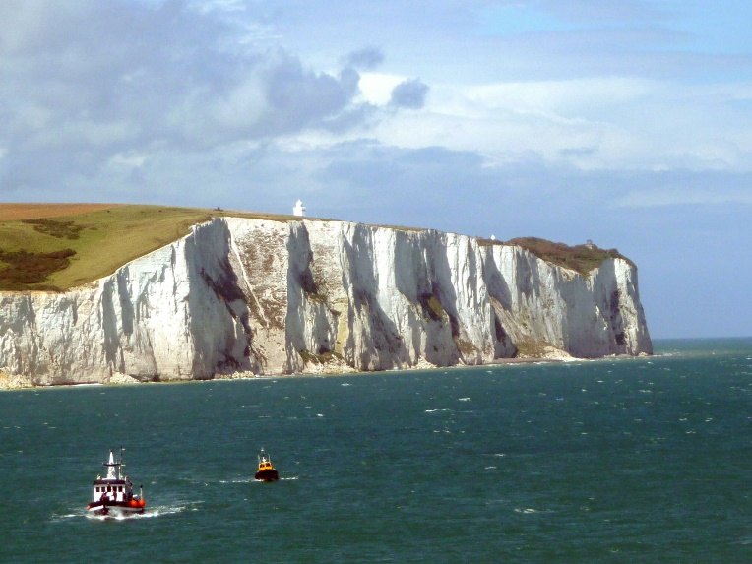
The poem contains an epigraph which references Matthew Arnold’s ‘On Dover Beach’. This famous poem (below is the first and last stanza) was written in 1851. It expresses typically Victorian concerns about the loss of faith in religion and a loss of certainty. Both poems address a lover in the final stanza. The epigraph also suggests Nagra’s attempts at a dialogue with Britain’s ‘traditiona;’ literary heritage and Victorian Empire. In the context of Nagra’s poem, the epigraph seems to suggest the hope that the immigrants have as they set out for Britain. Arnold, however, felt that the world seems beautiful but is in fact full of doubt and suffering.

Dover Beach

BY MATTHEW ARNOLD

The sea is calm tonight.
The tide is full, the moon lies fair
Upon the straits; on the French coast the light
Gleams and is gone; the cliffs of England stand,
Glimmering and vast, out in the tranquil bay.
…

Ah, love, let us be true
To one another! for the world, which seems
To lie before us like a land of dreams,
So various, so beautiful, so new,
Hath really neither joy, nor love, nor light,
Nor certitude, nor peace, nor help for pain;
And we are here as on a darkling plain
Swept with confused alarms of struggle and flight,
Where ignorant armies clash by night

Key Words/ definitions:
Alfresco – Adjective – out side. Mostly used to describe eating in the outdoors. For example: ‘ It’s very mild this evening, shall we eat our dinner alfresco?’
Ratchet – noun – a workman’s tool used to tighten bolts but can Be used as a verb. To ‘ratchet’ up a situation means to cause something to increase in level.
Brunt – adjective – the hardest/ most difficult/ roughest part of something. For example you received the brunt of his anger.
Cushy – slang for easy / not difficult.
Ministered – verb – attend to the needs of (someone). In this context it might have been used because it has connotations of Ministers/ government/ bureaucrac.
Blarnies – slang for deceptive or misleading talk; nonsense.
Prow – the front of a boat (but say prow’d out loud. What does it sound like?)
Blair – noun – Prime Minister Tony Blair –Labour Prime Minister (1997 – 2007) associated with a time of Middle Class success, a good Economy and a confident and optimistic time to be British.

Poetic methods
- Epigraph - a short quotation or saying at the beginning of a poem, book or chapter, intended to suggest its theme.

Puns
Unusual Syntax
Colloquial language

Summary and notes
The poem’s title alerts us to concepts of England and Englishness which are gleefully dismantled in the rest of the poem. Grammatically incorrect, the title sets the context of a speaker for whom English is a second language. The mention of Dover, one of the key entry points into the UK for immigrants, legal and illegal, provides a further clue as to the narrative voice. Dover is also a deeply resonant English location, its famous white cliffs a cultural shorthand for the country’s history as an island power. It also has a powerful literary heritage as the epigraph reminds us: Matthew Arnold’s ‘On Dover Beach’ is a famous poem written in 1851 which expresses society’s growing anxiety about the modern secular world. Nagra’s poem also echoes Arnold’s in the implied
presence of a beloved to whom the poem is addressed.

In contrast to Arnold’s poem, however, the title’s exclamation mark is expressive of an energetic optimism which sets the tone for what follows. The story this voice discloses is one of hardship and poverty. The speaker appears to be an illegal immigrant who has smuggled in on a tourist boat. In comparison to the ‘cushy’ tourists, the narrator and his kind have very little power – economic or otherwise. They are ‘huddled’, ‘hutched’, ‘burdened’, ‘grafting’, out of sight and mind.

But despite this the narrator can imagine a future where they’ve won their way to prosperity. The poem ends where it began, with a reference to the Arnold poem, to a mythical England as symbolised by the white chalk of the Dover cliffs – and an exclamation mark.

The tone and energy of the poem is bound up in its language. Each stanza is packed with a dizzying array of sound effects – rhyme, half-rhyme, alliteration and assonance. Coupled with these is an infectious irreverence towards ‘proper’ English. Nagra coins new verbs such as ‘phlegmed’, ‘unbladders’, ‘passport us’ and ‘Blair’d’. These he mixes with phrases from colloquial English such as ‘gobfuls’, ‘scramming’, ‘hoick’ and ‘lingoes’ to form a lively hybrid which mirrors the mixing of cultures that immigration entails.

The effect is fun and funny – both at the expense of the English but also, to an extent, the narrator whose dreams of a new life are a parody of aspiration. The poem also incorporates language often used by those who see immigration as a threat to national identity – ‘invade’, ‘teemed’ and ‘swarms’ – and subverts it by putting it in the mouth of an immigrant, in this case a Punjabi Indian.

Through this cheerful disregard of ‘standard’ or ‘correct’ English and subversion of the tabloid discourse on immigration, Nagra puts the issue of what constitutes national identity at the heart of his poem. The place and its language are, in effect, one and the same – which gives the narrator’s remaking of the latter its satirical and political edge.

Questions:

Who is the narrator of the poem? What kind of voice do they have? How do you know? (title?)

The poet uses a mixture of colloquial English and non-standard English (slang, incorrect grammar, nouns used as verbs) to convey the cheerful, immigrant voice. Find examples of these:

The poet uses a pattern of words to convey the powerless but hard-working position of the illegal immigrant. Find examples of these words:

The poem also incorporates language often used by those who see immigration as a threat to national identity. Find examples and explain the specific ideas/images the words convey.

Describe the shape of the poem. What ideas might the form, enjambment and punctuation convey?

Do you think the poem has any satirical intent? If so, who or what is being satirised?

Look We Have Coming to Dover (2007)

Daljit Nagra

‘So various, so beautiful, so new…’
– Matthew Arnold, ‘Dover Beach’

Stowed in the sea to invade
the lash alfresco of a diesel-breeze
ratcheting speed into the tide, with brunt
gobfuls of surf phlegmed by cushy come-and-go
tourists prow’d on the cruisers, lording the ministered waves.

Seagull and shoal life
Vexin their upon our huddled
camouflage past the vast crumble of scummed
cliffs, scramming on mulch as thunder unbladders
yobbish rain and wind on our escape, hutched in a Bedford van.

Seasons or years we reap
inland, unclocked by the national eye
or stab in the back, teemed for breathing
sweeps of grass through the whistling asthma of parks,
burdened, ennobled, poling sparks across pylon and pylon.

Swarms of us, grafting in
the black within shot of the moon’s
spotlight, banking on the miracle of sun –
span its rainbow, passport us to life. Only then
can it be human to hoick ourselves, bare-faced for the clear.

Imagine my love and I,
our sundry others, Blair’d in the cash
of our beeswax’d cars, our crash clothes, free,
we raise our charged glasses over unparasol’d tables
East, babbling our lingoes, flecked by the chalk of Britannia!

