Year 7 RE booklet – Spring Work
Morality

Name
House group

Lesson 1: ‘To be able to explain what morality is’
What is morality? | What society says is wrong or right behaviour

Do now:
Someone is going to put poison in London’s water and you haven’t time to warn the police. The only way for you to prevent the death of thousands of innocent people is to murder the person before they have a chance to do it.
- I would…
- More specifically..
- This is because…

Morality tells us how to act towards other people, how to speak to them, what we can and can’t do.
Morality is the concept of doing the right thing. Morals are basic guidelines for living.
Many people have written about ways of choosing what the right thing is. Some believe that there is an objective (true even if you do not agree with it) morality, often thinking it was set by God or another similar being; others think that morality is subjective (that what is good or bad is a community choice).
People can learn morals from religion, parents, friends, school, books, or from ethical traditions. People that teach or follow morals are called moralists.
It can also be a lesson that someone learns in a book or story. It is usually one line at the end of the story ("The moral of this story is....."). Fables are stories with a moral.
The opposite of "moral" is "immoral", meaning the wrong thing to do. "Amoral" means something that is not related to morality, or has no morally good or bad aspect to it. It is the same as "morally neutral". Morality means that you can tell between a right and a wrong thing.

Rank these actions using a 1-10 scale. 1 being very moral and 10 being pure evil:

What is moral behaviour?
Morality is the behaviour that….
More specifically…
The benefits if we all behaved morally would be…
If everyone behaved immorally, the world would be…
More specifically…
Behaviour that I would expect to see from a moral person would be….
Behaviour that I would expect to see from an immoral person would be….
Lesson 2: ‘To assess how I make moral decisions’
What is relative morality? | You believe that different actions are needed in different situations
What is original sin? | The first sin, committed by Adam and Eve
What is authority? | When you have power over someone else
What is a sin? | When you break a religious rule
What is morality? | What society says is wrong or right behaviour
What is the conscience? | Inner voice inside you that tells you what is wrong and right

Different people have different ways in which they make decisions and different people who have influenced them throughout their lives to make decisions in a certain way. For example, religion, family, friends etc.
In the following grid, give your opinion of why each of these factors make people make decisions in a particular way.
 | Why is it important to you? | Why is this a good way to make a moral decision? | Why is this a bad way to make a moral decision?
Religion
Parents
Friends
Law

How do I make moral decisions?
The best way to make a moral decision is…
More specifically…
The worst way to make a moral decision is…
More specifically…
It is important to be moral because…
In the situation….
I made a moral decision by…
I would advise other people to make a moral decision by…because…

Lesson 3: ‘How do religious people make decisions’
How do religious people make moral decisions? | Speaking to and getting advice from god
How do religious people make moral decisions? | Religious leaders study and interpret god’s words, they advise others on how to act
How do religious people make moral decisions? | People read god’s word in holy books and make decisions based on it
How do religious people make moral decisions? | Following the religious rules and laws god has given to them

Authority- the power to make rules or give orders. Religious people have three different sources of authority:
Speaks directly to people and is always right

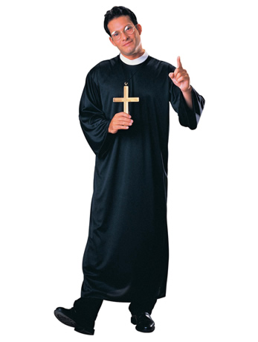
God speaks through religious leaders
Studied the bible
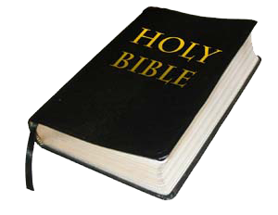
Word of God.
Teachings of Jesus- role model

Fill in the table with your opinion:

 | Good way to make a moral decision | Bad way to make a moral decision
God
Religious leader
Bible

Some people think your conscience is from god- this is how we know what is right and wrong. It could be God speaking directly to humans
Should people always use their conscience to guide them? Give two strengths and two weaknesses of it.

Sentence starters
I think your conscience is…
More specifically..

The best way for a religious person to make a moral decision is…
because…
More specifically…
A religious person should always use…..
when making a moral decision because…
More specifically…
When making a moral decision a religious person should not…
More specifically..

Lesson 4: ‘To understand the difference between absolute and relative morality’

What is absolute morality? | You believe that there are set rules to follow at any time or in any situation e.g. Do not kill
What is relative morality? | You believe that different actions are needed in different situations
Strength of absolute morality | there are some ideas that everyone in the world
Weakness of absolute morality | It is too inflexible
Strength of relative morality | It is a flexible system so everyone’s views are counted
Weakness of relative morality | It allows feelings and emotions to get in the way

- Absolute morality- You believe there are set rules to follow at any time or in any situation e.g. Do not kill
- Relative morality- You believe that different actions are needed in different situations e.g. killing is bad but sometimes it is necessary

Are these statements absolute or relative?
- There are moral rules that are always the same, in all times, places and in situations
- There aren’t just one set of morals that everyone agrees with
- Things are right or wrong and cannot change
- Things are good or bad depending on the circumstances
- Torturing children, rape and murder are always wrong. That will never change
- All cultures and people have different values and morals
- Some acts are intrinsically wrong, which means wrong in themselves

Absolute morality
If you believe in absolute morality you will have faith that there is a right course of action to take in a moral dilemma, which is true in all situations regardless of culture, religious tradition, time or age.
How would a follower of this sort of morality respond to the commandment 'Do not kill'? They would try to make sure that they were not involved in any killing, which would affect their views on issues such as war, abortion and euthanasia. They would say that these actions are wrong in all circumstances.
Relative morality
If you believe in relative morality you would agree that different courses of action might be needed in different situations.
How would a follower of this sort of morality respond to the commandment Do not kill? They would agree that killing is wrong. However, they would look at a range of other issues as well. For example, they might say that killing is necessary in a particular situation, such as in the case of abortion, if continuing the pregnancy would result in the birth of a severely disabled child, or if the mother had been raped

Is absolute or relative morality better?
Absolute morality is…
For example…
An advantage of absolute morality is…
A disadvantage of absolute morality is…
Relative morality is…
An example of this is…
An advantage of absolute morality is…
A disadvantage of relative morality is…
Overall, I think the best type of morality is….because…
I don’t believe that….is useful because…

Lesson 5: ‘To assess whether humans are born bad’
What is original sin? | The first sin, committed by Adam and Eve
What is authority? | When you have power over someone else
What is a sin? | When you break a religious rule
What is enlightenment? | State of perfect knowledge/wisdom
What is karma? | The Hindu belief that your actions and behaviour affects what happens to you in the future

- Sin- breaking a religious law
- Original sin- the first sin, committed by Adam and Eve. Passed down through generations so we are all born with sin.

Read the passage below and answer the questions on original sin
Now the serpent was more crafty than any of the wild animals the LORD God had made. He said to the woman, "Did God really say, `You must not eat from any tree in the garden'?"
The woman said to the serpent, "We may eat fruit from the trees in the garden, but God did say, `You must not eat fruit from the tree that is in the middle of the garden, and you must not touch it, or you will die.'"
"You will not surely die," the serpent said to the woman.
"For God knows that when you eat of it your eyes will be opened, and you will be like God, knowing good and evil."
When the woman saw that the fruit of the tree was good for food and pleasing to the eye, and also desirable for gaining wisdom, she took some and ate it. She also gave some to her husband, who was with her, and he ate it. Then the eyes of both of them were opened, and they realized they were naked; so they sewed fig leaves together and made coverings for themselves. Then the man and his wife heard the sound of the LORD God as he was walking in the garden in the cool of the day, and they hid from the LORD God among the trees of the garden. But the LORD God called to the man, "Where are you?"
He answered, "I heard you in the garden, and I was afraid because I was naked; so I hid."
And he said, "Who told you that you were naked? Have you eaten from the tree that I commanded you not to eat from?"
The man said, "The woman you put here with me--she gave me some fruit from the tree, and I ate it."
Then the LORD God said to the woman, "What is this you have done?" The woman said, "The serpent deceived me, and I ate."
So the LORD God said to the serpent, "Because you have done this, "Cursed are you above all the livestock and all the wild animals! You will crawl on your belly and you will eat dust all the days of your life. And I will put enmity between you and the woman, and between your offspring and hers; he will crush your head, and you will strike his heel." To the woman he said, "I will greatly increase your pains in childbearing; with pain you will give birth to children. Your desire will be for your husband, and he will rule over you." To Adam he said, "Because you listened to your wife and ate from the tree about which I commanded you, `You must not eat of it,' "Cursed is the ground because of you; through painful toil you will eat of it all the days of your life. It will produce thorns and thistles for you, and you will eat the plants of the field. By the sweat of your brow you will eat your food until you return to the ground, since from it you were taken; for dust you are and to dust you will return."
Adam named his wife Eve, because she would become the mother of all the living. The LORD God made garments of skin for Adam and his wife and clothed them. And the LORD God said, "The man has now become like one of us, knowing good and evil. He must not be allowed to reach out his hand and take also from the tree of life and eat, and live forever."
So the LORD God banished him from the Garden of Eden to work the ground from which he had been taken. After he drove the man out, he placed on the east side of the Garden of Eden cherubim and a flaming sword flashing back and forth to guard the way to the tree of life.

Original sin questions
What did Eve do wrong?
______________________________________________________________________________________________________________________________________________________________
What did Adam do wrong?
______________________________________________________________________________________________________________________________________________________________
Why was God angry?
______________________________________________________________________________________________________________________________________________________________
What punishments did they receive?
Adam- ____________________________________________________________________________
Eve- ______________________________________________________________________________
Snake- ____________________________________________________________________________
To assess whether humans are born bad”
Christians believe that humans are born bad, they are sinners. They think this because all people are born with original sin meaning that…
More specifically….
In my opinion, humans are/are not born bad…I believe this because…

Lesson 6: ‘To be able to explain how Buddhists make moral decisions’

What are the 5 precepts for Buddhists? | - Not to kill or harm living things  - Not to take things that are not freely given  - Not to have wrong relationships  - Not to tell lies or speak unkindly  - Not to drink alcohol or take drugs
What is the eightfold path for Buddhists? | - Right understanding  - Right emotion  - Right meditation  - Right speech  - Right action  - Right job  - Right effort  - Right awareness

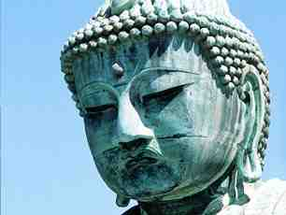

Buddha taught that all life is suffering and we have to learn to avoid selfishness and greed to be free from suffering.

Buddhists follow the teachings of Buddha (which means “enlightened one”- the one who has found the truth.) They do not believe in God.
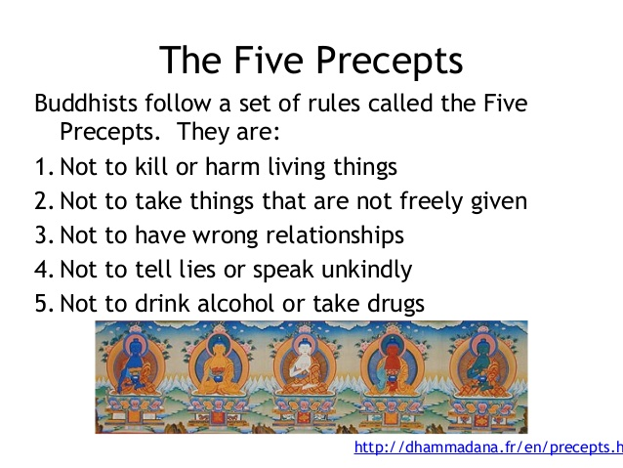

The Five Precepts are the Buddhist version of a code of conduct or rules to help people behave in a moral and ethical way. Buddhists should follow the Five Precepts to ensure they are living a morally good life. This helps them to get rid of suffering and achieve enlightenment.
It is important to practise the precepts over time as they are not always easy to carry out. The main aim of a Buddhist is get rid of suffering, and therefore following the Five Precepts is important as they help Buddhists to avoid causing others to suffer. Following the Five Precepts is linked to kamma, as these count as skilful actions, which produce good consequences

Sentence starters
The five precepts are rules…
The five precepts are beneficial for society because…

- Noble eightfold path- the 8 ways you should live your life to achieve enlightenment
The Noble Eightfold Path, or magga, is a more detailed development of the Threefold Way (ethics, meditation and wisdom). Below are the eight steps of the Noble Eightfold Path, shown in relation to the Threefold Way

Think of a scenario in the last week from school and answer the sentence starters
Last week at school….
More specifically..
I should deal with this using the right….
This would tell me to…..
Another thing that happened was….
More specifically..
I should deal with this using the right….
This would tell me to…..
Sometimes it might be difficult to use the eightfold path because…
More specifically..

Lesson 7: ‘To be able to explain how Christians make moral decisions’
What are the two great laws for Christians? | - ‘Love the Lord your God with all your heart and with all your soul and with all your mind’  - ‘Love your neighbour as yourself.’
What are the 10 commandments? | - You shall have no other Gods but me.  - You shall not make for yourself any idol  - You shall not misuse the name of God.  - You shall remember and keep the Sabbath day holy.  - Respect your father and mother.  - You must not commit murder.  - You must not commit adultery.  - You must not steal.  - You must not give false evidence against your neighbour.  - You must not be jealous of your neighbour's goods.

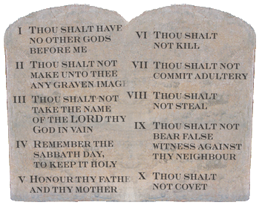
According to Christian belief, the Ten Commandments are important rules from God that tell Christians how to live.
The first four commandments are instructions about how humans should relate to God
The last six commandments are about how people should treat each other
Sentence starters
#

The 10 commandments are…
The 10 commandments help Christians to make a moral decision because…

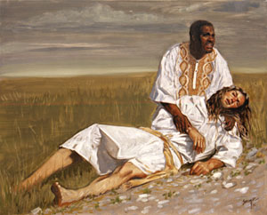
"There once was a Jewish man walking along a road. He was coming from Jerusalem and was heading to Jericho, which was a full day or two of walking.
The road was rocky and there were small hills all around. The man was just humming to himself and enjoying the nice day when suddenly a group of men jumped out from behind a hill. They took all his belongings and tore off most of his clothes. They didn't want him to follow them so they beat him up very badly, and left him lying and bleeding on the side of the road.
A few minutes later, a priest was walking down the same path and noticed the man lying on the side of the road. Do you know what he did? You'd think he would run over and help the man. Instead he crossed the road and walked on the other side and acted like he didn't see the man.
About an hour or so later, another man, called a Levite, was walking down the road. Levites were people who assisted priests with their work. He would probably help the man. But you know what he did? He slowed down and walked a little closer to the man, but then kept walking without helping him at all.
You might be thinking that maybe the man lying by the side of the road looked like he was resting or something and that is why the priest and the Levite didn't stop to help. The trouble is, it was easy to tell he was badly hurt. The man was bleeding, had most of his clothes ripped off him, and he was bruised and hardly breathing.
Just a few minutes later, another man came walking. He was a Samaritan. One thing you should know about Samaritans is that Jews didn't like them. Jews usually didn't treat Samaritans very well, so they never got along. The man who was dying on the road was a Jew. So what do you think the Samaritan did? You would think he would walk by and maybe even laugh at the man.
But as soon as he saw the man, he went over to him and felt compassion for him. He put bandages on his sores and poured oil and wine (which were quite expensive) on the sores to prevent them from getting worse. Then he lifted the man on his own donkey and took him to a hotel to take care of him.
The next day the Samaritan took out enough money so the man could stay at the hotel until he was well enough to leave. He paid the man at the front desk and asked him to take care of the man. If he wasn't better after about two months the Samaritan would come back and pay for any extra cost."
After Jesus finished the story, he asked, "Which of the three men do you think was a neighbor to the man who was left beaten on the side of the road?"
The man who asked him the question at the beginning replied, "The one who had compassion and helped him."
Jesus told him, "Go and do the same."
#

Sentence starters
The parable of the good Samaritan helps Christians to make moral decisions because…
More specifically…
#

Think of a scenario in the last week from school and answer the sentence starters
Last week at school….
More specifically..
I should deal with this using the 10 commandments….
This would tell me to…..
Another thing that happened was….
More specifically..
I should deal with this using the law….
This would tell me to…..
Sometimes it might be difficult to use the commandments/great laws because…
More specifically..

