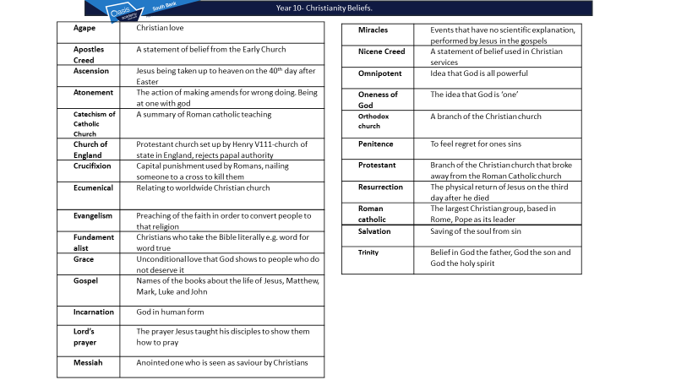

Christianity Beliefs Summer homework
Complete all lessons up to the point it says

Part one- COMPULSARY holiday homework
- Complete all the questions
- If you get stuck answers are in the text.
- Learnt the quotes in the text.
- Pages 1-35

Part two- Pages 35 onwards
- optional resources for practice ( that people who want to do well will use to beat the competition.)

Name:
You can hand this in online or on this hard copy.

Week 1 – Christianity

Different kinds of Christians

What do we know about Christianity?
- What do all Christians agree on?
- Name two different denominations ( kinds of) Christians.
- Who do Catholics follow?
- Describe the difference between Protestant and catholic. .
- What is Orthodox Christianity?
- Describe how the Quakers worship.
- Describe the Quaker beliefs about war.
KEY TERMS
Catholic- branch of Christianity based in Rome and led by the Pope
Orthodox- branch of Christianity mainly practised in Eastern Europe
Protestant- branch of Christianity, protested against some Catholic practices, believe the Bible is the only authority for Christians
Denomination- distinct group within the Christian faith with its own organisation and traditions
God – the Supreme being.

Around one in three of the world’s population claim to be Christians. Some are more committed to their faith than other but there is no doubting that Christianity has a major influence across the world.
Christianity was founded 2000 years ago and its founding belief is that Jesus died and rose from the dead. Christianity grew as early followers spread the word of Jesus, inspired by his disciples and the apostle Paul.
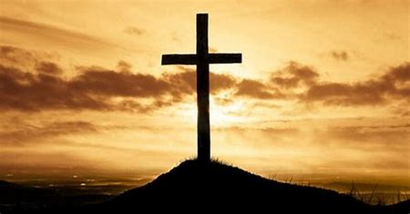
All over the world the cross is a familiar symbol of Christianity
Christianity is a monotheistic religion (monotheism means the belief in one God) with an estimated2.2 billion followers. Christianity originated over 2000 years ago. It is founded on the belief that Jesus died and was resurrected to allow humans to overcome their sinful nature. Christianity initially grew as early followers spread the messages of the resurrected Jesus.
The word denomination is used for a large group of Christian people right across the world who use the same name, the same sort of organisation and have the same (or very similar) beliefs. Christianity is divided into three main groups. These groups all branched out at different dates from the early Christianity founded by the followers of Jesus. The splits generally happened because they could not agree on certain beliefs or practices.

Thhe word denomination is used for a large group of Christian people right across the world who use the same name, the same sort of organisation and have the same (or very similar) beliefs. In 1054 Christianity split into Western Roman Christianity (Catholicism) led by the Pope, and Eastern Orthodox Christianity. These two groups remain today, however the Western Roman Church in England was split in the sixteenth century when King Henry VIII declared himself the head of the newly established Church of England.
During this period, Christians in Western Europe continued to break away from the Roman Church, and the Protestant branch of Christianity was formed. This is known as the Reformation. The three main branches of Christianity are now Catholic, Orthodox and Protestant. All three branches now exist side-by-side and all three are rightly called ‘Christianity’.
Different kinds of Christians: A case study of a Protestant denomination
Quakers
In 1650 Englishman George Fox started The Society of Friends. Fox thought that
Christianity had lost sight of the simple and pure beliefs and lifestyle of the Early
Church. He called it the Society of Friends, because he wanted followers to
be friends with each other and friends with Jesus. Today there are around
210,000 members around the world including 17,000 in Britain. They are
known as Quakers. Quakers meet in meeting houses, rather than in churches. They meet in plain
rooms and sit silently, usually for an hour, in a circle or a square. The silence is only
broken if someone feels that the Holy Spirit is leading them to say something.
When they speak, they might read something from the Bible or another
book, or they might pray or speak about an experience that they have had. Quakers
believe that God speaks through the people who contribute to their meetings.
Discussions and arguments are not allowed and there is always a period of
silence after someone has spoken. This allows people to reflect on what has been
said. The meetings do not follow any structure and sometimes nobody will
speak for the whole hour. In Quaker meetings there is no leader, no music and no creeds. They believe that
these things can be an obstacle to an individual experiencing God directly. They think that faith is a personal thing, which should not rely on following
someone else’s ideas or words. Quakers place less emphasis on the Bible than
other Protestant denominations because they believe that people should find
spiritual truth in their own experience and let their conscience guide their moral. Quakers do not believe in war and so are called pacifists.

Lesson 2 The nature of God
1. Explain two beliefs about the nature of God. (5)
2. Explain two ways in which belief that God is all loving/a judge influences Christians today (4)
3. ‘For a Christian, believing that God is all-powerful is not important’. Discuss. (12)

Key words
Monotheistic – a religion that oly believes in one God.
Holy- separate and set apart for a sp ecial purpose by God.
Omnipotent – almighty, having unlimited power, a quality of God.
Benevolent – all-loving, all-good, a quality of God.
Omniscient – all knowing, a quality of God.
Justice – bringing about what is right and fair, according to the law, or making up for a wrong that has been committed.

Week 2 Nature of God
All Christians are monotheist, they only believe in one god. They believe God creates and sustains all that exists. God has worked through history, guiding and inspiring people to do God’s will. Christians have a relationship with God and communicate with God through prayer.
Christians believe that God has no gender (even though they call God he/Father). He has traditional male and female characteristics e.g. power and love. Describing God is ultimately very difficult. He is often depicted as being in the sky in a human body, but Christians do not believe that he has a physical human body.
‘’ Nothing is impossible with God’’ LUKE 1:37
‘’God so loved the world that he gave his one and only Son’’ JOHN 3:16

In order to be the perfect ‘Supreme Being’, it is important that God is omnipotent. This means all powerful with unlimited authority. Although many images show God’s omnipotence in terms of power and authority, it also consists of the strength and power to do good. God’s omnipotence is benevolent.

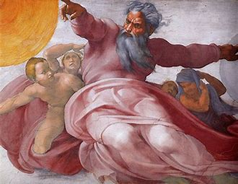

A traditional depiction of God. One of power, authority, but also of kindness.

With unlimited power and authority, together with total love, God is believed to be the perfect giver of justice. This not only includes deciding on right and wrong but also being the perfect judge of human character. As the ultimate source of justice, God will never support injustice, ill-treatment, prejudice or oppression. Therefore Christians should do all they can to prevent these wrongs wherever they encounter them.
For Christians the idea of God as loving is very important. They believe that as God loves humans, God wants what is best for them. They believe that God created humans because he is all-loving and desired to bestow his love upon creatures. This encourages Christians to believe that God’s greatest act of kindness was sending God’s Son, Jesus to earth.

The Nicene Creed outlines to Christians the basis of their faith, and some of the characteristics of God

Nicene Creed
We believe in one God,
the Father almighty,
maker of heaven and earth,
of all things visible and invisible.
And in one Lord Jesus Christ,
the only Son of God,
begotten from the Father before all ages,
God from God,
Light from Light,
true God from true God,
begotten, not made;
of the same essence as the Father.
Through him all things were made.
For us and for our salvation
he came down from heaven;
he became incarnate by the Holy Spirit and the virgin Mary,
and was made human.
He was crucified for us under Pontius Pilate;
he suffered and was buried.
The third day he rose again, according to the Scriptures.
He ascended to heaven
and is seated at the right hand of the Father.
He will come again with glory
to judge the living and the dead.
His kingdom will never end.
And we believe in the Holy Spirit,
the Lord, the giver of life.
He proceeds from the Father and the Son,
and with the Father and the Son is worshiped and glorified.
He spoke through the prophets.
We believe in one holy catholic and apostolic church.
We affirm one baptism for the forgiveness of sins.
We look forward to the resurrection of the dead,
and to life in the world to come. Amen.

Week 2 – The Problem of evil
Questions:
- The problem of evil is….
- What is original sin?
2. Explain two ways in which Christians have responded to ‘the problem of evil’. (4)
3. Explain two ways in which the belief that God is just (kind) influences Christians today. (4)

The problems of evil and suffering
Many people question why a loving God would allow people to suffer, rather than just prevent the evil actions of others from happening. Christians believe that a just God treats all people fairly and is incapable of making a wrong judgement. Therefore, Christians are sure that they can trust God even when things appear to be wrong.

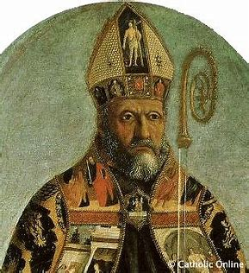
Augustine of Hippo. The Theologian who posited the concept of ‘original sin’

Explanations of the existence of evil in the world
Free will:
Christians say God gave humanity ‘free will’. This means the ability and right to choose. If God had not given free will, then people would have no choice but to believe and follow him, they would basically be robots. People can choose to do what is right, or not. Evil happens when humans misuse their free will. The price we pay for freedom is suffering. Real choice means we have real consequences. Christians believe that moral evil is not a result of God, but of choices humanity makes. For God to intervene and stop it means taking away free will.

Augustine’s ‘original sin’:
Original sin is an Augustine Christian doctrine that says that everyone is born sinful. This means that they are born with a built-in urge to do bad things and to disobey God. It is an important doctrine within the Roman Catholic Church. The concept of Original Sin was explained in depth by St Augustine and formalised as part of Roman Catholic doctrine by the Councils of Trent in the 16th Century.
Some Christians believe that original sin explains why there is so much wrong in a world created by a perfect God, and why people need to have their souls 'saved' by God.

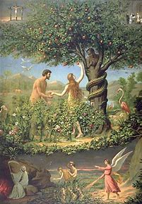
The Garden of Eden – where Adam and Eve were tempted

Test of faith:
Evil exists within the world as a test from God, so that he can see who is need of punishment or intervention to believe in him. The existence of evil allows God to see those are dedicated to their faith and respect him, as well as those who do not.
KEY TERMS
Evil – deliberately morally wrong or bad.
Just – acting with compassion in a way that is fair to everyone.
Free will – the ability to choose.
Original sin – everyone has sin within them due to Adam and Eve’s temptation.

Week 3 and 4 – The Oneness of God and the Trinity
Questions:
1. The Trinity is made up of…
2. Explain the role of two out of the three elements of the Trinity (4)
3. ‘For a Christian, believing that God is all-powerful is not important’. Discuss. (12)
The oneness of God and the Trinity?
Christians believe in one God – monotheism – and this belief is developed by the idea of the Trinity.
In simple terms, the concept of the Trinity is that there are three ‘persons’ all of which are God. The idea of the Trinity is a mystery and Christians accept that it is hard to explain in words. Any attempt to compare the concept of the Trinity with something humans can fully understand will have limited success. However, Christians have tried to explain a little of what the Trinity may be like in different ways so people may begin to understand it. For example, just as a clover leaf is made up of what seems to be three separate leaves, the one God in made up of three ‘persons’ – God the Father, God the Son and God the Holy Spirit.

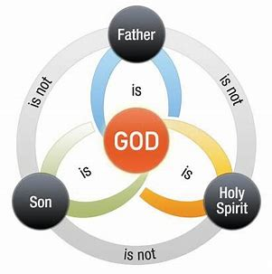
A common visual representation of the Trinity. All ‘persons’ are linked, but are distinct.
Nature of God as the Trinity
God is not a physical being, although one ‘person’ of the Trinity – Jesus (the son) – did have a physical presence in history. It may be best to think of these three ‘persons’ as non-physical elements of realities. They are all God and so, within the Trinity, the idea of the Oneness of God should not be forgotten. God can be seen as one in three and three in one, all at the same time. This may seem like a contradictory idea, and difficult for the human mind to fully understand.
The Trinity describes all three of the following at once:
- There is only one God
- Each ‘person’ of the Trinity is fully God
- The ‘persons’ of the Trinity are not the same

God the Father
Christians believe that the first person of the Trinity is God the Father. The Lord’s Prayer, a prayer Jesus taught his disciples and which is commonly used in worship begins with the words:
‘Our Father in heaven’.
God the Father is believed to be the creator of the earth and all living things on it. As creator of life, he acts as a good father would towards his children. He is believed to be all powerful (omnipotent), all loving (omnibenevolent), all knowing (omniscient) and present everywhere (omnipresent).

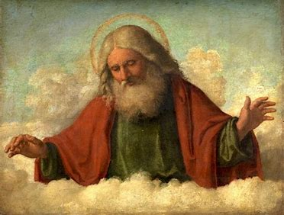
A typical depiction of God the Father. Powerfully looking down from heaven to earth.
God the Son
The second person of the Trinity is often referred to as God the Son and became incarnate on earth and in history as Jesus. Christians believe Jesus was both fully human whilst on earth and also fully God.
Jesus is said to be God’s representative on earth who died to redeem the sin of man and also provides an example of how to act in the world, for all other mankind to follow.
God the Holy Spirit
Christians believe that once Jesus had left the earth, God sent the Holy Spirit to influence, guide and sustain the earth and all life on it. The Holy Spirit was believed to be the unseen power of God at work in the world in the past, present and future.
KEY TERMS
Trinity – the belief that there are three persons in the One God; the Father, the Son and the Holy Spirit are separate, but also one being.
Holy Spirit – the third person of the Trinity whom Christians believe is the inspiring presence of God in the world.
Son of God – a title used for Jesus, the second person of the Trinity; denotes the special relationship between Jesus and God the father.

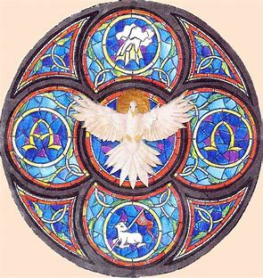
The Holy Spirit as stained glass window. A dove is the typical representation of the Holy Spirit.

Week 5 – Different Christian beliefs about creation
Questions:
1. What is original sin?
2. Explain the difference between a liberal and a literalist or creationist Christian (4)
3. Explain two ways that the creation story influences Christians (4)
4. Explain two beliefs about God the creator (4)

Role of the Word and Spirit
Genesis 1 states that’ the Spirit of God was hovering over the waters’.
For Christians, it was the Spirit of God that created the universe out of nothing. This is important because it shows that God is omnipotent and the source of all life. It also shows that the concept of the Holy Spirit has been part of the universe since the beginning of time.
- What is part of the Trinity is the ‘Spirit of God’ referring to?
- What does the quote show about creation?
- What does the quote show about the Trinity?

The account of Creation is mentioned again in the Gospel of John. John starts his Gospel with the words,’ In the beginning was the Word, and the Word was with God, and the Word was God’ (John 1:1).
John uses ‘the Word’ to refer to Jesus, showing that Jesus was present at the Creation of the universe.
- What is part of the Trinity is the ‘word’ referring to
- What does the quote show about creation?
- What does the quote show about the Trinity?

Creation: Genesis 1:1-3
Christians believe that God created the earth and all living things on the earth. One story about the creation of the world is found in the first book of Genesis in Chapter 1. Many Christians believe that although it may not be scientifically accurate, this account of contains religious truth, explaining that the process of creation was God’s choice and that God designed and caused it to happen.
The book of Genesis begins:
‘’ In the beginning, God created the heaven and the earth. Now the earth was formless and empty, darkness was over the surface of the deep, and the spirit of God was hovering over the waters. And God said ‘Let there be light,’ and there was light.”

The story continues by giving an account of how the universe was created, how the earth was made fit for life and finally how God created life, including humans, who were the last of God’s creations. This is believed to have happened in six periods of time (days) after which God rested.

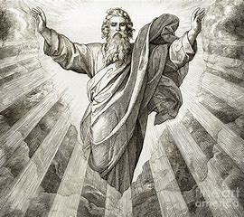
A traditional picture of God creating light

The role of the Spirit
It is interesting to note the reference to the ‘Spirit of God’ hovering over the waters. It could be argued that even though God the Father is referred to as the creator, the Holy Spirit, the third person of the Trinity, was already active in what has become the world. This perhaps reinforces the Oneness of God rather than the three ‘persons’ of the Trinity.

Literal and liberal Christians
There are different ways to read and understand the Bible.
Some Christians believe that the Bible stories, including the Genesis account, should be taken literally. This means that the biblical accounts are to be taken as fact, ie that God created the world in six days and rested on the seventh, and that no alternative or scientific theory is considered. These are known as literalist Christians, or creationists.
However, liberal Christians believe that The Genesis account works alongside science and reason to try and understand the key message – that God is responsible for the creation of the world. Science may be able to explain how the universe was created, but Christians believe that religion explains the reason why it was created.
KEY TERMS
Creationist – people who believe the Bible, specifically the creation story, is literally true.
Liberal Christians – view the creation story as a metaphor for God’s power.
Creation – the act by which God brought the universe into being.
The Word – term used in John’s gospel to refer to God the Son.

Augustine’s ‘original sin’:
Original sin is an Augustine Christian doctrine that says that everyone is born sinful. This means that they are born with a built-in urge to do bad things and to disobey God. It is an important doctrine within the Roman Catholic Church. The concept of Original Sin was explained in depth by St Augustine and formalised as part of Roman Catholic doctrine by the Councils of Trent in the 16th Century.
Some Christians believe that original sin explains why there is so much wrong in a world created by a perfect God, and why people need to have their souls 'saved' by God.

Week 6 – The afterlife and judgement
Questions:
1. The day of judgement is…. More specifically….
2. Explain the two main ways in which Christians act during life in order to be saved on judgement day. (5)
3. Explain two ways in which Christian beliefs about the afterlife influence Christians today (4)
The afterlife
1. Religions have varying ideas on the afterlife, and groups within religions have slightly different views. Christians, for example, believe that humans receive eternal life as a gift from God, and so a belief in the afterlife is for Christians dependent on a belief in God. The afterlife either begins upon death or at the Day of Judgement when Jesus will come again to judge the living and the dead, as the Apostles’ Creed says below. At this time Christians believe their souls enter a different dimension about which little is known.
The Apostles Creed, a statement of Christian belief dating back to around 400CE but which is till considered important today, contains the following beliefs:
“He ascended into heaven, and is seated at the right hand of the Father, and he will come to judge the quick and the dead:
I believe in the resurrection of the body and the life everlasting”
Apostles Creed

Judgment
10. Christians believe that it is God who decides the fate of those who die. God will take into account the life of the person and the extent to which they have tried to get close to him, by following the teaching and example of Jesus. Jesus told a parable recorded in Matthew’s gospel that contains a clear description of God at work in judgement:

“All the nations will be gathered before him (God), and he will separate the people one from another as a shepherd separates the sheep from the goats. He will put the sheep on the right and the goats on his left”.
Matthew 25:31

The ‘sheep’ (those who were blessed) asked when they had done these good things. They were told that whenever they had done them for others they had done them for him (God). He then condemned the ‘goats’ for not acting in this way for others.

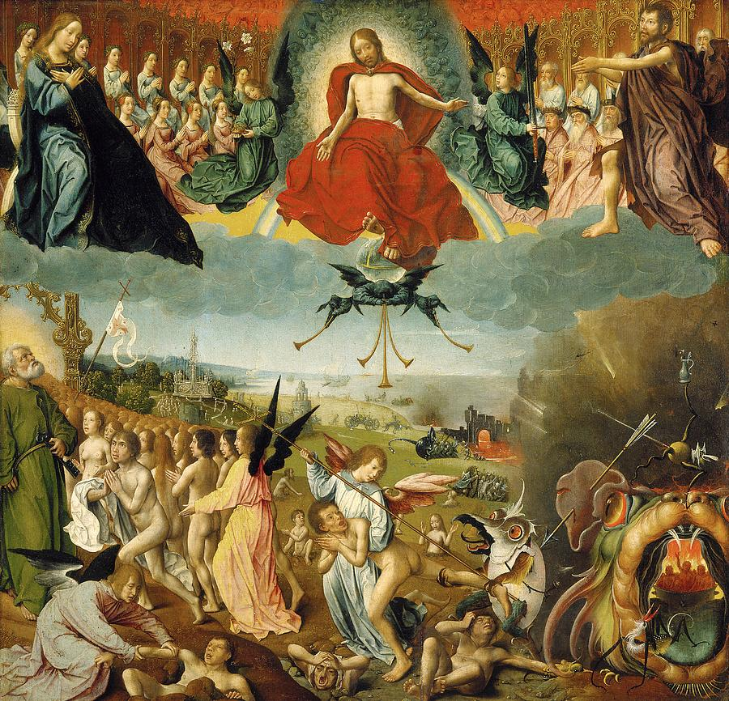
A religious image on judgement day.

15. This passage gives Christians a good idea about the criteria God uses in judgement and shows what they need to do to be saved. Jesus makes it clear that in serving other people, Christians are serving him. In his Gospel, John records a conversation Jesus had with a disciple, in which Jesus was preparing his disciples for his death. Jesus told them that he would go and prepare a place for them so that they could join him.
It is clear that Christians believe that simply treating other people well and in accordance with Christian morality is not enough to guarantee a good afterlife. They believe that Jesus is the Son of God and following his teaching is also important.
Jesus says:
“I am the way and the truth and the life. No one comes to the Father except through me”
John 14:6

KEY TERMS
Afterlife – what Christians believe follows life on earth.
Day of Judgement – a time when the world will end and every soul will be judged by God and rewarded or punished

Week 7 – The incarnation and Jesus, the Son of God
Questions:
- Incarnate means…. More specifically….
- What evidence do Christians believe show Jesus is the son of god?
2. Explain two reasons why the incarnation of Jesus is important to Christians (4)
3. ‘The incarnation is most important belief within Christianity’. Do you agree? Give reasons for your answer (12)

The Incarnation
1. Many people in the world today know the Christmas story, the account of what happened when Jesus was born, even though some of the details of the story we hear at Christmas may not be historically accurate, it does express basic Christian truths.
The gospels of Matthew and Luke explain clearly that Mary, Jesus’ mother, did not conceive Jesus sexually. She was engaged to Joseph who took Jesus as his son, even though he knew he was not his natural father. An angel appears to Mary in Luke’s Gospel and to Joseph in Matthew’s Gospel. In both cases the angel explains that the conception was no ordinary conception and that the child would be no ordinary child. Mark and John do not include any information about the birth of Jesus. Maybe they did not think the story important, but they are both clear that Jesus is the Son of God
‘’She was found pregnant through the Holy Spirit.”
Matthew 1:18

10. Although many people question the virgin conception because it is not a natural thing to happen and is unlikely to have happened since, for Christians it is very important. It gives evidence for the belief, shared by all Christians, that Jesus is incarnate – made flesh in human form, fully God yet fully human and thus the God the Son as part of the Trinity. It is fundamental to Christians belief that through incarnation, God showed himself as a human being for around 30 years.

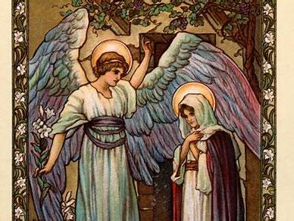
An image of the angel Gabriel announcing to Mary the coming of Jesus
Son of God
Instead of telling the story of Jesus’ conception and birth in his gospel, John is more interested in the meaning of it:
‘’The Word became flesh and made his dwelling among us”
John 1:14

17. Prior to this, in verse 1, John seems to identify ‘the Word’ as God the Son. For Christians, this gives clear support to the belief that Jesus was God incarnate, in the flesh as a man. This gives his words, deeds and promises great authority because they are the word of God, delivered by a man who was fully God as well as fully human. The belief that Jesus was God incarnate makes it easier for Christians to explain and accept as truth some of his actions whilst on earth, including miracles and his resurrection (rising from death).

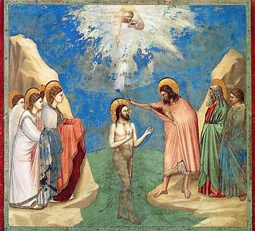
A scene depicting the baptism of Jesus

22. Jews developed an expectation well before Jesus was born that God would send a special leader, the Messiah, to save his people from tyranny and establish an age of global peace. Jews do not accept that Jesus is the Messiah. Christians accept that Jesus is the Messiah, but a spiritual one, rather than a political one.
When Jesus was baptised a voice from heaven said, ‘You are my Son’. On one occasion the disciple Peter referred to Jesus as the Christ. However, Jesus warned his followers that they should not use this term for him as his opponents would have him arrested for claiming to be God (blasphemy). The gospel writers do use it in their writing as they were writing some years later.
KEY TERMS
Incarnation – becoming flesh, taking human form.
Resurrection – rising from the dead.
Blasphemy – a religious offence, including claiming to be God.

Week 8 – The Crucifixion
Questions:
1. Crucifixion is when…. More specifically….
2. Explain two ways in which the crucifixion impacts the lives of Christians today. (4)
3. ‘Belief in the crucifixion of Jesus is not an important element of Christianity’. Do you agree? (12)
The Crucifixion
1. One of the most detailed stories from the whole of Jesus’ life is the account of how he died. He was sentenced to death by Pontius Pilate, the Roman Governor, and his death was by crucifixion.
Crucifixion was a particular form of execution favoured by the Romans. It consisted of the victim being laid down onto a large wooden cross, attached to it using nails, rope or sometimes both and then having the cross lifted upright. Once the cross was upright in the ground, the victim waited for death, usually by asphyxiation (not being able to breath). Some managed to resist death for a couple o days whilst others lasted a matter of hours. All of this happened in pubic. Jesus was crucified in a similar way to others, including the two men crucified on either side of him.

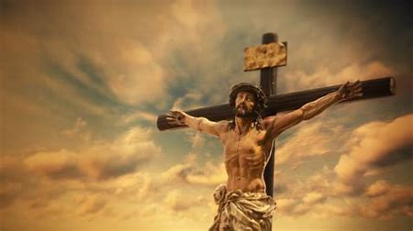
A representation of Jesus’ crucifixion

9. Even though Christians believe that Jesus was the Son of God, it does not mean that he was in some way spared the pain and horror of his crucifixion. Not only was he fully God, he was also fully human, and had the same feelings as anybody else. However, according to Luke’s version of the story, possibly told to him by people who were there, Jesus forgave the guards who killed him because they did not realise the significance of what was going on. He also had conversations with the two men who were crucified with him, promising one of them that he would soon join God in paradise.

Jesus called out with a loud voice, ‘Father, into your hands I commit my spirit’. When he had said this, he breathed his last.
Luke 23:46

The impact of the crucifixion for Christians today
15. There are several ways in which the crucifixion affects Christians today. It gives them confidence that if they accept Jesus’ sacrifice, sin can no longer destroy their lives because God forgives those who faithfully ask for forgiveness. They believe that suffering is part of life, just as it was a part of Jesus’ life and that, having also experienced it, God understands what the sufferer is going through.
Jesus is buried
Once Jesus was dead and the Roman guards had made sure that he was, a man called Joseph from Arimathea asked for the body of Jesus so he could bury it. Joseph was a member of the Council that had pressed for Jesus to be killed but he had himself disagreed with it. As there was insufficient time to bury Jesus properly because of the Sabbath day of rest and religious observance was due to start, he laid the body of Jesus in a cave-like tomb and rolled a large stone to block the entrance.
KEY TERMS
Crucifixion – Roman method of execution by which criminals were fixed to a cross.

Week 9/10 – The Resurrection and Ascension
Questions:
1. The resurrection is….more specifically…
2. The ascension is…more specifically…
2. Explain two ways in which the ascension affect Christians today. (4)
3. The crucifixion is more important to Christians than the resurrection’. Evaluate this statement. (12)
The Resurrection of Jesus
1. According to the accounts of Jesus’ burial in the New Testament, he was placed in a tomb on Friday afternoon. We know this because it states that Shabbat (the Sabbath) was due to begin and Jews keep Shabbat at sunset every Friday. There was no time to anoint his body and bury him properly, so he was laid in the cave-like tomb. How long he remained there is unclear because early on Sunday after Shabbat had ended, some of Jesus’ female followers went to the tomb to anoint the body and prepare it for burial. There are some differences in the gospels as to the identity of these women, although all four name Mary Magdalene as one of them, and according to the Gospel of John she was the only one.
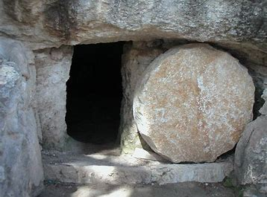
An empty tomb: a symbol of the resurrection of Jesus.

9. Although other details vary between the four versions of the story, they all make it quite clear that the body of Jesus was nowhere to be found, a fact that was reported to the disciples. Each story mentions to the women meeting a man or two men, who may have been angels, who told them that Jesus had risen from the dead and that they should pass the word on to his followers, including the disciples. The belief that Jesus rose from the dead is known as the resurrection and is a key teaching in the Christian faith. For Christians, it is significant evidence of the divine nature of Jesus.
For the next few weeks Jesus appeared to people, informing them that he had risen from the dead, as was predicted to them when he was alive.

The ascension of Jesus
15. Just as the resurrection is a matter of faith and interpretation, so is the ascension. There are other explanations but if Jesus had the special power of God to rise from the dead, it is equally possible that this same power means he was able to leave the earth physically and return to heaven. Only Mark’s and Luke’s gospels finish off their story by telling their readers that, after meeting his disciples and asking them to carry on his good work, Jesus left them for the last time.
Significance of the resurrection and ascension for Christians today
The significance of these two events still affects Christians today in a number of ways:
- The resurrection shows the power of good over evil.

- Christians believe that by accepting Jesus, they can also be resurrected in some way.

- It assures Christians that God will forgive their sins and they can ascend to heaven.

- Both pave the way for the Holy Spirit to work providing comfort and guidance.

- It is the basis of the Christian faith.
KEY TERMS
Resurrection: rising from the dead, just as Jesus did on Easter day. An event recorded in all four gospels.
Ascension: the event, 40 days after the resurrection, when Jesus returned to God, the Father, in heaven.
Heaven: a state of eternal happiness in the presence of God; the place of eternal peace ruled over by God.

Week 11 – Heaven and Hell
Questions:
1. Heaven is….hell is….
2. A traditional interpretation of hell is…..A modern interpretation is….
3. Explain two contrasting ideas about what the afterlife will be like. 4 marks
Heaven
1. The result of judgement in the eyes of God is either that they are able to experience the presence of God eternally (heaven) or that they are unable to experience God’s presence (hell). Catholics believe in an intermediate state called purgatory where the souls of some Christians wait to receive their place in heaven.

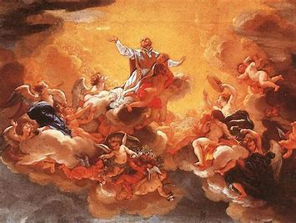
Traditional paintings of heaven provide the modern world which much of our understanding of what heaven may look like.

5. Traditional paintings of heaven show it as beyond the clouds and where God sits on a huge throne, surveying the earth with angels flying around. It is seen as a place of peace, joy and freedom from pain, and a chance to be with friends and family who are already in heaven. Whether this is a spiritual or physical existence is unclear. In pictures and images it is often represented as a physical paradise rewarding the good, possibly because this is the easiest way to represent it. However, this does not mean that Christians necessarily believe it is physical not spiritual.
10. Among Christians there are different opinions about who will be with God eternally. Some Christians believe that only those who believe in Jesus will be with God in heaven. Other Christians think that heaven is reserved for Christians and perhaps followers of other faiths who have lived good, principled live and pleased God in doing so. All Christians believe that God will forgive sins and this will enable people to approach God’s presence. The Parable of the Sheep and the Goats does seem to indicate that heaven is a reward for BOTH faith and actions – having only one is insufficient.

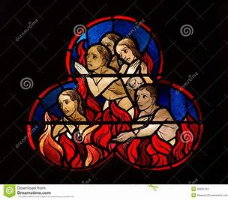
Stained glass window depicting hell

Hell
15. Hell is often seen as the opposite of heaven. Christians understand it to be a state of existence without God. It is often depicted in paintings to be a place of eternal suffering, terror, fire and torture ruled by the Devil (Satan). It is pictured as a fiery pit somewhere beneath the earth. This is perhaps a believer’s image of what it would be like to be permanently without God.
This raises the difficult question of whether non-Christians go to hell if heaven is reserved for Christians. This would appear to be very unfair and, as Christians believe God is incapable of being unfair, may believe that all those who believe in God and try to follow him will be accepted by God and be welcomed eternally into his presence.
22. However, there is great debate about whether a loving God would condemn people to eternal torment and pain. If this is not the case, perhaps a more interpretation is that hell is an eternal state of mind of being cut off from the possibility of God. This would be what awaits a person who throughout their life did not acknowledge God or follow his teachings.
KEY TERMS
Heaven: a state of eternal happiness in the presence of God; the place of eternal peace ruled over by God.
Hell: the place of eternal suffering or the state of being without God.
Purgatory: the intermediate state where souls are cleansed in order to enter heaven.

Week 12 – Sin and Salvation
Questions:
1. Sin is…
2. Salvation is…
3. Explain two Christian beliefs about salvation.
The origins and meanings of sin.
1. Sin is any action or thought that separates humans from God, that is, an action or thought against God’s laws and wishes or against principles of morality God requires his people to follow. Sinful thoughts such as anger can lead to sinful actions such as assault and murder; lust can lead to adultery or rape. Many sinful actions such as assault, murder and rape are also illegal (against the law of the state) whereas some, such as adultery are not. However, just because some sinful actions are not illegal, as far as Christianity is concerned it does not make them right. Christians believe that all humans commit sins. Indeed, as nobody is perfect, it is impossible not to sin.
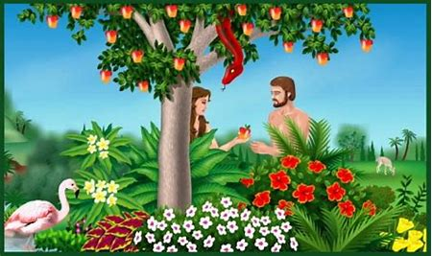
Adam and Eve being tempted by the snake to eat the fruit, therefore bringing sin into the world.

8. Many have interpreted the serpent that tempts Eve to eat the forbidden fruit to represent Satan (the devil) who is seen as a force of evil. Christians recognise that humans are tempted to do things to displease God, such as abusing drugs, misusing money by spending it on things God would not approve of or using the opportunities technology provides in a way that is harmful to others. As temptation is powerful and difficult to resist, some Christians believe its origins are with Satan who is constantly trying to tempt humans to disobey God.
14. Christians believe that God gave humans free will in order to choose how they live their lives. However, this does not mean that they can do whatever they want. They believe that if people use their free will to make choices that God would not approve of, these will be sinful and will separate them from God. The Ten Commandments, the Beatitudes and other Christian teachings give Christians guidance to allow Christians to use their free will wisely, rather than to commit sinful actions.

Salvation
20. In Christian belief, salvation, means to be saved from sin and the consequences of it and be granted eternal life with God. Sin has separated humans from God who is holy, and salvation enables humans to get close to God again. These are the main Christians ideas about how salvation can come about:
- Salvation through good works – the Old Testament makes it clear that a person achieves salvation by having faith in God and obeying God’s law.
- Salvation through grace – salvation is given by God through faith in Jesus. It is not earned or deserved but is a gift for the faithful.
While salvation by works is a predominantly held viewpoint, many Christians dispute this and argue that elsewhere in the Bible there is evidence of salvation by grace alone.
KEY TERMS
Sin: any action or thought that separate’s humans from God.
Original sin: an Augustinian Christine doctrine that says that everyone is born with a built-in urge to do bad things and disobey God.

Week 13/14 – The Role of Christ in Salvation/Atonement
Questions:
1. Salvation is….more specifically….
2. Atonement is…more specifically….
3. Explain two Christian beliefs about salvation.
4.
The role of Jesus in Salvation
1. Many people have wondered why Jesus is seen by Christians to be so special. They accept much of his teaching as being a way of living a good life but find it hard to grasp the meaning behind Jesus’ crucifixion and resurrection.
‘The gift of God is eternal life in Christ Jesus our Lord’.
Romans 6:23

4. Christians believe that Jesus’ death makes up for the original sin committed by Adam and Eve and so can bring people back to God. The crucifixion was the result of human evil set against an innocent man. As Son of God, Jesus could easily have avoided being crucified. Indeed, while he was being crucified. Indeed, while he was being crucified, some people shouted to him that he should use his powers to get down from the cross. However, he knew that his death was necessary to restore the relationship between God and believers and make the opportunity salvation available to all people.
10. Jesus’ resurrection, three days after his death, shows Christians that death has been defeated and that the goodness of Jesus had defeated the evil of sin. So Christians believe that through Jesus’ death and resurrection, humans can receive forgiveness for sin, are able to get close to God and will receive eternal life.
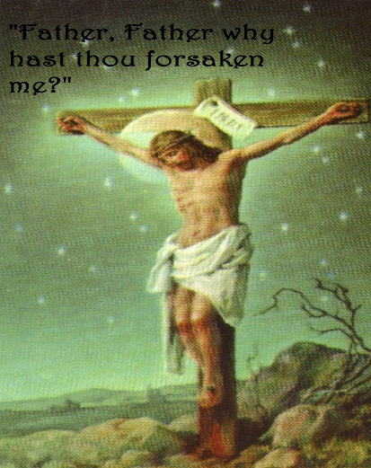
Christ on the cross

15. The fact that Jesus rose from the dead shows that God accepted Jesus’ sacrifice as atonement, which means that Jesus restored the relationship between God and humanity. Jesus made salvation possible because God will now forgive anybody who asks in faith. Christians believe that this is why God came to earth in the form of Jesus and that it demonstrates the importance of following his teachings.
Atonement
20. As the Bible makes clear, atonement removes the effects of sin and allows people to restore their relationship with God. This is only possible because Jesus atoned for the sin of mankind when he died and rose again. In the first of John, it is written:

‘He is sacrificing for our sins, and not only for ours but also for sins of the whole world’.
John 2:1-2

God is holy and so does not overlook sin. For many Christians, although the penalty of sin must be paid, Jesus too sins upon himself and suffered the penalty for all humankind. He was the only one who could do this. Not only did Jesus pay debt of sin on behalf of those who believe and put their trust in him but he also made it possible for all those his teachings
KEY TERMS
Forgiveness: showing grace and mercy and pardoning someone for what they have done wrong.
Atonement: restoring the relationship between people and God through the life, death and resurrection of Jesus
Mass: ceremony, also called Eucharist, in which the sacrificial death and resurrection of Jesus is celebrated using bread and wine.

Week 14 – Atonement
Questions:
1. Atonement is…more specifically…
2. Explain two Christian beliefs about atonement.
3. ‘Salvation is the most important Christian belief’. Discuss.
On the one hand some Christians would agree with this statement because…..
More specifically….
Another reason salvation is the most important belief is…..
More specifically….

On the other hand some would say…..
More specifically….
Another reason that salvation is not the most important belief is….
More specifically….

To conclude I feel….
Atonement
20. As the Bible makes clear, atonement removes the effects of sin and allows people to restore their relationship with God. This is only possible because Jesus atoned for the sin of mankind when he died and rose again. In the first of John, it is written:

‘He is sacrificing for our sins, and not only for ours but also for sins of the whole world’.
John 2:1-2

God is holy and so does not overlook sin. For many Christians, although the penalty of sin must be paid, Jesus too sins upon himself and suffered the penalty for all humankind. He was the only one who could do this. Not only did Jesus pay debt of sin on behalf of those who believe and put their trust in him but he also made it possible for all those his teachings
KEY TERMS
Forgiveness: showing grace and mercy and pardoning someone for what they have done wrong.
Atonement: restoring the relationship between people and God through the life, death and resurrection of Jesus
Mass: ceremony, also called Eucharist, in which the sacrificial death and resurrection of Jesus is celebrated using bread and wine.

PART TWO OF THE BOOKLET OPTIONAL FOR REVISION
Recommended
- Try 2 exam questions a week.
- Test yourself on your quotes.

Exam guidance
Christian Beliefs – POSSIBLE Examination Style Questions (March 17 v.1)
The Nature of God
Give two characteristics which describe the nature of God. (2)
Explain two ways in which the nature of God influences Christians today. (4)
Explain two ways a belief in God influences Christians today. (4)
Explain two ways in which a belief in God as omnipotence influences Christians today. (4)
Explain two ways in which a belief in God as loving influences Christians today. (4)
Explain two ways in which a belief in God as just influences Christians today. (4)
Explain two beliefs about the nature of God. Refer to scripture or sacred writing in your answer. (5)
Explain two teachings about the nature of God. Refer to scripture or sacred writing in your answer. (5)
Explain two Christian teachings about God’s omnipotence. Refer to scripture or sacred writing in your answer. (5)
Explain two Christian teachings about God’s loving nature. Refer to scripture or sacred writing in your answer. (5)
Explain two Christian teachings about God’s justness. Refer to scripture or sacred writing in your answer. (5)
God is omnipotent. Evaluate this statement. (12+5)
God is loving. Evaluate this statement. (12+5)
God is just. Evaluate this statement. (12+5)
It is impossible to understand the nature of God. Evaluate this statement. (12+5)
Evil and Suffering
Give two examples of suffering in the world today. (2)
Give two examples of evil in the world today. (2)
Give two examples of moral evil. (2)
Give to examples of natural evil. (2)
Give two ways Christians may respond to the problem of evil and suffering in the world today. (2)
Explain two ways the problem of evil and suffering may influence Christians today. (4)
Explain two beliefs about evil and suffering. Refer to scripture or sacred writing in your answer. (5)
Explain two teachings about evil and suffering. Refer to scripture or sacred writing in your answer. (5)
The problem of evil and suffering is the biggest challenge to Christian faith today. Evaluate this statement. (12+5)
If God was loving, there would be no evil and suffering in the world today. Evaluate this statement. (12+5)
Christian responses to the problem of evil are unsatisfactory. Evaluate this statement. (12+5)
Evil is needed in the world. Evaluate this statement. (12+5)

The Oneness of God and the Trinity
Give two persons of the trinity. (2)
Explain two ways the trinity influences Christians today. (4)
Explain two Christian teachings about the trinity. Refer to scripture or sacred writing in your answer. (5)
Explain two Christian beliefs about the trinity. Refer to scripture or sacred writing in your answer. (5)
It does not make sense to believe in the trinity. Evaluate this statement. (12+5)
If the trinity exists, God is not one. Evaluate this statement. (12+5)
Creation
Give two God created in the Genesis story. (2)
Explain two ways in which a belief in creation influences Christians today. (4)
Explain two Christian beliefs about creation. Refer to scripture or sacred writing in your answer. (5)
Explain two Christian teachings about creation. Refer to scripture or sacred writing in your answer. (5)
The Bible is all that is needed for Christians to understand creation. Evaluate this statement. (12+5)
Christians should take Genesis literally. Evaluate this statement. (12+5)
Life After Death
Give two different states of life after death in Christianity. (2)
Explain two ways a belief in life after death influences Christians today. (4)
Explain two ways a belief in resurrection influences Christians today. (4)
Explain two ways a belief in judgement influences Christians today. (4)
Explain two ways a belief in heaven influences Christians today. (4)
Explain two ways a belief in hell influences Christians today. (4)
Explain two Christian beliefs about the afterlife. Refer to scripture or sacred writing in your answer. (5)
Explain two Christian teachings about life after death. Refer to scripture or sacred writing in your answer. (5)
Explain two Christian beliefs about resurrection. Refer to scripture or sacred writing in your answer. (5)
Explain two Christian teachings about resurrection. Refer to scripture or sacred writing in your answer. (5)
Explain two Christian beliefs about judgement. Refer to scripture or sacred writing in your answer. (5)
Explain two Christian teachings about judgement. Refer to scripture or sacred writing in your answer. (5)
Explain two Christian beliefs about heaven. Refer to scripture or sacred writing in your answer. (5)
Explain two Christian teachings about heaven. Refer to scripture or sacred writing in your answer. (5)
Explain two Christian beliefs about hell. Refer to scripture or sacred writing in your answer. (5)
Explain two Christian teachings about hell. Refer to scripture or sacred writing in your answer. (5)
A belief in the afterlife is not important in Christianity. Evaluate this statement. (12+5)
Life after death is impossible. Evaluate this statement. (12+5)
The Incarnation
Explain two ways a belief in the Incarnation can influence Christians today. (4)
Explain two beliefs about the Incarnation. Refer to scripture or sacred writing in your answer. (5)
Explain two Christian teachings about the Incarnation. Refer to scripture or sacred writing in your answer. (5)
The Incarnation was the most important event in Jesus’ life. Evaluate this statement. (12+5)
It does not make sense to belief in the Incarnation. Evaluate this statement. (12+5)
Jesus as Son of God
Explain two ways a belief in Jesus as the Son of God influences Christians today. (4)
Explain two beliefs about Jesus as the Son of God. Refer to scripture or sacred writing in your answer. (5)
Explain two teachings about Jesus as the Son of God. Refer to scripture or sacred writing in your answer. (5)
Jesus is the Son of God. Evaluate this statement. (12+5)
It does not make sense to believe that Jesus is the Son of God. Evaluate this statement. (12+5)
The Crucifixion
Explain two ways Jesus’ crucifixion influences Christians today. (4)
Explain two beliefs about Jesus’ crucifixion. Refer to scripture or sacred writing in your answer. (5)
Explain two teachings about Jesus’ crucifixion. Refer to scripture or sacred writing in your answer. (5)
Jesus was crucified. Evaluate this statement. (12+5)
The Resurrection
Give two reasons why the disciplines believed Jesus was alive after his resurrection. (2)
Give two events which happened after Jesus resurrected.
Explain two ways Jesus’ resurrection influences Christians today. (4)
Explain two beliefs about Jesus’ resurrection. Refer to scripture or sacred writing in your answer. (5)
Explain two teachings about Jesus’ resurrection. Refer to scripture or sacred writing in your answer. (5)
Jesus resurrected. Evaluate this statement. (12+5)
The Ascension
Explain two ways Jesus’ ascension influences Christians today. (4)
Explain two beliefs about Jesus’ ascension. Refer to scripture or sacred writing in your answer. (5)
Explain two teachings about Jesus’ ascension. Refer to scripture or sacred writing in your answer. (5)
Jesus ascended. Evaluate this statement. (12+5)
Sin and Original Sin
Give two examples of sin. (2)
Give two ways sin may influence a Christian today. (4)
Give two ways original sin may influence a Christian today. (4)
Explain two beliefs about sin. Refer to scripture or sacred writing in your answer. (5)
Explain two beliefs about original sin. Refer to scripture or sacred writing in your answer. (5)
Explain two teachings about sin. Refer to scripture or sacred writing in your answer. (5)
Explain two teachings about original sin. Refer to scripture or sacred writing in your answer. (5)
It does not make sense to believe in the idea of original sin. Evaluate this statement. (12+5)
Salvation
Give two means of salvation. (2)
Explain two ways a belief in salvation may influence a Christian today. (4)
Explain two beliefs about the means on salvation. Refer to scripture or sacred writing in your answer. (5)
Explain two Christian teachings about the means of salvation. Refer to scripture or sacred writing in your answer. (5)
Salvation from sin is the most important belief for Christians today. Evaluate this statement. (12+5)
Jesus and Salvation (Atonement)
Explain two ways a belief in atonement may influence a Christian today. (4)
Explain two beliefs about Jesus’ role in salvation. Refer to scripture or sacred writing in your answer. (5)
Explain two teachings about Jesus’ role in salvation. Refer to scripture or sacred writing in your answer. (5)
Explain two beliefs about atonement. Refer to scripture or sacred writing in your answer. (5)
Explain two teachings about atonement. Refer to scripture or sacred writing in your answer. (5)

All Christian quotes
Only the texts in red compulsory, you must know they are from Genesus

Christianity
Teaching | Source of Authority | Specification
In the beginning was the Word, and the Word was with God, and the Word was God. He was with God in the beginning. Through him all things were made; without him nothing was made that has been made. |  | Prescribed  3.1.2.1 Beliefs – Key beliefs  Themes – Religion and life
In the beginning God created the heavens and the earth. Now the | Genesis 1:1–3. | Prescribed  3.1.2.1 Beliefs – Key beliefs
earth was formless and empty, darkness was over the surface of the deep, and the Spirit of God was hovering over the waters. And God said, “Let there be light,” and there was light. |  | (page 13)  Themes – Religion and life

Other Helpful Teachings
Teaching | Source of Authority | Specification topics
I am the LORD your God, who brought you out of Egypt, out of the land of slavery. You shall have no others gods before me. |  | Beliefs – Key beliefs
God so loved the world that He gave His one and only son, that whoever believes in Him shall not perish but have eternal life. |  | Beliefs – Key beliefs Beliefs – Jesus Christ and salvation  Themes – Religion and life
He ascended into heaven, and is seated at the right had of the Father, and He will come to judge the living and the dead: I believe in……..  The resurrection of the body; And the life everlasting. |  | Beliefs – Key beliefs Beliefs – Jesus Christ and salvation  Practices – Worship and festivals  Themes – Religion and life
The Word became flesh and made His dwelling among us. |  | Beliefs – Key beliefs Beliefs – Jesus Christ and  salvation
When Jesus was baptised, a voice from Heaven said ‘You are my Son’. | Mark 1:11 | Beliefs – Key beliefs Beliefs – Jesus Christ and salvation  Practices – Worship and  festivals
I am the way and the truth and the life. No one comes to the Father except through me. | John 14:6 | Beliefs – Key beliefs Beliefs – Jesus Christ and salvation  Themes – Religion and life
For since death came through a man, the resurrection of the dead, also comes through a man. For as in Adam all die, so in Christ all will be made alive. | 1 Corinthians 15:21 | Beliefs – Key beliefs Beliefs – Jesus Christ and salvation  Themes – Religion and life

On the third day he rose again in accordance with the Scriptures | Nicene Creed | Beliefs – Key beliefs Beliefs – Jesus Christ and salvation  Practices – Worship and festivals  Themes – Religion and life
But when they looked up, they saw that the stone, which was very large, had been rolled away. As they entered the tomb, they saw a young man dressed in a white robe sitting on the right side, and they were alarmed. | Mark 16:4-5 | Beliefs – Key beliefs Beliefs – Jesus Christ and  salvation
“For the wages of sin is death, but the gift of God is eternal life in Christ Jesus our Lord.” | Romans 6:23 | Beliefs – Key beliefs Beliefs – Jesus Christ and salvation  Themes – Religion and life
My home is in Heaven. I'm just traveling through this world. | Billy Graham | Beliefs – Key beliefs Beliefs – Jesus Christ and salvation  Themes – Religion and life
For it is by grace you have been saved, through faith—and this is not from yourselves, it is the gift of God— not by works, so that no one can boast. | Ephesians 2:8-9 | Beliefs – Key beliefs Beliefs – Jesus Christ and  salvation
Here is the conclusion of the matter.  Fear God and keep His commandments, for this is the whole duty of man. | Ecclesiastes 12:13 | Beliefs – Key beliefs Beliefs – Jesus Christ and  salvation
Our Father in heaven, hallowed be your name…. | The Lord’s Prayer (Matthew 6:9-13) | Beliefs – Key beliefs Practices – Worship and festivals
Prayer is simply a two-way conversation between you and God. | Billy Graham | Practices – Worship and festivals
I pray mentally even when I am waiting at the dentist or at other times of the day | Pope Francis | Practices – Worship and festivals
While they were eating, Jesus took bread, and when he had given thanks, he broke it and gave it to his disciples, saying, “Take and eat; this is my body.”  Then he took a cup, and when he had given thanks, he gave it to them, saying, “Drink from it, all of you. This is my blood of the covenant, which is poured out for many for the forgiveness of sins” | Matthew 26:26-28 | Practices – Worship and  festivals  Beliefs – Key beliefs Beliefs – Jesus Christ and  salvation

As I raised my head to look at the grotto, I saw a Lady dressed in white… | Bernadette  (describing the Virgin Mary at Lourdes) | Practices – Worship and festivals
Rejoice, heavenly powers! Sing, choirs of angels!  O Universe, dance around God’s throne!  Jesus Christ, our King, is risen! Sound the victorious trumpet of salvation!  Rejoice, O earth, in glory, revealing the splendour of your creation, radiant in the brightness of your triumphant King!  Christ has conquered! Now his life and glory fill you!  Darkness vanishes for ever! Rejoice, O Mother Church! Exult in glory!  The risen Saviour, our Lord of life, shines upon you!  Let all God’s people sing and shout for joy. | Church of England  Easter liturgy (Easter  Song of Praise) | Practices – Worship and  festivals  Beliefs – Key beliefs Beliefs – Jesus Christ and  salvation
Faith by itself, if it is not accompanied by action is dead | James 2:17 | Practices – The role of the church  Themes – religion, peace and conflict  Themes – religion, crime and punishment
Now you are the body of Christ, and each one of you is a part of it. | 1 Corinthians 12:27 | Practices – The role of the church
For I was hungry and you gave me something to eat….I was in prison and you came to visit me | (The Parable of the Sheep and the Goats) | Practices – The role of the church  Key beliefs Beliefs – Jesus Christ and  salvation
Blessed are those who are persecuted because of righteousness | Matthew 5:10 | Practices – The role of the church

I see clearly that the thing the church needs most today is the ability to heal wounds and to warm the hearts of the faithful; it needs nearness, proximity. I see the church as a field hospital after battle.….The most important thing is the first proclamation: Jesus Christ has saved you. | Pope Francis | Practices – The role of the church  Beliefs – Key beliefs
Do not have sexual relations with a man as one does with a woman; that is detestable | Leviticus 18:22 | Themes – Relationships and families
You shall not commit adultery | Exodus 20:14 | Themes – Relationships and families
Every sexual act should have the possibility of creating new life | Humanae Vitae (1968  RC | Themes – Relationships and families  Themes – Religion and life
That is why a man leaves his father and mother and is united to his wife, and they become one flesh | Genesis 2:24 | Themes – Relationships and families  Themes – Religion and life
You don't choose your family. They are God's gift to you, as you are to them. | Desmond Tutu | Themes – Relationships and families  Themes – Religion and life
There is neither Jew nor Gentile, neither slave nor free, nor is there male and female, for you are all one in Christ Jesus | Galatians 3:28 | Themes – Relationships and families  Themes – religion, crime and punishment
Let us make mankind in our image, in our likeness | Genesis 1:27 | Themes – Religion and life Themes – Relationships and families  Beliefs – Key beliefs
God blessed them and said to them, “Be fruitful and increase in number; fill the earth and subdue it. Rule over the fish in the sea and the birds in the sky and over every living creature that moves on the ground.” | Genesis 1:28 | Themes – Religion and life Beliefs – Key beliefs

The earth is the Lord’s, and everything in it | Psalm 24:1 | Themes – Religion and life  Beliefs – Key beliefs
The righteous care for the needs of their animals | Proverbs 12:10 | Themes – Religion and life
Everything that lives and moves about will be food for you | Genesis 9:3 | Themes – Religion and life
“We read in the Gospel that Jesus says of the birds of the air that ‘not one of them is forgotten before God’ ( Lk 12:6). How then can we possibly mistreat them or cause them harm?” | Pope Francis | Themes – Religion and life
Before I formed you in the womb I knew you | Jeremiah 1:5 | Themes – Religion and life
Blessed are the merciful | Matthew 5:7 | Themes – Religion and life Practices – The role of the church  Themes – religion, crime and punishment  Themes – religion, peace and conflict
They will beat their swords into ploughshares | Isaiah 2:4 | Themes – religion, peace and conflict

If anyone slaps you on the right cheek, turn to them the other cheek also | Matthew 5:39 | Themes – religion, peace and conflict  Themes – religion, crime and punishment
The love of money is the root of all kinds of evil | 1 Timothy 6:10 | Themes – religion, peace and conflict  Practices – The role of the church
The purpose of all wars is peace | St Augustine | Themes – religion, peace and conflict
Let everyone be subject to the governing authorities | Romans 13:1 | Themes – religion, crime and punishment  Themes – religion, peace and conflict
God's love is too great to be confined to any one side of a conflict or to any one religion | Desmond Tutu | Themes – religion, peace and conflict  Themes – religion, crime and punishment
Love your neighbour as yourself | Mark 12:31 | Themes – religion, peace and conflict  Themes – religion, crime and punishment  Practices – The role of the church
Forgive us our sins as we forgive those who sin against us | The Lord’s Prayer | Themes – religion, crime and punishment
Women should remain silent in the churches | 1 Corinthians 14:34-35 | Themes – Religion and life
Truly I tell you, whatever you did for one of the least of these brothers and sisters of mine, you did for me | Matthew 25:40 | Practices – The role of the church
I look to a day when people will not be judged by the colour of their skin, but by the content of their character. | Martin Luther King Jnr | Practices – The role of the church
Injustice anywhere is a threat to justice everywhere. | Martin Luther King Jnr | Themes – religion, human rights and social justice Practices – The role of the church

Practice questions
Knowledge test
- Give two persons of the trinity. (2)
- Explain two ways the trinity influences Christians today. (4)
- Give two examples of things God created in the Genesis story. (2)
- Explain two ways in which a belief in creation influences Christians today. (4)
- Give two different beliefs about life after death in Christianity. (2)
- Explain two ways a belief in life after death influences Christians today. (4)
- Give two characteristics which describe the nature of God. (2)
- Explain two ways in which the nature of God influences Christians today. (4)
- Explain two ways a belief in God influences Christians today. (4)
- Give two examples of suffering in the world today. (2)
- Give two examples of evil in the world today. (2)
- Give two examples of moral evil. (2)
- Give to examples of natural evil. (2)
- Give two ways Christians may respond to the problem of evil and suffering in the world today. (2)

Exam practice questions for lesson
- Which one of the following is the book in the Bible in which the story of Creation can be found?
A Exodus. B Genesis. C Proverbs. D Revelation ( 1 mark)
- Give two Christian teachings about original sin. [2 marks]

- Give two qualities which Christians believe describe the nature of God. ( 2 mark)

- Explain two ways in which belief in the resurrection of Jesus influences Christians today.( 4 marks)

- . Explain two ways in which Jesus’ crucifixion influences Christians today. [4 marks]
- Explain two Christian teachings about judgement ( 5 marks)

- ‘If God were loving, there would be no suffering in the world.’ Evaluate this statement. 12 mark

Exam Questions for the Christianity Unit.
12 mark questions
‘The existence of evil is proof that God is not omniscient, omnipotent and benevolent.’ Evaluate this statement.
‘The Trinity is the most important belief in Christianity’. Evaluate this statement.
‘The belief in hell is the most important belief for Christians today’. Evaluate this statement.
‘Believing in Jesus is crucial for someone to gain admittance to heaven’. Evaluate this statement.
‘Forgiveness was Jesus's most important teaching’. Evaluate this statement.
5 mark questions ( Refer to scripture or sacred writings in your answer)
Explain two Christian teachings about the Trinity.
Explain two Christian teachings about resurrection.
Explain two Christian teachings about incarnation.
Explain two Christian teachings about hell.
Explain two Christian beliefs about ascension.
Explain two Christian beliefs about heaven.
Explain two Christian beliefs about the afterlife.
Explain two Christian teachings about original sin.
Explain two ways that Christian beliefs about salvation influence Christians today.
Explain two ways that Christian teachings about atonement influence the daily life of Christians.

Peace and Conflict

4 mark
Explain two religious beliefs about peace.
Explain two religious beliefs about reconciliation.
5 mark
Explain two religious beliefs about retaliation.
Explain two religious beliefs about Just War.
Explain two religious beliefs about Holy War.
12 mark
‘War is always justified if the cause is just. ‘Evaluate this statement.
‘There are no circumstances that terrorism can be justified.’ Evaluate this statement.
‘The use of violence is always wrong’ Evaluate this statement.
‘Self defence is the only justifiable cause of war’ Evaluate this statement.
‘There is no such thing as a Just war’ Evaluate this statement.
‘Every religious person should be a pacifist’ Evaluate this statement.

Explain two Christian beliefs about God. 4 marks
One Christian belief about God is that he is the sole God within the religion. More specifically, in the Nicene Creed it says ‘we believe in one God’’.
Another Christian belief about God is that he is all powerful and the giver of life. More specifically, it says in the Nicene Creed that ‘through him all things were made’.

‘Jesus’ resurrection is not literally true’ 12 marks

On the one hand some people would agree with this statement as miracles are impossible. More specifically, there is no scientific evidence for Jesus rising from the dead. Instead, a liberal Christian would argue that the resurrection story is a metaphor for Jesus’ power to help persuade people to follow his example. Therefore this shows that resurrection is not literally true as there is no scientific evidence for it.
‘The existence of hell does not fit with an all-loving god’. Evaluate this statement

On the one hand some Christians would agree with this statement as within the Bible it says that God ‘loves his creation'. More specifically, God is all loving and to let his people suffer for hell in eternity does not reflect this love. The existence of hell means that there must, therefore, be some element of evil within God if he is capable of letting hell exist.
Another point to back up this statement is the fact that God is also forgiving in nature. More specifically, forgiveness is a key message within Christianity. For example, at Jesus’ crucifixion he asks God to forgive his killers, therefore showing that God is able to forgive. Therefore the existence of hell does not fit with his all loving nature.
11. ‘Salvation is the most important Christian belief’. Discuss.

On the other hand, some Christians would disagree with this statement as there are other more important Christian beliefs. More specifically, some Christians might view the incarnation as the most important Christian belief because it was at this point that ‘the word (Jesus) became flesh and dwelt amongst us’. Therefore this shows that the incarnation is in fact the most important element of Christian belief.
Another point to support this argument is that some Christians may see the resurrection as the most important belief. More specifically, this shows the ultimate power of Jesus as the son of God as he was able to come back from the dead. This is important to Christians as it shows the power of Christ and gives Christians hope.

‘crucifixion is the most important Christian belief’. Discuss.
On the one hand some Christians would agree with this statement because it is the crucifixion that ultimately leads to humans being able to achieve salvation. More specifically, the crucifixion was the sacrifice of Jesus, the Son of God, who died to redeem the sins of man and allowed us to be forgiven by God and receive his grace. A quote to support this is, ‘you can only get to the father through me’. This quote shows that it is by following the word of Jesus, as well as his death, that allows mankind to be saved. Therefore crucifixion is the most important element of Christian belief as it is the gateway to salvation.
Another point to support crucifixion being the most important Christian belief is that it showed the forgiving nature of Jesus. More specifically, even when he was being killed and tortured, he was able to find it in his heart to forgive those around him. A quote to support this is, ‘father forgive them for the do not know what they are doing’. This shows that Jesus was able to forgive even his killers. therefore this shows crucifixion is the most important belief as it provides an example of Jesus of putting into action his teaching of forgiveness for mankind to follow.
On the other hand, some Christians may argue that it was the incarnation that is the most important Christian belief. More specifically, the incarnation is Jesus becoming a physical form of God for mankind to follow. A quote to support this is, ‘the word became flesh and dwelt amongst us’. This quote shows that Jesus became flesh and literally a human in order to provide guide of how to live how lives. Therefore, this shows that crucifixion is not the most important Christian belief as without the incarnation Jesus would not ultimately exist.
Another point that shows that crucifixion is not the most important belief is the salvation. More specifically, this is the belief that we are saved by God. This is the most important belief because it is what allows Christians to be saved and enter into the kingdom of heaven. Therefore this shows that crucifixion is not the most important element of Christianity as it is salvation that is the ultimate goal.
To conclude, I disagree with the statement because I feel that salvation is a more important Christian belief, as this is what the life of a Christian should strive to achieve and what Jesus died for. Some people would disagree, however, they are incorrect as crucifixion is ultimately less important that salvation.

Which word best describes letting go of blame against a person?
- Justice B- Forgiveness C – Rehabilitation D- Pacifism
Which word best describes getting revenge on the criminal?
A-Corporal punishment B- Death penalty C – Hate crime D- Retribution
Which word best describes a place to care for the dying?
- Hospice B- Hospital C – Euthanasia D- Passive euthanasia
Which word best describes the cancellation of a marriage?
- Polygamy B- Divorce C – Annulment D- Homosexuality
Which word best describes the unconditional love god shows to all people?
- Grace B- Faith C – Benevolent D- Salvation
Which word best describes a church service with a set structure?
- Non-liturgical worship B- Liturgical worship C – Prayer D- Church
Mastery quizzes

Revision all GCSE topics

Mastery quiz 1

Give two reasons why people are against retribution
Give two reasons why people believe young offenders should be treated less harshly than other criminals
Give two pro-life arguments
Give two reasons why polygamy is wrong
State two qualities of god
Give two reasons why people prefer private worship

Mastery quiz 2
Which word best describes when two sides make up after a disagreement?
- Reconciliation B- Reformation C – Justice D- Atonement
Which word best describes a punishment involving physical labour or clearing an area?
A-Corporal punishment B- Community service C – Parole D- Deterrence
Which word best describes when the foetus can survive outside the womb?
- Conception B- Abortion C – Sanctity of life D- Viable
Which word best describes a method to prevent pregnancy?
- Contraception B- Conception C – Chastity D- Commitment
Which word best describes when Jesus was taken up to heaven?
- Incarnation B- Resurrection C – Ascension D- Salvation
Which word best describes an outward sign of an inward and spiritual grace?
- Communion B- Baptism C – Prayer D- Sacrament

State two religious beliefs against war
State two religious beliefs against corporal punishment
State two religious beliefs in favour of caring for animals
State two religious beliefs in favour of marriage
State two things that happened during the crucifixion
State two things that happen during a believers baptism

Mastery quiz 3
Which word best describes when something is fair under the law?
- Peace B- Just war C – Justice D- Protection
Which word best describes when someone is monitored after release from prison?
A-Reformation B- Conscience C – Parole D- Protest
Which word best describes repairing and protecting the natural world?
- Conservation B- Dominion C – Awe D- Stewardship
Which word best describes treating someone differently due to their gender?
- Family planning B- Discrimination C – Prejudice D- Equality
Which word best describes when the soul is saved from sin?
- Incarnation B- Resurrection C – Ascension D- Salvation
Which word best describes a ceremony to recall the last supper?
- Transubstantiation B- Lourdes C – Eucharist D- Baptism

State two reasons why people might want a non-religious marriage
State two reasons why hate crimes are wrong
State two reasons why people believe they should have the right to die when they choose
State two criteria of a Just war
State two things that happened during the incarnation
State two objects that could be used during prayer

Mastery quiz 4
Which word best describes use of violence to create fear?
- Holy war B- Just war C – Terrorism D- Violence
Which word best describes an aim of punishment to put people off committing a crime?
A-Protection B- Community service C – Reformation D- Deterrence
Which word best describes how good or comfortable a life is?
- Stewardship B- Quality of life C – Right to die D- Sanctity of life
Which word best describes a couple living together without being married?
- Cohabitation B- Commitment C – Chastity D- Polygamy
Which word best describes Christian love?
- Agape B- Omnipotent C – Benevolent D- Messiah
Which word best describes an effort to spread the Christian message?
- Mission B- Worship C – Rosary D- Bible

State two reasons why humans should care for the world

State two reasons why people should forgive others
State two reasons people should not violently protest
State two reasons why divorce is wrong
State two qualities of god
State two reasons why reasons why people should volunteer at food banks

Mastery quiz 5
Which word best describes the belief that all violence is wrong?
- Reconciliation B- Just war C – Protest D- Pacifism
Which word best describes our internal sense of right and wrong?
A-Conscience B- Crime C – Reformation D- Morality
Which word best describes a sense of wonderment at the world?
- Stewardship B- Awe C – Animal rights D- Dominion
Which word best describes never having sexual relations?
- Celibacy B- Commitment C – Contraception D- Conception
Which word best describes the anointed one seen as the saviour?
- Trinity B- Apostle C – Messiah D- Disciple
Which word best describes a place of pilgrimage?
- Lourdes B- CAFOD C – Corrymeela D- Church

State two reasons why peace is preferable to war

State two reasons why community service is a good punishment
State two ways people can protect animal rights
State two reasons why adultery is wrong
State two roles of the holy spirit
State two reasons why baptism should happen to a baby

Mastery quiz 6
Which word best describes getting revenge on someone?
- Retribution B- Protest C – Rehabilitation D- Violence
Which word best describes an act committed due to prejudice?
A-Hate crime B- Discrimination C – Crime D- Sin
Which word best describes the belief a woman can decide what happens to her body?
- Abortion B- Pro life C – Pro choice D- Viable
Which word best describes a sexual relationship between two people who are married to someone else?
- Heterosexuality B- Adultery C – Sex before marriage D- Polygamy
Which word best describes belief in one god?
- Polytheist B- Trinity C – Monotheist D- Omnipotent
Which word best describes when the bread and wine becomes the body and blood of Christ?
- Mass B- Reconciliation C – Transubstantiation D- Iona

State two ways believers could support someone suffering from a terminal illness
State two reasons why nuclear weapons should be used as a deterrent
State two reasons why reformation is the best aim of punishment
State two reasons someone might to wait until marriage to have sex
State two things Christians might do on a pilgrimage
State two things that happened during the ascension

Revision videos and clips

The Birth of Christianity
Watch this clip • https://www.youtube.com/watch?v=TG55ErfdaeY
1) What religion was Jesus born into?
……………………………………………………………………………………………………………………………………………………………………………………………………………………………………………………………………………………………………………………………………………………………………………………………………………………………………………….
2) What was Jesus’ message when he was preaching?
……………………………………………………………………………………………………………………………………………………………………………………………………………………………………………………………………………………………………………………………………………………………………………………………………………………………………………….
3) Why where those is power angry with Jesus?
……………………………………………………………………………………………………………………………………………………………………………………………………………………………………………………………………………………………………………………………………………………………………………………………………………………………………………….
4) How was Jesus killed, and who by?
……………………………………………………………………………………………………………………………………………… ……………………………………………………………………………………………………………………………………………… ……………………………………………………………………………………………………………………………………………….
5) What was Jesus so influential (three points)?
……………………………………………………………………………………………………………………………………………………………………………………………………………………………………………………………………………………………………………………………………………………………………………………………………………………………………………….

Christians view of the Trinity
http://request.org.uk/life/beliefs/christianity-basically-father-god/
1. What does Jesus call God?
2. What was given to sons?
3. What kind of food does the boy eat?
4. What is the message of the story?
• http://request.org.uk/life/beliefs/christianity-basically-jesus-christ/
3. why did God send Jesus to earth?
4.What amazing things did Jesus do on earth?
5. What is a miracle? Give an example of Jesus’s miracles.
6. How did Jesus die?
7. What happened 3 days later? • http://request.org.uk/life/beliefs/christianity-basically-the-holy-spirit/
8. What happened to people’s language when they received the holy spirit?
9. What is the Holy spirit?
10. How does the Holy spirit help us? What is one of his gifts

Crucifixion video
https://www.youtube.com/watch?v=rFrh8vKMM80
Watch video and answer questions.
1. Who was Jesus crucified by?
2. Why was Jesus crucified?
3. Why were Jesus’ followers upset when he was crucified?
4. Who was Jesus crucified alongside?
5. What does one of the other men being crucified ask?
6. Why are the observers amazed that Jesus quotes the scriptures?
7. What is Jesus’ final message?

RE
The story of the Exodus and Moses https://www.youtube.com/watch?time_continue=6&v=RdSQT7DS1lI&feature=emb_logo
1. Why was Moses not raised by his mother?
………………………………………………………………….
2. How did god communicate to Moses? What was on fire?
…………………………………………………………………………………….
3. What did God do as the Pharaoh wouldn’t let the Jews leave?
…………………………………………………………………………………………….
4. What Jewish festival remembers the events of the Exodus?
……………………………………………………………………………..
5. Revise the different parts of the synagogue – you will be tested on them in the lesson.
https://www.bbc.co.uk/teach/inside-the-synagogue-what-do-you-need-to-know/zb3f2sg
1. What is the bimah?
…………………………………
2. What is the Ner tamid?
………………………..
3. What is the Ark?
…………………………………………………….

Jesus’s life
https://www.youtube.com/watch?v=UcFw8pLBSIo
1. What did Jesus do on earth? ( miracles)
2. Where was Jesus buried?
3. How long did Jesus stay in the world after he was resurrected? Where did he go?
4. What did he tell the disciples/followers to do?
5. Who helped the disciples/followers?

RS GCSE- Themes Paper-How to get the marks!
?? | How does the question start? | What do I need to write? | Any other tips?
1 mark | Which of these is…. | Just circle the correct answer | You will only be asked about words  listed on the specification
2 mark | Give two examples of  Give two aims…. | Two bullet points- that’s it! | Do not write long sentences explaining  or justifying them  Example- something you can see happening e.g. recycling
4 mark | Explain two contrasting religious view about…  OR  Explain two contrasting beliefs in contemporary British society about…. In your answer you should refer to the main religious tradition of Great Britain and one or more religious traditions. | You need to give DIFFERENT (opposite) views about the topic.  You can:  - Give a quote and then explain the meaning e.g. ‘Thou shall not kill’ this is against abortion because only god should take a life away  - Make two short points e.g. Christians believe life begins at conception, this means abortion is the same as murdering a human being | You can use non-religious views as long as you include the  word Christian or Jewish  e.g. Christians believe in reformation because…  If it asks for the ‘main religious tradition of Great Britain’-  you MUST give at least one Christian view
5 mark | Explain two religious beliefs about…. | You need to give two religious beliefs about the topic. They can be the same or different.  You MUST: Give a quote  Then  Answer how you would on a 4 mark question e.g. Explain two different views. Link one to the quote.  e.g. ‘Forgive your brother 70x7’ This shows that Christians believe that people make mistakes in their life but everyone deserves a second chance to reform themselves. | For the fifth mark you need to include scripture  e.g. a bible quote  You can’t just say sanctity of life, stewardship etc.  It needs to be an actual quote  The mark you get for using a quote is separate  from the explanation marks
12 mark | ‘Statement’  Evaluate this statement  In your answer you:  - Should give reasoned arguments in support of this statement  - Should give reasoned arguments to support a different point of view  - Should refer to religious arguments  - Should refer to non-religious arguments  - Should give a justified conclusion | Opinion given with reasons to back it up- 1-3 marks  Reasons given for different points of view OR a well-argued one-sided argument backed up by evidence 4-6 marks  Reasoned consideration of different points of view. Two sides of the argument, well-explained, backed up by evidence and information. 7-9 marks  A well-argued response, reasoned consideration of different points of view. Logical chains of reasoning, judgement made supported by knowledge and understanding of evidence. | If your answer is one-sided or doesn’t include religion,  you can only get 6 marks.

