RE Year 8 Lockdown work

Name ________________

House group ____________

Year 8 RE Booklet
Name
House group

– Does it make sense to believe in god?
1 Why do people believe in god? |  | Different reasons people believe in god
2 Miracles |  | Are miracles proof that god exists? |  |  |  | M
3 Revelation |  | Is revelation proof that god exists?
4 Morality argument |  | Is morality proof that god exists? |  |  |  | M
5 Faith |  | Why does people’s faith change over time?
6 Revision |  | Preparing for post unit assessment
7 Post unit assessment
Post unit assessment | Complete? |  | % | Progress made | %

Booklet

“Where is God? Where is He?” someone behind me asked. ..
For more than half an hour [the child in the noose] stayed there, struggling between life and death, dying in slow agony under our eyes. And we had to look him full in the face. He was still alive when I passed in front of him. His tongue was still red, his eyes were not yet glazed.
Behind me, I heard the same man asking:
“Where is God now?”
And I heard a voice within me answer him:
“Where is He? Here He is—He is hanging here on this gallows. . . .”

This quote means that…

“After the Holocaust I did not lose faith in God. I lost faith in mankind.”

This quote means that…

How the Holocaust Challenged Faith

Religion attempts to make sense out of the world around us, finding order and meaning in what often seems chaotic and meaningless. Nothing has shaken the foundation of our religion like the Shoah (Holocaust). Its devastation was so widespread, its evil so extensive, it raised questions about God and His role in the world; about good, evil, and justice; about the value of life and death; and about whether there was any point to being Jewish.

What We Expect of God
Until the Holocaust, the traditional view of God was that God was our Provider and Protector. Even though bad things would happen to His people– periods of oppression would always be followed by salvation, and eventually the suffering would end. Jewish people say, “in every generation enemies rise up seeking to destroy us, but God delivers us from their hands.”
This faith that God would protect them carried the Jews through the Crusades, repeated humiliations and expulsions, pogroms and persecutions, even the Spanish Inquisition. But it was shaken (and for some, completely shattered) by the success of the Nazis in destroying European Jewry. The murder of six million Jews challenged the long-held belief that God intervenes in the world to balance injustice by punishing evil and rewarding good.
Was God dead? Was He just indifferent? If He could not be counted on to live up to His reputation for mercy and intervene, what good was He? And if He did not intervene, why should Jews follow or believe in him? Nothing could possibly justify what was seen as God’s brutal and wholesale betrayal of the Jewish people.

Was the Covenant (promise) Broken?
The Holocaust called into question whether the covenant–what was supposed to be an eternal contract between God and the Jewish people–had expired. Without it, there was no sense of order in the universe, no purpose in life, no hope for a better future, no meaning in past or present suffering, no need for Jews or Jewish life.
This was also exactly the response of many victims, for whom the covenant had been rendered null and void. They could not believe that God and the Holocaust’s degree of evil could coexist. Or they could not recognize a God who would allow such evil to operate. They had no faith that such crimes would never again occur and feeling no hope in life, and expecting no meaning in death, saw no reason to continue Judaism. To spare their descendants the horrors they had endured, they abandoned Judaism, sometimes converting and raising their children as non-Jews.

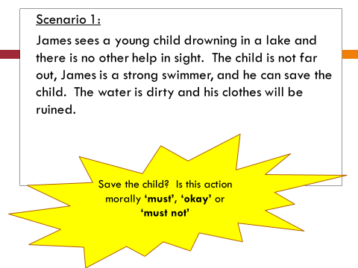
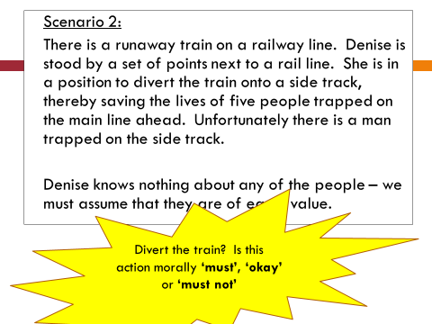
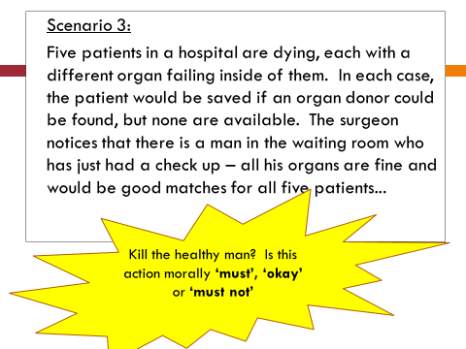

Argument 1: Evolution and Morality
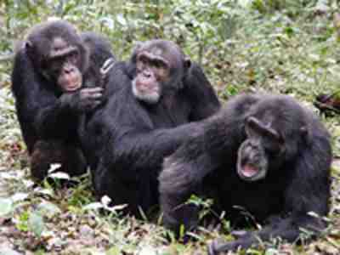
The morality argument for the existence of God is based on the claim that humans have clear knowledge of what is right and what is wrong. For example, we just know that stealing is wrong. Some believe this shared moral knowledge is evidence that there must be a God.
But perhaps our moral behaviour comes from how we have evolved. Over millions of years we have learnt that we have a much better chance of surviving if we co-operate, help each other out and avoid killing or stealing from each other. So our moral knowledge is no great mystery. As a species, if we had not learnt that it pays to be sociable, we would either be solitary animals or else extinct.
‘You scratch my back, and I’ll scratch yours’ – being ‘nice’ and ‘moral’ is a good survival strategy?
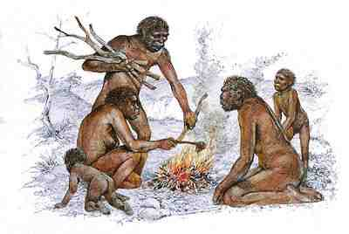
Imagine the following scene. One and a half million years ago, five of our early ancestors find a forest glade close to a riverbank. Living by the river already is another band of five of our early ancestors. What do they do? Do the bands fight against each other? Do they try and steal from each other?
If they did, what would be the sense in that? By doing so they might weaken both bands so that when winter comes both bands die out. Instead, the two groups learn to work together. They hunt for food, build homes, huddle together for warmth. They start to help each other and by doing so they increase their own survival chances.
Because it works, the willingness to work together and avoid making enemies becomes the normal way of behaving. The feeling that working together and not fighting is the best thing to do remains as a powerful instinct inside of us. Our moral values and feelings of guilt do not come from God. They are evolved attitudes that helped us to survive.

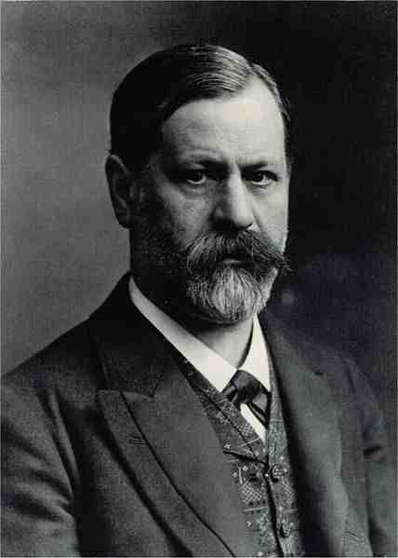
Argument 2: Social conditioning
Sigmund Freud (1856-1939) argued that what we learn from our parents and the society in which we are brought up remains with us throughout our life. This is where our moral knowledge comes from.
From an early age we are taught that lying and stealing is wrong. In the main, these early lessons about what is right and wrong remain with us.
We may not remember specifically being taught by the society around us or by our parents. What we are taught becomes part of our unconscious mind and creates the conscience. This is called social conditioning.
If, for some reason, we lie about a friend and get a guilty conscience, this is not because our guilty conscience is the voice of God. It is because our unconscious mind is reminding us of what our parents taught us. This may explain why some people may be cruel and violent and yet suffer twinges of guilt. Their parents may have beaten them, or neglected them as children, and so they grew up not properly learning that violently attacking another person is considered to be wrong.
Social conditioning might also explain why some people’s conscience seems to vary. People brought up in different places and at different times in history may have very different ideas about what is right and what is wrong.
Special revelations occur to individuals and are difficult to prove
Causes people to change their religion
General revelations are available to everyone and are interpreted differently
Difficult to determine which claims are true
Causes people to change their beliefs and become religious –
Not possible to prove revelations happen with observations or scientific testing
Revelations correspond with things in the real world e.g. water that actually heals people
Revelations are similar to ones that have happened in the past
Special revelations occur to individuals and are difficult to prove
Causes people to change their religion
General revelations are available to everyone and are interpreted differently
Difficult to determine which claims are true
Causes people to change their beliefs and become religious –
Not possible to prove revelations happen with observations or scientific testing
Revelations correspond with things in the real world e.g. water that actually heals people
Revelations are similar to ones that have happened in the past
For example, why is it that a child born and brought up on an island of cannibals (people who eat the flesh of other humans) might happily enjoy eating human meat and not feel any sense of guilt, while a child born in Wanstead who found him or herself on the same island might suffer nightmares and a crippling sense of guilt for the rest of their life when forced to eat the same meal? If the conscience really was the voice of God, why is it that God’s message is not always the same? Our social background gives us our sense of morality; this knowledge doesn’t come straight from God.

Siddhartha Gotama (Buddhism)
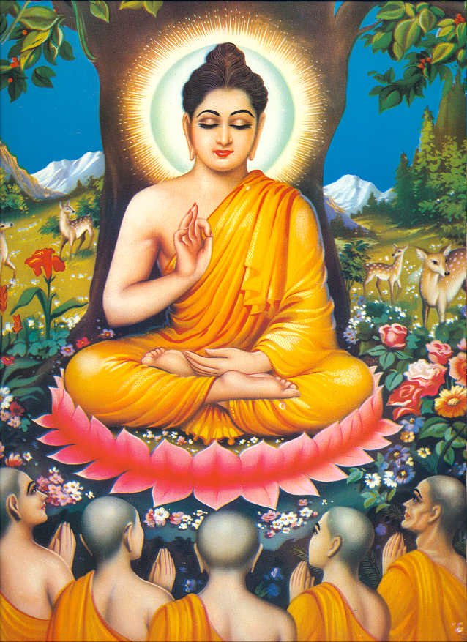
Siddhartha was born a prince. During his teenage years he left the
palace and saw four examples of people suffering. He has never
witnessed any kind of suffering before and left the palace to seek
understanding and answers for all of the suffering in the world. He
spent years trying to find answers. One day, he sat underneath a
Bodhi Tree and meditated for weeks on end, refusing to move until
he sought the answers he wanted. A demon tried everything in his
power to tempt Siddhartha, but he did not move. After a while, Siddhartha discovered the answers he was looking for and achieved enlightenment. Enlightenment means understanding the truth about the way things are and began teaching people about life and suffering; that life cannot exist without suffering, as well as how to achieve enlightenment for themselves. Siddhartha was now known as the Buddha.
St Paul (Christianity)
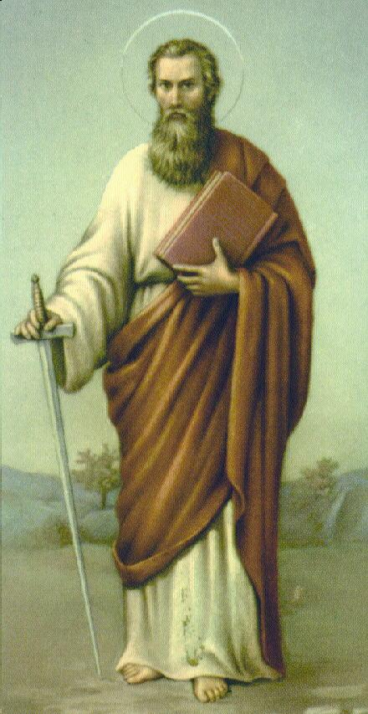
During the time of Jesus, there was a man called Saul who persecuted any followers of Jesus by stoning them to death. Saul was a Pharisee, one of the religious leaders of the day and persecuted the Church because he truly believed that the teaching of Christ was dangerous and heretical. He went to the chief priests and got permission to go to Damascas to hunt for Christians.
On his way to Damascas, he was blinded by a bright light. Jesus had appeared to him and told him to continue onto the city to receive further instructions. Saul rose from the ground and discovered he was blind. His companions led him the rest of the way. Saul remained blind and didn’t eat or drink for three days. He had a vision of a man called Ananias restoring his sight, and when this happened, Saul was filled with the Holy Spirit and was baptized. He stayed in Damascas for several days and preached Christ in the synagogues. Saul was now known as Paul – a preacher of Christ’s gospel.
Muhammad [(pbuh) Islam)
Muhammad was born in 570 CE and lived with his Uncle, a new leader of the most powerful tribe in Mecca after his parents died. At the age of 25, he worked as a merchant and was married.
As he grew older he became very thoughtful and began to spend nights in a cave near Mecca deep in meditation. During one of these times, Muhammad was visited by the Angel Gabriel who commanded him to recite the verses sent by God (Allah). These verses were later collected as part of the Qur’an. Muhammad believed he had been given a message from Allah to be shared with everyone. Most people who heard this message mocked him or ignored him, others believed and joined him. Muhammad and his followers were seen to be a threat against the rich rulers of Mecca. To avoid trouble, Muhammad moved to Madinah where he solved arguments between local tribes. He taught people to pray towards Mecca and delivered Allah’s teaching for mankind. He is known as the Prophet of Islam.
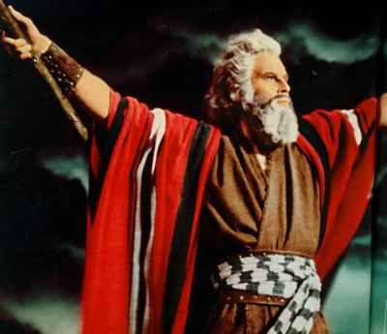
Moses (Judaism)
Moses was born an Israelite (Jew) in a time when the Israelites were working as slaves in Egypt. The Pharoah viewed the Israelites as a threat and ordered all first-born sons to be killed. Moses’ mother hid him in a basket on the River Nile and was found by the Princess. Moses grew up in the palace, but one day, he saw a soldier beating one of the Israelite
Slaves and he ended up killing the soldier and had to run away from Egypt. He lived in the wilderness for a time. One day, he was blinded by a bright light. God began to speak through a burning bush to Moses telling him to visit the Pharaoh and demand the freedom of the Jewish slaves. Moses did this, and each time the Pharaoh said no, a terrible plague was inflicted on the Egyptians. After the last plague, when the Pharoah’s son had died, the Jews were granted their freedom and escaped through the parted Red Sea. Moses led the Jews into the wilderness. He disappeared for a few days, and when he returned he carried two tablets of stone containing the Ten Commandments for how they should live their lives.
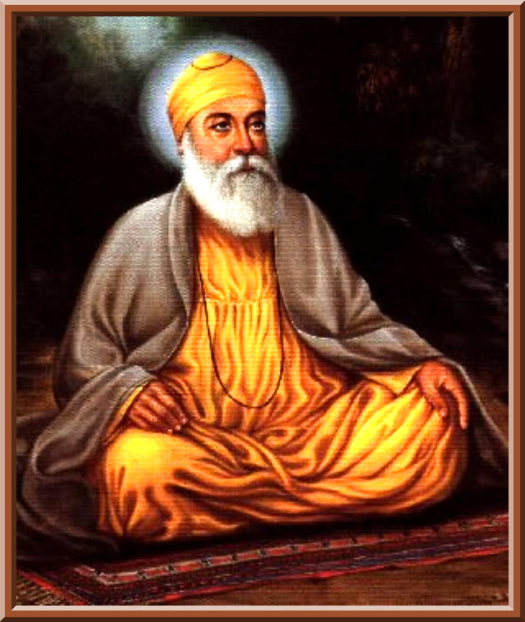

Guru Nanak (Sikhism)
Nanak was born in India as a Hindu. He grew up following Hindu
beliefs, worked in an office, married at 19 and had two sons. It
seemed he had everything in life he could want. One morning
when he was about 30 years old, he went to the River to bathe
as usual, then he disappeared for three days. When he returned
he told people that he had had a vision from God. He learned that just following a religion did not make people any different. Doing what the religions says – going on pilgrimages or making offerings – doesn’t make a person religious. It is the way they live which really matters and this comes from knowing God. For the next 20 years, he began teaching God’s message and was known as Guru Nanak. During his travels he taught people how to live and behave in order to find God. He taught that everyone was equal and should be treated with respect. He created the ‘langar’ whereby anyone could share free food no matter what religion or social group they belonged to. At this time, this was unheard of for people to eat like this. Guru Nanak said was important.

The little boy who came back to life after being held by his parents

On March 25, 2010, Kate Ogg gave birth to twins Jamie and Emily just 27 weeks into her pregnancy. Although Emily survived the birthing process, Jamie was born in distress and was not breathing. Doctors spent 20 minutes trying to resuscitate Jamie, but were unable to do so. They told Kate and her husband David that Jamie had died. Nurses placed Jamie's unmoving body onto his mother's chest so she could say her goodbyes.
As Kate and David thought they were extending a farewell to their deceased child, a remarkable thing occurred – after about five minutes or so, Jamie began moving. Nonetheless, the doctor present informed his parents such movements were simply reflex actions and were not indicative of life.
Kate and David asked to spend an extra minute or two with the child they believed was on his way out of the world. Those few minutes turned into two hours, and something even more remarkable than Jamie's previous movements took place – the supposedly dead child opened his eyes.
At this point, the couple started to question if Jaime was dead after all but were still told by the hospital that what they were seeing were simply reflex actions. Eventually, they had to resort to a little white lie to get the doctor to come back. They told him they had come to terms with the baby's death.
Once inside the room, the doctor was in disbelief when he arrived back at the bedside. "He got a stethoscope, listened to Jamie's chest and just kept shaking his head. He said, 'I don't believe it, I don't believe it.'"
Jamie was indeed alive. Doctors believe the warmth of Kate's body and the stimulation that the baby may have received from hearing her heartbeat made all the difference between life and death.
Jamie and his sister Emily are now happy, healthy five years olds. The little boy has not encountered one medical problem in the five years since his birth.

Arguments for and against miracles

- All miracles can be explained, for example, Jesus was not dead when he was taken down from the cross.
- All miracles rely on the evidence of eye witnesses and witnesses can always be deceived.
- There is evidence in the Old and New Testament
- We can argue that miracles do not exist at all, we can say that these events are a result of a lack of scientific knowledge.
- Miracles are not impossible but that it is impossible for us to prove them.
- People have seen miracles happen and believe they are true
- The laws of nature continue to occur and we have millions of examples of this, millions of dead do not return to life etc. Any miracle would need to outweigh all this evidence.
- There is very little evidence, what evidence there is, is questionable.
- People want miracles to happen so convince themselves they have
- An event has occurred that cannot be explained by normal scientific laws

Arguments for and against miracles

- All miracles can be explained, for example, Jesus was not dead when he was taken down from the cross.
- All miracles rely on the evidence of eye witnesses and witnesses can always be deceived.
- There is evidence in the Old and New Testament
- We can argue that miracles do not exist at all, we can say that these events are a result of a lack of scientific knowledge.
- Miracles are not impossible but that it is impossible for us to prove them.
- People have seen miracles happen and believe they are true
- The laws of nature continue to occur and we have millions of examples of this, millions of dead do not return to life etc. Any miracle would need to outweigh all this evidence.
- There is very little evidence, what evidence there is, is questionable.
- People want miracles to happen so convince themselves they ha
- An event has occurred that cannot be explained by normal scientific laws

Year 8- autumn 1 revision worksheet
When you have finished, do the questions on your learning ladder
Word | Definitions
Omnipotent
Omnibenevolent
Omniscient
Monotheism
Polytheism
Incorporeal
Prayer
Ritual
Immanent
Transcendent
Explain the different roles that god has. (Creator, saviour, healer).

What are the three parts of the trinity?

Explain what each of them does.

Do religious people think god is immanent or transcendent? Explain your answer and give examples.

Give three similarities between God in Islam and Judaism and three differences

Explain three reasons why people pray:

How do Jewish people pray?

How do Muslims pray?

Give three similarities and three differences between Jewish and Muslim prayer

What beliefs are Jewish people showing when they pray?

What beliefs are Muslims showing when they pray?

Spring revision worksheet
When you have finished, do the questions on your learning ladder
Word | Definitions
Moral
Absolute morality
Relative morality
Authority
Conscience
Noble eightfold path
10 commandments
Karma

The two different ways I make a moral decision are:

Explain two different ways religious people would make a moral decision

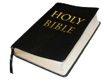

Situation.
A war has broken out between two countries and you have been asked to fight in it.
How would you act if you believed in absolute morality?

How would you act if you believed in relative morality?

Explain how Christians would make a moral decision:

Explain how Buddhists would make a moral decision:

In these scenarios, explain how a Buddhist and a Christian would act:

Scenario
You are really angry that someone has been rude to you at school. They have been teasing you and winding you up for no reason. What do you do?

Buddhist:

Christian:

Scenario
An evil dictator has invaded your country and is trying to kill people. What do you do?

Buddhist:

Christian:

Who created the universe?
Bible | Holy book for Christians, contains all their religious teachings
Genesis | The first chapter of the bible. Means ‘beginning’.
Creationism | The belief that God created the world
Evolution | When something has grown and developed over time, from a simple life form to a more complex one

Who? | Story/Theory | Evidence
Christians | Genesis story. God created the world in seven days. He created the heavens and earth, light and dark, land and sea, plants and trees, sun, moon and stars, animals, fish and birds and then man and woman. | Written in the bible, Christians believe this was given by God. Passed down for thousands of years.
Hindu | There was nothing in the world, a giant cobra appeared with Lord Vishnu sleeping on it. A sound began…ohm…Vishnu told Brahma to create the world. He split the lotus flower into three- the heaven, earth and skies. He created trees, plants, animals, birds and fish. Eventually Lord Shiva will destroy the earth and then the cycle will continue. | Hindu sacred texts
Evolution | People believe that humans developed from simple life forms. The DNS has changed over time to develop to enable species to survive. | Fossil record showing how organisms have changed over time  Animals on different islands- comparing their beaks and claws  Evolution of the horse over time
Big bang | A powerful explosion occurred, created neutrons and electrons. Generated enormous heat, as the universe cooled, other elements were created. Formed galaxies and planets. As the earth continued to cool, life started to develop | The universe is getting bigger so it must have once been smaller
Intelligent design | The theory that life cannot have come about by chance, it is too complex. It must have been designed and created by an intelligent being | Watchmaker analogy- where there is complex design, there must have been a designer. Nature is complex and therefore must have been designed.  The eye

Revision activities:
- Look, cover, write and check on all of the key words
- Explain in detail each of the creation stories/theories
- Explain the evidence for each of the creation stories/theories

Who created the universe?
Does it make sense to believe in god?
Atheist | Someone that does not believe in god
Agnostic | Someone that believes we can never know whether god exists.
Monotheist | Believes in one god
Polytheist | Believes in many gods
Miracle | An event that breaks the rules of science, point towards the existence of god
General revelation | God making himself known through ordinary common human experiences
Special revelation | God making himself known through direct personal experience or an unusual specific event
Why do people believe in god?
- Evidence from Jesus
- Bible
- Upbringing
- Faith
- Everything needs a creator

What is it? | Examples | Is it reliable?
Miracles | Jesus walk on water  Jesus feeding 5000 with 5 loaves of bread and 2 fish | All miracles can be explained  Eyewitnesses can be deceived  Evidence in the bible for them  People have seen them and believe them  People convince themselves they are true
Revelation  Special- God speaking to you, miracle, vision  General- nature, holy books, conscience | St Paul- revelation on the road to Damascus. Jesus appeared to him.  Moses- saw god in the burning bush and received instructions from him | Occur to individuals and are difficult to probe  Cause people to change their religion  Cannot prove revelations with scientific testing  General revelations available to everyone and interpreted differently
Moral argument | Everyone knows the difference between right and wrong, has to come from somewhere and that is god. | Could be from evolution- we have developed a sense of morality over time. We will survive if we are moral and work together  Could be from social conditioning- taught from an early age that lying and stealing in wrong. Our conscience is because we have been conditioned by our parents to know right and wrong.
Revision activities:
- Look, cover, write and check on all of the key words
- Explain in detail why people believe in god
- Explain whether it makes sense to believe in god according to miracles, revelation and the moral argument

Does it make sense to believe in god?
Is there life after death?
Death | The permanent end of life in a person or animal
Sorrow | Great sadness, often caused by loss
Akhira | Life after death in Islam
Jannah | Heaven in Islam
Jahannam | Hell in Islam
Atman | Spirit, it is permanent. Never changes.
Samsara | Rebirth in Hinduism
Moksha | Release from rebirth
Soul | The spiritual part of a person, thought to be immortal

Muslim funerals | Life after death in Islam
Bodies are never cremated -As some Muslims believe in a complete physical resurrection  Funerals are simple, no decorations or large tombstones- to show that wealth is not important  The body is wrapped in white cloth- showing that all humans are equal  Bodies are very gently washed- as some Muslims think the dead still experience physical sensations | Allah controls everything that happens, Allah decides when people die.  One day all life will end and Allah will destroy everything. Everyone will be judged by Allah. They will remain in their graves until this day.  Their good and bad deeds are weighed and then they will go to heaven or hell.
Hindu funerals | Life after death in Hinduism
The body is very ritually washed- to make the body pure for the next life  The body is wrapped in a white cloth- colour of mourning and purity, death should not be feared  Flowers and incense are put around the body- purify the body and make it sweet smelling  The body is cremated until the skull cracks- the soul departs the body so it can move on to the next life | When the body dies, the soul, atman, is released. As the body is cremated the soul leaves the body depending on the karma of the persons previous life, goes into a new life. If you have been good you will be rewarded but if you have been bad then you will be punished in the next life. This will continue until moksha, release from the cycle.
Christian beliefs about the soul | Hindu beliefs about the soul
The soul is unique, immortal, created by god. It will be reunited with the body at the final resurrection. Cannot be seen, part of god inside all humans. | Soul is reborn into a new life depending on your karma. The cycle ends with moksha when the soul has overcome all ignorance and desires. Separate from the body which is temporary and dies.
Revision activities:
- Look, cover, write and check on all of the key words
- Explain the actions and meanings from Muslim and Hindu funerals
- Explain what happens after death in Hinduism and Christianity
- Assess whether there is life after death based on evidence

Is there life after death?
Ghosts- maybe something survives the death of the body? There is no scientific evidence that this has happened. No one has returned from the dead to tell us
Mediums- claim they can communicate with dead people. Scientists think it is all fraud and people using tricks
Near Death Experiences- People that have briefly died claim to see similar things e.g. lights or heaven. Maybe this is the brain being stressed or it is what they expect to see?
Religious evidence- it says in the bible that if you believe in Jesus you will live on after death. Can we prove this is true?

Problem of Evil
Natural evil | Suffering caused by events that have nothing to do with humans e.g. volcanoes
Moral evil | Suffering caused by humans acting in a way that is morally wrong e.g. murder
Omnibenevolent | All loving
Omniscient | All knowing
Omnipotent | All powerful
Theodicy | An argument that explains how god can be all loving, all powerful and there still be evil in the world
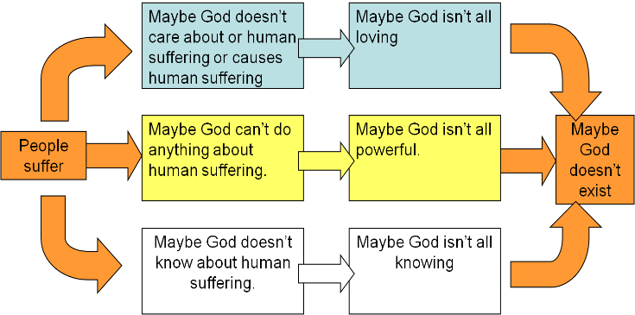

Theodicy | Strength | Weakness
Augustine’s theodicy
God created a perfect world with no evil. Evil is not created, it is the absence of god. Humans given free will. Adam and Eve disobeyed God and brought evil into the world. This is original sin. Everyone is guilty because they were present in Adam’s loins. Moral evil- from human choice. Natural evil- because disobeying god destroyed the natural order.
Free will
God gave humans free will. Without it we would be robots. We can choose to do right or wrong. Evil happens when humans misuse their free will. It God stopped evil, he would be taking away our free will.
Soul making
Humans were created in the likeness of god. We are in an immature moral state. Suffering is a necessary part of God’s universe, through suffering, human souls are made noble. Suffering is for our benefit to learn positive values.

Revision activities:
- Look, cover, write and check on all of the key words
- Explain in detail the problem of evil
- Explain the different theodicies
- Assess the strengths and weaknesses of each theodicy

Year 8- Half term homework
Revise all the knowledge using look cover write check AND use this revision sheet

What is the name of the Christian creation story?
Where is the Christian creation story written down?

Explain the Christian theory for how the world was created.

Explain what the big bang theory is:

Explain what evolution is:

What do you think is the most convincing answer for how the world was created? Justify your answer using evidence.

Theory | Explain why people think this proves god exists
Miracles
Revelation
Morality argument
Pascals wager

Pick two of the above theories and give a strength and a weakness of each one.
E.g. there is no proof that a miracle has happened so it can’t prove that God exists

Theory:
Strength
Weakness

Theory:
Strength
Weakness

Why might people’s faith change over time? Explain two reasons

Finish this essay in your books:

The Genesis story is the most convincing story of the creation of the world. To what extent do you agree??
The Genesis theory could be argued to be the most convincing story of creation because…
In this theory…..More specifically…
The evidence for this theory is…
A strength of this is…
A weakness of this is…

On the other hand, another explanation of how the world was created is…..
In this theory…..
More specifically…
The evidence for this theory is…
A strength of this is…
A weakness of this is…
In conclusion I think that the most likely explanation is….because

Year 8 summer revision worksheet

Theodicy
Natural Evil
Moral Evil
Omnibenevolent
Omniscient
Omnipotent
What is the problem of evil? Use the words: Omniscient, omnibenevolent, omnipotent and evil in your answer

Augustine theodicy | Soul making | Free will

What are the criteria for a Just war?

Christian beliefs about war | Hindu beliefs about war

What do Muslims believe about war? Refer to Jihad in your answer

