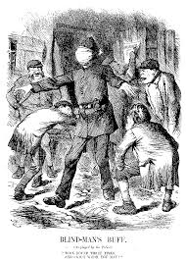
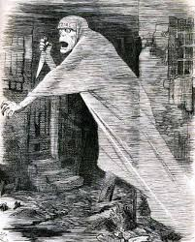
Whitechapel 1870-1900
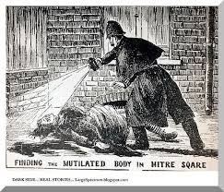
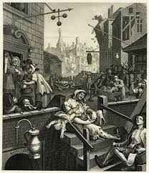

Contents

Topic | Pages | Tick when complete
Knowledge | 2
Blank Knowledge; for Look Cover Write Check | 3
Poor Living Conditions | 4-6
Jobs | 7-9
Immigration | 10-12
Police Problems (Organisation) | 13-14
Police Problems (Attitudes) | 15-16
Police (Ripper Murders) | 17-18
Whitechapel Vigilance Committee | 19-20
Warren and the Media | 21-23
Crime Scene and Witnesses | 24-25
Exam Practise | 26-28
Quiz | 29
Learning Ladder 8 mark ‘source utility’ question | 30
Learning Ladder 4 mark’ follow up’ question | 31
Learning Ladder 4 mark ‘give two features of’ question | 32

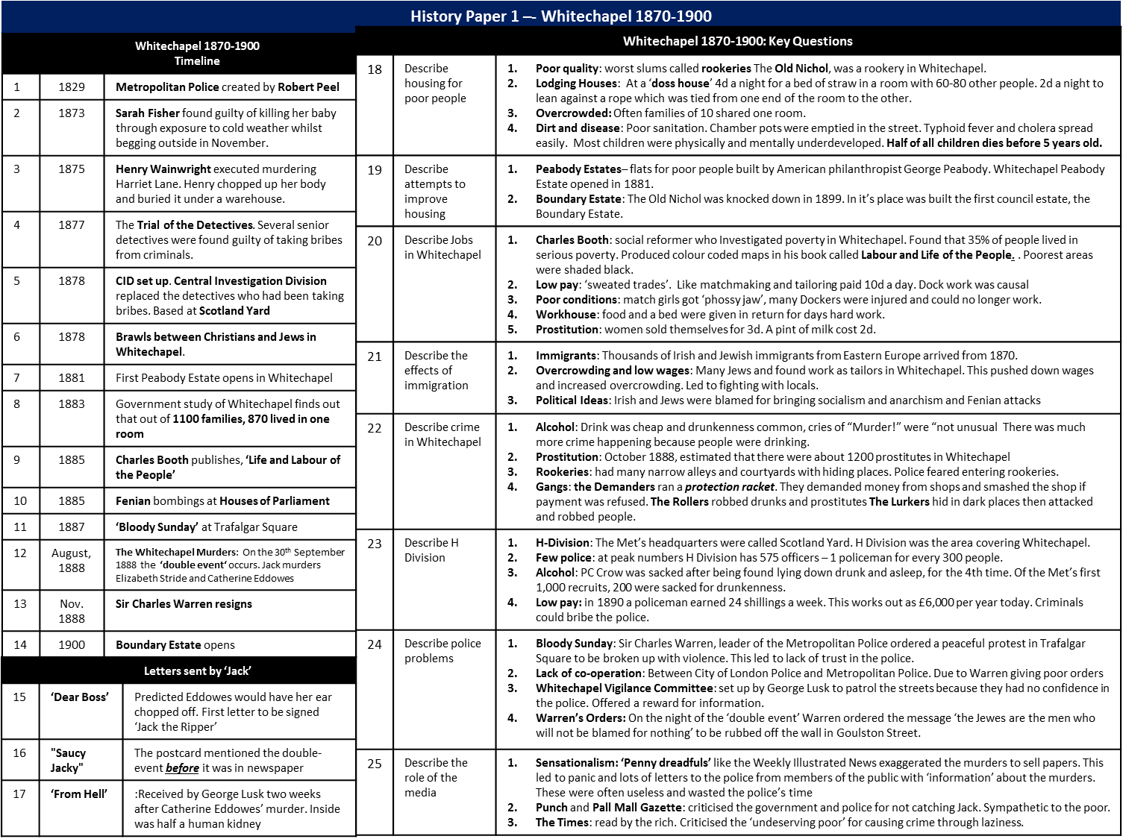

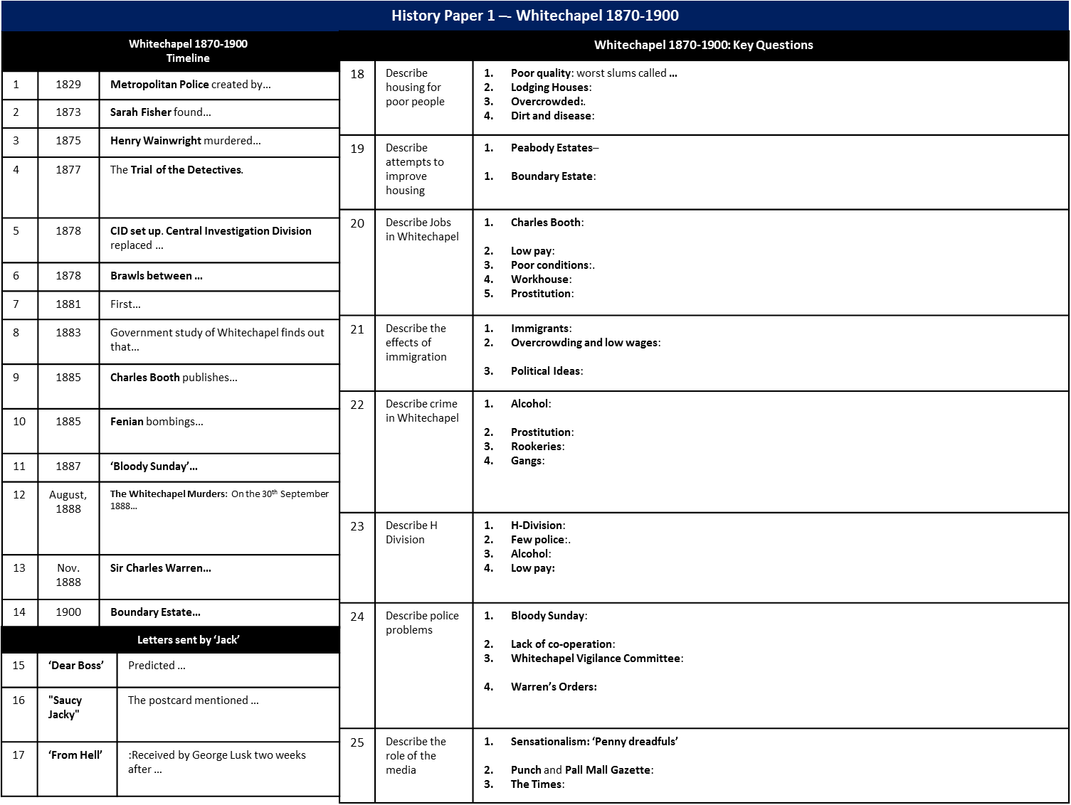

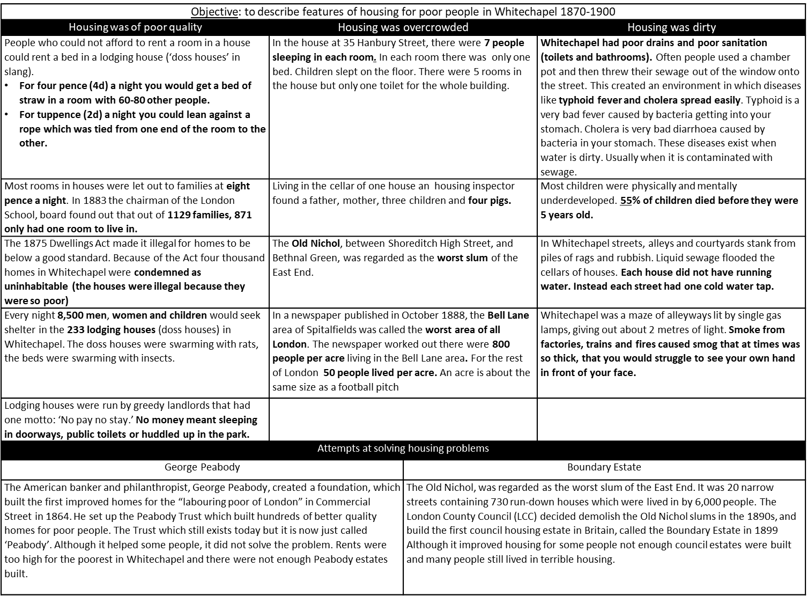
Poor Living Conditions

Objective: to describe features of housing for poor people in Whitechapel 1870-1900
Housing was of poor quality
What was a lodging house?
What was the slang name for a lodging house?
Would you get for 4d?
What would you get for 2d?
How many people used lodging houses during this period?
Why would a doss house be an unpleasant place to stay?
If they had no ‘doss money’ where did people sleep?
In what sized space did most families live?
What did the 1875 Dwellings Act make illegal?
How does this prove houses in Whitechapel were poor quality?
Housing was overcrowded
How does 35 Hanbury Street prove housing was overcrowded?
What did the housing inspector find in the cellar?
What was the name of the worst slum in Whitechapel?
In October 1888 a newspaper discovered how many people living in each acre of the Bell Lane area?
Approximately how big is an acre?
How many people lived in each acre of the rest of London?
How does this prove Whitechapel was overcrowded?
Housing was dirty
Whitechapel had poor sanitation. What does this mean?
What is cholera?
What is typhoid?
How did poor sanitation cause these diseases?
What was the infant mortality rate in Whitechapel?
What caused there to be lots of smoke in the air in Whitechapel?
Attempts at solving housing problems
What did George Peabody create?
Why did this not solve the housing problems?
What was the Boundary Estate?
Why did this not solve the housing problems?

KNOWLEDGE Tasks: | Tick when complete
Topic 1 Living Conditions in Whitechapel ;Look, cover write check on blank knowledge organiser
Topic 1 Living Conditions in Whitechapel multiple choice quiz (repeat till 100% correct)
Topic 1 Living Conditions in Whitechapel -; free recall quiz (repeat till 100% correct)

4 mark
Describe two features of living conditions in Whitechapel 1870-1900

8 mark
Study sources A and B. How useful are sources A and B for an enquiry into crime in Whitechapel 1870-1900. Explain your answer, using sources A and B and your knowledge of the Historical context
Source A: This illustration from the satirical magazine Punch in 1888, accompanies an article about the slums in London, entitled ‘The Nemesis of Neglect’.
Nemesis: a person or thing that is very difficult to defeat. Here the nemesis is crime caused by neglect

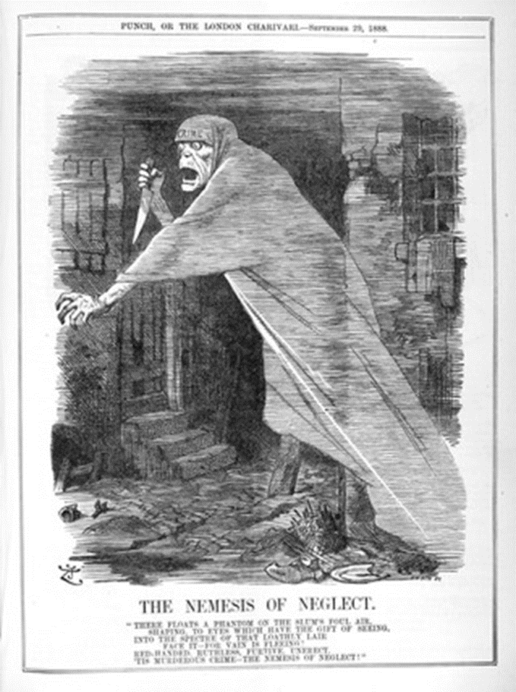
Source B: From ‘A Child of the Jago’ a novel by Arthur Morrison in 1896. He was a social reformer. This meant he campaigned to improve the lives of poor people. The book sold in very large numbers. The Jago is a rookery.

Jago Court gave it’s name to one of the blackest slums in London – the Jago. The streets of the Jago were black and close. From the foul earth and the grimy walls rose a vile stink. People did not walk with their heads held high in the Jago. They moved more like slinking rats.
The houses all had lights even though many front doors had been burned away for warmth a long time ago. In this place light kept away three types of vermin away – the lice, the rats and the cosh carriers. Cosh carrying was almost an industry in the Jago. The cosh was an iron club and cosh carriers waited in dark stair cases for the unsuspecting stranger.

4 Mark
Study Source A: How could you follow up source A to find out more about living conditions in Whitechapel. In your answer, you must give the question you would ask and the type of source you could use. Complete the table below.
Detail in Source A I would follow up:

Question I would ask:

What type of source I could use:

How this might help answer my question:

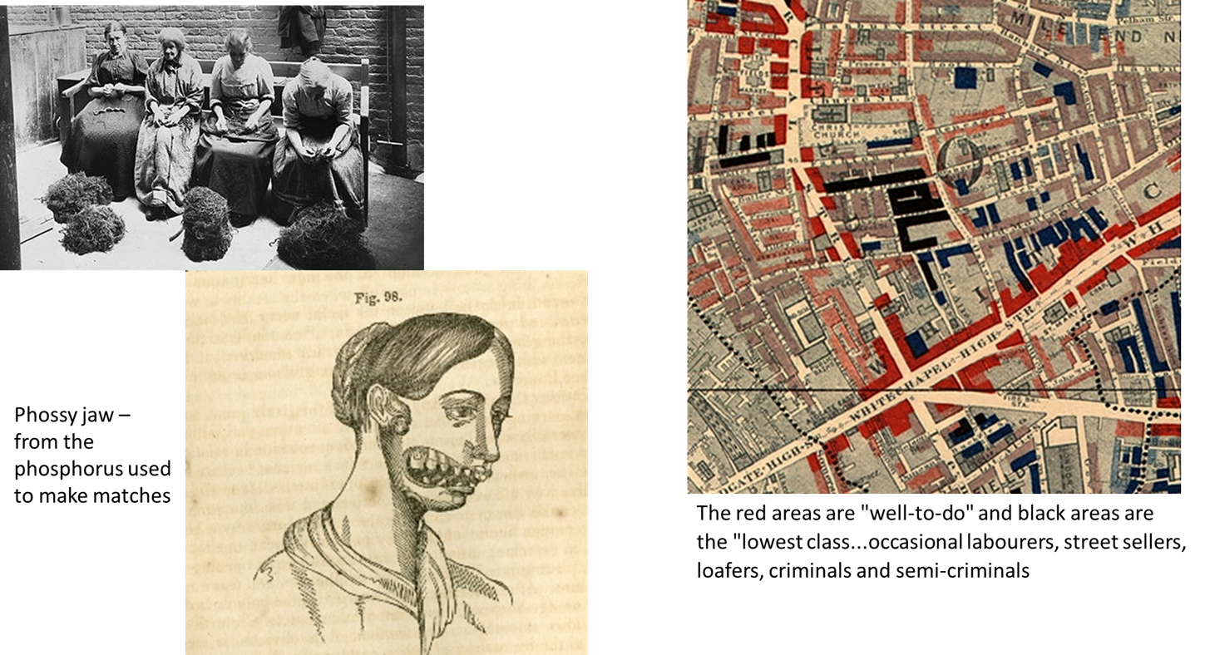
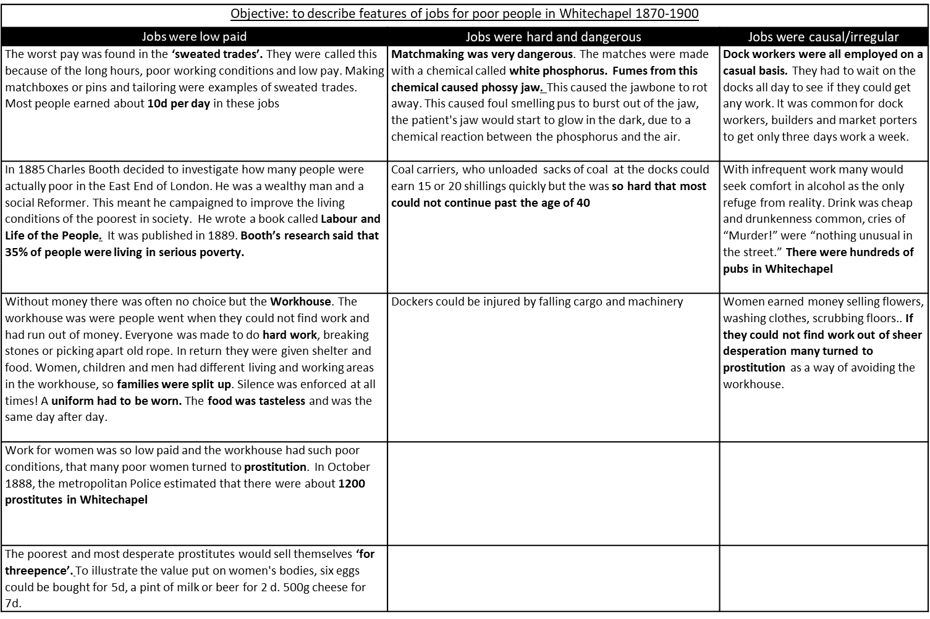
Jobs

Objective: to describe features of jobs for poor people in Whitechapel 1870-1900
Jobs were low paid
Give examples of sweated trades
Why were they called this?
How much might a matchmaking girl earn in a day?
Who was Charles Booth?
What did he write?
What did his research find?
What colour were the poorest areas on his maps?
When did people go to the workhouse?
What jobs did they do there?
Why was the workhouse un popular?
Out of desperation for money many women turned to prostitution. How many by 1888?
Women sold their bodies very cheaply as they were desperate for money. Select a fact that supports this point.
Housing was overcrowded
How does 35 Hanbury Street prove housing was overcrowded?
What did the housing inspector find in the cellar?
What was the name of the worst slum in Whitechapel?
In October 1888 a newspaper discovered how many people living in each acre of the Bell Lane area?
Approximately how big is an acre?
How many people lived in each acre of the rest of London?
How does this prove Whitechapel was overcrowded?
Jobs were hard and dangerous
What condition was caused by matchmaking?
Describe this condition?
Why was working at the docks dangerous?
Jobs were causal/irregular
Why was dock work casual?
What did people do when they could not find work?
Why did this cause crime to increase?
Why did the casual nature of jobs for women lead to an increase in prostitution?
KNOWLEDGE Tasks: | Tick when complete
Topic 2 Jobs in Whitechapel ;Look, cover write check on blank knowledge organiser
Topic 2 Jobs in Whitechapel multiple choice quiz (repeat till 100% correct)
Topic 2 Jobs in Whitechapel -; free recall quiz (repeat till 100% correct)

4 mark
Describe two features of casual work in Whitechapel 1870-1900
Describe two features of a sweated trade in Whitechapel 1879-1900
Describe two features of the workhouse 1870-1900
Describe two features of jobs for poorer people in Whitechapel 1870-1900
8 mark
Study sources A and B. How useful are sources A and B for an enquiry into jobs for poor people in Whitechapel 1870-1900. Explain your answer, using sources A and B and your knowledge of the Historical context.
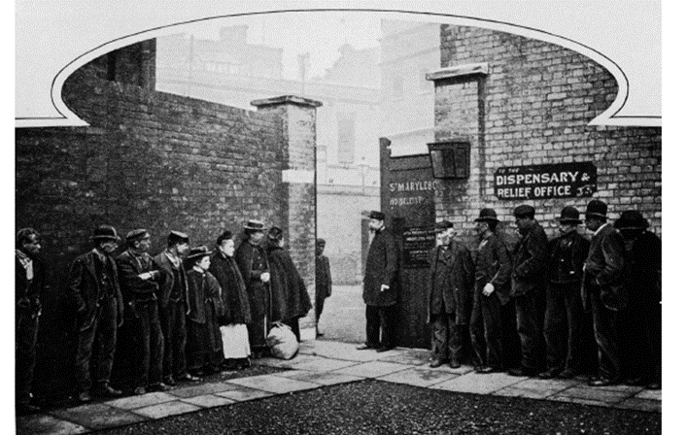
Source A: A photograph of people queuing to get into a workhouse in Whitechapel in 1900. It was published in ‘Poverty: the Nations Black Stain’ by social reformer George Sims.

Source B: A quote from The People of the Abyss by Jack London. An author from the USA who was a journalist and social activist. This meant he campaigned to make society better. To write this book he spent time living in doss houses in the East End.

Worst of all is the lead dust in the white-lead trades. Here is a description of a few specific cases of white-lead poisoning:-
Charlotte Rafferty, a fine, well-grown young woman with a splendid constitution—who had never had a day’s illness in her life—became a white-lead worker. Convulsions seized her at the foot of the ladder in the works. Dr. Oliver examined her, found the blue line along her gums, which shows that the system is under the influence of the lead. He knew that the convulsions would shortly return. They did so, and she died.

Mary Ann Toler—a girl of seventeen, who had never had a fit in her life—three times became ill, and had to leave off work in the factory. Before she was nineteen she showed symptoms of lead poisoning—had fits, frothed at the mouth, and died.

4 Mark
Study Source A: How could you follow up source A to find out more about jobs for poor people in Whitechapel. In your answer, you must give the question you would ask and the type of source you could use. Complete the table below.
Detail in Source A I would follow up:

Question I would ask:

What type of source I could use:

How this might help answer my question:

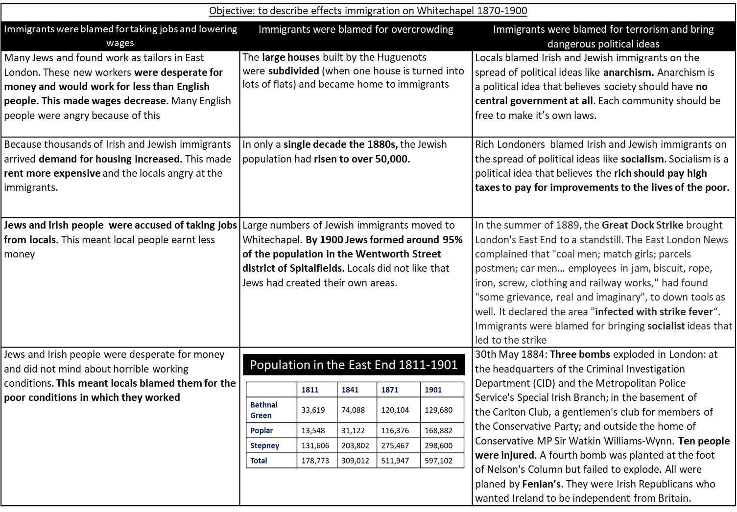
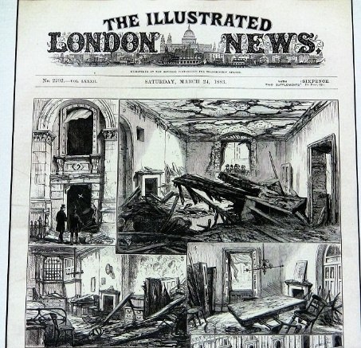
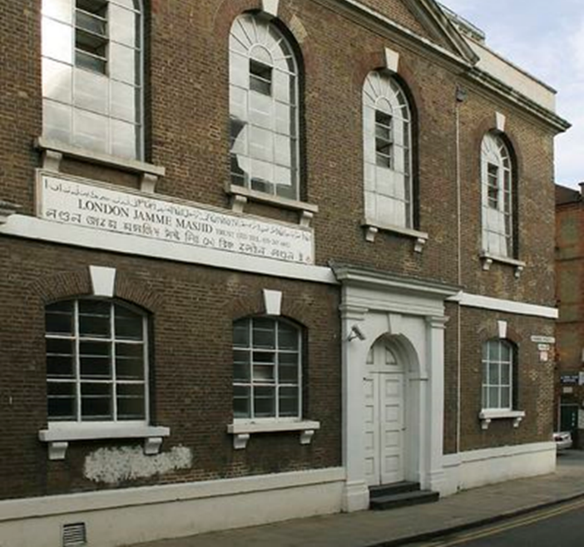
Immigration
Objective: to describe effects immigration on Whitechapel 1870-1900
Immigrants were blamed for taking jobs and lowering wages
What job did many Jewish immigrants do?
Why did this cause tension?
What effect did immigration have on rent prices?
Why did this cause tension?
Immigrants were accused of taking jobs from locals. Why did this cause tension?
Why were immigrants blamed for poor working conditions?
Immigrants were blamed for overcrowding
What happened to large houses in Whitechapel?
Why did this make overcrowding worse?
What happened to the Jewish population of the East End in the 1880s?
What % of the population of Wentworth Street was Jewish?
What was the total population of Whitechapel in 1811?
What was it in 1901?
Immigrants were blamed for terrorism and bring dangerous political ideas
Immigrants were blamed for spreading anarchism. What is anarchism?
Why would rich people have been worried about anarchism?
Immigrants were blamed for spreading socialism. What is socialism?
Why would rich people have been worried about socialism?
What was the Great Dock Strike in 1889?
Why were immigrants blamed for this?
Where was bombed in May 1884?
Why were immigrants blamed for this?
KNOWLEDGE Tasks: | Tick when complete
Topic 3 Immigration in Whitechapel ;Look, cover write check on blank knowledge organiser
Topic 3 Immigration in Whitechapel; multiple choice quiz (repeat till 100% correct)
Topic 3 Immigration in Whitechapel -; free recall quiz (repeat till 100% correct)

4 mark
Describe two features of immigration to Whitechapel 1870-1900
8 mark
Study sources A and B. How useful are sources A and B for an enquiry into attitudes to immigration to Whitechapel 1870-1900. Explain your answer, using sources A and B and your knowledge of the Historical context.
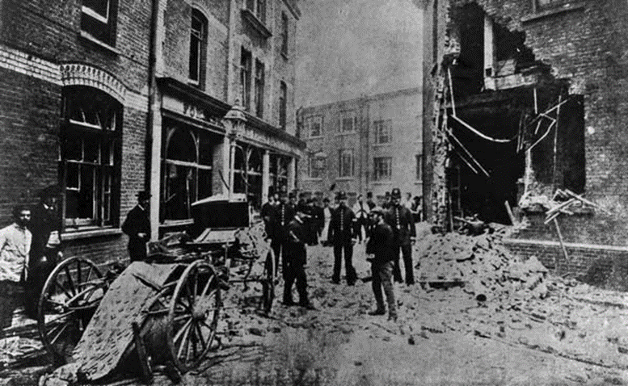  Source A: The damage to Scotland Yard police headquarters after a Fenian bomb attack, 30 May 1884 | Source B: An article from the conservative newspaper, the St James Gazette called ‘Jewish East London’  The social, economic moral and political questions created by the existence of a vast colony of Jews in Whitechapel was discussed in my last article’ The Invasion of Foreign Pauperism.’  They never forget that they are Jews. They are a people apart. Long as they live among us, they will never become merged into the mass of the English population. There are streets in Whitechapel without a single English inhabitant.
4 Mark
Study Source A: How could you follow up source A to find out more about immigration in Whitechapel. In your answer, you must give the question you would ask and the type of source you could use. Complete the table below.
Detail in Source A I would follow up:

Question I would ask:

What type of source I could use:

How this might help answer my question:

Police Problems – Organisation

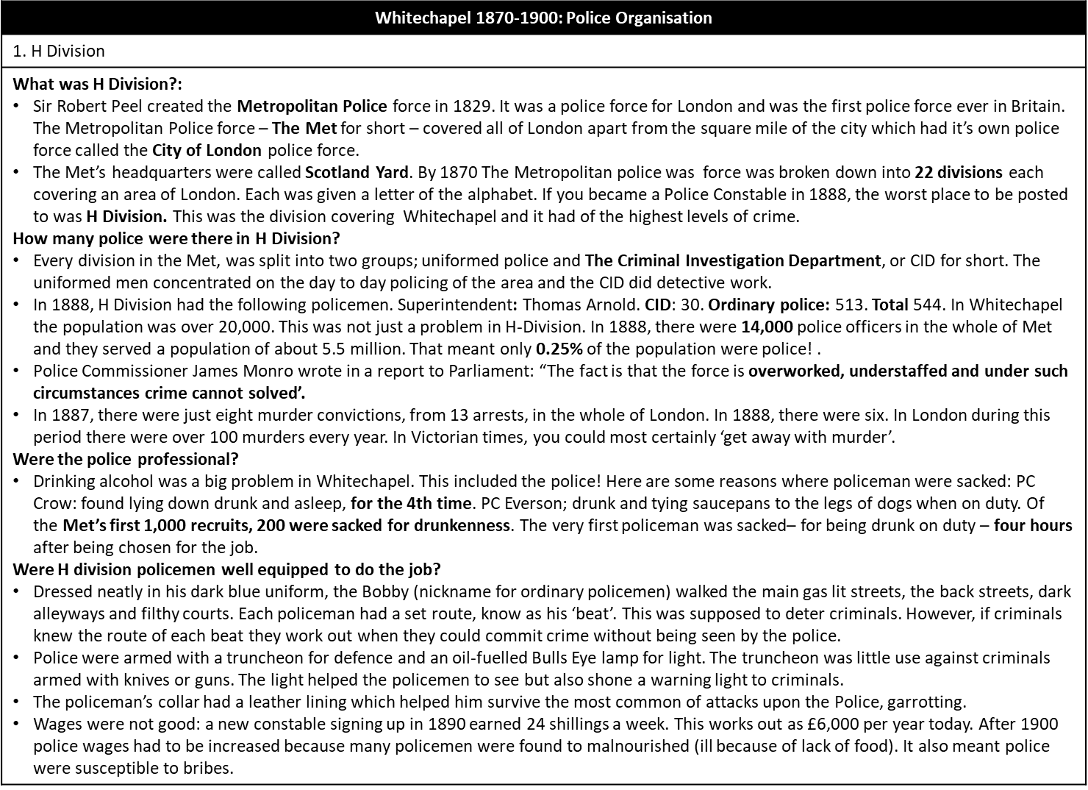
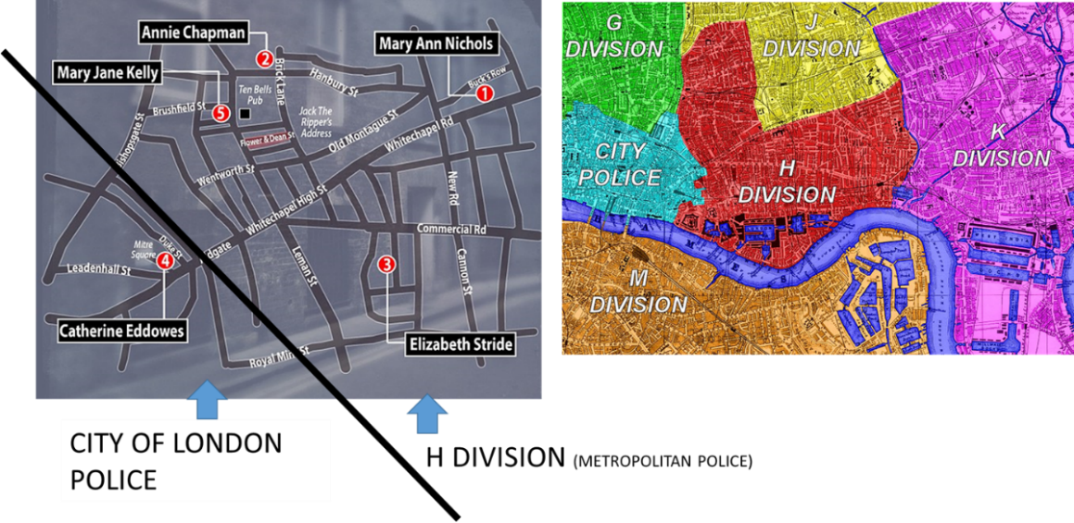
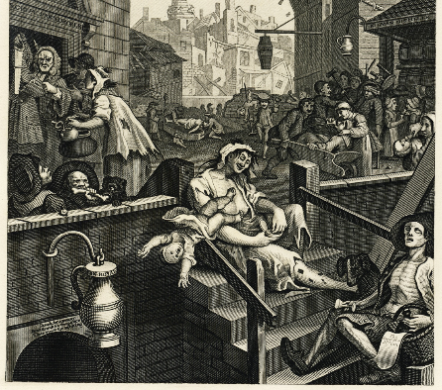
Objective: identify and describe reasons why police organisation made it difficult to catch criminals.
What was H Division?:
Who created the Metropolitan Police and in what year?
What was the name of the other Police force in London?
What was the Metropolitan Police’s nickname?
Howe many divisions was the Met divided into?
Which division policed Whitechapel?
How many police were there in H Division?
What was the job of the CID?
What was the job of uniformed police?
How many police were there in Whitechapel?
How many were there in London?
What % of the population of London were police?
What did Police Commissioner Monro say about police numbers in?
Why did this cause more crime, or failed to prevent crime?
Were the police professional?
Why was PC Crow sacked?
Why was PC Everson sacked?
How many of the first 1000 recruits were sacked for drunkenness?
How long was the first ever police recruit in the job before he was sacked for drunkenness?
Why did this cause more crime, or failed to prevent crime?
Were H division policemen well equipped to do the job?
Describe the police uniform
What was the ‘beat’?
Why might this have failed to prevent crime?
Describe policeman’s equipment
Why might this have failed to prevent crime?
Describe policeman’s equipment
Why might this have failed to prevent crime?
Police Problems – Attitudes to the Police
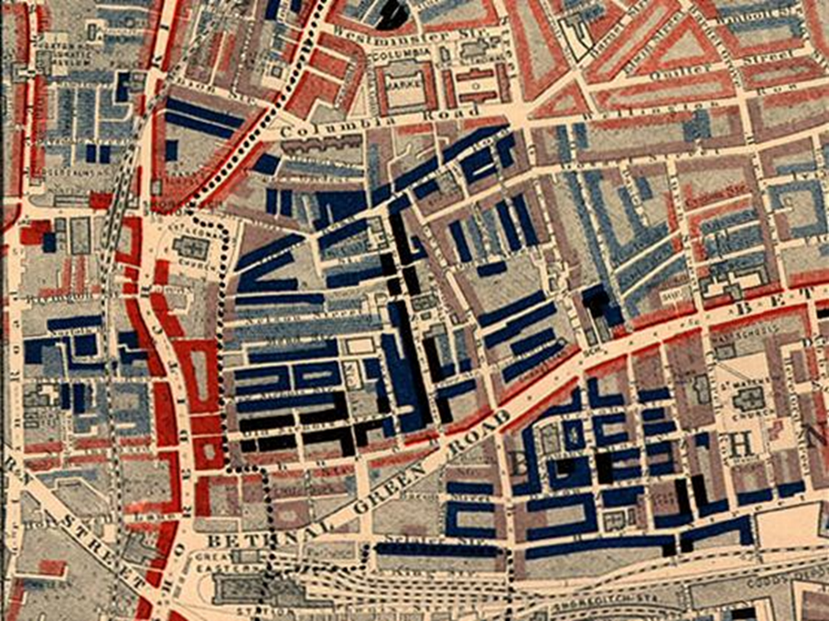
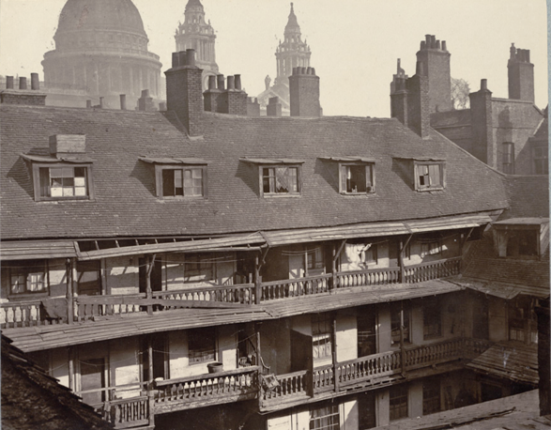
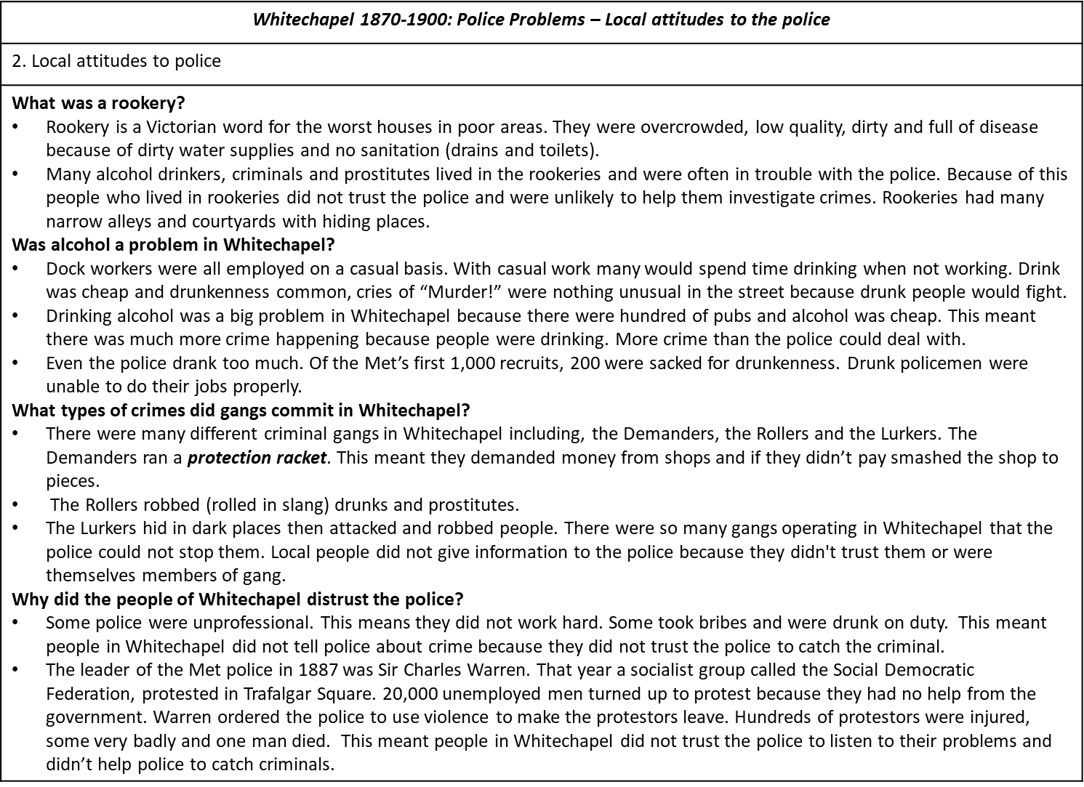
Objective: identify and describe attitudes to the police that made it difficult to catch criminals
Rookeries
What was a rookery?
Who lived in rookeries?
Why would they not be interested in helping the police?
Why did the layout of rookeries make it hard to catch criminals?
Alcohol
Why did many people drink alcohol in Whitechapel?
Why did this cause crime?
Gangs
The Demanders ran a protection racket. What does this mean?
What crime did The Rollers commit?
How did The Lurkers make money?
Local people distrusted the Police.
Who was Sir Charles Warren?
What happened at Bloody Sunday 1887?
Why was Warren blamed?
Why did this cause people to distrust the police?
Why did this make it more difficult to catch criminals?
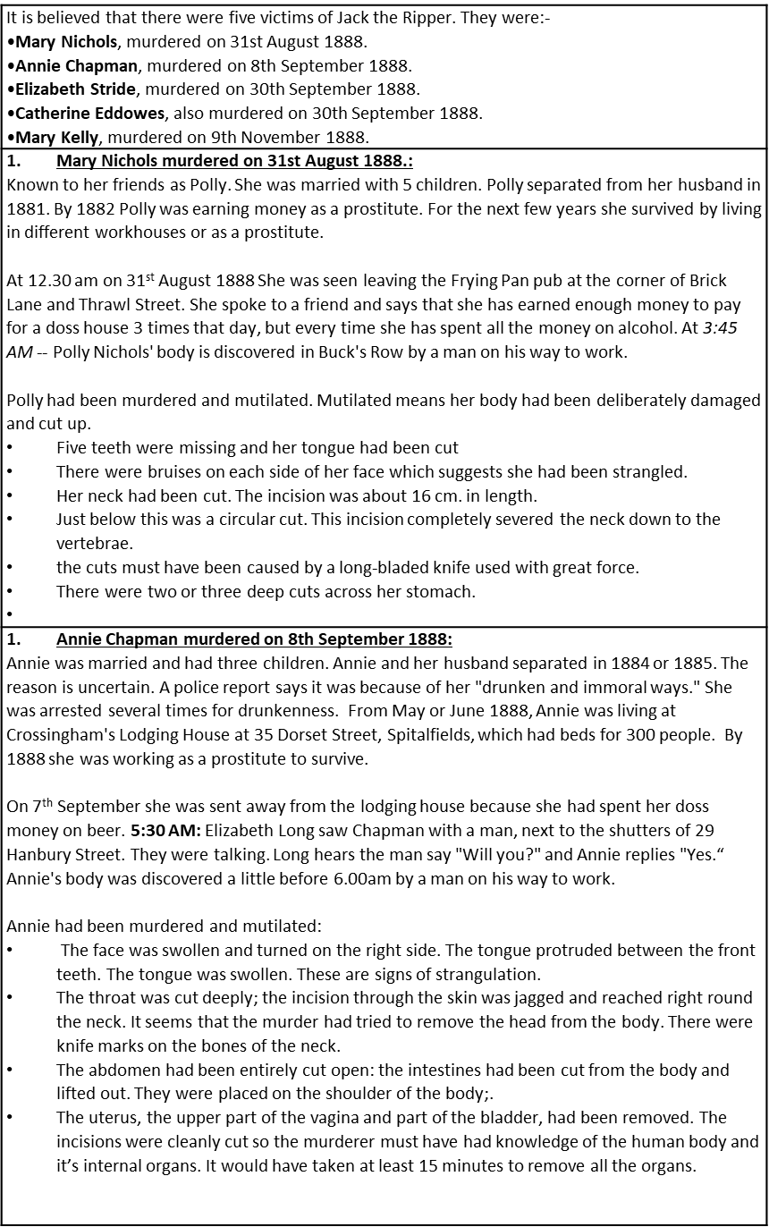
Police Problems – Ripper Murders

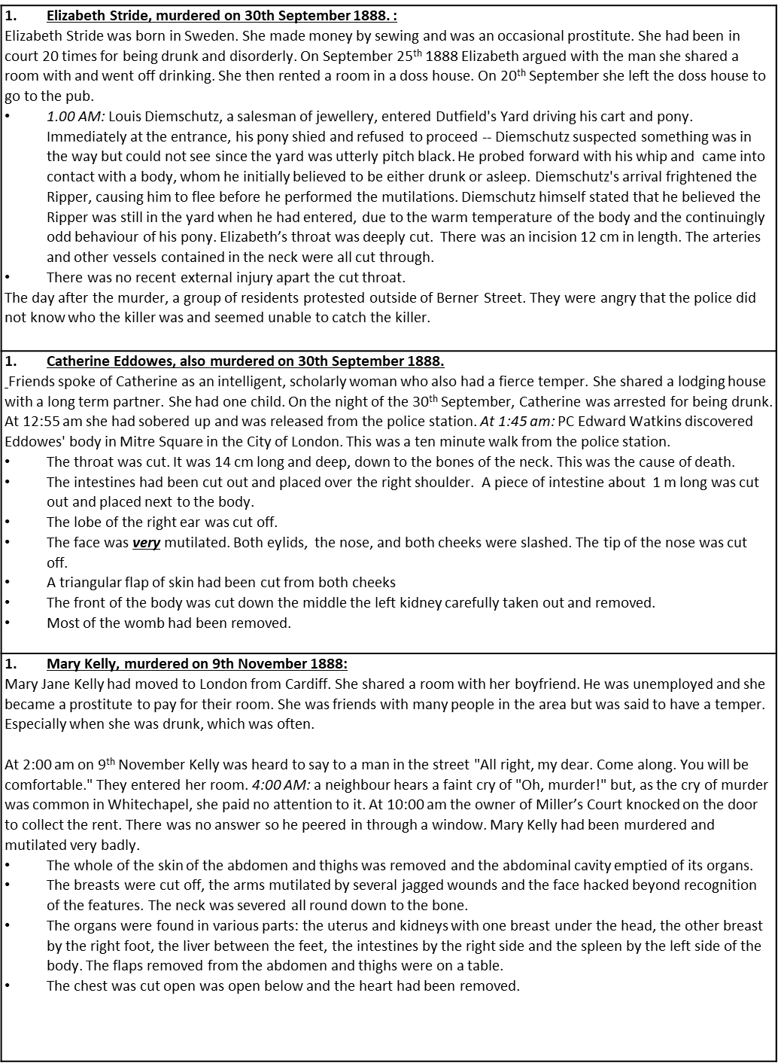

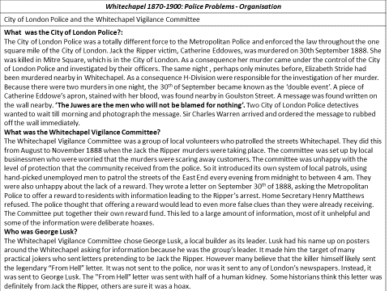
Police - Whitechapel Vigilance Committee

Whitechapel 1870-1900: Police Problems - Organisation
2. City of London Police and the Whitechapel Vigilance Committee
What area of London were the City of London police in charge of?

What was the ‘double event’?

How did Charles Warren negatively affect the working relationship with the City of London Police?

Whitechapel Vigilance Committee
What was the Whitechapel Vigilance Committee?

What were the Whitechapel Vigilance Committee worried about?
What two things did the Committee do to try and stop crime?
Why did the reward not help to catch Jack?
George Lusk
What did George Lusk lead?
What famous letter was addressed to him?
Describe the contents of the letter
Why did this make it harder to catch Jack?
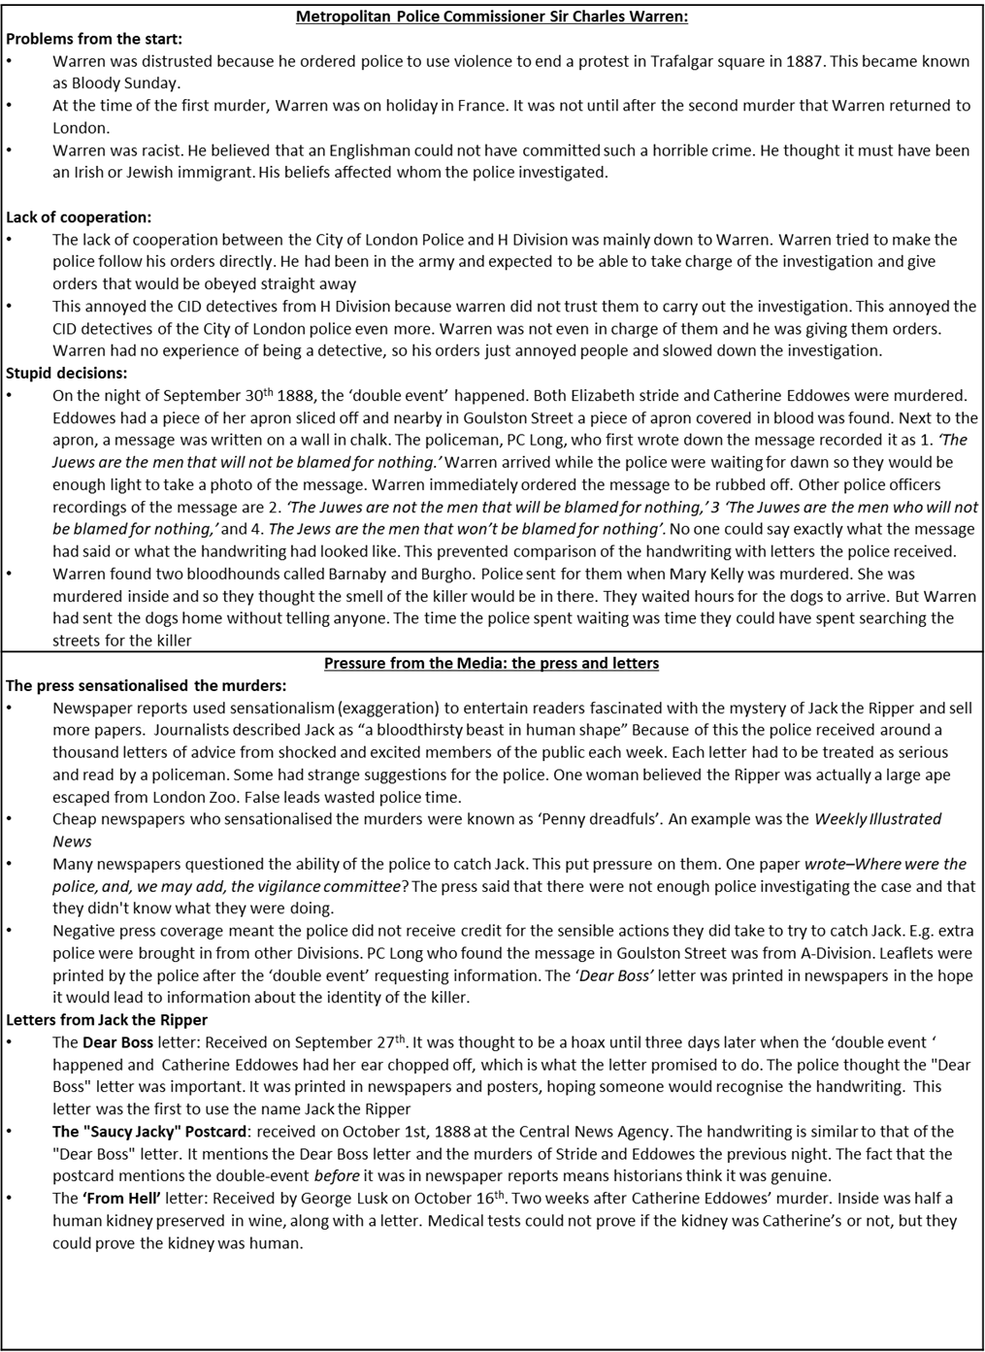
Warren and the Media

Why was Warren distrusted by ordinary people because of Bloody Sunday?

Why was Warren distrusted because of his holidays?

Why did Warren’s racist ideas negatively affect the investigation?

Why did Warren’s previous job negatively affect the investigation?

Why were the murders on 30th September 1888, referred to as the ‘double event’?

What was discovered in Goulston Street?

Why did Warren’s action regarding message negatively affect the investigation?

What were Barnaby and Burgo?

What did Warren order to be done with them?

Why did this negatively affect the investigation?

Why did the press sensationalise the murders?

What was the result of this sensationalism?

Why did this negatively affect the investigation?

What was a Penny Dreadful?

Give an example of a Penny Dreadful

The police were heavily criticised in the press. Why did this negatively affect the investigation?

Give three examples of tactics the police tried to catch Jack

What were the key features of the Dear Boss letter?

What were the key features of the ‘Saucy Jacky’ Postcard?

What were the key features of the ‘From Hell’ Letter?

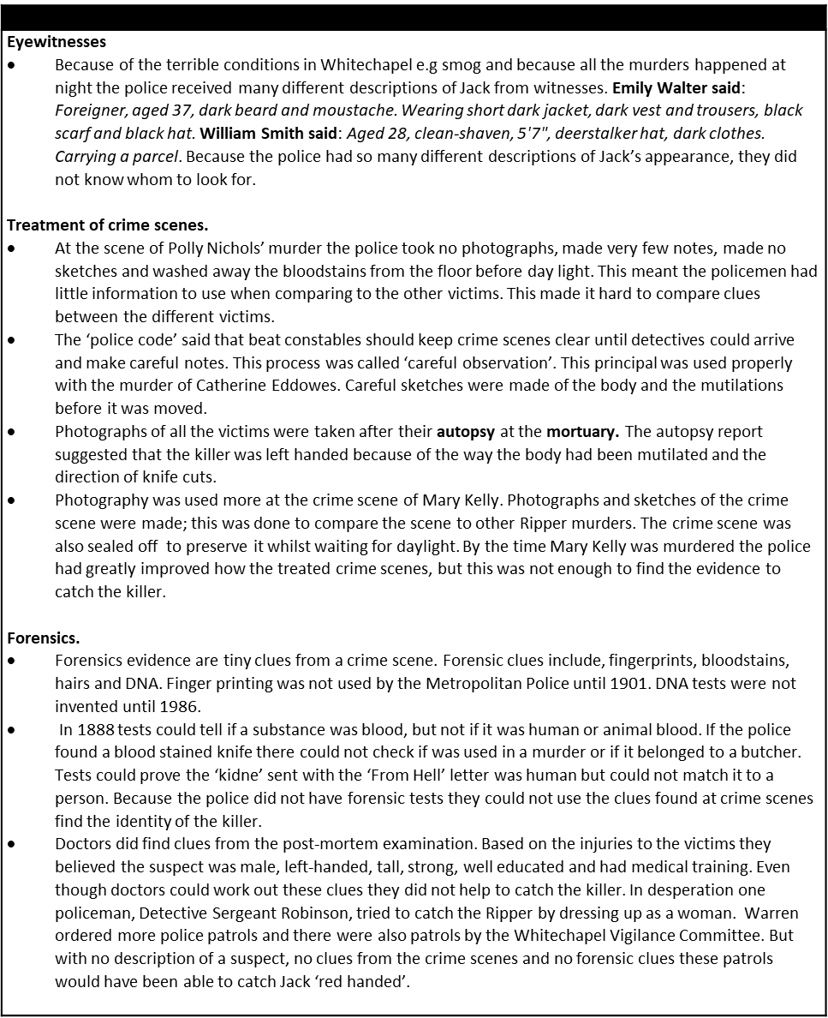
Crime Scene and Witnesses

What did witnesses disagree about?

Why did this make it difficult to catch Jack?

Describe how the police did not treat early crime scenes carefully

What instructions did the police code give about how crime scenes should be treated?

Describe how police treatment of Catherine Eddowes crime scene was an improvement.

Describe how police treatment of Mary Kelly’s crime scene was an improvement.

What are forensic clues?

What forensic clues could the Metropolitan Police use in 1888?

What forensic clues could the Metropolitan Police NOT use in 1888

What is an autopsy?
What information did the police receive from the autopsy report?

KNOWLEDGE Tasks: | Tick when complete
Topic 4 Police and Crime; Look, cover write check on blank knowledge organiser
Topic 4 Police and Crime; multiple choice quiz (repeat till 100% correct)
Topic 4 Police and Crime-; free recall quiz (repeat till 100% correct)

4 mark
Describe two reasons why attitudes to the police were poor in Whitechapel 1870-1900
Describe two features of policing in Whitechapel 1870-1900
Describe two features of the Whitechapel Vigilance Committee
Describe two features of the media’s response to the Whitechapel murders
Describe two features of techniques the police used to try and catch Jack the Ripper
8 mark
Study sources A and B. How useful are sources A and B for an enquiry into attitudes to the police 1870-1900. Explain your answer, using sources A and B and your knowledge of the Historical context
Source A  Bloody Sunday, 1887. This engraving from The Illustrated London News Demonstrations by the unemployed had been taking place in the square daily since the summer. Many unemployed men and women also slept in the square, washing in the fountains.  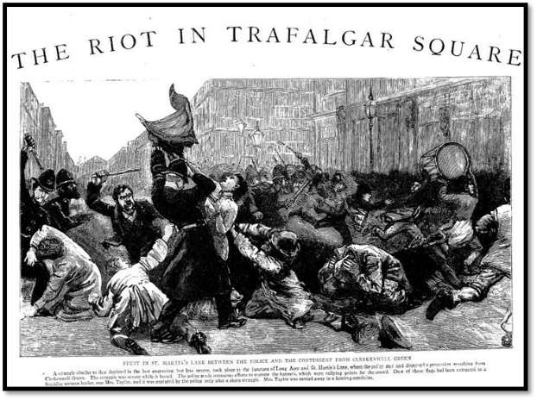 | Source B  An article from the newspaper ‘The Pall Mall Gazette’, 8th October 1888. The Pall Mall Gazette was a newspaper which was very popular and read by many people in London.  The collapse of the Metropolitan Police Force as a thief-catching organisation is due to Sir Charles Warren, and it is the direct consequence of the defects of his qualities. He is capable and energetic. He always thinks things will be best done if he does them himself. Hence the centralization of a camp has been forced upon the police, and the result has been to destroy the force as thief-catchers.  The evil effect of the new system, by which the constable has been reduced to a more or less discontented machine, is naturally felt most in the Detective Department, which ought to be the brain of the force. There is no confidence anywhere, but discontent everywhere, and this discontent is felt most keenly at the headquarters of the force--in Scotland-yard.
Study sources A and B. How useful are sources A and B for an enquiry into the effectiveness of the police in Whitechapel 1870-1900. Explain your answer, using sources A and B and your knowledge of the Historical context.
Source A:  The title of the cartoon is ‘Real presence of mind’ and the caption says: Policeman X drunk and almost incapable, is just able to blow his whistle for help. From the satirical magazine Punch.  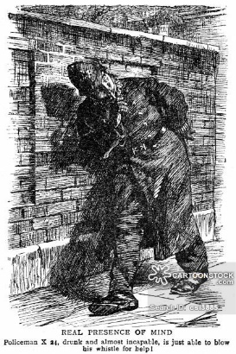 | Source B: Punch magazine: Whitechapel, 1888. First member of "Criminal Class." "Fine body of men, the police!"  Second member of "Criminal Class." "Uncommon fine!- It's lucky for us as there's such a bloomin' few of 'em!!!"  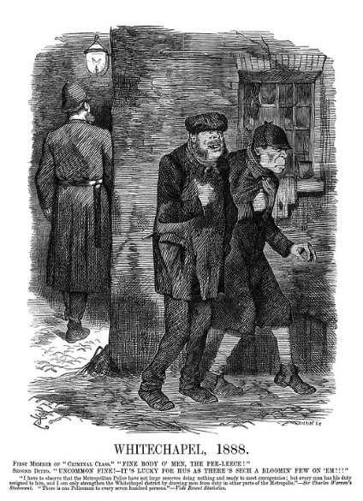
Study sources A and B. How useful are sources A and B for an enquiry into the police investigation into the Whitechapel murders. Explain your answer, using sources A and B and your knowledge of the Historical context
Source A  ‘From Hell’ letter, received by George Lusk of the Whitechapel Vigilance Committee. The letter was accompanied by a human kidney preserved in alcohol.  From hell  Mr Lusk,  Sor  I send you half the Kidne I took from one women prasarved it for you tother piece I fried and ate it was very nise. I may send you the bloody knif that took it out if you only wate a whil longer  signed  Catch me when you can Mishter Lusk | Source B  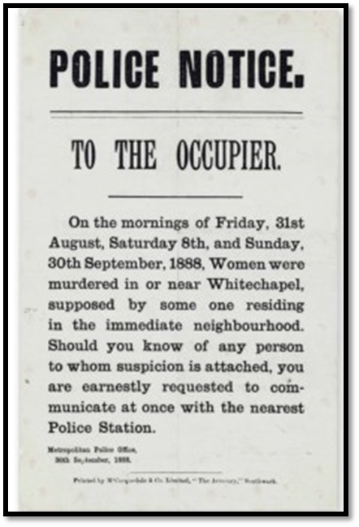  One of 80,000 leaflets that were handed out in the days after the ‘double event’, 30th September 1888.
Study sources A and B. How useful are sources A and B for an enquiry into the attitude of the media to the police during the Whitechapel, murders. Explain your answer, using sources A and B and your knowledge of the Historical context
Source A:  Part of an article from The Daily Telegraph SATURDAY, OCTOBER 6, 1888. The Daily Telegraph and The Times were very popular national newspapers.  The police are still busily engaged in their investigations respecting the Whitehall tragedy, and some progress has been made in following up the various clues to establish the identity of the remains. It is now thought that the miscreant who deposited the mutilated corpse in the basement archways of the new police buildings gained access thereto through an opening in the hoarding where a board had been removed. Detectives and police are still employed to watch the buildings, and inquiries are being diligently made in the vicinity. | Source B  ‘Blind man’s Buff. A cartoon from Punch magazine 22nd September 1888.  Shows a policeman wearing a blindfold that also covers his ears and nose, flailing into space as various criminals surround him.  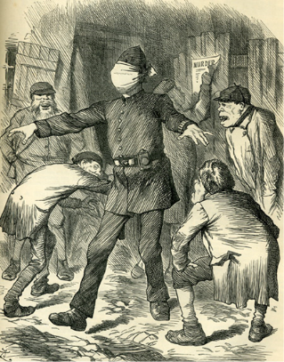
Study sources A and B. How useful are sources A and B for an enquiry into the effectiveness of the police investigation into the Whitechapel murders? Explain your answer, using sources A and B and your knowledge of the Historical context
Source A: a sketch made of Catherine Eddowes body by the police surgeon, Fred Forster, of the City of London Police.  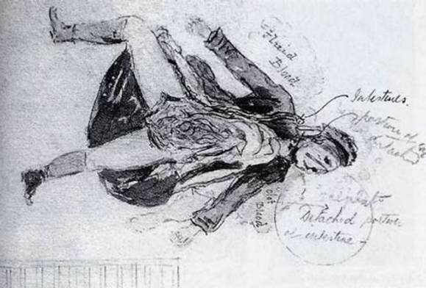 |  | Source B:  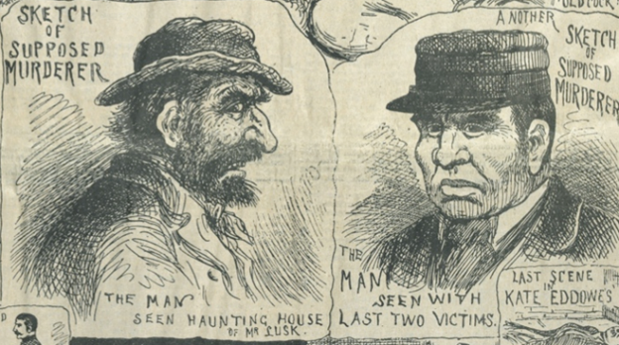  Sketches of Jack the Ripper based on different descriptions given to the police by eyewitnesses. The Police Illustrated News 20th October 1888
4 Mark
Study Source A: How could you follow up source A to find out more about the effectiveness of the police investigation into the Whitechapel murders? In your answer, you must give the question you would ask and the type of source you could use. Complete the table below
Detail in Source A I would follow up:

Question I would ask:

What type of source I could use:

How this might help answer my question:

Whitechapel 1870-1900
Housing
- What was the word used to describe the worst slums with poor housing and lots of alleyways? | Coweries | Rookeries | Kipperies
- What was the slang term for a lodging house? | Doss house | Toss house | Workhouse
- What water diseases were common because of poor sanitation | Gout and plague | Tuberculosis and smallpox | Cholera and Typhoid
- Housing was overcrowded. How many rooms did most families live in? | One | Two | Three
- Which American knocked down slums and built better housing for the poor? | Charles Booth | George Peabody | George Lusk
- What was the name of the first council estate, built on the site of the Old Nichol slum? | Peabody Estate | Grosvenor estate | Boundary Estate
- Jobs and Immigration
- Which social reformer crafted a colour coded map showing the extent of Povertly in Whitechapel? | Charles Booth | George Peabody | George Lusk
- Which of these jobs was a low paid, ‘sweated trade’? | Docker | Train driver | Matchmaking
- Where could poor people go for food and shelter in return for a days hard work. | Doss house | Toss house | Workhouse
- What race were many immigrants who became tailors in Whitechapel? | Irish | Jews | Scottish
- What race were blamed for bombing the Houses of Parliament? | Irish | Jews | Scottish
- Why did immigration case tensions | People were racist | Lowered wages and increased overcrowding | Many immigrants were criminals
- Police and Crime
- Why was prostitution very common? | Women were poorly educated | Women were desperate for money to survive | Women were too lazy to find jobs
- What gang hid in dark places and attacked and robbed people? | The Demanders | The Lurkers | The Rollers
- What substance increased crime and also made the police less effective? | Alcohol | Phosphorous | Blood
- Why was it hard for the police to catch criminals in rookeries? | No street signs | Many alleyways and hiding places | Clean streets
- Why was it hard for police to deal with the large amount of crime? | There were too many policemen, they got in each other’s way | They wore blue uniforms | There was only one policeman for every 300 people
- Even before the Whitechapel murders people disliked Charles warren. Why? | High crime rate | Bloody Sunday | High taxes
- What did George Lusk set up? | Whitechapel vigilance Committee | Whitechapel Jobs Committee | Whitechapel Housing Committee
- What big mistake did Sir Charles Warren make during the Whitechapel murders? | Didn’t use fingerprint technology. | Sacked too many police | Ordered the message to rubbed off the wall on Goulston Street
- Give an example of a sensationalist paper for the poor? | Punch | Weekly Illustrated News | The Times
- Give an example of a paper that criticised the police? | Punch | Weekly Illustrated News | The Times
- Give an example of a paper that supported the police and blamed the poor from crime? | Punch | Weekly Illustrated News | The Times

