Year 8: Autumn 2
“World War I the biggest turning point for British Women in the 20th century”,
how far do you agree?

Name: _____________________ Class:__________________ Teacher: ______________

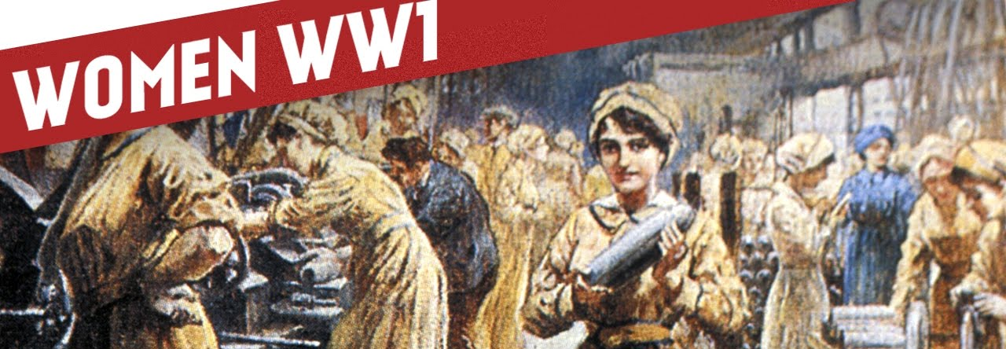

Contents
Lesson/Resource | Page Numbers | Tick when complete
Knowledge Organiser | 2-5
Do Now – Lesson 1 | 6
- How much has the position of women improved since 1900? | 7-10
- Was World War I really a turning point for women? | 11-13
- How did the position of Women improve from 1940-1970? | 14 -17
- What did women’s lib’ achieve? | 18-21
Learning Ladder | 22-23
“Because, but, so” vocabulary table | 24

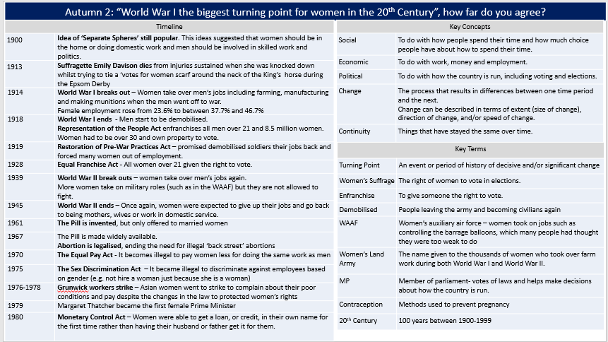

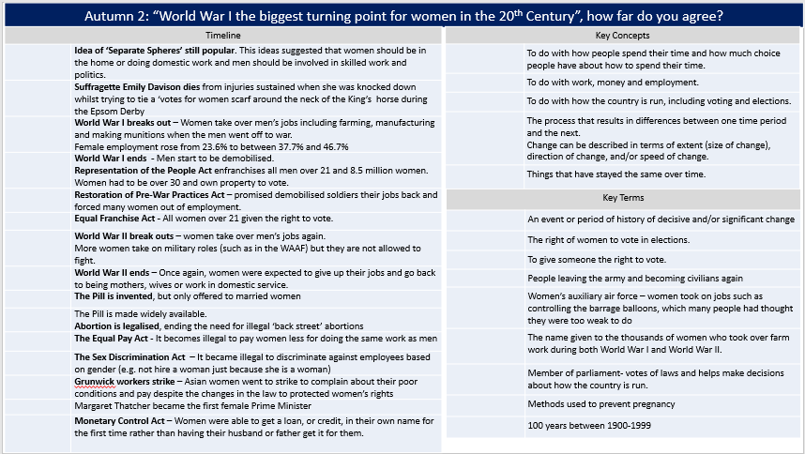

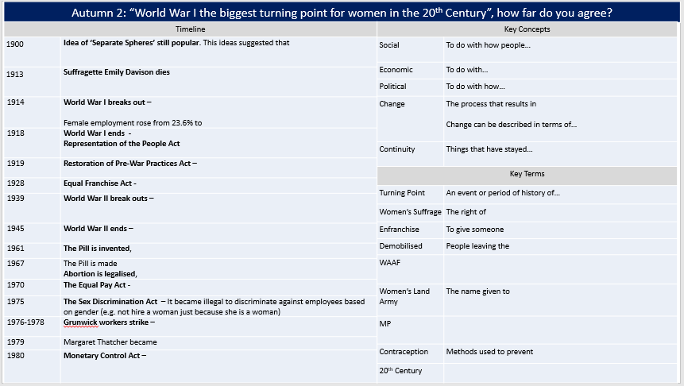

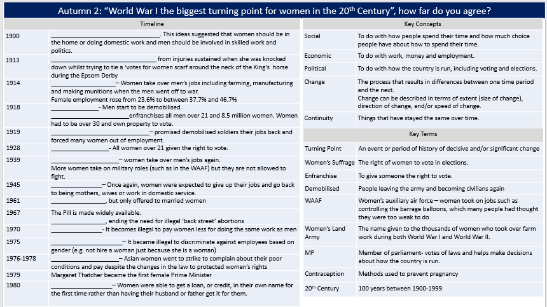

Lesson 1 – Do Now

- The years 1900-1999 were part of which century?

18th Century | 19th Century | 20th Century

- Today, in 2019, we are in the __st century.
- The 20th Century was part of which period of History?
Middle Ages (Also known as the Medieval Period) 500- 1500 | Early Modern Period 1500-1700 | Industrial Period 1700-1900 | Modern Period 1900-present

- World War I took place from 1914-1918, this was in the ___ century.

- Which definition of a historical ‘turning point’ is correct?

A moment of continuity | A small moment of change | A decisive/significant moment of change

- The idea of ‘separate spheres’ for men and women was very popular at the beginning of the 20th century. What did the idea of ‘separate spheres’ actually mean?
People thought that men and women had different roles in society, such as women belonging in the home and men taking part in politics | People thought that men and women should live in different places

Challenge! Answer these questions in your books.
Why do you think many people supported the idea of ‘separate spheres’ for men and women?

1. Was World War I the biggest turning point for British Women in the 20th century?
How much has the position of women improved since 1900?
Before we can answer our big question, we need to know what the position of women was like at the beginning of the 20th century. This will help us judge when the biggest change (turning point) in the position of women took place.
Look at the postcard below. It was made in the early 1900s and shows what a lot of people thought about women at the time. Answer the questions in order (1, 2, 3…) filling up the boxes with as many ideas as you can.

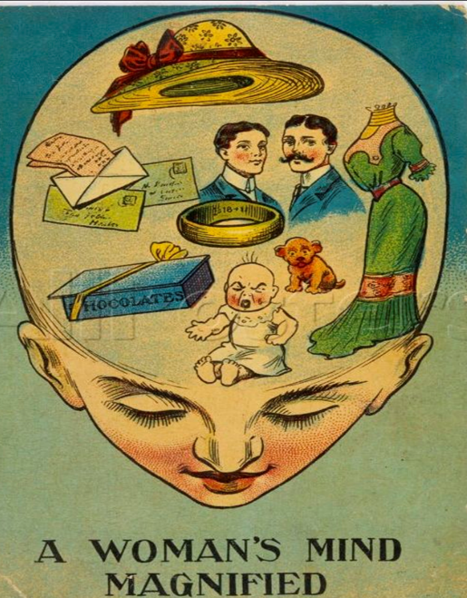
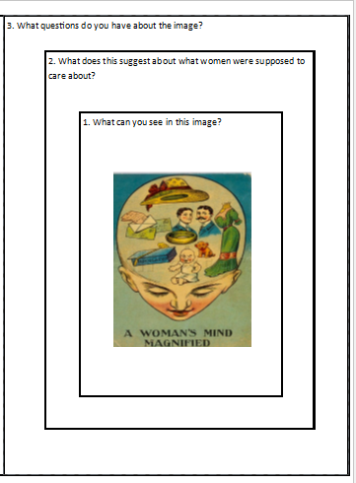
Dress

Check your understanding by answering the following questions.

- Social limitations meant that women…
Had little choice over how and where to spend their time, including staying in education | Had little choice over who ran the country | Had little chance to earn their own money and had to rely on men, such as their fathers or husbands
- Economic limitations meant that women…
Had little choice over how and where to spend their time, including staying in education | Had little choice over who ran the country | Had little chance to earn their own money and had to rely on men, such as their fathers or husbands
- Political limitations meant that women…
Had little choice over how and where to spend their time, including staying in education | Had little choice over who ran the country | Had little chance to earn their own money and had to rely on men, such as their fathers or husbands
- Women were not allowed to vote at the beginning of the 20th century, this is an example of women’s…
Political limitation | Economic limitation | Social Limitation
5. Only 11% of married women were employed in the early 1900s, this is an example of women’s…
Political limitation | Economic limitation | Social Limitation
6. Most men, and many women, believed a woman’s place was in the home, this is an example of women’s…
Political limitation | Economic limitation | Social Limitation

The lesson question is not just asking ‘if’ the position of women has improved. The question is asking how much the position of women has changed. This means we need to make a judgement about the extent (size) of change.
Extent of change
complete
massive
partial
small
tiny

large

Read through the information on the early 1900s and the position of women today.
- Judge the extent of change between the early 1900s and today (choosing a word from above)
- Explain your judgment of extent (E.g. why was it a large change rather than a small change?)

Earl 1900s | Today | Extent of change  (e.g. Tiny/partial/  massive) | Explanation of extent of change
Only 11% of Married women were employed | 72% of working age women are in work
Women were not allowed to vote | All women over 18 can now vote
Women were paid less for doing the same job | Men still earn on average 9.1% more than women.
Most women did not stay in school past the age of 11 | More girls stay on in full time education than boys (82% to 76%
Most universities did not accept women. | All universities accept women and women are 30% more likely to go to university
People thought women were too stupid and emotional to be involved in politics | There have been two female Prime Ministers in the 20th century, Margaret Thatcher and Theresa May

- Categorise each change into social, political or economic by writing S, P, or E in the right had column above.
- Then complete the statements below:

- The social position of women has changed _________ since the start of the 20th century.

- The economic position of women has changed __________ since the early 1900s.

- The political position of women has changed __________ since the start of the 20th century.
Challenge! Answer these questions in your books.
- In which category has the position of women improved the most? Why?

Everybody writes. Complete the sentences
Overall, the position of women has improved __________ in the 20th century.
For example___________________________________________________________________________ ________ _______________________________________________________________________________________________More specifically_________________________________________________________________________________ ______________________________________________________________________________________________ _______________________________________________________________________________________________Futhermore_____________________________________________________________________________________ _______________________________________________________________________________________________This meant that the position of women has improved __________ in the 20th century because______________ ___ _________________________________________________________________________________________________________________________________________________________________________________________________________________________________________________________________________________________________________________________________________________________________________________________________________________________________________________________________________________________________________________________________________________________________________________________________________________________________________________________________________________________
Key Terms/Concepts:
In my own words, being politically limited means…
In my own words, being socially limited means..
In my own words, being economically limited means…
In my own words, the ‘extent of change’ means…
The 20th century includes the years from _______ to ___________ .

2. Was World War I the biggest turning point for British Women in the 20th century?
Were women happy with their position in the early 1900s?
Last lesson we saw that there has been an improvement in the position of women in the 20th century. Now we need to work out when that change took place and judge when the biggest turning point for women was in the 20th century. A turning point is a moment of decisive and significant change. We will study a number of events and periods of the 20th century, one of which you will choose as the turning point in the positon of women in the 20th Century.
1939-1945
World War II
1970s
Equal Pay Act
1890s-1914
Suffragette and suffragists
1914-1918
World War I
1960s
Contraception & Women’s lib

As we have seen from our first two lessons, the position of women was very limited in the early 1900s compared to today. Whilst some women accepted their position, many wanted to challenge the limitations put on them and campaigned to improve their position and gain more rights for women. The right to vote was seen as particularly important because once women could vote, their opinions would start to influence politics, the government and the laws that were made.
1. Despite their differences, the Suffragists and Suffragettes main aim was…
Better working conditions for women | Female suffrage (the right for women to vote) | to improve education for women
2. The suffragists tactics could be described as…
Peaceful and legal | Militant and illegal | Peaceful but illegal
- The suffragettes tactics could be described as…
Peaceful and legal | Militant and illegal | Peaceful but illegal
- The suffragists used methods such as… (pick two)
Large-scale marches | petitions | Blowing up phone boxes
5. The suffragettes used methods such as..
Petitions | Chaining themselves to railings | Blowing up phone boxes
6. The suffragettes used these methods because they believed that the suffragist’s methods were…
Not working | Working well | Very good
7. The suffragettes used methods such as..
Petitions | Chaining themselves to railings | Blowing up phone boxes
8. One of the most famous suffragettes was Emily Davison, she was...
Killed setting off a bomb in the houses of parliament | Killed trying to attach a ‘votes for women’ scarf to the Queens Horse during the 1913 Epsom Derby | Killed trying to attach a ‘votes for women’ scarf to the Kings Horse during the 1913 Epsom Derby
8. The suffragettes and suffragists both stopped campaigning when…
Emily Davison died t trying to attach a ‘votes for women’ scarf to the Kings Horse during the 1913 Epsom Derby | World War I broke out and both groups agreed to put their efforts into helping to win the war. | It was clear that their campaigns were not working, so they gave up.

The BBC Bitesize website says that “The Great War (World War I) was a major turning point in the role of women in British society”. This suggests that it must have led to big changes and improvements in the position of women. Today, you will learn about what happened during the war and decide if you agree with the BBC Bitesize website.
Watch the video clip. The first time you watch the clip, watch and listen carefully. The second time you watch the clip. Answer the questions below.

In order to fight World War I the British army needed millions of…
Bullets, shells and guns – known as munitions | Horses and other animals, to carry heavy equipment | Tanks and other vehicles
Why women were suddenly wanted to join the workforce?
People realised women were strong | Lloyd George wanted equality for women | There were not enough workers because most working age men joined the army
What was different about the jobs that women did during the war?
They began to do jobs which only men had done | There wasn’t anything different about the jobs they did | They did jobs that replaced machines
Tick the type of jobs women did during the war.
Services (such as the fire service) | Farming | Metal work
Why was being a “munitionette” so dangerous?
It was too hard work for women | It involved toxic chemicals and the ammunition could explode | People disliked women working in the ammunition factories
Women were very successful at doing men’s jobs. For example, the time it took to make advanced weapons…
Decreased from a year to three weeks | Increased from 3 weeks to a year | Decreased twentyfold
Turning Point = decisive/significant change.

Turning Point = decisive/significant change.

Were the changes that took place permanent, or did the position of women go back to the way it was before the war?
When the war ended thousands of soldiers were demobilised, this meant that…
They kept their jobs as soldiers | They left the army and became civilians again | They were given their old jobs back
What did the Restoration of Pre-War Practices Act promise soldiers?
Their old jobs back | A house | The right to vote
What percentage of women were back in domestic service only a few years after World War I?
20% | 25% | 30%
Some jobs were now considered ‘women’s work’, these included…
Metal work | Farming | Clerks and Typists
The Sex Discrimination Removal Act (1919) made it easier for some women to get work but married women suffered because…
They were paid less than unmarried women | Marriage bars meant that they had to leave work | They were less respected than unmarried women
The Representation of the People 1918 gave the right to vote to…
All men and women over the age of 21 | All men over the age of 21 and women over the age of 30 with property | All men over the age of 21 but no women.
Was World War I really a turning point?
- Use evidence from last lesson and today to complete the table below. Give specific examples including facts, figures and dates.
- Label the evidence to show which category it belongs to: political, social, or economic.

Evidence for World War I being a turning point | Evidence against World War I being a turning Point

Overall, World War I was/was not really a turning point because__________________________________________ ____________________________________________________________________________________________________________________________________________________________________________________________________________________________________________________________________________________________________________________________________________________________________________________________
Challenge! Answer these questions in your books.
- In which category (social, political, economic) did the position of women improve the most because of World War I and in which category did it improve the least? Why?

3. Was World War I the biggest turning point for British Women in the 20th century?
How did the position of women change between 1940 and 1970?
World War II was similar to World War I because most working age men…
Stayed at home | Refused to fight | Joined the army
This meant that the jobs they left behind needed to be filled by
children | women | Young people
One difference between World War I and World War II was that women took on more roles in…
factories | The military | farming
However, women were still not allowed to…
fight | vote | Leave the home

Everybody writes. Complete the sentences

The WAAF
The Women's Auxiliary Air Force (WAAF) was formed in June 1939 and by 1943 there were 180,000 women in the WAAF.
To being with, members of the WAAF were given jobs as clerks, kitchen helpers and drivers, meaning the men who had done these jobs could go off and fight. However, more jobs became open to women as the war continued. Women in the WAAF were involved the interception of codes and ciphers, including at the Government Code and Cypher School at Bletchley Park. They were mechanics, engineers, electricians and fitters for aeroplanes. Many members of the WAAF worked in the radar control system as reporters and plotters, telling the British pilots where the enemy planes were. Their work was vital during the Battle of Britain and later in guiding night-fighter aeroplanes against German bombers.
One of the hardest jobs in the WAAF was the operation of balloons sites. This involved raising and lowering the barrage balloons, which were designed to deter enemy bombers. There were doubts over whether women would have the physical strength or stamina as the balloons were 66 feet long and 30 feet high when inflated. But the female volunteers were so successful that women eventually ran more than 1,000 barrage balloon sites throughout Britain.
One job that the women of the WAAF were not allowed to do was fly. However, as more male pilots were needed fight in the war, the Air Transport Auxiliary (ATA) was created. 150 women flew with the ATA during the war, including the famous pilot Amy Johnson. ATA duties included delivering new planes from factories to RAF units and flying planes back for repairs. All ATA pilots were civilians, as the RAF thought it unacceptable to have women pilots flying military aircraft.
The WAAF was short for the…
At its highest, the number of women in the WAAF was…
Initially, the jobs given to women included…
However, women started taking on other jobs, such as…
Many people thought that women would not be able to operate barrage plans, they thought this because…
Women proved this belief wrong, evidence for this is that…
Some women ended up flying planes as part of the ATA, this involved them…
However, female pilots were not allowed to…

Challenge! Answer these questions in your books.
- Which category, social, political, or economic, changed the most for women during World War II? Why?

Just like with World War I, however, we need to see if these changes lasted in order to judge whether World War II was really a turning point for women.

Watch the video clip. The first time you watch the clip, watch and listen carefully. The second time you watch the clip. Answer the questions below.

Why did the Ford car company say it did not employ women before World War II?
They were not strong enough | A man should earn enough to support his family | Women were too stupid to make cars
What does the film make clear about the wartime jobs women took on?
Women would keep their jobs after the war ended | Women would be paid the same as men | The jobs were temporary, whilst the men were away fighting
Why did the lady like crane driving?
Because it was easy | Because it was seen as a ‘man’s job’ | Because she got paid a lot.
What were women expected to do at the end of the war?
Leave their jobs | Stay in their jobs | Whatever they wanted to do
Why could the female crane driver not carry on her job?
She was not qualified | People wouldn’t employ a woman as a crane driver | She did not want to
What were women supposed to be hoping for?
Marriage, a husband, and a family | A job and financial independence | A better education
What skills were women taught at school?
Home marking, cooking, cleaning, baking | Mechanics, engineering and science | Farming, gardening,

How did access to contraception help women?
Watch the video clip. The first time you watch the clip, watch and listen carefully. The second time you watch the clip. Answer the questions below.

How many children did Queen Victoria have?
8 | 9 | 10
What proportion of women died in childbirth around 1900?
1 in 20 | 1 in 15 | 1 in 10
Having large families meant that poor women especially were tied…
To their parents | To their jobs | To the home
In 1921 contraception was available to…
Married women | All women | Women over 30
What was invented in 1961 that changed contraception for women?
The cup | condoms | The pill
This form of contraception gave women…
the choice of when to get married | the choice of when to have children | no choice about marriage or children
What was the alternative before this?
There were no alternatives | Back Street Abortions | Going to hospital
Abortion was legalised because to prevent
pregnant women dying (maternal death) | People making money from pregnant women | Women having too many children
Abortion was legalised in….
1967 | 1968 | 1969

Everybody writes. Complete the sentences

- How the contraceptive Pill changed Britain

The contraceptive pill has been called the ‘greatest scientific invention’ of the 20th Century. It was invented at a moment of social and political upheaval (change). In 1961, women often married at an early age, and most women were expected to stay at home and raise their expanding family while men went out to work. Contraceptives that prevented pregnancy, such as condoms, were mainly available to men, and most did not use them. This meant women had little choice over if and when they wanted to start a family. The pill changed this. Nowadays, women can choose if and when to have children, to stay in further education and chose their career on their own terms. By being able to choose when and if to have children, women were able to prioritise going to university and their careers, giving them greater chances of higher-skilled jobs and promotions, resulting in many women earning more money.

The pill has been described as ‘the greatest scientific invention’ of the 20th century, in other words…
Expectations of women in 1961 were still mainly the same as they had been for the 1st half of the 20th century
because…
The amount of control women had over their own bodies was limited because…
The impact the pill had on the amount of choice women had was huge because…

"I don't think people thought it would be as revolutionary as it was," says Dame Valerie Beral, a professor of at Oxford University, who has spent the last 40 years researching the pill. She added that for women's health, it was the "most important thing in the latter half of the century - no question about it".

Dame Valerie Beral described the pill as ‘revolutionary’, in other words…
She said this because the pill…

Which event was more of a turning point for women, World War II or the invention of the contraceptive pill? Why?
Overall, ___________________ was more of a turning point because______________________________________ ____________________________________________________________________________________________________________________________________________________________________________________________________________________________________________________________________________________________________________________________________________________________________________________________
______________ was less of a turning point because ____________________________________________________
_____________________________________________________________________________________________________________________________________________________________________________________________________________________________________________________________________________________________

Challenge! Answer these questions in your books.
- Which category, social, political, or economic, did the invention of the pill change the most for women? Why?

4. Was World War I the biggest turning point for British Women in the 20th century?
What did women’s lib’ achieve?
Watch the video clip. The first time you watch the clip, watch and listen carefully. The second time you watch the clip. Answer the questions below.

What changed in the 1960s to improve the economic position of women?
A boom large (increase) in the number of jobs for single women | A small increase in the number of jobs for single women | A decrease in the number of jobs available to single women
How many women were at university in 1962?
Over 25,000 | Over 26,000 | Over 27,000
What impact did this have on women?
It gave women greater expectations | It made women want to be wives and mothers | It had no impact on women
What was the name of the campaign for women’s rights in the 1960s and 70s?
Women’s Freedom | Women’s movement | Women’s Lib (short for liberation)
What was the key demand of their movement?
Votes for women | Equal pay and equal opportunities | Education for women

- Everybody writes. Complete the sentences
- Read about each act and decide if it improved the social, political, and/or economic position of women.
- Explain your choice. (Hint: Did it give women more freedom/independence/choice? Did it give women more power and control? Did it make women more equal with men in society?)

- 1967—Abortion Law Reform Act
Abortion becomes legal up to 28 weeks of pregnancy.

This improved the Social/Political/Economic position of women because _______________________________
___________________________________________________________________________________________
___________________________________________________________________________________________

- 1967– Contraceptive pill available from family planning clinics
Women, regardless of whether they are married can get the pill.

This improved the Social/Political/Economic position of women because _______________________________
___________________________________________________________________________________________
___________________________________________________________________________________________

- 1970- Equal Pay Act
This law made it illegal to pay women less for doing the same job as a man

This improved the Social/Political/Economic position of women because _______________________________
___________________________________________________________________________________________
___________________________________________________________________________________________

- 1975– Sex Discrimination Act
It is illegal for employers to discriminate against women at work due to their gender.

This improved the Social/Political/Economic position of women because _______________________________
___________________________________________________________________________________________
___________________________________________________________________________________________

- 1975 Employment Protection Act
Women were given the right to 24 weeks of leave from work when pregnant/ having given birth. It is made illegal to sack someone for being pregnant.

This improved the Social/Political/Economic position of women because _______________________________
___________________________________________________________________________________________
___________________________________________________________________________________________

- 1979 Margaret Thatcher becomes the first female Prime Minister
Margaret Thatcher is elected to be the Prime Minister in the 1979 general election
This improved the Social/Political/Economic position of women because _______________________________
___________________________________________________________________________________________
___________________________________________________________________________________________

- 1980 Monetary Control Act
Women were able to get a loan, or credit, in their own name for the first time rather than having their husband or father get it for them.

This improved the Social/Political/Economic position of women because _______________________________
___________________________________________________________________________________________
___________________________________________________________________________________________

Challenge! Answer these questions in your books.
- Which of these changes to the law improved the position of women the most? Why did it help women more than the other changes?

- Did the laws change everyone’s attitudes towards women?

“Despite the 1970 Equal Pay Act, a gender pay gap still exists today. In some professions and at some levels women’s wages are equal to men’s. But on average women are still paid less than men to do the same jobs. In the 1970s women, on average, were paid about 50% of men’s wages in manufacturing and the professions.”
Quote from the British Library Website, in an article called ‘Sisterhood and After’

What can you infer from the article about the position of women in Britain today?
I can infer…
A detail that supports this is…
This suggests that the legal changes led to no/a slight/a partial/a large/a complete improvement in the
position of women because…
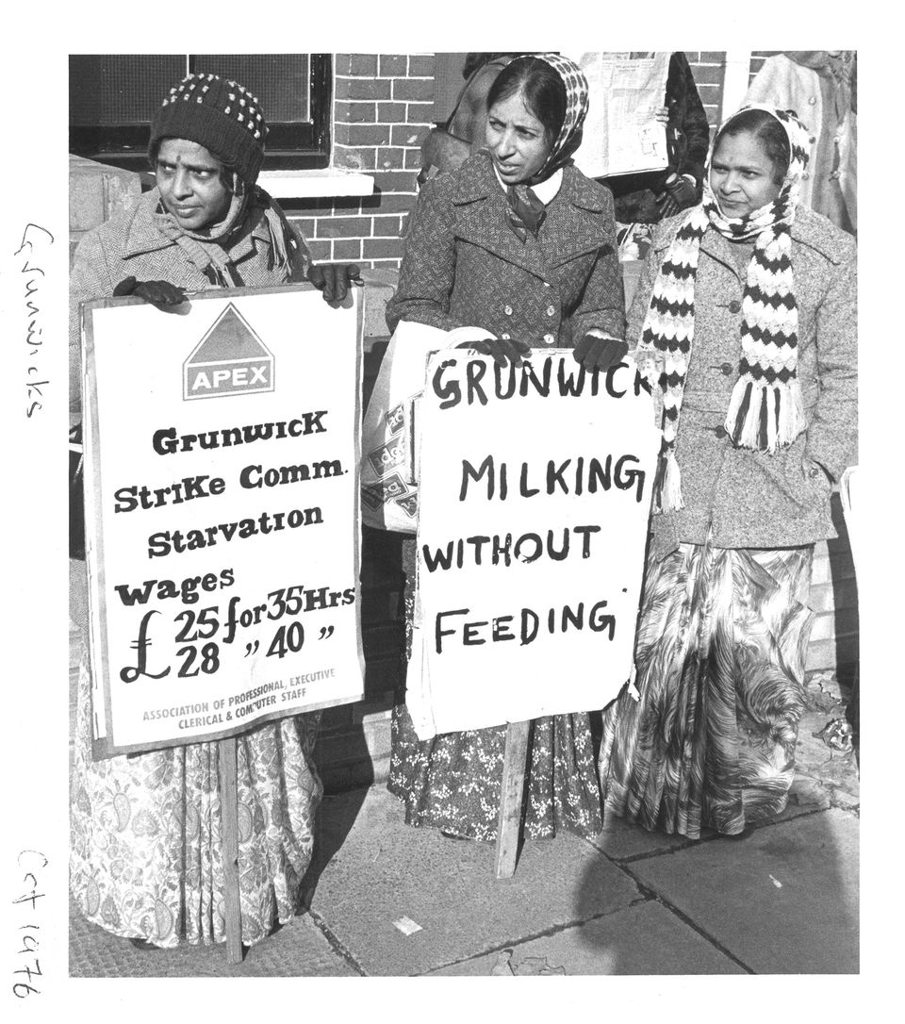
This picture shows the Grunwick Strike, which took place from August 1976 to July 1978. The workers at the Grunwick Film Processing Laboratory were mostly Asian women, who were paid incredibly low wages and worked long hours in terrible conditions. In order to improve their conditions, they went on strike. The strike was led by Jayaben Desai, and after her and her co-workers spent a few months picketing outside the Grunwick factory, the cause of the Grunwick strikers was taken up by the wider trade union movement (organisations that support the rights of workers) of the day. By June 1977 there were marches in support of the Grunwick strikers, and on some days more than 20,000 people packed themselves into the narrow lanes near Dollis Hill tube station.

What can you infer from the article about the position of women in Britain in the 1970s?
I can infer…
A detail that supports this is…
This suggests that the legal changes that had taken place led to no/a slight/a partial/a large/a complete
improvement in the position of women because…

Turning Point = a decisive/significant moment of change
Was the Women’s liberation campaign and the legal changes they achieved a turning point for women?
Complete the checklist giving examples of the changes that took place because of Women’s lib
 | Turning Point Checklist
Type of Change: | Political Change | Social Change | Economic Change
Extent of Change: | None/Tiny/Small/Partial/  Large/massive/complete | None/Tiny/Small/Partial/  Large/massive/complete | None/Tiny/Small/Partial/  Large/massive/complete
Evidence:

Overall, I think that Women’s liberation was/was not a turning point in the position of women in the 20th century because_______________________________________________________________ _______________________ ______________________________________________________________________________________________
_______________________________________________________________________________________________
______________________________________________________________________________________________________________________________________________________

Key Terms/Concepts:
Contraception refers to…
In my own words, ‘back street’ abortions were…

Learning Ladder
I can…. | Prove it!
Identify events key features of events that have affected the position of women | 1. List 3 ways in which women were limited in the early 1900s  2. List 3 ways in which the position of women is different today than it was in the 1900s.  3. List 3 changes that took place during World War I  4. List 3 changes that took place after World War I  5. List 3 changes took place during or after World War II  6. List 2 changes that improved women’s health in the 1960s  7. List 4 laws that changed as a result of Women’s lib
Describe events relating to the position of women.  Say a lot about a little, try and include at least three details.  - For example…More specifically…. This meant that…  Women were limited economically in the early 1900s. For example, many women did not have jobs. More specifically, only 11% of married women were employed, and even women who did work were paid low wages. This meant that women earnt very little money of their own and, as a result, had very little financial independence. Most women had to rely on their husbands or fathers to support them. | 1.. Describe 4 ways in which women were limited in the early 1900s  2. Describe 3 ways in which the position of women is different today than it was in the 1900s.  3. Describe changes that took place during World War I  4. Describe 3 changes that took place after World War I  5. Describe 3 3 changes took place during or after World War II  6. Describe 2 changes that improved women’s health in the 1960s  7. Describe 4 laws that changed as a result of Women’s lib
Explain the rate, nature and extent of changes of the position of women  Use the change and continuity words.  - The rate/nature/extent of this change was … because…  The position of women today has changed massively since the early 1900s. The nature of this change has been social, political and economic, because women have far more choice over how to spend their time and when and if to have a family, have a much larger say in how the country is run, and have a lot more financial independence with greater career prospects. | For each of the questions 1-7 above, identify and explain the rate, nature and extent of change
Evaluate an historian’s interpretation of the Norman Conquest  - Summarise you overall opinion about the BBC’s interpretation of World War I  - Summarise the evidence that agrees with The BBC  - Summarise the evidence that disagrees with The BBC  - Explain your overall opinion of the BBC’s interpretation | Overall, how far do you agree with the BBC that “The Great War (World War I) was a major turning point in the role of women in British society?”  Overall I agree with the BBC’s interpretation that World War I was a major turning point to a large/certain/small extent.  On the one hand, the BBC is right to argue that World War I improved the position of women, such as…  However, this ignores the fact that…  Therefore, I agree to a large/certain/small extent because…

Glossary of Academic Vocabulary
Word | Definition | Because | But | So
Political
Social
Economic | To do with money, work, jobs and finance | Women were limited economically in the early 1900s because most women did not work and relied on their husbands for money | The economic position of women improved during World War I as they took on men’s work but this soon changed back when men took over their old jobs again after the war.
Continue in the back of your exercise book

