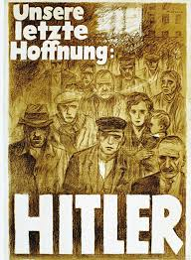
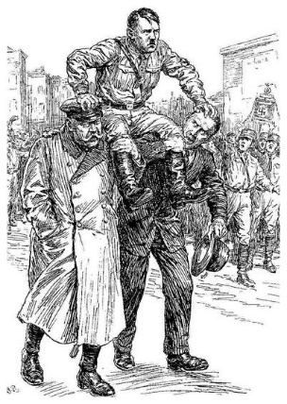
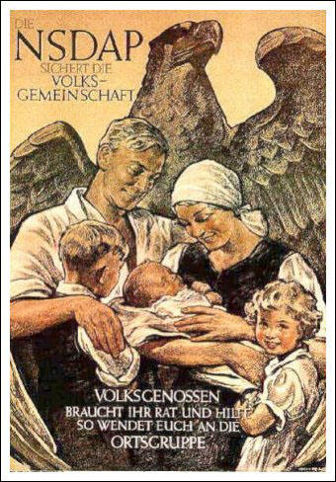
Weimar and Nazi Germany 1919-1939: Name:_________________________
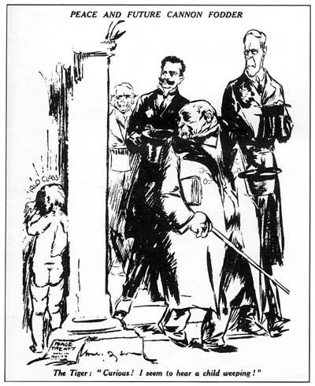
Contents
Contents |  | Tick when complete
Topic 1  The Weimar Republic 1919-1929 | - Creation of the Weimar Republic 1918-1919 p2-3  - Threats to the Weimar Republic 1919-23 p4  - The Treaty of Versailles p5-6  - Why did German’s believe in the ‘stab in the back myth’? p6-7  - What Caused Hyperinflation in 1923? 8-9  - Why did the economy recover 1924-29? p10-11  - Why was there a Golden Age 1924-29? p12-13  - Knowledge and Exam Question Checklist p14
Topic 2  The Nazi Party 1919-1932 | - Hitler’s Early Life p15  - Early Features of the Nazi Party 1919-23 p15-16  - Causes and consequences of The Munich Putsch 1923 p17-19  - Why did Support for the Nazis increase dramatically from 1929-32? p20-23  - Describe the events that Led to Hitler becoming Chancellor in January 1933 p24-25  - Describe the events that Led to Hitler becoming Fuhrer in August 1934 p26-27  - Knowledge and Exam Questions Checklist p26- 27
Topic 3  The Nazi Police State 1933-39 | - How did the Nazis create a ‘Police State’ in order to control people’s opinions? p28-30  - Describe how Propaganda and Censorship were used to control people’s opinions as part of the Police State p30-33  - Describe opposition and resistance to the Nazis p33-36  - Knowledge and Exam Questions Checklist p36-37
Topic 4  Life in Nazi Germany 1933-1939 | - What Were Nazi Polices towards Women? p38-41  - What Were Nazi Polices towards Young Germans? p41-44  - What Were Polices towards Minorities? p45-48  - How did the Nazi’s try to improve the economy 1933-39? p48-51  - Knowledge and Exam Questions Checklist p51-51
Quizzes | - Topic 1 p52  - Topic 2 p53  - Topic 3 p54  - Topic 4 p55
Learning Ladders | - 16 mark questions p56  - 12 mark questions p57  - 8 mark source utility p58  - 4 mark interpretations, explain the difference p 59  - 4 mark interpretations explain why they are different using Sources B and C p60  - 4 mark give two things you can infer p61

TOPIC 1: The Weimar Republic 1918-29
The Creation of the Weimar Republic
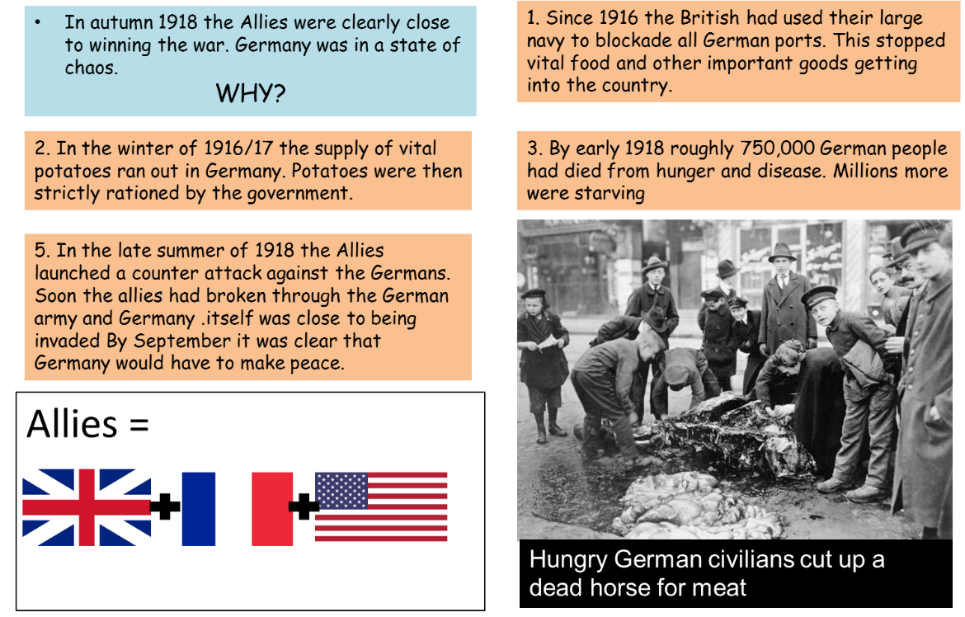

4. In autumn 1918 The Allies offered Germany peace, but insisted that Germany should become more DEMCORACTIC.
- But the Kaiser refused. Before 1914 the Kaiser had ruled by himself with the support of the army. This is known as being a dictator
- This led sailors in northern Germany to MUTINY and take over the town of Kiel.

5. Rebellion spread throughout Germany. In November Germany was forced to drop out of the World War I.
- Kaiser Wilhelm II abdicated and fled the country.
- A new Republic was declared. In January 1919, elections were held for a new Reichstag and in February 1919, in the town of Weimar, a new government was agreed.
- Freidrich Ebert was elected President of the new Weimar Republic.

End of World War I
When did World War I end?
The end of the war was called an armistice, in other words…

Who was the Kaiser?
He was forced to abdicate at the end of the war, in other words…

WEIMAR CONSTITUTION
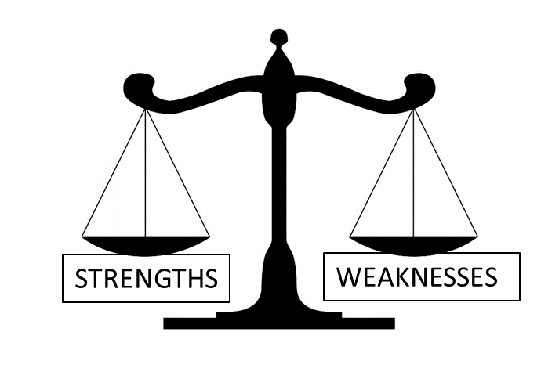
1.Weimar Republic was very democratic. All men and women above the age of 20 could vote. In Britain in 1918 men over 21and women over 30 could vote.

2. Proportional voting led to 28 parties. This made it impossible for one party to control the Reichstag This meant coalition government. With at least two parties involved. This led to lots of disagreements During 1919-33, there were twenty separate coalition governments and the longest government lasted only two years.
3. Many government officials – especially judges – supported the Kaiser and wanted to destroy the Weimar Government.
4. The Army’s leaders wanted the Kaiser to return and did not support the Weimar Republic.
5. Article 48 (article means law) of the constitution gave the President the power to rule by themselves with the army in ‘times of emergency’
TASK: Match the description of each Strength/Weakmess to it’s exmplanation by writing a number in the box.
3. | This meant judges did not punish rebellions against Weimar e.g. the Kapp Putsch 1920 – this encouraged more rebellions!
 | This meant every German citizen chose who was elected to the Reichstag and who formed the government in the Weimar Republic
 | This meant if people were scared enough, whoever was President could become a dictator legally!
 | This meant the Government struggled to put down rebellions. In the Kapp Putsch the army was even on the side of the rebels!
 | This meant political chaos and many lost faith in the new democratic system. They wanted a different type of government.
Weaknesses of the Weimar Constitution
- Put these events in the correct order. Number the boxes from 1-7
 | In autumn 1918 The Allies offered Germany peace, but insisted that Germany should become more DEMCORACTIC. |  | A new Republic was declared. In January 1919, elections were held for a new Reichstag and in February 1919, in the town of Weimar, a new government was agreed.
 | On November 9th 1918 Kaiser Wilhelm II abdicated and fled the country. |  | In the late summer of 1918, the Allies launched a counter attack against the Germans. By September, it was clear that Germany would have to make peace.
 | Freidrich Ebert was elected President of the new Weimar Republic. |  | The Kaiser refused democracy. This led sailors in northern Germany to MUTINY and take over the town of Kiel.
 | Since 1916, the British had used their large navy to blockade all German ports. This stopped vital food and other important goods getting into the country.

Weimar Government
Why was the new Weimar constitution, republic and government called ‘Weimar’?

The Weimar constitution had Proportional Voting, in other words…

This was weakness because it meant….

The Weimar constitution had no support from judges, this was a weakness because it meant…

The Weimar constitution had no support from the army, this was a weakness because it meant…

The Weimar constitution had Article 48, in other words…

Threats to the Weimar Republic 1919-23
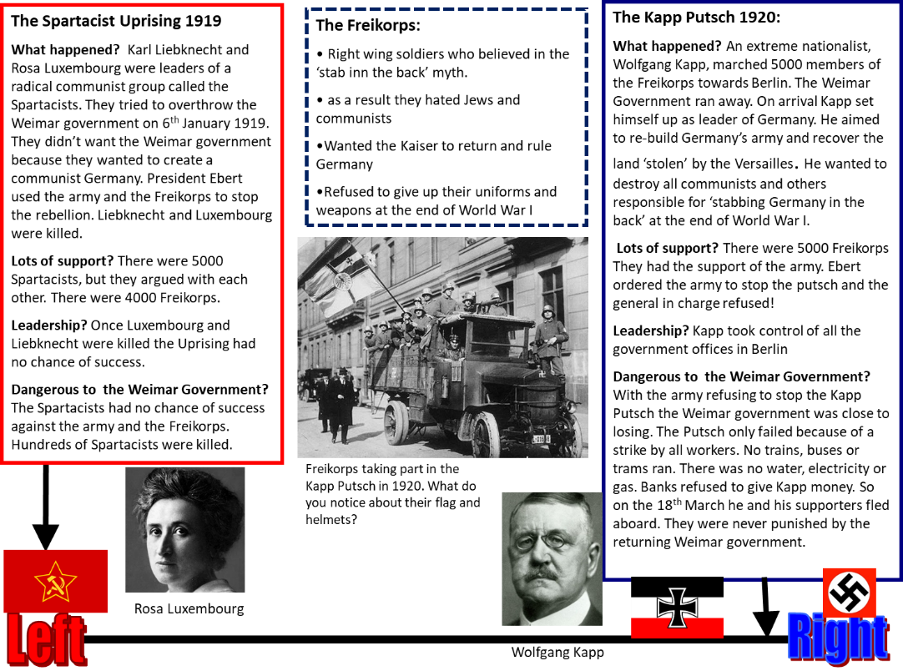

Spartacist Uprising
When was the Spartacist Uprising? (month and year)
Who were the leaders of the Spartacist Uprising?
What political party were they linked with?
Is this a left wing or right wing group?
What colour is associated with this party/political belief?
What did the Spartacists want?

Why did the Saptacist Uprising fail?

Kapp Putsch
When was the Kapp Putsch?
What does putsch mean?
Who led the Kapp Putsch
Was this a left wing or right wing putsch?
What flag and symbols are associated with this putsch?
What did the Kapp Putsch want to achieve?

Why did it succeed in the short term?

Why did it fail after a few days?

Which was the greater threat, Saptacist Uprising or the Kapp Putsch? Why?

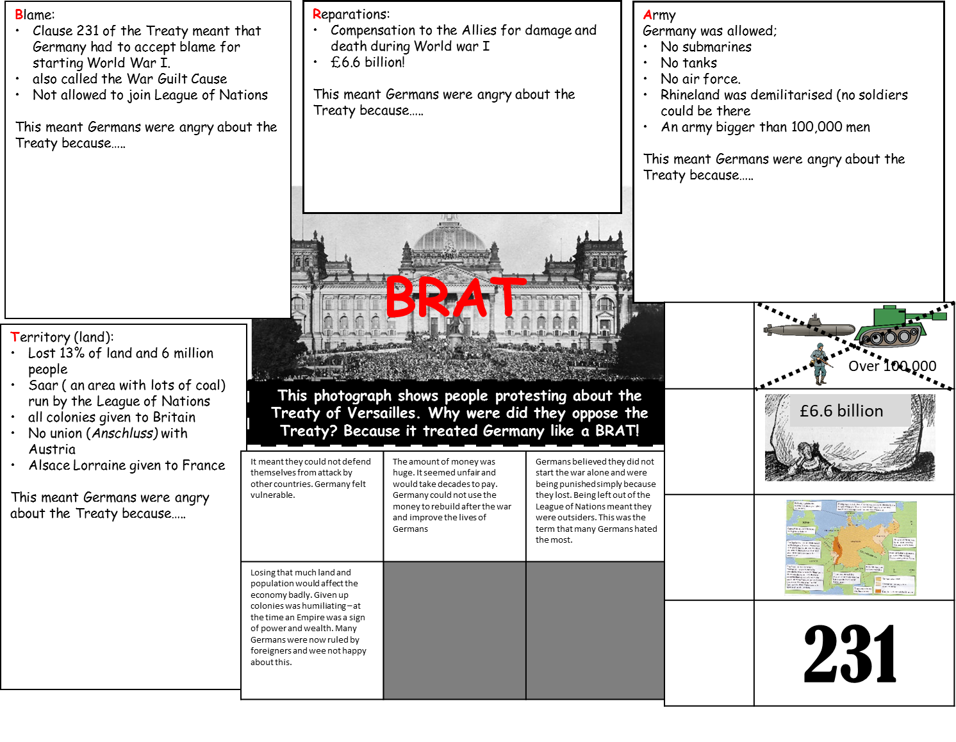
Why did Germans hate the Treaty of Versailles?
Represents Territory

Treaty of Versailles
When was the Traety of Versailles signed? (month and date)
What were four main terms of the Treaty: Describe each term with precise examples
B =
Germany had to admit…..
Part of the Treaty that enforced this was C____________ 2_______
Also known as the W_ ________ G__________ clause
R =
£ ____________________
To pay the Allies c_____________________ for……..
A. =
1.

2.

3.

T= territory
- Lost 13% of land and 6 million people
•Saar ( an area with lots of coal) run by the League of Nations
•all colonies given to Britain
•No union (Anschluss) with Austria
•Alsace Lorraine given to France

Why did each of these terms make Germany angry?:
Blame made Germany angry because…

Reparations made Germany angry because…

Limits on their army made Germany angry because…

Losing territory made Germany angry because…

The Germans were also angry because they saw the treaty as a diktat, in other words…

Why did German’s believe in the ‘stab in the back myth’?
For most Germans the treaty was humiliating because Clause 231 made them take the blame for starting the war. It also made lives much harder for Germans because Germany had to pay £6.6 billion in reparations. Germany had not even had a say in terms of the treaty. It was a Diktat, a dictated peace.

A scapegoat – someone to blame for the Treaty and it’s problems- was needed. Freidrich Ebert and the Weimar Government were perfect. Germans began to call them the ‘November Criminals’ (the armistice was agreed in November)
Soldiers returned home and spread the myth that Germany could have won the war if politicians like Ebert had not ‘stabbed Germany in the back’. Many Germans also blamed a Jews and communists for the armistice. This myth spread amongst German civilians. They called it Dolchstoss.

The Weimar Government became very unpopular amongst soldiers, the middle class and right wing groups like the Nazis. More and more people began to believe that Weimar Government politicians had ‘stabbed Germany in the back’ by ending the war. They were also to blame for Germany's problems because they signed the Treaty of Versailles.

In addition to Clause 231 and reparations, the treaty was humiliating for Germany because in was a Diktat.
This means…..

Why were Ebert and the Weimar Government called the November Criminals?

What does Dolchstoss mean?

Apart from politicians who else was blamed?

Who spread the myth
The Weimar Government was unpopular because some Germans blamed them for two bad things that had happened to Germany;
1.

2.
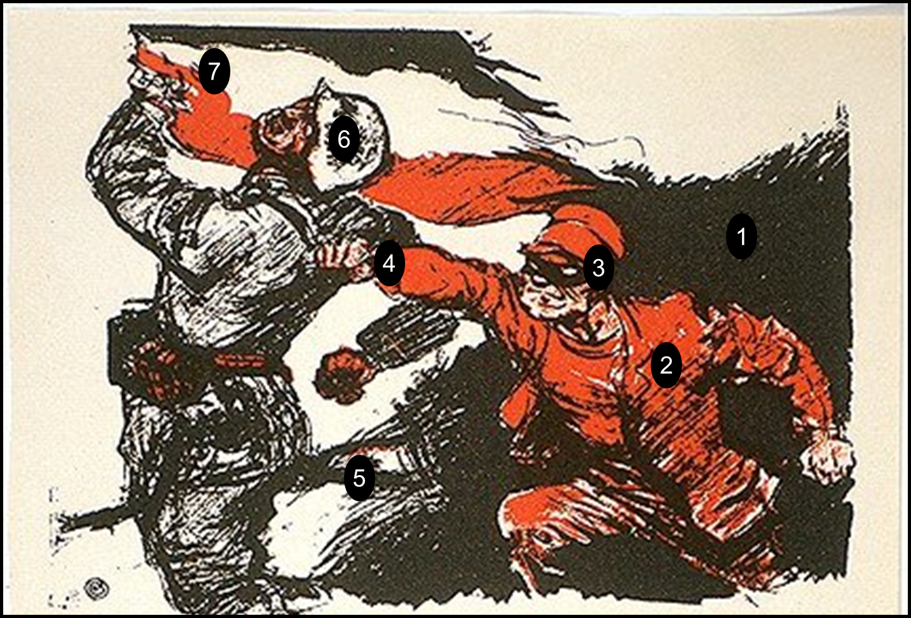
This source is useful because I can infer that some Germans thought that the army had been ‘stabbed in the back’ by communist ‘November Criminals’. The details in the source that tell me this are………
1.

2.

3.
This does not surprise me because I know that……..
More specifically….
The purpose the source is to criticise the Weimar politicians for betraying the German Army. This purpose is useful for an enquiry into reactions to Germany losing the war because it reveals that…

What caused hyperinflation in November 1923?
TASK: Match the part of the Hyperinflation story to it’s picture (pictures on the next page)

Part 1
- In 1919 The Treaty of Versailles said Germany had to pay reparations to the Allies.
- In 1921 the amount of reparations was set at £6.6 billion.
- This money was to be paid in instalments each year.
Part 2
- By 1922 the Germans announced they could not afford to pay reparations
- The French refused to believe this. They invaded the Ruhr industrial region to take what they were owed by force in the form of coal steel and other goods
- The invasion began on 9th January 1923.
Part 3
- to stop the French taking coal, steel and other valuable goods from Germany the Weimar Government told the workers in the Ruhr to go on strike.
- The striking workers were not earning money but still needed money to survive. The Weimar government solved this problem by printing more money
- When more and more money is printed the money loses its worth. The value goes down and the prices of goods increase very quickly. This is hyperinflation
Part 4
- Faced with economic collapse, the government ended the strike in September 1923.
- But this was an unpopular move. Many Germans wanted it to continue.
- In Munich the Nazi Party, led by Hitler decided to seize control of the large area of Bavaria. On 8th November 1923 he marched 2000 of his men to Munich. Many came from other areas on the backs of lorries.
- This attempted rebellion became known as the Munich Putsch. It failed; Hitler was arrested, put on trial and sent to prison.

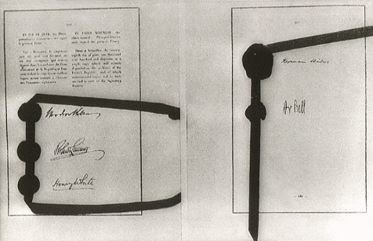
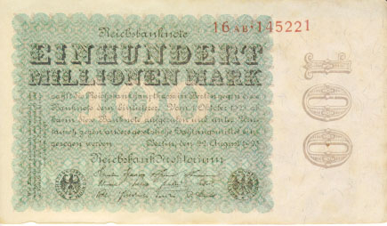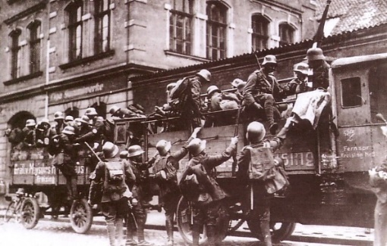
This represents Part 1 the Treaty of Versailles
TASK: Read the text below and fill the gaps using the words in the box at the bottom of the page
1. The origin of hyperinflation was in 1919 when the Treaty of Versailles said reparations had to be paid. In 1921 the amount was set at _________________
By 1922 the Germans said they couldn’t pay. The French invaded the __________ area of Germany to take __________ and __________as payment.
2. To stop the French, the Weimar government ordered the German workers to go on ___________This stopped the French taking coal and steel but as the workers were on strike they weren’t earning any ____________. So the workers could stay on strike but also have money to live on the Weimar Government _____________ more money. This caused prices to __________ out of control. Money became ___________. This was hyperinflation
3. Faced with economic collapse The Weimar government called off the strike but this was unpopular. In the city of Munich the _________Party led by Adolf __________ thought they could take control through rebellion because the Weimar government was so unpopular. They led a ____________ on 9th November 1923 which failed. Hitler was imprisoned and 16 Nazis were killed.

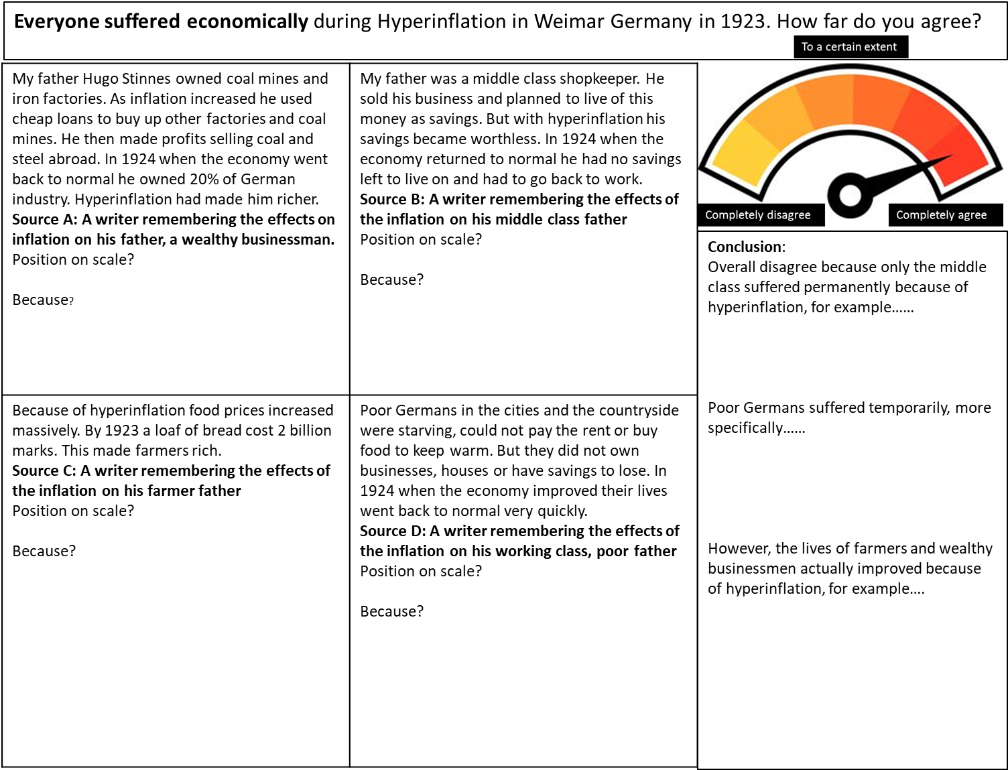
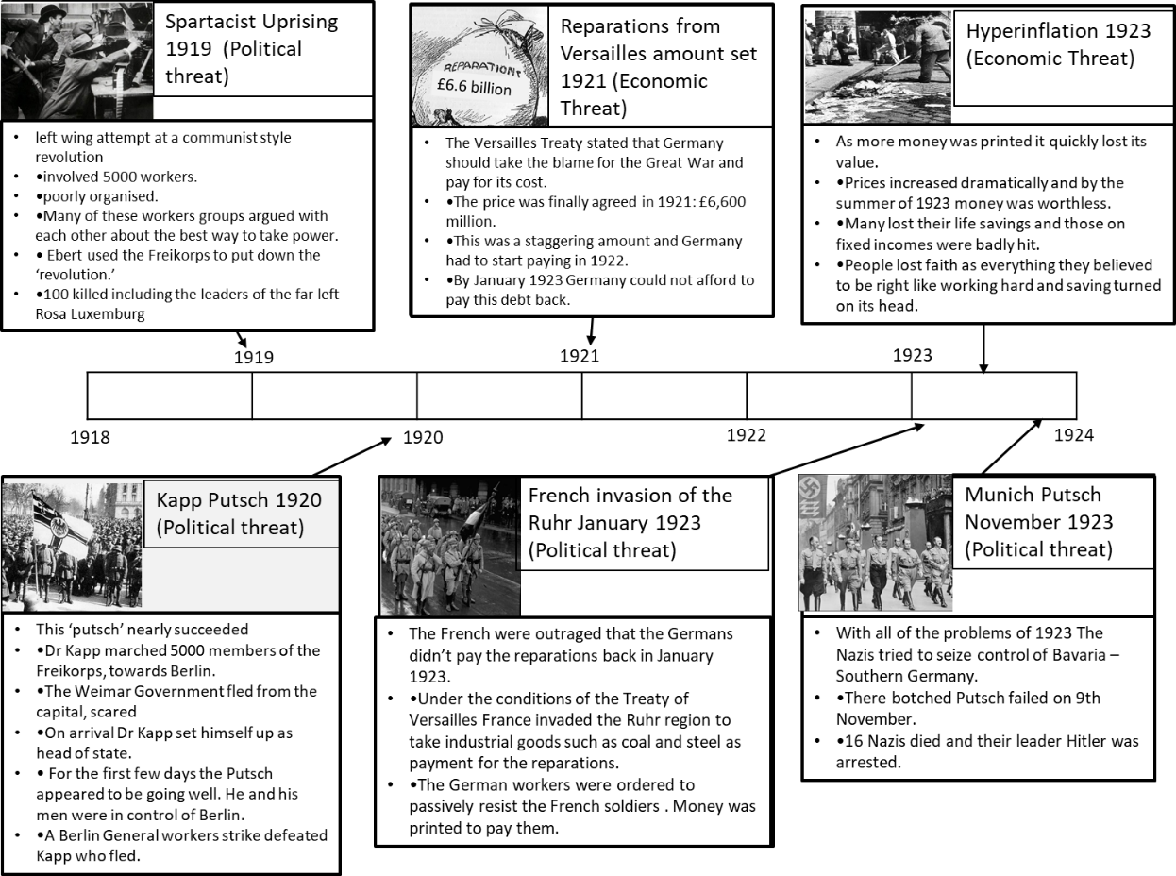
The source suggests that Hugo Stinnes did not suffer at all, in fact he did well out of hyperinflation because he was able to use cheap loans to buy businesses. He became richer because of hyperinflation
Completely disagrees
Economic Recovery and Golden Age
Cause of Recovery | Example of Economic or political recovery?
The Dawes Plan 1924  - Stresemann realised Germany could no afford reparations.  - He persuaded the French British and USA to reduce the amount of reparations payments to 2.5 billion marks a year  - He persuaded to the USA to loan Germany $3 billion dollars to improve their economy | Economic
The Retenmark 1924
- Hyperinflation had made the Reichsmark worthless.
- Stresemann introduced a new currency called the Retenmark
- It’s value was linked to amount of gold owned by the government
The Locarno Pact 1925
- Germany agreed to keep the existing borders with Belgium and France as created in the Treaty of Versailles.
The League of Nations 1926
- Germany was allowed to join the League of Nations in 1926
- They had been excluded from it by the Treaty of Versailles.
- The League of nations was like the United Nations organisation we have today.
The Kellogg-Briand Pact 1928
- This was a treaty signed by 64 countries.
- They all agreed to solve problems ‘by peaceful means’ and not by war.
The Young Plan 1929
- Reduced the reparations bill from £6.6 billion to £1.8 billion pounds
- Germany was given an extra 59 years to make the payments. The final payment was due in 1988
Explanation or recovery
Because the new currency was linked to the amount of gold owned by the government people began to have confidence in the currency. This ended hyperinflation.
The Rentenmark
Because the Weimar Government agreed to the territory changes made in the Treaty of Versailles, this meant that Germany was co-operating with other countries. This was a big step forward from the end of the war.
This reduced the amount of reparations that needed to be paid each year and gave a huge amount of money in loans. This meant Germany could afford reparation repayments and recover economically.
This meant another war was less likely. Germany had joined 64 countries in an international agreement which proved that relations with other countries were improving even further.
Because Germany had longer to pay reparations and had to pay less overall it meant the payments were more affordable and Germany could concentrate spending money on their own economy.
Because Germany was now part of an international organisation it meant the German people believed they were once more a ‘great power’. An important country that other countries listened to.

Answer these questions: Economic and Political Recovery 1924-1929
- What was the name of the man responsible for the recovery?
- Put these causes of recovery in chronological order. Number them 1-6
 | The Dawes Plan |  | The Locarno Pact
 | The Kellogg-Briand Pact |  | The Retenmark
 | The Young Plan |  | The League of Nations
3. Label each description with the correct cause of recovery
Stresemann introduced a new currency. It’s value was linked to amount of gold owned by the government | He persuaded the French British and USA to reduce the amount of reparations payments to 2.5 billion marks a year. He persuaded to the USA to loan Germany $3 billion dollars to improve their economy
Reduced the total reparations bill from £6.6 billion to £1.8 billion pounds. Germany was given an extra 59 years to make the payments. | Germany was allowed to join an international organisation in 1926. They had been excluded from it by the Treaty of Versailles.
This was a treaty signed by 64 countries. They all agreed to solve problems ‘by peaceful means’ and not by war. | Germany agreed to keep the existing borders with Belgium and France as created in the Treaty of Versailles
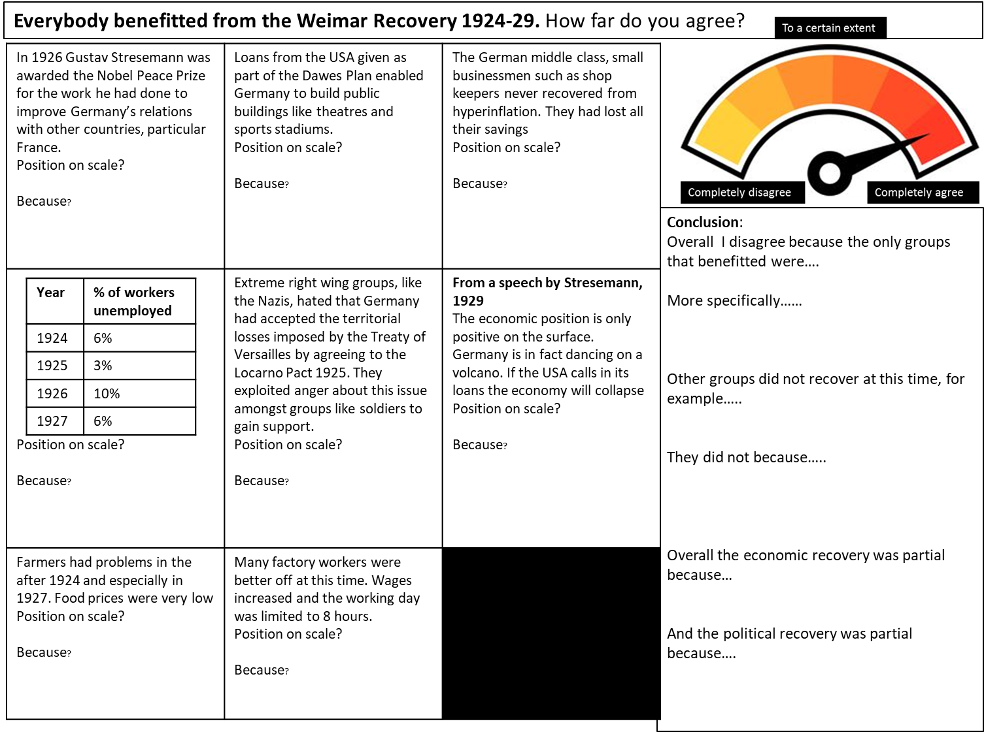
Stresemann won the Nobel prise, proving how Germany’s relations with other countries had improved
Agrees

Why was there a Golden Age 1924-29
Cause of Golden Age | Example of culture, living standards or role of women
Housing  - Between 1924 and 1931 two million new homes were built  - Homelessness reduced by 60%  - The Government asking Bauhaus architects to design the new housing estates. This housing was modern and comfortable. | Living standards
Cinema
- Film was a new medium in the 1920s.
- Fritz Lang produced a film called Metropolis, it’s special effects were so advanced it is still studied by students today.
- Marlene Dietrich became one of the most popular film stars in the world. Her most famous film was Blue Angel
Art.
- George Grosz and Otto Dix became world famous modern artists
- They painted pictures about ordinary people's lives, anti-war pictures and pictures that criticised the rich. Previously most art had been religious, celebrating war and about rich people.
Employment
- Factory workers wages increased in this period
- Many women went out to work for the first time. By 1933 there were 3000 female German doctors.
- By 1932 there were 32 female members of the Reichstag
- Before World War I women were expected to stay at home, look after children and e housewives.
Leisure
- Women enjoyed much greater social freedom. They went out to clubs like the El Dorado club, drank alcohol and smoked in public.
- Fashions for women because less traditional, they wore shorter skirts, more colourful clothes, make up and had short hair.
- Many more ordinary people went to the cinema, theatre and art galleries than before the war.
Explanation of why this was a Golden Age
Because wages increased and more women went out to work, this meant many people enjoyed a higher standard of living and women had more freedom to choose the career they wanted.
Because new architects like the Bauhaus and the government built thousands of new homes this meant the quality of housing for many Germans improved
Because women enjoyed more social freedom and more people went out to the theatre and cinema this meant the social lives of many people improved.
Because German cinema produced famous film stars and popular films this meant Weimar Germany was seen as having a having highly advanced culture
Because many famous modern artists were German and were changing the subject matter of paintings Weimar Germany was seen as having highly developed culture
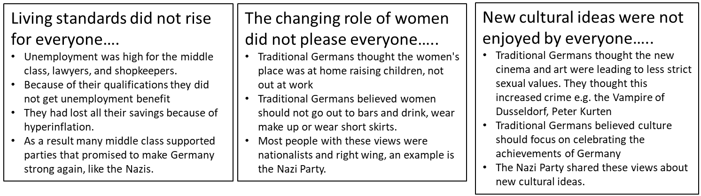
Task: Complete the table above and then the questions below:

Give a precise example of how it was a Golden Age for cinema
Give a precise example of how it was a Golden Age for architecture

.Give a precise example of how it was a Golden Age for art
Give a precise example of how it was a Golden Age for women in terms of freedom of choice.
Which evil criminal’s crimes did the Nazis blame on ‘immoral’ Golden Age changes?
Why was this ridiculous?
Why did traditional Germans not think it was Golden Age?

KNOWLEDGE Tasks: Topic 1 | Tick when complete
Topic 1 Treaty of Versailles and early threats to Weimar 1919-23 ; Look, cover write check on blank knowledge organiser
Topic 1 Treaty of Versailles and early threats to Weimar 1919- punishment multiple choice quiz (repeat till 100% correct)
Topic 1 Treaty of Versailles and early threats to Weimar 1919-; free recall quiz (repeat till 100% correct)

12 marks | Tick when complete
Explain why Germans were angered by the terms of the Treaty of Versailles:
• War Guilt
• Diktat
You must use information of your own (reparations, army, land)
Explain why the Weimar Constitution was weak.
You may use the following in your answer:
• Article 48
• the army
You must use information of your own.
Explain why the German economy suffered before 1924
• French invasion of the Ruhr
• hyperinflation
You must also use information of your own. (reparations
Explain why German economy recovered after 1924:
• Dawes Plan
• Rentenmark
You must also use information of your own.
Explain why some Germans experienced a Golden Age 1924-29
- Changing role of women
- cinema
Explain why some Germans did not experience a Golden Age 1924-29
- views of traditional Germans
- Peter Kurten the ‘Vampire of Dusseldorf’

4 marks | Tick when complete
Give two things you can infer from Source A about the Treaty of Versailles of 1919.
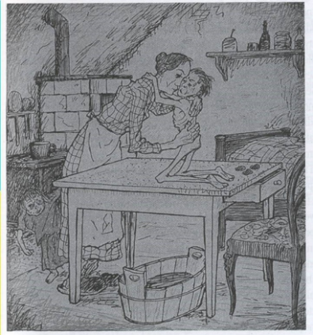
Source A
A German cartoon published in the left wing magazine Simplissimus. Published in 1919. The title of the cartoon is ‘Mother to her starving child: When we have paid one hundred billion marks then I can give you something to eat.’

8 marks | Tick when complete
Study Sources B and C. How useful are sources B and C for an enquiry into the the effect of hyperinflation on the German people in 1923? Explain your answer using Sources B and C and your knowledge of the historical context.
Source A: A British cartoon showing the French, German (Stresemann) and British Foreign ministers joining hands in the Locarno Pact. The French Foreign Minister has a boxing glove on the hand behind his back

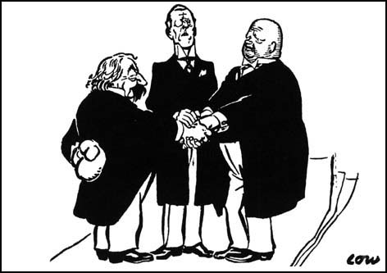
Source B: From a speech by German Foreign Minister, Gustav Stresemann. 1929
The economic position is only flourishing on the surface. Germany is in fact dancing on a volcano. If the short term loans are called in by America, a large section of our economy would collapse

Interpretation 1: From Weimar and Nazi Germany, by F. Reynoldson
From 1924-29 the Weimar Republic was much stronger than it had been just after the war. The German people were much better off and contented. The Weimar Republic looked safe and foreign countries started making deals with Germany. Led by Stresemann in the Reichstag, the different parties managed to work together. Extreme parties like the Nazis gained fewer seats
Interpretation 2: From Weimar and Nazi Germany. F. Wilmott
German prosperity was built on quicksand foundations. The Weimar economy was depended upon loans from America. In times of depression the US Money lenders could demand rapid repayment. Although big businesses grew in the 1920s, small firms struggled and many went bankrupt
4 mark - Interpretations | Tick when complete
Interpretations 1 and 2 give different views about extent of the political and economic recovery 1924-29. What is the main difference between these views? Explain your answer using both interpretations
4 mark – Link Source to Interpretation
Suggest one reason why Interpretations 1 and 2 give different views about extent of the political and economic recovery 1924-29. You must use Sources A and B to help explain your answer.
16 mark
How far do you agree with Interpretation 2 about the extent of the political and economic recovery 1924-29? Explain your answer, using both interpretations and your knowledge of the historical context.

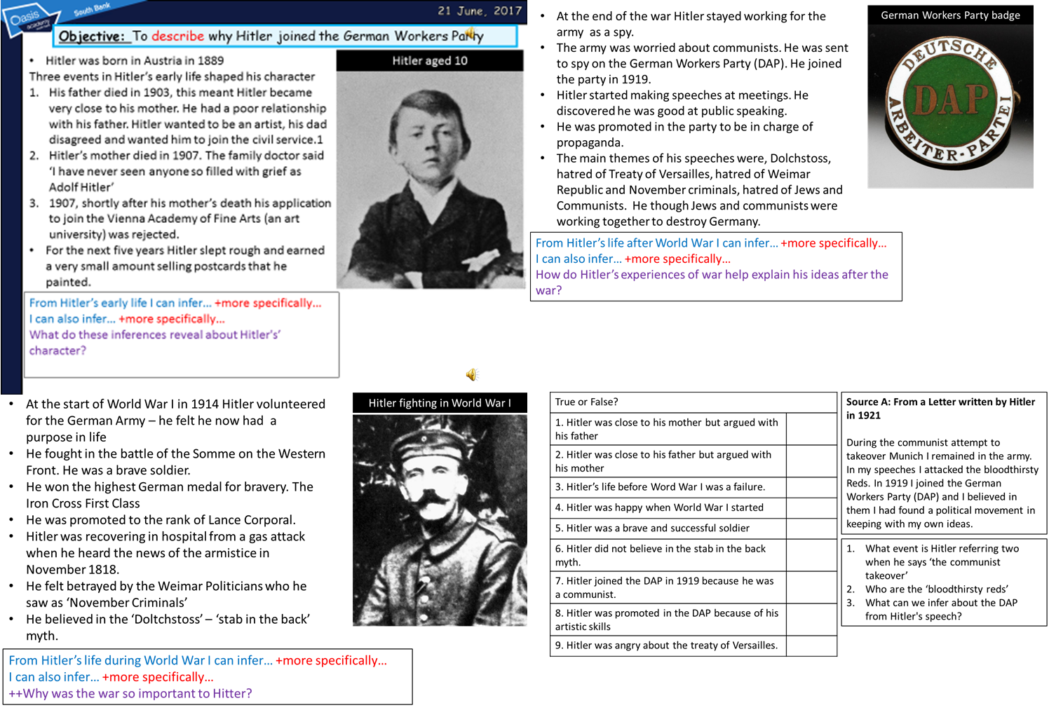
TOPIC 2; The Nazi party 1919-32

Early Features of the Nazi Party
Important features 1920-23:
- 1920 – Twenty Five Point Programme released. A list of what the Nazis would do when in power.
- 1920 – Name Changed from DAP to NSDAP – Nazi Party for short
- 1921 – Party buys a newspaper the Volkischer Beobachter (People’s Observer) – a useful propaganda tool
- 1921 – Hitler becomes Fuhrer (leader of the Nazi Party). He develops the idea that he should have ultimate power and be questioned by no one. This was know as the Fuhrerprinzip (Fuhrer principle)
- 1921 Sturmabteilung (SA). The Nazis private army, known as the ‘brownshirts’

25 Point Plan
POINT
1 | The unity of all German-speaking peoples.
2 | The abolition of the Treaty of Versailles.
3 | Land and colonies to feed Germany’s population.
4 | Only Germans can be citizens. No Jew can be a German citizen.
5 | People in Germany who are not citizens must obey special laws for foreigners.
6 | Only German citizens can vote, be employed or hold public office.
7 | Only German citizens can vote, be employed or hold public office.
8 | No further immigration of non-German must be allowed. All foreigners who have come to Germany since 1914 must be expelled.
9 | All citizens have equal rights and duties.
10 | The first duty of a citizen is to work.
11 | All payments to unemployed people should end.
12 | All profits made by profiteers during the war must be shared.
13 | Nationalisation of public industries*. (water , gas , electricity, railways)
14 | Large companies must share their profits.
15 | Pensions must be improved.
16 | Help for small shops and businesses; large department stores** must be closed down.(most department stores were owned by Jews)
17 | Property reform to give small farmers their land.
18 | An all-out battle against criminals, profiteers, etc., who must be punished by death.
19 | Reform of the law to make it more German.
20 | Improve education so that all Germans can get a job.
21 | Improve people’s health by making a law for people to do sport.
22 | Abolition of the Army, and a new People’s Army in its place.
23 | German newspapers must be free of foreign influence.
24 | Freedom of religion.
25 | Strong central government with unrestricted authority.

Which of the points would have appealed to:
A nationalist? (who thought the Germany is better than other countries) | 1, 2, 5, 19
A socialist? (who wanted the government to help the poorest in society)

Someone who was angry about losing the war e.g. the Freikorps?

Someone who wanted a return to strong government by one person.?

Someone who hated Jews?

A key Nazi idea was Lebensraum (living space). Which point proves this? Why?

The Nazis were becoming extremely anti-Semitic (anti-Jew). Which point proves this? Why?

The Nazis wanted to abolish the Treaty of Versailles. Which point proves this? Why?

1921 Sturmabteilung – The SA - ‘Brownshirts’
- Hitler became Fuhrer (leader) of the Party in 1921
- He introduced the swastika logo
- He introduced the raised arm salute and ‘heil Hitler’ greeting.
- There was lots of violence at political meetings at these times so it was common for political parties to organise protection for their speakers.
- The Nazis had the SA (Sturmabteilung). They were more commonly known as the ‘brownshirts’ because of their uniform.
- The SA became the private army of the Nazi Party. Members swore an oath of loyalty when they joined.
- From 1921-23 the SA was used to attack meetings of the Communist Party and Social Democrat party.
- Hitler’s speeches and the popularity of Nazi ideas like ‘Dolchstoss’, hating the Treaty of Versailles, blaming Jews and communists for all Germany’s problems increased the membership of the Party. It was 1100 in 1920 and 55,000 in 1923.
- Another key Nazi idea that was popular was volkisch. The that the German race was pure and superior
Nazi party in the Early 1920s: Check your understanding
TASK: 1.Put these events in the correct order. Number the boxes from 1-4. Add dates
 | Hitler becomes Fuhrer of the Nazi Party |  | Nazis release the Twenty Five Point Programme
 | Change name from DAP to NSDAP |  | Hitler sets up the SA – the ‘brownshirts’

2. Lebensraum translates as ‘living space’. In other words the Nazis wanted invade and conquer other countries to create an ….
They planned to do this by…
3. Scrapping the Treaty of Versailles, anti- Semitic ideas and anti communist ideas would have made the Nazis popular with which groups in German society?
4. This would have made the Nazis popular with this group because…?
5. The Nazis appealed to socialists and factory workers, with some of the 25 points, for example…
This appealed to these groups because…
Describe the role of the SA;
The role of the SA was to…
For example…
More specifically…

The Munich Putsch 1923
Cause of Munich putsch 1923 | Cause to do with: Hatred of treaty of Versailles? Hatred of the Weimar Republic? Belief in support for the Putsch?
General Ludendorff  - Extremely popular General from World War I  - Nationalist who had supported the Kapp Putsch in 1920  - Ludendorff supported Hitler’s attempt to take power | Belief in support for the Putsch
French invasion of the Ruhr
- Germany was humiliated when the French invaded the Ruhr
- This had happened because Germany could not afford to pay £6.6 billion reparations.
- The Weimar government was unable to stop the French invading and taking German coal and steel
Nazi Support
- By 1923 the Nazi Party had 55,000 members and many more supporters
- Support for the Party was especially strong in Bavaria.
Versailles
- Hitler hated the terms of the Treaty of Versailles
Hyperinflation
- The Weimar Republic had printed paper money causing hyperinflation
- The Nazis also believed the Weimar Republic had ‘stabbed Germany in the back’ with the armistice.
Explanation or recovery
Because the Treaty of Versailles had set reparations so high, the Germans could not pay, the French invaded and the Weimar Government could not stop them. This meant that Hitler wanted to take power to remove the Treaty of Versailles and replace the Weimar government.
Because Nazi support had increased and was strong in Bavaria this meant Hitler believed the Munich putsch would be a success with this level of support.
Because Hitler hated the Treaty and wanted to remove its terms from Germany this meant he wanted to take power so he could remove the treaty.
Because Nazi blamed Weimar Republic for hyperinflation and the ‘stab in the back myth’ this meant Hitler was motivated to take control and remove Weimar politicians from power.
Because Hitler had the support of General Ludendorff this meant that Hitler had the support of the army. This led him to believe that the Munich putsch would be a success with this level of support.

Munich Putsch, Nov. 1923; Check your understanding
1.Put these events in the correct order. Number the boxes from 1-4.
 | When the Nazis marched through Munich both sides opened fire. 16 Nazis were killed, the rest fled. Hitler was arrested. Nazi Party banned. |  | Hitler and 600 Nazis stormed the Burgerbraukeller. Forced Bavarian politicians to agree to the putsch at gunpoint
 | Surprisingly the politicians were released and changed their minds. They organised the army and police to stop the putsch. |  | Hitler and the Nazis thought they could seize power because Germans were angry with Weimar e.g. hyperinflation
2. Who was General Ludendorff?
3. Why did Ludendorff’s cause the Putsch?
4. Why did Hitler had the Weimar Republic/Politicians?
5. Why did this hatred cause the Putsch
6. Why did Hitler hate the Treaty of Versailles?
7. Why did Hitler’s hatred of the Treaty of Versailles cause the Putsch?
Consequences of the Putsch
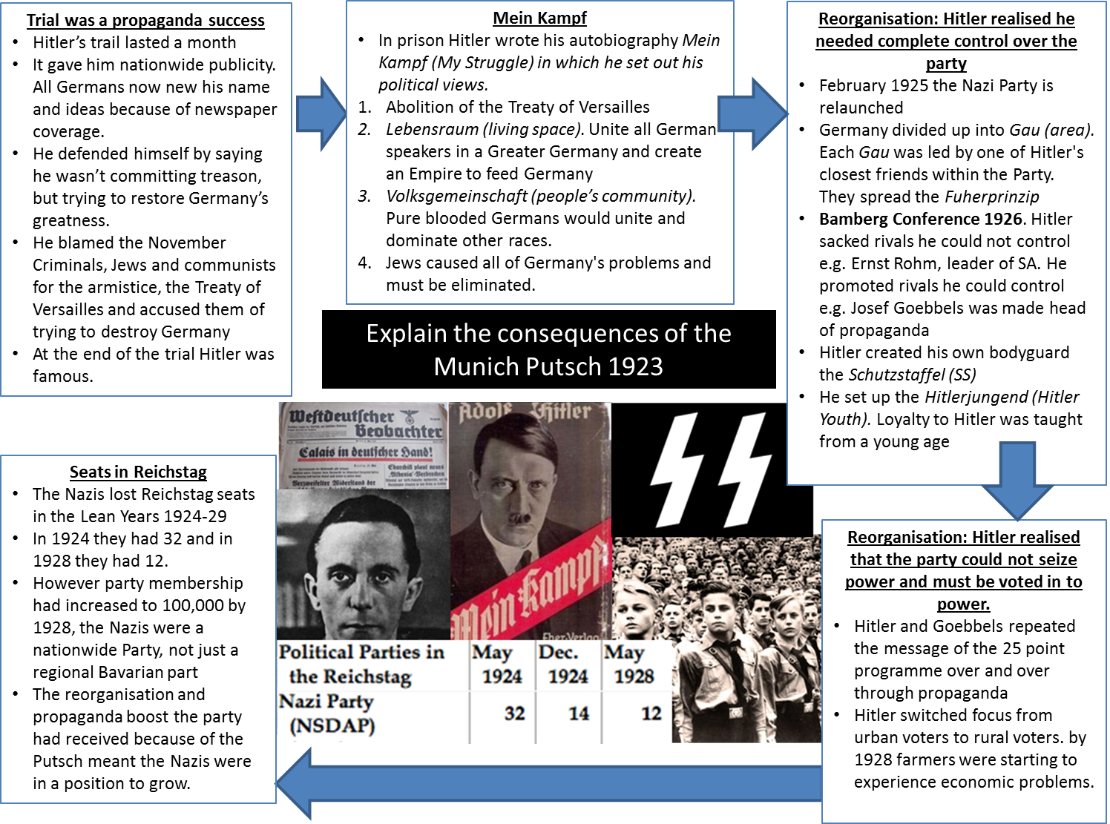
Trial was a propaganda success
The trial made Hitler famous because…..

Hitler used the trial as a platform to repeat his key ideas, such as……

+Why were the Bavarian judges sympathetic to Hitler and his views?

Mein Kampf
Put the views expressed by Hitler in Mein Kampf into your own words:
1.

2.

3.

4.

+Which groups in German society would like these ideas? Why?

Reorganisation: Hitler needed complete control
Dividing Germany up into Gau, made it easier for Hitler to control the party because…….

What did Hitler did to increase his control at the Bamberg Conference?

How did Hitler increase his protection at the Conference?

How did Hitler improve loyalty at the conference?

Reorganisation: Hitler realised Nazis needed to be voted into power.
Which Nazi individual was key to propaganda (apart from Hitler)

How did Hitler try and persuade people to vote for the Nazis?

Why did Hitler switch focus from urban to rural voters?

Seats in the Reichstag
Prove that the Nazis were not successful in the years 1924-1928 using the table of election statistics on the previous page

Why were the Nazis less popular during this time?

+The Nazis called these the Lean Years. Why did they call them this?

In what ways did the Nazis set themselves up for success later on?

Why did Nazi Support increase dramatically 1929-32
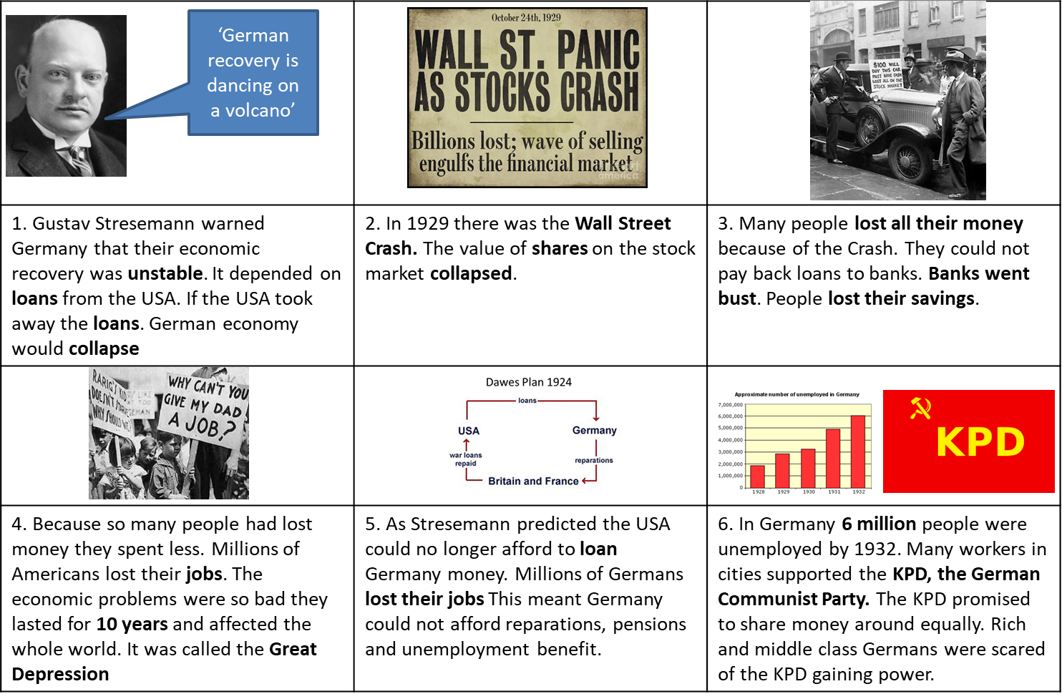

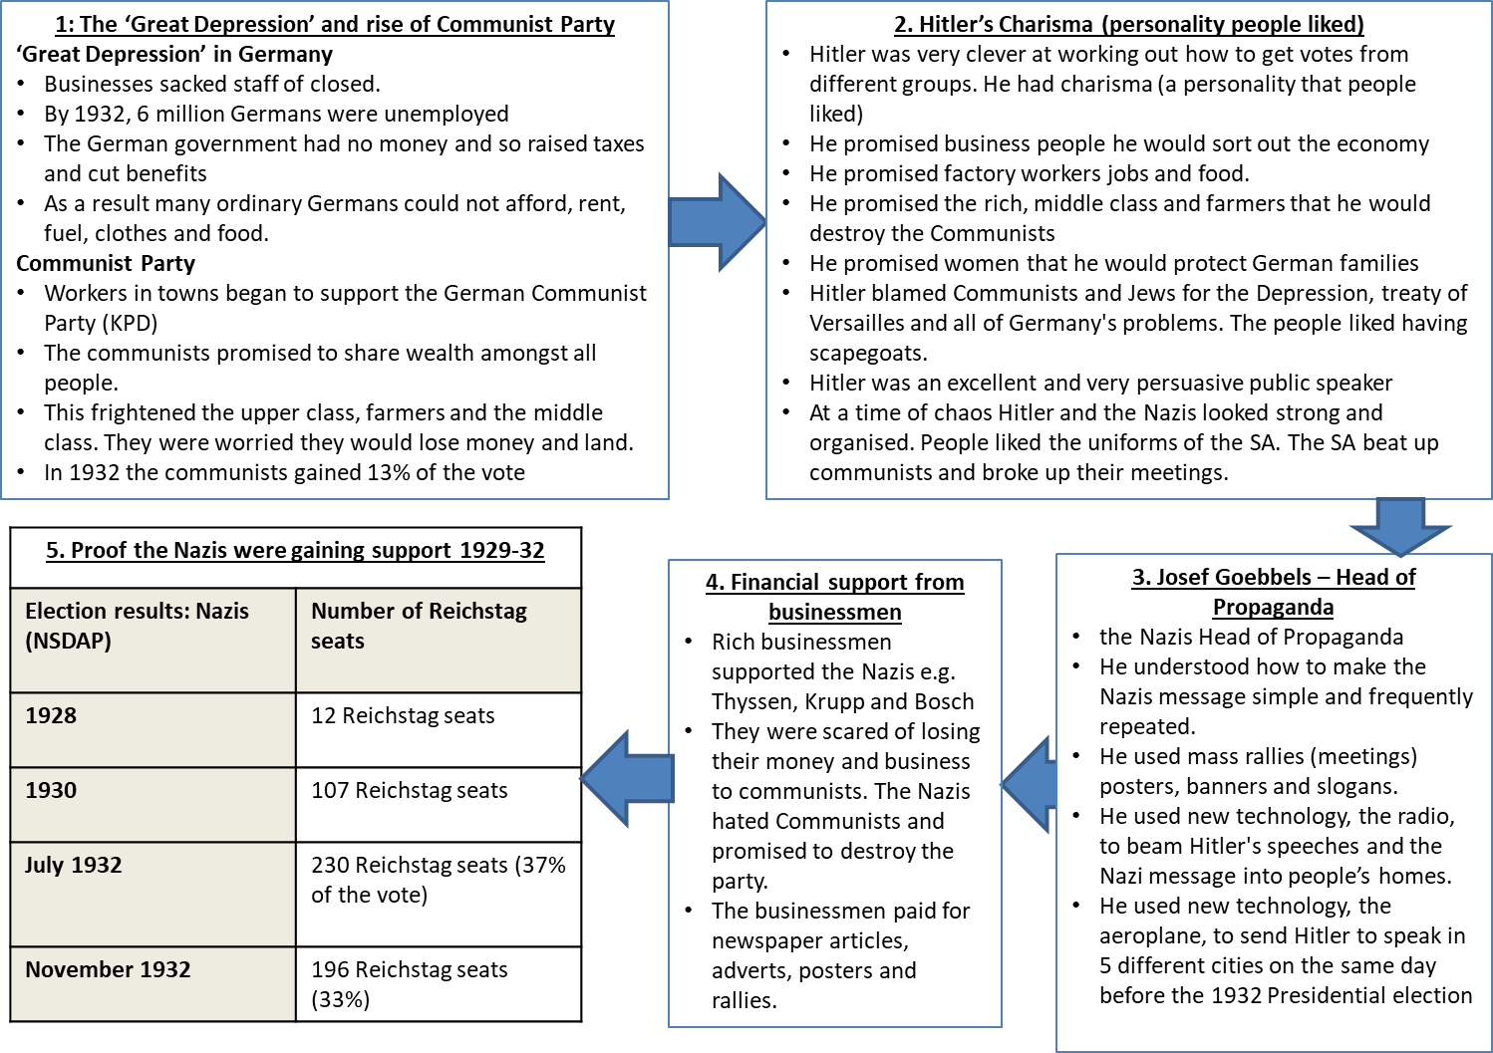
1: The ‘Great Depression’ and rise of Communist Party
The Great Depression badly effected Germany, for example;
1.

2.

3.

The Great Depression caused the German Communist Party to gain support because;
1

2

Rich Germans were scared of the Communists gaining power because…

This meant support for the Nazis increased because; (tick correct answer)
- What the Nazis promised to do once in they were in power persuaded people to support them
- Hitler’s public speaking persuaded people to support them
- Nazi propaganda persuaded people to support them
2. Hitler’s Charisma (personality people liked)
Hitler promised to destroy the Communist Party, this would have appealed to the rich, the middle class and farmers because…

Hitler was very good at promising to give people what they wanted, for example, he promised factory workers that…

He promised women that…

He promised businessmen that…

The Nazis looked organised in a time of chaos and uncertainty, more specifically…

This meant support for the Nazis increased because; (tick correct explanation)
- What the Nazis promised to do once in they were in power persuaded people to support them
- Hitler’s public speaking persuaded people to support them
- Nazi propaganda persuaded people to support them
3. Josef Goebbels
Josef Goebbels was the Nazi head of propaganda, in my own words this means his job was….

3 ways Goebbels got the Nazis message out to people were…
1.

2.

3.

Goebbels used new technology, for example, the radio; this helped spread the Nazi message by…

Goebbels used new technology, for example, the aeroplane; this helped spread the Nazi message by...

This meant support for the Nazis increased because; (tick correct explanation)
- What the Nazis promised to do once in they were in power persuaded people to support them
- Hitler’s public speaking persuaded people to support them
- Nazi propaganda persuaded people to support them
4. Financial support
The three rich businessmen that supported Hitler were ________________, _______________ and _______________
They supported Hitler because…

They paid for…

This meant support for the Nazis increased because; (tick correct explanation)
- What the Nazis promised to do once in they were in power persuaded people to support them
- Hitler’s public speaking persuaded people to support them
- Nazi propaganda persuaded people to support them
5. Proof the Nazis were gaining support 1929-32
The table proves that in 1928 the Nazis had very little support because it shows us that…

In 1930, soon after the Wall Street Crash the table proves their support increased a great deal because it shows us that…

By July 1932 the table proves Hitler’s charisma and Goebbels propaganda were effective an increasing support because it shows us that…

Increased Nazi Support 1929-32: Check your understanding
1.Put these events in the correct order. Number the boxes from 1-4.
 | The USA stopped lending Germany money. This caused the Great Depression to spread to Germany |  | By 1932 6 million Germans were unemployed. The government could not afford to pay pensions, unemployment benefit or reparations.
 | Many factory workers supported the German Communist Party because they promised to share wealth equally amongst all Germans |  | The US stock market crashed in October 1929. It was called the Wall Street Crash.
 | The Wall St. Crash was the start of economic problems that lasted 10 years. They were so bad it was called the ‘great Depression’. |  | The upper and middle classes feared Communists taking power and supported party’s that were anti-communist like the Nazis.
2. What are the reasons for increased Nazi support we have learnt about this lesson?
1.
2.
3.
4
3. Which party did many factory workers support (German initials KPD) G____________________ C__________________ P__________

4. Why did the rich, farmers and Middle class fear communist rule?

6. Who was the Nazi Head of Propaganda?
7. List two things he did to spread the Nazis message effectively

8. Nazis used two examples of new technology to spread their message. What were they?

9. Name the businessman who supported the Nazis. T_____________ , B____________ and K_____________

10. What did businessmen pay for that helped increase Nazi support

11 Why did middle class Germans support Hitler?

12. How did Hitler persuade people to support him?

Describe the events that led to Hitler becoming Chancellor in January 1933
Hitler becomes Chancellor: Timeline.
Election: May 1932 | - Hindenburg elected President  - Nazis increased their share of the vote. No Party had more than 50% of vote – so a coalition had to be formed.  - Bruning banned the SA which was unpopular because the Nazis were now had millions of supporters. Bruning planned to buy land from famers and give it to the unemployed. Both ideas were very unpopular  - Bruning resigned and was replaced by von Papen  - Von Papen planned a coalition of right wing parties.  - Hitler agreds to join if the ban on the SA was removed. Von Papen lifted the ban.  - Hitler and the Nazis entered government. But the coalition soon broke apart.
Election: July 1932 | - Before the election there was lots of fighting between the SA and communists.  - Nazis gained 38% of the vote. They were the biggest part in the Reichstag  - Hitler demanded to be Chancellor. Hindenburg refused. He did not trust Hitler because Hitler was not an army officer or member of the upper class (like Hindenburg, Von Papen and Von Schleicher)  - Von Papen remained as Chancellor but his new coalition only lasted 5 months
Election: November 1932 | - Following this election, Von Papen still struggled to form a coalition.  - Von Papen suggested abolishing the Weimar constitution as it kept failing to provide stable governments  - Von Schleicher warned Hindenburg that this would lead to Civil War  - Hindenburg forceed von Papen to resign
December 1932 | - Hindenburg appointed von Schleicher as Chancellor.  - He planned to create a Querfront (cross front). With a range of different Parties in a coalition, including the communists.  - Papen and Hitler persuaded the rich, judges and the army that this meant communists would take over ruling Germany. Hindenburg sacked von Schleicher
January 1933 | - Papen persuaded Hindenburg to make Hitler Chancellor. Papen said he would control Hitler. He said he could ‘make Hitler squeak’.  - Hitler became Chancellor on 30th January 1930

Hitler becomes Chancellor: Timeline.
Election: May 1932 | Brining’s first mistake was to ban…  This was unpopular because…  Bruning’s second mistake was his plan to…  This was unpopular because….  Bruning resigned and von Papen become Chancellor. Von Papen persuades Hitler to join his coalition by lifting…
Election: July 1932 | Before the election the SA fought…  The Nazis gained their highest share of the vote, more precisely…  However, Hindenburg refused to make Hitler Chancellor. Hindenburg did not trust Hitler because….
Election: November 1932 | Von Papen suggested abolishing the Weimar Constitution because…  Von Schleicher warns Hindenburg off this idea because….  Von Papen is forced to…
December 1932 | Von Schleicher thought he could create a coalition of all parties called the …  Hitler and Von Papen used this to create fear amongst the ‘establishment’ (rich, judges, and army) by…  This results in Von Schleicher sacking.
January 1933 | Papen persuaded Hindenburg to make Hitler Chancellor by promising Hindenburg that he could…  Hitler became Chancellor on the date of …  The equivalent position to Chancellor in Britain is…

Hitler becoming Chancellor: Check your understanding
1.Put these events in the correct order. Number the boxes from 1-6.
 | Papen convinced Hindenburg he could control Hitler. Hitler became Chancellor January 1933 |  | Von Schleicher’s Querfront coalition shocked the rich, the army and Hindenburg. Papen and Hitler convinced Hindenburg it would allow communists to take over.
 | After the November 1932 election, Von Papen struggled, again, to make a coalition and suggested abolishing the Weimar Construction. |  | Bruning banned the SA and planned to give land to the unemployed in May 1932. These ideas were very unpopular and he was forced to resign.
 | July 1932 the Nazis won 38% of the vote. Hitler demanded to be made Chancellor. Hindenburg refused. Von Papen made Chancellor. |  | Von Scheicher persuaded Hindenburg that if the constitution is abolished it would lead to civil war. Von Papen was forced to resign.
2. Bruning’s two mistakes were…
i)
ii)

3. The Nazis agreed to enter Government in May 1932 when Von Papen lifted the ban on…

6. Von Papen had to resign After suggesting…

7. Von Schleicher had to reign after planning…

8. Von Papen persuaded Hindenburg to make Hitler Chancellor by promising…

9. The quote Von Papen made was…

10. The date Hitler became Chancellor was…

Describe how Hitler became Fuhrer and dictator of Germany by August 1934
Hitler becomes Chancellor: Timeline.
February 1933  Reichstag Fire | - A Dutch communist is executed for starting the fire. Hitler uses the fire as an opportunity to accuse the Communist party of attempted treason.  - Hitler used Article 48 to issue the Decree for Protection of the People. This gives him the power to ban opposition newspapers and arrest political opponents. Four thousand communists are arrested.  - With the decree in effect the Nazis win 288 seats in an election held in March. The Nazis now have enough seats to change the constitution.  - The Reichstag Fire allowed Hitler to issue the decree. This helped the Nazis to win more seats in the Reichstag which meant that they could change the constitution.
March 1933  Enabling Act | - Passed by 444 votes to 94 the Enabling Act meant Hitler could make laws. He did not need the approval of the Reichstag. In effect the Reichstag voted it self out of existence. Germany was no longer a democracy. Hitler was a dictator.  - The Enabling Act allowed Hitler to change the law and destroy his political opposition on the left for good.
May 1933  Opposition parties and Trade Unions banned | - Using the powers given to him by the Enabling Act Hitler bans all political parties except for the Nazi Party. This meant the Communist Party and the SPD could not longer oppose Hitler.  - Hitler also passed a law banning trade unions. This meant that workers could not organise resistance to the Nazis.  - Banning other political parties and trade unions allowed Hitler to legally remove his political opposition.
June 1934  Night of long Knives | - With political opponents on the left dealt with. Hitler decided to remove opponents within his own Party.  - The SA had 3 million members who were loyal to Ernst Rohm.  - The SS was jealous of the SA’s size and power they encouraged Hitler to act. The army hated the power of the SA. Hitler needed the army on his side. Businessmen hated Ernst Rohm who was a socialist, destroying Rohm would ensure their support for Hitler remained.  - On 30th of June 1934 Rohm and 100 SA leaders were invited to a meeting. When they arrived they were arrested by the SS and shot  - The Knight of the Long Knives allowed Hitler to remove political opponents from with his Party and to please the army and businessmen. He needed they support.
August 1934  - Hindenburg Died  - Hitler made himself Fuhrer  - Army swore loyalty | - Hindenburg died in august 1934. Hitler decided to merge the jobs of Chancellor and President. He made himself Fuhrer of Germany. In a referendum held shortly afterwards, 90% of Germans approved.  - Hitler announced that the army should swear an oath of loyalty to him instead of to Germany.  - These changes, propaganda and the ‘heil Hitler’ salute were all designed to increase loyalty to Hitler and make him spear powerful.  - Hindenburg’s death allowed Hitler to make himself Fuhrer of Germany. There were no other rivals for power.  - The oath of loyalty from the army allowed Hitler to increase loyalty among the army which was important for his power to be secure.

Hitler becomes Chancellor: Timeline.
February 1933  Reichstag Fire | The arrest of a Dutch communist allowed Hitler to blame the fire on…  This led to the Decree for Protection of the People which meant that Hitler could prevent communists from entering the …  With this restriction in place, the Nazis won...  This meant they were able to...  Without the Reichstag fire the Nazis could not have….
March 1933  Enabling Act | The Enabling Act meant Hitler had the power to…  It took away the power of the…  The Enabling Act meant Hitler was….  +Without the Enabling Act the Nazis could not have….
May 1933  Opposition parties and Trade Unions banned | Using the Enabling Act Hitler banned...  This allowed Hitler to…
June 1934  Night of long Knives | The SS encouraged the Night of the Long Knives because…  The army encouraged it because…  Businessmen encouraged it because…  Hitler wanted to do it because…  The Night of the Long Knives allowed Hitler to become dictator because….
August 1934  - Hindenburg Died  - Hitler made himself Fuhrer  - Army swore loyalty | When Hindenburg died Hitler made himself…  The majority of Germans approved, more precisely…  Hitler announced that the army would swear an oath of loyalty to him instead of Germany, he did this because…  Hindenburg’s death allowed Hitler to become a dictator because…

Hitler become Dictator: Check your understanding
1.Put these events in the correct order. Number the boxes from 1-6. Add year
 | Reichstag Fire  Month and year = |  | Hitler banned all political parties except the Nazi Party. Banned all trade unions  Month and year =
 | Night of the Long Knives  Month and year = |  | Hindenburg died and Hitler made himself Fuhrer of Germany. The army swore loyalty to Hitler.  Month and year =
 | Enabling Act  Month and Year |  | The Decree for the Protection of the People banned opposition newspapers and leads to the arrest of 4000 communists.  Month and year =
2. Which event allowed Hitler to stir up fears of a communist takeover?

3. Which law gave Hitler the power to make laws and meant the Reichstag was powerless?

4. What two things did Hitler ban which destroyed his left wing political opponents ?

5. Which event allowed Hitler to destroy his opponents within the Nazi Party?

6. Which event allowed Hitler to abolish the jobs of President and Chancellor and declare himself Fuhrer of Germany?

7. Which event caused Hitler to ensure the loyalty of the army?

Two causes of Hitler becoming dictator in 1934 that link are the Reichstag Fire and the Enabling Act
They link because…

Two causes of Hitler becoming dictator in 1934 that link are the Enabling Act and Hitler baning trade unions and other political parties They link because…

Two causes of Hitler becoming dictator in 1934 that link are the Night of the Long Knives and the army swearing loyalty to Hitler. They link because…

Knowledge Tasks: Topic 2
Topic 2 Early Nazi Party and growing popularity; Look, cover write check on blank knowledge organiser
Topic 2 Early Nazi Party and growing Popularity multiple choice quiz (repeat till 100% correct)
Topic 2 Early Nazi Party and growing popularity-; free recall quiz (repeat till 100% correct)
12 mark questions
Explain the causes of the Munich Putsch 1923
• Ludendorff
• hyperinflation
You must also use information of your own.
Explain why Nazi popularity increased 1929-33
• the Depression
• Goebbels
You must also use information of your own.
Explain why Hitler became a Dictator in 1934:
• Reichstag Fire Feb 1933
• Enabling Acct July 1933
You must also use information of your own.
8 marks questions
How useful are Sources B and C for an enquiry into increased support for the Nazi Party 1929-32? Explain your answer using the sources and your knowledge.
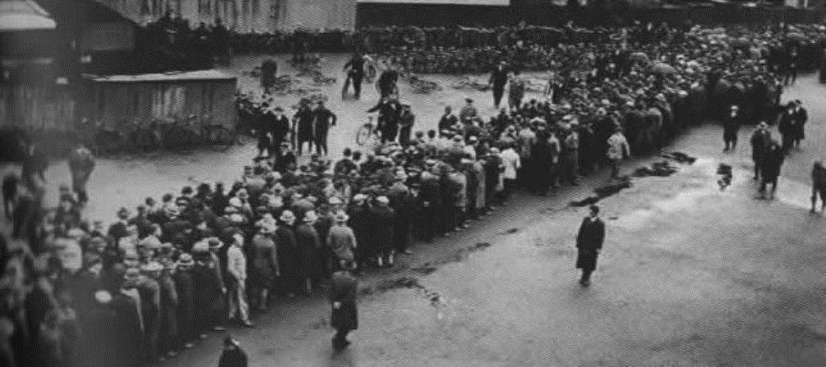
Source B: A photograph published in 1932 in a German newspaper. It shows people from Hanover queuing for their unemployment benefits. The writing on the wall of the building says ‘Vote Hitler’.

Source C Albert Speer from his book inside the Third Reich. Speer recalls a meeting in Berlin in 1930. Speer became a government minister in Nazi Germany

I was carried away by a wave of enthusiasm (by the speech)…..Here it seemed to me was hope. Here were new ideas, new tasks. The peril of communism could be stripped. Hitler persuaded us that instead of hopeless unemployment, Germany could move to economic recovery

Interpretation 1: From a History textbook, GCSE MODERN WORLD HISTORY, Ben Walsh, published 1996.  The Nazis won increased support after 1929 due to Hitler. He was a powerful speaker and years ahead of his time as a communicator. He travelled by plane on a tour of rallies all over Germany. He appeared to be someone who new and understood the people and their problems. | Interpretation 2 : From a History textbook, Modern World History, T Hewitt, published 1999.  The Depression was the main reason for increased support for the Nazis. The government was taken by surprise by the speed and extent of the Depression and had no idea how to deal with it. The Depression brought out all the weaknesses of the Weimar Republic. It is not surprising the German people began to look towards parties that promised to do something. In particular they began to look to and support that Nazis.
4 mark - Interpretations
Study Interpretations 1 and 2. They give different views about why the Nazi party gained support. What is the main difference between these two views? Explain your answer using details from both interpretations.

4 mark – Link Source to Interpretation
Suggest one reason why Interpretations 1 and 2 give different views about increasing support for the Nazis 1929-33 . You may use Sources A and B to help explain your answer
16 mark
How far do you agree with Interpretation 2 about reasons for the growth in support for the Nazi Party in the years 1929–32? Explain your answer, using both interpretations and your knowledge of the historical.

TOPIC 3: the Nazi Police State
What did the Nazis use the create a ‘Police State’ to control people’s opinions.
Police state is when…
- The police are used to control people’s opinions
- The police are used to secretly monitor people’s opinions
- The police are used to arrest, put on trial and punish people with the ‘wrong’ political opinions.
- these action scare most people into obedience and conformity.

Describe the features of a Police State.
SS | - Set up by Heinrich Himmler in 1925  - Responsible for the removal of all opposition to the Nazis  - Another aim was to intimidate all Germans into obedience. The SS was made up of the General SS, which found and arrested the opponents e.g the SD and Gestapo. And the Armed SS, who looked like soldiers and were part of the army by 1939. The Armed SS also ran the extermination and concentration camps.  The SS created a Police State because the whole organisation was designed to control the German people. It was feared by Germans and scared them into obedience.
SD | - The Sicherheitsdienst. The part of the SS responsible for secret intelligence  - They spied on people who were suspected of opposing the Nazis e.g Jews, communists and trade unionists  - They gathered information from informants and their secret agents.  The SD created a Police State because it secretly monitored people’s opinions, gathered information about opponents and informed the Gestapo who to arrest. People who were worried about the SD were more likely to be obedient
Gestapo | - Led by Reynhard Heydrich  - The SS’s secret police, it arrested opponents based on information provided by the SD  - The Gestapo could arrest and imprison anyone suspected of opposing the Nazis.  - During the Holocaust, the Gestapo looked for Jews and sent them to concentration camps.  The Gestapo created a Police State because they used information from the SD to arrest and imprison opponents of the Nazis. People who had the ‘wrong’ political ideas like communists. Fear of the Gestapo made people more obedient.
People's Courts | - Hitler controlled the courts so that it was more difficult for anyone to oppose him. Opponents did not receive fair trials  - All judges had to join the Nazi Party. Trial by jury was abolished. So only Nazi judges made decisions about guilt or innocence.  - People’s Courts were set up to hear cases of treason in secret with hand-picked judges.  The People’s Courts' created a Police State because Nazi people opponents did not receive a fair trial and were given unfair sentences. The fear of not receiving a fair trail sacred people into obedience.
Concentration  Camps | - The first concentration camp was called Dachau and was created in 1933.  - People sent there were regarded by the Nazis as ‘degenerates’ = political enemies or people who did not conform to Nazi beliefs e.g. Jews, communists, socialists, trade unionists, criminals, prostitutes, homosexuals.  The Concentration Camps created a Police State because the people arrested by the Gestapo would be sent to the camps as punishment. This fear of concentration camps also increased obedience

Describe the features of a Police State.
SS | The leader of the SS was…  The General SS was responsible for…  The armed SS was responsible for…
SD | SD stands for…  The SD’s job was to…  Groups they spied on included…  The SD created a police state by… (tick correct answer)  - controlling people’s opinions  - secretly monitoring people’s opinions  - arresting , putting on trial or punishing people with the ‘wrong’ political opinions.  - Scaring people into obedience and conformity.
Gestapo | The Gestapo was led by…  The Gestapo’s job was to…  The Gestapo created a police state by… (tick correct answer)  - controlling people’s opinions  - secretly monitoring people’s opinions  - arresting , putting on trial or punishing people with the ‘wrong’ political opinions.  - Scaring people into obedience and conformity.
People's Courts | The Nazis wanted to control the courts because…  Nazi courts wee unfair because…  People’s courts were set up to…  The People’s Courts created a police state by… (tick correct answer)  - controlling people’s opinions  - secretly monitoring people’s opinions  - arresting , putting on trial or punishing people with the ‘wrong’ political opinions.  - Scaring people into obedience and conformity.
Concentration  Camps | The first concentration camp was called…  The Nazis called people sent there…  People were sent there because they were…  The Concentration Camps created a police state by… (tick correct answer)  - controlling people’s opinions  - secretly monitoring people’s opinions  - arresting , putting on trial or punishing people with the ‘wrong’ political opinions.  - Scaring people into obedience and conformity.

Creation of the Police State: Check your understanding
True or false (T of F)
 | SS stands for Sicherheitsdienst |  | SD stands for Schutzstaffel
 | Concentration Camps were run by the SS |  | The Gestapo arrested Nazi opponents
 | The job of the SD was to spy on Nazi opponents and gather information |  | People’s Courts were fair because they used trial by jury.
2. Who was the leader of the SS?

3. Who was the leader of the Gestapo?

4. Which part of the Nazi Police state was responsible for being Hitler’s bodyguards?

5. Which part of the Nazi Police state was responsible for secretly gathering intelligence and spying on German people?

6. Which part of the Nazi Police state was responsible for arresting opponents?

7. Which part of the Nazi Police state was sentencing criminals accused of treason

8. The Nazi police state controlled people through fear, for example…

9. The Nazi police state controlled people by punishing people who did not conform to Nazi views, for example…

10 The police state made many Germans obey the Nazis because they were scared of…

Describe how propaganda and censorship were used to control people’s opinions s part of the police state
Censorship: the banning or editing of books, films, news, etc. that the Nazis considered obscene, politically unacceptable, or a threat to security.

Propaganda: advertising by political parties to persuade you to act or think a certain way. Josef Goebbels was in charge or Nazi propaganda

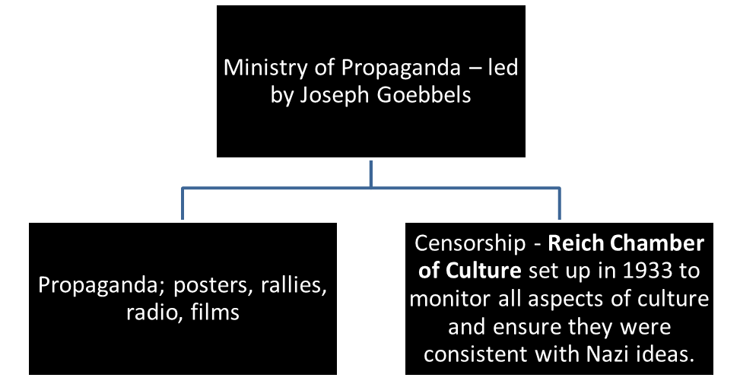
Censorship: methods
May 1933  Book Burning in Berlin | - German students burnt books in Berlin by Jewish writes and those whose ideas disagreed with Nazi views e.g. communists like Karl Marx  - Other book burnings took place throughout the 1930s.
1933 Reich Chamber of Culture | - Told radio shows, playwrights, filmmakers and newspapers what they could and not include in their work
Newspapers | - Newspapers opposition the Nazis were closed. The Nazis ran their own newspaper the Volkischer Beobachter = ‘People's Observer’
Radi | - The Nazis made cheap radios called ‘People's Radios’  - They were designed so they could not receive foreign radio stations like the BBC
Art and Music | - Modern music like jazz was banned  - Modern art was banned  - Both were considered ‘degenerate’. This meant the Nazis thought they were immoral.
Propaganda: methods: methods
Posters | - Posters showing Nazi beliefs were displayed everywhere  - Some encouraged loyalty and respect for Hitler.  - Others criticised Jews and communists.
Rallies and Parades | - Huge Nazi rallies and parades were held. Particularly in the city of Nuremburg.  - The Nazis wanted to impress people by showing power and strength  - Lots of photos of rallies appeared in newspapers  - Speeches from rallies were broadcast on radio  - Rallies were filmed and shown in cinemas
Radio | - The Nazis made cheap radios called ‘People's Radios’  - They were cheap and this encouraged people to buy the which meant Hitler’s speeches could be beamed directly into people's homes.
Film | - Nazis filmed their rallies and showed them I cinemas e.g 1935 film called the ‘Triumph of the Will’ was a film of a rally I Nuremburg.  - Even entertainment films had Nazi messages. E.g. Hitler Youth Quex. About a boy named Heini, nicknamed “Quex” or “Quicksilver,” is being beaten by his Communist father and struggles to survive. Heini meets Nazi boys his own age. They are kind to him, and he finally feels as though he belongs to a sort of family.  - Heini overhears his parents’ Communist friends planning to blow up a Nazi building with dynamite, and he calls ahead to save the Nazis’ lives. Completely crushed by her son’s betrayal, Heini’s mother waits until he falls asleep and tries to kill them both by filling the house with gas.  - Although his mother dies, Heini survives, only to be chased down later and stabbed to death by a mob of Communists. His Hitler Youth friends are too late to save him, but they hear his last words—the lyrics to a Nazi song.
Art | - The Nazis encouraged artists to create art that matched their ideas e.g. promoting family life and hard work.
Sport | - The Nazis encouraged all people to be fit and healthy so thet boys would be effective soldiers and girls could have lots of children. They wanted sport to show the strength of Aryan Germans over other groups. In 1936 the Olympic Games was held in Berlin. This was meant to show off Nazi Germany and be a chance for German athletes to prove they were better than other nations.

Censorship: methods
May 1933  Book Burning in Berlin | In May 1933 the Nazis burnt books by authors who were and for example…  They did this because…
1933 Reich Chamber of Culture | The job of the Reich Chamber of Commerce was to…
Newspapers | All non-Nazi newspapers were…  The Nazis had their own newspaper called the P O
Radio | The Nazis made cheap radios called … they were designed so they could not…
Art and Music | The Nazis banned modern art and music like jazz because it was degenerate, in other words…
Propaganda: methods
Posters | Posters were used to remind people of Nazi ideas, such as
Rallies and Parades | Rallies and parades were held frequently, the purpose of them was to…
Radio | The Nazis encouraged everyone to buy a People’s radio so that…
Film | The Nazis filed their rallies to create films in cinemas for example…  Entertainment films also carried Nazi messages, for example….  A summary of the plot is…
Art | The Nazis banned modern art and encouraged art with traditional subject matter such as….  They did this because…
Sport | The Nazis wanted girls and boys to play sport because….  The Nazis hosted the Olympics in 1936, the purpose of this was to…

Propaganda and censorship: Check your understanding
1. C (censorship) or P (Propaganda) ?
 | Book Burning 1933 |  | Film e.g. ‘Triumph of the Will’
 | Rallies and Parades |  | Radio – Foreign radio stations like the BBC were banned
 | Radios – Hitler’s speeches could be beamed directly into people’s homes. |  | Posters showing Nazi beliefs
 | Berlin Olympics 1936 |  | Reich Chamber of Culture
 | Jazz and modern art was banned |  | Posters
2..Joseph Goebbels was in charge of…….

3. Radio was used to control people’s opinions by …

4. The purpose of the book burnings was to...

5. Aryan race means …

6. Jazz and moderns art was banned because the Nazis viewed it as…

7. The Reich Chamber of Culture’s job was to……

8. Nazi censorship secretly monitored peopled opinions, for example…

9. Nazi propaganda controlled people’s opinions, for example…

10. Censorship and propaganda made many Germans obey the Nazis because …

Between 1933 and 1939 about 1.3 million people were sent to concentration camps. This seems to indicate that opposition was widespread. 300,000 people also left Germany to start new lives in other countries like the USA. However, all though there was some opposition it was never organised enough to seriously threaten the Nazi regime.
Opposition from churches : Catholics
Background
- Hitler was determined to break the influence of the Catholic church because they owed loyalty to the Pope before him. Hitler said ‘a person is either a Christian or a German, but not both’
- In 1933 Hitler signed an agreement with the Pope called a Concordat. The Nazis agreed to leave the Catholic church alone if the Catholic church agreed to stay out of politics.
Nazi action
- Within a year the Nazis broke the agreement and closed Catholic schools and abolished Catholic youth groups. The Nazis wanted to have control of the education of all young people and for young German’s to join the Hitler youth.
Opposition
- Some Catholic priests criticised the Nazis and were arrested and sent to concentration camps. 400 were sent to Dachau by 1939
- This had the opposite effect to what the Nazis intended. These priests were seen as martyrs and Catholic churches were packed every Sunday.
- However, this opposition was limited to criticising Hitler in church and giving loyalty to the Pope. It was never a serious threat to the Nazi regime.

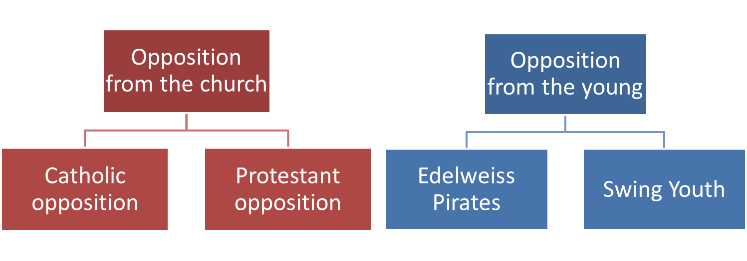
Opposition and Resistance
Opposition from churches : Protestants
Background
- Many Protestants opposed Nazism because they believed Nazi beliefs were the opposite of their Christian beliefs.
- Protestant resistance was led by Pastor Martin Niemoller, who organised the ‘Confessional Church’ ‘to criticise the Nazis
Nazi action
- Protestant Pastors who criticised the Nazis were arrested and sent to concentration camps. Pastor Niemoller was imprisoned at Dachau between 1938 and 1945
Opposition
- Similarly to Catholic opposition, the imprisonment of pastors made Protestants think of them as martyrs and Protestant opposition was never destroyed.
- However, this opposition was limited to criticising Hitler. It was never a serious threat to the Nazi regime.

Opposition from Youth : Edelweiss Pirates
Background
- The Edelweiss Pirates were not one group but the name given to a number of gangs that had the same interests and wore similar clothes. In the town of Cologne there was a gang called the Navajos. In the town of Essen there was a gang called the Roving Dudes. They disliked the rules imposed by the Nazis and did not want to conform.
Nazi action
- There were only ever about 2000 Edelweiss Pirates, the Nazis never considered them to be a serious threat.
Opposition
- Edelweiss Pirate groups were working class children. They listened to banned swing music and wrote anti Nazi graffiti
- They wore clothes considered extreme by the Nazis. Dark shorts, checked shirts and white socks
- They had fights with local groups of Hitler Youth
- They loved the countryside and often went hiking and camping.

Opposition from Youth : the Swing Youth
Background
- Children from wealthy and middle class families who loved banned swing music and American style fashions.
- They disliked the rules imposed by the Nazis and did not want to conform.
Nazi action
- The Swing Youth activities were never considered a great treat by the Nazi authorities.
Opposition
- Swing Youth organised parties to dance to American swing music, smoke and drink alcohol.
- They did not take part in the activities of the Hitler Youth.

Opposition: Catholics
Hitler was determined to break the influence for the catholic church because…

A quote that sums up his views on religion is…

In my own words, this means…

In 1933 Hitler signed an agreement with the Pope called…
They agreement was…

The Nazis broke the agreement by…

Catholic priests who criticised Hitler were sent to concentration camps, more specifically…

However, catholic opposition was never a great threat because…

Opposition: Protestants
Many protestants opposed Nazism because…

Their opposition was led by…

Protestant Pastors who criticised Hitler were sent to concentration camps, more specifically…

However, Protestant opposition was never a great threat because…

Opposition: Edelweiss Pirates
The Edelweiss Pirates was the name given to…

More specifically…

Members of the Edelweiss Pirates wore…

They did not conform to Nazi rule because they…

However, they were not a great threat because…

Opposition: Swing Youth
The Swing Youth loved…

They did not conform to Nazi rule because they…

However, they were not a great threat because…

Opposition by Church and Youth Groups: Check your understanding
Catholic, Protestant, Edelweiss Pirates or Swing Youth opposition?
C, P, EP or SY?
EP | Wrote anti-Nazi graffiti |  | Organised parties to drink, smoke and dance to swing music
 | Loyal to the Pope before Hitler |  | Wore dark shorts and white socks
 | Resistance led by Pastor Niemoller |  | From wealthy and middle class families
 | Fought with the Hitler youth |  | By 1939, 400 priests had been sent to Dachau
 | Resistance group called the Confessional Church |  | Wore American style clothes
2. Hitler disliked Catholics because…

3. Protestants opposed Nazis because…

4. Hitler broke the Concordat with the Pope by…

- Religious groups opposed the Nazis by…

6. An example of an Edelweiss Pirates gang was…

7. Edelweiss Pirates opposed the Nazis by not conforming to Nazi ideals for young people, more specifically..

8. Swing Youth opposed the Nazis by not conforming to Nazi ideals for young people, more specifically..

9. Church opposition was not a great threat because…

10. Youth opposition was not a great threat because…

Knowledge Tasks | Tick when complete
Topic 3 Police State; Look, cover write check on blank knowledge organiser
Topic 3 Police State multiple choice quiz (repeat till 100% correct)
Topic 3 Police State-; free recall quiz (repeat till 100% correct)

12 marks
Explain how the Nazis controlled people with the police state:
• SD
• Gestapo
You must also use information of your own
Explain why the Nazis were successful at controlling people’s attitudes in the 1930s
- sport
- Censorship of books
Use information of your own
Explain how some groups opposed the Nazis in the 1930s
- Protestants
- Swing Youth
Use information of your own
4 marks
Give two things you can infer from Source A about how and why the Edelweiss Pirates resisted the Nazis

Source A: Verse from an Edelweiss Pirates song
Hitler’s power may lay us low,
And keep us locked in chains,
But we’ll be free again.
We’ve got fists and we can fight.
We’ve got knives and we’ll get them out.
We want freedom don’t we boys?
We’re the fighting Navajos.

4 marks
Give two things you can infer from Source B about how the Nazis used propaganda to look impressive and powerful.

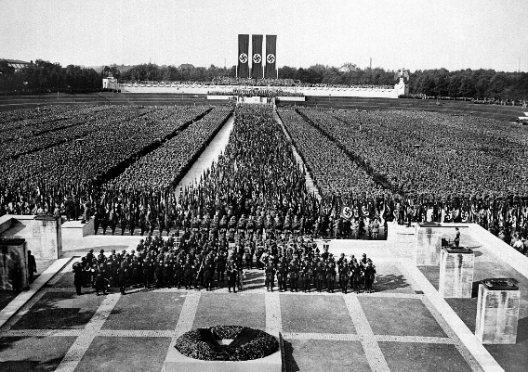
Source B
A still frame taken from Leni Reifenstahl’s 1935 documentary film The Triumph of the Will.

8 marks
How useful are sources C and D for an enquiry into how the Nazi party controlled people's opinions in the 1930s

Source C:  A Nazi Poster from the 1930s. The writing says, ‘All Germany hears the Fuhrer on the people’s Radio’.  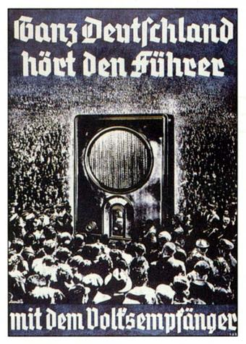 | Source D  An incident reported in the Rhineland, July 1938  In a café, a 64 year old woman remarked to her companion at the table: ‘Mussolini (leader of Italy), has more political sense in one of his boots than Hitler has in his brain’. The remark was overheard and five minutes later the woman was arrested by the Gestapo, who had been alerted by telephone.

TOPIC 4: Life in Nazi Germany 1933-39
What were Nazi Policies to Women?
Gleichschaltung for Women (Nazi Policies towards women)
Gleichschaltung: Making a sure all political, economic, and social activities of every person followed Nazi ideals.
Nazi view of the role of women
- Nazi policies to women reflected Hitler's own views.
- He hated changes to the position of women in society that had happened during the Weimar Republic of the 1920s. e.g. Women gained the vote, went out to work, went out to nightclubs, smoked drank, wore shorter dresses and make up.
- Hitler wanted to create a society where women had a very specific role, motherhood, raising children and looking after husbands who were at work.
The ideal Nazi women had these characteristics:
- Did not wear make up
- Was blond, wide hipped and athletic
- Did not smoke or drink alcohol.
- Did not go out to work
- Did all the household duties, cooking, cleaning and raising children
- Took no interest in politics.

1. Marriage and Family
- A massive propaganda campaign was launched to encourage motherhood and large, healthy, German families.
- 1933 Law for the Encouragement of Marriage gave loans to couples who married and had children. If they had four or more children they didn’t have to pay the loan back.
- 1933 the Sterilisation Law forced people to be sterilised if they had a physical or mental disability. As a result 320,000 were sterilised
- 1935 Marriage Health Law made it illegal for a German and a Jewish person to marry or have a sexual relationship.
- On Hitler's Mother’s Birthday, 12th August, medals were given out to women with large families. They also received 30 marks per child.
- Lebensborn ‘source of life’, a programme where unmarried Aryan women could ‘donate a baby to the Fuhrer’ by becoming pregnant by ‘racially pure SS men’
- In 1933, 1 million babies were born in Germany. By 1939 it was 1.4 million. However, in 1900 it had been 2 million
2. Appearance
- The Nazis encouraged women to keep an appearance that they considered appropriate for having large healthy families.
- They should have long hair but wear it in a bun or plaits.
- Discouraged from wearing trousers, high heels, make up or dyeing and styling their hair.
- Discouraged from dieting and slimming as this was considered bad for child bearing (having children).

3. Work
- The Nazis did not want women to work, instead they wanted women to stay at home and look after children.
- Propaganda encouraged women to follow the three K’s – Kinder Kuche and Kirsche – ‘children cooking and church’
- By 1933 there were 3000 female doctors and 100,00 female teachers. The Nazis sacked them.
- Only 10 % of female applicants were allowed to go to university.
- However after 1937 the Nazis had to reverse this policy. More men were joining the army and so the Nazis needed women to go back to work. The number of women in work decreased 1933 – 1936, however numbers increased to 1939, particular in factory and farm work.
4. Concentration Camps
- Women who disagreed with Nazi views, broke the 1935 Marriage Health Law, had abortions and criticised the Nazis were sent to concentration camps
- Ravensbruck concentration camp housed many women prisoners. By the end of 1939 there were more than 2000 women imprisoned at Ravensbruck.

Gleichschaltung for Women (Nazi Policies towards women)
In my own words Gleichschaltung means…

Hitler wanted to create a society where women had a specific role, more specifically…

The ideal Nazi woman had these characteristics…

1. Marriage and Family
The Nazis aims for women were for them to have…

1933 Law for the Encouragement of Marriage led to…

This helped to achieve the aim of: tick/highlight correct answer(s)
- Encouraging women to have large families
- Encouraging women to have healthy children
- Encouraging women to have ‘pure’ Aryan children.

1933 the Sterilisation Law led to…

This helped to achieve the aim of: tick/highlight correct answer(s)
- Encouraging women to have large families
- Encouraging women to have healthy children
- Encouraging women to have ‘pure’ Aryan children.

1935 Marriage Health Law led to…

This helped to achieve the aim of: tick/highlight correct answer(s)
- Encouraging women to have large families
- Encouraging women to have healthy children
- Encouraging women to have ‘pure’ Aryan children.

On Hitler's Mother’s Birthday, 12th August medals were given to…

This helped to achieve the aim of: tick/highlight correct answer(s)
- Encouraging women to have large families
- Encouraging women to have healthy children
- Encouraging women to have ‘pure’ Aryan children.
Lebensborn ‘source of life’, led to…

This helped to achieve the aim of: tick/highlight correct answer(s)
- Encouraging women to have large families
- Encouraging women to have healthy children
- Encouraging women to have ‘pure’ Aryan children.

Nazi policies towards families were only partially successful because…

2. Appearance
Nazis encouraged… | Nazis discouraged…
Nazi ideas about appearance aimed to…

3. Work
Nazis encouraged women to follow the three K’s which were…
This encouraged women to…
Nazis stopped women working, for example…

Nazis stopped women being educated, for example…
However, their policies to do with work were unsuccessful because…

4. Concentration Camps
The Nazis sent women to concentration camps if they…

The concentration camp women were sent to was called…
By 1939 the number of female prisoners was…

Nazi Policies Towards Women: Check your understanding
- Which law is being described below: A. 1933 Law for the Encouragement of Marriage B. 1933 the Sterilisation Law C. 1935 Marriage Health Law, D. Hitler's Mother’s Birthday, 12th August E. Lebensborn
Forced people to be sterilised if they had a physical or mental disability. As a result 320,000 were sterilised
Medals were given out to women with large families. They also received 30 marks per child.
A programme where unmarried Aryan women could ‘donate a baby to the Fuhrer’ by becoming pregnant by ‘racially pure SS men’
Gave loans to couples who married and had children. If they had four or more children they didn’t have to pay the loan back.
Made it illegal for a German and a Jewish person to marry or have a sexual relationship.
2. The aim of laws about marriage was to encourage…

3. The Nazis were only partially successful at encouraging Germans to have more children, for example…

4. The ideal Nazi women had the following characteristics…

5. The ideal Nazi women had the following appearance…

- The Nazis did not want women to work. Their ideal was summed up by the three KKK’s which in English stood for..

7.The Nazis stopped 3000 female doctors and 100,000 female teachers from continuing with their jobs by…

- Nazi policies at stopping women working were ultimately unsuccessful because…

- Women who broke Nazi rules were sent to…

- The number of women imprisoned by 1939 was…

Gleichschaltung for young People (Nazi Policies towards young people)
Gleichschaltung: Making a sure every person followed Nazi ideals.
Nazi aims for children:
- To be proud Germans who were loyal to Germany
- To be loyal members of the Nazi Party and believe in Nazi policies. To be loyal to Hitler.
- To be strong and healthy for their future roles in society– girls for childbearing – boys for being soldiers and workers.
1. Education
Schools
- Academic ability was not the most important feature of a student for the Nazis. Courage and athletic ability were praised more highly.
- Separate schools for boys and girls
- Napola schools were run by the SS. They focussed on military training and fitness. After leaving school students went straight into the army
- Adolf Hitler Schools were for the best members of the Hitler Youth. They focussed on learning about Nazi policies and glorifying Hitler. After leaving school students went to work for the Nazi Party itself.
Teachers
- It was compulsory for teachers to join the Nazi Party, those that refused were sacked
- Teachers were sent on training courses about Nazi ideals.
- 97% of teachers joined the Nazi Teachers League, an organisation that promoted the teaching of Nazi ideas.
Subjects
- 15% of the school day was devoted to PE – and for boys the was an focus on military training.
- Lessons like foreign languages were scrapped and instead more time was spent studying German history, particularly German military successes.
- Students were taught in biology lessons about the superiority of the Aryan race. They were taught that Jews and other races were inferior and Germans should not marry these races. Children were taught to measure skulls and analyse facial features to classify different racial groups.
- For girls extra lessons were spent on cookery, sewing to encourage them to be good housewives.
What were Nazi Policies towards Young Germans?
Lessons
- All lessons began with the ‘Heil Hitler’ salute
- Every classroom had Nazi flags and posters
- All textbooks had to be approved by the Nazi Party
- Racist ideas and anti Semitism (being anti Jewish) were embedded in all subjects e.g. in literature classes only no Jewish authors, only German authors were studied.

2. Hitler Youth and League of German Maidens
Hitler Youth (boys)
- After 1936 membership was compulsory for all children from the ages of 14-18
- Boys wore a military style uniform and completed activities deigned to prepare them for the army e.g. shooting weapons, camping, marching,
League of German Maiden’s (Girls)
- This was the girls branch of the Hitler Youth. Girls wore uniforms, but learnt cookery, housework, caring for babies and small children, looking after their future husband.
Both groups
- Learnt about Hitler’s ‘greatness’
- Sang patriotic songs
- Learnt about the ‘superiority of Aryans’

3. Success and failures
Education
- The Nazis totally controlled the education system and what was taught in schools.
- Any resistance by teachers meant they were sacked.
Youth Groups
- By 1939 the Hitler Youth had 7 million members
- Many young Germans enjoyed the physical activities and working together as group.
Many other young Germans did not like the rules and having to conform. They joined opposition groups like the Swing Youth and Edelweiss Pirates

Gleichschaltung for young People (Nazi Policies towards young people)
In my own words, Gleichschaltung means…

The three aims of Gleichschaltung for young people were…

1. Education
Schools
The Nazis believed the most important feature of education was…

Napola schools were run by the SS and focussed on…

These policies helped achieve the aim of…

Adolf Hitler Schools focussed on…

This helped to achieve the aim of: tick/highlight correct answer(s)
- To be proud Germans who were loyal to Germany
- To be loyal members of the Nazi Party and believe in Nazi policies. To be loyal to Hitler.
- To be strong and healthy for their future roles in society– girls for childbearing – boys for being soldiers and workers.

Teachers
It was compulsory for teachers to join the Nazi Party, or else they were…
Teachers were s trained about…
97% of teachers joined …
This helped to achieve the aim of: tick/highlight correct answer(s)
- To be proud Germans who were loyal to Germany
- To be loyal members of the Nazi Party and believe in Nazi policies. To be loyal to Hitler.
- To be strong and healthy for their future roles in society– girls for childbearing – boys for being soldiers and workers.

Subjects
More time was devoted to PE, specifically…

This helped to achieve the aim of: tick/highlight correct answer(s)
- To be proud Germans who were loyal to Germany
- To be loyal members of the Nazi Party and believe in Nazi policies. To be loyal to Hitler.
- To be strong and healthy for their future roles in society– girls for childbearing – boys for being soldiers and workers.

More time was spent learning about History, specifically…

This helped to achieve the aim of: tick/highlight correct answer(s)
- To be proud Germans who were loyal to Germany
- To be loyal members of the Nazi Party and believe in Nazi policies. To be loyal to Hitler.
- To be strong and healthy for their future roles in society– girls for childbearing – boys for being soldiers and workers.

Biology lessons were changed, more specifically….

This helped to achieve the aim of: tick/highlight correct answer(s)
- To be proud Germans who were loyal to Germany
- To be loyal members of the Nazi Party and believe in Nazi policies. To be loyal to Hitler.
- To be strong and healthy for their future roles in society– girls for childbearing – boys for being soldiers and workers.

Girls were encouraged to…

This helped to achieve the aim of: tick/highlight correct answer(s)
- To be proud Germans who were loyal to Germany
- To be loyal members of the Nazi Party and believe in Nazi policies. To be loyal to Hitler.
- To be strong and healthy for their future roles in society– girls for childbearing – boys for being soldiers and workers

Lessons
All lessons began with…
All classrooms had…
All subjects contained ideas about…
This helped to achieve the aim of: tick/highlight correct answer(s)
- To be proud Germans who were loyal to Germany
- To be loyal members of the Nazi Party and believe in Nazi policies. To be loyal to Hitler.
- To be strong and healthy for their future roles in society– girls for childbearing – boys for being soldiers and workers

2. Hitler Youth and League of German Maidens
Hitler Youth (boys)
Compulsory for all after the year…
Boys took part in activities such as…

League of German Maiden’s (Girls)
Girls took part in activities such as…

This helped to achieve the aim of: tick/highlight correct answer(s)
• To be proud Germans who were loyal to Germany
• To be loyal members of the Nazi Party and believe in Nazi policies. To be loyal to Hitler.
• To be strong and healthy for their future roles in society– girls for childbearing – boys for being soldiers and workers

3. Success and failures
Nazi Education policies were successful, more specifically…

In some ways Nazi Youth group policies were successful, for example

In other ways they were not, for example…

Nazi Policies Young People: Check your understanding
- Which Nazi policy towards young people is being described?
A. Schools B Hitler Youth C League of German Maidens
Compulsory for all boys after 1936
Every lesson started with Heil Hitler salute
Girls learnt about caring for babies, housework and caring for their future husband
Focus on military History and learning about German victories
- List two ways German schools prepared children for future roles in society

- List two ways German schools prepared children for to be loyal Nazis

- List two ways German schools prepared children to understand Nazi policies

- List two ways German the Hitler Youth prepared children for future roles in society

- List two ways German the Hitler Youth prepared children to be loyal Nazis

- List two ways German the Hitler Youth prepared children to understand Nazi polices

- Nazi policies to young people were successful, for example…

- Nazi policies to young people were partially unsuccessful because…

What were Nazi Policies towards Minorities?
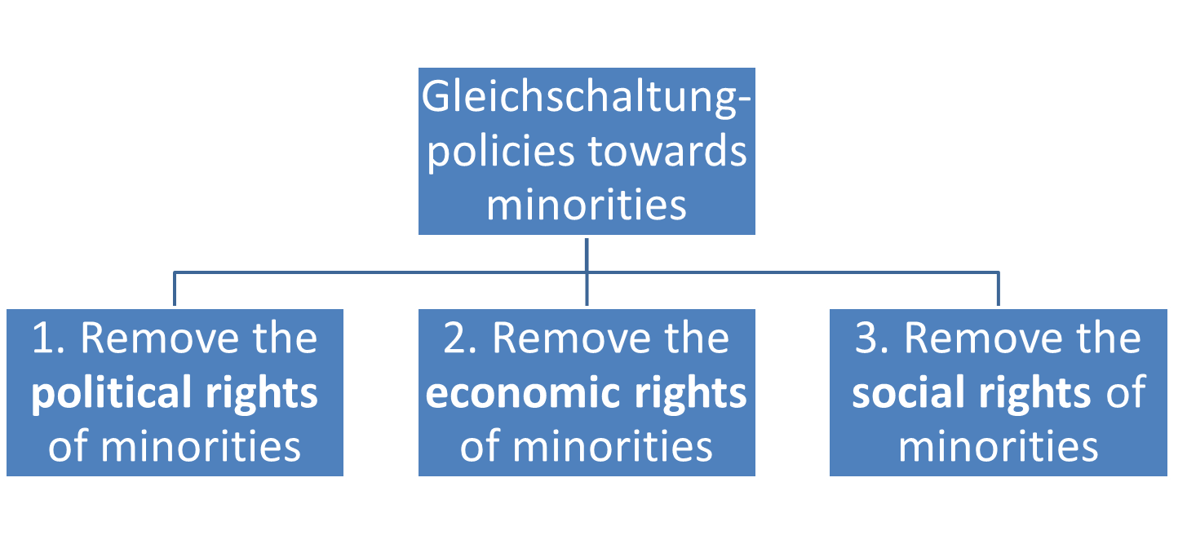

Nazi Racial Beliefs Influenced their polices to minorities.
- In order to win support before 1933, Hitler had used the Jews as scapegoats for many of Germany’s problems e.g. Germany's defeat in World War I and the harshness of the Treaty of Versailles
- Once in power, Goebbels and the Ministry of Propaganda was used to turn more and more Germans against Jews and justify the Nazi policy of persecution against Jews.
- Other groups were also persecuted by the Nazis e.g Gypsies, homosexuals, the mentally ill and the physically disabled.
- These groups were persecuted because race policy was central to the Nazi government
- This was based on Hitler’s theory of race. He believed Germans were Aryans, the master race (Herrenvolk) and all other groups were sub-human (untermenchen)
- Hitler believed Germany’s future success was based on the creation of a pure Aryan state. The ideal Aryan was tall, blonde and blue eyed
- This would be achieved by selective breeding – preventing anyone who did not conform to the Aryan type from having children and destroying the Jews.
- Gleichschaltung- ways the Nazis achieved selected breeding and destroyed the Jews 1. Remove the political rights of minorities 2. Remove the economic rights of minorities 3. Remove the social rights of minorities

1933 | - The SA organised a boycott of Jewish owned shops. They painted Jude (Jew) on the windows and stood outside persuading people not to enter.  - All Jews who were civil servants (government office workers) were sacked.  Examples of Jews’ economic rights being removed. Jews struggled to earn money to survive.
1934 | - Local councils Jews were banned from public spaces such as parks, plating fields and swimming pools  - An example of Jews’ social rights being removed. Jews could not take part in society fully.
1935 | - Nuremburg Laws – two important racial laws  - Reich Citizenship Law: meant that only Aryans could be German citizens. This meant Jews lost their citizenship. They lost all their rights, including the right to vote.  - An example of political rights being removed. Jews were no longer protected by the law or able to vote to change the law.  - Law to protect German Blood: made marriage or sexual relationships between Aryans and Jews illegal.  - An example of Jews’ social rights being removed. Jews could not take part in society fully, they could not choose who they had relationships with
1936 | - Jews were banned from being doctors, vets, dentists, accountants, teachers and nurses.  - Examples of Jews’ economic rights being removed. Jews struggled to earn money to survive.
1938 | - 9 November, Kristallnacht  - Goebbels organised attacks across Germany on Jewish shops, homes and synagogues. So many windows were smashed in the attacks that the 9th November became known as ‘Kristallnacht’ meaning ‘Crystal Night’ or ‘Night of Broken Glass’  - 100 Jews were killed and 20,000 were arrested and sent to concentration camps. 7500 Jewish businesses and 191 synagogues were destroyed  - Hitler officially blamed Jews themselves for having provoked the attacks. He ordered Jewish communities to pay 1 billion marks compensation for the damage caused and banned Jews from owning business. This made Jews pay for repairs to their businesses which were then confiscated from them and given to Germans  - Examples of Jews’ economic rights being removed. Jews could not to earn money to survive.  - Examples of Jews’ social rights being removed. Bullying and intimidation had reached new levels. Homes were destroyed and many Jews were arrested
1939 | - Jewish children were banned from Aryan schools  - Jews were forced to live in designated ‘Jewish’ areas or ghettos  - Examples of Jews’ social rights being removed. They could not longer choose to live or be educated where they wanted
Other groups | - Jewish children were banned from Aryan schools  - Jews were forced to live in designated ‘Jewish’ areas or ghettos  - Examples of Jews’ social rights being removed. They could not longer choose to live or be educated where they wanted

Nazi Racial Beliefs Influenced their policies towards minorities.
Before 1933, Hitler blamed Jews for…
After 1933, propaganda was used to justify…
Other minority groups persecuted by the Nazis were…
Hitler believed that the German’s were…
Hitler believed all other races were…
Nazi policies towards minorities aimed to create…
The Nazis meant to achieve this aim by doing two things for example…
The Nazis attempted selective breeding and destroying the Jews by doing three things, for example…
1933
The SA organised…
All Jewish civil Servants were…
These examples removed… tick/highlight correct answer(s)
- Political rights of minorities
- Economic rights of minorities
- Social rights of minorities (social rights = being included equally in society)
1934
Jews were banned from…
This removed…
1935
Nuremburg Laws
Reich Citizenship Law meant that…
This removed… tick/highlight correct answer(s)
- Political rights of minorities
- Economic rights of minorities
- Social rights of minorities (social rights = being included equally in society)
Law for the Protection of German Blood meant that…
This removed… tick/highlight correct answer(s)
- Political rights of minorities
- Economic rights of minorities
- Social rights of minorities (social rights = being included equally in society)
1937
Jews were banned from being…
This removed… This removed… tick/highlight correct answer(s)
- Political rights of minorities
- Economic rights of minorities
Social rights of minorities (social rights = being included equally in society)
1938

Kristallnacht
When Goebbels organised…
Also known as…
Because…
Many Jews suffered, for example…
This removed… tick/highlight correct answer(s)
• Political rights of minorities
• Economic rights of minorities
• Social rights of minorities (social rights = being included equally in society)
Other groups
The mentally ill were persecuted, for example…
Homosexuals were persecuted, for example…
Gypsies were persecuted, for example…

Nazi Policies Towards Minorities : Check your understanding
- Put these examples of Jewish persecution on chronological order 1-6. Add the date they happened
 | Kristallnacht  Date: |  | Nuremburg Laws  Date:
 | Boycott of Jewish shops by SA  Date: |  | Jews banned from public spaces e.g. parks  Date:
 | Banned from professional jobs e.g doctor, teacher etc  Date: |  | Forced to live in ghettos  Date:
2. Give an two examples of economic rights being removed

3. Give two examples of social rights being removed

4. Give an example of political rights being removed
5. The Reich Citizenship Law meant that…
6. The Law for Protection of German Blood meant that…
7. Describe what happened on Kristallnacht
9. Why was it called Kristallnacht?

How did the Nazis try to improve the economy?
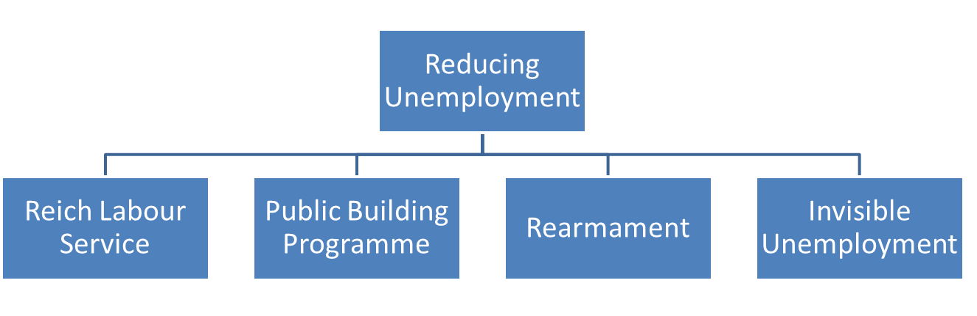

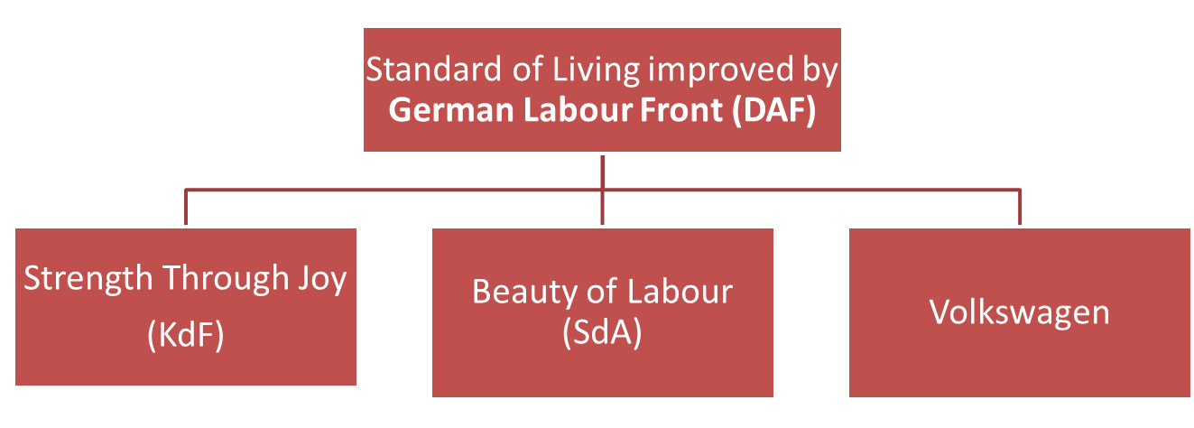

Nazi Policies to end unemployment 1933-1939
- One of the main reasons support fro the Nazis increased after 1929 was the high level of unemployment caused by the Wall Street Crash. By 1932, 6 million people were unemployed.
- Once in power the Nazis reduced unemployment. They knew it was important to reduce unemployment to prevent people becoming unhappy with Nazi rule.
- The Nazis were successful at reducing unemployment. By 1939 there were only 300,000 unemployed people
In the table below are the four reasons why Nazis were able to reduce unemployment

Reich Labour  Service | - This was an organisation that provided young men with manual labour jobs. For example, clearing leaves from parks  - From 1935 it was compulsory for all men aged 18-25 to serve in the Reich Labour Service for 6 months  - Workers lived in camps, had very low wages, wore uniforms and did military drill as well as working.
Public Building Programmes | - The Nazis spent billions on public building programmes. 37.1 billion marks in 1938  - The Nazis paid private companies to build, schools, swimming pools and autobahn – motorways.  - Building the autobahn employed 125, 000 alone. Hitler also hoped the autobahn would help speed up the movement of soldiers during wartime
Rearmament | - Hitler was determined to build up Germany’s military so it was ready for war. This broke the Treaty of Versailles, Hitler was not concerned by this and none of the allies attempted to stop him  - He reintroduced conscription. The army grew from 100,000 men in 1933, to 1.4 million men by 1939.  - Millions of men were employed in factories producing goods the army needed. e.g. chemical production for explosives doubled from 1933-39. Oil and steel production trebled.  - Billions were spent on making weapons; tanks, aircraft and ships. In 1933 3.5 million marks was spent on weapons. By 1939 it was 26 billion marks.
Invisible unemployment | - Nazis used sneaky tactics to keep the official unemployment figures down. Official figures did not include the following  - Jews sacked from their jobs or who had their business destroyed and confiscated.  - Members of the Reich Labour Service  - Women sacked from their jobs or who were convinced to stay at home to raise families.  - Opponents of Nazis arrested and imprisoned in concentration camps.
Nazi Policies to raise living standards 1933-1939
- The Nazis knew that propaganda and the threat of the Gestapo were not enough to make sure people were obedient and conformed to Nazi policies.
- To win workers over and make them feel like they were all part of one German community, the Nazis tried to improve living standards.
- They did this through an organisation called the German Labour Front (Deutsche Arbeitsfront). This replaced all previous trade unions and all workers had to be a member. The German Labour Front had a number of ideas to make workers happy

BETTER OFF
Strength Through Joy | - Set up by the German Workers Front, Strength Through Joy improved the leisure time of workers. It set up trips, for example, concerts, theatre, museum, sporting events, camping holidays and cruises to other countries. Strength Through Joy organised these trips for reduced prices and so ordinary workers could experience trips that previously only wealthier people could afford. In 1938 10 million Germans went on trios organised by Strength Through Joy
Beauty of Labour | - A department of Strength through Joy that improved working conditions. Building better canteens, swimming pools and sports facilities
Volkswagen | - In 1938 the German Workers Front set up the ‘People’s Car’ (Volkswagen) scheme. Workers could pay 5 marks a month, eventually allowing them to own their own car – a luxury usually only available to the very rich
WORSE OFF
Lack of Freedom |  | - It was compulsory to join the German Labour Front and the Reich Labour Service. The German Labour Front banned workers from negotiating better pay and conditions.
Strength through Joy |  | - Very few workers could actually afford the best holidays e.g. cruises to Spain.  - Beauty of Labour projects had to be completed by workers in their spare time. Few did.
Volkswagen |  | - Ordinary people saving for a car was a trick. By 1939 not one worker had received a car. When the war started the Nazis spent all the saved money on weapons for the army
Hours of work |  | - Working hours increased under the Nazis. Average hours per week in 1933 was 42. In 1939 it was 48. This suggests that balance between work and leisure time was worse under the Nazis

Nazi Policies to deal with Unemployment and Living Standards : Check your understanding
- Label ‘E’ if it was designed to improve the economy and reduce unemployment. ‘L’ if aimed to improve living standards
L | Volkswagen |  | Reich Labour Service
 | Autobahn |  | German Labour front
 | Strength Through Joy |  | Rearmament
 | Invisible Unemployment
2. Who did the Reich Labour Service employ? How long for?
3. Give two examples of things built by public building programmes
4. Give two examples of how rearmament reduced unemployment
5. Give two ‘invisible’ groups who were not included in the official unemployment statistics
6. Describe the role of the German Labour Front
7. Give two examples of activities that were organised by Strength Through Joy
8. Give two examples of how Beauty of Labour improved working conditions
9. What was the ‘Volkswagen’ and how did it improve living standards?

Knowledge Task | Tick When Complete
Topic 4 Life in Nazi Germany; Look, cover write check on blank knowledge organiser
Topic 4 Life in Nazi Germany; multiple choice quiz (repeat till 100% correct)
Topic 4 Life in Nazi Germany-; free recall quiz (repeat till 100% correct)

12 marks
Explain why women’s lives changed in Nazi Germany 1933- 39.
- Large families
- employment
Explain why there was opposition to the Nazis 1934 -39. You may use:
- Swing Youth
- Confessional Church
Explain why the lives of young Germans changed 1933-39. You must use:
- Schools
- Hitler Youth
Explain why the lives minorities changed in Nazi Germany 1933-39. You must use:
- The Nuremburg Laws 1935
- Kristallnacht 1938
Explain why here was a great reduction in unemployment in Germany 1933-39
- The Reich Labour Service
- Rearmament
4 marks
Give two things you can infer from Source B about Nazi propaganda about the treatment of minorities in Nazi Germany
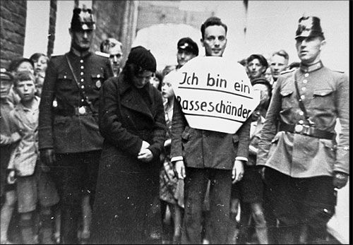
Source A: A Jewish women and her German boyfriend being humiliated by the police in a town square. His placard reads ‘I am a race defiler’ defile = spoil or ruin

History Paper 3 –- Germany - 1. Treaty of Versailles and Weimar Germany 1919-29
Question | Choose one of the answers below
- On 11th November 1918 the armistice was signed. What was this? | End of fighting in World War I | Kaiser Abdicated | Weimar Constitution
- Right wing Germans believed the myth that Germany could have won World War I but they were betrayed by Jews and communists. What was this called? | brown shirts | November Criminals | Stab in the back myth
- What did right wing Germans call the politicians who signed the armistice? | brown shirts | November Criminals | Stab in the back myth
- In January 1919 communists tried to take control of Berlin. What was this called? | Kapp Putsch | Spartacist Uprising | Munich Putsch
- In June 1919 the Treaty of Versailles was signed. What were its terms? | Book burning: students burnt books in Berlin by Jews and communists  Newspapers: Nazi newspaper Volkischer Beobachter = ‘People's Observer’. All other papers banned | 1923 Retenmark. New currency put an end to hyperinflation  1924 – Dawes Plan – loans to Germany from USA  1929 Young Plan – reduced monthly reparations payments | B = Blame. Germany had to take blame for the war. Clause 231  R = Reparations;  A = Army; limited to 100,000 men. No air force, no tanks, no submarines  T = Territory; Germany lost land e.g. Alsace-Lorraine, Saar, all African colonies
- August 1919 A new constitution was signed in which German town? | Berlin | Weimar | Munich
- In 1920 a right wing General tried to take over Berlin. What was this called? | Kapp Putsch | Spartacist Uprising | Munich Putsch
- In 1921 the amount of reparations was set. How much? | £6.6. billion | £ 6 million | £1 million
- What did the French do in January 1923 when Germany stopped paying reparations | Signed the Treaty of Versailles | Invaded the Ruhr | Joined the League of Nations
- The Weimar republic printed money to pay striking workers, what did this cause? | Hyperinflation | Great Depression | Wall Street Crash
- What was the event when the Nazis tried to take control of Bavaria? | Kapp Putsch | Spartacist Uprising | Munich Putsch
- What new currency was introduced in 1923 which stopped hyperinflation? | Retenmark | Young Plan | Dawes Plan
- What gave loans to Germany and helped economic recovery in 1924? | Retenmark | Young Plan | Dawes Plan
- What reduced the monthly amount of reparations in 1929? | Retenmark | Young Plan | Dawes Plan
- Who experienced a Golden Age 1924-29 because of increase social freedom | Women | Factory Workers | Nazis
- What music became popular during the Golden age? | Jazz | Blues | Techno
- Who experienced a Golden Age 1924-29 because of increased wages? | Women | Factory Workers | Nazis
- Who was a modern artist in the Golden Age? | Josef Goebbels | George Grosz | Marlene Dietrich
- Who was a famous actress in the Golden Age? | Josef Goebbels | George Grosz | Marlene Dietrich
- Why did the middle class not experience a Golden Age? | Price of wheat fell | Lost savings because of hyperinflation. | Great Depression
- Why did farmers not experience a Golden Age? | Price of wheat fell | Great Depression | Lost savings because of hyperinflation.
- Traditional Germans blamed modern art and music for increasing crime. The most gruesome example was? | Josef Goebbels | Peter Kurten ‘the Vampire of Dusseldorf’ | Marlene Dietrich

History Paper 3 –- Germany - Topic 2: Nazi Party 1919-33
Question | Choose one of the answers below
- Why was Hitler successful World War I | He was wounded several times | He Won the highest German medal for bravery. The Iron Cross First Class | He was hospitalised by a gas attack
- Hitler was angry about the end of World War I, what myth did he believe in? | Golden Age | Spartacist Uprising | ‘stab in the back’ myth
- What was the 25 point plan, announced in 1920? | Weimar Constitution | Hitler’s autobiography | Outlined key Nazi ideas
- Part of the 25 point plan was the creation of a body guard for the whole party. What were they called and what colour shirts did they wear? | SA (Sturmabteilung)  Brownshirts | KPD (German Communist Party)  Redshirts | SS  (Schutzstaffel)  Blackshirts
- When did Hitler become leader of the Nazi Party? | 1921 | 1919 | 1925
- What was a cause of the Munich Putsch to do with politics? | Wall Street Crash | Hyperinflation | Hated of the Treaty of Versailles and support from General Ludendorff
- What was a cause of the Munich Putsch to do with economics? | Wall Street Crash | Hyperinflation | Hated of the Treaty of Versailles and support from General Ludendorff
- What was a consequence of the Munich Putsch for Hitler? | He was shot and killed | He was put on trial and imprisoned | He was put on trial and acquitted
- What was a consequence of the Munich Putsch for the Nazi Party? | They decided to gain power through elections instead of force | The changed their name to the German Workers Party | The Great Depression
- Hitler’s bodyguard was created at the Bamberg conference in 1926. What was it called, and what colour shirts did they wear? | SA (Sturmabteilung)  Brownshirts | KPD (German Communist Party)  Redshirts | SS  (Schutzstaffel)  Blackshirts
- Nazi Youth group was created in 1926, what was it called? | Hitler Youth | Nazi Youth | Swing Youth
- The Nazis were not successful in elections 1925-1929. What did they call this period? | Hard Years | Lean Years | Quiet Years
- What economic event was the origin of increased Nazi popularity after 1929? | Wall Street Crash caused the Great Depression | French Invasion of Ruhr caused hyperinflation | Reparations set at £6.6 billion
- How many Germans were unemployed by 1932? | 6.6 billion | 6 million | 60, 000
- What left wing political party became more popular as a result of the Great Depression | Nazi Party | Centre Party | German Communist Party (KPD)
- Which sections of German society were scared of the Communist party? | Factor workers and the unemployed | Middle class, upper class and farmers | Jews, women and Gypsies
- How did Hitler exploit fear of communism 1929-32? | He put communists in prison | He offered to join forces with the communists | Through passionate and persuasive speeches
- What was the job of Josef Goebbels? | Head of Propaganda | Head of the SS | Head of the Gestapo
- Which rich businessmen paid for Nazi propaganda? | Rohm, Goebbels and Goering | Bruning, von Papen and von Schleicher | Bosch, Krupp and Thyssen
- What did Bruning do wrong that meant he was sacked as Chancellor? | Wanted to give farmland to the unemployed | Wanted to create a ‘querfront’ cross front of all parties including the communists | Wanted to scrap the Weimar constitution
- What did Von Papen do wrong that meant he was sacked as Chancellor? | Wanted to give farmland to the unemployed | Wanted to create a ‘querfront’ cross front of all parties including the communists | Wanted to scrap the Weimar constitution
- What did von Schleicher do wrong that meant he was sacked as Chancellor? | Wanted to give farmland to the unemployed | Wanted to create a ‘querfront’ cross front of all parties including the communists | Wanted to scrap the Weimar constitution
- Von Papen convinced Hindenburg he could control Hitler. What did he say? | He could ‘make Hitler squeak’ | He could ‘make Hitler speak’ | He could ‘make Hitler quake’
- When did Hindenburg make Hitler Chancellor? | 30th January 1933 | 30th February 1933 | 30th March 1933

History Paper 3 –- Germany- Topic 3: Control through the Police State
Question | Choose one of the answers below
- Which event was the origin of Hitler becoming dictator? | March 1933: Enabling Act | February 1933: Reichstag Fire | February 1933: Decree for the Protection of German People
- Next Hitler used Article 48 to give him a majority in the Reichstag. How did he do this? | March 1933: Enabling Act | February 1933: Reichstag Fire | February 1933: Decree for the Protection of German People
- This allowed the Reichstag to pass a law that gave him the power to make laws by himself. What was it called? | March 1933: Enabling Act | February 1933: Reichstag Fire | February 1933: Decree for the Protection of German People
- Next; Hitler destroyed his rivals within the Nazi Party, in particular Ernst Rohm. What was this called? | July 1934: Night of the Long Knives | August 1934: Hitler declared himself Fuhrer of Germany | August 1934: army swore loyalty to Hitler and gave ‘heil Hitler’ salute
- When did Hindenburg die, allowing Hitler to merge the jobs pf Chancellor and President? | July 1934: Night of the Long Knives | August 1934: Hitler declared himself Fuhrer of Germany | August 1934: army swore loyalty to Hitler and gave ‘heil Hitler’ salute
- What final event meant Hitler was secure in his position as dictator? | July 1934: Night of the Long Knives | August 1934: Hitler declared himself Fuhrer of Germany | August 1934: army swore loyalty to Hitler and gave ‘heil Hitler’ salute
- Who was the leader of the SS | Henrich Himmler | Josef Goebbels | Ernst Rohm
- From 1934 the SS was not just Hitler’s bodyguard. It was part of the police state, controlling ordinary Germans. Which part of the SS spied on people? | Gestapo | People’s Court | SD
- Which part of the SS arrested opponents? | Gestapo | People’s Court | SD
- Which part of the police state sentenced opponents at unfair trials? | Gestapo | People’s Court | SD
- Where were opponents imprisoned? | Prison | Concentration Camps | Extermination Camps
- Who was the Head of Propaganda? | Henrich Himmler | Josef Goebbels | Ernst Rohm
- What was the most common form of propaganda | Posters | Films | Radio
- The Nazis filmed rallies and showed them at cinemas. What was the film of a rally at Nuremberg in 1935 called? | Hitler Youth Quex | Triumph of the Will | The Eternal Jew
- What was the cheap radio called that beamed Hitler’s propaganda directly into homes | Volkswagen | Strength Through Joy | People’s Radio
- What entertainment film contained anti-communist propaganda? | Hitler Youth Quex | Triumph of the Will | The Eternal Jew
- What topic did the Nazis make artists focus on? | Family life and hard work | Anti-war and army | Anti-Treaty of Versailles
- Which event encouraged German’s to play sport and as supposed to demonstrate Aryan superiority? | Kristallnacht 1938 | Berlin Olympics 1936 | Dachau 1933
- What censorship method stopped people from reading books the Nazis did not approve of? | Book burning | Modern art and jazz banned | All non-Nazi Newspapers banned
- What censorship method stopped people from reading newspapers the Nazis did not approve of? | Book burning | Modern art and jazz banned | All non-Nazi Newspapers banned
- What censorship method stopped people from listening to foreign radio? | People’s radios could not receive the BBC | Modern art and jazz banned | All non-Nazi Newspapers banned
- How did Catholics resist the Nazis? | Pastor Niemoller organised the ‘Confessional Church’ which criticised Nazis | Criticised Hitler in church and gave loyalty to the Pope. | Listened to banned Swing Music
- How did Protestants resist the Nazis? | Pastor Niemoller organised the ‘Confessional Church’ which criticised Nazis | Criticised Hitler in church and gave loyalty to the Pope. | Listened to banned Swing Music
- How did Edelweiss Pirates resist the Nazis? | Clothes; shorts and checked shirts, wrote graffiti, fought Hitler Youth | Organised parties to drink, smoke and listen to banned swing music | Criticised Hitler in church and gave loyalty to the Pope.
- How did Swing Youth resist the Nazis? | Clothes; shorts and checked shirts, wrote graffiti, fought Hitler Youth | Organised parties to drink, smoke and listen to banned swing music | Criticised Hitler in church and gave loyalty to the Pope.

History Paper 3 –- Germany- Topic 4: Life in Nazi Germany 1934-39
Question | Choose one of the answers below
- Which law to women encouraged marriage and children by giving loans | Law for Encouragement of Marriage 1933 | Sterilisation Law 1933 | Law for the protection of German Blood 1935
- Which law led to sterilisation of 320,000 mentally and physically disabled people | Law for Encouragement of Marriage 1933 | Sterilisation Law 1933 | Law for the protection of German Blood 1935
- On Hitler’s Mother’s birthday, 12th August what was given to women with large families? | Loans | Medals for the amount of children they had. Bronze= 4, silver= 6 Gold =8. | cake
- Which group encouraged young, unmarried girls to get pregnant by an SS officer | Napola Schools | League of German Maidens | Lebensborn
- What kind of appearance did Nazis encourage for women? | Long hair in plaits, no makeup, long dress | Short hair, make up, short skirts | trousers
- What slogan encouraged women to be housewives? | All Young boys are in the Hitler Youth | Kinder, Kirche, Kuche (children, church, cooking) | Thousand Year Reich
- Which concentration camp were women sent to if the opposes the Nazis? | Dachau | Auschwitz | Ravensbruck
- What was the most important subject I Nazi schools | PE | English | Maths
- Which schools were run by the SS? | Napola Schools | Hitler Youth Schools | Lebensborn
- Which Schools took the best members of the Hitler Youth? | Napola Schools | Hitler Youth Schools | Lebensborn
- What were students taught in Biology | Theory of evolution | The superiority of the Aryan race | Military History
- What Nazi youth group prepared boys for war with military drill and physical exercise? | Hitler Youth | League of German Maidens | Lebensborn
- What Nazi youth group prepared girls to become housewives | Hitler Youth | League of German Maidens | Lebensborn
- In 1933 how did SA remove economic rights of Jews? | Boycotted Jewish shops | Jews banned from professions, lawyer, teacher, doctor | Kristallnacht 1938
- In 1934 where were Jews banned from? | Public spaces e.g. parks | Jews banned from professions, lawyer, teacher, doctor | Having relationships with Aryans
- In 1935 which Nuremberg Law prevented Jews form being citizens and took away their right to vote? | Law for the Protection of German Blood | Reich Citizenship Law | Law for Encouragement of Marriage 1933
- In 1935 which Nuremberg Law prevented Jews from marrying or having a relationship with Aryans? | Law for the Protection of German Blood | Reich Citizenship Law | Law for Encouragement of Marriage 1933
- In 1936 what were Jews banned from? | Public spaces e.g. parks | Jews banned from professions, lawyer, teacher, doctor | Having relationships with Aryans
- In 1938, the SA organised attacks on Jewish, shops, business and homes. What was this called? | Boycotted Jewish shops | Jews banned from professions, lawyer, teacher, doctor | Kristallnacht 1938
- Where were Jews forced to live from 1939 | ghettos | Auschwitz | Austria
- Which organisation did 18-25 year olds have to join for 6 months? | Invisible unemployment | Rearmament | Reich Labour Service
- Unemployment was reduced by conscription and building tanks etc for the army. What was this called? | German Workers Front (DAF) | Rearmament | Reich Labour Service
- What were 125, 000 men employed building? | Autobahn | Aircraft | Tanks
- Nazis did not count unemployed Jews and housewives. What was this called? | Invisible unemployment | Rearmament | Reich Labour Service
- What was the Nazis workers union called | Strength Through Joy | Beauty of Labour | German Workers Front (DAF)
- Which part of the union organised leisure activities for workers | Strength Through Joy | German Communist Party (KPD) | German Workers Front (DAF)
- Which part of the union improved working facilities e.g canteens? | Beauty of Labour | German Communist Party (KPD) | German Workers Front (DAF)
- What was the cheap car that the Nazis promised workers? | Mercedes-Benz | BMW | Volkswagen (People’s Car)

