Year 9 Module 1:

Othello Remote Learning

Name:
Teacher:
Class:

Instructions for Students

You need this booklet, as well as the one that is printed and contains the text of Othello. The two booklets work together. This one contains all the activities and tasks you need. The other booklet contains the text you’ll need to read.
This booklet takes you through the work you need to cover lesson-by-lesson. You should be completing a lesson for every lesson you miss in class.
If you finish all the work, you can do the following:
- Test yourself on the vocabulary list
- Use the words in the vocabulary list to write sentences about the characters in Othello
- Use the words in the vocabulary list in creative writing about the characters in Othello
- Learn the Most Revealing Moments
- Use the Most Revealing Moments to write sentences about the characters in Othello
- Use the Most Revealing Moments to write descriptions of the characters in Othello
- Imagine that you are the characters at the end of Othello. Use the vocabulary list and the Most Revealing Moments to write about how you feel.

Vocabulary
Word | Definition | Example
Duplicitous (adjective) | Someone who is duplicitous lies and is two-faced. | The duplicitous friend was never trusted.
Credulous  (adjective) | If you describe someone as credulous, they are too ready to believe what people tell them and are gullible. | Because she was credulous, she was always easily fooled by her friends’ foolish stories.
Malevolent  (adjective) | A malevolent person deliberately tries to cause harm or evil. | She showed she was malevolent when she stole from her friend.
Benevolent  (adjective) | If you describe a person as benevolent, they are kind and fair. | Because she was benevolent, she had many friends.
Impervious to  (adjective) | If you are impervious to someone's actions, you are not changed by them. | She seems almost impervious to the criticism.
Affected by  (verb) | If you are affected by someone’s actions, you are changed by them. | He was deeply affected by the film about climate change.
Dehumanise  (verb) | If you dehumanise someone, you treat them as less than human. | The years of civil war have dehumanised all of us.
Defer to  (verb) | If you defer to someone, you follow them because you respect them or their authority. | I defer to my superior when I’m planning my lessons.
Stabilise  (verb) | If you stabilise someone or something, you make it stable. | She added glue to stabilise the table legs.
Destabilise  (verb) | If you destabilise something, you make it unstable. | Their aim is to destabilise the government.
Subservient  (adjective) | If you are subservient, you do whatever someone wants you to do. | He was taught to be subservient to his parents.
Hierarchy  (noun) | A hierarchy is a system of organising people into different ranks or levels of importance | She was at the top of the social hierarchy.
Malcontent  (noun) | You can describe people as malcontents when you disapprove of the fact that they are unhappy with a situation and want it to change. | Even though he had no reason to be unhappy, he was a malcontent
Animalistic  (adjective) | If you describe a person or their behaviour as animalistic, you mean that they behave like an animal. | The two teams were matched in a ferocious, almost animalistic battle.
Alien  (adjective) | If something is alien to you, it is not normal or expected. | This attitude was alien to many businesspeople.
Alien  (noun) | An alien is an insulting word for someone who is not familiar to you. | He said they were against alien forces in the region.
Controlled  (adjective) | Someone who is controlled stops themselves from behaving badly or strangely. | They talked it through in careful, controlled voices.
Subvert  (verb) | To subvert something like a rule or expectation means to destroy its power by going against it. | This government will not allow anyone to subvert the law.
Subversion  (noun) | Subversion is the attempt to weaken or destroy a system. | He was arrested in parliament on charges of subversion for organizing the protest.
Deceptive  (adjective) | If something or someone is deceptive, it encourages you to believe something which is not true. | Appearances can be deceptive.
Fascination  (noun) | A feeling of fascination is a feeling of being greatly interested by something. | I've had a lifelong fascination with the sea
Entrance  (verb) | If something or someone entrances you, they cause you to feel delight and wonder, often so that all your attention is taken up and you cannot think about anything else. | Last Friday she entranced the audience with her dancing.
Steadfast  (adjective) | If someone is steadfast in something that they are doing, they are convinced that what they are doing is right and they refuse to change it or to give up. | He remained steadfast in his belief that he had done the right thing.
Reverence  (noun) | Reverence for someone or something is a feeling of great respect for them. | The silence in church showed their deep reverence for their religion.
Stereotype  (noun) | A stereotype is a fixed general image or set of characteristics that a lot of people apply to someone without knowing them. | She went against stereotypes held by her family by becoming a builder.
Measured  (adjective) | You use measured to describe someone who is careful. | They spoke in soft, measured tones.
Logical  (adjective) | Someone who is logical is sensible and thinks carefully about things. | She made sure her reasons were logical and she was following the rules.
Machination  (noun) | A machination is a plot or a plan. | His machination was working; he had managed to force everyone to do what he wanted!
Manipulation  (noun) | Manipulation is persuading someone to do something they don’t want to do forcefully. | She was a victim of her friend’s manipulation.
Soliloquy  (noun) | A soliloquy is a speech in a play in which an actor or actress speaks to himself or herself and to the audience, rather than to another actor. | In Iago’s soliloquy, he confesses his plans to the audience.
Deferential  (adjective) | Someone who is deferential is polite and respectful towards someone else. | They always went to the same restaurant because the staff were so deferential towards them!
Machiavellian  (adjective) | If you describe someone as Machiavellian, you are critical of them because they often make clever and secret plans to achieve their aims and are not honest with people. | A Machiavellian plot was suspected.
Complimentary  (adjective) | If you are complimentary about something or someone, you say you like and admire it or them. | We often get complimentary remarks about the cleanliness of our patio.
Hyperbole  (noun) | If someone uses hyperbole, they say or write things that make something sound much more impressive than it really is. | The hyperbole in the newspapers made everyone think he was the best leader in the world.
Contrast  (noun) | A contrast is a great difference between two or more things which is clear when you compare them. | The two visitors provided a startling contrast in appearance.
Ecstatic  (adjective) | If you are ecstatic, you feel very happy and full of excitement. | They were greeted by the cheers of an ecstatic crowd.
Knavery  (noun) | Knavery is dishonest behaviour. | The office was full of knavery and lies.
Motive  (noun) | Your motive for doing something is your reason for doing it. | The doctor's motive was to bring an end to his patient's suffering.
Malignity  (noun) | Malignity is being deadly and evil. | Malignity was everywhere in the town.
Ambiguity  (noun) | If you say that there is ambiguity in something, you mean that it is unclear or confusing, or it can be understood in more than one way.  (Ambiguous – adjective) | Students sometimes struggle with the ambiguities of the English language.  The author's style suggests a certain ambiguity in his moral view.
Disguise  (verb) | To disguise something means to hide it or make it appear different so that people will not know about it or will not recognise it. | Their healthy image disguises the fact that they are highly processed foods.  I played along, and disguised my voice.
Objectify  (verb) | If you objectify someone, you treat them as an object.  (Objectification – noun) | The way he spoke to his friend made him feel objectified.
Cajole  (verb) | If you cajole someone into doing something, you get them to do it after persuading them for some time. | It was he who had cajoled Garland into doing the film.  He cajoled Mr Dobson to stand for mayor.
Puppeteer  (noun) | A puppeteer is someone who controls puppets. | He acted like a puppeteer when he forced them all to follow exactly what he said.
Susceptible to  (adjective) | If you are susceptible to something or someone, you are very likely to be influenced by them. | Young people are the most susceptible to advertisements.  He was extremely susceptible to flattery.
Generosity  (noun) | If you refer to someone's generosity, you mean that they do or give more than is usual or expected. | There are stories about his generosity, the massive amounts of money he gave to charities.
Fidelity  (noun) | Fidelity is loyalty to a person, organisation, or set of beliefs. | I had to promise fidelity to the Queen.
Infidelity  (noun) | Infidelity occurs when a person who is married or in a long-term relationship has sex with another person. | I divorced him for infidelity.
Inarticulacy  (noun) | If someone is reduced to inarticulacy, they can’t speak properly. | The pain of his tooth reduced him to inarticulacy
Irrational  (adjective) | If you describe someone's feelings and behaviour as irrational, you mean they are not based on logical reasons or clear thinking. | She had an irrational fear of chicken pies.

Most Revealing Moments
Moment | What is revealed
- Act 1, Scene 1. Iago shares his malevolent plan, to ‘follow [Othello] to serve [his] turn upon him’ because Othello did not promote him to lieutenant. He proudly proclaims his duplicity: ‘I am not what I am.’ | Shakespeare unconventionally opens the play with the villain sharing his plan, leading the audience to fear for the unsuspecting hero, Othello. Iago is established as the malcontent – he subverts Jesus’ divine statement of wholeness ‘I am what I am’, gaining power instead through deception.
- Act 1, Scene 1. Iago and Roderigo awaken Brabantio using racist, animalistic epithets to describe Othello: ‘old black ram’, ‘the thick-lips’, ‘the devil’. | Othello is dehumanised, despite his social standing. The Renaissance fear of ‘the other’ is foregrounded here, before Othello’s entry. The Jacobean audience therefore know that Othello is an alien, and build an impression of him as a stereotype.
- Act 2, Scene 2. Othello is impervious to Iago’s reports that Brabantio is angry, saying ‘Let him do his spite: / My services which I have done the signory, / Shall out-tongue his complaints.’, ‘My parts, my title, and my perfect soul / Shall manifest me rightly.’ | Shakespeare presents Othello has supremely confident in his military power and reputation, contrasting with what the audience were led to expect from the dehumanised ‘other’. Othello is a typical Aristotelian hero: high status, pride, confidence.
- Act 1, Scene 3. Brabantio accuses Othello of bewitching Desdemona: ‘she is abused, stolen from me, and corrupted / by spells and medicines.’ | In the 17th century, ‘the other’ was treated with both fear and fascination. Brabantio’s accusation shows how quickly Othello becomes mistrusted. It is, however, Othello’s power over language and storytelling which entrances people, not deceptive witchcraft.
- Act 1, Scene 3. Othello describes his love for Desdemona: ‘She loved me for the dangers I had passed, / And I loved her, that she did pity them’ and rejects Brabantio’s warning that Desdemona might ‘deceive’ him with ‘My life upon her faith.’ | Desdemona is drawn to both Othello’s poetry and his military prowess. He loves her for her sympathy. The balance of the relationship is established, with Othello as the powerful speaker and army general, and Desdemona adoring him. Othello is steadfast and confident: he believes entirely in Desdemona. Here, Shakespeare lays the foundations for the later tragic drama and Othello’s inevitable tragic fall from this state of over-confidence.
- Act 1, Scene 3. Desdemona responds to Brabantio’s question about who she obeys more: ‘My noble father, / I do perceive here a divided duty.’ | Desdemona is bold, speaking openly in the Venetian court, and presenting a challenge to her father. She is measured, logical and intelligent, like Othello.
- Act 1, Scene 1. Roderigo despairs because he desires Desdemona and she has chosen Othello. Iago convinces Roderigo to give him money, and then shares his new plan with the audience in a soliloquy: ‘I have’t. It is engendered. Hell and night / Must bring this monstrous birth to the world’s light.’ | Iago takes advantage of Roderigo’s weakness and plans to do the same with Othello and his ‘free and open nature’. ‘Hell and night’ aligns Iago with evil and secrecy, while ‘monstrous birth’ shows the perverse pride he has in his evil machinations. The dramatic irony here makes us fear for Othello.
- Act 2 begins in Cyprus. | The play shifts to Cyprus, a colony of Venice at the time. The characters are away from home as well as away from the social and legal structures of Venice which protect them. This structural shift aids the progress of the tragic drama, particularly the breakdown of Othello.
- Act 2, Scene 1. Iago speaks in asides, sharing the new details of his plan: ‘with as little a web as this will I ensnare as great a fly as Cassio.’ | Iago comments on the action using asides which emphasise his Machiavellian duplicity. He takes pride in his role as the malcontent and the audience see that he is powerful. The metaphor of ‘web’ accentuates his deadly and yet hidden evil.
- Act 2, Scene 1. Othello and Desdemona reunite after being separated by the storm: ‘O my fair warrior!’, ‘O my soul’s joy!’ | Othello sees Desdemona as an equal and uses military language to greet her. Their love is hyperbolic and ecstatic and this is set alongside the machinations which Iago has just made clear. The audience is encouraged to believe in and fear for their love.
- Act 2, Scene 1. Iago playfully suggests reasons for his malevolence, further presenting himself as ambiguous and false: ‘Knavery's plain face is never seen till used.’ | Iago is self-consciously villainous and playfully suggests reasons for destroying Othello and Desdemona. The tone here suggests, though, that Iago is defying even the audience and refusing to fit a typical definition of villainy. Coleridge’s opinion, that Iago is pure ‘motiveless malignity’ is interesting here.
- Act 2, Scene 3. Iago cajoles Cassio into drinking whilst he is on watch for Othello, intending to ruin his reputation: ‘If I can fasten but one cup upon him.’ | Iago speaks bawdily about women while Cassio idealises them. Iago is shown here as the puppeteer: he manages other characters and yet remains unseen. In this way, we see Iago’s power and the potential he has to do harm, both to others’ reputation and lives. He later disguises this trickery, saying ‘I had rather have this tongue cut from my mouth / Than it should do offense to Michael Cassio.’
- Act 2, Scene 3. Othello dismisses Cassio as his lieutenant because of the drunken fight he caused with Montano. Cassio is distraught: ‘Reputation, reputation, reputation! O I have lost my reputation. I have lost the immortal part of myself, and what remains is bestial.’ | Shakespeare uses this moment to foreshadow Othello’s later tragic fall: both are susceptible to Iago’s malevolent scheming, and both lose their prized reputation. Cassio equates his reputation to his soul. Bestiality is only a heartbeat away from divinity.
- Act 2, Scene 3. Iago speaks in a soliloquy, delighting in his undetected evil: ‘Divinity of hell, / When devils will the blackest sins put on, /That do suggest at first with heavenly shows, / as I do now.’ He revealing his plan to the audience to ‘pour this pestilence into [Othello’s] ear’ and ‘make the net / That shall enmesh them all.’ | Shakespeare alludes to the devil in the garden of evil, tempting Eve. This religious imagery sets Iago up as the anti-hero, turning good into evil. Iago achieves this with his powerful language which is imperceptible and deadly, like ‘pestilence’ or a ‘net’.
- Act 3, Scene 3. Iago begins to suggest that Desdemona is unfaithful with ‘Ha! I like not that.’ | The imprecise pronoun ‘that’ prompts Othello’s mind, usually used to certainty and control, to wander. Othello’s response ‘what dost thou say?’ begins a stichomythic sharing, where the two share the lines of verse, thereby showing their fated connectedness.
- Act 3, Scene 3. Othello sees Desdemona and is reminded of the intensity of his love for her: ‘Excellent wretch! Perdition catch my soul / But I do love thee; and when I love thee not, / Chaos is come again.’ | This is proleptic irony, hinting to Othello’s later tragic downfall. This primordial Chaos suggests both the beginning and the end of the world – a state of nothingness and suspension.
- Act 3, Scene 3. Othello is speechless and echoes Iago (‘Ha!’) while Iago cautions him: ‘O beware my lord of jealousy; / It is the green-eyed monster which doth mock / the meat it feeds on.’ | Othello is reduced to inarticulacy and echoes Iago, presenting a stark contrast to his earlier controlled, commanding language. The irony here is that Iago is the monster, and this metaphor openly suggests that to be jealous is to be irrational and gullible. Othello’s following ‘O misery!’ shows that he is now changed by Iago.
- Act 3, Scene 3. Iago warns Othello that Desdemona cannot be trusted, and that her love for him was never real: ‘She did deceive her father, marrying you; / And when she seemed to shake, and fear your looks, / She loved them most.’ | Iago echoes Brabantio’s language (‘Damned as thou art, thou hast enchanted her! Of such a thing as thou—to fear, not to delight.’). He destabilises Othello, suggesting that Desdemona was untrustworthy from the start because what seemed like fear was actually delight. Shakespeare shows the unstable position of ‘the other’, and the sadistic power of Iago who manipulates that.
- Act 3, Scene 3. Iago makes a false exit: ‘[Going] My lord, I take my leave […] [Returns] My lord, I would I might entreat you honour / To scan this thing no further.’ | This coming and going represents Iago’s falseness and his omniscience – he is a puppeteer and he returns to ensure that Othello is sufficiently jealous.
- Act 3, Scene 3. Othello’s first soliloquy: ‘This fellow’s of exceeding honesty […] I am abused, and my relief / Must be to loathe her. O curse of marriage! / That we can call these creatures ours, / but not their appetites. […] Yet ‘tis the plague of great ones, […] ‘Tis destiny unshunnable, like death.’ | Othello initially blames himself – his race and his age – before moving to blame Desdemona and then to seeing this deception as inevitable, given his nobility. He is inconsistent and vulnerable and is unlike the earlier, steadfast ‘My life upon her faith.’ ‘Great ones’ shows that Othello’s susceptibility could come from his hubris.
- Act 3, Scene 3. Emilia finds the handkerchief and resolves to give it to Iago: ‘I nothing but to please his fantasy.’ | Emilia is desperate to please Iago, and we see another side to his malevolence and how women are subjugated in the play.
- Act 3, Scene 3. Othello speaks hyperbolically, wishing that he did not know of the infidelity and could regain his confidence: ‘Othello’s occupation’s gone.’ | Shakespeare crafts this shift to third person to reflect Othello’s increasing breakdown and loss of identity. He is distanced from his earlier poetic language and therefore is distanced from himself.
- Act 3, Scene 3. Othello swears vengeance: ‘I’ll tear her all to pieces’, ‘O, blood, blood, blood!’ | Iago has reduced Othello to the animalistic stereotype which began the play. Here, we see again how Othello’s stately, poetic language has left him and he is, as Cassio said ‘bestial’ and primal in his revenge.
- Act 3, Scene 4. Desdemona unwillingly adds to Othello’s jealousy by importuning him about Cassio. She remains compassionate, though confused: ‘My lord is not my lord’, ‘[I] stood within the blank of his displeasure / For my free speech.’ | Desdemona’s response to Othello’s sudden unkindness shows us both her innocence and love, as well as her bravery and eloquence. Their relationship initially seemed to be founded on equality, and Desdemona continues under this impression, with her ‘free speech’ and soliciting for Cassio. Shakespeare shows how fragmented this relationship has become, and that, perhaps, the seeming equality was in fact based on Othello’s pride.
- Act 3, Scene 4. Bianca confronts Cassio, believing him to be unfaithful because he asked her to ‘take the work out’ on the handkerchief he found. | Bianca and Cassio’s disagreement about infidelity echoes the conflict between Othello and Desdemona and adds to the sense of distrust and suspicion in the play. We see Cassio’s dismissive unkindness to Bianca and are reminded of his idealising language about Desdemona – this falseness also foreshadows Othello and Desdemona’s increasing conflict, and how they are crucial to Iago’s plan.
- Act 4, Scene 1. Othello breaks down: ‘Pish! Noses, ears, and lips. Is’t possible? Confess – handkerchief! O devil! [Falls in a trance].’ | The breakdown of syntax here mirrors Othello’s fragmented and uncontrolled state. He has been dehumanised by his jealousy. His language is reduced to ‘noses, ears and lips’, representing the psychological and physical breakdown.
- Act 4, Scene 1. Iago tells Othello how to kill Desdemona and Othello agrees: ‘Good, good; the justice of it pleases; very good.’ | Iago and Othello forge their own moral and legal code, in which Desdemona can be killed without trial. Othello’s repeated ‘good’ signifies his commitment to this new system, and arguably suggests that he believes himself to be a hero.
- Act 4, Scene 2. ‘[Striking her] Devil!’ | Othello takes on the religious language of a wrathful God, pointing to his sense of being a wronged, noble hero and further condemning Desdemona.
- Act 4, Scene 2. Othello looks for proof of guilt in Desdemona, damning her: ‘Heaven truly knows that thou art false as hell.’ | Desdemona’s word means nothing to Othello because he is set on his path of revenge. He uses religious language, seeking to align Desdemona with hell in order to justify the destruction he plans. In this way, Othello is also able to protect himself and his morality: he aligns himself with the heroes of the past in order to dramatize his suffering and excuse his vengeance.
- Act 4, Scene 3. Emilia comforts Desdemona and we see the contrast between her world-weary wisdom and Desdemona’s perplexed naivety. Desdemona sings the Willow Song, which her mother’s maid sung before she died broken-hearted. | This intimate scene of female solidarity between Emilia and Desdemona contrasts with the masculine anger of earlier in the play. Desdemona’s song, aligning herself with past female suffering, foreshadows her mistreatment and death. We also see two different reactions to mistreatment: Emilia’s cynicism and Desdemona’s hopefulness, and both are presented as tragically futile.
- Act 5, Scene 1. ‘[Iago from behind wounds Cassio in the leg, and exits]’, ‘[Enter Iago with a light]’ | Iago secretly controls and directs the action of the play towards his evil end. The ‘light’ suggests truth and honesty which is how others, like Othello, see him. He seems to shed light on a situation for Othello but, in fact, misdirects him.
- Act 5, Scene 2.’[Enter Othello, with a light]’, ‘It is the cause, it is the cause […] It is the cause.’ | Othello enters, prepared to do sacrifice. He sees himself as the agent of justice, reminding himself that what he is doing is both moral and necessary. He later denies responsibility: ‘It is the very error of the moon.’
- Act 5, Scene 2. Desdemona revives after being smothered. Emilia asks her ‘who hath done this deed?’, to which she replies ‘Nobody. I myself. Farewell. Commend my to my kind lord. O farewell.’ | Desdemona remains faithful and lies to protect Othello.
- Act 5, Scene 2. Emilia realises and then reveals the horror of Iago’s evil: ‘may his pernicious soul / Rot half a grain a day. He lies to th’heart’. When Iago instructs her to be quiet, she is prepared to give up her life in order to expose him: ‘I peace? / No, I will speak as liberal as the North. / Let heaven, and men, and devils, let them all, /All, all cry shame against me, yet I’ll speak.’ | Emilia aligns herself with the uncontrollable elements, harnessing their strength and therefore the strength of her language and the anger of the wronged women in the play. Emilia is arguably the hero of the play here.
- Act 5, Scene 2. Iago speaks his last line: ‘Demand me nothing. What you know, you know. / From this time forth I never will speak word.’ | Iago’s earlier power came from his language and ability to manipulate, and now he continues to exert power but through his silence. Iago refuses to provide catharsis, where he explains his motivations and we see him in pain. His is perhaps, as Coleridge says, ‘motiveless malignity.’
- Act 5, Scene 2. Othello tells the listening noblemen how to report what has happened: ‘Then must you speak / Of one that loved not wisely, but too well; / Of one, not easily jealous, but being wrong, / Perplexed in the extreme.’ | Othello asserts his final significance as a military and romantic hero – this is how he wants to be remembered. Here, we see him attempting to control his narrative, as he did in Act 1. His rhetoric is poetic and exotic, and he seeks to exempt himself from blame and receive sympathy.

Lessons
L.O. To explore 17th Century beliefs and fears
Do Now:
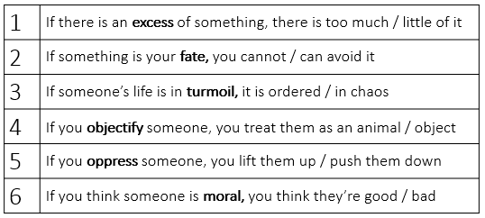
Vocabulary: look, cover, write, check to learn the definitions
Subservient  (adjective) | If you are subservient, you do whatever someone wants you to do | He was taught to be subservient to his parents.
Hierarchy  (noun) | A hierarchy is a system of organising people into different ranks or levels of importance | She was at the top of the social hierarchy.
Dehumanise  (verb) | If you dehumanise someone, you treat them as less than human. | The years of civil war have dehumanised all of us.

New Knowledge: follow the instructions and read the information twice
- Read each part of the context section in the booklet.
- Focus in particular on the ‘why’ of the prejudice discussed and emphasise that both racism and sexism is alive today but perhaps sometimes in more covert or hidden forms.
Task 1: Copy and complete
- Women were expected to be subservient to men because… and so…
- Racist stereotypes against Moors existed because… and so…
Task 2: Complete these sentences
- In the 17th Century, the social hierarchy was both racist and sexist and so…
- For example… because… and so…

L.O. To explore the effects of Shakespeare unconventionally opening the play with Iago, the villain, who proudly proclaims his duplicity.
Do Now:
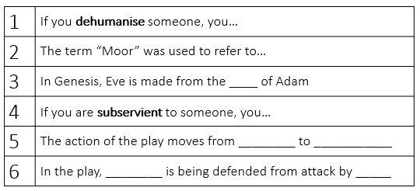
Vocabulary: look, cover, write, check to learn the definitions
Duplicitous (adjective) | Someone who is duplicitous lies and is two-faced. | The duplicitous friend was never trusted.
Malevolent  (adjective) | A malevolent person deliberately tries to cause harm or evil. | She showed she was malevolent when she stole from her friend.
Malcontent  (noun) | You can describe people as malcontents when they are always unhappy with a situation and want it to change. | Even though he had no reason to be unhappy, he was a malcontent

New Knowledge: follow the instructions and read the information twice
- The play is called ‘Othello’ so we’d expect to meet him first, wouldn’t we? But instead, Shakespeare decides to open the play with the villain: Iago. This might be to show us how powerful Iago is or to show us that unexpected things are going to keep happening in this play! We fear for the unsuspecting hero, Othello.
- Read A1S1 lines 5-39 + (MOST REVEALING MOMENT 1)
- Iago is angry because Michael Cassio, who ‘never set a squadron in a field’ has been promoted to Othello’s lieutenant.
- Iago is so angry that he tells us that he is only pretending to be subservient to Othello to “serve” his “turn upon him”.
- He is established as the malcontent – he is gaining power through deception and duplicity and is afraid of honesty.
Task 1: Annotate these quotations. Think about what the characters are feeling, what the most important words are and what these words reveal.

I follow the Moor to serve my turn upon him:
We cannot all be masters, nor all masters
Cannot be truly follow'd. In following him, I follow but myself;

when my outward action doth demonstrate
The native act and figure of my heart… 'tis not long after
That I will wear my heart upon my sleeve
For daws to peck at: I am not what I am.

Task 2: Complete these sentences
- Shakespeare opens the play with Iago instead of Othello because…
- Iago hates Othello but he will hide his hatred because…
- Iago is proud of his duplicity because…

Task 3: Complete these sentences
Shakespeare unconventionally opens the play with Iago, the villain and malcontent because…
Iago hates Othello but he will hide his hatred because…
For example…
Iago is proud of his duplicity because…
For example…

L.O. To explore how Iago and Roderigo’s racism dehumanises Othello
Do Now:
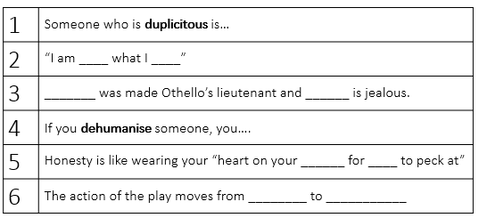
Vocabulary: look, cover, write, check to learn the definitions
Animalistic  (adjective) | If you describe a person or their behaviour as animalistic, you mean that they behave like an animal. | The two teams were matched in a ferocious, almost animalistic battle.
Alien  (adjective) | If something is alien to you, it is not normal or expected. | This attitude was alien to many businesspeople.
Alien  (noun) | An alien is an insulting word for someone who is not familiar to you. | He said they were against alien forces in the region.
Dehumanise  (verb) | If you dehumanise someone, you treat them as less than human. | The years of civil war have dehumanised all of us.

New Knowledge: follow the instructions and read the information twice
- We know Iago hates Othello. So he decides to wake up Othello’s father-in-law and reveal to him that Othello has married his daughter, Desdemona. Because of their racism, Iago knows that Brabantio will be shocked and horrified.
- At first, Brabantio is angry that he’s been disturbed by Iago and Roderigo but when he realises Iago is telling the truth, he is furious and sends Roderigo to go and find Othello. We haven’t met Othello but we’ve seen the racist world in which he has to live!
- Read A1S1 Line 41- end of scene and MOST REVEALING MOMENT 2
Task 1: Complete these sentences
- Despite Othello’s position as a general in the army,…
- Because he wants to present Othello as alien to Brabantio, Iago…
- Before we meet Othello, we hear racist dehumanising language about him. For example…

Task 2: Complete these sentences
Shakespeare shows that, despite Othello’s elevated position in the social hierarchy as a general in the army, he is dehumanised by Iago and Brabantio’s racist and animalistic language because…
For example…
More specifically…

L.O. To explain why Shakespeare contrasts Othello’s controlled reaction with the earlier dehumanising descriptions of him, and how he is a typical Aristotelian hero.
Do Now:
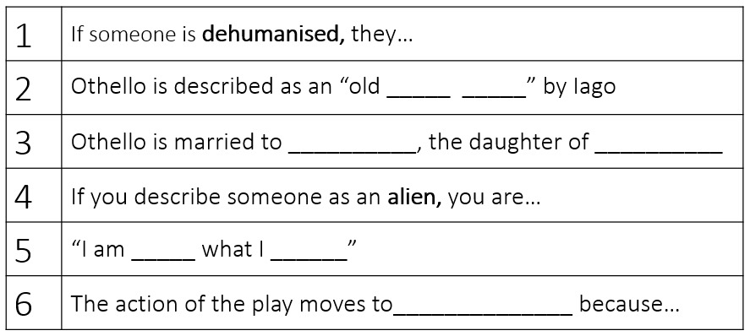
Vocabulary: look, cover, write, check to learn the definitions
Impervious to  (adjective) | If you are impervious to someone's actions, you are not changed by them. | She seems almost impervious to the criticism
Controlled  (adjective) | Someone who is controlled stops themselves from behaving badly or strangely. | They talked it through in careful, controlled voices.
Subvert  (verb) | To subvert something like a rule or expectation means to destroy its power by going against it. | This government will not allow anyone to subvert the law.
Dehumanise  (verb) | If you dehumanise someone, you treat them as less than human. | The years of civil war have dehumanised all of us.

New Knowledge: follow the instructions and read the information twice
- There are some types of characters that come up over and over again in plays; there are some trends that we can expect. And one of those is the tragic hero. We’re going to meet Othello today and it becomes very clear he’s going to be a tragic hero! This makes the play even more sad because it’s almost as if every action he takes is leading him closer and closer to his downfall.
- Read Poetics, Aristotle, 322 BC (On ‘The Tragic Hero’) in the booklet.
- Then, read A1S2 lines 150 – 229 and MOST REVEALING MOMENT 3. Notice how Othello is controlled and dignified! He subverts Iago’s racist stereotypes.
- Read A1S1 Line 41- end of scene and MOST REVEALING MOMENT 2
Task 1: Complete these sentences
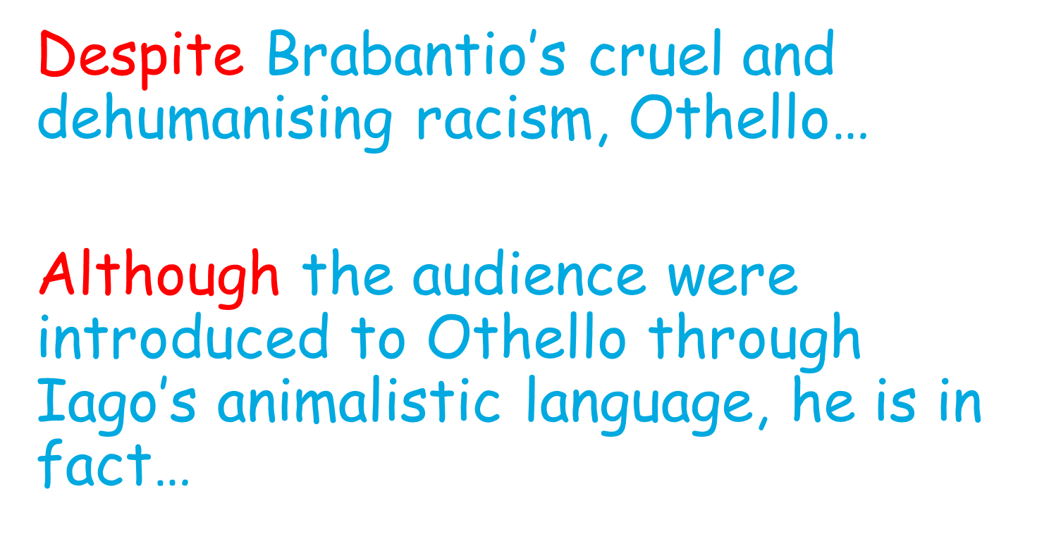
Task 2: Complete this paragraph
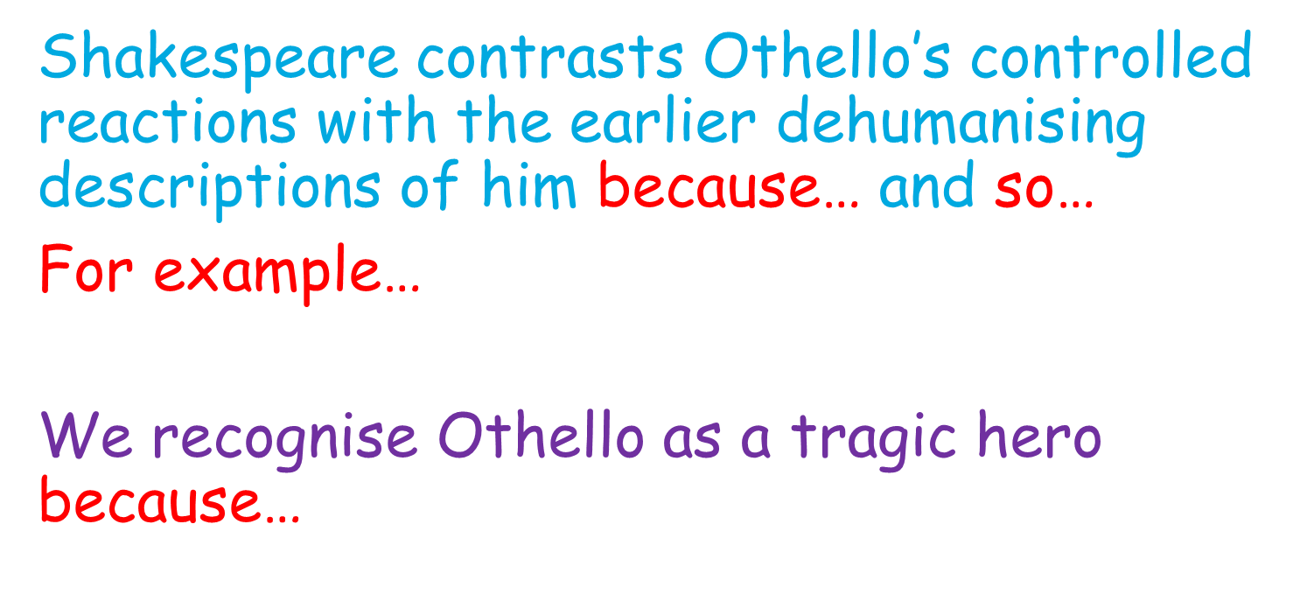

L.O. To explore how Brabantio’s accusations of witchcraft reveal his racism.
Do Now:
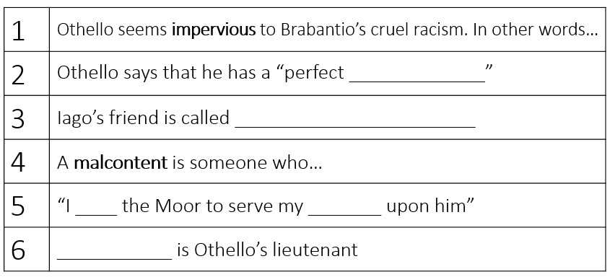
Vocabulary: look, cover, write, check to learn the definitions
Deceptive  (adjective) | If something or someone is deceptive, it encourages you to believe something which is not true. | Appearances can be deceptive.
Fascination  (noun) | A feeling of fascination is a feeling of being greatly interested by something. | I've had a lifelong fascination with the sea
Entrance  (verb) | If something or someone entrances you, they cause you to feel delight and wonder, often so that all your attention is taken up and you cannot think about anything else. | Last Friday she entranced the audience with her dancing.

New Knowledge: follow the instructions and read the information twice
- Now, we’re seeing Othello getting questioned by Brabantio in the presence of the Duke of Venice. Here’s where we see another side of the characters’ racism. We’ve seen Othello depicted as animalistic but now we see how he is presented as not human; alien; someone with supernatural powers. It’s a way of excluding him and excusing their hatred of him.
- Read A1S3 lines 235 – 305 and MOST REVEALING MOMENT 4.
- Brabantio thinks that Othello has used “witchcraft” or “cunning hell” to force Desdemona to love him.
Task 1: Complete these sentences
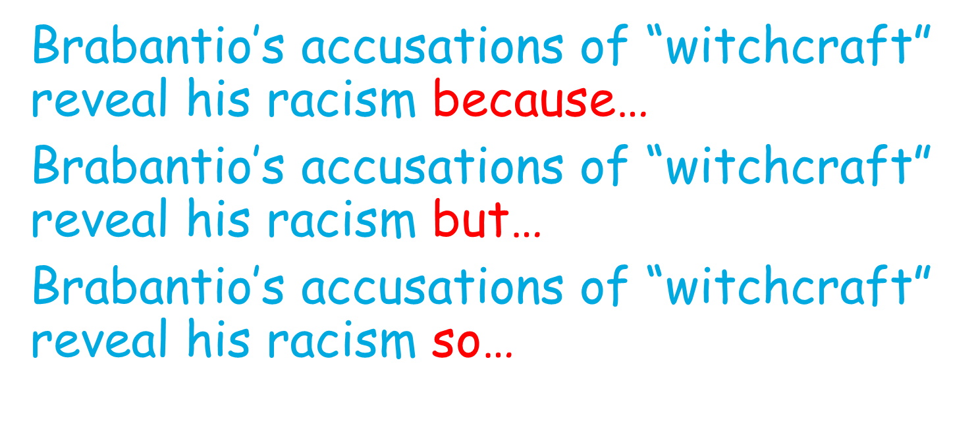
Task 2: Complete this paragraph
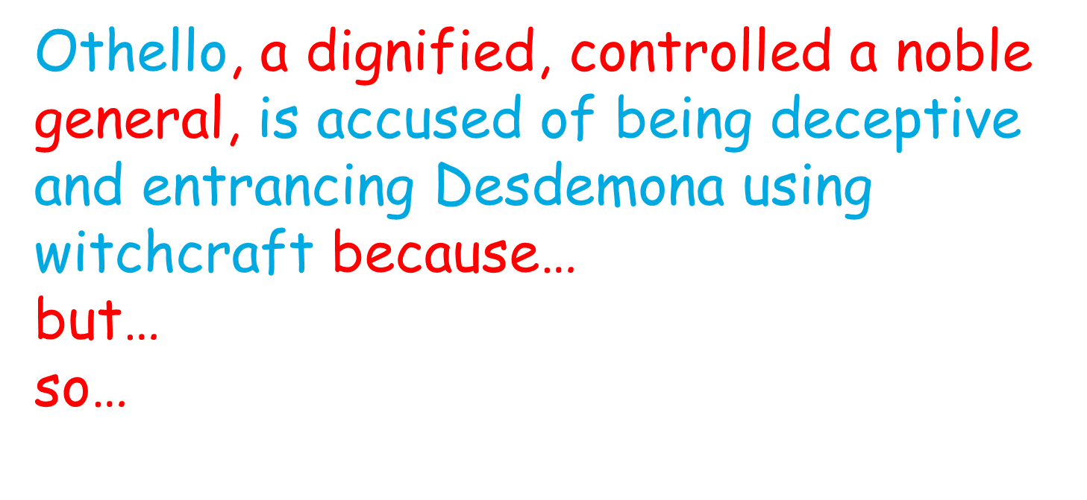

L.O. To explore how Othello powerfully subverts Brabantio’s accusations with his powerful storytelling and steadfast love for Desdemona using correlative conjunctions
Do Now:
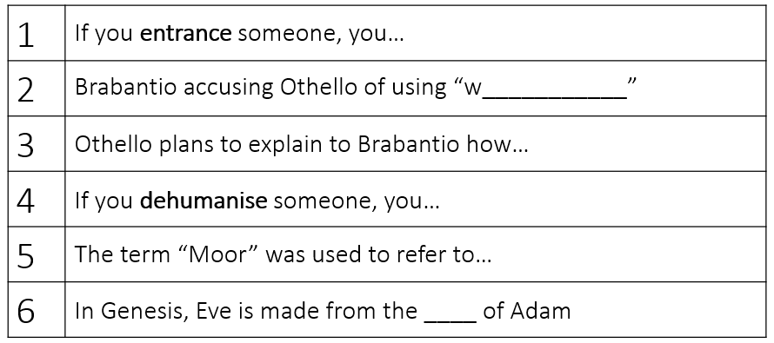
Vocabulary: look, cover, write, check to learn the definitions
Steadfast  (adjective) | If someone is steadfast in something that they are doing, they are convinced that what they are doing is right and they refuse to change it or to give up. | He remained steadfast in his belief that he had done the right thing.
Reverence  (noun) | Reverence for someone or something is a feeling of great respect for them. | The silence in church showed their deep reverence for their religion.
Subversion  (noun) | Subversion is the attempt to weaken or destroy a system. | He was arrested in parliament on charges of subversion for organizing the protest.

New Knowledge: follow the instructions and read the information twice
- Othello has been accused of using “witchcraft” and “cunning hell” to entrance Desdemona. In this monologue, we see his steadfast personality; he is stable, controlled and treats Desdemona with reverence. Here is the ultimate subversion of all of the racist stereotypes he has been attacked with so far. His life’s story is what has entranced Desdemona: their relationship is built on the truth!
- Read A1S3 line 305 – 334 and MOST REVEALING MOMENT 5.
- Desdemona is drawn to both Othello’s poetry and his military prowess. He loves her for her sympathy. The balance of the relationship is established, with Othello as the powerful speaker and army general, and Desdemona adoring him. Othello is steadfast and confident: he believes entirely in Desdemona. Here, Shakespeare lays the foundations for the later tragic drama and Othello’s inevitable tragic fall from this state of confidence.
Grammar: read this twice
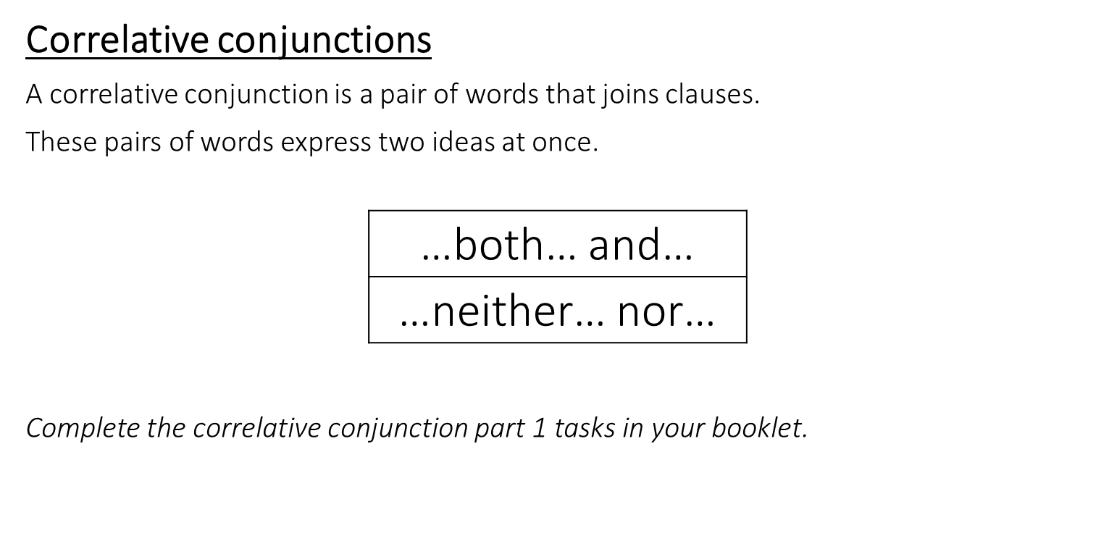
Task 1: Complete the correlative conjunction Part 1 task in your booklet
Task 2: Complete these sentences
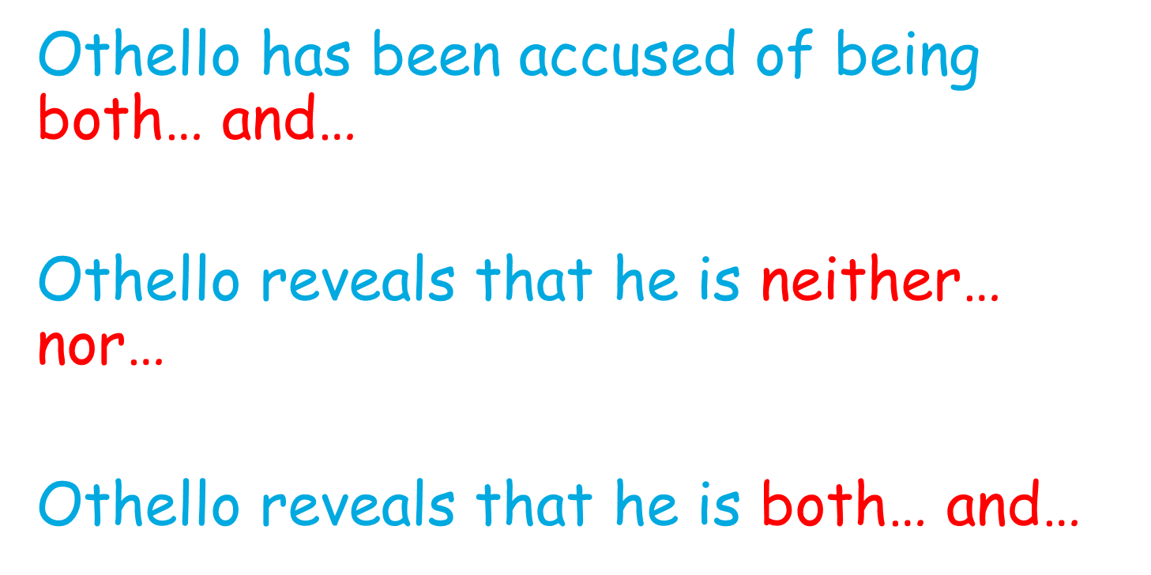
Task 3: Complete this paragraph
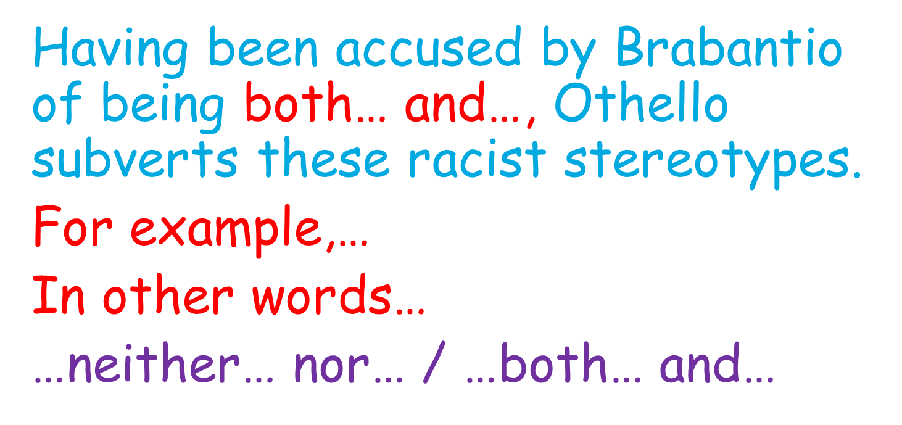
L.O. To explore how Desdemona’s response to her angered father shows intelligence and bravery.
Do Now:
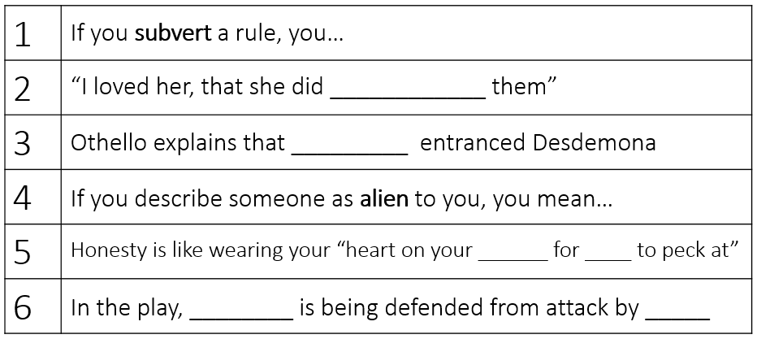
Vocabulary: look, cover, write, check to learn the definitions
Measured  (adjective) | You use measured to describe someone who is careful. | They spoke in soft, measured tones.
Logical  (adjective) | Someone who is logical is sensible and thinks carefully about things. | She made sure her reasons were logical and she was following the rules.
Controlled  (adjective) | Someone who is controlled stops themselves from behaving badly or strangely. | They talked it through in careful, controlled voices.

New Knowledge: follow the instructions and read the information twice
- We’ve heard Othello’s side of the story; now we hear Desdemona’s. Remember that in Elizabethan and Jacobean England, women belonged either to their father or their husband; they couldn’t own their own property or money. So Desdemona’s stuck between the two of them!
- Read A1S3 lines 334 - 399. Particular focus on 344 – 349 and MOST REVEALING MOMENT 6.
- Because of Othello and Desdemona’s measured, logical and controlled arguments, Brabantio gives the “jewel” (Desdemona) to Othello but warns Othello that, since Desdemona deceived her father, she could deceive him.
- Note that, at the end of this section, Othello is sent away to Cyprus to defend it from the Turks and he asks Iago to take care of Desdemona. Bad move!
Task 1: Annotate this section. Think about what the characters are feeling, what the most important words are and what these words reveal.
My noble father,
I do perceive here a divided duty:
To you I am bound for life and education;
My life and education both do learn me
How to respect you; you are the lord of duty;
I am hitherto your daughter: but here's my husband,

Task 2: Complete these sentences
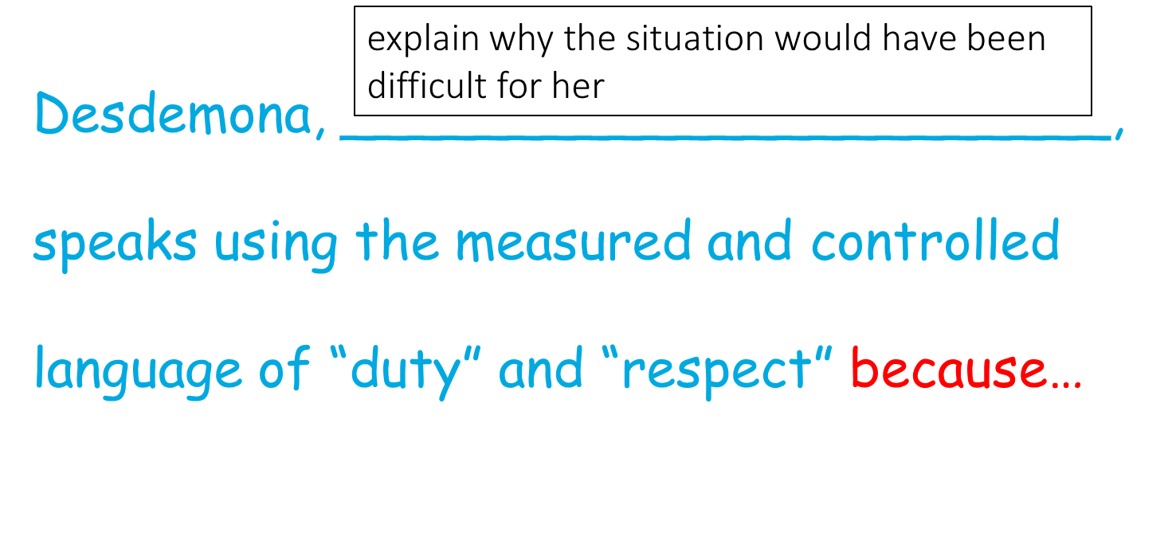
Task 3: Complete this paragraph
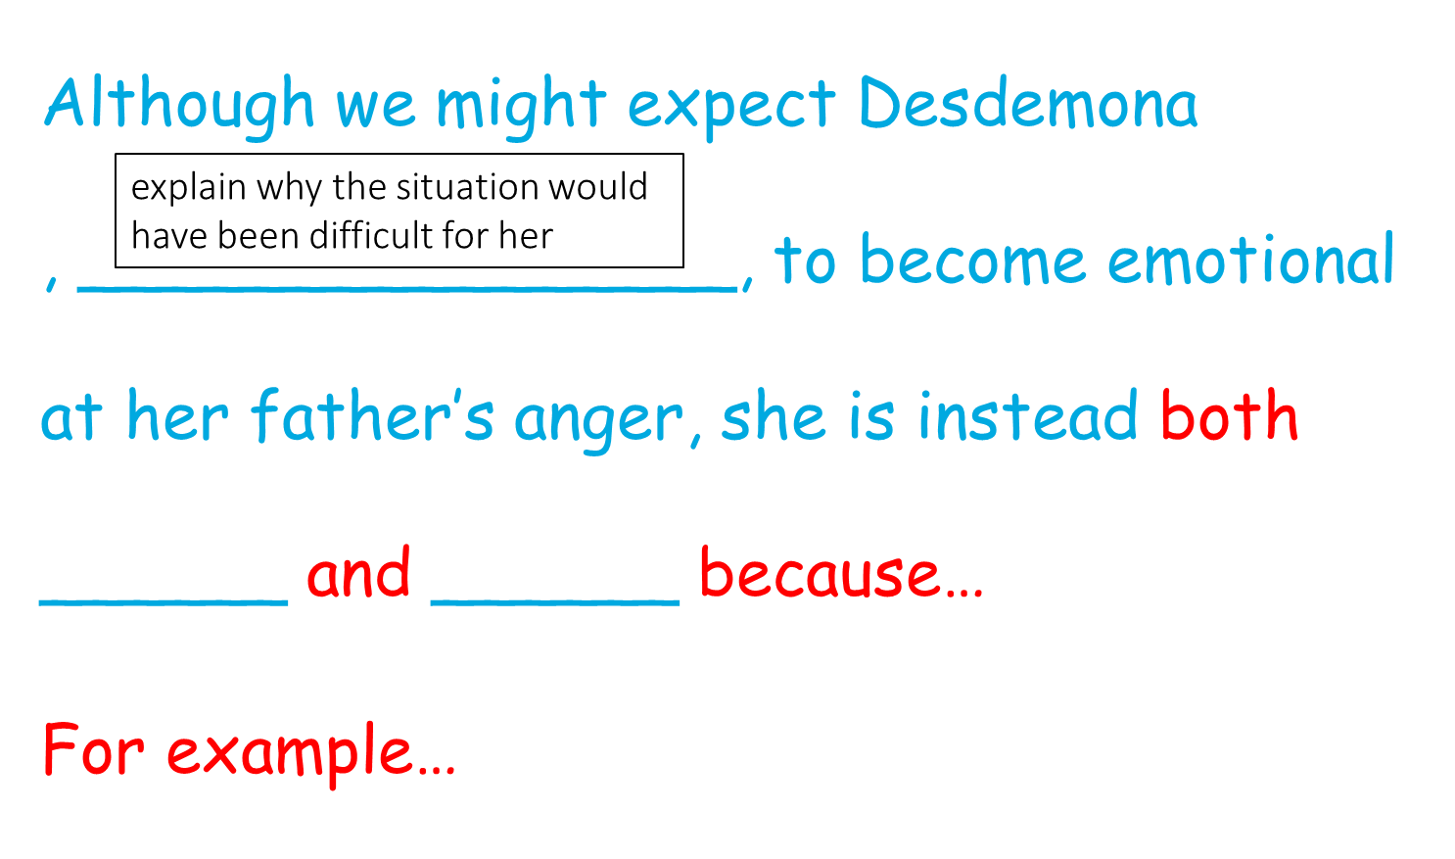

L.O. To explore how Iago successfully manipulates Roderigo and explains his plans for destruction.
Do Now:
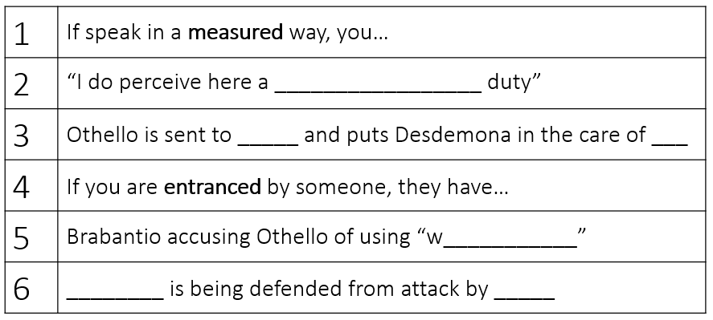
Vocabulary: look, cover, write, check to learn the definitions
Machination  (noun) | A machination is a plot or a plan. | His machination was working; he had managed to force everyone to do what he wanted!
Manipulation  (noun) | Manipulation is persuading someone to do something they don’t want to do forcefully. | She was a victim of her friend’s manipulation.
Soliloquy  (noun) | A soliloquy is a speech in a play in which an actor or actress speaks to himself or herself and to the audience. | In Iago’s soliloquy, he confesses his plans to the audience.

New Knowledge: follow the instructions and read the information twice
- Yesterday, we heard that Othello is going away to Cyprus and he’s putting Desdemona in the care of Iago. Bad idea! But he thinks Iago is a good friend and colleague to him.
- Read A1S3 line 401 – end of scene. Particular focus on Iago the puppeteer 400 – 479 and MOST REVEALING MOMENT 7.
- Lines 401 – 423: Roderigo confesses that he’s in love with Desdemona.
- Lines 425 – 445: Iago advises him to sell everything he owns so that he’s ready for Desdemona when she rejects Othello. He tells him to seduce Desdemona and make a fool of Othello.
- Lines 457 – end: Iago says he suspects Othello of sleeping with his wife. He plans to ruin Cassio and Othello at the same time by persuading Othello that his wife is having an affair with Cassio.
Task 1: Annotate this section. Think about what the characters are feeling, what the most important words are and what these words reveal
He… will as tenderly be led by the nose
As asses are.
I have't. It is engender'd. Hell and night
Must bring this monstrous birth to the world's light.

(an ass is a donkey; donkeys are usually symbols of stupidity or foolishness)

Task 2: Complete these sentences
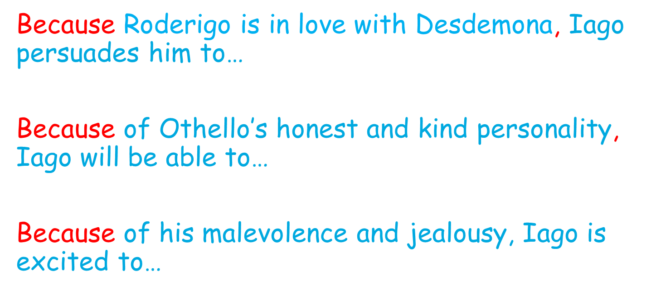
Task 3: Complete this paragraph
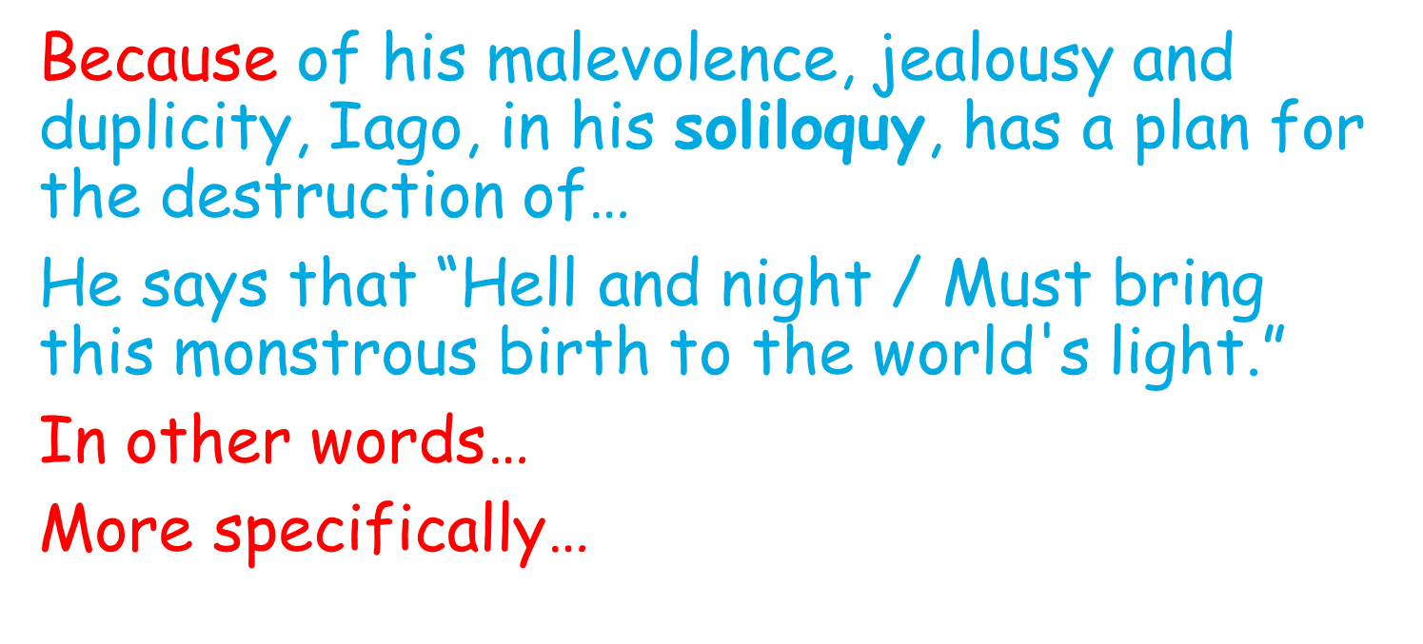

L.O. To explore how Shakespeare emphasises Iago’s Machiavellian role through asides, and how this presents a contrast to the morality of Desdemona.
Do Now:
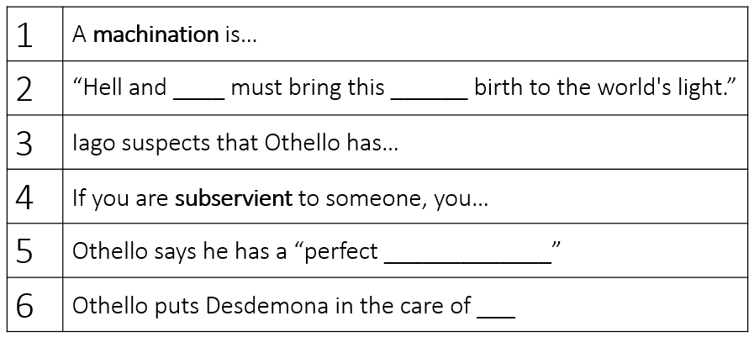
Vocabulary: look, cover, write, check to learn the definitions
Deferential  (adjective) | Someone who is deferential is polite and respectful towards someone else. | They always went to the same restaurant because the staff were so deferential towards them!
Machiavellian  (adjective) | If you describe someone as Machiavellian, you are critical of them because they often make clever and secret plans to achieve their aims and are not honest with people. | A Machiavellian plot was suspected.
Manipulation  (noun) | Manipulation is persuading someone to do something they don’t want to do forcefully. | She was a victim of her friend’s manipulation.

New Knowledge: follow the instructions and read the information twice
- Now we know Iago’s plan. He’s going to get Roderigo to sell all his things, persuade Othello that Cassio’s having an affair with Desdemona and ruin everyone’s lives. The fact that we know this makes us see the rest of the play differently; we know that all of these characters are just his puppets and they’re doomed!
- Read A2S1 lines 480 – 572 and MOST REVEALING MOMENT 9
- We’re now in Cyprus and Cassio, Iago, Emilia and Desdemona are waiting for Othello to arrive.
- Lines 555-560: Iago’s sexism
- Lines 562-566: Desdemona’s morality and benevolence
- Lines 570-572: Iago tells the audience he’ll ensnare Cassio
Task 1: Complete these sentences
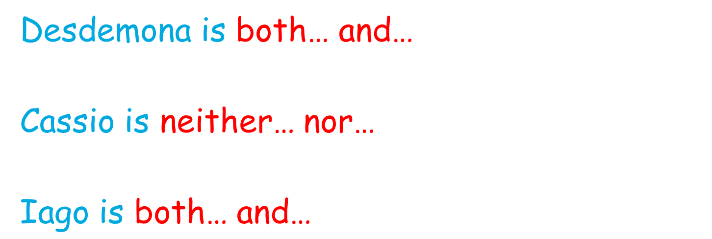
Task 2: Annotate these quotations. Think about what the characters are feeling, what the most important words are and what these words reveal.
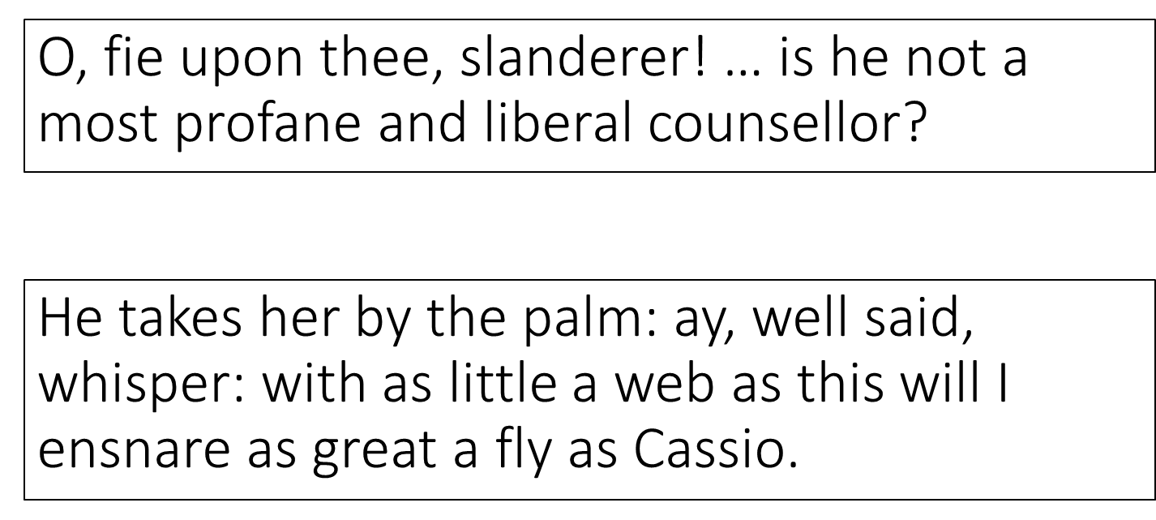
Task 3: Complete this paragraph
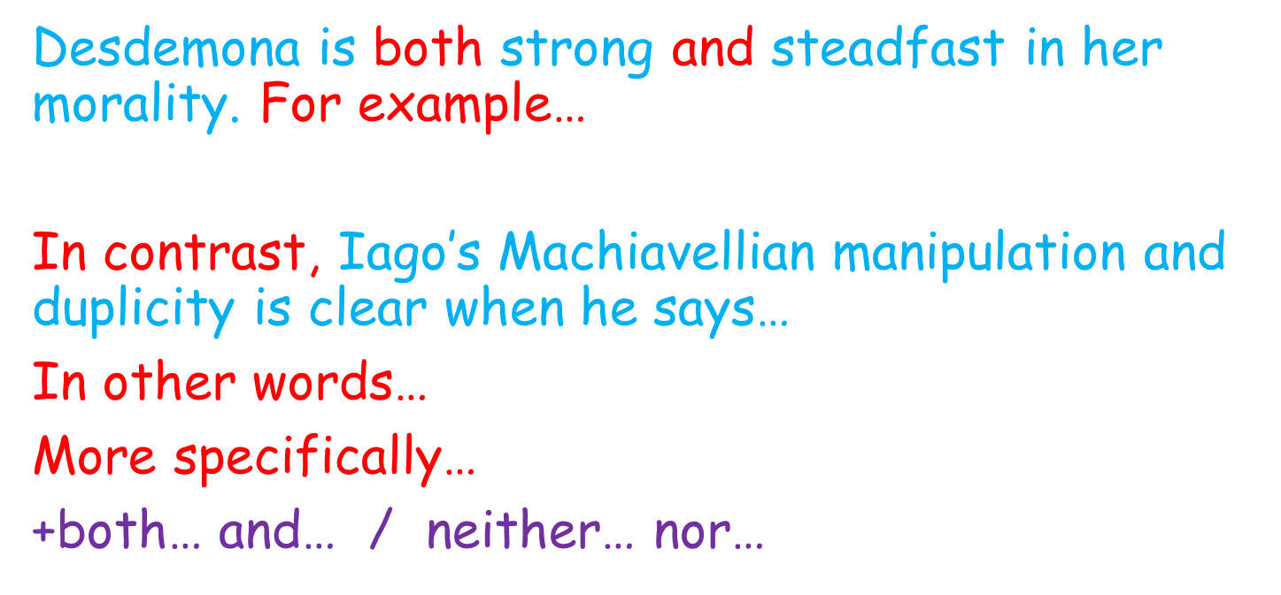

L.O. To explore how Othello and Desdemona’s love is presented as equal and perfect through hyperbolic metaphor.
Do Now:
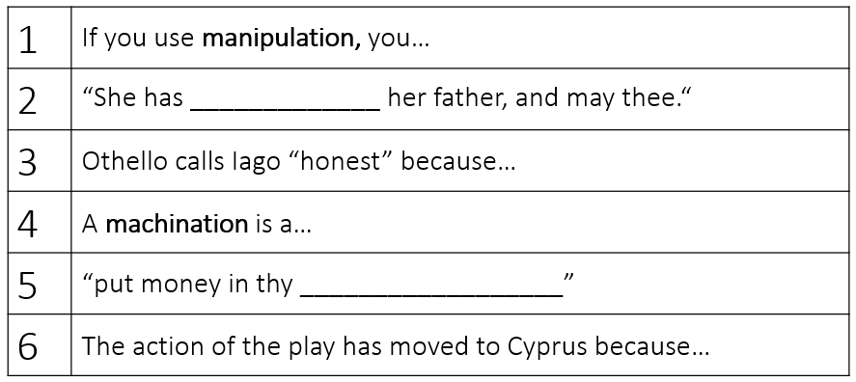
Vocabulary: look, cover, write, check to learn the definitions
Hyperbole  (noun) | If someone uses hyperbole, they say or write things that make something sound much more impressive than it really is. | The hyperbole in the newspapers made everyone think he was the best leader in the world.
Machination  (noun) | A machination is a plot or a plan. | His machination was working; he had managed to force everyone to do what he wanted!
Contrast  (noun) | A contrast is a great difference between two or more things which is clear when you compare them. | The two visitors provided a startling contrast in appearance.
Ecstatic  (adjective) | If you are ecstatic, you feel very happy and full of excitement. | They were greeted by the cheers of an ecstatic crowd.

New Knowledge: follow the instructions and read the information twice
- We’ve just heard that Iago plans to “ensnare” “Cassio” using his polite kisses and hand holding! But now, Othello arrives and we see what steadfast and true love really is!
- Read A2S1 P15 line 574 – 606 and MOST REVEALING MOMENT 10.
- Othello sees Desdemona as an equal and uses military language to greet her. Their love is hyperbolic and ecstatic and this is set alongside the machinations which Iago has just made clear. The audience is encouraged to both believe in and fear for their love.
Task 1: Annotate this section. Think about what the characters are feeling, what the most important words are and what these words reveal.
It gives me wonder great as my content
To see you here before me. O my soul's joy!
If after every tempest come such calms,
May the winds blow till they have waken'd death!
If I were now to die,
'Twere now to be most happy; for, I fear,
My soul hath her content so absolute
That not another comfort like to this
Succeeds in unknown fate.
Task 2: Complete these sentences
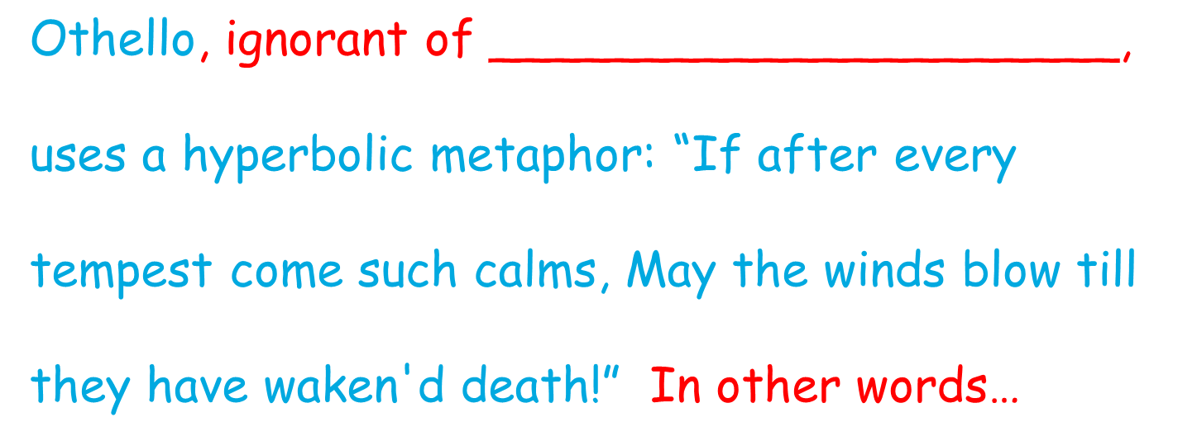
Task 3: Complete this paragraph
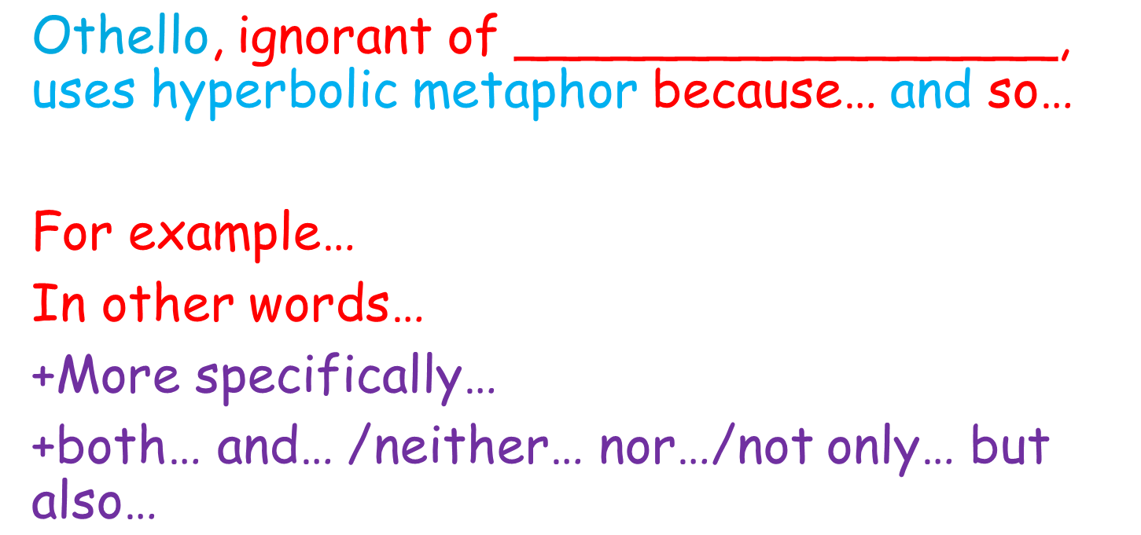
L.O. To explore how Iago playfully suggests reasons for his malevolence and yet remains ambiguous, arguably fitting Coleridge’s view that his is ‘motiveless malignity’.
Do Now:
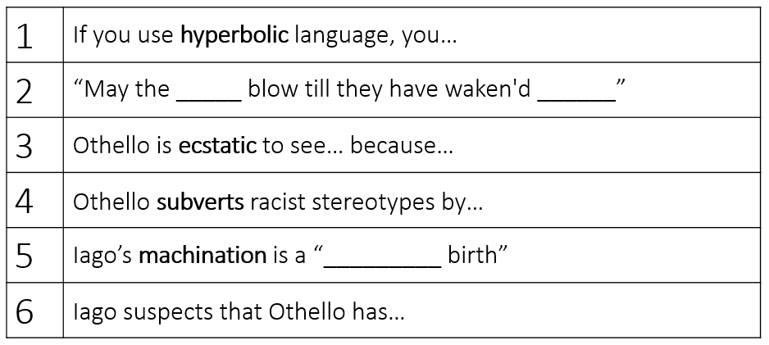
Vocabulary: look, cover, write, check to learn the definitions
Knavery  (noun) | Knavery is dishonest behaviour. | The office was full of knavery and lies.
Motive  (noun) | Your motive for doing something is your reason for doing it. | The doctor's motive was to bring an end to his patient's suffering.
Malignity  (noun) | Malignity is being deadly and evil. | Malignity was everywhere in the town.
Ambiguity  (noun) | If you say that there is ambiguity in something, you mean that it is unclear or confusing, or it can be understood in more than one way.  (Ambiguous – adjective) | Students sometimes struggle with the ambiguities of the English language.  The author's style suggests a certain ambiguity in his moral view.

New Knowledge: follow the instructions and read the information twice
- A2S1 lines 606 – 675 and MOST REVEALING MOMENT 11
- To Roderigo, Iago says that Desdemona will definitely get bored with Othello and will look elsewhere: ‘her eye must be fed’ and she will look for a ‘second choice’. He’s saying this to make Roderigo jealous and to justify his actions.
- However, we get a soliloquy from Iago (651 – 675) where he gives us a few different reasons or motives for his knavery. How many can we see? Find as many reasons as possible in this soliloquy. E.g. love for Desdemona, suspicion that Othello has ‘leap’d into’ his ‘seat’.
- But we do not get one clear reason! Iago keeps ambiguity here. Coleridge said that his is a “motiveless malignity”. Do we agree?

Task 1: Complete these sentences
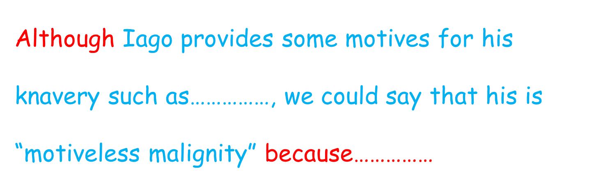

Task 2: Complete this paragraph
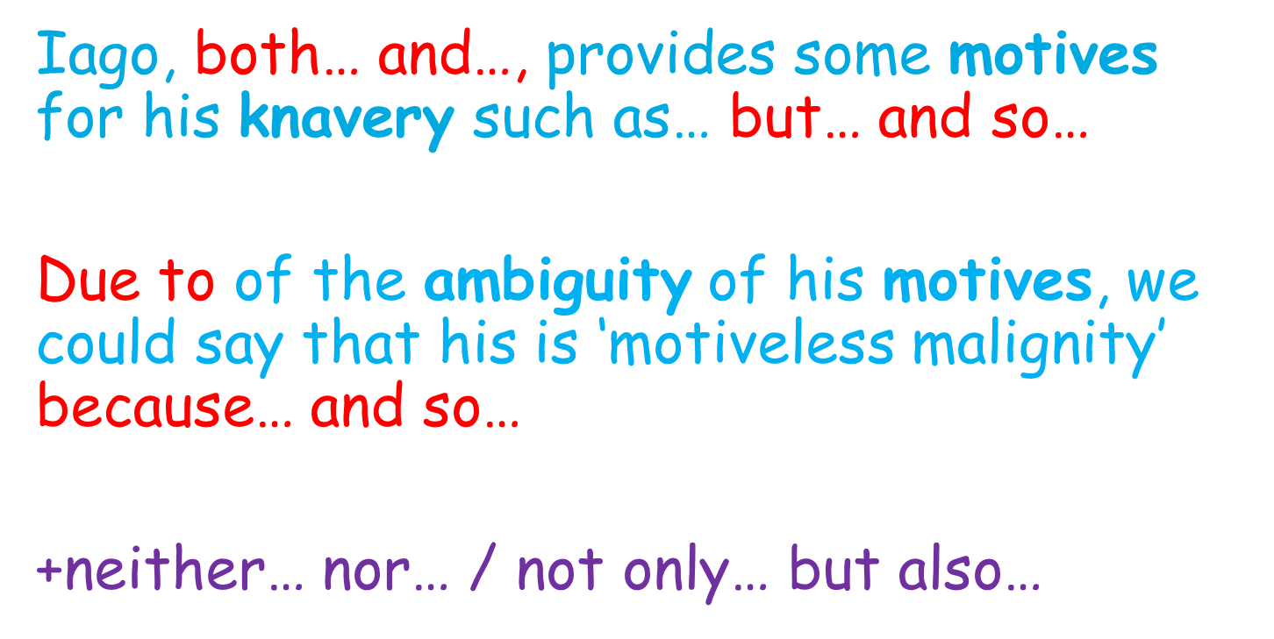

L.O. To explain how Iago manipulates Cassio and cajoles him into drinking while he is on watch.
Do Now:
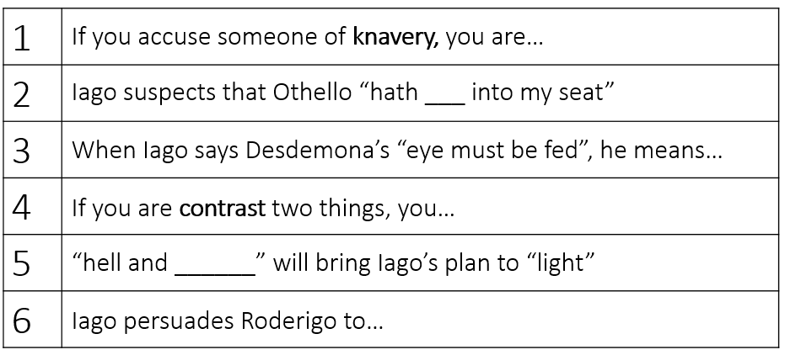
Vocabulary: look, cover, write, check to learn the definitions
Disguise  (verb) | To disguise something means to hide it or make it appear different so that people will not know about it or will not recognise it. | Their healthy image disguises the fact that they are highly processed foods.  I played along, and disguised my voice.
Objectify  (verb) | If you objectify someone, you treat them as an object.  (Objectification – noun) | The way he spoke to his friend made him feel objectified.
Cajole  (verb) | If you cajole someone into doing something, you get them to do it after persuading them for some time. | It was he who had cajoled Garland into doing the film.  He cajoled Mr Dobson to stand for mayor.
Puppeteer  (noun) | A puppeteer is someone who controls puppets. | He acted like a puppeteer when he forced them all to follow exactly what he said.

New Knowledge: follow the instructions and read the information twice
- Last lesson, we wondered whether Iago had motives for his knavery or whether his was a motiveless malignity. We suspected that he didn’t really have a good reason because although he listed some, his main motive is ambiguous. Today, we’re going to see some amazing puppet work from Iago and find a little more out about how he feels about women.
- A2S2&3 lines 679 – 751 and MOST REVEALING MOMENT 12
- Notice that Iago is great at using language to manipulate Cassio – Cassio says that Desdemona is “exquisite” and “modest” and “delicate” but Iago keeps adding words like “provocation” and “game” to manipulate his opinion! He keeps mentioning wine to Cassio to force him to drink!

Task 1: Annotate this section. Think about what the characters are feeling, what the most important words are and what these words reveal.
CASSIO She's a most exquisite lady.
IAGO And, I'll warrant her, fun of game.
CASSIO Indeed, she's a most fresh and delicate creature.
IAGO What an eye she has! methinks it sounds a parley of
provocation.
CASSIO An inviting eye; and yet methinks right modest.
IAGO And when she speaks, is it not an alarum to love?
CASSIO She is indeed perfection.

Task 2: Complete these sentences.
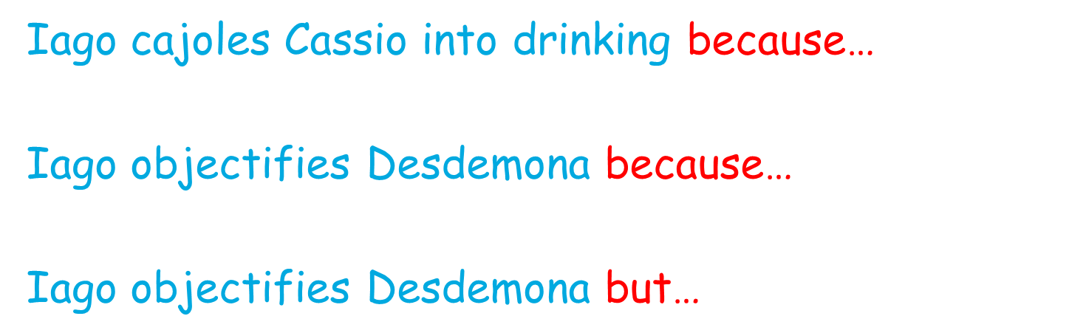
Task 3: Complete this paragraph.
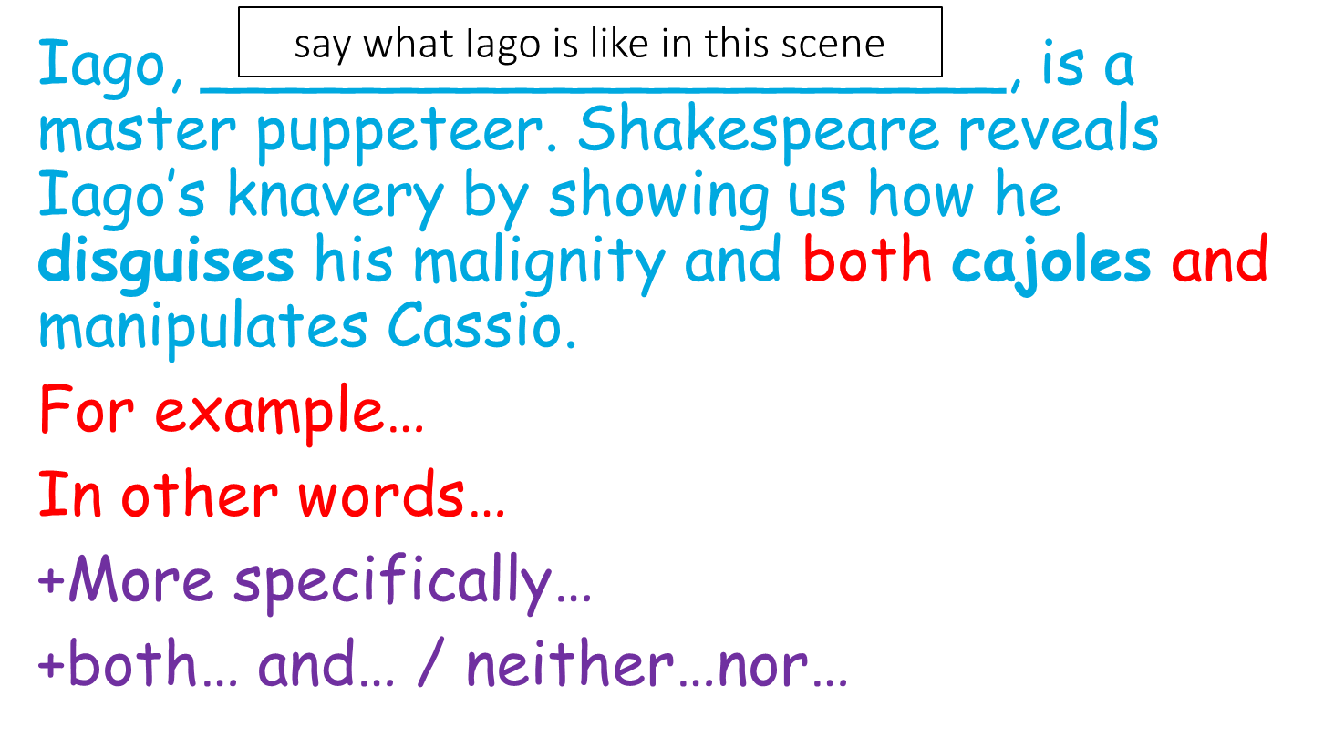
L.O. To explain Iago’s machinations using fronted subordinate clauses.
Do Now:
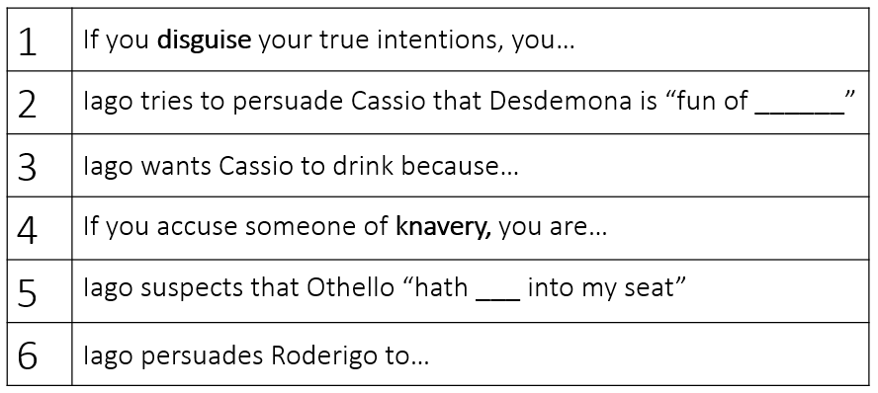
Vocabulary: look, cover, write, check to learn the definitions
Cajole  (verb) | If you cajole someone into doing something, you get them to do it after persuading them for some time. | It was he who had cajoled Garland into doing the film.  He cajoled Mr Dobson to stand for mayor.
Susceptible to  (adjective) | If you are susceptible to something or someone, you are very likely to be influenced by them. | Young people are the most susceptible to advertisements.  He was extremely susceptible to flattery.
Machination  (noun) | A machination is a plot or a plan. | His machination was working; he had managed to force everyone to do what he wanted!
Puppeteer  (noun) | A puppeteer is someone who controls puppets. | He acted like a puppeteer when he forced them all to follow exactly what he said.

New Knowledge: follow the instructions and read the information twice
- We’ve seen Iago trying to make Cassio objectify Desdemona. That didn’t go too well but he still needs to bring Cassio down. So he’s planning to get him drunk. Today, we’ll see some more of his malevolent machinations.
- Read A2S2 lines 751-805
- In Iago’s song, he’s cajoling Cassio into drinking.
- Notice how he’s manipulating Montano’s impression of Cassio; we notice here how reputations are susceptible to changing.
- Iago seems to be a benevolent, caring colleague to Cassio, and we see that his machinations involve destroying Cassio’s reputation.

Task 1: Annotate this section. Think about what the characters are feeling, what the most important words are and what these words reveal.
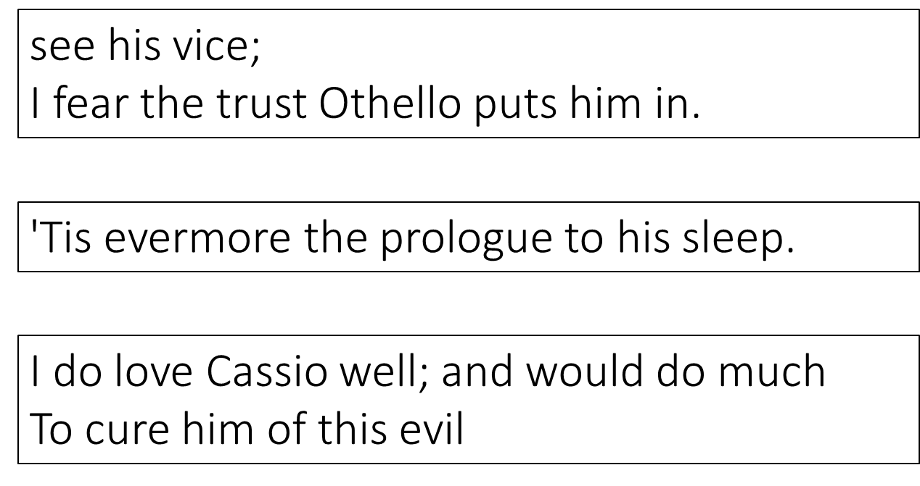
Task 2: Complete these sentences.
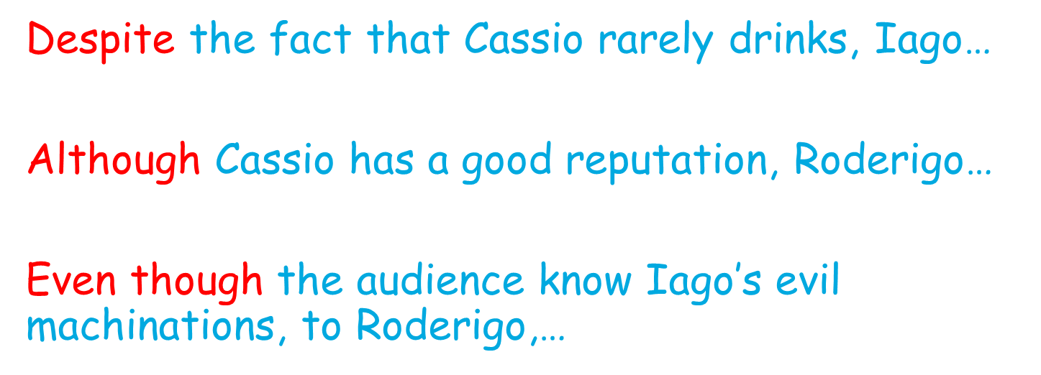
Task 3: Complete this paragraph.
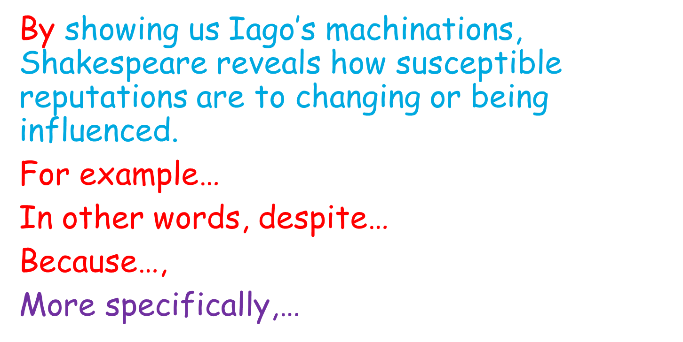

L.O. To explain how Iago gains control by creating chaos and ruining reputations.
Do Now:
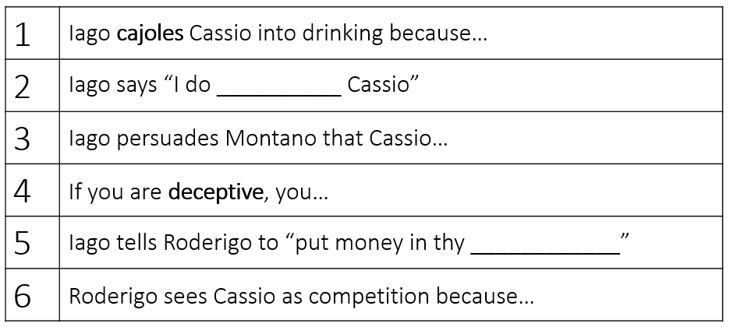
Vocabulary: look, cover, write, check to learn the definitions
Duplicitous (adjective) | Someone who is duplicitous lies and is two-faced. | The duplicitous friend was never trusted.
Deceptive  (adjective) | If something or someone is deceptive, it encourages you to believe something which is not true. | Appearances can be deceptive.
Machination  (noun) | A machination is a plot or a plan. | His machination was working; he had managed to force everyone to do what he wanted!

New Knowledge: follow the instructions and read the information twice
- Last lesson, we saw how Iago was cajoling Cassio into drinking and also persuading Montano that Cassio had a drinking problem. Today, we’re going to see how Iago’s deceptive machinations lead to a fight and to Cassio’s downfall.
- A2S3 line 806 – 910. Particular focus on comprehension of the fight.
- Cassio and Roderigo are fighting
- Montano steps in to stop Cassio from fighting but Cassio demands to be let go and attacks Montano
- Iago makes Roderigo go and shout so that Othello turns up!
- Pretending to be loyal to Cassio, Iago tells Othello the tale of the fight and Cassio is fired! Let’s see how Iago preserves his own reputation whilst ruining Cassio’s!

Task 1: Annotate this section. Think about what the characters are feeling, what the most important words are and what these words reveal.
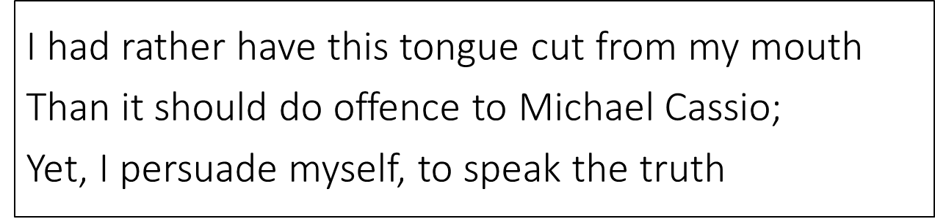
Task 2: Complete these sentences.
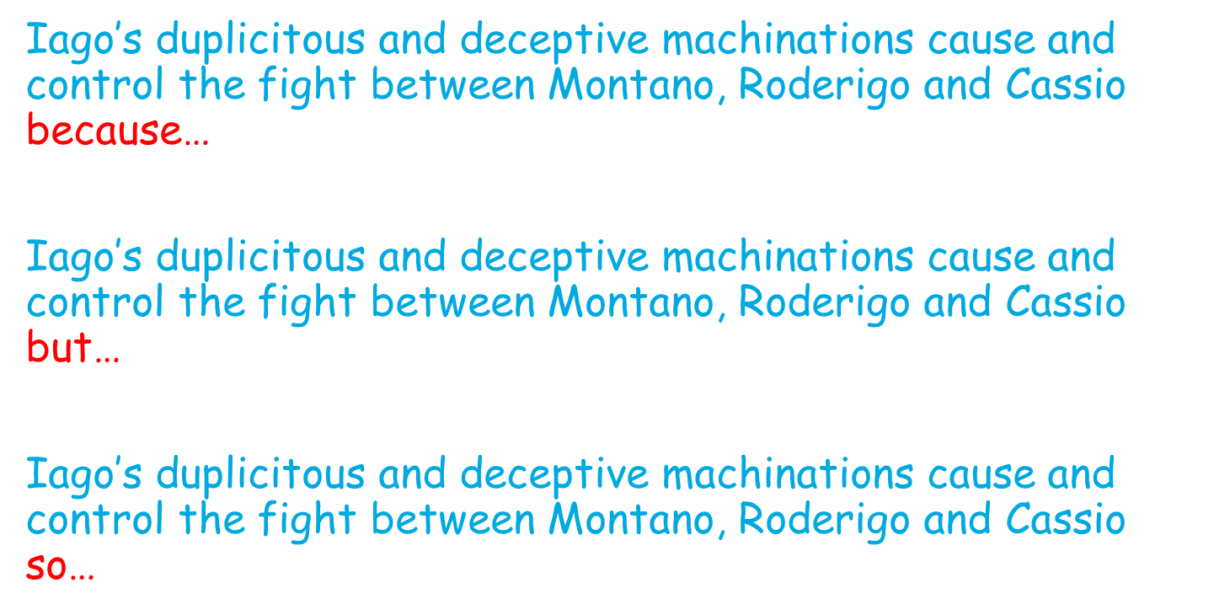
Task 3: Complete this paragraph.
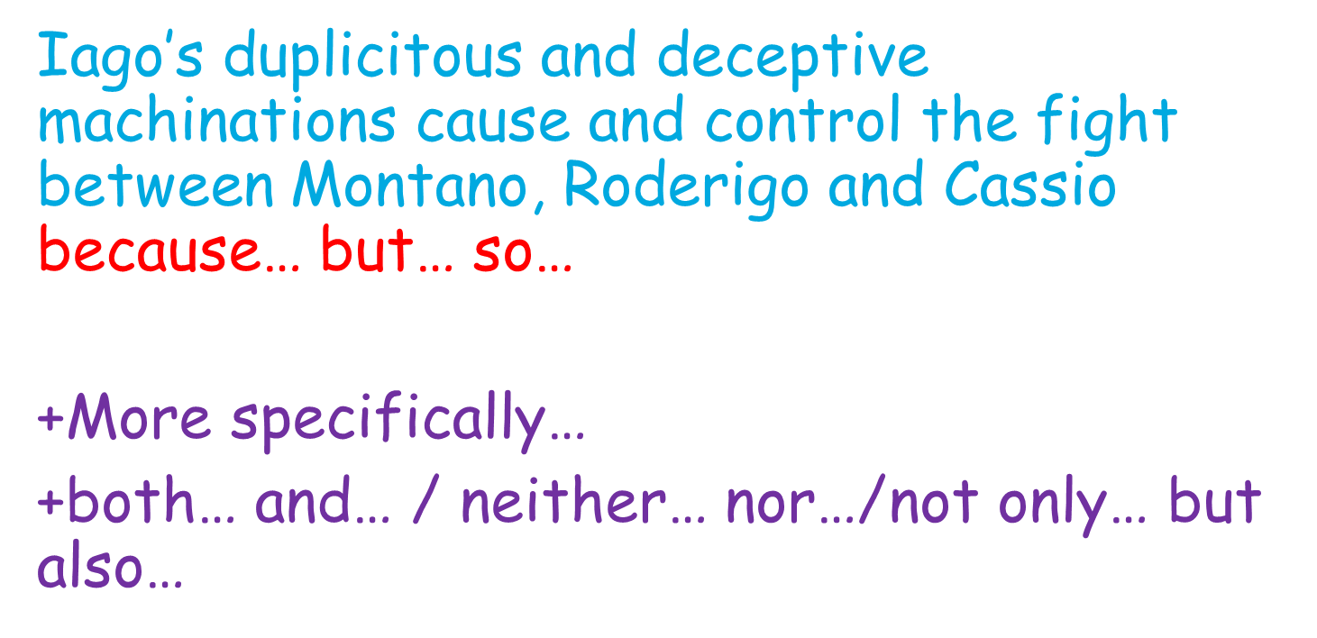

L.O. To explore how Cassio’s response to being dismissed shows how Iago takes advantage of credulity and pretends innocence.
Do Now:
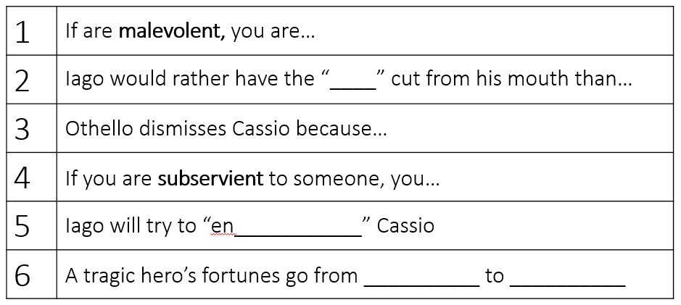
Vocabulary: look, cover, write, check to learn the definitions
Credulous  (adjective) | If you describe someone as credulous, they are too ready to believe what people tell them and are gullible.  (Noun – credulity) | Because she was credulous, she was always easily fooled by her friends’ foolish stories.
Duplicitous (adjective) | Someone who is duplicitous lies and is two-faced.  (Noun – duplicity) | The duplicitous friend was never trusted.

New Knowledge: follow the instructions and read the information twice
- Iago has told so many lies in this scene! He’s only going to keep going! In a way, his manipulation of Cassio is practice for the biggest fly he wants to “ensnare”: Othello. So, bear this in mind as we see how Iago takes advantage of Cassio’s credulity.
- Read A2S3 lines 911 – 1026 and MOST REVEALING MOMENT 13 + 14
- Focus on Cassio’s distress at having lost his reputation: Shakespeare uses this moment to foreshadow Othello’s later tragic fall: both are susceptible to Iago’s malevolent scheming, and both lose their prized reputation. Cassio equates his reputation to his soul. Bestiality is only a heartbeat away from divinity.
- Also, focus on Iago’s further plans and schemes: Shakespeare alludes to the devil in the garden of evil, tempting Eve. This religious imagery sets Iago up as the anti-hero, turning good into evil. Iago achieves this with the deadly ‘pestilence’ or ‘net’.
Task 1: Annotate this section. Think about what the characters are feeling, what the most important words are and what these words reveal.
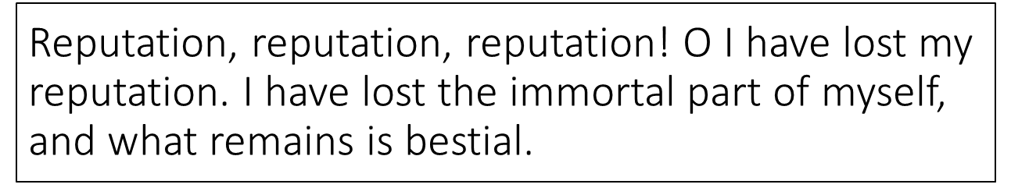
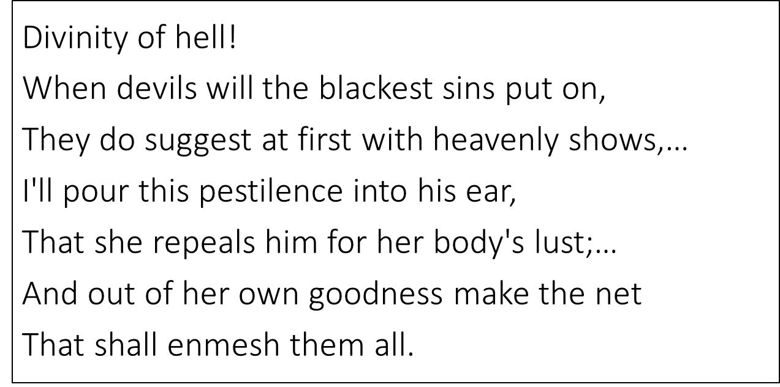

Task 2: Complete these sentences.
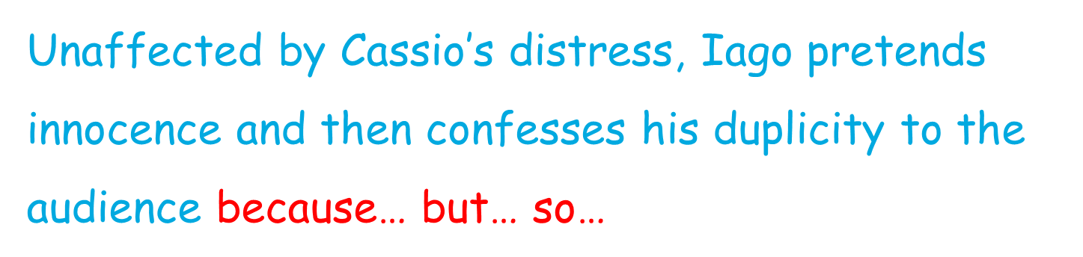
Task 3: Complete this paragraph.
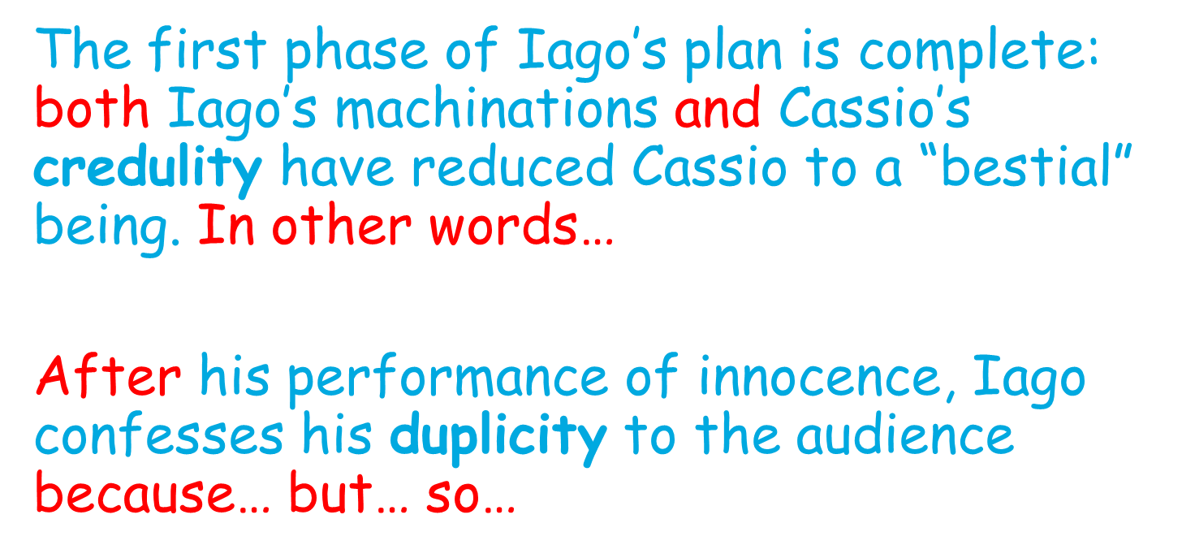

L.O. To explore how Iago’s powerful but ambiguous suggestions destabilise Othello and leave him questioning Desdemona’s fidelity and trusting Iago more.
Do Now:
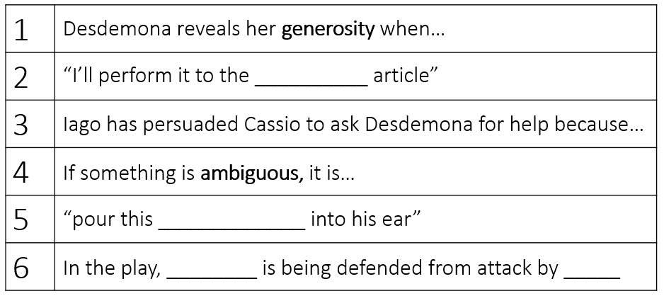
Vocabulary: look, cover, write, check to learn the definitions
Ambiguity  (noun) | If you say that there is ambiguity in something, you mean that it is unclear or confusing, or it can be understood in more than one way.  (Ambiguous – adjective) | Students sometimes struggle with the ambiguities of the English language.  The author's style suggests a certain ambiguity in his moral view.
Fidelity  (noun) | Fidelity is loyalty to a person, organisation, or set of beliefs. | I had to promise fidelity to the Queen.
Destabilise  (verb) | To destabilise something or someone is to make it weak and unstable. | Their aim is to destabilise the government
New Knowledge: follow the instructions and read the information twice
- We just saw Desdemona promise Cassio that she’d talk to Othello about reinstating him. She’s loyal and generous! Cassio leaves as he sees Othello coming because he’s nervous. Now we see Iago’s truly impressive use of language to weave his wicked web!
- A3S3 line 1115 – 1241 Iago as a puppeteer. (MOST REVEALING MOMENT 15)
- The ambiguous pronoun ‘that’ prompts Othello’s mind, usually used to certainty and control, to wander.
Task 1: Annotate this section. Think about what the characters are feeling, what the most important words are and what these words reveal.
IAGO Ha! I like not that.
OTHELLO What dost thou say?
IAGO Nothing, my lord: or if--I know not what.
OTHELLO Was not that Cassio parted from my wife?
IAGO Cassio, my lord! No, sure, I cannot think it,
That he would steal away so guilty-like,
Seeing you coming.
OTHELLO Indeed! Is he not honest?
IAGO Honest, my lord!
OTHELLO Honest! ay, honest.
IAGO My lord, for aught I know.
OTHELLO What dost thou think?
IAGO Think, my lord!
OTHELLO Think, my lord!
By heaven, he echoes me,
As if there were some monster in his thought
Too hideous to be shown.
Task 2: Complete these sentences.
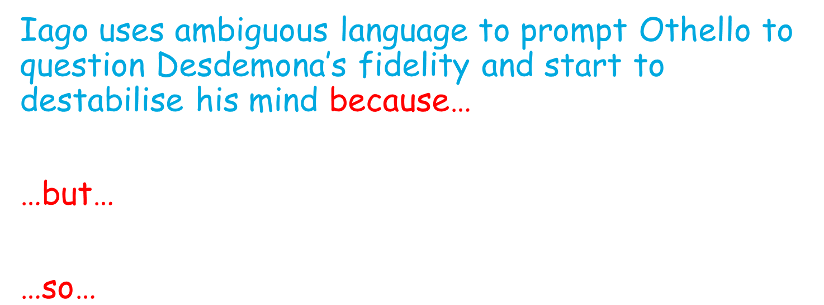
Task 3: Complete this paragraph.
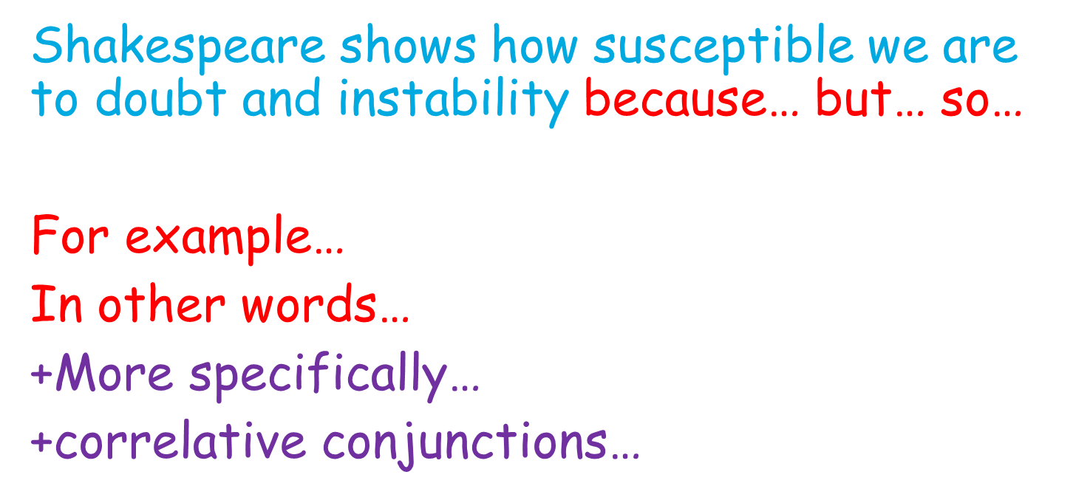
L.O. To explain the tragic change in Othello, who has been reduced to inarticulacy and suspicion by Iago’s power.
Do Now:
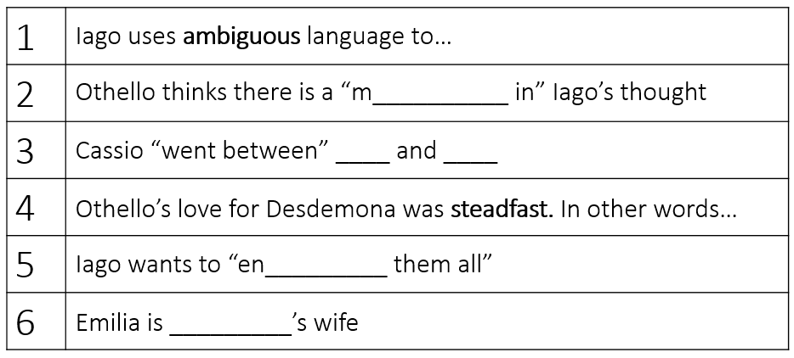
Vocabulary: look, cover, write, check to learn the definitions
Inarticulacy  (noun) | If someone is reduced to inarticulacy, they can’t speak properly. | The pain of his tooth reduced him to inarticulacy
Irrational  (adjective) | If you describe someone's feelings and behaviour as irrational, you mean they are not based on logical reasons or clear thinking. | She had an irrational fear of chicken pies.
Credulous  (adjective) | If you describe someone as credulous, they are too ready to believe what people tell them and are gullible. (Noun – credulity) | Because she was credulous, she was always easily fooled by her friends’ foolish stories.
New Knowledge: follow the instructions and read the information twice
- 1241 – 1326 + MOST REVEALING MOMENT 17, 18
- Othello is reduced to inarticulacy and echoes Iago, presenting a stark contrast to his earlier controlled, commanding language. The irony here is that Iago is the monster, and this metaphor openly suggests that to be jealous is to be irrational and gullible. Othello’s following ‘O misery!’ shows that he is now changed by Iago.
- Iago echoes Brabantio’s language (‘Damned as thou art, thou hast enchanted her! Of such a thing as thou—to fear, not to delight.’). He destabilises Othello, suggesting that Desdemona was untrustworthy from the start because what seemed like fear was actually delight. Shakespeare shows the unstable position of ‘the other’, and the sadistic power of Iago who manipulates that.
Task 1: Annotate these sections. Think about what the characters are feeling, what the most important words are and what these words reveal.
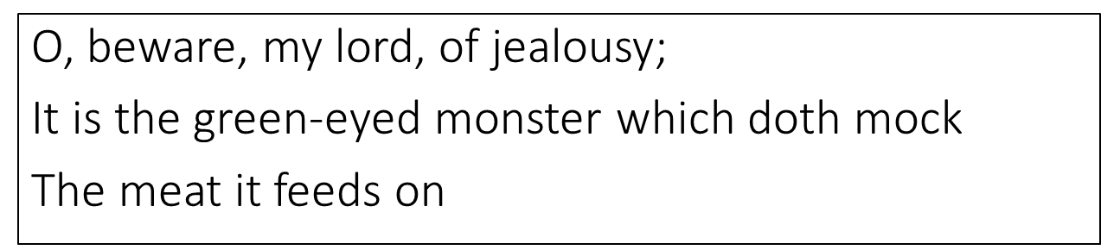
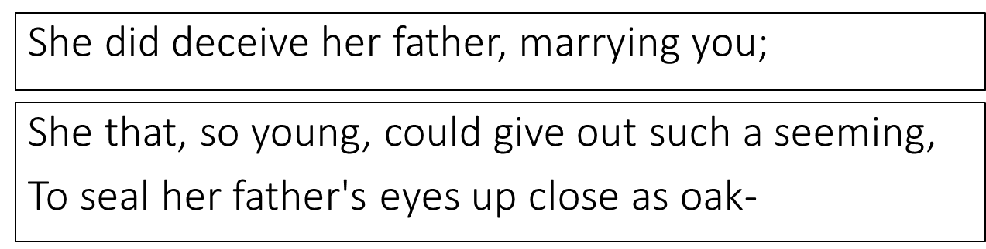

Task 2: Complete these sentences.
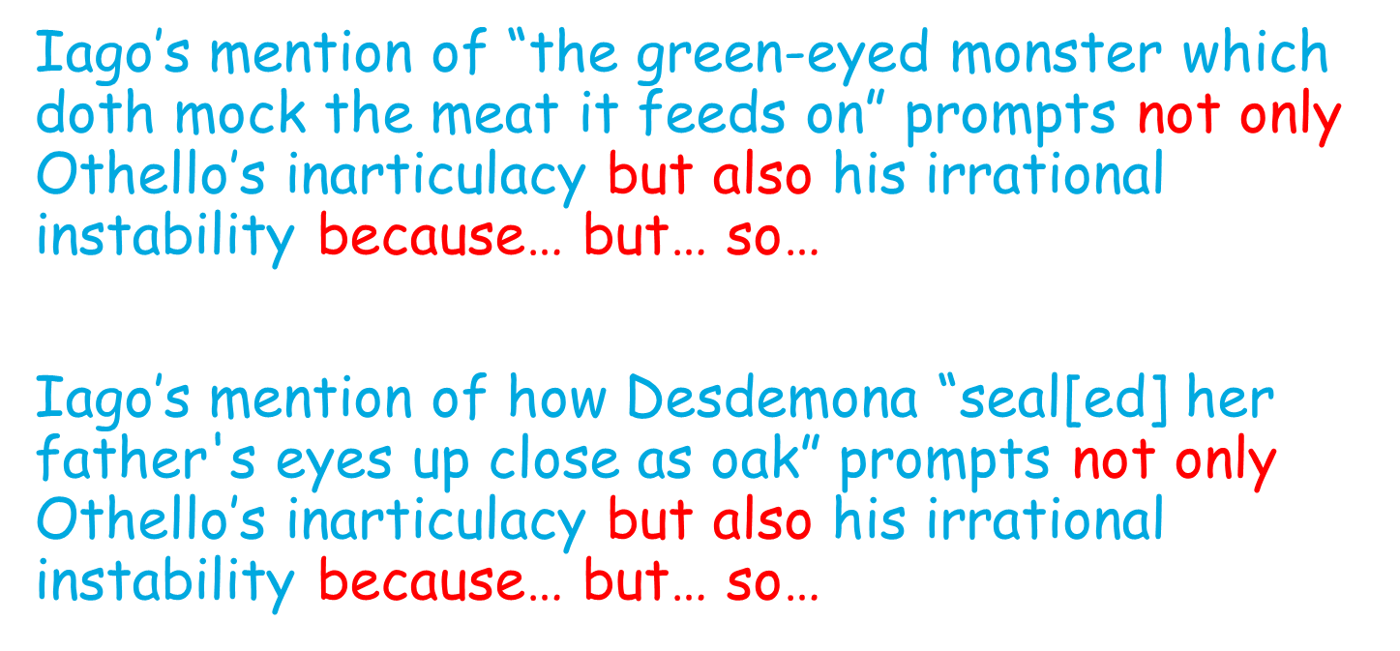

Task 3: Complete this paragraph.
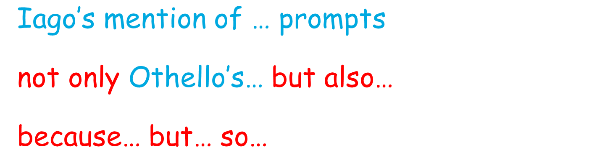

L.O. To explain how Othello has changed from steadfast and confident to doubtful and unstable.
Do Now:
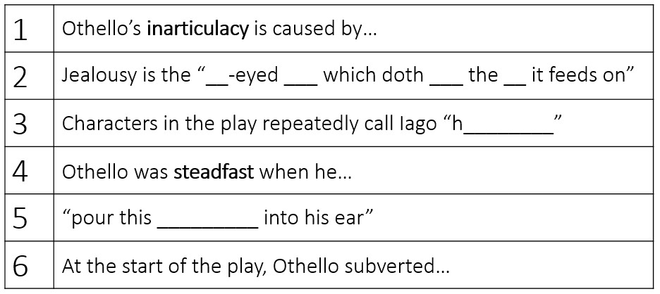
Vocabulary: look, cover, write, check to learn the definitions
Inarticulacy  (noun) | If someone is reduced to inarticulacy, they can’t speak properly. | The pain of his tooth reduced him to inarticulacy
Irrational  (adjective) | If you describe someone's feelings and behaviour as irrational, you mean they are not based on logical reasons or clear thinking. | She had an irrational fear of chicken pies.
Credulous  (adjective) | If you describe someone as credulous, they are too ready to believe what people tell them and are gullible. (Noun – credulity) | Because she was credulous, she was always easily fooled by her friends’ foolish stories.
New Knowledge: follow the instructions and read the information twice
- Today, we’re going to plan to combine all of our knowledge into a big write-up.
- The question is How does Shakespeare present the Othello’s change from steadfast and confident to doubtful and unstable??
- We’re going to use all of our past lessons to help us. But first, let’s think of our ‘big idea’.
- Complete Task 1 in the mid-module assessment section of the booklet.
- Complete Task 2 in the mid-module assessment section of the booklet.
- Display slide 5 as students are writing.
Task 1: Complete this introduction
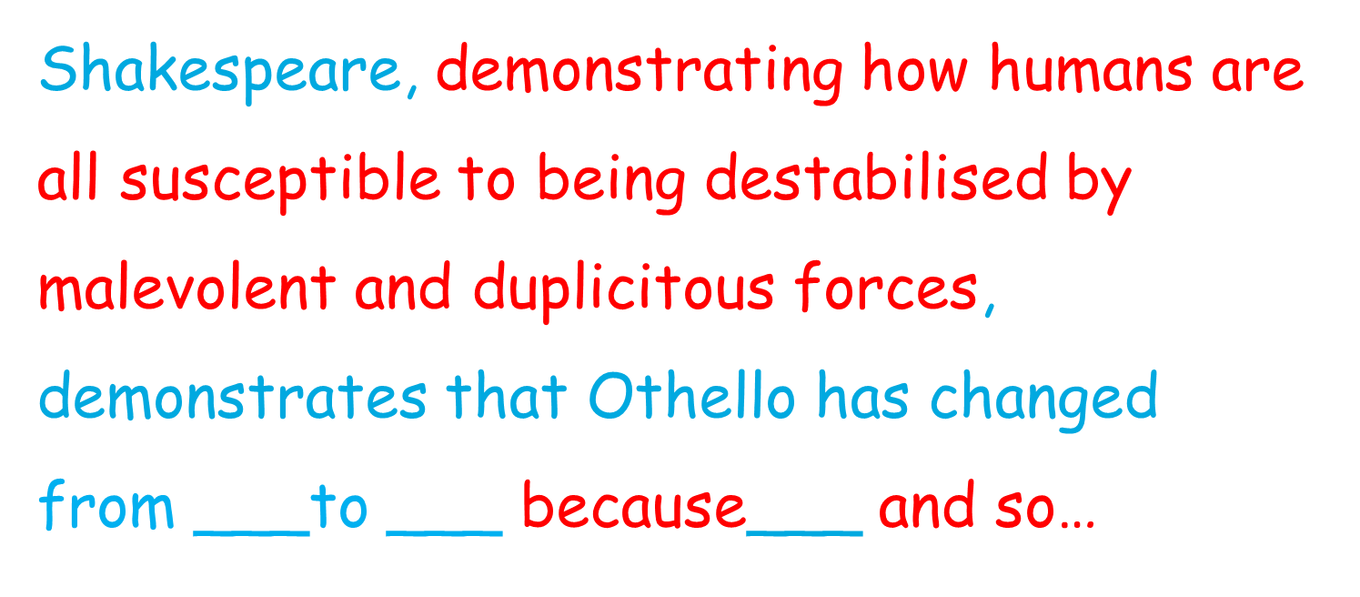

Task 2: Use this resource to help you to write an essay
