Ks3 Writing student self-study workbook

Mastery Writing Self-Study Unit: Parent and Student Guide
This booklet is for KS3 students to practice writing on their own or with the help of a parent or carer.
What will I do and learn?

- You will learn to write a well-structured love story with an opening, problem, solution and happy ending.
- You will learn about key grammatical rules that will make your writing more accurate and precise.

How do I use the booklet?
- Set aside 1 hour to complete each lesson (20 minutes on grammar tasks and 40 minutes on the writing task).
- Read the grammar rules and explanations carefully before completing the tasks.
- For the grammar tasks, you can find the answers in the answer booklet.

How do the lessons work?
Each lesson is divided into four parts:
- Do Now reviewing previously studied grammar: 5 minutes
- New grammar instruction and exercise one: 5 minutes
- Revision exercises two and three: 10 minutes
- Explanation of how to structure your story: 10 minutes
- Planning and writing your story: 25 minutes
- Reading and checking your story: 5 minutes

How can I check the quality of my writing?
- After finishing your writing, re-read and check through it. Circle the key vocabulary. Underline and label the Mastery Checks.
- If you have not used all of the Mastery Checks or key vocabulary, edit your work to include them.

Can parents, carers and siblings help?
Yes, of course! Family members can help in the following ways:
- Help you check your work using the answer booklet we provide.
- Help you with the planning of the story and check their writing after you have completed it using the Mastery Checks.
- Write a story at the same time as you. You could then compare your stories and check
each other’s writing.
What else can I do if I love writing and I want more of a challenge?
- Keep writing stories using your own ideas.
- Use the structure you learn in this unit to write other types of stories, such as fantasy quests and mysteries.

Lesson 1
Do Now: Complete the sentences by writing a correct list.
RULE: In a list, replace all the ands with commas, except the last one.

You are mastering how to punctuate a list.
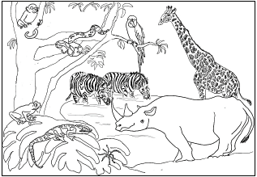
a frog | a monkey | a giraffe
a lizard | a snake | a rhino
a spider | a parrot | two zebras

- sat on the leaf.

- By the watering hole, drank.

- You could see peeping from the tree.

Read the information below to understand how to punctuate when it happened.

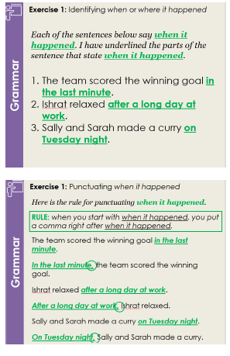

Exercise 1
RULE: when you start with when it happened, you put a comma right after when it happened.
Task: Underline when it happened in each of these sentences.
Task: Re-write each sentence so that it begins with when it happened.
1. The telephone rang as she was leaving the office. | 1.
2. You will be given your pocket money at the end of the month. | 2.
3. The man and the woman held hands while they walked. | 3.
4. Nelli blushed when her name was called. | 4.

Exercise 2
RULE: When you combine two sentences with the word but, you put a comma before the word but.

Task: Punctuate the sentences correctly.
- Adrian wanted to see the film but it was fully booked.
- The elephants were huge but they were also gentle.
- I read the book but I didn’t enjoy it.
- We tried to go to Spain but our flights were cancelled.
- Sasha looked for you but she couldn’t find you.

Exercise 3
RULE: What a person said should start and end with speech marks.
What a person said should start with a capital letter and end with a full stop. “X said” should always be followed by a comma if it is before what a person said.

Task: Write what each person said in the space below.

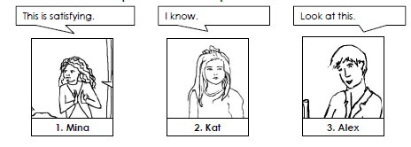

Example | Sam said, “Let me help.”
1. | Mina said, "
2. | Kat said,
3. | Alex said,

Story Writing:
- Look at the vocabulary below the image. You will need to use each of these words in your writing to say what happened in the image. Tick off the words as and when you use them.
- You will also need to make sure you have included all of the mastery checks in your writing. You have 30 minutes to complete your writing
- You should use the notes and pictures in each box to help you plan your story.
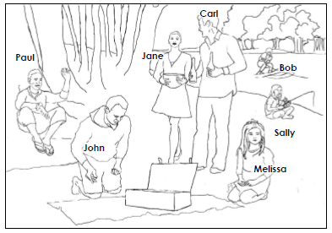

Vocabulary
dangled | fishing rod |  | lake |  |  | skimmed
knelt | picnic |  | water skis |  |  | brought
Mastery Checks
Mastery Check 1 |  | Mastery Check 2 |  |  | Mastery Check 3
I have used every word from the vocabulary box correctly. |  | I have commented on all the important things that happened in the image. |  |  | I have used capital letters and full stops correctly.

Lesson 2

Do Now: Complete the sentences by writing a correct list

You are mastering how to punctuate lists.

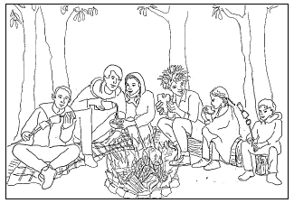

the men | logs | soup
the women | tree stumps | sandwiches
the children | rugs | marshmallows

- sat round the campfire.

- The campers sat on

- They ate

Read the information below to understand how to punctuate when it happened

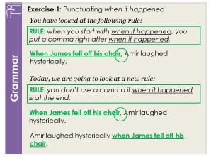

Exercise 1
RULE: You don’t use a comma if when it happened is at the end.

Task: Re-write these sentences. If when it happened is at the start, move it to the end. If when it happened is at the end, move it to the start.
1. Sulef gazed out of the window as he drank his coffee. | 1.
2. After break, the class trooped back to lessons. | 2.
3. The family went on holiday every summer. | 3.
4. Before he ate it, John sniffed the food. | 4.

Exercise 2
Read the information below to understand how to punctuate where it happened.

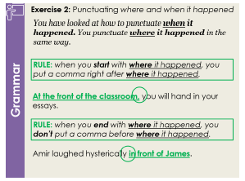

Task: Re-write these sentences.
- If where or when it happened is at the start, move it to the end.
- If where or when it happened is at the end, move it to the start.

1. In the next room, the baby cried.
2. On the desk, there was a pile of
papers.
3. The sun started to shine over the
city.
4. At the café, he bought a coffee.
5. There was a clock next to the
image.
6. Melt the chocolate above a pan of
boiling water.

Exercise 3
You are mastering how to punctuate speech.
RULE: If the sentence starts with the words someone said, put a comma before the final speech marks.

Task: Punctuate the sentences below correctly.

1. | I want to return this package Karim said
2. | This is my favourite book the lady said
3. | The wedding was moving the old man said
4. | Do not be late again my teacher said
5. | You need to eat more fruit Doctor Black said
6. | Don’t be afraid to call Alex said to me

Read the information below to understand how to infer. You will need to look at the images on the next page to help you.

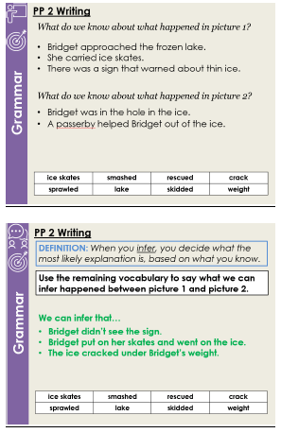

Story Writing:
- Look at the vocabulary below the images. You will need to use each of these words in your writing to say what happened in the image. Tick off the words as and when you use them.
- You will also need to make sure you have included all of the mastery checks in your writing. You have 30 minutes to complete your writing
- You should use the pictures in each box to help you plan your story.

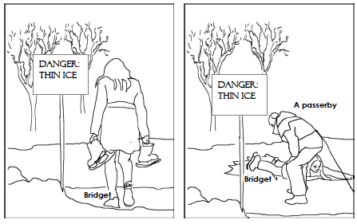

Vocabulary
ice skates | smashed |  | rescued |  |  | crack
sprawled | lake |  | skidded |  |  | weight
Mastery Checks
Mastery Check 1 |  | Mastery Check 2 |  |  | Mastery Check 3
I have used a list and punctuated it correctly. |  | I have said when or where it happened and punctuated this correctly. |  |  | I have used speech and punctuated it correctly.

Lesson 3

Do Now: Punctuate this paragraph correctly.

You are mastering how to punctuate but.

Kevin decided it was time to buy a new jacket but he needed help. He always felt envious of the way his friends dressed. They seemed to just know what made them look good but Kevin was the opposite.
Kevin asked his friend Kwasi to come with him on his shopping trip. “Of course I’ll come but I don’t know if I’ll be able to help that much,” Kwasi said. “I always get the sense that everyone else knows what to wear but, I don’t have a clue.”
“That makes two of us,” Kevin replied. “I’m sure we’ll muddle through together.” He felt relieved and reflected that maybe he wasn’t the only one who didn’t know what he was doing.

Exercise 1
Read the information below to understand how to punctuate speech.

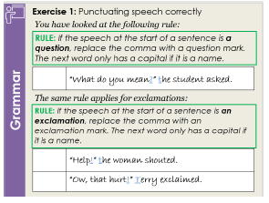
RULE: If the speech at the start of a sentence is an exclamation, replace the comma with an exclamation mark. The next word only has a capital if it is a name.

Task: punctuate the speech correctly.

1. | What a mess my mum said
2. | That lightening is terrifying Clare exclaimed
3. | I don’t want to talk about it the boy shouted
4. | Happy Birthday They cheered
5. | Wow, what an incredible painting nabil said.

Exercise 2

Read the information below to understand paragraphing.

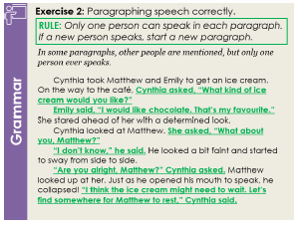

Write a whenever a new paragraph should start.
P
RULE: Only one person can speak in each paragraph. If a new person speaks, start a new paragraph.

Cynthia took Matthew and Emily to get an ice cream. On the way to the café, Cynthia asked, “What kind of ice cream do you each want?” Emily said, “I would like chocolate. That’s my favourite.” She stared ahead of her with a determined
look. Cynthia looked at Matthew. She asked, “What about you, Matthew?” “I don’t know,” he said. He looked a bit faint and started to sway from side to side. “Are you alright, Matthew?” Cynthia asked. Matthew looked up at her. Just as he opened his mouth to speak, he collapsed! “I think the ice cream might need to wait. Let’s find somewhere for Matthew to rest,” Cynthia said.

Exercise 3
You are mastering how to punctuate when and where it happened.
Task: Correct this passage so that every sentence is punctuated correctly.

Zain and Trevon walked along the gangway. As they approached the plane Zain began to feel nervous. At the entrance to the plane the air steward greeted them.
As they took their seats Trevon kept spouting facts about how rare plane crashes were. In his head Zain knew that this was true. His stomach seemed to have other ideas.
Up ahead the safety demonstration began. Zain began to feel less convinced that crashes were rare. He fastened his seatbelt across his lap.
Once the announcement was over he put his headphones in. It was going to be a long flight.

Story Writing:
  - Look at the vocabulary below the images on the next page. You will need to use each of these words in your writing to say what happened in the image. Tick off the words as and when you use them.
  - You will also need to make sure you have included all of the mastery checks in your writing. You have 30 minutes to complete your writing
  - You should use the pictures in each box to help you plan your story.

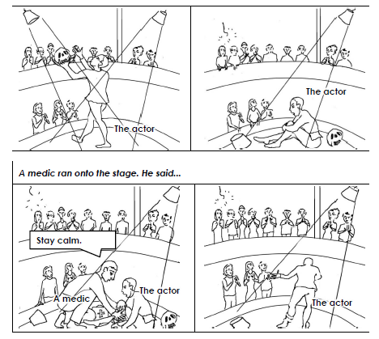

Vocabulary
plummeted | theatre |  | crack |  |  | bandage
audience | light |  | knelt |  |  | wires
Mastery Checks
Mastery Check 1 |  | Mastery Check 2 |  |  | Mastery Check 3
I have used the word but and punctuated it correctly. |  | I have included speech and punctuated and paragraphed it correctly. |  |  | I have included when and where it happened and punctuated this correctly.

Lesson 4

Do Now: Write a whenever a new paragraph should start.
P

You are mastering how to paragraph speech.

Josh said, “I’m not sure I can do this.” He was sweating and looked very pale. “What if they hate me?” he asked. “Don’t be ridiculous, Josh.” Amir replied.
“Seriously, I think I’m going to be sick.” Josh said. Amir took him by the shoulders. Josh said, “Help me Amir.” “Take a deep breath,” his friend said. He breathed in to show Josh what he meant. Josh nodded and took a deep breath too. “That’s it,” said Amir. “Now, off you go,” he said as he gave Josh a firm shove onto the stage.

Exercise 1
Read the information below to understand how to punctuate two-part speech.
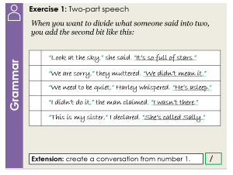

Task: Punctuate these sentences correctly.

1. | “That’s strange,” the man said. I thought I looked there
2. | “Have a sweet,” Will offered they are very tasty
3. | Chloe isn’t here they said she’s gone home
4. | Pass the popcorn her mum whispered I’m hungry
5. | I write poetry said Kelvin to George it helps me think
6. | What a great coat the man said I must get one

Exercise 2
Read the information below to understand how to punctuate although, unless and if.
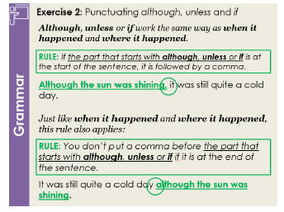

Task: Re-write the sentences. Move the part that starts with although, unless or if to the start or end of the sentence.
1. If you could tell me the time, it would be helpful. | 1.
2. We can’t allow you in unless you are on the guest list. | 2.
3. Although it was raining, I did not take an umbrella. | 3.
4. You should follow your passion if it is important to you. | 4.
5. Unless he stops eating, he will be sick. | 5.
6. Samira could not sleep, although she was tired. | 6.

Exercise 3

You are mastering how to paragraph place shifts.

RULE: Start a new paragraph whenever there is a change in where the main action happens.

Task: Correct this passage so that every sentence is punctuated correctly.

Outside the forest, Johnnie stopped for a minute to read the sign. ‘Experts only,’
it said. He watched three cyclists whizz past him on their flashy mountain bikes.
Johnnie looked down at his bike. It was hardly high tech because he’d only been cycling for a couple of weeks. Johnnie shrugged. “I’m sure I’ll be fine,” he said to himself. Inside the forest, Johnnie found the track. His eyes followed it through the trees. It did look quite tricky. There were lots of bends and some very steep declines. Johnnie proceeded. He was very wobbly, but was determined to keep up with the other cyclists. After some shaky cycling, Johnnie reached the top of a hill and had to take a minute to catch his breath. He nearly got knocked off his bike as other cyclists flew past him down the slope. “Here goes,” he said to himself. He took a deep breath and pushed off from the top of the hill. The next thing he knew, Johnnie was flying through the air before he landed with a loud “splash” in the nearest pond. His bicycle landed just next to him, showering him in a cold wave of pond water. On the edge of the pond, a lady stood and giggled. She had dismounted from her
professional bike and was looking at Johnnie with a mixture of disgust and pity. “I
think you may be on the wrong course, mate!” she laughed.

Writing
One way to structure a story is as a “problem solved story”. Read the information
below to understand how these stories work.

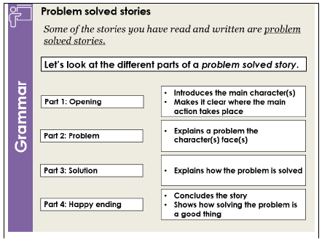

Story Writing:
    - Look at the vocabulary below the images on the next page. You will need to use each of these words in your writing to say what happened in the image. Tick off the words as and when you use them.
    - You will also need to make sure you have included all of the mastery checks in your writing. You have 30 minutes to complete your writing
    - You should use the notes and pictures in each box to help you plan your story.

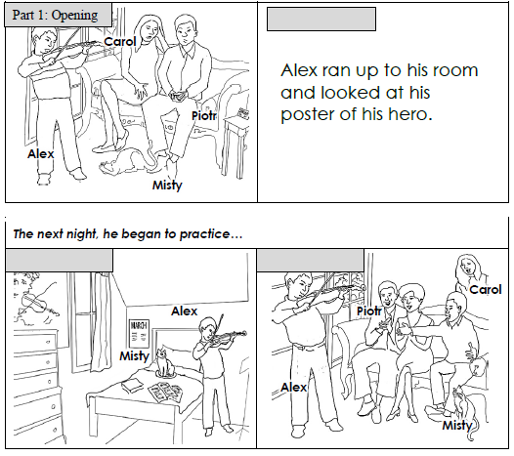
Vocabulary
January | practise |  | celebrated |  |  | screeched
inspired | strings |  | June |  |  | bow
Mastery Checks
Mastery Check 1 |  | Mastery Check 2 |  |  | Mastery Check 3
I have included speech and have punctuated and paragraphed it properly. |  | I have included although, unless or if and punctuated it correctly. |  |  | I have paragraphed my work correctly.

Lesson 5
You are mastering punctuating lists.

Do Now: Punctuate these lists correctly.

  - The man turned smiled waved at the lady
  - I cleaned the windows the floors the walls the kitchen surfaces.
  - Kirsten painted hummed. Mercedes sat on the sofa read listened to music.
  - The twins ordered the food sat at the table chatted whilst I went outside called my mum
  - Although I enjoy swimming playing tennis, I dislike running cycling weightlifting.

Exercise 1
RULE:
- If the part that starts with even though, because or whenever is at the start of the sentence, it is followed by a comma.
- You don’t put a comma after this part if it is at the end of the sentence.

You are mastering how to punctuate even though, because and whenever.

Task: Underline the part of the sentence that starts with even though, because or whenever. Then, put a comma in the sentence that need one.

- Whenever I go to the cinema I buy popcorn.
- Even though I don’t think you should have done it I understand why you did.
- They went shopping because he needed new shoes.
- Even though it’s too big I still wear this jumper.
- He laughed whenever Kelly told a joke.
- Because Ella cheated she was disqualified.

Exercise 2

You are mastering how to paragraph.

Task: Write a whenever a new paragraph should start.
P

Mandy decided to bake a cake. She worked for hours to make and decorate a delicious chocolate cake. Outside, Sarah and Raj watched through the kitchen window. They couldn’t take their eyes off the luxurious sponge, the chocolaty icing and the tempting fruit decorations. The children sneaked into the kitchen when Mandy went to have a shower. Raj gave Sarah a look and she knew exactly what he was thinking. It was as if the cake was begging them to eat it. They crept up to the counter and started to devour the cake. When Mandy came back into the kitchen, the children were covered in chocolate cake. The kitchen was a mess as well. Crumbs were everywhere and chocolate was on every surface. “If you are quite finished, I would like a slice!” Mandy exclaimed. The children turned around guiltily. “Sorry Mandy, but there’s none left,” replied Sarah sheepishly. “Well, you
had better make another cake then,” Mandy replied. She strutted away to leave the children to it. Raj and Sarah worked all afternoon to make a new cake. After many hours, they told Mandy that it was ready to try. Mandy enjoyed a slice of the cake in peace because the children felt too sick to even look at it.

Exercise 3
You are mastering how to punctuate speech.

Task: Punctuate this passage carefully.

As Tim and Samira trekked through the jungle, Tim saw something that made his blood freeze.
Samira can you see what I can see? Tim asked.
Samira looked up and whispered yes Tim. I can see that enormous snake right in front of us.
Ok, we need to get past it, but we must be careful not to disturb it Tim said.
Let’s tread really carefully around the tree.
I’ll go first Samira said. I’ve dealt with snakes before. Follow me.
Samira carefully stepped past the snake being very careful not to make a noise. Tim followed softly behind. The snake continued to doze.

Writing
You have written a problem solved story. Another kind of story you can write is a
“comeuppance story”. Read the information below to understand what these stories look
like.

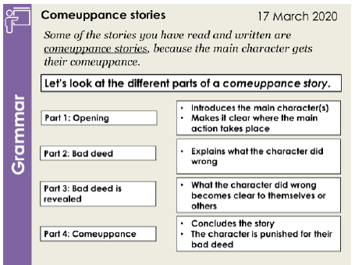

Story Writing:
- Look at the vocabulary below the images on the next page. You will need to use each of these words in your writing to say what happened in the image. Tick off the words as and when you use them.
- You will also need to make sure you have included all of the mastery checks in your writing. You have 30 minutes to complete your writing
- You should use the notes and pictures in each box to help you plan your story.

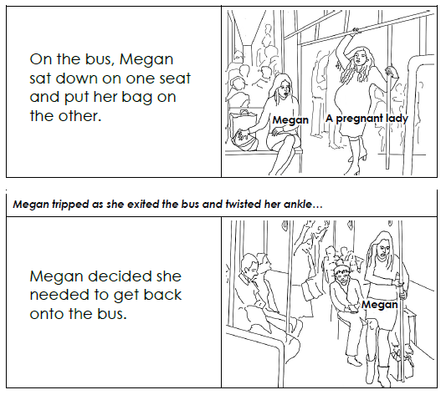
Vocabulary
exhausted | ignored |  | pleaded |  |  | dumped
pain | hobbled |  | cried |  |  | nobody
Mastery Checks
Mastery Check 1 |  | Mastery Check 2 |  |  | Mastery Check 3
I have used even though, because or whenever and punctuated it correctly. |  | I have paragraphed my work correctly. |  |  | I have included speech and have punctuated and paragraphed it correctly.

Lesson 6

Do Now: Correct the errors in the following passage
miranda looked at the ocean where a wild sea was raging and she

watched as the waves went wild and she said “ What a dramatic storm.

Exercise 1
DEFINITION: The subject of a sentence is who or what is doing the main action.

Task: Underline the subject in these sentences.
Task: Circle the main verb. Main verbs tell what the subject was doing.

- Tim threw the paper in the bin.

- The rain caused flooding in Shropshire.

- In the city, many people lived in poverty.

- After they ran away from Athens, Lysander and Hermia escaped into the forest.

- Leaves, twigs and sticks littered the ground.

- Although he loved the theatre, Sam was not confident enough to go to the audition.
- “I want to be a dinosaur!” yelled Diana.

- After he came home from school, James completed his homework straight
away because he didn’t want to get a detention from Mr Rowley the next day.

Exercise 2
You are now mastering sentences.
RULE: To be complete, a sentence must:

- Contain a subject
- Contain a verb
- Express a complete idea

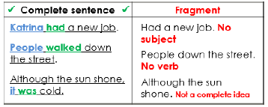

Task: Decide whether the following examples are complete sentences or fragments.

Sentence | Complete sentence or Fragment?
1. Sikes, a violent, vicious and venomous criminal.
2. The island looked stunning.
3. Starting to shine through the clouds.
4. Gabriel really loved to play football.
5. Although the hurdles were really hard.
6. Jill carelessly tripped over the muddy stick.
7. Anita won several awards at the school presentation evening.

8. I enjoyed fishing.
9. Fagin and Dodger stole all the jewels.
10. Robin hadn’t quite mastered
badminton.

Exercise 3

RULE: If when it happened is at the start of the sentence, you put a comma after it.

Rewrite these sentences so that when it happened is at the start.

- The ground gets very soggy when it rains.

- People applauded when Tyren had finished his cello performance.

- Shelly clapped her hands as the monkeys performed their tricks.

Error Correction
Task: Correct the errors in this passage (There are 6 errors).

I cannot describe to you what it was like to be stood alone in the darkness. I was so lonely and cold. The silence was as deep as death.
The only sounds that I could hear was the ones I made myself. I tried to keep still. For as long as possible.
I listened and listened. I held my breath and listened again. I had a strange feeling. That the whole wood was listening with me. I could hear the trees the bushes the little animals hiding in the bushes and the birds
roosting in the trees. I could even hear the snuffling of a stray hedgehog.

Although the moon lit up the clearing. I couldn’t see past the shadows.

You have written a problem solved story. Read the information below to revise what these stories involve.

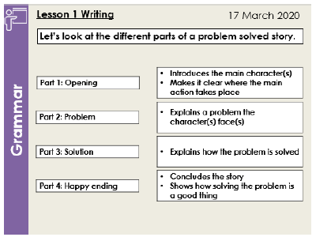
You can use a problem solved structure to write a love story. Read the information below to see an example of how this might work. This picture could show the opening of the story or the happy ending.

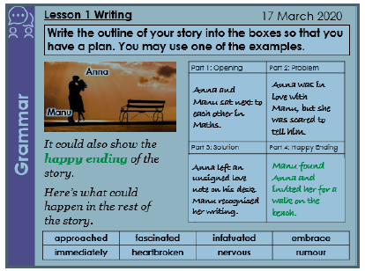

Story Writing:
- Look at the vocabulary below the image. You will need to use each of these words in your writing to say what happened in the image. Tick off the words as and when you use them.
- You will also need to make sure you have included all of the mastery checks in your writing. You have 30 minutes to complete your writing
- You should plan your story by writing your ideas for each part in the boxes.

Part one: Opening |  |  |  | Part two: Problem
Part three: Solution |  |  |  | Part four: Happy ending
Vocabulary
approached | fascinated |  |  | infatuated |  |  | embrace
immediately | heartbroken |  |  | nervous |  |  | rumour
Mastery Checks
Mastery Check 1 |  |  | Mastery Check 2 |  |  | Mastery Check 3
I have used capital letters correctly. |  |  | I have written consistently in the past simple tense. |  |  | I have included when it happened and punctuated it correctly.
Crafting check: I have written a problem solved story with a clear opening, problem, solution and happy ending.

Lesson 7

Do Now:
Task: Correct the errors in this student’s work.
Thunder rolled and cracked across the hills. as rain lashed the rocky mountainside. the two travellers staggered on they were t ired cold and hungry they felt more dead than alive. “There is hope one of them
gasped, “because I can see lights in the castle

Exercise 1
Task: Underline the subject in these sentences.
  - Last December, a party of students set out to climb Mount Everest.

  - Ahmed Khan, a drama teacher, said that their performance was fantastic.

  - After they had filled the raisins with sleeping pills, Danny and his father fed them to the pheasants.
  - It was a few days later than this that the pigs discovered a case of whisky in the cellar.
  - It is a 3 pipe problem.

  - I have done nothing but in care of thee.

  - Fortunately, the fall was not serious.

Exercise 2
Read the information below to understand what an independent clause is.

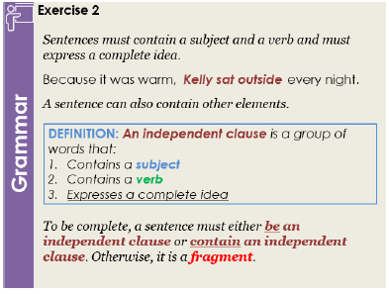

Task: Decide whether the following examples are independent clauses or fragments.
If they are independent clauses, name the subject and the verb. If they are fragments, explain why.

Sentence | Independent Clause or Fragment? | If it is an independent clause, what is the subject/verb?  If it is a fragment, explain why.
1. The lonely boy stumbled into the dingy room.
2. The guard laughed loudly.
3. Despite his many flaws.
4. Billy thought about dancing.
5. Because her mother encouraged her to be ambitious.
6. Although she couldn’t explain it.
7. The characters display a variety of emotions.
8. The geese, ducks and hens staged a month-long strike.
9. Jeremy dodged the ball.
10. Claudia’s cat stretched out on the
rug laid before the fire.

Exercise 3

DEFINITION: An independent clause is a group of words that:

- Contains a subject
- Contains a verb
- Expresses a complete idea
DEFINITION: A subordinate clause adds extra information to an independent clause.

Read the information below to understand the difference between an independent clause and a subordinate clause.

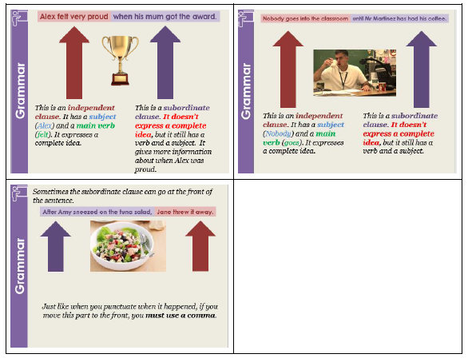

Task: Circle the subordinate clauses in these sentences. Underline the independent clauses.
- As Sherri blew out the candles on top of her birthday cake, her hair caught on fire.
- Sara begins to sneeze whenever she opens the window to get a breath of fresh air.
- When the doorbell rang, my dog barked loudly.

- After the basement flooded, we spent all day cleaning up.

- Even though my alarm had gone off twenty times, I hit the snooze button.

- After we had had lunch, we went back to work.

- The children need to take the bus no matter how much it costs.

- I first saw her in Paris where I lived in the early nineties.

Correct the errors in this passage (There are 4 errors) Error Correction
Although Orwell presents Boxer as a stupid animal, the reader is also sympathetic towards him. They want him to succeed even though they know that he is wrong to trust Napoleon. Orwell shows that Boxer cannot learn the alphabet past “d” can’t remember anything and
doesn’t listen to Benjamin when he is being warned about the pigs. Whilst Boxer may be stupid. He does have some moments of clarity. This is
demonstrated when he says “Then we have won back what we had

before. He recognises that the war was pointless.

Read the information below to revise how you can use a problem solved structure to write a love story. We will look at the opening in more detail.

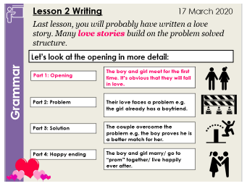

Read the information below to find out more about what the opening of a love story involves.

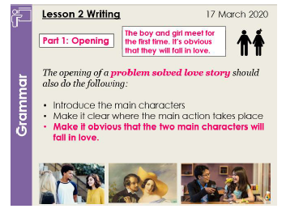

Story Writing:
- Look at the vocabulary below the image. You will need to use each of these words in your writing to say what happened in the image. Tick off the words as and when you use them.
- You will also need to make sure you have included all of the mastery checks in your writing. You have 30 minutes to complete your writing
- You should plan your story by writing your ideas for each part in the boxes.

Part one: Opening |  |  |  | Part two: Problem
Part three: Solution |  |  |  | Part four: Happy ending
Vocabulary
approached | fascinated |  |  | infatuated |  |  | nervous
rival | smiled |  |  | realised |  |  | heartbroken
Mastery Checks
Mastery Check 1 |  |  | Mastery Check 2 |  |  | Mastery Check 3
I have used capital letters correctly. |  |  | I have written consistently in the past simple tense. |  |  | I have not used any fragments.
Crafting check: I have written a problem solved love story with a clear opening, problem, solution and happy ending.

Lesson 8

Do Now:

e subjects and circle the main verbs in the sentences below. Remember, tell the action that the subject was doing.
Underline th main verbs

A bowler hat, magnifying glass and old boot lay on the table. Sherlock’s face furrowed in contemplation. This case had attracted attention from across the world. A loud bang, followed by a noisy crash, interrupted Sherlock’s reverie. Suddenly, the table and all its contents flew into the air. Watson, who was late for his meeting with Holmes, dashed into the room.

Exercise 1
Read the information below to understand the difference between singular and plural.

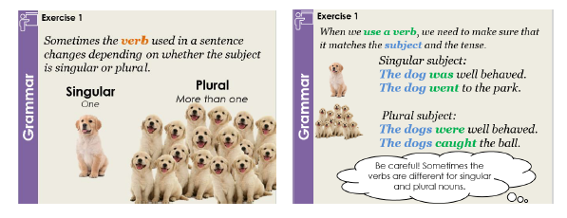

Task: Complete the table.

Subject | Singular/Plural | Convert the verb into past simple tense
He |  | [teach] geography.
The girls |  | [drink] lemonade.
They |  | [build] a wall.
Twigs and leaves |  | [lie] on the forest floor.
Holmes |  | [ban] the boy from speaking.
Deborah’s pet  goldfish |  | [eat] algae.
Ashley and her friends |  | [do] their homework every Friday night.

Exercise 2
Read the information below to understand how what makes an independent clause rather than a subordinate clause or fragment.

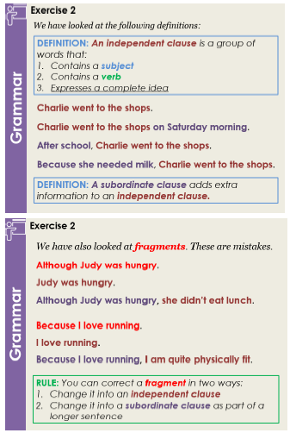

Task: Change the first 3 fragments into independent clauses.

  - Because Linda had eaten all of the cake.

  - Even though Nick loved Drama.

  - Whilst Emma ran home.

Task: Change the last 3 fragments into subordinate clauses in longer sentences. You can make up the rest of the sentence.

  - Sherlock Holmes, Doctor Watson, and Irene Adler.

  - In the battered old suitcase.

  - At 5 o’clock in the morning.

Exercise 3
Read the information below to understand what a temporal clause is.

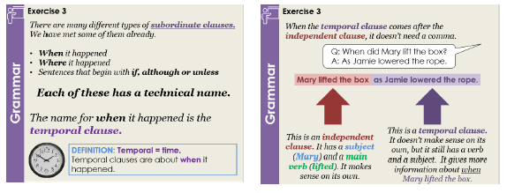

Task: Punctuate these sentences correctly.

- Whenever Daisy looked through the window she always saw things that she wanted to buy
- Kaleigh twisted the dial on the machine before Makayla could reach it

- As Holmes and Watson investigated the case more clues were revealed

- Brenda said before I go to the shops I need to get some petrol

Error Correction
Correct the errors in this passage (there are 5 errors).

Until 1547, King Henry VIII reigned over England, Ireland Scotland

and Wales. Catherine of Aragon, his first wife and a Princess of Spain. The only child she had was a girl called Mary. King H enry was angry. He
wanted a son. After he realised Queen Catherine was not able to have a son. He divorced her. He married a woman called Anne Boleyn, soon
afterwards. She was incredibly pretty and funny. Anne Boleyn had a daughter called Elizabeth, but no sons. Lots of people thinks that Anne Boleyn was the most intelligent wife. King Henry executed her in 1536.

Writing
You have written problem solved love stories. Read the information below to revise this structure.

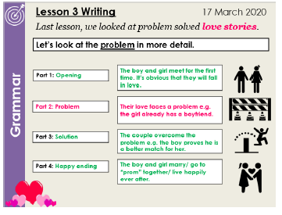

Read the information below to understand what the problem part of a love story looks like.

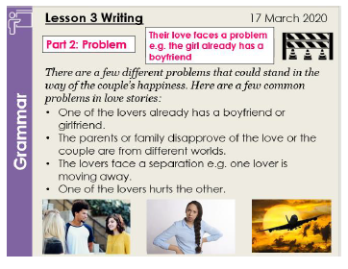

Story Writing:
- Look at the vocabulary below the image. You will need to use each of these words in your writing to say what happened in the image. Tick off the words as and when you use them.
- You will also need to make sure you have included all of the mastery checks in your writing. You have 30 minutes to complete your writing
- You should plan your story by writing your ideas for each part in the boxes.

Part one: Opening |  |  |  | Part two: Problem
Part three: Solution |  |  |  | Part four: Happy ending
Vocabulary
threatened | departed |  |  | infatuated |  |  | painful
career | desperate |  |  | relieved |  |  | romantic
Mastery Checks
Mastery Check 1 |  |  | Mastery Check 2 |  |  | Mastery Check 3
I have written consistently in the past simple tense. |  |  | I have not used any fragments. |  |  | I have included a temporal clause and punctuated it correctly.
Crafting check: I have written a problem solved love story with a clear opening, problem, solution and happy ending.

Lesson 9

Do Now:
Task: The verbs in the box are in the present tense. Change them into the past simple tense and fill in the blank spaces in the passage.

teach lie do sleep have bring try is

Gwen a horse called Barry. Barry loved to do tricks. Every day after school, Gwen Barry a new trick. The best trick was when he down and pretended to be asleep. When he did well, Gwen Barry a carrot. He always
to eat it quietly, but often he just gobbled it up. In the evening, Barry

in the stables. Barry and Gwen lots of things together. He a very happy horse!

Exercise 1
Task: Underline the independent clause and circle the temporal clause in these sentences.
- While Sabine drove, Katie navigated.
- Whenever his mum wasn’t looking, Callum rode his bike too fast.
- Angela explained what had happened before Stephanie could interrupt.

Exercise 2
Read the information below to understand fragments and subordinate clauses.
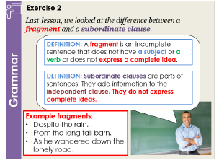

Task: Change the first three fragments into independent clauses.

Example: Before Francis drank his drink → Francis drank his drink.
- After Tim paid for his lunch.

- As he laid it beneath the red and yellow striped umbrella.

- Even though he did well in his exams.

Task: Change the next three fragments into subordinate clauses in longer sentences. You can make up the rest of the sentence.

Example: Instead of leaving it alone. → Instead of leaving it alone, John messed around with the toy on his desk.

- Rather than asking someone else.

- In the middle of the long, cold night.

- At the edge of the paper.

Exercise 3
Read the information below to revise temporal clauses.
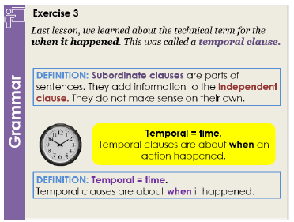

Read the information below to understand what a prepositional phrase is.

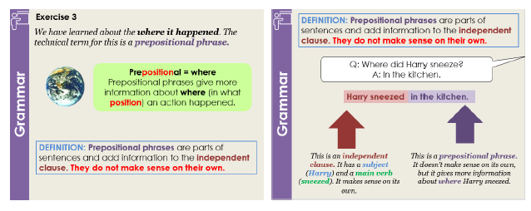

Task: Underline the independent clauses and circle the prepositional phrases.
- Nicholas put his bottle down on the table.
- At the restaurant, James waited to be served.
- Jemima would not sit down in her chair.
- Inside, the room was nice and cosy.
- In the corner of the box, two mice lay sleeping.

Error Correction
Task: Read these paragraphs. This student has made some mistakes when punctuating the prepositional phrases. They have also made some other errors with punctuation.
Correct these errors (there are 5 errors).

Henry VIII had a total of six wives. He divorced his first wife and

beheaded his second wife. Henry’s third wife was called Jane Seymour.

She died, soon after she gave birth to her son. She named the son Edward.
After Jane’s death, Henry married a German princess called Anne of Cleves, in Westminster Cathedral. There was celebrations all over
England. In Greenwich lots of celebrations and parties were held. Henry had originally thought that Anne was pretty, but after the wedding he
decided that she was too ugly to be his wife. He sent her away to live in Kent. In the countryside. She learned to ride horses and hunt deer.

Writing
You have written problem solved love stories and thought about what the opening and problem should involve. Read the information below to understand what the solution should involve.

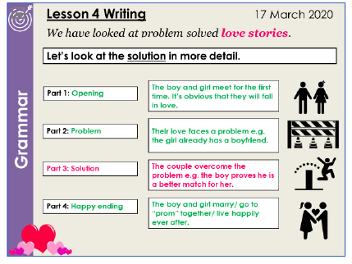

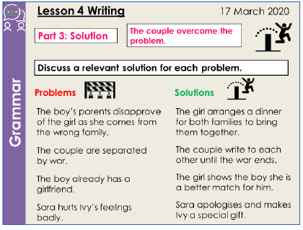

Story Writing:
- Look at the vocabulary below the image. You will need to use each of these words in your writing to say what happened in the image. Tick off the words as and when you use them.
- You will also need to make sure you have included all of the mastery checks in your writing. You have 30 minutes to complete your writing
- You should plan your story by writing your ideas for each part in the boxes.

Part one: Opening |  |  |  | Part two: Problem
Part three: Solution |  |  |  | Part four: Happy ending
Vocabulary
specialty | dejected |  |  | hope |  |  | pastry
skilled | inseparable |  |  | sublime |  |  | romantic
Mastery Checks
Mastery Check 1 |  |  | Mastery Check 2 |  |  | Mastery Check 3
I have written consistently in the past simple tense. |  |  | I have not used any fragments. |  |  | I have included a temporal clause at the start of a sentence and at the end of a sentence.
Crafting check: I have written a problem solved love story in which the solution is prepared in the opening.

Lesson 10

Do Now:
Punctuate these sentences correctly.
- After the men had gone home the building site was deserted

- Amelia smiled as she opened her exercise book

- Whenever the siren went off the school children evacuated the building
- The insects flew away when they ran out of food

Exercise 1
Read the information below to find out more about irregular past simple tense verbs.

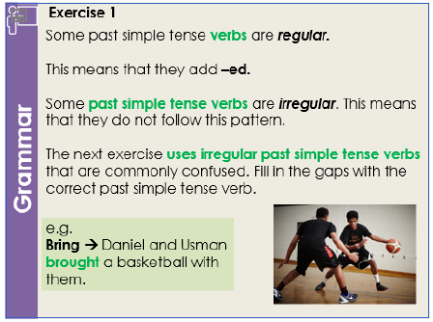

Task: Read this passage and add in the correct version of the past simple tense verbs. Some may appear more than once.

do | choose | bring come find | buy drive
 | break | can eat tell is | begin

We did it! Mum’s surprise birthday party a success. Everyone

on time and people very thoughtful presents. People who not come sent beautiful cards. When she out, Mum to cry with happiness. We lots of work to make sure that she had a good time. We
her a nice cake, her a lovely card and all the way to Yorkshire to find the perfect balloon animal maker. Even though Orhan the plate of sausage rolls, nothing spoil this day. We all lots of food and danced to music. At the end of the day, Mum us that she the proudest mother in the world!

Exercise 2
Task: Underline the independent clauses and circle the prepositional phrases.
- Beryl waited in a queue at the Post Office.
- In the city, life is much faster.
- On a faraway island full of tropical birds and exotic animals, Sycorax reigned.
- You will find the information on the left.
- From the very first page of a book, one can imagine what great adventures await.
- “I want the yellow one!” Jessica yelled down the corridor.

Read the information below to understand how to punctuate lists in subordinate clauses.

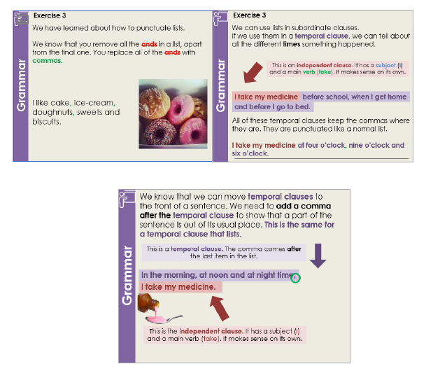

Task: Punctuate the sentences in Exercise 3 correctly. Exercise 3
- At three seven and nine o’clock the performances will begin.
- When Lucy started yelling Mercy Victor and Hazel started to cry.

Exercise 3
- I like to eat blackberries on summer mornings at lunch t ime and as I’m

walking home.

- Bertie does his homework on a Monday Tuesday Thursday and Friday.

- In March April and May the daffodils are beautiful.

- When i t’s raining thundering or snowing we have fewer visitors.

- On the 18 th 19th and 20 th of July a large funfair will arrive in Birmingham.

- As Pippa played basketball Chad opened his bag took out a book and started to read.

Error Correction
Read this paragraph. The writer has made some mistakes when punctuating the subordinate clauses. They have also made some other errors with punctuation. Correct these errors (there are 7 errors).
After he had sent Anne of Cleves to Kent, King Henry refused to

speak to anybody. He was furious that she had not given him a son. He was now an old man. Throughout the winter autumn and spring Henry moped.
Just as everyone was about to give up hope Henry fell in love with a woman called Catherine Howard. They spent all of their t ime together.
During breakfast lunch and dinner Henry sat next to her and gave her fine food and good wine. He married her in 1540.
Because she was very young and pretty. Catherine got lots of attention from other men. King Henry was so jealous that he had her executed, after less than two years of marriage.

Writing
You have written problem solved love stories. Read the information below to revise the solution part of a problem solved love story.

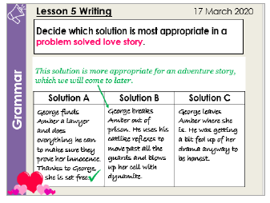

Read the information below to understand what the happy ending part of a problem solved love story should involve.

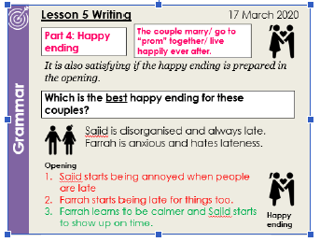
Story Writing:
- Look at the vocabulary below the image. You will need to use each of these words in your writing to say what happened in the image. Tick off the words as and when you use them.
- You will also need to make sure you have included all of the mastery checks in your writing. You have 30 minutes to complete your writing
- You should plan your story by writing your ideas for each part in the boxes.

Part one: Opening |  |  |  | Part two: Problem
Part three: Solution |  |  |  | Part four: Happy ending
Vocabulary
threatened | terrified |  |  | infatuated |  |  | determined
sacrificed | inseparable |  |  | intrigued |  |  | romantic
Mastery Checks
Mastery Check 1 |  |  | Mastery Check 2 |  |  | Mastery Check 3
I have written consistently in the past simple tense. |  |  | I have included a prepositional phrase and punctuated it correctly. |  |  | I have included a prepositional phrase with a list in it and punctuated it correctly.
Crafting check: I have written a problem solved love story in which the happy ending and the solution are prepared in the opening.

