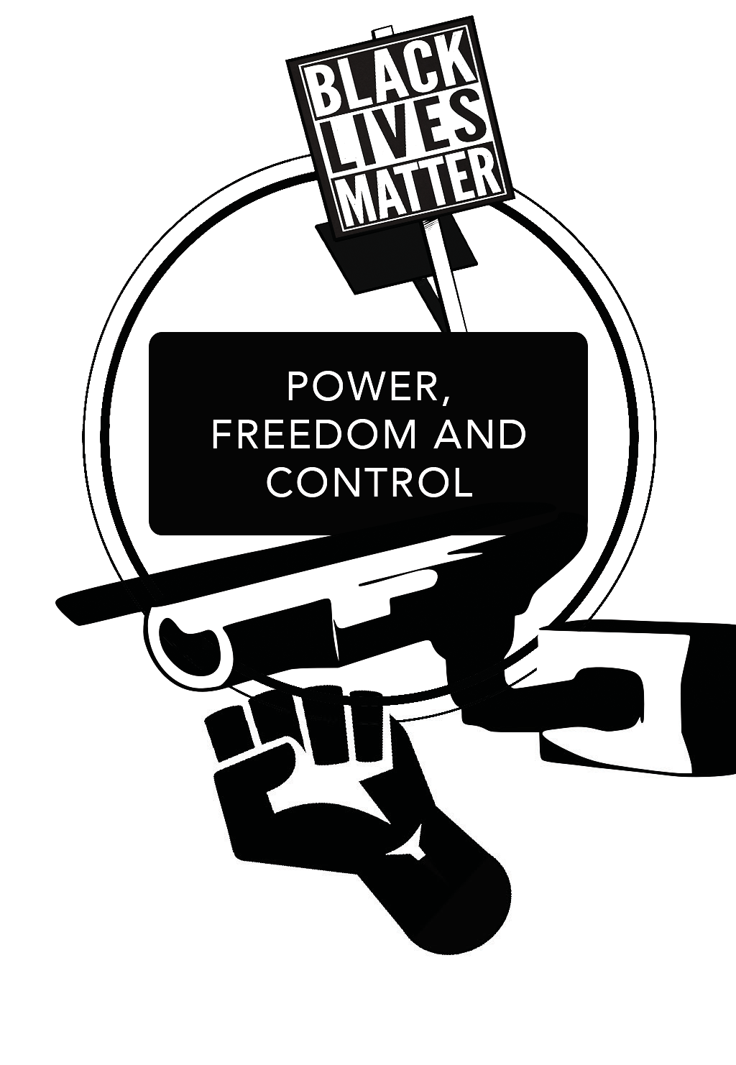

The Hate U Give, by Angie Thomas
The Hate U Give is a novel loosely based on the Black Lives Matter movement in the United States. This is a movement that campaigns against the unjust treatment of black people by the police in the U.S., particularly young black men, who are up to nine times more likely to be shot dead by police than other Americans.

Connecting to the topic
- Think about your responses to these three statements:

1. People should respect the police at all times, whatever the situation.
2. All police in the UK should carry guns. (The majority don’t.)
3. The law should apply differently to the police than to the rest of the population.
- Choose one of the statements and explain what you think about it:

- Now read the extract from ‘The Hate You Give’ by Angie Thomas and answer the questions that follow

THE HATE U GIVE

ANGIE THOMAS
When I was twelve, my parents had two talks with me.
One was the usual birds and bees. Well, I didn’t really get the usual version. My mom, Lisa, is a registered nurse, and she told me what went where, and what didn’t need to go here, there, or any damn where till I’m grown. Back then, I doubted anything was going anywhere anyway. While all the other girls
sprouted breasts between sixth and seventh grade, my chest was as flat as my back.
The other talk was about what to do if a cop stopped me.
Momma fussed and told Daddy I was too young for that. He argued that I wasn’t too young to get arrested or shot.
‘Starr-Starr, you do whatever they tell you to do,’ he said. ‘Keep your hands visible. Don’t make any sudden moves. Only speak when they speak to you.’
I knew it must’ve been serious. Daddy has the biggest mouth of anybody I know, and if he said to be quiet, I needed to be quiet.
I hope somebody had the talk with Khalil.
He cusses under his breath, turns Tupac down, and manoeuvres the Impala to the side of the street. We’re on Carnation where most of the houses are abandoned and half the streetlights are busted. Nobody around but us and the cop.
Khalil turns the ignition oﬀ. ‘Wonder what this fool wants.’
The oﬃcer parks and puts his brights on. I blink to keep from being blinded.
I remember something else Daddy said. If you’re with somebody, you better hope they don’t have nothing on them, or both of y’all going down.
‘K, you don’t have anything in the car, do you?’ I ask. He watches the cop in his side mirror. ‘Nah.’
The oﬃcer approaches the driver’s door and taps the window. Khalil cranks the handle to roll it down. As if we aren’t blinded enough, the oﬃcer beams his flashlight in our faces.
‘Licence, registration, and proof of insurance.’

Khalil breaks a rule – he doesn’t do what the cop wants. ‘What you pull us over for?’
‘Licence, registration, and proof of insurance.’ ‘I said what you pull us over for?’
‘Khalil,’ I plead. ‘Do what he said.’
Khalil groans and takes his wallet out. The oﬃcer follows his movements with the flashlight.
My heart pounds loudly, but Daddy’s instructions echo in my head: Get a good look at the cop’s face. If you can remember his badge number, that’s even better.
With the flashlight following Khalil’s hands, I make out the numbers on the badge – one-fifteen. He’s white, midthirties to early forties, has a brown buzz cut and a thin scar over his top lip.
Khalil hands the oﬃcer his papers and licence.
One-Fifteen looks over them. ‘Where are you two coming from tonight?’ ‘Nunya,’ Khalil says, meaning none of your business. ‘What you pull me over
for?’
‘Your taillight’s broken.’
‘So are you gon’ give me a ticket or what?’ Khalil asks. ‘You know what? Get out the car, smart guy.’
‘Man, just give me my ticket –’
‘Get out the car! Hands up, where I can see them.’
Khalil gets out with his hands up. One-Fifteen yanks him by his arm and pins him against the back door.
I fight to find my voice. ‘He didn’t mean –’
‘Hands on the dashboard!’ the oﬃcer barks at me. ‘Don’t move!’
I do what he tells me, but my hands are shaking too much to be still.
He pats Khalil down. ‘Okay, smart mouth, let’s see what we find on you today.’ ‘You ain’t gon’ find nothing,’ Khalil says.
One-Fifteen pats him down two more times. He turns up empty.
‘Stay here,’ he tells Khalil. ‘And you.’ He looks in the window at me. ‘Don’t move.’ I can’t even nod.
The oﬃcer walks back to his patrol car.

My parents haven’t raised me to fear the police, just to be smart around them.
They told me it’s not smart to move while a cop has his back to you.
Khalil does. He comes to his door.
It’s not smart to make a sudden move. Khalil does. He opens the driver’s door. ‘You okay, Starr –’
Pow!
One. Khalil’s body jerks. Blood splatters from his back. He holds on to the door to keep himself upright.
Pow!
Two. Khalil gasps.
Pow!
Three. Khalil looks at me, stunned. He falls to the ground.
I’m ten again, watching Natasha drop.
An earsplitting scream emerges from my gut, explodes in my throat, and uses every inch of me to be heard.
Instinct says don’t move, but everything else says check on Khalil. I jump out the Impala and rush around to the other side. Khalil stares at the sky as if he hopes to see God. His mouth is open like he wants to scream. I scream loud enough for the both of us.
‘No, no, no,’ is all I can say, like I’m a year old and it’s the only word I know. I’m not sure how I end up on the ground next to him. My mom once said that if someone gets shot, try to stop the bleeding. But there’s so much blood. Too much blood.
‘No, no, no.’
Khalil doesn’t move. He doesn’t utter a word. He doesn’t even look at me. His body stiﬀens and he’s gone. I hope he sees God.
Someone else screams.
I blink through my tears. Oﬃcer One-Fifteen yells at me, pointing the same gun he killed my friend with.
I put my hands up.

Connecting to the story
- Write two brief accounts of what you have just read from two diﬀerent perspectives:
- From the point of view of another police oﬃcer watching on.

- From the point of view of a passer-by who saw the whole thing.

- Write down your thoughts about Khalil’s behaviour. For example, was he justiﬁed in behaving as he did?

Connecting to the real world
- Write down your thoughts about whether or not you think the incident you have just read could happen in this way in the real world, with reasons.

- Write down your thoughts about whether the police oﬃcer involved in this chapter should be treated as a criminal in any investigation. If he is found guilty of an oﬀence, what should his punishment be?

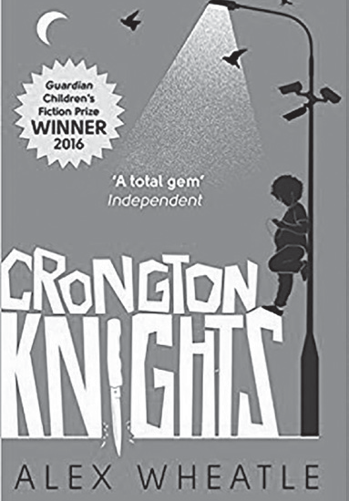
Crongton Knights, by Alex Wheatle
This extract comes from a novel about life on the ﬁctional South Crongton council estate. The narrator, McKay, is walking with his older brother, Nesta, after they have been to the police station to report the theft of Nesta’s bike.
Nesta is normally in trouble with the police and would stay away from them, but he has been persuaded to turn over a new leaf by his girlfriend, Yvonne.

Connecting to the topic
Crongton Knights is part of the Crongton sequence. The other books written so far in the series are Straight Outta Crongton and Liccle Bit. The books have proved popular in part because they portray the lives of people who don’t often feature in ﬁction: young, urban teenagers who speak in a distinctive dialect.
- Imagine you have been asked to write a novel based on the lives of young people in your school, or where you live. Write a paragraph or two, outlining the aspects of life that you would explore. If you like, you can come up with an outline for a story.
- Now read the extract and answer the questions that follow.

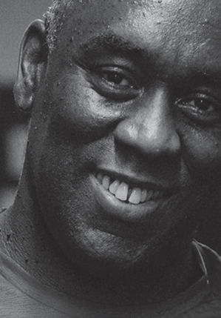
CRONGTON KNIGHTS

ALEX WHEATLE
Stop and Search
We walked back along the High Street. There were now six feds on patrol – three on either side. The Hot Rooster take-away was teasing my nostrils. Nesta was still jibber-jabbering away about Yvonne this and Yvonne that. It was funny. He hadn’t said a fat zero to me about her before today. It sounds cold but I blocked him out.
A couple or so days ago Dad had bought a tray of chicken fillets that he had left in the fridge. I wanted to get back, slice and dice up a piece of prime rooster, spin some seasoning on it, chop up onions, peppers, garlic and stir-fry that mother with veg and a serious dose of Jamaican jerk. Yeah, I think there was a little bit of olive oil left to fry it in. I’d let it steam for a few minutes under some foil and get it smelling all sexy and ripe for sinking. And a pot of rice too, boiled up sweetly on the stove to go with it. Mmm. My mouth was watering big time.
‘So, what do you think?’ Nesta asked me as we headed towards South Crong ends.
‘Think of what?’ I said.
‘Haven’t you been listening to me, McKay? Yvonne, innit.’ ‘Yvonne,’ I repeated. ‘What about her?’
‘What’s a matter with you? I asked you what you think of her.’
‘Oh, she seems cool,’ I answered. ‘But crush your balls! She has you under lock though! Go to the fed station... Speak to your dad!’
‘No, she ain’t,’ Nesta argued. ‘I just respect her.’ I killed another smirk.
We rolled towards the shop in the middle of our estate cos Nesta was thirsty – I hoped he would buy me a drink too. I was wondering if Nesta was gonna step back to our castle with me, when I saw flashing blue lights about a hundred metres away
– not too far from the shop.

‘Step it up, bruv,’ Nesta told me. ‘Something’s going down.’
We hot-toed to the scene. A crowd had gathered on the pavement outside the store. A fed car was parked up and Mr Dagthorn, the forever stressed-out bald- headed owner of the place, was pointing this way and that, mauling the ears of two male feds. About thirty metres away, two other feds were dragging a hood-rat oﬀ towards their car, which they’d parked a little further along the road. Collie Vulture! His hands were cuﬀed behind his back. Curses spat from his mouth. His bike was abandoned on the pavement. I glanced at Nesta. He was shaking his head
and spitting something dark under his breath. I spotted Boy from the Hills leaning against the shop door and bounced up to him. ‘What’s the score?’ I asked.
‘Collie jacked a bottle of tonic wine from the shop but when he jumped on his bike the feds appeared out of nowhere.’
I shook my head.
‘Collie was raging. He’d promised Mr Dagthorn he’d pay him tomorrow,’ Boy from the Hills added.
I rewound to earlier in the afternoon when Collie asked Yvonne for a fiver for collecting me from school. It was messed up how small dramas could turn into major blockbusters.
‘I’ve banned him from coming in here but he’s always stealing from my shop,’ ranted Mr Dagthorn to the oﬃcers.
‘Sweets, chocolate bars, chewing gum, porno mags – I’m sick and tired of young people robbing from me. Throw away the bloody key, I say!’
Collie heard what Mr Dagthorn said and wasted no time in biting back. ‘Screw you, old man. I said I’d pay for the drink tomorrow and I would have!’
The feds tried to shove Collie into the back seat of their car. Collie put up nuﬀ resistance. ‘Get in the car!’ one of the feds ordered.
In trying to get away, Collie banged his head on the door handle. A red mark appeared across his eyebrow. Onlookers raged their disapproval. More people were starting to pay attention now; windows opened in the slabs above us. A council worker, wearing a yellow Day-Glo top, stopped sweeping the street and tuned in to the drama.
‘Don’t you ever enter my shop again,’ yelled Mr Dagthorn. ‘You’ll probably even steal from the prison canteen!’
Someone threw a fat stone, hitting one of the fed cars on its bonnet. We all turned to see a hood-rat Usain-Bolting away from the scene towards Wareika Way.

The soles of his trainers were bright orange. I tried not to laugh, but it was well funny. The feds weren’t exactly singing ‘Always Look on the Bright Side of Life’. Poor Collie yelped and shrieked as they slam-dunked him hard through the car door. Nesta’s expression switched.
Someone threw another stone, and blitzed the front window of Mr Dagthorn’s shop. A nine or ten-year-old boy laughed as he burned oﬀ through the estate, a fed hot on his heels.
Boy from the Hills and I stepped away quickly, not wanting to get caught up in any trouble.
‘Everyone calm down,’ shouted an oﬃcer.
‘You see what I have to put up with!’ roared Mr Dagthorn, his hands now on his head. ‘You see how much respect they have for me? Do I deserve this? If I wasn’t here where would they go to get their milk for the morning? I’m just trying to make a living and this is how they treat me!’
Nesta approached the oﬃcers who had Collie. ‘If I pay for the drink he jacked, will you let him go?’
‘He’s committed a crime,’ a fed replied. ‘We can’t have everybody walking into shops and taking what they like.’
‘It doesn’t even cost three pound,’ said Nesta. ‘And Dagthorn charges fifty pence more than the supermarket – freaking t’ief! I’ll pay for it and, trust me, after I spill to his sis he won’t ever jack from the shop again.’
I wasn’t sure if Nesta had three pound on him. My own funds were low – I only had twenty-seven pence blessing my pocket.
The fed shook his head and slammed the car door. The other oﬃcer climbed into the driver’s seat and switched the ignition. Nesta slapped the window.
Mr Dagthorn had stopped his ranting and was now watching my brother like everybody else.
‘Nesta!’ I called. He didn’t hear me. The Kraken was about to be set loose. Oh crap!
‘Can’t you feds be on a freaking level?’ Nesta raged, hammering the top of the fed car. ‘Why arrest him for something that don’t even cost three pound? Let him go! Nobody was hurt. He hasn’t even touched the bottle. It can go back on the friggin’ shelf.’
My heartbeat accelerated. The oﬃcer inside the car pushed the passenger door open. It smacked Nesta in the leg, nearly knocking him over. ‘Why don’t you move along!’ ordered the fed to my brother. ‘And go home!’

I could feel Nesta’s rage burst. Without hesitation he ran into the fed and headbutted him dead in the chest. The oﬃcer lost his balance and fell hard on to the ground.
Someone cheered from the pavement. A girl giggled hysterically. Even the road sweeper had a smile on his face. Others stared in disbelief.
‘Nesta!’ I shouted again.
The feds gathered round. Two of them grabbed my bro in a hard bear hug, almost strangling him, trying to put cuﬀs on him. Nesta wriggled this way and that, kicked and flailed. He managed to scratch a face or two, but he was overpowered.
Everyone around me cussed the feds. A voice inside me screamed, Don’t stand up there like a pussy! Help him! Help him!
I started oﬀ to Nesta’s aid, but Boy from the Hills barged me to the ground and said, ‘McKay, keep your big self still.’
My right knee kissed the concrete. ‘The feds are arresting my bro!’
‘And how’s your dad gonna feel when news beats him that not one but two of his boys are sinking oats in a fed cell?’
By the time I climbed to my feet, Nesta was being handcuﬀed. All struggle left him. His chest was heaving but he was weirdly calm. I think he was staring at me. His mouth was moving. I guessed at what he was saying. He wouldn’t want me to tell Dad.
They shoved him into another car. Doors were slammed. Engines were revved. I watched as he sped away. He didn’t look back. The road sweeper resumed sweeping.

Connecting to the story
- How do you think Nesta’s behaviour is portrayed in this extract? Was he provoked into acting as he did? Is there ever an excuse for this kind of behaviour? What should happen to him now? Write down your thoughts.

Connecting to the real world
In the extract you have just read, there seems to be a lot of distrust between people on the estate, particularly young people, and the police.
- Imagine a new character in Crongton Knights: a youth leader, who liaises between young people and the police. Script a meeting between the youth leader and a police chief, in which they discuss how to make life better for everyone on the South Crongton estate. The youth leader should mainly focus on young people, the police chief should focus on everyone else.

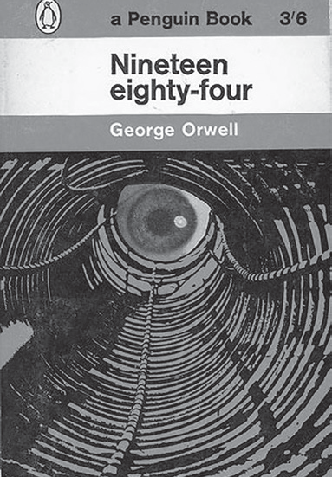
1984, by George Orwell
Nineteen Eighty-Four is one of the best-known novels ever written. It is set in a brutal totalitarian regime, ruled by the symbolically named Big Brother. Under this regime, there are no elections and there is no law. Big Brother watches everything and controls everyone. The extract you are about to read comes from the very start of the novel.

Connecting to the topic
Nineteen Eighty-Four describes a ‘surveillance state’: the state tries to watch everything that each citizen does, in order to control them. Even though the United Kingdom is a democracy, some people still refer to it as a ‘surveillance state’. This is because our movements can – and at times are –
tracked to a degree that has never happened before. For example, CCTV cameras track people’s movements, and we leave a ‘digital footprint’ when we use the internet, or mobile phone technology.
  - Think about your response to the following statements, then pick the one you feel most strongly about and explain your response to one of them below

The principle of free speech should mean that anyone can say anything at any time and in any place.
The government should be allowed to look at your internet search history without seeking permission.
There are too many CCTV cameras in this country.

- Now read the extract from 1984 and answer the questions that follow:

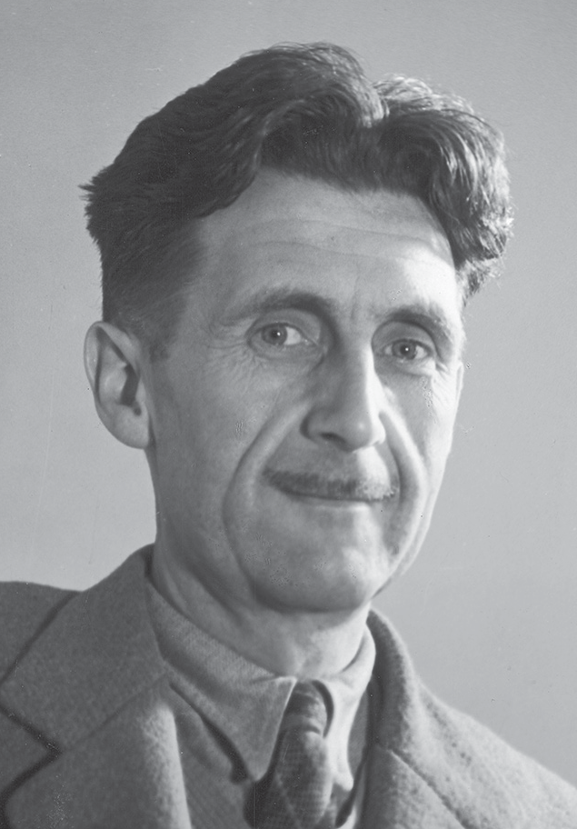
NINETEEN EIGHTY- FOUR

GEORGE ORWELL

Chapter I
It was a bright cold day in April, and the clocks were striking thirteen. Winston Smith, his chin nuzzled into his breast in an eﬀort to escape the vile wind, slipped quickly through the glass doors of Victory Mansions, though not quickly enough to
prevent a swirl of gritty dust from entering along with him.
The hallway smelt of boiled cabbage and old rag mats. At one end of it a coloured poster, too large for indoor display, had been tacked to the wall. It depicted simply an enormous face, more than a metre wide: the face of a man of about forty-five, with a heavy black moustache and ruggedly handsome features. Winston made
for the stairs. It was no use trying the lift. Even at the best of times it was seldom working, and at present the electric current was cut oﬀ during daylight hours. It was part of the economy drive in preparation for Hate Week. The flat was seven flights up, and Winston, who was thirty-nine and had a varicose ulcer above
his right ankle, went slowly, resting several times on the way. On each landing, opposite the lift shaft, the poster with the enormous face gazed from the wall. It was one of those pictures which are so contrived that the eyes follow you about when you move. BIG BROTHER IS WATCHING YOU, the caption beneath it ran.
Inside the flat a fruity voice was reading out a list of figures which had something to do with the production of pig-iron. The voice came from an oblong metal plaque like a dulled mirror which formed part of the surface of the right- hand wall. Winston turned a switch and the voice sank somewhat, though the words were still distinguishable. The instrument (the telescreen, it was called) could be dimmed, but there was no way of shutting it oﬀ completely. He moved over to the window: a smallish, frail figure, the meagreness of his body merely emphasised by the blue overalls which were the uniform of the Party. His hair was very fair, his face naturally sanguine, his skin roughened by coarse soap and blunt razor blades and the cold of the winter that had just ended.
Outside, even through the shut window-pane, the world looked cold. Down in the street little eddies of wind were whirling dust and torn paper into spirals,

and though the sun was shining and the sky a harsh blue, there seemed to be no colour in anything, except the posters that were plastered everywhere. The black moustachio’d face gazed down from every commanding corner. There was one on the house-front immediately opposite. BIG BROTHER IS WATCHING YOU, the caption said, while the dark eyes looked deep into Winston’s own. Down at street level another poster, torn at one corner, flapped fitfully in the wind, alternately covering and uncovering the single word INGSOC. In the far distance a helicopter skimmed down between the roofs, hovered for an instant like a bluebottle, and darted away again with a curving flight. It was the police patrol, snooping into people’s windows. The patrols did not matter, however. Only the Thought Police mattered.
Behind Winston’s back the voice from the telescreen was still babbling away about pig-iron and the over-fulfilment of the Ninth Three-Year Plan. The telescreen received and transmitted simultaneously. Any sound that Winston made, above the level of a very low whisper, would be picked up by it; moreover, so long as he remained within the field of vision which the metal plaque commanded, he could be seen as well as heard. There was of course no way of knowing whether you were being watched at any given moment. How often, or on what system, the Thought Police plugged in on any individual wire was guesswork. It was even conceivable that they watched everybody all the time. But at any rate they could plug in your wire whenever they wanted to. You had to live – did live, from habit that became instinct – in the assumption that every sound you made was overheard, and, except in darkness, every movement scrutinised.
Winston kept his back turned to the telescreen. It was safer; though, as he well knew, even a back can be revealing. A kilometre away the Ministry of Truth, his place of work, towered vast and white above the grimy landscape. This, he thought with a sort of vague distaste – this was London, chief city of Airstrip One, itself the third most populous of the provinces of Oceania. He tried to squeeze out some childhood memory that should tell him whether London had always been quite
like this. Were there always these vistas of rotting nineteenth-century houses, their sides shored up with baulks of timber, their windows patched with cardboard and their roofs with corrugated iron, their crazy garden walls sagging in all directions? And the bombed sites where the plaster dust swirled in the air and the willowherb straggled over the heaps of rubble; and the places where the bombs had cleared
a larger patch and there had sprung up sordid colonies of wooden dwellings like chicken-houses? But it was no use, he could not remember: nothing remained of his childhood except a series of bright-lit tableaux, occurring against no background and mostly unintelligible.

The Ministry of Truth – Minitrue, in Newspeak – was startlingly diﬀerent from any other object in sight. It was an enormous pyramidal structure of glittering white concrete, soaring up, terrace after terrace, three hundred metres into the air. From where Winston stood it was just possible to read, picked out on its white face in elegant lettering, the three slogans of the Party:
WAR IS PEACE FREEDOM IS SLAVERY
IGNORANCE IS STRENGTH
The Ministry of Truth contained, it was said, three thousand rooms above ground level, and corresponding ramifications below. Scattered about London there were just three other buildings of similar appearance and size. So completely did they dwarf the surrounding architecture that from the roof of Victory Mansions you could see all four of them simultaneously. They were the homes of the four Ministries between which the entire apparatus of government was divided. The Ministry of Truth, which concerned itself with news, entertainment, education and the fine arts. The Ministry of Peace, which concerned itself with war. The Ministry of Love, which maintained law and order. And the Ministry of Plenty, which was responsible for economic aﬀairs. Their names, in Newspeak: Minitrue, Minipax, Miniluv and Miniplenty.
The Ministry of Love was the really frightening one. There were no windows in it at all. Winston had never been inside the Ministry of Love, nor within half a kilometre of it. It was a place impossible to enter except on oﬃcial business, and
then only by penetrating through a maze of barbed-wire entanglements, steel doors and hidden machine-gun nests. Even the streets leading up to its outer barriers were roamed by gorilla-faced guards in black uniforms, armed with jointed truncheons.
Winston turned round abruptly. He had set his features into the expression of quiet optimism which it was advisable to wear when facing the telescreen. He
crossed the room into the tiny kitchen. By leaving the Ministry at this time of day he had sacrificed his lunch in the canteen, and he was aware that there was no food in the kitchen except a hunk of dark-coloured bread which had got to be saved for tomorrow’s breakfast. He took down from the shelf a bottle of colourless liquid with a plain white label marked VICTORY GIN. It gave oﬀ a sickly, oily smell, as of Chinese rice-spirit. Winston poured out nearly a teacupful, nerved himself for a shock, and gulped it down like a dose of medicine.
Instantly his face turned scarlet and the water ran out of his eyes. The stuﬀ was like nitric acid, and moreover, in swallowing it one had the sensation of being

hit on the back of the head with a rubber club. The next moment, however, the burning in his belly died down and the world began to look more cheerful. He took a cigarette from a crumpled packet marked VICTORY CIGARETTES and incautiously held it upright, whereupon the tobacco fell out onto the floor. With the next he was more successful. He went back to the living room and sat down at a small table that stood to the left of the telescreen.
From the table drawer he took out a penholder, a bottle of ink and a thick, quarto-sized blank book with a red back and a marbled cover.
For some reason the telescreen in the living room was in an unusual position. Instead of being placed, as was normal, in the end wall, where it could command the whole room, it was in the longer wall, opposite the window. To one side of it there was a shallow alcove in which Winston was now sitting, and which, when the flats were built, had probably been intended to hold bookshelves. By sitting in the alcove, and keeping well back, Winston was able to remain outside the range of the telescreen, so far as sight went. He could be heard, of course, but so long as he stayed in his present position he could not be seen. It was partly the unusual geography of the room that had suggested to him the thing that he was now about to do.
But it had also been suggested by the book that he had just taken out of the drawer. It was a peculiarly beautiful book. Its smooth creamy paper, a little yellowed by age, was of a kind that had not been manufactured for at least forty years past. He could guess, however, that the book was much older than that.
He had seen it lying in the window of a frowsy little junk-shop in a slummy quarter of the town (just what quarter he did not now remember) and had been stricken immediately by an overwhelming desire to possess it. Party members were supposed not to go into ordinary shops (‘dealing on the free market’, it was called), but the rule was not strictly kept, because there were various things such as shoelaces and razor blades which it was impossible to get hold of in any other way. He had given a quick glance up and down the street and then had slipped inside and bought the book for two dollars fifty. At the time he was not conscious of wanting it for any particular purpose. He had carried it guiltily home in his briefcase. Even with nothing written in it, it was a compromising possession.
The thing that he was about to do was to open a diary. This was not illegal (nothing was illegal, since there were no longer any laws), but if detected it was reasonably certain that it would be punished by death, or at least by twenty-five years in a forced-labour camp. Winston fitted a nib into the penholder and sucked it to get the grease oﬀ. The pen was an archaic instrument, seldom used even for signatures, and he had procured one, furtively and with some diﬃculty, simply because of a feeling that the beautiful creamy paper deserved to be written on with

a real nib instead of being scratched with an ink-pencil. Actually he was not used to writing by hand. Apart from very short notes, it was usual to dictate everything into the speakwrite, which was of course impossible for his present purpose. He dipped the pen into the ink and then faltered for just a second. A tremor had gone through his bowels. To mark the paper was the decisive act. In small clumsy letters he wrote:
April 4th, 1984.
He sat back. A sense of complete helplessness had descended upon him. To begin with he did not know with any certainty that this was 1984. It must be round about that date, since he was fairly sure that his age was thirty-nine, and he believed that he had been born in 1944 to 1945; but it was never possible nowadays to pin down any date within a year or two. For whom, it suddenly occurred to him to wonder, was he writing this diary? For the future, for the unborn. His mind hovered for a moment round the doubtful date on the page, and then fetched up with a bump against the Newspeak word doublethink. For the first time the magnitude of
what he had undertaken came home to him. How could you communicate with the future? It was of its nature impossible. Either the future would resemble the present, in which case it would not listen to him: or it would be diﬀerent from it, and his predicament would be meaningless.
For some time he sat gazing stupidly at the paper. The telescreen had changed over to strident military music. It was curious that he seemed not merely to have lost the power of expressing himself, but even to have forgotten what it was that he had originally intended to say. For weeks past he had been making ready for this moment, and it had never crossed his mind that anything would be needed except courage. The actual writing would be easy. All he had to do was to transfer to paper the interminable restless monologue that had been running inside his head, literally for years. At this moment, however, even the monologue had dried up.
Moreover his varicose ulcer had begun itching unbearably. He dared not scratch it, because if he did so it always became inflamed. The seconds were ticking by.
He was conscious of nothing except the blankness of the page in front of him, the itching of the skin above his ankle, the blaring of the music, and a slight booziness caused by the gin.
Suddenly he began writing in sheer panic, only imperfectly aware of what he was setting down. His small but childish handwriting straggled up and down the page, shedding first its capital letters and finally even its full stops:
April 4th, 1984. Last night…

Connecting to the story
At the end of the extract you have just read, Winston Smith is about to write his ﬁrst diary entry.
  - Write the first two paragraphs of this entry, trying to imagine Winston’s feelings both about the world he lives in and about what he is doing:

Connecting to the real world
  - Have a go at writing a second diary entry, this one giving the thoughts and feelings Winston would have if he spent a day in the United Kingdom as it is now (during the Pandemic and lock down). You might like to focus on what he would think about the values of democracy and equality that you can ﬁnd in the United Kingdom.

