

**An Inspector Calls & Poetry Revision**

**Name:**

**House Coach:**

**English Teacher:**

|  |  |  |  |
| --- | --- | --- | --- |
| **Versatile Vocabulary** | | | |
| Solid, real | Concrete | Abstract | Not physical, an idea |
| Tidy, controlled, clear | Order | Chaos | Confusion, disorder |
| Difficult to harm | Secure | Vulnerable | Easy to harm, fragile |
| Stubborn, unchangeable | Dogmatic | Malleable | Able to be changed, flexible |
| Stable, the same | Constant | Volatile | Unpredictable, uncertain |
| Every so often | Intermittent | Perpetual | Cyclical, repetitive, incessant |
| Can be touched, real | Tangible | Intangible | Cannot be touched |
| Can be touched, real | Physical | Metaphysical | Not physical, not real |
| Expected, logical, usual | Natural | Supernatural | Beyond laws of nature, magical |
| Expected, logical, usual | Normal | Abnormal | Beyond what is expected |
| Original, basic, true | Literal | Metaphorical | Symbolic, not literal |
| Logical, using reason | Rational | Emotional | Using mood or feelings |
| Lasting forever | Permanent | Ephemeral | Lasting for a short time, temporary |
| Make stronger, support | Reinforce | Transgress | Go against |
| Right, good | Moral | Immoral | Wrong, bad |
| Kind, good | Benevolent | Malevolent | Unkind, evil |
| Gullible | Credulous | Duplicitous | Two-faced |
| Inside | Interior | Exterior | Outside |
| Inside | Internal | External | Outside |
| Less than | Inferior to | Superior to | Better than |
| The worst imaginable world | Dystopia | Utopia | The best imaginable world |
| Staying still | Static | Active | Moving |
| Hunted | Prey | Predator | Hunter |
| Sufferer | Victim | Villain | Creator of suffering |
| Free | Liberated | Imprisoned | Trapped |
| Generous, loves people | Philanthropic | Misanthropic | Mean, hates people |

**A brief guide to writing: the basics**

Remember the 4 Is in each paragraph, after your quotation:

* In other words…
* In particular…
* It is almost as if…
* [writer] intends…

**An Inspector Calls:**

* First performed in Moscow, Soviet Union in 1945.
* Set in the ironically named “Golden” Edwardian era in 1912.
* The Edwardian era was a deeply patriarchal, misogynistic and hierarchical time.
* Priestley was a socialist – he believed that society should be equal and people should share their profits.
* Priestley criticised capitalists – people who believe that profits should be kept and those with money should keep it.
* The proletariat are the working class and the bourgeoisie are the upper class.
* As the play was being performed, the socialist Labour Party won the election. The audience would have known this and so also knew that the Edwardian capitalism would have a drastic downfall.
* Dramatic irony is when the audience know something that the character in the play do not.

**Inspector Goole**

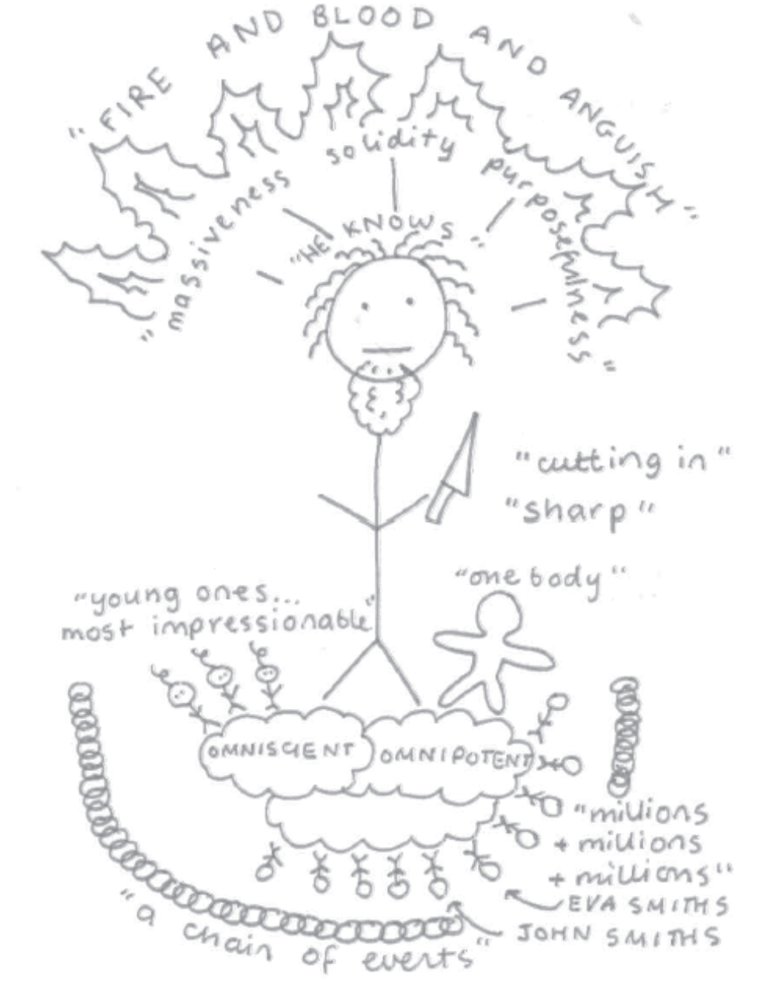

*[Task: fill this in and then repeat 3 times for different quotations]*

Inspector Goole

For example

In other words

In particular

It is almost as if

Priestley intends

**Mr Birling**



*[Task: fill this in and then repeat 3 times for different quotations]*

Mr Birling

For example

In other words

In particular

It is almost as if

Priestley intends

**Mrs Birling**



*[Task: fill this in and then repeat 3 times for different quotations]*

Mrs Birling

For example

In other words

In particular

It is almost as if

Priestley intends

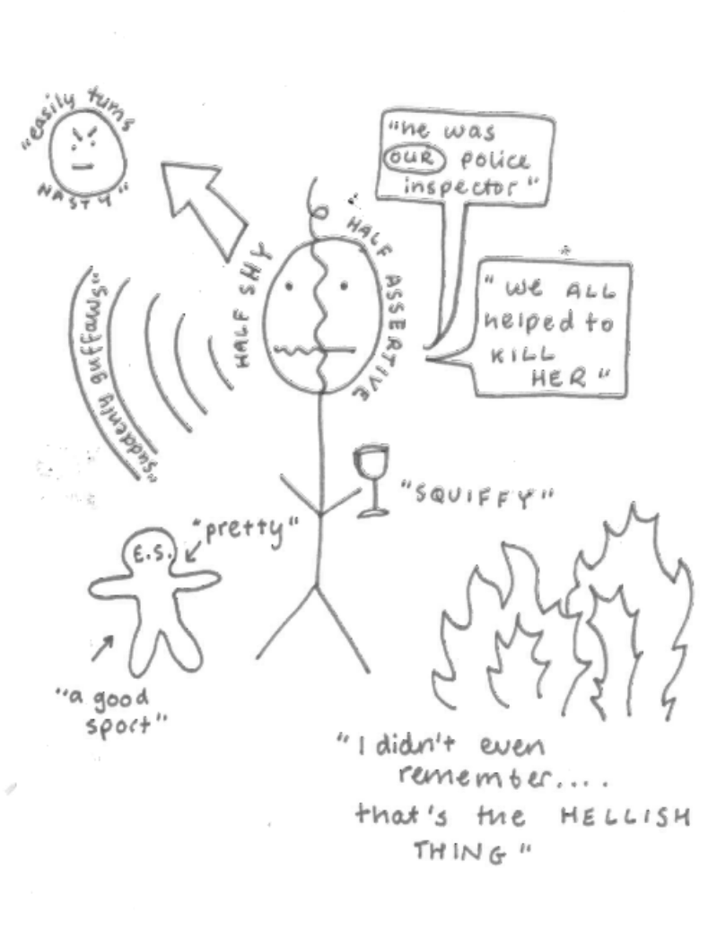**Eric Birling**

*[Task: fill this in and then repeat 3 times for different quotations]*

Eric Birling

For example

In other words

In particular

It is almost as if

Priestley intends

**Gerald Croft**

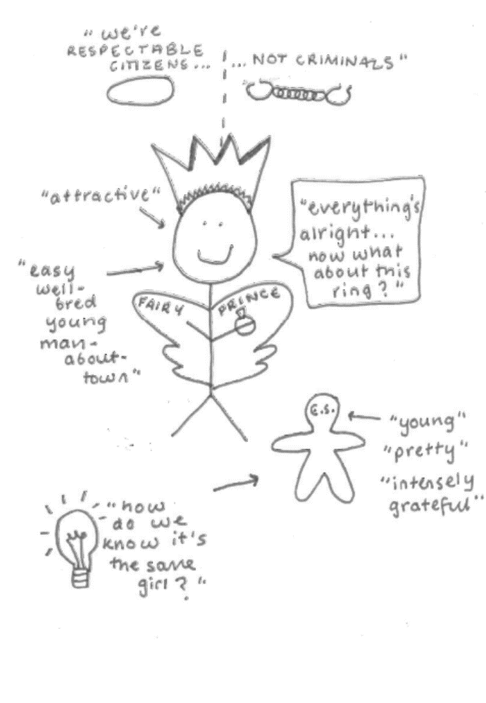

*[Task: fill this in and then repeat 3 times for different quotations]*

Gerald Croft

For example

In other words

In particular

It is almost as if

Priestley intends

**Sheila Birling**

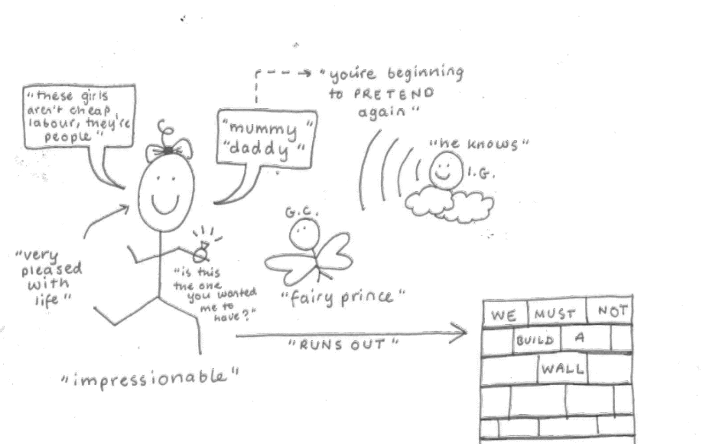

*[Task: fill this in and then repeat 3 times for different quotations]*

Sheila Birling

For example

In other words

In particular

It is almost as if

Priestley intends

**Example Essay: How does Priestley present Mrs Birling?**

**At its heart, An Inspector Calls, written in 1945 but set in 1912, is a transgressive, didactic and instructive morality tale that aims to** demonstrate that the foundations of the social hierarchy need to be radically altered, revolution is inevitable and disruptive forces are essential by showing us the dogmatic and “superior” Mrs Birling, who wants desperately to maintain the stability of the social hierarchy.

**Clearly**, Mrs Birling is almost a caricature of the bourgeoisie indifference to the plight of the proletariat. We are introduced to Mrs Birling as Mr Birling’s “social superior”. Concerned primarily about her “social” reputation, she reprimands Mr Birling for complimenting the cook, saying “Arthur, you’re not supposed to say such things” and also says “I don’t think you ought to talk business”. **Here, we see that** she is concerned with upholding the rules of the social hierarchy. **More specifically, Priestley implies** that she is preoccupied with ensuring that the conventions of capitalism are maintained and that her husband follows these conventions precisely. **Perhaps** because she is her husband’s “social superior”, she is to some extent transgressing the expectations of women’s social inferiority in Edwardian England. **Thus the contemporary audience understands** that because she is in a transgressive social position (as her husband’s “superior”), this increases the desperation with which she clings on to social categories. **Through the use of** the verbs “supposed” and “ought”, we see that she is trying to teach her socially inferior husband the way to behave as though he is a child. **It is almost as if** her excessive interest in what her family “ought” to do foreshadows the fragility of their social status, predicting a downfall. **Priestley may be proposing** that the contemporary audience understand the futility of bourgeoisie Birling’s obsession with class.

**We observe that,** after hearing the confessions of Mr Birling and Sheila, Mrs Birling “enters, smiling” and speaks with an “easy tone”. **Here, Priestley implies that** Mrs Birling’s impression of positivity and optimism is merely a fragile façade. **The use of** dramatic irony here reveals her foolish naivety; she believes her family to be “respectable citizens” but we know them to be “criminals”. **In particular,** her confidence about her family’s innocence and respectability has been undermined without her knowledge, reinforcing the idea that the building blocks of the social hierarchy have been destabilised. **Maybe** she represents the arrogant ignorance of the bourgeoisie, who wilfully blind themselves to the deep instability of their social structures with a “smiling” façade. **It is almost as if** her arrogance is her hamartia.

**We see that,** failing to comprehend Sheila’s malleability and change and “annoyed” at her new persona, Mrs Birling repeatedly states “I don’t understand you” and calls her a “hysterical child”. **Thus the audience understands** that Mrs Birling has become separated from her daughter, from the younger generation and from the future; she has become disconnected from reality and from her own family, breaking the bonds of their relationship. **The use of the adjective** “hysterical” reveals Mrs Birling’s fear of change. **It is almost as if** she sees Sheila’s transformation and epiphany as damaging and dangerous volatility rather than responsive and positive alteration. **Perhaps** she fears change because she is afraid of destabilising her position, her status and her identity**. It is as though** she wants to construct and maintain “solid”, stable and unchanging identities for her family to preserve their “respectable” position and protect them from the proletariat.

**Priestley reveals that,** dogmatically refusing to take “responsibility” for her actions, Mrs Birling calls Eva “girls of that class,” “a girl in her position” and “a girl of that sort” and refers to her suicide as an “absurd” and “wretched business”. She is also offended that Eva Smith was “impertinent”. **Through the use of** the abstract nouns “position”, “sort” and “class”, we see that Mrs Birling sees Eva as only defined by her social status. **It is almost as if** Mrs Birling wishes to remove Eva’s individuality and dehumanises her due to her lack of respect for her. **Maybe** Mrs Birling is preoccupied with categorising Eva and in fact herself based on where they are in the social hierarchy. **In particular,** Mrs Birling’s description of Eva as “impertinent” reveals that she is distressed by those who break the rules of society. “Impertinent” literally means rude and so we see that Mrs Birling is most offended by the way that she perceived Eva as transgressing the boundaries of her “position”. **It is as though** Mrs Birling’s priority is the stability of the dichotomy between the bourgeoisie and the proletariat but again, her obsession with this idea may hint that beneath her façade is an understanding of the inherently precarious social hierarchy.

**Clearly,** by the end of Act 2, the Inspector’s destabilising force has resulted in Mrs Birling becoming “frightened”, “terrified” and “agitated” after she inadvertently condemned her own son to be “severely” dealt with as she believed him to be “entirely responsible”. We see that she is “ready to collapse” but she says “I don’t believe it. I won’t believe it”. **Here, we see that** although literally Mrs Birling is on the verge of “collapse”, this may be a metaphor for the fact that the social hierarchy, her family relationships, the solidity of their views, the concepts of capitalism, the Birling’s reputation or perhaps even the “wall” she attempted to construct between herself and Eva Smith is also “ready to collapse”. **More specifically**, the Inspector has almost shattered and fractured the apparently “solid” structures that capitalists rely on. **More broadly, we may consider that** Priestley is reflecting the Marxist idea that radical disruption of the bourgeoisie is necessary for meaningful social change. **In particular**, a contemporary 1945 audience watching the first ever performance of the play in Moscow, Russia would have recognised Mrs Birling’s dogmatic statement “I don’t believe it. I won’t believe it” as a representation of the stubborn arrogance of the bourgeoisie. **We notice that** even though Mrs Birling is “frightened” and “agitated” and on the edge of “collapse”, she refuses to “believe” that Eric is a flawed or immoral character in an effort to preserve her family’s reputation and therefore the stability of the social hierarchy. **It is almost as if** for her, it is impossible for the bourgeoisie to be immoral; they embody stability, perfection and excellence.

**Example Essay: How does Priestley present Gerald?**

**At its heart**, An Inspector Calls is a play that questions the stability of the foundations of socialism and reveals the arrogance, ignorance and malevolence behind the façades constructed by the bourgeoisie. Gerald is a “well-bred”, “attractive” embodiment of masculine, bourgeoisie arrogance. Also deeply misogynistic, Priestley has him depict Daisy Renton as a “grateful” recipient of his charitable and noble actions to demonstrate the way in which the upper class fail to see their perceived social inferiors as real, authentic or three-dimensional humans. Gerald’s failure to change is emblematic of the failure of the upper class to accept social progress.

He is introduced as “an attractive”, “easy well-bred young man-about-town”. **In other words**, he is a character who is at ease and confident thanks to his heritage and familial wealth. **Through the use of** the adjective “easy”, Gerald is immediately presented as the antithesis of Eva Smith, a “penniless” and “desperate” symbol of the oppressed proletariat. **It is as though** in depicting Gerald’s almost hyperbolic, excessively relaxed demeanour, Priestley is foreshadowing his inevitable downfall. It is his hubris and expectation of an “easy” life that prevents him from seeing the immorality of his actions. **On the surface**, the description of Gerald as a “man-about-town” refers to his extensive and “easy” social life. **Reading more closely**, the idea of him being a “man-about-town” could foreshadow his involvement with Eva; he is a “man” who travels “about town” and frequents the Palace Bar (“a favourite haunt of women of the town”) and thus is not the vision of perfection that his “well-bred” façade seeks to uphold. **Thus we see that** whilst Gerald may superficially embody Edwardian masculine ideals, beneath the surface is a callousness and inevitable downfall. **Priestley may be proposing that,** like Gerald, beneath the “well-bred” bourgeoisie is immorality and excess that will inevitably lead to their destruction, possibly mirroring the events of the Russian Revolution. **A contemporary 1945 audience** would have recognised the folly of Gerald’s self-obsession and “easy” approach to his social status, having observed the Russian Revolution and been part of the socialist victory in the 1945 election.

Like the Birlings, Gerald is preoccupied with establishing a clear dichotomies and “solid” categories in order to make sense of the world and preserve his superiority. When he says to the Inspector “we’re respectable citizens and not criminals”, he **uses** the juxtaposition of “citizens” and “criminals” to establish himself as distinct from and superior to “criminals”, marginalising them as not worthy of being deemed “citizens” at all. **He means that** these categories are stable and immoveable; he takes comfort in defining himself as a “respectable citizen” because this allows him to ignore, ostracise and look down on those who he does not consider to be “respectable”. **It is almost as if** the desperation with which he holds on to his “respectable” status hints that he is aware of its fragility. **Symbolically**, the “wall” between “citizens” and “criminals” is gradually destroyed by the Inspector, who deconstructs, through “enquiry”, the metaphorical “door” that Gerald and the Birlings use to shut out Eva and, by extension, the working class. **Therefore, the contemporary audience concludes** that Gerald’s preoccupation with dividing society into “citizens” and “criminals” is futile.

Attempting to construct an image of Eva Smith as a needy, vulnerable and fragile woman who was “grateful” for his help, Gerald clearly demonstrates his failure to see his social inferiors as human beings; to him, she is a “thing”. He describes her as “young and pretty and warm-hearted and intensely grateful.” **Through the use of** the adjective “pretty”, we see that he is superficial in his judgements of women, reflecting the prevalent patriarchal views of Edwardian England. It is as though he sees merely her exterior and views her only as an object to be viewed; “an animal, a thing, not a person”. **It seems that** Gerald infers from her appearance that she is “intensely grateful”. **In others words**, he portrays himself as a saviour. **Through the use of** the adverb “intensely”, we see that Gerald is attempting to emphasise the depth of Eva’s gratitude, as though he believes he is a Christ-like figure bringing her redemption. **Perhaps Priestley** aims to mock the way in which the bourgeoisie perceive the working class as so inferior that they lack independence, agency and freedom and thus are universally “grateful” for being saved. **Therefore we conclude that** the veneer of generosity constructed by Gerald is not authentic, but instead is a symbol and symptom of the self-indulgent superiority complex of the bourgeoisie. **Priestley may be suggesting** that the 1945 audience must look beyond masks of benevolence worn by the privileged; these masks merely demonstrate their patronising and dehumanising view of the working class.

Sheila sees through the “wall” of generosity constructed by Gerald, mirroring the journey of realisation that Priestley wishes the audience to embark upon when she calls Gerald a “Fairy Prince”. **In other words**, she is accusing him of imagining himself to be a noble and heroic saviour. Through the use of the noun “fairy”, we see that she is accusing him of creating a fantasy in his story about Eva Smith. **It is almost as if** she is criticising the way in which he has depicted himself as a superior monarch, delivering generosity and kindness to those who he sees are his subordinates. **We are encouraged to** mirror Sheila’s perceptive and critical view of Gerald’s “fairy” story, seeing him instead as possessing a fragile façade of philanthropy.

After desperately attempting to avoid guilt for himself and Birling family by proposing that Eva is merely the Inspector’s construct, Gerald blithely says “everything’s alright now… Sheila... what about this ring?”. Here, he facilitates and embraces the idea of the “horrible” suicide being a hoax and returns the focus immediately back to the engagement. **Perhaps Priestley** is attempting to reveal the dogmatic ignorance of reality that the bourgeoisie cling onto in order to maintain their superiority. **It is as though** Gerald wishes to return to the “ring” in order to undo or erase the “events” revealed in the “enquiry”. **It is almost as if** he wants to return to the “solid” ideas and stability of capitalism and his clear position in the social hierarchy as a “respectable” citizen. **Metaphorically,** the “ring” represents a symbol of ownership of Sheila; a permanent bond that binds Sheila to him. **Thus we see that he** wishes to re-establish his patriarchal dominance after the temporary transgressions due to the Inspector’s “enquiry”. **Here, Priestley reveals that** Gerald is the antithesis of Inspector Goole, who speaks not about a “ring” but instead a “chain of events”. Whilst Gerald is preoccupied with individual emblems of objectification and ownership, Inspector Goole proposes that each individual and their actions are linked and “intertwined” in a “chain of events”. **Therefore we conclude** that Gerald is an embodiment of the willingness and dogmatic ignorance by the bourgeoisie of the injustices perpetuated by the social hierarchy; we learn that Gerald and, by extension, capitalism is hollow and callous, wishing to erase and disregard the plight of the proletariat.

**Power and Conflict Poetry:**

Key ideas:

1. Predator / prey
2. Tyrant / oppressed
3. Villain / victim
4. Transient / permanent
5. Mortal / immortal
6. Moral / immoral
7. Transgress / conform
8. Superior / inferior
9. Temporary / cyclical
10. Venerate / criticise

* **Ozymandias, Percy Shelley**
  + Shelley was a Romantic poet – he believed that nature could provide a realm of experience beyond the measurable and so was superior to humans and that tyrannical authorities should be challenged.
  + The poem is a sonnet (which we usually expect to be about romantic love).
  + “King of kings”
  + “shattered visage”
  + “look upon my works, ye mighty and despair”
  + “Nothing beside remains”
  + “colossal wreck”

*[Task: fill this in and then repeat 4 times for different quotations]*

In Ozymandias,

For example

In other words

In particular

It is almost as if

Shelley intends

* **London, William Blake**
  + Blake was a Romantic poet – he believed that nature could provide a realm of experience beyond the measurable and so was superior to humans and that tyrannical authorities should be challenged and the innocence of children should be celebrated.
  + The poem has a regular, alternate rhyme scheme and is divided into strictly regular stanzas.
  + “marks of weakness, marks of woe”
  + “mind-forg’d manacles”
  + “chartered street / chartered Thames”
  + “in every cry…”
  + “blackning Church”

*[Task: fill this in and then repeat 2 more times for different quotations]*

In London,

For example

In other words

In particular

It is almost as if

Blake intends

In London,

For example

In other words

In particular

It is almost as if

Blake intends

* **War Photographer, Carol Ann Duffy**
  + Inspired by Duffy’s friendship with a war photographer.
  + The poem has a strictly regular rhyme scheme including rhyming couplets.
  + “spools of suffering set out in ordered rows”
  + “ordinary pain”
  + “half-formed ghost”
  + “blood stained into foreign dust”

*[Task: fill this in and then repeat 2 more times for different quotations]*

In War Photographer,

For example

In other words

In particular

It is almost as if

Duffy intends

In War Photographer,

For example

In other words

In particular

It is almost as if

Duffy intends

* **Poppies, Jane Weir**
  + Jane Weir was a textiles designer and so is inspired by the layers and details of fabric.
  + The poem is written in free verse and has stanzas of irregular length.
  + “released a songbird from its cage”
  + “red…disrupting a blockade of yellow”
  + “like a wishbone”
  + “steeled the softening of my face”
  + “all my words flattened, rolled, turned into felt”

*[Task: fill this in and then repeat 2 more times for different quotations]*

In Poppies,

For example

In other words

In particular

It is almost as if

Weir intends

In Poppies,

For example

In other words

In particular

It is almost as if

Weir intends

* **Exposure, Wilfred Owen**
  + Wilfred Owen fought in the First World War and was sent to Craiglockhart Hospital with shellshock (now known as PTSD). The first line reminds the reader of Keats, who wrote about how his “heart aches” for the nightingale.
  + The poem is separated into stanzas of regular length and has half-rhyme. The refrain “but nothing happens” is used.
  + “all their eyes are ice”
  + “but nothing happens”
  + “on us the doors are closed”
  + “our brains ache in the merciless iced east winds that knive us”

*[Task: fill this in and then repeat 2 more times for different quotations]*

In Exposure,

For example

In other words

In particular

It is almost as if

Owen intends

In Exposure,

For example

In other words

In particular

It is almost as if

Owen intends

* **The Charge of the Light Brigade**
  + Tennyson, the Poet Laureate, wrote about this charge during the Battle of Balaclava in the Crimean War. The many deaths were caused by a miscommunication by the generals.
  + The poem is written in six stanzas in dactylic dimeter, which mirrors the rhythm of horses galloping. The reduction in lines in the last stanza represents loss of life.
  + “cannon” (repeated)
  + “jaws of death / mouth of hell”
  + “honour the light brigade, noble six hundred”
  + “half a league” (repeated)

*[Task: fill this in and then repeat 2 more times for different quotations]*

In The Charge of the Light Brigade,

For example

In other words

In particular

It is almost as if

Tennyson intends

In The Charge of the Light Brigade,

For example

In other words

In particular

It is almost as if

Tennyson intends

**Example essay: compare how poets present conflict in Remains and War Photographer**

**Clearly,** Armitage uses a first person perspective to reflect the experience of an interviewee, taking on the voice of a soldier suffering from PTSD after fighting in Basra in the Iraq war. **Here, Armitage means** to put the reader in the position of interviewer or maybe even friend, reflecting the isolation of the soldier as he confesses his sins to them. **Perhaps** Armitage uses free verse (no rhyme) to demonstrate the chaos of the soldier’s mental state and its disorganised nature. **Maybe** the regularity of the stanza length shows the regularity of violence in war or maybe even the regularity of his own suffering; it is inescapable. **Thus we see that** the soldier is trapped between his disorganised mind and the continuous, regular suffering that he is experiencing.

**However**, Duffy uses a third person perspective to reflect the distance that the protagonist feels from society, reality and maybe even himself. **Here, Duffy means** to show the mental separation that his experience of war has caused; he cannot get back to the utopia of “Rural England” and is stuck instead in the dystopian “nightmare heat”. **Perhaps** Duffy uses a strict and regular rhyme scheme to depict the desire for control and structure that the protagonist has. **Maybe** this regularity reflects the photographer’s desperation for order. **Therefore the reader understands** that war causes mental distancing from reality, as well as a futile desire to control and command the mental chaos created.

**We observe that** in Remains, the soldiers uses chaotic methods to erase his memory of the “looter”. This is seen in the quotation “and the drink and the drugs won’t flush him out”. **In other words**, the soldier has turned to “drink” and “drugs” to rid himself of the trauma he experienced. **More specifically**, his aim is to “flush” out this memory. **It is as though** the “looter” is seen as a waste product or maybe even something that causes disgust because the word “flush” means to remove waste. **Perhaps** Armitage is demonstrating that the solider wants to cleanse or clean his mind or maybe even his conscience. **It could be that** the words “drink” and “drugs” reveal the disordered and uncontrollable methods that he is using to rid himself of his guilt. **This could represent** the futility of his attempts to escape his feelings and his own mind. **Therefore we conclude that** the speaker’s trauma has made him turn to chaotic “drink” and “drugs” in a desperate attempt to rid his mind of its stains and re-establish order.

**Similarly**, in War Photographer, Duffy shows that conflict has caused the protagonist to desperately try to re-establish order. We see this in the quotation “spools of suffering set out in ordered rows”. **In other words,** the protagonist is arranging the “spools” of film into clear and structured “rows”. **Perhaps** these “ordered rows” represent the protagonist’s desperation for mental discipline in order to deal with his chaotic mental state. **Maybe** the “ordered rows” also call to mind “rows” of graves, soldiers or even memorial poppies. **It could be that** Duffy aims to show that even in “Rural England”, perpetual reminders of conflict are inescapable. **It seems that**, like the soldier in Remains, the war photographer feels trapped by “suffering”. In particular, the use of sibilance running through this line highlights the continuous nature of the photographer’s psychological “nightmare,” which cannot be solved through the construction of “ordered rows”. **Therefore we conclude that** both Duffy and Armitage depict conflict as imprisoning victims in a cycle of repetitive suffering, which cannot be solved by creating “order” or through the use of “drink and drugs”.

**We see that**, in Remains, conflict leaves a permanent mark both literally and metaphorically in the quotation “his blood-shadow stays on the street”. **In other words,** the blood of the looter, after being shot “a dozen times”, “remains” on the street in Basra, making a permanent mark. **Here, Armitage emphasises** the permanent consequences of sins, presenting the “blood” as a symbol of the soldier’s guilt and a representation of the way that he is psychologically marked by his actions. **Perhaps** the “blood-shadow” acts as a sign, revealing his sin to observers and civilians and showing that he feels his conscience cannot be cleansed and he cannot achieve retribution. **Maybe**, in an allusion to Shakespeare’s Macbeth, his “bloody hands” and this permanent “blood-shadow” become signs of his mental fracturing, becoming almost like hallucinations that reveal his disordered mind and permanent guilt. **It could be that** the “street” represents his conscience, his mind or maybe even his psyche. **It seems that** the “blood-shadow” therefore represents his guilt, his suffering or perhaps even his sinful and malevolent id. **Therefore we conclude that** conflict has permanently fractured, scarred and marked the soldier’s mental state.

**Similarly**, a permanent “blood stain” is used to represent the permanence of trauma. We see this when the war photographer remembered how the “blood stained into foreign dust”. **Here, Duffy** is saying that the enduring memory for the photographer is the “stain” created by the “blood” of the subject of the photographer’s image. **It is as though** the war photographer’s passive taking of the photo has caused this “stain” to become permanently ingrained or embedded in his mind. **Perhaps** the verb “stained” demonstrates the way that past memories taunt and haunt the photographer because of his “job”; it is as if he cannot escape this “foreign dust”, even in his “ordinary” home. **Thus we see that** the “dust” here is symbolic, like the “street” in Remains, of his mind or psyche. The adjective “foreign” reveals the distance he feels from others, his family or maybe himself. **Duffy might be suggesting** that it is the memory “stained” in the psyche that leads to this feeling of distance or separation because of its inescapable nature.

**Practice Essays**

**An Inspector Calls**

1. How does Priestley present the character of Eric in An Inspector Calls?
2. To what extend is Gerald a moral character in An Inspector Calls?
3. How does Priestley use dramatic irony in An Inspector Calls?
4. What is the significance of stage directions in An Inspector Calls?
5. How does Priestley present Inspector Goole in An Inspector Calls?
6. How and why does Priestley present Mr Birling as an unlikeable character in An Inspector Calls?
7. To what extent does Priestley present men and women as different in An Inspector Calls?
8. How does Priestley present Mrs Birling in An Inspector Calls?
9. How does Priestley present the difference between generations in the play?
10. Explain how Priestley portrays socialism in the play.
11. Explain how Sheila is presented in the play.
12. How does Priestley explore morality in An Inspector Calls?
13. How does Priestley present class in An Inspector Calls?

**Power and conflict poetry**

1. How do poets explore conflict with nature in Storm on the Island and Exposure?
2. How do poets explore the memory of conflict in Remains and War Photographer?
3. How do poets explore ideas about the experience of conflict in Remains and Exposure?
4. How do poets explore ideas about internal conflict in The Emigrée and Checking Out Me History?
5. How do poets explore ideas about the power of location in The Emigrée and London?
6. How do poets look at the power of authorities in London and Ozymandias?
7. How do poets look at conflict in war in The Charge of the Light Brigade and Bayonet Charge?
8. How do poets look at the power of men in My Last Duchess and Ozymandias?
9. How do poets explore powerlessness in London and Storm on the Island?
10. How do poets explore ideas about the pain of conflict in Poppies and War Photographer?
11. How do poets explore the power of nature in London and Extract from the Prelude?
12. How do poets look at the memory of conflict in Poppies and War Photographer?
13. How do poets explore power in London and Ozymandias?