Drama
Spring 2 - Post Assessment – Year 9
Topic: Approaching a script
Component 2+3 – AO2 + AO3
Name: ……………………………………………………
Teacher: …………………………………………………

AO3: …/10

Exam-style questions 1(a)(i) + (ii)

(i) You are going to play Jan. Explain two ways you would use physical skills to play the character in this extract.

(ii) You are going to play Mark. In this extract, Mark is talking about the actions of the group. As a performer, give three suggestions of how you would use performance skills to show that Mark is traumatised by what has happened. You must provide a reason for each suggestion.

Begin by reading the extract on the following page and then answering the questions above.
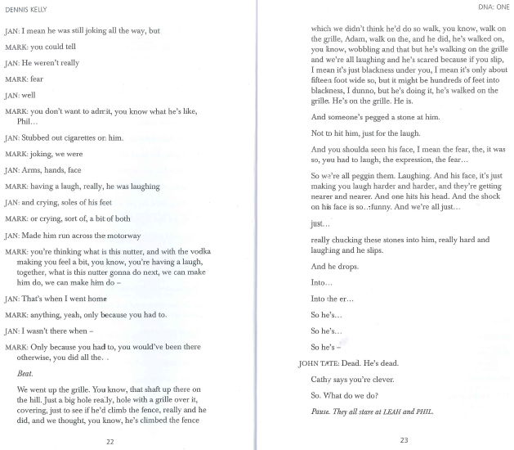
(i)
………………………………………………………………………………………………………………………………………………………………………………………………………………………………………………………………………………………………………………………………………………………………………………………………………………………………………………………………………………………………………………………………………………………………………………………………………………………………………………………………………………………………………………………………………………………………………………………………………………………………………………………………………………………………………………………………………………………………………………………………………………………………………………………………………………………………………………………………………………………………………………………………………………………………………………………………………………………………………………………………………………………………………………………………………………………………………………………………………………………………………………………………………………………………………………………………………………………………………………………………………………………………………………………………………………………………………………………………………………………………………………………………………………………………………………………………………………………………………………………………………………………………………………………………………………………………………………………………………………………………………………………………………………………………………………………………………………………………………………………………………………………………………………………………………………………………………………………………………………………………………………………………………………………………………………………………………………………………………………………………………………………………………………………………………………………………………………………………………………………………………………………………………………………………………………………………………………………………………………………………………………………………………………………………………………………………………………………………………………………………………………………………………………………………………………………………………………………………………………………………………………………………………………………………………………………………………………………………………………………………………………………………………………………………………………………………………………………………………………………………………………………………………………………………………………………………………………………………………………………………………………………………………………………………………………………………………………………………………………………………………………………………………………………………………………………………………………………………………………………………………………………………………………………………………………………………………………………………………………………………………………………………………………………………………………………………………………………………………………………………………………………………………………………………………………………………
(4)

(ii)
………………………………………………………………………………………………………………………………………………………………………………………………………………………………………………………………………………………………………………………………………………………………………………………………………………………………………………………………………………………………………………………………………………………………………………………………………………………………………………………………………………………………………………………………………………………………………………………………………………………………………………………………………………………………………………………………………………………………………………………………………………………………………………………………………………………………………………………………………………………………………………………………………………………………………………………………………………………………………………………………………………………………………………………………………………………………………………………………………………………………………………………………………………………………………………………………………………………………………………………………………………………………………………………………………………………………………………………………………………………………………………………………………………………………………………………………………………………………………………………………………………………………………………………………………………………………………………………………………………………………………………………………………………………………………………………………………………………………………………………………………………………………………………………………………………………………………………………………………………………………………………………………………………………………………………………………………………………………………………………………………………………………………………………………………………………………………………………………………………………………………………………………………………………………………………………………………………………………………………………………………………………………………………………………………………………………………………………………………………………………………………………………………………………………………………………………………………………………………………………………………………………………………………………………………………………………………………………………………………………………………………………………………………………………………………………………………………………………………………………………………………………………………………………………………………………………………………………………………………………………………………………………………………………………………………………………………………………………………………………………………………………………………………………………………………………………………………………………………………………………………………………………………………………………………………………………………………………………………………………………………………………………………………………………………………………………………………………………………………………………………………………………………………………………………………………………
(6)

