Y11 Coursework support
- Focus on section F – evaluation
- Work through the rest of it checking that you have done everything because this is the last chance
- If you are working at home and would like to do your coursework, please e-mail kim.coplee@oasissouthbank.org and I can send you your portfolio.
- If you go to www.office.com you can get an online version of powerpoint to work on.
- If you don’t have a computer or access to your portfolio then you can do the work by hand and scan it in when later.

Section A – What to include |  | Example
Mind map | - Write the title “mind map”  - Write the context from AQA in the middle. Choose one of these options:  - Providing a safe and comfortable home  - Working towards a sustainable future  - A high profile activity or occasion  - Coming off the centre of your mind map, write the following categories:  - Function  - Customer  - Material  - Size/shape  - For each of the categories, write any questions or ideas you have about the context | Your context here  Material  Size/shape  Function  Users
Research plan | - Write the title “research plan”  - Say which of these forms of research you will do and why.  - Customer interview  - What sort of person will you interview?  - Why will this be helpful  - Existing product analysis  - What sort of products will you look at?  - How will it help you chose a product of your own  - Material testing  - Explain how you will test lots of materials to see which is best. Which of these tests will you do?  - Waterproof testing – put different materials in water to see how waterproof it is  - Paint test – try different paints and finishes to see which works best  - Rough/smooth test – feel a range of materials to judge which is the smoothest  - Online research – reading articles and existing information  - e.g. If you are providing a product to attract wildlife, you will need to use the RSPCA website to find out about certain animals  - Be specific about what you will look at. E.g. I will Search for articles related to problems people with disabilities have in the home  - Anthropometrics  - Will you need to find anthropometric measurements?  - Will you measure people/animals/existing products yourself?  - Will you find anthropometric measurements from the internet?  - Use full sentences | EXAMPLE Context – “Assisting the needs of people with disabilities”  For my primary research I will interview people with disabilities that effect their mobility and discuss with them the struggles they have e.g. going downstairs. With the information I receive I will formulate rough ideas on processes or products which would help support their needs/problems. Examples of questions I would ask: What types of places do you struggle to get to?  My secondary research will be to look online for products that already provide a product alternative for disabled people and see what I can use and build on. I will use google to get information on the anthropometrics I need for my product. Examples of what I would search up would be: How do people with mobility issues get up stairs or get things off of shelves?
Client/customer interview | - The section has the title “customer interview”  - select an appropriate user for your product – Someone who is the type of person who may use it at the end  - Say who your customer is, why you chose them and why they’re appropriate as a customer  - Create 5-10 questions for your customer about the following topics  - What problems do they have related to the context  - What are their hobbies?  - What products do they currently use related to the context?  - What products can they think of that will make life easier?  - Questions allow you to find out more information about they need from a product  - Type their responses in full  - Your answer is just below each question  - The question is in a different colour or size to the answer so it’s easy to read  - Write 1-4 sentences to say what you learnt from the interview. E.g. I learnt from my customer that a device that helps with mobility will be really useful | Examples of useful questions  What can you do to improve your house?  Do you have a garden?  What animals do you see in your garden  What do you have in your house that makes it safe?  What brings safety to your home?  Do you normally get visitors at home?  Do you notice the amount of security when at said events?  What challenges do you face?  Do you have challenges being safe and comfortable in the kitchen or in the bathroom?  What is the size of your house?  Do you find there isn’t enough space to be comfortable?  Can you name the things that you have problems with at home?  Do you live in a flat?  Have you had any accidents in your home?  Would better storage solutions help with the lack of space?  Example of full interview  Who is our potential customer?  My potential customer is Farmer Tim. Farmer Tim works on the Oasis Farm. He has lambs, chickens, pigs and robins (which often visit the farm). I questioned him to help me design a product that would help attract wildlife to an urban area  What type of wildlife do you have at the farm?  Many type of animals live on the farm such as pigs and chickens and some visit the farm such as robins  Do any other animals visit the farm?  I often get pests who come in like squirrels who eat the animal food and sometimes mice.  Would you be interested in a product that attracts wildlife?  Yeah. I’d love a bird house or bird bath. There’s often a Robin who comes to visit, especially when I’m digging because she likes to come and eat all the worms in the soil. It would be great to get more visits like that.  What would you like the product to do exactly?  I’d love to be able to watch birds and feed them. It would be good to be able to see them so either in an open bird bath or maybe a bird house with a see through side.  Is there a particular style of bird house or bird bath that you like?  I like more traditional instead of modern. Something that will blend in nicely to the farm like natural wood or something like that.  Is there anywhere in particular the bird house should be?  It should be at least 2 metres from the ground so that it’s harder for pests to get in. I think maybe hanging from a tree or on a post on the grass.  Are there any other requirements?  Whatever it is needs to be easy to clean so maybe a way of opening it.
Other user/client research (optional) | - The section has a title  - identify other relevant users/clients or stakeholders  - use the internet or real life meetings to gather information  - write up the information using sentences/charts or diagrams  - write a summary paragraph of what you learnt from this section | Attracting wildlife to a domestic garden. Some students went to a garden centre to see the range of products they had. Some students read information about specific birds to find out what they would need from a bird house.
Design brief (first draft) | - Write the title “Design brief”  - Explain the problem you are looking to solve  - Where will it be used?  - (home/garden/on the bus/while out shopping)  - Who will use it?  - (old people/children/disabled people/active people/someone trying to be healthy/someone who cares about the environment)  - What will it do?  - (furniture/toy/exercise equipment/organisation item/food item)  - What shape/size will it be?  - (fit into a pocket/fit on a table/fit inside a car/be taller than a typical person)  - Any decisions you have made come from research you have already done. If not, add some research to support this. | Context – providing a healthy lifestyle  I am going to make a product that helps people bring a healthy packed lunch to work. It will be carried from home to work and then used in the office. It will be used by someone who has a job and wants to be healthy. It will have a handle or strap so it can be carried and it will have sections for different types of healthy foods. It should be small enough to fit into a backpack
Initial sketches | - The section has the title “initial sketches”  - Draw 5 designs of products you could make  - Label them to explain what they do  - Say what sort of product you have decided to make after doing your drawings. | 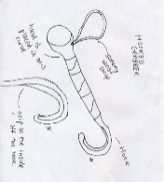  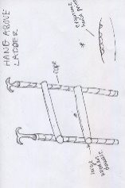  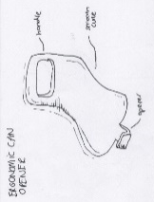  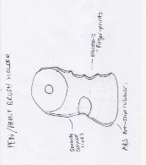  I have to decided to make a walking stick because I think this will help support old people when walking
Existing product analysis | - Make a title “product analysis”  - Choose 6 products from the internet that are similar to the product you’re thinking of making.  - Write an introduction product to say why you have chosen these types of product you have chosen  - Use the letters of ACCESSFM to analyse your product. (Aesthetics, cost, customer, environment, safety, size, function, material)  - All ACCESSFM words are in bold.  - For each product, choose 3 letters of ACCESSFM and say what you like and don’t like about it  - Explain specifically what you like and don’t like  - Write a summary to say what you can see from any of these products that you would like to try in your product. | Example  I have chosen products that help with personal fitness so I can get some ideas for my product. I have analysed health tracking devices as well as some exercise equipment.  (you will need 6 like this)  Environment - This product is not good for the environment because it is difficult to recycle. The rubber strap is not able to be recycled at home and the electronic components can only be recycled if they are separated.  Aesthetics – I like how the product looks because it is sleek and simple  Function – it can be worn on your wrist so it is easy to carry around  Summary – I think that designing a health tracking product will be good for my context. Something that can be carried around easily.
Work of others | - The section has the title “work of others”  - Choose an art movement. E.g.  - Art nouveau  - Art Deco  - Memphis  - Choose 10-20 pictures of art/buildings or products from this style  - Say what you like about the artist movement  - Say what shapes, colours and materials you can see | 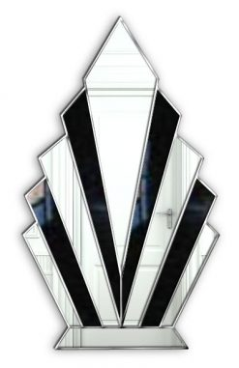  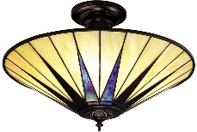  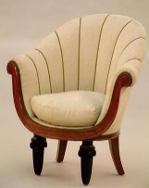  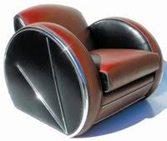  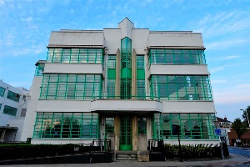  (you will need more pictures than this)  I like art deco because it has simple line sand symmetrical shapes and I think the products are really aesthetically pleasing. I can see sunrise and shell shapes as well as symmetrical geometric shapes.
Impact on society | - The section has the title “impact on society”  - Use the sub heading “society”  - Society – Say how you can make a product that helps people with specific needs. E.g. elderly/disabled/blind/deaf  - Use the sub heading “environment”  - Environment – Give examples of how you can make your product environmentally friendly and explain. Examples are:  - Create a recyclable product – so it doesn’t go to landfill  - Use recycled materials like wood that has already been used – not wasteful  - Use FSC wood – sustainably sourced  - Use Fairtrade cotton – good for famers and workers  - Use renewable (wood, cotton) – can be replanted  - Use renewable energy – doesn’t add to greenhouse effect | Society  My product needs to be safe for elderly people to use. They may struggle to stand up so it should have handles to help support them  Environment  I will make my product from FSC approved wood. This means that the forest it has been taken from is sustainable and isn’t causing deforestation. I will try to find recycled materials, for example use manufactured boards made from existing products.  I will make sure my product can be recycled at the end of its life because then it won’t go to landfill. Landfill is bad because it adds to the greenhouse effect and is an eyesore.

Section B NEA
Name _____________________

Section B | What to include | Example
Design brief (second draft) | - The section has the title “Design brief – second draft”  - Add in any requirements from the research you have done since your first draft  - Sustainability – explain how it will be sustainable  - Work of others – explain which art movement style you are going to use  - If you have changed your mind about anything, change it in the second draft brief. E.g. if you were going to make a product for the kitchen but you would now like to make a product for the living room.  - By now, your brief must be specific about what the product does and what it is for.  - E.g. I am going to make bird house for birds to nest in the garden  - I am going to make a travel torch that can be attached to a keyring | First draft  I am going to make a product that helps people bring a healthy packed lunch to work. It will be carried from home to work and then used in the office. It will be used by someone who has a job and wants to be healthy. It will have a handle or strap so it can be carried and it will have sections for different types of healthy foods. It should be small enough to fit into a backpack  Second draft  I am going to make a product that helps people bring a healthy packed lunch to work. It will be carried from home to work and then used in the office. It will be used by someone who has a job and wants to be healthy. It will have a handle or strap so it can be carried and it will have sections for different types of healthy foods. It should be small enough to fit into a backpack. My product should be environmentally friendly because it will be made from sustainable materials and be able to be recycled at the end. I will design the lunchbox in the style of the Memphis art movement
Specification points | - The section has the title “Specification points”  - You have 10 specification points  - Each spec point links to an ACCESSFM word  - Your spec points are realistic – something you can do in this classroom  - Your spec points are measurable. E.g. “The product should be less than 30cm tall” rather than “The product should be small”  - Your spec points are specific but not too specific. E.g. “the product will be made out of a recyclable material” not “the product will be made out of MDF  - You have covered all the letters of ACCESSFM in your spec points  - Each point comes from some research you have done. You may want to add in more research at this stage if you don’t have anything that fits | Example  Category Spec point Reason Research link  Size less than 20cm high and 20cm wide It will need to fit in the fridge Measurements of a fridge  Aesthetics Bright colours It will be eye catching and be Memphis themed Work of others  Function Have sections for different foods My client wanted something they could separate food in Client interview  Environment It will be made from a sustainable material Because this is good for the environment Impact on society

Section C – What to include
Initial designs  (can be up to 3  pages) | - The section has the title “initial designs”  - Draw 8-1- initial designs  - Draw in 3D  - Shade in your drawings  - Show pictures of your inspiration images (from your artist movement or elsewhere)  - Add annotations where anything that isn’t clear needs explaining  - At least 3 of your designs are based on an art movement/product or picture you have looked at – you can include this on the page  - For each design say how it meets your specification points from your research – It’s fine if it doesn’t meet all the points, you just need to identify this  - Write a summary of the section  - Your summary explains any decisions you have made in this section  - Your summary says which are your favourite designs and what you like/dislike about them  - Your summary says which are your least favourite designs d what you like/dislike about them | Example 1 – sketches based on research images  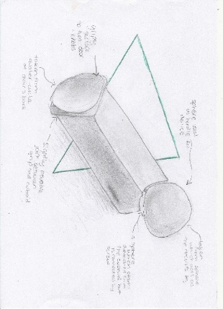  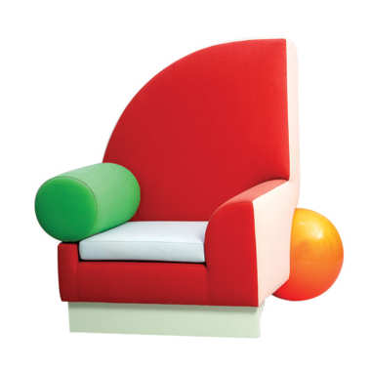  Example 2  Door Knob Turner  Bel Air Chair by Peter Shire, 1982  Although it is not “fully curved it has a smooth sphere handle. Also it is an abstract design with aesthetically catches the eye. The product has not met the specification because the edges are sharp which can be dangerous. It has met the specification because will be able to make the lightweight by deciding to use certain materials and It is repairable due to the fact certain parts of the product are detachable.  Example 3 - Spec check  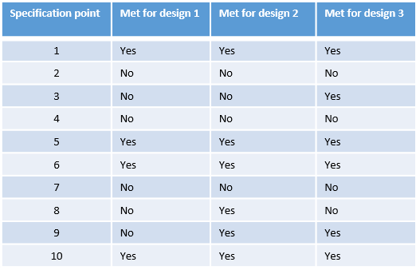  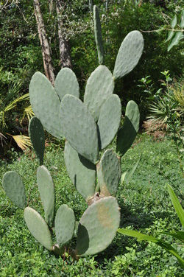

Section D | What to include | Example
CAD designs | - The section has the title “CAD designs”  - You have created 1-10 designs using google sketchup  - You have used the acronym SCAMPER to create these designs by changing one of your drawings:  - Substitute  - Combine  - Adapt  - Modify  - Put to another use  - Eliminate  - reverse  - For each design, you can included different options. E.g. different shaped handles. This shows you are exploring possibilities  - save all your sketchup designs in your named folder  - Add screen shots of your designs from different angles onto your powerpoint  - Write a summary of the page  - What decision have you chosen to move on with  - Say which designs you like the most and which you don’t like | Different angles  This student used the term “Modify” to change her product  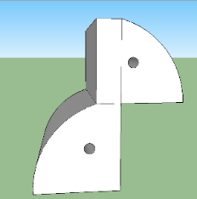
Paper/board model | - The section has a title “first card prototype”  - You have created a model of your favourite design using papers/boards or foam  - You have pictures of all your prototypes which show any changes you have made  - Evaluate the prototype  - Say what you like and dislike about it  - Say what you want to improve for the next stage  - included a summary of the page  - Your summary explains any decisions you have made in this section | 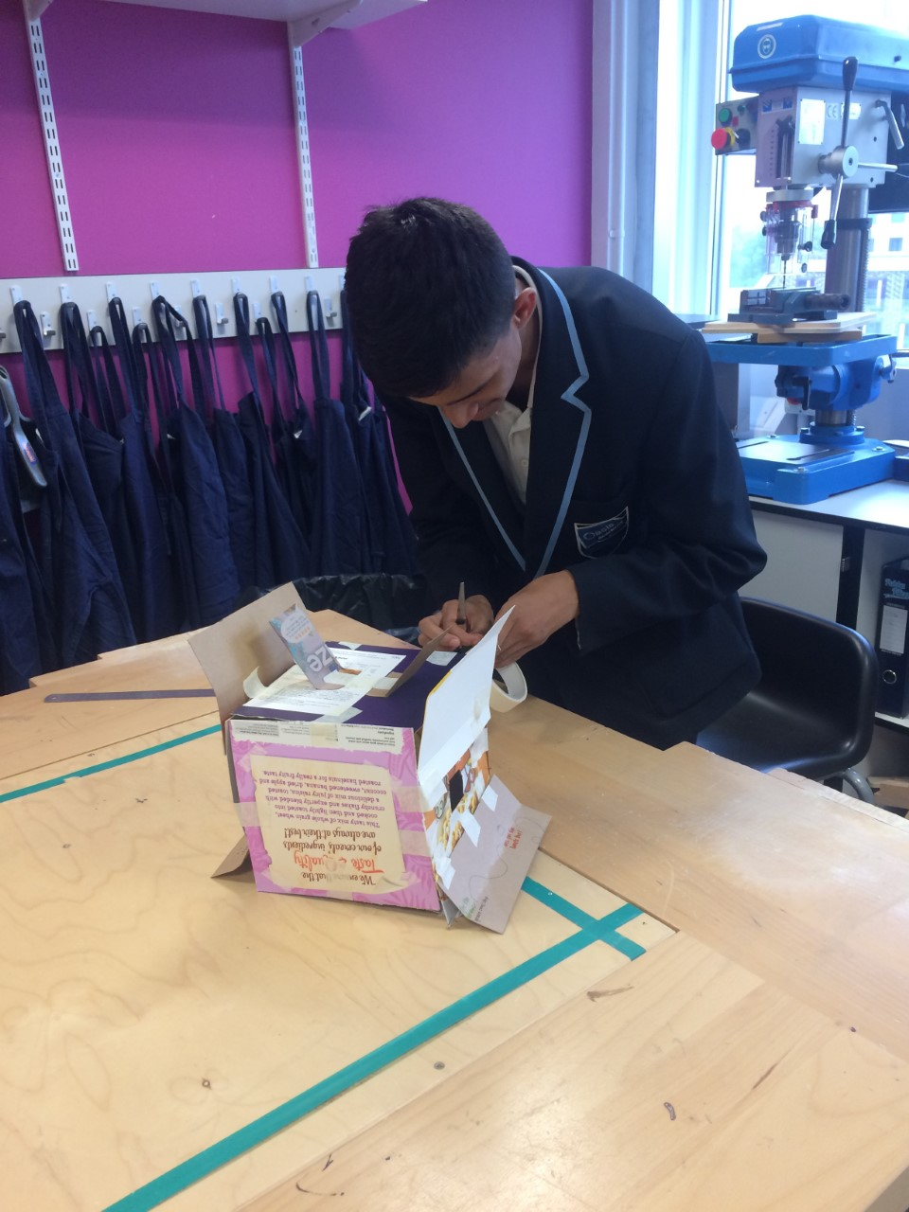  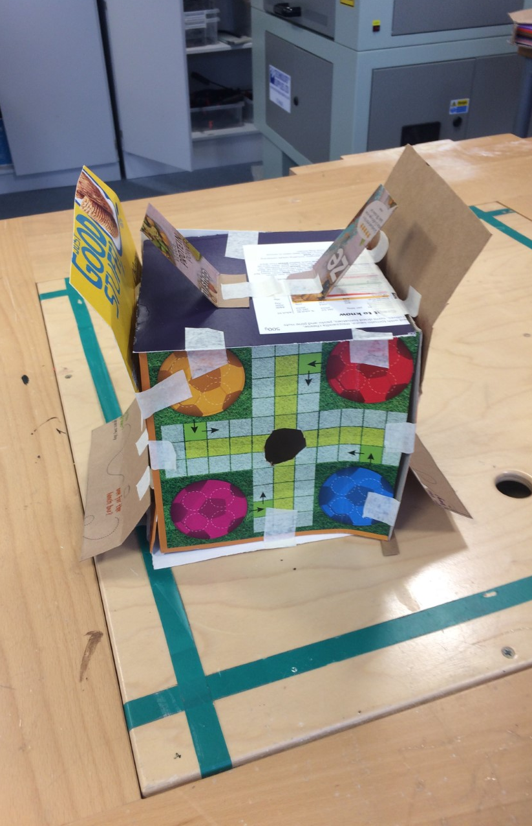  Evaluation  I used the card model as a way to experiment my new design change to my design (that I explained in the CAD section). This mainly involved making a cube and adding “flaps” to each side of the bird house. I also added some handles but I did not make an operational lid. Securing the side flaps was difficult since they would not position very well, which was a big factor as to why I didn’t like this change of the design. I have learned that perhaps securing these flaps to a support beam above or below the flaps. The flexi-ply can either be secured to the beam using adhesives such as epoxy resin or wood glue (if the beam is to be made out of wood) or it can be nailed to the beam (using both a nail and adhesive may make the flexi-ply even more secure). I most likely will use pine again for these beams, but if pine is found to be too soft, plywood may be a better option since it has more cross dimensional stability.

Section E | What to include | Example
Materials and finishes | - The section has the title “materials and finishes”  - Create a table to display your information  - List a range of materials that you could use for your product  - List a range of finishes you could use “e.g. paint, varnish”  - Say the main 1-3 properties of that material  - Include materials that you may not use to show why they aren’t appropriate  - You have said the advantages and disadvantages of using this material based on its working properties  - Include a material and finish test  - Find scraps of materials and use a range of finishes to test on them  - Explain what you liked and didn’t like about the look and feel of the material  - Explain what you liked and didn’t like about the feel of the finish and how it was to apply  - Take a photo of the test  You have a summary which says what you have learnt from this page | Material property Part of my product Advantage disadvantage  plywood It is strong It can be used on a laser cutter The main box It works well on a laser cutter It doesn’t have a good aesthetic look  paint Comes in looks of colours Adds protection The drawer It can be coloured It can look messy if it’s not applied well  Material and finish table  Material and finish test  The materials I used were MDF, pine, plywood and flexi ply. The finishes which I used were wax, stain, acrylic paint, oil and varnish. On my timbersI used wax, stain and acrylic paint.  The paint had a nice smooth surface which made it easy to apply the finishes. The wax gave it a nice natural finish and went on really well, the stain also looked nice and went on well however the with acrylic paint I put too much on and it didn’t look nice.  Even though the acrylic paint didn’t go well on my pine wood, it went on really well with MDF and plywood, which both had a nice smooth surface. However on the MDF stain did not go well on it because the stain splashed everywhere and the stain is very watery so it runs along the wood.
Final product | - Make a change to your product since your last prototype or drawing  - Change the shape of your product  - Add an extra feature  - A handle  - A drawer  - A cup holder  - A more stable stand  - Make your product more ergonomic  - Add finger grooves  - Add a handle  - Add smooth edges  - Change the size  - Remove part of the product  - create the net of your product on 2D design  - Save your work to be cut on the laser cutter  - Use tools and materials in the workshop to complete your prototype  - Make more than 1 prototype if you want to make changes  - Test different ways for your product to work  - Try using 2 different types of hinge (take photos of each)  - Write a list of quality controls you have used. Explain why and how you did them (you can use sketches or photos to help you explain)  - E.g  - Marking out accurately using a sharp pencil and metal rule  - Using a try square to get right angles  - Using red lines for cutting your 2D design file  - Using blue lines for etching your 2D design file | 2D design net  Quality controls  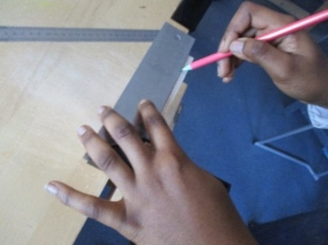  Marking out the dowel joints.  Final photos
Ongoing research | - Do more research to help you make changes to your product  - Ask client thoughts on the prototype and drawings so far  - Look at existing products  - Could be part of a product e.g. different handles  - Explore ergonomics – look at existing ergonomic products  - Explore anthropometrics (can take your own measurements)

Section F– What to include |  | Example
Specification check | - Add the title “specification check”  - Copy your specification from your research section  - For each one, write if your product meets this spec or not  - If it does, explain how  - If it doesn’t, explain why not or explain what you would do to make it meet that point
- Add the title “Testing”
- Test 3-5 things about your product.
- For example:
  - if your product is supposed to hold a pen, see if you can put a pen in
  - If your product has a drawer that’s supposed to open, does it open?
  - If your product is supposed to have a handle, can you hold it from a handle
  - If your product is supposed to be water resistant, does it get wet when you run it under a tap?
- Explain the test you are doing
- Explain the result – did it work and if not, what went wrong?

- Add the title “final client interview”
- Ask 1-3 potential users what they think of the product (one of these people should be the person you interviewed in the research section)
- You can either do this with an interview or by writing a couple of paragraphs about their opinion

If you choose an interview:
- Ask the client 10 questions about what they think about your product
- Ask questions about what they like or don’t like about the product
- Ask what they will find useful about it
- Ask what they would do to improve it

If you choose to write it in paragraphs
- Explain 2-3 things they like about the product
- Explain 2-3 things they don’t like about the product
- Explain what they would do to improve the product
 | - Write a title saying “making the product in industry”  - Explain what you would do differently if you made the product in the real world  - Explain if you would use different materials if you had them and say why they would be better  - Explain what machines you would use if you made it in a factory. E.g. injection moulding machine, wood lathe or 3D printer | - One way I would make it suitable for commercial use is that I would make the case have a more durable material on the outside rather than cheap MDF like a plastic that would be easier and quicker to manufacture this would make it so that it can be a higher quality and more people would buy it and would also reduce the manufacture time. Also another change I would make to the case is that I would improve the aesthetics of it and add a well known, noticeable theme so that people would be attracted to it and more people would buy it.  - Also I would have to change the manufacturing process as the one I used was to slow and there was a high chance for human error meaning that this was not a commercially viable option. This is because if I need it to be for commercial use it has t be mass-produced so there has to be as little and as cheap manufacturing process as you can get.  - The final thing I would do to make my product commercially viable is that I would have to make a box for the product to make it so that it can be shown off with all of its features and I would also have to make advertisements for it so that my product can be shown off by many different types of media so that more people can see my product making it more noticeable meaning more people would buy it.
- Add the title “suggested changes”
- Say 2 things you would improve if you had more time or resources
- Explain how you would make these changes
You can show your ideas using sketches, sketchup or just explain with annotations.

