The transition from GCSE to A-level Physics
Welcome to A-level physics! September is going to come round fast and you need to be ready
There is a significant step up from GCSE to A-level so we need to make sure that you are fully ready for September.
Summer transition work
The tasks on the following pages are intended to give you the opportunity to practice some of the key skills that you need on the A-level physics course.
Complete all the tasks before the start of term either and bring the completed booklet to your first Physics lesson.
Section A: How to become a better physicist over the summer:
- Compulsory:
Join Isaac Physics – https://isaacphysics.org/
- Recommended:
Join the Institute of Physics – this is completely free for A-level students. Here you can keep up-to-date on cutting edge physics topics. http://members.iop.org/16-19.asp and in the ‘school details’ section you need to enter school address: Oasis Academy South Bank, 75 Westminster Bridge Road, London SW1P 2DY
- Recommended: read books. It can help to stand back and see physics in a wider context. Scientific truth is actually stranger and more interesting than science fiction!
Here are some recommendations:
  - A short history of nearly everything by Bill Bryson
  - Seven brief lessons of physics by Carlo Rovelli
  - Six Easy Pieces: Fundamentals of Physics Explained by Richard Feynman
  - Seduced by logic: Emilie du Chatelet, Mary Somerville and the Newtonian Revolution by Robyn Arianrhod this book is about two of the most influential female physicists of all time
Good luck and if you have any questions do not hesitate to email: beccie.whittaker@oasissouthbank.org
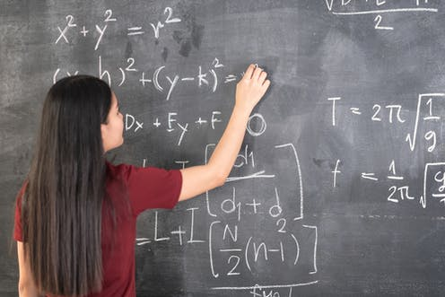

Section B: Physics Transition tasks
- Dealing with symbols and SI units
One of the biggest jumps between GCSE and A-level physics is the way things are written down. At A-level you are expected to start using standard scientific notation.
Standard scientific notation means:
- Using conventional symbols for quantities
- Writing all quantities in terms of SI units (Système International)
- Writing very large and very small numbers in standard form (e.g. 1x10⁻⁶ instead of 0.000001)
Task 1: you need to memorise the unit prefixes shown in the table. Take note of whether the symbols are capital or lower case letters! They will be used in all exams and it is assumed that you know what they mean.
Multiple | Prefix | Symbol
10¹² | tera- | T
10⁹ | giga- | G
10⁶ | mega- | M
10³ | kilo- | k
10⁻³ | milli- | m
10⁻⁶ | micro- | μ
10⁻⁹ | nano- | n
10⁻¹² | pico- | p

Task 2: In the following pairs of quantities, circle the quantity that is greater.
- 12 mW or 12 MW f. 22x10⁻² Ω or 220 Ω
- 3.0 μs or 3.0 ns g. 300 kg or 3x10³ kg
- 27 kV or 27 GV h. 121 kN or 0.121x10⁶ N
- 6 pm or 6 μm i. 20x10⁻⁶ F or 0.003 pF
- 1024 TW or 1024 GW j. 14000 MHz or 1.4x10⁹ Hz
Task 3: When you write out the name of a unit in full it is always written completely in lower case letters. For example the unit for power is watt (symbol W). In the box above write the full name of the SI unit in the question.
Bonus point if you can find out why some symbols are written in lower case while other are in upper case (e.g. N).
Task 4: you must bring a working scientific calculator to all of your physics lessons and exams. Your calculator has a button on it that says ENG. Find out what this button does, and why it will be useful to you on your physics course.
Describe the function and usefulness in the space below.

- Graph skills
Graph skills are incredibly important for both analysis data and presenting new data. You need to be confident at drawing graphs, interpreting graphs and calculating quantities from graphs.
Task 1: Drawing graphs
Rules when drawing a graph:
- Use pencil and ruler
- Independent variable does on the x-axis, dependent variable goes on the y-axis
- Range of data points must take up AT LEAST half the page
- Axes must be labelled with name and units
- If plotting a scatter graph, a line of best fit must be one continuous line (NEVER join the dots!)
Use the data below to plot a graph of atomic radius against atomic number and draw a line of best fit.
 | Atomic  number | Atomic radius in  picometres (pm)
 | 15 | 100
 | 35 | 115
 | 50 | 130
 | 70 | 150
 | 95 | 170

Use your graph in Figure 2 to predict the atomic radius of an atom with atomic number 126.
Atomic radius = ........................................ pm
Task 2: Interpreting graphs and calculating quantities from graphs. This question is about distance-time graphs, covered in your physics GCSE course.
The distance – time graph shows how far the bus travelled along the high street and how long it took.
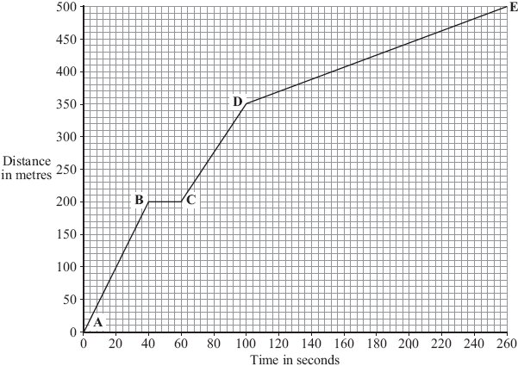
(a) The bus travels the slowest between points D and E. How can you tell this from the graph?
.............................................................................................................................
.............................................................................................................................
(1)
(b) Between which two points was the bus travelling the fastest? ……………………………………………….
(1)
(c) There is a bus stop in the high street. This is marked as point B on the graph.
(i) What is the distance between point A on the graph and the bus stop?
Distance .............................. metres
(1)
(ii) How long did the bus stop at the bus stop?
Show clearly how you work out your answer.
...................................................................................................................
Time = .............................. seconds
(2)
(d) A cyclist made the same journey along the high street. The cyclist started at the same time as the bus and completed the journey in 200 seconds. The cyclist travelled the whole distance at a constant speed.
(i) Draw a line on the graph to show the cyclist’s journey. (2)
(ii) After how many seconds did the cyclist overtake the bus? After............................. seconds.
(1)
(Total 8 marks)

- Essential KS4 revision for first half term. You will need your GCSE Collins Physics Revision guide

Task 1: Model of the atom
Read through p.86-87 in the Collins physics revision guide, make a set of notes and answer the quick test questions.
Then complete the Q1-3 below.
Q1. Draw a labelled diagram of the model of the atom that we use in current day

Q2a.
Use your periodic table to find the number of protons, neutrons and electrons in…
protons neutrons electrons
- Hydrogen, H
- Beryllium, Be
- Magnesium, Mg
- Manganese, Mn
- Carbon, C
- Nitrogen, N
- Oxygen, O
- Sulphur, S

Q2b.
Use your periodic table and determine the number of protons, neutrons and electrons in the following ions
protons neutrons electrons
- Sodium ion, Na⁺
- Bromide, Br-
- Fluoride, F⁻
- Beryllium ion, Be²⁺
- Magnesium ion, Mg²⁺
- Oxide, O²⁻
- Sulphide, S²⁻

Q3
Element | Number of protons | Number of neutrons | Number of electrons
A | 6 | 6 | 6
B | 17 | 18 | 17
C | 2 | 2 | 2
D | 17 | 20 | 17
E | 3 | 4 | 3

a. Which element (A-E) has atomic number 6? ……………………………………………………………………
b. Which element (A-E) has mass number of 4? ……………………………………………………………………
c. Which two (A-E) are isotopes? ……………………………………………………………………
d. Which element in the periodic is element E? ……………………………………………………………………
e. Which element(s) (A-E) has the largest atomic number? ……………………………………………………………………
f. Which element(s) (A-E) has the largest mass number? ……………………………………………………………………
Task 2: Momentum
Read through p.18-19 in your Collins physics revision guide, make a set of notes and answer the quick test questions.
The complete Q1 and Q2 below.
Q1. The diagram shows two supermarket trolleys moving in the same direction.
Trolley A is full of shopping, has a total mass of 8 kg and is moving at a velocity of 2 m / s with a kinetic energy of 16 J. Trolley B is empty, has a mass of 4 kg and is moving at a velocity of 0.5 m / s with a kinetic energy of 0.5 J.
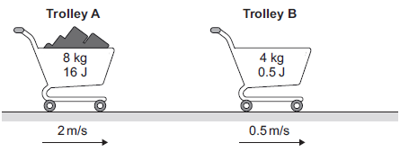
(i) Calculate the momentum of both trolley A and trolley B. Give the unit.
_________________________________________________________________________________________
_________________________________________________________________________________________
Momentum of trolley A = _______________
Momentum of trolley B = _______________
Unit __________
(4)
(ii) The trolleys in the diagram collide and join together. They move off together. Calculate the velocity with which they move off together.
_________________________________________________________________________________________
_________________________________________________________________________________________
_________________________________________________________________________________________
Velocity = _______________ m / s (3)
(iii) In a different situation, the trolleys in the diagram move at the same speeds as before but now move towards each other. Calculate the total momentum and the total kinetic energy of the two trolleys before they collide.
__________________________________________________________________________________________
__________________________________________________________________________________________
Total momentum = _________________
__________________________________________________________________________________________
__________________________________________________________________________________________
Total kinetic energy = _______________ J (2)
(Total 9 marks)
Q2. The figure below shows two cars, just before and just after the collision.
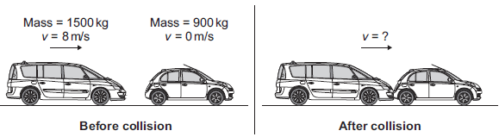
(i) The momentum of the two cars was conserved. What is meant by the statement ‘momentum is conserved?
__________________________________________________________________________________________
__________________________________________________________________________________________
(1)
(ii) Calculate the velocity of the two joined cars immediately after the collision.
_________________________________________________________________________________________
__________________________________________________________________________________________
__________________________________________________________________________________________
__________________________________________________________________________________________
__________________________________________________________________________________________
Velocity = ___________________ m/s
(3)
(Total 4 marks)

Section C: Introducing our first topic: Particle Physics
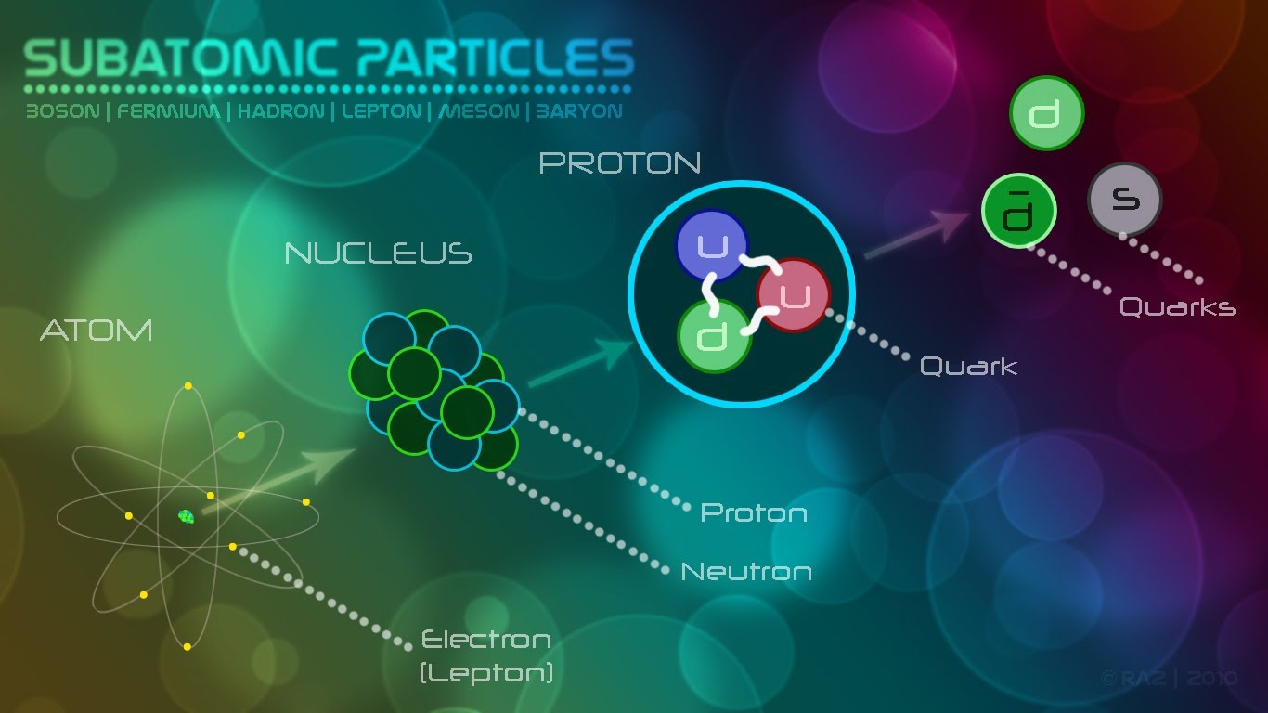

Our first topic will be on particle physics – this is a completely new topic for you.

Task 1:
Watch the documentary “Particle Fever” where Scientists re-create conditions from the big-bang theory to investigate the origin of all matter and unravel the mysteries of the universe.

Task 2:
Research the following particle groups and particles. For each, write a description for each or make a poster containing all the information.
Particle groups:
- Hadrons
  - Baryons
  - Mesons
- Leptons
Particles:
- Muons
- Neutrinos
- Quarks

