A level English Literature
Summer project
Suggested reading list
These are the novels you will study on your course, although it is not compulsory, it would be sensible to have read them ahead of September.

- Never Let me Go by Kazuo Ishiguro
- Frankenstein by Mary Shelley
- A Thousand Splendid Suns by Khaled Hosseini
- The Art of Fiction by David Lodge

You could also watch these film versions:

- Mary Shelley's Frankenstein (1994, directed by Kenneth Branagh)
- A Streetcar Named Desire (1951, directed by Elia Kazan)
- Never Let Me Go (2010, directed by Mark Romanek)
- Othello (1995, directed by Oliver Parker)

Enjoying reading widely is an essential trait of an English Literature student so aim to read at least every other day: more than 20 pages at a time.

This work is a compulsory part of your preparation for September.

The amount of work required is reasonably significant; more than you will have been used to at GCSE level.

Have a quick glance through all the activities so you have a feel for how much work is involved, and so you can plan your time accordingly.

Completing this work will mean you are ready to start the course in September feeling confident and prepared.

Good luck!

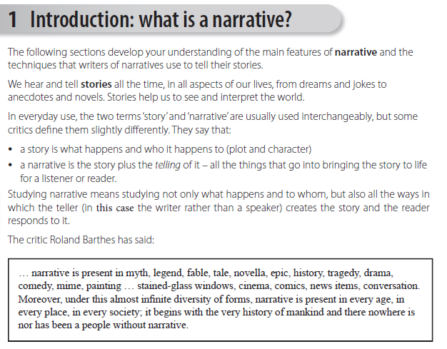

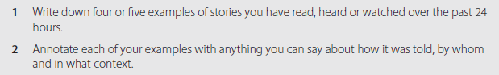

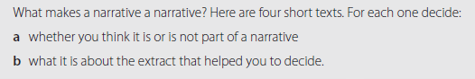

Write your answers in the box next to each extract.
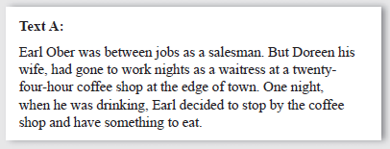
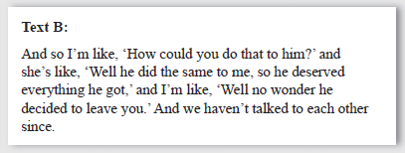
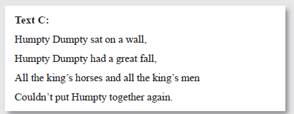
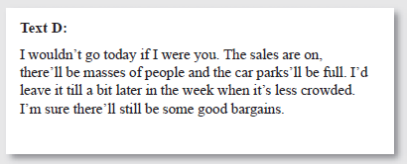

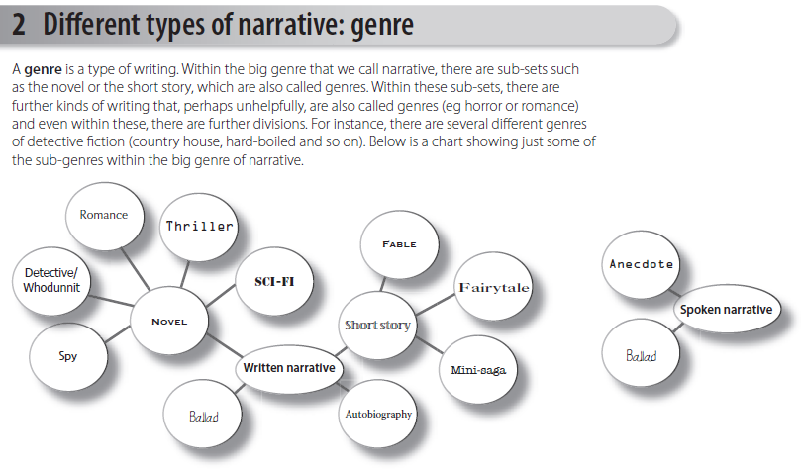
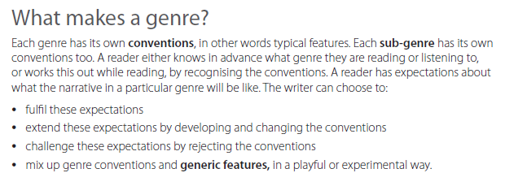

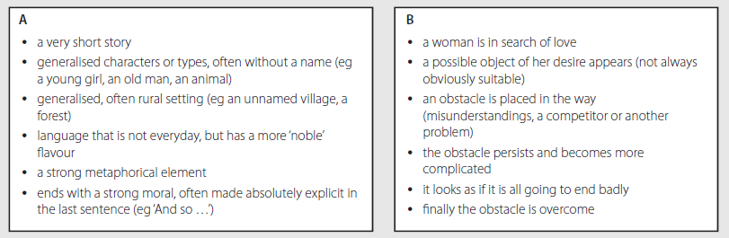
Genre:  + because… | Genre:  + because…

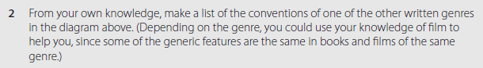

Identifying genre

Read this extract.
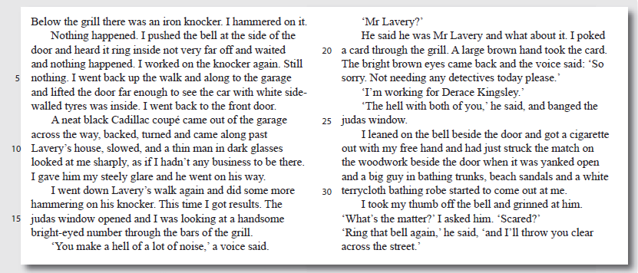
- Identify the genre of the text
- Explain how you came to this decision. What features did you identify?

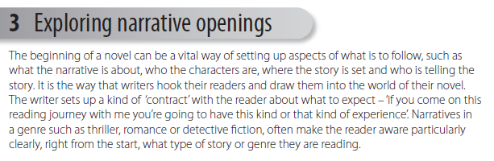

Read these openings:
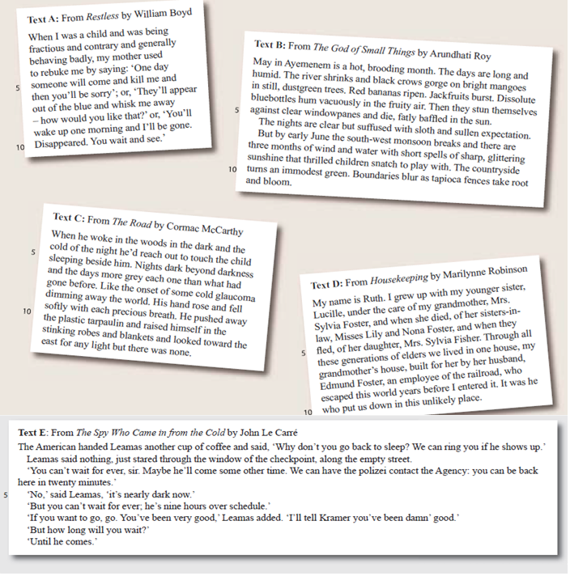

Fill in the chart using this number system:

1 = not really 2 = slightly 3 = quite a lot 4 = hugely
 | A | B | C | D | E
The opening focuses on the setting.
We get a strong sense of what the characters are like.
The narrator tells you a lot about him or herself.
You’re dropped right into the middle of the story.
The opening makes us aware of the genre of the novel.
The opening makes you want to read on.

Which of the openings did you most enjoy? Write two high quality paragraphs.
Write about:

- what it focuses on (characters, setting, situation etc)
- what sort of ‘contract’ you think it is setting up with the reader

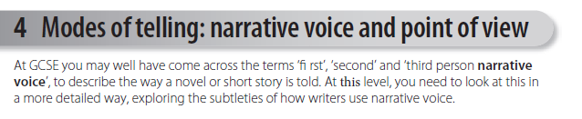
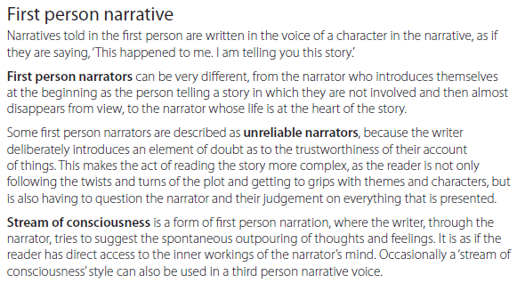
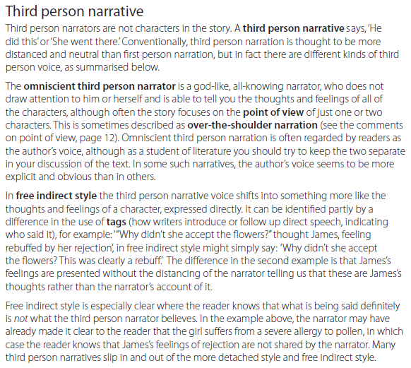
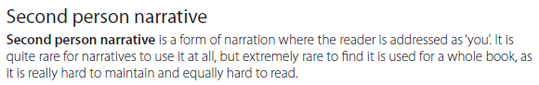

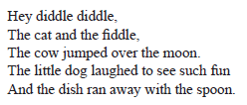
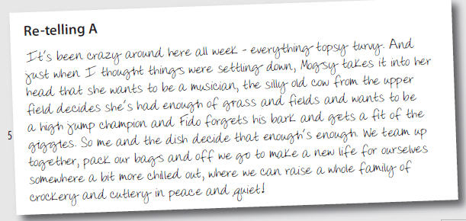
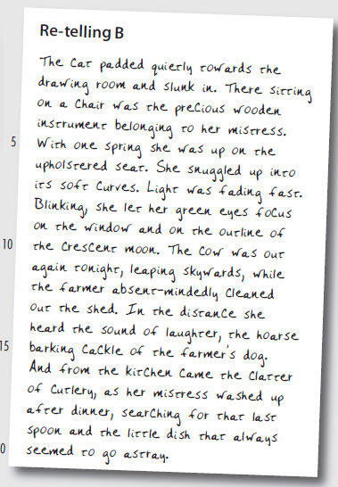
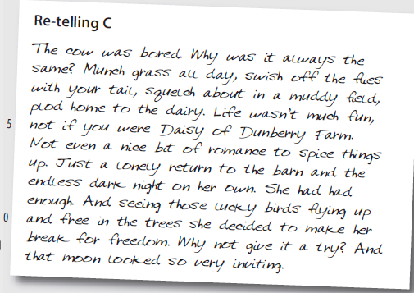
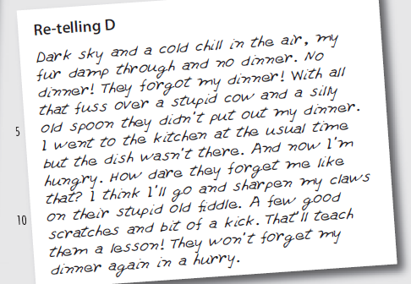
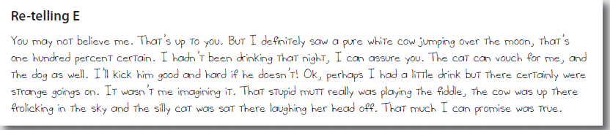
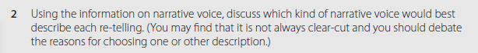
A -
B -
C -
D -
E -
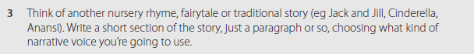

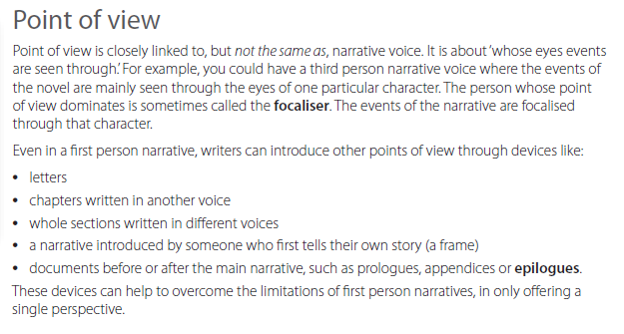

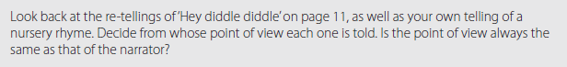
A
B
C
D
E
Yours

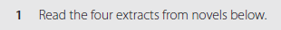
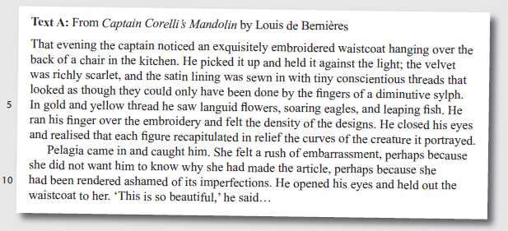
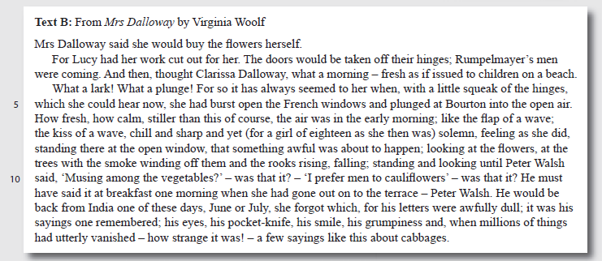
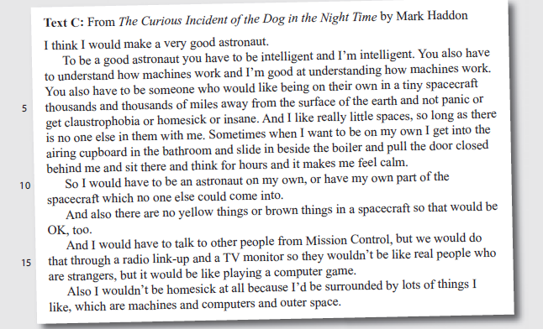
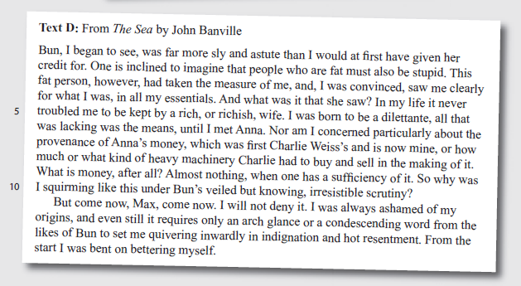

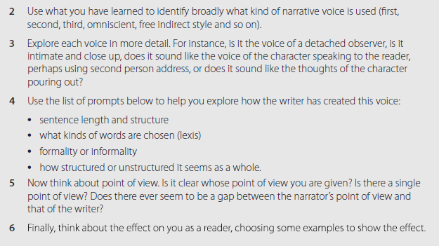
Read this model for text D, then write your responses for texts A, B and C.
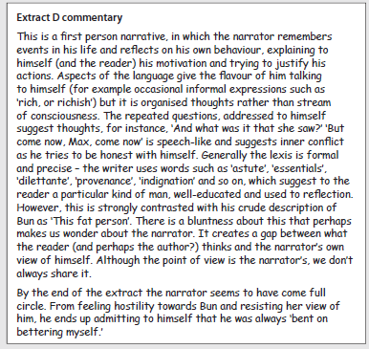
A
B
C

Pick of the extracts from the last activity and rewrite the first four or five sentences using a different narrative voice.

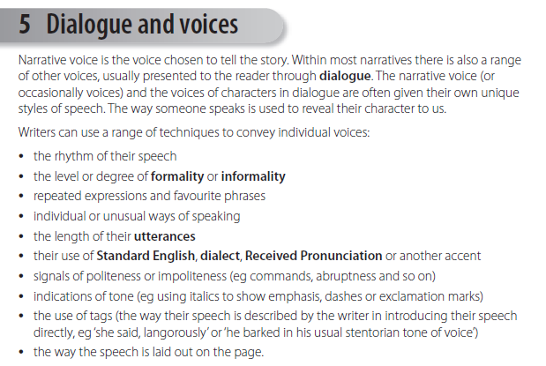

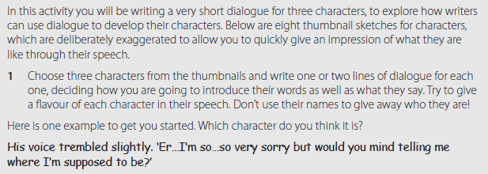
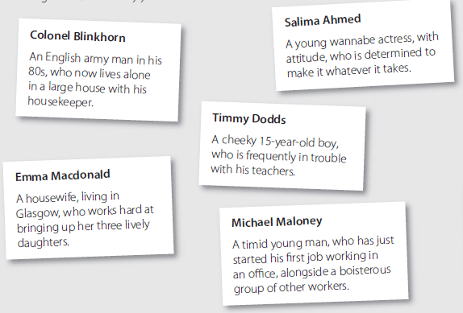 | 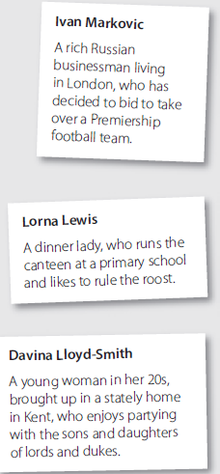
1
2
3

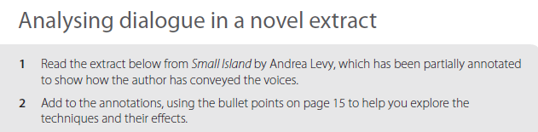
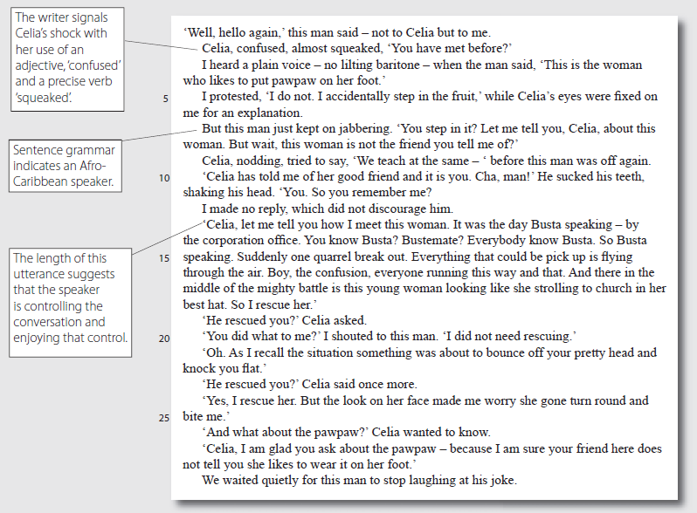
Write you annotations below, making sure you include line numbers, and quotations if necessary.

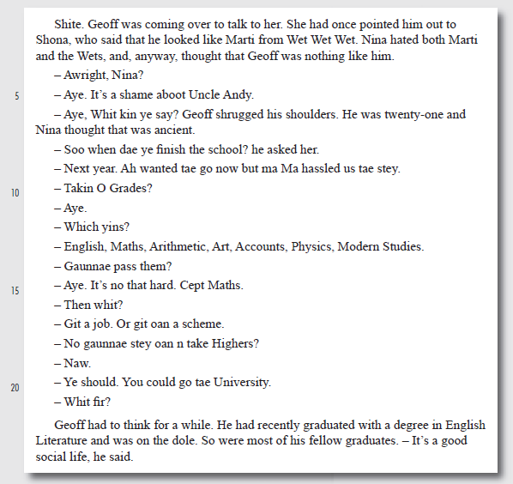

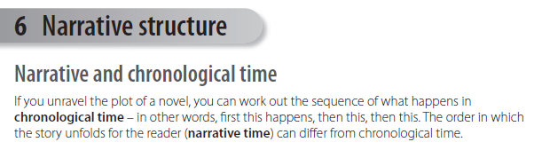

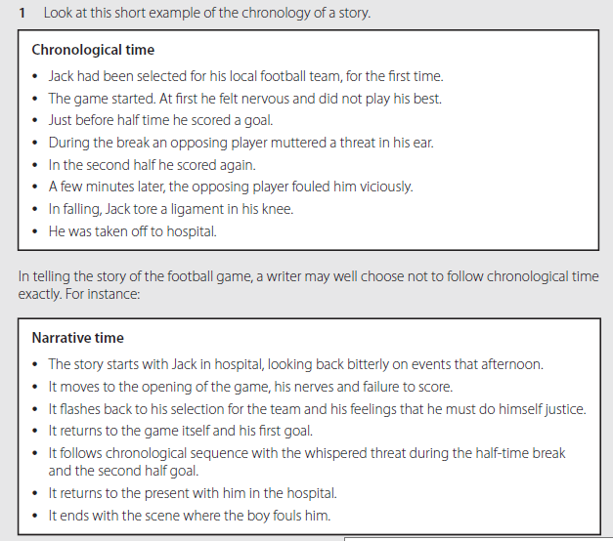
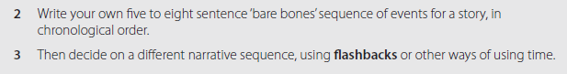

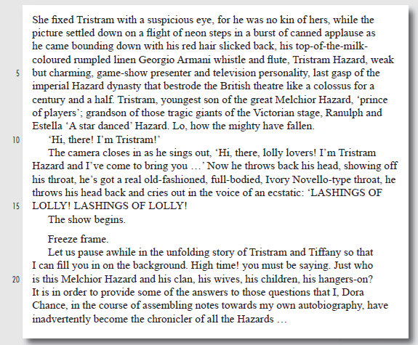
2. what are your first reactions to the text? What effects do you think Atwood is trying to achieve?
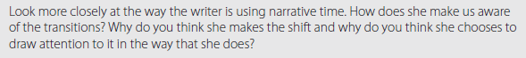
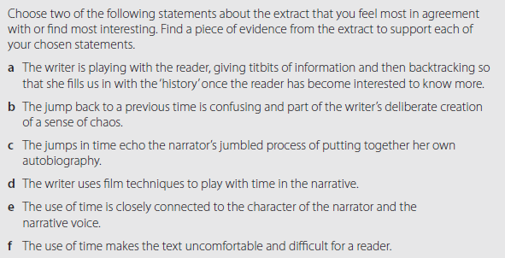

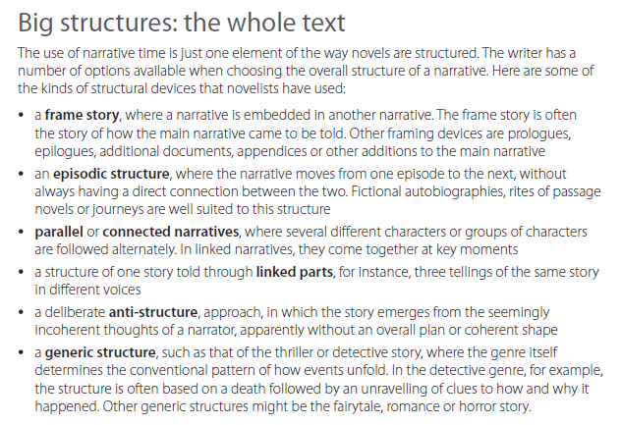

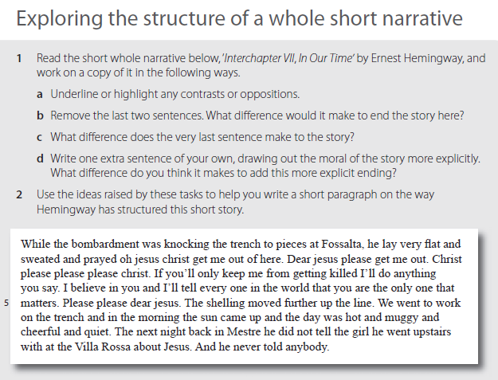

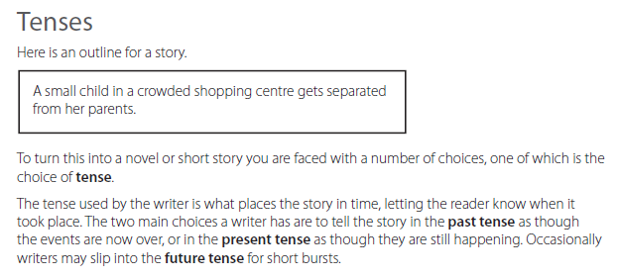
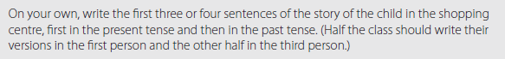

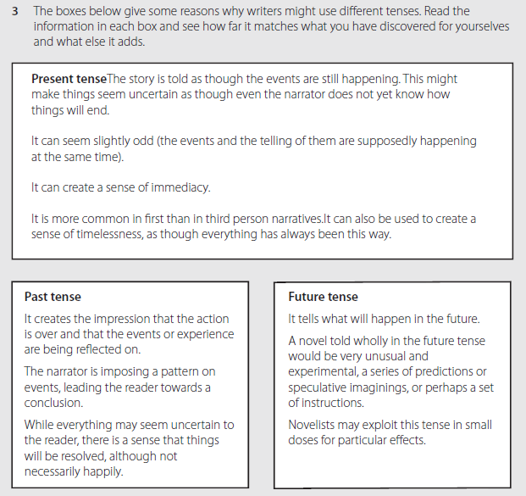
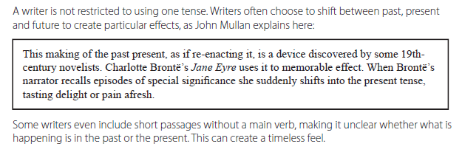

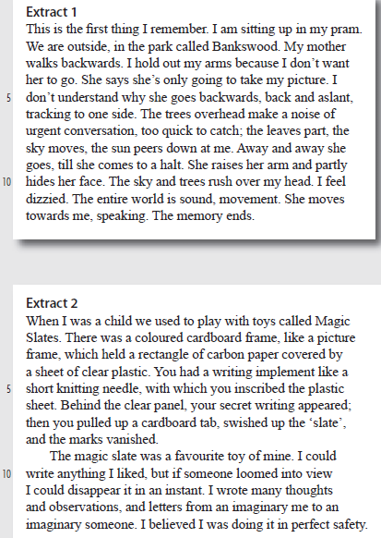

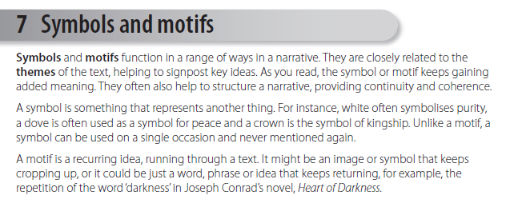

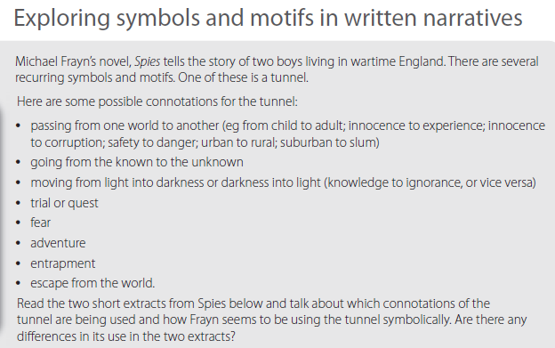
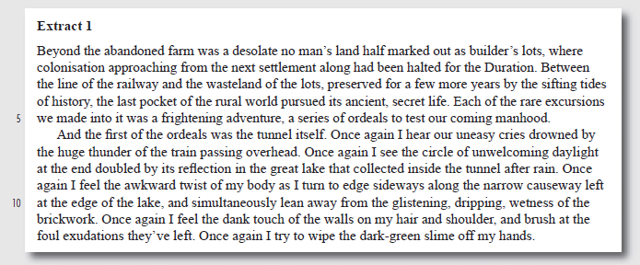
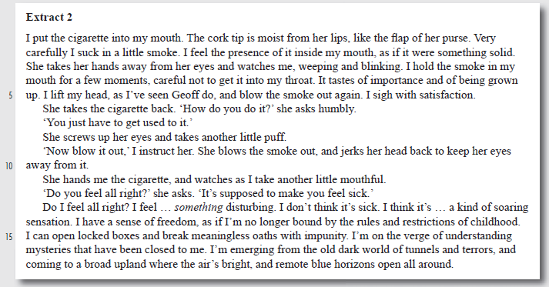

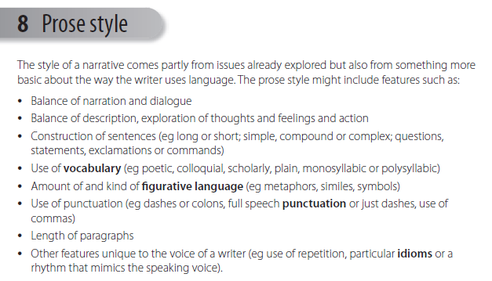

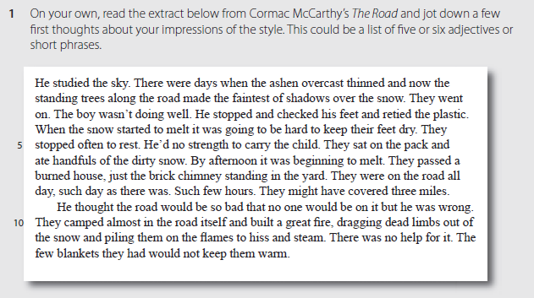
Describe the narrative style of the Cormac McCarthy extract referring to features in the bullet pointed list.

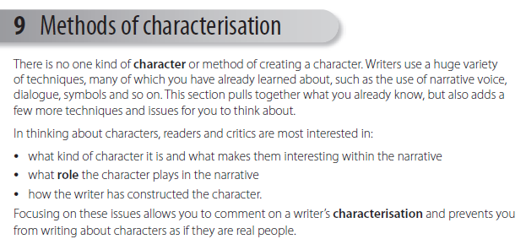

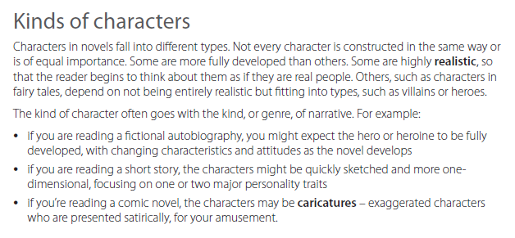

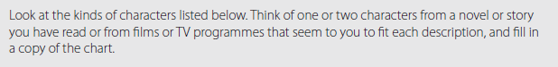
Write your answers on the right.
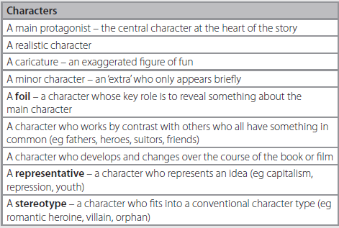

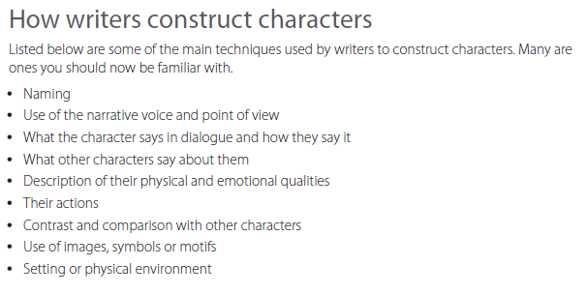

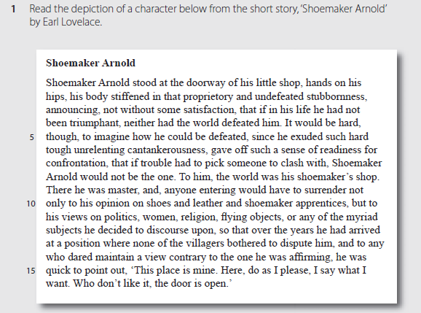
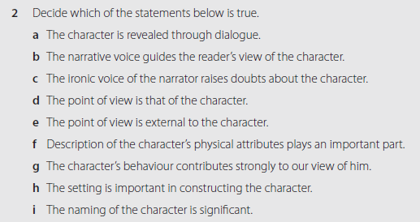
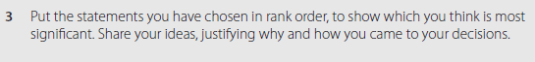

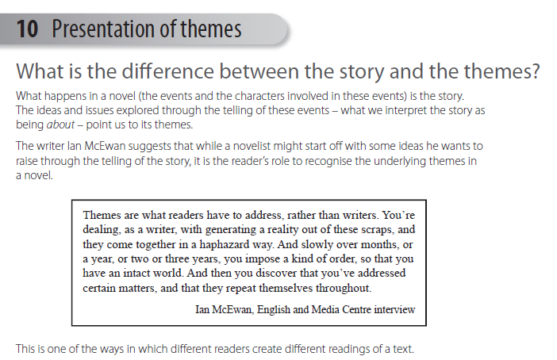

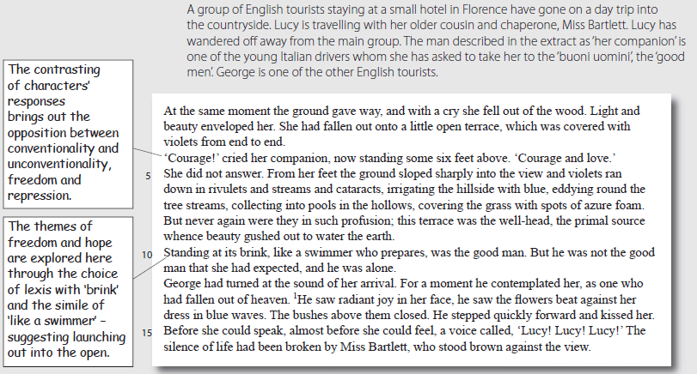
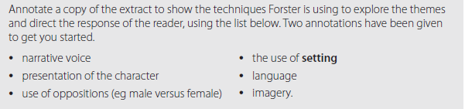
Put you annotations here:

