Reading List

 | KS3
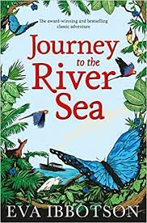 | Journey to the River Sea  Sent in 1910 to live with distant relatives who own a rubber plantation along the Amazon River, English orphan Maia is excited. She believes she is in for brightly coloured macaws, enormous butterflies, and "curtains of sweetly scented orchids trailing from the trees." Her British classmates warn her of man-eating alligators and wild, murderous Indians. Unfortunately, no one cautions Maia about her nasty, xenophobic cousins, who douse the house in bug spray and forbid her from venturing beyond their coiffed compound. Maia, however, is resourceful enough to find herself smack in the middle of more excitement than she ever imagined, from a mysterious "Indian" with an inheritance, to an itinerant actor dreading his impending adolescence, to a remarkable journey down the Amazon in search of the legendary giant sloth.
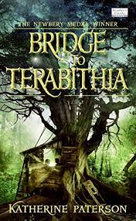 | Bridge to Terabithia  Jess Aarons has been practicing all summer so he can be the fastest runner in the fifth grade. And he almost is, until the new girl in school, Leslie Burke, outpaces him. The two become fast friends and spend most days in the woods behind Leslie's house, where they invent an enchanted land called Terabithia. One morning, Leslie goes to Terabithia without Jess and a tragedy occurs.
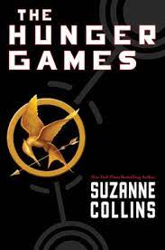 | The Hunger Games Series  Sixteen-year-old Katniss Everdeen, who lives alone with her mother and younger sister, regards the annual televised Hunger Games as a death sentence when she steps forward to take her sister's place in the Games. But Katniss has been close to dead before – and survival, for her, is second nature. She becomes a contender. If she is to win, she will have to start making choices that weight survival against humanity and life against love.
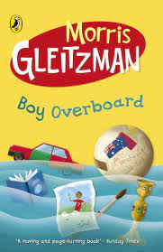 | Boy Overboard  Jamal and Bibi have a dream to lead Australia to football glory in the next World Cup. But first they must face landmines, pirates, storms and assassins.
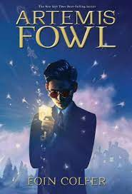 | Artemis Fowl  Twelve-year-old Artemis Fowl is a millionaire, a genius, and above all, a criminal mastermind. But even Artemis doesn't know what he's taken on when he kidnaps a fairy, Captain Holly Short of the LEPrecon Unit. These are not the fairies of bedtime stories—they're dangerous!
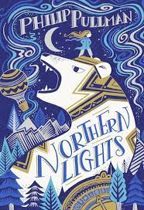 | Northern Lights  When Lyra's friend Roger disappears, she and her demon, Pantalaimon, determine to find him. The ensuing quest leads them to the bleak splendour of the North, where armoured bears rule the ice and witch-queens fly through the frozen skies - and where a team of scientists is conducting experiments too horrible to be spoken about. Lyra overcomes these strange terrors, only to find something yet more perilous waiting for her - something with consequences which may even reach beyond the Northern Lights...
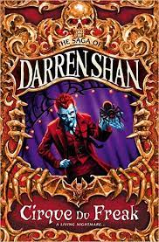 | The Saga of Darren Shan, Cirque du Freak Series  Darren Shan, author and narrator, sets the book up as a true story, warning readers: "Real life's nasty. It's cruel.... Evil often wins." Indeed, evil begins to win when Darren and his buddies find a flier for "Cirque Du Freak," a traveling freak show promising performances by the snake-boy, the wolf-man, and Larten Crepsley and his giant spider, Madame Octa. Darren and his friend Steve wouldn't miss it for the world. So, Saturday night they sneak out to the old theatre, tall and dark, with broken windows. "Every act you see tonight is real," croaks Mr. Tall. "Each performer is unique. And none are harmless." That is for sure. (A werewolf bites off the hand of someone in the audience, for instance.) Things grow very serious for the two boys when Steve not only recognizes Mr. Crepsley as a famous vampire but professes his true desire to join him! To make matters worse, the spider-obsessed Darren goes back to the old theatre to steal Madame Octa so he can teach her tricks in his room. (He does, with mixed results.) The plot further coagulates as Darren is faced with some terrible decisions about what to do to save his bloodthirsty friend Steve.
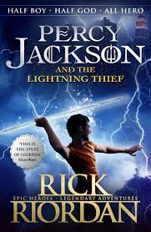 | Percy Jackson and the Lightening Thief  Percy Jackson is a good kid, but he cannot seem to focus on his schoolwork or control his temper. And lately, being away at boarding school is only getting worse - Percy could have sworn his teacher turned into a murderous monster. When Percy's mom finds out, she knows it is time that he knew the truth about where he came from. She sends Percy to Camp Half Blood, a summer camp for demigods, where he learns his father is Poseidon, God of the Sea. Soon a mystery unfolds and together with his friends—one a satyr and the other the demigod daughter of Athena, Percy sets out on a quest across the USA to reach the gates of the Underworld and prevent a catastrophic war between the gods.
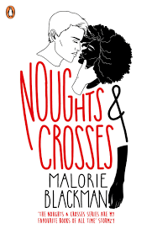 | Noughts and Crosses  Two young people are forced to make a stand in this thought-provoking look at racism and prejudice in an alternate society. Sephy is a Cross – a member of the dark-skinned ruling class. Callum is a Nought – “colourless” member of the underclass who were once slaves to the Crosses. The two have been friends since early childhood, but that is as far as it can go. In their world, Noughts and Crosses simply do not mix. Against a background of prejudice and distrust, intensely highlighted by violent terrorist activity, a romance builds between Sephy and Callum.
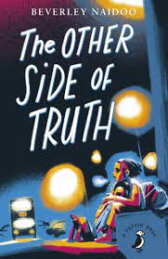 | The Other Side of Truth  After the murder of their mother, 12-year-old Sade and her younger brother are smuggled out of Nigeria by their journalist father to escape the corrupt military government and growing violence. They are sent to their uncle in London, but when they arrive, he is missing and they are abandoned, passed between foster homes. Their father escapes to England to find them -- but he will be sent back to Nigeria unless Sade can find a way to tell the world what happened to her family.
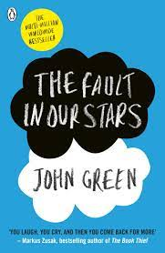 | The Fault in Our Stars  Despite the tumour-shrinking medical miracle that has bought her a few years, Hazel has never been anything but terminal, her final chapter inscribed upon diagnosis. But when a gorgeous plot twist named Augustus Waters suddenly appears at Cancer Kid Support Group, Hazel's story is about to be completely rewritten.
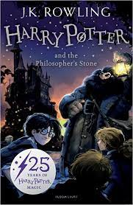 | Harry Potter Series  Harry Potter thinks he is an ordinary boy - until he is rescued by an owl, taken to Hogwarts School of Witchcraft and Wizardry, learns to play Quidditch and does battle in a deadly duel. The Reason ... HARRY POTTER IS A WIZARD!
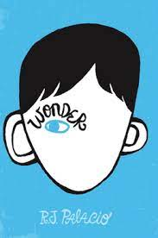 | Wonder  August Pullman was born with a facial difference that, up until now, has prevented him from going to a mainstream school. Starting 5th grade at Beecher Prep, he wants nothing more than to be treated as an ordinary kid—but his new classmates can’t get past Auggie’s extraordinary face. Wonder, begins from Auggie’s point of view, but soon switches to include his classmates, his sister, her boyfriend, and others.
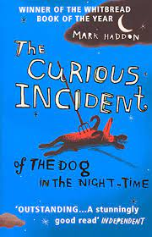 | The Curious Incident of the Dog in the Night Time  Christopher John Francis Boone knows all the countries of the world and their capitals and every prime number up to 7,057. He relates well to animals but has no understanding of human emotions. He cannot stand to be touched. And he detests the colour yellow. This improbable story of Christopher’s quest to investigate the suspicious death of a neighbourhood dog makes for one of the most captivating, unusual, and widely heralded novels in recent years.
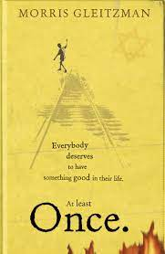 | Once  Once is the story of a young Jewish boy who is determined to escape the orphanage he lives in to save his Jewish parents from the Nazis in the occupied Poland of the Second World War.  Everybody deserves to have something good in their life. At least Once.
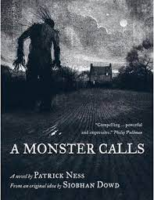 | A Monster Calls  Conor has the same dream every night, ever since his mother first fell ill, ever since she started the treatments that don't quite seem to be working. But tonight is different. Tonight, when he wakes, there is a visitor at his window. It is ancient, elemental, a force of nature. And it wants the most dangerous thing of all from Conor. It wants the truth.
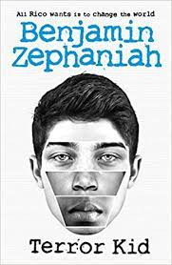 | Terror Kid  Rico knows trouble. He knows the look of it and the sound of it. He also knows to stay away from it as best as he can. Because if there's one thing his Romany background has taught him, it's that he will always be a suspect.  Despite his best efforts to stay on the right side of the law, Rico is angry and frustrated at the injustices he sees happening at home and around the world. He wants to do something - but what? When he is approached by Speech, a mysterious man who shares Rico's hacktivist interests, Rico is given the perfect opportunity to speak out about injustice. After all, what harm can a peaceful cyber protest do...
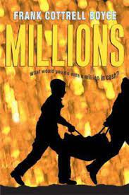 | Millions  It was a one-in-a-million chance. A bag crammed with cash comes tumbling out of the air and lands right at Damian's feet. Suddenly the Cunningham brothers are rich. Very rich. They can buy anything they want. There's just one problem -- they have only seventeen days to spend all the money before it becomes worthless. And the crooks who stole the cash in the first place are closing in -- fast.
I Am Malala
When the Taliban took control of the Swat Valley in Pakistan, one girl spoke out. Malala Yousafzai refused to be silenced and fought for her right to an education.
On Tuesday, October 9, 2012, when she was fifteen, she was shot in the head at point-blank range while riding the bus home from school, and few expected her to survive. Instead, Malala's miraculous recovery has taken her on an extraordinary journey: at 16, she has become a global symbol of peaceful protest and the youngest-ever Nobel Peace Prize laureate.
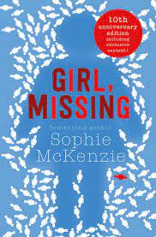 | Girl, Missing  Lauren has always known she was adopted but when a little research turns up the possibility that she was snatched from an American family as a baby, suddenly Lauren's life seems like a sham. How can she find her biological parents? And are her adoptive parents really responsible for kidnapping her?
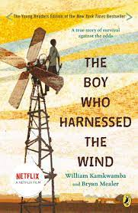 | The Boy Who Harnessed  When a terrible drought struck William Kamkwamba's tiny village in Malawi, his family lost all of the season's crops, leaving them with nothing to eat and nothing to sell. William began to explore science books in his village library, looking for a solution. There, he came up with the idea that he could build a windmill. William's windmill brought electricity to his home and helped his family pump the water they needed to farm the land. Even in a desperate situation, one boy's brilliant idea can light up the world.
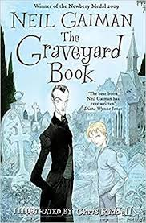 | The Graveyard Book  Nobody Owens, known to his friends as Bod, is a perfectly normal boy. Well, he would be perfectly normal if he didn't live in a graveyard, being raised and educated by ghosts, with a solitary guardian who belongs to neither the world of the living nor the world of the dead. There are dangers and adventures for Bod in the graveyard: the strange and terrible menace of the Sleer; a gravestone entrance to a desert that leads to the city of ghouls; friendship with a witch, and so much more. But it is in the land of the living that real danger lurks, for it is there that the man Jack lives and he has already killed Bod's family.
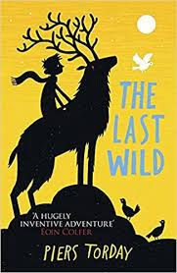 | The Last Wild  In a world where animals no longer exist, twelve-year-old Kester Jaynes sometimes feels like he hardly exists either. Locked away in a home for troubled children, he's told there's something wrong with him. So, when he meets a flock of talking pigeons and a bossy cockroach, Kester thinks he's finally gone crazy. But the animals have something to say. And they need him. The pigeons fly Kester to a wild place where the last creatures in the land have survived. A wise stag needs Kester's help, and together they must embark on a great journey, joined along the way by an overenthusiastic wolf cub, a military-trained cockroach, a mouse with a ritual for everything, and a stubborn girl named Polly. The animals saved Kester Jaynes. But can Kester save the animals?
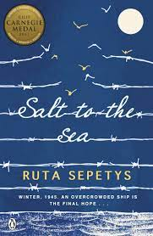 | The Salt to the Sea  While the Titanic and Lusitania are both well-documented disasters, the single greatest tragedy in maritime history is the little-known: in the January of 1945, an overcrowded German cruise liner was supposed to ferry wartime personnel and refugees to safety from the advancing Red Army, however was tragically sunk in the Baltic Sea by Wilhelm Gustloff’s Soviet submarine. Approximately more than 9,000 people, including 5,000 children, lost their lives.  Joana, a Lithuanian with nursing experience; Florian, a Prussian soldier fleeing the Nazis with stolen treasure; and Emilia, a Polish girl close to the end of her pregnancy, converge on their escape journeys as Russian troops advance. Each will eventually meet Albert, a Nazi peon with delusions of grandeur, assigned to the Gustloff decks.
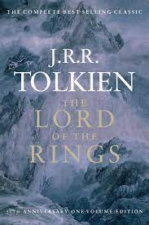 | Lord of the Rings  In a hole in the ground there lived a hobbit. Not a nasty, dirty, wet hole, filled with the ends of worms and an oozy smell, nor yet a dry, bare, sandy hole with nothing in it to sit down on or to eat: it was a hobbit-hole, and that means comfort.
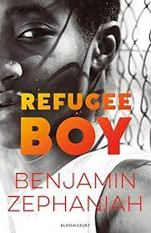 | The Refugee Boy  Alem has never been out of Ethiopia before and is very excited to be on holiday with his father in London. They have had a great few days together until one morning when Alem wakes up in the bed and breakfast they are staying at to find the unthinkable. His father has left him. It is only when the owner of the bed and breakfast hands him a letter that Alem is given an explanation. Alem's father admits that because of the political problems in Ethiopia both he and Alem's mother felt Alem would be safer in London - even though it is breaking their hearts to do this. Alem is now on his own, in the hands of the social services and the Refugee Council. He lives from letter to letter, waiting to hear from his father, and in particular about his mother, who has now gone missing...
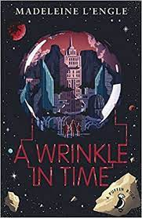 | A Wrinkle in Time  It was a dark and stormy night. Out of this wild night, a strange visitor comes to the Murry house and beckons Meg, her brother Charles Wallace, and their friend Calvin O'Keefe on a most dangerous and extraordinary adventure—one that will threaten their lives and our universe.

 | KS4
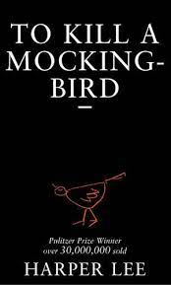 | To Kill a Mockingbird  A black man is falsely charged with the rape of a white girl. Through the young eyes of Scout and Jem Finch, Harper Lee explores with exuberant humour the irrationality of adult attitudes to race and class in the Deep South of the 1930s. The conscience of a town steeped in prejudice, violence and hypocrisy is pricked by the stamina of one man's struggle for justice. But the weight of history will only tolerate so much.
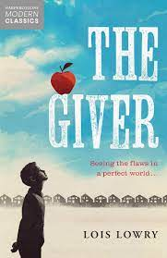 | The Giver  The haunting story centres on twelve-year-old Jonas, who lives in a seemingly ideal, if colourless, world of conformity and contentment. Not until he is given his life assignment as the Receiver of Memory does he begin to understand the dark, complex secrets behind his fragile community.
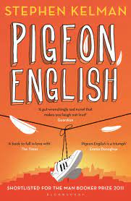 | Pigeon English  Dying in front of Harrison Opoku is the body of one of his classmates, a boy known for his crazy basketball skills, who seems to have been murdered for his dinner. Armed with a pair of camouflage binoculars and detective techniques absorbed from television shows like CSI, Harri and his best friend, Dean, plot to bring the perpetrator to justice. They gather evidence and lay traps to flush out the murderer. But nothing can prepare them for what happens when a criminal feels you closing in on him. Recently emigrated from Ghana with his sister and mother to London’s enormous housing projects, Harri is pure curiosity and ebullience, a friend to the pigeon who visits his balcony, quite possibly the fastest runner in his school, and clearly also fast on the trail of a murderer.
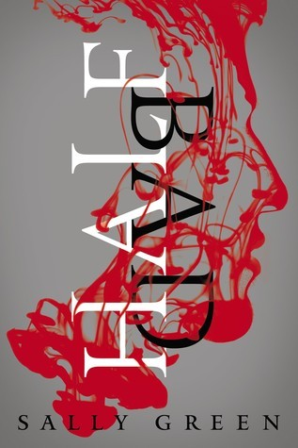 | Half Bad  16-year-old Nathan lives in a cage: beaten, shackled, trained to kill. In modern England where two warring factions of witches live amongst humans, Nathan is an abomination, the illegitimate son of the world's most terrifying and violent witch, Marcus. Nathan's only hope for survival is to escape his captors, track down Marcus, and receive the three gifts that will bring him into his own magical powers—before it's too late. But how can Nathan find his father when there is no one safe to trust, not even family, not even the girl he loves?
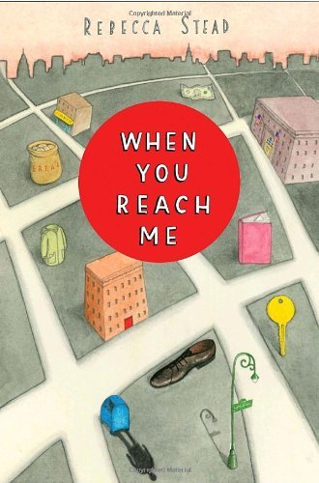 | When You Reach Me  Miranda is an ordinary sixth grader, until she starts receiving mysterious messages from somebody who knows all about her, including things that have not even happened yet. Each message brings her closer to believing that only she can prevent a tragic death. Until the final note makes her think she’s too late.
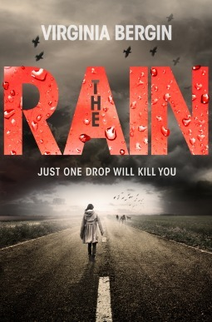 | The Rain  They don't believe it at first. Crowded in Zach's kitchen, Ruby and the rest of the partygoers laugh at Zach's parents' frenzied push to get them all inside as it starts to drizzle. But then the radio comes on with the warning, "It's in the rain! It's fatal, it's contagious, and there's no cure." Two weeks later, Ruby is alone. Anyone who's been touched by rain or washed their hands with tap water is dead. The only drinkable water is quickly running out. Ruby's only chance for survival is a treacherous hike across the country to find her father-if he's even still alive.
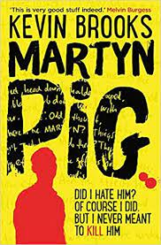 | Martyn Pig  His name may be bad, but his life is worse. Martyn's life is miserable, and it always has been. His mother is gone. His father hates him. But at least things can't get any worse. Or so he thought. When his father dies in a sudden accident, Martyn realizes that for the first time in his life, he has a choice. Sure, he could report what happened - and move in with his horrible Aunty Jean. Or he could get rid of the body and move on with the rest of his life. Hey, what could go wrong?
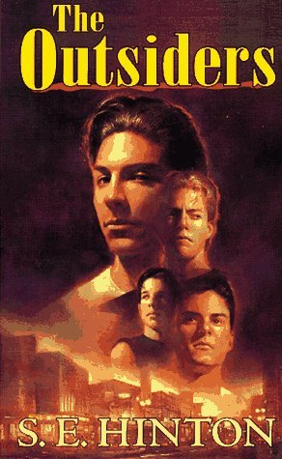 | The Outsider  The novel tells the story of a 14-year-old Ponyboy Curtis and his struggles with right and wrong in a society in which he believes that he is an outsider. There are two kinds of people in the world: greasers and socs. A soc has money, can get away with just about anything, and has an attitude longer than a limousine. A greaser, on the other hand, always lives on the outside and needs to watch his back. Ponyboy is a greaser, and he's always been proud of it, even willing to rumble against a gang of socs for the sake of his fellow greasers--until one terrible night when his friend Johnny kills a soc.
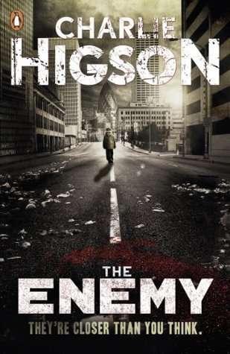 | The Enemy  Everyone over the age of 14 has succumbed to a deadly zombie virus and now the kids must keep themselves alive. When the sickness came, every parent, police officer, politician - every adult fell ill. The lucky ones died. The others are crazed, confused and hungry. Only children under fourteen remain, and they're fighting to survive. Now there are rumours of a safe place to hide. And so, a gang of children begin their quest across London, where all through the city - down alleyways, in deserted houses, underground - the grown-ups lie in wait. But can they make it there - alive?
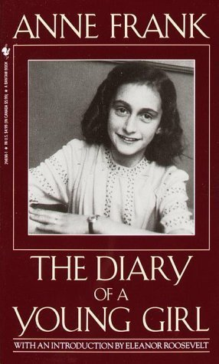 | The Diary of a Young Girl  In 1942, with the Nazis occupying Holland, a 13-year-old Jewish girl and her family fled their home in Amsterdam and went into hiding. For the next two years, until their whereabouts were betrayed to the Gestapo, the Franks and another family lived cloistered in the “Secret Annexe” of an old office building. Cut off from the outside world, they faced hunger, boredom, the constant cruelties of living in confined quarters, and the ever-present threat of discovery and death.
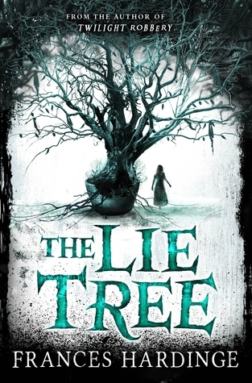 | The Lie Tree  The leaves were cold and slightly clammy. There was no mistaking them. She had seen their likeness painstakingly sketched in her father's journal. This was his greatest secret, his treasure and his undoing. The Tree of Lies. Now it was hers, and the journey he had never finished stretched out before her. When Faith's father is found dead under mysterious circumstances, she is determined to untangle the truth from the lies. Searching through his belongings for clues, she discovers a strange tree. A tree that feeds off whispered lies and bears fruit that reveals hidden secrets. But as Faith's untruths spiral out of control, she discovers that where lies seduce, truths shatter...
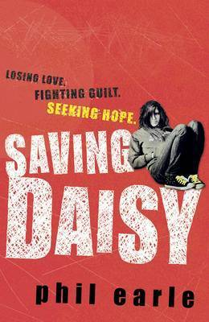 | Saving Daisy  Daisy's mum is gone. Her dad refuses to talk about it. As far as Daisy's concerned, it is all her fault. As her life starts to spiral out of control, panic leads to tragedy and Daisy's left alone. But sometimes the kindness of a stranger can turn things around. A stranger who desperately wants to save Daisy - if she'll only let herself be saved…
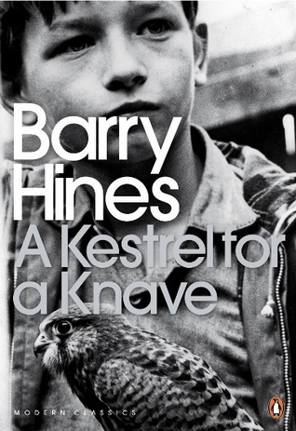 | A Kestrel for A Knave  Life is tough and cheerless for Billy Casper, a troubled teenager growing up in the small Yorkshire mining town of Barnsley. Treated as a failure at school, and unhappy at home, Billy discovers a new passion in life when he finds Kes, a kestrel hawk. Billy identifies with her silent strength and she inspires in him the trust and love that nothing else can, discovering through her the passion missing from his life.
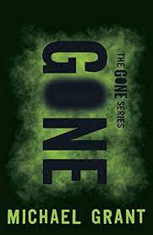 | Gone (Series)  In the blink of an eye, everyone disappears. Except for the young. Just as suddenly, there are no phones, no internet, no television. No way to get help. And no way to figure out what's happened. Hunger threatens. Bullies rule. A sinister creature lurks. Animals are mutating. And the teens themselves are changing, developing new talents—unimaginable, dangerous, deadly powers—that grow stronger by the day. It's a terrifying new world. Sides are being chosen; a fight is shaping up. Townies against rich kids. Bullies against the weak. Powerful against powerless. And time is running out: On your 15th birthday, you disappear just like everyone else...
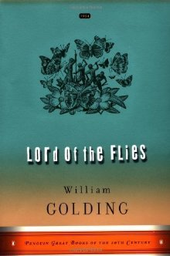 | Lord of the Flies  At the dawn of the next world war, a plane crashes on an uncharted island, stranding a group of schoolboys. At first, with no adult supervision, their freedom is something to celebrate; this far from civilization the boys can do anything they want. Anything. They attempt to forge their own society, failing, however, in the face of terror, sin and evil. And as order collapses, as strange howls echo in the night, as terror begins its reign, the hope of adventure seems as far from reality as the hope of being rescued.
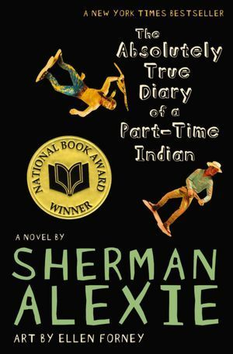 | The Absolutely True Diary of a Part-Time Indian  Junior, a budding cartoonist, lives on the Spokane Indian Reservation. Determined to take his future into his own hands, Junior leaves his troubled school on the reservation to attend an all-white farm town high school where the only other Indian is the school mascot.
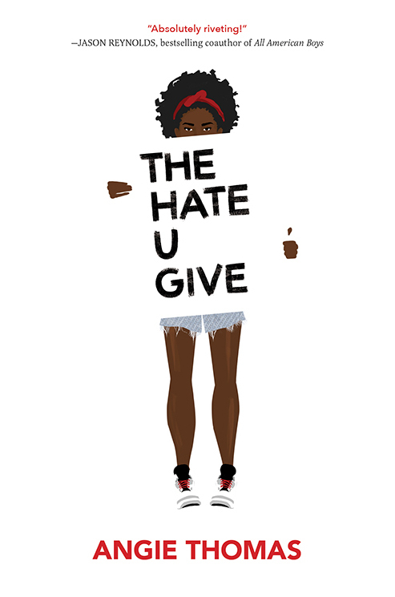 | The Hate U Give  16-year-old Starr Carter moves between two worlds: the poor neighbourhood where she lives and the fancy suburban prep school she attends. The uneasy balance between these worlds is shattered when Starr witnesses the fatal shooting of her childhood best friend Khalil at the hands of a police officer. Khalil was unarmed. Soon afterward, his death is a national headline. Some are calling him a thug, maybe even a drug dealer and a gangbanger. Protesters are taking to the streets in Khalil’s name. Some cops and the local drug lord try to intimidate Starr and her family. What everyone wants to know is: what really went down that night? And the only person alive who can answer that is Starr. But what Starr does—or does not—say could upend her community. It could also endanger her life.
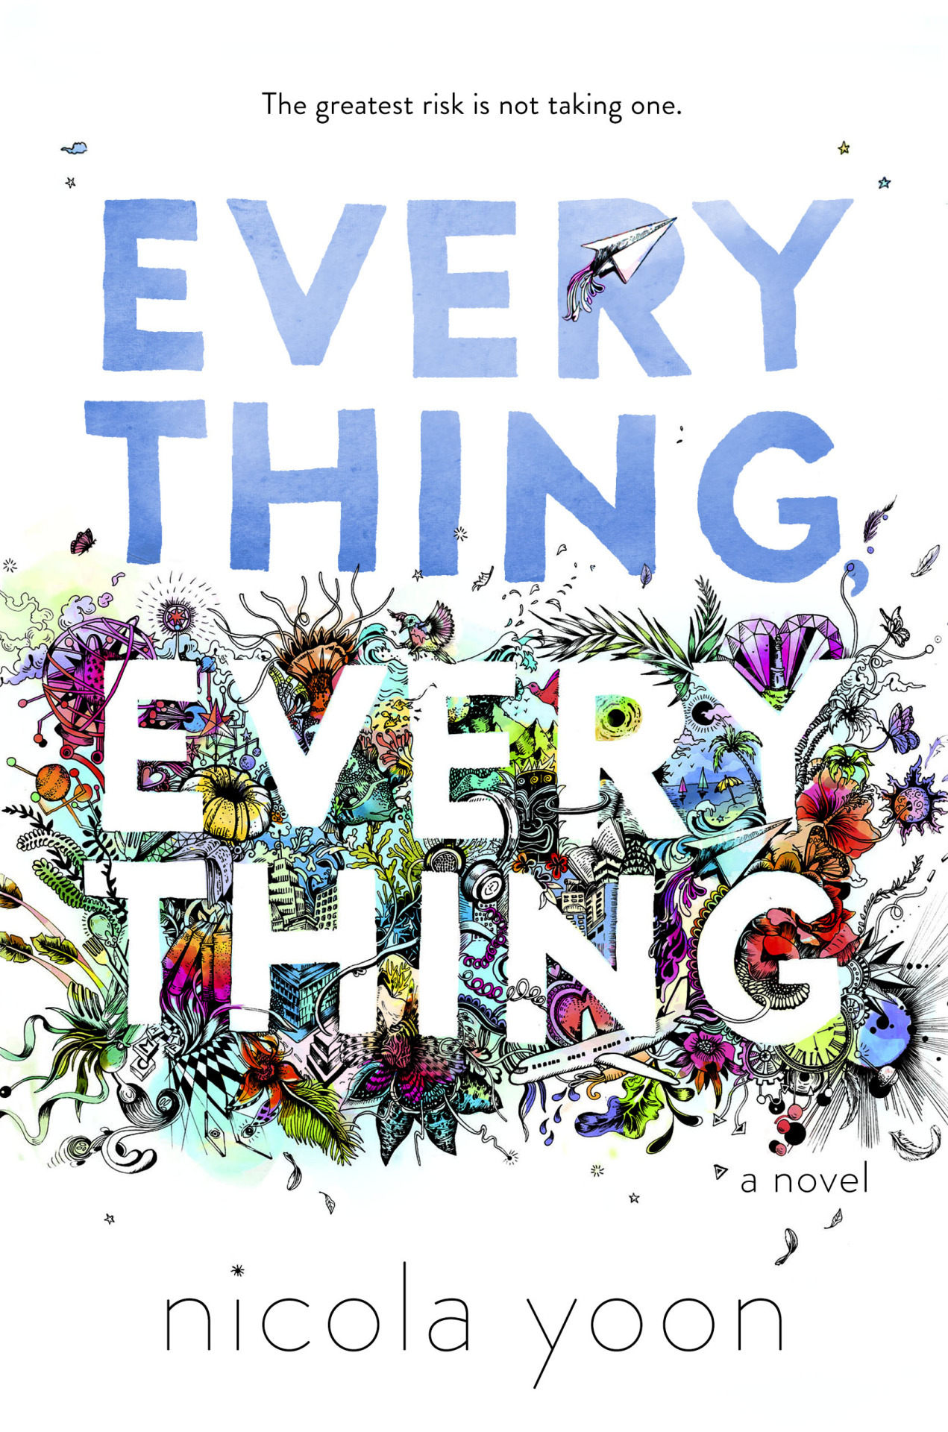 | Everything Everything  My disease is as rare as it is famous. It’s a form of Severe Combined Immunodeficiency, but basically, I’m allergic to the world. I don’t leave my house, have not left my house in fifteen years. The only people I ever see are my mom and my nurse, Carla. But then one day, a moving truck arrives. New next door neighbours. I look out the window, and I see him. He’s tall, lean and wearing all black—black t-shirt, black jeans, black sneakers and a black knit cap that covers his hair completely. He catches me looking and stares at me. I stare right back. His name is Olly. I want to learn everything about him, and I do. I learn that he is funny and fierce. I learn that his eyes are Atlantic Ocean-blue and that his vice is stealing silverware. I learn that when I talk to him, my whole world opens up, and I feel myself starting to change—starting to want things. To want out of my bubble. To want everything, everything the world has to offer. Maybe we can’t predict the future, but we can predict some things. For example, I am certainly going to fall in love with Olly. It’s almost certainly going to be a disaster.
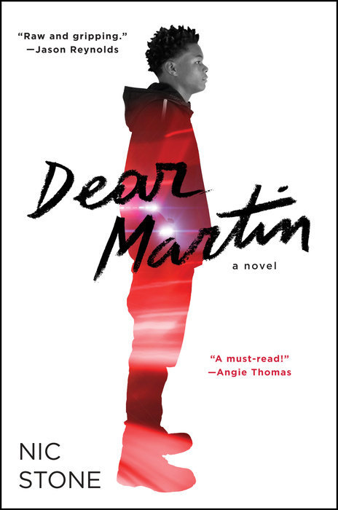 | Dear Martin  Justyce McAllister is top of his class and set for the Ivy League—but none of that matters to the police officer who just put him in handcuffs. And despite leaving his rough neighbourhood behind, he can't escape the scorn of his former peers or the ridicule of his new classmates. Justyce looks to the teachings of Dr. Martin Luther King Jr. for answers. But do they hold up anymore? He starts a journal to Dr. King to find out. Then comes the day Justyce goes driving with his best friend, Manny, windows rolled down, music turned up—way up, sparking the fury of a white off-duty cop beside them. Words fly. Shots are fired. Justyce and Manny are caught in the crosshairs. In the media fallout, it's Justyce who is under attack.
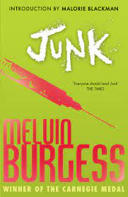 | Junk  Two teens fall in love with each other and heroin. Tar has reasons for running away from home that run deep and sour, whereas Gemma, with her middle-class roots firmly on show, has a deep-rooted lust for adventure. Their first hit brings bliss, the next despair.
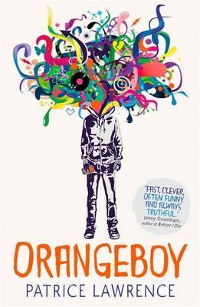 | OrangeBoy  Sixteen-year-old Marlon has promised his widowed mum that he'll be good, and nothing like his gang-leader brother Andre. It's easy when you keep yourself to yourself, listening to your dead dad's Earth, Wind and Fire albums and watching sci-fi. But everything changes when Marlon's first date with the beautiful Sonya ends in tragedy; he becomes a hunted man and he has no idea why. With his dad dead and his brother helpless, Marlon has little choice but to enter Andre's old world of guns, knives and drug runs in order to uncover the truth and protect those close to him.
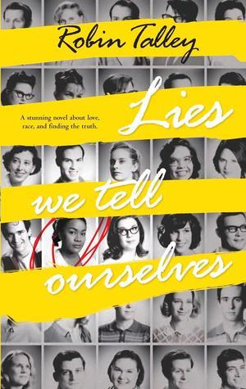 | The Lies We Tell Ourselves  In 1959 Virginia, the lives of two girls on opposite sides of the battle for civil rights will be changed forever. Sarah Dunbar is one of the first black students to attend the previously all-white Jefferson High School. An honours student at her old school, she is put into remedial classes, spit on, and tormented daily. Linda Hairston is the daughter of one of the town's most vocal opponents of school integration. She has been taught all her life that the races should be kept separate but equal. Forced to work together on a school project, Sarah and Linda must confront harsh truths about race, power and how they really feel about one another.
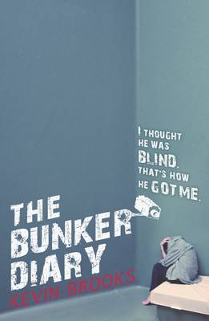 | The Bunker Diary  I can't believe I fell for it. It was still dark when I woke up this morning. As soon as my eyes opened I knew where I was. A low-ceilinged rectangular building made entirely of whitewashed concrete. There are six little rooms along the main corridor. There are no windows. No doors. The elevator is the only way in or out.  What's he going to do to me? What am I going to do? People are really quite simple, and they have simple needs. Food, water, light, space, privacy. Maybe a small measure of dignity. A bit of freedom. What happens when someone simply takes all that away?
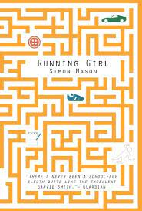 | Running Girl  Meet Garvie Smith. Highest IQ ever recorded at Marsh Academy. Lowest ever grades. What's the point, anyway? Life sucks. Nothing ever happens. Until Chloe Dow's body is pulled from a pond. DI Singh is already on the case. Ambitious, uptight, methodical - he's determined to solve the mystery and get promoted. He doesn't need any 'assistance' from notorious slacker, Smith. Or does he?
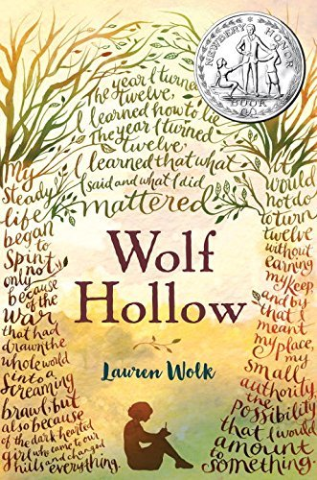 | Wolf Hollow  Growing up in the shadows cast by two world wars, Annabelle has lived a mostly quiet, steady life in her small Pennsylvania town. Until the day new student Betty Glengarry walks into her class. Betty quickly reveals herself to be cruel and manipulative, and while her bullying seems isolated at first, things quickly escalate, and reclusive World War I veteran Toby becomes a target of her attacks. While others have always seen Toby’s strangeness, Annabelle knows only kindness. She will soon need to find the courage to stand as a lone voice of justice as tensions mount.
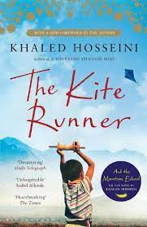 | The Kite Runner  1970s Afghanistan: Twelve-year-old Amir is desperate to win the local kite-fighting tournament and his loyal friend Hassan promises to help him. But neither of the boys can foresee what would happen to Hassan that afternoon, an event that is to shatter their lives. After the Russians invade and the family is forced to flee to America, Amir realises that one day he must return to an Afghanistan under Taliban rule to find the one thing that his new world cannot grant him: redemption
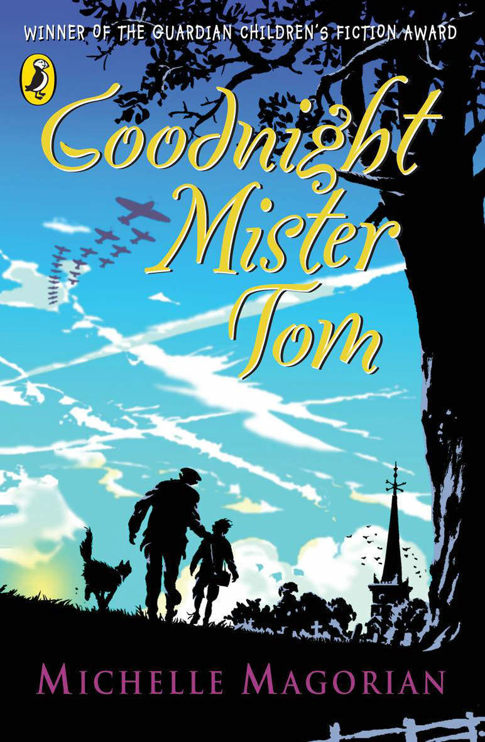 | Goodnight, Mister Tom  When the Second World War breaks out, young Willie Beech is evacuated to the countryside. A sad, deprived child, he slowly begins to flourish under the care of kind old Tom Oakley. But then his cruel mother summons him back to war-torn London...
Crazy Rich Asians
When Rachel Chu agrees to spend the summer in Singapore with her boyfriend, Nicholas Young, she envisions a humble family home, long drives to explore the island, and quality time with the man she might one day marry. What she doesn't know is that Nick's family home happens to look like a palace, that she'll ride in more private planes than cars, and that with one of Asia's most eligible bachelors on her arm, Rachel might as well have a target on her back.
Initiated into a world of dynastic splendor beyond imagination, Rachel meets Astrid, the It Girl of Singapore society; Eddie, whose family practically lives in the pages of the Hong Kong socialite magazines; and Eleanor, Nick's formidable mother, a woman who has very strong feelings about who her son should—and should not—marry.

Library Highlights

 | 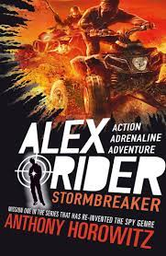 | Alex Rider Stormbreaker  They told him his uncle died in an accident. He wasn't wearing his seatbelt, they said. But when 14-year-old Alex finds his uncle's windshield riddled with bullet holes, he knows it was no accident. What he doesn't know yet is that his uncle was killed while on a top-secret mission. But he is about to, and once he does, there is no turning back. Finding himself in the middle of terrorists, Alex must outsmart the people who want him dead. The government has given him the technology, but only he can provide the courage. Should he fail, every child in England will be murdered in cold blood.
 | 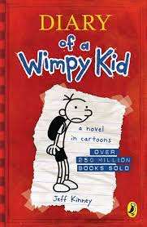 | Diary of a Wimpy Kid  Greg Heffley finds himself thrust into a new year and a new school where undersize weaklings share the corridors with kids who are taller, meaner and already shaving. Desperate to prove his newfound maturity, which only going up a grade can bring, Greg is happy to have his not-quite-so-cool sidekick, Rowley, along for the ride. But when Rowley's star starts to rise, Greg tries to use his best friend's popularity to his own advantage. Recorded in his diary with comic pictures and his very own words, this test of Greg and Rowley's friendship unfolds with hilarious results.
 | 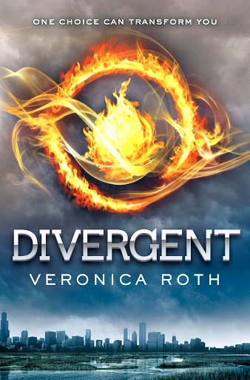 | Divergent  In a dystopian Chicago world, society is divided into five factions – each dedicated to the cultivation of a particular virtue: Candor (the honest), Abnegation (the selfless), Dauntless (the brave), Amity (the peaceful), and Erudite (the intelligent). On an appointed day of every year, all 16-year-olds must select the faction to which they will devote the rest of their lives. During the highly competitive initiation that follows, Beatrice renames herself Tris and struggles alongside her fellow initiates to live out the choice they have made. Together they must undergo extreme physical tests of endurance and intense psychological simulations, some with devastating consequences.
 | 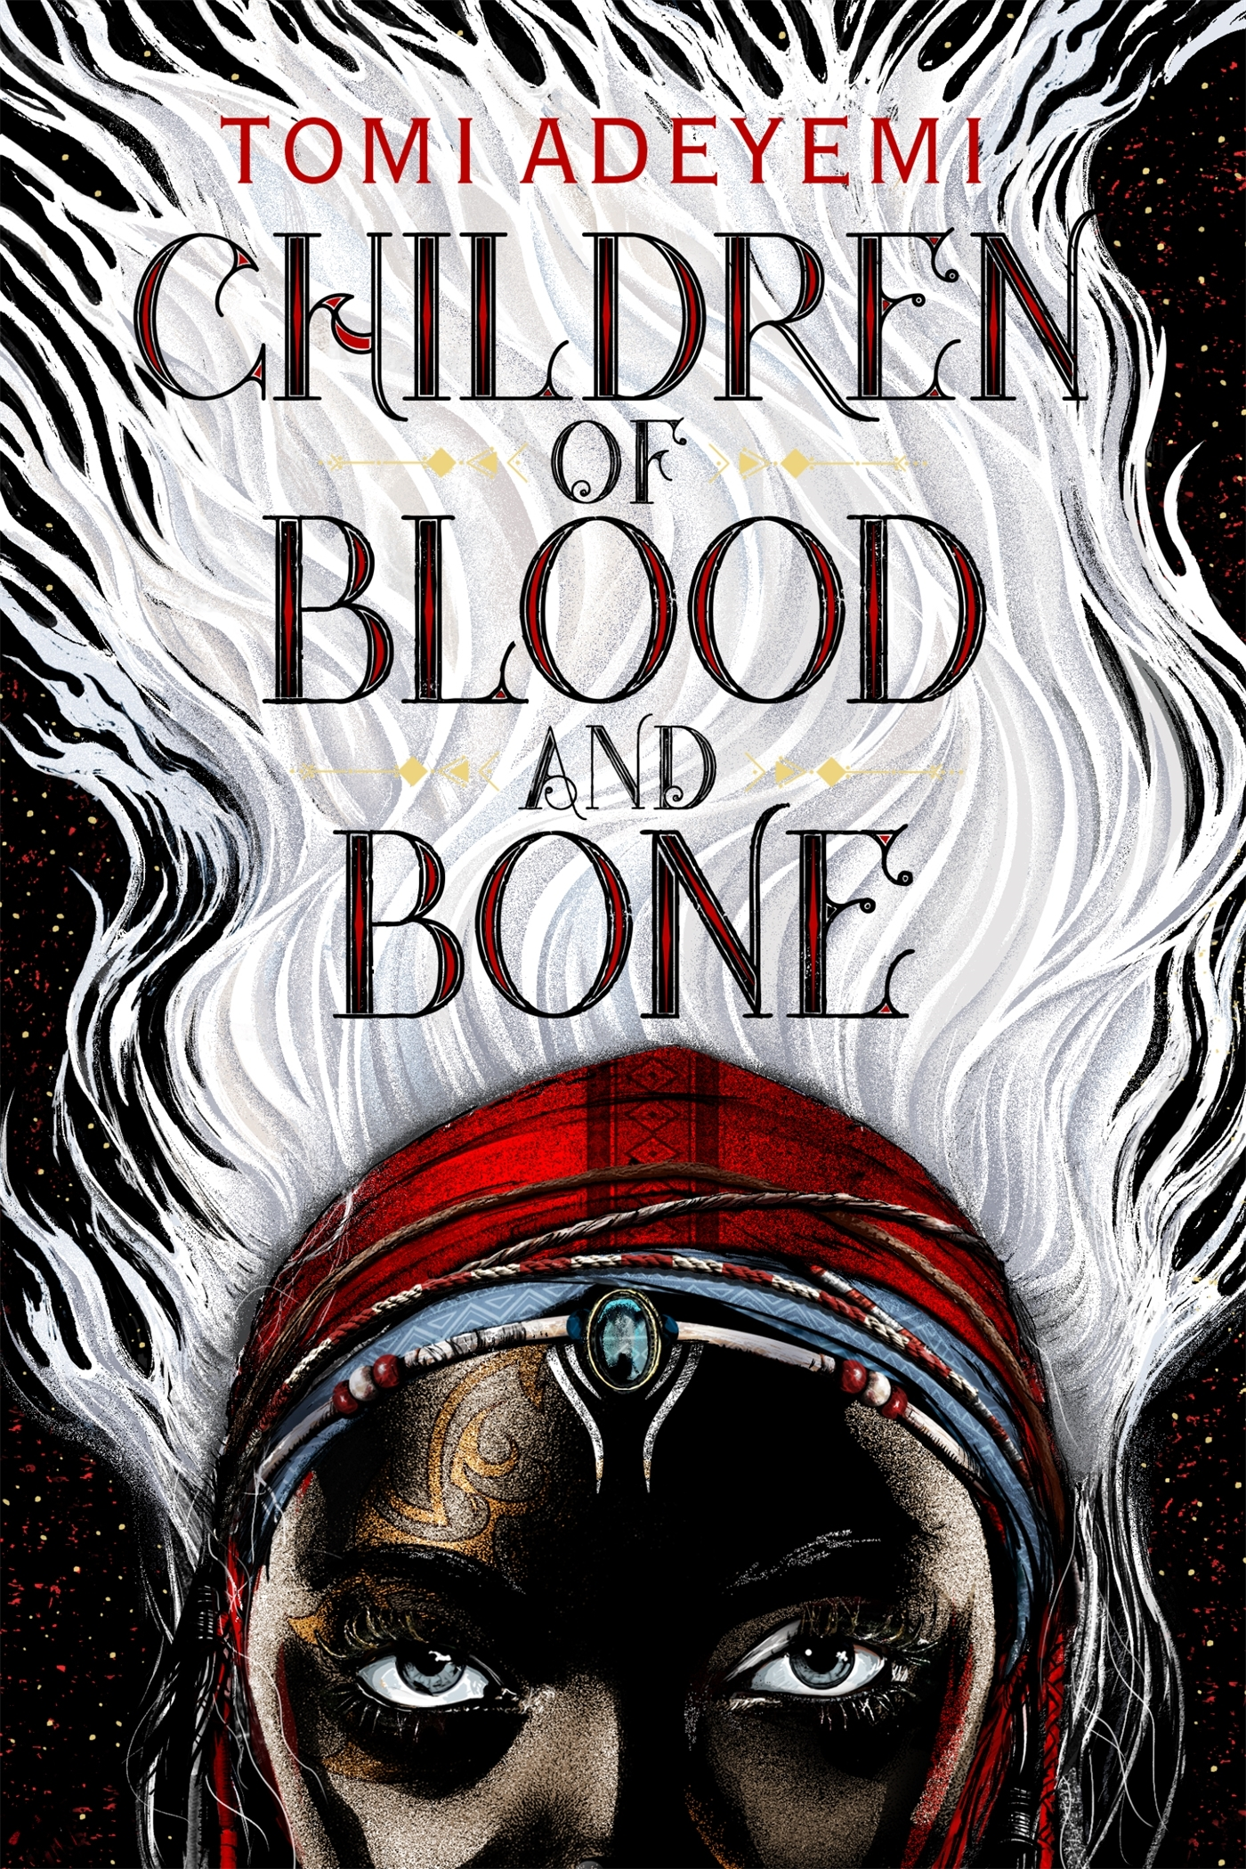 | Children of Blood and Bone  Zélie Adebola remembers when the soil of Orïsha hummed with magic. Burners ignited flames, Tiders beckoned waves, and Zélie’s Reaper mother summoned forth souls. But everything changed the night magic disappeared. Under the orders of a ruthless king, maji were killed, leaving Zélie without a mother and her people without hope. Now Zélie has one chance to bring back magic and strike against the monarchy. With the help of a rogue princess, Zélie must outwit and outrun the crown prince, who is hell-bent on eradicating magic for good. Danger lurks in Orïsha, where snow leoponaires prowl and vengeful spirits wait in the waters. Yet the greatest danger may be Zélie herself as she struggles to control her powers and her growing feelings for an enemy.
 | 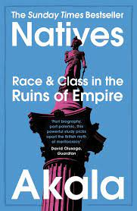 | Natives Race & Class in the Ruins of Empire  From the first time he was stopped and searched as a child, to the day he realised his mum was white, to his first encounters with racist teachers - race and class have shaped Akala's life and outlook. In this unique book he takes his own experiences and widens them out to look at the social, historical and political factors that have left us where we are today. Covering everything from the police, education and identity to politics, sexual objectification and the far right, Natives speaks directly to British denial and squeamishness when it comes to confronting issues of race and class that are at the heart of the legacy of Britain's racialised empire.
 | 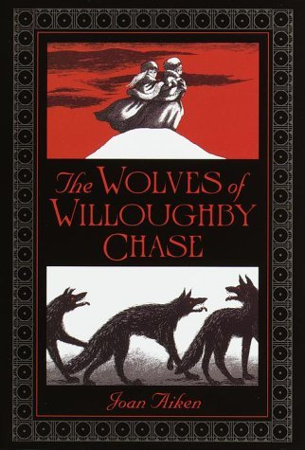 | The Wolves of Willoughby Chase  Wicked wolves and a grim governess threaten Bonnie and Sylvia when Bonnie's parents leave Willoughby Chase for a sea voyage. Left with the cruel Miss Slighcarp, the girls can hardly believe what is happening to their once happy home. The servants are dismissed, the furniture is sold, and Bonnie and Sylvia are sent to a prison-like orphan school.
 | 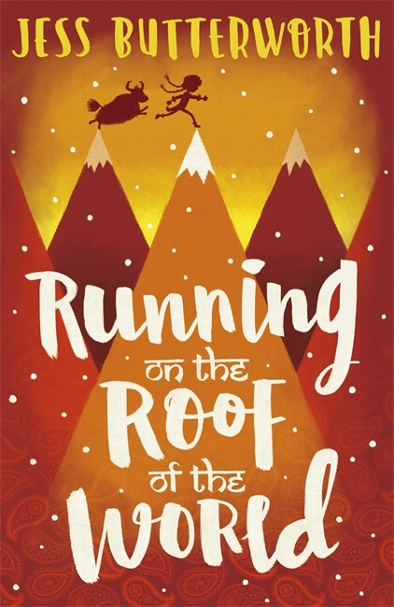 | Running on the Roof of the World  There are two words that are banned in Tibet. Two words that can get you locked in prison without a second thought. I watch the soldiers tramping away and call the words after them. 'Dalai Lama.' Tash has to follow many rules to survive in Tibet, a country occupied by Chinese soldiers. But when a man sets himself on fire in protest and soldiers seize Tash's parents, she and her best friend Sam must break the rules. They are determined to escape Tibet - and seek the help of the Dalai Lama himself in India.
 | 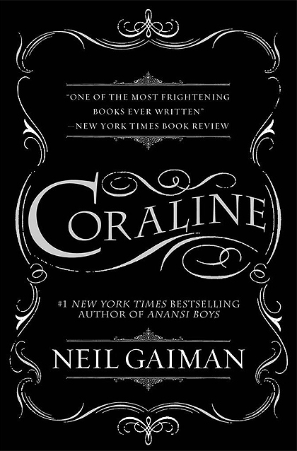 | Coraline  In Coraline's family's new flat are twenty-one windows and fourteen doors. Thirteen of the doors open and close. The fourteenth is locked, and on the other side is only a brick wall, until the day Coraline unlocks the door to find a passage to another flat in another house just like her own. Only it's different. At first, things seem marvellous in the other flat. The food is better. The toy box is filled with wind-up angels that flutter around the bedroom, books whose pictures writhe and crawl and shimmer, little dinosaur skulls that chatter their teeth. But there's another mother, and another father, and they want Coraline to stay with them and be their little girl. They want to change her and never let her go. Other children are trapped there as well, lost souls behind the mirrors.
 | 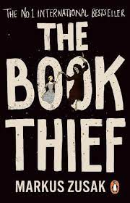 | The Book Thief  It is 1939. Nazi Germany. The country is holding its breath. Death has never been busier and will be busier still. By her brother's graveside, Liesel's life is changed when she picks up a single object, partially hidden in the snow. It is The Gravedigger's Handbook, left behind there by accident, and it is her first act of book thievery. Soon she is stealing books from Nazi book-burnings, the mayor's wife's library, wherever there are books to be found. But these are dangerous times. When Liesel's foster family hides a Jew in their basement, Liesel's world is both opened up, and closed down.
 | 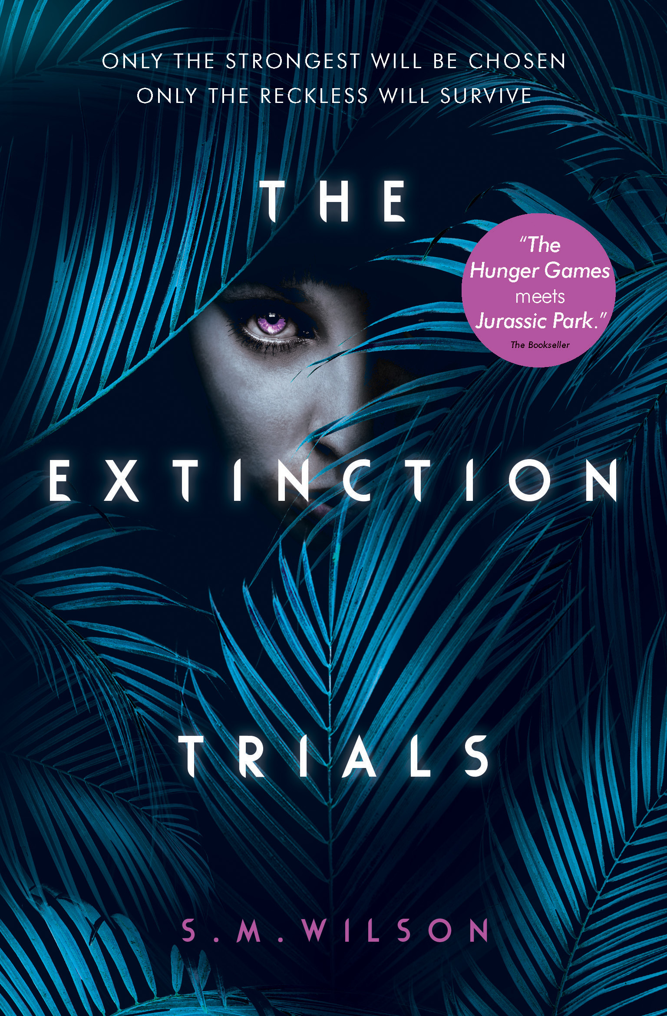 | The Extinction Trials  Betrayal. Sacrifice. Survival. Welcome to the Extinction Trials. In Stormchaser and Lincoln's ruined world, the only way to survive is to risk everything. To face a contest more dangerous than anyone can imagine. And they will do anything to win. But in a land full of monsters - human and reptilian - they can't afford to trust anyone. Perhaps not even each other...
 | 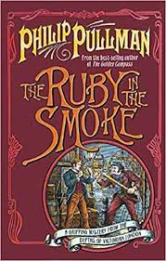 | Ruby in the Smoke  Sally is sixteen and uncommonly pretty. She has a thorough grounding in military tactics, can run a business, ride like a Cossack and shoot straight with a pistol. When her dear father is drowned in suspicious circumstances in the South China Sea, Sally is left to fend for herself, an orphan and alone in the smoky fog of Victorian London. Though she doesn't know it, Sally is already in terrible danger.
 | 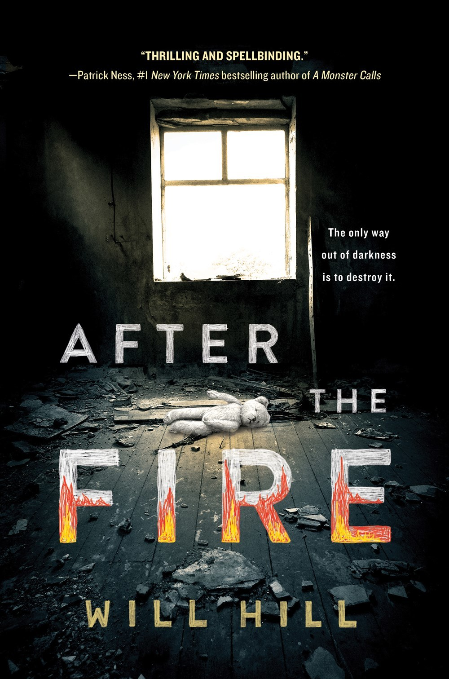 | After the Fire  The things I've seen are burned into me, like scars that refuse to fade. Before, she lived inside the fence. Before, she was never allowed to leave the property, never allowed to talk to Outsiders, never allowed to speak her mind. Disobeying Father John came with terrible consequences. But there are lies behind Father John's words. Outside, there are different truths. Then came the fire.
 | 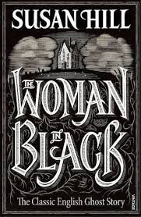 | The Woman in Black  Arthur Kipps, an up-and-coming young solicitor, has come north from London to attend the funeral and settle the affairs of Mrs. Alice Drablow of Eel Marsh House. The routine formalities he anticipates give way to a tumble of events and secrets more sinister and terrifying than any nightmare: the rocking chair in the deserted nursery, the eerie sound of a pony and trap, a child's scream in the fog, and most dreadfully: The Woman In Black.
 | 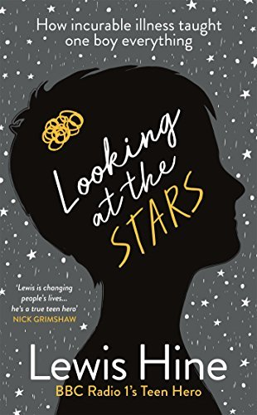 | Looking at the Stars  17-year-old Lewis Hine is a global phenomenon. Diagnosed with a life-threatening brain tumour and water on the brain at 17 months, he wasn't expected to survive. But Lewis proved everyone wrong; he's not only surviving but thriving. In one Facebook post on his 16th birthday Lewis invited everyone to see how he faces head on the challenges from his ongoing illness, and he went viral. 30 million views later, Lewis now spearheads a campaign, Friend Finder, to make sure no one ever faces childhood illness alone.
The Poet X
Xiomara Batista feels unheard and unable to hide in her Harlem neighbourhood. Xiomara has plenty she wants to say, and she pours all her frustration and passion onto the pages of a leather notebook, reciting the words to herself like prayers—especially after she catches feelings for a boy in her bio class named Aman, who her family can never know about.
 | 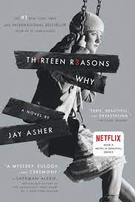 | Thirteen Reasons Why  You can’t stop the future. You can’t rewind the past. The only way to learn the secret is to press play. Clay Jensen returns home from school to find a strange package with his name on it lying on his porch. Inside he discovers several cassette tapes recorded by Hannah Baker–his classmate and crush–who committed suicide two weeks earlier. Hannah’s voice tells him that there are thirteen reasons why she decided to end her life. Clay is one of them.
 | 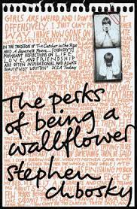 | The Perks of Being a Wallflower  Standing on the fringes of life offers a unique perspective. But there comes a time to see what it looks like from the dance floor. More intimate than a diary, Charlie's letters are singular and unique, hilarious and devastating. Caught between trying to live his life and trying to run from it puts him on a strange course through uncharted territory. The world of first dates and mixed tapes, family dramas and new friends. The world of sex, drugs, and The Rocky Horror Picture Show, when all one requires is that the perfect song on that perfect drive to feel infinite. A haunting novel about the dilemma of passivity vs. passion.
 | 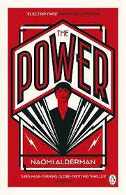 | The Power  The world is a recognizable place: there's a rich Nigerian boy who lounges around the family pool; a foster kid whose religious parents hide their true nature; an ambitious American politician; a tough London girl from a tricky family. But then a vital new force takes root and flourishes, causing their lives to converge with devastating effect. Teenage girls now have immense physical power--they can cause agonizing pain and even death. And, with this small twist of nature, the world drastically resets.
 | 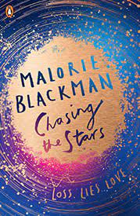 | Chasing the Stars  Olivia and her twin brother Aidan are heading alone back to Earth following the virus that wiped out the rest of their crew, and their family, in its entirety. Nathan is part of a community heading in the opposite direction. But on their journey, Nathan’s ship is attacked and most of the community killed. Only a few survive. Their lives unexpectedly collided, Nathan and Olivia are instantly attracted to each other, deeply, head-over-heels – like nothing they have ever experienced. But not everyone is pleased.
 | 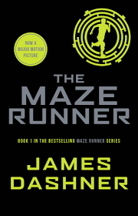 | The Maze Runner  If you ain’t scared, you ain’t human. When Thomas wakes up in the lift, the only thing he can remember is his name. He’s surrounded by strangers—boys whose memories are also gone. Nice to meet ya, shank. Welcome to the Glade. Outside the towering stone walls that surround the Glade is a limitless, ever-changing maze. It’s the only way out—and no one’s ever made it through alive. Everything is going to change. Then a girl arrives. The first girl ever. And the message she delivers is terrifying. Remember. Survive. Run.
 | 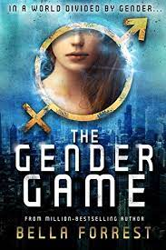 | The Gender Game  A toxic river divides nineteen-year-old Violet Bates's world by gender. Women rule the East. Men rule the West. Welcome to the lands of Matrus and Patrus. Ever since the disappearance of her beloved younger brother, Violet's life has been consumed by an anger she struggles to control. Already a prisoner to her own nation, now she has been sentenced to death for her crimes. But one decision could save her life. To enter the kingdom of Patrus, where men rule and women submit. Everything about the patriarchy is dangerous for a rebellious girl like Violet.
 | 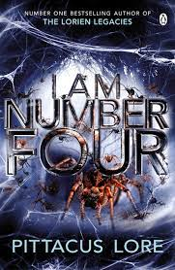 | I Am Number Four  Nine of us came here. We look like you. We talk like you. We live among you. But we are not you. We can do things you dream of doing. We have powers you dream of having. We are stronger and faster than anything you have ever seen. We are the superheroes you worship in movies and comic books--but we are real. Our plan was to grow, and train, and become strong, and become one, and fight them. But they found us and started hunting us first. Now all of us are running. Spending our lives in shadows, in places where no one would look, blending in. We have lived among you without you knowing. But they know. They caught Number One in Malaysia. Number Two in England. And Number Three in Kenya. They killed them all. I am Number Four. I am next.
Legend
What was once the western United States is now home to the Republic. From very different worlds, June and Day have no reason to cross paths—until the day June's brother, Metias, is murdered and Day becomes the prime suspect. Caught in the ultimate game of cat and mouse, Day is in a race for his family's survival, while June seeks to avenge Metias's death.
 | 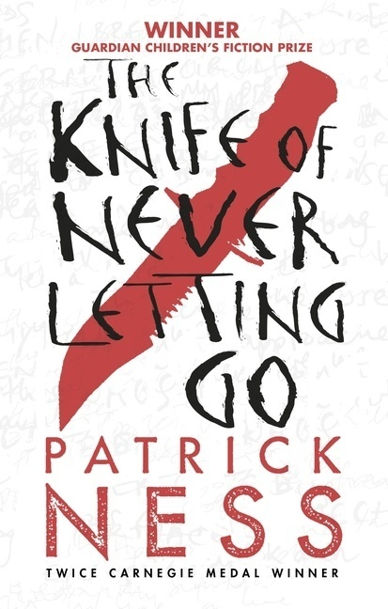 | The Knife of Never Letting Go  Todd Hewitt is the only boy in a town of men. Ever since the settlers were infected with the Noise germ, Todd can hear everything the men think, and they hear everything he thinks. Todd is just a month away from becoming a man, but in the midst of the cacophony, he knows that the town is hiding something from him -- something so awful Todd is forced to flee with only his dog, whose simple, loyal voice he hears too. With hostile men from the town in pursuit, the two stumbles upon a strange and eerily silent creature: a girl. Who is she? Why wasn't she killed by the germ like all the females on New World? Propelled by Todd's gritty narration, readers are in for a white-knuckle journey in which a boy on the cusp of manhood must unlearn everything he knows in order to figure out who he truly is.
 | 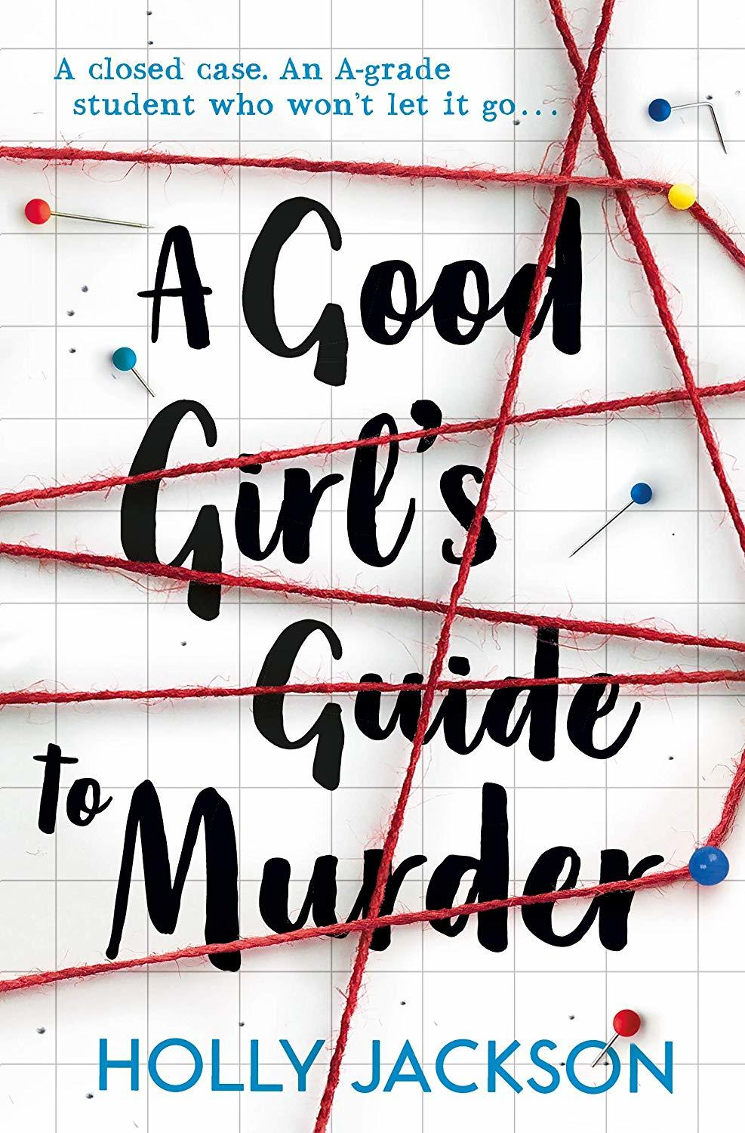 | A Good Girl’s Guide to Murder  The case is closed. Five years ago, schoolgirl Andie Bell was murdered by Sal Singh. The police know he did it. Everyone in town knows he did it. But having grown up in the same small town that was consumed by the murder, Pippa Fitz-Amobi is not so sure. When she chooses the case as the topic for her final year project, she starts to uncover secrets that someone in town desperately wants to stay hidden. And if the real killer is still out there, how far will they go to keep Pip from the truth?
 | 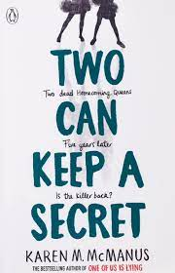 | Two Can Keep a Secret  Echo Ridge is small-town America. Ellery's never been there, but she's heard all about it. Her aunt went missing there at age seventeen. And only five years ago, a homecoming queen put the town on the map when she was killed. Now Ellery has to move there to live with a grandmother she barely knows. The town is picture-perfect, but it's hiding secrets. And before school even begins for Ellery, someone's declared open season on homecoming, promising to make it as dangerous as it was five years ago. Then, almost as if to prove it, another girl goes missing. Ellery knows all about secrets. Her mother has them; her grandmother does too. And the longer she's in Echo Ridge, the clearer it becomes that everyone there is hiding something. The thing is, secrets are dangerous--and most people aren't good at keeping them. Which is why in Echo Ridge, it's safest to keep your secrets to yourself.
 | 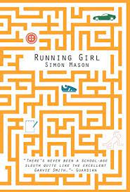 | The Running Girl  Meet Garvie Smith. Highest IQ ever recorded at Marsh Academy. Lowest ever grades. What's the point, anyway? Life sucks. Nothing ever happens. Until Chloe Dow's body is pulled from a pond. DI Singh is already on the case. Ambitious, uptight, methodical - he's determined to solve the mystery and get promoted. He doesn't need any 'assistance' from notorious slacker, Smith. Or does he?

